

Utilising Modern Business Computing Systems to Illustrate the Impact Electrical Vehicle Technology will have on the Welsh Automotive Industry.

By
Myles Alexander Anderson

Supervisor: James Williams
Second Marker: John Rees

Project submitted as part of the requirements for the award of
BSc (Hons) Business Computing
27th April 2017

DECLARATION

I, Myles Alexander Anderson declare that I am the sole author of this Project; that all references cited have been consulted; that I have conducted all work of which this is a record, and that the finished work lies within the prescribed word limits.

This work has not previously been accepted as part of any other degree submission.

Signed: .............................................

Date: ...............................................

FORM OF CONSENT

I, Myles Alexander Anderson hereby consent that my Project, submitted in candidature for the B.Sc.(Hons) Business Computing degree, if successful, may be made available for inter-library loan or photocopying (subject to the law of copyright), and that the title and abstract may be made available to outside organisations.

Signed: .............................................

Date: ...............................................

Abstract

The following project will focus its attention on the possibility of an electrical, low-emission and sustainable automotive future. With cancerous, toxic gases in our cities leading to increased levels of air pollution and a slow but deadly rise in global temperatures, change is needed. With the rising figures of both sales and the number automotive manufactures producing zero-emission electrical vehicles, this change is on the horizon. However, is Wales and her people ready? This project will use a quantitative survey to investigate respondent’s opinions regarding electrical cars and the surrounding infrastructure in Wales, this will help identify whether our country is ready to embrace this potential new face of the motor industry. To ensure its validity and objectiveness, the survey was created using the ‘SMART’ methodology, SMART being an abbreviation for; ‘Specific’, ‘Measurable’, ‘Attainable’, ‘Relevant’ and ‘Time Based’.
The findings of this survey will be analysed and evaluated once the results have come in. Once these processes have been completed, the conclusions will be outlined and established before future recommendations are made.
With the help of a Geographical Information System, an application will be developed to identify the location of fast electrical charging stations across Wales, this application can be used by current and future electric vehicle users to help them find the station closest to them. This application will be produced using the developmental methodology ‘Rapid Application Development’ (RAD) which will allow for faster development by using an iterative testing procedure, RAD is used when a system needs to produce great results within a short time frame. Furthermore, the application will be tested by both students and real-world users who either own or are considering purchasing an electric vehicle.
Once the testing and development of the application has been completed, it will be detailed as to what problems and successes occurred during these phases. It will be asked what could have been done differently in retrospective and a conclusion will be completed to determine what was learnt and to discuss any further developments that could be featured.

Contents
Figures 1
1.0 Introduction 1
1.1 Aims and Objectives 1
2.0 Literature Review 1
2.1 The Technological Revolution of the Motor Industry 1
2.1.1 Origins of the Motor Vehicle 1
2.1.2 Attempts to Make the Gas Guzzler ‘Green’. 1
2.1.3 Hybrid Technology 1
2.1.4 The Hydrogen Fuel Cell 1
2.1.5 Electrical Technology and the Growth of the Electrical Car. 1
2.2 What are Geographical Information Systems (GIS), and what different GIS packages could be used? 1
2.2.1 What is GIS? 1
2.2.2 The Relationship between Geographical Information Systems and Data. 1
2.2.3 What can GIS Maps can show us? 1
2.2.4 What GIS Packages are available? 1
3.0 Research Methodology: 1
3.1 Research Onion 1
3.1.1 Research Philosophy 1
3.1.2 Research Approach 1
3.1.3 Research Strategy 1
3.1.4 Time Horizons 1
3.1.5 Data Collection Type 1
3.1.6 Conclusion and Summary 1
3.2 Survey Methodology: 1
3.2.1 Who is the target audience? 1
3.2.2 Survey Questions and Investigation: 1
3.2.3 Survey Validity: 1
3.2.4 Survey Reliability: 1
3.2.5 Survey Generalisability: 1
3.2.6 Prototyping: 1
3.2.7 Changes made after prototyping: 1
3.2.8 How will these results be analysed? 1
3.3 Developmental Methodology: 1
3.3.1 Rapid Application Development: 1
3.3.2 Software used and why: 1
4.0 Analysis 1
4.1 Survey Result Analysis 1
4.2 Data Correlations, Patterns and Trends. 1
5.0 Design and Implementation 1
5.1 What are the project requirements for the application? 1
5.2 Prototypes and Storyboards. 1
5.3 Description of Application 1
5.4 Paper Prototypes 1
5.4.1 Main Interactive Map 1
5.4.2 Charge Point Details Page: 1
5.4.3 Welsh Charging Station Index 1
5.4.4 Survey Results Page: 1
5.5 Storyboards 1
5.5.1 Main Interactive Map 1
5.5.2 Charge Point Details Page 1
5.5.3 Welsh Charging Station Index: 1
5.5.4 Survey Results Page: 1
5.6 The Final Application. 1
5.7 Software Testing 1
6.0 Evaluation 1
6.1 Evaluation of Survey Data: 1
6.2 Did the survey provided the answers expected? 1
6.3 Did the Application Meet its Aims and Objectives? 1
6.4 What Could Be Done Differently? 1
7.0 Conclusions and Recommendations 1
7.1 Suggestions for Further Work. 1
8.0 Reflection 1
9.0 References 1
10.0 Bibliography 1
11.0 Appendices 1

Table of Figures:

Figure 1: Screen from MapInfo 1
Figure 2: Map from Maptitude 1
Figure 3: Survey Prototype 1
Figure 4: Final Survey Design 1
Figure 5: Survey Question 1 Results 1
Figure 6: Survey Question 2 Results 1
Figure 7: Survey Question 3 Results 1
Figure 8: : Survey Question 4 Results 1
Figure 9: Survey Question 5 Results 1
Figure 10: : Survey Question 6 Results 1
Figure 11: Content Analysis showing reasons for purchasing an electric car 1
Figure 12: Reasons against purchasing an electric car 1
Figure 13: Survey Question 7 Results 1
Figure 14: Survey Question 8 Results 1
Figure 15: Survey Question 9 Results 1
Figure 16: Survey Question 10 Results 1
Figure 17:Average amount of charging stations in Wales 1
Figure 18: Survey Question 11 Results 1
Figure 19:: Survey Question 12 Results 1
Figure 20: Survey Question 13 Results 1
Figure 21: Survey Question 14 Results 1
Figure 22: Survey Question 15 Results 1
Figure 23: Survey Question 16 Results 1
Figure 24: Survey Question 17 Results 1
Figure 25: Survey Question 18 Results 1
Figure 26: Survey Question 19 Results 1
Figure 27: Survey Question 20 Results 1
Figure 28: Content Analysis Showing the incentives people would like to see. 1
Figure 29: Survey Question 21 Results 1
Figure 30: Survey Question 22 Results 1
Figure 31: Project Requirements 1
Figure 32: Paper Prototype Home Page 1
Figure 33: Paper Prototype Details Page 1
Figure 34: Paper Prototype Index 1
Figure 35: Paper Prototype Statistics 1
Figure 36: Storyboard Main Menu 1
Figure 37: Storyboard details page 1
Figure 38: Storyboard Index 1
Figure 39: Storyboard Statistics 1
Figure 40:Digimap Download 1
Figure 41: Wales Outline in GIS 1
Figure 42: Digimap Download 2 1
Figure 43: Wales outline with main roads 1
Figure 44: Welsh Roads Colourised 1
Figure 45: Initial Data Capture 1
Figure 46: Searching for Co-ordinates of charging stations 1
Figure 47: Co-ordinates added to data capture sheet 1
Figure 48: Exported as .CSV and imported into MapInfo as flat-file database 1
Figure 49: Creating Plot Points 1
Figure 50: Modifying Plot Points 1
Figure 51: First layer of interactivity shown 1
Figure 52: Map of Wales with Plots 1
Figure 53: Creation of HTML Map 1
Figure 54: HTML Map First Look 1
Figure 55: HTML Details Page First Look 1
Figure 56: Cloud 9 main workspace 1
Figure 57: First Look at WordPress Homepage 1
Figure 58: Creation of WordPress Homepage 1
Figure 59: Faulty Code 1
Figure 60: Fixed Code 1
Figure 61: Ensuring Links worked correctly and image integration 1
Figure 62: WordPress Details Page 1
Figure 63: WordPress Index 1
Figure 64: WordPress Statistics page 1

1.0 Introduction

The predominant aim for this project is to investigate the number of electrical fast-charging stations available in Wales and to ask Welsh motorists for their opinions on electrical vehicles and the surrounding electrical infrastructure.
Moreover, the survey will discover whether motorists and potential electrical car users believe there is enough infrastructure in place to support the growth of the electrical vehicle industry. The survey will also identify how respondents would like to see this infrastructure improved and help discover the usefulness of an application which would help users detect the location of fast-charging stations near them.
To coincide with the survey, the project will also undertake the development of an application, this application will be created using a geographical information system and will be exported into a HTML file format which will be later implemented into WordPress website.
In the following chapters, we will be analysing pre-existing writings in the literature review, specifically focusing attention on the electrical vehicle industry and various geographical information system software packages. Afterwards, the ‘Research Onion’ methodology will be employed to identify the surveys research philosophy, approach and strategy. The onion will also help determine the time frame for the survey and the style in which it gathers data. The onion acts as a precursor for the research methodology which can be broken down into two distinct sections; the survey and developmental methodologies.
Once the methodologies are completed and outlined, the analysis of the survey results will begin, this will allow for the identification of any patterns and trends in the data and will result in concluding upon any key results. Following on from this is the design and implementation chapter, this will focus on the prototyping, development and testing of the application, highlighting the various problems and successes found throughout.
Subsequently, the project will advance onwards into the evaluation of both the survey and the application. Followed by identifying any conclusions and recommendations that can be drawn for the two will be outlined. Finally, a reflection will be produced looking back at what has been discovered and identifying what has been learnt throughout the course of the following project.

1.1 Aims and Objectives

- Conduct secondary Research discussing different future vehicular technologies.

  - Documenting the origins of the motor vehicle
  - Discuss attempts to make the combustion engine more efficient,
  - Document and analyse hybrid vehicle technologies
  - Detail hydrogen fuel cell technology.
  - Document and discuss the growth of the electrical car, how the government incentivises the purchase of electrical vehicles, and the growing number of electrical charging stations.

- Conduct Secondary Research analysing Geographical Information Systems (GIS)

2.1 Discuss the meaning of GIS, and identify what exactly a GIS is.
2.2 Discover the relationship between data and a GIS.
2.3. Identify what we can learn from a GIS map.
2.4 Compare and Contrast the two market leading GIS software packages.

- Perform primary research through a quantitative survey, investigating public opinion on electric vehicle, the electrical industry and the surrounding infrastructure.

  - Ask participants their opinions regarding electrical vehicles, discover how green people believe they really are and where future charging stations should be located.
  - Discover if the survey participant would purchase a zero-emission car, if so, why? If not, why not?
  - Identify whether the participant believes there is enough infrastructure in place to support this type of modern vehicle.
  - Determine whether respondents are aware of government tax breaks and if so, do they have a significant effect on the sales of electrical vehicles. Also, try to discover what other tax measure can be implemented to encourage growth.
  - Discover the number of respondent would use a map based application to find the location of fast charging points, much like the one being created for this project.

- Develop an online Geographical Information System map illustrating charging stations in Wales.

  - Use chosen GIS package to plot and discover the locations of electrical fast-charging stations.
  - Identify Wales as a focus area, illuminate locations and compare to main transport routes nearby.
  - Export the application into a HTML format.
  - Try to implement the application into a WordPress website so it may be used by the public in the future.

- Evaluate all primary research, identifying key findings and reflect on results.

  - Evaluate the results of the survey.
  - Evaluate the effectiveness of the application, discussing whether it reached its full potential.
  - Make conclusions from study and reflect on results.

2.0 Literature Review

2.1 The Technological Revolution of the Motor Industry

2.1.1 Origins of the Motor Vehicle

Exactly who invented the first ‘true’ car is a matter of opinion, as many lay claim to the title. However, if recognition were to be given to one individual, this title should surely be assigned to Mr Karl Friedrich Benz. [1] Benz’s brainchild was named the ‘Benz Patent Motorwagen’. Created in 1886, it was the first automobile to be powered by an internal combustion engine running on traditional gasoline. [2]
Twenty years afterwards, the Model T Ford was released to market excitement on the first of October 1908. The original Model T was powered by a four stroke, 20 horsepower engine which allowed for Model T to achieve 40 miles per hour. What was even more remarkable was the fact the vehicle managed to achieve around 20 miles per gallon of gasoline and weighed just shy of 550 kilograms. [3]
This amazing feat of engineering cost only $850 on upon its release (The equivalent to $21000 today) [4] which ensured that Ford sold over 10000 Model T’s by the end of 1908. Fast forward six years and the price tag of Model T has fallen to just $575.00 and its sales had begun to soar worldwide. By the end of 1914, Ford had sold 15 million Model T’s and occupied nearly 50% of the automobile market share – a record that’s never been broken. [5]

2.1.2 Attempts to Make the Gas Guzzler ‘Green’.

Since 1914 the traditional gasoline powered car has revolutionised itself many times, developing into a vehicle that’s faster, safer, and more environmentally friendly.
Despite manufacturer attempts to make cars cleaner using turbochargers and multiple catalytic converters [6], the internal combustion engine still produces carbon-based emissions. These external exhaust gases are estimated to contribute over 13% towards the world’s output of artificial global greenhouse gas emissions, unfortunately resulting in the undeniable truth that is climate change. [7]
With global temperatures on the rise, the world’s governments are mounting increasing pressure on their respective countries automotive manufacturers to produce vehicles that are cleaner and more efficient than ever before. [8] However, manufacturers are succumbing to the law of diminishing returns. It is being found that in its traditional form, the potential energy efficiency of the internal combustion engine is reaching a plateau.
It is often argued by many that these diminishing returns are the beginning of the end for the internal combustion engine. Despite the traditional gasoline powered engines existence for over a century, car manufacturers are feeling the environmental and social pressures to look for a cleaner, more modern way of powering their vehicles. Various manufactures are searching for an innovative solution to power the ‘Next Generation’ of automobile and there are three technologies underdevelopment that have stolen a march on the others. These are; Hybrid, Hydrogen and Electrical vehicles.

2.1.3 Hybrid Technology

Hybrid technology has been around for many decades; however, it is only in the past decade that the technology has been refined and made its way to the forefront of the automotive industry. Hybrid technology is on the march; and through analysis sales data from the past year, it has been found that the sales for plug in hybrid vehicles have risen by a massive 133%. [9]
But where was it that hybrid technology began? Unbelievably, the first hybrid car was created over a century ago by the revered automotive designer Ferdinand Porsche in the year 1898. Porsche’s machine used an internal combustion engine to spin an electric generator that provided power to two electric motors within the wheel hubs. On this battery power alone, the car could travel an impressive 40 miles. [10]
Despite this early success, it was nearly a century later in 1997 before hybrid technology reached the mainstream market. The ground-breaking Toyota Prius was the world’s first mass-produced petrol-electric hybrid vehicle. Over the last 20 years, this same hybrid technology has been reproduced by companies such Nissan and the Volkswagen-Audi Group. This replication has a resulted in rivalry within the hybrid vehicle market, the competitive nature of the hybrid-market has led to accelerated development, refinement of the technology and lower prices for the end consumer. [11]
However, hybrid vehicles have often been widely criticised. It is argued by many activist groups that hybrid technology is not as ‘green’ as the electric and hydrogen solutions as it still uses non-renewable fossils fuels to power the internal combustion engine. Furthermore, it is argued that during the production process of the lithium ion batteries which power hybrid and electrical vehicles, there is more toxic chemicals created than a traditional car releases over an average lifetime of use. [12].

2.1.4 The Hydrogen Fuel Cell

In comparison to hybrid technology, hydrogen ‘fuel cell’ power is considered by many as a renewable solution to motoring for the long-term future. Hydrogen fuel cells are units that convert hydrogen based chemical energy straight into kinetic electrical energy. With the only excess ‘waste’ being water and heat. In most hydrogen fuel cell cars, a motor energised by a high-power fuel cell delivers significant thrust in place of a traditional gasoline powered combustion engine. Like many electric cars found on the market today, hydrogen powered vehicles are classed as ultra-low emission vehicles, as only substance to come out of the exhaust is water vapour.
Hydrogen fuel cell technology is an ever-growing faction of the motor industry that is becoming progressively more significant as time progresses. In the 21st century most major vehicle manufacturers are committing major resources to develop this category of power-unit. [13]
One of the largest drawbacks of hydrogen fuel cells is the basic fact that it is still extremely expensive to produce. With current manufacturing techniques, procedures are not efficient enough to yield hydrogen energy in a cost-effective way. This is clearly shown by the OTR (On the road) price of the new Toyota Mirai (the hydrogen equivalent to the Toyota Prius). Retailing at £66000, the hydrogen vehicle is twice the price of the hybrid Prius and therefore out of the price range for many potential buyers. [14]

2.1.5 Electrical Technology and the Growth of the Electrical Car.

Finally, the third automotive technology is the one that holds the most relevance to this project. Electrical vehicular technology takes the ‘hybrid’ philosophy one step further by completely eliminating the need for a traditional internal combustion engine. Instead of being powered by gasoline, the cars propulsion comes as a result of the electricity found within large battery pack. This battery powers an electric motor that in turn rotates the vehicles wheels. When the lithium ion battery packs are depleted, the batteries can be recharged using national grid electricity. [15]
Since ‘all electric’ vehicles don’t require energy from conventional fossil fuels such as diesel or gasoline, electric cars and are considered “all-green” vehicles. This allows for new owners to qualify for various tax credit breaks and non-refundable grants, for example, here in the UK new electric vehicle purchasers can apply for a grant of up to 35% of the cost of a car. However, this grant is only up to a maximum of either £2,500 or £4,500 depending on the vehicle model [16] as a further incentive to potential buyers, all electric vehicles are also road tax exempt. [17] These incentives allow for the often more expensive all electric vehicles to retail at a more competitive price on the automotive market. Nevertheless, despite these buyer enticements, electric vehicles are often more expensive than their gasoline powered equivalents. For example, in the U.K. the base model ‘Nissan Leaf’ retails at £17180 after the £4500 grant is applied. [18]. In contrast to the Leaf, the Nissan ‘Micra’ is Nissan’s direct in-house gasoline counterpart. In the U.K the base model Micra retails at just £11995, [19] a massive £5185 less than the leaf. In continuation, due to a relatively low carbon output, the Micra qualifies for one the lowest car tax band at only £30 per annum. [20] This expensive price tag is illustrated in vehicle sales, with electric powered cars only accounting for 3.2% of all new road vehicle in the financial year of 2015. [21] However, during 2015 in the U.K. alone, new electric vehicles registrations rose to over 2.6 million units, a rise of 6.3% compared to the year before. This figure continued the trend of over four years of successive growth, cementing the fact that the electric car sector is still the fastest growing faction in the automotive industry. [22]
Moreover, due to U.K. governmental rulings, electrical vehicles will continue to be more appealing to the everyday car user. For instance, changes to government VED (Vehicle Excise Duty) or road tax are set to come into effect at the beginning of April 2017. These rulings have resulted in large changes to the car taxation system, [23] those who purchase a new ‘low emission’ gasoline powered car will now pay a minimum of £140 a year from 1st of April 2017. However, electrical vehicles will remain tax exempt. [24]
Due to this reasoning, some Hybrid vehicles will now be subjected to tax, for example, the new 2017 Toyota Prius Plug-In Hybrid emits 49 grams of CO2 per kilometre, meaning that whilst it was tax free, as of April 2017, new owners will be paying £140 a year to keep it on the road.
This ruling has infuriated many environmentalists as it can be claimed that whilst we will see a vast increase in electrical vehicle sales, we could also possibly see a decrease in the number of ‘plug in’ hybrid vehicles. [25] This is a statement that the RAC agrees with, with them arguing that the tax rise could ‘destroy’ the appetite for future hybrid car sales. [26]
Nevertheless, whilst hybrid vehicle sales may fall, electric vehicle technology is maturing and developing faster than any other sector of the automotive industry. For instance, in 2014 it was the Nissan Leaf that held the record for the longest range capable between charges. (150 miles) [26] However in 2016, the crown is now held by the Renault Zoe which can now travel up to an impressive 250 miles between charges. [27]
Unfortunately, the normal (3 Kilowatt) chargers provided by vehicle manufactures still take more than 8 hours to charge a fully depleted battery pack. [28] This charging time is manageable for when a car is parked at home over night, but unfeasible if the owner is wishing to travel any sort of great distance. Fortuitously, automotive manufacturers in coalition with the U.K. government are now investing in building an electrical charging point infrastructure across the country and there now being over 1700 new ‘Fast Charge’ points being found across the U.K. on many busy travel routes. [29] The location of these ‘Fast Charge’ points are an area of heated debate, with over 90% of the ultra-high speed ‘Rapid Charge’ points being in the South East of England, there are only a mere 14 fast charging points found in all of Wales; nine of which are in the South of Wales along the M4 corridor. [30] This point has been discussed in the Welsh assembly in February 2017 as a major issue which Wales needs to rectify. [31]
A report by Nissan discovered the report found that there were 8,472 traditional fuel stations in the UK at the end of last year, representing a steady decline from the 37,539 record in 1970. Based on the rate of decline in recent decades the number of petrol stations is likely to fall to under 7,870 by summer 2020, at which point they are predicted to be outnumbered by electrical charging stations. [32]

This shows the exponential growth of ‘fast-charge’ electrical charging stations, as noted earlier there are now over 1700 fast charge stations in the U.K compared to only 250 found in 2011. [33]

In addition to this, the UK government has recently announced a bold ambition for the future of the UK’s automotive industry, with electric cars at the forefront of the envisagement. [34]
At the end of 2015 the government reaffirmed the UK’s promise for all new vehicles to produce zero exhaust emissions by 2050. This pledge was made by Transport Minister Andrew Jones at the Paris COP21 conference. At the conference the UK became one of 13 global super powers to sign the Zero Emission Vehicle (ZEV) Alliance. [35] The members of the Alliance set impressive, yet attainable goals for ZEV implementation and for each member to act for them to achieve the overall target as possible in each area. [36] To read more about these goals, please read the appendix.

2.2 What are Geographical Information Systems (GIS), and what different GIS packages could be used?

2.2.1 What is GIS?

A geographic information system or ‘GIS’ is a computer based software package used for attaining, storing, examining, and demonstrating data which is directly related to locations found on the surface of the Earth. GIS can display various different data types on one single map. This ability can enable users to view the information in a simpler manner, as well as allowing them to analyse, and understand the patterns and relationships found within the information. [37]
The GIS software package can utilise any data that includes locations. The locations found within the data can be illustrated in various different techniques such as both longitude and latitude. In continuation, the location based data can also comprise of home addresses, post codes, counties and various others. The number of different information types that can be contrasted and compared in GIS is almost endless. [38]
The software can often encompass information about the human demographic, such as income, education level, age, gender, and location. GIS can also include data about the terrain, such as the location of rivers, shorelines, different kinds of plant life, and various different kinds of earth. The information system can also include data about the sites of bus stops, schools, roads, train lines, universities and power lines. With GIS expertise, people can compare the information found in different locations in order to identify how this information can be directly related to each other. [39]
For instance, whilst using a GIS, the same map could contain the locations of various public transport services, such as bus stations, and the different routes that buses uses. This GIS map could help a local council determine which routes are used most frequently and which areas are in need of new routes. In continuation, a GIS could compare the amount of people in an area who qualify for bus passes against the number of buses and routes available in the region. [40]

2.2.2 The Relationship between Geographical Information Systems and Data.

Inserting data into a Geographical Information System is termed ‘data capture’. Data can be captured in two main ways; data that is already in a digital format can be easily and simply uploaded directly into the GIS. This is data such as satellite images and most table based data, such as the 2011 census data found on website for the Office of National Statistics. [41] Physical data such as maps and graphs must be scanned into the system in order for it to be converted into digital data. [42]
Data of various formats can be inserted directly into a GIS. Data that is already in a digital map based format can be inserted directly into most GIS. [43] There are various types of digital data that can be included in a GIS, for example satellite data that shows the usage of land; such as the locations of town, beaches, and post code divisions. Furthermore, as mentioned previously, data found in a flat-file database based format can also be directly inserted into a GIS, this table based data can comprise of locational information and this will utilised later in the project during the development of the application. The technology found within a GIS software package allows all these different forms of data, to be overlapped on top of one another in a single, all-encompassing map that includes all the various data sets, no matter their original format or where they originated from. [44]
However, to make this work efficiently, it is essential that the GIS allows for the information from all the various sources and maps fit together correctly, so that they all align in a coherent and easy to read manner. The main reason that this is needed is due to the way that most maps have different sized scales. [45] A scale is the relationship between the distances found on a virtual, software based map compared to the real distances found on its own physical counterpart. The right GIS package can combine the data found from the various sources in a way that allows each map to have the same scale. [46]
It is frequently found that a GIS must mutate data due to the way that different maps often have very different projections. A data projection is a technique of conveying data from the curved surface of the earth to a completely level computer screen. Despite advances in GIS software, no projections can ever reproduce the authenticity of the Earth’s curved surface flawlessly. [47]
There are various individual ways to project data, but each individual way still results in some small amount of distortion. In order to transfer a three-dimensional, rounded shape onto a level surface the data unfortunately requires some stretching and squeezing of numerous areas. [48]
A digitalised map of the earth can either show the precise sizes of countries or their right shapes, but it cannot do both. A GIS will take information from the maps that were created during projection and combine them together so that all the data can be exhibited using one collective projection. [49]

2.2.3 What can GIS Maps can show us?

As soon as all of the chosen data has been inserted into the GIS package, it can be merged to provide various layers of a detailed map, the map design will always depend on which layers are chosen for display. For instance, there are numerous layers of information that can be shown about an individual town. Maps can be created to provide infographics on average household income, average number of vehicles per household, and average age. Any GIS layer can be inserted or removed at any time from same main map. [50]
Additionally, a GIS map can be utilised to illustrate information about population density, the number of schools in an area, the number of people living in poverty or how many petrol station there are in a certain vicinity. [51] For example, GIS can be used to show how many petrol stations are in a certain area versus the number of cars. Or in our scenario, we will be using GIS software to examine the number of electrical charging station, within a certain region (Wales). This information will identify which areas are in desperate need of charging stations, but also allow electrical motorists to find their nearest fast-charge station.
With the technology GIS provides, users can also analyse changes in behavioural patterns over an extended period of time. [52] In continuation, user can also benefit from the use of satellite data to analyse topics such as how many new roads have been built in South Wales region over the last 10 years. Furthermore, a company hoping to implement new electrical charging station can view the locations of pre-existing locations, to analyse the best place to invest.
The technology found within a GIS package allows for the updating of maps to be a trouble free process. New, updated information can be included easily to a current GIS program allowing for an updated map to make use of new data. [53] This usability allows users to avoid the outdated process of creating a new physical map, which can be often be expensive, tedious and time consuming.
In addition, GIS packages often includes a large variety of background data that does not appear onscreen to the user most of the time. However, some geographical information systems will often allow users to retrieve this data as a result a user can isolate a particular spot on a computerised map to identify other information kept in the dataset about that position. [54] For instance, in the map that will be created for this project, it is intended that by hovering over a charging location, its postcode will be shown.
Individuals from various different fields of work utilise the benefits of GIS technology. Many large, corporate organisations make use of GIS to assist them in the decision of where to locate a new store. For instance, a trade supplier based retailer may look at the number self-employed tradesman to decide where to open a new store. In continuation, zoologists may use a GIS package to analyse animal migration patterns. [55]
Swansea City Council officials could use a GIS package to help them create a response strategy in the case of a bus strike. A GIS map would could show officials what regions use the bus the most and therefore, where would face the most disruption. [56] In continuation, the map would also show where the nearest rail station is relative to this location and what routes people should take to get to the rail station instead.
Lastly, data analysts from car manufacturers can compare the growth in electrical vehicle sales to resources such as the number of electrical charging stations in a region. This information would help manufacturers determine whether the growth rate is sustainable or whether the electrical vehicle infrastructure will be unable to cope with the growing number of electrical vehicles on the road. [57] Based on this information, manufactures can decide whether investment is needed to improve the number charging points, or whether they need to create reports to urge governments to financially invest more in a certain area. The information that GIS packages provide can often be invaluable, the software allows for data analysis like never before.

2.2.4 What GIS Packages are available?

There are various different GIS software packages available on the market, all of which provide many of the benefits mentioned previously. However, with varying levels of graphical user interface complexity and with differences in the way data is illustrated, each package has its own advantages and disadvantages. We shall be comparing the two class leading GIS software packages, before deciding which one would be the most useful package to use.
- MapInfo Pro. 15

MapInfo is a GIS software package used throughout the university and in various other educational institutes. MapInfo is a geographical data system that provides a great balance between an intuitive, user friendly interface and a sophisticated, data-intensive back-end application. With the ability to import data simply, quickly and efficiently, MapInfo is a very powerful GIS. MapInfo also allows users to alter and customise their maps colour schemes, scale and datasets on the fly, as the map is being produced.

As a result of this, MapInfo Pro is a very expensive software package, costing £1799 for a one year support package. Fortunately, this cost doesn’t apply to UWTSD students.
Figure 1: Screen from MapInfo
The above image shows the day to day bus routes taken through the Gower. The software allowed me to import the data from the Office of National Statistics website, and combine in with number of bus stops (Stars) in the area. This data allows users to compare and contrast the number of bus stops in one area, compared to another.
- Maptitude

Maptitude is another great GIS software package that gives the user the tools, maps, and data required to analyse various different maps and data sets. However, despite this, Maptitude costs significantly less than MapInfo, costing only £599 for one year subscription, it is £1200 less than its rival despite only having marginally less features. This is a great selling point for the software package, and one that is sure to appeal to lots of small businesses. Maptitude is a relatively new GIS package and is still in its ‘Beta’ stage, hence its low cost. Despite this, Maptitude is very capable, and is a fully featured GIS package.
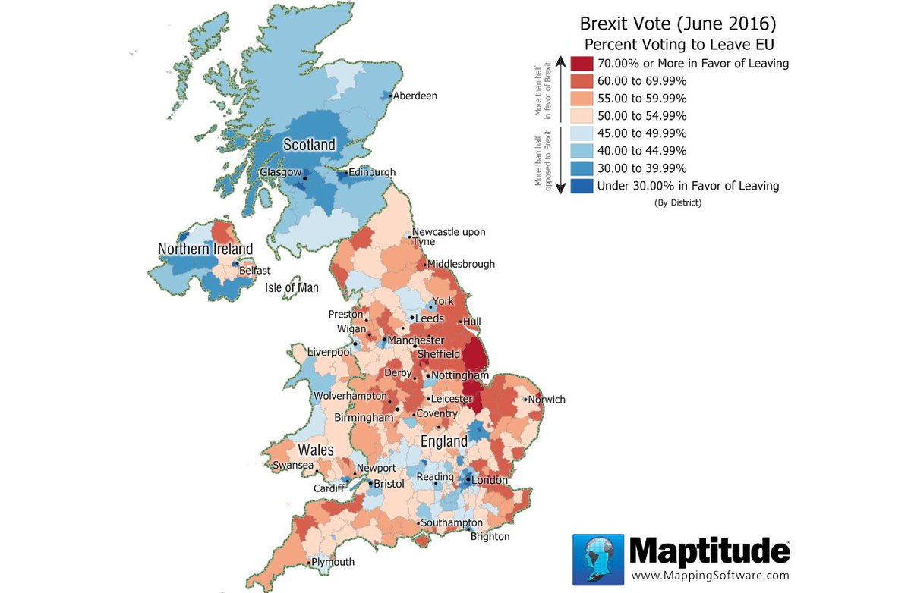
Figure 2: Map from Maptitude

The image shown above illustrates the Maptitude package in use, it shows the clear divide in the vote for Brexit, with Scotland in favour of remaining, and a majority of England and Wales, pushing for the leave vote.
Overall, out of the two packages reviewed, MapInfo has the most features, is the most stable and is free to all University of Wales Trinity Saint David (UWTSD) computing students. Despite this, in a normal business environment Maptitude is a far more economically viable solution. Providing nearly as many features as MapInfo for only a third of the price, it’s understandable why Maptitude was 2016’s bestselling GIS software package. [57]
However, thanks to the UWTSD, most students would be far more inclined to use MapInfo due to its availability. Therefore, MapInfo is the one which shall be used to demonstrate the location of electrical fast-charging stations in Wales.

3.0 Research Methodology:

3.1 Research Onion

3.1.1 Research Philosophy
The Research Onion research philosophy was designed by Saunders et al (2007). [58] The onion allows a researcher to outline the steps that must be taken when creating a detailed research strategy. From an outside perception, each single layer of the onion thoroughly explains a stage of the research process. [59] In continuation, the Research Onion delivers an efficient step by step sequence in which a research methodology can be created. Its practicality can be found in its flexibility to adapt to various types of research methodology, as this allows the method to be used in a wide variety of situations.
As alluded to above, the Research Onion has a wide range of adaptability, therefore, it was decided to employ this method to create and define our research methodology. The outermost layer of the onion focuses its attention onto the researches philosophy, it asks the user whether the researcher is Positivist, a Realist or an Interpretivist. A Positivist philosophy is adopted if the research follows the stance that only “factual” information gained through quantitative collection methods such as surveys is trustworthy. [60] The Positivism philosophy dictates that the task of the researcher is restricted to just data collection and interpretation through an objective approach. The research methodology and findings provided by a Positivist philosophy are usually observable, scientific, numeric and therefore quantifiable. [61] In comparison to Positivism, the theory of Interpretivism is relatively self-explanatory. Interpretivist based research allows the researcher to decipher information in a more subjective manner. [62] Conclusions made from data collection are often not objective, and therefore more open to researcher bias. Interpretivist research methodologies focus more on qualitative research collection methods such as interviews and case studies and provide in depth, rich data. This data is often less quantifiable and scientific when compared to data provided by the Positivist philosophy. [63]
The final research philosophy is Realism, Realism acts almost as a blend of both the Positivist and Interpretivist research philosophies. Whereas positivism uses highly structured, large sample based quantitative measurement and Interpretivism uses small, in depth and qualitative research methods. [64] Realism believes that the style of measurement used must each given scenario. It argues that one part of the research can use a large sample questionnaire, whereas another part can focus on one participant in a qualitative case study and that this diversification can often provide a more in depth and detailed piece of research. [65]
When comparing the three philosophies above and applying them to our own research there is only one viewpoint that clearly aligns with our own methodology. The Positivist theory is the one to be employed by our research as it intends to provide observable, scientific and quantifiable data through the use of a survey. The survey will be completed by a large sample group and will provide participants with mainly closed questions which can often be completed with a one word answer or a simple ‘tick’ box. The data provided will therefore be objective, allowing no room for subjectivity as it will be numeric and quantifiable. Any qualitative data will be subject to content analysis so that is can be measured in a scientific format.

3.1.2 Research Approach
Now that the research philosophy has been decided, the secondary layer focuses on the research approach. The onion provides the researcher with two option at this stage, one being the ‘inductive’ approach, the second being the ‘deductive’ approach. The inductive approach starts by concentrating its efforts on a specific observation and then expanding it through generalisations to wider theories. To expand, when reasoning inductively, the researcher starts with a specific observation, tries to establish patterns and regularities and forms an initial hypothesis that can be explored before making a general conclusion. [66] Furthermore, the inductive approach generally uses qualitative data collection to gain rich, detailed data that can be used to explore a phenomenon. This exploration can help researchers identify themes and patterns in data to create an in depth conceptual framework. [67]
In contrast to this, deductive reasoning is almost the opposite of inductive reasoning as it moves from a general theory to a specific conclusion. Deductive techniques tend to be more scientific in nature and is often coined as the ‘top down’ approach due to the way that the researcher initialises the research with a general theory (I.E. Are there enough electrical charging stations in Wales) and then focuses themselves around making specific observations to determine a conclusion; such as a survey collecting data about the public opinion. [68] In support of this, the deductive approach continues by suggesting that data collection should be used to answer a specific questions and that it should conclude by providing quantifiable and objective results. Moreover, the deductive approach often relies on tests that provide quantitative data as this allows for a simple and scientific confirmation or rejection of a particular hypothesis. [69]
When deciphering the characteristics of both techniques, the deductive approach shares many similarities with the approach the project will take. Initially, the project started with a general theory about electric cars, before moving onto specific questions about the availability of charging points. Furthermore, the project will entail making specific observations through the use of a survey which will provide us with the ability to make decisive conclusions using scientific and quantitative data.

3.1.3 Research Strategy

The third layer of the onion asks the researcher to determine the strategy that will be exercised to collect data. There are six possible routes, each sharing their own unique characteristics.
The three primary strategies that could be utilised are case studies, ground theory and survey based strategy. In addition, the three secondary strategies are action, experimental and ethnography strategies. These three strategies are less widely used due to their specific nature and do not relate to our category of project. [70]
However, the first primary strategy that could be applied to this project is a case study. This study is an in-depth assessment of an individual situation that allows observers to identify key features and make specific generalisations. Unfortunately, case studies only provide very rich, qualitative data which is not what is needed in this particular type of project. Furthermore, case studies can often result in high levels of subjective researcher bias due to the close proximity a researcher can have with a specific case. [71] Additionally, the following main strategy is titled ‘Grounded theory’. Grounded theory is another qualitative methodology that extracts qualities from the inductive approach by deriving patterns from the data as a precondition for the study. Once again, this specific qualitative style data is not what is required in this project and therefore, will be discarded as an option. [72]
In comparison to this, a survey based strategy is precisely the type of strategy that could be utilised by this project. Quantitative in nature, a survey centred research project often encompass the usage of a large sample base to provide a representative portion of the target audience. Surveys provide the researcher with scientific, quantifiable data that can be deduced numerically with relative ease. [73] A survey would help the project complete many of its aims and objectives as it provides generalisable, quantitative data needed to provide a definitive conclusions to specific questions.
In continuation, the survey based research strategy will provide the project with an accurate and valid overview that can clearly illustrate the wider public’s opinion on electrical charging stations and will allow us to decipher its quantitative data with ease. This quantitative data can then be easily inserted into various data visualisations which will demonstrate public opinion in a decipherable, aesthetically pleasing manner.

3.1.4 Time Horizons

The Time Horizon is an outline in which a project will be completed. It acts as a framework that is put in place before research begins and defines the timeline in which each stage will be completed.
There are only two different types of time horizons specified within this layer of the research onion, these are identified as a cross sectional horizon, and a longitudinal horizon.
Firstly, there is option of choosing a longitudinal horizon, this type of time horizon refers to the collection of same type of data repeatedly over an extended period of time. Longitudinal time horizons are used when a piece of research needs to examine change over time, such as if this project was measuring peoples changing opinions of electrical vehicles. [74]
Alternatively, the cross-sectional time horizon is one whereby the data must be collected from a specific time period; hence why it is often dubbed the ‘snapshot’ time horizon. This type of horizon is often used when a piece of research is concerned with an exact issue at a specific time. [75] This relates particularly well to this type of project and the data it hopes to garner. For instance, this project intends to investigate the specific issue of electrical vehicle and the surrounding infrastructure, this subject is a very current topic and as the cross-sectional horizon identifies, the data collected from respondents by the survey will only be gathered once.

3.1.5 Data Collection Type

The innermost layer of the onion progresses the research design further into the details of data collection and analysis. The data collection and analysis process is solely dependent on the methodological approach applied. The process that is chosen at this stage of the research will contribute extensively to the projects overall validity and reliability. Irrespective of the approach chosen for usage in the project, the category of data accumulated can be separated into two specific varieties which are defined as primary and secondary data. [76]
Primary data is data that has originated from direct, first hand sources. This data can originate from many sources such as respondents taking part in a survey or even data from an interview. Alternatively, primary data can be garnered from historic first hand sources. [77] Primary data is most frequently produced due to new research being undertaken as a result, the research survey produced for this project will gather first hand, primary data. This is exceptionally useful for our chosen topic of research as the technology found within the electric car industry is relatively new and therefore, there is not large amount of pre-existing secondary data on the subject.
Alternatively, secondary data is data that has been derived from the preceding efforts of past researchers. For example, any conclusions that are made from analysing an existing research article can be identified as secondary data. As alluded to above, this is unlikely to be used during the creation of the survey as not much previous research exists, furthermore, the core aim of the survey is to produce new, primary data for analysis. [78]

3.1.6 Conclusion and Summary

To conclude, through using the research onion, it has been relatively trouble-free to create an effective research strategy in which the project can follow.
Initially, a research philosophy was chosen for the project to follow. The philosophy that will be utilised for this project is the Positivist viewpoint. The Positivist philosophy provides findings that are usually observable, scientific, numeric and quantifiable. This type of objective data is exactly what will be required to clearly analyse and illustrate what the public opinions are regarding the electrical vehicle infrastructure.
Secondly, the research onion helped provide a definitive research approach for this project. The approach chosen was the ‘top down’ deductive approach, the deductive approach moves from a general theory to a specific conclusion, much like how this project moves from a general theory about the availability of electrical charging points, to specific conclusion on whether the public thinks there are enough, how many they believe Wales needs and where they should be located.
Moreover, the third layer of the onion identified the research strategy that will be undertaken. Through analysis of the various strategies, evidently a survey based strategy is exactly what is needed for this project to get great results. Due to its quantitative makeup, a survey centred research strategy will utilise a large sample base to provide a representative opinion of the target audience, for example a large and varied survey audience will provide a generalisable public viewpoint on electrical technology and the charging points available.
Additionally, the time horizon chosen was the cross-sectional horizon as this horizon focuses its attention on looking at an individual issue at a specific time, whereas the alternative longitudinal horizon looks at a certain set of data over an extended time period. In this scenario, the project needs to identify current public opinion just once before and compare that to current electrical charging locations.
Lastly, the type of data that this research will generate is primary data. This is new data, gaining new public opinion from a first-hand data collection technique.

3.2 Survey Methodology:

Before the design and creation of the survey, it is important to understand what it intends to achieve. To determine this, the project will follow the SMART objective [79] formula and follow each guideline to determine the objectives in place are suitable for the task ahead.
SMART is an abbreviation for; Specific, Measurable, Attainable, Relevant and Time Based. Without following these objective guidelines, the survey has the potential to fall short by asking the wrong questions which can lead to incorrect results and therefore, invalid data. These guidelines also ensure that the survey creation is managed correctly and that during its production, goals are both set and later achieved. [80] For a breakdown of SMART objectives; please see the appendices (1)
When designating the objectives for this survey, each one of these guidelines had a significant influence on the decision-making progress. Each objective created for the survey follows at least one of these SMART guidelines, as outlined below. [81]
Firstly, the survey aims to discover the public opinion on electric vehicles and the surrounding infrastructure. This objective is not only relevant to the task at hand but it is also specific in the way that it acknowledges the exact area we wish to focus our attention on, as well as revealing that it is the public opinion that we wish to analyse.
Another objective is to determine the viewpoints of the audience on electric charging stations. The survey aims to discover just how many fast charging stations people believe there are in Wales, whether they think that this is a large enough number, and if not, how many charging station do people believe this country needs to support the growth of electric vehicles. This objective is once again relevant to the topic at hand and it is also measurable thanks to quantitative data capture methods provided by the survey creation tool; ‘Survey Monkey’. Additionally, this objective is achievable as survey users can convey their opinion in a clear, easy to read manner.
In continuation, another objective is to determine where the public thinks it is best to place future fast-charging stations. This objective is very important as it allows for the project to establish a proposal for where future charging stations should be constructed to support the growth of this sector. Whether supportive of the electrical car sector or not, one thing is inevitable; larger adoption of electrical vehicles is likely and the significance of having the right infrastructure in place to support this is paramount in the development of an effective Welsh transport grid. Having the correct structure may lead to increased tourism, a smaller carbon footprint for Wales and the potential for an economic boost for the smaller, more rural areas of Wales.
This objective is relevant to the overall philosophy of this research and it is also relevant to one of the moral dilemmas that our countries transport authorities face today. It is specific and sensible in its field as it focuses on one precise sector: location. Furthermore, the collection of accurate results is achievable as multiple choice questions will be used to determine the areas participants would like to see future charging stations. Choices such as; ‘Rural’, ‘City Centres’, ‘Motorways and Busy Roads’, will allow the survey to discover where our sample population would prefer to see these stations situated. Lastly, these results will once again be simplistic to measure as they will be collected in a quantitative data format.
Another objective of the survey is to uncover what the public perceives to be the main advantages and disadvantages of electrical vehicles. This objective will make for highly interesting analysis as it may identify why many motorists find the prospect of electrical transportation either attractive or unattractive. Once again, the survey will employ multiple choice questions to determine the main reasons why people would wish to buy electric and the main reasons why some may wish to hold station. This objective it is still relevant to the overarching aim of this study, as it gathers information illustrating the perceived advantages and disadvantages of electrical cars. Furthermore, this objective will be measurable due to the surveys quantitative data collection techniques.
Additionally, the survey will remain open after its pilot study for just two weeks. This objective is time-bound and it ensures that the other objectives outlined are achieved on time and that the overall project does not fall behind schedule, once the survey is closed; data can be analysed and the project can progress.
Lastly, an objective of the survey will be to establish the usefulness of a geographical information system (GIS) based map to display the location of fast-charging stations within Wales. The map itself will be created in conjunction with this survey and one of the main objectives of the survey will be to determine how many members of our sample audience would find this type of application useful. This objective is highly relevant to the overall project as part of the project will be dedicated to the creation of this system. This objective will be achieved by asking a simple ‘Yes/No’ question during the survey. (Would you use a map based system to locate charging points near you?). The results of this question will be easily measurable once again, thanks to the infographics provided by the Survey Monkey.

3.2.1 Who is the target audience?

This survey will be focused at a specific target group, the target group would be those who already own an electrical vehicle and for those who may one day be wish to purchase one. The survey will be specifically aimed at Welsh adults regardless of gender. Furthermore, it would be important for those taking part in the survey to be automotive vehicle users as this would allow them to emphasise with the problems faced by the modern Welsh motorist.

3.2.2 Survey Questions and Investigation:

- Please state your current age:
- Please state your gender:
Firstly, the survey start by asking participants to state their age, followed by their gender. These two basic starter questions help to identify the demographic of those completing the survey. Furthermore, these demographic based questions will help determine whether the survey is reaching the target audience and whether the survey will be collecting the data needed for proper analysis. Additionally, the survey is aiming for a generalisable sample audience, so by distinguishing the demographical characteristics of participants, we can determine whether the survey reaches a varied enough sample audience.

- Please enter your postcode:
The third question in the survey helps locate the address in which the participant resides. This data is extremely useful as it helps us locate whether they are living in a rural area, near the M4 corridor or in an inner city. This may make for an interesting analysis as it may be found that those nearer the M4 corridor may be more willing to purchase an electric vehicle due to the wider availability of charging stations when compared to a participant living in Mid-Wales.

- Do you currently own an electric car?
This relatively simplistic questions is used to merely register the number of participants who own an electrical car, participants who already an electrical car may offer insights into the difficulties they have faced or the benefits they have found.
- Would you consider purchasing an electric car in the near future?
Question 5 is used as a follow up to question 4, if the participant has selected ‘Yes’ to question 4, the survey will automatically skip this question due to the ‘logic’ entered into the Survey Monkey system. This ‘Logic’ entered can be seen in the appendices. (2)
As was the case with the previous question, this data will be used to discover the number of participants who are considering purchasing an electrical car in the near future. The postcode data gathered from question 3 will allow for the cross-analysis of data and the determination of whether those in a rural area are less likely to want to purchase an electrical vehicle in the upcoming months and years. The question relates directly to point ‘3.2’ of the ‘Aims and Objectives’ outlined in the introduction which states that the survey should discover if the participant would purchase and electrical car.

- Please explain the reasoning behind your decision:

Question 6 empowers the participant to expand upon their answer given in question 5. This will allow for a better understanding as to why individuals may wish or not wish to adopt electrical technology soon. A case study analysis can help us spot patterns and trends in the qualitative data.

- How ‘Green’ do you perceive electric cars as being? (1 star being extremely non-environmentally friendly and 10 being extremely friendly)
The above question is a 1 to 10 ‘Star Rating’ based question. It allows results to be collected in a quantitative, measurable and scientific manner. The aim of the question is to gather public opinion as to how ‘green’ electrical cars are perceived. Furthermore, the star rating system will provide a simple average rating which will be easy to analyse once the survey has been concluded. The question relates directly to point ‘3.1’ of the ‘Aims and Objectives’ found in the introduction which states that the survey should aim to gather participant opinions regarding how green they perceive electrical vehicles as actually being.

- How practical do you perceive electrical vehicular technology? (1 Being extremely non-impractical and 10 being extremely practical)
This question directly relates to the one found above it, it is once again a star rating based system and this question is being asked to find out how practical people perceive electrical cars as being. Practicality is an overarching term when referring to electrical vehicles as practicality can relate to the often-smaller spaces often found within these types of vehicles (due to battery housing) as well as referring to the impracticality of having divert off-route in order to find a charging point for the vehicle. Once again, this question relates to point ‘3.1’ of the aim and objectives found in the literature review.

- What do you believe is the proportion of vehicles powered solely by electricity in Wales?
Question 9 is once again comparatively self-explanatory as it aims to determine public perceptions as to the proportion of electrical vehicles on the road. This is for later analysis of the perceived amount versus the actual amount.

- How many ‘fast-charge’ charging stations do you think there are in Wales?
As is the case in question 9, question 10 aims to measure public perception. This question is asked as it will provide for interesting analysis when comparing the amount envisaged by respondents compared to the actual number of fast charge stations found on the road-side.

- Do you believe this number is enough?

This question directly follows on from the last and straightforwardly attaches to point ‘3.3’ of the aims and objectives in the introduction which states the survey should identify whether the participant believes there is enough infrastructure in place to support the growth of electrical cars. If the user answers ‘Yes’ to this question, they are automatically transferred to question 15.

- How many electrical charging stations do you believe Wales requires to support the growth of electrical vehicles?
Question 12 of the survey will encourage the participant to expand upon their ‘No’ answer provided in question eleven. This question was asked to provide the opportunity for additional analysis by comparing the average number provided here to the average number provided in the answer to question 10 which asked participants how many stations they thought Wales currently had. Much like question 11, this question relates to point ‘3.3’ of the aim and objectives.

- Where should a large proportion of these charging stations be located?
This question allows survey users to expand upon the answers provided in the previous question by choosing from several multiple-choice answers. This question will allow for analysis of where respondents believe that future Welsh fast charging locations should be located. These answers can be expanded further to see how respondents residing in different areas select different locations for future charging points. This question can be directly linked to point ‘3.1’ of the aim and objectives which asks to identify where participants believe future stations should be located.

- If there were the number of charging stations in the locations outlined above, how much more inclined would you be to invest in an electrical vehicle? (1 being none at all, 10 being extremely likely)
Question 14 is in directly relation to the one before it, allowing respondents to show how much of a difference having the selected stations built would make on their buying decisions. The results of this question will be most interesting to analyse as it will give an inclination as to how much more likely people would be to purchase an electric vehicle if the correct infrastructure was in place.

- Do you believe it is easy enough to find the location of your nearest ‘fast-charge’ station?

This question is asked as a leading question to question 16.

- Would you use a map based application which displayed the location of ‘fast-charge’ stations?
This is perhaps the most important question in the survey, analysis of these results will determine whether building a GIS based map is both feasible and necessary. Once the GIS map has been built and implemented into a website, the responses to this question will help give an inclination to the number of people who may use such an application. This question can be directly linked to point ‘3.5’ of in the aims and objectives which aims to discover the number of respondent would use a map based application to find the location of fast charging points.

- Are you aware of the tax breaks and grants given by the government available to purchasers of zero emission vehicles?
This question was asked to help determine what proportion of respondents are aware of tax breaks implemented by the British Government to help influence the sales of electrical vehicles. Respondents who answer no to this question skip through to question 21. This question can be directly linked to point ‘3.4’ of the aim and objectives found in the literature review

- Do these government incentives influence you significantly?
This is a follow up question to question 17 and acts as a leading question to question 19. Answering no to this question will move participants to question twenty.

- If you have selected yes, please explain why these incentives influence you?
Question 19 allows respondents to expand on why government incentives influence their buying decisions, this will allow determine what incentives are working and what other ones can be improved. This question can be directly linked to point ‘3.4 of the aim and objectives found in the introduction.

- What other incentives could be put in place by the government to encourage electrical car sales
This further expands the previous questions and allows for the respondent to state what incentive they would like to see implemented. Content analysis of these answers may provide a very interesting data set showing a trend of incentives the public would like to see, which, if implemented could encouraging sales and growth. This once again, can be directly linked to point ‘3.4’ of the aim and objectives found in the literature review

- Please place tick next to the 3 largest advantages found when comparing electrical vehicles to traditional vehicles:
Question twenty-one was asked to determine what were the main selling points of electrical vehicles, this question provided for simple analysis showing what it is people like most about this style of motoring. This question can be related to point ‘3.1’ of the aim and objectives which intends to ask participants their opinions regarding electrical vehicles.

- Please place a tick next to the 3 largest disadvantages electrical vehicles face when compared to more traditional vehicles
Question twenty-two is much like the previous question, it allows for an easy determination of what factors respondents dislike most about electrical cars. This can also be linked to point ‘3.1’ of the aim and objectives.

3.2.3 Survey Validity:

What exactly is validity? The concept of validity was devised by the researcher Kelly in 1927 [82]. Kelly argued that research is only valid if it measures what it declares to measure. [83] For example, the survey created for this project aims to collect participant opinions on various topics such electrical vehicles, the locations of fast charging points and the practicality of a GIS-based map showing their charging locations as stated in the literature review. So, does this survey allow for the measurement of that criteria? Arguably yes, as the survey directly confronts these factors by gathering opinions on the advantages and disadvantages of electrical vehicles, asking respondents whether they would use a map based system to locate charging points and by asking their opinion on where future stations should be constructed.

3.2.4 Survey Reliability:

Reliability can be defined as the degree to which an assessment tool produces stable and consistent results. [84] As the survey asks questions in a closed and quantitative format, the results provided will be allow for consistent analysis. Additionally, the survey can be repeated with ease due to its set question presentation, allowing it to be reopened at another time and potentially evolving into a longitudinal study, rather than its current ‘snapshot’ data collection style. Thanks to the repeatability of the survey, results from 2017 could be directly compared to results collected in 2022. This would allow researchers to analyse the changing opinions of respondents on electrical cars and the surrounding in industry. Consequently, it can be concluded that this survey is a reliable form of data capture.

3.2.5 Survey Generalisability:

Generalisability can be described as the degree to which research findings can be applied to settings other than that in which they were originally tested, whether the results found be applied to different areas and different audiences. [85]
The survey focuses specifically on charging stations in Wales, however, with modifications the survey can become suitable for other countries such as England and Scotland. Would Welsh results be generalisable to other countries? Possibly not as both England as well as Scotland have a far higher number of charging stations when compared to Wales. In fact, with over 50 ‘fast charge’ stations in Scotland, there are over four times the number found in Wales. [86] Therefore, public opinions in both nations may differ significantly. Within Wales however, the survey can be generalised to most Welsh motorists as the survey reaches a large, varied number of respondents, from all age groups and different genders in from various postcodes ranging from South to North Wales.

3.2.6 Prototyping:

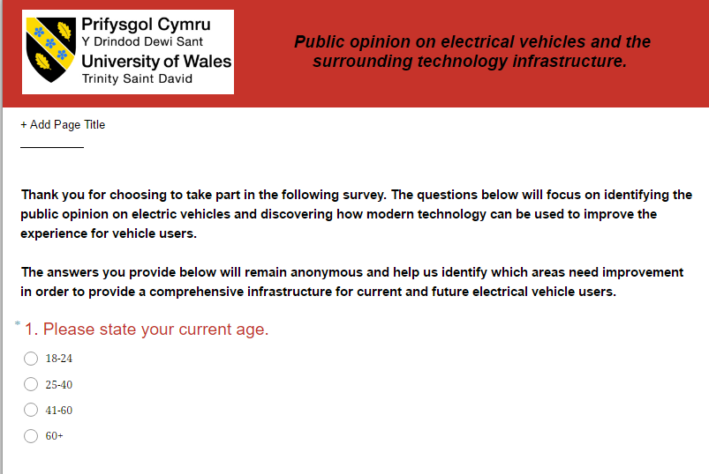
In software development, a prototype is defined as an undeveloped working example of an information system, it is often created as part of the developmental procedure. [87] The survey was prototyped during the first weeks of development and it included many of the final questions but had a different, more basic design ethos of red and white rather than the final all ‘green’ appearance. The prototype was sent out to five individual respondents as part of a pilot study for initial feedback, the feedback received was both positive and negative in nature.
Figure 3: Survey Prototype

3.2.7 Changes made after prototyping:


After the pilot prototype study, feedback from respondents who had partaken in the study was received and noted. Fortunately, each one of the five pilot participants were extremely happy with the initial prototype and very little negative feedback was received. Small changes were made including the design ethos as noted earlier. The final green theme implemented was more in line with the area of research. In addition, small changes were made to the wording of certain questions, allowing them to be more easily understood and less technical. For instance, question 14 was altered from “If there were the number of charging stations in the locations outlined above, how much more accessible would you perceive electrical vehicles as being”. The reformed question is the one found below:
Figure 4: Final Survey Design

3.2.8 How will these results be analysed?

Most results gathered from this survey will be quantitative in nature and this will allow for easy, statistical analysis. The analysis will be multivariate as there will be lots of data sets requiring investigation. [88] Fortunately, the survey creation tool Survey Monkey offers the ability to analyse data through data visualisations. The infographics are materialised in a variety of bar charts, line graphs and pie charts which allow for simple but in-depth statistical analysis.
However, not all the data garnered from the survey will be in a quantitative in nature, there will be some questions which will provided qualitative data for instance; question 20 asks “What other incentives could be put in place by the government to encourage electrical car sales”. To analyse this data correctly, content analysis will be used to identify key words to spot any patterns or trends in answers provided by participants. In continuation, another statistical measurement tool that will be used is the ‘mean’ measurement. The arithmetic mean, is most frequently named as “the average,” the mean is the sum of a list of numbers divided by the number of numbers on the list. [89] A mean will be used in two separate occasions; once in question 10 and again during question 12. The first asks the respondent to answer how many fast charging stations they believe there are in Wales, the latter asks how many they believe there should be. A mean of each will be calculated and compared to see the disparity between the two figures and then compared to the number of fast charging stations actually found in Wales. Lastly, the data collected will be analysed to ensure that it fulfils all the aims and objectives required of it in the initially outlined in the introduction.

3.3 Developmental Methodology:

3.3.1 Rapid Application Development:

Before the development of the geographical information system based map, it was decided to develop the application using the developmental methodology ‘Rapid Application Development’ or ‘RAD’. The RAD model allows the developer to create applications quicker by using an iterative development process. [90] In continuation, after discussing with others and researching online, RAD was highly recommended for when a system needs to produce results within a short time frame and for when technical risk is less (I.E. not working on a highly important system such as a monitoring system for air traffic control). It is also recommended for when the requirements of the system are known before the development begins, as was the case with this project. [91]
The methodology was created by James Martin in 1991, Martin collaborated with colleagues to develop the new methodology out of frustration due to the more established waterfall software development approach being too slow during the technological revolution of the late eighties. The archaic and slow waterfall methodology often resulted in applications and products that were outdated or redundant by the time they were developed and released. [92]
There are many different advantages to using the RAD methodology when compared to the traditional software development techniques such as Scrum, Spiral or Waterfall model. Firstly, the initial stage of analysing what needs to be developed and then creating the very first prototype design is very quick, this reduces overall development time and allows for the developer to start creating the package as soon as possible, this is fantastic if the developer (or team) has an inflexible deadline and needs to complete the application as soon as possible. [93] In addition, as alluded to earlier the more traditional methodologies such as the Waterfall method can lead to products that have ‘missed the boat’. [94] With a strict deadline and a very current topic such as electrical vehicle development, this software could not afford to stay in the initial design stage for an extended period.
Furthermore, another advantage of RAD is that testing occurs during every design iteration, testing occurs after every major change. [95] For example, once the excel database was imported into the MapInfo software, testing ensued to ensure the dataset had been correctly transferred over. Moreover, once the imported dataset had been geographically coded into MapInfo to show our location based data, the map was once again tested to ensure that each location that had appeared exactly where they were intended to be on the map. This instantaneous testing ironed out any small potential issues at an early stage, guaranteeing that no errors would occur later in the development once the map had been transferred into a HTML format and subsequently implemented into the WordPress site. Additionally, unlike with most other development methodologies, RAD can function extremely effectively with only one developer which can promote better documentation through the design process. [96] Moreover, with only one developer, productivity can be increased within a short period and the development can progress at a pace that suites both the creator and the deadline.
Unfortunately, there are some disadvantages to RAD too. Due to its fast-paced nature, testing is not as rigorous and in depth as to what would be found during a more traditional development process. [97] This may not be an issue in this case as it is relatively low risk, however, if it was a NHS based system or a system for air traffic control, it could be argued that a RAD methodology would be far too high a risk. Additionally, this method may not be of use if the project it very large, complex and high budget. The teams required for these types of projects would need to be much larger, the time taken to test would need to be much longer and the developmental stages may need to be slower to prevent major, potentially costly mistakes. [98] The last major disadvantage is that the success of the project is fully dependant on technical capabilities of those within the team, in the case of this project, the success of the application relied only on one person. [99] A lack of motivation or inability to complete a certain task could result in the project running behind schedule or even missing a crucial deadline.

3.3.2 Software used and why:

There we a few different software packages that will be required for the developmental stage of this project. The major software package that will be used in the most part is MapInfo, MapInfo is a Geographical Information System (GIS) and allows for the manipulation of locational based data in a map based infographic. Out of the two GIS packages discussed in the literature review, MapInfo had the greatest number of features and was free to use thanks to the university. Thus, MapInfo was the chosen GIS package for this project, it is appropriate for the developmental stage of this project as it allows for the locational data to be displayed in a visual format. In this case, MapInfo will be used to plot the locations of electrical ‘Fast Charge’ stations throughout Wales, therefore, highlighting the lack of facilities available for these types of motorists. With the correct development, this map can be made into an interactive display, with each location ‘plot’ on the map taking the user to an information page once clicked upon. This information page will contain details about that chosen charge point including; its name, the speed of charge available and the address of the charge point.

However, none of this can exist without the right dataset in place. To insert the correct data into the GIS package, Microsoft Excel will be used. With usage of the government website ‘DigiMap’, the postcode data for each charging station can be found. Once the postcode of each charging station has been successfully verified, they will be used to extract the co-ordinates for each individual station. These co-ordinates will then be inserted into Microsoft Excel in a specific format, named and saved. This Excel file can then be imported and geographically coded into MapInfo, MapInfo will then display the coordinates in the form of plots on the map of Wales. This map would have been previously downloaded before the ‘plotting’ process begins.
Finally, once this developmental process is completed, the map and its secondary pages can be tested to ensure they are running correctly. Once this is done they will be exported into a HTML format. With sufficient coding, it will be proposed that the HTML files are implemented into a professionally styled WordPress webpage, this will be a somewhat difficult task as some of the HTML code found in each webpage will need to be manipulated to all link together and display correctly. However, the advantages of this final effort are that the development will then be aesthetically pleasing in a professional, engaging and appealingly styled webpage. The webpage would then be accessible to current and future Welsh electrical car users, allowing them to locate fast charging stations near them. No specific hardware will be required for the development of this system, MapInfo is the only specialist equipment required and that is software-based.

4.0 Analysis

4.1 Survey Result Analysis

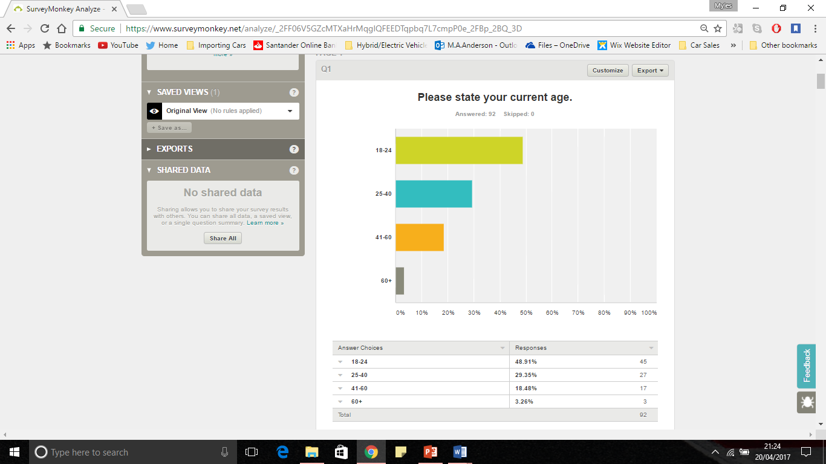
- Please state your current age:
Figure 5: Survey Question 1 Results

The results of the first question were much as expected. The survey was distributed via social media and by targeting electrical car forums, thus it could be argued that these online distribution techniques were always going to result in a lower age demographic. If the survey had been distributed physically, the age split may have been more balanced and this is something that must be considered for any future study. Nevertheless, it is interesting and pleasing to see that there also responses from participants in the later age groups.


- Please state your gender:
Figure 6: Survey Question 2 Results

Predictably, as with the first question; the results of the second question are perhaps as expected. Due to the automotive nature of the electric car industry, history shows that this is a more male dominated sector. However, despite this it is still very pleasing to see that fourteen women decided to complete the survey and give their opinion.


- Please enter your postcode:
Figure 7: Survey Question 3 Results

Due to the nature of the question, participants were required to enter in their home postcode manually. Therefore, Survey Monkey was unable to provide an infographic to display the data. Fortunately, Survey Monkey does allow the user to interrogate the dataset and consequently perform data analysis on the data that had been provided, this is seen above when the dataset is queried to show just the postcodes beginning in ‘SA1’. Through manually recording and comparing this data, it was discovered that the largest proportion of respondents were from the ‘SA1’ vicinity with 7 entries found, secondly was the ‘SA4’ area, with four entries identified and the third largest was the ‘SA10’ zone with another four submissions found. This data was recorded to discover whether peoples opinion on electric cars depended on area, for example those living in rural areas may be less open to purchasing an electric car when compared to someone living near the M4 corridor. In continuation, one of the questions in the survey asked participants where new charging stations should be located, it will be interesting to see whether this differs depending on a respondent’s postcode.

- Do you currently own an electric car?

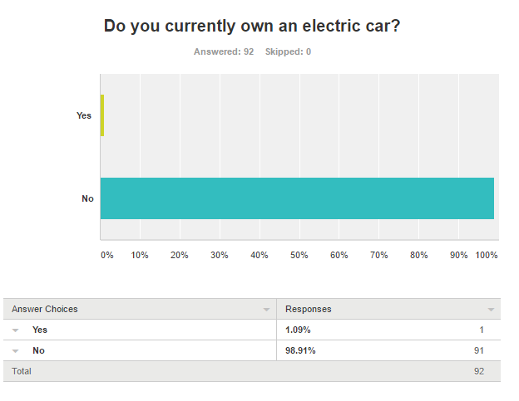
Figure 8: : Survey Question 4 Results

When analysing the diagram for question 4, it is unsurprising to see that all but one of respondents did not own an electric car. Through analysing individual responses, it was found that the one person who answered yes lived in the district ‘SA13’ this is highly interesting as SA13 is based in the eastern part of Port Talbot, heading towards Bridgend; an area that has the M4 motorway running right through the centre of it. Furthermore, the respondent’s postcode was less than 10 miles away from Sarn Park Services, the largest electrical car charging station in Wales.

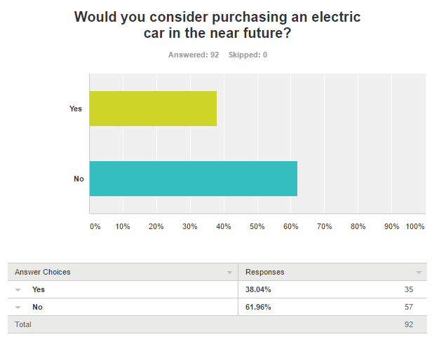
- Would you consider purchasing an electric car in the near future?
Figure 9: Survey Question 5 Results

The results of question 5 were somewhat unanticipated, of the 92 respondents who answered, a majority of 57 said they would not consider purchasing an electric car in the near future. However, 35 individuals said that they would and this is far higher than what was originally expected. These results could highlight the beginning of a shift in public opinion when it comes to running an all-electric vehicle. These results link directly back to point ‘3.2’ of the aims and objectives which stated; “Discover if the survey participant would purchase a zero-emission car, if so, why? If not, why not?”
The latter part of this aim was to find out why a participant would or wouldn’t purchase an electric car and once again, this aim is satisfied by the results below.

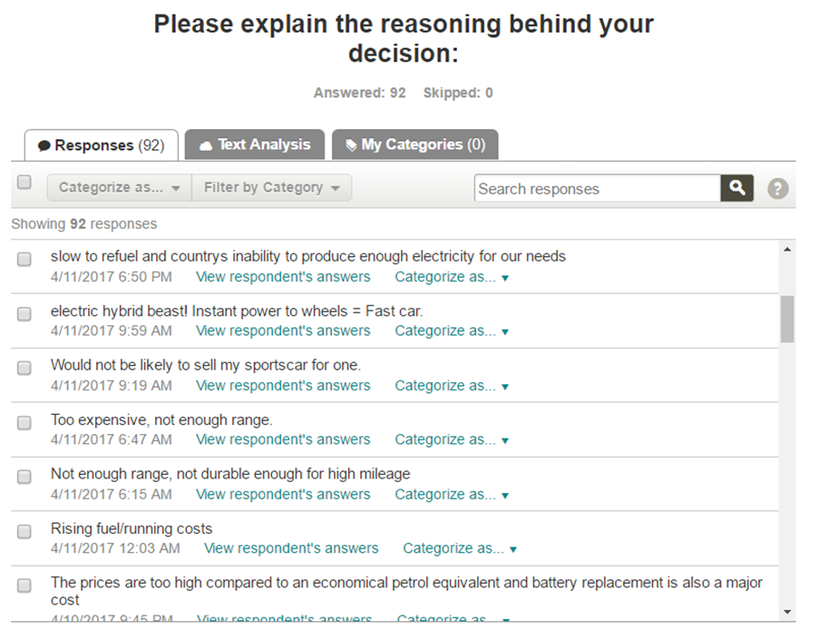
- Please explain the reasoning behind your decision:
Figure 10: : Survey Question 6 Results

The data collected in question 6 was qualitative in nature, it allowed participants to elaborate on why they would be willing or unwilling to purchase a battery powered vehicle in the near future. Due to its qualitative nature, content analysis was performed to identify any reoccurring patterns in the data. This resulted in a straightforward understanding as to why people would be willing or unwilling to make the electrical plunge. This statistical analysis is displayed on the next page:

Content Analysis: Reasons for purchasing an electric car

Figure 11: Content Analysis showing reasons for purchasing an electric car


Content Analysis: Reasons against purchasing an electric car
Figure 12: Reasons against purchasing an electric car

- How ‘Green’ do you perceive electric cars as being? (1 star being extremely non-environmentally friendly and 10 being extremely friendly)
Figure 13: Survey Question 7 Results


The results of question 7 were quite unexpected, with an average of just 6.6 out of 10, it would appear that the participants of this survey do not believe electrical vehicles are a fully ‘green’ solution. This may down to many factors, such as electricity often coming from non-renewable energy sources and the non-enviromentally friendly lithium ion battery packs used to store the charge requried to power the vehcile. These results relate precisely back to point ‘3.1’ of the aims and objectives found in the introduction which aimed to discover how ‘green’ participants perceived electrical vehicles as being.

- How practical do you perceive electrical vehicular technology? (1 Being extremely non-impractical and 10 being extremely practical)
Figure 14: Survey Question 8 Results

Question 8 highlights just how much impracticality is associated with electrical cars, whether it is the lack of charging infrastructure, smaller internal space due to battery storage or the time needed to fully charge a vehicle, especially when on the move. At an average of just 4.8 these results are fairly unsurprising, however, in the coming years as the technology matures, hopefully a majority of these impracticalities will become a thing of the past.

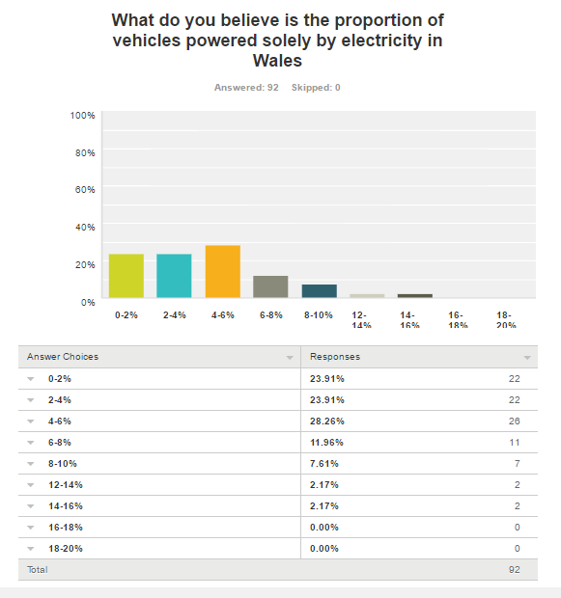
- What do you believe is the proportion of vehicles powered solely by electricity in Wales?
Figure 15: Survey Question 9 Results
Question 9 was asked to determine how large a percentage of market share participants perceived electrical cars as having. Most answers came in below the 6% mark, and no one saw the market share of electrical vehicles being over 16%. However, it is highly fascinating to compare the figures gathered by respondents to actual real-world figures, by the end of 2016, there were 1,774,000 vehicles on Welsh roads, 787,000 of these were diesel vehicles taking a 44.3% slice of the market share, 55% of the market was dominated by the 997,000 petrol powered vehicles and only 4,300 cars were electrically powered. When worked out as a percentage, electrical vehicles only equate to just under 0.25%, a staggeringly low figure when compared to what is perceived. [100]
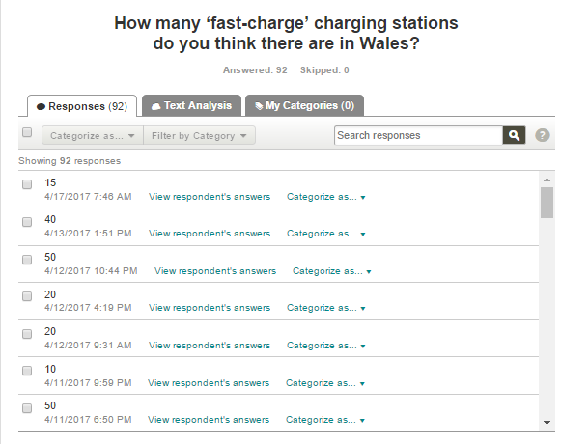
- How many ‘fast-charge’ charging stations do you think there are in Wales?
Figure 16: Survey Question 10 Results

Question 10 allowed participants to manually enter the number of charging points they thought available. Unfortunately, Survey Monkey did not contain the statistical features required to find the average amount inputted. However, the respondent data was manually recorded, anomaly results were removed and then the figures were entered into an Excel spreadsheet as displayed below:
Figure 17:Average amount of charging stations in Wales
The average number of charging stations participants thought were available was 41.5 (to 1 decimal place.) This is higher than expected as the actual number is just 14. As seen in the results for question 9, respondents over estimated the number of charging stations available just as they did the number of electrical cars on Welsh roads, this may be a potential trend to follow in the upcoming results.
- Do you believe this number is enough?

Figure 18: Survey Question 11 Results

Unsurprisingly, nearly 90% of respondents believed that the number of fast charging stations available in Wales was too low. This is despite the fact participants on average believe that the number available is 41.5 compared to the reality of only 14. These findings can be related to point ‘3.3’ of the aims and which wanted to identify whether participants believe there is enough infrastructure in place to support electrical vehicles.


- How many electrical charging stations do you believe Wales requires to support the growth of electrical vehicles?
Figure 19:: Survey Question 12 Results

Much like question ten before it, question 12 relied on respondents manually entering the number of charging stations they thought required to support the growth of the electrical car market. However, once again Survey Monkey did not have the ability to display the average figure recorded. Nevertheless, the respondent data was manually noted and then once again freak entries were removed. The remainder were inputted and into an Excel spreadsheet, and the figures are as displayed below:
The figure shown above can be rounded to 686, with just over 750 petrol stations found in Wales, it could be argued that this is an equitable number [101]. When compared to the 14 fast-charging stations available in Wales, 686 is a surprisingly high figure as it is nearly 50 times greater than the actual amount
.
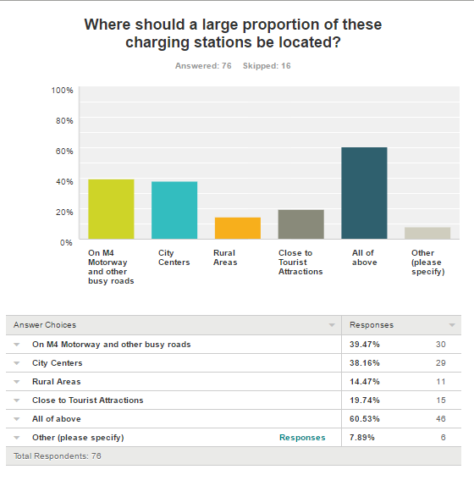
- Where should a large proportion of these charging stations be located?
Figure 20: Survey Question 13 Results
The results of question 13 show that a bulk of respondents would like to see charging stations on the M4, in city centres, in rural areas and close to tourist attractions. However, when broken down individually, it can be seen that most participants would like to see charging station in city centres and on the M4 and various busy main roads. This is unsurprising as through analysis of respondent postcode data, it was found that a large proportion of responses came from residents of South Wales, as opposed to those living in rural areas such as Mid, West and North Wales. Through further postcode analysis, it was found that respondents living in areas which postcodes begin with ‘CF’ or ‘LL’ chose the ‘Rural’ option every single time. The ‘other’ responses from individuals highlighted interesting opinions such as “Shopping car parks” and “outside workplaces”.
These discoveries can be associated to point ‘3.1’ of the aims and objectives found in the literature review which wanted to identify where participants believed future charging stations should be placed.
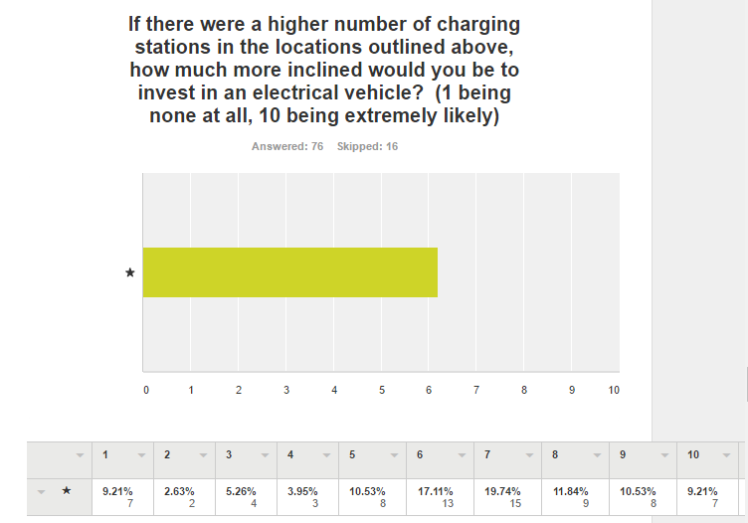
- If there were a higher number of charging stations in the locations outlined above, how much more inclined would you be to invest in an electrical vehicle? (1 being none at all, 10 being extremely likely)
Figure 21: Survey Question 14 Results
Question 14 continues directly onwards from the question before it, the number displayed above is higher than what was initially anticipated. Averaging at 6.2 out of 10, it shows that on average people would be significantly influenced if there were a higher number of charging stations in the places that they deem they are required. This implies that one of main factors holding back the growth of electrical cars is the lack of infrastructure in the places that require them.
This conclusion is supported by a recent statement from Russell George, the Conservative assembly member for Montgomeryshire who stated “The trouble is it's a chicken and egg situation - people want to use electric vehicles but they can't because the infrastructure's not there.” [102]
The extended statement can be found in the appendices. (3)

- Do you believe it is easy enough to find the location of your nearest ‘fast-charge’ station?
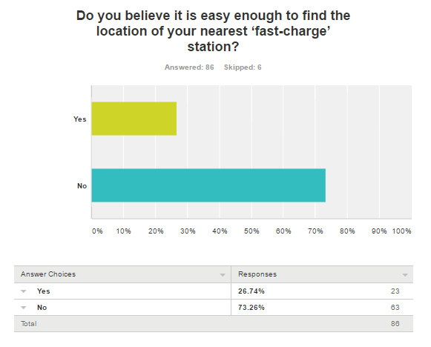
Figure 22: Survey Question 15 Results

The answers provided by participants is much in line with what was initially expected and documented. With nearly three quarters of the results determining that finding the locations of fast charging stations is too difficult a process, it can be identified that there is definite need in the market to build an application that displays the locations of charging stations.

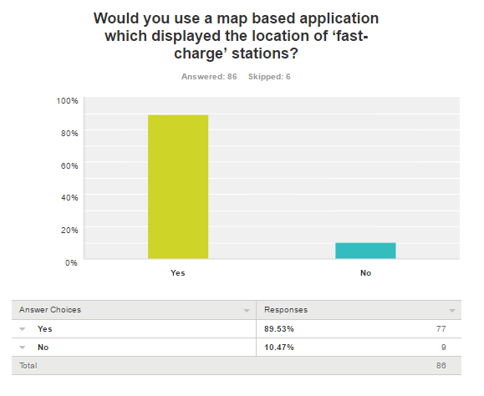
- Would you use a map based application which displayed the location of ‘fast-charge’ stations?
Figure 23: Survey Question 16 Results
The results of question 16 are without doubt some of most important responses in the entire survey. The answers above show that nearly 90% of respondents would use a map based application to determine the location of fast charging stations. Fortunately, these results completely justify the feasibility of creating a map-based application for this project and they also show how the application may be extensively used by the wider public.
It is somewhat unsurprising to see these results, as an application such as the one that has been developed would be useful for any electrical vehicle owner. Nevertheless, it is very surprising to see such a high percentage of respondents wanting an application of this nature.
The response displayed above can be linked directly to point ‘3.5’ of the aims and objectives which requires for the survey to “Discover whether the respondent would use a map based application to find the location of fast charging points”.
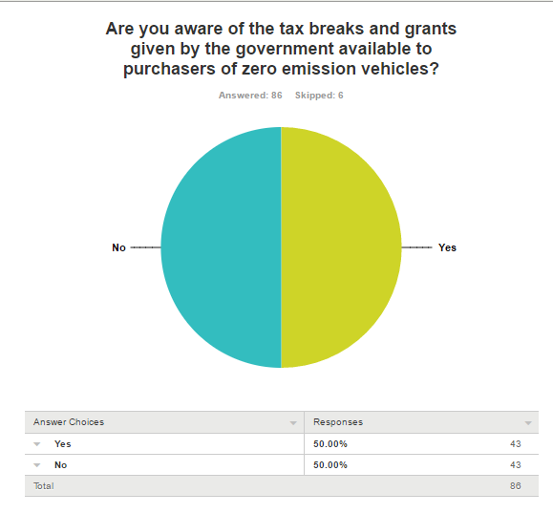
- Are you aware of the tax breaks and grants given by the government available to purchasers of zero emission vehicles?
Figure 24: Survey Question 17 Results

Much like question 16, results of question 17 were also highly surprising. As displayed above, it has been found that there is a perfect 50% split in answers, with half of respondents knowing above government tax breaks and the other half unaware. The number of participants unaware of government tax breaks is far higher than what was originally expected. Evidently, the government does not do enough to promote the tax benefits for those who invest in an electrical vehicle, perhaps with better advertisement the growth of electrical vehicles would be significantly higher than it is currently.
The response displayed above can be related to point ‘3.4’ of the aims and objectives which wished to determine whether respondents are aware of government tax breaks.
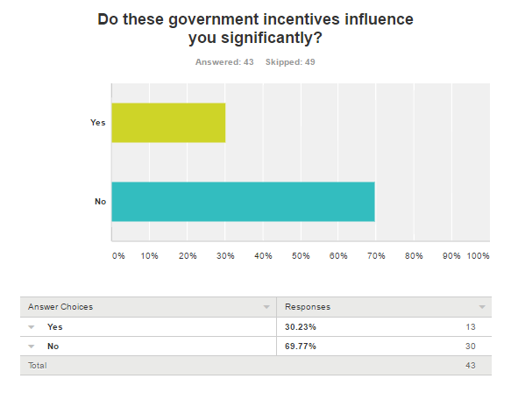
- Do these government incentives influence you significantly?
Figure 25: Survey Question 18 Results

The results above show that an overwhelming majority of respondents do not find government electrical car incentives significantly influential. With a unexpected amount of nearly 70% of participants answering no, it is clear that more needs to be done by the government if they wish to see a significant growth in the market share held by electrical cars.
The response displayed above can be associated to point ‘3.4’ of the aims and objectives found in the introduction which sought to conclude the likelihood of governmental tax breaks having a significant effect on the publics automotive purchasing habits, as shown above the answer is unmistakably; no.


- If you have selected yes, please explain why these incentives influence you?
Figure 26: Survey Question 19 Results

Much like question 6 before it, question 19 provided qualitative data for analysis. Only a small minority of respondents were significantly influenced by the governmental incentives in place, so the amount of data available for content analysis was significantly reduced, making it almost impossible. However, through reading the result there were certain phrases that kept reoccurring and these were ‘savings’ and ‘money’. Unsurprisingly, it would seem most people are only influenced by the financial incentives when purchasing an electrical vehicle. However, this is somewhat understandable to the extensive costs involved when purchasing a vehicle of this type.

- What other incentives could be put in place by the government to encourage electrical car sales
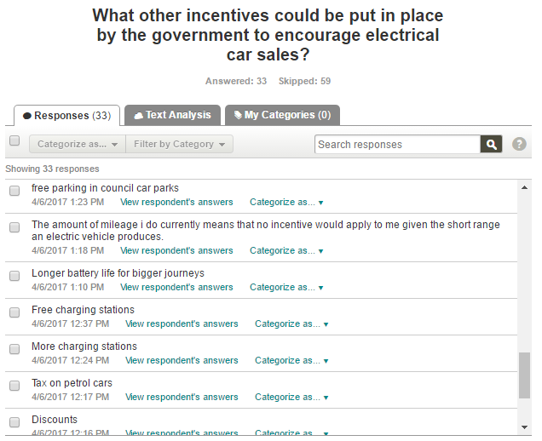
Question 20 also provides rich, detailed qualitative data for analysis. The qualitative nature of this question allowed participants to elaborate on what incentives they would like to see implemented to help encourage electrical car sales. Due to its qualitative nature, content analysis was performed to identify any reoccurring patterns in the data.
Figure 27: Survey Question 20 Results

As shown below, many the results focus on wanting more monetary subsidies and making sure that there were more charging stations available, these results are unsurprising once again as they follow many of the trends found in the previous results. The suggestions shown above can be related to point ‘3.4’ of the aims and objectives found in the literature review which wanted to determine what other incentives respondents would like to see implemented by the government.
Figure 28: Content Analysis Showing the incentives people would like to see.
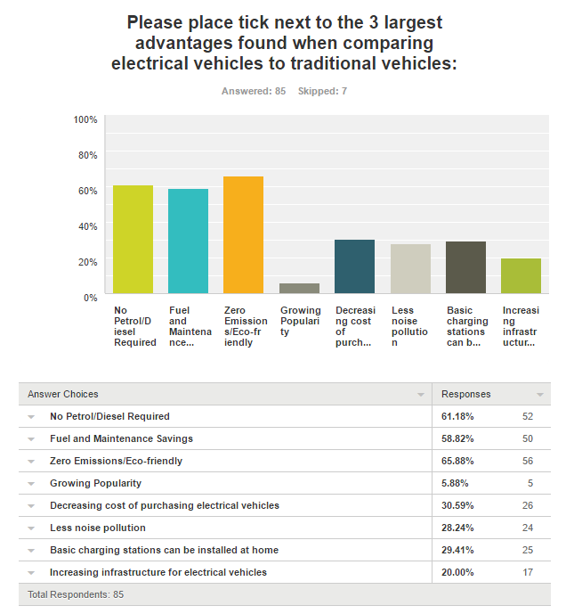
- Please place tick next to the 3 largest advantages found when comparing electrical vehicles to traditional vehicles:
Figure 29: Survey Question 21 Results

Question 21 allowed participants to choose three advantages that they perceived electrical cars as having over their traditional counterparts. The main three answers were; ‘Zero-Emission/Eco-Friendly’ at 65.88%, second was ‘No Petrol/Diesel Required’ at 61.18% and the third highest was ‘Fuel and Maintenance savings’ at 58.82%. The fact that these are the top three chosen by most participants is predictable, as these are arguably the main three advantages of this type of drivetrain.

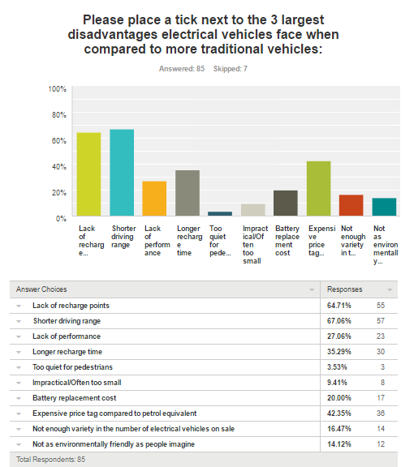
- Please place a tick next to the 3 largest disadvantages electrical vehicles face when compared to more traditional vehicles
Figure 30: Survey Question 22 Results
Question 22 followed many similarities with its predecessor and allowed participants to choose three disadvantages that they identify electrical cars as having over their traditional counterparts. The main three answers were; “Short Driving Range” at 67.06%, secondly was “Lack of Recharge Points” at 64.71% and there was a drop to third with “Expensive Price Tag” coming in at 42.35%.
With the top two answers relating to a short driving range and a lack of electrical charging points, this supports the results established by question 6, whereby the content analysis identified those exact two issues as coming out on top. This trend identifies two of the biggest shortfalls found with current electrical vehicle technology. Nevertheless, the results of question 21 and 22 can be related back to point ‘3.1’ of the aims and objectives as it gathers participant’s opinions with regards to electrical vehicles, including the advantages and disadvantages associated with them.

4.2 Data Correlations, Patterns and Trends.
Upon analysing the results of the survey, it was undeniable that there were some identifiable patterns and trends in the data received. Firstly, it was found that often participants overestimated the size of the current Welsh electrical car industry. This was first seen by the answers provided for question 9 which asked respondents for the percentage of electrical cars they thought were on Welsh roads, the largest response being 4-6% with nearly 29% of the vote, when in fact the percentage is only a diminutive 0.25%. In continuation, this overestimation was also seen when respondents were asked about the number of electric fast-charging stations in Wales, the average figure provided by the 90+ participants was 41.5, when in fact the number was just 14.
Secondly, there was a clear pattern spotted when analysing the reasons why participants are dissuaded from purchasing an electrical vehicle. In question 5, respondents were asked whether they would consider purchasing an electrical car in the near future, the following question allowed them to expand on the reasoning for their decision. By performing content analysis on this reasoning, it allowed an understanding as to why some respondents were so against purchasing an electric car, the three most identified arguments were that there was a lack of recharge stations, a lack of driving range and that the purchase cost of an electrical car was too high. These exact three responses also topped the charts in question 22, which asked what are the main disadvantages with purchasing an electrical car. These factors could have also led to the low ‘practicality’ rating of just 4.8 that was found in question 8.
This trend was not apparent when studying the positive answers revealed by the content analysis of question 6 and the 3 main advantages given for question in 21. Question 21 identified a lack of emissions, a saving on maintenance and a lack of fuel required as the three main reasons to invest, whereas the similarities found in the first part of the content analysis only stretched to the lack of fuel required. After which, the main reasons were identified as the decreasing purchase cost and increasing number of charging stations. It could be expected to see similarities between both questions, especially considering the resemblances found between the responses for question 22 and the part of the content analysis focusing on the reasons why people do not wish to invest in electrical cars.
In the first question, respondents were asked to choose an age group for which they belonged, the main answer for this was 18-25 which took nearly 50% of the vote. This young demographic could be related to the high percentage of participants who said they would use an online map-based application to find fast charging stations near them. It could be argued, that if the majority of respondents belonged to the 60+ age category, they may be less willing or less able to use such an application and the percentage choosing to use the application would be far lower.
Another identifiable trend was the number of respondents who were dissatisfied or even unaware of the government electrical vehicle incentives. There was a perfect 50-50 split in the number of people who knew there were government incentives and grants in place, and of the 50% that were aware, only 30% felt as though they were significantly influential. However, by analysing the answers of the 30% that were influenced it could be identified that the main motive was the prospect of money off in the form of grants, no road tax and free charging stations. Additionally, the trend of value being placed on monetary subsidisations was outlined further by question 20 which asked respondents to list further incentives they would like to see implemented. By performing further content analysis, it was recognised that most respondents would like to see additional monetary incentives such as the availability of free battery replacements, scrappage schemes and even government led subsidies which would help lower the price of insurance policies for electrical cars. This trend of consumers wanting financial incentives can be expected due the expensive costs involved when purchasing an electrical vehicle. In continuation, it could be reasoned that early adopters feel entitled to further grants due to the inconvenience they may face with this new and still under-developed technology.

5.0 Design and Implementation
Requirement Number: | Title and Description | Importance:
1 | GIS Based Map of Wales  A map of Wales which has been imported into the GIS software package MapInfo. The map will have geocoded data files to show plotted locations of fast charging stations. | Mandatory
2 | Interactive Plot Points  The plotted points on the map become interactive. With the incorporation of a flat-file database each plot location can have data attached to it, by clicking on a plot the user will be taken to a separate details page containing the locations address. | Mandatory
3 | Map Reference Points  This requirement refers to how the map is viewed by users. The map could have motorways and main roads colourised as found on traditional maps, it could also contain major city names and the plots could be modified into a brighter shape to make them more identifiable. | Optional
4 | HTML Based Version of Map  The completed map will be extracted and exported from the MapInfo software and saved as a separate HTML file. This file can then be viewed in a web browser | Mandatory
5 | Full WordPress Integration  The HTML file will be integrated into a WordPress website. The website would be accessible from any computer and have a fully functioning map. | Optional
6 | Each Charging Station Having its Own Information Page  Every individual charging station will have its own sub-page. The interactive plot points will continue to function on the WordPress map and once a point has been clicked upon, users will be taken to the relevant page displaying the stations address, name and any additional details. | Optional
7 | Key Survey Results Displayed in Application  The key findings from the survey will be displayed on a separate page. This will educate users as to what the public thinks of electric vehicles and the infrastructure. | Optional

5.1 What are the project requirements for the application?
Figure 31: Project Requirements

The project requirements were outlined at the very beginning of the application development process, the rapid application development (RAD) model terms this stage the ‘requirements planning phase’ [103]. The requirements planning phase determines that to discover the correct requirements the developer must determine the applications needs, the scope of the project, what constraints are in place and what the user desires. [104]. The needs of the application were the most influential factor when creating the requirements as they needed to ensure that the application fulfilled its full potential. The scope and constraints ensure that the size of the project was kept in check, factoring in issues such as budget, quality and the time required to build the application to a high standard. Lastly, empathising with what a user may wish to see also helped formulate the shape of the requirements, as without a happy user base, the application would not be considered a success.

5.2 Prototypes and Storyboards.
From the start, it was always envisioned that map would focus on Wales, require user interaction and would be aim to be easily accessible as an online service. Before development initiated, a large importance was placed on the aesthetic presentation of the design.

5.3 Description of Application
The application was designed to allow both potential buyers and users of electric cars to identify the location of their closest fast-charging station, a fast charging station is one that can be used on the go as it has a high kilowatt output when compared to standard chargers. A fast charger can charge a car up to 15x faster than a traditional home installed charge point. A 50KW fast charger can charge a car in half hour, compared to the 3KW home charger that needs to be used overnight. Fast-chargers are ideal for travelling electric car users as there is not as much of an extensive charge time.
The application will utilise the power of GIS software to display the location of fast charging points in Wales, the map will be interactive and allow for users to click upon each station plot point if they wish to know more details about that given location. Each location plot point will link to an information page that has been integrated into the map through the use of a flat-file database. The map and its supporting pages will be created in the GIS program MapInfo and will be extracted from MapInfo as HTML files, these files will then be integrated into an online WordPress website. The basic online functionality of the map will theoretically allow for users to access the application from any place at any time, this online functionality is essential as this application could hypothetically empower users to find a fast-charging station when they are on the move.

5.4 Paper Prototypes

The first original designs were hand drawn, paper based prototypes. The reason for doing this was that the designs were easy to modify, quick to produce and could be easily revisited later in the design process. The four main screens were sketched out into a final draft, these screens were the home ‘main map’ page, a ‘details’ page, an index for all Welsh fast charging points and a statistics page that highlights the key findings from the survey completed in the additional part of this project. These four paper prototypes are displayed below:

5.4.1 Main Interactive Map

The original paper prototype seen above shares many characteristic with the final design. A large map of Wales dominates the main menu, with stars representing fast charge points scattered across the country. The A-roads are highlighted in pink, the M4 motorway in green, the two main southern cities are identified along with the charge point ‘Holyhead’, an arrow is drawn to Holyhead explaining that when a user clicks upon the star they are taken to the details page.
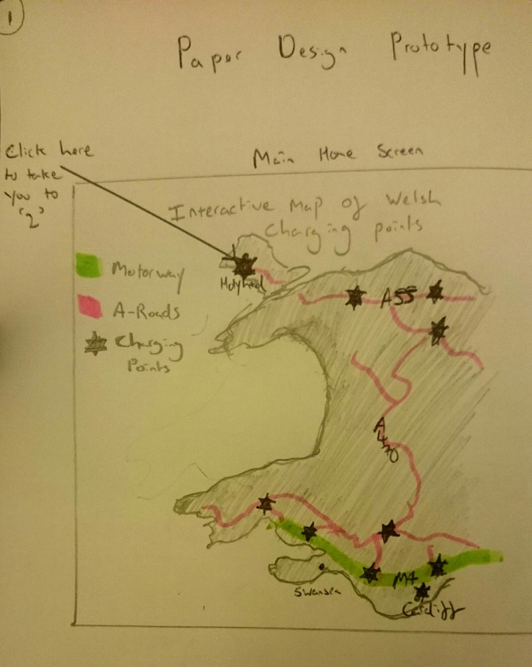
Figure 32: Paper Prototype Home Page

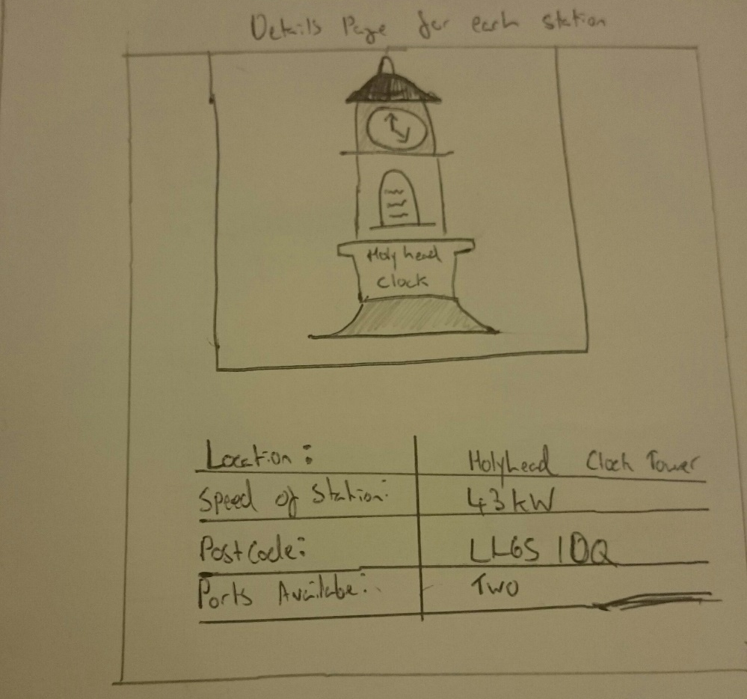
5.4.2 Charge Point Details Page:
Figure 33: Paper Prototype Details Page

This second paper prototype demonstrates a basic illustration of what the user will see when they click upon the Holyhead charging station plot on the main map, this prototype details page shows a (very crude) image of the Holyhead clock tower. The table below informs the user of the name of the charging point, the speed of the stations available, the postcode of the charging station and the number of ports available. The name is displayed so that the user can identify what area the station is in, the speed is displayed so that the user can see if the station is the correct speed for their needs. Furthermore, the postcode is also registered so the user can enter it into their Sat-Nav to find the station whilst mobile. Lastly, the number of ports available is presented so that users can speculate as to whether they will need to wait for a port to become available or if the stop point would be of use if they were in a convoy of electrical vehicles.

5.4.3 Welsh Charging Station Index
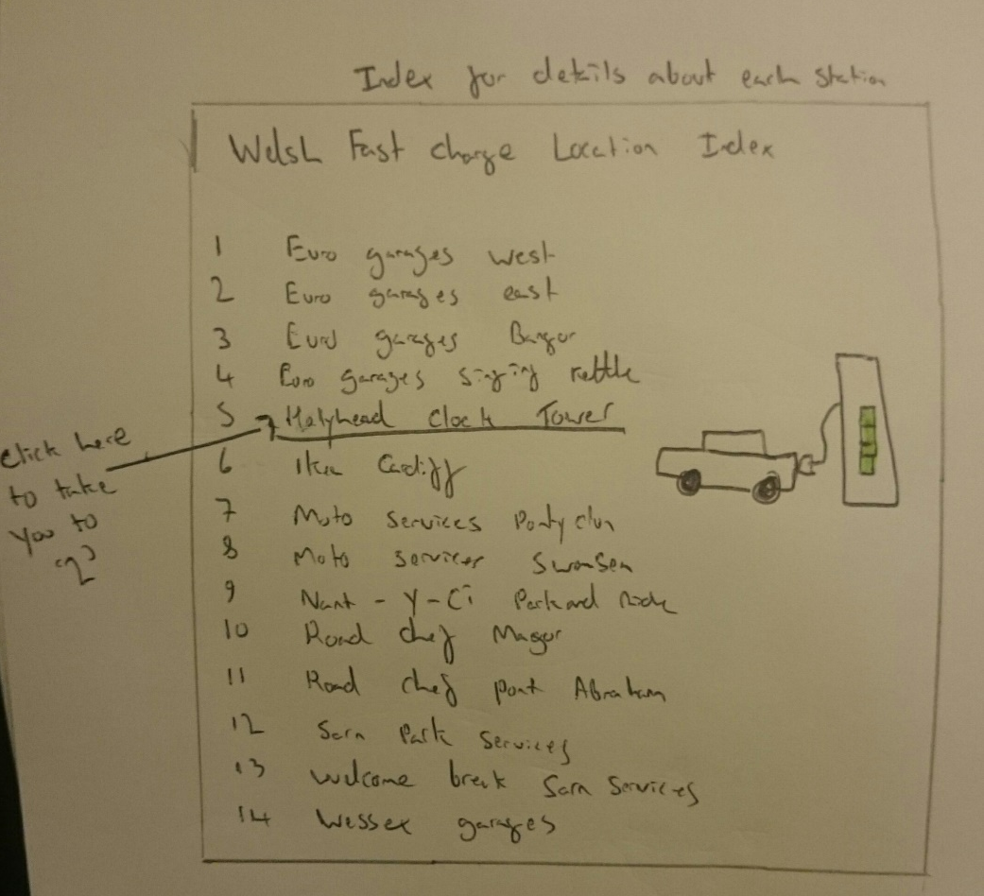
Figure 34: Paper Prototype Index

This third paper prototype acts as preliminary index of all the electrical fast charging station in Wales. Once integrated into the website, each one of these names will act as a hyperlink, taking a user to the chosen details page, as displayed above. For instance, clicking index number 5 above for Holyhead, would take the user to the details page for Holyhead. The purpose of this index is that it allows users to quickly find the station their looking for in a situation whereby know the name of the location, but don’t know the address, or where it is on the map.

5.4.4 Survey Results Page:

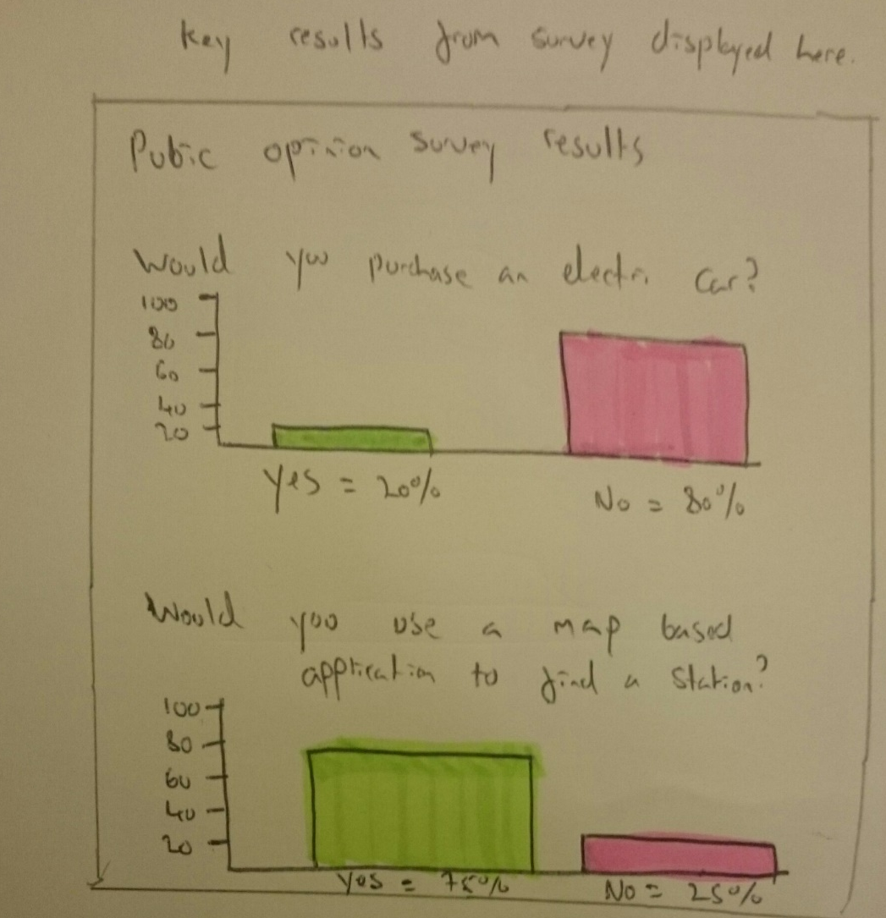

Figure 35: Paper Prototype Statistics
The final paper prototype design acts as an early display of the key findings from the public opinion survey that was conducted in conjunction with the development segment of this project. It was a development decision that the key findings from this survey would be displayed on the application webpage. The question asking “Would you use a map based application to find a station?” fits into this section perfectly as it was asked purely to discover the percentage of users that would use an application of this nature. The target audience of this application is Welsh adults who either own an electric car or are open to buying one in the future. Displaying the results of the survey to users may help influence and aid their decision making one way of the other as they can now see what other people think of these vehicles and what people believe are the advantages and disadvantages.

5.5 Storyboards

Through analysing the early paper based prototypes, it was easy to determine what could remain in the next iteration of the design and what needed to change. The next stage in the design process was transferring the paper prototypes from their physical real world form, into a digital ‘storyboard’ based format. The software used to recreate the prototypes was Microsoft Publisher, the reason for using this software package related to the needs required of the storyboard. An in depth, high fidelity design was not essential, what was essential was a mock-up interface that could be modified with ease and created within a short production schedule. This philosophy once again supported the requirements of this project and supported the methodology of RAD. Four storyboards were created in Microsoft Publisher and these were the home ‘main map’ page, a ‘details’ page, an index for all Welsh fast charging points and a statistics page.

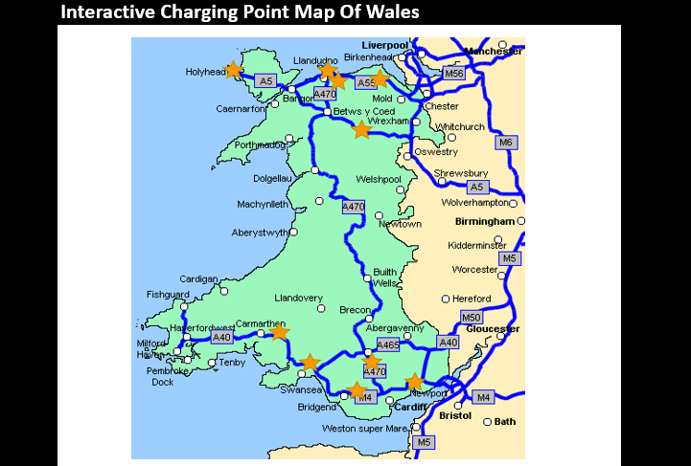
5.5.1 Main Interactive Map
Figure 36: Storyboard Main Menu

The storyboard iteration of the interactive map retains many of the features found in the original paper prototype. The stars still represent the locations of charging station, even though they are now gold to seem more prominent to the user. The background of the storyboard is now white on black, and this is similar to the design that will be shown on the final map. This simplistic, high contrasting design background was implemented to aid those suffering from sight difficulties and colour blindness. In the final version, motorways have been changed from green to blue and A-roads remain pink as is found in most traditional maps. Thanks to this traditional colouring, users will now find it easier to navigate the map as they can rely on pre-existing visual metaphors from past map usage. [105]

5.5.2 Charge Point Details Page

Figure 37: Storyboard details page

The charge point details page retains many of the same design characteristics as its paper prototype, the information displayed is just the key information required and refrains from giving the user ‘information overload’. The background now follows the white on black theme that will be found throughout and the Picasso-like drawing of Holyhead’s prestigious clock tower has now been replaced with a high-quality photo.

5.5.3 Welsh Charging Station Index:
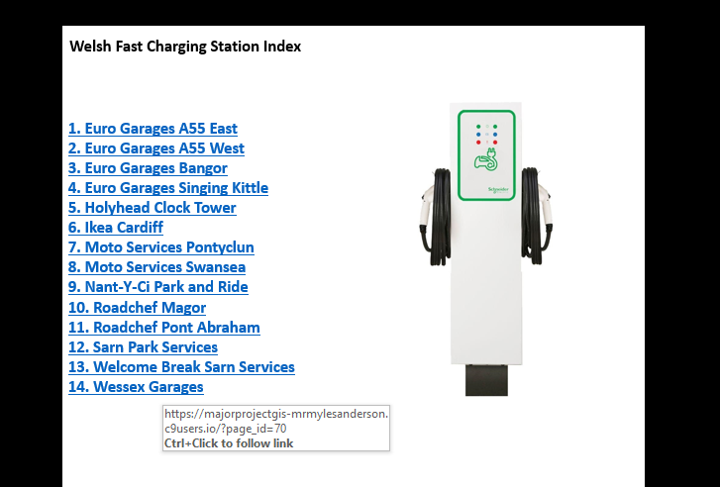
Figure 38: Storyboard Index
The station index page retains many of the same characteristics as it paper-based predecessor. However, as seen above, the names of the stations are now live hyperlinks and were used to test the effectiveness of using hyperlinks before they were implemented into the final design.

5.5.4 Survey Results Page:

Figure 39: Storyboard Statistics

Unfortunately, at the time of creating this final storyboard the results of the survey had not been finalised. Therefore, it was chosen not to display any preliminary infographics and instead implement the graphs when the survey had concluded. Nevertheless, the rest of this page also retains many similarities to its paper prototype. The final graphs will be displayed in a comparable fashion and will be the dominating factor on this page.

5.6 The Final Application.
Figure 40:Digimap Download

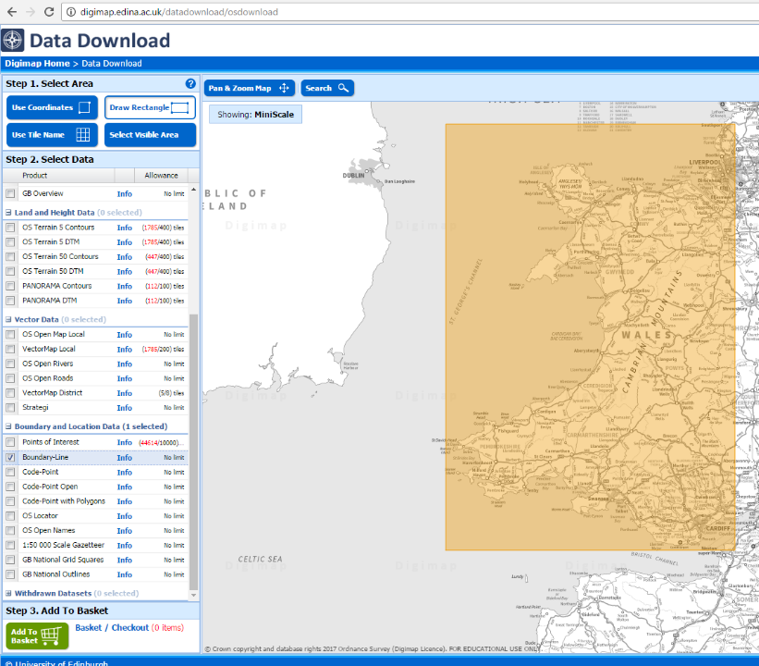
The final application begun by downloading a detailed, virtual map of Wales from the government website ‘Digimap’. Digimap, allows for the download of detailed, GIS based maps.
The user draws a rectangle around the area of the map that is required and then the map is ordered. Once the order has been processed by Digimap the file is sent to an email of choice as an attachment. The attachment file is then downloaded and imported into the GIS software package ‘MapInfo’.

After being imported into MapInfo, the unwanted areas of the maps can be discarded so that the user is left with just the outline of Wales; as displayed below.
Figure 41: Wales Outline in GIS

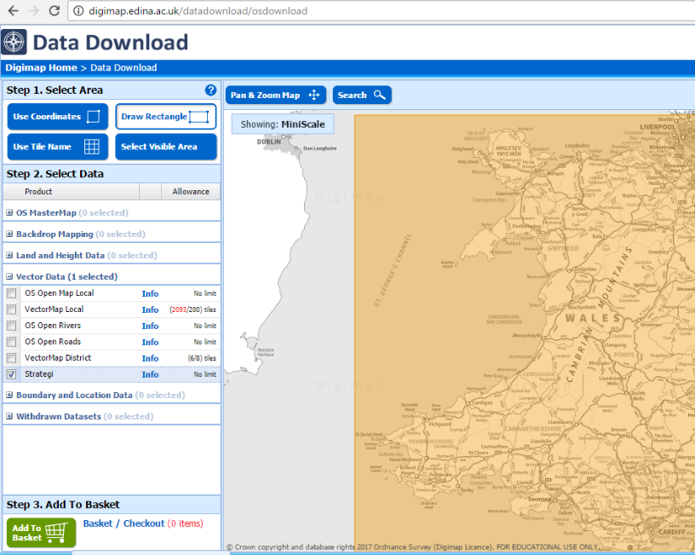
Once the outline of Wales is successfully displayed in MapInfo, the second layer of the map can be downloaded and then implemented into the design. The second layer chosen for implementation was the Welsh local road network, this layer was once again ordered and downloaded from Digimap, and was titled ‘Strategi’.
Figure 42: Digimap Road Layout Download
Before entering the file into the map, the file needs to be unzipped and the relevant files chosen for extraction, due to the location of the fast charging stations, the only files we needed were the map outlines of Welsh A-roads and the M4 motorway.




Once the selected files were extracted, they could be implemented into our map as a second layer, resulting in the screen seen below:
Figure 43: Wales outline with main roads
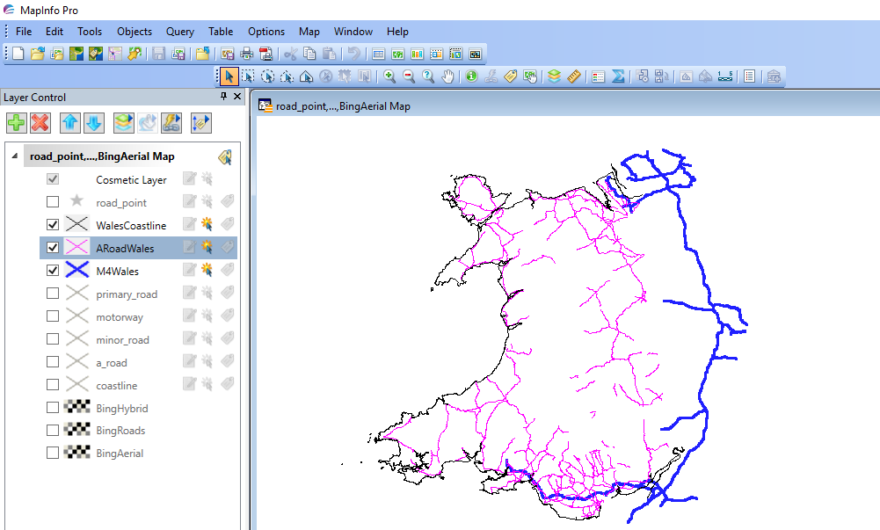
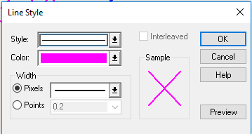
To allow for greater ease of use, it was decided to modify the road colour. The colour chosen was pink for A-roads and blue for the motorways, this colouring follows the design trend used by traditional maps and will utilise users pre-existing visual metaphors to assist them when using the interface. This adjustment process and resultant modification resulted in an aesthetically appealing interface.
Figure 44: Welsh Roads Colourised

Subsequently, once the roads have been incorporated into the application, it was time to create a flat-file designed database in excel which would contain the co-ordinates of the fast-charging stations. The co-ordinates were required to allow MapInfo to create the charging plots on the map, in order to find the co-ordinates, the charging point postcodes were found online. Once found, the address details were entered into the spreadsheets.
Figure 45: Initial Data Capture

Once the details were recorded, a government database was queried for all Welsh postcodes, this flat-file database was downloaded from the UK data service website and contained all of the postcodes and co-ordinates from the areas which were home to a fast-charging station. [106] To find the exact co-ordinates of the charging stations, it required the manual searching of over 11,000 individual records.
Figure 46: Searching for Co-ordinates of charging stations

After the co-ordinate searching had been completed, the records of the 14 charging stations were completed; now with the ‘Easting’ and ‘Northing’ points to allow MapInfo to determine their exact location.
Figure 47: Co-ordinates added to data capture sheet
This spreadsheet was then saved as a ‘.CSV’ (Comma Separated Values) ensuring its flat-file status, this file type allowed for the data to be opened within the MapInfo software package.

The next stage required registering the co-ordinates as location-based data within the GIS software package. Therefore, the database needed to be ‘Geo-Coded’ by MapInfo.
Figure 48: Exported as .CSV and imported into MapInfo as flat-file database
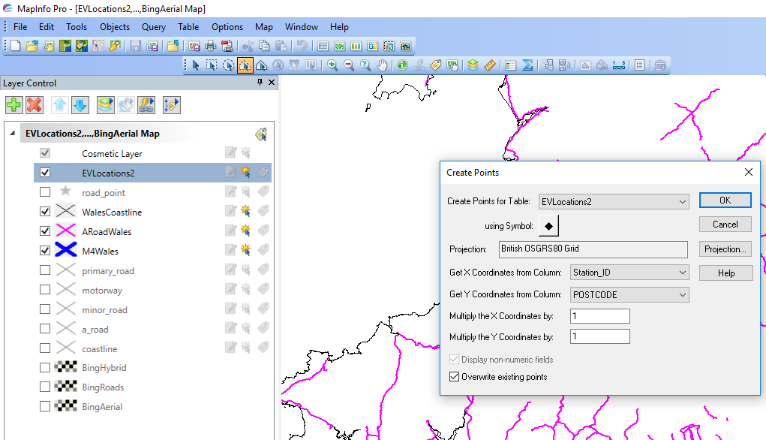
Once the charging stations co-ordinates were recorded as locational data, it was then possible to create points on the map which would illustrate where they were in Wales.
Figure 49: Creating Plot Points

Now that the points were displayed upon the map, it was then possible to modify the design on the points, making them more identifiable for the user.
Figure 50: Modifying Plot Points
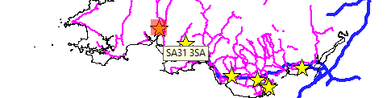
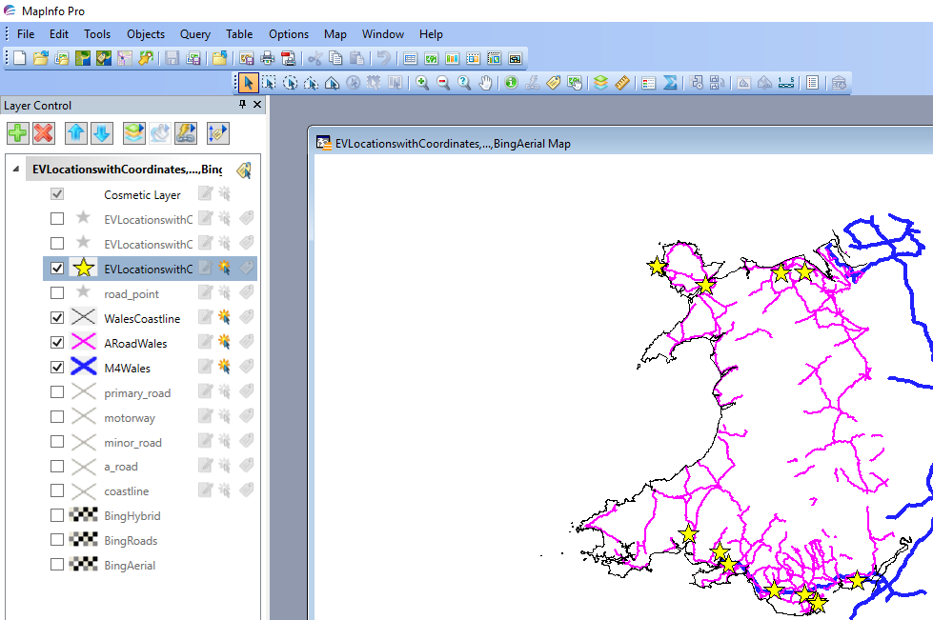
These plot points were fully interactive and by hovering over them and subsequently clicking upon them, the user can see the plots postcode.
Figure 51: First layer of interactivity shown
Figure 52: Map of Wales with Plots

The last major modification of the map requires the integration of ‘Bing Maps’, thankfully, MapInfo has this feature preinstalled and all that was needed to activate it was a valid ‘Bing Key’. The university were very helpful in providing this code and the results of its appliance can be seen in all of the online maps.
At this stage, the design of the map had been completed within MapInfo. It was now time to try and get the map to function effectively online.


The ‘HTML Image Map’ function found within the MapInfo package allows the user to save their maps as .HTML files with relative ease. To ensure the map displayed correctly when transferred into a HTML format, the correct map-layers and their subsequent columns needed to be selected for processing. Initially, the webpage title was named ‘Electric Vehicle Fast Charging Locations in Wales’, before naming the copyright as ‘Crown’ which is a stern requirement when presenting governmental data. [107]
Figure 53: Creation of HTML Map

Additionally, the HTML map function allowed for the creation of individual sub-pages for each charging-point. When geo-coding the data for each plot point, the remaining data in the record was also attached to that location, e.g. its name, postcode, and charging speed. So when creating the main image map, the 14 charging points had web pages created for them under the name of their unique ‘station_IDs’. These IDs were later renamed to each stations name and this made it easier to ensure the map to remain interactive in its HTML format. When in the HTML map, clicking upon a plot point would now transfer the user to the unique page created for that station.
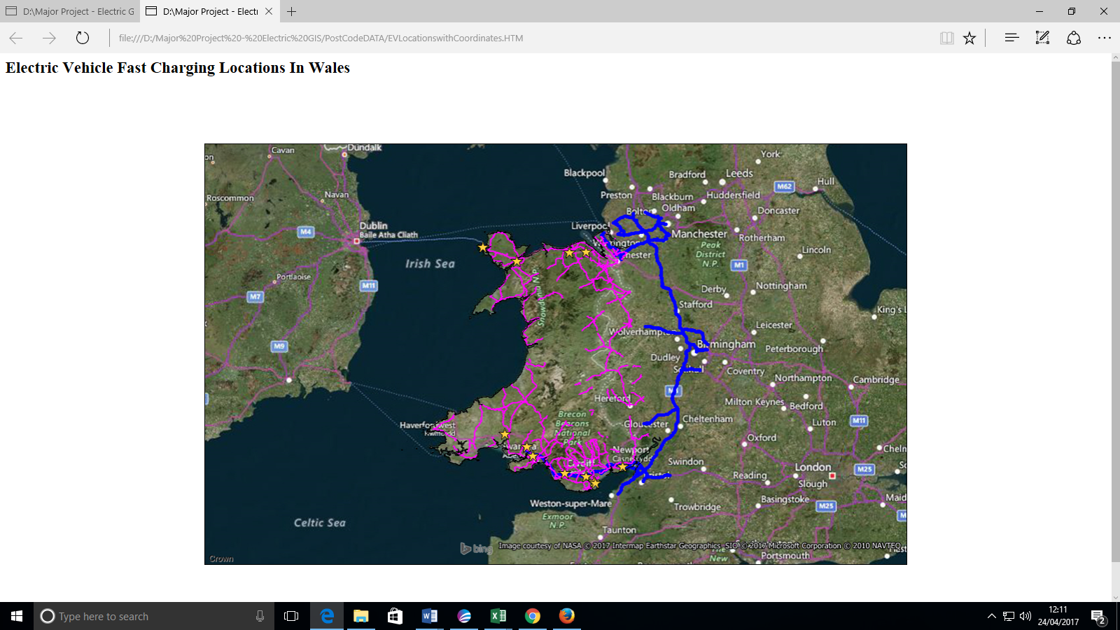
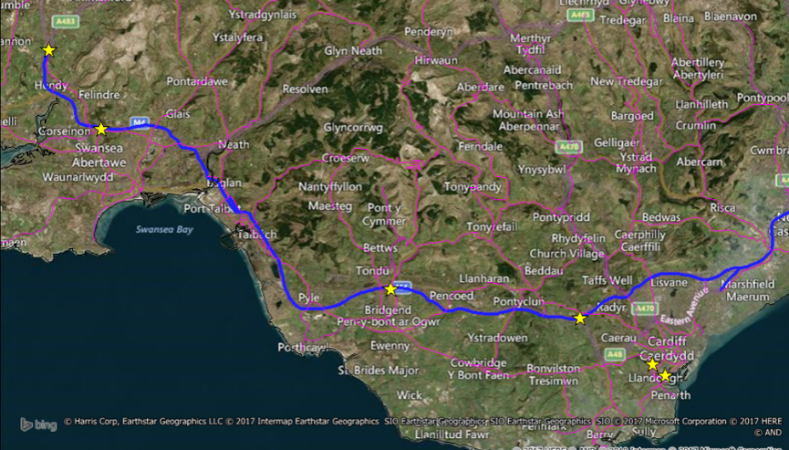
Displayed below is the initial HTML charging map, the map shows off the motorways in blue, the A roads in pink and the charging stations as golden star plots. The Bing Maps integration allows for a more professional look and allows for users to see the names of local towns, cities and national parks.
Figure 54: HTML Map First Look

As mentioned previously, upon clicking a charging plot the user is transferred to a unique HTML page depending on the plot selected.
Figure 55: HTML Details Page First Look
The images displayed show the HTML pages provided by the MapInfo software, besides the maps themselves, they are rudimentary and visually unappealing in nature. These factors resulted in trying to integrate the maps into a WordPress webpage. Subsequently, the maps would be more accessible and more aesthetically pleasing; despite the challenge involved.

Firstly, to integrate the HTML maps into a WordPress site it was decided to use the cloud development tool ‘Cloud 9’ [108]. Cloud nine is a developmental tool that allows for the hosting and creation of websites over the internet. Through opening the WordPress website through Cloud 9 the development can be accessed from any machine at any time.
Figure 56: Cloud 9 main workspace
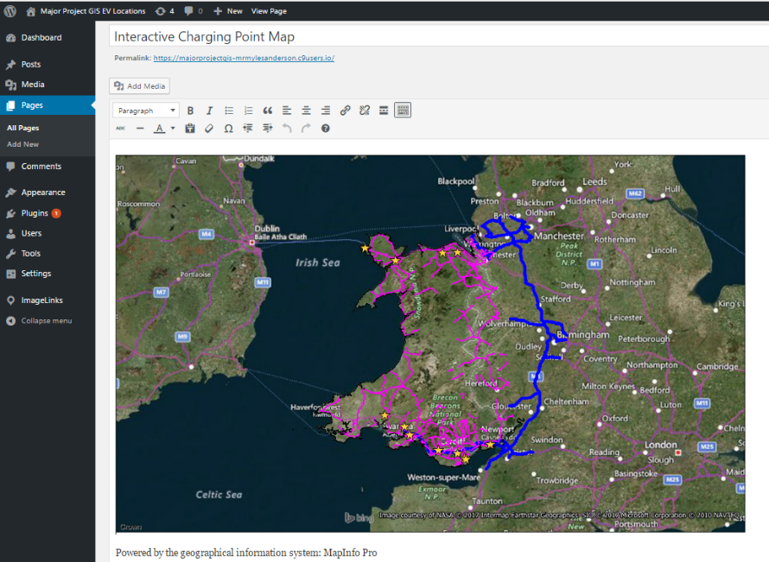
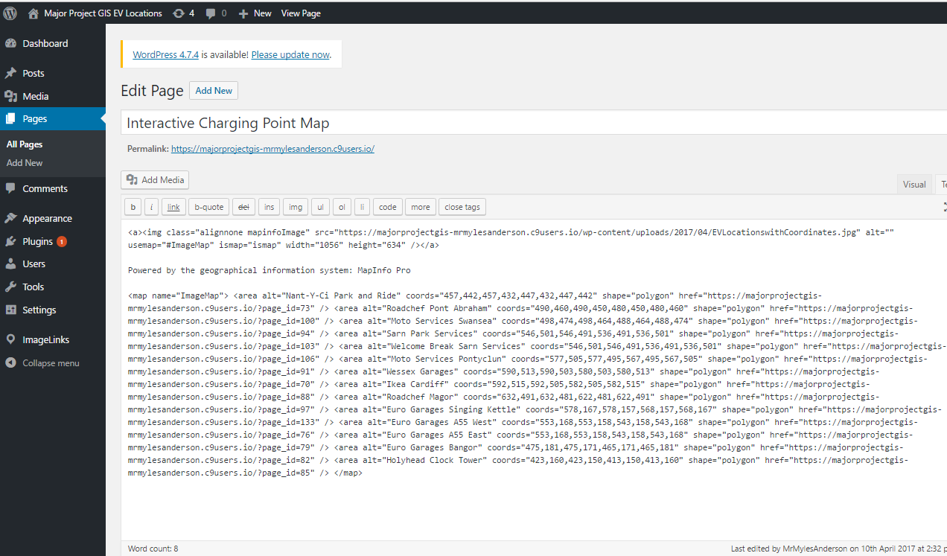
Through Cloud 9, a WordPress webpage was built with the various themes, sub-menus and formatting required to host the maps in a visually enticing manner. Once this was completed, it was time to transfer the HTML maps into the WordPress website. The HTML code for the main map was opened and copied into the ‘Text’ portion of the WordPress page creation tool.
Figure 57: First Look at WordPress Homepage
Figure 58: Creation of WordPress Homepage
Each plot point had its own reference link so that the map could remain interactive within WordPress. Initially, this was extremely difficult to get working; the references used in the main map must link to the individual cloud based webpages created when making the WordPress document in Cloud 9. However, when originally trying to integrate the map it was attempted to reference to the physical HTML files rather than the online cloud file, this resulted in a map appearing correctly, but none of the plot points linking to their associated page.
Eventually, and with some advice from web lecturer Kemi Ademoye it was established that for in order for the map to function as expected, each plot point had to be linked to their respective cloud based webpage.
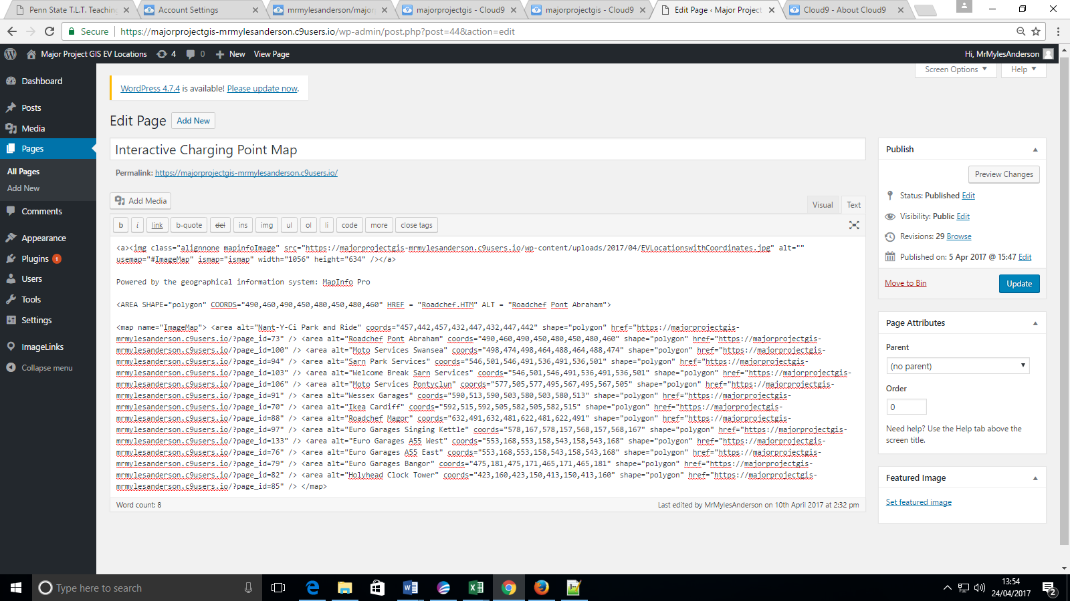
The code displayed below is the initial HTML code that would not function as anticipated:
Figure 59: Faulty Code


This issue was rectified by modifying the code to the following:
Figure 60: Fixed Code

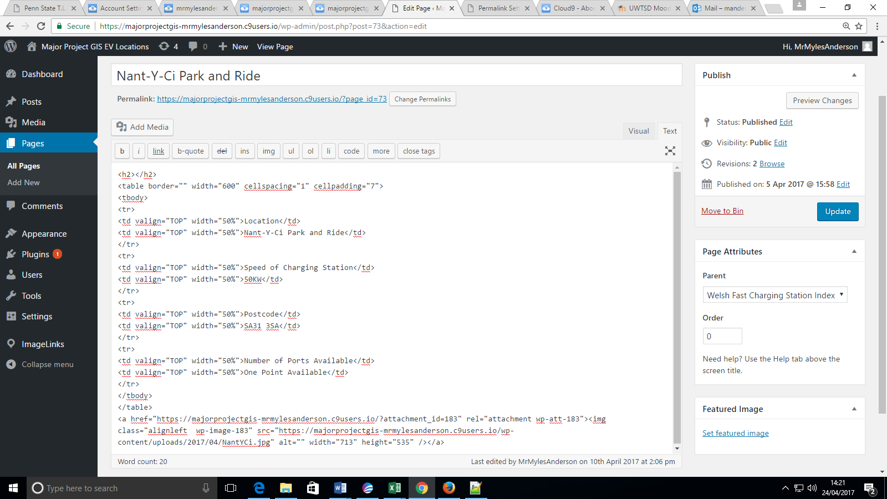
After the main home page was functioning as expected, each sub-page had to be linked to the correct webpage file too, as seen on the previous page “Nant-Y-Ci Park and Ride” has the page ID of 73. For this specific details page to work correctly, the ‘Permalink’ connected to the Wordpress page needed to be changed to the same. (As seen in the blue text.) Additionally, images of each location were found online and the image files of each were inserted into their corresponding details page as seen at the bottom of the text below. (NantYCi.jpg)
Figure 61: Ensuring Links worked correctly and image integration
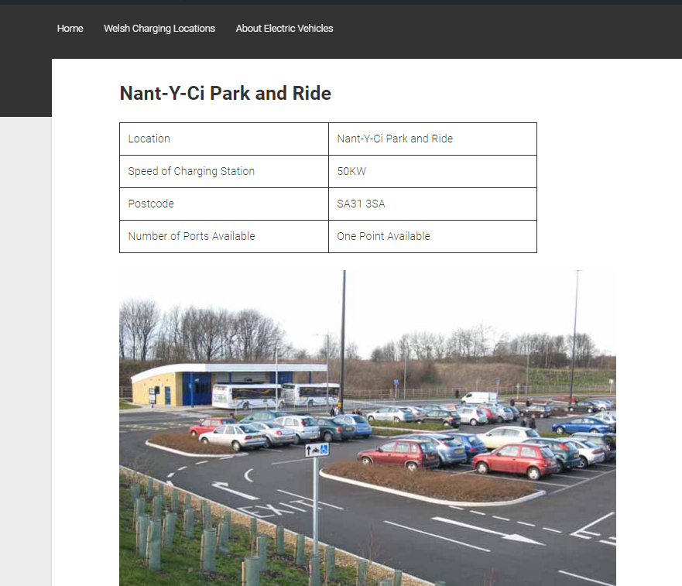
As a result of these alterations, the new details page is presented below:
Figure 62: WordPress Details Page


This details page looks considerably more professional than the one generated by MapInfo and this details page is just 1 of 14 examples. The details page of each location can be accessed from two different location on the website. Firstly, it can be accessed from the home interactive map, but it can also be accessed through the index page that was built into a submenu on the WordPress site. As mentioned previously, the purpose of the index is to allow users to see information for a charging station that they know the name of, but are not necessarily aware of its located on the map.
Figure 63: WordPress Index

The last page on the website is donned ‘What the Public Thinks about Electrical Motoring’, the page is used to inform the webpage user about the results of the survey that was created in conjunction with this application. The application utilises the results of the survey and applies them in a way that can educate users by displaying the key findings.
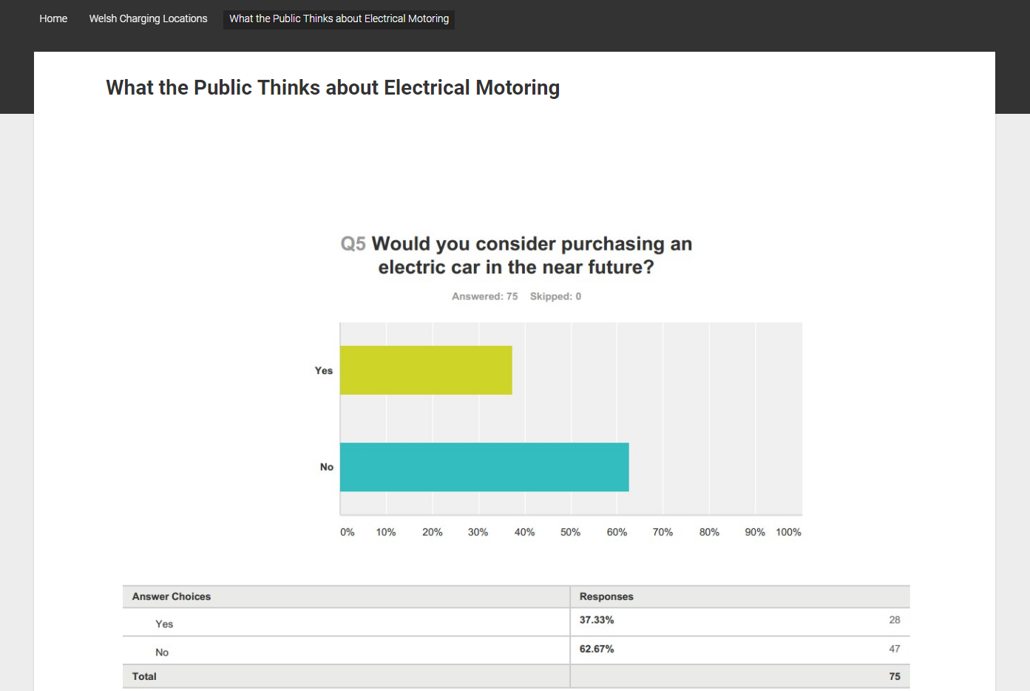
Figure 64: WordPress Statistics page

5.7 Software Testing

Due to the Rapid Application Development technique used during the development of this application, testing took place iteratively, as the application was designed. Initially, the map was tested extensively within the GIS software package, trying to identify any errors in the plot points; such as whether the right plots associated to the station right details. Thankfully, due to the use of a .CSV flat-file database, once the details had been entered and imported into the map, there was no chance of this happening.
Secondly, once in its HTML format, this was once again tested; with positive results. Furthermore, classmates used the HTML pages, each plot worked as it should, the user could return to the main page with no errors occurring and the map could adapt to zooming inwards and outwards without any issues.
Lastly, once the maps had been incorporated into the WordPress website during the final phase of development, unit testing took place to ensure each individual part of the code worked as expected. Each HTML hyperlink worked correctly, each map plot point was fully functioning and the details page showed the correct content for each station selected.
Overall, the system was tested rigorously to guarantee it all functioned collectively as it should, thankfully there were zero system issues with the webpage interface, maps or the ability to move from page to page. All of the testing by the developer (myself) was verified by 3 separate real world users. The 3 users in question are individuals who are strongly deliberating whether to or not to purchase an electrical vehicle as their next car, after each user spent a period of time with the application it was reported that there were no issues needing to be rectified and it was accepted that the application performed all of the tasks it initially set out to do, fulfilling all of the original requirements.

6.0 Evaluation

6.1 Evaluation of Survey Data:

There are many assessments to be made from the primary data provided by the survey, firstly, it was discovered that of the 92 participants that entered, only 1 individual owned an electric car, significantly however, out of the same 92 respondents; 35 said they were considering purchasing an electric car in the near future showing that slowly, opinions are changing. Additionally, in the content analysis performed the main factors people liked about electrical cars were the lack of fuel required, the decreasing purchase cost and the lack of exhaust emission. However, it can be concluded that there is still large majority of individuals who are not ready to let go of the internal combustion engine anytime soon, the main arguments being that electrical cars just have too short a range, that they are still too expensive to purchase and that the lack of fast-charge stations is just unacceptable.
Furthermore, it can be concluded from the results that participants not only grossly overestimated the number of electrical cars on the road, they also thought there were over 40 fast charge stations in Wales, compared to the actual number of just 14. Despite this overestimation, 88% of respondents do not believe there are enough charging stations on U.K. roads and on average; respondents believe there should be nearly 700 fast charging stations in Wales. When asked where these stations should be located, most participants selected that there should be more charging stations all across Wales, whereas others decided that the M4 motorway, A-Roads and city centres should be the primary focus for new fast-charging points.
In continuation, surprisingly only 50% of participants knew about the government grants and tax cuts incentives in place for electrical car buyers. The other 50% of respondents were completely unaware of the measures in place. Moreover, of the 50% that knew about the incentives, only 30% said that they felt significantly influenced buy them, alluding to the questions of whether more needs to be done to try and advertise the benefits of purchasing a ‘zero emission’ vehicle and whether current incentives go far enough. After further content analysis, it was discovered that respondents mainly want to see a greater number of charging stations and larger monetary enticements before purchasing.

Lastly, it was determined that nearly 3 quarters of respondents feel as though fast-charge stations are too difficult to locate and that if there was an application built displaying the location of the points in Wales, a gargantuan 90% of participants would use it, therefore, firmly concluding that there was indeed a big need for the type of application that was being built.
The survey completed all that was asked of it in the aims and objectives, it was created to discover participant opinions regarding electrical vehicles, whether they would purchase one and where charging stations should be located. The survey also identified whether participants believed there was enough infrastructure in place to support future growth, with the overwhelming consensus being no. In continuation, the survey also determined that a lot of respondents were not aware of the government incentives in place and a majority believed more can be done to entice potential buyers. And lastly, the survey conclusively answered the last objective, which asked to discover whether there was a market for an application showing users the locations of local fast-charging station with a resounding yes. The survey uncovered all the data that it set out to and conclusively solved all the questions it was created to answer.

6.2 Did the survey provided the answers expected?

Overall; yes. The survey provided data that was much in line with initial expectations and pre-existing secondary data. Without any shadow of a doubt, there are not enough fast-charging stations within Wales. Furthermore, it was confirmed by the survey that the main motives that make the Welsh public apprehensive to invest in electrical cars is due to the lack of infrastructure in place that compounds the issue of short driving ranges. Moreover, with only 14 different locations for fast charging in Wales, extended journeys for some Welsh electrical vehicle users in just not feasible.
Another expected result was confirmed when investigating participant answers for where future charging stations should be located, by collecting respondent’s postcodes a clear trend was identified; those who live in highly populated areas believe charging stations should be located near the M4 or city centres and those who reside in sparsely populated areas argue more rural charging stations are needed. Generally, as expected the consensus amongst respondents is that there are not enough stations nationwide.
In contrast, a surprising trend was identified with the number of respondents who were unaware of governmental incentives, only 50% of respondents said they were aware of the measures in place and of the same 50%, nearly 3 quarters of respondents argued the incentives did not go far enough
Lastly, the survey provided the expected result that many find charging stations too difficult to locate. Fortunately, due to this factor a massive 90% of respondents said they would use an application that displayed the location of fast-charging points in Wales.

6.3 Did the Application Meet its Aims and Objectives?

The fundamental reason for the development of this application was to allow users to identify the location of their closest fast-charging stations. The application was to be created using the GIS package of choice and displays the locations of all electrical fast-charging stations across Wales. The application exhibits a map with full ‘Bing Maps’ integration as well as presenting the names of Welsh major cities and national parks. User accessibility was a priority when designing the map and this is increased further thanks to Welsh A-roads and motorways being colour coded in a distinctive fashion, this colour scheme was implemented as it follows precedents set by physical and traditional maps. The charging stations themselves are easily identifiable as they are represented as large, golden stars on the map interface, the charging station plot star for Swansea West ‘Moto’ services can be found on the M4 alongside Swansea, the Ikea Cardiff charging station plot star can be found in central Cardiff and so forth.
Thankfully, due to the versatility of the ‘MapInfo’ software package, the overarching aim of trying to create a GIS based map interface was achieved. The map presents the location of Welsh fast-charging stations in a professional, user-friendly and distinctive manner as it was envisioned to do.
Another objective of the application was to use Wales as a focus area for the map and clearly identify the locations of Welsh fast-charging station relative to local transport routes. Firstly, this was achieved when downloading and extracting data from the Government website ‘Digimap’. During this phase, only Welsh data was chosen for download; this can be seen during at the start of ‘The Final Application’ segment on page 68 of this project. Subsequently, once this data was imported into MapInfo, the road markings and plot points were extensively modified to make them clearly identifiable to the application user. The reasoning behind this objective is linked to the context in which the application may be used; most users will not want to spend an elongated time period searching for the nearest fast-charge point along the route they are taking, they want instant gratification and this is assured by the user interface measures implemented into the design.
The penultimate objective for the application required for the MapInfo based map to be extracted into a HTML application whilst retaining full functionality. Fortunately, this objective was once again accomplished. The GIS software package included the functionality which allowed for the relatively unproblematic conversion of the map from its original format, to a HTML file type. Correspondingly, due to the early flat-file integration whilst creating the application in MapInfo, the data relations embedded into the plot for each charging station remained intact when the map was converted into its HTML format. Therefore, when using the map in its preliminary HTML based format it functioned exactly as expected, allowing the application to accomplish its third objective.
Finally, the HTML file was amalgamated into an online WordPress webpage, this was a difficult task to achieve as not only did the HTML file need to be imported, but it also needed to retain full functionality. In continuation, each plot point file needed to be converted and saved onto the ‘Cloud 9’ online hosting service, then the new files needed to be carried across into the WordPress site and correctly aligned with its respective webpage. Furthermore, the homepage CSS needed to be adjusted to accommodate for the size of the map. However, once these tasks were finally completed, the application was successfully embedded into the WordPress webpage which allowed for the application to be accessed from any computer at any time. Completing this final objective was potentially the hardest but most rewarding segment of this project, by succeeding at this final objective, it ensured that the application achieved all the aims and objectives it initially set out to complete.

6.4 What Could Be Done Differently?

Now that the application has been completed, it can be analysed to determine what could be done differently in the future. Whilst the map completed and achieved all the objectives it initially set out to achieve, there is major part of the design process that would be altered in retrospective. This change relates to the process of integrating the map into the WordPress website. The process of saving all the HTML files into Cloud 9 and then editing the links of every single webpage was a tedious and confusing task. It was extremely time consuming to edit and alter each of the web links and to ensure that each plot point linked to the correct corresponding page. It was a problematic challenge and would become increasingly difficult if the number of charging stations increased in the future.
Furthermore, there are some changes that would be made to the data collection process. In reflection, it could be argued that the survey was slightly elongated; this can be comprehended by examining the drop off rates when comparing the number of respondents who answered the first question to the number that answered the last. A total of 92 respondents answered the first question, compared to only 78 answered the final one. Whilst this may be natural for most surveys, it could be reasoned that a lower question count may have led to a more consistent number of responses.
Additionally, in retrospect, interviews could have also been conducted in conjunction with the survey. Though this would have led to an even larger workload, this parallel data collection would have allowed for greater analysis of both qualitative and quantitative data. Consequently, providing more depth to the research.

7.0 Conclusions and Recommendations

This project has been an extensive but rewarding challenge, at the beginning of this project, the aims and objectives were outlined as guidelines to follow and more importantly, as tasks to achieve.
Firstly, the project set out to conduct secondary research evaluating the various different future vehicular technologies. This research also entailed analysing the growth of the electrical car, how the government tries to incentivise the public into purchasing an electrical vehicle and whether there is significant growth in the number of fast-charging stations in Wales.
This research was conduct in the first segment of the literature review and identified the 3-main current automotive solutions. Each solution was analysed and discussed, focusing on how and why the growth of the electrical vehicle is a reoccurring trend around the globe. The literature review also identifies what governmental grants and tax breaks that are in place to encourage the sales of electrical vehicles, what new emission targets have been set and what they mean for the future of the automotive industry. Lastly, the initial section of the literature review analysed figures showing the exponential growth of the electrical infrastructure In the U.K, with there now being over 1700 fast-charging stations nationwide, compared to the 14 fast-charge stations found in Wales.
For the second objective, the project continues to analyse secondary research in the literature review. This segment helped define the purpose of a geographical information system and acknowledged how a GIS utilises data. It also listed ways in which GIS software can be used and how it will be used in the application built to show the location of Welsh fast-charging stations. In order to fulfil the second objective, the project also distinguishes what can be learnt from analysing a GIS map, the answer to this question being almost endless amount of information thanks to the way these systems can act as a complex data visualisation tool and produce in-depth infographics. Finally, to the last aim of the objective was to identify the two class leading GIS software packages and conclude on which package would be best to use. The first package was Maptitude and whilst Maptitude was the cheaper and easier system to use, it was found to not include many of the features located in the more comprehensive MapInfo GIS package. Furthermore, MapInfo is preinstalled on some university computers making it the system of choice, despite its complex nature.
The third part of this project resulted in the creation of a survey which allowed for the collection of primary research data. The survey was primarily quantitative in nature and aimed to investigate public opinion on various topics from within the electrical automotive industry.
To begin with, the survey identified what people really thought about electrical vehicles, asking whether they would own one, what they like and what they dislike about electrical cars, and how ‘green’ respondents really thought there were. Generally, it was identified that most respondents did not like the idea of electrical cars, arguing there was not enough travelling range and not enough infrastructure to support the decision to purchase one. Furthermore, on average the environmental-friendliness of electrical cars was rated at just 6.6 out of 10, with many participants contesting that a lot of electricity comes from non-renewable sources and that the lithium ion battery construction process creates a large amount of excess emissions. Furthermore, the survey identified that an overwhelming majority of 88% believed that there were not enough charging stations and when asked to enter how many charging stations there were in Wales, the average number given by respondents was 41 compared the reality of only 14. Additionally, the aims outlined that respondents were to be asked whether they were aware of governmental incentives aimed at encouraging the sales of electrical vehicles. Surprisingly, only 50% of respondents were aware of the measures in place and 70% of those said they did not go far enough. Lastly, the survey intended to identify whether there was a market for an application that displayed all the fast charging points in Wales, this would support the development of the application built for this project that would have that exact purpose. Fortuitously, a generous 90% of respondents said they would use an application of this exact nature.
Whilst the survey was live and receiving results, an application was being built in the GIS program MapInfo. This application would be an interactive map showing the location of all the different fast-charging stations from within Wales and upon clicking upon a station point, the user would be transferred to a details page containing all the information about that chosen station.
Once this application was built in MapInfo, it was exported into an online HTML format. The map would then be implemented into an online WordPress webpage so that users can utilise the application from anywhere at any given time. The application clearly identified various roads and cities across Wales and amongst these, golden stars were found, highlighting the location of fast charging stations.
As mentioned previously, the application remained interactive throughout, it clearly identified roads, motorways, cities and visibly marked the location of fast-charge points in Wales. The map was successfully extricated from MapInfo and into a HTML format, and this HTML format was effectively integrated into a WordPress website for all to use. By completing all of these tasks the application fulfilled all that was required of it in the original aims and objectives it needed to follow.

7.1 Suggestions for Further Work.

As detailed in the literature review, the electrical automotive industry is currently in a period of large growth, with the increase of manufactures offering electrical motors and the recent ‘Diesel-Gate’ scandal, all the signs suggests that the U.K. is on the cusp of an electrical car boom; the likes of which has never been seen in the automotive industry.
Therefore, this project has almost endless future avenues for research to continue, for example, a similar survey could be used in future years as part of a longitudinal study, comparing how respondent’s opinions have changed due to the advances in technology and an increased number of charging points in Wales. Additionally, the application could also be developed further to show fast charging stations across all of Britain, moreover, it could also be expanded to include the locations of slower charging stations, highlighting them in a different colour for users who have more time to charge their vehicles.

8.0 Reflection

In reflection, the research and developmental sections of this project helped educate me in ways I never thought it would. The secondary research performed in the literature review enlightened me to just how much growth the electrical automotive industry has seen in the last decade and just how harmful traditional internal combustion engines are for the environment. In continuation, the literature review enlightened me to the various way in which geographical information system can be used and how, with the correct input they can be utilised as a very powerful data visualisation tool.
Before the initiation of this project, I was a self-confessed electric-car sceptic, as a ‘petrol-head’ I believed that the process of creating the electrical powertrain was too inefficient and that electrical cars relied too heavily on a non-renewable energy source. And whilst some of that scepticism remains, thanks to further background research completed during the completion of this project, I learnt about the recent refinements in automotive battery development and this development is only accelerating due to the increasing funds made available by the growth in sales. In continuation, the steady increase of renewable electrical energy means that overtime, less and less fossil fuels will be required to charge electrical vehicles. As a result of this, I now find myself more open minded to an electrical automotive future.
Furthermore, by performing the primary research survey it empowered me to become responsible for my own data collection. It enabled me to ask the questions I wanted to ask and display the results in way that I thought was best. When it came to distributing the data, the project encouraged me to use my initiative to gather valid data that was relevant to my project. This encouragement lead to me joining electrical car ‘groups’ on social media and asking fellow members to complete the survey, whom many of which were very happy to oblige.
The use of Gantt charts and schedule trackers ensured that I did not fall behind in the developmental stages of the project and these new-found time charts will be advantageous in future work-based situations.
If there was anything that could have been done better, it would be the timing of the survey. The survey needed to be completed far earlier in the project life cycle as this would have allowed time for greater analysis and potentially even cross analysis with a secondary survey.
Nevertheless, the developmental design of the GIS application allowed me to become relatively proficient at using the software package MapInfo. MapInfo is one of the most widely used geographical information systems and GIS skills I acquired during completion of this project will be invaluable if I ever need to use this popular system in my working career.
Finally, I would like to say thank you to my project supervisor James Williams who was exceedingly supportive and helpful throughout each stage of this project.

9.0 References

- http://www.loc.gov/rr/scitech/mysteries/auto.html
- https://www.daimler.com/company/tradition/company-history/1885-1886.html
- https://media.ford.com/content/fordmedia/fna/us/en/news/2013/08/05/model-t-facts.html
- http://www.in2013dollars.com/1908-dollars-in-2016?amount=850
- http://www.eyewitnesstohistory.com/ford.htm
- http://www.pollutionissues.com/Br-Co/Catalytic-Converter.html
- http://www.greenpeace.org/international/en/campaigns/climate-change/cars/questions-answers/
- https://www.ft.com/content/6bb116c0-9912-11e6-8f9b-70e3cabccfae
- https://www.theguardian.com/environment/2016/jan/07/uk-demand-soars-for-electric-and-hybrid-vehicles
- http://www.hybridcars.com/history-of-hybrid-vehicles/
- http://www.wsj.com/articles/SB124640553503576637
- http://greenliving.lovetoknow.com/Hybrid_Vehicles_Negative_Environmental_Impact
- http://www.nextgreencar.com/fuelcellcars/
- http://www.autoexpress.co.uk/toyota/mirai/89487/new-toyota-mirai-2016-review
- http://www.ucsusa.org/clean-vehicles/electric-vehicles/how-do-battery-electric-cars-work#.WFLce_mLS01
- https://www.gov.uk/plug-in-car-van-grants/what-youll-get
- https://www.gov.uk/vehicle-exempt-from-vehicle-tax
- https://www.nissan.co.uk/vehicles/new-vehicles/leaf/prices-specifications.html
- https://www.nissan.co.uk/vehicles/new-vehicles/micra.html
- http://www.nextgreencar.com/car-tax/make-model/nissan/micra/
- http://www.whatcar.com/nissan/leaf/hatchback/review/
- https://www.smmt.co.uk/2016/01/record-year-for-new-car-market-as-registrations-hit-2-6-million-in-2015/
- https://www.gov.uk/government/news/new-vehicle-tax-rates-from-1-april-2017
- http://home.bt.com/lifestyle/money/mortgages-bills/new-car-tax-rules-in-april-2017-whats-changing-and-what-it-costs-11364136303340
- http://www.rac.co.uk/drive/advice/driving-advice/april-2017-new-car-tax-rules-explained/
- https://www.nissan.co.uk/vehicles/new-vehicles/leaf/charging-range.html
- https://www.theguardian.com/environment/2016/sep/29/renault-says-new-zoe-has-longest-range-of-any-mainstream-electric-car
- https://www.zap-map.com/statistics/
- https://www.ecotricity.co.uk/for-the-road/our-electric-highway
- https://www.sust-it.net/vehicles-charging-stations.php
- http://www.chargeyourcar.org.uk/
- http://www.autoexpress.co.uk/car-tech/96638/electric-car-charging-stations-in-the-uk
- http://www.national-charge-point-registry.uk/
- http://www.rolecserv.com/ev-charging
- http://climateinitiativesplatform.org/index.php/International_Zero-Emission_Vehicle_Alliance_(ZEV_Alliance)
- https://www.zevstates.us/
- http://www.nationalgeographic.org/encyclopedia/geographic-information-system-gis/
- http://www.esri.com/what-is-gis
- GIS: A Visual Approach. – Page 22
Bruce Ellsworth Davis.
Cengage Learning; 2001.
ISBN 0-7668-2764-X.

- http://gisgeography.com/what-gis-geographic-information-systems/
- https://www.ordnancesurvey.co.uk/support/understanding-gis/what-is-gis-data.html
- https://www.gislounge.com/difference-gis-geospatial/
- Integrated Geospatial Technologies: A Guide to GPS, GIS, and Data Logging
– Page 31
John Wiley & Sons; 22 September 2003.
ISBN 978-0-471-24409-7.

- https://www.fugro.com/our-services/consulting/gis-and-data-management
- https://www.usgs.gov/products/data-and-tools/gis-data
- GIS: A Visual Approach. – Page 16
Bruce Ellsworth Davis.
Cengage Learning; 2001.
ISBN 0-7668-2764-X.

- Integrated Geospatial Technologies: A Guide to GPS, GIS, and Data Logging.
– Page 33
John Wiley & Sons; 22 September 2003.
ISBN 978-0-471-24409-7.

- http://data.geocomm.com/
- http://www.atmosconsulting.com/what-we-do/gis-and-data-management.html
- http://www.esri.com/what-is-gis/howgisworks
- https://blogs.esri.com/esri/arcgis/2009/11/11/show-us-your-geography/
- https://egsc.usgs.gov/isb//pubs/gis_poster/
- GIS: A Visual Approach – Page 18
Bruce Ellsworth Davis.
Cengage Learning; 2001.
ISBN 978-1-139-46771-1.

- Historical GIS: Technologies, Methodologies, and Scholarship.
Ian N. Gregor
13 December 2007.
Cambridge University Press;
- https://www.thoughtco.com/how-is-gis-used-today-1434620
- https://www.forbes.com/sites/netapp/2015/03/13/gis-1-what-can-maps-do/#2890a26e11ba
- http://www.environmentalscience.org/climate-science-gis
- https://www.ukessays.com/essays/psychology/explanation-of-the-concept-of-research-onion-psychology-essay.php
- https://onion.derby.ac.uk/onion.pdf
- http://research-methodology.net/research-philosophy/positivism/
- https://www.socialresearchmethods.net/kb/positvsm.php
- research-methodology.net/research-philosophy/interpretivism/
- https://revisesociology.com/2015/05/18/positivism-interpretivism-sociology/
- research-methodology.net/research-philosophy/realism/
- understandingsociety.blogspot.com/2014/08/realism-and-methodology.html
- research-methodology.net/research-methodology/research.../inductive-approach-2
- https://www.socialresearchmethods.net/kb/dedind.php
- whatis.techtarget.com/definition/deductive-reasoning
- http://changingminds.org/disciplines/argument/types_reasoning/deduction.htm
- http://www.academia.edu/4107831/The_Layers_of_Research_Design
- https://writepass.com/journal/2014/04/sample-dissertation-methodology-survey-strategy/
- http://www.groundedtheory.com/what-is-gt.aspx
- https://www.stat.wisc.edu/node/2081
- https://www.iwh.on.ca/wrmb/cross-sectional-vs-longitudinal-studies

- Research Methods for Business Students. Page 145
Mark Saunders; Philip Lewis; Adrian Thornhill (2009).
Financial Times Prentice Hall.
ISBN 978-0-273-71686-0.

- http://www.iwh.on.ca/wrmb/primary-data-and-secondary-data
- http://libweb.surrey.ac.uk/library/skills/Introduction%20to%20Research%20and%20Managing%20Information%20Leicester/page_21.htm

- Secondary Data Analysis. Page 26
Thomas P. Vartanian (2011).
Oxford University Press, USA.
ISBN 978-0-19-538881-7.

- http://www.yourcoach.be/en/coaching-tools/smart-goal-setting.php
- https://www.mindtools.com/pages/article/smart-goals.htm
- https://www.simplypsychology.org/validity.html
- https://en.oxforddictionaries.com/definition/validity
- https://www.simplypsychology.org/reliability.html
- http://www.adolphus.me.uk/emx/empirical_research/reliability.htm
- http://www.bbc.co.uk/news/uk-scotland-31449607
- http://searchmanufacturingerp.techtarget.com/definition/prototype
- http://www.bigskyassociates.com/blog/bid/356764/5-Most-Important-Methods-For-Statistical-Data-Analysis
- http://searchsoftwarequality.techtarget.com/definition/rapid-application-development

- Rapid Development - Page 19
Steve McConnell.
2 July 1996.
Microsoft Press;

- Rapid Development - Page 17
Steve McConnell.
2 July 1996.
Microsoft Press;

- https://www.tutorialspoint.com/sdlc/sdlc_rad_model.htm

- https://www.wavemaker.com/rapid-application-development-model/

- A Quality Software Process for Rapid Application Development – Page 47
Coleman, G.
1997,
Dublin City University. School of Computing

- http://istqbexamcertification.com/what-is-rad-model-advantages-disadvantages-and-when-to-use-it/

- https://www.wavemaker.com/rapid-application-development-vs-traditional-sdlc/

- A Quality Software Process for Rapid Application Development – Page 31
Coleman, G.
1997,
Dublin City University. School of Computing

- https://www.projectmanagement.com/content/processes/11306.cfm]

- A Quality Software Process for Rapid Application Development – Page 36
Coleman, G.
1997,
Dublin City University. School of Computing

- http://www.guru99.com/what-is-rad-rapid-software-development-model-advantages-disadvantages.html
- http://gov.wales/statistics-and-research/licensing-vehicle-ownership/?lang=en

- https://www.statista.com/statistics/312331/number-of-petrol-stations-in-the-united-kingdom-uk/

- http://www.bbc.co.uk/news/uk-wales-38984848

- Rapid Application Development – Page 9
Martin, J
The James Martin productivity series,
1991
Macmillan Publishing Company

- Rapid Application Development – Page 12
Martin, J
The James Martin productivity series,
1991
Macmillan Publishing Company

- https://www.thoughtco.com/visual-metaphor-1692595

- https://borders.ukdataservice.ac.uk/pds.html

- https://www.ordnancesurvey.co.uk/business-and-government/licensing/crown-copyright.html

- https://c9.io/site/about
- http://www.yourcoach.be/en/coaching-tools/smart-goal-setting.php
- https://www.mindtools.com/pages/article/smart-goals.htm
- http://topachievement.com/smart.html
- https://www.smartsheet.com/blog/essential-guide-writing-smart-goals
- http://www.smart-goals-guide.com/smart-goal.html

10.0 Bibliography

- Rapid Application Development
Martin, J
The James Martin productivity series,
1991
Macmillan Publishing Company

- A Quality Software Process for Rapid Application Development
Coleman, G.
1997,
Dublin City University. School of Computing

- Rapid Development
Steve McConnell.
2 July 1996.
Microsoft Press;

- GIS: A Visual Approach – Page 18
Bruce Ellsworth Davis.
Cengage Learning; 2001.
ISBN 978-1-139-46771-1.

- Historical GIS: Technologies, Methodologies, and Scholarship.
Ian N. Gregor
13 December 2007
Cambridge University Press.

https://www.brookings.edu/blog/techtank/2015/09/15/five-emerging-battery-technologies-for-electric-vehicles/

http://uk.businessinsider.com/henrik-fisker-is-using-revolutionary-battery-tech-for-electric-car-2016-10?r=US&IR=T

https://electrek.co/2016/11/24/toyota-electric-car-battery-breakthrough/

http://www.hybridcars.com/supercapacitor-breakthrough-allows-electric-vehicle-charging-in-seconds/

http://www.iflscience.com/technology/graphene-based-supercapacitors-could-eliminate-batteries-electric-cars-within-5-years/

http://www.iotjournal.com/articles/view?15029

https://transportevolved.com/2016/05/05/tech-insight-are-graphene-batteries-just-around-the-corner-or-just-wishful-thinking/

11.0 Appendices

(1)
The first letter in the abbreviation is ‘S’ which represents the objective of ‘Specific’. Specific ensures that the objectives are significant, sensible and simple. [109] Specific asks the creator what it is they wish to accomplish, why it is important, who will be involved, where it will be located and what resources may be involved.
The second designation is ‘M’ which signifies ‘Measurable’. Measurable goals allow the researcher to track progress and retain motivation, moreover, measurable goals as questions such as; how will we know when something is successful? How many? How much? [110]
The ‘A’ in SMART symbolises the word ‘Achievable’ and relates to what the name implies. Goals set by researchers must be attainable and reachable to be fulfilled, it needs to push boundaries but also remain possible. Achievable goals often satisfy questions such as; how realistic are the objectives? How can this survey accomplish this? [111]
Additionally, the ‘R’ stands for Relevant. Relevance ensure that an objective is in align with other goals and that the objective is relevant to the task at hand. The relevant goals ensure that the objectives put in place seem worthwhile, match the projects needs and ensures that the objectives in place are right for the given scenario. [112]
Lastly, the ‘T’ stands for ‘Time-bound’ and this is arguably the most important guideline to be followed. It ensures that the objectives have a deadline in place and that the project can formulate around these dates. It ensures that goals are achieved on time and do not fall behind the dates put into place. [113]

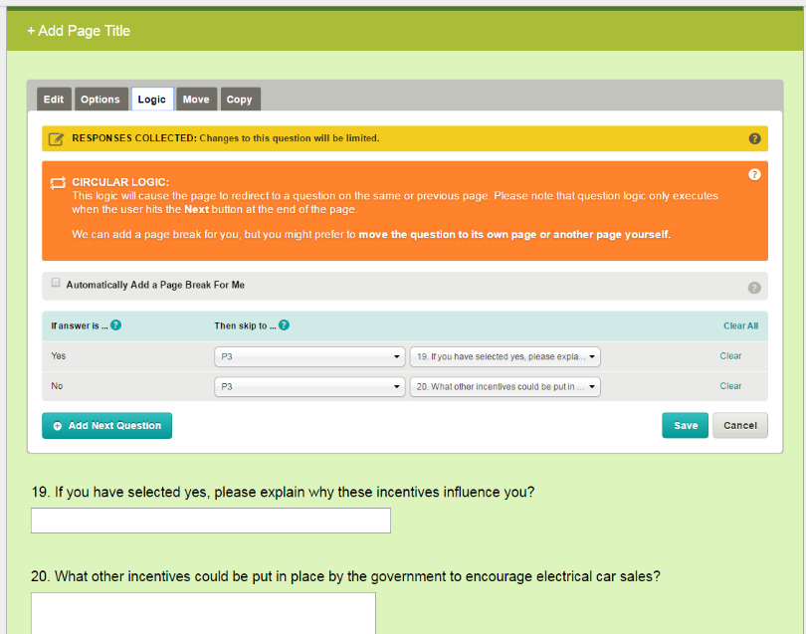
(2)
(3)
“The trouble is it's a chicken and egg situation - people want to use electric vehicles but they can't because the infrastructure's not there - and the infrastructures not going to be built until the demand is there," he said.
"I would like to see government recognising that it does need some grant and funding support for this - in order for anyone in Wales to make sufficient use of electric vehicles you've got to have charging points in rural areas as well”
“I think we need to look at ourselves as a country and ask what ten years will look like and what do we need to put in place. At the moment this is still a cottage industry - it's not at the infrastructure level."
"Some grown up chats need to take place.”
(4) Main Code Screenshots

Fix to WordPress CSS

Fixed and Final Homepage Code:

