BMSW6103

Leading and implementing workplace change

Change Management Portfolio

Shapali Khanam

1713884

Lecturer Nauman Ali



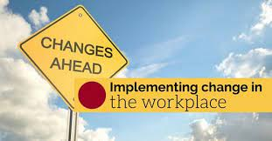

Contents

Introduction………………………………………………………………….Page 3
Organisational/Portfolio Information………………………………………Page 3-4
Current Position/Environmental sustainability…………………………...Page 5-6
Sonali Model Canvas……………………………………...........................Page 7
Swot Internal Analysis………………………………………………………Page 8
External Analysis PEST………………………………………………….....Page 8-13
Porters 5 Forces Model……………………………………………………..Page 13-14
Sonali Stakeholder Management………………………………… … ..Page 14-16
Sonali Power/Interest Matrix ……………………………………………….Page 16
Need for Change in Supply Chain Management…………………....Page 16-19
Examples of strategic change previously………………………...............Page 19
Change Management ……………………………………………………….Page 21
Transitional Curve……………………………………..............................Page 21
Value Based Strategy ……………………………………………………….Page 22
Sonali Strategic Matching Approach………………………………………. Page 22
Kotters Eight Step Change Plan………………………………………….....Page 22-26
Change Administration ……………………………………………………….Page 26
Leadership style for change………………….............................................Page 26
Sonali Organisational Structure ……………………….............................. Page 27
McKinsey 7S Model/Design ………………………………………………....Page 27-30
Development Cube…………………………………….................................Page 31-32
Organisational Culture…………………………………………………. ........Page 32
Culture Supports change objectives……………………….........................Page 33
Insights Organisational prospective…………………................................Page 33
Consultant prospective……………………................................................Page 34
References…………………………………………………………………. Page 35-39

Introduction

Sonali is a supermarket in the Retail Sector that sell Bangladeshi food products directly to customers and family-run business.

Limited company having three stores in UK. One in Manchester and two in Birmingham located in Lozells and Small Heath they are an importer, distributor and retailer of Bangladeshi products trading for the last five years.

Sonali provides products to the Asian Bangladeshi Community and restaurants
Providing local restaurants with supplies for their catering trade. One-stop-sho for Asian grocery.
Organisational Information

Sonali has website giving general oversight of products but public do not order online.

Sonali has Facebook account where they post current special offers to customers.

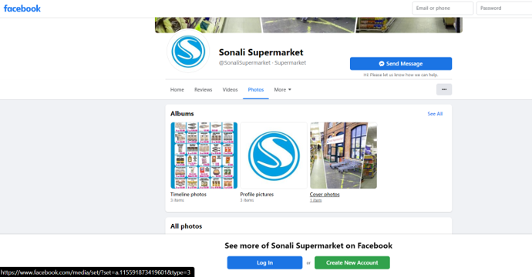

Sonali has Instagram account for Manchester store but not utilized this as no posts been made yet.

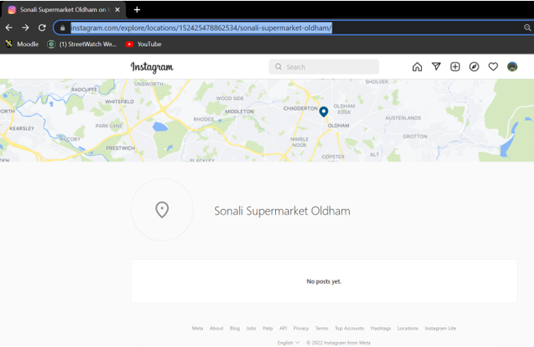

You Tube

Sonali have used platform to advertise Business products for public, created Bengali language advertisement receiving 17K views to create brand awareness and welcome vloggers to promote business e.g Hamzas World.

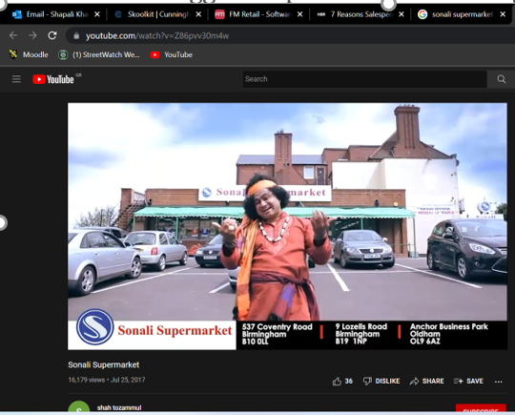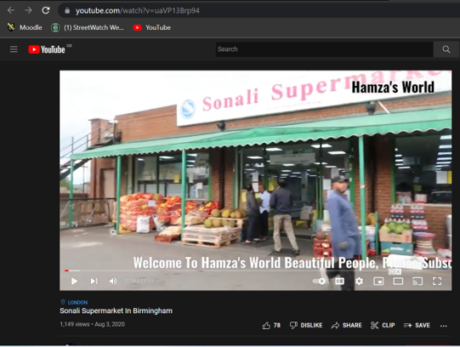

WhattsApp

Sonali use WhatsApp Social media on a daily basis to order products from suppliers and keep in contact with customers and promote special offers in-store.

Portfolio Information

Mc Kinsey article focused on how businesses were affected by COVID-19 and how they were forced to use digital transformation in their business operations to be efficient.

Portfolio will focus and analyse to resolve Sonali’s problem situation of wastage across the supply chain area after Covid-19.

Sonali objective is to be effective first to be efficient in its supply chain management function area. Creating a change management plan for improvements strategy will improve the survival of the stores. As this overall impacts brand building improvement towards customers and creating loyalty for repeat business. Enhancing the use of innovation and digital transformation in the process of change plan.

This portfolio will also analyse Sonali's current organisation position and external environment using models.

Analyse strategic change requirements and need for stakeholders management for brand building.

Create change management plan for Sonali supply chain management using Kotters eight-step model and highlighting the importance of change management using the transition Curve Model for Sonali.

Evaluating Sonali’s organisation structure, design using McKinsey 7 star model along with development cube and focusing on impact of culture towards change management.

Lastly, reflection on sonali's problem by an organisational and consultant prospective.

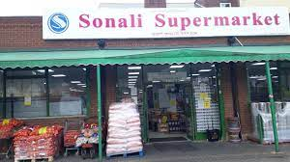

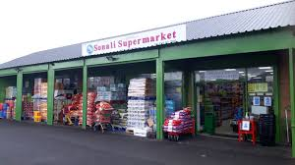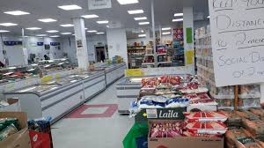

Sonali Current Position/Environmental sustainability

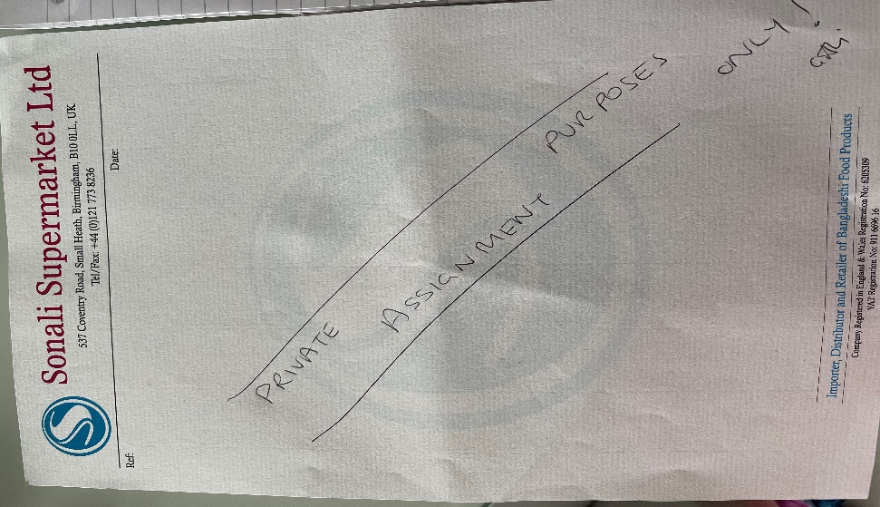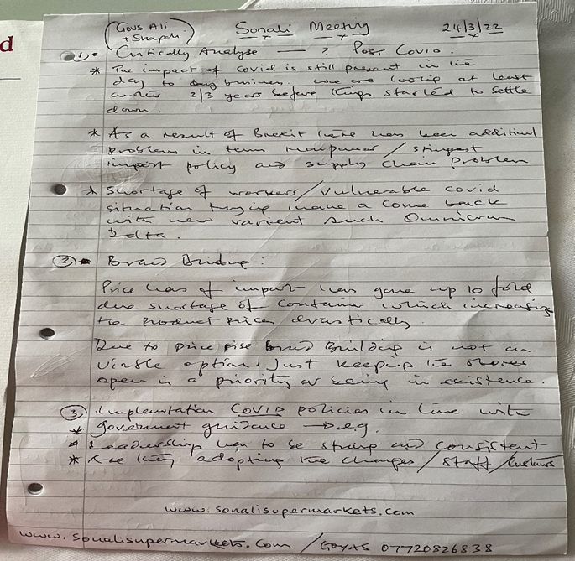

Charges 5p extra for plastic bags to customers to reduce Plastic wastage

Charity events Sales in stores to raise money Bangladesh and Palestine that creates loyalty.

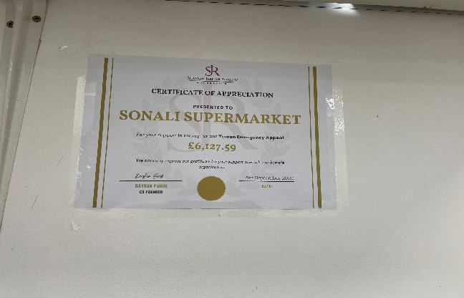

Recycle all cardboard and plastic using Council Commercial bin collection contract.

Currently dispose food that is out of date and not in good condition causing a lot of wastage and money. Sonali should decrease wastage by monitoring dates before out of date and vegetables losing freshness by reducing prices or having sales on items prior that will save on costs. This will benefit the landfill environment and business profits.

This year Sonali signed contracts to receive a monthly commission to help increase profits.

In-Post Delivery collection boxes outside stores

Ummah Charity Clothes Bank that their customers can also use

Sonali was short of money and used equity from mortgage so this is driving force of business change for survival and success.

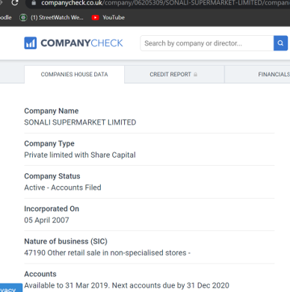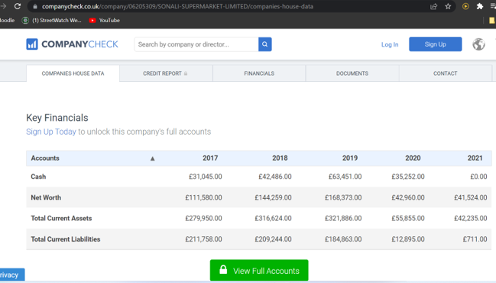

So trying to provide the customer a good service to the Bangladeshi community.

However, they need to concentrate on meeting customers’ needs at the right time. In essence, ensuring products are available for customers at the right price and quality.

Therefore concentrate on Sonali Supply Chain management a development approach for change for business survival goals for making profits and efficiency.

Sonali Model Canvas



B2C:Business to Customers providing Bangladeshi products to sell in-store to Asian customers.

B2B. Business to Business
Supply Bengali/Indian restaurants catering trade
Customer Segments
Predominantly 95%Bengali customers
Speak in Bengali and English Good friendly relationship with customers
Regular customers.
Google Reviews star rating 4*
Cleanliness Rating

What type of relationship do you have with your customers? How do you interact with customers and how does this differ amongst customer segments? Do you communicate frequently with your customers? How much support does your company provide?
Predominantly 95%Bengali customers
Speak in Bengali and English Good friendly relationship with customers
Regular customers.
Google Reviews star rating 4*
Cleanliness Rating

Providing quality, well priced various Bangladeshi Products to customers a one stop supermarket including daily household goods.
Customers can purchase in store or collect phone order or Home Delivery is available.

- Customers
- Restaurant Businesses custom
- Business Bank Loan
- Bangladeshi Exporter
- Government- Ltd registered company in UK
- UK People-recruit staff
- Leasehold contract

Sonali key partners in your supply chain.

Customer Relationships
Provide products that customers want and on time in stores.

Deliver orders on time and meet customer requirements.

Order products

Keep costs and prices low for customers and quality good.
Key Resources
Channels
Value Propositions
Key Activities

B2C:Business to Customers providing Bangladeshi products to sell in store to Asian customers.

B2B. Business to Business
Supply Bengali/Indian restaurants catering trade

Key Partners
Customer Segments




- People at stores to manage, stock and deliver.
- Stores for customers to purchase
- Management experience to run business
- Business Loan
- Delivery Vans and forklift
Advertise and serve customers
Face to Face in store
Website
FaceBook
WhattsApp
Instagram
YouTube







Profits from Business
Carpark monitored monthly commission
InPost Pacel monthly commission
Charity Clothes Bank monthly commission
Charity Events – customer awareness for
community
?
Revenue Streams

- Petrol
- Staff Wages
- Export Product price increases
- Rent

Cost Structure





SWOT Internal Analysis

Internal
 Strengths |  Weaknesses
- Good Work Culture  - Delivery Vans  - Good Customer Service and rapport  - Loyal customers  - Store Prices very competitive  - Footfall Good  - Location excellent Bengali Community  - Good range of stock  - Customer Carpark  - Staff Training provided | - Customers comprises of low-income families (Market Research Society 2022)  - Warehouse organised unwell  - Warehouse Space limited  - Once a year Stock Control  - Paper-based order system
External

 Opportunities |  Threats
Outsourcing Container Collections  Reduce environmental waste  Technology for stock control and order  New Bangladeshi Supplier in UK  New Bangladeshi Exporter | - Supermarket price competition  - Getir grocery delivery  - UN Environmental Sustainable Development Goals (2021)  - Inflation rose in February 5.5% from January 4.9%  - Energy Hikes hit low-income families  - Petrol Prices Increased

Organize stock resources more visible and accountable for correct ordering.

External Environment Analysis

PEST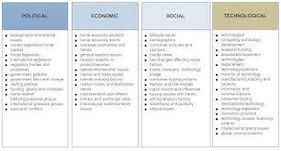

Political

Bangladesh imports have dropped during 2021 a decrease of 8.2% so Sonali need to locate better supplier or outsource in UK supplier options.

COVID-19 pandemic affecting still global trade as factories suppliers were closed during lockdowns, operating with fewer staff, disrupting trading and from post-Brexit.

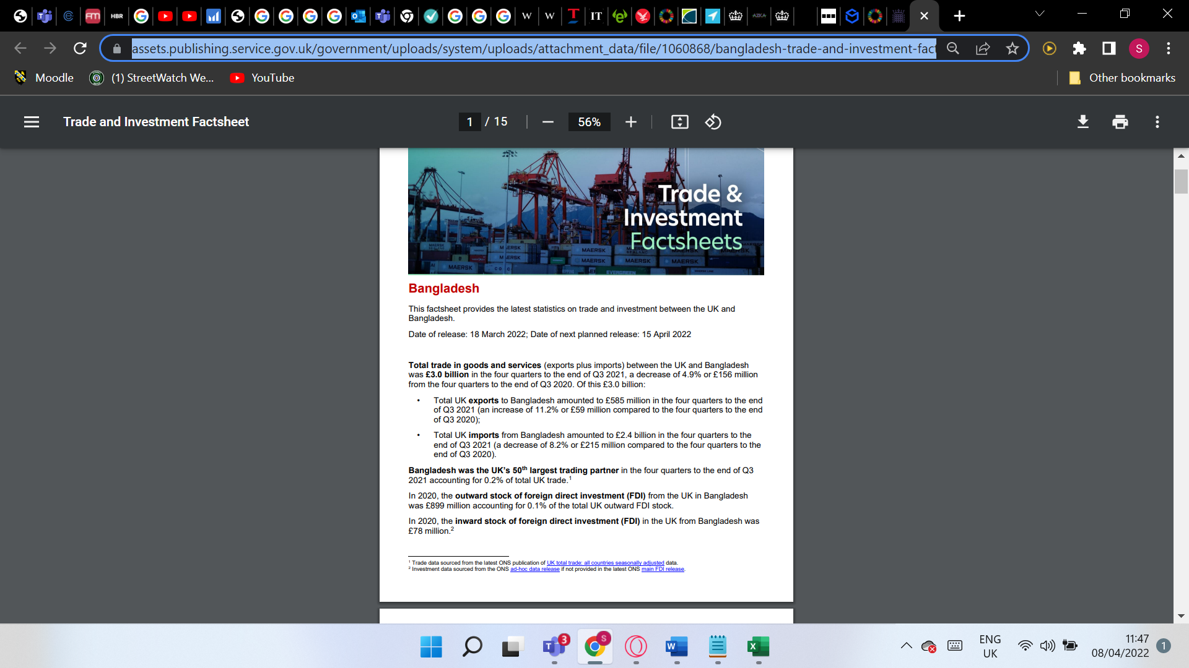

UK Parliament (2022) have discussed rise of costs, increased paperwork and delays in border UK companies since Brexit and new import rules.

National Insurance

threshold to £12,570 a year so employees don’t pay any income tax or national insurance below that so Sonali will pay an extra 1.25p in the pound over this threshold to employees that receive higher wages than this as Government will use for UK health & social care. However, Sonali have only two people per store have salary over threshold.

Economic

Interest Rates

Bank of England (2022) raised interest rates to 0.75% in March 2022 this will effect customer spending as they have less money to spend and effecting business equity increased on mortgage cutting down on business costs is high priority for Owner not to lose home and business to increase sales.

Petrol

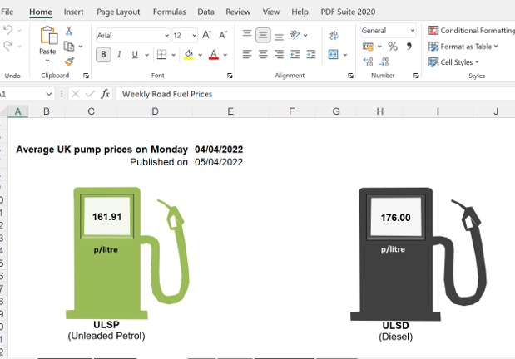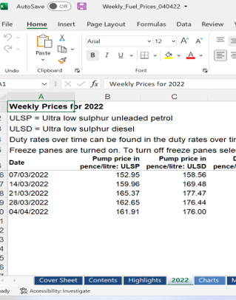

Sonali should contemplate using Azka to provide Bangladeshi products to help with supply chain Saving on fuel and inventory. They have stores in Birmingham and London and they can deliver all round the UK. They are a cash and carry of Bangladeshi products where they to import from Bangladesh.

Inflation

Office of National Statistics (2022) UK Inflation is highest ever at 5.5% Feb 2022 since 2012 causing cost of living to increase so Sonali needs to focus on tightening supply chain operations to save and to customers.

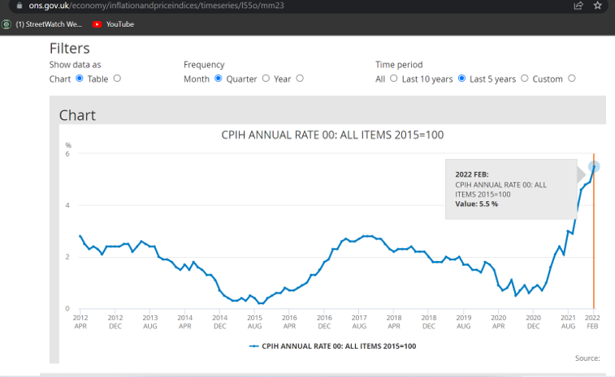

(Independent 2022) states UK customers are facing energy hikes so cutting down on supply chain petrol will be cost effective, by viewing delivery routes per day that’s more effecient.

Social
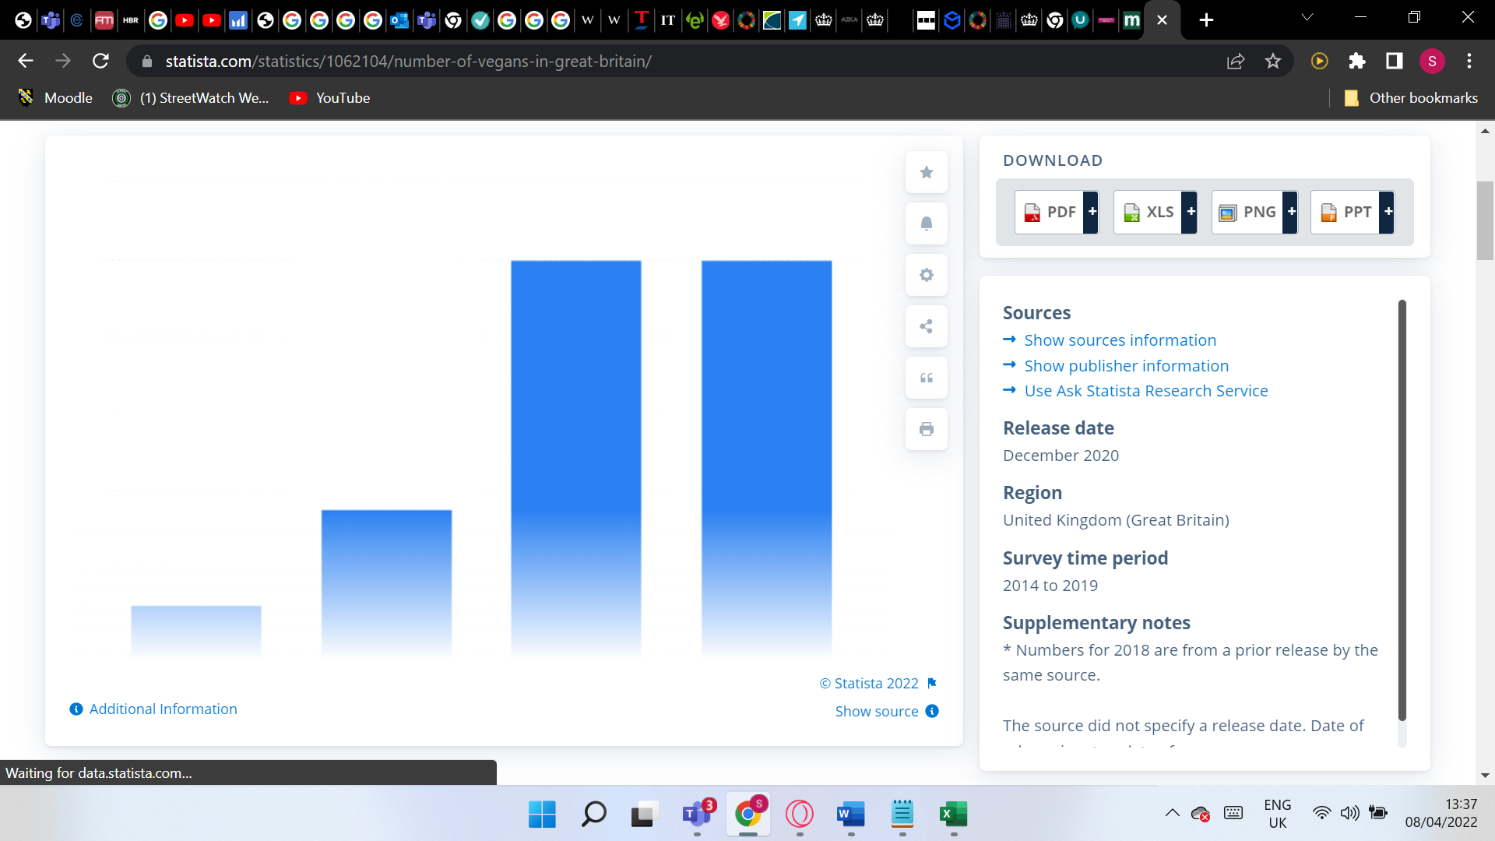

All stores are located where customers have low household income that is lower than UK average from Census 2011.

Rise in vegetarianism
The Number of vegans in UK between 2014-2019 quadrupled
(Statista 2019) survey barchart from 2014 shows a leap from 150,000 to 600,000 thousand in 2019. This is important for Sonali to ensure they have fresh vegetables and fruits daily as there is a need from customers who want better vegetarian products for health purposes.

Health

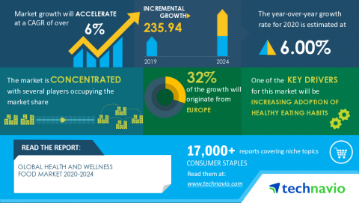
Technavio has announced its latest market research report titled Global Health and Wellness Market 2019-2023
LONDON Technavio recent report monitors health and wellness in UK food market and will increase CAGR of 6%.
Study focuses on growing need for vegetarian food as one of the prime reasons driving the health and wellness food market growth during the next few years and reduce healthcare-related savings.

Technology

Technology impacts speed, accuracy, and efficiency within the supply chain. By implementing new technology, supply chain managers are able to use more data, and other tools to make decisions faster, forecast demand more accurately, and prepare for unexpected events throughout the supply chain.

Customers are increasingly requiring good products meeting their expectations on fast accurate and reliable delivery.

Focusing on supply chain managment with technology advancements will boost efficiency through the supply chain and supporting Sonali Brand.
Self-Checkout

Customers using self-checkout for purchasing shopping saving time in ques, quick, and easy to use technology that many large supermarkets use that customers satisfied in using. The counters use less space than tills, and are faster

According sprintingretail study, 74% customers experienced difficulties in entering products where staff had to override. 59% of customers said if technology improved then would use it.

Sonali may not benefit due to the expense of purchasing and manning tills for shoplifting and issues and not busy all of the time like major supermarkets. As language barrier some Bengali customers may not be able to operate so still need tills.

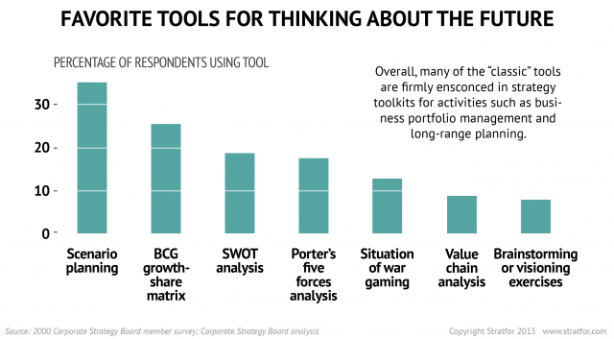
Porters 5 forces Model

Porter’s Five Forces Analysis for Sonali will measure its current competitive position in the grocery industry basing it on five forces but will focus only of the four main elements of the model.

Threat of New Entrants

Threat of a new Bangladeshi Supermarket is medium force as they have set up in two densely i populated Bengali areas of Birmingham and Manchester.
Starting up a new Bengali store will require a large amount of capital and competing with existing supermarkets on sales and marketing efforts. Having established bulk discounts and offers will prove difficult to contend with but some may take risk of opening.
Matching efficient staffing, management and distribution networks, operations and supply chains is difficult to compete without experience.

Bargaining Power of Customers

Sonali is trying to be a one stop shop to improve economies of scale to the local bengali asian customers. Hopefully customers have loyalty with the brand, however some supermarkets are providing limited bengali products within stores to compete e.g Bangla Station
Customers can choose to visit other stores but quality of products and variety of what Sonali provide might not be matched and normal goods are priced competitively that impacts profit margins so Sonali retains customers. So assume bargaining power of customers to be medium.

Bargaining Power of Suppliers:

Sonali has one major supplier that they import goods from Bangladesh e.g. frozen fish, vegetables and bengali food products. Have many suppliers also from the UK supplying Halal Meat and UK products. Thus, suppliers have low bargaining power, switching suppliers is not difficult as there are many suppliers and they are competing for Sonali Business when negotiating on best price and quality and range of products provided especially having other branches increasing margins on profits.

Intensity of Competitive Rivalry

Competitive rivalry a high force effecting Sonali business operations. There are many supermarkets but because Sonali is focused on Bengali community they are specialising in capturing their whole shopping at their stores. Supplying to restaurants is an added advantage they hold that assists business sales, than other supermarkets.
Competitors advertise well with offers on seasonal and events like Ramadan. So, Sonali does advertise instore and on social media like Facebook. Attracting customers to special offers with prices being low.
Having robust supply-chains and logistics can help to reduce costs on products which is an area that major supermarkets like Tesco, Lidl rely on.
(Arup 2019) report statistic of only 8% of believe they operate truly agile supply chains that can quickly respond to a disruption like Covid-19 and 51% of businesses do not assess their firm’s competitiveness based on technology and R&D innovation in the supply chain.
To conclude there are many factors that impact Sonali competitive environment. Using this model assists in understanding evaluating external business factors that can effect Sonali and how they can change.

Sonali Stakeholder Management

KEY | Internal stakeholders | KEY | External stakeholders
 | Employees |  | Suppliers
 | Managers |  | Customers
 | Managing Director |  | Bank
 |  |  | Competitors
 |  |  | Council
 |  |  | Government

Internal stakeholders are those who have an influence within the grocery store.
The main internal stakeholders are employees for Sonali to operate. Employees influence the brand image of Sonali as they assist smooth store running daily and are the main face for the business. Responsible for meeting objectives of sonali. Efficient staff creates good customer relationships helping reputation of sonali and repeat business that increases profits. They are the vital stakeholder for business success.
Managing Director responsible for financial control to meet goals and objectives to maximise profits and running of Sonali and also employs all the staff ensuring they are motivated to become efficient.
Manager responsible for achieving objectives of the stores that owner has set ensuring employee relationships are good and that they are working effectively.
They purchase products from suppliers that are quality, well priced and delivered into stores at the right time for customer demands to achieve more sales and increase profits.
Managers provide induction and training for employees like Health & Safety Training for butcher and fish counter and Till operation system too.
External stakeholders are those outside Sonali that have an influence
Suppliers; are important for Sonali forms first part of the supply chain and provide goods to Sonali for their customers. Bangladesh manufacturer supplier completes Sonali orders and shipped or by air cargo to UK containers and collected by Sonali for their stores.
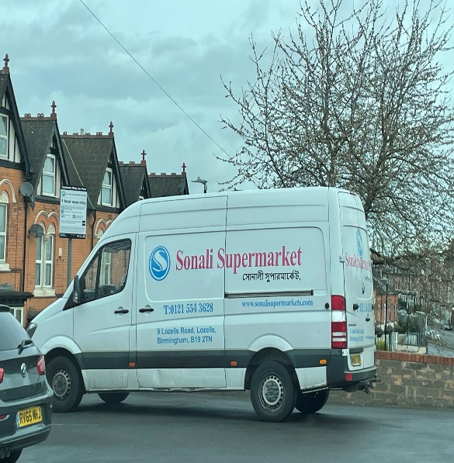
Sonali's major supplier has huge influence as it provides approximately 85% of the goods.
General UK Suppliers attend store weekly and replenish stock if empty. Having stocked items important for customers otherwise they will go elsewhere.
Council; Recycle Bins contract and business rates and health and safety checks paid to them. So meet environmental and health and safety laws otherwise business could incur fines or close down.
Bank: Need to ensure that business can pay off their debts with monthly payments. So they have used home as asset if business is not successful. Sonali really need to ensure business is striving and make changes to supply chain to save and compete otherwise homes could be lost by repossession.
Competitors: knowing what competitors are supplying and prices they can try to be competitive which attracts customers. Main competitor is Bangla Station in Lozells.
Government
(The National Minimum wage,2022) rates increased on 1 April to £9.50 an increase of 6.6% that need to be altered with all Sonali staff wages.
National Insurance contributions increased by 1.25% that needs to be applied for government health and social care.
If not implemented staff may go to seek unions or business receives fine so Government has high influence
Customer Stakeholders want Sonali to do well as customers want to have the best possible product and service otherwise, they will not revisit and lose custom and are core for future business.
Competitors put pressure on pricing competitively to gain customers.
Stakeholders are important for Sonali for their existence as company to function and survive.

Sonali Power/Interest Matrix
This identifies importance of stakeholder communication strategy for change management showing how they influence Sonali business and in what capacities.

Power (Decision Making) | High | Actively Consult | Regularly Engage
Power (Decision Making) | Low | Keep Informed | Maintain Interest
 |  | Low | High
 |  | Influence

Need for Change in Supply Chain Management

Currently Sonali needs to focus on their whole supply chain management to see whether they can make it effective to be efficient as a business for survival.
Akin et,al (2022) meta-analysis found a significant positive relationship between supply chain and innovation performance with financial performance.
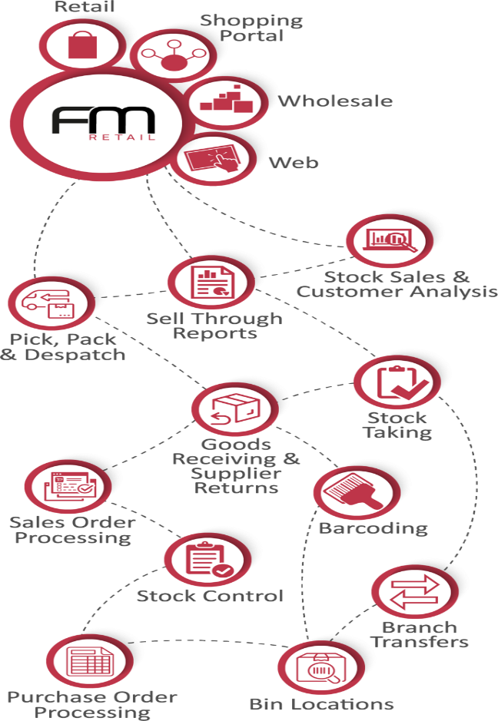
Savings can be made on Labor and leaner processes of operations within their supply chain.
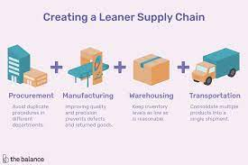
Implementing change in this function area can have positive effect on competitive edge on prices, reducing food waste, time, savings on fuel and labor costs.
Having time to review business processes and encouraging change is worthwhile creating new ideas through brainstorming, innovation, new systems and technology, develop employee skills leading to better staff morale and opportunity to be efficient.
Sales are plummeting between 5-9% last year and need to be increased Mr
Sonali currently has one supplier from Bangladesh
each store separately orders containers from Bangladesh and then delivered to store
Telephone orders are delivered to customers within 2-3 days which is long waiting time that needs to be reduced.
Orders from restaurant and customer are 95% of the time fulfilled mainly due to shortages or errors when taking telephone orders. Not to have disgruntled customers, as they may voice to other potential customers and reputation tarnished as I find words spreads like fire.
No stock or shortage to fulfill orders - Birmingham branches to swap and invoice ensure orders fulfillment and happy customers
Suppliers only order if shelf emptied – should no which products are fast moving and slow moving and ensure that they are stocked.
Warehouse is unorganised and take time to find items
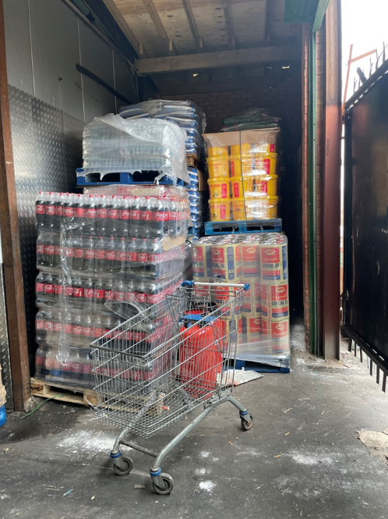
no electronic inventory of stock – only count stock once a year for account purposes, just visual and memory check.
No key performace indicators for continious improvement
Reduce food waste out of date stock, or vegetables defects – pur on sale before products not able to sell. unsold food redistributed in the UK to local charity food banks,
The above should be looked at further to reduce costs in supply chain. Centralising the stock into one system for all three stores will be beneficial.

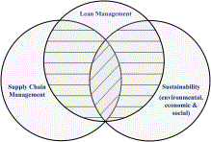

Lean Management, Supply Chain Management and Sustainability

(Martínez-Jurado and Moyano-Fuentes, 2014) literature review identifies the positive connection of the supply chain management to business sustainability assisting the environmental and economic and social for the business survival honing on lean management model of continious improvement in entire supply chain work process.

Examples of strategic change previously
- Covid-19 EPOS Till Training
During COVID-19 the supermarket tills desks were busy with long ques and shortage of cashier’s staff due to illness, cover breaks etc. so it was decided by management that everybody on the shop floor should know how to use the EPOS till system and assist cashier's with bagging customer purchases too. So that customers experience was pleasant with quick and efficient service.
Managers conducted EPOS system Training for all staff within two days after shop closed. This created an increase in staff morale as learnt a new skill and working as a team.
- Food Hygiene Rating Scheme
This popular scheme assists customers where to shop for food and eat. Local authority environmental health officers inspect and provide rating for Sonali hygiene standards. Sonali created Health & Safety Policy and procedure of Food Safety System, showing they can create professional strategys.
Sonali received in 2018 a low rating 2 improvement necessary but then changed it around in 2019 with a top score of 5 very good hygiene standards. This outcome turn around in a short amount of space shows the dedication of Sonali workforce. When put under pressure they want to succeed for the business.
Process of change involved management communicating in meetings to staff the importance of this rating for customers and developing a rota of cleaning shop floor regularly and fairly by all staff in their areas of work e.g. Butchery and Fish section were cleaned by staff three times a day and everyone required to complete a cleaning rota on a daily basis showing Qualitative information for monitoring purposes with a quantitative outcome of measure from health officers.

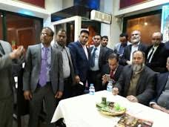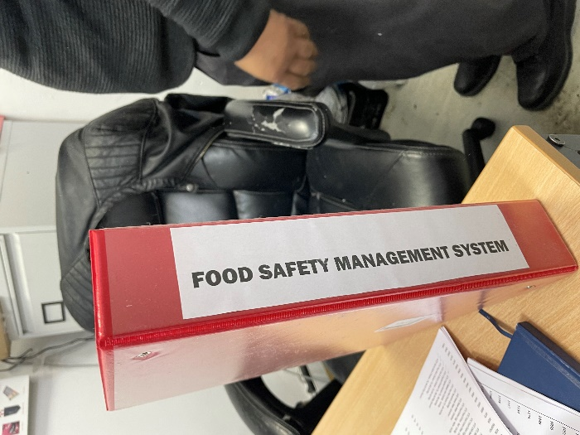
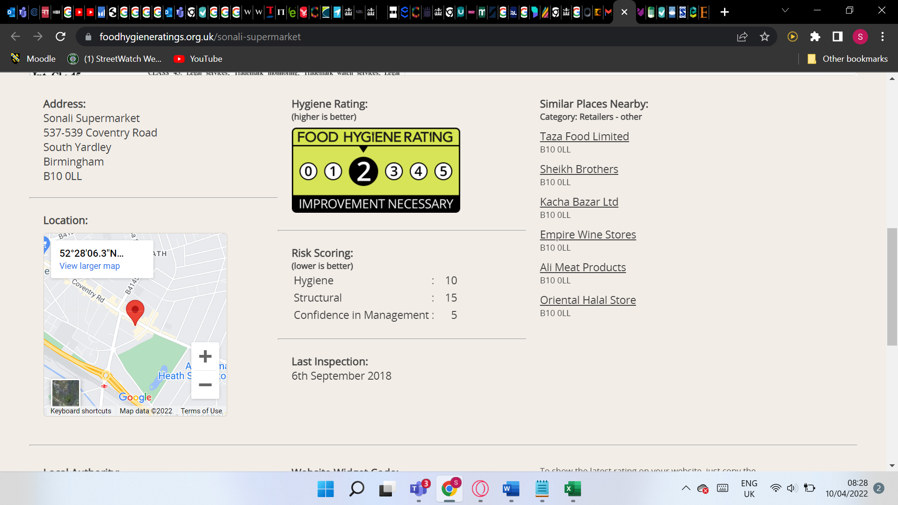

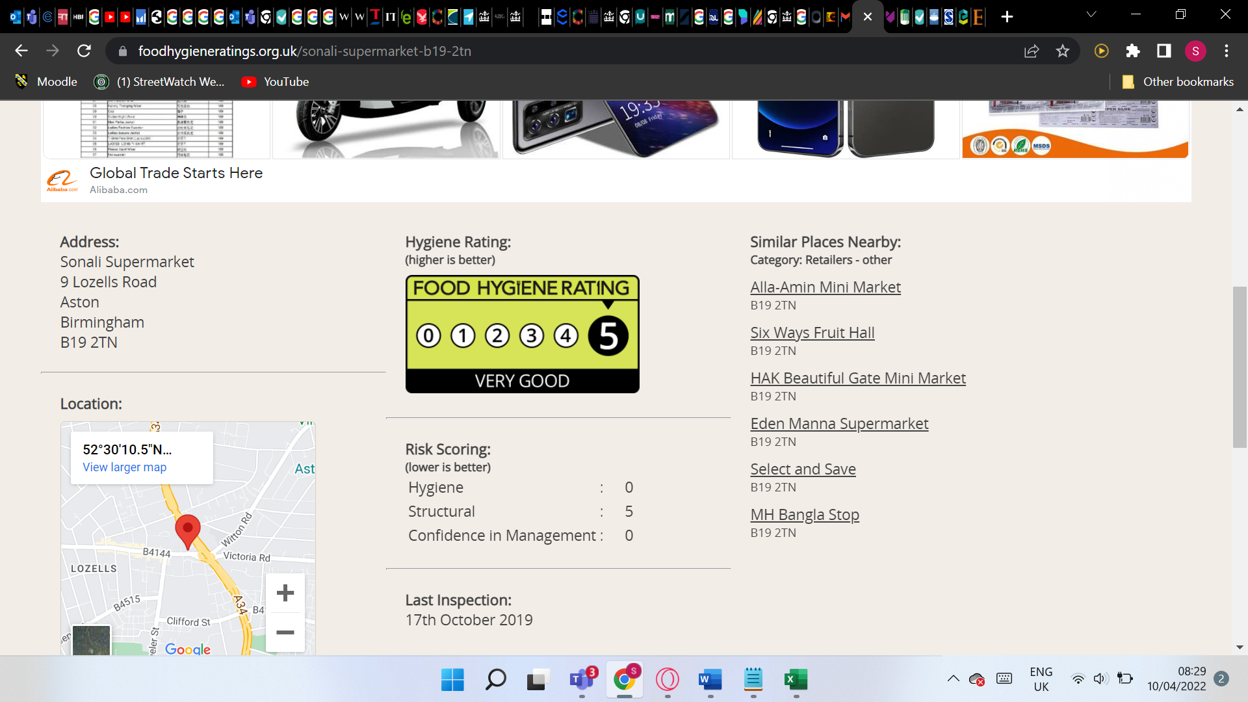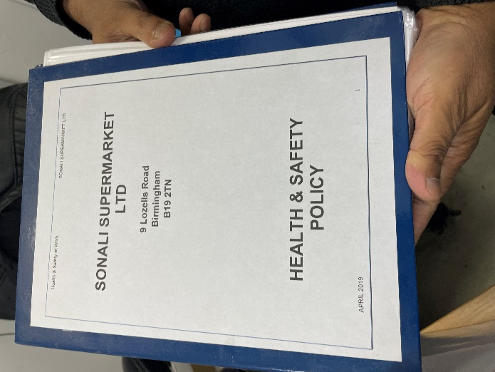
Both changes come under organisation development approach required input from all staff involvement, had initial team meetings to discuss issue and progression from problem. Discussing and involving feedback on developing new process and achieving aim.

Change Management
Modular transformation necessitating a major change in the supply chain management function area of Sonali.

Transitional Curve
Transitional curve a common model to understand an employees transition through organisational change.

Aim to quicken the change and increase the success. A major barrier to change is Humanistic and need to address this responsibly for staff to adapt to change and make process happen easier.
Staff will move through four transitional stages upon the organisational change.
Sonali management will need to be aware of these for the investment system and process to be successful after training and not resort to previous ways of working for improvements to be fruitful

1) Denial-When faced with new introduction of the change staff may reject to accept change and convince co-workers to do the same.
Deal with this by managers communicating clearly and give staff time to adjust and providing information to understand fully and how they will be supported. Having regular meetings to communicate and discuss, answer issues and feedback will alleviate this and not get them overwhelmed.
2) Resistance-staff may resist organizational change by expressing or even hidden. so its critical for managers to listen and observe staff within the team otherwise it could be a disaster making It harder to progress. Excellent planning and preparation to minimize and diminish problems that staff may have and persuasive skills for a better future will aid a smoother change.
3) Exploration-having team meetings about current supply chain problems with staff being part of the system will create positivity and growing acceptance. Guidance on the change and offering training will help good outcome.
4) Commitment-Managing the change successfully is an accomplishment when people are all committed to meeting the company aims and objective of change. Staff adopt the new improvements of way of working, and business moves forward through the benefits. Celebrating the journey by providing rewards and praising staff will make future changes easier and staff adapt to becoming more productive and efficient.
Management role is to guide and help support staff through identifying using transitional curve phase Model people are in successfully as every staff is different. Communication and listening skills are vital once everyone is on board is when changes happen and performance excels.

Value Based Strategy
A dynamic and progressive value-based approach to systems change at Sonali and communicate it striving to build capacity to achieve and sustain a new desired state that benefits Sonali customers and community with great service and well-priced products. Re-evaluating Sonali’s right pricing strategy to maximise profits.
Lean management approach focuses on increasing customer value, the removal of waste and optimising operations to reduce costs and provide value to customer.
Lean thinking provides improved value for the customer by: Reducing costs and lead time, Refining work processes and simply flow and decreasing errors that improves staff morale.

Sonali Strategic Matching Approach
Verma (2012) Porter developed matching approach for HR strategic in three areas.
Cost reduction - Use best employees Manager and Assistant Manager and warehouse staff to carry out process of delivering new centralised stock database incorporating all three stores. Secondary activity of supply chain to be carried out in store to minimise costs and develop employee skills and job satisfaction.

Innovation - Cunningham company can provide new software system digital technology and linked with EPOS and support with training on using software system to meet requirements of Sonali and workforce developing advantage from competitors.
Quality - success of strategy achieved by maintaining a standard of quality advanced to that of competitors.
With this system Sonali will be able to enhance competitiveness by lowering the prices of products where it can now clearly view on the system per product. Showing profit margins for each product and quantity in stock. Helps to analyse and compare to increase competitiveness by using innovation to improving processes to decrease their costs.

Kotters Eight Step Change Plan
Sonali required to adjust to it's ever changing internal and environment to grow and survive in the sector. Changes are unavoidable and the use of technology are rising, and the inevitable competition involves constant change.
(Appelbaum, Habashy, Malo and Shafiq, 2012) Research shows that failed business change initiatives range from 30%- 80% of attempted change efforts if not successfully managed main reasons were it led to conflict and interrupted status quo so its not easy to implement.
A common framework for overcoming change challenges that Sonali can successfully use is Kotters 8 step change plan ensuring Sonali is ready and committed to the change.
- Creating a Sense of Urgency by Managing Director- Sonali should have meetings with management and employees to state that business needs to grow and an area for change is in the supply chain management function. Everything is done on paperwork and phone calls and their have been errors and time for processes is too long so need to be addressed.

Organise staff meetings with managers and employees to highlight the change

Increase Sales as plummeted by 5-9%
Show sales and profit loss charts financial accounts
Keep customers happy for repeat custom meet all order requests
State need to become more efficient by being effective in work practices need cooperation
Clarify no redundancies scare but future survival of business is with commitment and effort by employees.
Decreasing food wastage to save money

Input (Work/Culture/Structure/People) + Process (Task/system) = Output(customer/brand high)
Introduce a central database system for all three stores using Cunnighams Group Software System for supply chain.
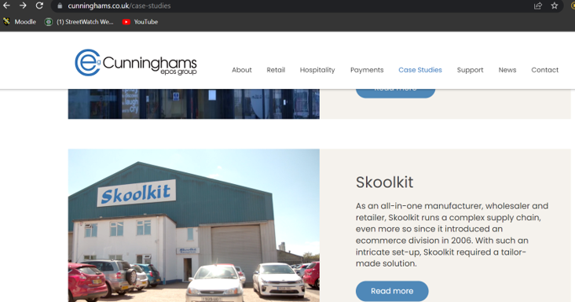
System will hold;
Orders placed with suppliers and from Customers B2C and Businesses B2B to system then handwritten reducing errors. Choose staff full usage and partial for security.
Stock received by suppliers and stock sold out to customers by linking new system to EPOS
Warehouse Inventory for all three and warehouse to be organised better
Better pricing and profit margin analysis view of all products
Less food wastage as sales can be added
Cooperating information for all three stores to enable best practices and unity of processes on central software system.
Fulfill all customer and business orders by using stock from other stores and improve delivery times within one to two days.
Ensure enough stock to meet customer needs and eliminating wastage of products out of date and unpopular items can be analysed on system into category of customer needs, high medium and low products.
Which will give true figure on sales for account purposes

Propose order limit of £50 to cover operational costs then £10

Ascertain a second supplier abroad and UK for competitive price on products
Saving time and becoming efficient in work processes.
Analysing products that are doing well or not creating new customer experiences as purchasing items that customer needs increasing satisfaction and boosting sales.
Fulfill orders first time then 90%

All communicating functions working together in harmony otherwise wont work.

(Airiodion, 2022) article John Kotter stated 50% of companies fail due to failure to create a great sense of urgency so this is important step to get majority of people to support change.
- Create Coalition
Creating group of powerful people that will drive the change encompassing great leadership skills including employees to move in positive direction maintaining urgency. Director, Manager, Assistant Manager along with warehouse employee as he has vast experience of warehouse, goods and delivery process would be key and Cunninghams systems representative. Having shared understanding of the need for change working together to get optimal results. Sonali produce policy and procedure of new supply chain process.

- Developing Vision and Strategies

Need to have a clear realistic vision and easily measured for what the end result will be and develop useful strategies to achieve changes. As it will guide and inspire decisions made by team.
Having a meeting and accepting ideas from stakeholders when creating vision and communicated and understood easily by everyone creates willingness to move with vision.
Showing Cunnighams system, and new warehouse layout and financial forecasts data, Bengali food trends and delivery flow processes will help establish vision.

- Communicating the Change Vision
Focusing on effectively communicating the vision and mission of the tasks will greatly assist in persuading employees understanding by Managing directors decision for change and what behavior is expected openly and honestly.

This needs to be done properly by answering questions thoroughly from stakeholders so they acknowledge and support change and worthwhile.

Having regular meetings for feedback for stakeholder to voice concerns, confusion and problem solve on plan. Also communicating in staff meetings, letters, emails and preparing new policies for new procedures for key stakeholders. Communicating in Bengali language aswell will help understanding too, as 90% staff Bengali.

- Remove Barriers to Action
Sonali management needs to be aware of obstacles to the change in the forms of attitudes becoming ready to remove these obstacles for the change to progress smoothly.
Lack of team spirit and leadership, fear of redundancies, resistance to change by employees, inflexible work culture. If any of these are revealed it needs to be rectified quickly by open communication and one to one meetings and coalition working as team to help co-workers.
Having a reward systems like staff recognition board, praising showing employees implementing the change will encourage and empower employees to work at the best of ability and provide staff training on system and processes.
If staff don’t trust or think more workloads can be demotivating by communicating efficiency and way of work.
- Accomplish Short-Term Wins
Having regular celebration of identification of peoples milestones in the short-term is important so effort can be progressive and encouraging and not fail in the urgency of matter as transformation may take time.

Sonali can breakdown the change in smaller parts with goals and acknowledging efforts and rewarding employees that will then encourage other employees.

7.Build on the Change

Ensuring sustainability of the implementation of change from employees working consistently and measuring progress. Identifying problems and how to improve them along the way as quick change leads to failure.

8.Make Change Stick
Goal here is to anchor down the new way of doing things for the change You need processes systems and rewards. Everyone is working to the new processes highlighted in step one and embracing them in the positive work culture Showing benefits and employee and business growth. Avoiding this step will allow people to go back to the habits and may lead to resistance.

Change Administration
Change effects all levels and starts from strategic goals set by Managing Director and then moves to Tactical via managers and through to last level functional operation. To establish change development hierarchy of communication on these three levels is important where there are three lines of communication that needs to be established horizontal, diagonal and vertical. But having a flat structure in the hierarchy is better and informal where staff are sharing common interest and work in harmony with managers to diminish issues.
Organisation design is important for the change management because all activities must work in cohesion of all business activities to avoid problems need to work in harmony to meet business objectives. Staff are in a learning culture and adapt to change well as they want business to succeed.

Leadership style for change
Adopting a democratic style of leadership will be beneficial for smooth workplace change allows for two way communication encouraging ideas but decision making can be slow and not effective if employees are unskilled or uneducated so therefore may need to use Autocratic to lead some people that require clear direction and instructions.
Establishing a culture at Sonali where work change is being planned and incremental in nature is important and sustainability of change.
(Ismaila Akinbode and Ali Al Shuhumi, 2018) Transformational leadership has been praised widely when it comes to change management within businesses. It assists with decreasing resistance to change mainly from employees that can hinder the effectiveness and sustainability of the workplace change. Which can be devastating if change is needed for survival.
Transformational leaders can positively inspire employees to excel with passion and provide support trust and confidence for meeting business mission and aims during each stage of the change process therefore less resistance. Instilling a continual better work culture for people be
Another leadership approach which would be best option is situational based leadership combining different leadership styles with skills to switch appropriate to situation depending on situation faced helps the flexibility and adaptableness required to effectively communicating and support change at Sonali.

Sonali Organisational Structure - Lozells and Small Heath Oldham Stores

Managing Director

Manager
Assistant Manager

Meat & Fish Department
Warehouse/Van Operatives
Vegetables Department
Catering Supply Department
Grocery Department
Cashiers

Sonali has a functional structure consisting of 24 people at each store managed by high level managers at top and then staff organised accordingly in function skill area of store and managed and supported independently by Manager and Assistant Manager.
Allowing employees to concentrate on their role of expertise but can cause silos hindering communication However Sonali Managers supervise and ensures procedures and processes are met and have trust in employees too.
Structure has accountability to managers and communication is free as managers are approachable. With the change programme having a whole company team meeting to discuss ideas of supply chain would show unity in establishment and create strategies that work. Assists in productivity on various functions for success, decision making quicker and cost savings reduced.

Sonali Design McKinsey 7S Model

Mukhamad (2020) stated organisations benefit the use of McKinsey 7 star model of design developed by Tom Peters and Robert Waterman in 1980’s encompasing 7 interconnected elements that need to align to reach goals of effective change.

Helpful for management in identifying problems in the design of Sonali for way of working, organisational structure culture and the staff to overcome in developing smooth change at Sonali supply chain..

Structure(Aligned)as above works well in store as everyone is part of the design through communication daily.

Strategy(Aligned)

Mwirigi (2017) study showed strategy is very important for competitive advantage within the Grocery Sector, having new-digital technology systems for effective strategy in procedures and policy in order to provide customers with good quality products increased customer sales and profits within supply chain analysis.

Systems(Aligned)

Incorporating the new system of ordering/stock database will allow Sonali to function smoothly if updated correctly everyday. It can calculate cost serve formulae for each product on profit margins ensuring that it is value for money for customer and Sonali.

Can be linked with EPOS system for accurate sales and end of store visual of stock per store aiding delivery and topping off customer order fulfilment saving time and good customer service.
Ensuring ordering what is required for store to elimnate wastage and over ordering.

Investing in system is a risk but puts control with digital transformation providing insights on products selling or not, control on promotions and breakeven point of sales for business.
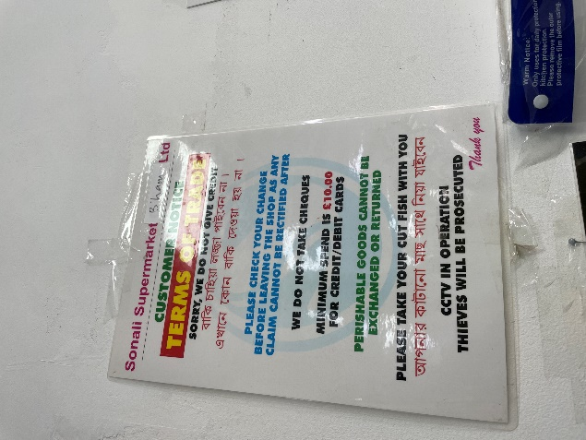

Style(Aligned)

Currently sonali's store managers have democratic style of leadership having a good rapport with all employees with respect and majority of staff hav been working since start of opening showing job satisfaction. Manager is seen to be fair, directs and delegates work with clear instructions for work flows.

Holds open door policy with all staff and problems solved instantly and work ethic is good which will help change move faster.
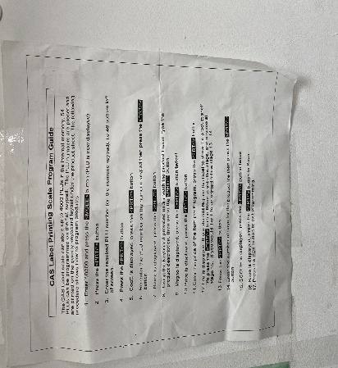

Staff(Aligned)

Employees wear no uniform having one would be advantagoues to help identify for customers if they need assistance. It also shows branding and symbolise unity instore and delivery of goods.

Managing Director employs white collared managers and sales assistants and blue collared like van driver and butchery that is suffecient for the store to run. All the job activites help the store to run successfully.

Skills(Slightly Aligned)

Employees have the various skills and conscientiousness to train in the new digital transformation system for the store.
Management want change to happen to be efficient and is driven to invest in this supply chain improvements to develop brand and increase customer loyalty.

Employees have the relevant qualifications and training and ability to do their job at a good standard. Any training willl be provided if needed to develop skills.

Employees communicate excellently with customers speaking Bengali to 95% of their customer base.

Shared Values(Aligned)

Store has no written mission or vision statement, but managers behaviour and vocalising importance during staff induction stating behaviours and attitudes for serving customers well and job roles carried out to best of ability. Having a wriiten mission and vision be beneficial for change so ingrained in staff minds and motivate to change.

Development Cube
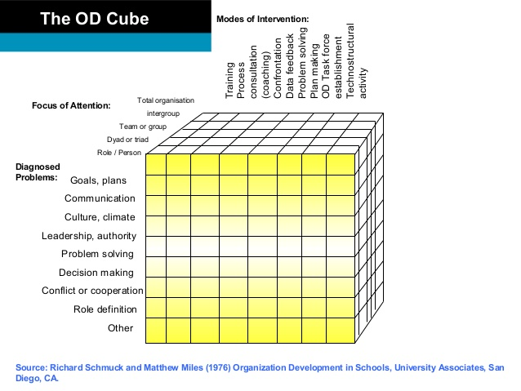
Organization design 3 phases Sonali should use

Diagnostic this is the exploring phase of the supply chain from start to finish. finding the current position, understanding the situation collecting quantitative from supplier costs I'm qualitative from cunninghams on how system will enhance strategy gathering primary data from current written information on policies and secondary data from, information, knowledge to support action planning of change.

Intervention need to be consistent in the whole planned process to gain positive outcome for overall effectiveness. Having a development approach to support the system in these 3 areas to understand change facilitations.
- Modes of intervention- providing training, meetings for problems solving and feedback on process change.
- Focus of attention-focusing on everyone who is apart of the supply chain system.
- Diagnosed problems-eliminate any problems arising with understanding and rectify with teamworking.

Evaluation
Setting key performance indicators will help to see supply chain change is working.

- Order entry accuracy % on system. from phone order
- Measuring inventory availability% – to see if we have stock to fulfill customer order
- Warehouse-DIFOT% (delivered in full on time) to customers so order is picked packed and ready for dispatch and accurate for van drivers to deliver.
- Carrier delivers from Port/Plan %-may need to shop around for other companies
- Customer Acceptance of order %-amount of customer that are happy with order or not and all paperwork is correct.
- Accurate Invoice Paid on time %-are invoices getting paid from B2B as B2C is paid before delivery.
Multiply all figures to get perfect order probability, to see that process is efficient.

Organisational Culture

Role of culture in organisational learning

How culture is applied makes the difference in tasks for supply chain change, otherwise will be scattered job not done properly.

(Alas and Vadi, 2006) Empirical research shows positive impact of good organisational culture influencing oranisational learning and employee attitudes toward change – task orientation and relationship orientation – have a different impact on the formation of attitudes toward change and organisational learning.

Staff meet customers with islamic greeting sometimes, this could be changed to a company wide showing respect to customers.
All stores layout are very similar setup using the same colour schemes of green and red of bangladeshi flag.
No dress code but would benefit customers identifying staff more easily quick enquiry.
Stories of charity events are displayed in till area raising funds for local community mosques.
Staff at Sonali are hardworking and support by teamworking. Cultures facilitate the variables, and they need to adjust itself as surrounding attitudes change which they accommodate.

How culture supports in acheiving the change objectives

This shows for change to be progressing smoothly Sonali should strive to ensure culture and structure both working in harmony together for Supply chain change objectives.

Berg (2004) Organisational culture are shared experiences, knowledge and capability of company work practices. Study showed organisational culture is foundation for business to establish work efficiency, customer satisfaction, growth and any imbalance of elements effect business negatively.

Organisational culture forms the connection that holds organisation together, stimulating employee and group behaviour and attitudes to commit to organisation to excel performance.

Sonali organizational structure people should all be involved and having a supportive work culture helps process of implementation supply change efficiency.

Sonali adopting these changes throughout their structure and satisfying customers providing value-based strategy and hopefully the growth that Sonali requires to survive in the ever-changing environment with harnessing culture. Adjusting resources and way of working, talent of labour, accountability, delegation of tasks in departments reaching empowerment of meeting goals and objectives for successful implementation of supply chain change.
Insights Organisational prospective
Have learned that to meet goals for success requires a whole organizational team effort. Consisting of specifying goals for the vision breaking it down into objectives as the whole process can take a year to implement fully.
Making supply chain lean is beneficial for Sonali to save on cost, build brand building for the service that they provide from gaining excellent customer experience in the whole chain.
Allowing time for looking at whole process of supply chain change is recommended for improving the business design and culture and can slowly be expanded to other functional areas within the business.
(Cameron, 2012, p.373) Research revealed strong link of level of competencies to business success with deploying IT to support strategy and work processes.
Having the motivation and commitment of seeing the change through is vital for success.
Removing issues and problems along the way of the wise they effect the journey of change afterwards.
Supply Chain change is a systematic process and needs to follow all the sequences using Kotters 8 step process for change and understanding and implementing thoroughly is key.
Having a plan of action that can be measured it's helpful in reaching results for true success of the implementation of change.
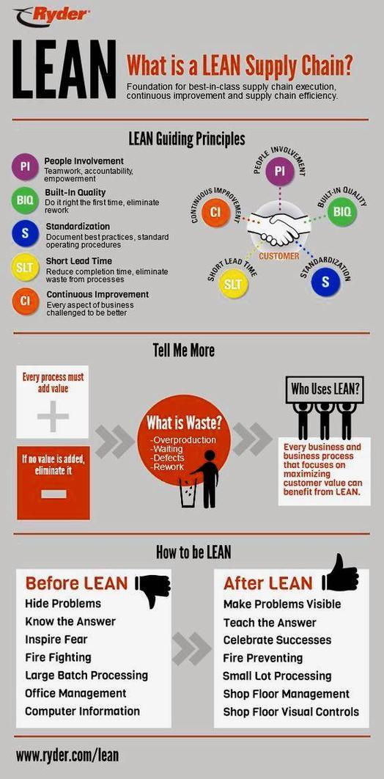
Consultant prospective
Having the right software for the system that Cunninghams will provide as they specialise in this already supply their epos system that can also be linked.
Employing the right people helps with tasks to be efficient as they have the correct knowledge, understanding and skills to progress for job in hand.
Meeting the requirements and objectives for Sonali to improve in areas for making the supply chain cost effective by using the lean model.
Having weekly team meetings with all employees well Gauge how well organization is working and communicating as a team to resolve problems.
Sonali developing a firm strategy can improve upon written policies and procedures for the supply chain it's currently there isn't a formal one in place. this can be done as there is folder on health and safety which met health and safety officers approval. so they have the means and experience to create one.
Being stuck in a way of working and not changing and spending time to create and develop written policy/procedures is just going to waste time resources and meeting customer requirements for quality, cost effectiveness of products that create brand building and survival.

References

Airiodion.com. 2022. Is John Kotter’s 8-Step Change Model Still Relevant? Is It Worth Using? Pros & Cons – Airiodion (AGS). [online] Available at: https://www.airiodion.com/john-kotter-change-model/[Accessed: 9th March 2022].
Alas, R. and Vadi, M., 2006. The impact of organisational culture on organisational learning and attitudes concerning change from an institutional perspective. International Journal of Strategic Change Management, 1(1/2), p.155. Available at:https://www.researchgate.net/publication/228617391 (Accessed: 12th March 2022)

Ali,G. (2022) Conversation Meeting Sonali Managing Director, 2nd March

Appelbaum, S., Habashy, S., Malo, J. and Shafiq, H., 2012. Back to the future: revisiting Kotter's 1996 change model. Journal of Management Development, 31(8), pp.764-782.Available at: https://www.researchgate.net/publication/242339672 (Accessed: 12th March 2022)

Arup.com. 2022. [online] Available at: <https://www.arup.com/-/media/arup/files/publications/f/understanding-uk-grocery-supply-chain-resilience.pdf> [Accessed 15 March 2022].

Assets.publishing.service.gov.uk. 2022. [online] Available at:

https://assets.publishing.service.gov.uk/government/uploads/system/uploads/attachment_data/file/1060868/bangladesh-trade-and-investment-factsheet-2022-03-18.pdf

[Accessed 30th March 2022].

Ateş MA, Suurmond,R Luzzini D, Krause, D. (2022) Journal of Supply Chain Management, 2022. Order from chaos: A meta- analysis of supply chain complexity and firm performance. 58(1), pp.1-2. Available at: https://onlinelibrary.wiley.com/doi/epdf/10.1111/jscm.12264 [Accessed 2nd April 2022].

Azka [online] Available at: https://www.azka.co/?gclid=CjwKCAjwur-SBhB6EiwA5sKtjrlV3OXOkGmdOi4prIfwG8qGRl1eK4byUt9UeziDgzMNfAE0A7g8dxoCHGQQAvD_BwE [Accessed 2nd April 2022].

Bankofengland.co.uk. Available at: https://www.bankofengland.co.uk/knowledgebank/why-are-interest-rates-in-the-uk-going-up [Accessed 10th April 2022].

Berg, P. (2004) ‘Defining, Measuring, and Comparing Organisational Cultures‘,Applied psychology an international review, 53(4), pp.570 –582. Available at:
https://web.b.ebscohost.com/ehost/detail/detail?vid=2&sid=c85aa01c-2402-4c18-b9a9-f13541efa31f%40pdc-v-sessmgr06&bdata=JnNpdGU9ZWhvc3QtbGl2ZQ%3d%3d#db=bth&AN=14354131 (Accessed: 15th March 2022).

Cameron, E. (2012) Making sense of change management. 3rd edn. London:Kogan Page.

Company Check. Available at: https://companycheck.co.uk/company/06205309/SONALI-SUPERMARKET-LIMITED/companies-house-data [Accessed 1st April 2022]

Cunninghams.co.uk. 2022. [online] Available at: <https://www.cunninghams.co.uk/case-studies> [Accessed 15th March 2022].

Demographics and statistics for B191QJ postcode and Birmingham region.. [online] Postcodearea.co.uk. Available at: https://www.postcodearea.co.uk/postaltowns/birmingham/b191qj/demographics/
[Accessed 13 April 2022].

Facebook [online] Available at https://www.facebook.com/SonaliSupermarket/photos/?ref=page_internal [Accessed 22nd March 2022].

Foodhygieneratings.org.uk. 2022. Sonali Supermarket | Food Hygiene Ratings | foodhygieneratings.org.uk. [online] Available at: https://www.foodhygieneratings.org.uk/sonali-supermarket [Accessed 15th March 2022].

GOV.UK. 2022. The National Minimum Wage in 2022. [online] Available at: https://www.gov.uk/government/publications/the-national-minimum-wage-in-2022
[Accessed 11th March 2022].

(Independent, 2022) Available at: https://www.independent.co.uk/news/uk/home-news/energy-bills-uk-price-hike-cap-rebate-latest-b2048771.html[Accessed 2nd April 2022].

Ismaila Akinbode, A. and Ali Al Shuhumi, S., 2018. CHANGE MANAGEMENT PROCESS AND LEADERSHIP STYLES. PEOPLE: International Journal of Social Sciences, 4(2), pp.609-618.
Available at: https://grdspublishing.org/index.php/people/article/view/553/507(Accessed: 10th March 2022)

Instagram. Available at: https://www.instagram.com/explore/locations/152425478862534/sonali-supermarket-oldham/[Accessed 31st March 2022]

Martínez-Jurado, P. and Moyano-Fuentes, J., 2014. Lean Management, Supply Chain Management and Sustainability: A Literature Review. Journal of Cleaner Production, 85, pp.134-150.
Available at:https://www.sciencedirect.com/science/article/abs/pii/S0959652613006550(Accessed: 8th March 2022)

Mukhamad (2020) ‘Implementation of McKinsey 7S management strategy for start-up business’ Journal of Agricultural and Socio-Economic Science. 1(97), pp133.
DOI 10.18551/rjoas.17.1.2020 [Accessed 17th March 2022].

Mwirigi, M (2017) ‘Strategies Adopted Towards Creation Of Competitive Advantage Among Supermarkets In Kenya’ Journal Business and Management. 19(7), pp. 64-97. DOI: 10.9790/487X-1907056497 [Accessed 19th March 2022].

Office for National Statistics 2022 [online] Available at: https://www.ons.gov.uk/economy/inflationandpriceindices/timeseries/l55o/mm23

[Accessed 1st April 2022].

National Insurance 2022 Available at:

https://commonslibrary.parliament.uk/research-briefings/cdp-2022-0069/

[Accessed 3rd April 2022].

Sonali. [online] Available at: https://www.sonalisupermarkets.com/about-us/

[Accessed 22nd March 2022].

Sprinting Retail. 2022. Advantages and Disadvantages of 6 Retail Self-Checkout Systems | Sprinting Retail. [online] Available at: https://sprintingretail.com/blog/retail-self-checkout-systems/
[Accessed 3rd April 2022].

Statista. 2022. Number of vegans Great Britain 2019 | Statista. [online] Available at: https://www.statista.com/statistics/1062104/number-of-vegans-in-great-britain/[Accessed 27th March 2022].

Technavio 2022. Health and Wellness Food Market 2020-2024|Increasing Adoption of Healthy Eating Habits to Boost Growth | Technavio. [online] Businesswire.com. Available at: [online] Available at: https://www.businesswire.com/news/home/20200317005775/en/Health-and-Wellness-Food-Market-2020-2024Increasing-Adoption-of-Healthy-Eating-Habits-to-Boost-Growth-Technavio [Accessed 28th March 2022].

Uk parliament 2022 Available at:
https://committees.parliament.uk/committee/127/public-accounts-committee/news/160856/clear-increase-in-costs-paperwork-and-border-delays-for-uk-business-since-brexit-not-helped-by-repeated-delays-to-new-import-regime/, [Accessed 3rd April 2022].

Verma (2012) Available at: https://core.ac.uk/download/pdf/234624163.pdfEuropean Journal of Business and Management Strategic Human Resource Management: A Choice or Compulsion? Vol 4, No.3 [Accessed 19th March 2022].

