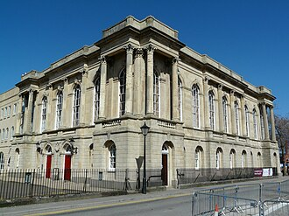  Building Survey Report  Planning, Practical Survey and Measurement Analysis | Matthew Jay - 2516508  Digital Surveying and Highway Design

Contents
1.0 Introduction 3
2.0 Part 1: Planning of the Survey 3
2.1 Purpose of the Survey 3
2.2 Survey Area Definition 3
2.3 Site Assessment 4
2.4 Risk Assessment Summary 7
3.0 Part 2: Practical 7
3.1 Evidence of On-Site Presence 7
3.2 Survey Execution Summary 8
3.3 Problems Encountered 9
4.0 Part 3: Measurement and Analysis 11
4.1 Extracted Measurements 11
4.2 Comparison with Traditional Methods 12
5.0 Appendices 14
Appendix A: Risk Assessment 14
Appendix B: Processed Scan / Point Cloud Data Extracts 15
Appendix C: Manual Measurement 16

Introduction
This report documents a structured digital building survey of the Dylan Thomas Building, undertaken to compare traditional measurement techniques against an RTC360 terrestrial laser scanner as methods of capturing building dimensions. It is presented in three parts. Part 1 sets out the plan for the survey, including its purpose, scope and associated risks. Part 2 describes how the practical survey was actually carried out, including the changes to original plan required on the day followed by part 3 which presents the measurements extracted from the processed scan data and compares this approach with traditional manual methods.

2.0 Part 1: Planning of the Survey

2.1 Purpose of the Survey
The purpose of this survey is to produce a fully measured internal layout of the first floor of the Dylan Thomas Building. This will then be used to compare traditional manual measurement techniques such as tape measure and hand-held laser distance meter against the RTC360 scanner as methods of capturing building dimensions. The Dylan Thomas Building in Swansea, which is an older-style building, was selected for the survey with the resulting data intended to support a direct comparison of the two approaches in terms of time, accuracy and completeness.

2.2 Survey Area Definition
The survey area is the first-floor communal areas which includes a corridor and canteen area in the Dylan Thomas Building in Swansea. This is the chosen area as it has many door openings as well as 90-degree corners. The level of detail that is intended to be captured are to include features such as overall dimensions of corridors e.g. length and width, as well as door opening sizes since this is sufficient detail to support the comparison with manual measurement.

2.3 Site Assessment
The Dylan Thomas Building was to be accessed via Somerset Place, using the front entrance of the building. There is a car park directly opposite the building which is free to use for students, lecturers and visitors. Once inside the building the main staircase or elevator can be used to access the area identified in section 2.2. Scanning positions were planned at regular intervals through the corridors and around the sitting area, spaced enough to ensure sufficient overlap between the individual scans for accurate point cloud registration. The way in which the RTC360 works is by firing out millions of single laser beams and measuring how long it takes for that laser to hit a surface, it can then determine how far away that surface was. Through collecting millions of points of data, it can then generate a map, the distance measurement is similar to the handheld laser meter but on a much larger scale (The Survey Association, 2022). Because lasers travel in straight lines it means the surveying equipment must be placed strategically to capture data that can tie into one another to form the floor layout, figures 1-4 below are marked-up plans of the first floor, the red lines indicate the general path that the scanning will take place along, whereas the yellow dots are the proposed scanning positions, these have been carefully selected in order to gain as much information as possible whilst having sufficient overlap to connect the data together.
In total there are seventeen proposed scanning locations which sounds excessive, however, there are a lot of fire doors throughout the corridor creating sections which require the laser to be situated in each to obtain the measurement.
As an older-style building, natural light was expected to vary considerably between spaces with larger windows and areas served mainly by artificial lighting, so scanning was scheduled for three two-hour sessions starting from 9am to make the most of the daylight. Safety considerations included checking the access routes in advance for the uneven flooring typical of aged buildings, limiting the use of the tripod on fire escape routes, making sure all equipment was stored safely and off the fire escape routes and following safe manual handling practice when moving the RTC360 laser scanner between positions.

Figure 1 – Proposed Scan Path
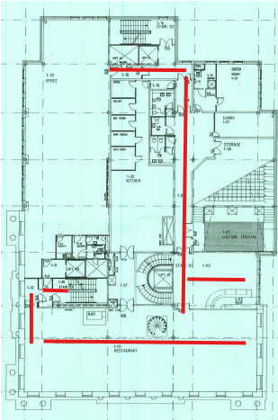
Figure 2 – Proposed Scan Path
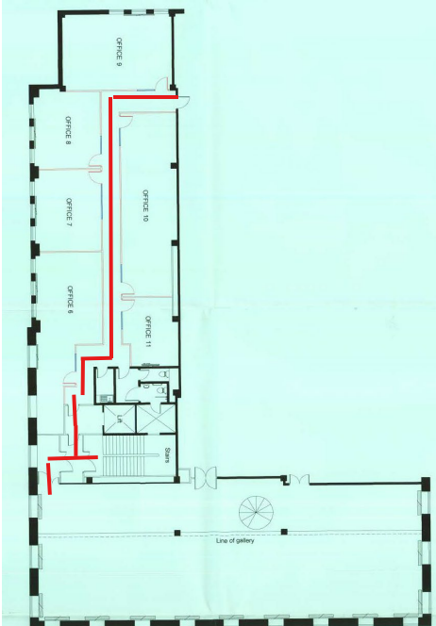

Figure 3 – Scan Locations
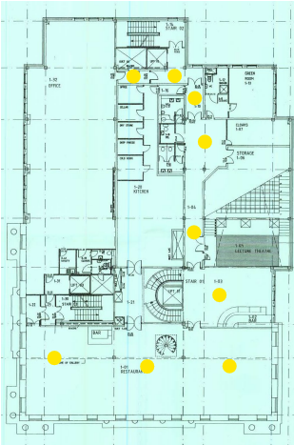
Figure 4 – Scan Locations
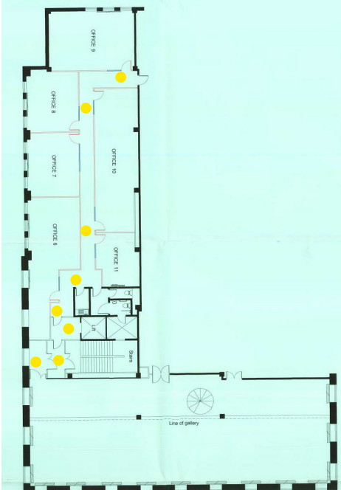

2.4 Risk Assessment Summary
As an older style building, the Dylan Thomas Building presented several hazards not typically found in modern facilities. The most significant were uneven and worn flooring, restricted circulation space through narrow corridors and doorways as well as the manual handling of the heavy RTC360 terrestrial laser scanner and tripod through the building (See appendix A for the full risk register). An additional environmental risk was identified around the lack of air conditioning; as described in section 3.2, this risk materialised on the day of the practical and required the survey to be relocated.

3.0 Part 2: Practical

3.1 Evidence of On-Site Presence
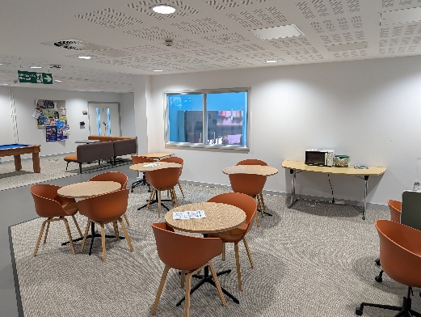(Seating Area of First floor IQ Building)
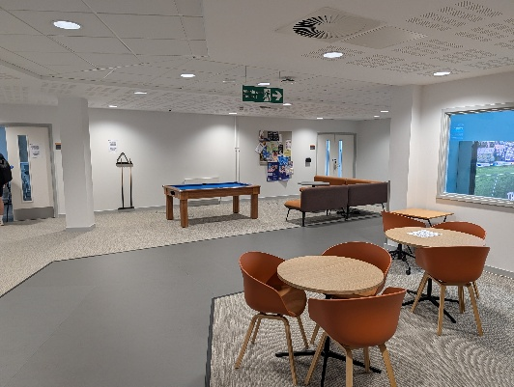 (Chill out area, First floor IQ Building)
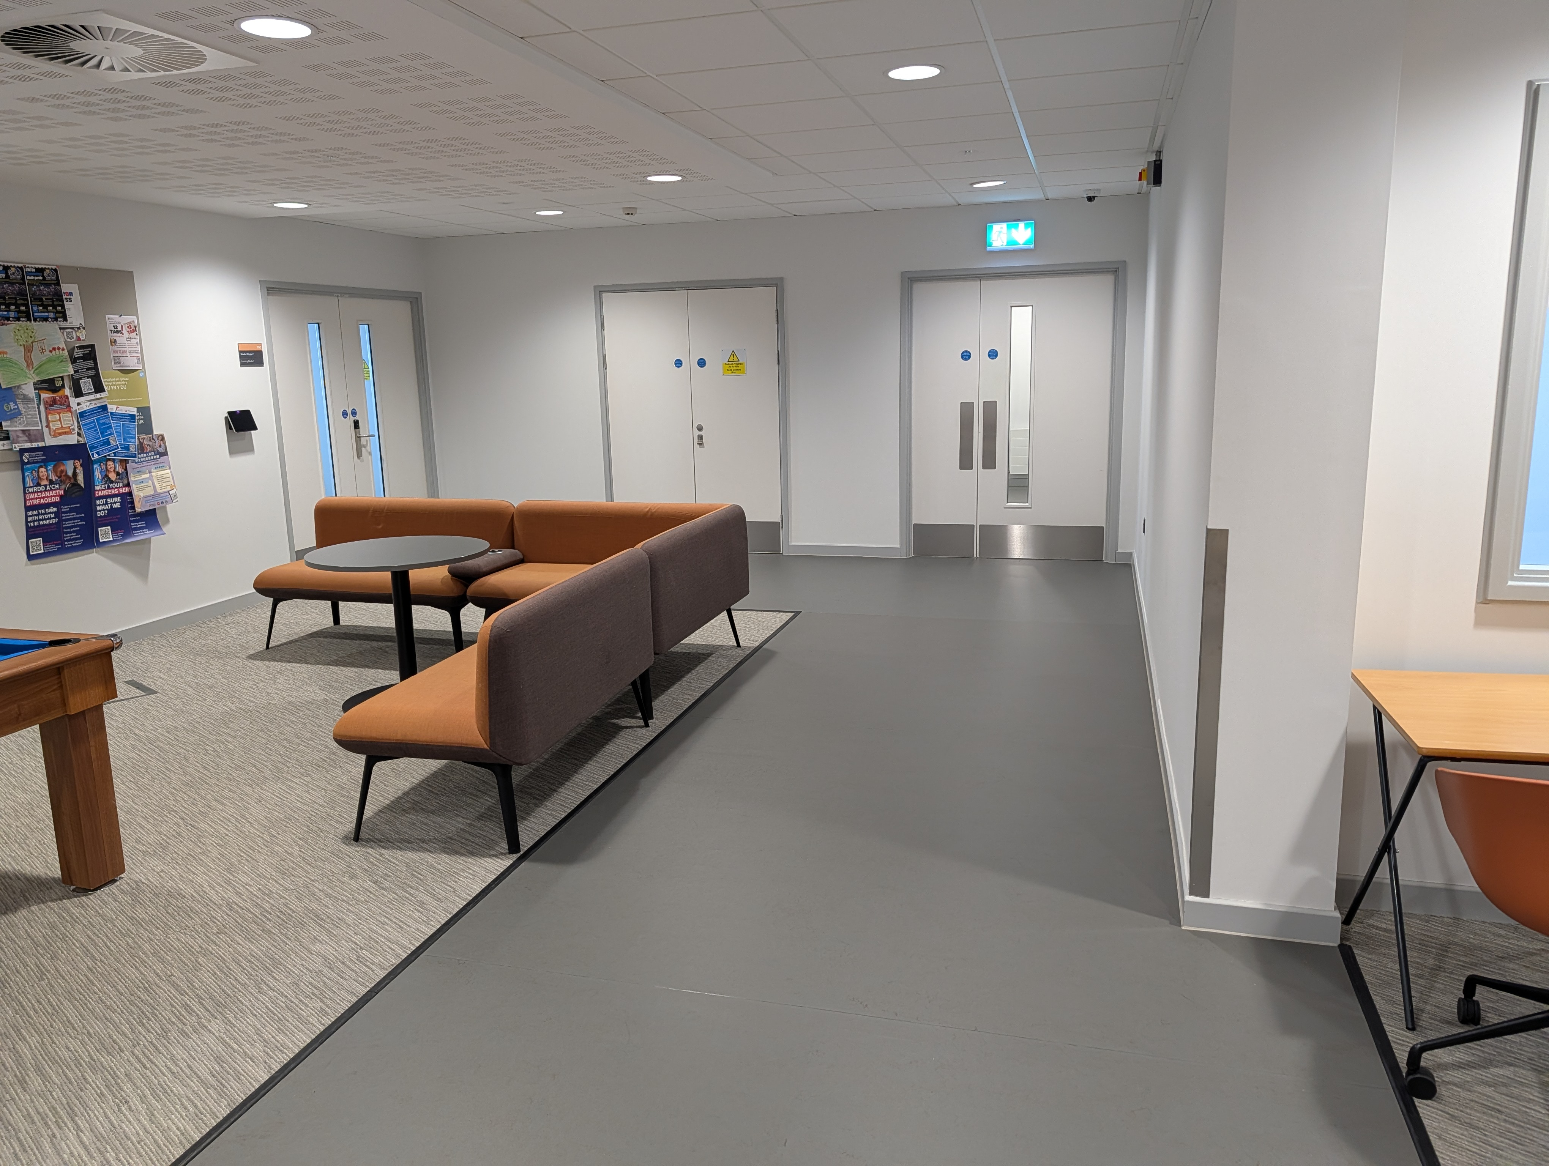(Pathway leading to Balcony First Floor IQ Building)
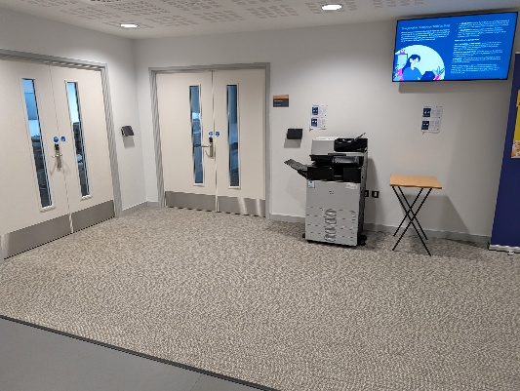(Doors to Room 107 + 108 First floor IQ Building)
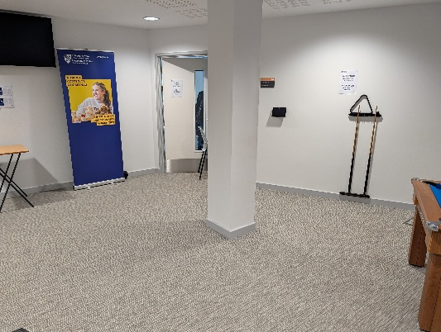 (Door to room 106 First floor IQ Building)
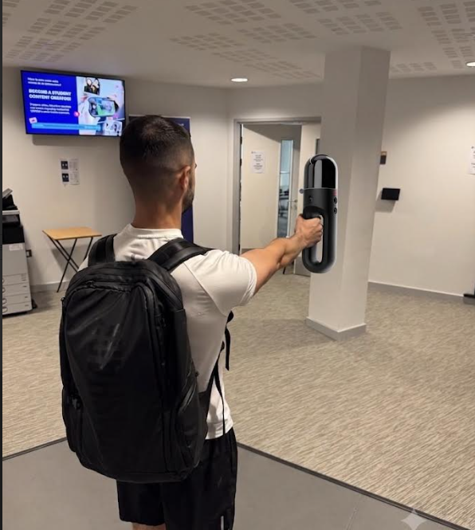 (Student using the BLK2GO)

3.2 Survey Execution Summary
The practical survey was originally planned to take place in the Dylan Thomas Building. However, the scheduled session on Thursday 25th June coincided with unusually high temperatures for South Wales and the building has no air conditioning. Carrying out a full scanning session inside an older style building under these conditions was judged an unacceptable welfare risk to the surveying team, consistent with the environmental risk identified during planning. As a result, the practical was relocated to the IQ Building which is a modern facility equipped with temperature controls allowing the session to be completed safely.
Because the venue changed, the area actually captured also differed from the area set out in the part 1 plan. The survey was carried out on the first floor of the IQ Building, covering the chill out area and three stretches of corridor. This area was deemed suitable as it was available and the footfall of students would be less as it was now the summer break. The ground floor was evaluated as too busy with passers-by who could have interfered with the laser scanning results. Ultimately, the first floor shared some of the key features with the original area e.g. fire compartments, fire doors, communal sitting area and corners.
A second, unplanned issue also occurred on the day of the practical assessment. The RTC360 terrestrial laser scanner specified in the original plan malfunctioned and would not operate. An alternative scanner which was a handheld known as BLK2GO was deemed suitable for the task in hand. This meant the practical assessment could continue and enabled all students to partake in the data capture.
For the manual measurement part of the practical the group was split into two smaller groups of 3-4 to enable students cover more area. The floor was split and each group was tasked with taking enough measurements to provide a solid comparison between the two methods.

3.3 Problems Encountered

3.3.1 Venue Change
The unusually high forecasted temperatures on the scheduled survey day it made the planned building unsuitable, since it had no air conditioning. The alternative was to use the IQ Building. This highlighted a gap in the original plan, the risk assessment had identified the lack of air conditioning as a risk but the contingency of relocating the whole session was only decided once the forecast was known, rather than being built into the plan from the outset.

3.3.2 Equipment Failure
The terrestrial laser scanner RTC360 intended for use failed to operate on the day for reasons not established on site and had to be substituted with a different handheld scanner known as BLK2GO. While this allowed the survey to proceed it exposed a genuine limitation of relying on digital surveying technology. The data capture is entirely dependent on the hardware functioning correctly, and a single equipment fault can halt or delay the collection altogether. Traditional measurement techniques such as a tape measure, have no equivalent single point of failure even though it is a much slower and labour-intensive means of obtaining the desired data. This trade-off between speed/detail and reliability is carried into the comparison with traditional methods in section 4.2.

4.0 Part 3: Measurement and Analysis

4.1 Extracted Measurements
Location / Room | Feature Measured | Dimension (Point Cloud) | Dimension (Manual) | Difference
Chill-out area | Wall of Room 106 Door | 11,574mm | 11,543mm | +31mm (0.3%)
Left Hand Corridor | Doorway to Matt’s Office | 1706mm | 1750mm | -44mm (2.5%)
Connecting Corridor | Width | 1998mm | 1988mm | +10mm (0.5%)
Balcony Corridor | Length | 31,913mm | 31,916mm | -3mm (0.01%)

The data extracted from the BLK2GO handheld scanner were checked against the manual measurements taken on site (full sketches of manual measurements in appendix C). Differences between the two methods ranged from 3mm on the full balcony corridor length to 44mm for the doorway to Matt’s office. The largest proportional difference of 44mm or 2.5% occurred on the doorway towards Matt’s office, this was also the shortest measurement compared. With the other measurements being much closer over larger areas, this could represent an issue with either measurement techniques. As this area of the first floor was measured by another group it is unknown if the manual measurement was the clear opening width of the door, lining to lining, if there were door stops or even the placement of the tape measure. Alternatively, it could identify a weakness in the BLK2GO scanner data, as it is possible it could not pinpoint the door edges accurately.
The largest measurement compared was the balcony corridor, this also provided the smallest variance in terms of length and therefore smallest proportionally. The tool of manual measurement for this was the hand-held laser distance meter. The laser measures in a straight line and it is therefore important that the trajectory of the laser from wall to wall is completely square, looking at the results of the both techniques it seems as if both devices were used correctly. A hand-held laser meter was used because over such a length, a measurement too such as a tape measure could suffer due to tape sag, or the having to take a few measurements if the tape was not long enough therefore increasing chance of mis measurement.

4.2 Comparison with Traditional Methods

4.2.1 Accuracy
Across all four of the features measured, the laser scan and the manual measurement agreed fairly closely, with differences ranging from 3mm to 44mm (0.01%-2.5%). The largest proportional variance which has been discussed in section 4.1 could be down to a few errors but collectively it can be assumed that both forms of measurement can achieve accurate results. If this were to be done again it would benefit the study if the definitions of features were set to ensure the comparison of certain features is identical.

4.2.2 Completeness
The scan captured the entire floor plan in much more detail than the manual methods, every wall, doorway and surface within range was measured, whereas the manual measurement was labour intensive and did not provide as much data. This is where technology outshines manual measurement, if there was a measurement required further down the line, the data would exist from the point cloud whereas the manual measurement would require a return visit.

4.2.3 Time
During the study the teams were given roughly one hour to obtain as many manual measurements as possible, the other hour was allocated to the BLK2GO scanner. The BLK2GO scanner was able to obtain every dimension in one pass through the designated area which took one person roughly 15 minutes. The manual measurement teams had one hour and were unable to obtain every measurement of every feature, this highlights the saving that could be obtained in time cost for on-site data collection in professional business.

4.2.4 Reliability
This is where the two methods deviated the most. As discussed in section 3.3 the RTC360 scanner originally specified for this survey failed to operate on the day and had to be substituted with the BLK2GO. This highlights the limitation to technology as manual methods such as a tape measure are very unlikely to fail and a spare can be produced fairly quickly rather than trying to locate a substitute specialist piece of equipment. This suggests that despite the accuracy and completeness, digital surveying technology is dependent on functioning hardware that manual methods do not require and that a professional survey plan should incorporate a contingency for that risk.

5.0 References
The Survey Association, TSA, represents UK surveying companies. (n.d.). [online] The Survey Association, TSA, United Kingdom, trade association representing UK private surveying firms. Available at: https://www.tsa-uk.org.uk/media/2025/06/Terrestrial-Laser-Scanning-Client-Guide-Issue-5_PQ.pdf [Accessed 12 July 2026].

6.0 Appendices

Appendix A: Risk Assessment
Hazard | Risk | Likelihood | Impact | Mitigation
Uneven / worn floor surfaces | Trips and falls; instability of tripod-mounted equipment | Medium | Medium | Visually check walking routes and scan locations before starting; use tripods with adjustable/locking legs; mark uneven areas
Manual handling of the heavy terrestrial laser scanner and tripod | Musculoskeletal injury; dropped/damaged equipment | Medium | Medium/High | Two-person lift and carry where possible; use a wheeled case between rooms; brief the team on manual handling technique
Narrow corridors, doorways and stairwells typical of older layouts | Restricted access; collisions while carrying equipment; difficulty positioning the scanner | Medium | Low/Medium | Walk the route in advance; plan scan positions and access order before the session
Variable/poor natural lighting (small or blocked windows, old fittings) | Trip hazard; reduced visibility; possible impact on scan data quality | Medium | Low/Medium | Schedule scanning during daylight hours where possible; bring portable lighting; check scan previews on site
High internal temperature / no air conditioning | Heat stress, dehydration and reduced concentration for the survey team; possible equipment overheating | Medium | Medium | Check the weather forecast ahead of the visit; schedule for the coolest part of the day; take hydration breaks; have a contingency plan to relocate if conditions become unsafe
Aged electrics / limited power outlets | Equipment unable to charge on site | Low | Low/Medium | Fully charge all batteries before arrival; bring spares

Appendix B: Processed Scan / Point Cloud Data Extracts
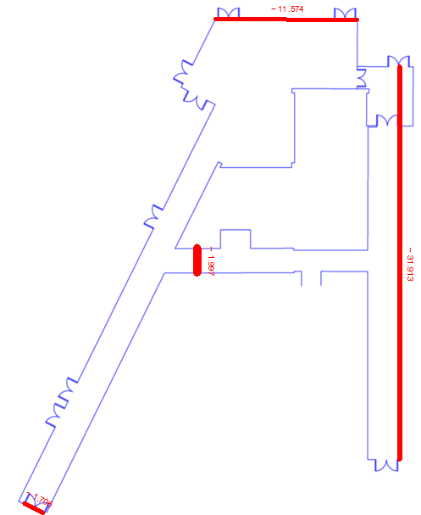

Appendix C: Manual Measurement


