  Component One: Student Journal (learning log) 750 words +/- 10%  Contribution to Overall Module Assessment: 25% | Student No: | 2232322
 | Module Title: | Operating hotel facilities
 | Module Code: | BMIH 4006
 | Lecturer: | Lisa-marie Bassler
Component One: Student Log

Component One: Student Log

Description
In Hilton Garden Inn Birmingham Brindleyplace, I was an apprentice in maintenance, and my responsibilities covered a wide range of duties that are directed to public areas and guest apartments that had to be in pristine condition. This comprised of jobs that required scrubbing, sweeping, laundry (asides normal clothing), restocking products, and of course general sanitation of all the areas (Casado, 2012). Moreover, I took part in storing and replenishing merchandise on storage trolleys, thereby being assures of its perfect condition and ready availability of provisions as supplies ran out.

Feelings
At the outset, I developed a personal interest in the job roles and procedures of the housekeeping staff. However, the farther I got in my duties, the more flooded I was by the amount of work and the busy atmosphere. These were hardest during the periods of peak demand, when the simultaneous cleaning of many flats necessitated my giving my undivided attention to each one, thus making it impossible to meet the requirements of each individual job.

Evaluation
After the process of a detailed assessment of my domestic experience, I managed to understand what my gifts and what gaps I have. Excellence in prioritizing responsibilities based on their level of importance and good communication skills among workers gave advantages to the whole organization (Fallon and Rutherford, 2010). As I came to terms with the fact that resourceful leadership was time-sensitive, I put my ultimate effort into enhancing my leadership skills specifically in dynamic scenarios. In front of the toughness of lack of some cleaning materials and any defect in machine, I have proved that I can quickly change the way of my work and generate various resolutions. I had to mix my strength and speed in order to come up with variations to my methodology and game plan if I was to surmount these challenges successfully.

Analyses
A notable limitation I experience on a daily basis is the insufficient staff in the housekeeping area. It was clear that the existing staff members were always overloaded with work and felt a type of devaluation that made them assume extra responsibilities to fill up the gap in personnel (Johnston et al., 2012). However, due to the time limitation, some areas were not completely vacuumed, which yield a big reduction in the quality of our guest services. I was amazed by the high level of attention to details we, housekeepers, expected to have. It was mandatory to use disinfectants on all surfaces, gaps, and spots to make sure the customers had a flawless and sanitized stay (Hayes et al., 2017). These detailing of the job also emphasizes upon importance of maintaining hygiene standards through precision and accuracy (Mullins and Dossor, 2013).

Conclusion
The work project gave a view on how crucial the security staff members are for maintaining customer satisfaction. The degree of cleanliness and visual attractiveness featured in a guest room has the greatest influence in the way they look at an accommodation establishment, therefore it is an indispensable part of their whole experience (Walls, 2013). I personally found a new respect for the people who normally have their jobs undervalued as janitors in the tourism industry while also appreciating the never-ending effort they put in. The issues observed by the maintenance agency unraveled more deep-rooted problems within the organization system, and so proactive solutions had to be implemented to improve employee grievances and optimize the process.

Action Plan
My plan is to be promoted in the hotel and restaurant production sector by the means of increasing my room cleaning level of competence. To address specific areas requiring improvement, I intend to perform the following actions: To address specific areas requiring improvement, I intend to perform the following actions:
- Improve Time Management Abilities: I intend to put to use different time management tools such as daily checklists, splitting of the entire undertaking into smaller achievable components and use of time-blocking methods to give each assignment attention it deserves.
- Pursue Added Education and Certification: In order to improve my skills in managing housekeeping process effectively, I am thoroughly looking forward to the opportunities which will pave the way for further training and certifications.
- Promote Awareness Regarding the Necessity for Additional Staff: Using authentic service with respect to housekeeping staff and the satisfaction of our guests in mind, I shall argue for the improvement of staffing level within the department (Rao and Sahu, 2013). I seek to illustrate how we are facing the problems due to the substandard recruitment practices, so that the leadership would get the information first-hand.
- Ongoing Feedback and Development: Aware of the fact of how impactful feedback is in achieving our personal and professional goals (Kobyak and Lvovna, 2015), I commit to requesting feedback actively from my supervisors and peers so that we can jointly identify and work on areas of improvement.

Component two Poster . Contribution to overall module assessment :25%

Health and Safety Guide for Room Cleaning in the Housekeeping Department
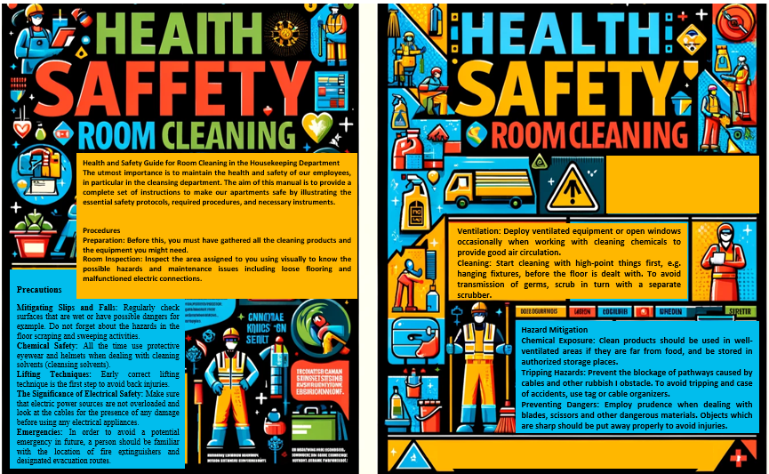
The utmost importance is to maintain the health and safety of our employees of Hilton Garden Inn Birmingham Brindleyplace, in particular in the cleansing department. The aim of this manual is to provide a complete set of instructions to make our apartments safe by illustrating the essential safety protocols, required procedures, and necessary instruments.

Precautions
- Mitigating Slips and Falls: Regularly check surfaces that are wet or have possible dangers for example. Do not forget about the hazards in the floor scraping and sweeping activities.
- Chemical Safety: All the time use protective eyewear and helmets when dealing with cleaning solvents (cleansing solvents). Adopt the dilution technique as directed by the manufacturer.
- Lifting Techniques: Early correct lifting technique is the first step to avoid back injuries. Squat down below hip level using parallel back, placing the feet flat on the floor under the hips, then lift a load that is relatively heavy with the use of both legs.
- The Significance of Electrical Safety: Make sure that electric power sources are not overloaded and look at the cables for the presence of any damage before using any electrical appliances.
- Emergencies: In order to avoid a potential emergency in future, a person should be familiar with the location of fire extinguishers and designated evacuation routes. If ever you find yourself in a situation that requires you to evacuate the building at once, make sure you stay calm and do so immediately.

Procedures
- Preparation: Before this, you must have gathered all the cleaning products and the equipment you might need.
- Room Inspection: Inspect the area assigned to you using visually to know the possible hazards and maintenance issues including loose flooring and malfunctioned electric connections.
- Ventilation: Deploy ventilated equipment or open windows occasionally when working with cleaning chemicals to provide good air circulation.
- Cleaning: Start cleaning with high-point things first, e.g. hanging fixtures, before the floor is dealt with. To avoid transmission of germs, scrub in turn with a separate scrubber.
- Waste Management: Respective sacks should be used with waste disposal occurring only in the receptacles. Recycling and disposal of the hazardous substances should be in accordance with regulatory guidelines.
- Conclude: Conduct a thorough final inspection to confirm that the area is clean and is devoid of any hazard. Ensure that there are no areas that may have been underestimated.

Equipment
- Safeguarding Equipment: Use protective elements such as gown, sleeves and goggles as a measure to defend against both physical and biological damage.
- Implementation of Cleaning Products: Utilize multifunctional cleaning agent, hand sanitizers, cotton duster, floor mopper heads, and cleaning machine accessories.
- Safety on Ladders: Utilize a ladder that is well-steady and properly positioned, for getting to the higher areas like lighting fixtures and bookcases
- Implement Housekeeping trolleys: Using the housekeeping trolleys be more efficient for moving and arranging the cleaning tools and materials.

Hazard Mitigation
- Chemical Exposure: Clean products should be used in well-ventilated areas if they are far from food, and be stored in authorized storage places.
- Tripping Hazards: Prevent the blockage of pathways caused by cables and other rubbish I obstacle. To avoid tripping and case of accidents, use tag or cable organizers.
- Manipulating Sizable Items: Team up, via partnerships or small groups, in order to maneuver large size items using dollies or carts for protection purposes.
- Preventing Dangers: Employ prudence when dealing with blades, scissors and other dangerous materials. Objects which are sharp should be put away properly to avoid injuries.
Housekeeping employees can adhere to the safety and security guidelines outlined in the safety and security manual in order to maintain a secure working environment. Through the observation of these regulations, they gain the ability to neatly and safely clean rooms plus that of protecting themselves from injuries. Regularly highlighting and remind these legislation's will be one of the important means to keep the compliance and safety for all house cleaning workers.

Reference List

Bangwal, D., Suyal, J. and Kumar, R. (2022) Hotel building design, occupants’ health and performance in response to COVID 19. International journal of hospitality management, 103, p.103212.
Casado, M. (2012) Housekeeping Management. London: Wiley.
Chela-Alvarez, X., Bulilete, O., Garcia-Illan, E., Vidal-Thomàs, M. and Llobera, J. (2022) Hotel housekeepers and occupational health: experiences and perceived risks. Annals of occupational and environmental medicine, 34.
Fallon, M. and Rutherford, D. (2010) Hotel Management and Operations. London: Pearson.
Hayes, D.K., Ninemeier, J.D. and Miller, A.A. (2017) Hotel operations management. Pearson.
Hu, X., Yan, H., Casey, T. and Wu, C.H. (2021) Creating a safe haven during the crisis: How organizations can achieve deep compliance with COVID-19 safety measures in the hospitality industry. International Journal of Hospitality Management, 92, p.102662.
Hughes, P. and Ferrett, E. (2011) Introduction to health and safety at work. Routledge.
Johnston, R., Clark, G. and Shulver, M. (2012) Service Operations Management. London: Pearson.
Kobyak, M.V. and Lvovna, I.E. (2015) The competitiveness of hotel facilities. Theory and practice. Organization, 6(2), p.12.
Mullins, L. and Dossor, P. (2013) Hospitality Management and Organisational Behaviour. 5th ed. Harlow: Pearson.
Raghubalan, G. and Raghubalan, S. (2016) Hotel Housekeeping - Operations And Management. 3rd ed. India: Oxford University Press.
Rao, P.S. and Sahu, P.C. (2013) Impact of service quality on customer satisfaction in hotel industry. IOSR Journal of Humanities and Social Science, 18(5), pp.39-44.
Rosemberg, M.A.S., Granner, J.R., Li, W.V., Adams, M. and Militzer, M.A. (2022) Intervention needs among hotel employees and managers. Work, 71(4), pp.1063-1071.
Selem, K.M., Ahmad, M.S., Belwal, R. and AlKayid, K. (2023) Fear of COVID-19, hotel employee outcomes and workplace health and safety management practices: Evidence from Sharm El-Sheikh, Egypt. Tourism and Hospitality Research, 23(4), pp.594-609.
Sianipar, R. and Cicilia, R.L. (2023) Procedure Housekeeping. Penerbit NEM.
Spellman, F.R. and Bieber, R.M. (2011) Physical hazard control: preventing injuries in the workplace. Government Institutes.
Tak, S. (2016) An assessment of occupational health and safety risks in the hospitality industry: The case of Sarova Stanley Hotel, Nairobi, Kenya (Doctoral dissertation, University of Nairobi).
Walls, A. R. (2013) A cross-sectional examination of hotel consumer experience and relative effects on consumer values. International Journal of Hospitality Management, 32, 179-192.

