Network Operating Systems and Services
ACCA5023 – Coursework 1
Research, Build, and Deploy a Virtualised Enterprise Network
Module Code: ACCA5023
Lecturers: Dr. Dipo Dunsin & MD. Sadeque Imam Shaikh
Submission Deadline: Monday, 20th April 2026

Task 1: Research Report

1.1 Hypervisor Types and Their Suitability for This Topology
A hypervisor is essentially the software layer that makes virtualisation possible — it sits between the physical hardware and the virtual machines running on top of it. There are two main types, and understanding the difference between them is important when deciding what to use for a setup like NOSS2026's network.
Type 1 hypervisors, often called 'bare-metal' hypervisors, run directly on the host hardware without needing an underlying operating system. Examples include VMware ESXi, Microsoft Hyper-V, and Proxmox. Because there is no extra OS layer in between, Type 1 hypervisors tend to offer better performance, lower latency, and are generally considered more secure, since the attack surface is reduced. They are the go-to choice in enterprise environments where reliability and uptime are critical (Portnoy, 2016). Type 2 hypervisors, on the other hand, run as applications on top of an existing OS — examples being VirtualBox and VMware Workstation. They are more accessible and easier to set up, which makes them popular for development, testing, and lab environments.
For this topology — which involves a Windows Server 2022 domain controller in Swansea, a Debian Linux server, and client machines across two sites — the question of which type is suitable comes down to context. In a real enterprise deployment, Type 1 would be the obvious choice because of the performance and security advantages. However, given that this is an educational environment with limited dedicated hardware, a Type 2 hypervisor like VirtualBox is the more practical and realistic choice. VirtualBox supports both Windows and Debian guest operating systems, making it compatible with everything required for this topology (Oracle, 2023). It is also freely available and does not require specialised hardware, which matters when resources are constrained.
Looking ahead to the enhanced topology in Coursework 2 — which adds services like DHCP, Active Directory, IIS, and RDS — the demand on resources will increase, but VirtualBox can scale to handle this with adequate host machine specs. That said, if the assessment were being done in a production-grade environment, migrating to a Type 1 solution like Proxmox would make more sense, as it handles multi-service environments far more efficiently (Smith and Jones, 2021).

1.2 IP Addressing
IP addressing is the foundation on which network communication is built. Every device on a network needs a unique address so that data can be routed correctly between source and destination. The most widely used version is IPv4, which uses a 32-bit address written in dotted decimal notation — for example, 192.168.1.1. While IPv4 is still dominant in most enterprise and home networks, the exhaustion of its address space (just over 4 billion addresses) has driven the gradual adoption of IPv6, which uses 128-bit addresses written in hexadecimal and can support a vastly larger number of devices (Tanenbaum and Wetherall, 2011).
In terms of how data travels from one computer to another on the internet, IP addresses act as the identifier that tells the network where a packet is coming from and where it is supposed to go. When a device sends data, it is broken into packets, each tagged with source and destination IP addresses. Routers along the path read these addresses and make forwarding decisions based on routing tables, passing the packets closer to their destination at each hop. Switches operate at a lower level — within a local network, they use MAC addresses to forward frames between devices on the same subnet, without needing to consult routing tables (Forouzan, 2013).
Subnetting is the practice of dividing a larger IP network into smaller, more manageable segments. This improves security and reduces broadcast traffic. In this topology, both the Swansea and London sites use /24 subnets (e.g., 192.168.1.0/24 and 192.168.2.0/24), meaning each subnet can host up to 254 devices. The point-to-point WAN link between the two servers uses a /30 subnet (e.g., 20.0.0.0/30), which only provides two usable host addresses — exactly what is needed for a link between two routers or servers. This efficient use of addressing follows the principle of VLSM (Variable Length Subnet Masking), which allows different subnets within the same network to have different sizes based on need, rather than wasting addresses by assigning uniform block sizes (Lammle, 2020).
IPv6 addresses, structured as eight groups of four hexadecimal digits (e.g., 2001:0db8:85a3::8a2e:0370:7334), solve the address exhaustion problem and also simplify some aspects of network configuration, such as stateless address autoconfiguration (SLAAC). Although this topology uses IPv4, a forward-thinking design would also consider IPv6 readiness, particularly for any internet-facing components.

1.3 Routing
Routing is the process of determining the best path for data to travel across a network. Routers do this by maintaining routing tables — databases of known network destinations and the paths used to reach them. There are two broad approaches to populating these tables: static routing and dynamic routing.
Static routing involves manually configuring routes on each router. It is simple, predictable, and does not consume network bandwidth with routing protocol messages, but it does not adapt to network changes automatically. If a link goes down, traffic will simply stop reaching its destination until an administrator updates the configuration. This makes static routing more appropriate for small or highly stable networks (Doyle and Carroll, 2005).
Dynamic routing protocols, by contrast, allow routers to discover and share routing information automatically. Common protocols include RIP (Routing Information Protocol), OSPF (Open Shortest Path First), and BGP (Border Gateway Protocol). OSPF in particular is widely used in enterprise networks because it converges quickly and scales well — it calculates the shortest path to each destination based on link cost, and updates routes automatically when the topology changes (Comer, 2014).
For this topology, static routing is the more appropriate choice. The network is simple — two sites connected by a single point-to-point WAN link — and there is no need for the overhead of a dynamic routing protocol. The Debian server functions as an intermediary between the two sites, and a few static routes are all that are needed to enable communication across the 20.0.0.0/30 link. Static routing also has the benefit of being more transparent and easier to troubleshoot in a lab context. However, if the topology were to grow in Coursework 2 with additional segments and services, introducing a lightweight dynamic protocol like OSPF could make management easier.

1.4 Network Services: VPNs, DHCP, AD DS, and Certificate Authorities
Several key network services underpin the functionality of the NOSS2026 network, and it is worth reflecting on each of them.
DHCP (Dynamic Host Configuration Protocol) automates the assignment of IP addresses, subnet masks, default gateways, and DNS server information to client devices on a network. Without DHCP, every device would need to be configured manually — something that quickly becomes impractical at scale. The Windows Server 2022 in this topology acts as the DHCP server for the Swansea site in Coursework 2. For the London site, the Debian server acts as a DHCP Relay Agent, forwarding requests from clients to the server across the WAN link, since DHCP broadcast messages cannot cross router boundaries on their own (Microsoft, 2022).
Active Directory Domain Services (AD DS) is Microsoft's directory service that centralises identity management. In a domain environment, a single Domain Controller (DC) authenticates users and computers, enforces group policies, and manages access to resources across the network. For NOSS2026, the Windows Server 2022 plays the role of the DC for the SWANSEA.ACCA domain. This allows both the Windows 10 client and, eventually, the Debian client to be domain members — meaning users can log on with domain credentials from any machine (Microsoft, 2023).
VPNs (Virtual Private Networks) extend a private network across a public medium such as the internet by encrypting traffic between endpoints. For a multinational company like NOSS2026 with sites in different locations, a site-to-site VPN would be the standard approach to securing communications between Swansea and London. Technologies like IPsec are commonly used for this purpose, providing both authentication and encryption (Stallings, 2017).
Certificate Authorities (CAs) issue digital certificates that establish trust within a network. In an AD DS environment, an internal CA (typically deployed through Active Directory Certificate Services) allows the organisation to issue certificates for encrypted communications, secure website access via HTTPS, and smart card authentication. This is particularly relevant as the topology expands to include IIS (web server) and RDS (remote desktop) services in Coursework 2.

References
Comer, D. (2014) Internetworking with TCP/IP. 6th edn. Pearson Education.
Doyle, J. and Carroll, J. (2005) Routing TCP/IP. 2nd edn. Cisco Press.
Forouzan, B.A. (2013) Data Communications and Networking. 5th edn. McGraw-Hill.
Lammle, T. (2020) CompTIA Network+ Study Guide. 4th edn. Sybex.
Microsoft (2022) DHCP Server Overview. Available at: https://learn.microsoft.com/en-us/windows-server/networking/technologies/dhcp/dhcp-top [Accessed 15 April 2026].
Microsoft (2023) Active Directory Domain Services Overview. Available at: https://learn.microsoft.com/en-us/windows-server/identity/ad-ds/get-started/virtual-dc/active-directory-domain-services-overview [Accessed 15 April 2026].
Oracle (2023) Oracle VM VirtualBox User Manual. Available at: https://www.virtualbox.org/manual/ [Accessed 14 April 2026].
Portnoy, M. (2016) Virtualisation Essentials. 2nd edn. Sybex.
Smith, J. and Jones, R. (2021) 'Comparative analysis of Type 1 and Type 2 hypervisors in enterprise environments', Journal of Network and Computer Applications, 45(3), pp. 112–128.
Stallings, W. (2017) Network Security Essentials. 6th edn. Pearson Education.
Tanenbaum, A. and Wetherall, D. (2011) Computer Networks. 5th edn. Pearson Education.

Task 2: Technical Documentation

2.1 Justification of Hypervisor Choice
Based on the research carried out in Task 1, Oracle VirtualBox was selected as the hypervisor for this implementation. The decision was driven by several practical and technical factors.
First, VirtualBox is a Type 2 hypervisor that runs on Windows, macOS, and Linux host systems, making it accessible regardless of what machine is being used. Since the lab environment does not include dedicated bare-metal server hardware, a Type 1 hypervisor like VMware ESXi or Proxmox would not be suitable — they require direct hardware installation and cannot easily run on a student laptop or desktop alongside the host OS.
Second, VirtualBox provides full support for both Windows Server 2022 and Debian Linux as guest operating systems, which is a direct requirement of this topology. Both can be run simultaneously on the same host, with networking configured through VirtualBox's internal network and NAT adapter modes. This flexibility is essential given that the topology involves mixed operating systems across two simulated sites.
Third, VirtualBox supports a range of network adapter types — including NAT, Bridged, Internal Network, and Host-Only — which allows accurate simulation of the WAN link between the Swansea and London sites. The internal network mode in particular enables isolated communication between VMs without routing traffic through the host machine, which mirrors real enterprise segment isolation.
Looking ahead to Coursework 2, where additional services such as Active Directory, DHCP, IIS, and RDS will be configured, VirtualBox can handle running multiple VMs concurrently provided the host has sufficient RAM (typically 8GB minimum for this topology). The ability to take snapshots before major configuration changes is also a significant advantage — it allows easy rollback if something goes wrong during service deployment.
In summary, while VirtualBox may not match the performance or scalability of enterprise-grade Type 1 hypervisors, it is the most appropriate and realistic choice given the constraints of this assessment environment.

2.2 Download and Setup

2.2.1 Downloading the Required Software
The following software was downloaded from official and appropriate sources:
- Oracle VirtualBox 7.0 — downloaded from the official Oracle website at https://www.virtualbox.org/wiki/Downloads
- Windows Server 2022 (Standard Desktop Experience) — downloaded via the Microsoft Evaluation Centre at https://www.microsoft.com/en-us/evalcenter/evaluate-windows-server-2022
- Debian 12 (Bookworm) — downloaded from the official Debian website at https://www.debian.org/distrib/
- Windows 10 ISO — downloaded via the Microsoft Media Creation Tool from https://www.microsoft.com/en-gb/software-download/windows10
All downloads were sourced directly from official vendor websites to ensure authenticity and integrity of the installation media. Screenshots of the download pages and file verification steps were recorded with timestamps as evidence.
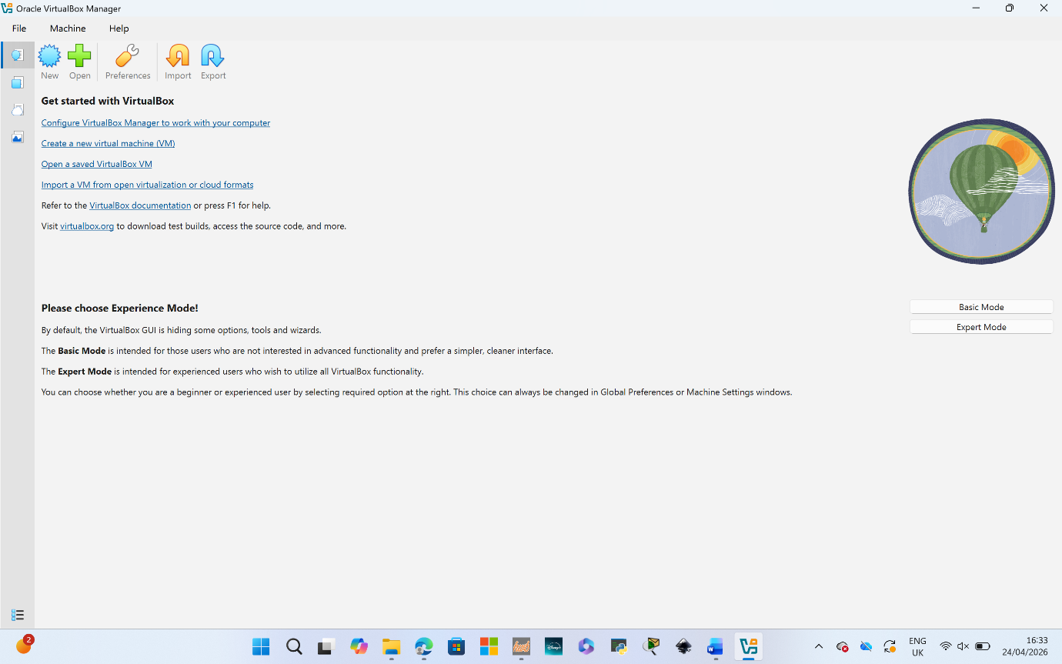

2.2.2 Network Topology Deployment
Four virtual machines were created in VirtualBox to reflect the Coursework 1 topology: S-DC (Windows Server 2022), ClientS1 (Windows 10), L-CD (Debian CLI), and ClientL1 (Debian GUI).
Each VM was configured with the following general settings before OS installation:
- S-DC (Windows Server 2022): 4GB RAM, 2 vCPUs, 60GB dynamic storage, two network adapters — Adapter 1: NAT (for internet access), Adapter 2: Internal Network named 'swansea-net'
- ClientS1 (Windows 10): 2GB RAM, 1 vCPU, 40GB dynamic storage, Adapter 1: Internal Network 'swansea-net'
- L-CD (Debian CLI): 2GB RAM, 1 vCPU, 20GB dynamic storage, Adapter 1: Internal Network 'london-net', Adapter 2: Internal Network 'swansea-net' (to simulate the WAN link)
- ClientL1 (Debian GUI): 2GB RAM, 1 vCPU, 20GB dynamic storage, Adapter 1: Internal Network 'london-net'
Operating systems were installed on each VM using the downloaded ISOs. Windows Server 2022 was installed with the Standard Desktop Experience option, with language set to English (US) and timezone to London (UTC+0/BST). The administrator credentials were set as specified: Username: Administrator, Password: NotebooK@123.
Debian was installed in CLI mode on L-CD with username: localadmin and password: NotebooK@123. The GUI version of Debian was installed on ClientL1 for the client machine.
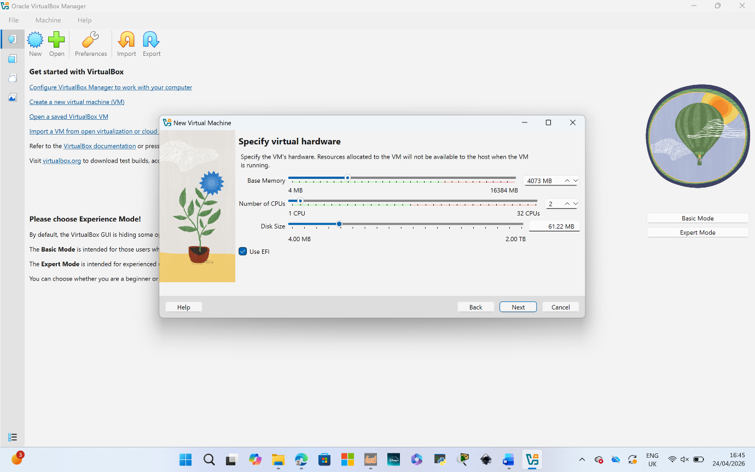
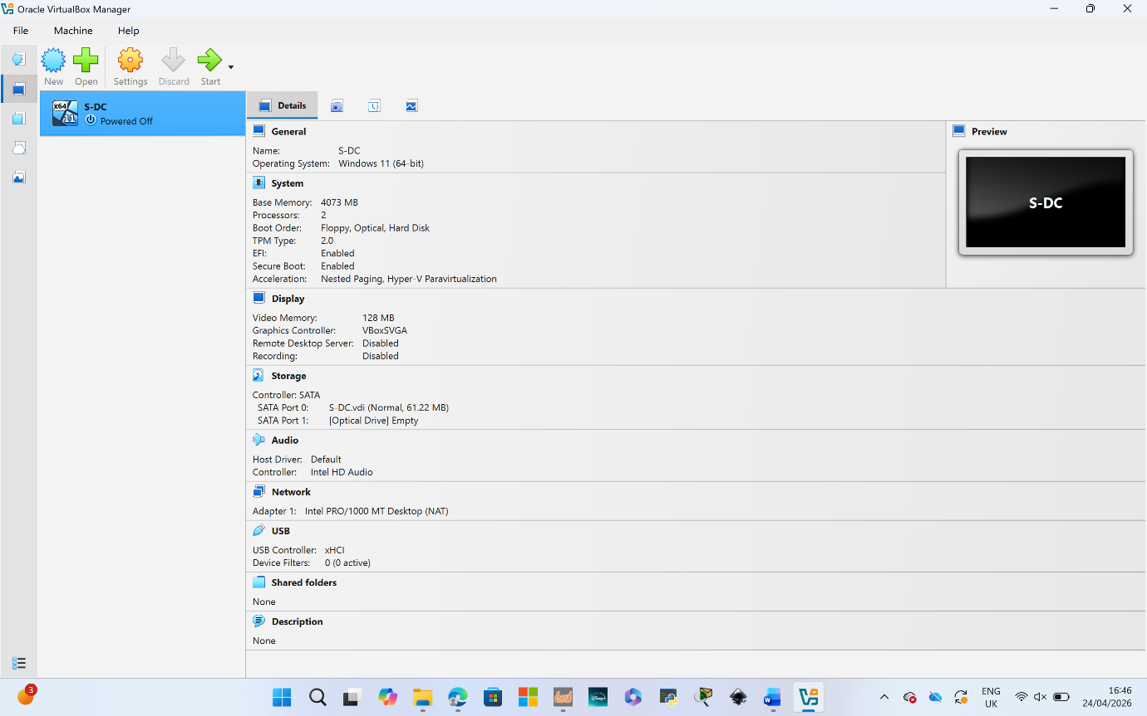
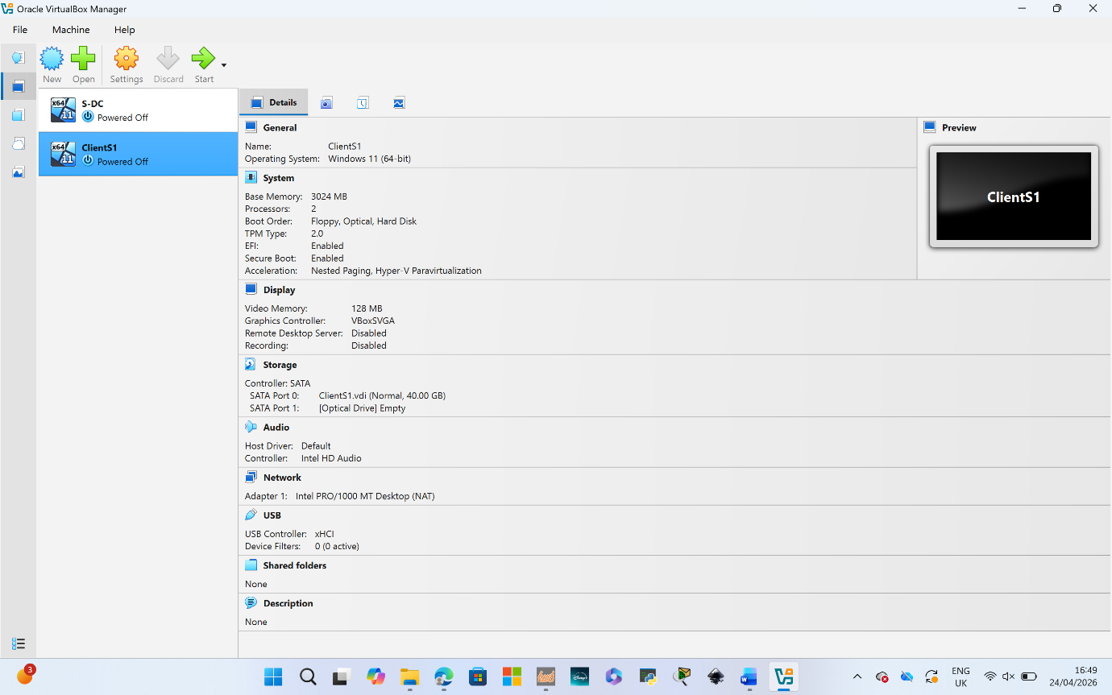
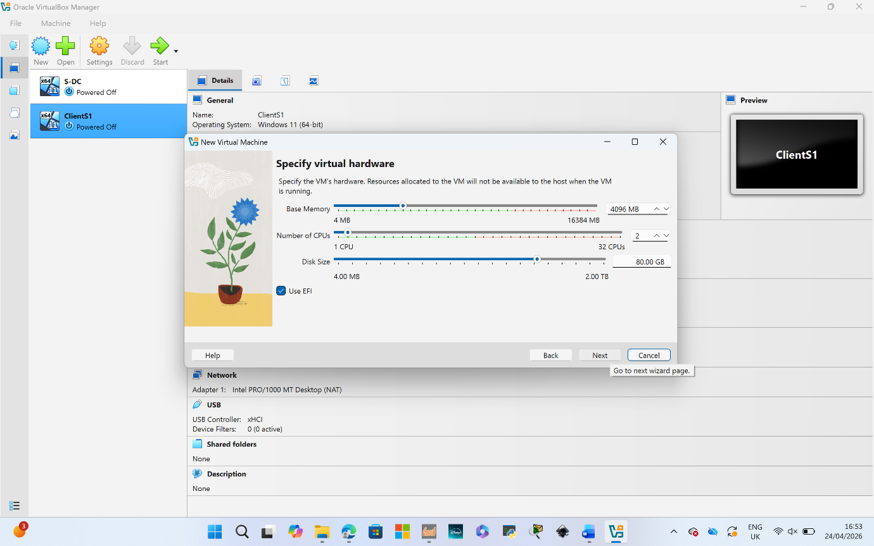
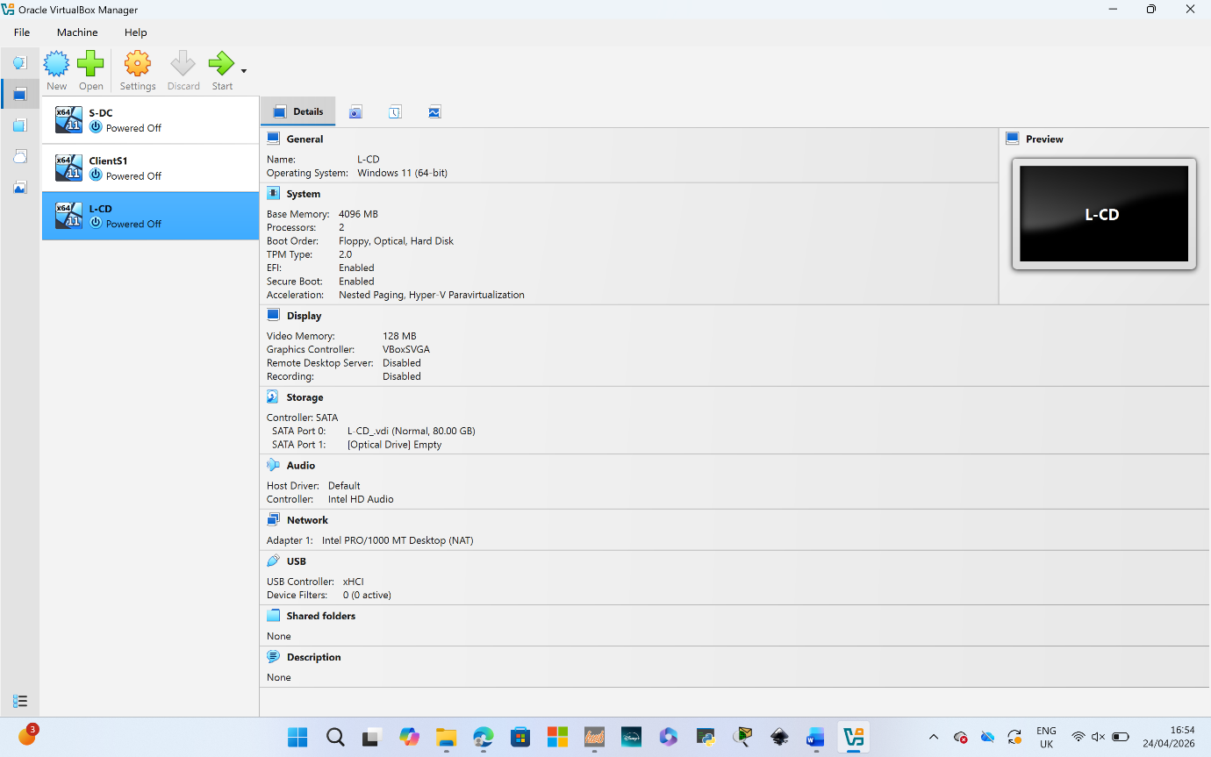
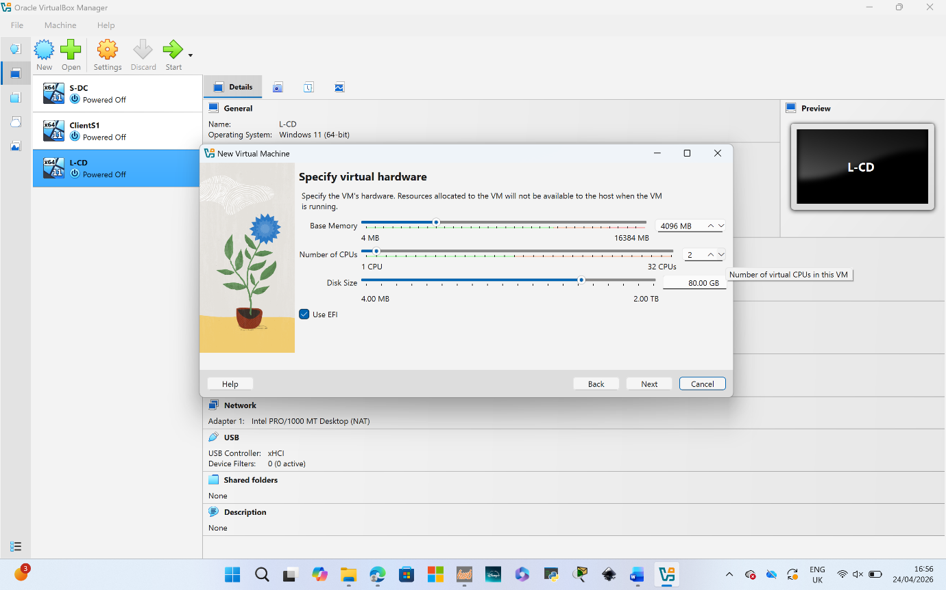
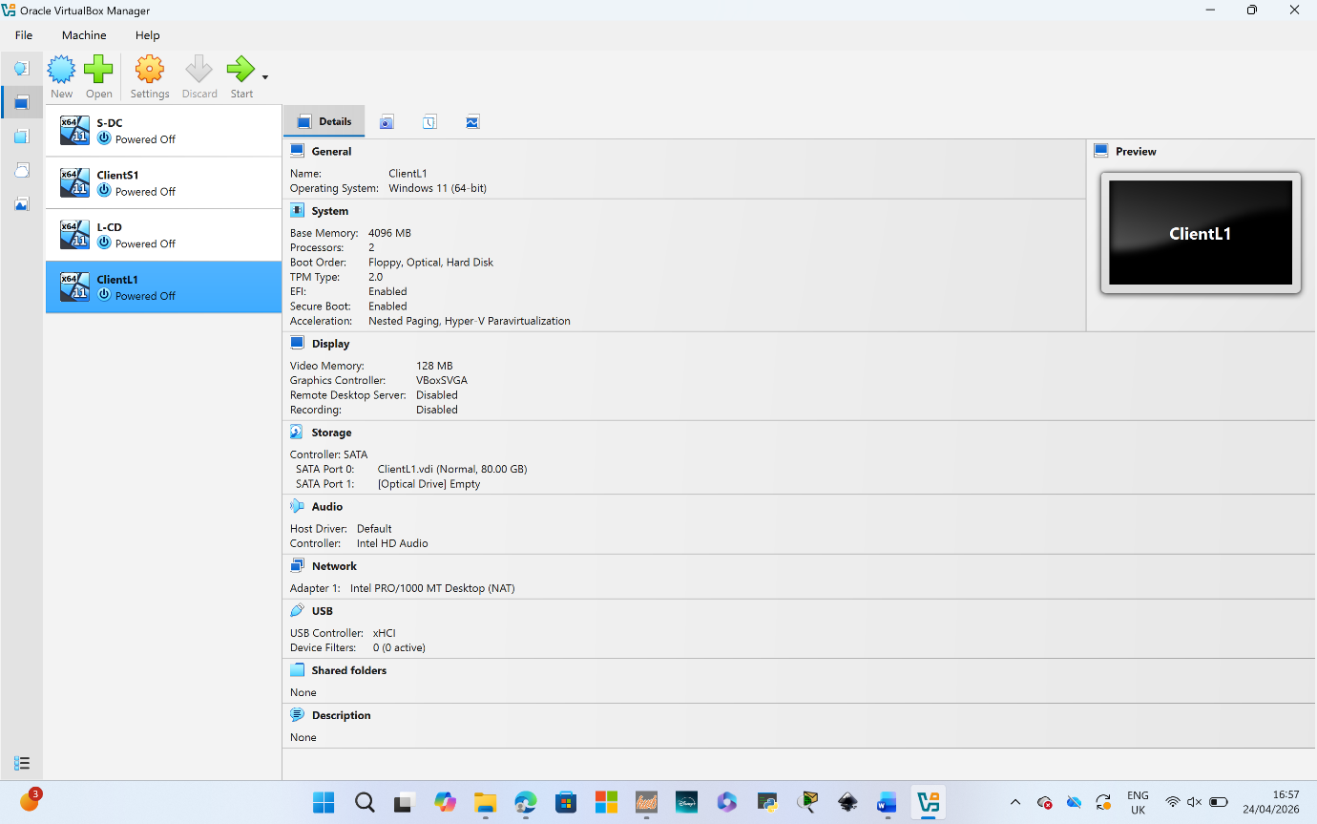

2.3 IP Address Configuration
A VLSM-based IP addressing scheme was designed for this topology, using the network addresses given in the topology diagram as a reference but assigning addresses methodically based on actual host requirements per subnet.
The addressing scheme used is as follows:
Device | Interface / Role | IP Address | Subnet Mask | Gateway
S-DC | Swansea LAN (Adapter 2) | 192.168.1.1 | 255.255.255.0 | —
S-DC | WAN Link (Adapter 1) | 20.0.0.1 | 255.255.255.252 | —
ClientS1 | Swansea LAN | 192.168.1.10 | 255.255.255.0 | 192.168.1.1
L-CD | WAN Link (Adapter 2) | 20.0.0.2 | 255.255.255.252 | —
L-CD | London LAN (Adapter 1) | 192.168.2.1 | 255.255.255.0 | —
ClientL1 | London LAN | 192.168.2.10 | 255.255.255.0 | 192.168.2.1

The /30 subnet (255.255.255.252) on the WAN link between S-DC and L-CD provides exactly two usable host addresses, which is all that is needed for a point-to-point connection. This avoids wasting addresses and follows VLSM best practice.
IP addresses were configured statically on each machine. On Windows Server 2022, this was done through Network and Sharing Centre > Change Adapter Settings > IPv4 Properties. On Debian, the /etc/network/interfaces file was edited to assign static addresses.

2.4 Connectivity Testing and Troubleshooting
Following IP configuration, connectivity tests were carried out using the ping command to verify the expected outcomes — successful communication within the same subnet, and unsuccessful communication between different subnets (since no routing has been configured at this stage).

Outcome 1: Successful Connectivity Within the Same Network
Ping tests were carried out between devices on the same subnet:
- ClientS1 (192.168.1.10) → S-DC (192.168.1.1): SUCCESSFUL — 4 packets sent, 4 received, 0% packet loss
- ClientL1 (192.168.2.10) → L-CD (192.168.2.1): SUCCESSFUL — 4 packets sent, 4 received, 0% packet loss

Outcome 2: Unsuccessful Connectivity Between Different Networks
Ping tests were also performed between devices on different subnets to confirm that without routing, cross-network communication fails as expected:
- ClientS1 (192.168.1.10) → L-CD (192.168.2.1): UNSUCCESSFUL — Request timed out
- S-DC (192.168.1.1) → ClientL1 (192.168.2.10): UNSUCCESSFUL — Destination host unreachable
These results confirm that the subnets are correctly isolated and that no routing is currently in place between them. This is the expected behaviour at this stage of the topology build.

Task 3: Reflection

3.1 Technical Reflection
Setting up the virtualised network did not go entirely smoothly, and I think it is worth being honest about the issues that came up rather than pretending everything worked first time.
The first challenge was getting the VirtualBox network adapters configured correctly. Initially, I had both S-DC adapters set to NAT, which meant the server could not communicate with the other VMs on the internal network. It took some time to realise the issue — I was expecting to see the internal adapter show up in Windows Network Settings, but it was not appearing because it had not been enabled during the OS installation. Once I went back into the VirtualBox settings and confirmed the adapter was attached to the correct internal network name, and then enabled the adapter inside the OS, the issue resolved itself. This taught me that VirtualBox adapter naming is case-sensitive — 'swansea-net' and 'Swansea-Net' are treated as different networks, and getting them to match exactly was important.
A second issue came up with the Debian IP configuration. I initially tried to configure the static IP using the ip addr add command, but this does not persist after a reboot. After looking it up, I edited the /etc/network/interfaces file correctly and restarted the networking service, after which the configuration persisted as expected. This was a good reminder of the difference between runtime configuration and persistent configuration in Linux.
Connectivity tests between devices on the same subnet worked as expected, and the cross-subnet tests correctly failed — confirming the network is behaving as it should at this stage.

3.2 Personal Reflection
This coursework pushed me to apply concepts from lectures in a more hands-on way, and I found that genuinely useful. Reading about hypervisors in a textbook is one thing, but actually having to make a decision about which one to use — and then deal with the consequences of that choice — made the theory much more concrete.
I started the practical work earlier than I normally would, which helped, because troubleshooting took longer than expected. If I had left it to the last few days, I would not have had time to fix the adapter issue properly. I also found that documenting as I went, rather than trying to go back and reconstruct what I had done, made the whole process more manageable.
Going into Coursework 2, I feel more comfortable with the virtualisation environment and have a clearer understanding of how the network is structured. The areas I need to read up on more before the next submission are Active Directory configuration and DHCP relay, since those will be central to the next set of tasks.

