 |  | Charles Hadley  DE&S OME Degree Student  +44 7919977349  Charles.Hadley104@mod.gov.uk  UWTSD IQ Campus,  Waterfront,  University of Wales Trinity,  Swansea  SA1 8EW
Charles Hadley | 31-May-25 Our Reference: PCW_01

DESIGN AND PROPOSE A SOLUTION TO A PROVIDED TARGET SET

References. See footnotes and references section 15.

Abstract

The intent of this report is to demonstrate the techniques used to explore and design a solution to the set brief. The report details a systems engineering approach that explores the target set, designs solutions and refines the design into a set of key subsystem and components. Due to the scope of the project key components here identified and focused on to allow better and more full exploration of these specific areas to demonstrate the use of the toolset. The scope of this report is solely to that of the systems approach taken and does not include aspects of the group structure, performance and analysis.

Table of Contents

Abstract 1
1. Table of Contents 2
2. Design Brief Introduction 3
3. System Design Process 4
4. Design Requirements 5
5. Functionality 5
6. Concept Derivation and Design Selection 6
7. System Architecture and Critical Components 8
8. Manufacturing Route 11
9. Test and Evaluation. 11
10. Noises and controls 11
11. Conclusion 12
12. Annex A – Requirements 13
12.1. System Requirements 13
12.2. SAU Requirements 14
12.3. Test and Evaluation Requirements 14
12.4. Annex B – SAU Test and Evaluation Plan 15
13. Annex C – Team Structure and Work Breakdown 16
14. Annex D – Final Presentation 17
15. Annex E –FFMEA 50
15.1. System FFMEA 50
15.2. SAU FFMEA 51
16. References 52

Design Brief Introduction
Before the outset of this task the team was defined and brought together as the task was presented. Upon initial meeting the team outlined broad roles that the individuals would take on and represent. The role of the author was the Test and Evaluation Engineer who is responsible for all aspects of Testing, Performance evaluation and regulatory compliance. The full group breakdown can be seen in Table 1.

Student Number | Initials | Member Order | Role
2217522 | GJ | A | Research and Development
2222538 | LJ | B | System Safety
2207149 | CH | C | Test and Evaluation
2219350 | DG | D | Manufacturing
2223157 | RM | E | Process Safety
2224230 | LG | F | Disposal
Table 1 - Group Breakdown

The initial brief set by the customer was to design a solution that could “Neutralise the communications centre whilst causing minimal collateral damage to the rest of the building structure or potential occupants” with a stretch target to “immobilise / disorientate occupants rather than eliminating them”. Further detail was provided for the structure, layout and construction of the target building. [1]

The information provided detailed a target that was situated in a dense urban environment and consisted of a single 10m x 8m x 4m room within a high-rise building of standard cavity wall construction as detailed in Figure 1

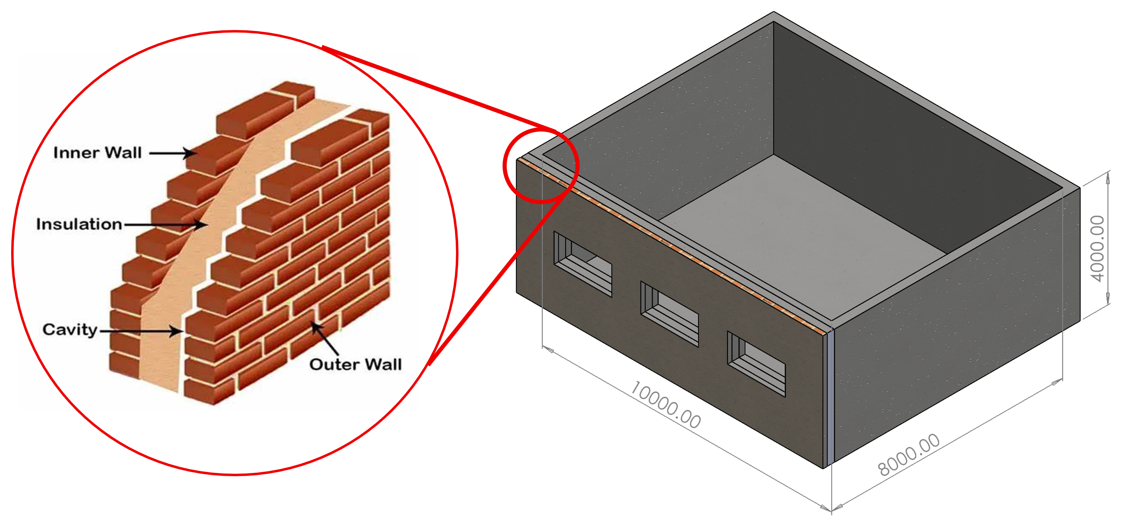
Figure 1 - Target and Construction [2]

Additional information from the customer dictated an energetic solution with a

System Design Process
All systems engineering is often based around a cyclical process that flows down through the various stages of the project in an iterative style. This method is often referred to in the project management as a mix between agile and waterfall.

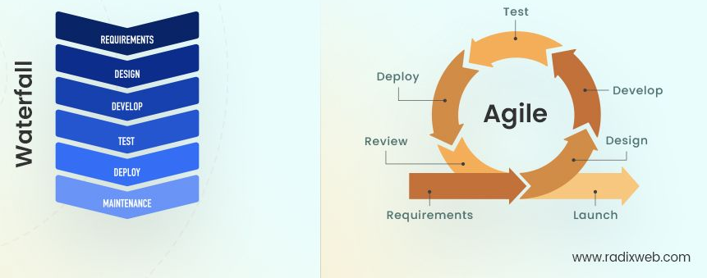
Figure 2 - Agile Vs waterfall [3]

Breaking down the stages for this project we will start with a given system level, define and evaluate requirements, develop functions and concepts before identifying the critical component. From here the same process will repeat for the identified critical component. This process would repeat for every component until sufficient detail is captured but due to time constraints for this project this was deemed excessive.

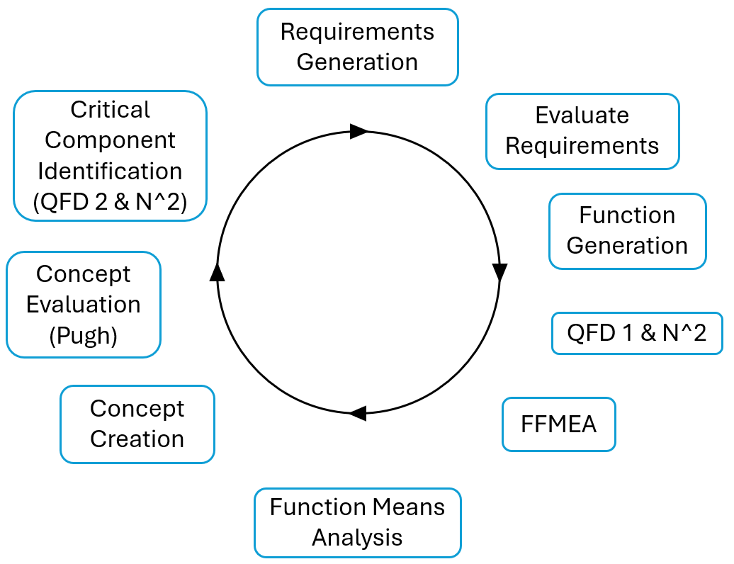
Figure 3 - Systems Process

Design Requirements
In the initial stages of any design exercise defining and detailing a good set of requirements is a critical step to ensure that all stakeholder needs are appropriately met, where possible. Without sufficient time and effort spent during the requirements phase greater time and cost will be required to rectify future issues that could have been designed out to begin with. The design team defined an initial set of stake holders using influence maps, affinity Diagrams and Boundary Maps. Which then supported all future requirement generation. The requirements generated for each of the relevant system levels can be seen in Annex A along with the associated Pairwise comparisons.

To best prioritize the requirements at each level, they were self-compared in a pairwise matrices. These matrices then provided the ranking for future use in QFD1’s

Functionality
Defining functionality for any new system is often a challenging task as without experience or guidance the functions created can often be over specific.

Table 2 below shows the functions derived for the relevant stages in this project. These functions are not perfect and could greatly be improved but where sufficient for this exercise. These functions where developed using a wide range of user experience as well as previous design and system understanding.

System | Missile SAU | SAU EBW
Arm Weapon | Provide PC Initiation | External Casing
Launch/ Release Munition | Provide FTB Initiation | Focus Shockwave
Arm Warhead | Safety Conformation | Provide Detonation
Identify Target | Electronic Circuit | Initiating Composition
Travel to Target | Protect Components | Bridge Wire
Pack down | Contain Components | Environmental Seal
Aim | FTB Interface
Reload | Sequential Safety Device 1 - Controller Safety Conformation
Neutralise Target | Sequential Safety Device 2 - Set back
Enter Target | Sequential Safety Device 3 - Time delay
Ready System | Receive Electronic Inputs
 | Delay Second detonation
 | Missile Structure Interface
 | Power Buffer
Table 2 - Functions

Concept Derivation and Design Selection
At each system level after defining the functions, the team used an ideation session to generate the set of functional means. This was a brain storming session simply used to generate possibilities for the functions. These could then be assembled to form solutions. These solutions where then listed as a series of options that where then evaluated initially through discussion and then through a Pugh diagram.

When initially eliminating options the same standard set of criteria where used, see Figure 4.

Figure 4 - Elimination Criteria

At the system level the below concepts where proposed. Options 2, 3 and 4 were taken forward and presented to the customer with option 3 being chosen as the favoured design.

Figure 5 - System Level Design Options

The next round of development focused on the key component of the missile, the SAU. 3 designs were proposed internally and option 3 was selected as the favoured choice through a Pugh Diagram

Figure 6 - SAU Design Options

In the last stage of development, the same design options process was used to define the manufacturing process for the Exploding bridge wire in the EBW. This step formed the initial stage of defining the manufacturing process.

Figure 7 - EBW Manufacturing Process Selection.

At the end of these design cycles the basic system architecture was defined and broad designs where in place to allow for the full design process to take place.

Once the final option was selected for each system level a Functional Failure Modes Effects Analysis (FFMEA) was used to identify possible failure modes and appropriate detection or prevention methods that could then either be integrated into the design or mitigating process. These can be found at Annex E.

System Architecture and Critical Components
The chosen system can be broken down into a series of component parts and subsystems. At the weapon level the system is made of 3 core components; Command and Launch Unit (CLU), Telescopic Missile Tube (TMT) and Missile shown in Figure 8 respectively. the assembled system is shown in Figure 9. Of the three core components the Missile is deemed to be the most critical component and where the future development and focus is placed.

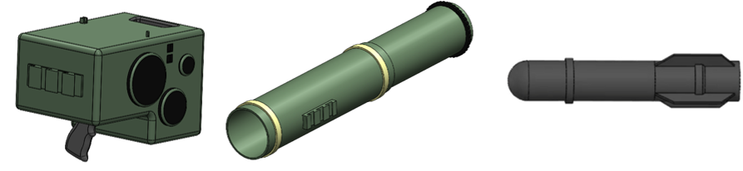
Figure 8 - CLU, TMT, Missile

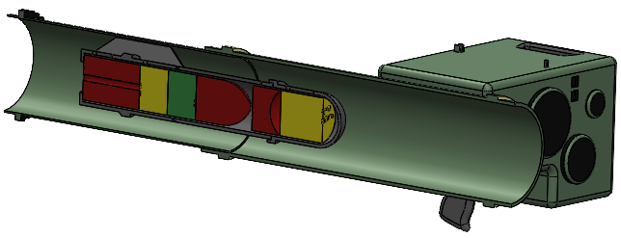
Figure 9 - Weapon System Assembled

Breaking down the Missile into its core components it is made up from a Case, Rocket Motor, Weapon Controller, Safety and Arming Unit, Lethal Package and Guidance Control Unit. Using a QFD 2 the Safety and Arming Unit (SAU) was determined to be the most critical component within the missile.

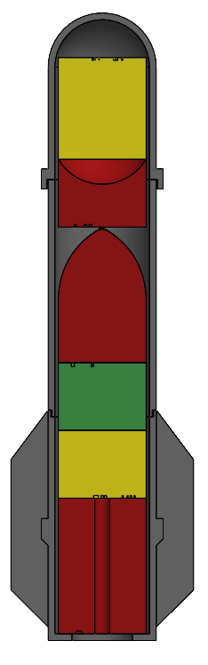
Figure 10 - Missile Cross Section
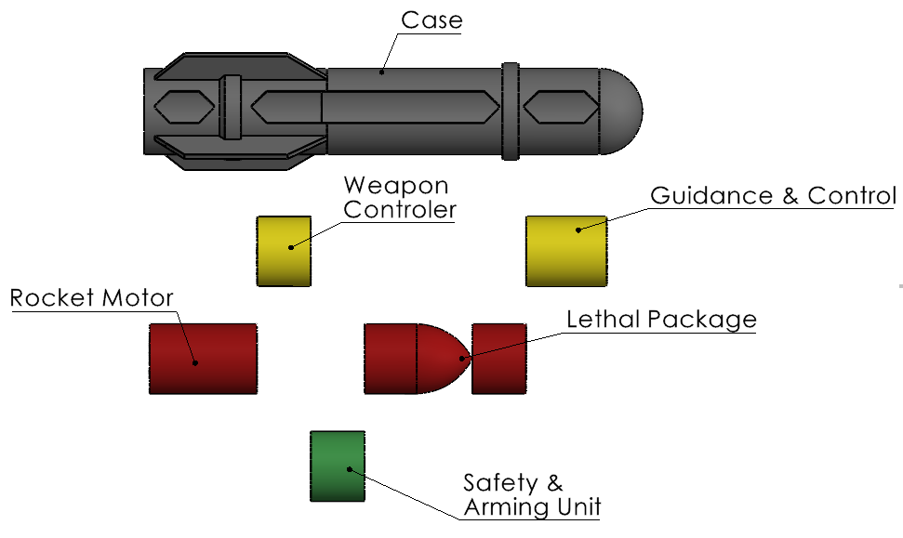
Figure 11 - Missile Component Breakdown

Whilst the full design for the SAU is yet to be determined and finalised broad functionality and sub systems/ components could be determined from current in-service examples below.

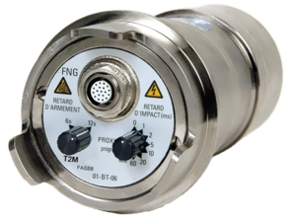
Figure 12 - Thales FBM21 [4]

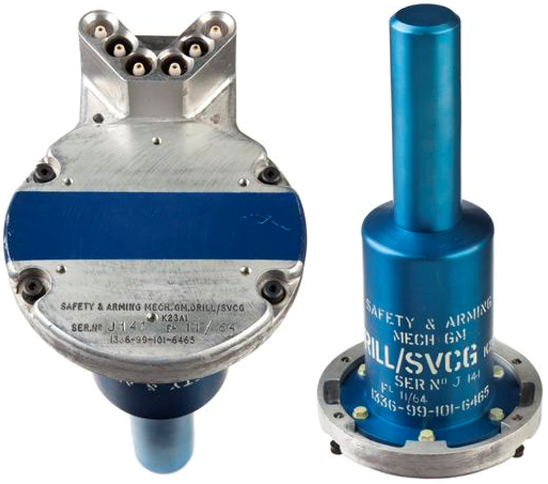
Figure 13 - Ferranti AAM [5]

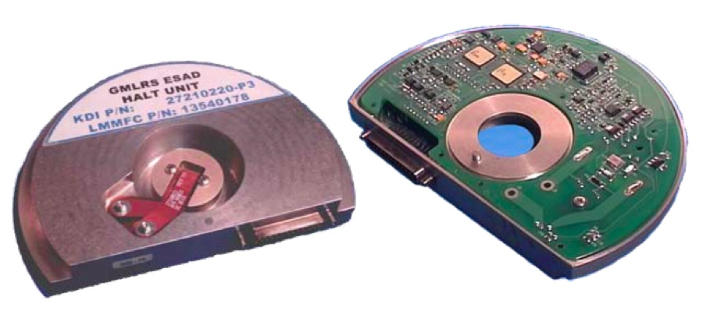
Figure 14 - GLMRS HALT Unit [6] [7]

This research allowed for the determination of a standard set of functions that the SAU required. Of which the initiator that translates electrical signal in to a detonative shock wave was identified as the key component. The chosen solution for this component was an Exploding Bridge Wire (EBW) detonator as shown in Figure 15.

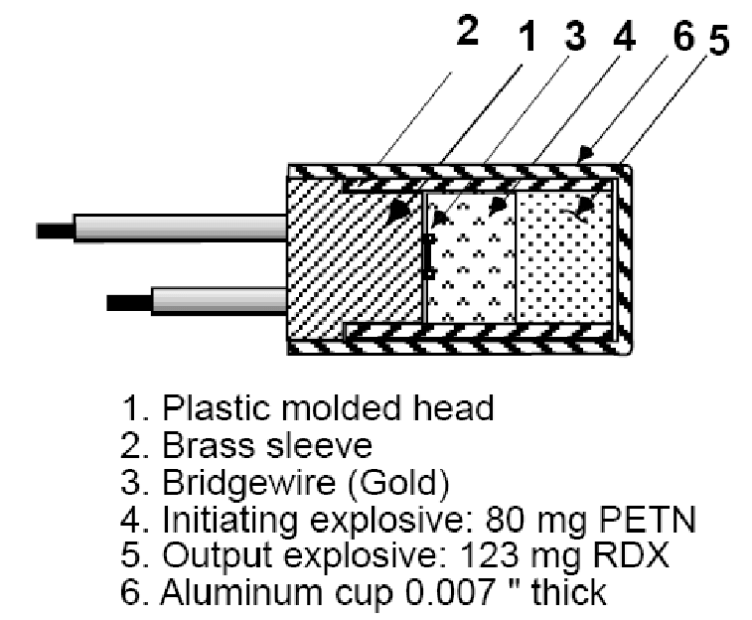
Figure 15 - EBW Detonator [8]

At this stage of the project, it was determined though that it was possible to keep going down the subsystem route and further defining design choices, this stage of development provided sufficient detail.

The final critical component architecture can be seen in Figure 16.

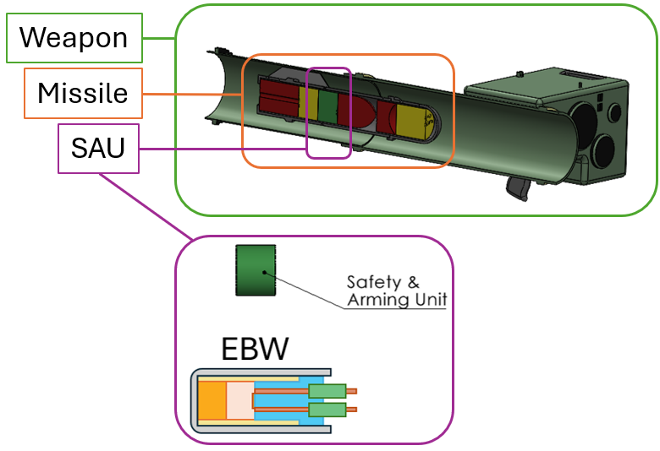
Figure 16 - Critical Component System Architecture

Manufacturing Route
The manufacturing route was defined by team member D as they volunteered to represent the manufacturing role within the team. As with the other system levels for the manufacturing aspect of this task the engineer decided to focus on the most important energetic component within the SAU. This was determined to be the EBW and within the EBW the EBW the Primary Initiation Pellet (PIP) was the most critical component.

To manufacture the PIP the broad process flow shown below is used. It outlined the broad steps and stages that occur to take the raw energetic material to the finalised pellet ready for further inclusion into the EBW.
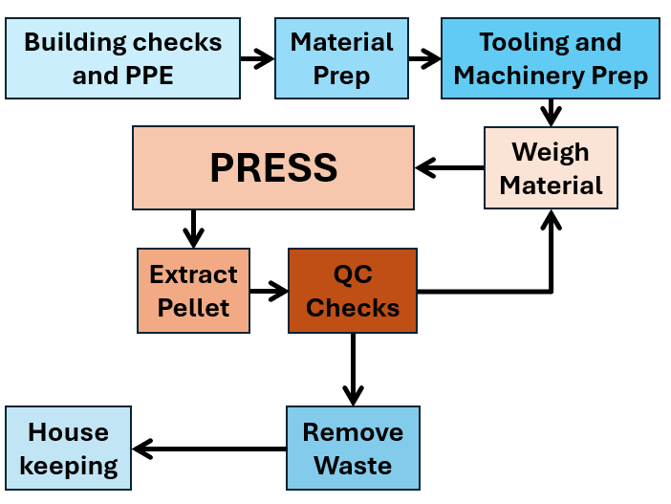
Figure 17 - PIP Manufacturing Process Flow

Test and Evaluation.
The Test and Evaluation (T&E) programme was drafted by the author, team member C. As with the manufacturing plan, it was determined that limiting the scope of the testing plan to that of the SAU rather than the whole set of Safe and Suitable for Service requirements would be beneficial and would best allow for detail to be captured without an excessively wide scope. The T&E programme for Safe, Arming and Functioning Devices is defined in the requirements of STANAG 4157 and AOP 20. These standards detail the sequence of tests that must be performed and the results that must be achieved for qualification to be granted. The full T&E plan can be found at Annex B

Though the (T&E) plan forms the qualification requirements for the SAU, it can also be used by manufacturers to support development and evaluate design decisions. For example, the D9 test will effectively test the performance of the EBW and energetic train to provide validation of the manufacturing process. The SAU testing will form a critical part of the Safe and Suitable for Service (S3) requirement that the MOD has for any new item coming into service.

Noises and controls
Noises and their associated controls are critical to any product. Noises can have an impact at any stage from design to manufacturing, use or disposal. With complex munitions such as missiles, unmitigated noises are often not fully experienced until many years later when their results are finally present or made obvious. This is why it is vital that at an early stage of design as many effective controls are made to mitigate known noises. In the example of this munition ensuring that the energetics used within the EBW are stable and have a known stabiliser consumption rate will allow for the effective predicting of SAU life and therefore allow for a stockpile to be effectively maintained without excessive Surveillance and Life Extension (SALE) on the inherently sensitive initiating systems.

Conclusion

In conclusion the design solution presented at Annex D has been designed and evaluated to be the most logical option for the customer, it effectively balances the requirements and delivers the designed effect. Although only the preliminary designs have taken place for the critical components, the initial stages of the design have demonstrated that the continued development should yield an effective product. The works conducted demonstrates how the effective use of the systems engineering tool set will guide, inform and document the clear process steps taken to achieve the end result. This not only allows for effective though life communication but also provides clarity and evidence to the customer on the reliability of the design solution and how changes in requirements could affect the chosen design.

References

[1] | UWTSD Lecturer, “L5 - Systems Engineering & Work-Based Group Project (ACDA5021&ACDA5022),” [Online]. Available: https://moodle.uwtsd.ac.uk/mod/resource/view.php?id=650673. [Accessed 25 05 18].
[2] | M. Faisal, “What is a cavity wall?,” archup, 24 12 2023. [Online]. Available: https://archup.net/cavity-wall-en/. [Accessed 05 18 2025].
[3] | P. Palkhiwala, “Waterfall vs Agile: What to Know Before Choosing Your Development Method,” 2023 08 25. [Online]. Available: https://radixweb.com/blog/waterfall-vs-agile. [Accessed 26 05 2025].
[4] | Atlantis Corperation, “FBM21 multifunction bomb fuze available from Atlantis Aviation,” 07 08 2014. [Online]. Available: https://www.defenceweb.co.za/company-zones/atlantis-corporation/vpo-atlantis-corporation-fbm21-multifunction-bomb-fuze-available-from-atlantis-aviation/. [Accessed 25 05 2025].
[5] | Science Museum Group, “Air-to-Air Missile Safety and Arming Unit. Y1996.10.1147.1 Science Museum Group Collection Online.,” [Online]. Available: https://collection.sciencemuseumgroup.org.uk/objects/co8410477/air-to-air-missile-safety-and-arming-unit.. [Accessed 25 05 2025].
[6] | Kenshirriff, “1552723873837318144,” 28 07 2022. [Online]. Available: https://x.com/kenshirriff/status/1552723873837318144/photo/1. [Accessed 25 05 2025].
[7] | KDI Precission Products, “43rd Gun & Missile Conference,” 04 2008. [Online]. Available: https://ndia.dtic.mil/wp-content/uploads/2008/gun_missile/6484KurtzWilliam.pdf. [Accessed 25 05 2025].
[8] | M. Bowden, “Characterization of Detonator Performance Using Photonic Doppler Velocimetry,” in SPIE - The International Society for Optical Engineering, 2008.
[9] | R. B. S. G.-L. E. a. Elie Allouis, “A FACILITY FOR THE VERIFICATION & VALIDATION OF ROBOTICS & AUTONOMY FOR PLANETARY EXPLORATION,” in Advanced Space Technologies in Robotics and Automation (ASTRA), Noordwijk, The Netherlands, 2013.
[10] | A. Hendricks, “Which Stakeholder Mapping Method Should You Use?,” simplystakeholders, [Online]. Available: https://simplystakeholders.com/stakeholder-mapping/. [Accessed 04 01 2024].
[11] | P. Landau, “What Is a Stakeholder? Definitions, Types & Examples,” projectmanager, 20 Mar 2022. [Online]. Available: https://www.projectmanager.com/blog/what-is-a-stakeholder. [Accessed 04 01 2024].
[12] | Collins Dictionary, “requirement,” Collins Dictionary, 2024. [Online]. Available: https://www.collinsdictionary.com/dictionary/english/requirement. [Accessed 04 01 2024].
[13] | M. W. K. &. T. E. Adams, The SAGE Encyclopedia of Communication Research Methods, SAGE Publications, Inc, 2017.
[14] | D. Kyne, “Pairwise Comparison (Definition, Methods, Examples, Tools),” OpinionX, 23 May 2023. [Online]. Available: https://www.opinionx.co/blog/pairwise-comparison. [Accessed 05 01 24].
[15] | Quality One, “Quality Function Deployment (QFD),” Quality-One, [Online]. Available: https://quality-one.com/qfd/. [Accessed 05 01 2024].
[16] | Rockwell Automation, “Functional failure mode and effects analysis (FFMEA),” FIIX, [Online]. Available: https://fiixsoftware.com/glossary/ffmea/. [Accessed 05 01 2024].
[17] | D. S. Burge, “Pugh Matrix (PM),” in The Systems Engineering Tool Box, Rugby, Burge Hughes Walsh, 2009, pp. 1-15.
[18] | UWTSD, “L5 - Systems Engineering & Work-Based Group Project (ACDA5021&ACDA5022),” [Online]. Available: https://moodle.uwtsd.ac.uk/course/view.php?id=12137. [Accessed 04 04 2025].

Annex A – Requirements

System Requirements
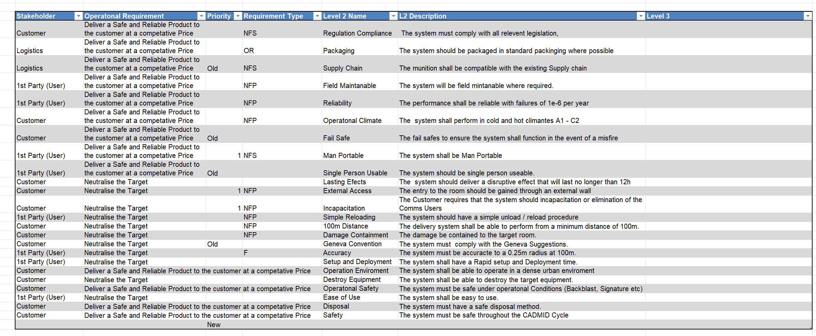

System Pairwise

SAU Requirements
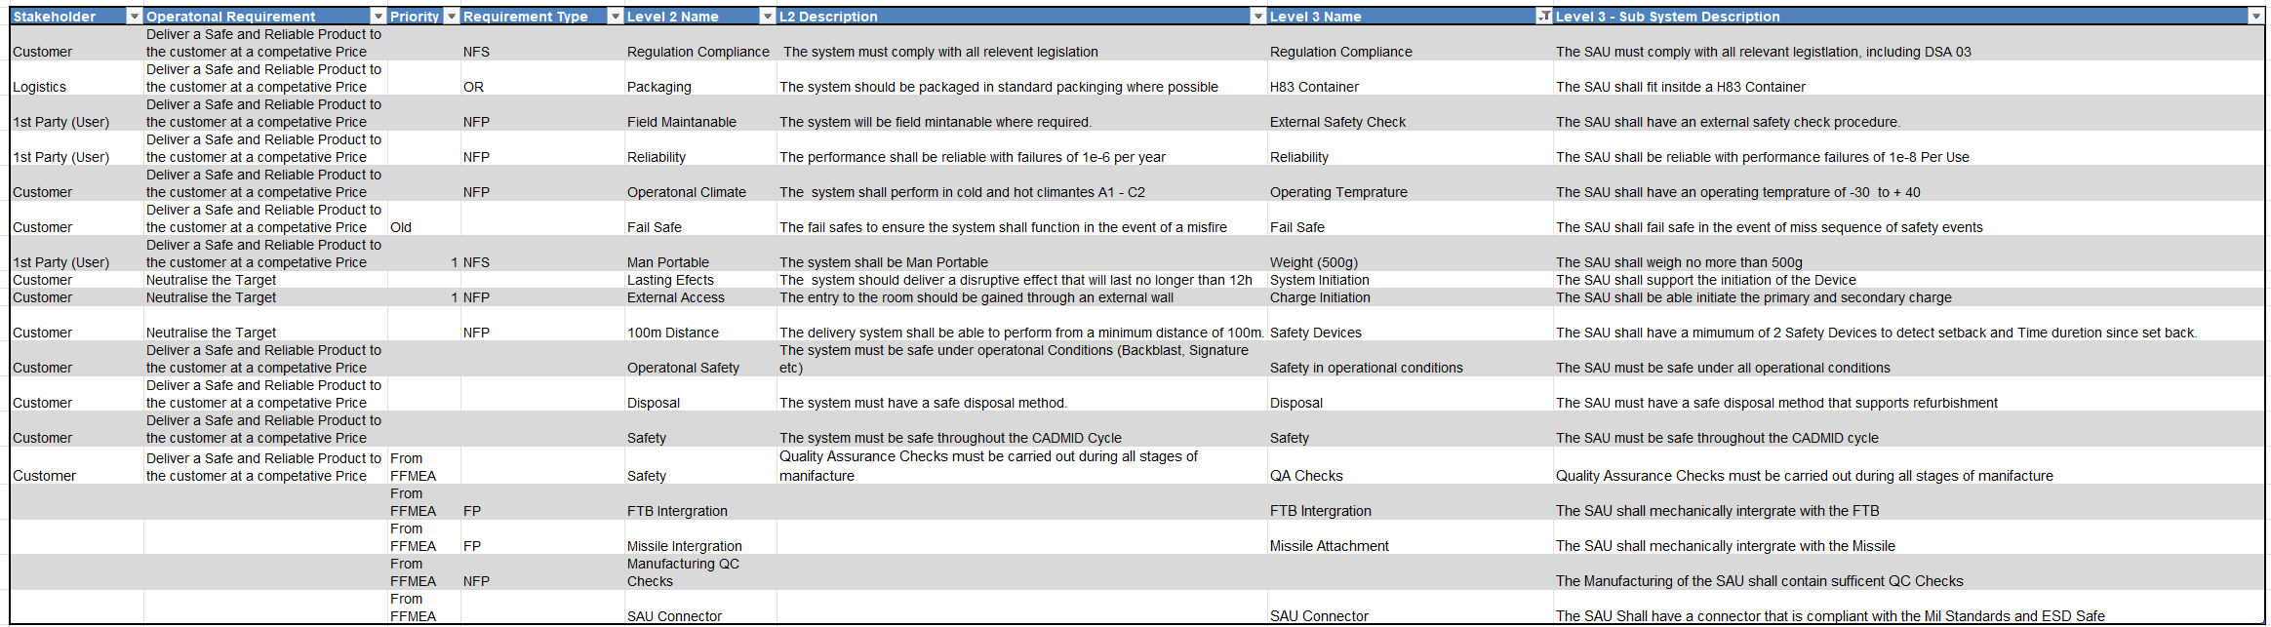

SAU Pairwise

Test and Evaluation Requirements

Test and Evaluation Pairwise
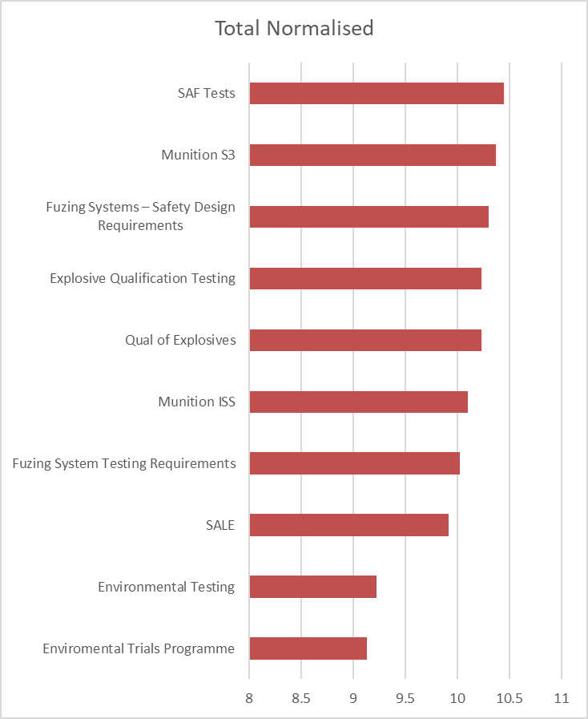

Annex B – SAU Test and Evaluation Plan
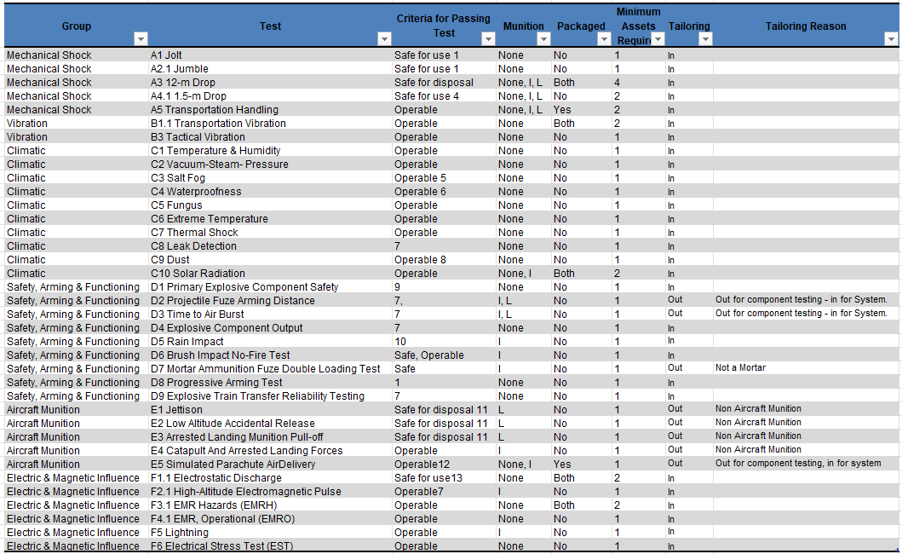

Annex C – Team Structure and Work Breakdown

Student Number | Initials | Member Order | Role
2217522 | GJ | A | Research and Development
2222538 | LJ | B | System Safety
2207149 | CH | C | Test and Evaluation
2219350 | DG | D | Manufacturing
2223157 | RM | E | Process Safety
2224230 | LG | F | Disposal

Annex D – Final Presentation

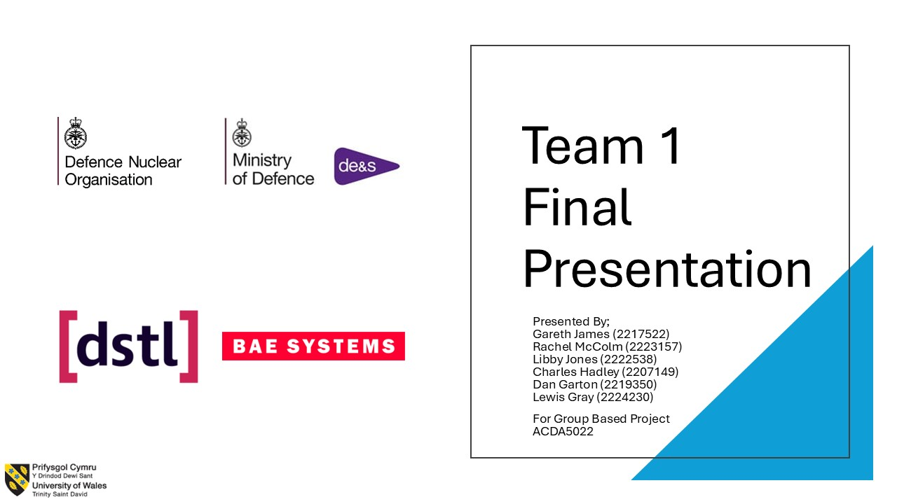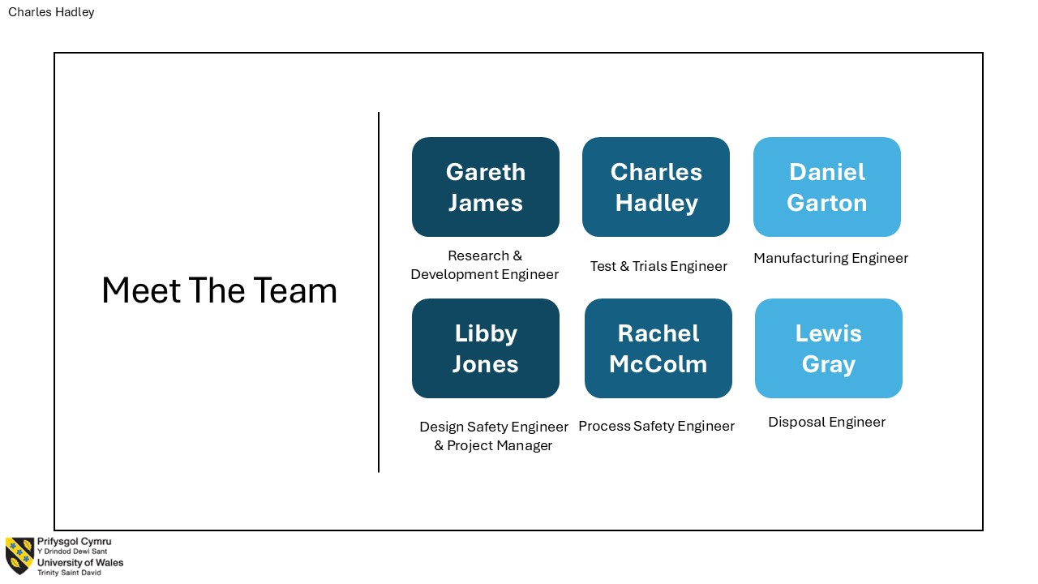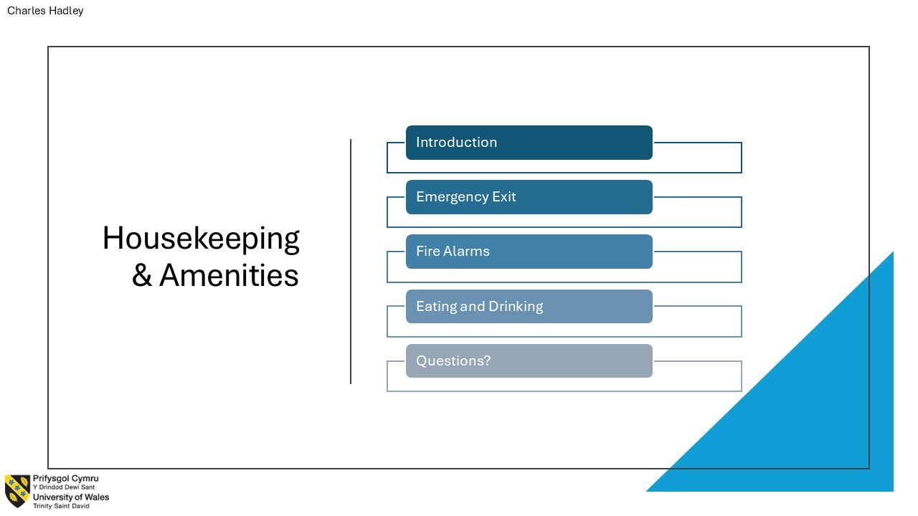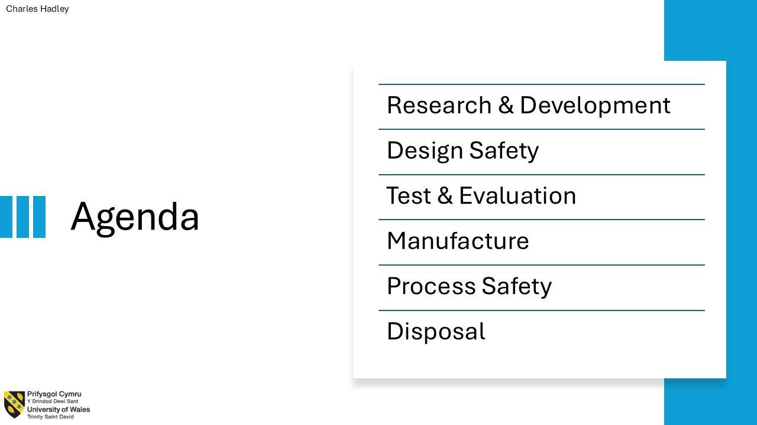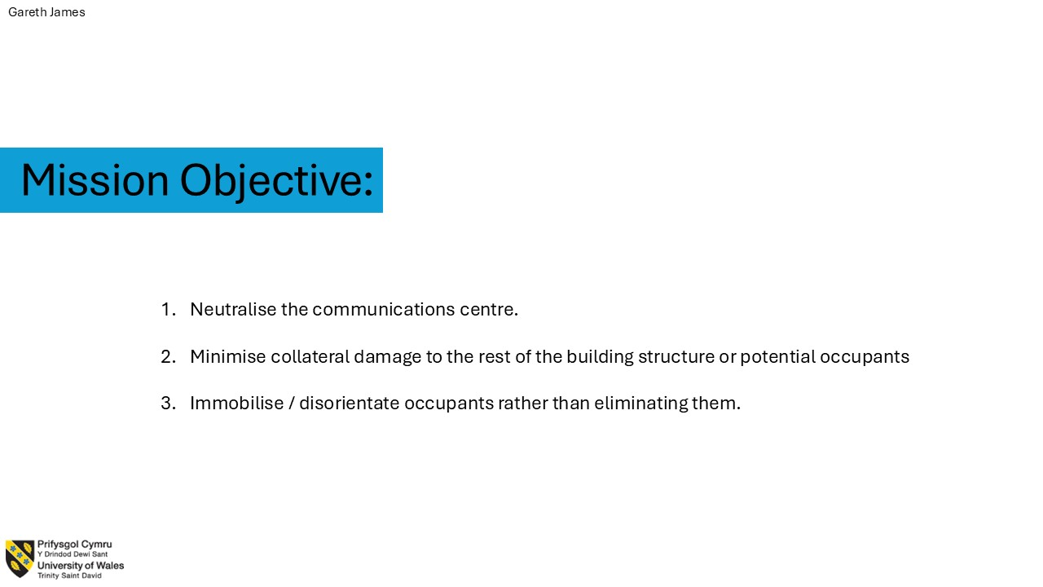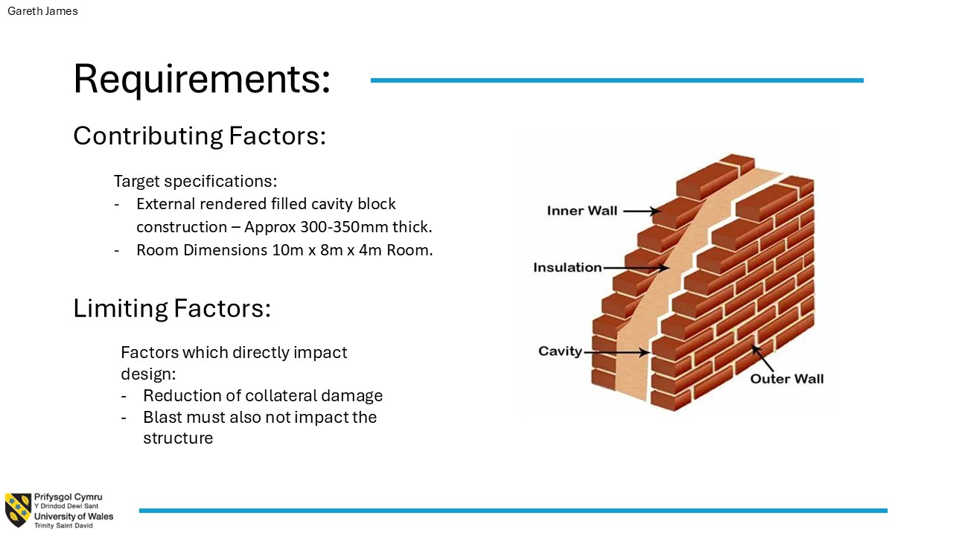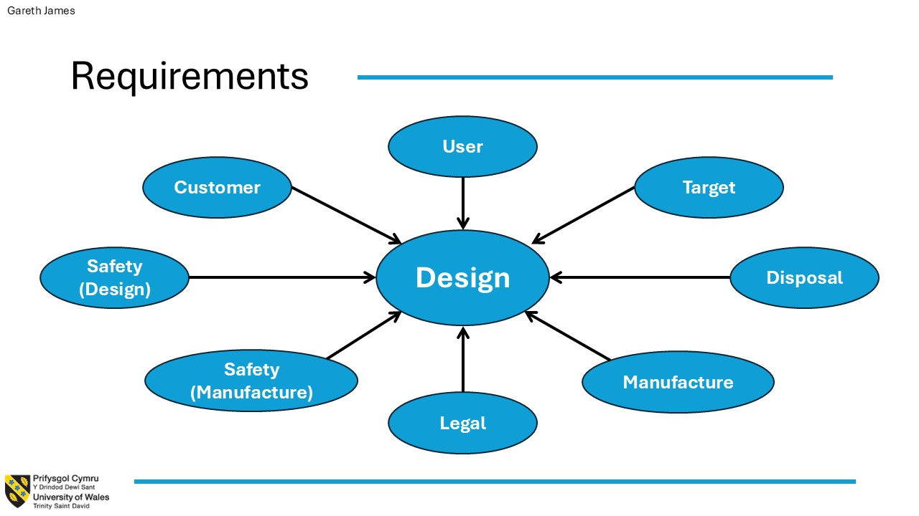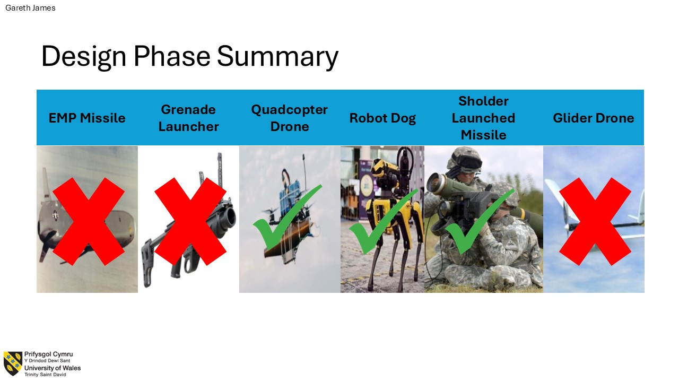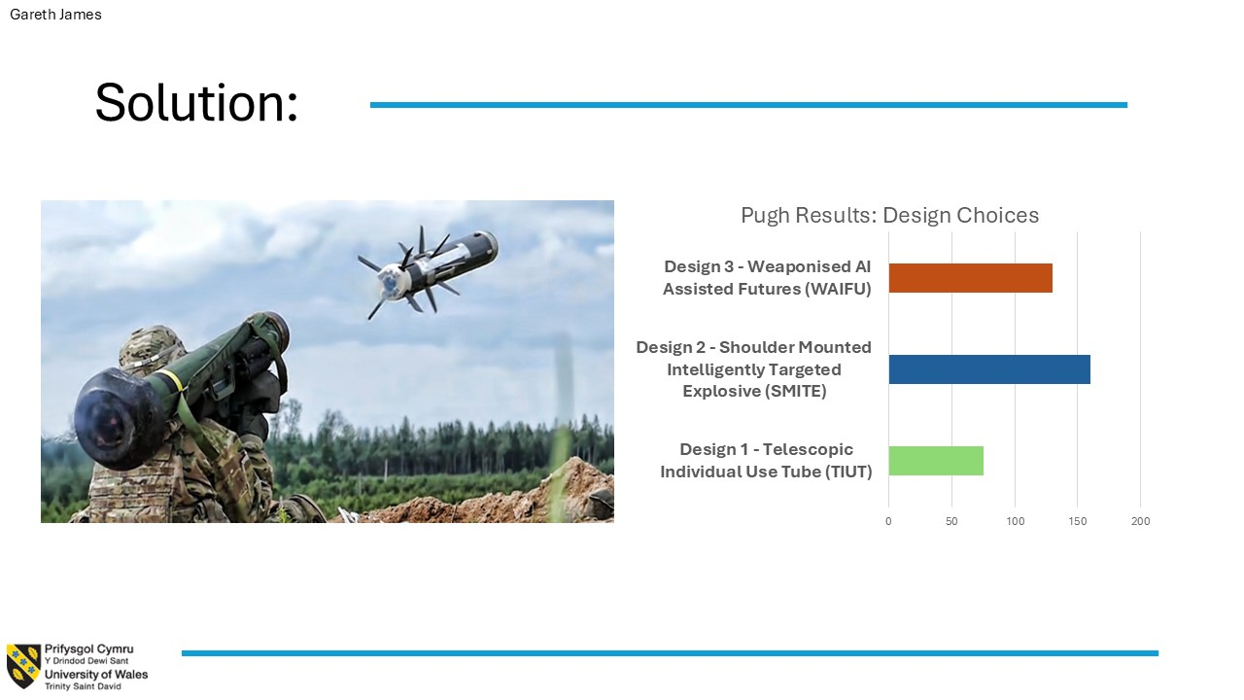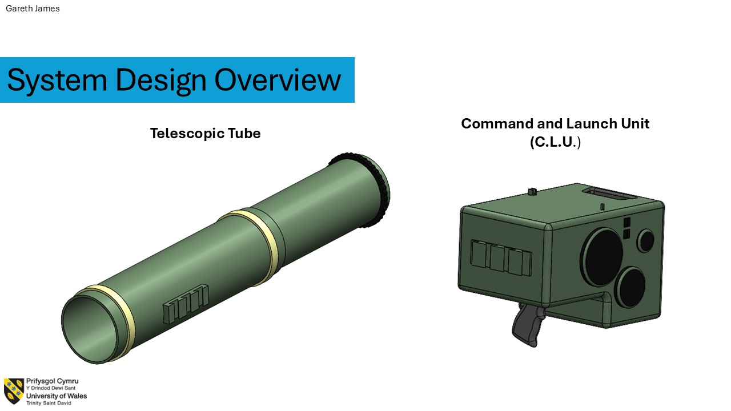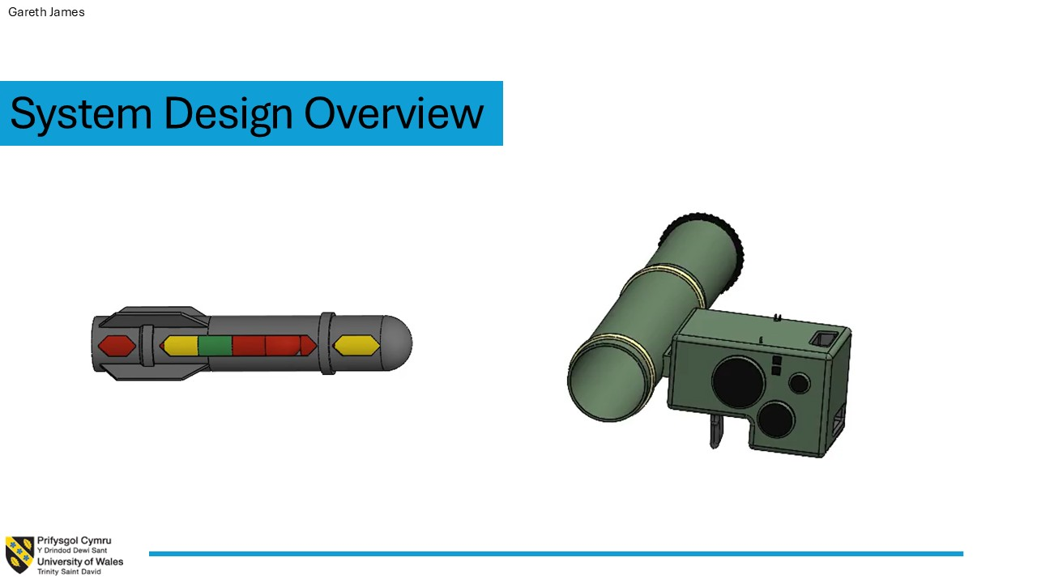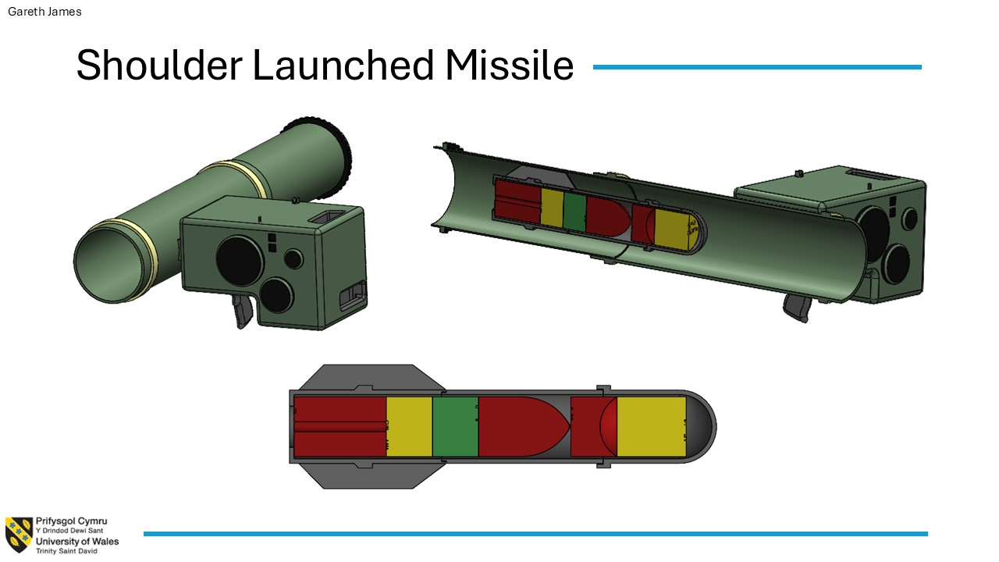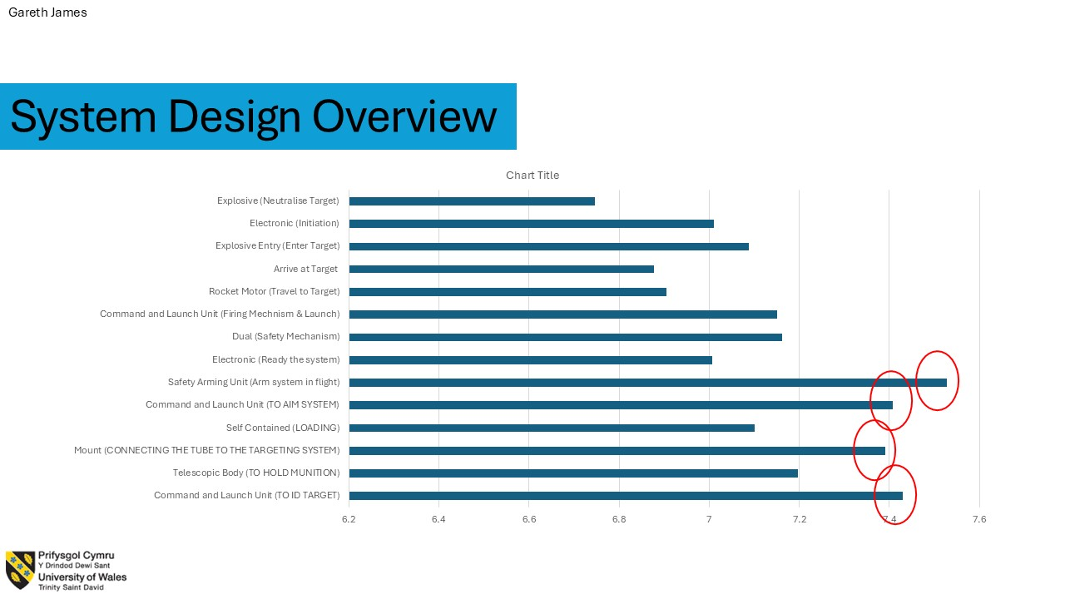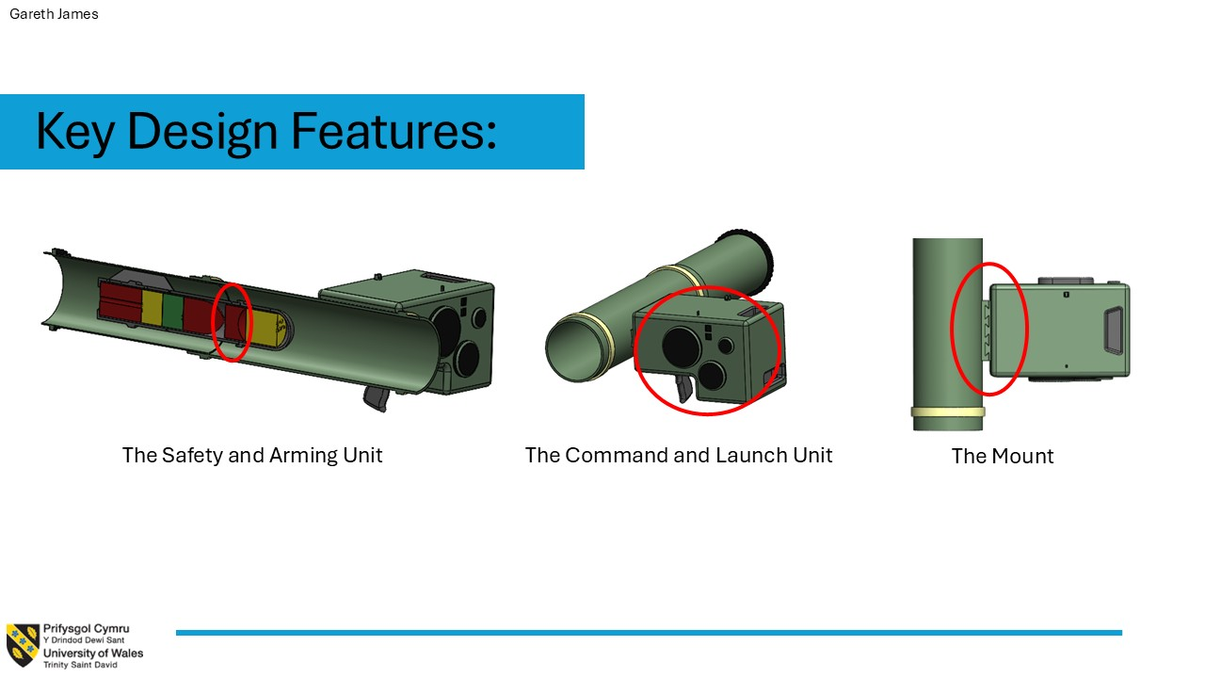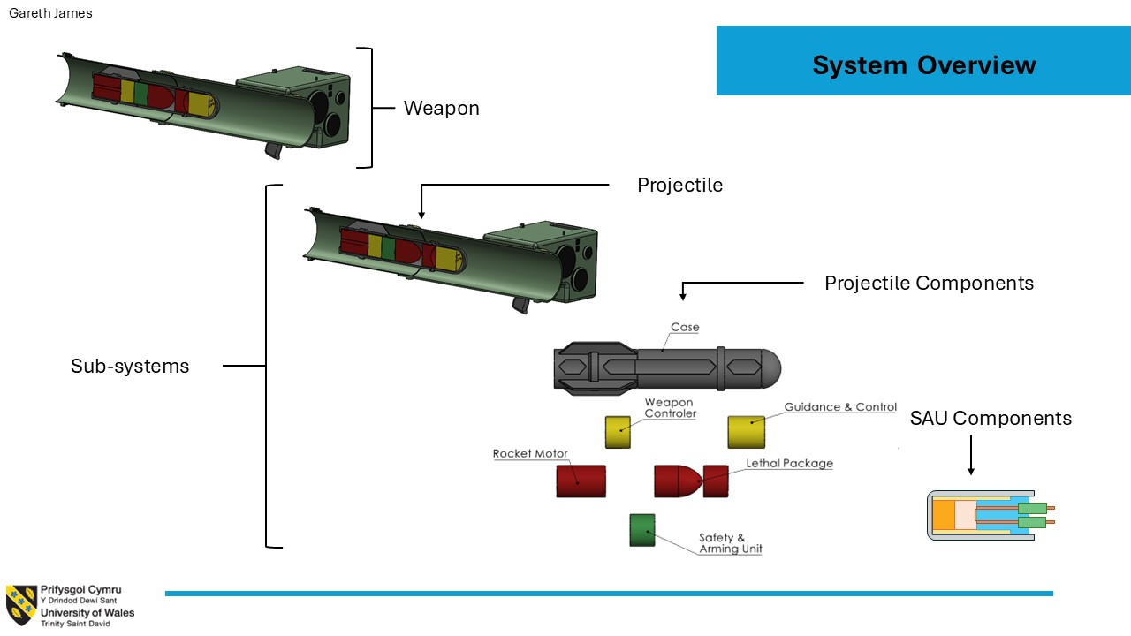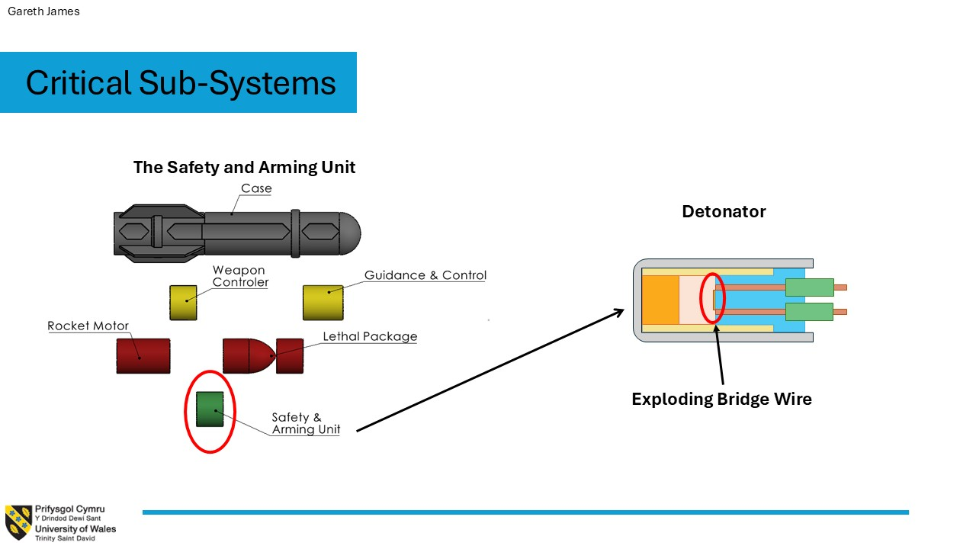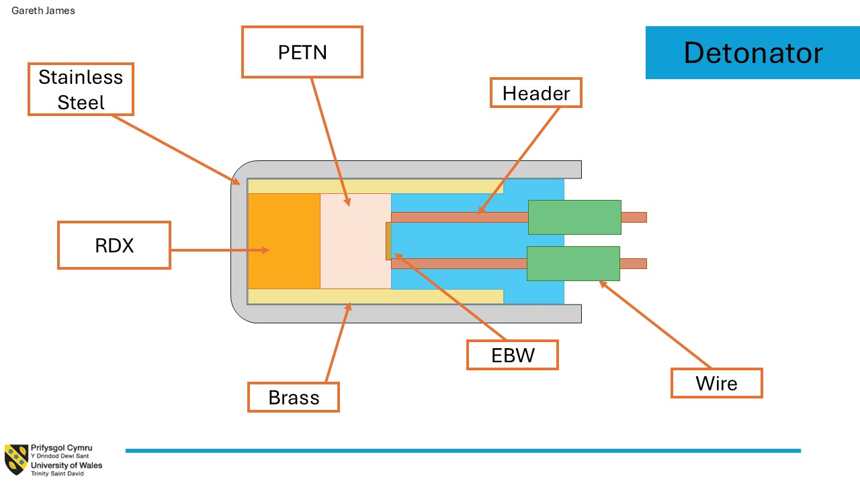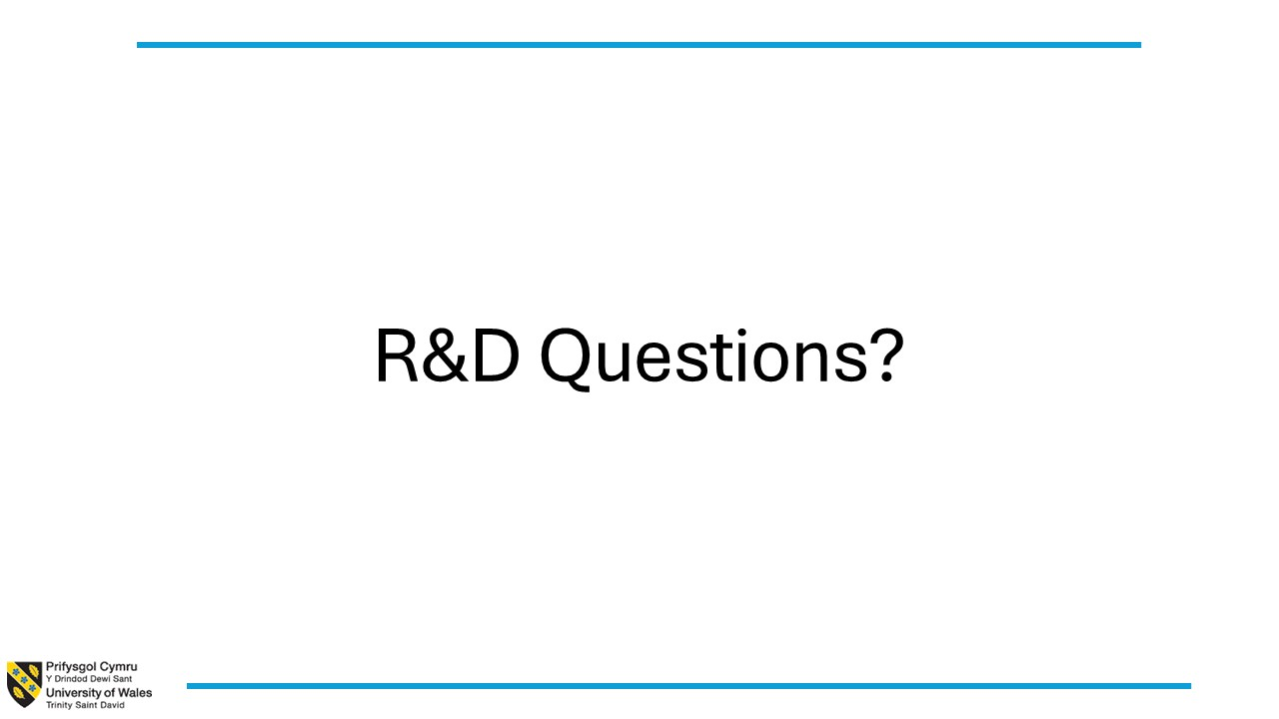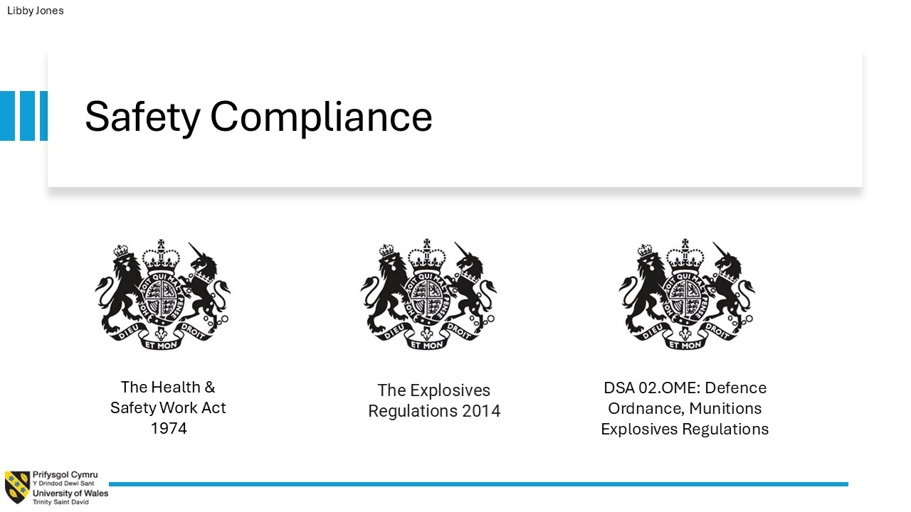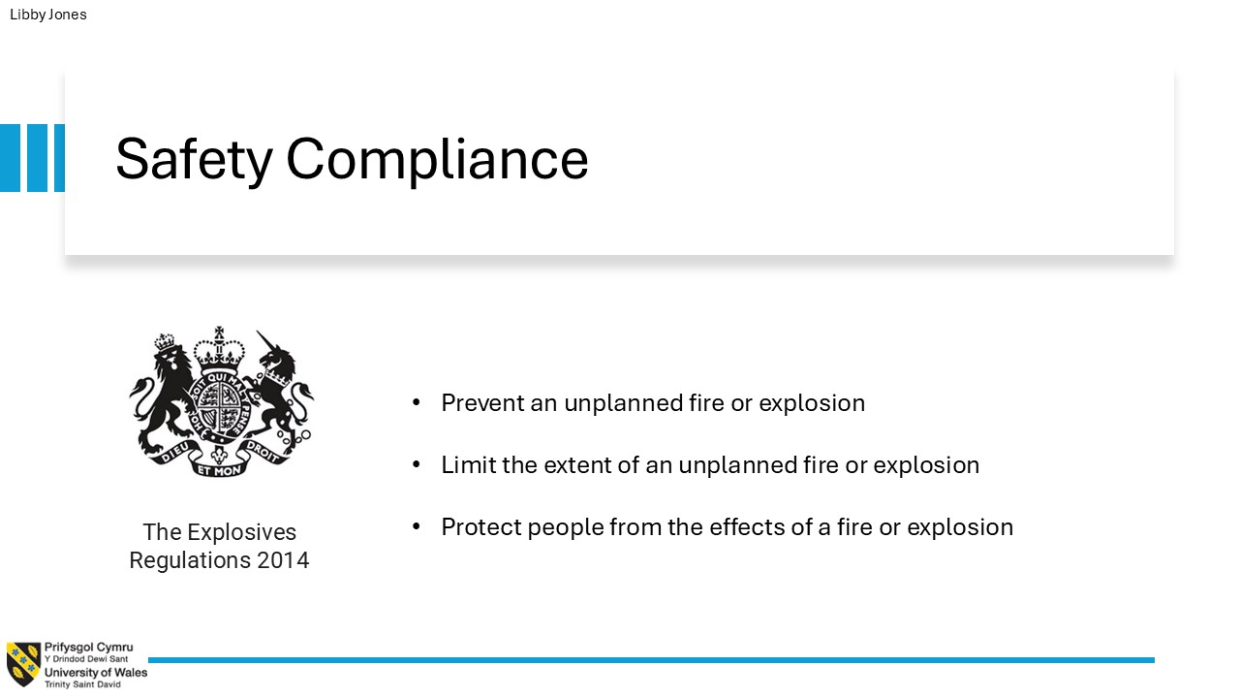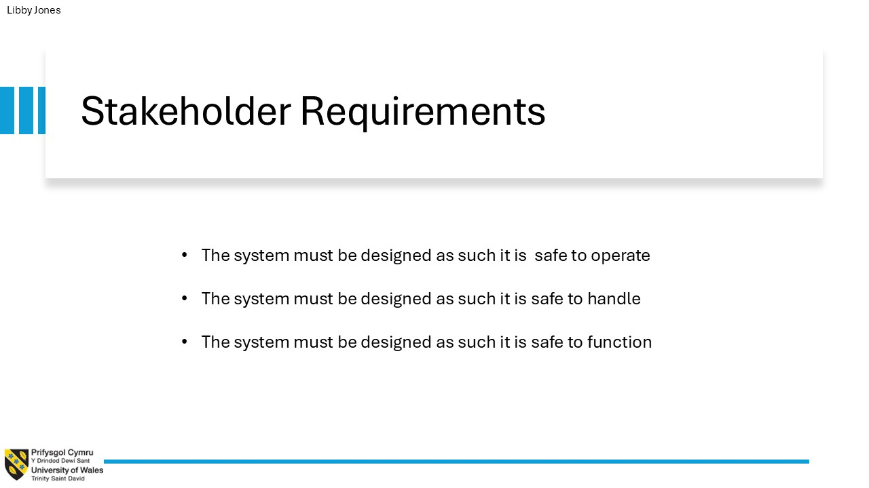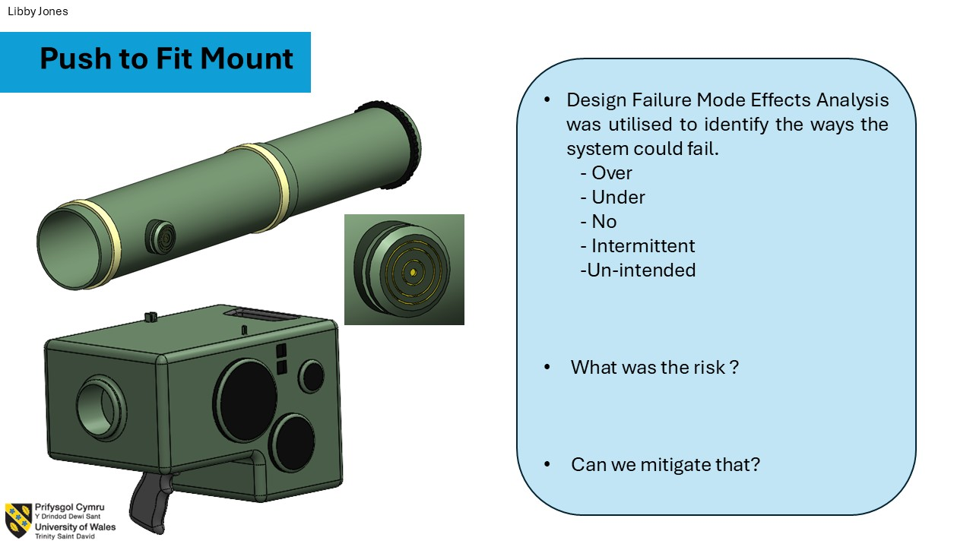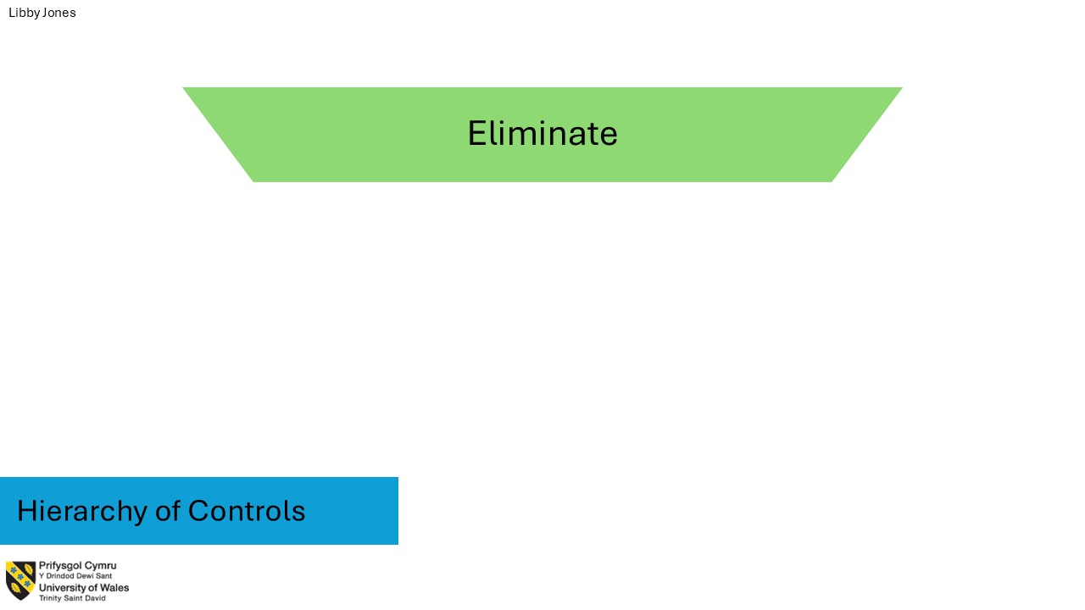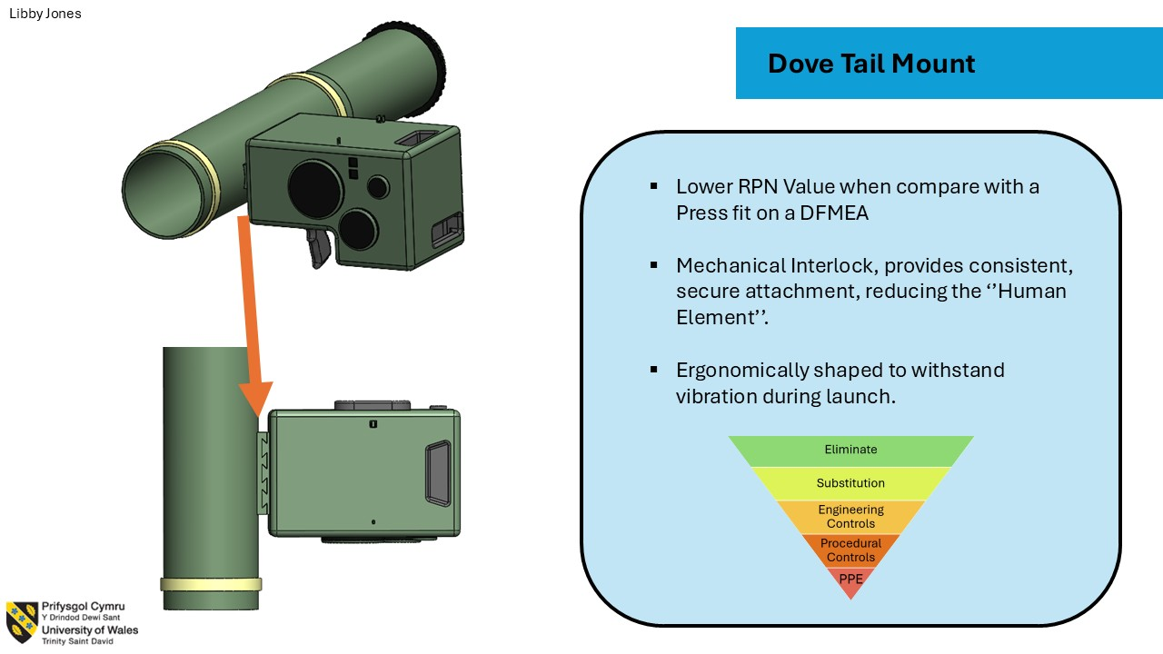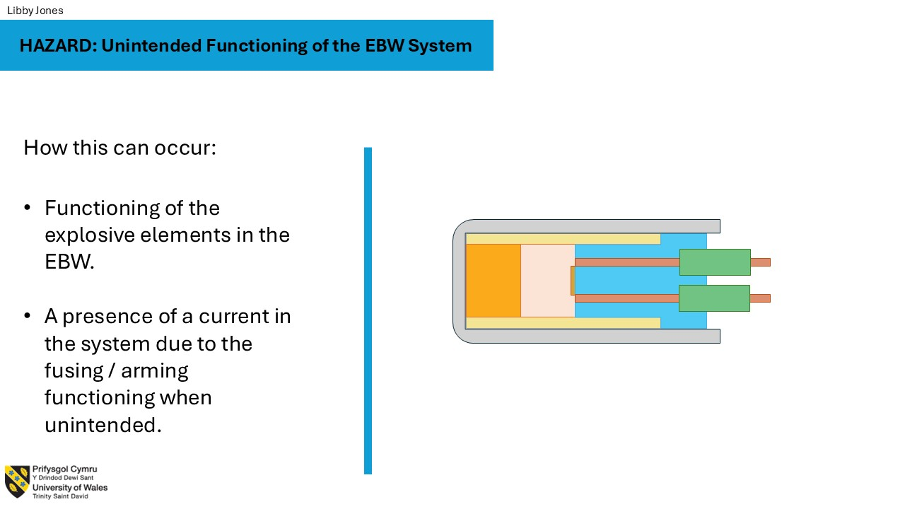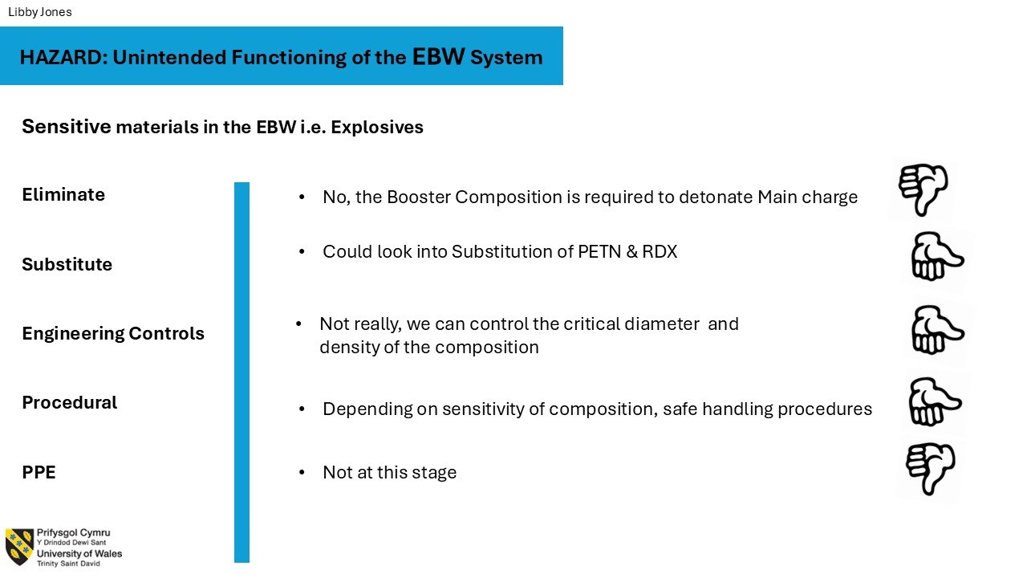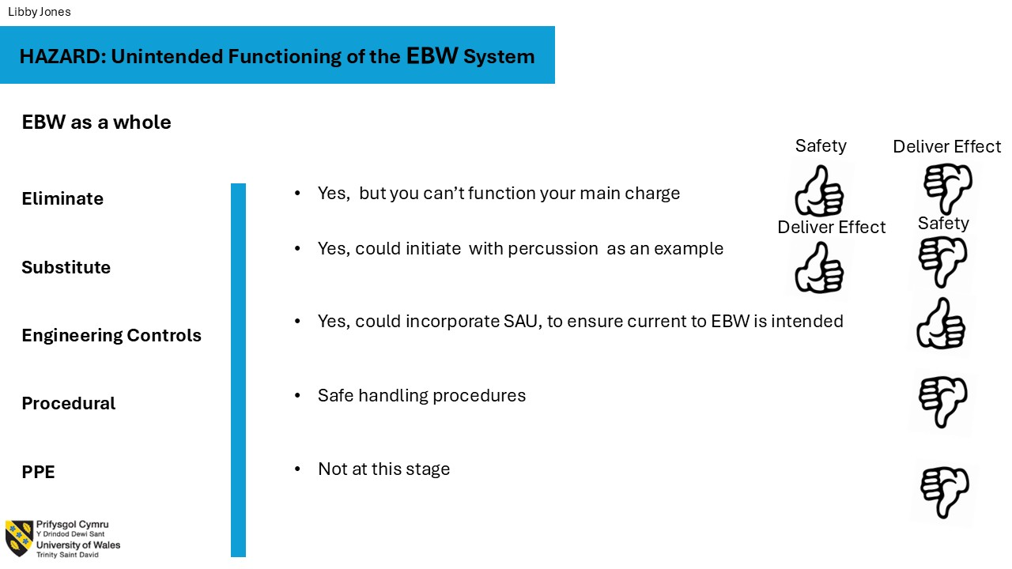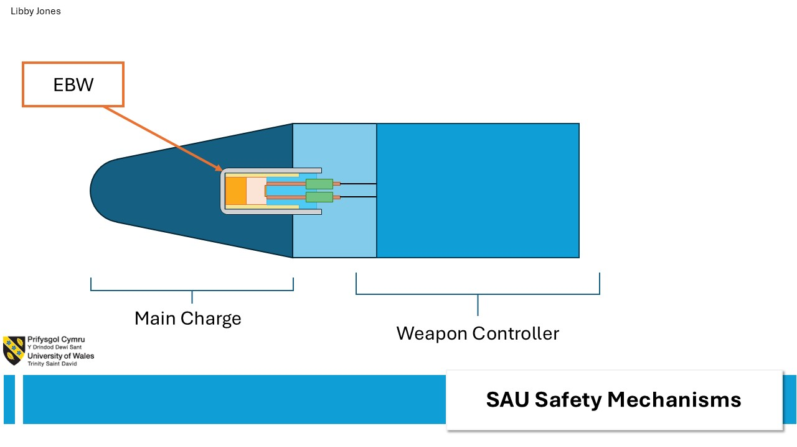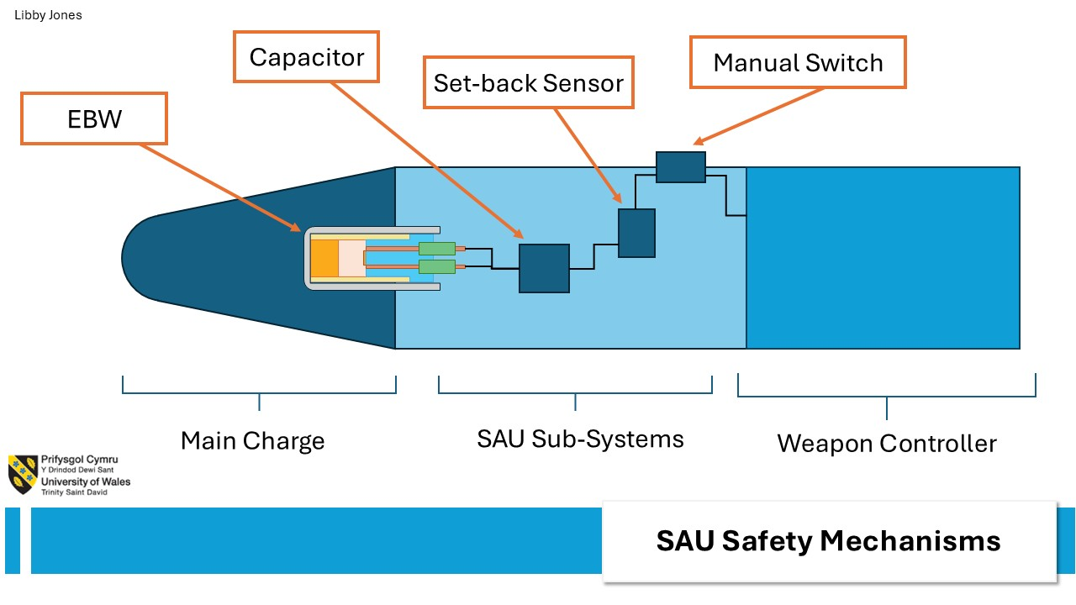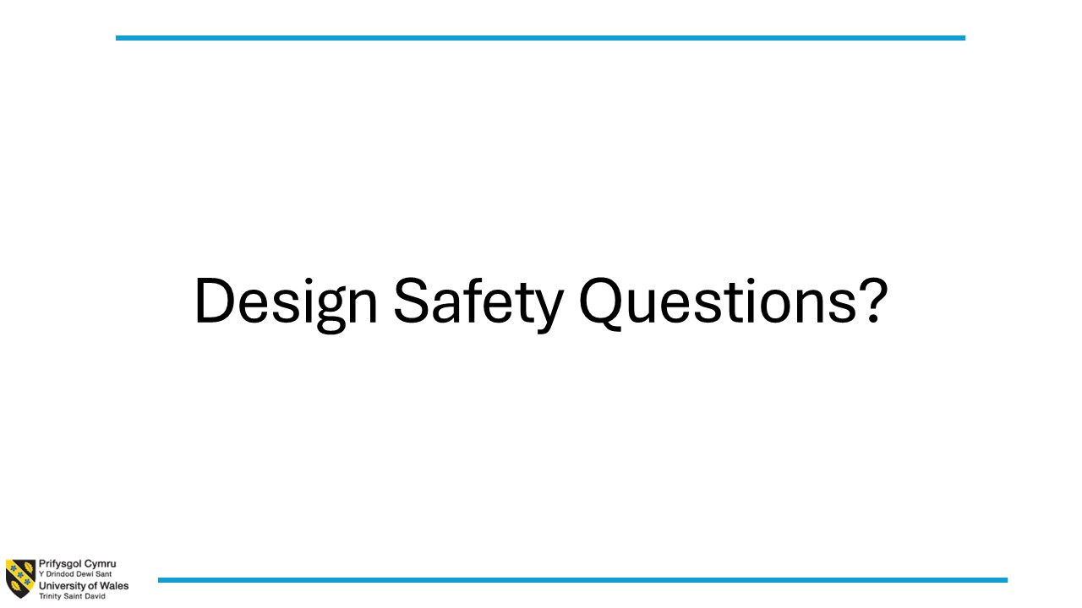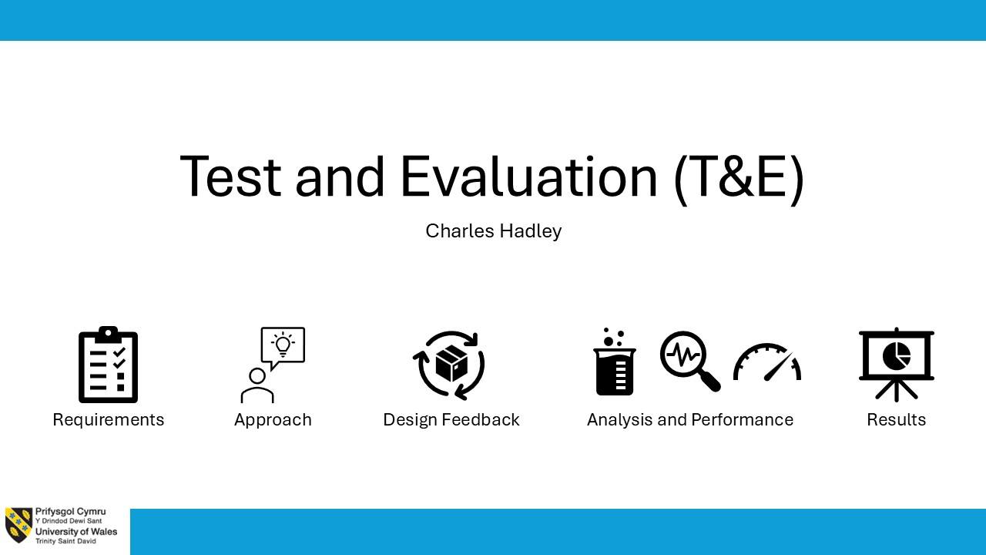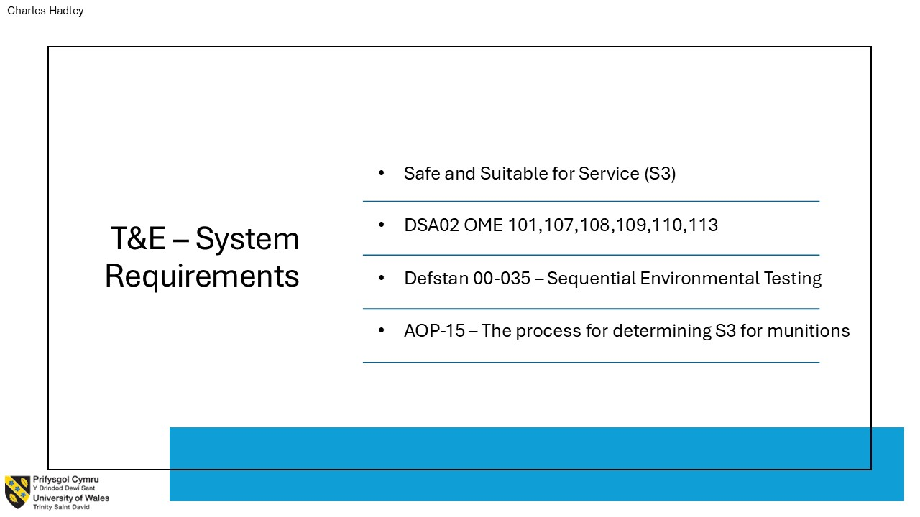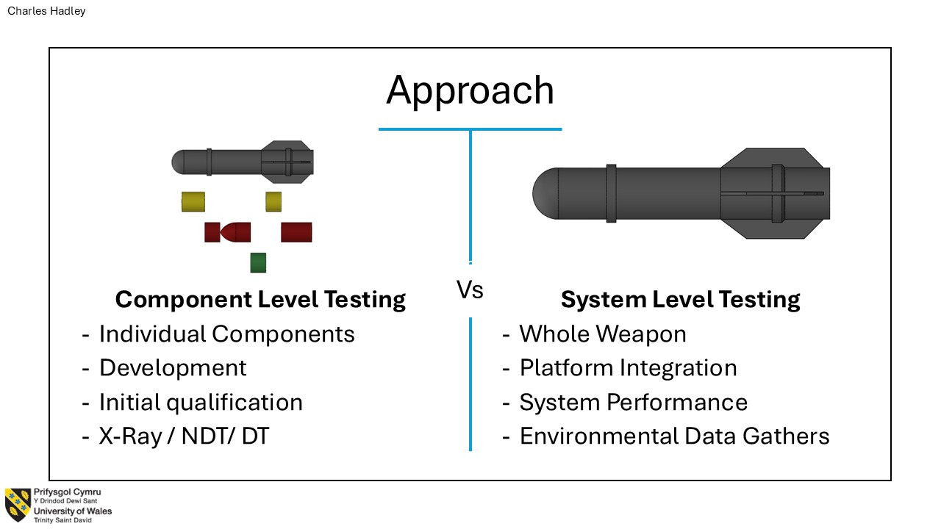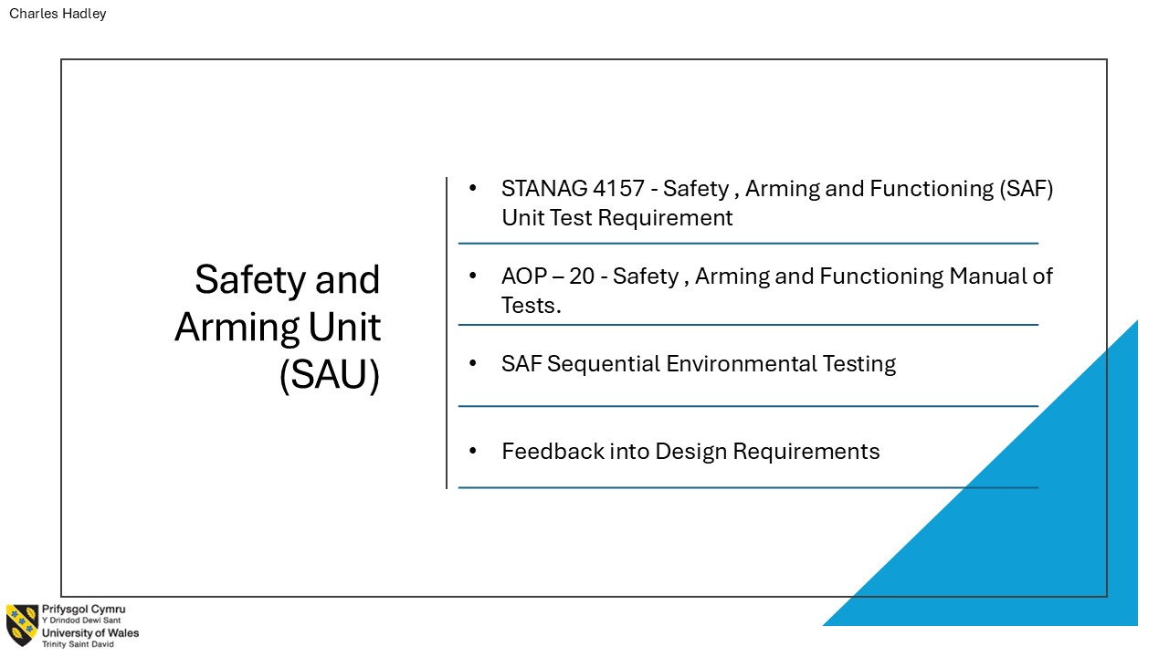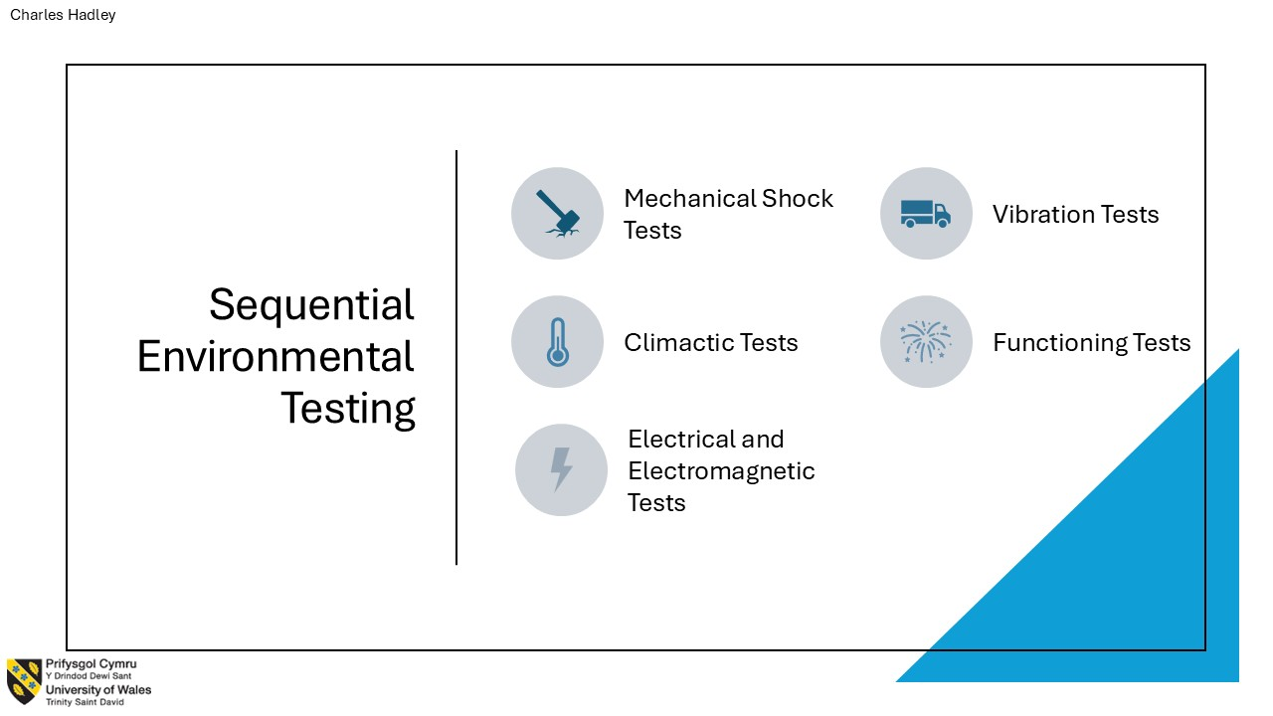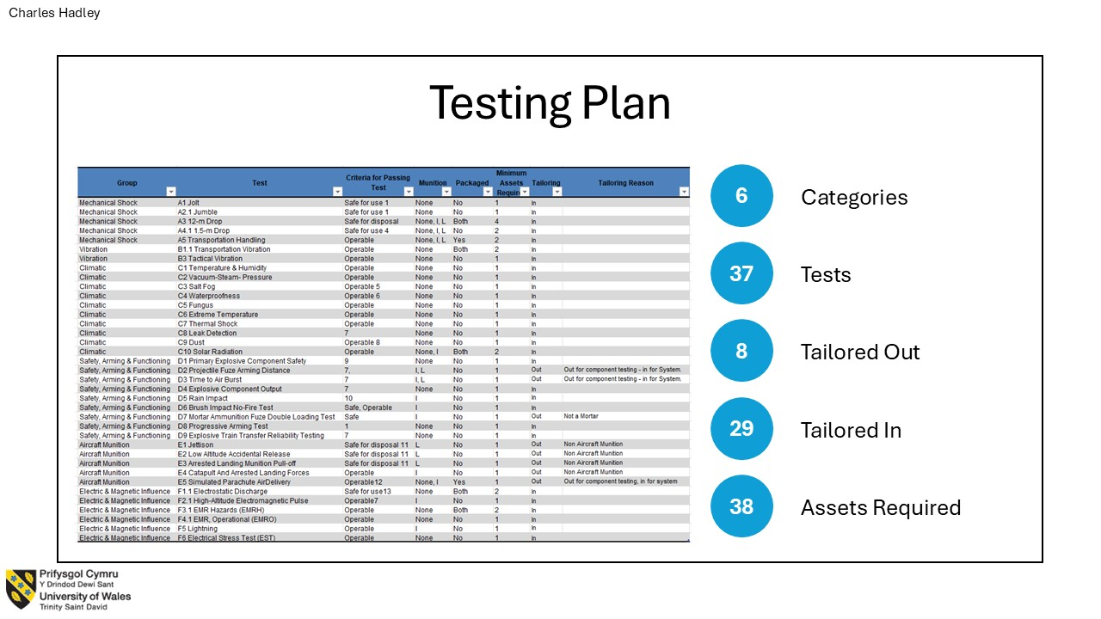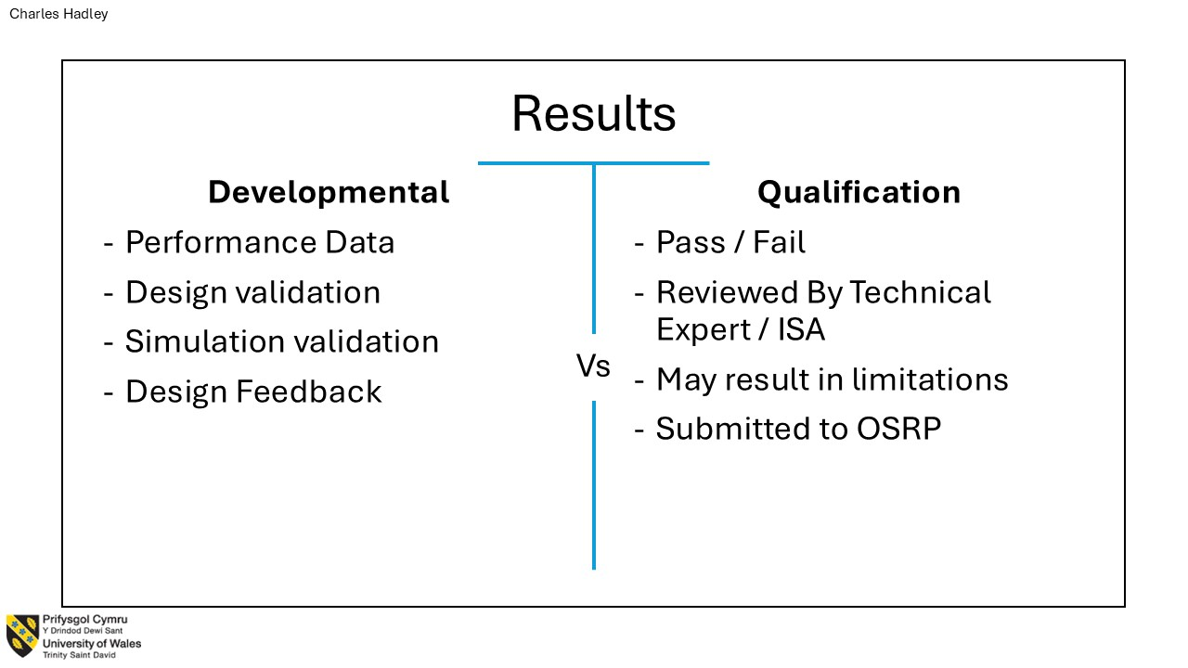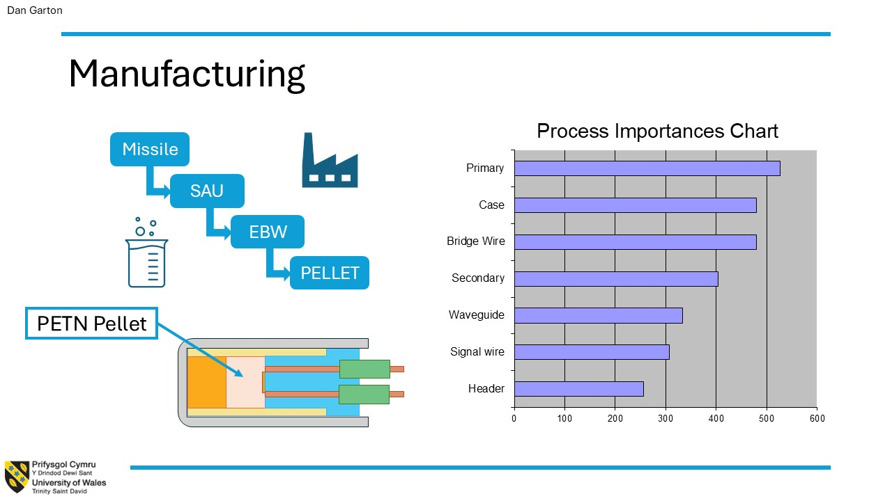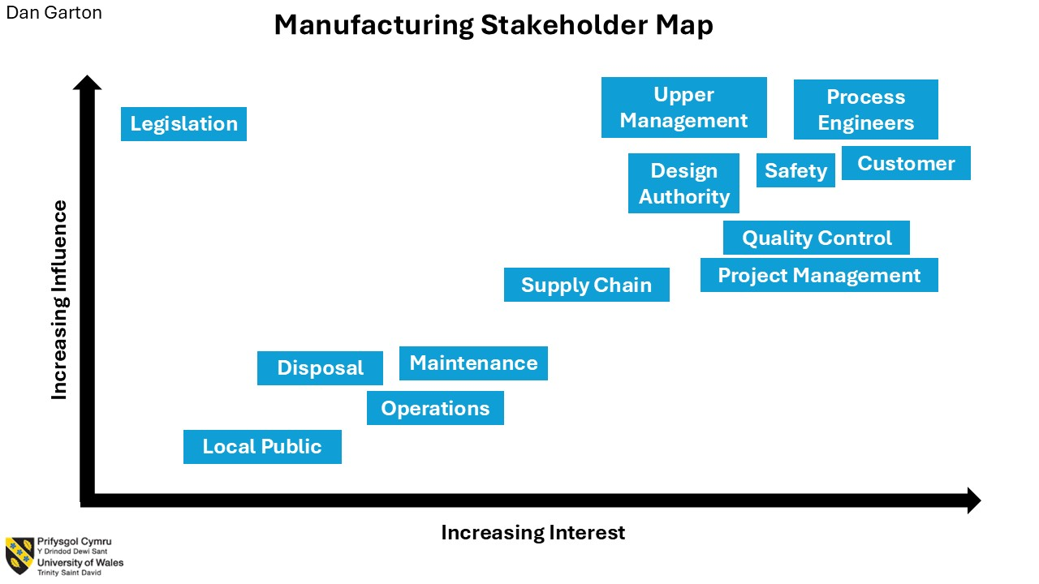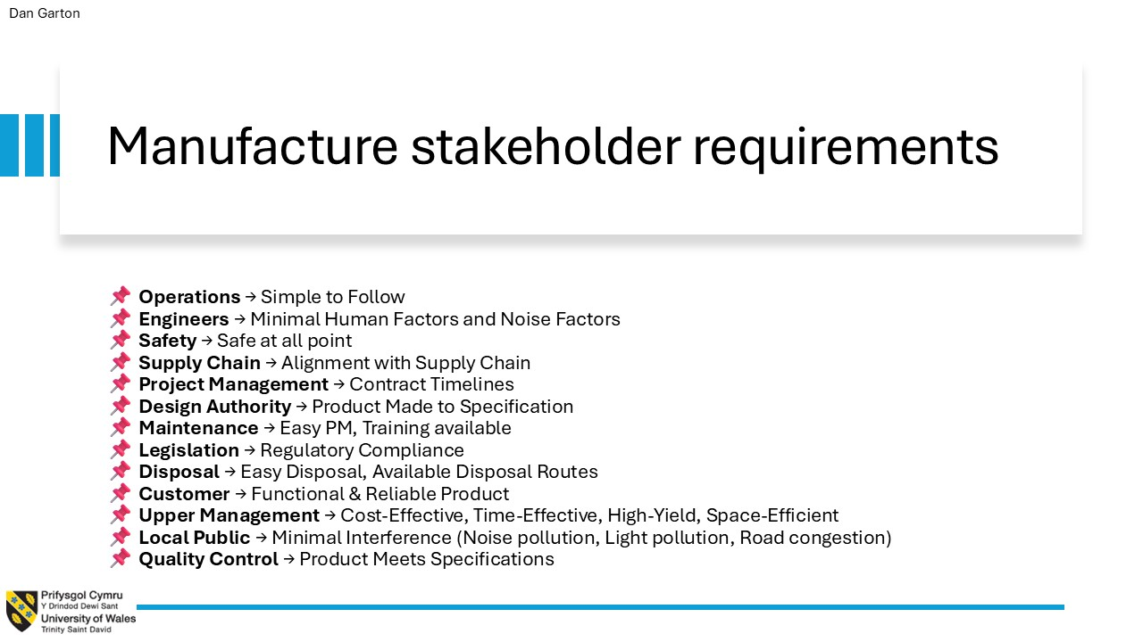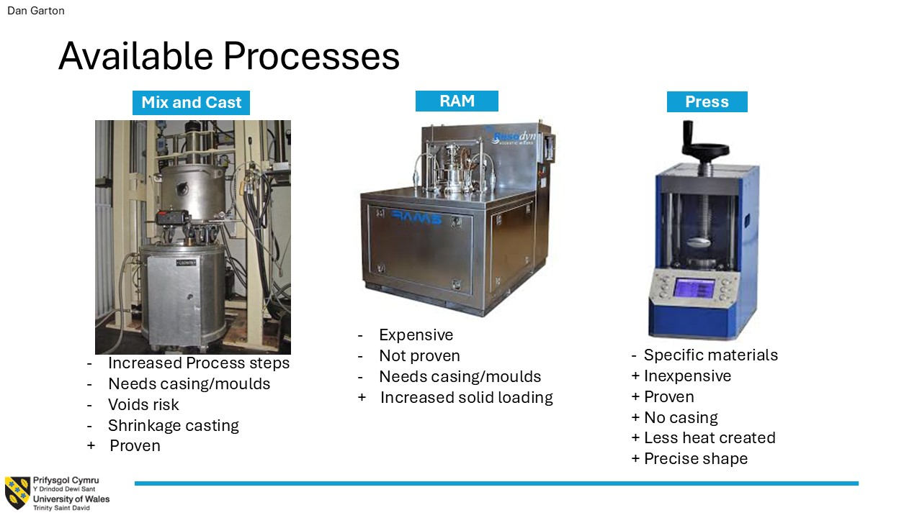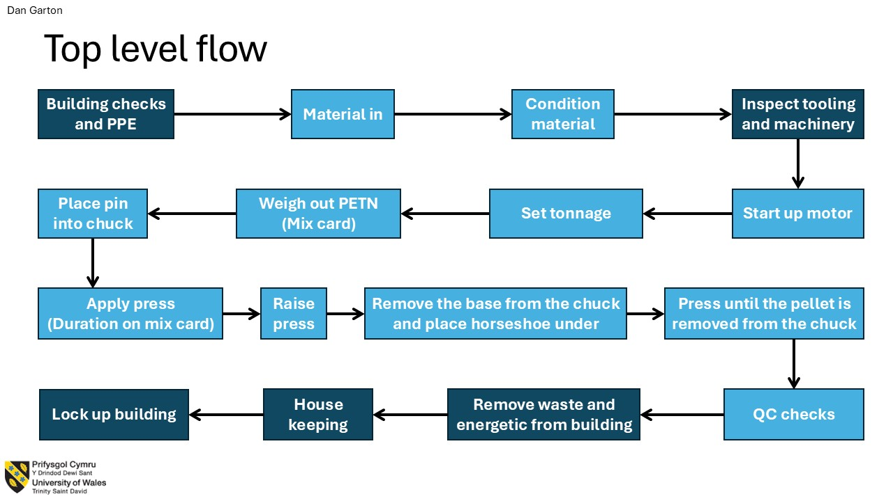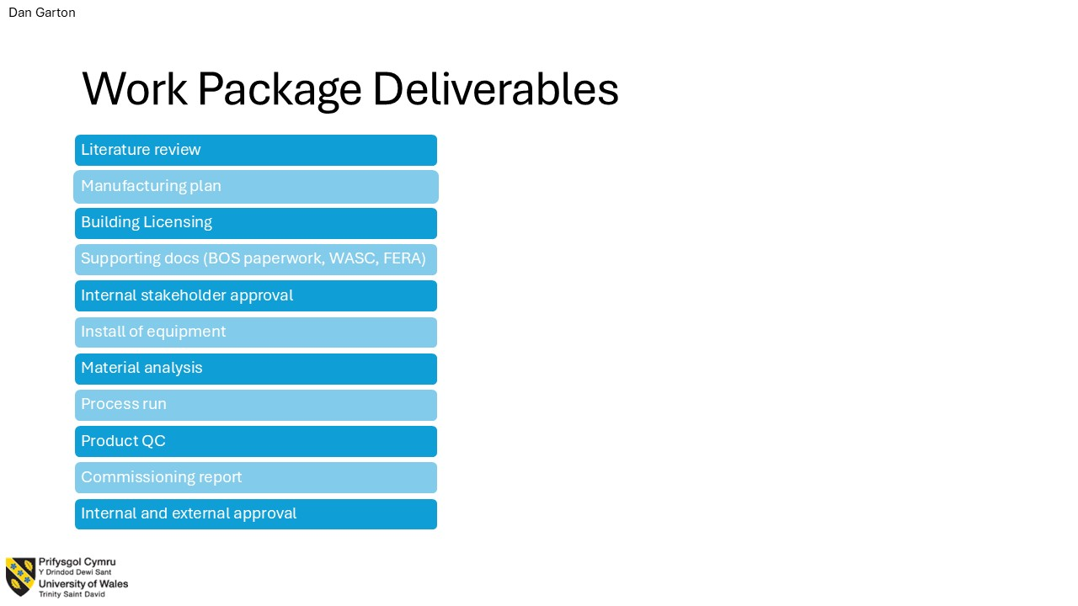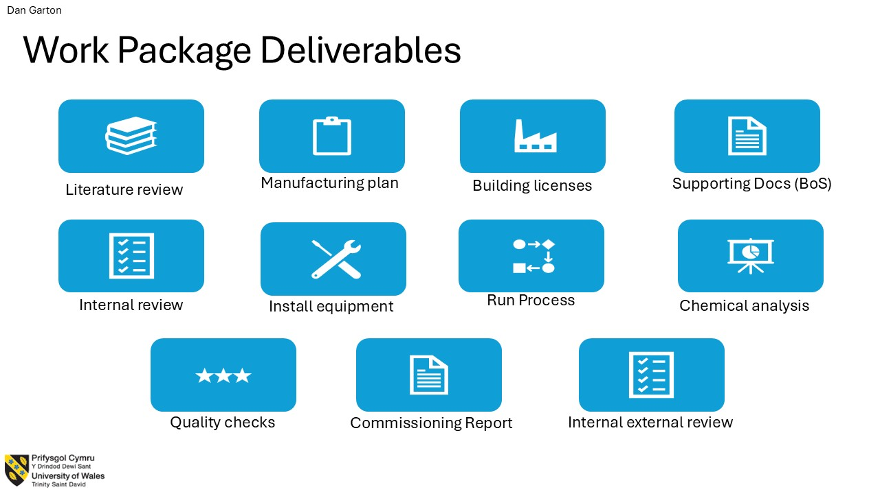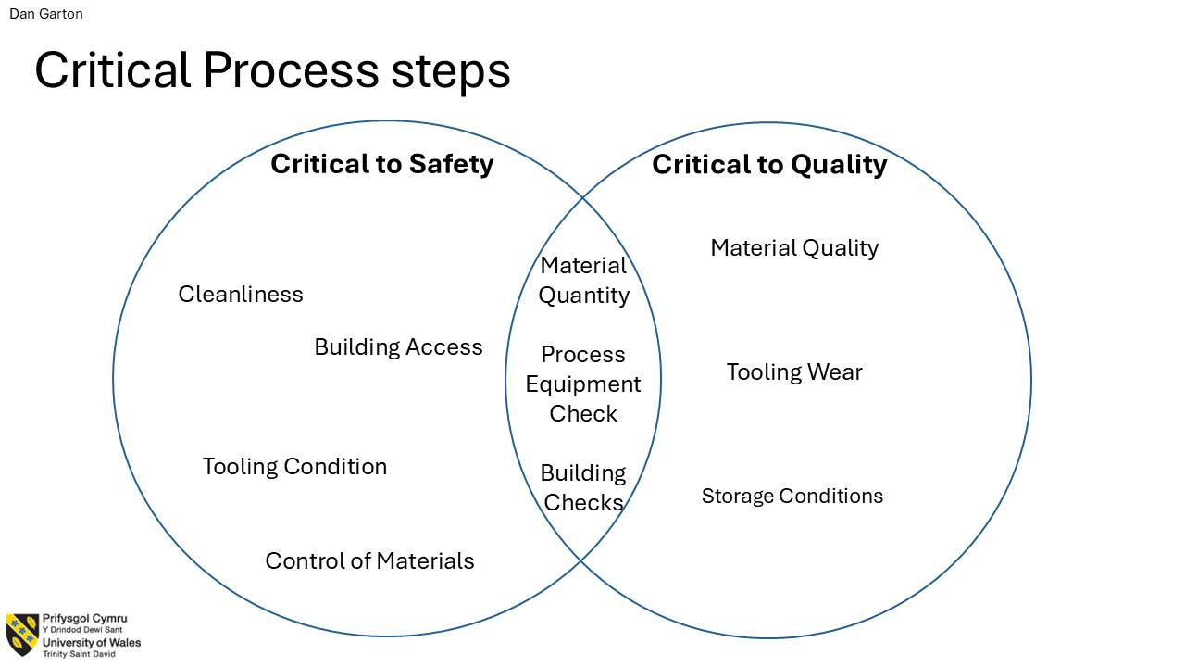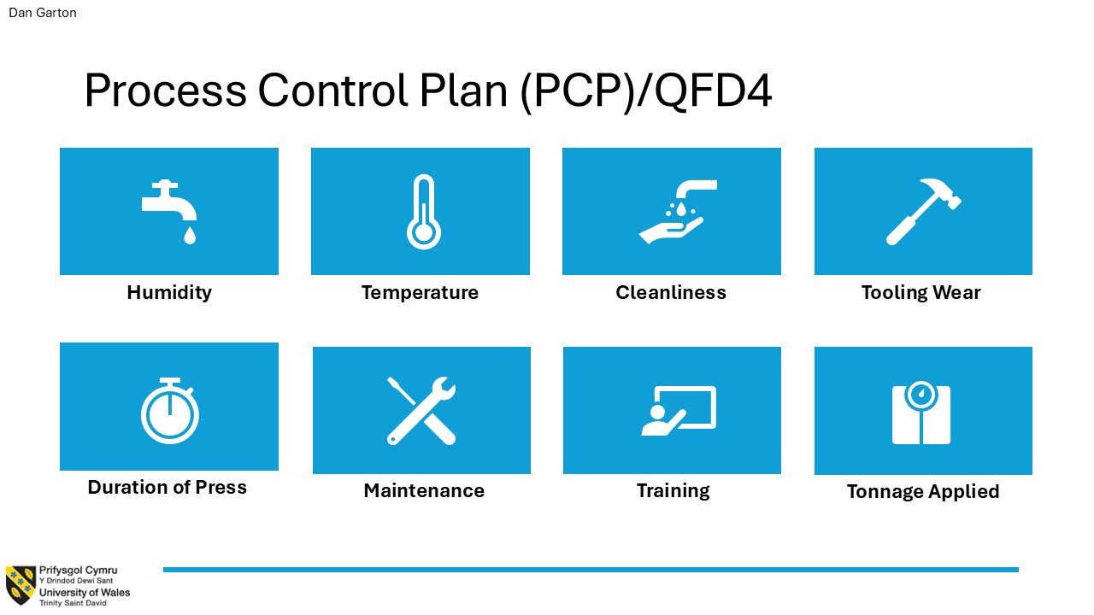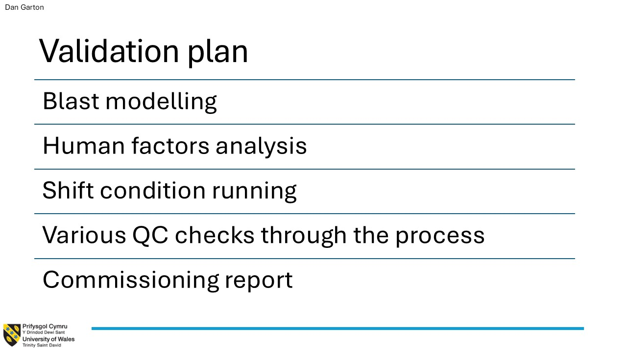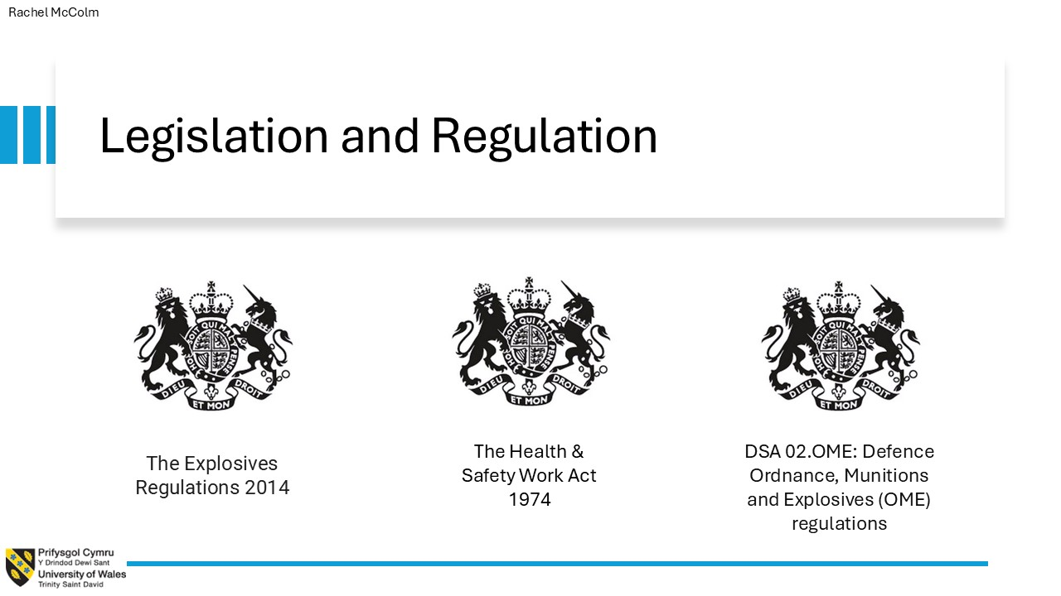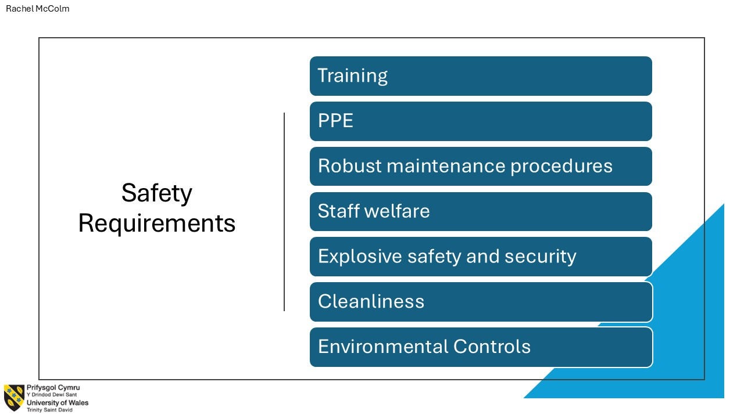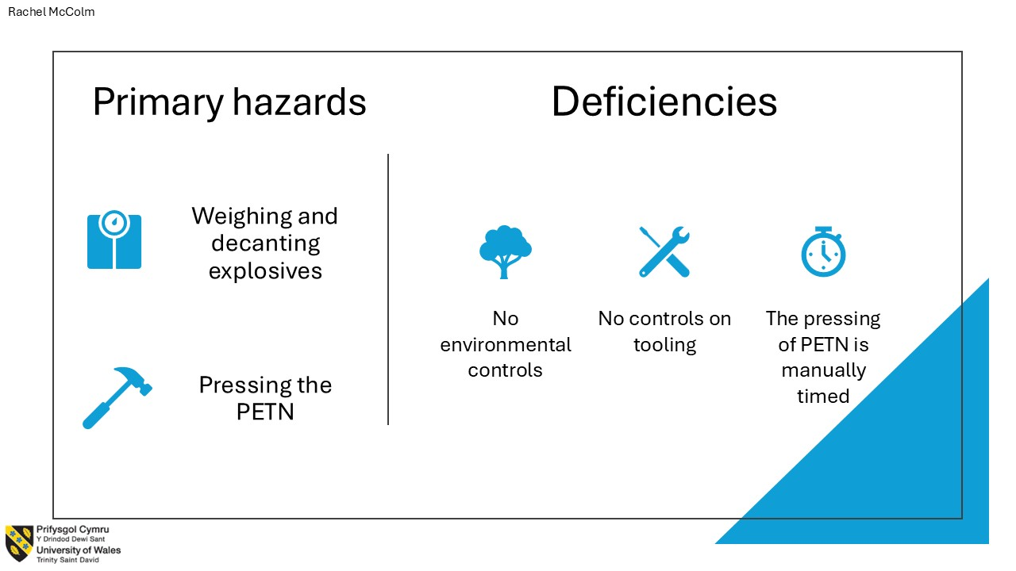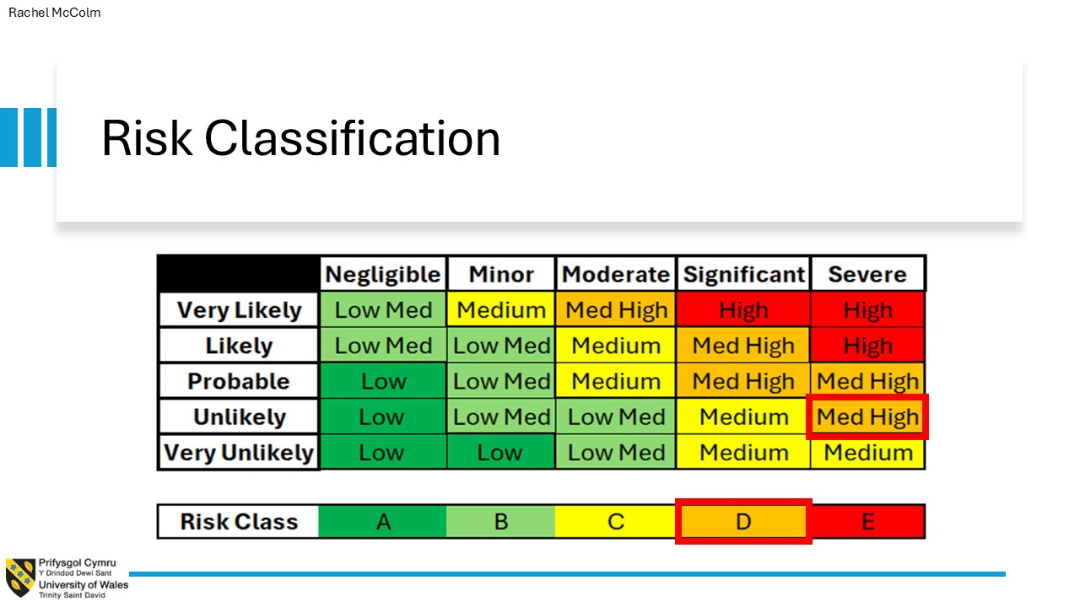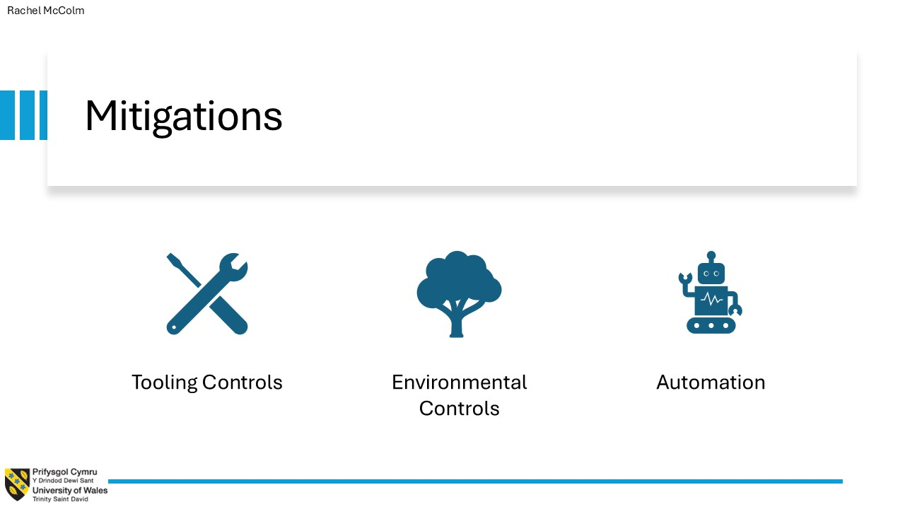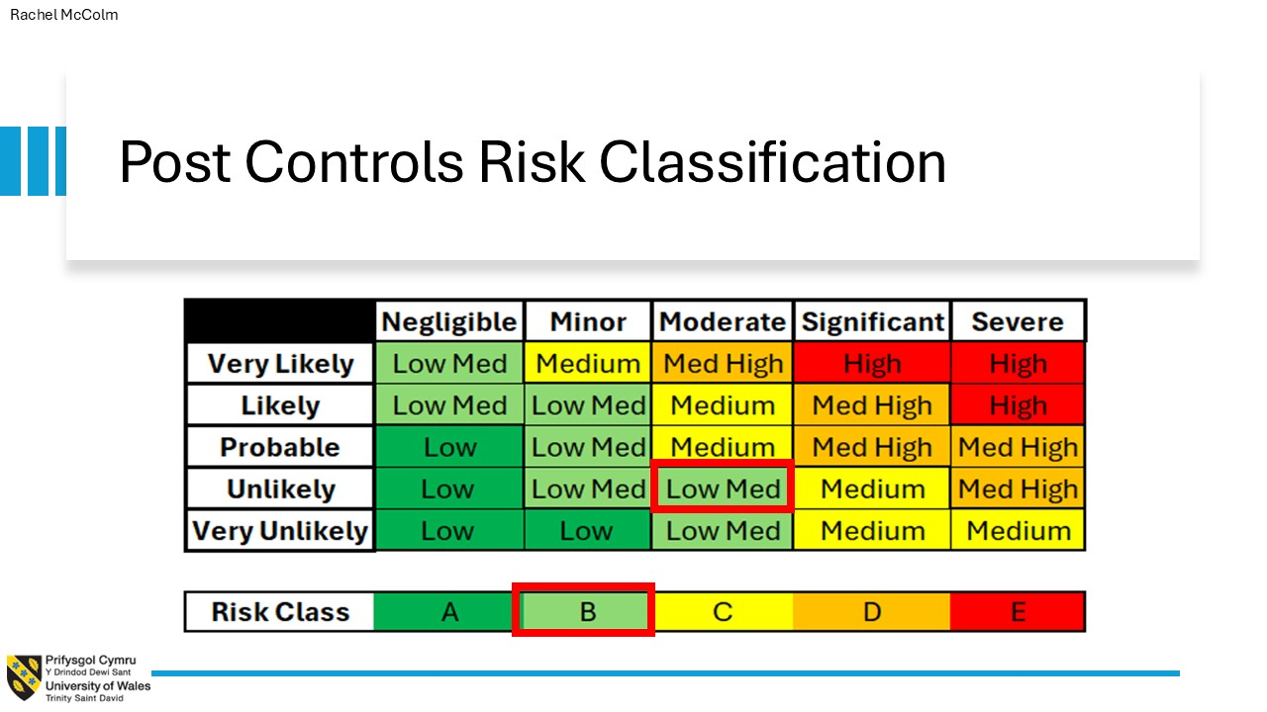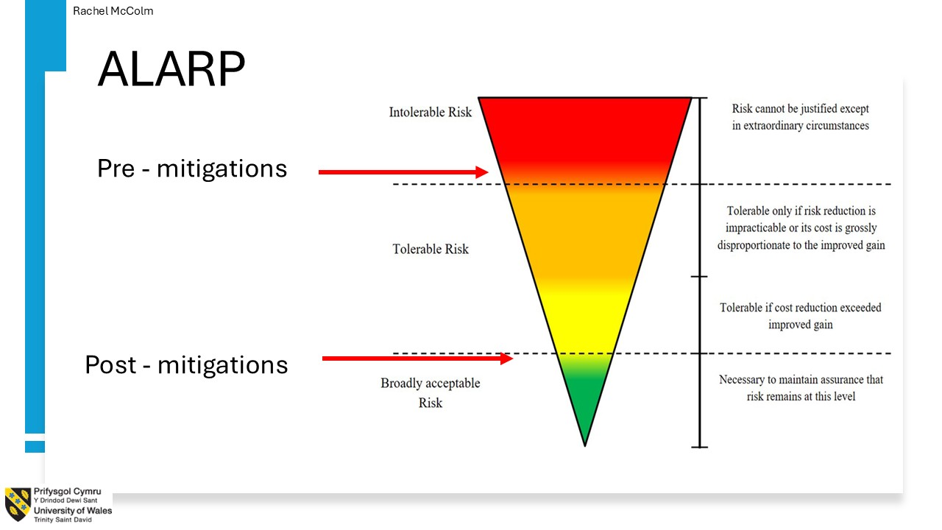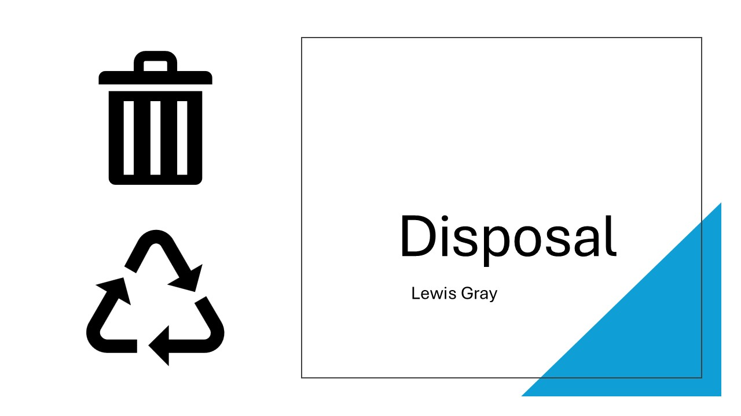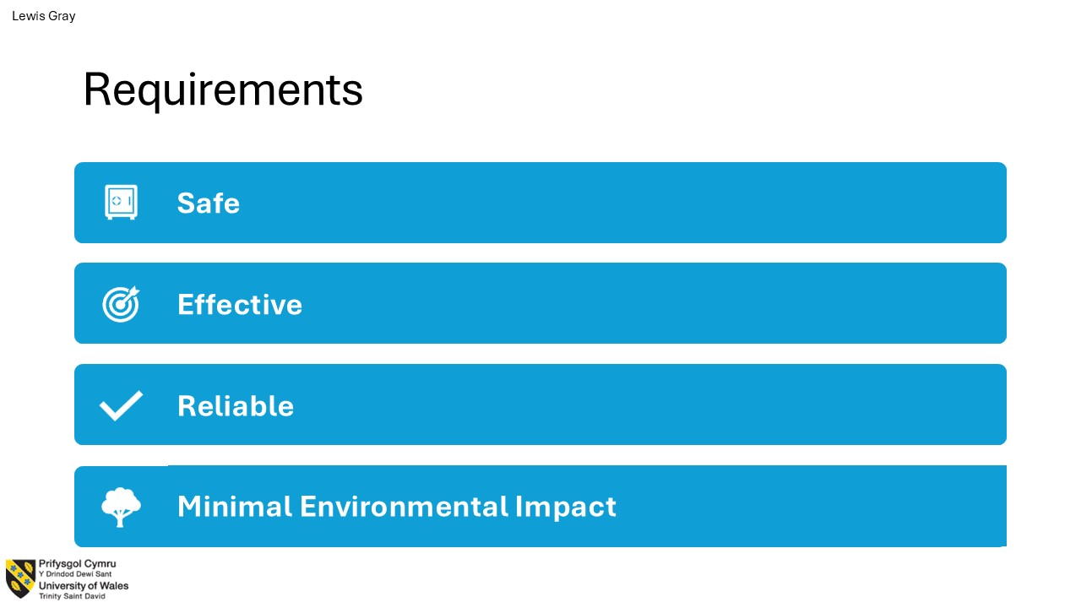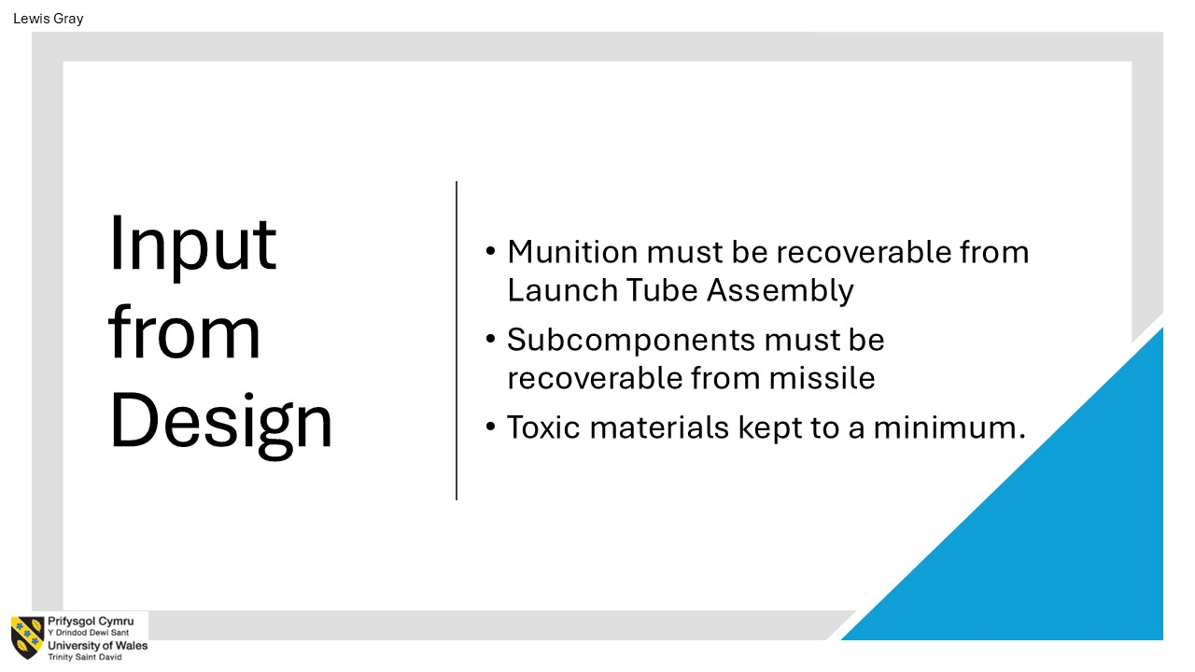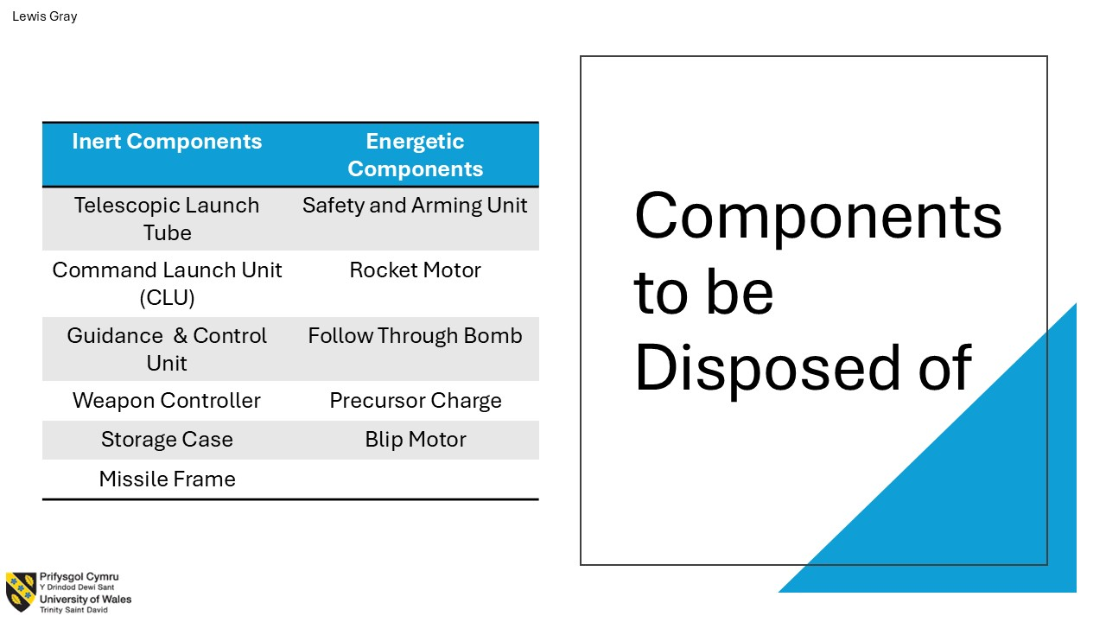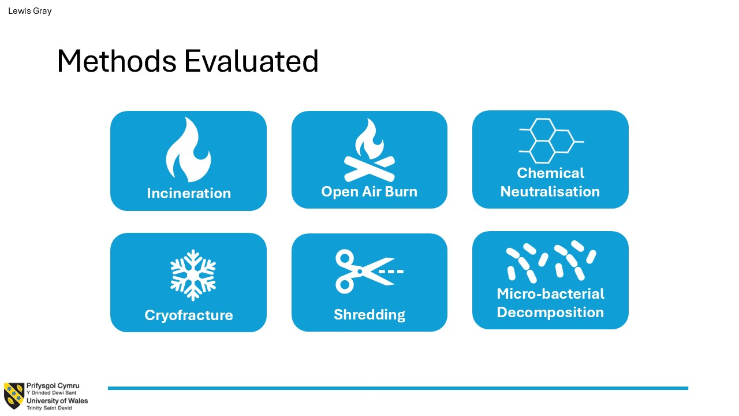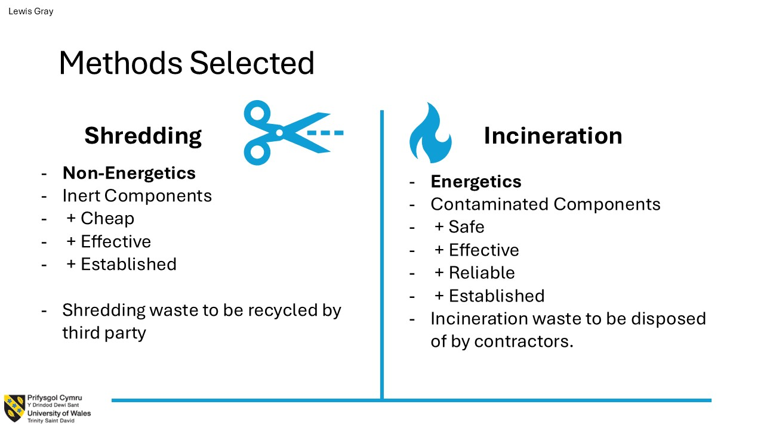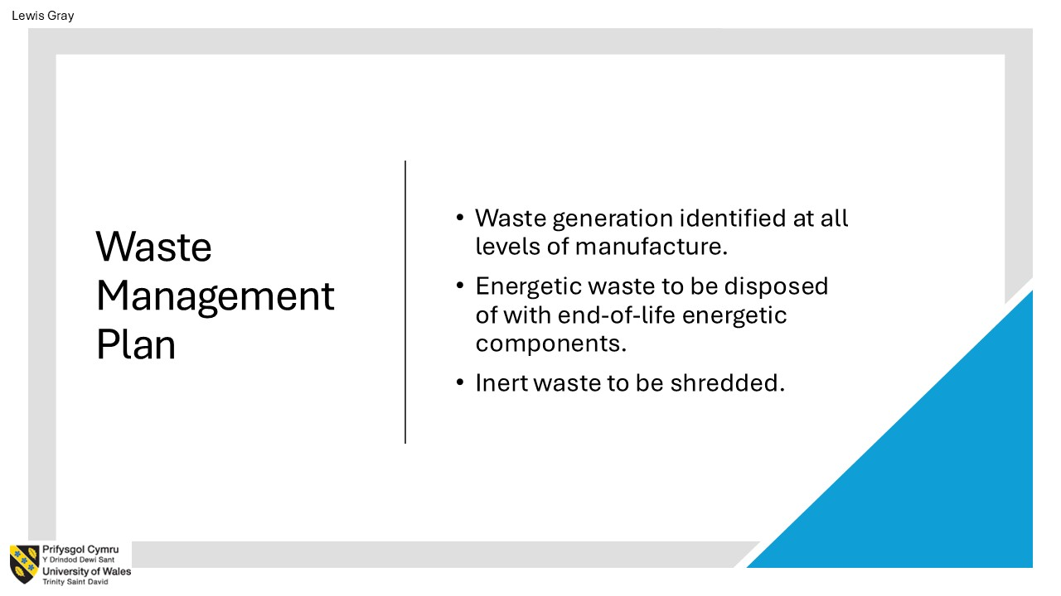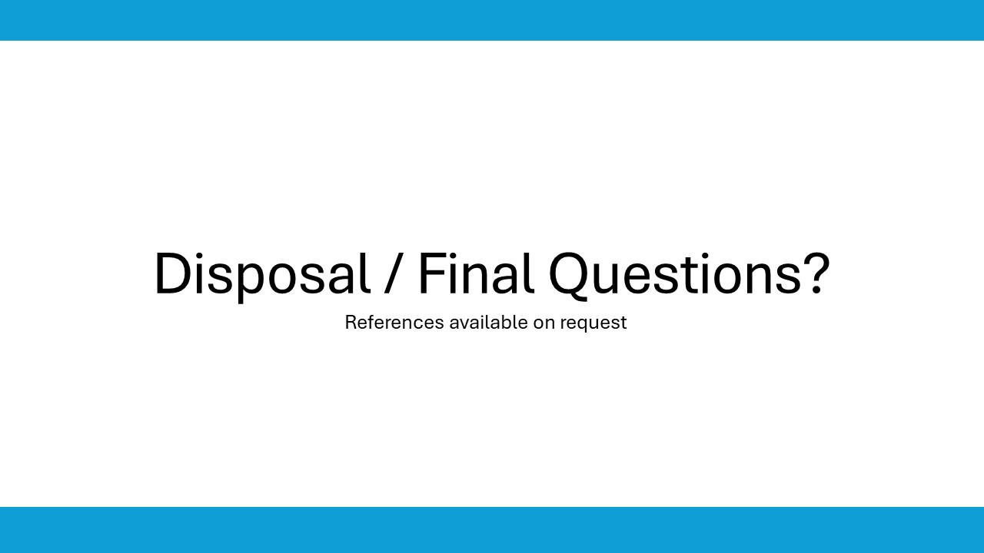

Annex E –FFMEA

System FFMEA

SAU FFMEA

See Table 2

