Human Resource Management – LCMB7000
Assessment 1

Shirina Begum
Student ID 1709360
MBA- Masters of Business Administration
Human Resource Management – Assessment 1
University of Wales Trinity Saint David

Table of Contents
Introduction 3
Company Background 3
Tesco PLC current recruitment strategies 5
Advertise the job vacancy 5
Check the application 5
Final store interview 6
A job offer to the applicant 6
Covid-19 Impact on Tesco PLC 7
Coronavirus 7
Lay-offs and Pay-cuts 7
Addressing the Changes Caused by Coronavirus 7
The 5Ps Model 8
P-E Fit Theory 9
Brexit Impact on Tesco PLC 10
Brexit 10
Competition in Attracting and Retaining Talents 11
Decline in Skilled EU Citizens 11
Employee Legislation 11
Addressing the response of Tesco PLC to Covid-19 and Brexit Impacts 12
Safety 12
Supporting Employees 13
Remote Working 13
Addressing the Changes Caused by Brexit 13
Conclusion 14
Recommendations 14
References 16

Introduction

Covid-19 and Brexit have had severe implications on the well-being of several companies in the United Kingdom, notably their human resource departments. The current global pandemic has led to temporal closures of businesses and learning institutions, impositions of lockdowns, flights cancellations, prohibition of all forms of public gatherings, and observation of social distancing (Kalogiannidis et al., 2020). These measures aimed at containing the spread of Covid-19 have presented a new challenging environment for businesses to operate normally which has promoted some of them to enforce pay-cuts and lay off some employees. For that reason, companies have adjusted and adopted measures such as remote working to enable them to maneuver through the pandemic.
Scholars have already warned on various HR implications that could be triggered by Brexit. Some impacts such as the war for talent and implementation of creative measures geared towards attracting and retaining talents are already taking centre stage in the human resource sector. This indicates that Brexit is likely to greatly impact the human resources department moving into the future. Chances are high that the United Kingdom may relax or abolish certain existing employment legislation applicable to all the EU member states following its exit from the European Union. Therefore, Covid-19 and Brexit are currently influencing the practices and strategies of human resources of organisations in the United Kingdom which is likely to continue moving into the future. For instance, Octopus Energy has responded to these changes in the external environment to remain operational.

Company Background

Tesco PLC is the largest food retailer in the United Kingdom and has stores spread across twelve countries. The number of employees working in the company is over half a million and it serves nearly a million customers on a weekly basis via online and stores. Looking back, Jack Cohen started the company as a group of market stalls in 1919 (Adamyk, 2019). He conceived a motto to depict that people could acquire huge quantities of food at cheaper prices. Over the years since its inception, the company has experienced massive growth and success to become among the largest retailers globally. Today, it deals in a wide range of products such as music downloads, furniture, petrol, clothing, electronics, books, telecom, software, and internet services. Currently, the company has over six thousand stores located in various parts of the world. Countries like China, United Kingdom, India, Thailand, Ireland, Poland, Turkey, South Korea, Malaysia, Czech Republic, Hungary, and Slovakia offer markets to Tesco products (Ahmad, 2021).
Tesco PLC is strongly rooted in the United Kingdom owing to the high number of stores and employees based in the British territory. It has over three thousand stores and approximately three thousand five hundred employees in the United Kingdom. Notable events in the company's history includes the introduction of Clubcard in 1996 (Adamyk, 2019). This was a scheme meant for consumers to appreciate them for having contributed to the company's massive success. Over decades, the company carried out several mergers and acquisitions. For instance, the company took over Hilliards chain and Williamlow chain in 1987 and 1994 respectively. It is worth noting that Tesco PLC was the first retailer in grocery and today it is the largest worldwide in online grocery retail. The company is listed in the London Stocks Exchange and has a hierarchical board members at the top of its management. The board comprises of chairperson, executive director, CFO, and eight non executive directors.
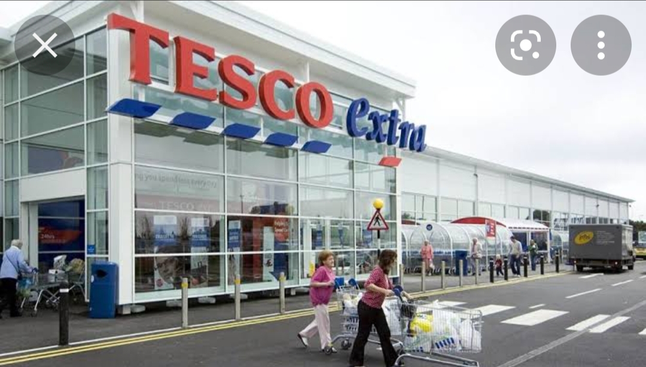
Fig 1 Tesco PLC

Tesco PLC current recruitment strategies

In regards to recruitment the HR department needs to create and define defined a new role for a new employee. The process of recruitment in an organization should match the employees with the jobs and generate a reasonable mere of the right candidate for the job as this would be cost effective for the organization. Tesco is very much cautious about selecting the right employees for their organization (Karen, 1993). The HR deaptment ensures that their motive is to select qualified employees for their organizarion. In the following part recruitment and selction processed will be discussed.

Advertise the job vacancy

In order to select the right employee for the job, organizations should interview between 15-25 candidates. This process will help HR department to find the right employee for the job. Tesco advertises their vacancies through various platforms. They will process the recruitment on the job which are available. Tesco will advertise their vacancies through their internal talent plan to fill all job vacancies first, they will consider employees who are looking for a promotion. This will give a chance for their employees to grow within company, when there is not right candidate available, they will then look externally and advertise through the Tesco website or external vacancies platforms such as JobCentre Plus, radio magazines and television.
After seeing the job advertisement people apply with their CV which then goes through to the HR Department.

Check the application

Once the CV’s are submitted the HR department will select a list of applicants and call them for an interview. This process will be followed by summarizing each applicant’s education and Job experience background. The HR department will analyze and look at select the applicant, one of the main reasons Tesco use this selection process, is to ensure that right candidate is chosen for the job requirement.
Telephone interview
When the candidates have been short listed and interview will be arranged, The HR personal manager will interview the person over the telephone. The interview will generally take 10-15 minutes and the applicant will be asked about their qualifications, job experience, skills and UK Job rights.

Final store interview

|The HR personal will select the applicant who were good over the phone and call them for a face-to-face interview in the store. In the store interview the applicant will be asked more questions regarding basic customer service, skills, knowledge, nationality and work right.
Based on the telephone interview, the HR personnel manager selects some applicants whose interview was good over the telephone, call them for a face to face interview in the store. In the final interview, the interviewer asks questions regarding basic customer services, their qualifications, skills, knowledge, work experience, nationality, work right, and so on.

A job offer to the applicant

After the final interview, the HR manager offers the selected employees to join the company and specify a date to take their joining date and call to collect the joining letter (Meighan and Meighan, 2000).
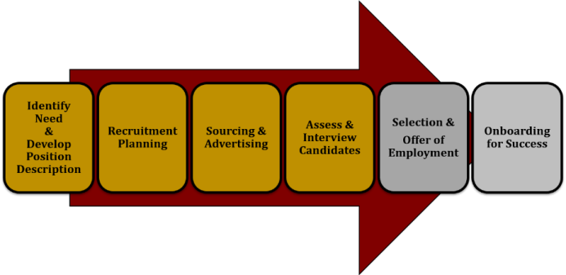
Fig 2: Recruitment and Selection Process of Tesco source Cbiz

Covid-19 Impact on Tesco PLC

Coronavirus

Covid-19 has triggered many organisations in the United Kingdom to battle numerous challenges notably, uncertainty concerning human resource control. Since the inception of the virus, many business set-ups have laid off workers owing to the imposed lockdowns and curfews aimed at restricting its spread. These measures forced several businesses, notably Tesco PLC to close some of their stores in various localities or reduce their production which led to a reduction in profitability making mass employees layoffs inevitable (Basari et al., 2020). The global pandemic has had a great impact on the human resource department in the United Kingdom threatening the ability of organisations to strategically operate and realise sustainable growth.

Lay-offs and Pay-cuts

The economic slowdown brought by the virus prompted the government and businesses of the United Kingdom to come up with responsive and adaptive measures geared towards controlling and managing the workforce in midst of the pandemic. Covid-19 has prompted Tesco PLC to experience a decline in their market share forcing them to lay off some employees to remain functional. Also, health experts have encouraged the need for individuals to practice social distancing to curb its spread. They have constantly discouraged normal lifestyle ways such as handshakes, hugging, and mass gatherings. As a result, human resources managers of industries have been compelled to conceive and adopt new operating practices to ensure that businesses remain operational in the wake of the pandemic.

Addressing the Changes Caused by Coronavirus

Companies in the United Kingdom have developed and continue to embrace remote working to ensure they remain functional and undisturbed despite the current global pandemic. Management of many firms is doing their best to assist their employees to adjust and adapt to various work changes. For instance, Tesco PLC has encouraged their employees to work from home have provided them with laptops and internet connectivity fees to ensure continuous operations. However, there have been numerous challenges associated with remote working hindering its effectiveness. For example, some employees are unable to effectively deliver while working at home because of several distractions associated with home surroundings (Kalogiannidis, 2020). The pandemic has caused alternative places like libraries and internet cyber to restrict their carrying capacities at a given moment making it hard for employees to easily access them. In some instances when new infection rates of Covid-19 have exacerbated, they have even closed down. Tesco PLC managers continue to face difficulties achieving employee commitment and cultivating good work relationships in remote working.
The prevailing environment of Covid-19 cannot sustain certain new policies and procedures necessary for realizing the duo. Also, Tesco PLC suffer insufficient resources making it hard to support such initiatives aimed at cultivating good work relationships and making employees to be committed. Moving into the future, remote working remains feasible and viable. The retail company is likely to address the existing challenges associated with remote working considering that new variants of Covid-19 such as omicron continue to emerge threatening possibilities of rebound to physical transacting of businesses (McKibbin & Fernando, 2020). Existing uncertainty regarding the end of the pandemic further creates a conducive atmosphere for businesses to continue venturing into remote working moving into the future.

The 5Ps Model

It is crucial for employers to take into consideration the five key Ps of strategic human resource management as they struggle to overcome the global pandemic and Brexit implications. People, Purpose, Performance, Processes, and Principles are core areas that must always be born in the mind of employers as they formulate HR practices and policies aimed at cushioning their firms against effects of Brexit and Coronavirus. For example, Tesco HR department need to seek legal and professional advice to avoid violating employees right moving into the future uncertainties of Brexit. They must embody principled behaviours and carry out restructuring and lay offs within the confines of the law. It is understandable Brexit and the global pandemic bears additional financial implications on Tesco and the company may be forced to restructure. The five Ps Model enables managers to remain within the scope of organisational strategies.
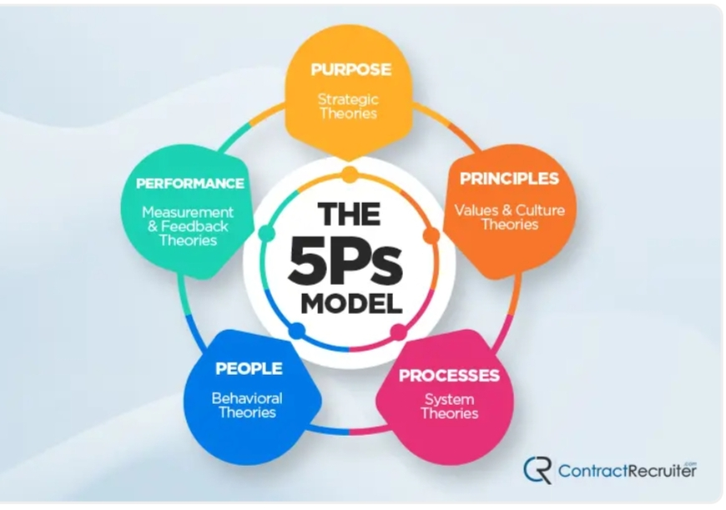
- Fig 3: The 5 Ps Model source: Contract Recruiter 2021

P-E Fit Theory

Besides remote working, Tesco PLC has also implemented new workplace procedures and policies such as maintenance of social distancing, constant hand washing, or sanitisation at various designated joints. It is important to note that employees have met these newly introduced practices with contempt viewing them as undesirable. According to the P-E fit theory, individuals tend to secure employment in organisations with a work culture that resonates with their attitudes, behaviors, beliefs, and values (He & Harris, 2020). People working in environments that maximize their P-E fit are likely to utilize fully their potential and enable a company to achieve sustainable growth. On the other hand, when the workplace surrounding that resonates with employees' beliefs and values becomes altered, the existing cordial relationship between the work environment and employees becomes threatened. Similarly, the benefits that employees could derive in their previous normal working environment before the emergence of Covid-19 underwent distortion. For that reason, the new working environment brought by Covid-19 is likely to compel employees not to fully utilize their potentials in their workplace which goes a long way to affect the well-being of organisations (Atkeson, 2020).
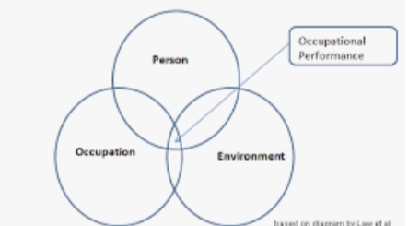
Fig 4: Occupational Performance Framework source O2 conceptual Framework

Brexit Impact on Tesco PLC

Brexit

The aftermath of Brexit has seen the HR game change and many more uncertain changes in the human resource department are likely to occur moving into the future. According to Kerridge (2020), MHR predicted several scenarios that would accompany the referendum that would see Britain exit the European Union. For instance, MHR opined that there will be a talent war in Britain. They further believed that Brexit would prompt the human resource department in Britain to enhance creativity to attract and retain talent. Also, MHR warned the HR department to brace itself for pressure associated with coping with legislative changes resulting from Brexit. These legislative changes would come with additional duties and responsibilities. Lastly, MHR saw Brexit as a move that would increase the significance of workforce management than any other sector in Britain. It is important to note that, numerous of these MHR forecasts have already materialized. For example, in the United Kingdom, studies reveal that many recruiters offer bumper wages and several lucrative benefits intending to attract and retain employees. Already there is a short supply of talent (Clarke et al., 2017).

Competition in Attracting and Retaining Talents

The EU has had notable impacts on organisations notably, their human resource departments. Market strength has seen the United Kingdom positioned as a conducive zone for accessing talents. This has allowed other nations under the umbrella of the EU to source talents freely and with much ease from the United Kingdom. Secondly, since the United Kingdom is centrally placed, other member countries of the EU could access skilled and unskilled workers from other countries via the United Kingdom (Human, 2020). Also, courtesy of the EU, there are employee rights. Firms within Britain such as Tesco PLC are obliged to adhere to all HR regulations such as TUPE, maternity and holidays entitlements, agency employees' rights, and protection against discrimination. Based on these, Britain's exit from the European Union has already brought a significant impact on the former's talent pool. As a result, this has shaped how companies in the United Kingdom strategize their workforce planning. Tesco PLC is facing competition in attracting and retaining the appropriate talent they require to accomplish their missions and visions. The extent to which this impact will be felt relies on the path the negotiations will take. There will be easier movement of talents between Britain and the European Union member states if the United Kingdom signs agreements with the EU extending free movement between Britain and the European Union (Ahmad, 2021). However, this is not guaranteed to happen. Already Tesco PLC is familiar and fond of EU regulations making them have difficulties adopting and implementing current Britain's immigration rules considered to be more restrictive.

Decline in Skilled EU Citizens

The United Kingdom is likely to become less attractive in the search for talented people considering that it no longer links the EU member states to talents. Chances are high that there will be a decline in the number of EU citizens seeking employment in Britain. The hiring of EU workers by organisations based in Britain will be complex due to increased administration requirements posed by Britain's immigration rules. The point-Based System demands that only immigrants capable of speaking English can secure employment within the United Kingdom. This system coupled with visa and work permits is likely to cause a decline in the number of EU citizens seeking jobs within Britain's territory (Stevovic, 2018).

Employee Legislation

Employee legislation stands to be relaxed or removed in the era of Brexit. Several comprehensive and stringent humane employment policies and trade union rights have been put in place by the EU. The United Kingdom is still under obligation to protect and uphold this employment legislation. Britain is a member of the European Convention of Human Rights (ECHR) which shall oversee that it operates within the confines of the existing employment legislation (Ridgway, 2019). Also, other legislation like shared parental leave, pensions, and auto-enrolment despite receiving no input from the EU will continue to be in use. However, Britain's exit from the European Union may prompt it to relax or remove certain EU laws concerning the workforce. The United Kingdom is likely to abolish benefits such as free healthcare and attendance allowance of EU workers. Brexit could offer attention to collective consultation rights that have elicited criticisms in the past. This compels employers to consult employees whenever they are carrying out redundancies.
Likewise, TUPE is likely to face relaxation to enable employers to harmonize the terms and conditions of employment of the EU workers to reduce obligations associated with employee consultations. Also, all types of pension schemes stand high chances of being affected following market volatility emanating from Brexit. Firms are cautious about their spending owing to the uncertainty of post-Brexit (Teleki, 2019). In some instances, Tesco PLC directors of HR have halted long-term projects because they still do not fully comprehend the financial implications that could be triggered by Brexit. Many Britons are accustomed to many EU employment law rights forming part of their cultures. For instance, chances are minimal that the United Kingdom will abolish working-time regulations. It seems unpopular to abolish the existing annual leave period.

Addressing the response of Tesco PLC to Covid-19 and Brexit Impacts

Safety

Tesco PLC has adopted several measures and restrictions to keep its employees and customers safe amidst Covid-19 pandemic. The HR department has adopted a policy that restricts the number of people inside stores at a given time. Traffic lights have been installed at the entrance of busy stores spread across different nations. They informs customers the right time they can gain entry into the stores. The company has availed entrance and exit points in stores and signage to assist clients observe social distancing (Basari et al., 2020). Customers and employees have access to hand sanitizers that are installed at strategic locations within the stores and their environs. The HR department have provided their drivers who are responsible for delivering goods ordered online with alcohol-based wipes, face masks, disposable gloves, and face coverings. Also, it allows customers who are self-isolating to inform in advance the company's drivers doing delivery to enable them take the necessary pre-cautions.

Supporting Employees

The current global pandemic has promoted Tesco HR department to ratify policies and practices aimed at supporting employees. For example, employees that will test positive for the virus will receive a paid sick leave. The company has created over fifteen thousand new roles to support online shopping during the pandemic. Several individuals have been hired temporarily to assist during peak seasons in serving customers. Line managers provide all sorts of assistance to employees to ensure they are satisfied (Basari et al., 2020).
Since the inception of the virus, the firm has remained operational thanks to the various strategic and adaptive measures it adopted. The company has functional phone lines that are open from 9.00 am to 5.00 pm during weekdays in addition to its digital customer service that supports both social media and email daily from 8.00 am to 10.00 pm (Basari et al., 2020). Their offices are only open to employees having their means of transport. Employees that can only access the offices using public transport have been directed to work remotely. Statistical evidence has revealed that new Covid-19 infections largely emanate from the public transport sector. It is much easier for an individual infected with the virus to spread it to commuters using public transport networks.

Remote Working

The company utilises a technology that is adaptive enabling it to conduct business with clients without necessarily being physically together. During the lockdown, the tech company stopped door-to-door sales. The firm has only allowed its sales team to physically interact with customers when reported cases of new infections of Covid-19 have dropped. Also, the company has prioritized remote working more so for its employees relying on public transport to reach the offices (Brennan et al., 2021). This is aimed at minimizing travel in line with the government directive. Also, the company has acknowledged that employees with kids may experience challenges working from home and therefore has allowed them to discuss such matters with their managers for flexibility. Employees living with vulnerable people or who have been exposed to individuals depicting Covid-19 symptoms have been advised to work from home and avoid coming to the offices.

Addressing the Changes Caused by Brexit

The HR CEO of Tesco PLC continues to constantly create a positive mindset to enable the company to make good use of opportunities that may arise during post-Brexit. It is worth noting that the organisation's human resource leaders constantly develop communication strategies that permit employees to air out their concerns. Also, these communications strategies have been crucial in reaffirming the firm's core values of inclusivity and openness. The existing EU ratified employee rights forms part of the company's culture (Human, 2020). Despite the exit of the United Kingdom from the European Union, the company remains committed to implementing humane employment practices according to the EU. It is this openness that has enabled the tech company to address emerging issues associated with Brexit. For instance, economic volatility associated with Brexit affects pension schemes, incentive targets, and bonus pools. The United Kingdom is currently in a transition period and the firm is determined to prioritise and reassure employees of their well-being by executing bonus plans capable of motivating them. Also, the organisation assists its employees to handle residence applications and other practical concerns (Ridgway, 2019).
The human resource department of Tesco PLC has its eyes fixed in the future. Brexit has prompted the UK-based company to assess impacts that may result from any initiated moves. Also, it reviews the immigration policy to enable the company to realise the likely implications of Brexit. This goes a long way to assist the company to prepare adequately by planning on retaining skilled labour upon full withdrawal of Britain from the European Union. Workforce data is a crucial asset during this transition period in the United Kingdom (Teleki, 2019). The company possesses a solid understanding of its workforce making it to be at an advantaged position that can make it weather the challenges moving forward to post-Brexit. Brexit threatens the ability of an organisation to attract and retain talent. Octopus Energy has put focus on coming up with creative ways to attract and retain its specialised employees.

Conclusion

In summary, both Covid-19 and Brexit have had a significant impact on the HR practices and policies of Tesco PLC. For example, the current global pandemic had forced Tesco PLC to rely mainly on online delivery. Several of its stores are closed prompting many employees to work from home. Also, some employees became jobless during the inception of the virus as the company embarked on closing stores following restrictive measures like lockdown. On the other hand, Brexit has brought uncertainty within the company forcing its HR department to put a halt to long-term projects. The external environment of Tesco PLC is likely going to be affected by Brexit moving into the future making it hard for HR department to effectively develop a strategic plan.

Recommendations

I. Employers need to assess the financial implications of Brexit on employees since it is likely to trigger additional business costs. This may force them to restructure and probably do away with some job positions. Therefore, employers need to be sincere and communicative about all these to their workforce.
II. Employers need to be familiar with the constant updates on immigration schemes. These schemes have a significant impact on employees settlements.
III. There is a need for employers to examine the areas within the organisation that are likely to suffer due to Brexit to assist them to evaluate their employee's demographics.
IV. Human Resource managers need to invest in remote working and implement data protection measures to minimise instances of data breaches.
V. Employers need to take into account their employee's health, safety, and overall well-being to enable the latter brace themselves for future uncertainties of Brexit and Coronavirus.

References
Adamyk, K. (2019). PESTLE Analysis on Tesco PLC. https://www.google.com/url?sa=t&source=web&rct=j&url=http://dspace.wunu.edu.ua/bitstream/316497/35536/1/10.pdf&ved=2ahUKEwj4qIOs5Zj1AhWP2qQKHXxNAIoQFnoECAMQAQ&usg=AOvVaw3bqUB6VTI26mydkX3iWTZe
Atkeson, A. (2020). what will be the economic impact of covid-19 on us? Rough estimates of disease scenarios. NBER Working Paper No. w26867. https://doi.org/10.3386/w26867
Ahmad Tajuddin, S. (2021). Technology Entrepreneurship Project (ENT 600): Tesco PLC.
Basari, M. A. M. D., Yazid, M. F., & Shamsudin, M. F. (2020). Suggestion for retailers during and post covid-19 downturn. Journal of Postgraduate Current Business Research, 1(1).
Baldwin, R., & Weder, B. (2020). Economics in the Time of COVID-19.
Brennan, N. M., Edgar, V. C., & Power, S. B. (2021). COVID-19 profit warnings: Delivering bad news in a time of crisis. The British Accounting Review, 101054.
Clarke, H. D., Goodwin, M., Goodwin, M. J., & Whiteley, P. (2017). Brexit. Cambridge University Press.
He, H., & Harris, L. (2020). Since January 2020 Elsevier has created a COVID-19 resource centre with free information in English and Mandarin on the novel coronavirus COVID-19. The COVID-19 resource centre is hosted on Elsevier Connect, the company ‟ s public news and information.
Human. (2020, March 12). Brexit and HR management: Effects and implications. Human. Retrieved January 2, 2022, from https://recruithuman.co.uk/2020/03/12/brexit-and-hr-management-effects-and-implications/
Kalogiannidis, S. (2020).Covid Impact on Small Business. International Journal of Social Science and Economics Invention, 6(12), 387-391.https://doi.org/10.23958/ijssei/vol06-i12/257
Kalogiannidis, S., Chatzitheodoridis, F., & Kontsas, S. (2020). Αn Eclectic Discussion of the Effects of COVID-19 Pandemic on the World Economy During the First Stage of the Spread. International Journal of Financial Research, 11(6), 137. https://doi.org/10.5430/ijfr.v11n6p137
Kerridge, C. (2020, December 4). How Brexit will change the game for HR. MHR. Retrieved January 2, 2022, from https://mhrglobal.com/uk/en/blog/how-brexit-will-affect-hr
McKibbin, W. J., & Fernando, R. (2020). The Global Macroeconomic Impacts of COVID-19: Seven Scenarios. SSRN Electronic Journal. https://doi.org/10.2139/ssrn.3547729
Ridgway, M. (2019). Brexit: human resourcing implications. Employee Relations: The International Journal. https://www.researchgate.net/publication/333785084_Brexit_human_resourcing_implications
Stevovic, M. (2018). Impact of Brexit on security and key areas in the EU and UK. Account and Financial Management Journal. https://doi.org/10.18535/afmj/v3i1.04
Teleki, B. (2019). Thoughts on Certain Aspects of the Brexit and its Management. Academic and Applied Research in Military and Public Management Science, 18(1), 137-148.

