  - Engine Control systems (M4X02197)

Electronic Ignition & Fuel Injection System
Subith Joseph (1902458)

Abstract
The purpose of this report is to collect live data and analyse the different characteristics the two chosen engines have for fuelling and ignition during open loop/ warm up phase. The Following report is in two parts.
A

Table of Contents
Abstract 2
Part 1 – Vauxhall 2.0L Motronic Injection/Ignition 7
Introduction 8
Research/Literature review 9
Vauxhall Motronic 9
Methodology 10
Results 11
12
Analysis 16
Part 2 – Bosh LE2 Jetronic 17
Introduction 18
Research/Literature review 19
Methodology 20
Results 21
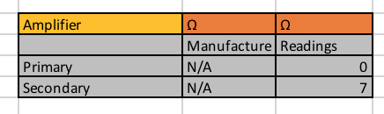 21
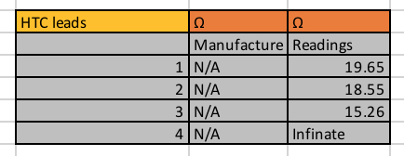 21
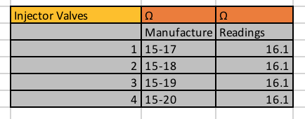 21
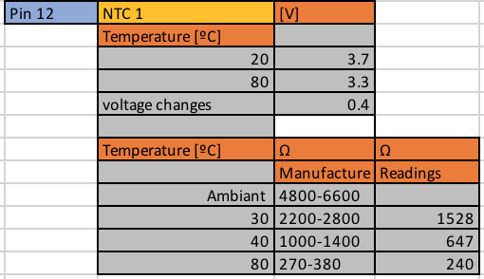 21
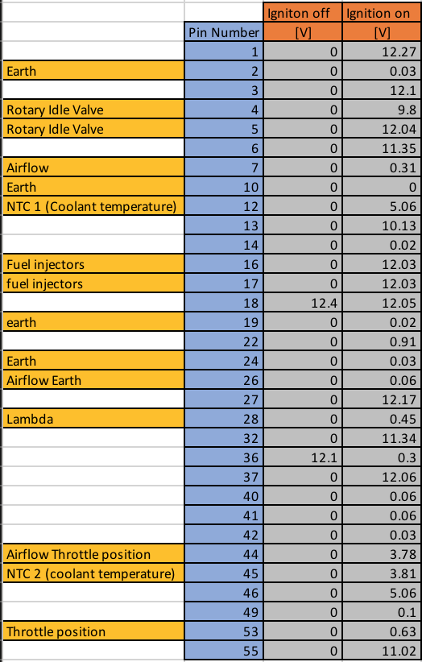 22
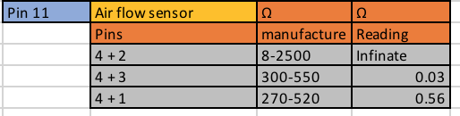 22
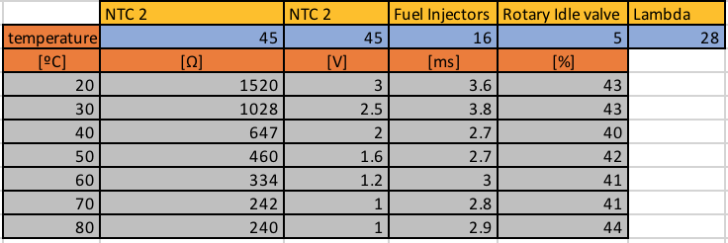 22
Analysis 23
Conclusion 24
Recommendation for Further study 25

Figure 1 // Part 1 // Injection (snap acceleration) 11
Figure 2 // Part 1 // Injection (Acceleration) 11
Figure 3 // Part 1 // Injector idle 12
Figure 4 // Part 1 // Crankshaft sensor 12
Figure 5 // Part 1 // Primary ignition 13
Figure 6 // Part 1 // Secondary Ignition 13
Figure 7 // Part 1 // Ignition ground 14
Figure 8 // Part 1 // Speed reference 14
Figure 9 // Part 1 // Spark time 15
Figure 11 // Part 2 // Amplifier 21
Figure 12 // Part 2 // HTC Leads 21

Part 1 – Vauxhall 2.0L Motronic Injection/Ignition

Introduction

The Vauxhall 2.0 litre engine using the Bosh Motronic 4.1 engine management system was introduced for 1987 Vauxhall model year. This engine was an astonishing engine for its time when it was developed as the engine was controlled and managed digitally using various sensors and ECU as this made it more reliable and also has a self-diagnosis system.

Research/Literature review

Vauxhall Motronic
The Engine uses its fleet of sensors to tell the ECU, these include;
- Airflow Meter – AC sinewave
- Air temperature sensor – AC Sinewave
- Water temperature sensor – AC sinewave
- Throttle switch – AC Sinewave
- Crankshaft sensor – AC sinewave
The data from these sensors are all AC (alternative current) form signal, for some sensors the ECU to read the data they are amplified and converted to a DC (Direct current) Hall effect signal. Digitalizing signal can be beneficial as they are simple to read but loss of data is possible in the conversion, AC raw data can be used to diagnosis and also give a far more detailed reading.
The Airflow meter measures airflow into the engine and also the intake air temperature. The data from this sensor can tell the ECU the correct Fuel/Air mixture and also any timing correction to be made.
The Water temperature sensor measures the coolant temperature. This sensor is in charge on telling the ECU the temperature of the engine, this can switch the engine to stay on an open loop cycle where the engine is programmed to burn a rich mixture to warm up the engine efficiently and quickly.
The Throttle switch measures the throttle position and also controls idle. This sensor can tell the engine about fuelling if the injection needs to be cut off due to deceleration or if there is a high load and need a snap injection.
The Crankshaft sensor measures the speed of the engine and also points out the position of TDC (Top dead centre) of cylinder 1. This is very important as it tells the engine about fuel and ignition timing
All of this is part of the Bosh Motronic 4.1 engine management system.

Methodology
- Before starting Wearing the correct and most appropriate PPE (Personal Protective Equipment) is mandatory
- Checking the working environment is mandatory
- Checking the equipment that they are working is needed before using them to take any readings (multi meter, oscilloscope)
- Disconnect battery before unplugging components
- Take a reading of the base battery voltage
- Test resistance and voltage to the engine ECU (disconnect all attachments on the ECU before taking resistance readings)
- With the ignition ON engine OFF test engine ECU Voltage
- Take voltage reading on the fuel ECU
- With ignition OFF engine OFF Take resistance values (Throttle sensor, Coolant temperature sensor, airflow meter, ignition coil (primary + secondary), Fuel injectors, HTC ignition leads)
- Remove dipstick and place a temperature probe where the dipstick would be located
- Place a probe from the oscilloscope into pin 3 Fuel ECU to read the voltage oscillation
- Start the engine and wait till engine settles
- After engine settles (roughly 6 seconds after start up) freeze data on the oscilloscope
- The data now shows injection timing in sine wave form
- When under acceleration the frequency of the on time is increased
- Using the oscilloscope probe, connect to crank speed sensor
- Cranks speed sensor frequency increases with the engine speed
- Using the oscilloscope probe connect to the ignition amplifier Pin 4 (Spark advance signal) and Pin 1 (Primary)
- This shows the activation of the dwell timing (ignition coil charge time) before it fires the spark plug and also spark time
- Using the oscilloscope probe connect to the ignition amplifier Pin 3 (supply) and Pin 2 (Earth)
- This shows the ground voltage as when engaged supply voltage should drop
- Using the probe take a reading from the Fuel ECU Pin 5 (speed reference)
- The Speed sensor is a Hall effect sensor, so output will be in DC (Direct Current) when the other readings that has been taken were sine wave AC (Alternative Current)
- The readings should be as the higher engine speed the higher the frequency
- Finally take a reading of the Secondary ignition voltage
- The readings should show the high voltage that is needed for the spark plugs also the ignition time as dwell time and spark time can be seen

Results
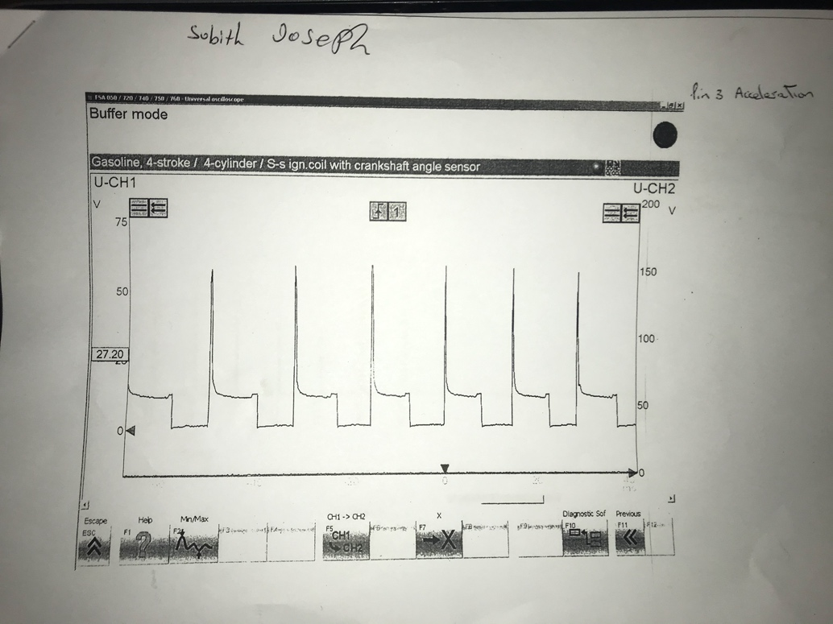
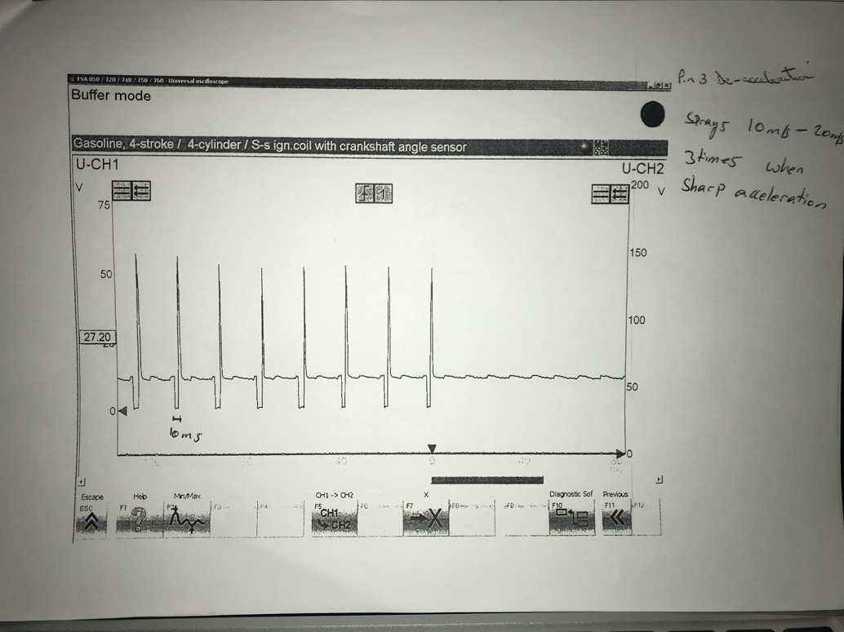
Figure 1 // Part 1 // Injection (snap acceleration)

Figure 2 // Part 1 // Injection (Acceleration)
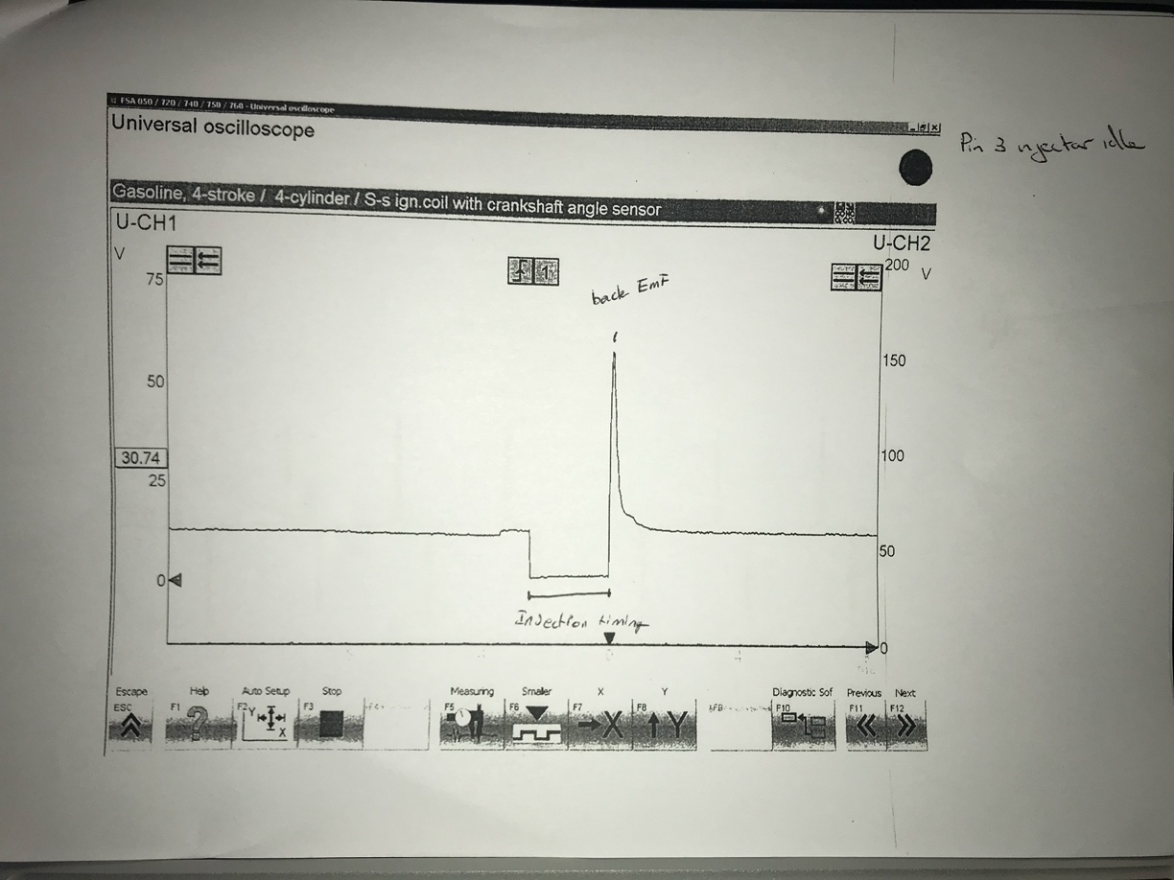
Figure 3 // Part 1 // Injector idle

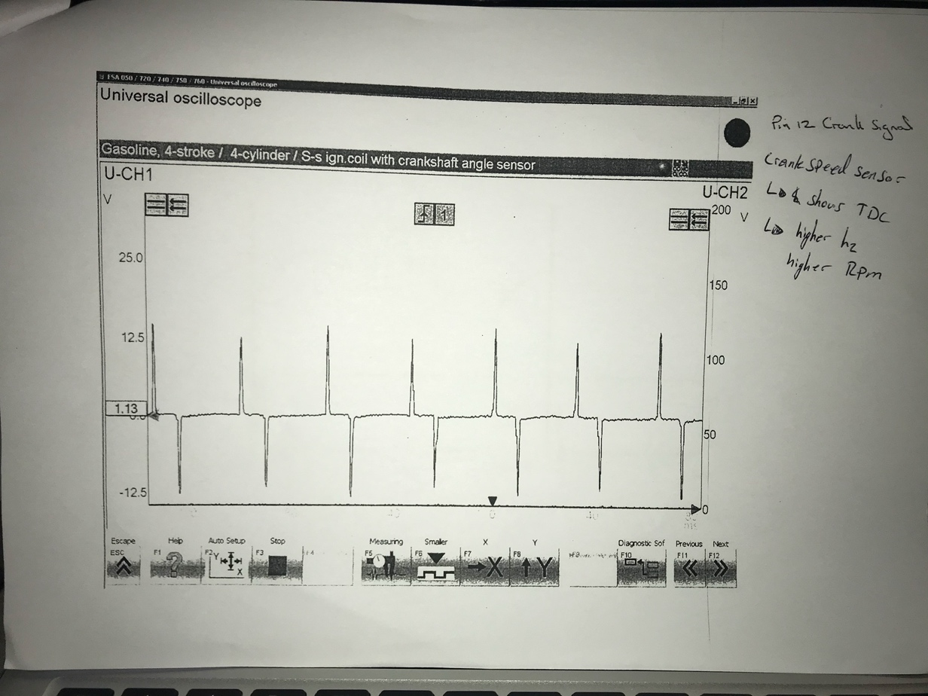

Figure 4 // Part 1 // Crankshaft sensor

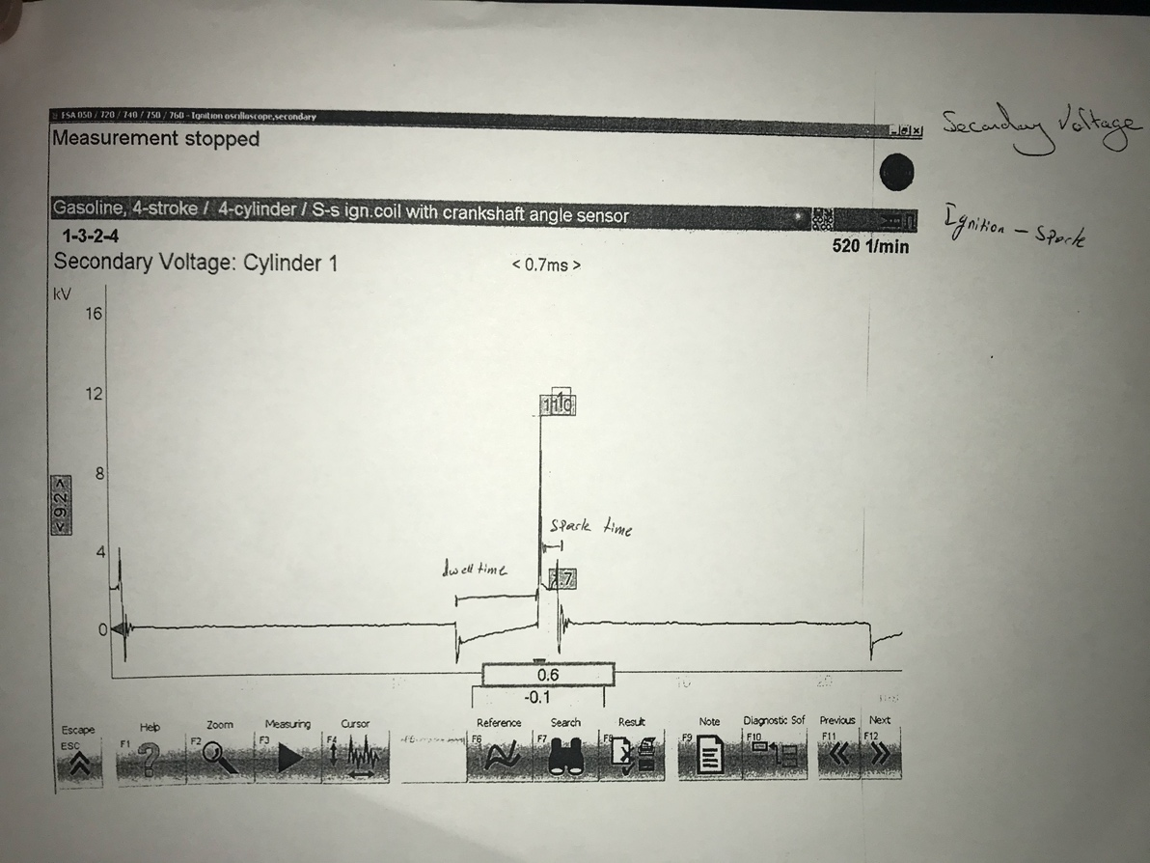
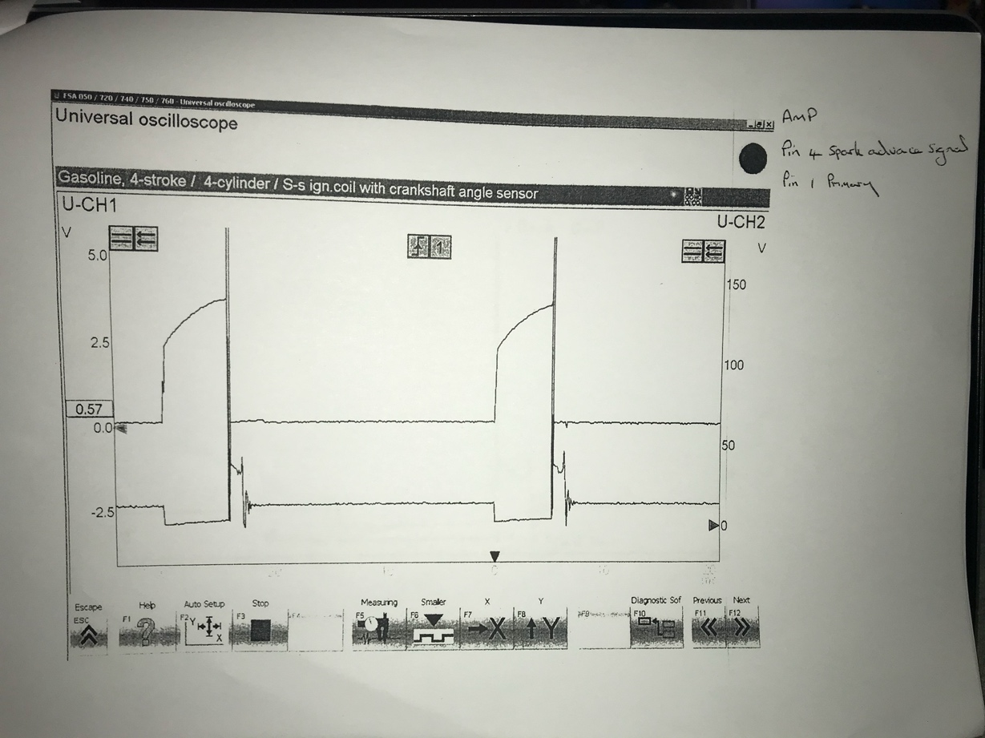
Figure 5 // Part 1 // Primary ignition
Figure 6 // Part 1 // Secondary Ignition
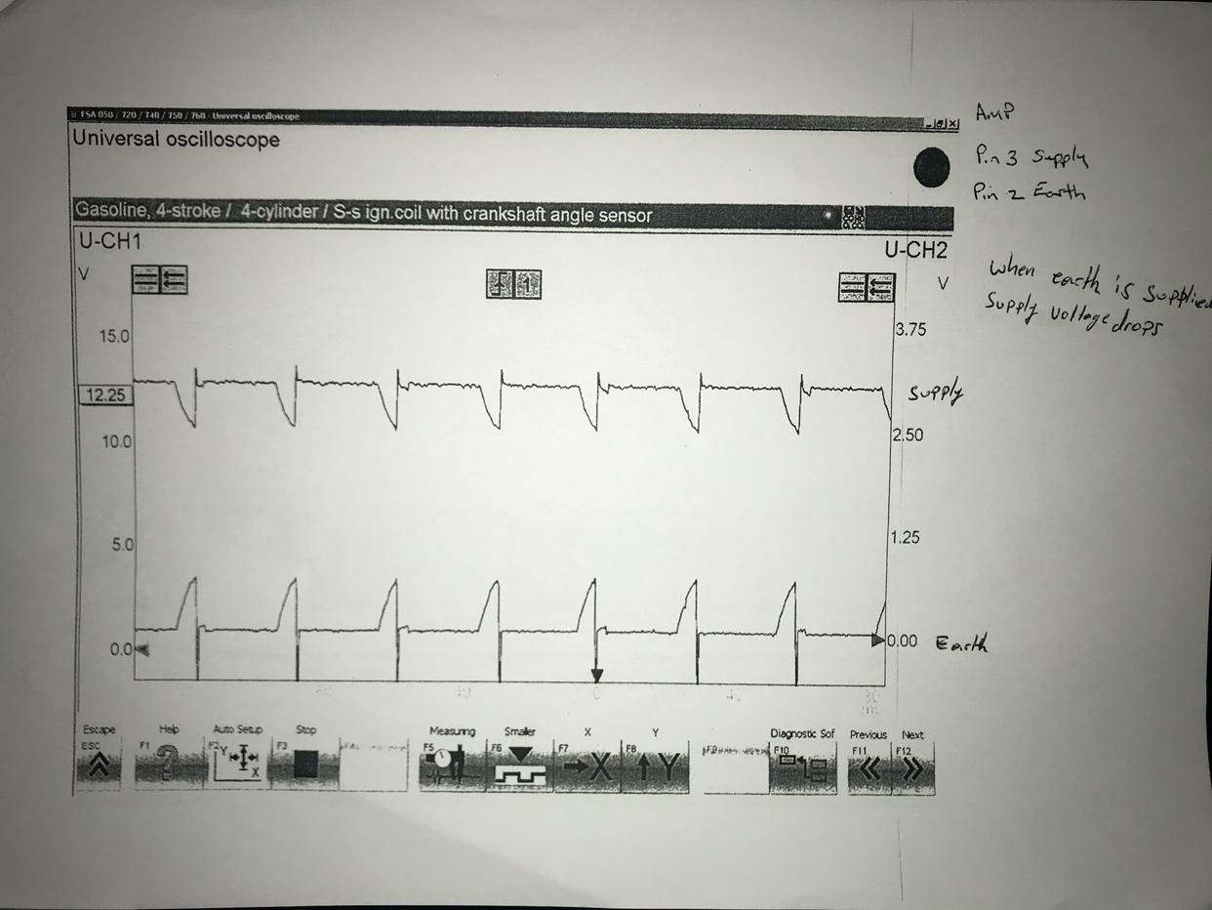
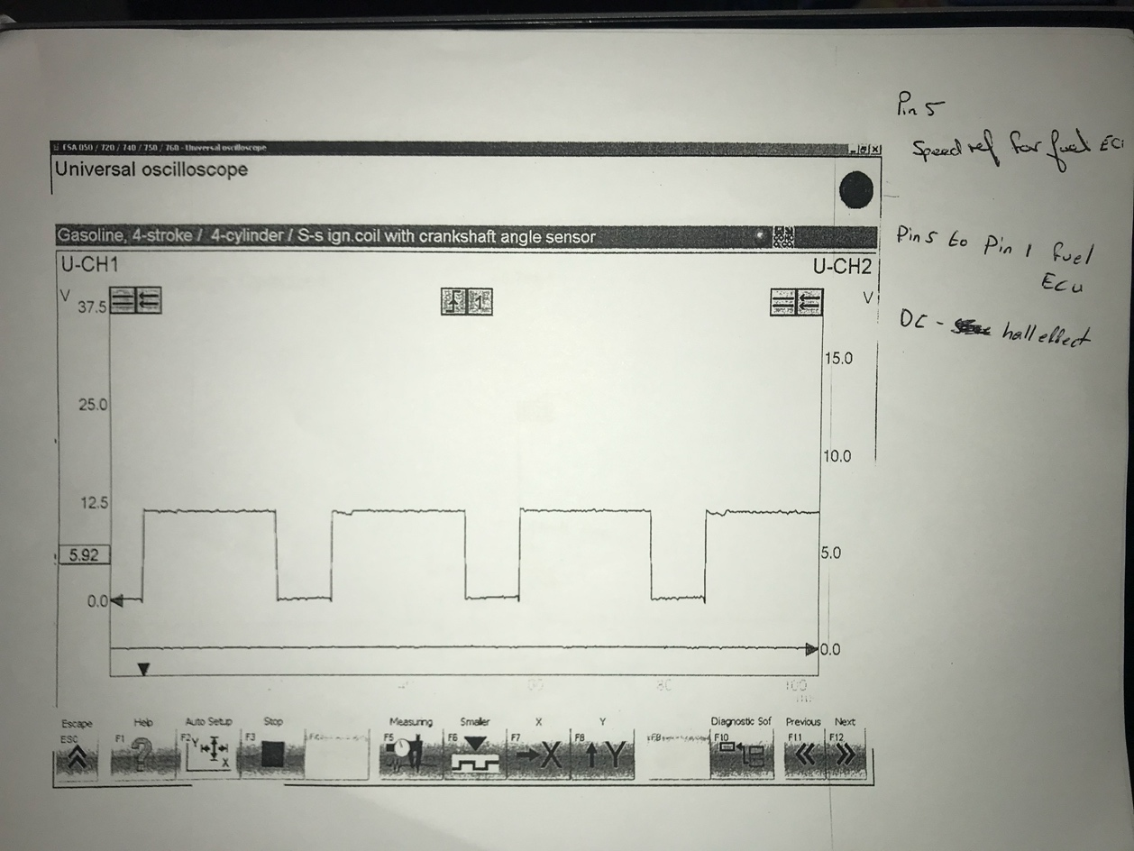
Figure 7 // Part 1 // Ignition ground

Figure 8 // Part 1 // Speed reference
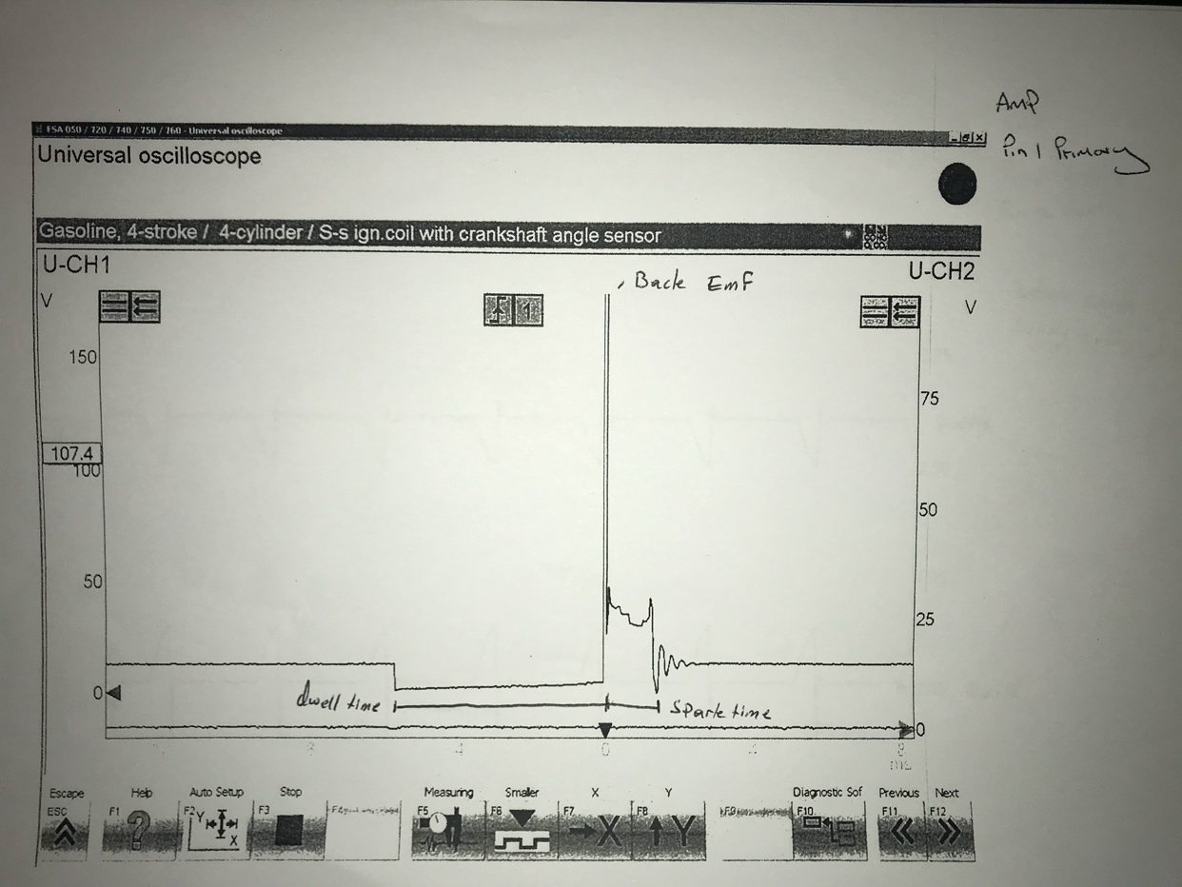
Figure 9 // Part 1 // Spark time

Analysis
Figure 1 // Part 1 // Injection (snap acceleration), shows that when the throttle is opened in a sudden the Fuel ECU decides to spray 10 Ms – 20 Ms 3 times. The point where the voltage drops to 0V is where the injectors are activated, the short burst of Voltage is the Back EMF (Electro-magnetic field).
Figure 2 // Part 1 // Injection (Acceleration), shows how injection timing changes when the engine speed is increased, the frequency is increased. The readings are similar to Figure 1 but a lower frequency.
Figure 3 // Part 1 // Injector idle, shows the injection timing while the engine is on idle, the reading is also similar to Figure 1 and 2 as they are all Injection timing.
Figure 4 // Part 1 // Crankshaft sensor, shows the sine wave speed sensor, this tells the Engine ECU the speed and also a reference of TDC (Top dead Centre), without this sensor the engine would not know when to spark the ignition and also when to inject fuel.
Figure 5 // Part 1 // Primary ignition, shows the point where the primary coil is charging up for the secondary coil to send it to the sparkplugs.
Figure 6 // Part 1 // Secondary Ignition, gives a closer look in the ignition timing from the Kettering coil to the spark plugs, the long period of 0V is the dwell time (primary coil charging the Kettering coil) and then the back EMF, which is 150+V and then the spark duration.
Figure 7 // Part 1 // Ignition ground, the readings shows that when earth is supplied supply voltage drops.
Figure 8 // Part 1 // Speed reference, shows the crankshaft sensor but digitalized by the amplifier into a DC hall effect voltage. This is done so that the data from this can be read from other ECUs in the vehicle
Figure 9 // Part 1 // Spark time, is just the same as Figure 6 as it shows the total spark time is 0.6 Ms

Part 2 – Bosh LE2 Jetronic

Introduction

The LE3 engine was introduced in a Vauxhall Carlton for the first time in 1986, the engine is a four-cylinder engine built by GM (general motors) and came in two capacity’s (1.8L and 2.0L) and was shared in various other models in the Vauxhall family or vehicles. The engine is a SOHC and has a maximum output of 89 BHP.

Research/Literature review

The engine Just like the first engine in part 1 uses a wide range of sensors to manage to the engine to run at its best at all time these include:
- Airflow sensor
- Throttle position sensor
- rotary idle valve
The Air flow sensor calculates the volume of air entering the intake, with this data the engine can decide and adjust the air to fuel mixture ratio to try and achieve 14.7:1. Having this enables the vehicle to be able to be driven in many different conditions as where air density changes the engine can adjust how much fuel is needed for injection.
The throttle position sensor is important since it tells the engine how much load is being forced to the engine, as the throttle opens the engine is taking in more air, as to more air is the higher volumetric efficiency as meaning more power output hence the increased amount of oxygen.
Rotary idle valve is important to control the idle of the vehicle. The valve can adjust the idle RPM depending on the engine temperature and load, if the vehicle is cold the idle valve would open up to allow more air into the engine making the rpm raise to warm the engine up, also if the vehicle is under stress the engine can tell the rotary idle valve to open up to compensate the stress the engine is currently under.

Methodology
- Before entering the work station, wearing the appropriate PPE (Personal Protective Equipment) is mandatory
- Before starting any procedure, checking the working environment if it is safe to work in is very important to lowering the risk or any personal injury
- Due to the engine being started up an extraction system is needed or if able to work in an environment with great ventilation
- Check equipment’s if they are correctly calibrated and in working order (multi meter, oscilloscope)
- Take a base battery voltage reading
- Before removing any components disconnecting the battery is very important to overcome a short circuit leading to the fuse popping
- With ignition OFF take resistance readings (Throttle potentiometer, Coolant temperature sensor 1&2, airflow sensor, injectors, idle speed control valve, HTC Leads)
- Take a voltage test with ignition OFF and ON to all Pins
- Using the probe from the oscilloscope measure the fuel injection timing, Pin 16 (Fuel injectors) Pin 45 (NTC 2, coolant temperature), Pin 28 (Lambda)
- Measure every 10ºC up to operating temperature (80ºC)
- When engine reaches 70ºC turn on fan (prevents overheating)

Results

Figure 11 // Part 2 // Amplifier
Figure 12 // Part 2 // HTC Leads

Figure 13 // Part 2 // Injector Values
Figure 14 // Part 2 // NTC 1
Figure 15 // Part 2 // Static test
Figure 16 // Part 2 // Air flow sensor
Figure 17 // Part 2 // Warm up phase

Analysis

Figure 11 // Part 2 // Amplifier, shows the Resistance reading for each Primary and Secondary lead going to the ignition coil. The primary has 0 ohms resistance as the Kettering coil has the job for resistance to amplify the voltage. There was no data on the manufacture specification so testing was just done to check if there were any break or corrosion within the cable.
Figure 12 // Part 2 // HTC Leads, shows the resistance value for the Ignition leads, the resistance rating is different to each cylinder, this is because of the length of the leads are different, to compensate the changes of length each lead has its one own rating for the specific cylinder.
Figure 13 // Part 2 // Injector Values, shows the resistance values on the fuel injectors for it to open and spray fuel. Comparing the values recorded to the manufacture specification it is within the range which mean the injectors are in the correct working condition.
Figure 14 // Part 2 // NTC 1, shows how when the temperature raises the less voltage the it produces, due to the name (Negative temperature coefficient) as the temperature raises the resistant lowers, this is shown on the chart as the temperature raises from ambient the ohms reading lowers. From the readings the sensor does look to be faulty as it is not performing in the ranges as it should be from the manufacture specification.
Figure 15 // Part 2 // Static test, shows the values of most the electrical components when the ignition is OFF and ON, doing this can view which pins are a constant Live (Pin 36 + 18) from the battery and also from comparing battery voltage can find out Ground Pins. The values read looks good although signs of voltage drop are compared to the base battery voltage.
Figure 16 // Part 2 // Air flow sensor, reading the resistance values on the Airflow sensor shows that the resistance reading isn’t up to manufacture specification, this can cause the engine to not function to its full capability as the engine is receiving incorrect data.
Figure 17 // Part 2 // Warm up phase, this shows how the vehicle behaves during the warm up phase (open loop), in this phase the Engine ECU only takes reading from the Coolant temperature and ignore the O2 lambda sensor. The ECU has a programmed mapping for close loop as the engine would have a rich air/fuel mixture, this is done to head up the engine and also the catalytic converter fast as possible by exhausting unburnt fuel and then as temperature raises the fuel will burn in the exhaust system creating heat. The lambda sensor needs to get up to a high temperature before I can start taking reading, lambda sensor only starts reading when engine temperature got up to 40ºC and above.

Conclusion

In conclusion this report has given me a greater understanding on how the two engines behave during open loop/ warm up phase, as the engine is cold the ignition timing and fuel timing are advanced and also the duty cycle is much longer compared to how the engines behave when reached to optimum temperature. Both engines are highly advance to the time they were built from and the technology from these vehicles are widely used in almost every modern vehicle to the least. From learning how each sensor works and what type on information they pass on to other components is great knowledge as in engineering it develops an understanding on what an engine needs to run and also maintain itself without any human input

Recommendation for Further study

For recommendations, if there were more time, and no budget then working on a modern engine and then comparing to the engine used in this report and then comparing on how each component has evolved and what kind of benefits does it have to not just the drivability but also environmentally.

