Application Development (Games)
  - Lecture 1 Lab Tutorial Exercise

Perky Penguin Game Part II

Objectives
The aim of this lab exercise is to introduce you to game development in Unity. You will create a basic 2D Game, Perky Penguin, which is a Jetpack Joyride-based game.
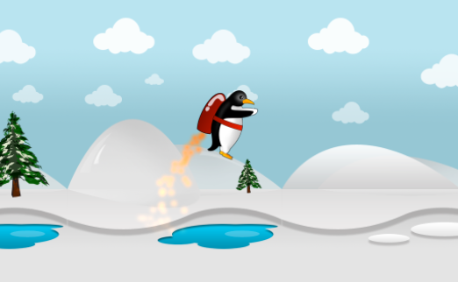

Game Level Backgrounds
- Download the assets available on Moodle and import it into your project.
- From the main menu, go to Edit Project Settings Tags and Layers.
- Expand the Sorting Layers section and create four new layers as follows. 2D has no concept of a z-axis. You use the sorting layers to position objects behind or in front of each other. You have a Default layer, which is the lowest layer and it will be behind everything else.
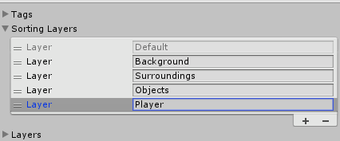
- Add a new empty Game Object to your scene and call it Platform Block 1 or something similar and set the transform properties as shown below.
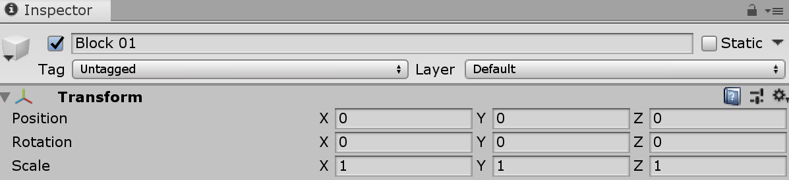
- Using the graphics in the downloaded package, create a background of your choice. You may add more layers if needed.
  - Make the background game objects children of the game object created in the last step.
  - Note: Adding gaps in the platforms can be used to create a more challenging game play.
Note: you may need to scale the graphics down (especially if you set up the Android build settings).
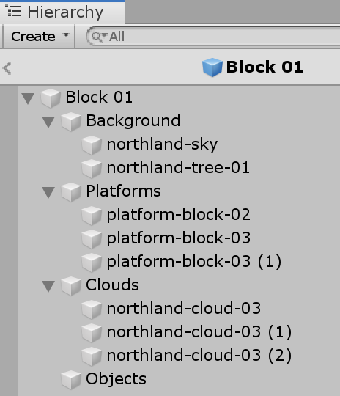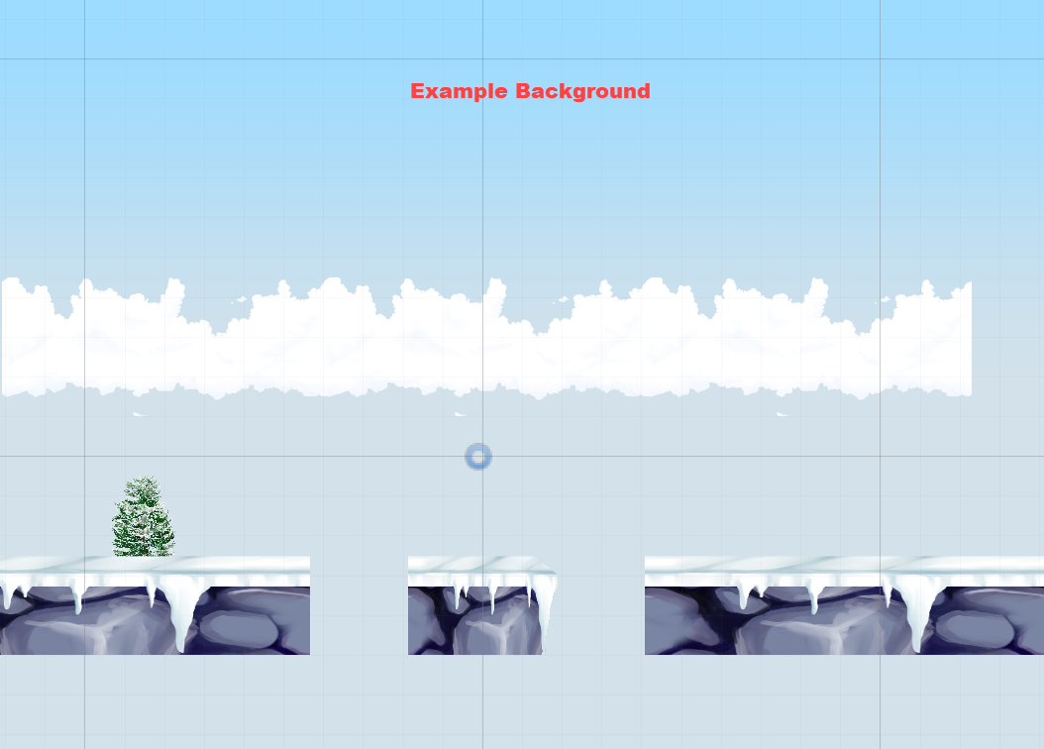
- For each of your background images, add them to the appropriate layers and remember to move Perky the Penguin to the Player layer, so it is visible.
For example, the clouds, platform and tree are part of the surroundings, while the skyn is part of the background.
- You will also need to adjust the penguin’s rocket fire layer.
  - Select the rocket fire child object of the Penguin
  - Under the particle system component, scroll down and locate the Renderer and expand it. It should have a Sorting Layer property – change this to Player.
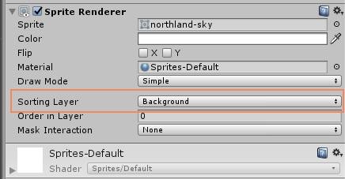

Adding a Ceiling and a Floor
As you have probably noticed, Perky falls out of the game world – disappears out of the screen display area.
You need to add a floor and ceiling to the game i.e. limit Perky between the screen bounds.

Adding a Floor
- Create a new empty game object from the menu GameObject Create Empty.
- Rename the game object to Floor.
  - Set its transform properties as shown below. You can set the width (x scale) to whatever works for your background, but try not to make it too big or too small (between 14.5 and 20) should be fine).
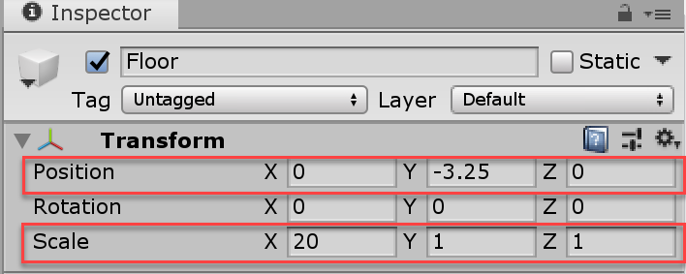
- For each of the platform blocks in your background, add a Box Collider 2D component to it using the Inspector window. Click Add Component Physics 2D Box Collider 2D.
For example, in my background, each of the highlighted blocks have a box collider component added to them.
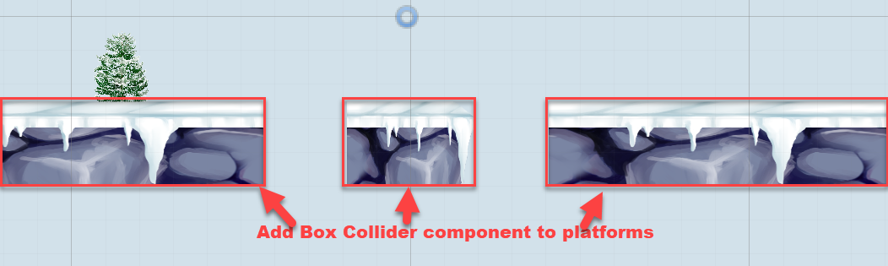

- Position Perky just above a platform block.
- Save your changes and test. Perky should now not fall out of the screen and will stop when it collides with the floor.

Adding a Ceiling
- Add another game object called ceiling.
  - Set its transform properties as shown below. NOTE The ceiling’s correct Y is +3.25
  - Add a Box Collider component to it as you did before.
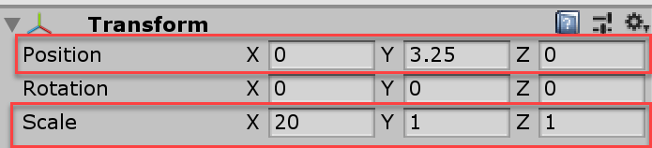
- Save your changes. Note: you will not notice the effect of the ceiling until Perky’s Swim behaviour has been scripted.
- Create a new folder in the Assets folder called Prefabs.
- Drag your Level Block game object from the hierarchy window to the prefabs folder to create a prefab.

Challenge Exercise
- Create multiple background environments:
  - Add a floor and ceiling to all of them.
  - For some of them, add gaps in the floor to create a more challenging game play.
    - You will need to add child game objects to the floor that are shorter than the floor and add the box collider to these.
    - Note: you still need the long floor (but no box collider on it) as this will be used to generate the environment later.
  - Save your background environment as a prefab.
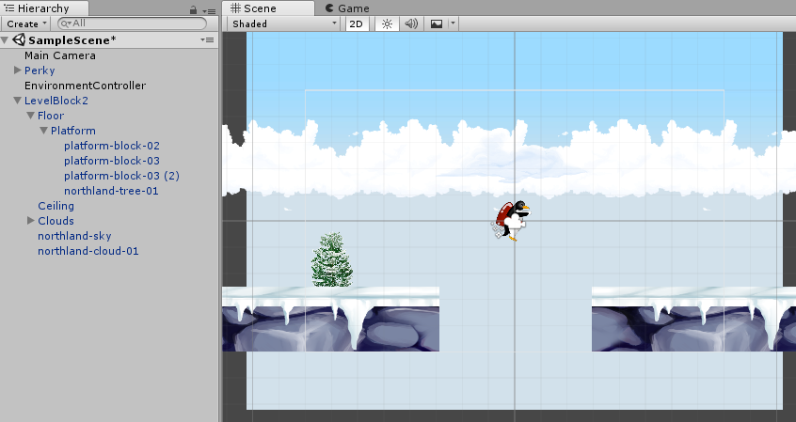
- To be Continued

Adapted from: Mastering Android Game Development with Unity, Packt (2017), By Siddharth Shekar, Wajahat Karim.

