

Assignment Title: Resit - A report detailing an innovative solution to an operational problem.
Module name: Creativity and Innovation BMSW5031_Swansea
Student name: Marian Mihai Luca (1712434)
Lecturer Name: Chris Wilkin
Submission date: Friday 19th of June 2026

AI Statement:
AI tools were used in Task 2 to generate responses that were then critically analysed and evaluated, as required by the assignment. The purpose was not to rely on AI for answers, but to assess its limitations and relevance to the case study.
Therefore, I declare, that the rest of the work has been completed independently.

Word count: 4257
Table of Contents
Task 1 3
Executive Summary 3
1. Introduction to the organisation and the issue 4
2. Root Cause Analysis of Structural and Managerial Challenges 5
3. The proposed innovation and the 4Ps of Innovation 6
4. The Creativity Process 8
5. Viability Using Lewin`s Force Field Analysis 9
6. Organisational Climate and Support for Innovation 10
7. Conclusion 11
Task 2 12
Critical Appraisal of AI Recommendations to Develop the Seren Coffi Innovation 12
Executive Summary 12
1. Introduction 13
2. How AI interpreted the problem 13
3. How AI attempted to develop the innovation 14
4. Limitations of AI Recommendations 15
5. Successes and Challenges of Using AI 16
6. Comparison Between AI Output and Human Judgement 17
7. Conclusion 17
8. Reference list 37

Task 1

Executive Summary

Seren Coffi is a small independent café in Cardiff that has managed to build something quite special. Through ethical sourcing, a Welsh language identity and a strong focus on community, the café has earned loyal customers and a good reputation, which is not easy for a small business to do. However, after reading through the case I think the main problem is not the concept itself but the fact that the business no longer has the right structure to deliver on that concept consistently. Rising costs, a broken grinder and three founders who are all trying to do too much at the same time have slowly caused the café to struggle, even though the original idea is still a good one.
In this report I am proposing one focused change. Rather than restructuring the whole business, looking for outside investment or bringing in new management, my proposal is simply to appoint one of the three existing founders as head of operations. This person would have clear responsibility for day-to-day decisions, things like scheduling, maintenance, service standards, event coordination and making sure problems actually get followed through. To support this, £1,000 from the available £2,000 budget would go towards pay recognition for the extra responsibility, and the remaining £1,000 would be used straight away to repair the broken grinder. I think fixing the grinder matters not just for practical reasons but also because of what it represents. It is probably the most visible sign of what happens when nobody has the authority to just make a call and see it through.
Throughout the report I look at this proposal using a range of frameworks including the Business Model Canvas, the Value Chain, Design Thinking, Force Field Analysis and an organisational climate review. In my view the conclusion from all of these points in the same direction. Seren Coffi does not need to reinvent itself. It just needs one person with enough responsibility to make sure what already exists actually works properly in practice.

Introduction to the organisation and the issue

Seren Coffi is a small independent café that opened in Cardiff in early 2024. It is in a narrow unit near the old docks, in a space that used to be a betting shop and then briefly a vape store. From the very beginning, the café was always more than just a place to get coffee. It sourced its coffee from ethical cooperatives, welcomed both Welsh and English speakers, used reclaimed furniture and organised community events like poetry evenings, language exchanges and pay what you can nights. All of this helped the café build a loyal customer base and even get press coverage, which I think is quite impressive for a small independent business. The café became known not just for its coffee but for what it stood for, and that kind of reputation takes real effort to build.
By January 2026 things had changed quite a lot. The cost of coffee beans went up because of global supply problems, energy bills also increased and the coffee grinder broke down and was never fixed. A bigger chain café opened nearby offering discounts and convenience. Inside the café, making decisions had become slow and frustrating. One of the founders had to take a second job and another had started missing meetings. The community events stopped completely and the chalkboard that used to tell customers about where the coffee came from was just left blank.
In my view the concept itself has not really failed. Customers still come in and the café still clearly means something to them. The problem is not the product or the market, it is the management structure. The way the business was set up made sense at the beginning but it was never really updated as things changed. Greiner (1972) explains that businesses moving from an early creative stage into a growth phase often face a leadership crisis, where the informal ways of doing things that once felt natural start getting in the way of making proper decisions. I think that is exactly what is happening at Seren Coffi right now. The innovation suggested in this report does not try to change what the business is or who owns it. It just tries to create the structure the business needs to work properly again.

Root Cause Analysis of Structural and Managerial Challenges

Creativity and innovation are related but they are not the same thing. Creativity is about coming up with new and useful ideas, while innovation is about actually putting those ideas into practice in a way that creates value (Tidd, 2018; Trott, 2016). In my opinion Seren Coffi has already shown plenty of creativity through its ethical sourcing, bilingual identity and community events. The problem is not that the café lacks ideas. The problem is that it does not have a reliable system for making sure those ideas actually get delivered consistently, and I think that is an important difference.
In most business contexts, innovation tends to be linked to growth, competitive advantage and making more profit (Schumpeter, 1934; Porter, 1996). A typical response to a café that is struggling might be to cut costs, find investors or even sell to a larger hospitality group. However, I think doing any of these things would seriously damage what makes Seren Coffi worth saving in the first place. Foss and Saebi (2015) argue that business model innovation should think about how value is created and delivered, not just how profit is made. For Seren Coffi, value comes from things like trust, community, the Welsh language and the ethical story behind every cup of coffee. These are not inefficiencies to remove, they are the whole point of the business.
Turner (2020) talks about businesses becoming what he calls zombie organisations, meaning they are still technically open but have lost the energy and purpose that made them different. I found this idea really relevant when thinking about Seren Coffi because the café is still running but the events have stopped, the grinder is broken and it is no longer communicating its story to customers. March (1991) makes a useful distinction between exploration and exploitation. Seren Coffi has done the exploration part well by building a creative values-led concept, but it has struggled to exploit that by turning its strengths into reliable daily performance. Pisano (2015) argues that creative advantages cannot last without operational support and I think this is exactly what the café is experiencing. Kim and Mauborgne (2004) also suggest that values-led businesses should compete through meaning and relationships rather than price. What Seren Coffi needs, in my view, is a structural change that protects its values while actually allowing the business to act on them.

The proposed innovation and the 4Ps of Innovation

The innovation I am proposing is quite simple. One of the three existing founders would be formally appointed as head of operations, with clear responsibility for day-to-day decisions including staff scheduling, maintaining equipment, managing stock, keeping service standards consistent, organising events and making sure problems actually get solved. This is not about changing who owns the business or who makes the big long-term decisions. All three founders would still be equal co-owners and would still decide strategy together. The change is simply that one founder becomes clearly responsible for making sure things get done day to day, because at the moment nobody really is.
The £2,000 available would be split equally. £1,000 would go towards pay recognition for the extra responsibility and £1,000 would be used straight away to fix the broken grinder. I think fixing the grinder is important not just practically but also because of what it represents. The fact that it has been broken for so long and nobody has fixed it shows exactly what happens when no one has the authority to just make a decision and follow it through. Fixing it would send a clear message to staff and customers that those things are changing. The role would be recorded in a simple one-page description covering what the head of operations is responsible for and what decisions they can make independently. Birkinshaw, Hamel and Mol (2008) describe this kind of change as management innovation because it changes the way an organisation is coordinated and led, which I think is a fair description of what this is.
Osterwalder and Pigneur's (2010) Business Model Canvas is helpful here, see Figure 1. The Value Proposition at Seren Coffi is still strong ethical coffee, Welsh identity and community connection are all things that clearly matter to customers. The weakness is in actually delivering that value. Key resources, mainly the founders' time and energy, are being used up by problems that never get properly resolved. Key activities are stuck in crisis management because every issue needs all three founders to agree before anything moves. Key partnerships with ethical suppliers are not being developed because nobody has the time. Customer relationships have weakened because events have stopped. Giving one founder clear operational responsibility would help with all of this, which supports Foss and Saebi's (2015) argument that business model innovation is about reorganising how value is delivered, not just how profit is made.
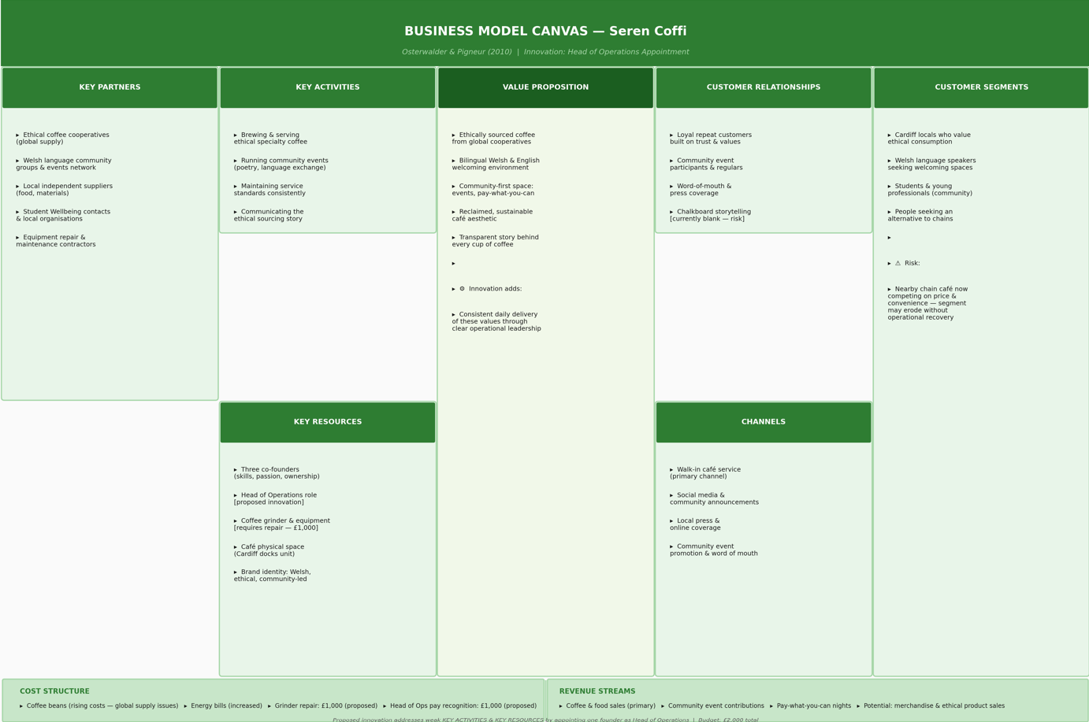
Figure1.
Porter's (1985) Value Chain also supports the proposal. The primary activities at Seren Coffi are strong in principle but the firm infrastructure, which includes the management systems and accountability structures, is weak. Without it everything else breaks down. Porter (1985) argues that competitive advantage depends on consistency across all activities and I think Seren Coffi is a clear example of what happens when that consistency is missing.
Looking at Tidd and Bessant's (2022) 4Ps of Innovation, I would say this is mainly Process Innovation because it changes how operational decisions are made. Trott (2016) argues that process innovation is especially important in service businesses because consistency shapes the customer experience directly. It is also Paradigm Innovation because it challenges the idea that equal ownership must always mean equal authority in every daily decision, which I think is a belief worth questioning at Seren Coffi. The proposal also supports Position Innovation because a café that fixes its equipment, restarts events and tells its story will naturally look stronger than one that is quietly declining. Kim and Mauborgne (2004) argue that positioning should be based on real operational substance rather than just marketing. Product innovation is less relevant here because the product itself is not really the problem, though better consistency would improve the overall experience (Tidd, 2018).

The Creativity Process

I found Brown's (2008) Design Thinking framework quite useful for explaining how this solution was developed. It has five stages: Empathise, Define, Ideate, Prototype and Test. In the Empathise stage, I tried to understand what the founders are actually going through. They clearly still care about the café but they seem completely exhausted by a structure that turns even small operational problems into complicated group decisions. One founder has taken a second job and another is missing meetings, and to me that suggests the problem is not commitment but the pressure caused by things that never get resolved.
In the Define stage, I tried to reframe the problem. The question is not how to cut costs or bring in outside management. It is how to help the founders deliver their values without damaging what makes the café special, which immediately rules out any solution that changes ownership or identity.
In the Ideate stage, March's (1991) exploration-exploitation distinction was really helpful. Since Seren Coffi already has creative strengths but cannot deliver them consistently, the answer is not a new product or a rebrand. It is a structural change that lets the original concept finally work the way it was supposed to.
In the Prototype and Test stages, appointing one founder as head of operations was tested against the brief. It needs no extra money, no outside recruitment and no change in ownership. Wallas (1926) would call this the illumination stage, where the right answer becomes clear once the problem has been properly understood. I think that description fits quite well here.

Viability Using Lewin`s Force Field Analysis

Lewin's (1947) Force Field Analysis looks at change by weighing up the forces pushing for it against the forces resisting it. For Seren Coffi I think the forces pushing for change are quite strong. The business is clearly struggling, costs have gone up, the grinder is still broken, events have stopped and a well-funded chain competitor has opened nearby. Kotter (1996) argues that urgency is essential for change because without it people tend to stick with what they know. In this case, doing nothing is not a neutral choice, it just lets the decline carry on.
The proposal is also financially realistic, which I think matters a lot for a business in this situation. It uses the £2,000 that is already available without needing debt or outside investment. It also keeps the culture intact because the head of operations comes from within the founding team. Rogers (2003) argues that innovations are more likely to be accepted when they fit with the existing culture, and I think an internal appointment is much more compatible with Seren Coffi's identity than bringing in someone from outside.
That said, there are real forces resisting change. The strongest is probably cultural resistance. Schein (2010) argues that organisational culture is built on deep assumptions that people treat as fixed principles. At Seren Coffi, the idea that equal ownership means equal authority in everything might feel impossible to change. If one founder gets formal authority the others might feel left out or undervalued. Tuckman (1965) shows that teams often go through tension when roles shift and I think that is a genuine risk here. There is also a question of whether the appointed founder has the right skills for a more formal management role. Mumford et al. (2000) note that creative founders sometimes struggle with the demands of structured management.
Overall, though, I think the driving forces are stronger because the alternative is just continued decline. Govindarajan and Trimble (2005) argue that how a change is implemented matters as much as the idea itself. Agreeing the appointment openly, writing the role boundaries clearly and doing a review after six months would help manage the risks without adding heavy bureaucracy.

Organisational Climate and Support for Innovation

The climate at Seren Coffi feels like it is pulling in two directions at the same time. On one hand it does support creativity because the founders still seem genuinely motivated by their purpose and community values. Amabile et al. (1996) identify intrinsic motivation, psychological safety and shared purpose as important conditions for creativity. Anderson and West (1998) also highlight vision and participation as key factors. These qualities clearly helped Seren Coffi build something original and I do not think they have completely disappeared.
On the other hand, the climate does not really support putting things into practice. Scott and Bruce (1994) argue that innovation needs proper mechanisms to turn ideas into action and Seren Coffi simply does not have those right now. Every decision needs agreement from three people and nobody has clear accountability. I think when problems keep building up without being resolved, people eventually stop raising them because they have learned nothing will change. Edmondson (1999) makes a similar point about psychological safety weakening when effort consistently produces no visible outcome.
Schein (2010) argues that what people actually do in an organisation reflects deeper assumptions. The assumption that shared authority is always the fairest approach once worked well for Seren Coffi but now it is getting in the way. Hofstede (2001) similarly argues that strong cultural values can start acting as barriers if they are not adapted when circumstances change. Turner's (2020) zombie organisation idea feels relevant again here. The proposed innovation does not try to go against the culture. It does not reject shared ownership, Welsh identity or community values. It just adds the operational accountability that is currently missing. Vaccaro et al. (2012) argue that management innovation works best when it reinforces cultural identity rather than disrupting it, and I think appointing one of the existing founders does exactly that.

Conclusion

Overall, I think the argument this report has made is quite clear. Seren Coffi does not need to reinvent itself. It just needs a structure that lets its concept actually work. The Business Model Canvas shows that a strong Value Proposition is being let down by unclear activities and exhausted resources (Osterwalder and Pigneur, 2010). Porter's Value Chain shows that weak firm infrastructure is damaging the café's primary activities (Porter, 1985). The 4Ps show this is mainly process and paradigm innovation because it changes how decisions are made (Tidd and Bessant, 2022). Design Thinking shows the solution came from genuinely understanding the founders' situation rather than applying something generic (Brown, 2008). Lewin's Force Field Analysis shows the case for change is stronger than the risks, as long as implementation is handled carefully (Lewin, 1947). The climate analysis shows creativity and purpose are still there but the structure to act on them is not.
Appointing one founder as head of operations, with a written role description, £1,000 pay recognition and an immediate grinder repair, is a small change in cost but I think it could make a significant difference in practice. It does not change what Seren Coffi is. It just gives the café a real chance to become what it was always supposed to be. One clear decision maker, agreed by all three founders, supported by a modest budget and reviewed before any trust is put at risk. That feels like the right kind of change for a business like this.

Task 2

Critical Appraisal of AI Recommendations to Develop the Seren Coffi Innovation

Executive Summary

This task evaluates my experience of using an AI LLM to support the development and critical testing of head of operations innovation proposed in Part 1. The aim was not to rely on AI for answers but critically assess its effectiveness, its limitations and the quality of its reasoning through a series of structured prompts, as documented in the screenshots included in the appendix.
The findings show that while the AI was able to generate fluent and well organised responses, they were frequently generalised and lacked the contextual sensitivity that the Seren Coffi`s case specifically requires. In several instances, the AI focused on surface level improvements rather than engaging with the underlying structural logic of the proposal. Its suggested improvements, such as formal KPIs, an Operations Coordinator and a formalised trial period, were all taken from standard management templates rather than tailored responses to this particular café`s situation.
The AI was at its most useful when it confirmed the importance of structure and leadership for small businesses, which directly supported the rationale behind my original proposal. However, this confirmation required no modification to the solution I had already developed.
The overall conclusion is that AI can stimulate critical thinking and highlight general areas of consideration, but it cannot replace the contextual human judgement needed to develop an appropriate and specific innovation for a case as complex as Seren Coffi.

Introduction

The purpose of this section is to critically evaluate how AI was used to develop the head of operations innovation presented in Part 1. The innovation already existed before the AI interaction began. Therefore, the objectives were not to ask AI to generate a solution, to test the proposal, identify weaknesses, explore alternatives and assess whether the innovation remained appropriate after critical examination.
As shown in Screenshots 1-3, the AI was first asked to read and understand the Seren Coffi case study. A series of prompts were then used to challenge the proposal from different perspectives. These included asking the AI to critique the innovation, assess its practicality, suggest improvements and compare alternative solutions against the original proposal.
This approach reflects the increasing use of AI as a decision support tool rather than a decision maker. Davenport and Ronanki (2018) argue that AI can support analysis and decision making by identifying patterns and generating options, but that human oversight remain essential.

How AI interpreted the problem

When I first asked it to review my proposal (Screenshots 4-7), it recognised that the main strength of appointing a founder as head of operations was the creation of clear operational accountability. The AI acknowledged that the proposal could improve decision making, reduce delays and create a clearer point of responsibility.
The AI also identified several risks. These included founder tensions, uncertainty around authority and concerns about whether the chosen founder would have the skills needed for the role. Although these observations did not change the innovation itself, they highlighted implementation issues that I had not explored. Simon (1997) suggests that effective decisions require an understanding of both benefits and constraints. In this aspect, the AI encouraged a more balanced evaluation of the proposal.
A particularly useful insight appeared when I asked the AI how easy the proposal would be to implement. In Screenshot 11, the AI argued that the biggest challenge would not be writing a role description or changing responsibilities, but convincing three founders to accept a shift in authority. I found this observation valuable because it moved beyond operational issues and focused on the human side of change. This aligns with Kahneman’s (2011) argument that organisational decisions are often influenced by behavioural and psychological factors rather than purely rational considerations.
The AI’s strongest performance came when I asked it to ignore my proposal and analyse the case independently (Screenshots 10–17). It concluded that Seren Coffi’s core problem was not declining demand or a weak product. Instead, it identified governance paralysis, founder fatigue and slow decision-making as the underlying issues.
Overall, the AI performed reasonably well in identifying the nature of the problem. It recognised that the café’s difficulties were primarily structural rather than commercial. However, its analysis was still based on broad management patterns rather than a deep understanding of the specific relationships and culture within Seren Coffi.

How AI attempted to develop the innovation

One example can be seen in Screenshots 4-5, where it suggested introducing clearer role boundaries, performance reviews and accountability measures. Whilst some of these recommendations were fairly standard, they encouraged me to think more carefully about how the role would operate in practice.
The most significant attempt to develop the innovation appeared in Screenshots 8-9 through the recommendation of a Founder Operations Council. Rather than replacing the head of operations, the AI attempted to strengthen it by creating a structure through which the other founders could remain informed and involved whilst allowing one founder to lead operationally.
This was probably the most creative recommendation produced during the interaction because it directly engages with one of the risks identified by the AI. It recognised that founder relationships could become strained if one individual was giving greater authority. By suggesting a council, the AI attempted to balance accountability and collaboration.
However, after evaluating the recommendation, I decided not to adopt it. The main reason was that Seren Coffi’s existing problem was excessive reliance on collective decision-making. Introducing another formal governance structure risked recreating the same issue. Consequently, I accepted the principle of maintaining communication between founders but rejected the formal council itself.
The AI later proposed a completely different solution, hiring a part-time Operations Coordinator (Screenshots 18–21). The recommendation was presented as a lower risk alternative because it avoided elevating one founder above the others and added operational support.
This appeared to be a reasonable suggestion. However, when assessed against the case, it became less convincing. Seren Coffi had only £2,000 available and was already under financial pressure. An external coordinator would require recruitment, training and supervision. The recommendation did not solve the underlying governance issue. It added support but left decision-making authority largely unchanged.

Limitations of AI Recommendations

Despite making some useful contributions, the AI also demonstrated several limitations.
The most obvious limitation was its tendency to rely on generic management solutions. Recommendations such as KPIs, performance monitoring and formal governance structures appeared repeatedly throughout the interaction. Whilst these ideas were not necessarily wrong, they often reflected standard management thinking rather than solutions specifically designed for Seren Coffi.
For example, the suggestion of formal KPIs initially sounded sensible because accountability is important. However, Seren Coffi is a small community-focused café built around trust, relationships and shared values. Introducing a highly formal performance management system could have altered the culture of the organisation. Morgan (2006) argues that management systems should reflect organisational context rather than be applied universally. This criticism applied directly to the KPI recommendation.
Floridi and Chiriatti (2020) argue that AI systems can produce plausible recommendations without understanding the context in which those recommendations will be implemented. This limitation became clear when the recommendation was examined more closely.
Another issue, the confidence with which the AI presented its responses. Most recommendations were delivered in a clear and convincing way, which created an impression of certainty. However, as Bender et al. (2021) argue, large language models generate responses based on patterns in language rather than genuine understanding. Several recommendations appeared persuasive, but became less appropriate once evaluated critically.
This experience highlighted the importance of questioning AI outputs rather than accepting them at face value.

Successes and Challenges of Using AI

There were several benefits to using AI during this process. One advantage was the speed with which it generated feedback and alternative viewpoints. Brynjolfsson and McAfee (2014) argue that digital technologies can enhance decision-making by expanding the range of options available for consideration. This was evident throughout the interaction.
The AI was also useful as a critical challenge tool. It repeatedly questioned assumptions, highlighted implementation risks and encouraged further reflection. Kolb (1984) suggests that learning is strengthened through cycles of reflection and evaluation. In this sense, the AI helped me examine the proposal more critically.
The biggest challenge was separating genuinely useful insights from recommendations that simply sounded convincing. Throughout the interaction, I found myself needing to assess whether suggestions were actually suitable for Seren Coffi or whether they reflected generic management advice.
Polanyi (1966) argues that much organisational knowledge is tacit and developed through experience. Because AI does not possess this tacit understanding, it struggled to appreciate some of the cultural and relational aspects of the case. Nonaka and Takeuchi (1995) similarly argue that knowledge creation depends on human experience and context. This helps explain why the AI could identify patterns but struggled with some of the more nuanced aspects of the problem.

Comparison Between AI Output and Human Judgement

The comparison between AI output and human judgement revealed important differences in approach. The AI approached Seren Coffi primarily as a management problem and generated solutions commonly associated with improving accountability and efficiency.
My own approach was more focused on the specific circumstances of the case. Rather than asking what management tools could be applied, I considered which solution would best fit the founders, the culture of the café and the financial constraints of the business.
This difference became particularly clear when comparing the Head of Operations proposal with the Operations Coordinator alternative. The coordinator model added support but did not fundamentally change decision-making. The Head of Operations role addressed the governance issue directly by creating a clear operational decision-maker.
Weick (1995) argues that organisational decisions are shaped by how individuals make sense of situations rather than by objective information alone. This perspective helps explain why the AI and I reached different conclusions despite analysing the same case.

Conclusion

Overall, the AI made a useful contribution to the development of the Head of Operations innovation, but it did not create the innovation itself. Its greatest value came from challenging assumptions, identifying implementation risks and forcing me to justify my own reasoning.
The interaction demonstrated that AI can be effective at recognising patterns, generating alternatives and encouraging reflection. References to Screenshots 4–25 show that the AI repeatedly tested the proposal, suggested modifications and compared alternative solutions. These interactions strengthened the final recommendation by requiring each aspect of the innovation to be examined critically.
At the same time, the exercise revealed important limitations. Many recommendations reflected generic management thinking and lacked sensitivity to the specific context of Seren Coffi. As Dwivedi et al. (2023) argue, AI can support analysis and idea development, but human judgement remains essential when deciding what is appropriate for a particular situation.
The final outcome therefore reflects a combination of AI-supported reflection and human evaluation. The innovation was strengthened by the process, but the final judgement remained a human one.

Screenshot 1
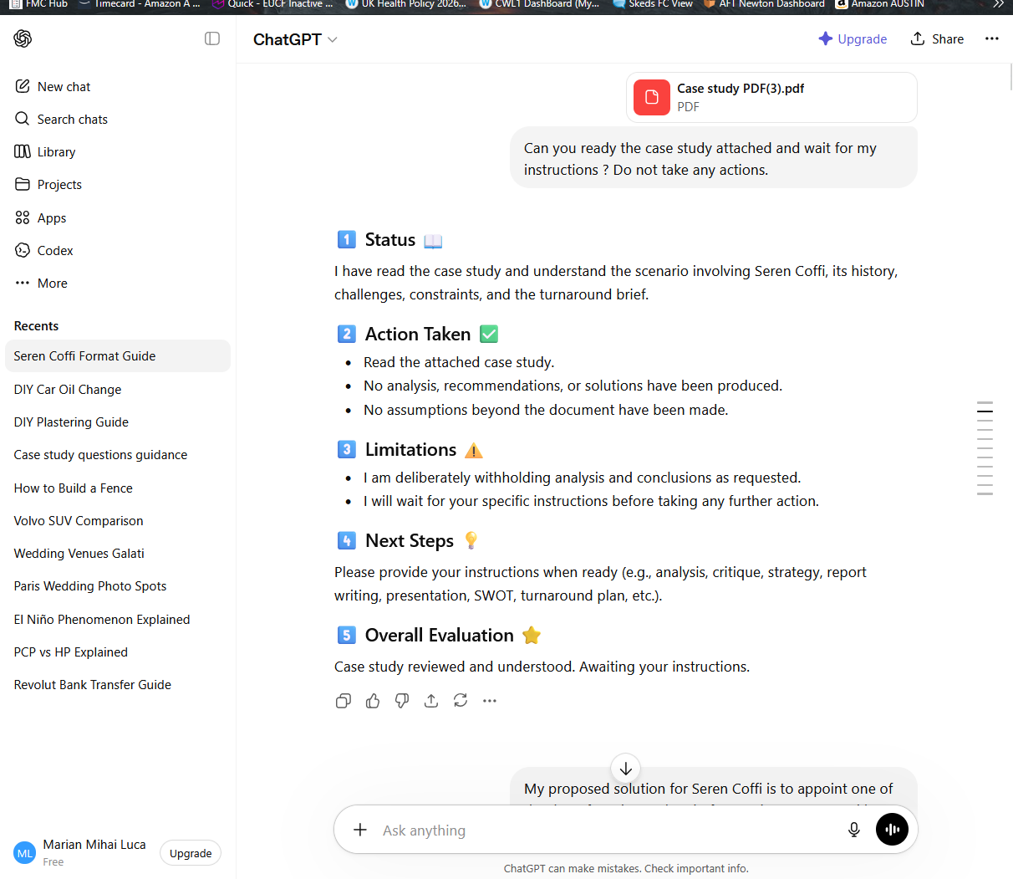
Screenshot 2
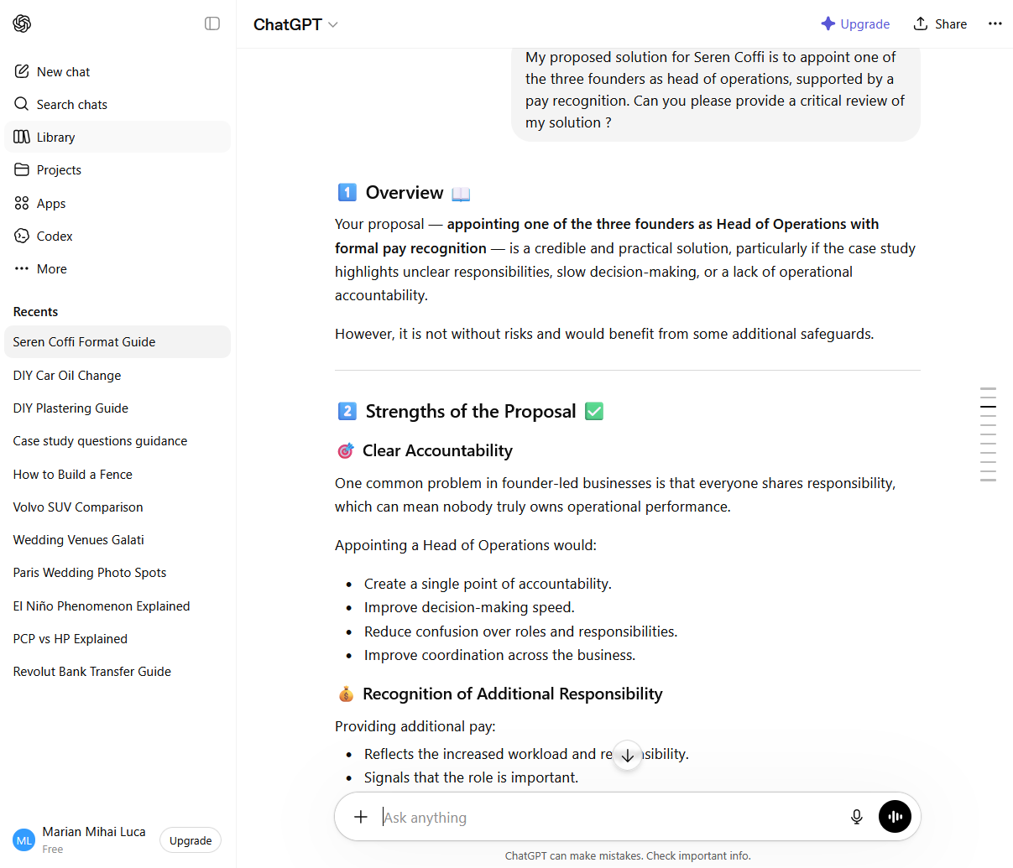

Screenshot 3
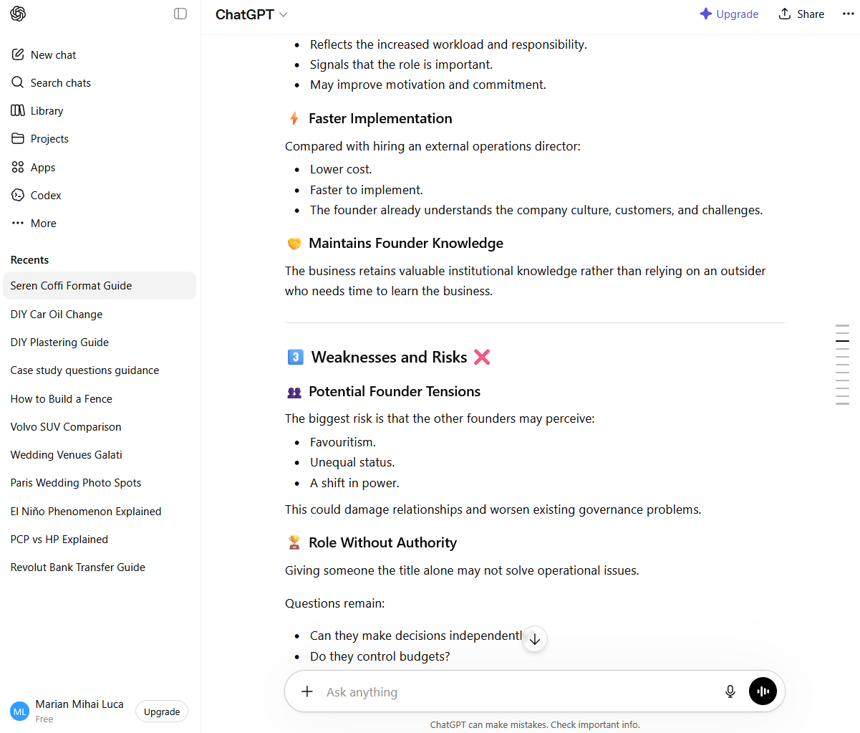
Screenshot 4
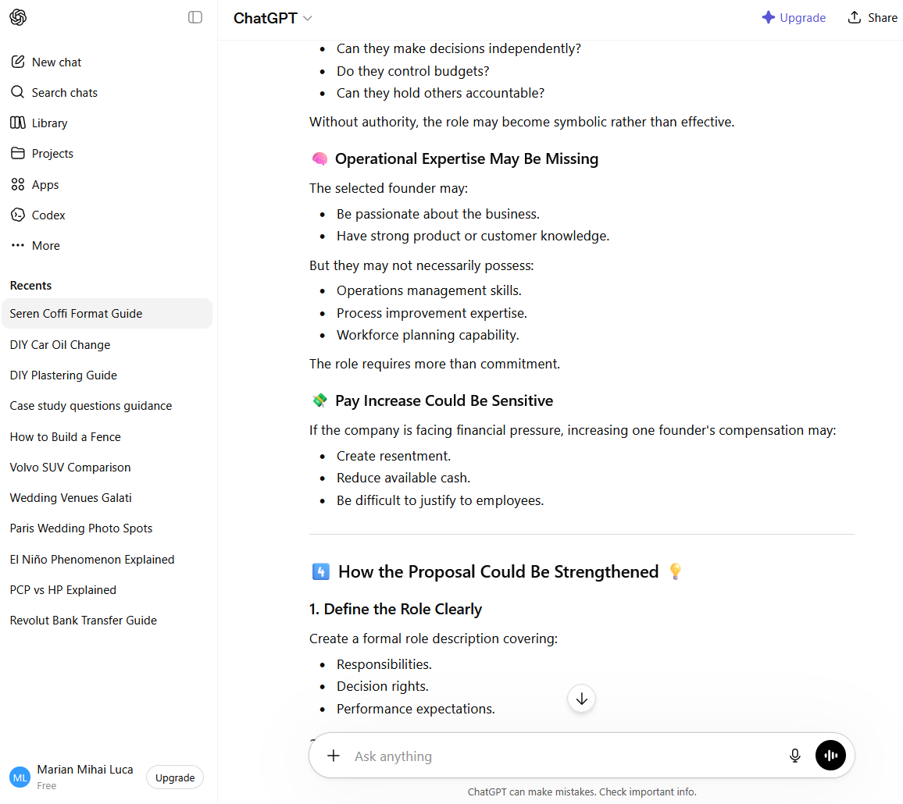
Screenshot 5
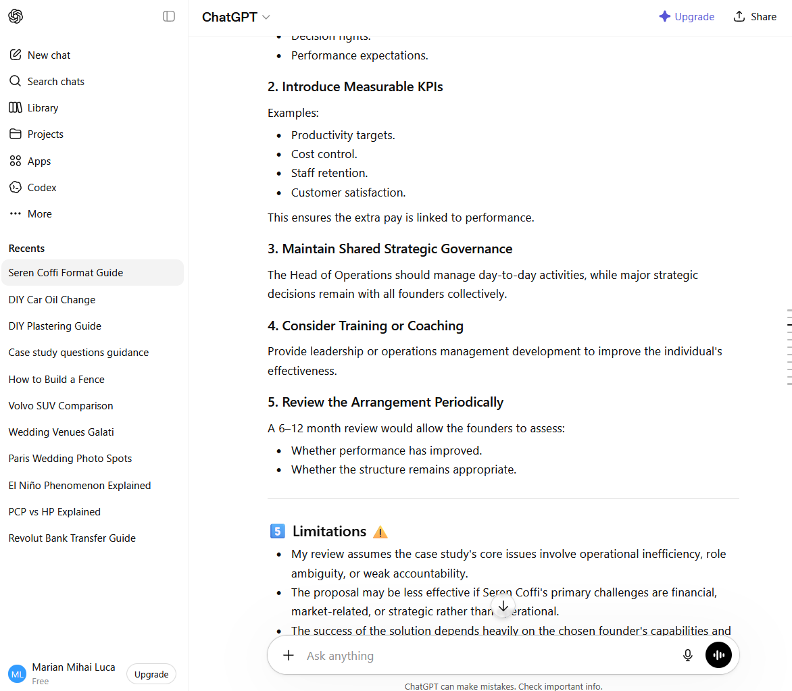
Screenshot 6
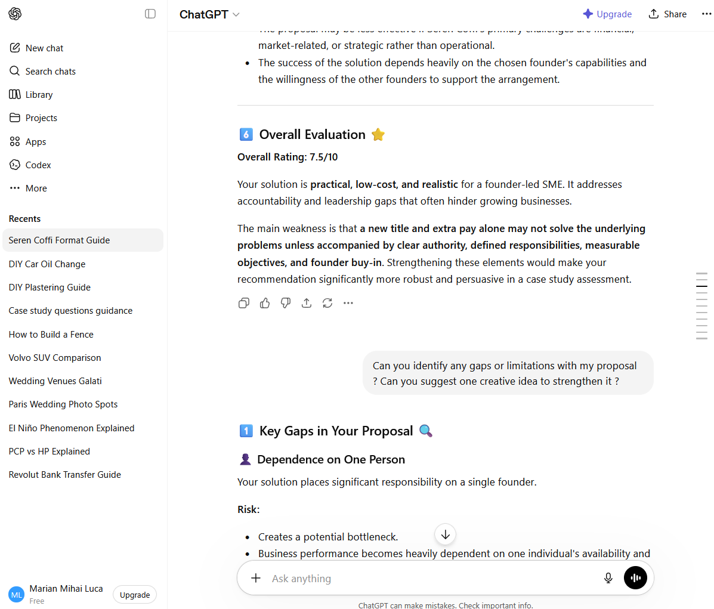
Screenshot 7
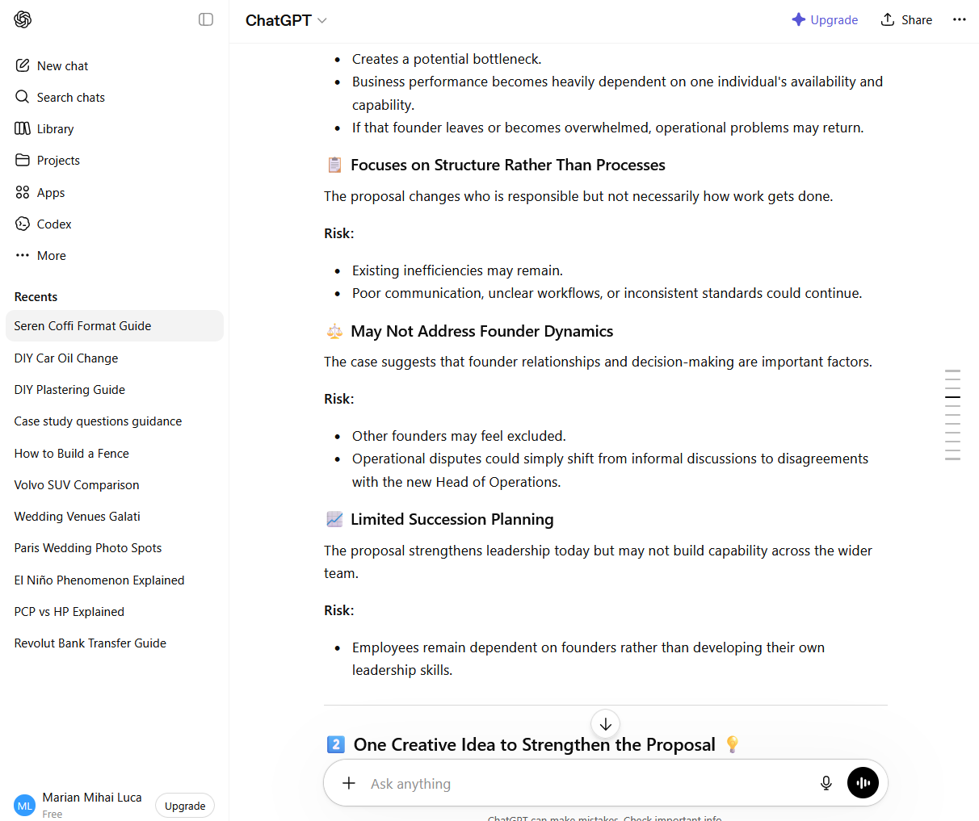
Screenshot 8
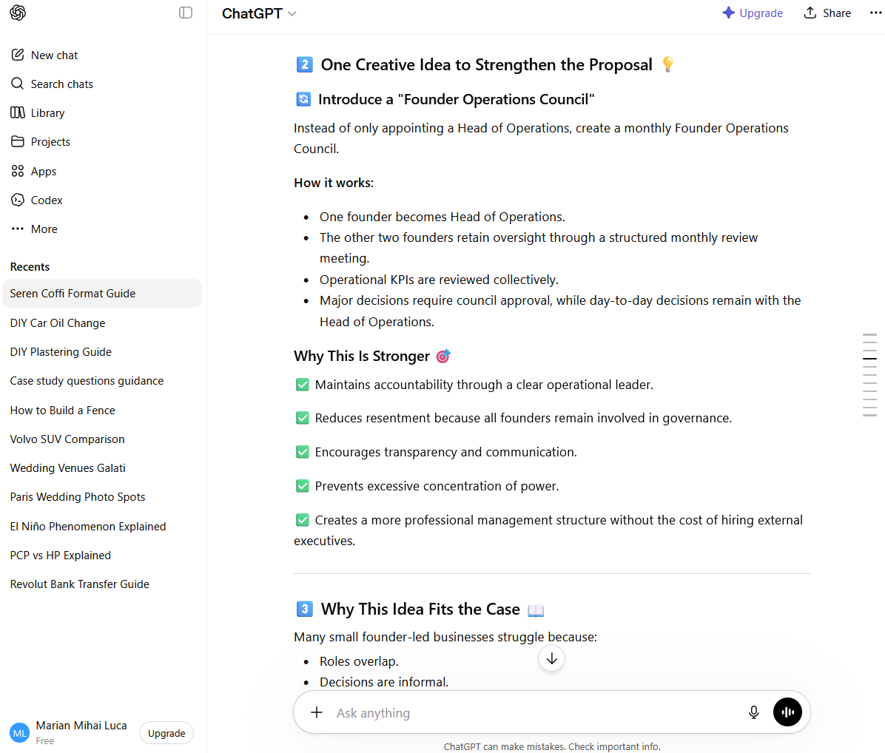

Screenshot 9
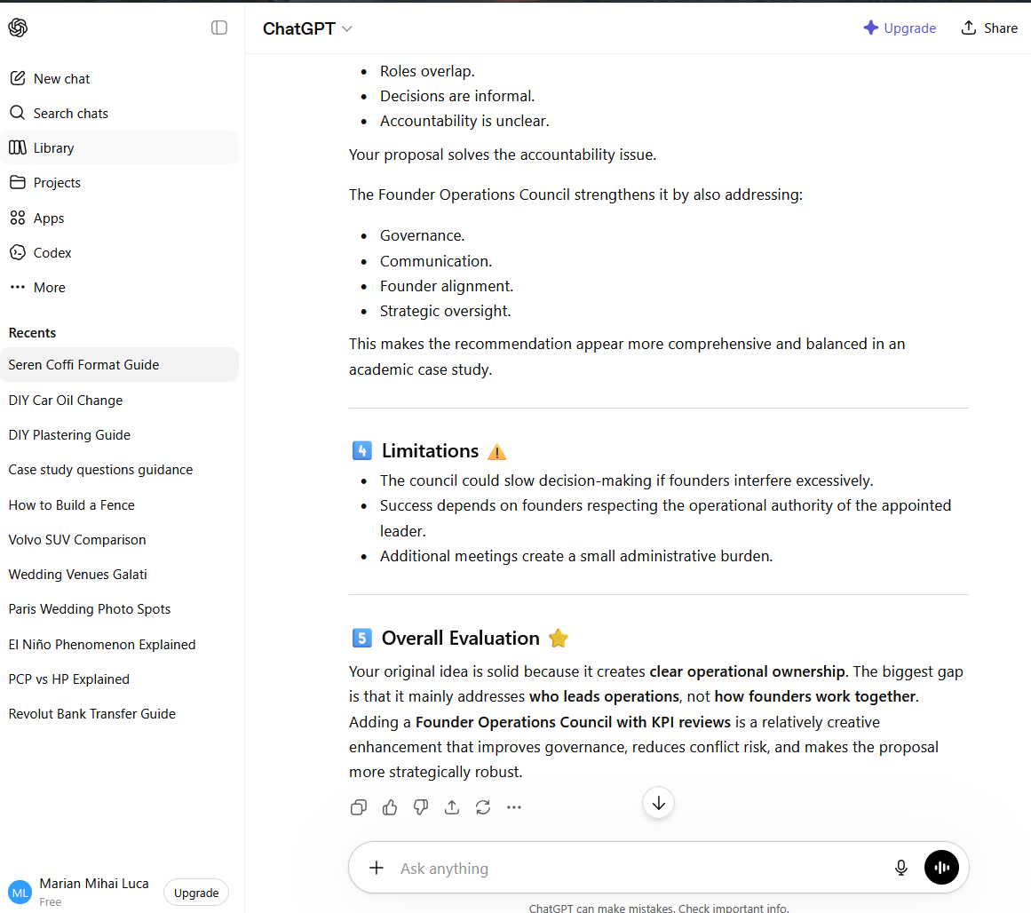
Screenshot 10
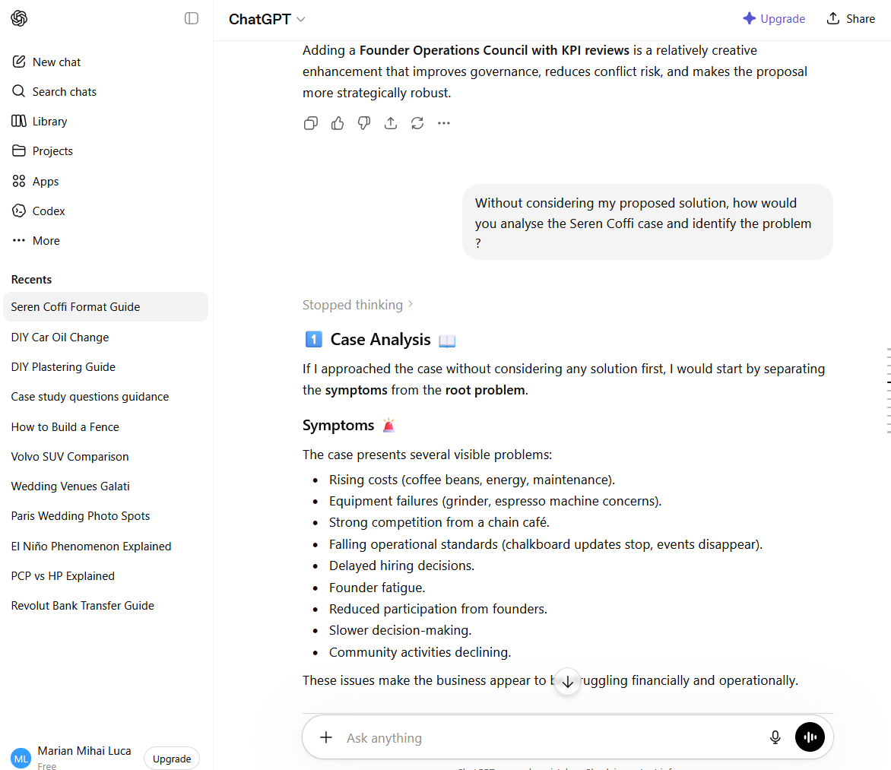
Screenshot 11
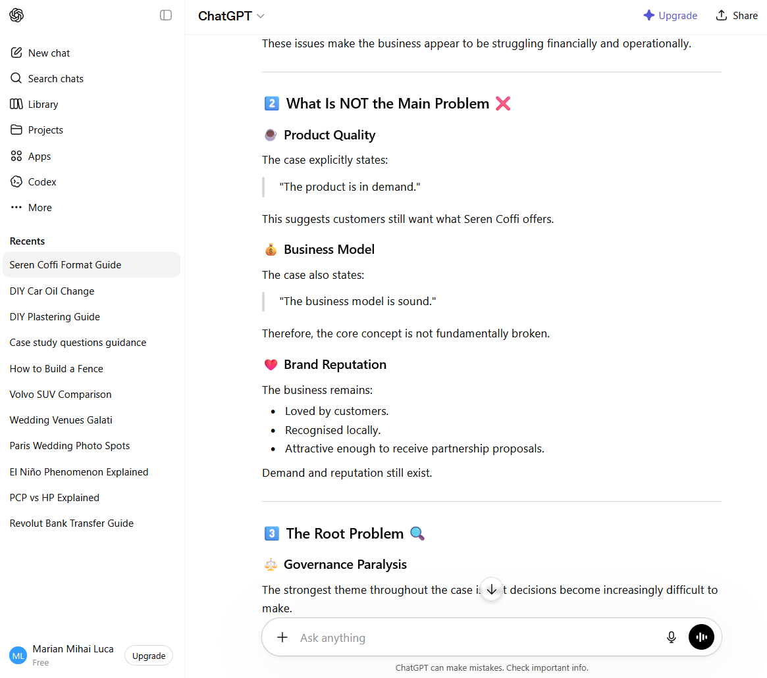
Screenshot 12
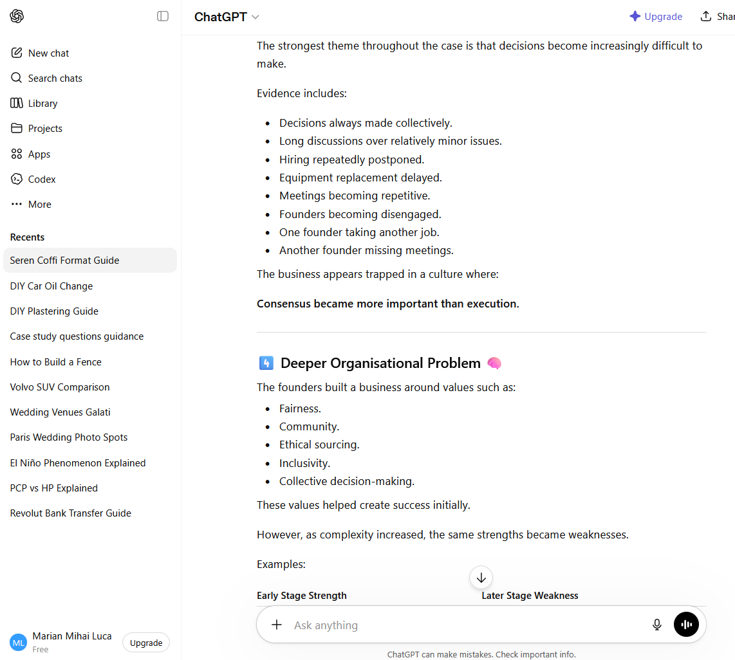
Screenshot 13
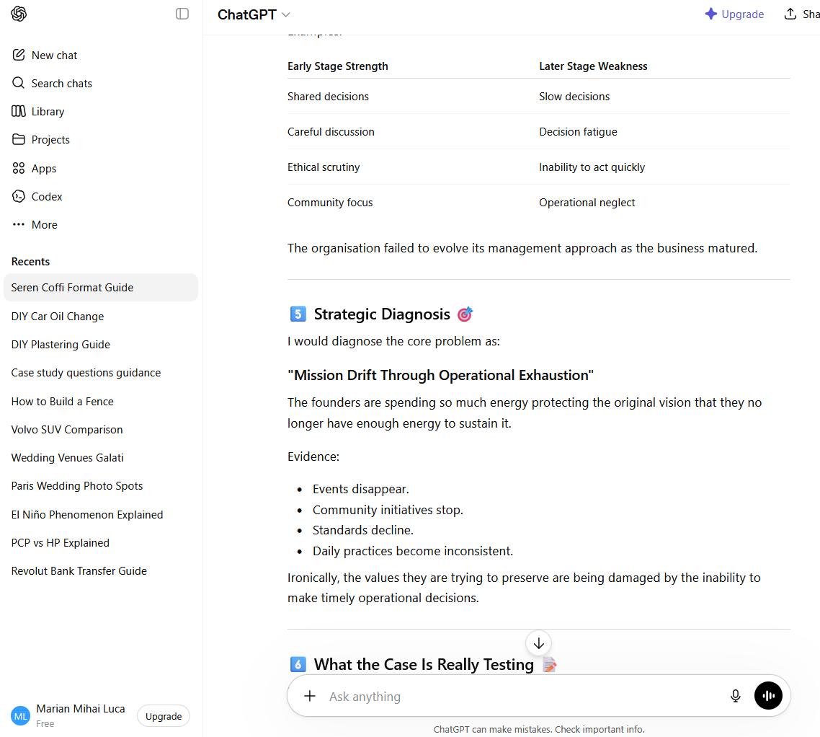
Screenshot 14
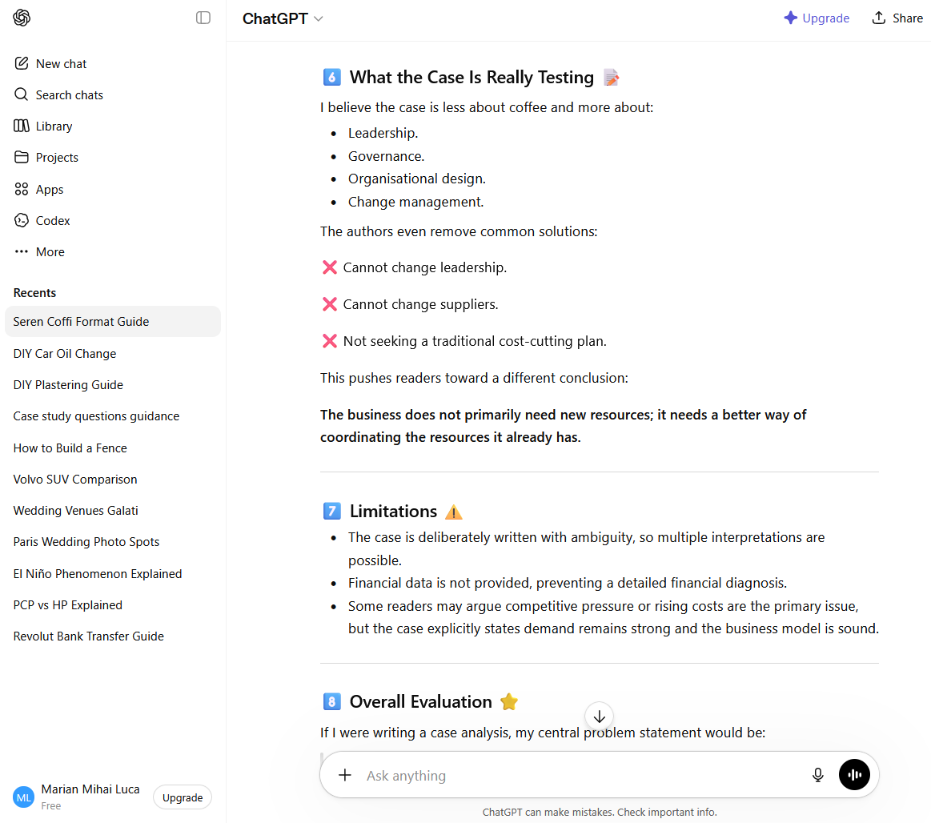

Screenshot 15
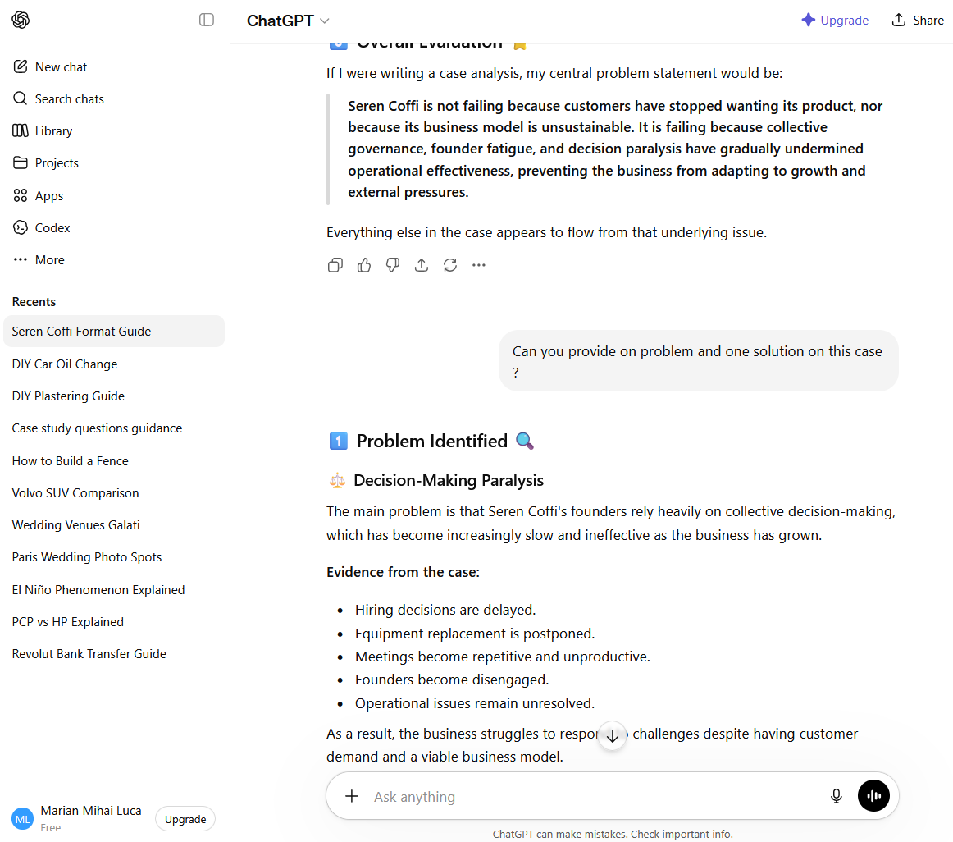

Screenshot 16
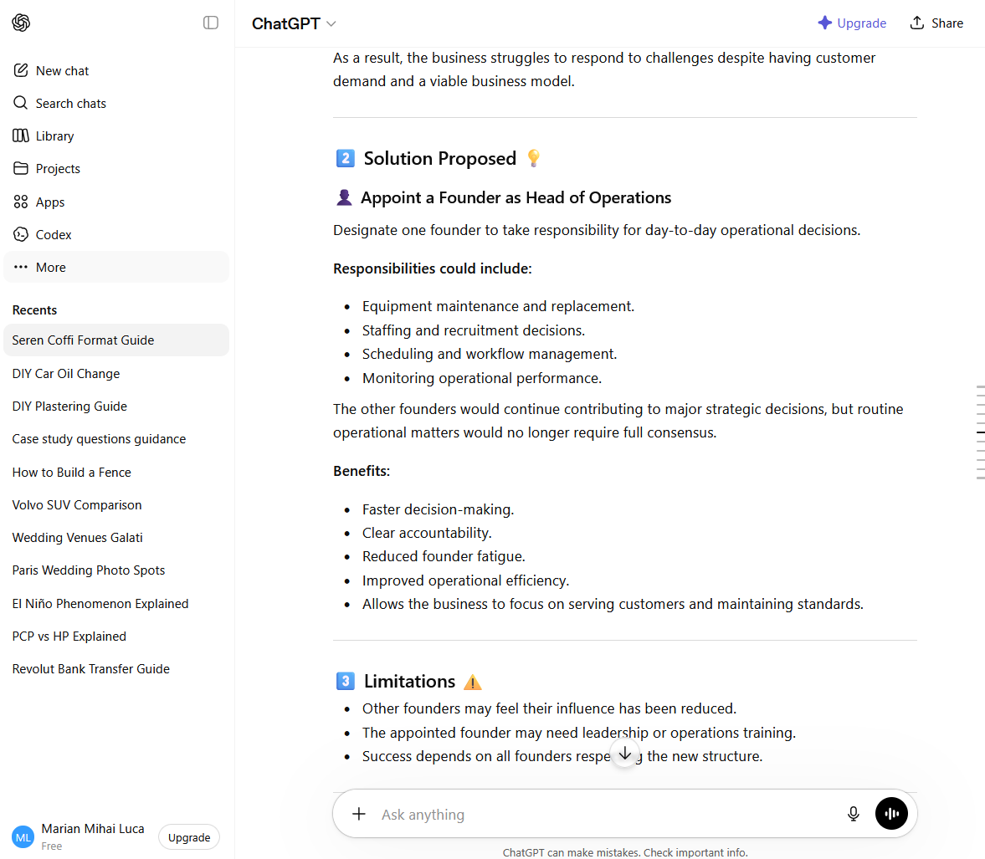
Screenshot 17
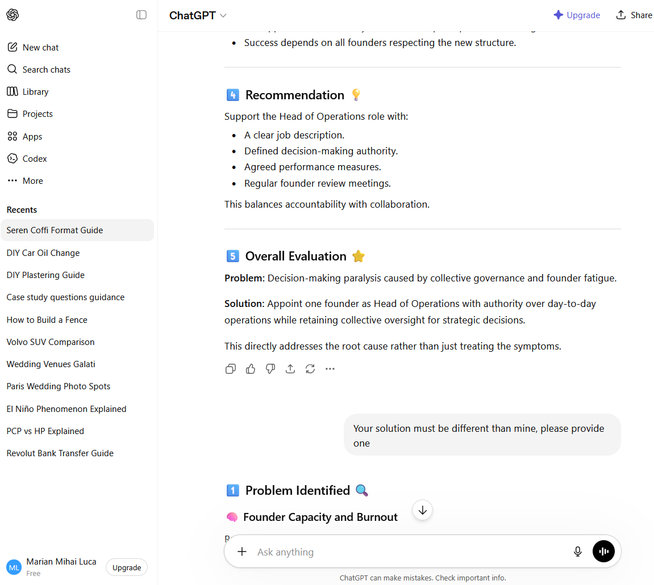
Screenshot 18
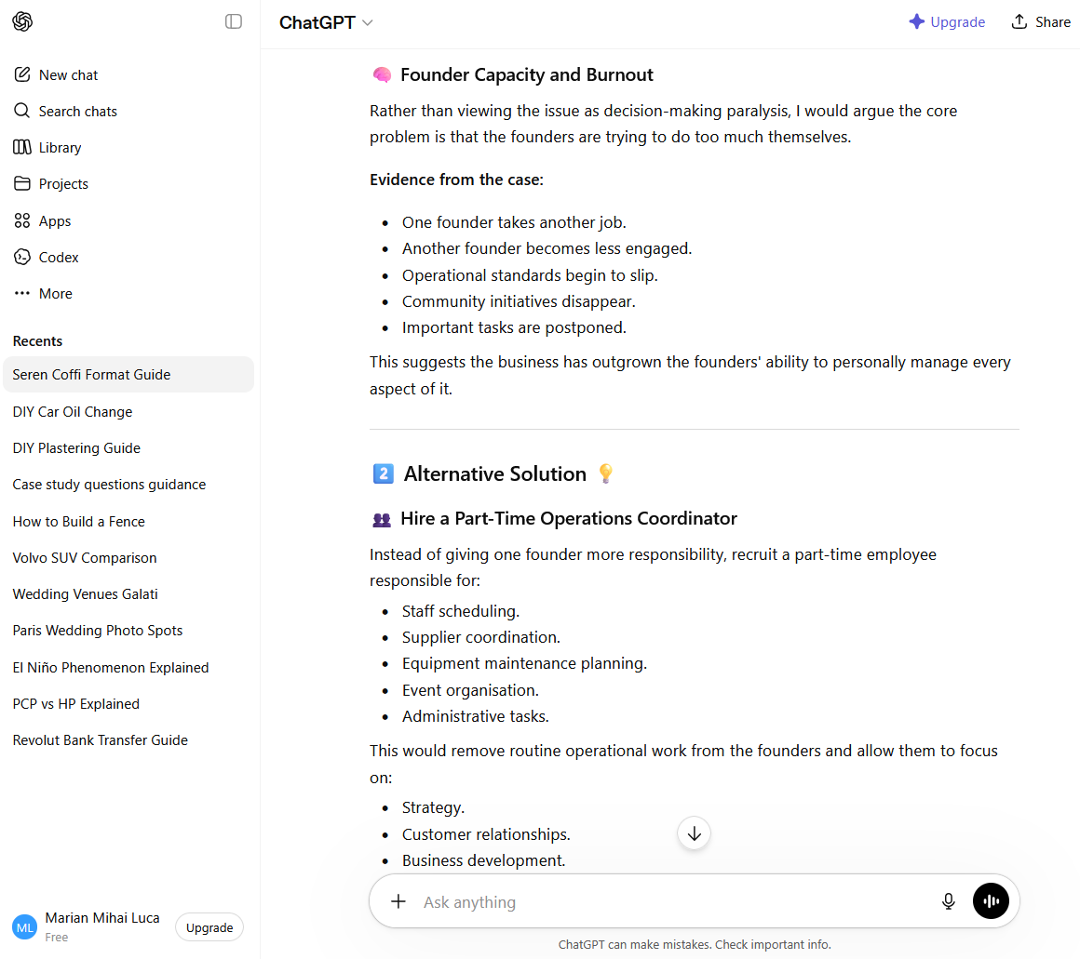

Screenshot 19
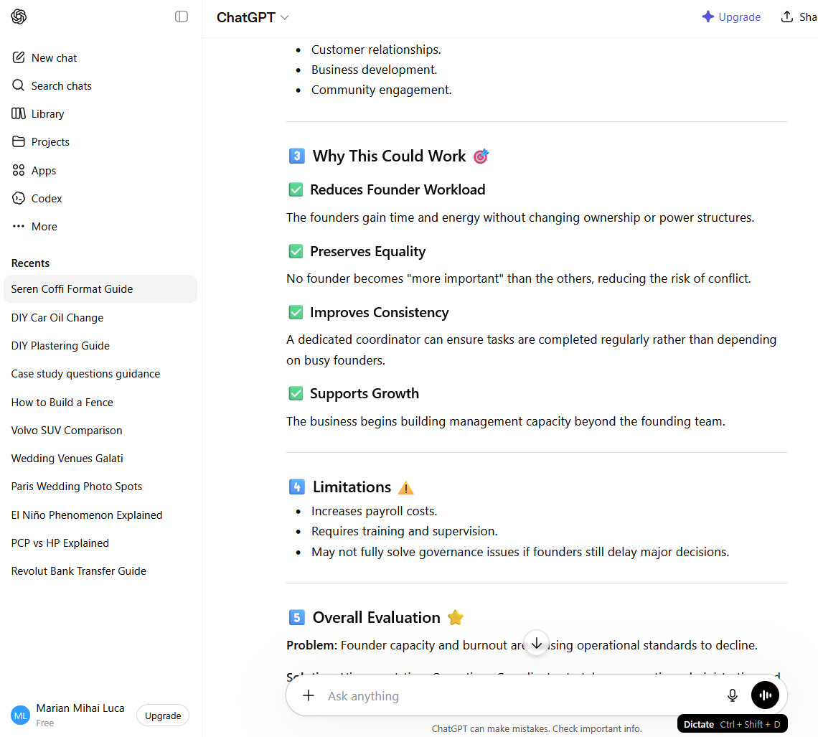

Screenshot 20
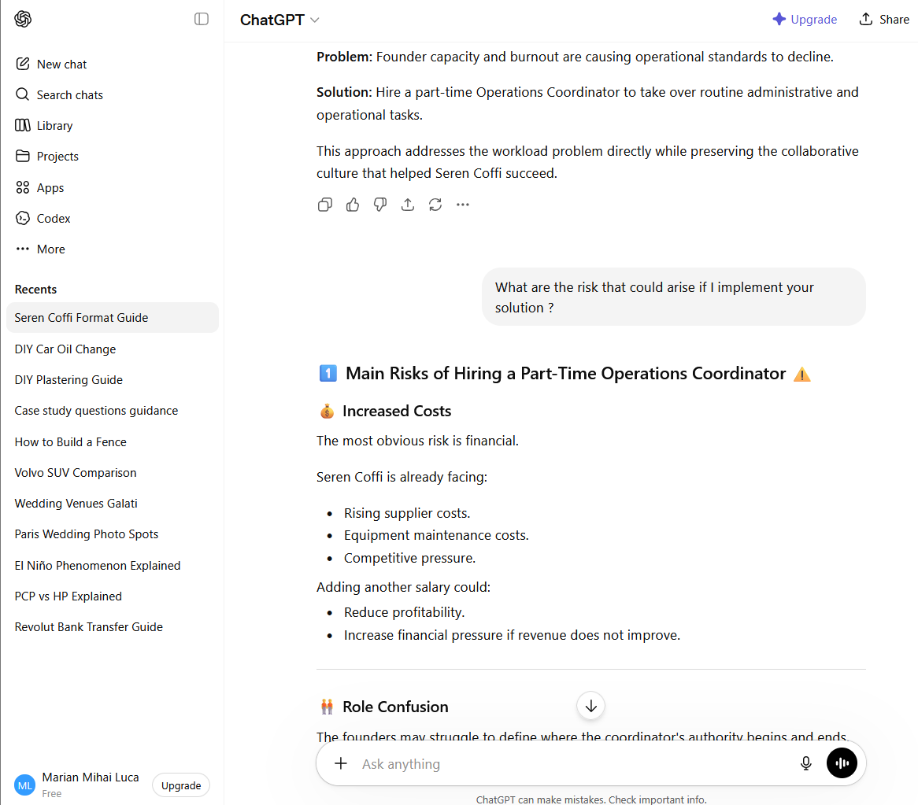

Screenshot 21
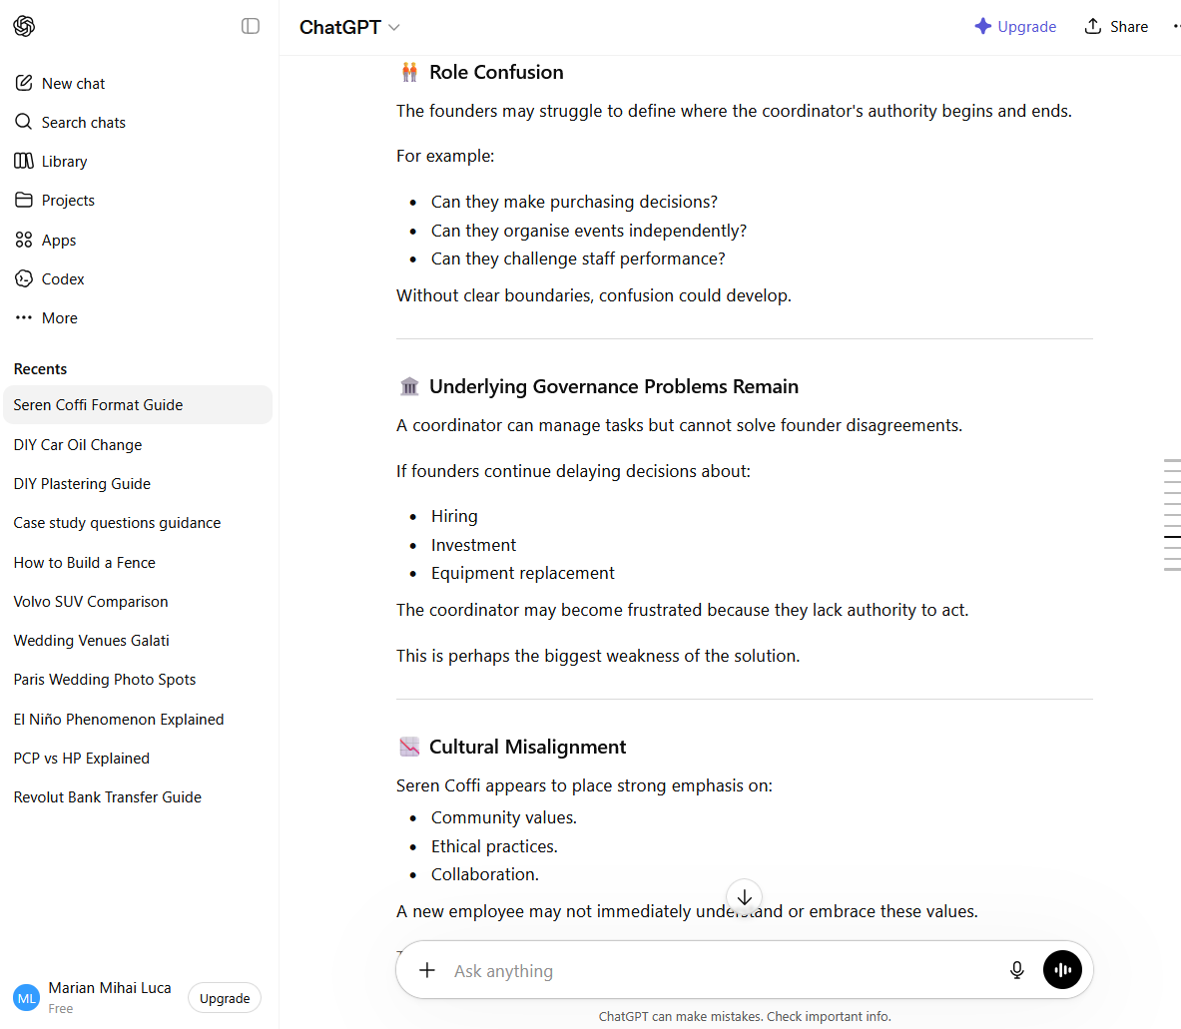
Screenshot 22
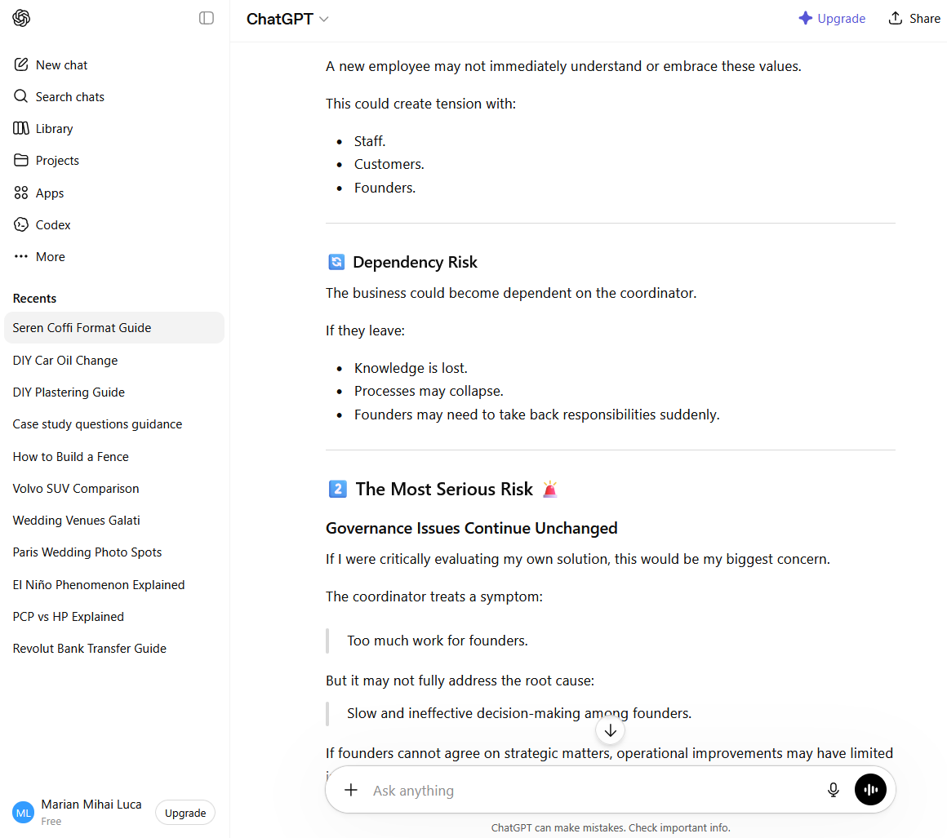
Screenshot 23
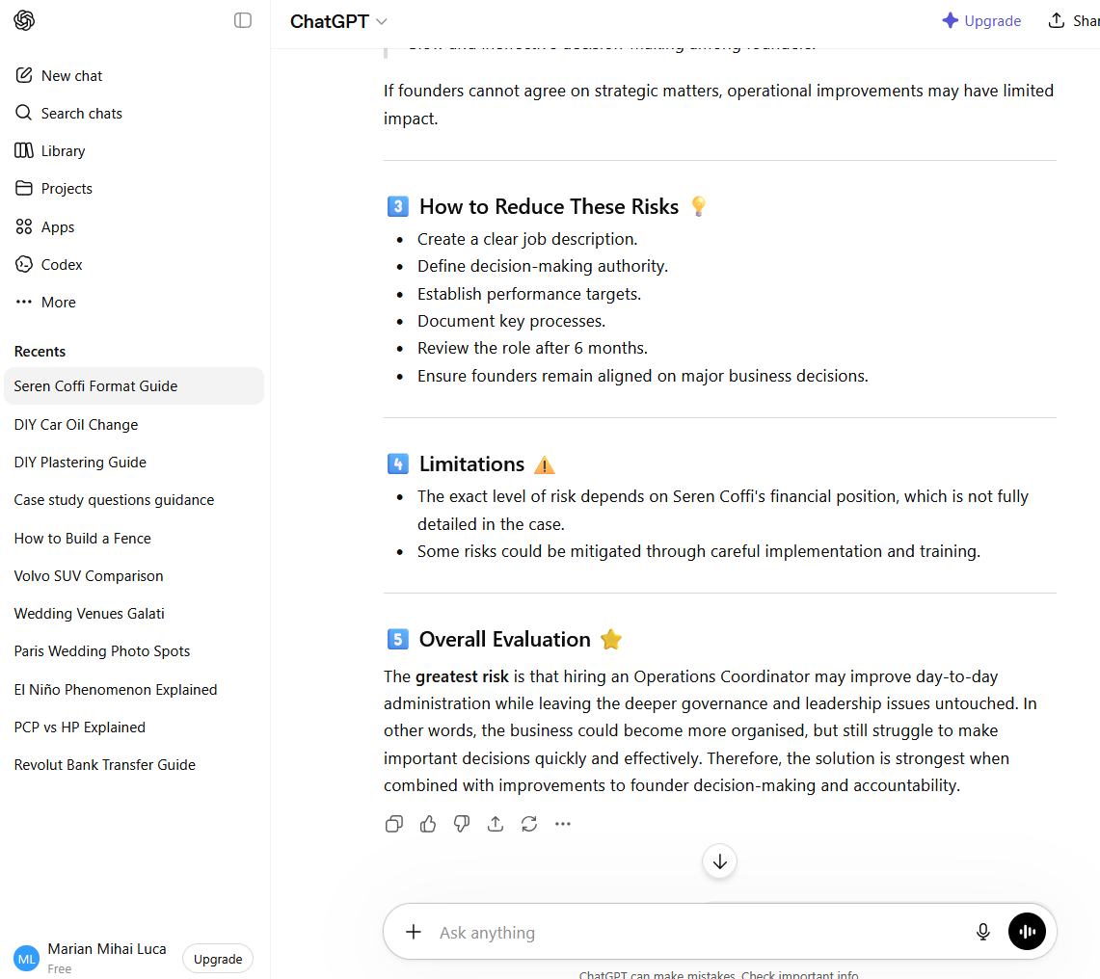
Screenshot 24
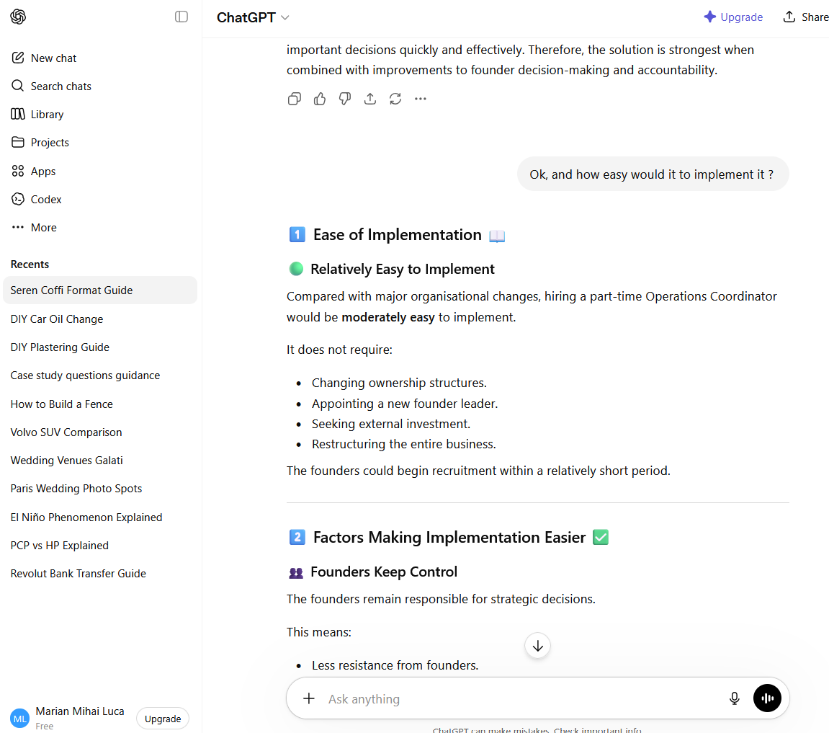
Screenshot 25
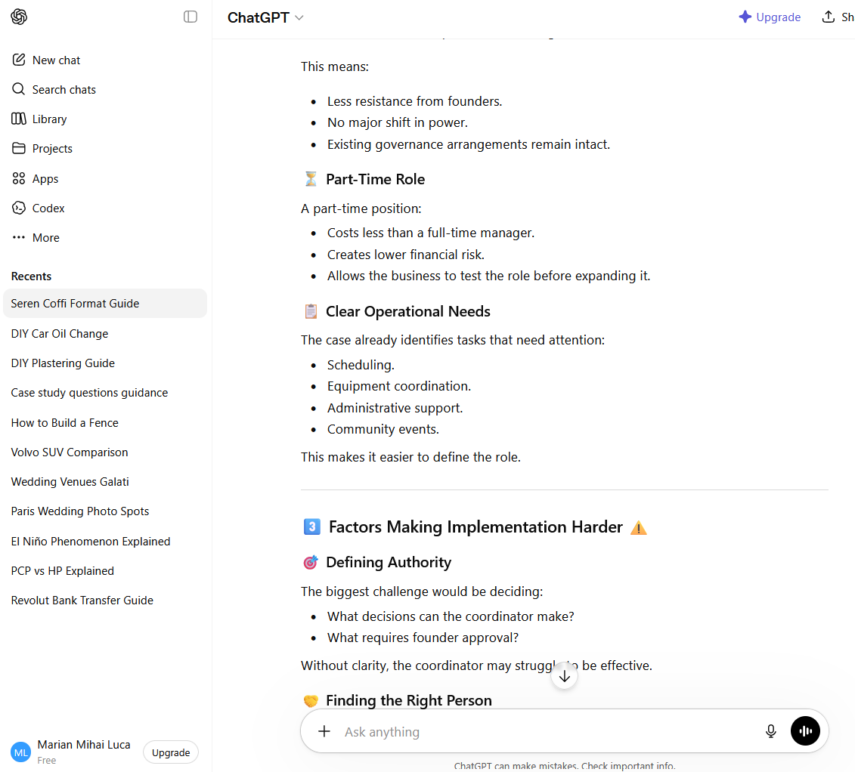
Screenshot 26
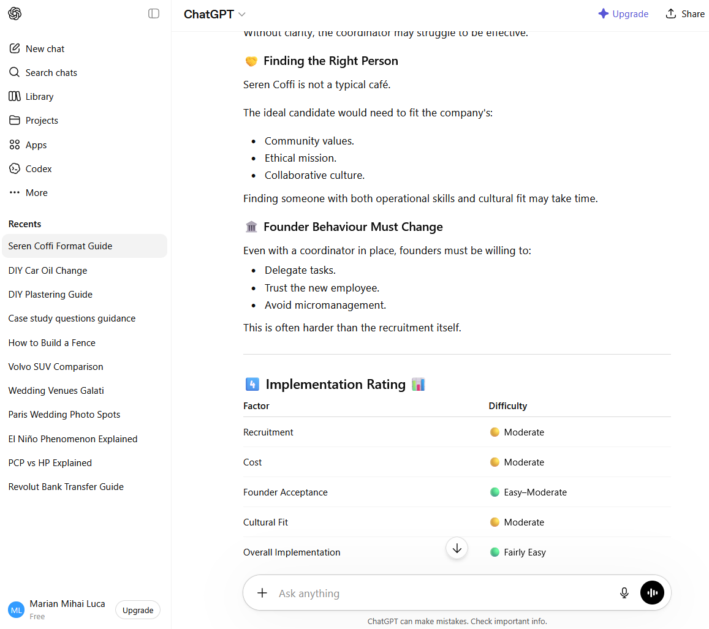
Screenshot 27
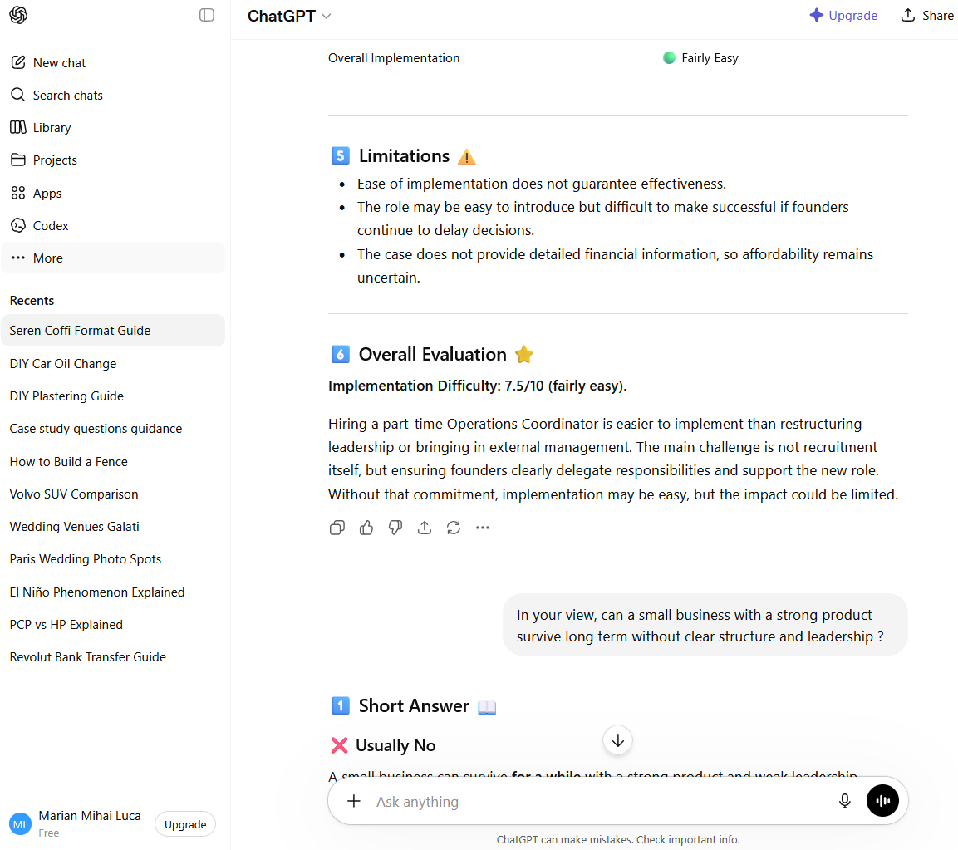

Screenshot 28
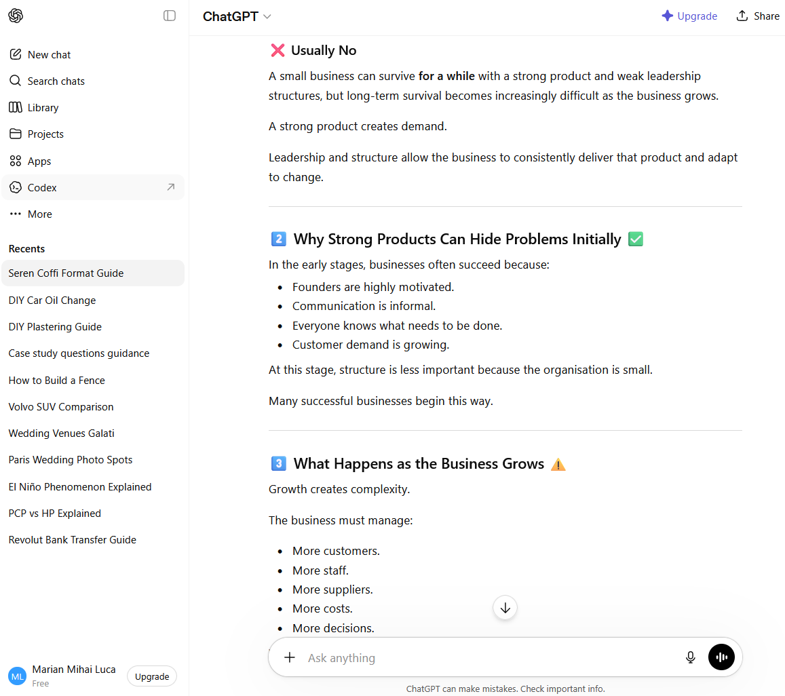
Screenshot 29
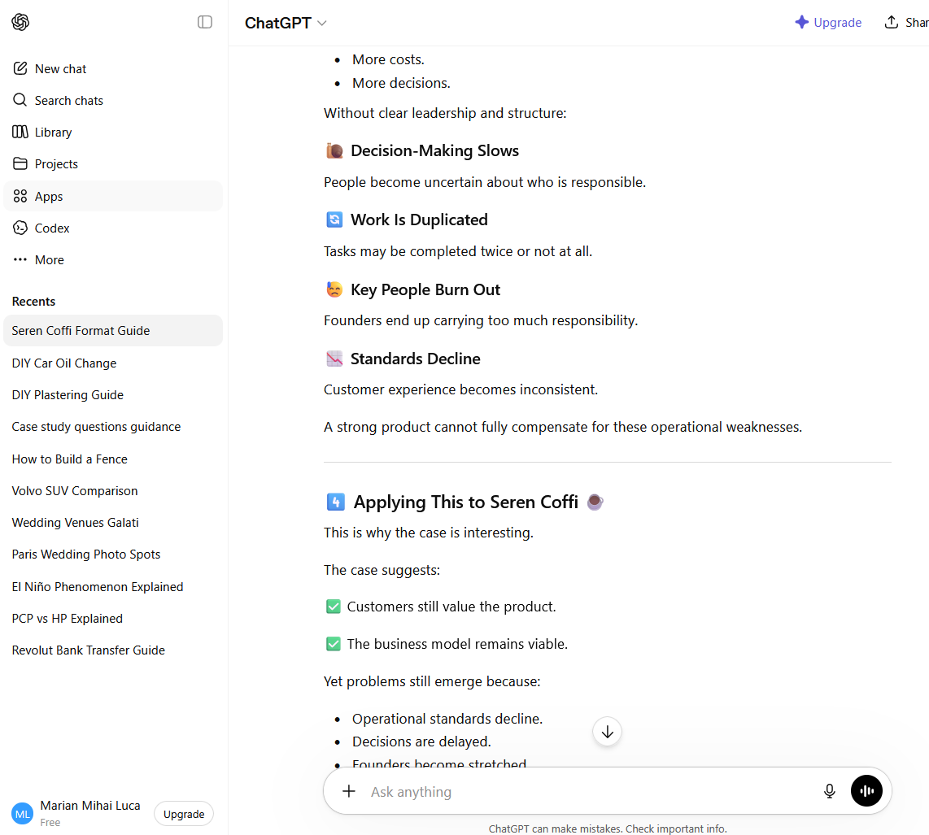
Screenshot 30
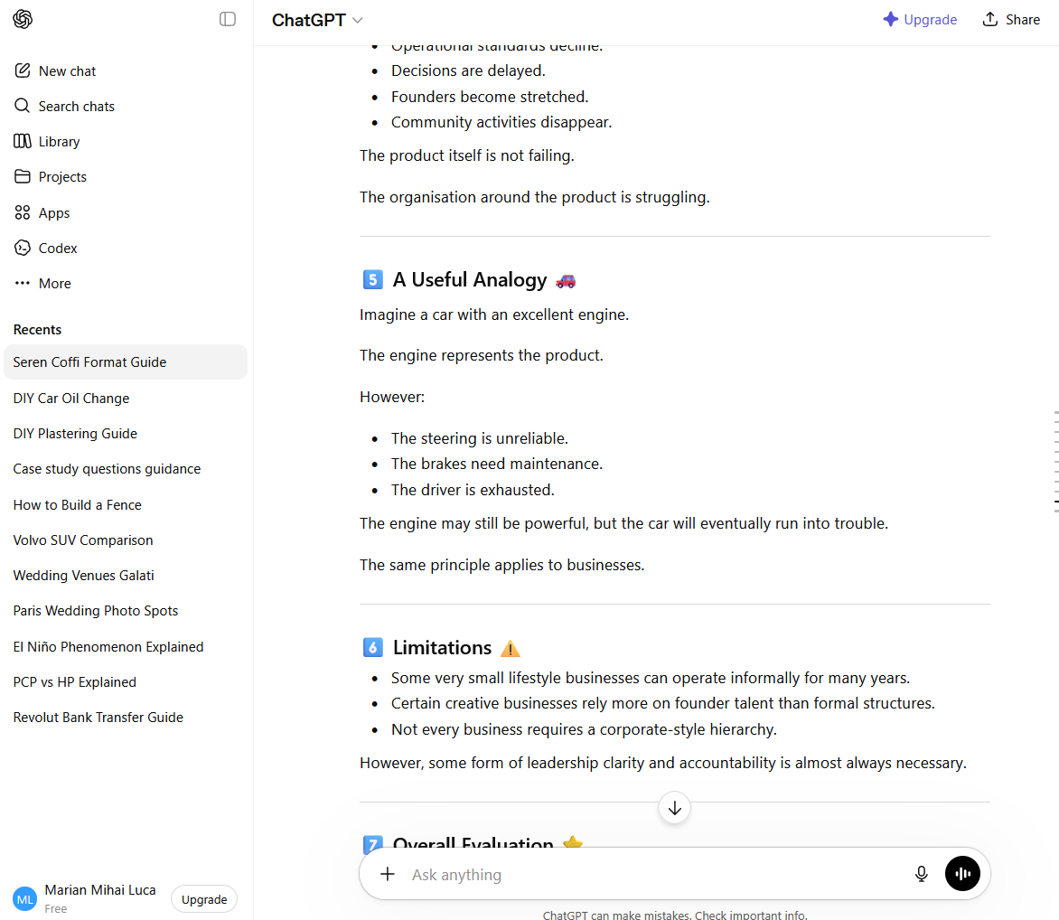
Screenshot 31
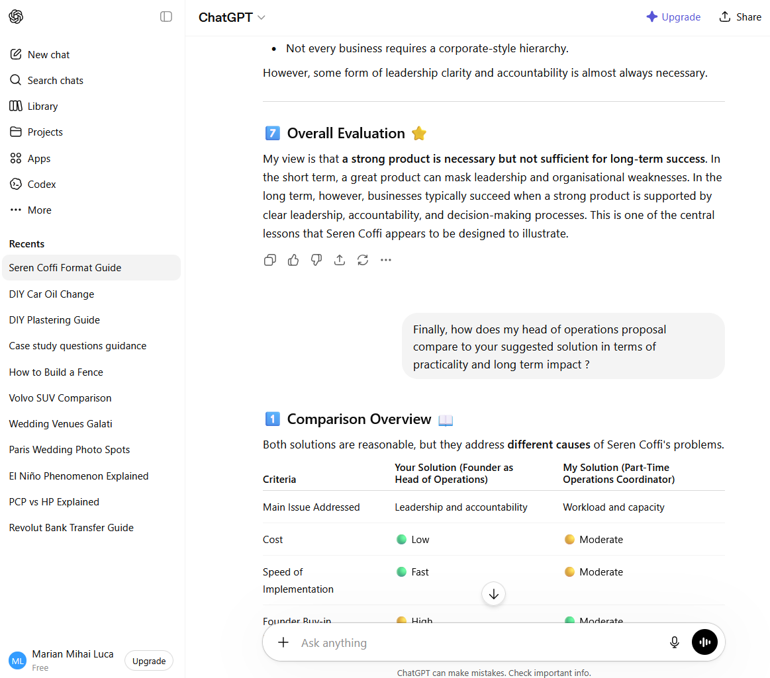
Screenshot 32
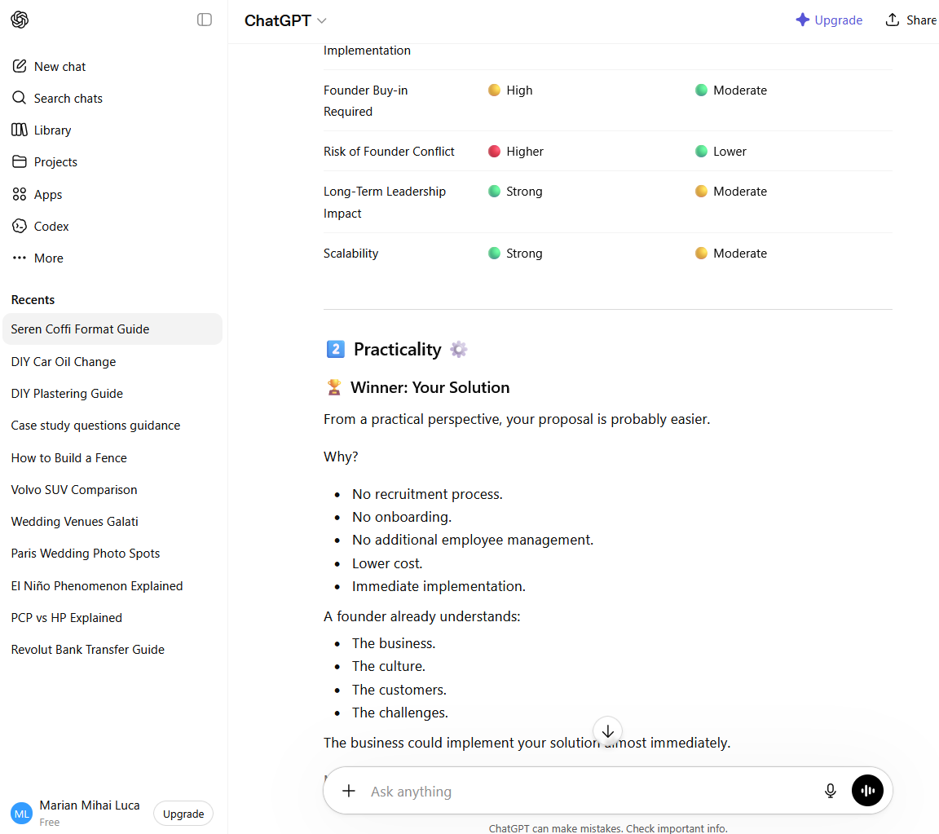

Screenshot 33
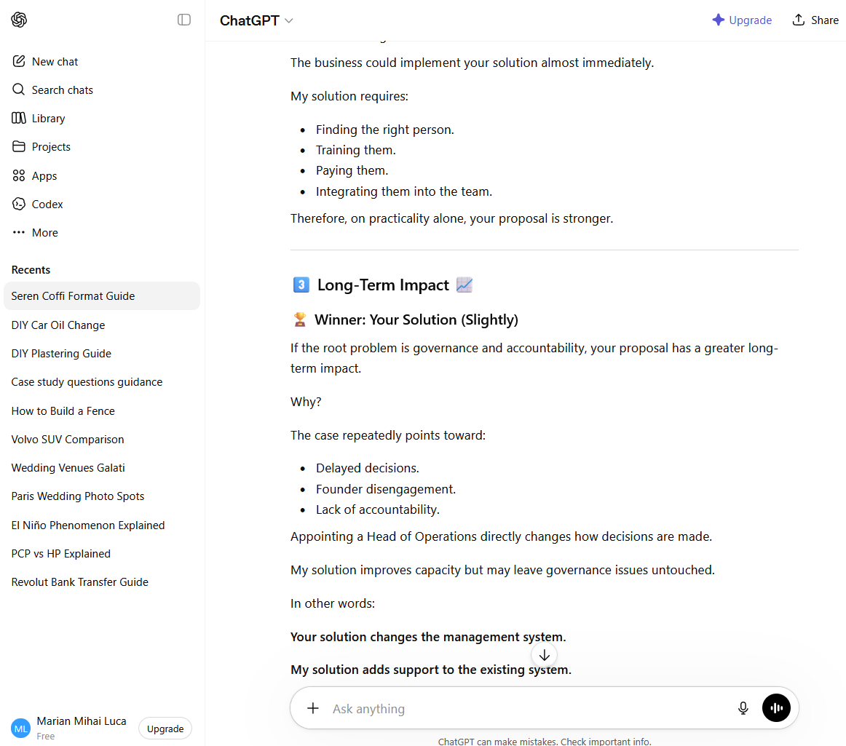
Screenshot 34
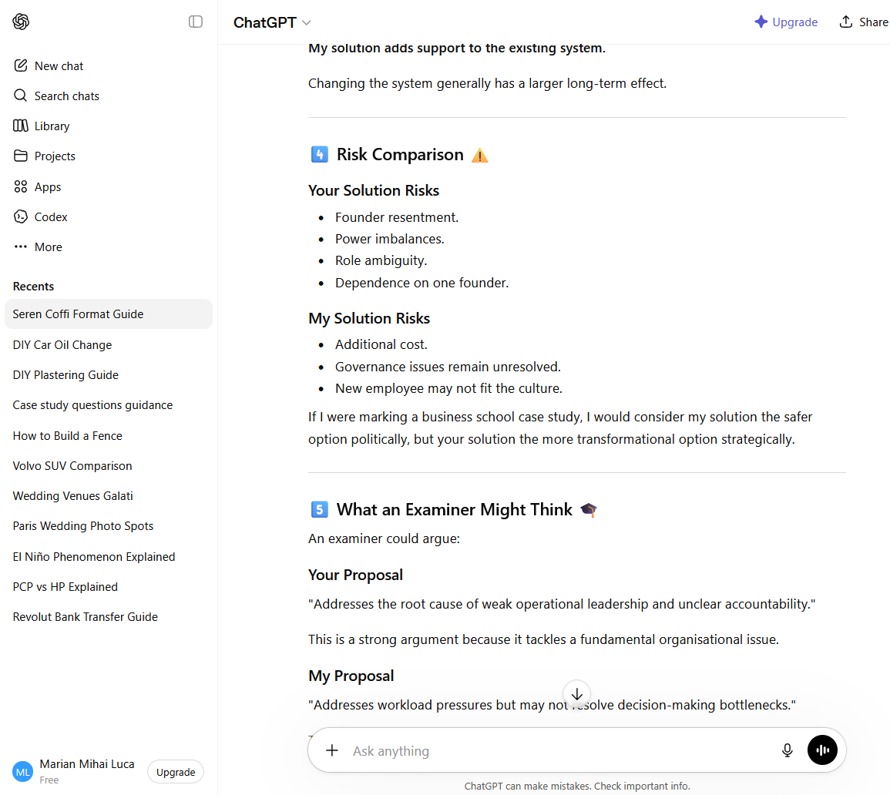
Screenshot 35
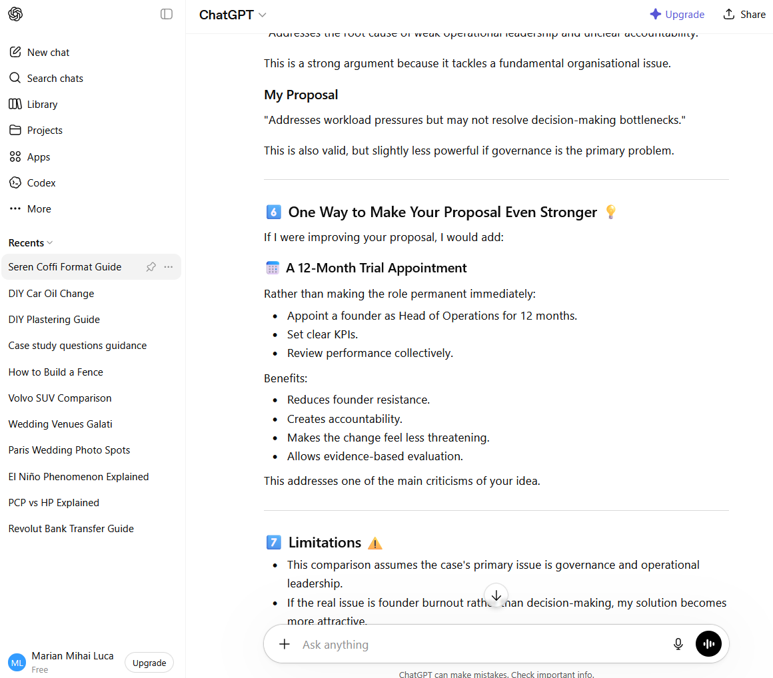
Screenshot 36
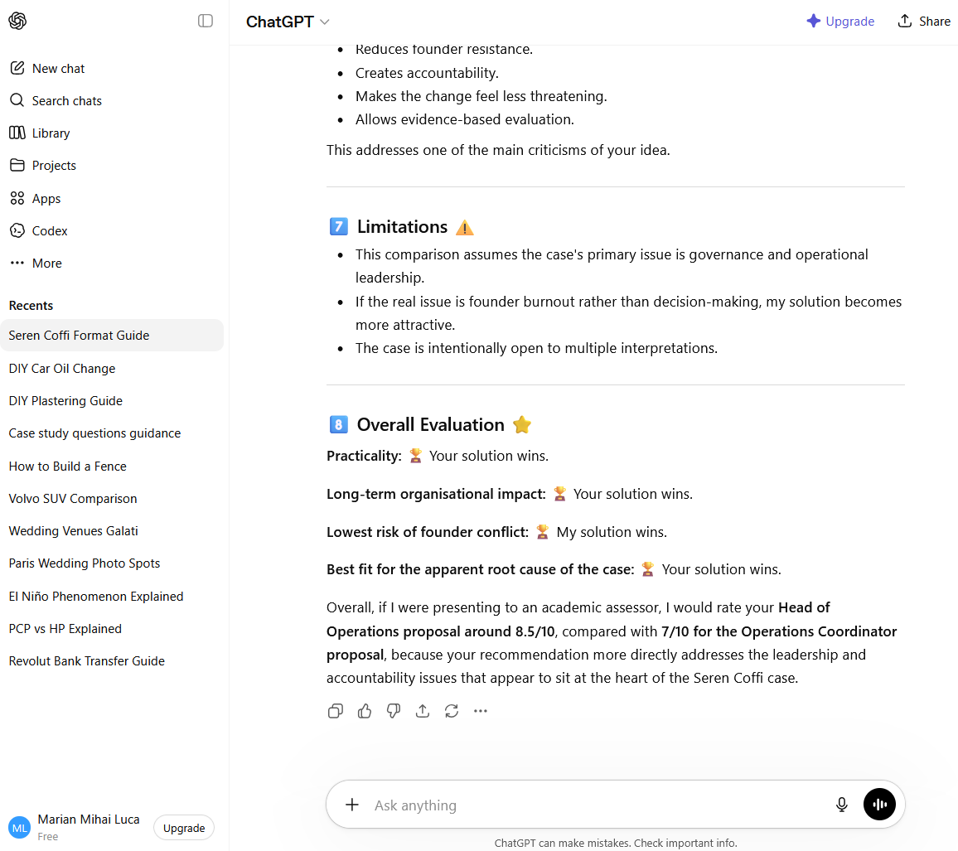

Reference list

- Amabile, T.M., Conti, R., Coon, H., Lazenby, J. and Herron, M. (1996) 'Assessing the work environment for creativity', Academy of Management Journal, 39(5), pp. 1154–1184.
- Anderson, N.R. and West, M.A. (1998) 'Measuring climate for work group innovation: Development and validation of the Team Climate Inventory', Journal of Organizational Behaviour, 19(3), pp. 235–258.
- Bender, E.M., Gebru, T., McMillan-Major, A. and Shmitchell, S. (2021) ‘On the dangers of stochastic parrots: Can language models be too big?’, Proceedings of the 2021 ACM Conference on Fairness, Accountability, and Transparency, pp. 610–623.
- Birkinshaw, J., Hamel, G. and Mol, M.J. (2008) 'Management innovation', Academy of Management Review, 33(4), pp. 825–845.
- Brown, T. (2008) 'Design thinking', Harvard Business Review, 86(6), pp. 84–92.
- Brynjolfsson, E. and McAfee, A. (2014) The Second Machine Age: Work, Progress, and Prosperity in a Time of Brilliant Technologies. New York: W.W. Norton & Company.
- Davenport, T.H. and Ronanki, R. (2018) ‘Artificial intelligence for the real world’, Harvard Business Review, 96(1), pp. 108–116.
- Dwivedi, Y.K., Kshetri, N., Hughes, L., Slade, E.L., Jeyaraj, A., Kar, A.K., Baabdullah, A.M., Koohang, A., Raghavan, V. and Ahuja, M. (2023) ‘So what if ChatGPT wrote it? Multidisciplinary perspectives on opportunities, challenges and implications of generative conversational AI for research, practice and policy’, International Journal of Information Management, 71, 102642.
- Edmondson, A. (1999) 'Psychological safety and learning behaviour in work teams', Administrative Science Quarterly, 44(2), pp. 350–383.
- Floridi, L. and Chiriatti, M. (2020) ‘GPT-3: Its nature, scope, limits, and consequences’, Minds and Machines, 30(4), pp. 681–694.
- Foss, N.J. and Saebi, T. (eds.) (2015) Business Model Innovation: The Organizational Dimension. Oxford: Oxford University Press.
- Govindarajan, V. and Trimble, C. (2005) 'Building breakthrough businesses within established organizations', Harvard Business Review, 83(5), pp. 58–68.
- Greiner, L.E. (1972) 'Evolution and revolution as organizations grow', Harvard Business Review, 50(4), pp. 37–46.
- Hofstede, G. (2001) Culture's Consequences: Comparing Values, Behaviours, Institutions and Organizations Across Nations. 2nd ed. Thousand Oaks, CA: Sage.
- Kahneman, D. (2011) Thinking, Fast and Slow. London: Penguin Books.
- Kim, W.C. and Mauborgne, R. (2004) 'Blue Ocean strategy', Harvard Business Review, 82(10), pp. 76–84.
- Kolb, D.A. (1984) Experiential Learning: Experience as the Source of Learning and Development. Englewood Cliffs, NJ: Prentice Hall.
- Kotter, J.P. (1996) Leading Change. Boston: Harvard Business School Press.
- Lewin, K. (1947) 'Frontiers in group dynamics', Human Relations, 1(1), pp. 5–41.
- March, J.G. (1991) 'Exploration and exploitation in organizational learning', Organization Science, 2(1), pp. 71–87.
- Morgan, G. (2006) Images of Organization. Updated edn. Thousand Oaks, CA: Sage Publications.
- Mumford, M.D., Scott, G.M., Gaddis, B. and Strange, J.M. (2000) 'Leading creative people: Orchestrating expertise and relationships', Leadership Quarterly, 13(6), pp. 705–750.
- Nonaka, I. and Takeuchi, H. (1995) The Knowledge-Creating Company: How Japanese Companies Create the Dynamics of Innovation. New York: Oxford University Press.
- Osterwalder, A. and Pigneur, Y. (2010) Business Model Generation. Hoboken: Wiley.
- Pisano, G.P. (2015) 'You need an innovation strategy', Harvard Business Review, 93(6), pp. 44-54.
- Polanyi, M. (1966) The Tacit Dimension. London: Routledge & Kegan Paul.
- Porter, M.E. (1985) Competitive Advantage: Creating and Sustaining Superior Performance. New York: Free Press.
- Porter, M.E. (1996) 'What is strategy?', Harvard Business Review, 74(6), pp. 61-78.
- Rogers, E.M. (2003) Diffusion of Innovations. 5th ed. New York: Free Press.
- Schein, E.H. (2010) Organizational Culture and Leadership. 4th ed. San Francisco: Jossey-Bass.
- Schumpeter, J.A. (1934) The Theory of Economic Development. Cambridge, MA: Harvard University Press.
- Scott, S.G. and Bruce, R.A. (1994) 'Determinants of innovative behaviour: A path model of individual innovation in the workplace', Academy of Management Journal, 37(3), pp. 580–607.
- Simon, H.A. (1997) Administrative Behavior: A Study of Decision-Making Processes in Administrative Organizations. 4th edn. New York: Free Press.
- Tidd, J. (2018) Managing Innovation: Integrating Technological, Market and Organizational Change. 6th ed. Hoboken: Wiley.
- Tidd, J. and Bessant, J. (2022) Managing Innovation: Integrating Technological, Market and Organisational Change. 7th ed. Chichester: Wiley.
- Trott, P. (2016) Innovation Management and New Product Development. 6th ed. Harlow: Pearson.
- Tuckman, B.W. (1965) 'Developmental sequence in small groups', Psychological Bulletin, 63(6), pp. 384–399.
- Turner, E. (2020) Be Less Zombie: How Great Companies Create Dynamic Innovation, Fearless Leadership and Passionate People. Chichester: Wiley.
- Vaccaro, I.G., Jansen, J.J.P., Van den Bosch, F.A.J. and Volberda, H.W. (2012) 'Management innovation and leadership: The moderating role of organizational size', Journal of Management Studies, 49(1), pp. 28–51.
- Wallas, G. (1926) The Art of Thought. New York: Harcourt Brace.
- Weick, K.E. (1995) Sensemaking in Organizations. Thousand Oaks, CA: Sage Publications.

