Tamanna sultana
1912525
Lecturer: Tayo Karen
Introduction to research.

THE EFFECTS OF CANCER ON MENTAL HEALTH
Table of Contents
Introduction 4
Introduction 4
Background of the Research 4
Research Aim 5
Research Objectives 5
Research Questions 5
Research Rationale 6
Summary 6
Literature Review 6
• Causes of mental health problems during cancer 6
• Effects of cancer on mental health 7
• Treatment of mental health for cancer patients 8
Few strategies to improve the mental health of cancer patient 9
Implementation of technologies 9
Methodology 10
Introduction 10
Research philosophy 10
Research design 10
Research approach 11
Data collection technique 11
Ethical consideration 12
Conclusion 12
Findings and discussion 12
• Anxiety and mental disorder 12
• Depression 13
• Therapy 15
Conclusions and recommendations for future policy and practice 15
Reference list 17

Introduction

Introduction
It has been seen that cancer cannot only harm the part of the body where it has been affected rather it has been seen that it also harms the mental condition of the people. The affected person often goes into depression, they from anxiety and also different other mental illness in their everyday life. It can be seen in many people that different significant changes in their emotional health. Cancer is a disease that can have big impact on a person who is suffering and also on the patients loved ones. It is also very important and necessary to remember that they are several treatments are there to treat the mental illness of the people.

Background of the Research
It has been estimated that the almost one-third of the people in the society who are having cancers are suffering from the mental health condition (Mentalhealth.org.uk. 2021). It can be said that the depressive disorder rate has been increased almost up to three times higher than the general population in the society. Almost 8 to 24 percent of the people having cancer are suffering from depression as well. It can be said that the young generation are having major risks for the depression and also for other condition compared to the adults in the society. The statistics shows that 1 among the 3 people will be suffering from the mental illness if they are having cancers.
Different mental health problems include depression, anxiety either before, or after the cancer treatment. It may happen that the cancer patient may suffer with mental illness during the treatment as well. It can be noticed that almost 49% of the people in the society suffering with cancers along with the mental illness do not get any proper mental advices or treatment to cure the depression or anxiety. It can be also seen that almost 66% people said that they were not being informed about the appropriate mental health problems that can arise after the treatment ends. It can be seen that the mental condition can be improved by different methods, like one to one counseling, better access to the information, peer support groups, and also better communication can help in healing the mentally ill people.
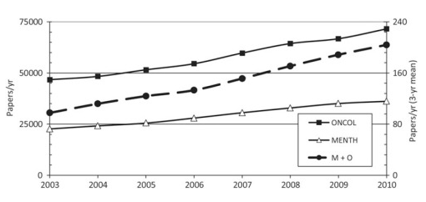
Figure 1: Effects of cancer on mental health
(Source: Brinkman et al. 2018)

Research Aim
The aim of the research is to understand the different effect of cancer on mental health of the patient.

Research Objectives
- To gain more knowledge about the effects of cancer on mental health in society.
- To analyze the factors that are involved in the mental illness due to the effect of cancer and to develop more care services in the society
- To identify different mental issues that the people are facing due to the cancer
- To recommend different solution to the patients facing mental health issues due to cancer treatment.

Research Questions
- How to gain more knowledge about the effects of the cancer on the mental health in the society?
- How to analyze the different factors that are being involved in the mental illness due to the effect of cancer and also develop more care services in the society for the patients?
- How to identify the different mental health issues that the patients are suffering due to the cancer treatment?
- What are the recommendations that will help in improving the mental health condition of the patient?

Research Rationale
In this research paper it can be seen that research rationale is one of the significant part that need to be covered with relevant and appropriate data. It can be said that the mental illness can impact badly on the patient suffering from cancer and can also affect mental condition of their close ones. The research is being done to know the mental illness of the patients going through cancer treatment. This research will also focus on the types of the mental illness that the cancer patients went through. It will focus on the different types of the mental health issues that they suffer from. This research will help in knowing what types of treatment can be initiated to the patients that will help in recovering them from the mental illness and also will help them in boosting mental condition to by providing strength to fight back from this deadly diseases. The research will help to gain wider aspect of knowledge regarding the mental suffering of the people.

Summary
This part of the research is based on the literature theories based on the impact of mental health due to cancer. The effects are properly discussed and that can help in understanding the importance of the mental health of the patients while suffering from cancer. The detection of a disease like this already makes a major impact on their family and other close people and that has a different impact on the scenario. The mitigation and strategies for making recovery are also explained and that can make a major effect in the scenario in terms of improvement of the mental health and the condition of health in other aspects.

Literature Review

Causes of mental health problems during cancer
Cancer patients often develop anxiety as well as nausea with the thought that they need to go through chemotherapy and its impact on the body. Few patients become worried about body image whereas patients with breast cancer or prostate cancer, on the other hand, develop mental health problems because of the loss of sexual identity with surgical operation in cancer (cancer.gov, 2021). Analyzing the socioeconomic aspect, it is stated that the financial tension regarding the cost of treatment is one of the prime reasons for mental health problems among the poorer people. Initially, the long-term cancer survivors often became patients of clinical depression with the anxiety that cancer may come back to them. Few cancer patients develop post-traumatic stress because cancer treatment often makes them isolated and alienated.

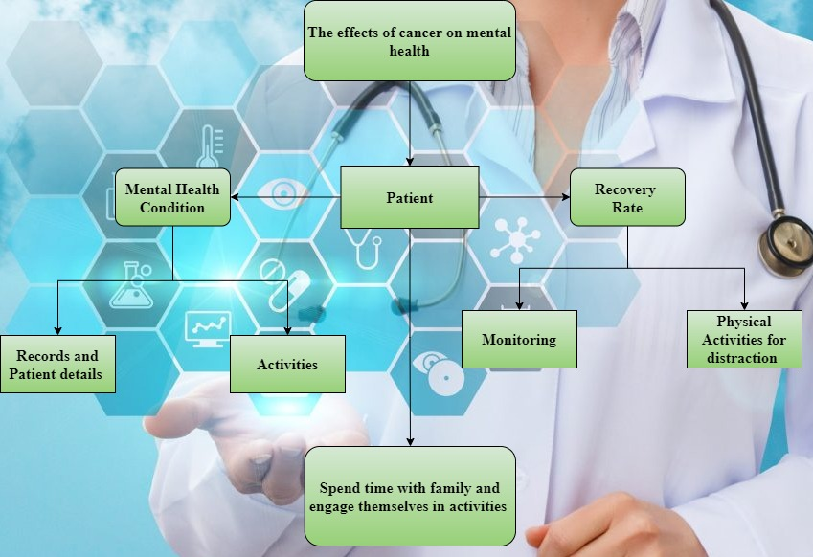
Figure 2: Conceptual Framework
(Source: created by the researcher)

Effects of cancer on mental health
Cancer is mainly a destructive disease and that can destroy emotional health, mental health, physical health, and also make an impact on the family and the patient as well. According to the view of McKenzie et al. (2018), this mainly affects a life-changing process and that mainly weakens the mental health and that is affecting the patient in a different way. In order to weaken the mental health of the family and close people that also make a major impact on the patient’s health. The changes must be recognized as they can make severe sense and that can help in mitigating the issues in the scenario. Cancer patients mainly suffered from mental health issues such as anxiety, panic attacks, depression, and many more and that can affect the patient in a crucial way. According to the study of Valdez, and Brennan, (2018), there are many ways that organizations and cancer service care are doing for improving their mental health and boosting their immunity so that they have the ability to fight against this disease. The patients are mainly undergone many related theories and that can make a positive impact on their health. The diagnosis is very important at that time and that can make a major impact on the health and that also help in boosting the strengths and the ability to improve on its own. According to the study of Brinkman et al. (2018), mental health is very much important for the patient and that condition can tell that how they are going to recover from this destructive disease. As per the reports, most of the cancer patients are suffering from major mental issues and that is after detecting cancer in the scenario. In the United Kingdom, there are many care centers that are helping the patients of many other diseases to fight and also strengthen their minds in the procedure.

Treatment of mental health for cancer patients
This disease is very much different and that causes death to the people and that is why people become more depressed and trapped into mental health issues at the same time. According to the opinion of Ilie et al. (2020), the development of mental health can happen to the patients and that can help in improving the condition of the patient. The impact of different kinds of therapy which are applicable to the patients in terms of agonizing diseases and in this case the therapies can make some basic improvement and help in making strengthen to the patient and boost their stamina for fighting against cancer. As there are many types of cancer and they have specific stages and based on that stages the patients can get the treatment. All kinds of cancer cause some rate of anxiety and depression to the people and that can be developed by engaging in different works and functions (Friend, 2020). In the United Kingdom, the treatment of diseases is very much advance, and based on that the people can get over Cancer if the mental condition and health of the patient are very strong and stable. The percentage of breast cancer in women is quite high in percentage and that can make several issues in the body and also in mental health. According to the study of Borstelmann et al. (2020), the treatment and the management of mental health issues are prominent and by taking stress, the impact of the effectiveness on the mental health becomes the result of deterioration of the patient. According to the reports and surveys, the people suffering from cancer who are under a treatment are making positive changes to fight against the disease and the recovery rate is comparatively high for the patients who are not taking proper care of their mental health.

Few strategies to improve the mental health of cancer patient
In recent conditions, there is still no such treatment for this disease cancer, and improving mental health can make a huge possibility to recover at some range. According to the opinion of Kim et al. (2021), the strategies that can make a major improvement in patient health and are engaging in any physical activity, spend time with the families and loved ones, many more. There is some kind of vaccines and that can resist the instability of the patient and chemotherapy is also there. Chemotherapy is mainly a chemical therapy that mainly affects the cancer tissue in the body and that can prevent cancer at some range. Cramer et al. (2017) there are many effects that happen in the mental condition during the patient having cancer and that fear, depression, anxiety, sadness, anger, disbelief, and many more and that are very much effective in the current situation of the patients. And there is some deadliest cancer which is not treated properly and that is pancreatic cancer, breast cancer, prostate cancer, lung cancer, and colorectal cancer. The people who have faced the fear of death become scared and that causes major depression and anxiety. The impact on health can be very effective and that can be mitigated by the explained strategies.

Implementation of technologies
The implementation of the technologies can make a major positive effect and that can be effective for mental health. There are many technologies that can help in improving mental health and that can also assist in distracting the mind. According to the opinion of Van Leeuwen et al. (2018), the feeling that includes fear, depression, anxiety, sadness, anger, disbelief, and many more are very much effective for mental health and it also weakens the condition of the patient in that procedure. In this case, the technology is also making an impact on doing chemotherapy and that can help in preventing cancer to be spread in the body. According to the perspective of Cramer et al. (2017), Lung cancer is very much common and can be mitigated in the same process as others. The patients have to become mentally enough strong so that they can make some changes in the body and that results in major progress.
This part of the research is based on the literature theories based on the impact of mental health due to cancer. The effects are properly discussed and that can help in understanding the importance of the mental health of the patients while suffering from cancer. The detection of a disease like this already makes a major impact on their family and other close people and that has a different impact on the scenario. The mitigation and strategies for making recovery are also explained and that can make a major effect in the scenario in terms of improvement of the mental health and the condition of health in other aspects.

Methodology

Introduction
The methodology is the most significant part of the study because on the abscess of the methodology the researcher will develop the findings and analysis of the study. In this study research methodology will also help to portray the impact on the mental health of the patients who are suffering from cancer.

Research philosophy
This part is another important area of the study and it helps in data interpretation crucially. In this study to enhance the validity of the study, the researcher will develop Interpretivism in the research. As per the view of Curry (2020), to analyze the secondary data this philosophy will help the researcher crucially and aids to enhance the relevance of the whole research effectively. This philosophy also helps in the contextual and complexity factors significantly.

Research design
This design mainly develops on the basis of the methods and techniques of the research, however, there are mainly three types of research design and those are explanatory, descriptive, and exploratory. In this study, the researcher will develop the descriptive design because this design-assist to portray the population, situation, and also phenomenon very easily. However, this also helps the researcher to answer all the relevant question of where, when, how and that help to meet the entire research question effectively.

Research approach
This part is another important part of the research because it aids to support the whole research methodology crucially. There are mainly two types of research approach inductive and deductive. Here to develop the secondary research, the researcher will select the inductive approach for further study (Miklian and Hoelscher, 2018). This approach helps the researcher in the observation and also in hypothetical analysis and that automatically brings crucial benefits for the study.
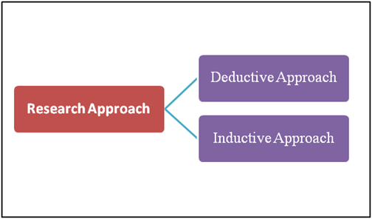
Figure 3: Research approach
(Source: Miklian and Hoelscher, 2018)
The inductive approach is one of the most flexible approaches and that will help the researcher for further research crucially.

Data collection technique
It is one of the most important parts of the study because on the basis of the technology the researchers will collect data to enhance the quality of the whole study. However, in this study, the researcher will follow secondary qualitative technology to collect authentic data for further research (Stobaugh et al. 2019). Here the researcher will select a total of 30 journals and articles for further study and all these articles will select from authentic sources because that aids to enhance the relevance of the study.

Ethical consideration
Maintain all the ethical considerations n will help the researcher to improve the authenticity of the research. However, in this study, the researcher will follow the data protection act of the UK to enhance the safety and security of the study. According to this law, the researcher will secure all the collected data and information for further study. Hence, that helps to maintain all the ethical boundaries crucially.

Conclusion
The methodology part of the study has portrayed all the relevant information to illustrate the further study while maintaining all the authenticity. However, the researcher will follow the appropriate approach and philosophy to maintain the reliability and validity of the study.

Findings and discussion

Anxiety and mental disorder
Experiencing anxiety after diagnosis of cancer is one of the most common factors. According to Bates et al. (2017), after cancer identification, fear of treatment, life expectancy and visiting doctors are seen to be common factors among most cancer patients. Cancer patients often develop the psychological symptoms of anxiety restlessness, feeling of being on the edge and difficulty concentrating are major psychological symptoms of anxiety. The mental disorder after the diagnosis of this fatal disease often noticed with difficulty with falling asleep, the inability of being relaxed, fatigue, muscle tension, headache and overall loss of appetite. On the other hand, Hughes et al. (2020) have explained that behavioural factors, as well as cancer-specific cognitions, often make important contributions to cancer-related. Initially, it is noticed that fatigue among the patients strategically enhances with chemotherapy and increased fatigue of the patients can be understood through the elevated anxiety before chemotherapy. This depression aspect is noticed to enhance the level of mortality rate among 94% of the patients (Healio.com, 2021). However, amongst the cancer patients, it is noticed that 61% of the patients suffer from the issues of MBC analysis, 56% of the patients suffer from insomnia whereas 56% of patients are noticed to suffer from depression (Prnewswire.com, 2020).
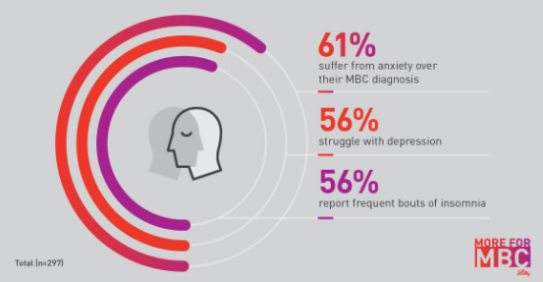
Figure 4: Emotional and mental health impact of patients with MBC in the US
(Source: Prnewswire.com, 2020)
Subsequently, based on the research of “Cancer Research UK”, it is found that the screening process of 7,000 cancer patients has stooped (Cancerresearchuk.org, 2020). This lack of screening programs is viewed to have enhanced the issue of fear and anxiety. The anxiety and distress can undoubtedly affect the quality of the lives of the patients with cancer along with their family members. This issue aggravates if the patients are derived from screening because screening is purposefully undertaken to understand if the patient requires help to deal with cancer or not (cancer.gov, 2021).

Depression
Demoralization can be viewed as a mental situation among the patients of cancer where there is a perceived inability to cope with the treatment-related distress. According to Vehling et al. (2017), Demoralization is one of the most significant important risk factors for suicidal ideation among patients with cancer. This demoralization among the patients is associated with depression which often leads to suicidal thoughts among many cancer patients. During cancer diagnosis, required treatment, and adequate rehabilitation, both mental disorders and demoralization are seen to be the most common factors among most of the patients. On the other hand, Jean and Syrjala (2017) have explained that clinical depression among people with cancer develop thoughts of suicide due to the feelings of guilt that their family need to go through financial sacrifices, worthlessness because of being unable to remain physically active among the family members and feeling of being insignificant. Similarly, based on the side effects of clinical depression, Breitbart (2018) has stated that People with cancer are noticed to be about 2 to 3 times more at risk of suicide as compared to the general mass pain, insomnia, fatigue, and nausea, the symptoms of depression are noticed be quite higher among the cancer patients. Alemayehu et al. (2018) have explained that both cancer and associated depression are often noticed to be neglected in most low-income countries. This issue of depression along with pain complaints is often noticed to be severe among the low-income countries as compared to the high-income countries because the mortality rate in those countries is noticed to be relatively high.
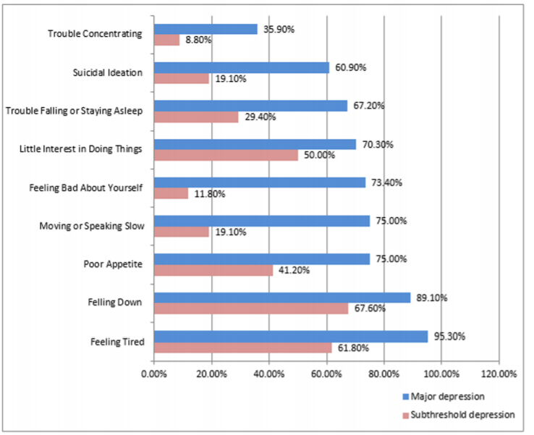
Figure 5: Proportions of depressive symptoms among cancer patients
(Source: Alemayehu et al. 2019)

Therapy
The cancer patients are given mainly three types of treatment such as cognitive behavioural therapy (CBT), support groups and medication. Bates et al. (2017) have explained that medication is mainly provided to the patients when anxiety prevents the patent to deal with everyday practices. However, it is often seen that medication is often not adequate to work alone on reduction of the mental disorder faced by the cancer patients. Both cognitive behavioural therapy (CBT) and prompt medication are important for the patients to work on the distress felt due to the issues. According to Serfaty et al. (2019), Cognitive Behavioural Therapy (CBT) is one of the most important tools that help in learning coping mechanisms to deal with the fatigue of suffering from this disease. CBT is an effective aspect that helps the patients to look at things from different perspectives. This not only helps the individuals with anxiety to manage their volatile emotions and they can identify their reasons for anxiety which is the main reason that helps them to work with the anxiety-inducing situation.
On the other hand, support groups also play an important role in helping patients to deal with cancer-related anxiety. In this case, the support groups share their feeling with people with similar issues and it helps people to deal with the issue of loneliness. Counselling or psychotherapy can be noticed as one of the most significant methods that help cancers patients with clinical depression to deal with controlling pain, getting exercise, eating well and focusing on the relaxation techniques effectively (Breitbart, 2018). It is seen that newer treatment aspects like ultraviolet light therapy and technology often use mild electrical stimulation and this often helps the cancer patients to combat clinical depression effectively.

Conclusions and recommendations for future policy and practice
It can be concluded that from introduction, a brief overview of the whole research is got along with a clear research aim and objectives. In literature review section, different concepts and strategies about handling mental health issues among cancer patients are properly analyzed. Secondary data collection method is used to gather authentic data about research topic. In analysis and findings section, a clear image of the present situation of mental health issues and treatments of cancer patients in different countries is gained. Recommendations are also provided to enhance the sincerity level of people and make them more humble and sensible toward cancer patients.
It can be recommended that in hospitals in UK, there is a necessity to include counseling practices for cancer patients permanently. In this regard, hospitals can make such deals with those organizations that help to fulfill this aim properly. A minimum of 6 months and a maximum of 2 years of counseling aspects need to be mandatory for each cancer patient. Such health policies must be developed as well that helps to take strong actions against the health workers who do not treat cancer patients with appropriate care. It is important to train the health workers about the treatment of cancer patients as this disease not only affects an individual physically, it affects mentally too. A consistent support system is also essential from family and friends and it must be taken under consideration also.

Reference list
Journals
Alemayehu, M., Deyessa, N., Medihin, G. and Fekadu, A., 2018. A descriptive analysis of depression and pain complaints among patients with cancer in a low income country. PloS one, 13(3), p.e0193713.
Bates, G.E., Mostel, J.L. and Hesdorffer, M., 2017. Cancer-related anxiety. JAMA oncology, 3(7), pp.1007-1007.
Borstelmann, N.A., Rosenberg, S., Gelber, S., Zheng, Y., Meyer, M., Ruddy, K.J., Schapira, L., Come, S., Borges, V., Cadet, T. and Maramaldi, P., 2020. Partners of young breast cancer survivors: a cross-sectional evaluation of psychosocial concerns, coping, and mental health. Journal of Psychosocial Oncology, 38(6), pp.670-686.
Brinkman, T.M., Recklitis, C.J., Michel, G., Grootenhuis, M.A. and Klosky, J.L., 2018. Psychological symptoms, social outcomes, socioeconomic attainment, and health behaviors among survivors of childhood cancer: current state of the literature. Journal of Clinical Oncology, 36(21), p.2190.
Cramer, H., Lauche, R., Klose, P., Lange, S., Langhorst, J. and Dobos, G.J., 2017. Yoga for improving health‐related quality of life, mental health and cancer‐related symptoms in women diagnosed with breast cancer. Cochrane Database of Systematic Reviews, (1).
Curry, D.S., 2020. Interpretivism and norms. Philosophical Studies, 177(4), pp.905-930.
Friend, A.J., 2020. The Long Term Mental Health of Survivors of Childhood and Young Adult Cancers (Doctoral dissertation, University of Leeds).
Hughes, A., Suleman, S., Rimes, K.A., Marsden, J. and Chalder, T., 2020. Cancer-related fatigue and functional impairment–Towards an understanding of cognitive and behavioural factors. Journal of Psychosomatic Research, 134, p.110127.
Ilie, G., Mason, R., Bell, D., Bailly, G., Rendon, R.A., Mann, R., Lawen, J.G., Bowes, D., Wilke, D., Patil, N. and Rutledge, R.D., 2020. Development and initial evaluation of a multifaceted intervention to improve mental health and quality of life among prostate cancer survivors. International Journal of Mental Health and Addiction, 18(4), pp.1067-1080.
Jean, C.Y. and Syrjala, K.L., 2017. Anxiety and depression in cancer survivors. Medical Clinics, 101(6), pp.1099-1113.
Kim, J., Kim, J., Han, A. and Nguyen, M.C., 2021. Leisure time physical activity, social support, health perception, and mental health among women with breast cancer. Leisure Studies, pp.1-11.
McKenzie, K., Bowes, R. and Murray, K., 2021. Effects of dance on mood and potential of dance as a mental health intervention. Mental Health Practice, 24(3).
Miklian, J. and Hoelscher, K., 2018. A new research approach for Peace Innovation. Innovation and Development, 8(2), pp.189-207.
Serfaty, M., King, M., Nazareth, I., Moorey, S., Aspden, T., Tookman, A., Mannix, K., Gola, A., Davis, S., Wood, J. and Jones, L., 2019. Manualised cognitive behavioural therapy in treating depression in advanced cancer: The CanTalk RCT. Health Technology Assessment, 23(19), pp.1-106.
Stobaugh, H.C., Mayberry, A., McGrath, M., Bahwere, P., Zagre, N.M., Manary, M.J., Black, R. and Lelijveld, N., 2019. Relapse after severe acute malnutrition: A systematic literature review and secondary data analysis. Maternal & child nutrition, 15(2), p.e12702.
Valdez, J.A. and Brennan, M.T., 2018. Impact of oral cancer on quality of life. Dental Clinics, 62(1), pp.143-154.
Van Leeuwen, M., Husson, O., Alberti, P., Arraras, J.I., Chinot, O.L., Costantini, A., Darlington, A.S., Dirven, L., Eichler, M., Hammerlid, E.B. and Holzner, B., 2018. Understanding the quality of life (QOL) issues in survivors of cancer: towards the development of an EORTC QOL cancer survivorship questionnaire. Health and Quality of life Outcomes, 16(1), pp.1-15.
Vehling, S., Kissane, D.W., Lo, C., Glaesmer, H., Hartung, T.J., Rodin, G. and Mehnert, A., 2017. The association of demoralization with mental disorders and suicidal ideation in patients with cancer. Cancer, 123(17), pp.3394-3401.
Websites
Breitbart, W., 2018. Cancer, Depression, and Suicide Risk: Signs to Watch For. Viewed on 05/07/2021 from:<https://www.cancer.net/blog/2018-08/cancer-depression-and-suicide-risk-signs-watch>
cancer.gov, 2021. Adjustment to Cancer: Anxiety and Distress (PDQ®)–Patient Version. Viewed on 05/07/2021 from:<https://www.cancer.gov/about-cancer/coping/feelings/anxiety-distress-pdq>
Cancerresearchuk.org. 2020, Impact-of-coronavirus-on-cancer-services-revealed-over-2-million-people-waiting-for-screening-tests-and-treatment. Viewed on 05/07/2021 from:<https://news.cancerresearchuk.org/2020/06/01/impact-of-coronavirus-on-cancer-services-revealed-over-2-million-people-waiting-for-screening-tests-and-treatments>
Healio.com. 2021, Women-with-ovarian-cancer-at-higher-risk-for-mental-health-disorders. Viewed on 05/07/2021 from:<https://www.healio.com/news/hematology-oncology/20210413/women-with-ovarian-cancer-at-higher-risk-for-mental-health-disorders>
Mentalhealth.org.uk. 2021.Cancer patients left to cope with mental health problems alone. Viewed on 05/07/2021 from :<https://www.mentalhealth.org.uk/news/cancer-patients-left-cope-mental-health-problems-alone>
Prnewswire.com. 2020, Lilly-anna-kaiser-launch-30-day-thriver-challenge-to-increase-awareness-of-daily-stress-of-living-with-metastatic-breast-cancer-elevate-support-for-women-and-men-living-with-the-disease. Viewed on 05/07/2021 from:<https://www.prnewswire.com/news-releases/lilly-anna-kaiser-launch-30-day-thriver-challenge-to-increase-awareness-of-daily-stress-of-living-with-metastatic-breast-cancer-elevate-support-for-women-and-men-living-with-the-disease-300987267.html>

