Introduction to Web and Database Concepts – Report

Homepage
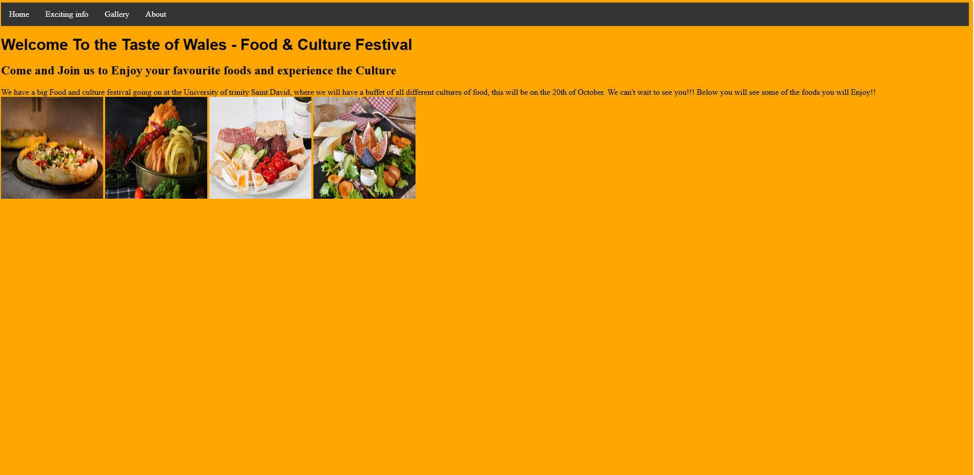
This is the homepage of the website, and it contains a heading which says what the website is about, and a subheading to say why you should come to the festival, and a paragraph text to say where and what date the festival will be on. I have also used photos that will be shown in the food festival.
Exciting Info Page
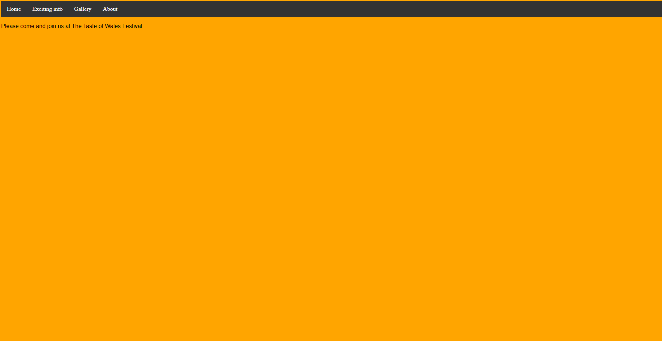
this is the exiting info page, which has small details but will be updated close the fetival date.
Gallery Page
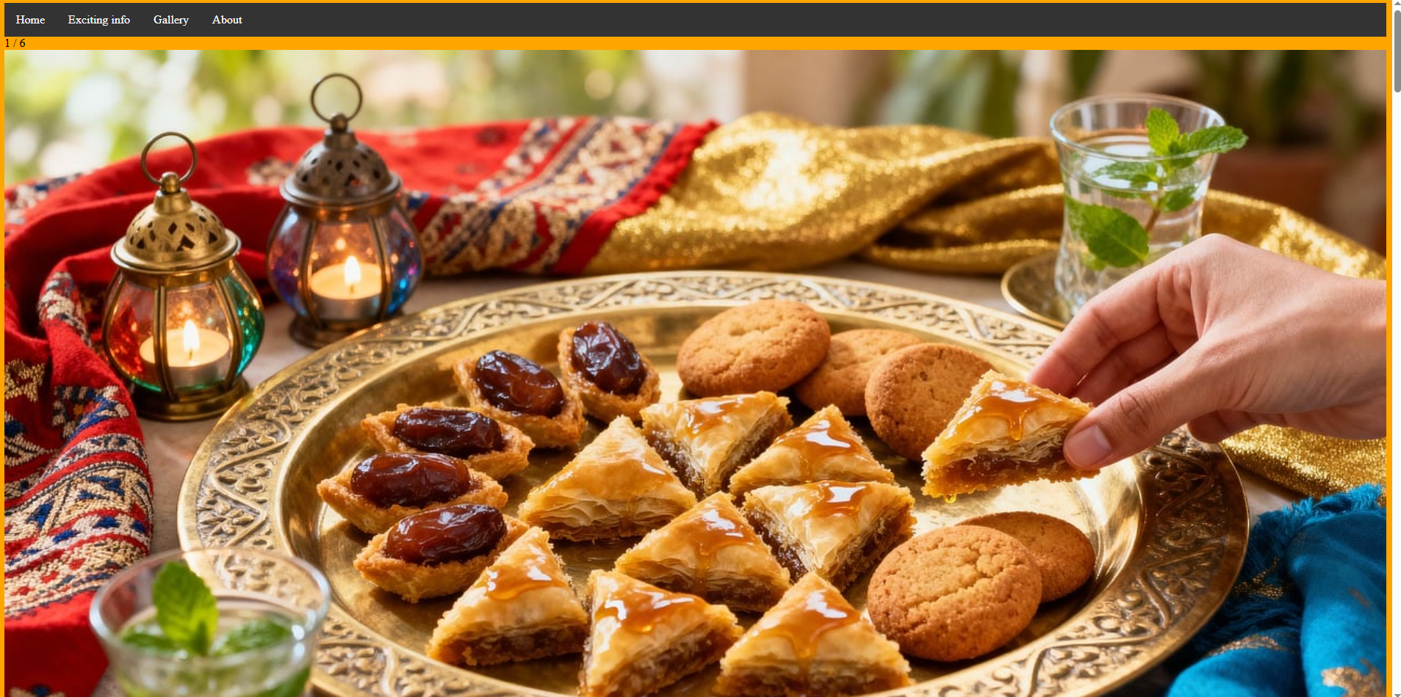
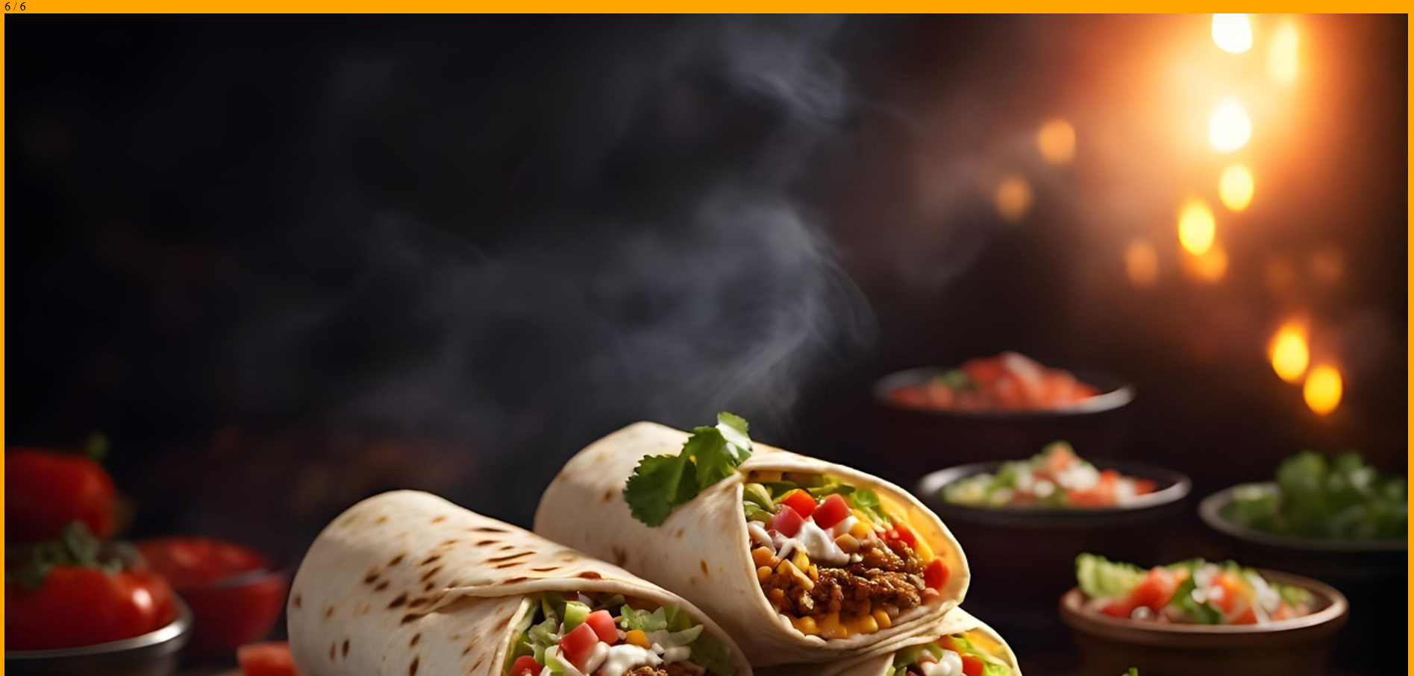
This is the gallery page, which displays 6 images showing all the different cultures of the food that will be at the festival. And I’ve used text to show the number of each photo, and have used an image gallery which I think is a great showcase photos.
About Page
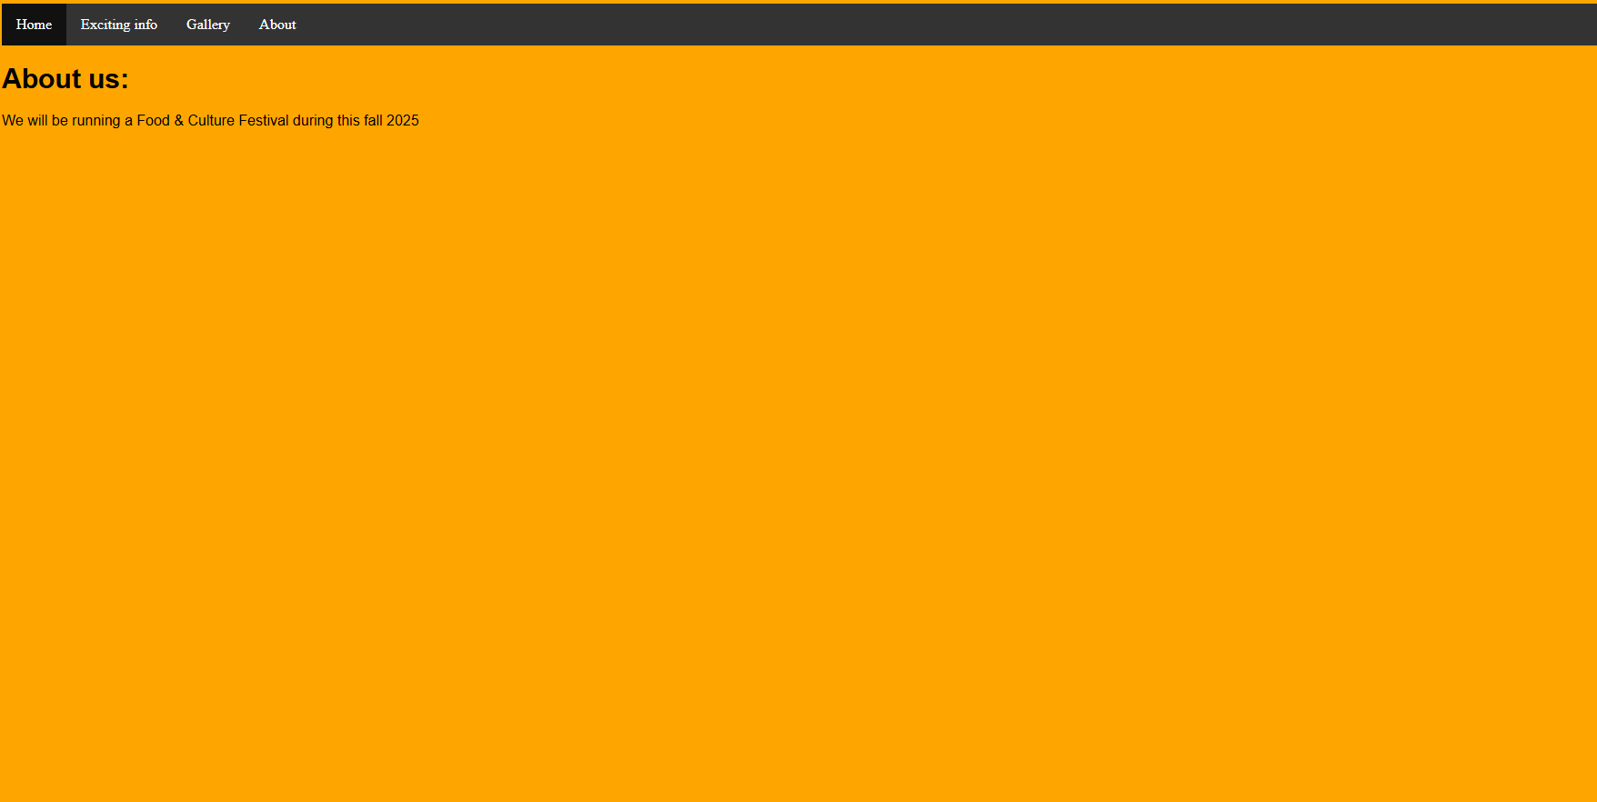
This is the about page to showcase all the details about the food festival including contact details, which will be all shown in one place using a div contains keeps all texts and headings organised.

Summary of the report
One consistent feature I used to design the page, was a navigation system which is very intuitive as it is displayed at the top of every page. And I think this works well as its easy to use in terms of accessibility, as the user won’t need to press the back arrow on the webpage which isn’t included on the website, meaning inexperienced users who are not familiar with the online web, won’t struggle and find it frustration to navigate throughout the website. Another feature I used was a stylesheet, and this allowed me to easily choose the type of colours I wanted to use for my website, which I used a dark text on a light background theme, and the navigation uses light text on a dark header, which I think is a good way to separate the navigation bar from the page’s information. Another great feature I used was a div class, and this feature allows me to show all text and images on one specific area which makes the website look very organised and easy to read for the user, which helps users with poorer eyesight, which makes the website have better accessibility. I think I also used clear images as it suits the theme of the website, whilst also fits the purpose. But there are many improvements I could make to this website, and one of them is more information as it looks very empty, with minimal information, as I have only used a small amount of text and loads of images which means the user might not find it professional and trustworthy. Another improvement I could make is using more features as this would make the website look more professional and better designed, making it more appealing to the user. But overall I think I have made some good choices of designs of the website which is the images as they fit the purpose. Another reason is because I have included an intuitive navigation which benefits the user with accessibility. But on the other hand there are many feature I could’ve added to make it more appealing an complete.

The website - index.html

