University of Wales Trinity Saint David
Wales Institute of Science and Art


Engine Performance Characteristics

ACHA4003

Owen Roberts
2203329
20/03/2023
Contents
1 Introduction 1
2 Experimental Procedure 2
2.1 Equipment 2
2.2 Methodology 2
3 Results 3
4 Analysis 4
4.1 Graphical Results 4
5 Evaluation 5
6 Conclusion 6
7 References 7

Introduction
In this report, an experiment has been carried out in order to investigate the performance characteristics using an engine dynamometer. The engine under investigation is a Honda Civic d16 1590cc VTec. The dynamometer used is an eddy current dyno that uses an electromagnet field and strain gauges to measure different variables of the engine. The engine dynamometer will record the engine load and rpm, using this we can calculate values such as corrected Power, Torque, BMEP, SFC, and Overall Thermal Efficiency and then analyse these values against the engine speed. These values are corrected by taking the ambient pressure, baro, and temperature in kelvin into account. This allows the power figure to be adjusted for different environments such as different altitudes and temperatures. This is due to the fact that at higher temperatures and altitudes, the air is less dense, meaning that the engine cannot take in the optimal amount of oxygen required, leading to a lower power measurement.

Experimental Procedure

Equipment
To carry out the experiment the only equipment required is the engine itself, the engine dynamometer, and a weight of a known value in order to calibrate the dyno against the torque arm with the weight attached to the end.
The dynamometer that was used is a Schenck WS230 which is limited to a maximum load of 10,000rpm and a maximum load of 130kW. It is an Eddy current dyno which works by having an inner core that moves freely powered by the engine, and an outer casing that is fed with a current. This current then produces an electromagnetic field which puts a load on the engine, thus trying to slow it down which creates strain. The load of the engine is measured using a strain gauge on the outer casing that measures how much it is trying to turn. The strain gauge sends a signal between 0v and 10v to the data logger. This voltage signal is then converted into a load value. To allow the signal to be converted accurately into a load value, the dyno must be calibrated, this is done using the calibration arms and a weight of a known value. Using the weight and the length of the calibration arm, the torque being applied can be calculated. (UWTSD, 2020)

Methodology
The first step was to calibrate the dyno, this involves hanging a mass on the end of the calibration arm. Using the equation T = F x D, the torque being applied can be calculated if the mass is known: 20kg and the distance, i.e. the length of the calibration arm: 0.815776m. e.g. T= (20kg x 9.81) x (0.815776m). This shows that the torque is 160.1Nm. The 0v to 10v value being displayed will allow the calibration. To collect the data that was required for this investigation, the Sweep test function was used. This gives the ability to read the data from the engine at set increments throughout a whole range of RPMs. In this case, data was recorded from 1000rpm to 5500rpm in 50rpm increments. Sweep testing has advantages over step testing as it doesn’t put as much stress on the engine and won’t allow it to overheat. This is because it doesn’t hold the engine at a certain RPM for an extended period. The downside, however, is that it isn’t as accurate as step testing, this is because the sensors don’t have as much time to read the data from the engine. Once the Sweep test function is selected on the computer and the RPM range and increments have been selected, the operator will press ‘Start Test’. The data (Load, Dyno speed, Fuel Flow Rate, and Lambda) will then be extrapolated into an excel document containing the Load, Dyno Speed, Fuel Flow Rate, and Lambda. The dynamometer will also log the Baro, humidity, and Ambient temp of the environment at the time of the test so that the figures can be adjusted/corrected (UWTSD, 2020)

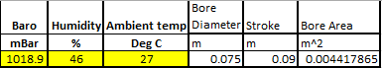
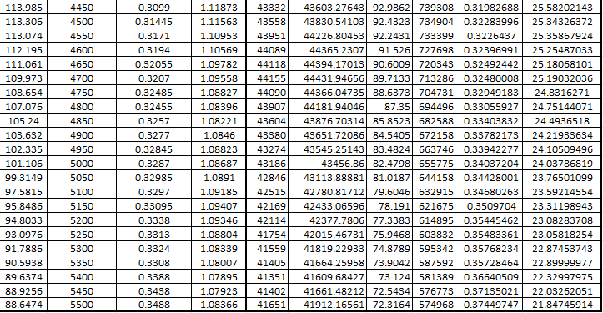
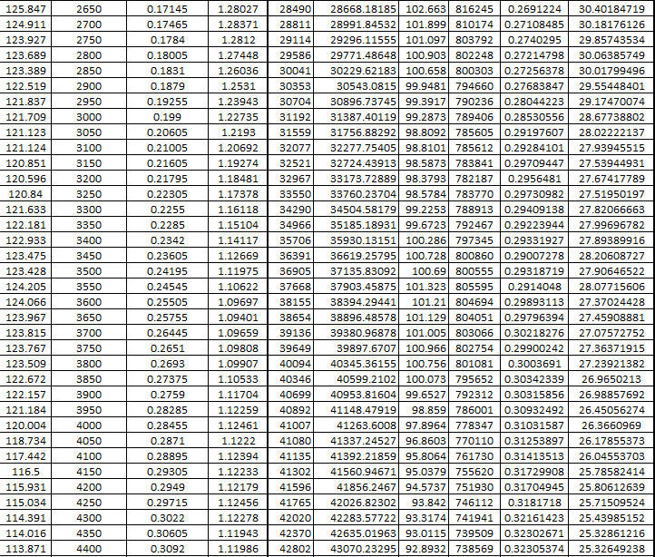
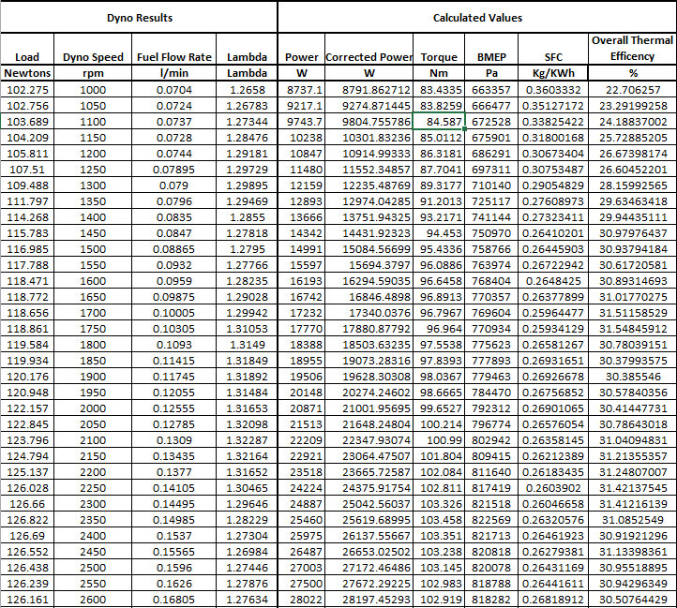
Results

Analysis

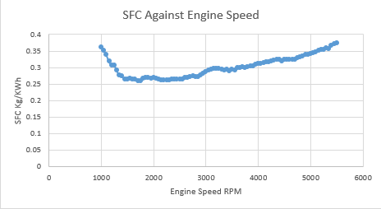
Graphical Results
Figure 1

SFC (Specific Fuel Consumption) is a measure of fuel efficiency of an engine it is defined as the amount of fuel consumed by a vehicle for each unit of power output. In this case it is Kg of fuel per kWh. Figure 1 shows the relationship between SFC and engine speed. As can be seen at around engine idle speed (1000rpm) the SFC is quite high at 0.36kg/kWh. This high fuel consumption at idle could be attributed to the fact that the engine is not operating at its optimal temperature, meaning fuel isn’t fully combusted. (Verizon Connect, 2022). As the revolutions per minute of the engine increase from 1000 to 1500rpm, the SFC steadily decreases to 0.26kg/kWh as the engine comes into more optimal temperatures for efficiency. After roughly 2700rpm there is a steady increase in SFC until 5500rpm, this is due to the engine using more fuel simply because of higher RPMs. A Lower Specific Fuel consumption indicates a more fuel efficient engine.

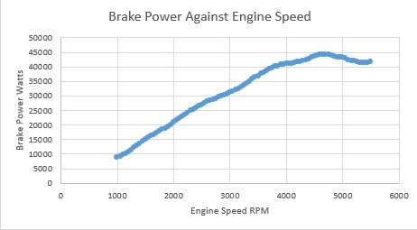
Figure 2
Figure 2 is a graph of the brake power in watts against the engine speed, there is a steady linear gradient of power increase from 1000rpm to 4750rpm. Once the engine reaches 4800rpm, the Brake Power starts to drop off. This is due to the engine’s inability to intake enough air in the shorter amount of time it has in the higher revolutions per minute, due to this reason, and increased frictional losses, the power the engine outputs declines. (Phillip H. Smith, 1977)

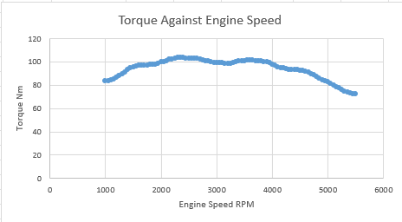
As Figure 3 shows, Torque increases with RPM until 2650rpm and then it decreases. Essentially this is due to the engine being mainly tuned to be its most efficient between 1500rpm and 2650rpm, this is due to the inlet and exhaust cams and timing. At higher RPMs, torque tends to drop off mostly from intake and exhaust flow restriction. Volumetric Efficiency declines because the engine can’t breathe any faster. (PhysicsForums, 2008) Volumetric Efficiency is the ratio between the real volume of air drawn the cylinder and the theoretic geometric volume of the cylinder. At lower RPMs there is a longer amount of time between strokes and revolutions, allowing more time for air to enter the cylinder- the inlet valves will also be open for a longer period of time. This allows for a higher volumetric efficiency at lower RPMs which cannot be achieved in the shorter intake stroke at higher RPMs. (x-engineer)
Figure 3
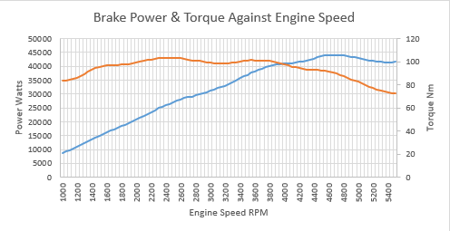
As can be seen in figure 4, peak power and torque for the d16 Honda engine are at different points in the RPM range. This is intentional, the higher low end torque is more beneficial to the launch and acceleration capabilities of the vehicle. For the best engine performance, an upshift through the gears should be executed at maximum engine power, which is higher up in the revs, due to the different gear ratios, the next gear will drop the engine speed to maximum torque, once again aiding optimum acceleration. (x-engineer, 2016) According to Michael Griese, the Project Manager for Electrical Drive Systems at BMW it’s the torque that matters at low engine speeds and at higher speeds it’s the engine power.
Figure 4

Evaluation
Whilst the equipment used for the test was accurate, there are a few ways the experiment could have been improved to gain more accurate numbers from the dynamometer. Firstly, the d16 engine did not have the standard air filter installed, in fact, it had a lawnmower air filter instead that was supplied by a workshop technician. This could have restricted air flow to the engine, causing inaccurate and deflated power figures. Furthermore, the exhaust manifold ports are extremely small and restrictive; a more free flowing exhaust manifold and a proper air filter and air box would allow the engine to produce more power and be closer to its full potential.

Conclusion
In conclusion, in this investigation of engine performance characteristics of a Honda Civic 1.6l VTec engine, an eddy current engine dynamometer was utilised to record the engine speed, load, fuel flow rate and lambda. Using these figures, power, torque, BMEP (Brake Mean Effective Pressure), SFC (Specific Fuel Consumption), and Overall Thermal Efficiency could be calculated.
 | Corrected Power (kW) | Torque (Nm) | BMEP (Pa) | SFC (Kg/KWh) | Overall Thermal Efficiency %
MAX Value | 44.4kW | 103.458Nm | 822569Pa | 0.374Kg/KWh | 31.5%
MIN Value | 8.79kW | 72.3Nm | 574968Pa | 0.259Kg/KWh | 21.8%

References

Collins Dictionary (2023) Definition of ‘Specific Fuel Consumption’, Accessed: 23/03/2023, Available at: https://www.collinsdictionary.com/dictionary/english/specific-fuel-consumption

Heisler, H. (1995) Advanced engine technology. London: Edward Arnold.

PhysicsForums (2008) Why does the torque curve drop off in a typical Piston Engine?, Accessed: 24/03/2023 Available at: https://www.physicsforums.com/threads/why-does-the-torque-curve-drop-off-at-low-rpm-in-a-typical-piston-engine.244434/#:~:text=At%20high%20RPM%2C%20torque%20drops,reduces%20torque%20at%20the%20output.

Smith, P.H. and Wenner, D. (1977) The design and tuning of competition engines / by Philip H. Smith. 6th rev. ed. / revised by David N. Wenner. Cambridge, MA: Robert Bentley.

UWTSD WISA Workshops (2019) Engine Dynamometer Overview, Accessed: 22/03/23, Available at: https://www.youtube.com/watch?v=-WajOAp2LUE

UWTSD WISA Workshops (2019) Engine Dynamometer Testing, Accessed: 22/03/23, Available at: https://www.youtube.com/watch?v=VD9OPoaAcJU

Verizon Connect (2022), How much gas does idling waste and what it means for your fuel tank, Accessed 23/03/2023, Available at: https://www.verizonconnect.com/resources/article/engine-idling/#:~:text=Because%20the%20engine%20is%20not,buildup%20on%20the%20cylinder%20walls.

X-engineer (2016) Power vs Torque, Accessed: 25/03/2023, Available at https://x-engineer.org/power-vs-torque/

