

Course: Business management
Module name: International Business Communications
Module code: LCBB6001
Lecturer: Dr Charles Nwaogwugwu
Title of report: Essay
Student: Stanimira Nikolova Nikolova
ID Number: 2118452

Adapting to host culture is vital for business success
TABLE OF CONTENT
Introduction………………………………………………………………………...page 3
Overview of the Planet Organic company………………………………………page 3
Overview of the countries- the UK, Austria, and Portugal……………………page 3
Hofstede’s 6 Cultural Dimensions and their importance ………………………………………………………………………………………page 5
Hofstede is used to analyse the UK, Austria, and Portugal ………………………………………………………………………………………page 6
Recommendation/Conclusion…………………………………………………page 13
Reference list……………………………………………………………………page 14

Introduction
According to Deresky (2017), International Business communication involves the challenges that businesses face managers in a global context. It also prepares individuals for the complex discipline of international management as the role of communication plays a crucial role in the context, especially when dealing with diverse cultures and adapting to different business environments. International business communication includes understanding and respecting cultural differences, building trust and effective relationships across cultural boundaries, and choosing the right channels for effective communication while considering local nuances and leveraging technology for global communication. Therefore, international business communication requires cultural awareness, adaptability, and effective strategies to foster communication and bridge gaps in a globalised world (Deresky,2017) This essay will analyse and evaluate which country is the best fit for expanding UK business such as Planet Organic abroad. British culture is presented and compared with Austria and Portugal, and Hofstede's theory is also used for strategic decision-making.
Overview of the company-According to Planet Organic (2024), Planet Organic is a UK company and the first fully certified organic market in the UK. Its values and mission are to provide healthy products such as food, drink, health, and beauty items within the communities as well as to be ethical and sustainable in their treatment of both- the planet and the people. Planet Organic provide support for community projects such as supporting young people from local schools with learning difficulties, charities that help the homeless find work, recycling groups and so on. They also value diversity and train all new starters to value it. Business Sale Report (2023) states that the company’s turnover for 2020 is £40.6 million while for 2021 is £37,6 million. The trend was accelerated by Covid- 19 pandemic but even that is a great profit for the company to be extended.
Overview of the countries - Helpful professor (2024) states the UK has a low context culture, where people communicate explicitly, relying on written rules and explicit code of words. This culture values autonomy and individualism, focusing on individuals rather than groups. It is easier to enter due to the lack of shared values and history, requiring no in-depth understanding of cultural norms. Frederic (2022) states that the British are also famous for drinking tea, they tend to be less direct and more polite in their communication with others.
Copyright (2016- 2024) points out that Austrians are decent and simple people who care a lot about formalities. For instance, without saying goodbye it is improper to leave. A lot of Austrian traditions are related to religious holidays such as New Year, Easter, Mother’s Day, Halloween, and others. They also value direct communication and straightforwardness, being honest and clear. As part of their etiquette and culture, they keep eye contact while saluting, shaking hands is also appreciated. They also respect time or in case of any cancellation or delays an apology or warning beforehand must be given. Therefore, UK companies such as Planet Organic should consider this cultural sensitivity when doing business there as any misunderstanding can lead to confusion and offence.
Mudita Consultancy (2022) state that Austria's business culture is low context, with direct, explicit communication, minimal body language, and minimal emotional expression. Punctuality is valued, and changes are seen as unprofessional. Meetings are formal, with a strict agenda, and small talk is limited. Proposals require detailed documentation and support. Helpful professor (2024) states that the UK has a low context culture. Therefore, as both countries share the same values such as direct communication, and punctuality it would be convenient for UK businesses to adapt to such a business environment.
According to companyformationaustria.com (2023), Austria is one of the most powerful, and stable with one of the most skilled labour forces in Europe and industrially developed countries in the world. Because of the business environment, foreign investors are very attracted. The main incentives for foreign investors are high living standards, a well-developed industry and Austria is one of the easiest countries to do business in. The country also offers one of the most favourable sets of foreign investment legislation as agriculture is also one the most likely to render the best return on investment. According to Planet Organic (2024), Planet Organic is a shop that offers healthy agricultural products; therefore, it is a fantastic way to be part of such a lucrative market.
companyformationaustria.com (2023) states that Austria does not discriminate between foreign and local investment, and it offers incentives such as subsidies, tax rebates, guarantees related to exports, loans with preferential interests and so on. It also ensures a strong protection of intellectual property rights as well as the requirements for opening a company in Austria are minimum and registration procedure can be completed remotely. As a member of European Union (EU) are also a good reason to set up and expand business there.
Kolodziejski (2019) states that Portugal is the thirteen largest territories in the European Union with a population of 10 291 027, the official language is Portuguese. According to Beachey (2020), Portugal is low-productivity country which is the main reason and the key driver for economic success. Thus, this reflects low investments as well as an elevated level of bureaucracy that has limited entrepreneurship as well as low-skilled workers. To make the Portuguese economy more attractive to investors, therefore further reforms are required.
Hofstede Insights (2024) highlights the significant role of culture in organizational success, stating that it shapes group behaviour and shared values. The Hofstede Model, developed by Professor Geert Hofstede, aids organizations in understanding and improving communication with diverse cultures.
Nickerson (2023) states that Hofstede’s cultural dimensions are 6 and they are below. Please refer to Figure. 1

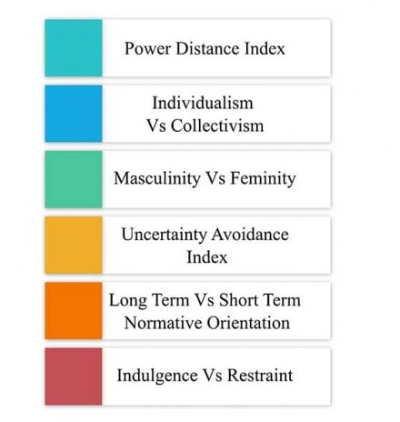

Fig. 1
(https://www.simplypsychology.org, date: 21/04/2024)
According to Toppan Digital Language (2024) the UK scores low for power distance, which means people will expect easy access to managers and involved decision-making. The UK also scored highly for individualism. In an individualistic country, people pursue personal fulfilment, value privacy, and expect to take care of themselves. The UK also scored 66 as a masculine society under Hofstede’s analysis. UK’s people tend to value achievement, competition, success, and value their career and they place less value on being modest and getting on well with others. Laigo (2020) states that in a masculine society, social gender roles are recognised, and men are expected to be tough, focused on material success and assertive, while women are expected to be tender, modest, and focused on the quality of life. Men hold more positions of power in a masculine culture and get paid more and are expected to behave in a masculine style; women are paid less. As masculine culture holds different values, they tend to prioritize material items, money, and dominance.
Toppan Digital Language (2024), points out that the UK shows low interest in uncertainty avoidance. Master Class (2024) states that a low uncertainty avoidance culture requires as few rules as possible such as culture can approach change through comfort, pragmaticism and adaptability. Toppan Digital Language (2024), points out that as part of short/long-term orientation, the UK scores neutrally. Short/long-term orientation shows how a society settles present challenges while still maintaining links to the past. Short/long-term orientation depends on society's culture. Indulgence/ Restraints- People in the UK tend to follow their desires but they have poor impulse control.
According to the International Business Centre (2003-2007), Austria scored 11 which indicates low Power Distance that displays a greater equality between society including organisation, government, and even within families. This orientation strengthens cooperative communication across power levels and builds stable cultural environments. Please refer to Figure 2.

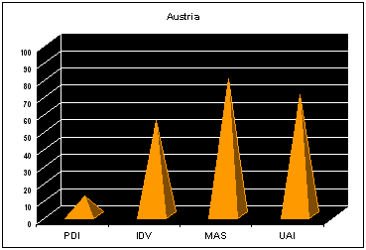
Fig. 2
(https://www.internationalbusinesscenter.org Date: 21/04/2024)
Therefore, as the UK also has low Power Distance according to Toppan Digital Language (2024), and both countries share the same values would not be a big communicational barrier if the UK company operates there. Thus, Planet Organic should consider employees as equal, give people power and expect in decision-making in their communication and cooperation.
According to Mosaica (2024), Austria places excellent value on social structure and the low Power Distance in Austria reflects this value of equality. The welfare system is extensive and provides support for most of the population’s education, health, retirement, and employment needs. Most of the Austria’s population has a high literacy rate and the standard of living in Austria is quite high, the unemployment rate is also low. There is a general trend and a sizable middle class for the Roma population as well as another immigrant group that is less economically stable. As the means to upward mobility, higher education is often seen. German is the official language in Austria but there is a recognizable difference between the German spoken in Austria and Germany.
Mosaica (2024), points out that Austria also has become a model of social, political, and economic stability. Cooperation, consensus, and tolerance are often the quality principles of many Austrians in their public and private lives. How Widely Spoken (2024) states that English is spoken in Austria by around 73 per cent of the population. Therefore, as a stable country like Austria, with a high standard of living and higher education as well as a low unemployment rate it is a wonderful opportunity for Planet Organic (UK company) to be part of their business environment.
According to jmercado12 (2013) in Austria the Power in decentralized and boss interaction and employee is very informal. Communication is straightforward in the workplace and very involving. Please refer to figure 3.

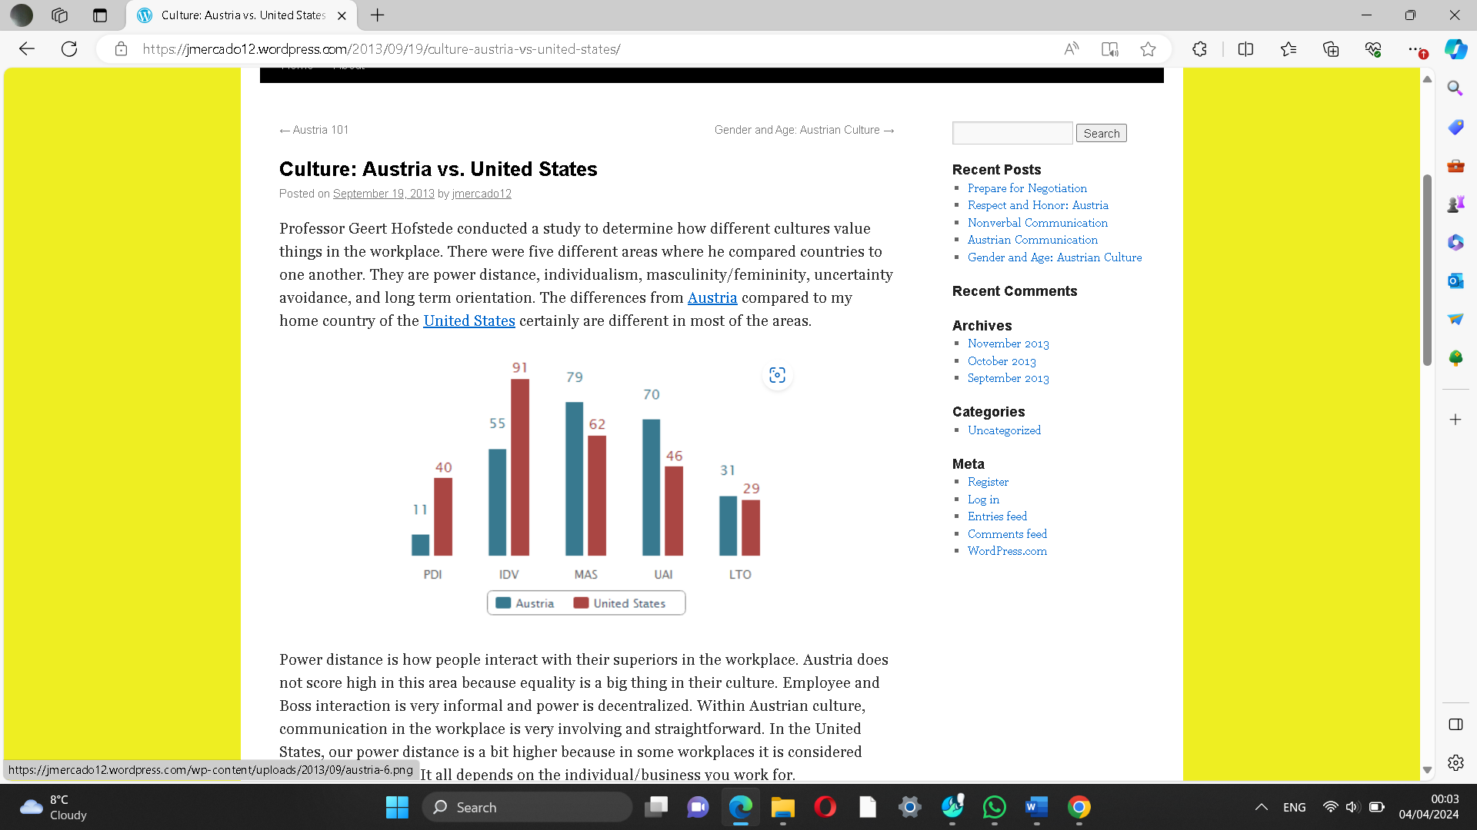
Fig. 3
(https://jmercado12.wordpress.com date: 21/04/2024)

According to jmercado12 (2013), Austria is an individualistic society as individuals take care of themselves and their families the most. This can be seen in Figure 3 above. Topan Digital Language (2024) states that the UK also scored high for individualism. Therefore, shared values can create a solid foundation for business relationships, but for UK businesses is vital to balance them with adaptability and an awareness of potential pitfalls. Engagement Strategies Media (2024) states that incentive programs should be provided to increase interest in work as well as to retain and attract quality workers. It will help to increase performance. Therefore, Planet Organic managers should take care of that as it will help to enhance effectiveness and prevent any future negotiations that can drive growth and profitability.
International Business Centre (2003-2007) states that Austria is also scored as Masculinity society at 79 which usually translates into a larger gap between the values of women and men and generates a more assertive and competitive female population, although still smaller than the male population. jmercado12 (2013), points out that as Austria is a Masculine society, managers are expected to be decisive as it is a highly competitive and driven culture with those associated with femininity. Toppan Digital Language (2024), highlights that UK is also Masculine society. Study. Com (2003-2024) states that Masculinity society usually brings greater social status, economic reward, and political power than those associated with the Feminine. Therefore, Planet Organic managers should be assertive, they have the same values.
jmercado12 (2013), states that Uncertainty avoidance is how society deals with uncertainty. Austria scored high, meaning society is not to take risks in business as the culture prefers to avoid uncertainty. Savoy Academy (2010-2024) points out that in high uncertainty avoidance, country managers should provide many written rules and procedures that tell employees what the company exactly expects of them. Therefore, Planet Organic should consider that as to ensure it builds good relationships and trust in their communication.
jmercado12 (2013), states that short-term orientation is scored for Austria as while people still respect traditions, cultures tend to live in the now. These factors are vital to be known as well as a lot of research before doing business in a different culture. Toppan Digital Language (2024), points out that as part of short/long-term orientation, the UK scores neutrally. Finance (2022) states that short-term goals motivate individuals to persist, increase success chances, and promote progress and growth in their personal and professional lives by maintaining focus and direction. Therefore, UK firms should be aware of this cultural awareness and pay attention to it as effective communication with employees is crucial for business success as it builds trust and prosperity.
According to Andreea (2020) with a high score of 63 Austria is an indulgent country about having fun and enjoying life. People tend towards optimism as well as they possess a positive attitude. They spend money as they wish and, please importance on leisure time. They also share similar values with UK culture.
According to Krebs (2022), Power Distance in Portugal scored 63 and taking Hofstede's descriptions this means that less powerful people in Portuguese institutions, societies or organisations are more likely to expect and tolerate that power is shared unequally. For the business environment, this means that hierarchical structures prevail in the workplace in Portugal as well and unequal distribution of power is accepted. Subordinates in Portugal according to Hofstede tend to act on institutions and to be guided. Portugal has different values than the UK in their power distance which would challenge UK business there.
Please refer to Figure 4 to see the Power Distance in Portugal.

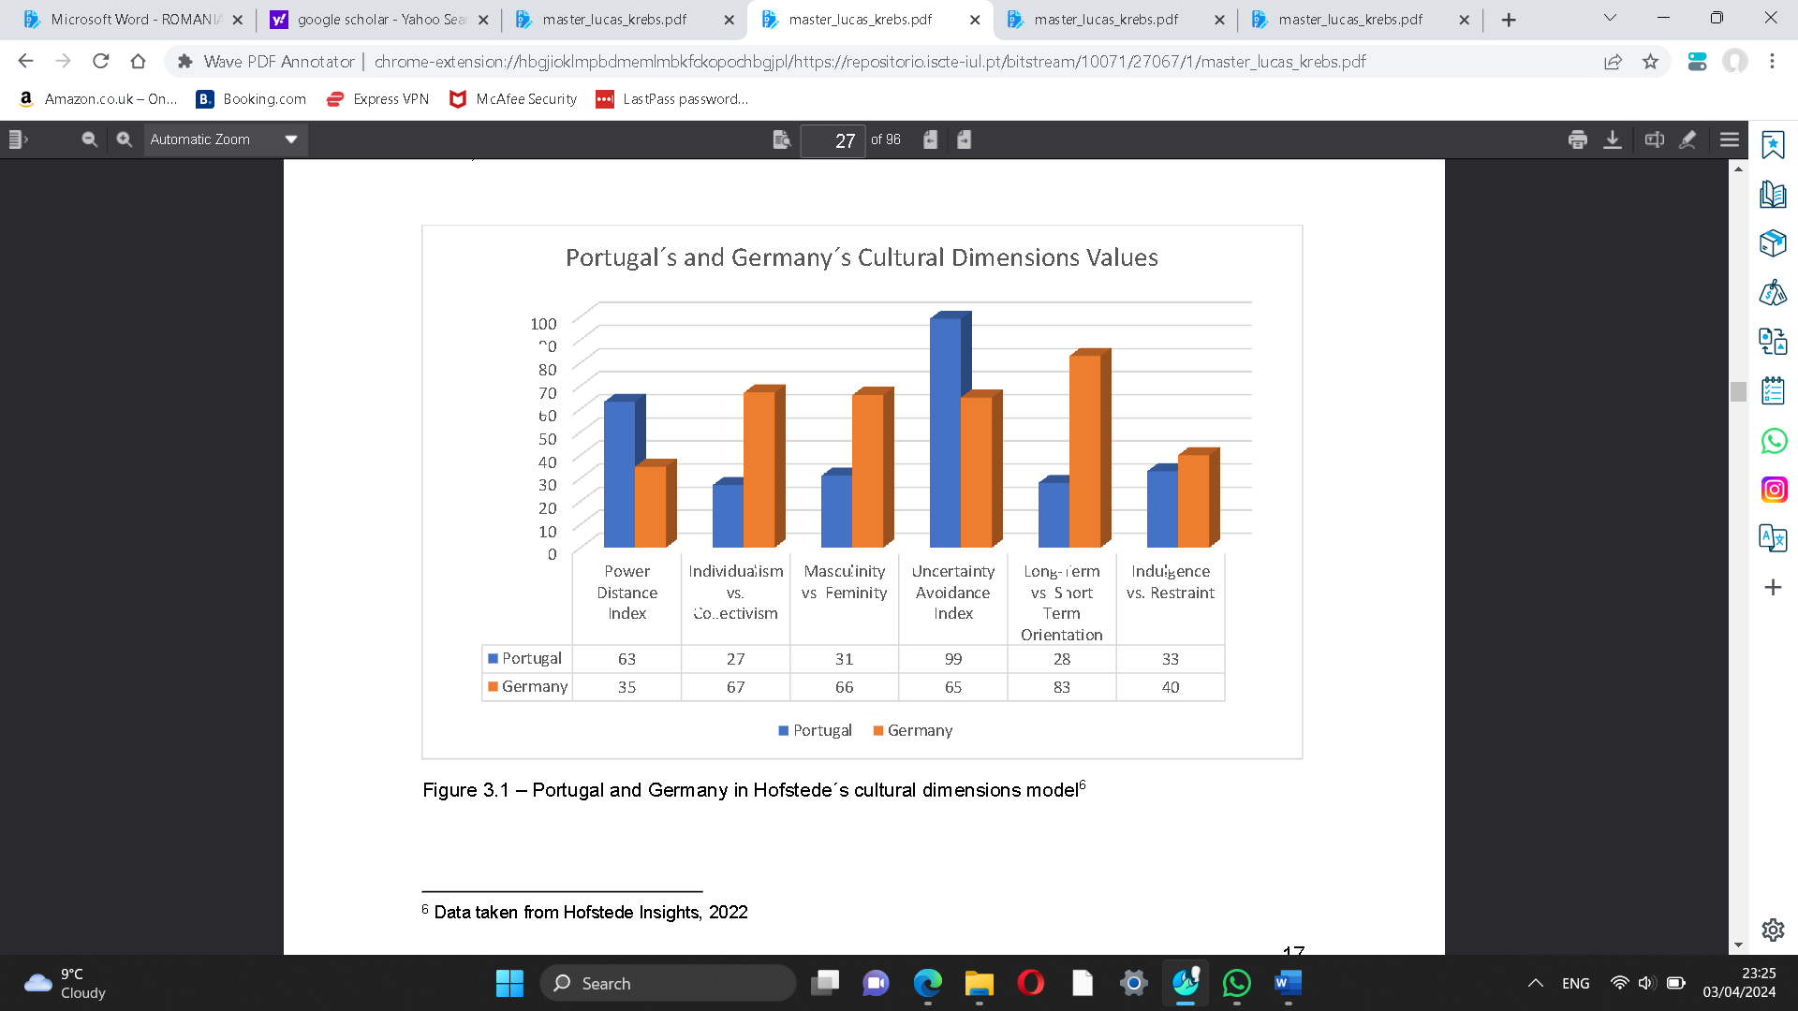
Fig. 4
(https://repositorio.iscte-iul.pt/bitstream/f date:21/04/2024)

According to Krebs (2022), Individualism/ Collectivism as a cultural dimension is determined by which members of a society are organized into social groups and in individualistic societies, loose social connection between members tends to be preferred. Every individual in this context is expected to be concerned with their well-being and close family. On the other hand, in collectivist societies, close social networks are maintained in which help, mutual loyalty and support are crucial.
Krebs (2022) states that with a score of 27 Portugal is a collectivist culture. There tends to be a very pronounced understanding of group belonging which is established on moral values such as loyalty. A group gives security and emotional stability to individuals which also means that relationships within groups such as close friends or extended family are long-term kept close. With regards to the organisational environment in Portugal, this means that the relationship between subordinates and superiors is established on moral condition and like family relations, management also means managing the collective. A collectivist culture in business and organizational environments prioritizes individual relationships as essential as the job itself for successful business and collaboration.
Krebs (2022) states that Portugal is a more Feminine culture with a score of 31. In Portugal, extreme competition is comparatively less appreciated in a feminine society such as a general agreement instead of open confrontation is preferred. In Portugal, Organisational context management is concerned with the well-being of its employees. Management also takes a more intuitive approach and strives to resolve conflict through deal and negotiation. Members of feminist society based on Hofstede’s assumption are more concerned with the quality of their live where people in such societies work to live their lives. As the UK is a Masculine society, according to Toppan Digital Language (2024), therefore, cultural differences can be a communicational barrier for UK businesses to succeed as they have different values.
Krebs (2022) states that the Uncertainty Avoidance Index refers to which members of a specific culture can deal with uncertain and unstructured situations in the future. High Uncertainty Avoidance Index society feels uncomfortable with uncertain and unstructured situations while countries with a low Uncertainty Avoidance Index show a flexible approach, value practice over principles and are more open to the unknown. Portugal with a score of 99 is considered as one of the cultures with the greatest tendency to uncertainty avoidance. Krebs (2022) point out that this means according to Hofstede Portugal’s society has a strong necessity for written and unwritten rules and laws. Unfamiliar and unstructured directions trigger anxiety and stress in people which is avoided by them. New, unconventional practices or ideas are met with suspicion for this reason traditional views and behaviours are strictly adhered to. In Portugal, the high Uncertainty Avoidance Index is expressed by an internal emotional necessity for rules and regulations and by the encouragement to work hard for job security. Master Class (2024) states that a low uncertainty avoidance culture requires as few rules as possible such as culture can approach change through comfort, pragmaticism and adaptability. According to Toppan Digital Language (2024), UK shows low interest in uncertainty avoidance. Therefore, cultural differences can be noticed here again between the two countries which would experience the UK's success and if they want to do business their different approaches should be considered such as written rules and laws.
Krebs (2022) points out that long and short-term measure evaluates how culture prioritises and handles customs and upcoming or present difficulties. Societies with short-term orientation are addicted to the protection of traditional values, customs and norms and are suspicious of social change. Long-term orientation societies are open to necessary changes and adopt a pragmatic approach, embracing future changes, as necessary. Portugal scored 28 as a short-term orientation country and people tend not to save or invest but think about closely on achieving quick outcomes.
Krebs (2022) points out that for the organisational environment in Portugal, short-term planning and action are taken. Indulgence vs Restraint is associated with the enjoyment of life and fun which is appreciated. In societies that tend towards restraint, the achievement of desires is regulated and controlled by social norms. Portugal is a country in which restraint prevails which tends to be cynical, and pessimist because they think that social rules restrict their behaviour, and people frequently resist meeting their wants (Krebs,2022). Cultural differences also can be seen here between the UK and Portugal which means they are completely different county with different values that would challenge company adaptability.
Recommendation/Conclusion
Based on the analysis, Austria is a wonderful place to extend a business there as it is a stable economy that provides better business opportunities.UK companies must respect their values such as direct communication, being honest and clear, keep eye contact if they want to succeed. Companies (such as Planet Organic) must treat everyone equally. Managers should provide incentive programmes and written rules and procedures to motivate people to persist and increase trust as a good attitude is also resilient. Trust is vital in business environments as it increases success chances which leads to a company’s productivity, strengthens relationships, provides new opportunities, and contributes to sustainable and rewarding business growth in this case in agriculture (as Planet Organic provides healthy products) as it is one of the most likely to render the best return of investment in Austria. Developing cultural sensitivity is crucial for managers to build trust, lead diverse teams, and create a positive work culture. UK businesses should adapt to Austria's similar values for success. Adapting to host culture is vital for business success.

Reference list:
Andreea (2020) Country Comparison: What about Austria? [Online] Available at:
https://www.scribd.com/document/481954309/Austria-docx (Accessed: 3 April 2024)

Beachey, A (2020) Why Portugal is so much poorer that other European countries
[Online] Available at: https://www.portugalresident.com/why-portugal-is-so-much-poorer-than-other-european-countries/ (Accessed: 15 April 2024)

Business Sale Report (2023) Organic supermarket Chain Planet Organic exploring sale [Online] Available at:
https://www.business-sale.com/news/business-sale/organic-supermarket-chain-planet-organic-exploring-sale-224075 (Accessed: 25 March 2024)

companyformationaustria.com (2023) Why is Austria an attractive country for Investors? [Online] Available at:
https://companyformationaustria.com/why-is-austria-an-attractive-country-for-investors/ (Accessed: 15 April 2024)

Copyright (2016- 2024) Customs and traditions of Austrian society [Online] Available at:
https://aljawaz.com/en/customs-and-traditions-of-austrian-society/#:~:text=Austrian%20culture%20and%20etiquette%201%20Home%20is%20for,year.%206%20Austrians%20respect%20time.%20...%20More%20items (Accessed: 3 April 2024)

Deresky, H (2017) International management: managing across borders and cultures: test and cases, 9th Ed., Boston: Pearson

Engagement Strategies Media (2024) Incentives, Motivation& Workplace performance [Online]
Available at: https://www.enterpriseengagement.org/articles/content/8288810/incentives-motivation-workplace-performance/#:~:text=Incentive%20programs%20improve%20performance.%20If%20selected%2C%20implemented%2C%20and,much%20as%2044%20percent.%20Incentive%20programs%20engage%20participants. (Accessed: 12 April 2024)

Finance (2022) Benefits of short-term Goals [Online] Available at:
https://edufund.in/blog/benefits-of-short-term-goals (Accessed: 11 April 2024)

Frederic, I (2022) Cultural differences between Germany and Great Britain [Online] Available at:
https://www.alphatrad.co.uk/news/cultural-differences-germany-great-britain (Accessed: 21 April 2024)

Helpful professor (2024) Low Context Culture: Examples, Definition & Countries [Online] Available at: https://helpfulprofessor.com/low-context-culture-examples/

(Accessed: 31 March 2024)

Hofstede Insights (2024) Intercultural management [Online] Available at:
https://www.hofstede-insights.com/intercultural-management (Accessed: 15 March 2024)
How Widely Spoken (2024) How Widely Spoken [Online] Available at:
https://howwidelyspoken.com/how-widely-spoken-english-austria/#:~:text=English%20is%20very%20widely%20taught%20and%20spoken%20in,behind%20only%20Scandinavia%20and%20a%20few%20other%20countries. (Accessed: 11 April 2024)

International Business Centre (2003-2007) Geert Hofstede Cultural Dimensions [Online] Available at: https://www.internationalbusinesscenter.org/geert-hofstede/hofstede_austria.shtml (Accessed: 2 April 2024)

jmercado12 (2013) Culture: Austria vs. United States [Online] Available at:
https://jmercado12.wordpress.com/2013/09/19/culture-austria-vs-united-states/
(Accessed: 2 April 2024)

Kolodziejski, M (2019) Economic, Social, and territorial situation of Portugal [Online] Available at: https://www.europarl.europa.eu/RegData/etudes/BRIE/2019/629190/IPOL_BRI%282019%29629190_EN.pdf (Accessed: 21 April 2024)

Krebs, L (2022) Portuguese cultural standards from a German perspective: A qualitative study of cultural differences in the organizational environment. Masters in international studies. Iscte - University Institute of Lisbon. Available at: chrome-extension://gphandlahdpffmccakmbngmbjnjiiahp/https://repositorio.iscte-iul.pt/bitstream/10071/27067/1/master_lucas_krebs.pdf
https://repositorio.iscte-iul.pt/bitstream/10071/27067/1/master_lucas_krebs.pdf
(Accessed: 4 April 2024)

Laigo, K (2020) Masculine vs. Feminine Culture: Another Layer of Culture [Online] Available at:
https://witi.com/articles/1824/Masculine-vs.-Feminine-Culture:-Another-Layer-of-Culture/#:~:text=Countries%20like%20the%20United%20States%2C%20Mexico%2C%20China%2C%20and,tender%2C%20and%20concerned%20with%20the%20quality%20of%20life.%22 (Accessed: 29 March 2024)

Master Class (2024) Uncertainty Avoidance: Examples of High, Moderate and Low
[Online] Available at: https://www.masterclass.com/articles/uncertainty-avoidance (Accessed: 30 March 2024)

Mosaica (2024) Core Concept [Online] Available at:
https://culturalatlas.sbs.com.au/austrian-culture/austrian-culture-core-concepts (Accessed: 3 April 2024)

Mudita Consultancy (2022) Business Culture in the Germanic Europe Cluster [Online] Available at:
https://www.muditaconsultancy.com/en/resource-center/visuals/introductions-to-culture-clusters/the-germanic-europe-cluster (Accessed: 1 April 2024)

Nickerson, C (2023) Hofstede’s Cultural Dimensions Theory& Examples [Online]
Available at: https://www.simplypsychology.org/hofstedes-cultural-dimensions-theory.html
(Accessed: 10 April 2024)

Planet Organic (2024) About us [Online] Available at:
https://www.planetorganic.com/pages/about-planet-organic (Accessed: 28 February 2024)

Savoy Academy (2010-2024) BUS613: Advanced International Business [Online] Available at:
https://learn.saylor.org/mod/book/view.php?id=58556&chapterid=45168#:~:text=In%20high%20uncertainty%20avoidance%20countries%2C%20for%20example%2C%20managers,employees%20exactly%20what%20the%20organization%20expects%20of%20them. (Accessed: 12 April 2024)

Study. Com (2003-2024) Masculine vs. Feminine Cultures: Distinctions & Communication Styles [Online] Available at:
https://study.com/academy/lesson/masculine-vs-feminine-cultures-distinctions-communication-styles.html (Accessed: 15 March 2024)

Toppan Digital Language (2024) Understanding the 6 Dimensions of UK culture [Online] Available at:
https://toppandigital.com/translation-blog/understanding-6-dimensions-uk-culture/
(Accessed: 15 March 2024)

