LCLM4005 – Component Two – Portfolio of Written Tasks
Programme: Cert HE Business Skills for the Workplace
Module: Employability and Career Development
Module code: LCLM4005
Assignment Title: Portfolio of written tasks
Student Name: Ioana Avramescu
Student ID: 2514739
Lecturer Name: Dr. Essa Bah

The two chosen job adverts are: Warehouse Supervisor and Logistics Team Leader.

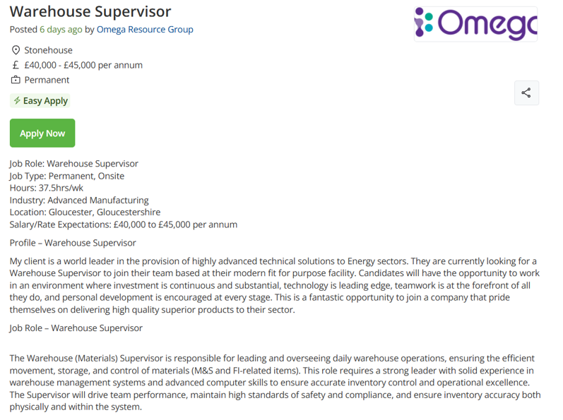

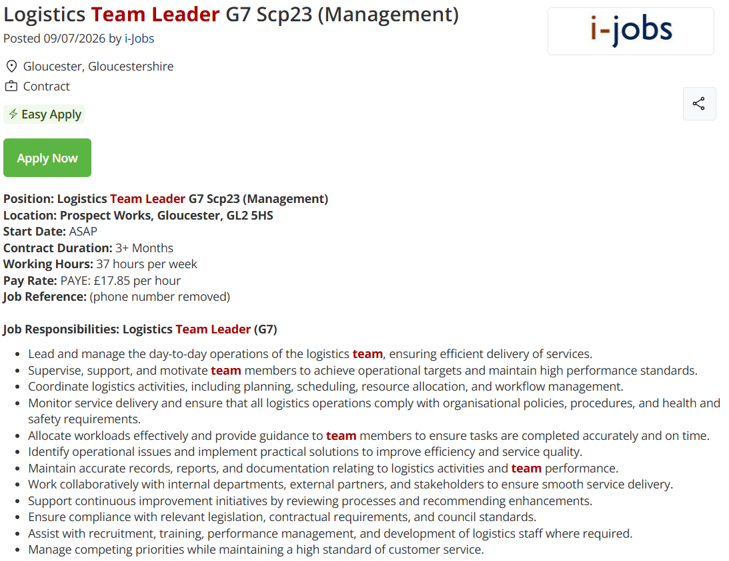
Task A – Comparison of Job Adverts

The logistics and supply chain sector requires employees to have a combination of technical knowledge, leadership abilities and interpersonal skills to ensure that operations run efficiently. To identify the skills and knowledge expected by employers, two job advertisements have been analysed: Warehouse Supervisor and Logistics Team Leader.
Both employers seek candidates with excellent communication skills, organisational skills, leadership potential and the capacity to work effectively under pressure. Each advert emphasises the importance of problem solving, planning work activities, maintaining health and safety standards and motivating team members to achieve organisational objectives. Employers value individuals who can coordinate operations while maintaining high standards of customer service and operational efficiency.
The Warehouse Supervisor role focuses on supervising warehouse operations, coordinating staff, monitoring stock levels, ensuring accurate inventory management and achieving productivity targets. Candidates are expected to demonstrate knowledge of warehouse procedures, health and safety regulations, continuous improvement and team supervision. Similarly, the Logistics Team Leader role requires effective leadership of logistics staff, resource planning, performance management, operational decision making and collaboration with internal and external stakeholders. Both positions require confidence in managing people while maintaining operational performance.
Another similarity between the two adverts is the emphasis placed on leadership: motivating employees, delegating responsibilities, resolving problems and supporting continuous improvement within the workplace (Northouse, 2022). Employers are seeking leaders who can build positive working relationships while ensuring goals are achieved (CIPS, 2024).
Leadership is a skill that I intend to apply in my future career. At Spirax, I have developed leadership qualities by coordinating activities across departments, supporting colleagues and mentoring new employees during their induction. My responsibilities have required clear communication, organisation and the ability to prioritise tasks within a fast-paced supply chain environment. These experiences have strengthened my confidence in making decisions and supporting team performance.
Developing stronger leadership skills will enable me to progress into supervisory and management positions within logistics. By improving my communication, decision making and people management abilities, I will be better prepared to lead teams, improve operational performance and contribute positively to organisational success.
Task B – Self-Assessment and Evidence of Readiness for Employability

Self-Assessment is a process that enables individuals to evaluate their abilities, recognise areas requiring improvement and develop strategies for achieving their career aspirations. One of the most widely used tools for self-evaluation is the SWOT analysis, which examines and individual’s strengths and weaknesses, opportunities and threats (Pickton and Wright, 1998). Completing a SWOT analysis has enabled me to reflect on my current employability skills and identify areas for personal and professional development.
SWOT Analysis
Strengths
- Extensive experience in logistics, warehousing and supply chain operations
- Strong communication and interpersonal skills developed through collaboration with multiple departments
- Excellent organizational and time management skills
- Experience training and mentoring new employees
- Problem-solving skills and commitment to continuous improvement
Weaknesses
- Limited experience in managing large teams in a formal supervisory position
- Public speaking and presenting to larger groups could be improved
- I would like to develop more advanced leadership and strategic management knowledge
- Limited experience with budgeting and financial management responsibilities
- Need to strengthen confidence when making higher-level management decisions
Opportunities
- Completing my Employability and Career Development module and continuing my university studies
- Internal promotion opportunities within logistics and supply chain organisations
- Professional training in leadership and management
- Expanding my qualifications through industry-recognised certifications
Threats
- Increased competition for supervisory and management positions
- Rapid technological developments requiring continuous learning
- Economic uncertainty affecting recruitment within the logistics sector
- Changes in organisational structures and business priorities

The SWOT analysis demonstrates that I have many of the competencies required for supervisory roles within logistics. My greatest strengths are my practical experience, organisational skills and ability to communicate effectively with colleagues across different departments. During my employment at Spirax, I have coordinated deliveries, maintained accurate ERP records, collaborated with purchasing, planning and engineering teams, and ensured smooth operational flow of the goods and services, and information, in the business. These responsibilities have required attention to detail, effective communication and the ability to work under pressure while maintaining high standards of customer service.
Another strength is my experience in supporting and training colleagues. At Wavin, I was responsible for demonstrating work procedures to new employees and helping them understand their daily responsibilities. This experience improved my communication skills, patience and ability to motivate others, all of which are important qualities for future leadership positions. I have consistently contributed to continuous improvement initiatives and demonstrated commitment to health and safety, quality assurance and operational efficiency throughout my career.
Although I have frequently coordinated work activities and supported colleagues, I have not yet held a formal management position with full responsibility for staff performance, recruitment and disciplinary procedures.
Developing greater confidence in leading larger teams and making strategic decisions will strengthen my readiness for promotion.
Another area requiring development is public speaking. While I communicate confidently with colleagues and customers daily, presenting information to larger audiences remains an area where I would benefit from additional practice.
The opportunities identified within the SWOT analysis provide a clear pathway for career progression. Undertaking professional development courses in leadership, project management and advanced logistics would increase my competitiveness within the labour market. The logistics industry increasingly values employees who combine practical operational experience with management capabilities and continuous learning (Chartered Institute of Logistics and Transport, 2024).
External threats should be considered, too. Employers seeking for candidates with both technical knowledge and proven leadership experience. Advances in digital technologies, warehouse automation and date-driven logistics mean that employees must continually update their knowledge and skills to remain employable. Lifelong learning has therefore become an essential aspect of career development (Jackson, 2016).

Evidence of Readiness for Employability and Personal Advancement:
My employability is supported by a combination of academic study, professional experience and workplace training. I am currently studying Business Skills for the Workplace, which is strengthening my understanding of professional practice while complementing my extensive practical experience within logistics and supply chain operations.
Professionally, I have developed a range of transferable skills through more than ten years of employment in manufacturing and logistics. I was responsible for monitoring customers orders, maintaining stock accuracy, coordinating deliveries with third-party logistics providers and ensuring compliance with organisational policies and procedures. My current position has expanded my knowledge of quality management, supplier documentation, inspection process and regulatory compliance. These experiences demonstrate my ability to adapt to changing responsibilities while maintaining high standards of performance.
I have also completed several professional development courses, including Safety Leadership, First Aid, Forklift Operation and Microsoft Excel. These qualifications demonstrate my commitment to continuous learning and my willingness to improve my professional competence. Employers increasingly value candidates who actively invest in their own development because it reflects motivation, adaptability and commitment to organisational success (CIPD, 2024).
Feedback received throughout my employment has consistently recognised my reliability, strong work ethic, positive attitude and willingness to support colleagues. Working collaboratively across departments has strengthened my interpersonal skills and reinforced the importance of teamwork in achieving organisational objectives. According to Goleman (1998), emotional intelligence, including self-awareness, communication and relationship management, is fundamental to effective leadership. These qualities have contributed to my professional success and will continue to support my progression into supervisory and management roles.

Task C – Employment Goals and Personal Development Plan

The SWOT analysis identified several areas for development, particularly gaining formal leadership experience, improving public speaking, developing strategic management knowledge and increasing confidence in decision-making.
My short-term employment goal is to secure a Warehouse Supervisor or Logistics Team Leader position within the next two years. This goal is important because it will allow me to apply the operational knowledge and leadership skills I have developed throughout my career while gaining formal responsibility for leading a team. Progressing into a supervisory role will also provide valuable experience in staff management, performance monitoring and operational planning.
My long-term employment goal is to become a Logistics or Supply Chain Manager. This position aligns with my career aspirations because I enjoy improving operational efficiency, supporting colleagues and contributing to organisational success. A management role would enable me to influence strategic decision-making, lead continuous improvement initiatives and develop high-performing teams. Achieving this goal will require continued professional development, practical leadership experience and lifelong learning.

Personal Development Plan
Development Need | Action | Timescale | Resources Required | Measure of Success
Develop leadership skills | Complete a recognised Leadership or ILM Level 3 qualification and seek opportunities to supervise projects or colleagues. | Within 12 months | Employer training, online courses, university resources | Successfully lead projects and receive positive management feedback.
Improve public speaking | Volunteer to deliver team briefings and presentations during meetings. | 6–12 months | Workplace opportunities, presentation practice, tutor feedback | Increased confidence and positive feedback from colleagues.
Increase management knowledge | Continue university studies and undertake additional CPD in logistics and supply chain management. | Ongoing | University library, CILT resources, professional reading | Successful completion of modules and additional certificates.
Strengthen decision-making confidence | Request mentoring from an experienced manager and participate in problem-solving activities. | 12 months | Workplace mentor, management meetings | Greater confidence when making operational decisions and managing priorities.

Regular reflection and evaluation of my progress will help ensure that I continue to develop professionally and remain competitive withing the logistics industry.

Reference List
Chartered Institute of Logistics and Transport (CILT) (2024) Professional Development and Careers in Logistics. Available at: https://www.ciltuk.org.uk (Accessed: 18/07/2026).
CIPD (2024) Employability Factsheet. Available at: https://www.cipd.org/uk/ (Accessed: 16/07/2026).
Goleman, D. (1998) Working with Emotional Intelligence. London: Bloomsbury.
Jackson, D. (2016) Re-conceptualising graduate employability: the importance of pre-professional identity. Higher Education Research & Development, 35(5), pp. 925–939.
Northouse, P.G. (2022) Leadership: Theory and Practice. 9th edn. Thousand Oaks, CA: Sage.
Pickton, D.W. and Wright, S. (1998) ‘What's SWOT in strategic analysis?’, Strategic Change, 7(2), pp. 101–109.
Prospects (2024) Skills Employers Want. Available at: https://www.prospects.ac.uk (Accessed: 19/07/2026).

