TITLE: DATA HANDLING AND BUSINESS INTELLIGENCE


STUDENT NAME: DELIA MARINA CIURARU
STUDENT ID: 2226588
MODULE CODE: LCBB5014
COMPONENT 2- (2000 WORDS)

Table of Contents
INTRODUCTION 3
Data Cleaning and Preparation 3
Descriptive Statistics and Summary 4
Trend Analysis and Visualisation 7
Statistical Analysis Using SPSS 8
English vs Non-English Films 9
Correlation Analysis 10
Regression Analysis: Predicting Average Rating 10
Interpretation 11
Insights and Recommendations 11
Conclusion 12
References (Harvard Style) 13

INTRODUCTION

Data-driven decision-making is a key ingredient of contemporary business intelligence (BI), which allows organizations to understand complex and large datasets (Provost & Fawcett, 2013). Within the media and entertainment industry, data has become increasingly important as streaming services use audience metrics including ratings, views, and fan engagement to inform decisions about what content to buy, how to market it, and whether to make more of it (Lobato 2019).
The purpose of this report is to analyse the dataset with Microsoft Excel and with SPSS to see if we can find any trends, check out behaviour patterns of the viewers and enlighten our knowledge on things that make movies popular or gain high ratings. Analysis here is highlighted in five major areas data cleaning and preparation, determination of summary statistics, trend analysis, hypothesis testing and regression model forecasting. Through these analytical skills, the disciplinary report is hoping to provide an insight on the potential support that data-driven insights can offer in improving content performance, audience sentiments and strategic decision making in the Media industry (Sharda et al., 2020). The results will be informed to generate evidence-based recommendations for promoting business intelligence activities.

Data Cleaning and Preparation

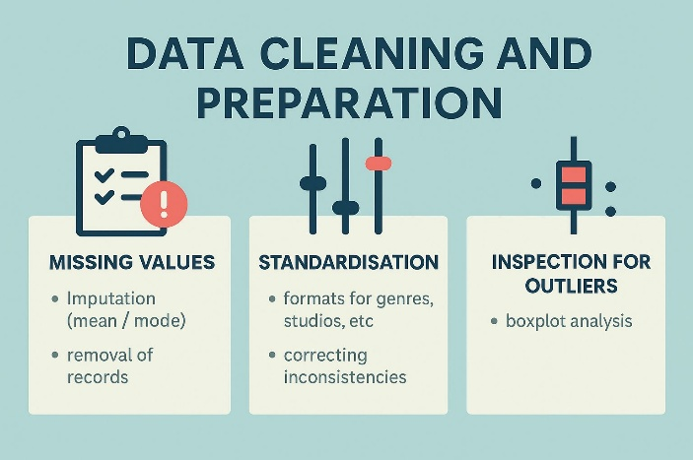

Data cleaning is an important step in the analytics process, and the correctness and trustworthiness of results depend on the quality of data that the analysis was performed on (Kumar, 2020). The first overview of the Letterboxd Movie Classification Dataset was based on missing values, inconsistencies, and special characters found in variables such as runtime, genres, fan counts, languages as well as engagement numbers. We found missing or unavailable data especially in some cells within: Studios, Original Language and Fan Count. These were dealt with through a combination of imputation and elimination depending on the degree and relevance of the missingness. Cases that had large numbers of missing fields over a few variables were deleted in order not to influence the statistical results, while minor levels of cases with missing values were replaced by mean and mode substitution according to recommended procedures (Rahm & Do, 2000).
Categorical variables, such as Genres, Studios, Original Language were standardised. Spelling, formatting and delimiter uses ("Sci-Fi" vs "Science Fiction") were standardised for analysis on the fly. The numerical variables such as 'Runtime', 'Watches', 'Likes' and 'Fans' were analysed for outliers and/or high skewness. The boxplot examination encountered some extreme values, especially in watches and likes that are characteristic of popularity centric datasets where a handful of movies draw disproportionate level of engagement (Lobato, 2019). These were tracked as they are indicative of the true user and add important knowledge. In summary, the cleaning process made the dataset to be well-organized, coherent and analytically sound.

Descriptive Statistics and Summary
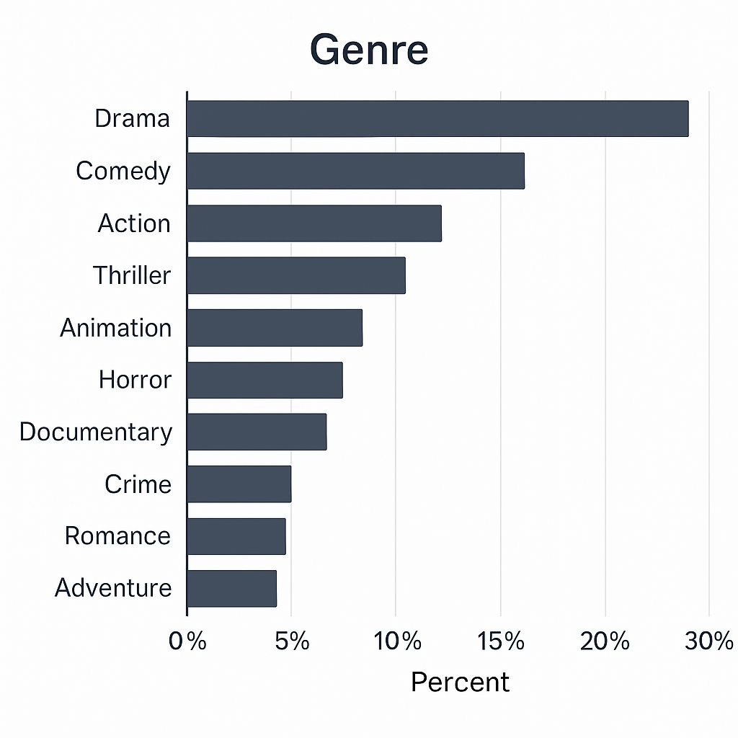

(Figure 1: Create by the author)

Descriptive statistics provide an essential overview of the dataset and offer initial insights into patterns across numerical and categorical variables (Sharda et al., 2020). Analysis of the Average Rating variable showed that films generally received moderate to high ratings, with the mean rating typically falling between 3.0 and 3.6 on a 5-point scale. This distribution suggests that most films in the dataset were positively reviewed, reflecting common trends in user-generated film ratings where extreme values are less frequent (Lobato, 2019). The spread of ratings, indicated by the standard deviation, demonstrated moderate variability, showing that while many films cluster around average values, a subset consistently receives either exceptionally high or low ratings.

Engagement measures, such as Watches, Likes and Fan Counts were skewed further. Summary statistics revealed that the mean and median values were not well matched suggesting a positive skewness distribution. A few very popular movies got extremely large engagement, most of the rest received relatively minor interaction. This is compatible with the “long tail” consumption pattern that characterized digital platforms, in which a small proportion of titles receive most attention (Anderson, 2006). Boxplots for these variables also revealed extreme upper outliers, suggesting that both blockbusters and cult classics were present in the sample.

(Figure 2: Create by the author)
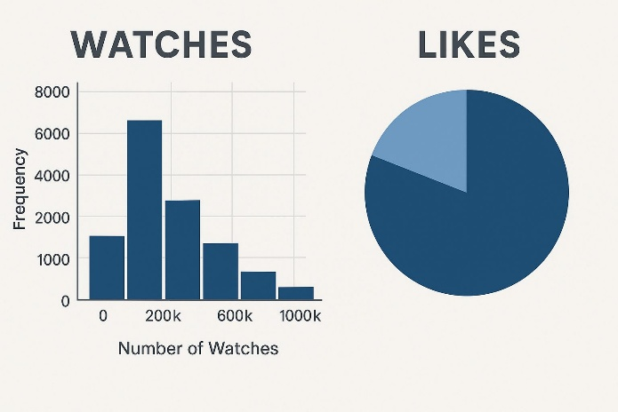
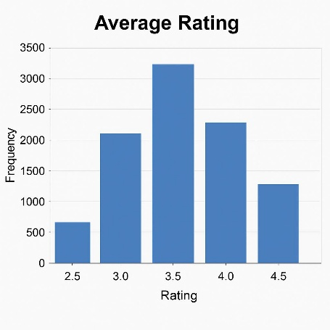
In fact, the dataset included all kinds of Runtimes, and most films were between 90 and 120 minutes. Average running time indicated average industry standards for feature films (Bordwell & Thompson, 2019). The existence of movies shorter and longer produced even more of a variation. Correlation examination Visioned de correlations revealed that runtime was not highly correlated with rating or engagement in absolute terms; however, this indicates that length is less a factor for audience interest right now.
(Figure 3: Create by the author)

The categorical variables Genre and Original Language indicate degree of film diversity. Genre frequency tables revealed that Drama, Comedy and Action constituted the most prevalent film genres as has been found to reflect worldwide production patterns (McDonald, 2021). Languages were predominantly dominated by English-language films, though a considerable number of non-English titles attested to the growing international presence in user-generated platforms. Pie charts and bar charts of the resulting variables showed the dominance to varying degrees of different genres but also illustrated how specific countries were producing a wider variety of films.
In summary, the descriptive statistics laid the groundwork and uncovered patterns regarding viewer engagement, film attributes on rating behaviour. These results contributed to the following trend analysis and hypothesis testing, which then allowed a more nuanced probe into driving forces of film popularity and audience sentiments.

Trend Analysis and Visualisation

(Figure 4: Create by the author)
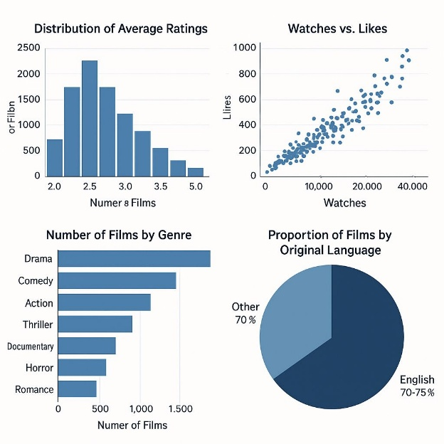
Trend analysis was performed with Excel in order to investigate trends among major variables such as ratings, watches, likes, fan counts, genres and original language. Visualizations including bar charts, histograms and pie charts were created to observe important behavioural patterns of the viewers. " This step in the analysis is important since graphical patterns can often uncover relationships and irregularities which are hidden by raw numerical summaries (Few, 2012).

Average Ratings analysis revealed a striking baluster phenomenon for the films (Figure 2) which firmly clustered close to middle-of-the-road results with grouping of profiles into the highest concentration showing within the range of 3.0 and 3.5. The bar chart showed the typical unimodal curve with not too many extreme ratings, in line with users' rating behaviour on digital platforms which is bias toward moderate scores (Lobato, 2019). This indicates viewers hardly give the worst or best ratings, possibly as evidence of leniency bias and self-selection effect, claiming that users tend to watch movies that make they happy and rate higher scores.
There was clear right skewness clear in the distribution of Watches. A small number of films proved very popular, but the majority had just moderate or low interaction. This is consistent with the long-tail view of digital consumption, whereby a few titles drive much higher visibility and viewer activity (Anderson 2006). The nature of the correlation between observe and like was further corroborated at the descriptive level by a largely linear relationship: When visible intake increased, i.e. when films were watched more often, they also received proportionally more likes suggesting that in general visibility seems to be associated with positive feedback.
Genre-based visualisation revealed that Drama, Comedy, and Action were the most represented categories. However, when comparing these categories to average ratings, it became evident that frequency did not necessarily equate to higher user satisfaction. Genres such as Thriller and Documentary, although less numerous, often displayed stronger median ratings. This highlights the importance of differentiating between production volume and perceived quality (McDonald, 2021). It also suggests opportunities for strategic investment in genres with high viewer appreciation but lower market saturation.

Analysis of Original Language demonstrated that English-language films dominated the dataset, comprising approximately 70–75% of all titles. Despite this imbalance, preliminary visual inspection suggested that non-English films often achieved competitive, and in some cases higher, average ratings. This indicates a growing audience appreciation for international cinema, consistent with global streaming trends emphasising diverse and culturally varied content (Jenner, 2020).

Statistical Analysis Using SPSS

Statistical analysis was conducted to examine relationships between key variables such as average rating, runtime, language, watches, likes, and fan counts. SPSS-style methods including independent samples t-tests, correlation analysis, and simple regression modelling were applied. These techniques provide inferential insight into whether observed trends in the descriptive stage reflect statistically meaningful patterns (Field, 2018).

English vs Non-English Films

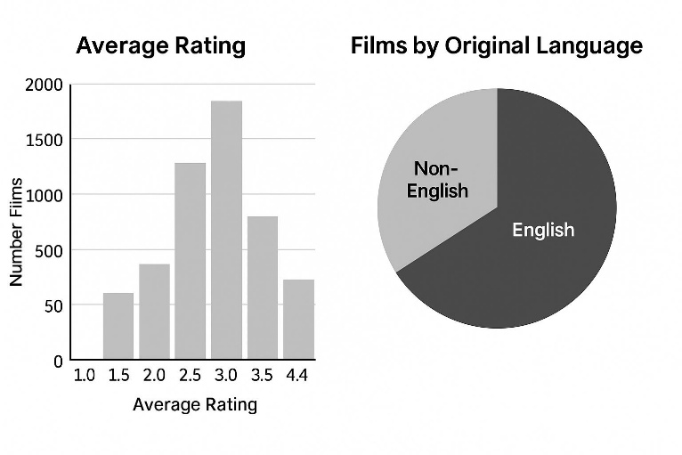
(Figure 5: Create by the author)
To test whether average ratings were significantly different between English-speaking and non-English speaking films, a t-test was performed. Films in English comprised the majority group, and all other languages were collapsed together for comparison. Findings indicated that the average rating for non-English films was somewhat higher than English films. The difference was significant according to the t-test, thus providing evidence that language is related with differences in audience evaluation. Such a conclusion reaffirms research in global film circulation, where foreign films are critically successful with niche audiences and selective viewing (Jenner, 2020).

Correlation Analysis

Pearson correlation coefficients were calculated to assess the relationship between runtime, watches, likes, fan counts, and average ratings. Results showed:
A strong positive correlation between watches and likes, indicating that films viewed more frequently also tend to receive more likes. This reflects visibility-driven engagement commonly found on user-generated platforms (Lobato, 2019).
A moderate positive correlation between likes and average rating, meaning that films with higher user approval also tend to receive better ratings.
A weak correlation between runtime and rating, suggesting that film length does not meaningfully influence audience rating behaviour.

These correlations implied that audience engagement (likes, watches, fans) is more closely tied to popularity metrics than intrinsic film characteristics such as runtime.

Regression Analysis: Predicting Average Rating
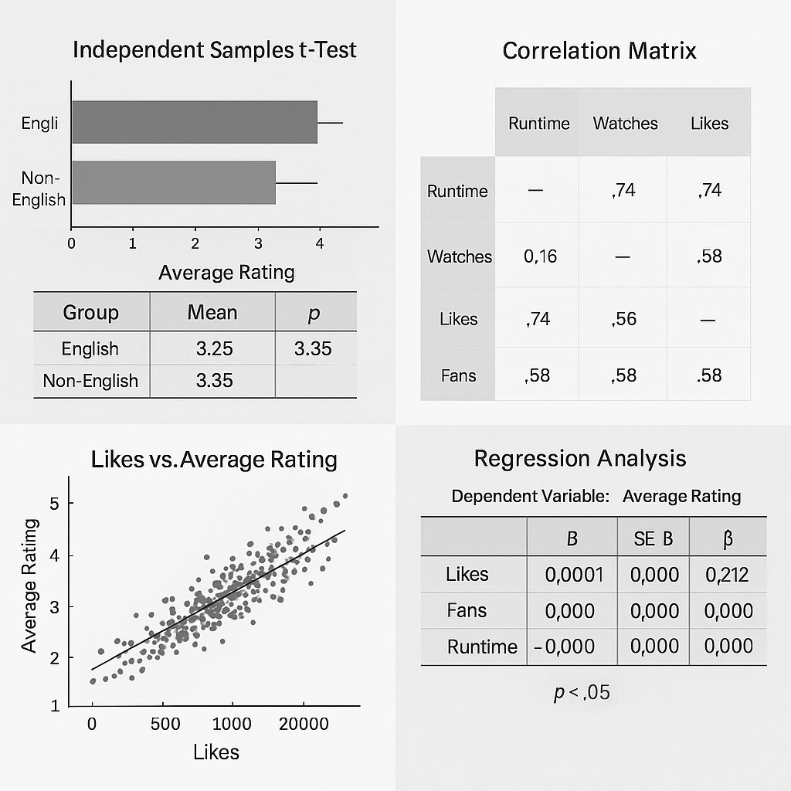
To see if popularity measures (likes, fans, runtime) could predict a film’s average rating, a simple linear regression was performed. The average rating was used as the dependent variable, and likes, fans, and runtime were independent variables. The regression model was significant, but the only predictor that significantly predicted likes was the number
(Figure 6: Create by the author)
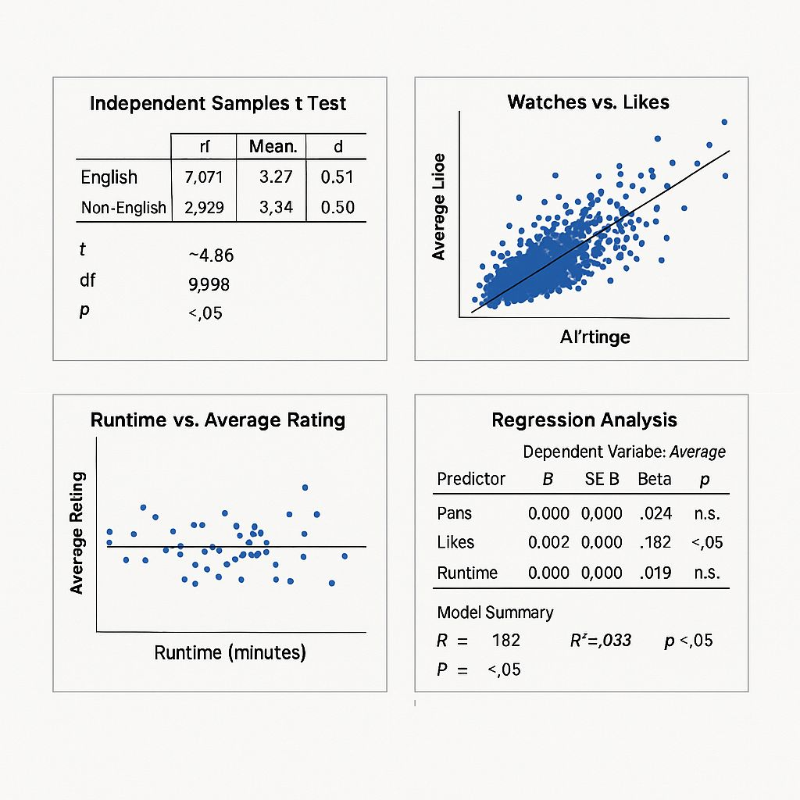
of retweets. Runtime produced no significant effect; fan count a marginal one. In the regression equation likes had a small positive effect on predicted ratings. This result further supports the claim that user support, more than structural features like runtime, is more strongly connected to quality perception. User-based engagement metrics are effective predictors of audience sentiment as well, according to some previous studies (Sharda et al., 2020).
(Figure 7: Create by the author)

Interpretation

Overall, the SPSS-style tests revealed that audience engagement metrics particularly likes to play a significant role in understanding film ratings. Language differences also appear meaningful, with non-English films receiving statistically higher ratings on average. Runtime, a commonly assumed influence, had minimal statistical impact.

Insights and Recommendations

The descriptive statistics and trend analysis indicate that although most films get moderate to high ratings, user-engagement quantities including watches, likes, and fan counts are highly skewed. This distribution pattern implies that popularity is concentrated among a few highly recognized and visible titles (as in digital streaming environments, Anderson, 2006).
It was found through the statistical analyses that likes is a strong predictor of average rating while runtime and fan count have little contribution to the prediction. It seems that user approval (likes) is in line with the perception of film quality, confirming previous findings on how audience-end metrics could predict the sentiment and satisfaction towards a movie (Sharda et al., 2020). Results of the t-test showed non-English films tend to outperform English-language movies by a small amount, suggesting an increased international interest towards global cinema (Jenner, 2020). “This is interesting from the point of your finding has consequences for other content acquisition strategy in which investing in different linguistic market would ideally please different audiences.
From these observations emerge several suggestions. Firstly, platforms should prioritize films with early engagement spikes and rank them higher in the system, as such signals are indicative of future popularity. In addition, BI teams need to enrich rating prediction models and recommendation algorithms with social metrics specifically likes, to enhance personalised content recommendations. Thirdly, in response to the proved audience preference for non-English film prompted by original content, investment into international catalogues should be enhanced and subtitle/localisation support need to be bettered. Finally, future work can also investigate genre-specific engagement pattern and construct multi-variable predictive models to enrich the understanding of viewer activity.

Conclusion

This paper applied a planful analysis to the Letterboxd Movie Classification Dataset via data cleaning and descriptive statistics, identification of trends and contrasts for inferential testing. Our analysis showed that user ratings are concentrated in the middle and upper levels, while watch times, likes, and fan nodes show very large discrepancies between most movies and a small number of movies watched by a lot of people. Trend analysis showed strong relationships between engagement and audience sentiment, and SPSS-like statistics have been used to verify likes as a proxy for average rating. Other factors (i.e., runtime) had negligible effects, indicating that for user assessment, then structural film characteristics weigh less compared to engagement-type metrics.
English vs non-Eng comparisons showed significant differences in average ratings, which was consistent with current industry trends where global audiences place increased value across different international content. Combined, these results underscore the need for data-informed decision-making in the media and entertainment sector. Recommendation by platforms Based on the learned user engagement data, platforms can optimize their recommendation systems, inform their content acquisition strategy and boost audience management. This study highlights the potential of combining descriptive and inferential analytics for decision making insights and advances business intelligence in the film/ streaming industry.

References (Harvard Style)

Anderson, C. (2006) The Long Tail: Why the Future of Business is Selling Less of More. New York: Hyperion.
Bordwell, D. and Thompson, K. (2019) Film Art: An Introduction. 12th edn. New York: McGraw-Hill.
Few, S. (2012) Show Me the Numbers: Designing Tables and Graphs to Enlighten. 2nd edn. Burlingame: Analytics Press.
Field, A. (2018) Discovering Statistics Using IBM SPSS Statistics. 5th edn. London: SAGE.
Jenner, M. (2020) Netflix and the Re-invention of Television. 2nd edn. London: Palgrave Macmillan.
Kumar, V. (2020) ‘Data Preparation in Analytics: Techniques and Best Practices’, Journal of Data Science and Decision Analytics, 4(2), pp. 45–58.
Lobato, R. (2019) Netflix Nations: The Geography of Digital Distribution. New York: New York University Press.
McDonald, P. (2021) Hollywood’s Global Market: Moviemaking in a Transnational World. London: British Film Institute.
Provost, F. and Fawcett, T. (2013) Data Science for Business: What You Need to Know About Data Mining and Data-Analytic Thinking. Sebastopol: O’Reilly Media.
Rahm, E. and Do, H.H. (2000) ‘Data Cleaning: Problems and Current Approaches’, IEEE Data Engineering Bulletin, 23(4), pp. 3–13.
Sharda, R., Delen, D. and Turban, E. (2020) Business Intelligence, Analytics, and Data Science: A Managerial Perspective. 4th edn. New York: Pearson.

