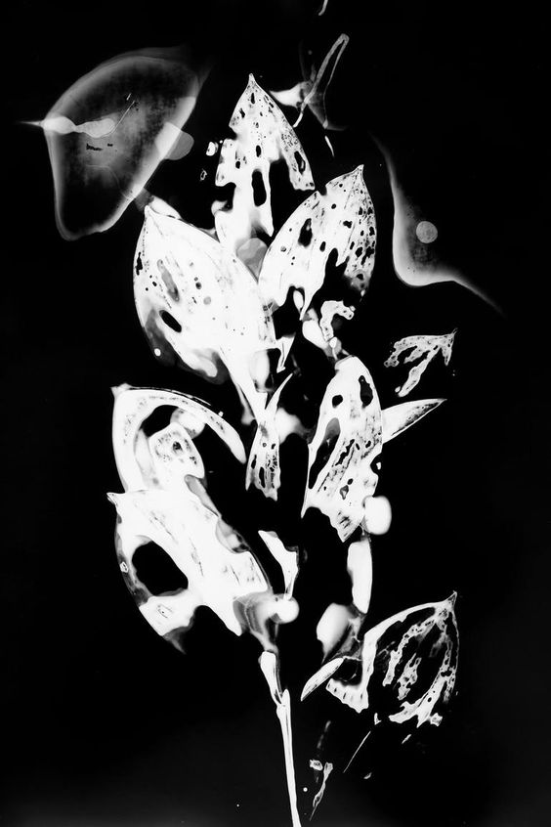
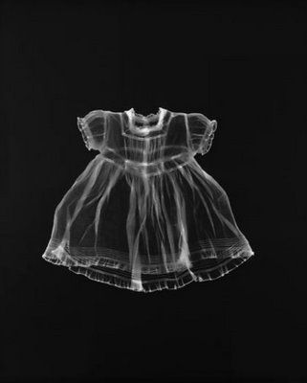
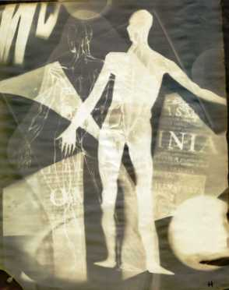

Desmond Paul Henry

Adam fuss
Sonia litynsskyj
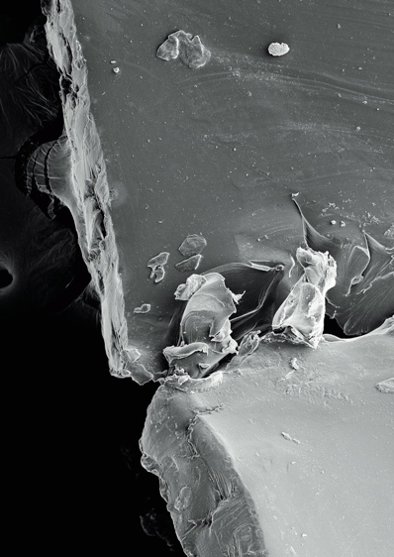
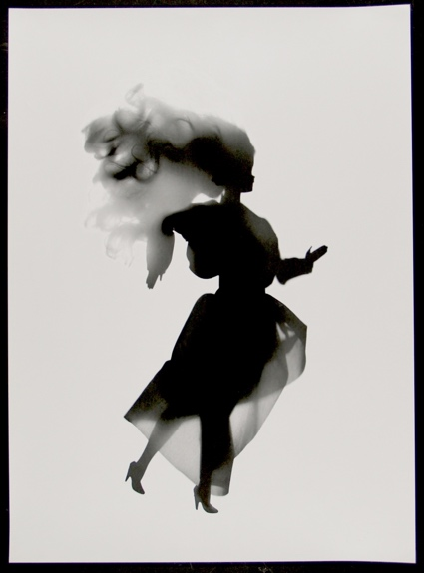
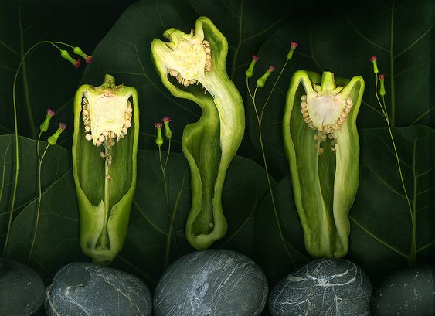
Luke evans
Doug mclarty

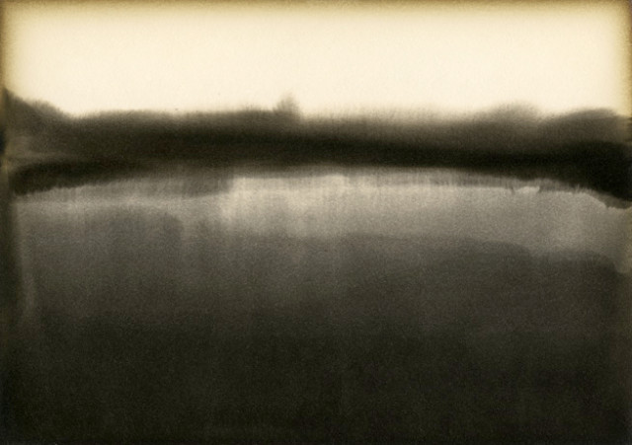
Floris Neusüss
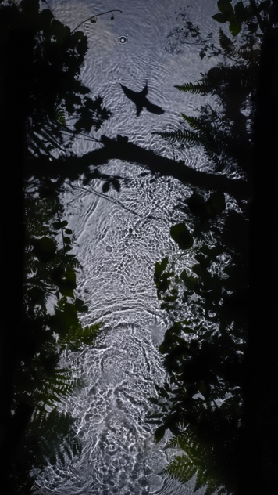

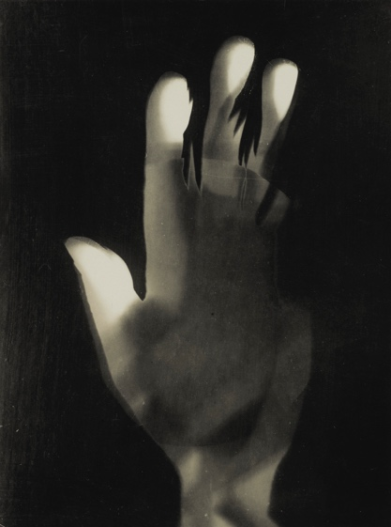

Alison rossiter

László Moholy-Nagy darkroom
Susan Derges
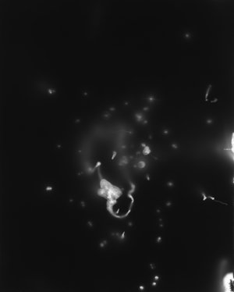
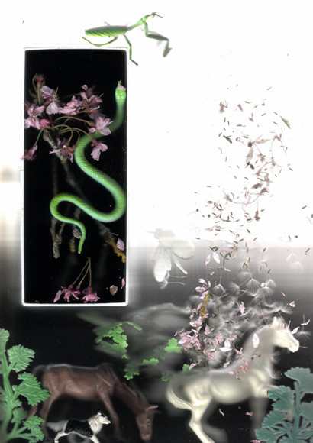

Hiroshi Sugimoto

Jan O'Highway

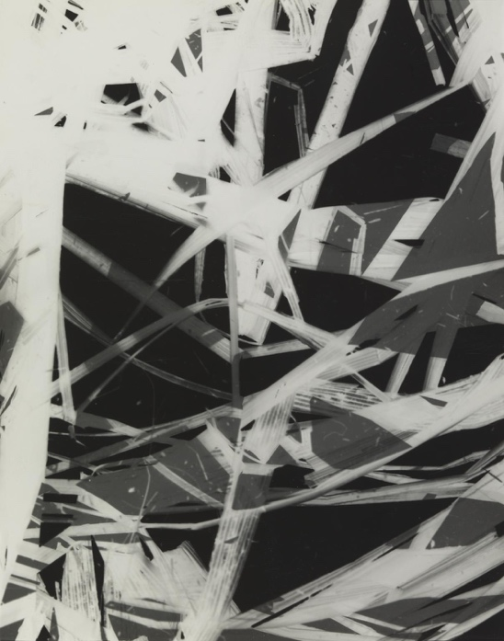
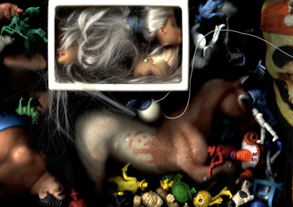

György Kepes

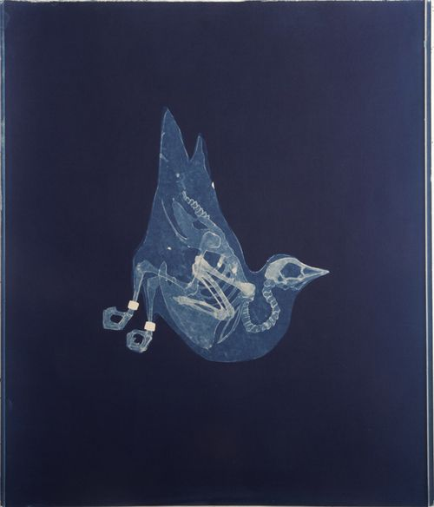

Adam fuss

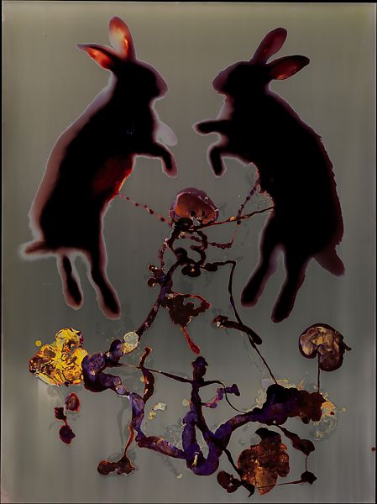
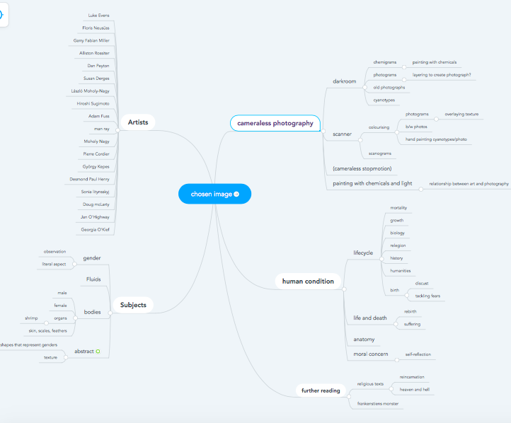
Access my mind map here.
https://www.mindmeister.com/1909634587
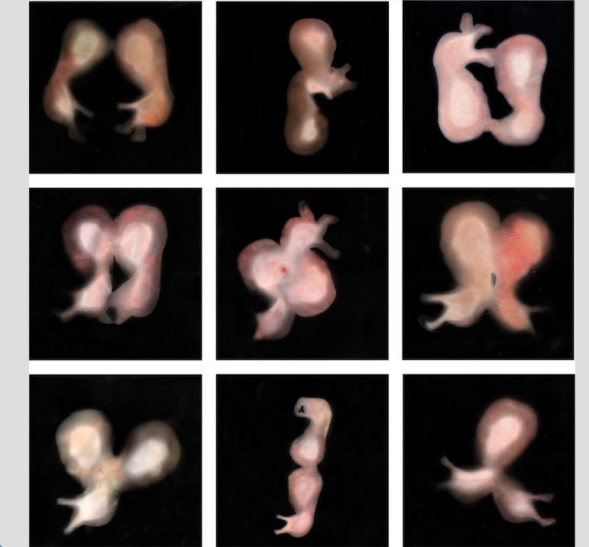

Of Family and Flesh/The Fragility of Flesh

I will be questioning and confronting mortality and how it affects me. My Fears of the human condition and the fragility of flesh.

I have chosen these photos to kickstart my endeavours for this project. These images were created for the ‘Opuculus’ exhibition based on the novel among wolves. It tells the story of a young girl using her newly founded femininity as a weapon. I homed in on the girl’s verge of maturity.

The thing that separates child from adult is the physical ability to reproduce I noticed how uncomfortable or scared I am about growing up in general. The images above fascinate yet deeply disturb me, which is how I want to make the viewer feel, I want to feel understood.

People tend to adore babies and bypass the grotesque nature of a thing growing inside you. I have been forced to think about this as all over my social media my classmates and friends from college are starting families and getting engaged; I feel an urgency to get on with my life, whatever that means.

The photograms have been scanned for the purpose of overlaying skin, I really like this technique and I would like to develop it further. I could do this by incorporating colour and texture into a traditional practice to renovate it, give it a facelift.

In combination of ‘coloured-in’ photograms, I would like to colourise old photographs of deceased family members, breathing life onto the dead, a rebirth.

I like the similarity between the photograms and life itself, it can only be created uniquely. Replicas can be made which look alike but not exactly the same. (Snowflake theory)

Scanning it immortalizes the paper, it turns the actual paper which can be misplaced, burnt or torn into a file on a computer which can be played with.

I find Adam Fuss’ coloured photogram strangely mesmerising, I want to use the same mediums to create a similar aesthetic, I think my images above have somewhat of a relationship.

