
Big data
Retail Sales Report


September 14, 2020
Priyank Patel
University of Wales Trinity Saint David

Task 2:
Write 1500 words report discuss the nature of the data that retail industry will handle. Recommend, whether your choice of selected retail store needs big data analytics. Justify your decision. Include what characteristics you have considered in your decision making and problems and challenges involved.
Retail Sales Report
Overview:
Big data portrays a huge volume of information that's utilized to uncover designs, patterns, and affiliations, particularly relating to human behaviour and communications. Generally, it has been characterized by three key variables: volume of data, speed with which it can be accessed and variety in the type of data. For the retail industry, huge information implies a more noteworthy understanding of customer shopping propensities and how to pull in new clients. Big data analytics in retail enables companies to form client suggestions based on their buy history, resulting in personalized shopping encounters. These huge datasets also offer assistance with estimating patterns and making vital decisions based on advertise examination.
Nature of data in retail industry:
With the emerging cloud technology, the volume and type of retail industry data has grown manifold. Companies can collect additional data such as wealth of the customers, their age group, geographical location, gender, general health of the customer, other shopping stores they associate with, their favourite eat-out places and any data that defines the purchase behaviour of the customer. These data incorporate online browsing, data spread across social media, smart phone usage data, buy information, client fulfilment information and the like. For case, a big retailer collects information on around 1 million transactions per hour, contributing to 2.5 terabytes of information. Furthermore, with the advent of the Web of Things (IoT), more information are ceaselessly extracted from sensors in multiple smart devices such as wrist watches, smart devices such as Alexa and other devices that are connected to the Web. This kind of big data requires enormously parallel program running on thousands of servers regularly in a cloud-based environment. [1]
How does big data help a retail store?
An ever-growing customer base also comes along with a challenge of retaining the customers. Using big data for business analytics will help them to identify profitable products and services, as well as target customers effectively throughout their purchase journeys. The real time data collected based on the pages the customer visits, time spent on viewing different category of products, time of day during which the customer browses the site, the geolocation of the visitor using the IP addresses, and user logins can help in determining the behavioural aspect of the customer. This helps in targeted marketing of a product, issuing promotional offers and recommendation of products. As more information is collected, retail markets can study the recede and surge of shopping and expenditure by consumers using past data to predict future spending and make personalized recommendations. [2]
Case Study: Does the retail store Holland and Barrett need big data analytics?
Holland & Barrett International is one of the world’s foremost fitness and wellness retailers and the largest in Europe, providing its consumers with a wide choice of vitamins, minerals, health complements, high-quality foods and natural beauty products. The have an extensive presence of about 718 stores in the United Kingdom alone and offer a range of over 9000 products catering to their large customer base.
Considering the humungous data availability, big data analytics can help retailers in forecasting a customer’s demand and thereby helping the company take effective and customer-focused decisions.
- • To retain the loyalty of a regular customer: Holland and Barrett hold membership cards by issuing a card on the first purchase of the customer. The loyalty points are updated on each purchase made by the customer. This helps them to promote their exclusive products, membership-only deals and other offers to retain the loyalty of the customer. The company is already segmenting customer based on frequency of purchase and spending capacity by issuing VIP cards and classifying the customer based on the points allocated. [3]
The company can extend the loyalty of its regular and potential customers by recommending health and nutrition related products and making the products readily available for purchase, based on the information on customer’s general health and his historical purchases. This creates better experiences for the customer. A contented customer is the one who is loyal too. [3]
- • Foretelling the demand of products: The retailer can use Weather Forecast to forecast the sales of the product by recommending them to the customers. Holland and Barrett offer Natural Beauty products. Based on the weather forecast, they can recommend face and hair care products to their customers, based on their gender and age group.
- • Optimizing price of products: Depending on the search words, the demand trend of products can be identified. Based on this, the retailer can device an effective pricing strategy, recommend the product to an expecting customer and can have an edge over their competitors.
- • Improving the quality of service: The customer service department logs the calls and complaints from customers. Big data analytics can analyse this data to bring out the problems faced by the customers and the area of improvement in service. Customer reviews and comments can be scrutinized for positive and negative feedback. Based on the sentiment analysis, the quality of service can be improved.
We can conclude that big data analytics will not only boost the company’s retail sales and customer base but will also help them improve customer experience by providing them high quality goods and services. [3]
Characteristics considered in decision making
Most of the features considered in decision making is based on the information available on them
website https://www.hollandandbarrett.com/. The features considered during analysis are:
- Customer information: Segmenting potential and loyal customers and targeted promotion and sales. Helps us to classify
o the customers who responded to new product promotions o who responded to offers and deals
o bought those new products
- Product information: Product price, category and brand the product belongs to, its validity period, promotional offers and deals on the product
- Store related data: Store locator to facilitate the customer to locate the nearest store. Data on the frequency of the customer to a particular store and his geospatial details can be saved. This data can be used forecast demand for certain category of products and pricing of these products can be strategically managed for effective sales.
- Customer service: Feedback on products and service from customers can be used to infer a positive or negative sentiment towards a particular product/store. This can be used to improve service or product availability.
- Supplier data: To monitor supply chain management data
- Customer classification data – VIP Card data helps in classification of customers - loyal, potential, visitors
- Inventory - Knowledge about the customers’ tastes on various categories of products and manage availability of products in the store
- Promotions and their frequencies
- Various media groups used for product promotion: The effectiveness of a promotion can be evaluated based on the variety of media used for it and the cost – effect benefit analysis. An insightful analysis on this data can help us know
o Successful media channels for promotion across different stores
o The segment of customers which responded well to the promotion
o The segment of customers who converted their response to purchase based on the promotion o The costs of promotion vs. sales resulted due to the promotion analysis
Challenges faced:
- Due to the security and privacy of data, sales related data or order related data could not be retrieved.
- Getting this data into a big data platform was another challenge
- The accuracy of the data cannot be assured due to the non-availability of authentic data.

Data Visualization
Objective
The scope of this assignment is to:
- Design and develop a small data ware house using appropriate tools and architecture.
- Identify retail sales in the form of dataset available in flat files (.csv files)
- Using an effective ETL tool extract, transform and load this data into the data warehouse
- Apply data mining techniques to select appropriate data and develop effective visualization from this data.
Based on the visualization and analysis of the reports, the management should be able to see hidden patterns and insights in the sales data. This will help them take further actions and decisions based on the analysis of the sales data. Retail sales data has been made available in the form of flat files. This data is uploaded into data tables in MySql. The data tables are in the 3NF form. A data ware house model using Star Schema is designed a fact table contains all the sales data of the products, their categories, store information and the information of the corresponding customer. This data is loaded using an ETL tool, Tableau. Using Tableau, generate effective data visualization graphs which will be used by the management in making decisions based on the data analysis
Tools used for the assignment
- MySql Server and MySql Work Bench for data warehousing
- Datasets in the form of flat files
- Tableau as ETL and for data visualization and report generation.
TASK 1 :
1. Identify the objective and collect data
The objective is to study the retail sales analysis of the company Holland and Barret.
2. Design an appropriate model
Retail sales data has been made available in the form of flat files. This data is uploaded into data tables in MySql. The datatables are in the 3NF form. A dataware house model using Star Schema is designed a fact table contains all the sales data of the products, their categories, store information and the information of the corresponding customer. This data is is loaded using an ETL tool, Tableau. Using Tableau, generate effective data visualization graphs which will be used by the management in making decisions based on the data analysis
• Dimension
o The dimension is a master table containing information of individual, non-redundant data
fields. They provide filtering, grouping and labeling on the data.
o Dimension tables in our case study : customer, category, store, product
• Measure
o Measure is a column that contains measurable data, usually numeric, that can be grouped and
is generally plotted to a column in a fact table o Sales Amount, Price, Quantity
• Fact
o Data in fact table are atrributes from independent tables, Fact table offers facts and figures
for sales to a customer, salesperson of a product, date of the transaction and store related information. It is a collection of historical transactional tickets of the production system. It is formed using the foreign keys which refer to various master tables and numeric measure values on which group and filter operations can be performed.
o Foreign key columns from other tables: customer ID, product ID, store ID, transaction ID etc. Using Star schema to design the model, considering categorized attributes for analysis and quick
presentation by running queries on the data
Schema of Retail_Sales_Data - Retail Sales Fact Table
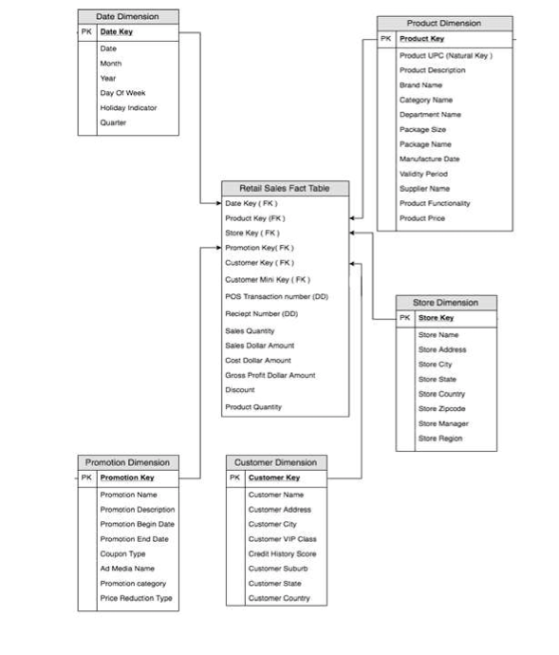
Medication Sales Fact Table
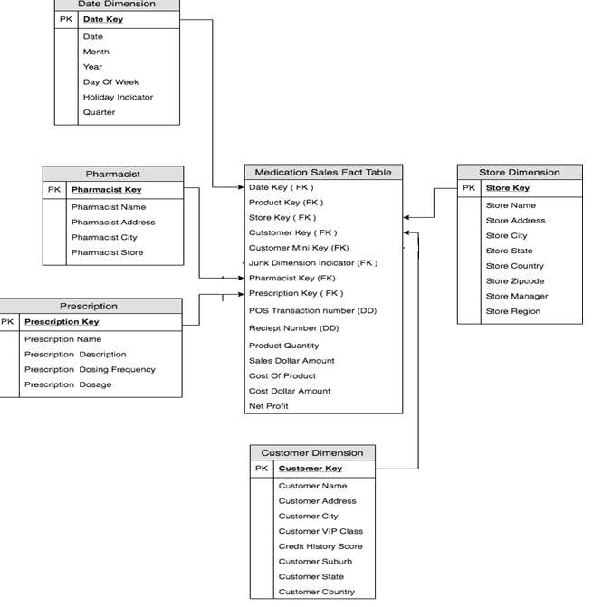
Inventory Management Fact Table
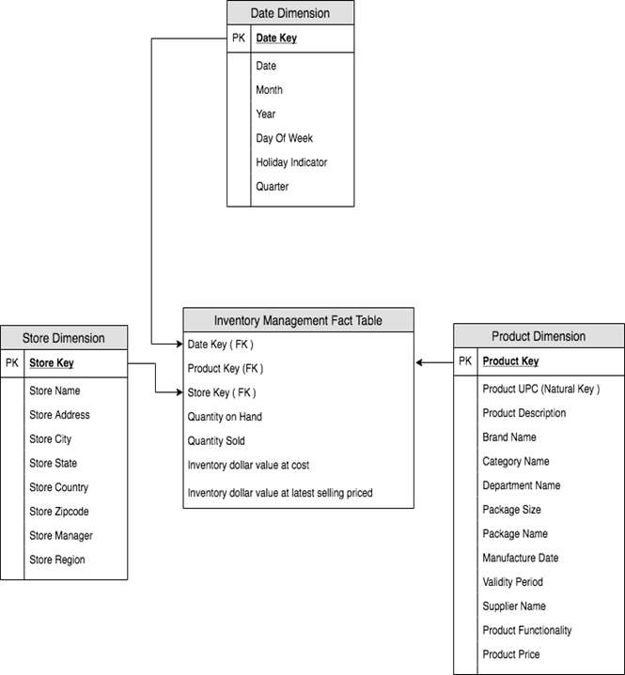
Order Management Fact Table
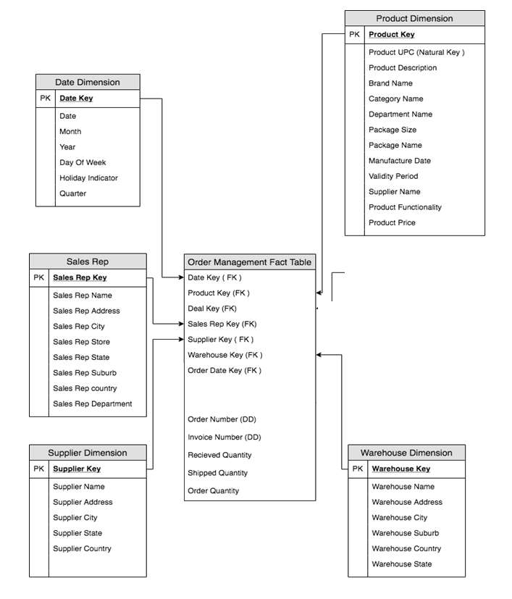
Marketing Analysis Fact Table
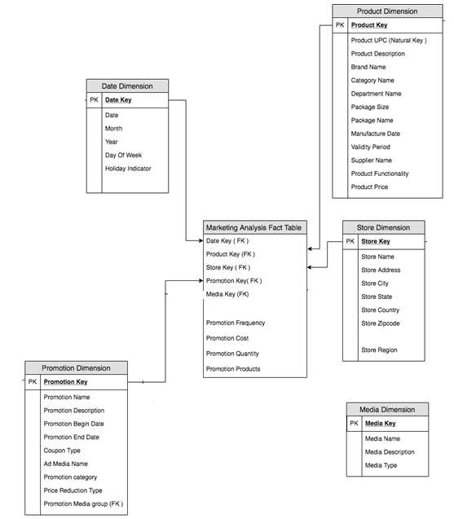
A. Most Popular products based on the orders
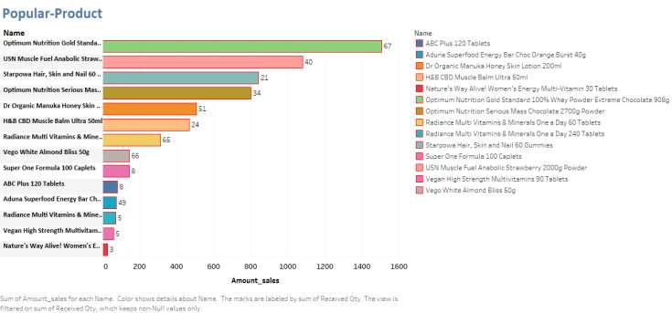
B. Sales details of each store.
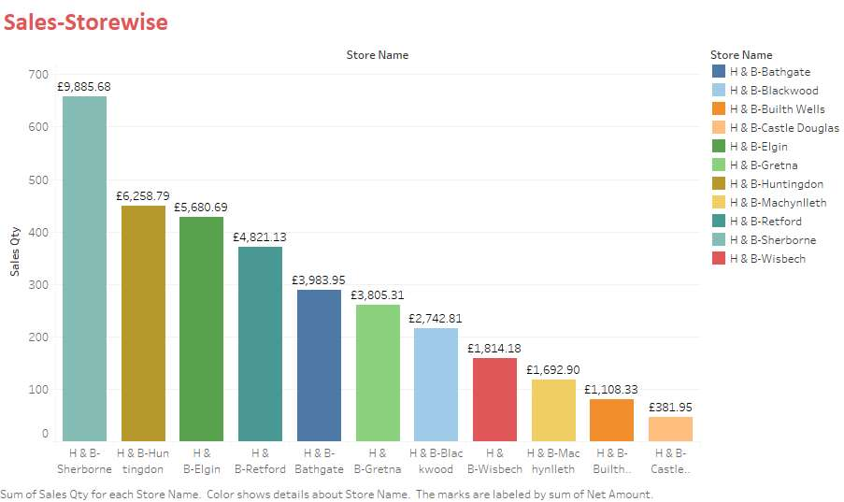
C. Potential Customer
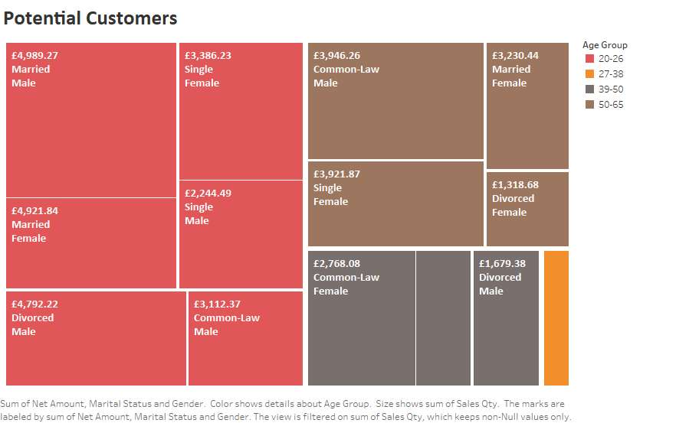
D. Promotional Cost
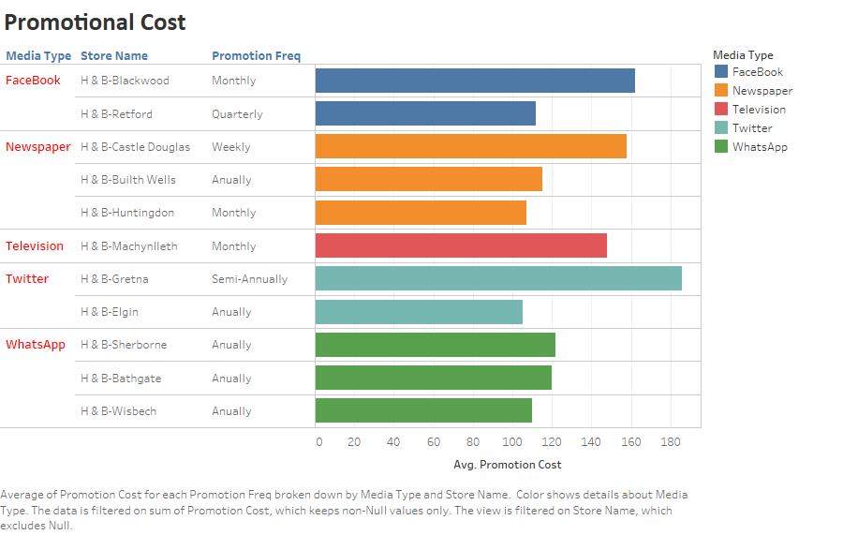
E. Inventory
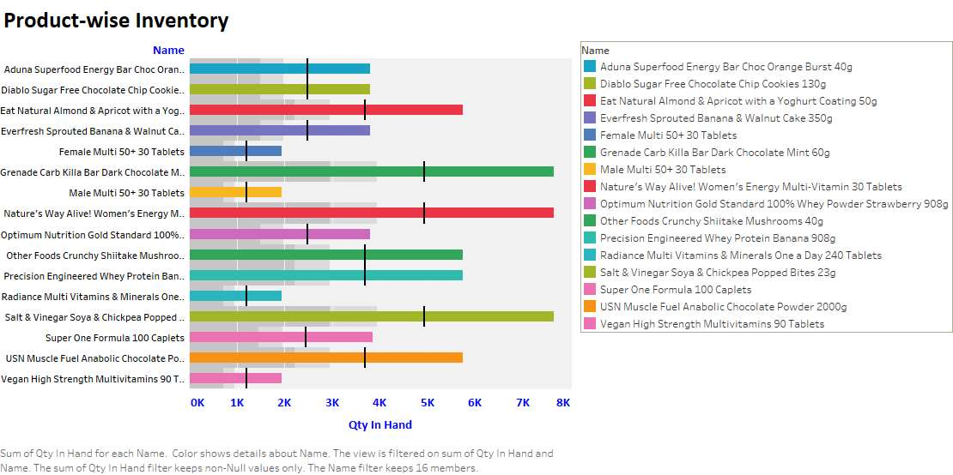

References:
[1] M. Singh, B. Ghutla, R. Lilo Jnr, A. F. S. Mohammed and M. A. Rashid, "Walmart's Sales Data Analysis - A
[2] Big Data Analytics Perspective," 2017 4th Asia-Pacific World Congress on Computer Science and
[3] Engineering (APWC on CSE), Nadi, 2017, pp. 114-119, doi: 10.1109/APWConCSE.2017.00028.
[4] Ramandeep Kaur1 , Dr. Gagandeep Jagdev2, “Big Data in Retail Sector – An Evolution that Turned to a Revolution” 2017 International Journal of Research Studies in Computer Science and Engineering [online] Available: www.arcjournals.org, Volume 4, Issue 4, 2017, PP 43-52, DOI: http://dx.doi.org/10.20431/2349-4859.0404006
[5] G. Park, V. Sugumaran and S. Park, "A Reference Model for Big Data Analytics," 2018 9th IEEE Annual Ubiquitous Computing, Electronics & Mobile Communication Conference (UEMCON), New York City, NY, USA, 2018, pp. 382-391, doi: 10.1109/UEMCON.2018.8796710.

