M5X01923_FLC_A5_Oct 19 - Part 1
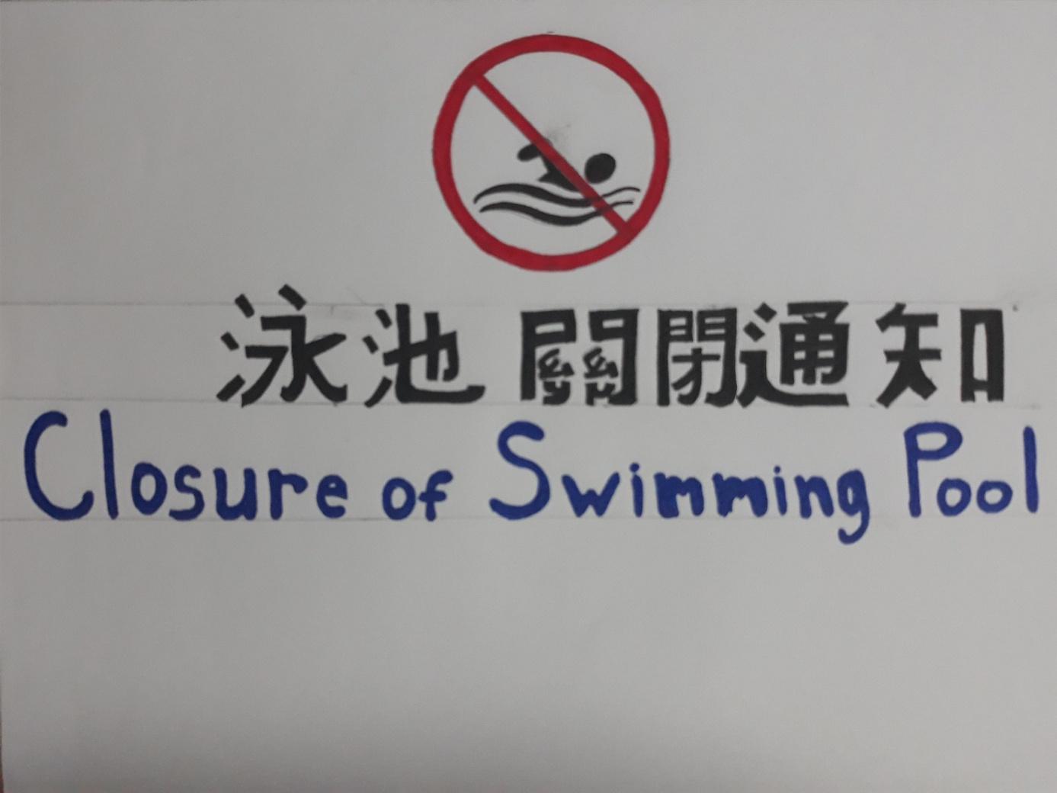
Milena Taneva
Student number: 1815095
Chinese Signboard

