Name: Tusevo Mansende
Student Number: 1604235
Module code: BMSK5006

Knowledge and Information Management
Table of Contents
Introduction: 1
Task 1 2
Explain the relationship between data, information and knowledge 2
Explain the relationship between individual knowledge and organizational knowledge 3
Apply analysis and modeling techniques to Identify knowledge assts 5
Evaluate actual and potential knowledge assets 7
Task 2 9
Explain what is required to create, store, apply and integrate knowledge 9
Consider the importance of intellectual property rights 11
Task 3 12
Explain the contribution knowledge assets have on an organization 12
Evaluate knowledge requirement for the organization 14
Evaluate the Organization framework for enabling knowledge sharing 15
Recommendation to improvement to the current framework 17
Conclusion: 18
References 19

Introduction:
Knowledge and information has a direct and indirect influence on the operation of the firm. Without proper information it will difficult to take the right decision regarding the firm. On the other hand, lack of proper knowledge will create barrier to make the operation effective. The author of this task is going to discuss the relationship between the data, information and knowledge. The relationship between the individual knowledge and organizational knowledge will be express here by the author. Various modeling technique to identify the knowledge asset will be discuss here. The required things for making, store, apply and integrate knowledge asset will be discuss here. The importance of the intellectual property right for any organization will be determined here by the author. The contribution of the knowledge asset on the operation of the organization will be disclosed here. The required knowledge to make the service and operation effective and efficient is going to analyze here by the author. The evaluation of the organizational framework along with the recommendation for making the framework will be determined here.

Task 1

Explain the relationship between data, information and knowledge
Data: Data are the symbols, characteristics and codes which are meaningless unless they are put into information. Variety of data consist information. Example of data could be the different symbols used by a specific organization and when the organization put all the data according to a system, it will turn into information. Data is scattered and unprocessed information. Computer is the data processor device, we input different types of data into the computer and different programs process different types of data and it gives us information which is the meaningful representation of data.
Information: information is the meaningful representation of data. We may have different types of data but if we do not know the actual arrangement of those data, it will be meaningless. When data are arranged in a pattern it turns into information. An example of information may be the age of a boy. 20 years is the age of a boy but if we say 20, it does not mean anything but a number which is not information. So, information is certain, and it needs some data to be information. Today we are live in a world of information and science. Science is based on information and data. Without the previous information and works of the previous scientist, it might not be possible of the current development of science and technology (Eliot, 2016).
Knowledge: Knowledge is the combination of data, information and real-life experiment of information. Knowledge is gathered when an individual work in a situation and based on information and data, he or she make decision and observe the use of those information and data.
Wisdom: wisdom is the ability of taking decision based on previous knowledge, information and data. Wisdom is the combination knowledge, information and data and wisdom are the ability to draw a picture on the basis of those data, information and knowledge.

Relation between data, information, knowledge and wisdom
There is a close relation between data, information, knowledge and wisdom. Data is the raw materials of information and knowledge is acquired using the real-life practice of information and wisdom is the ability to produce right decision on the basis of data and previous knowledge (Barnard, 2013). These four things are closely interrelated, and one is not complete without others. Tesco is a multinational grocery retailer which has a specific information management system by which it gathers information of the market and manage knowledge and use the information to achieve organization goals and objectives.

Explain the relationship between individual knowledge and organizational knowledge
Individual knowledge: Individual knowledge is the knowledge is the knowledge acquired by the individuals. An individual make decision based on the information he or she has. Individual of an organization gather information by different training and real-life experiences and gather knowledge. Tesco is an organization and its employees in different sectors have different knowledge and based on those knowledge he or she work in different perspective and situation. Individual knowledge of a manager may be the ability to deal with the employee under him or her and decision-making capability based on his or her acquired information. Individual knowledge may be used in two ways structured way and unstructured way. In structured way, individual is bound in a system to take decision and deal with different situation.
Organizational knowledge: Organization knowledge is structured knowledge and it is set by the organization. Organizational knowledge is the combination of individual knowledge. Organizational knowledge is created by the real-life experiment of the organization. Organization gathers knowledge from different sources and it takes relevant information and knowledge to us it for achieving its organizational goals and objectives. Organization takes decision about planning and setting goals and implementing the planning based on previous experiences to get desired outcomes. There are different kinds of organizational knowledge such as knowledge about human resource management, knowledge about organizational behavior, knowledge about strategic planning and implementation of those planning and knowledge on decision making ( Lystra’s et al, 2010).
Relation between organizational knowledge and individual knowledge
There is an intimate relation between organizational knowledge and individual knowledge. Individual knowledge consists of individual knowledge. Organization disseminates previous organizational knowledge among its employee and tries to achieve its desired goals and objectives. Organization disseminates information on the job of every employee or members and tries to create an effective knowledge among all the employee so that they can perform well in the job to acquire their specific goals and objectives and target. For example, Tesco is multinational grocery item selling organization and it has many employee, it tries to teach the employee how to provide services to its customer effectively and efficiently and how to achieve personal target to get personal incentives. Every successful organization has their information management system to gather information and based on those information, organization takes decision in different situation as market is quite unpredictable sometimes and without proper knowledge on the market, it might be impossible to take right decisions (Maier, 2017).
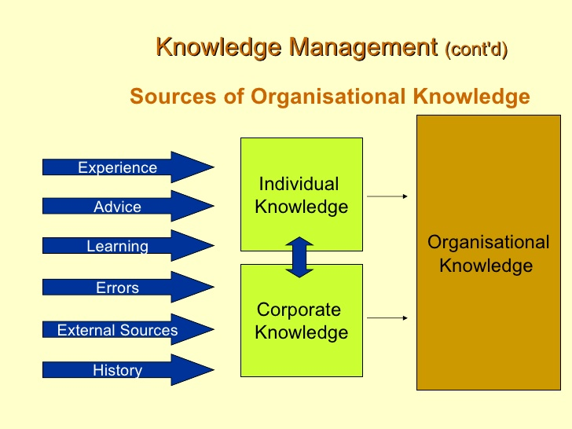
Source: Shelter, 2018

Apply analysis and modeling techniques to Identify knowledge assets
The term knowledge assets refer to accumulated resources of information which produce knowledge. Knowledge which is processed in an organization by different systems which process different information, ideas, understanding, learning, skills and capabilities of an organization. By analyzing SWOT of an organization knowledge could be identified as SWOT gives different information about the organization like the strengths, weakness, opportunities and threats of an organization. By analyzing SWOT variety of information can be gathered which might be useful to transform into valuable knowledge and information.
SWOT analysis: SWOT analysis is a tool by which an organization can finds its strengths, weakness, opportunities and threats. SWOT is a useful tool to gather information on different area of the organization which can be used in future to take organizational decisions.
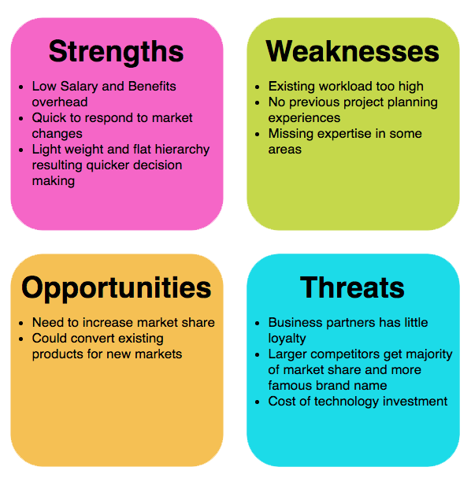
Source: Maiter, 2017
Strengths: Strengths are the strong points of the organization which can be used to reach organizational goals and objectives. If any organization identifies its strong points, it would be valuable information which may be used in different situation of the organization to take effective decisions. Tesco has some strong points like it has a strong network system by which it can connect any sister concern around the world (Shukla and Srinivasan, 2010).
Weakness: In SWOT tool, identify the weakness of the organization is the main aim. If any organization knows its weakness, it will consider the weakness of the organization to take decision. Every organization has some weakness and information on weakness helps the organization to overcome those weaknesses.
Opportunities: Opportunities are the possibilities of the organization. It is the information on the possible outcome of the organization. Information on the opportunities of the organization is necessary to find new path for the development of the organization. If any organization its opportunity which may give a big boost to the organization, it would be its turning point and the organization is unaware about the opportunities, it would be a great loss for the organization.
Threats: Threat is the information about the hindrance ahead of the organization. When organization goes in search of the threat of the organization, it helps the organization to take decision considering the possible threats of the organization. So, in knowledge management in an organization threats identification is important (Adhikari, 2010).
PESTEL Analysis
PESTEL analysis means analyzing the political, economic, socio-cultural, Environmental and legal analysis of the organization. PESTEL analysis helps the organization to create a useful knowledge getting information about the political, economic, social, technological, environmental and legal information. To achieve organizational goals and objectives, this information is essential.

Source:Lytras, 2010

Evaluate actual and potential knowledge assets
Actual and potential knowledge assets of an organization are the knowledge which is effective for the organization to achieve organizational goals and objectives. Actual and potential knowledge may be unstructured, explicit and tacit knowledge assets. An organization may have different potential knowledge assets for example experienced worker who has special knowledge to accomplish his work, unique ideas and ideologies of the organization which gives the organization competitive advantages, specific system developed by the organization. These all are the example of the potential and actual knowledge assets. Different potential knowledge assets which give the organization special benefits to boost growth of the organization should be conserved secretly and it should be recognized properly. Potential knowledge assets of an organization and individual help the organization to reach broader goal of the organization and if these potential knowledge is not used properly, it would be the weakness of the organization in identifying and using the knowledge. Potential and actual knowledge of the organization is not created in a day rather it takes time to gather those knowledge and information by different real experiment and research (Shelter, 2018).

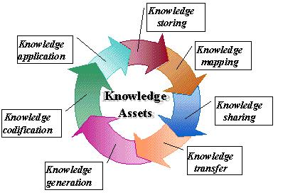
Source: Maier, 2017
There are some criteria to evaluate the actual and potential knowledge assets of an organization which are given below.
Criteria | Potential value to the organization
Knowledge on the organization and its aim | Knowledge on the organization and its aim is one of the potential and actual knowledge which is helpful to achieve organizational objectives
Knowledge on products and services | Knowledge on product and services is one of the actual and potential knowledge which helps the organization and individual employee to take effective decisions
Knowledge on environment | Knowledge on business environment is essential and it helps to react within the environment
Analytical knowledge | Analytical knowledge is also important to analysis different situation within an organization
Promotional knowledge | Knowledge on the promotion of the product and services is required to get desired result
Knowledge on technology | Knowledge on technology is must in this era and it may be quite useful to handle complex problems

Task 2

Explain what is required to create, store, apply and integrate knowledge
Creating, storing, applying and integrate knowledge requires a system. By a specific system data and information are gathered and processed and turned into information. Knowledge creation is a system process by which knowledge is created and created knowledge is stored in another specific system and disseminates and integrates.

Source: Abdul-Hamid, 2011
Capture or create knowledge: Capturing or creating knowledge requires a explicit system for example in current times organization create knowledge by storing and analyzing information by a computerized software. For example, Tesco analyses the data of selling in different seasons and it developed knowledge on which product much sold at which season. So, knowledge gathering, or creation is a systematic process by which data and information are transformed into knowledge.
Storing knowledge: Storing knowledge also requires a specific system. Today computerized data storing system is used in every organization. Computer can store huge information and knowledge at a time. As knowledge is the combination of data and information, knowledge is stored in a system from which essential knowledge can be taken. Tesco store its knowledge in software which can store millions of data and information and can analyze that information. The aim of storing knowledge is using the knowledge further and it should be stored such a way that it can be found easily (Singh, & Kant, 2008).
Applying knowledge: the purpose of creating and storing the knowledge is applying the knowledge further. Knowledge is created by different experiment and research and after long term experiment and research; the knowledge which is created can be used again and again. Different organization applies different knowledge to get business and strategic advantages. For example, Tesco have a secret knowledge to supply their products and services across the world. Apple incorporation has a specific strategy to design their device. So, appropriate application of knowledge requires a certain system by which knowledge and information can be used.
Integrate knowledge: The main objectives of integrating knowledge are to use different knowledge to achieve a specific goal of the organization or individual level. Knowledge gathered from different sources requires a specific system to integrate that knowledge. First, effective decision-making should be made on using the knowledge from different sources (Abdul-Hamid, et al, 2011)

Consider the importance of intellectual property rights
Intellectual works of the individual and organization is considered to an asset or property which is sold around the world for example Windows operating system of Microsoft is an intellectual property and if anyone use it without the permission of the organization, it would be illegal. There are various kinds of intellectual properties in different field. In the field of science and technology invention of different ideas, technologies and theories are the intellectual property. There is an act of intellectual property right which recognizes different intellectual work as a property across the world. The purpose of intellectual property right is to conserve the right of the individual who is the father of that invention. Importance of property right is pervasive, people around the world invent many distinct things but some of them don not get the benefit of his invention (Eliot, 2016). So, to give the recognition of the invention, it is necessary to implement property right act. Some of the invention and idea required huge money and long term research and when an organization and individual does a long term research an invest money to invent something or some ideas, it should be given the property right and it should be allowed to sell its invention and that’s why intellectual property rights is essential to help the inventor or intellects who invent new ideas, ideologies and technologies. Property rights inspire organization and individual to discover new ideas and systems which are useful to get desired objectives in specific fields. So, property rights acts should be implemented and followed by every country to ensure justice to the intellectual property owners (Maier, 2017).

Source: Raj Adhikari, 2010

Task 3

Explain the contribution knowledge assets have on an organization
Knowledge asset of an organization will help to be exceptional and better than any other organization. The organization which has proper knowledge assets they are doing well in the operation of the firm (Bentley, 2018). On the other hand, they can provide their best thorough ensuring proper use of that knowledge in their product or the service. There are some knowledge assets which contribute on the operation of the Tesco. Those are given below
Conceptual knowledge assets: Tesco plc has a strong conceptual knowledge asset. That assets contains product concept, design of the product and equity of the brand. The quality of the product along with the price of that product will be determined by that factor. The shape and size of the product will be set by considering and analyzing that knowledge asset. The selection of the product which will able to attain the satisfaction of the customer will be determined by that asset of the Tesco plc. Here they will also consider the language and other factor of the product which will able to express the content of the product very easily (Curley and Kivowitz, 2011).
Social knowledge assets: The societies of the product where any product will be selling need to consider rigorously. Tesco plc has a strong social value and reputation for their quality product and service. They try to ensure necessary product for the customer which that society needed. They show their responsibility to the society through ensuring some facility like love and affection. On the other hand, they conduct some social work which will ensure the best use of their social asset. They gather trust from the society by ensuring the demanded product or service to the customer. On the other hand, they provide necessary benefit and training to the people to make sure their social asset knowledge properly and perfectly.

Figure: Knowledge Asset
Source: Frappaolo, 2012
Systematic knowledge assets: Tesco plc has many branches over the UK along with the other country. They provide necessary information about their business and product to the customer. According to the “Knowledge management (2014)” This will help the customer to know their activity properly and perfectly. They are managing documentation and data base for their regular and financial year activity. That systematic collection of data and information of the Tesco plc will have to place them to the concern stakeholder very easily and properly. The patent and license of the product which they sell in the market will help to ensure the legal procurement of the systematic knowledge asset of the Tesco plc.
Routine knowledge assets: Tesco plc conduct some work regularly where they follow a specific way for the fulfilling of those work that is known by the culture of the firm. That will help to determine the operational style of the firm very easily (Lytras et al, 2010). That routine bound work of the Tesco plc ensures the routine knowledge asset. It includes promotion, marketing and use of the technology for the production and service providing to the concern customer. The daily operation of the Tesco plc will express very easily by that asset of that firm. That will contribute to the developing of the operation and service of the Tesco plc.

Evaluate knowledge requirement for the organization
Knowledge of the operation of the firm is very important for making it effective. That knowledge which id related to the operation has a direct and indirect influence of the operation and production of the Tesco plc. Some required knowledge which will help to ensure the success of the firm are given below
Communication: Communication is one of the important requirements for the organization like Tesco plc. Without proper communication with each wing of the Tesco plc along with the customer, the firms will not able reach its goal easily (Maier, 2017). By the proper communication, the concern authority of the Tesco plc will be able to know the demand and need of the customer very easily along with the employee of the firm. That helps to ensure the satisfaction of the customer and employee very easily. The misunderstanding and other problem among the stakeholder will be address very easily.
Retention: The retention of the customer is very important for any kinds of firm (Saad, et al, 2014). When any organization did not able to retention their customer, they will not able to sustain their business properly and perfectly. And in the long run, they will not survive in the market, Tesco plc must have that knowledge so that they will able to retention their customer very easily. By ensuring proper incentive and discount, the Tesco plc will able to do that and they must have that knowledge of conducting that work.
Motivation and management: Motivation is the process to fulfilling the need and demand of the employee so that they will able to give their bets to the firm. Tesco plc has a huge number of employees who are working on the service providing and collecting the product. When they did not ensure their duty properly, the firm will not able to reach their goal very easily. By providing financial and other benefit, the concern authority of the Tesco plc will able to do that easily. Proper management of the operation is also a mandatory requirement for the Tesco plc in order make the service and sale more effective and efficient.

Structural and transformational: Better structure and style of the operation is one of the important factors for any kinds of business operation. The strategy is the key factor for the making better structure (Burgess, 2012). The leader of the Tesco plc is needed to transfer the style of problem and solving and operation. That will help the employee to be experienced and skilled in their work. That will reduce the chance of improper use of the human resource in the Tesco plc.

Evaluate the Organization framework for enabling knowledge sharing
Tesco plc a specific framework which used for operating the business. There are some committee of the Tesco plc which are used for the serving the customer and ensure a better work force of the Tesco plc. That framework of the Tesco plc are given below

Source: Stamper, 2013
Tesco plc has an audit committee for conducting audit and examining the operation of the firm properly and perfectly. That committee investigates and observes the work of the operation. They determine the problem and loophole so that the service becomes effective. The potential solution of that problem will be express by that committee. That committee of the Tesco plc also provides a clear picture of the firm which indicates the situation and position of the firm easily. They have a corporate social responsibility committee which is entitles for the conducting social welfare for the society, due to providing that facility, the concern authority of the Tesco plc need to research on the society which will help them to determine what they actually have to do. They provide various social services like training, education, stipend etc. That responsibility of the society will help to make a better society (Tolksdorf and Abramowicz, 2010). There is a nomination committee of the Tesco plc. That committee recruits the employee for the firm. They are responsible for the selection of the better employee, training and promoting to the employee. They access the performance of the employee and determine the employee who did not do well in the operation. That committee nominates the employee who needs to promote as they are conducting better in their workplace.
The remuneration and compensation of the employee will be provided with the scale based. That nomination committee set the salary and other incentive for the employee to satisfy them. When any employee faces any kinds of financial problem, the concern authority of that committee will set the compensation for those employees. The accident happed in the firm and employee is wounded or any other occurrence, they will be compensated by that committee. The disclosure committee are responsible for the expressing the financial statement along with the other document which are needed for the customer and stakeholder (Tozer, 2009). After a definite period, that committee provides that report as they entitle for that duty and responsibility. The shareholder of the Tesco plc will get proper divided through that statement of the disclosure committee.

Recommendation to improvement to the current framework
That current framework of the Tesco plc is better to operate the service and ensure product for the customer very easily. That framework of the Tesco plc ensures all kinds of the benefit for both the customer and employee. But that framework is not adequate for being a better firm in the business world as they have a potentiality for being the best. Some recommendation to improve the current framework of the Tesco plc are given below
- Sub-committee need to set and create to make the operation of the Tesco plc proper and perfect as that is a large firm of the UK
- The number of the committee of the Tesco plc need to increase to make the service effective
- Information regarding the operation of the Tesco plc needs to share through the various systems
- The audit work needs to conduct monthly to address the potential problem very easily.
- Legal and advisory committee need to reduce the work of illegal things in the operation of the Tesco plc
- Health and safety team need to create for making a better environment for both the customer and employee

Conclusion:
The author of this task finds out various factor of the knowledge and information management. The author finds pout data, information and knowledge. The relationship between the individual and organizational knowledge is determine by the author in this task. The author evaluates the actual and potential knowledge regarding the better information and knowledge management disclose by the author here. The author identified the required things which will store and apply the knowledge properly and perfectly. The contribution of the knowledge asset has on the organization are disclose by the author. Various required things for making a better knowledge management for the operation of the organization showed by the author here. A recommendation for making the framework better are determine by the author in this task.

References
- Bentley, T. (2018). Stage four information management. [London]: CIMA.
- Curley, K. and Kivowitz, B. (2011). The manager's pocket guide to knowledge management. Amherst, Mass.: HRD Press.
- Frappaolo, C. (2012). Knowledge Management. Chichester: Capstone Pub.
- Knowledge management. (2014). Bradford, England: Emerald Group Pub.
- Lytras, M., Lytras, M., Ordonez De Pablos, P., Ziderman, A., Roulstone, A., Maurer, H. and Imber, J. (2010). Knowledge Management, Information Systems, E-Learning, and Sustainability Research. Berlin, Heidelberg: Springer Berlin Heidelberg.
- Maier, R. (2017). Knowledge management systems. Berlin: Springer.
- Saad, I., Rosenthal-Sabroux, C. and Gargouri, F. (2014). Information systems for knowledge management. Hoboken, NJ: John Wiley and Sons.
- Burgess, S. (2012). Managing information technology in small business. Hershey, PA: Idea Group Pub.
- Stamper, R. (2013). Information in business and administrative systems. New York: Wiley.
- Tolksdorf, R. and Abramowicz, W. (2010). Business information systems. Berlin: Springer.
- Tozer, G. (2009). Metadata management for information conrol and business success. Boston: Artech House.
- Abdul-Hamid, H., Mintz, S. and Saraogi, N. (2011). Lessons learned from World Bank education management information system operations.
- Barnard, G. (2013). Knowledge Sharing in Development Agencies: knowledge fortress or knowledge pool? Information Development, 19(4), pp.280-288.
- Bukowitz, W. and Williams, R. (2010). The knowledge management fieldbook. [London]: Financial Times Prentice Hall.
- Eliot, G. (2016). The mill on the Floss. New York: Open Road Integrated Media.
- Encyclopedia of Knowledge Management, (2 Volumes). (2010). Information Science Reference.
- Knowledge management. (2012). Bradford, England: Emerald Group Pub.
- Lytras, M., Lytras, M., Ordonez De Pablos, P., Ziderman, A., Roulstone, A., Maurer, H. and Imber, J. (2010). Knowledge Management, Information Systems, E-Learning, and Sustainability Research. Berlin, Heidelberg: Springer Berlin Heidelberg.
- Maier, R. (2017). Knowledge management systems. Berlin: Springer.
- Raj Adhikari, D. (2010). Knowledge management in academic institutions. International Journal of Educational Management, 24(2), 94-104.
- Shelter England. (2018). What we do. [online] Available at: https://england.shelter.org.uk/what_we_do [Accessed 05 January 2019].
- Shukla, A. and Srinivasan, R. (2010). Designing knowledge management architecture. New Delhi: Response Books.
- Singh, M. D., & Kant, R. (2008). Knowledge management barriers: An interpretive structural modeling approach. International Journal of Management Science and Engineering Management, 3(2), 141-150.

