PROGRAMME: MASTER OF BUSINESS ADMINISTRATION
MODULE: FINANCIAL MANAGEMENT
MODULE CODE: LCMB7002
ASSIGNMENT TITLE: FINANCIAL PERFORMANCE AND MANAGEMENT
CHOSEN COMPANY: NEXT PLC
Student Name: Rumen Ivanov Kovachev
Student ID: 2119897
Words: 5000

Table of Contents
Task 1: Informal Business Report 3
1. Company Overview 3
2. Trend Analysis 3
3. Financial Ratio Analysis 4
4. Working Capital Management 13
5. Overall Financial Performance Summary 16
Task 2: Academic Essay on Investment Appraisal Methods 17
1. Introduction 17
2. Main Body 17
3. Conclusions 21
References 22

List of Figures
Figure 1: 5-year trends 5
Figure 2: Profitability Ratios 8
Figure 3: Liquidity Ratios 9
Figure 4: Gearing Ratios 10
Figure 5: Efficiency Ratios 12
Figure 6: Investment Ratios 12
Figure 7: Working Capital 14

List of Tables
Table 1: Ratio Calculation for Next plc 8

Task 1: Informal Business Report

1. Company Overview
Introduction to chosen company:
Next Plc is a FTSE 100 listed company operating in the retail sector of the UK. The company is a multinational clothing, footwear as well as home products retailer of Britain (Next Plc, 2025). Key people involved in the business are David Jones as the Chairperson and the CEO. The company has been selected in this study because of its strong position within the market and strong disclosure of financial statements. The main source of information involves annual reports of the company for 2021 - 2025 that has been used in computing financial ratios.
Company Overview:
The company was founded in 1864 which was 161 years ago by Joseph Hepworth (Next Plc, 2023). The headquarters of the business is located at ‘Enderby, England, UK.’ There are 700 stores of the business serving across the UK, Europe, Asia, and Middle East. Main brands that Next Plc has are “Lipsy, Victoria's Secret UK, Gap UK, Joules, Cath Kidston, Fat Face, Made.com and Seraphine.” Nearly, 48,417 employees are working in the company. Core business activities of the business are selling clothes on a retail basis. Main subsidiaries of the company are JoJo Maman Bébé and Reiss and current market position. Revenue earned by the business was 6118.1 million pounds in 2025 and 5491 million pounds in 2024 (Next Plc, 2024). In addition, Net Profit was 743.2 million pounds for 2025 and 800.5 million pounds for 2024. Current share price is 14200 GBP. Next plc has achieved the position of the leading high street retailer of Britain, along with a strong presence across the UK (Statista, 2025). Till November 2025, the company created a market capitalization of 1.941 trillion making it the 1030th most valuable firm of the world (Companies Market Cap, 2025).

2. Trend Analysis
Graphical illustration of five-year trends:
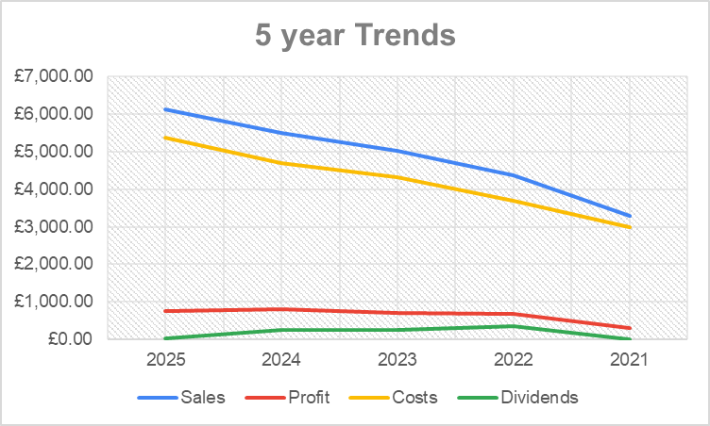

Figure 1: 5-year trends
(Source: Excel)
Summary:
Figure 1 shows the changes in Sales, Profits, Costs, and Dividends of Next Plc over the last 5 years. Sales and profits of the company are increasing as shown above which is an indication of improved performance and position. Costs can be seen increasing which is made up of production costs and other operating expenses. Dividends can be seen in a decreasing trend which means the company is willing to reinvest the profit within the business instead of distributing the same among the stakeholders.

3. Financial Ratio Analysis
Calculation of main financial ratios for 5 years:
Key Financial Ratios of Next Plc
Profitability Ratios (£ m)
Ratio Name and Formula | 2025 | 2024 | 2023 | 2022 | 2021
Net Profit | £ 743.20 | £ 800.50 | £ 710.70 | £ 677.50 | £ 286.70
Revenue | £ 6118.10 | £ 5491.00 | £ 5034.00 | £ 4376.50 | £ 3284.10
Gross Profit | £ 2642.20 | £ 2420.50 | £ 2175.30 | £ 1972.00 | £ 1247.90
Net Profit Margin (Net Profit/Revenue*100) | 12.15% | 14.58% | 14.12% | 15.48% | 8.73%
Gross Profit Margin (Gross Profit/Revenue*100) | 43.19% | 44.08% | 43.21% | 45.06% | 38.00%
Efficiency Ratios (£ m)
Ratio Name and Formula | 2025 | 2024 | 2023 | 2022 | 2021
COGS | £ 3456.50 | £ 3034.50 | £ 2827.70 | £ 2625.30 | £ 2231.70
Inventory | £ 865.20 | £ 769.00 | £ 662.20 | £ 633.00 | £ 536.90
Revenue | £ 6118.10 | £ 5491.00 | £ 5034.00 | £ 4376.50 | £ 3284.10
Total Assets | £ 4872.50 | £ 4724.30 | £ 3983.80 | £ 3981.80 | £ 3758.00
Inventory Turnover Ratio (COGS/Inventory) | 4.00 | 3.95 | 4.27 | 4.15 | 4.16
Asset Turnover Ratio (Revenue/Total Assets) | 1.26 | 1.16 | 1.26 | 1.10 | 0.87
Liquidity Ratios (£ m)
Ratio Name and Formula | 2025 | 2024 | 2023 | 2022 | 2021
Current Assets | £ 2649.90 | £ 2447.70 | £ 2234.50 | £ 2407.20 | £ 2288.60
Inventories | £ 865.20 | £ 769.00 | £ 662.20 | £ 633.00 | £ 536.90
Current Liabilities | £ 1566.40 | £ 1245.70 | £ 1093.30 | £ 1208.10 | £ 1196.80
Current Ratio (Current Assets/Current Liabilities) | 1.69 | 1.96 | 2.04 | 1.99 | 1.91
Quick Ratio (Current Assets - Inventories) / Current Liabilities | 1.14 | 1.35 | 1.44 | 1.47 | 1.46
Gearing Ratio (£ m)
Ratio Name and Formula | 2025 | 2024 | 2023 | 2022 | 2021
EBIT | £ 1075.40 | £ 987.90 | £ 941.50 | £ 905.40 | £ 444.50
Interest Expenses | £ 96.60 | £ 87.50 | £ 77.90 | £ 86.50 | £ 102.70
Total Debt | £ 3118.20 | £ 3085.50 | £ 2818.70 | £ 2971.80 | £ 3097.10
Total Equity | £ 1754.30 | £ 1638.80 | £ 1165.10 | £ 1010.00 | £ 660.90
Interest Coverage Ratio (EBIT/Interest Expenses) | 11.13 | 11.29 | 12.09 | 10.47 | 4.33
Debt-to-Equity Ratio (Total Debt/Total Equity) | 1.78 | 1.88 | 2.42 | 2.94 | 4.69
Investment Ratios (£ m)
Ratio Name and Formula | 2025 | 2024 | 2023 | 2022 | 2021
Dividend Paid | £ 257.80 | £ 248.30 | £ 237.40 | £ 344.50 | £ 0.00
Net Income | £ 743.20 | £ 800.50 | £ 710.70 | £ 677.50 | £ 286.70
Total Assets | £ 4872.50 | £ 4724.30 | £ 3983.80 | £ 3981.80 | £ 3758.00
Dividend Payout Ratio (Dividend Paid/Net Income) | 0.35 | 0.31 | 0.33 | 0.51 | 0.00
Return on Assets (Net Income/Total Assets) | 0.15 | 0.17 | 0.18 | 0.17 | 0.08
EPS | 615.1p | 661.6p | 573.4p | 530.8p | 223.3p

Table 1: Ratio Calculation for Next plc
(Source: Excel)
Analysis of ratios:
Profitability Ratios:
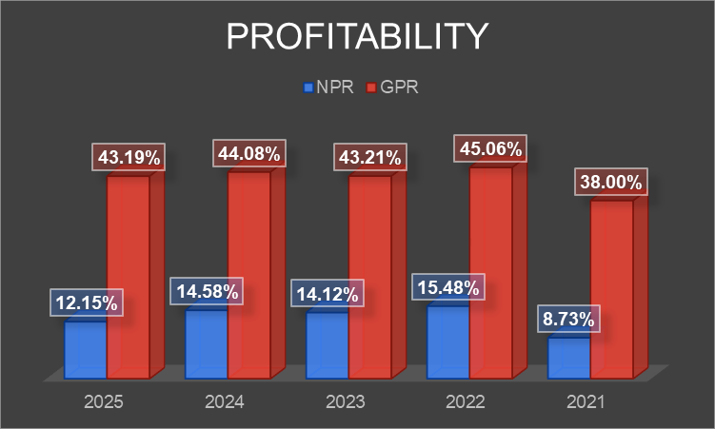

Figure 2: Profitability Ratios
(Source: Excel)
Net Profit Margin of Next Plc was 12.15% in 2025, 14.58% in 2024, 14.12% in 2023, 15.48% in 2022 and 8.73% in 2021. The ratio reports a decreasing trend over the chosen time. The decrease in ratio has taken place because the increase in revenue is greater than the increase in net profit (Next Plc, 2021). The decreasing ratio is an indication of poor profitability of the business indicating that Next PLC is unable to control its business costs. In other words, the company is not generating sufficient profits as shown from the ratio. Eventually, the company is unable to pay dividends to the shareholders with such a decreasing ratio. Gross Profit Margin of Next Plc was 43.19% in 2025, 44.08% in 2024, 43.21% in 2023, 45.06% in 2022 and 38% in 2021. The ratio shows a decrease but is quite high indicating that the company is implementing sufficient control over its production costs. Next PLC has enough profit to pay other expenses of the business which is good. An increase in sales is visible which indicates that the company can successfully attract customers with the quality of products it is offering. However, NPR of the business is significantly low indicating a need for improvement as it makes sustainability of the business overall difficult.
Liquidity Ratios:
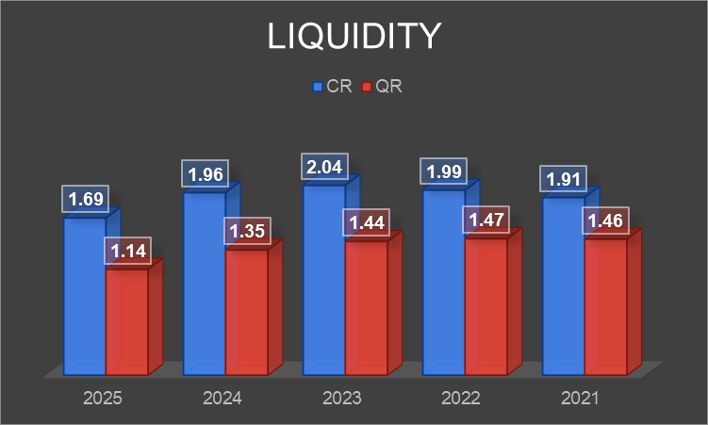

Figure 3: Liquidity Ratios
(Source: Excel)
Liquidity ratio like Current Ratio has been used for measuring ability of current assets of the company to meet debts to be paid (Widiasmara et al. 2022). Current Ratio of Next Plc was 1.69 in 2025, 1.96 in 2024, 2.04 in 2023, 1.99 in 2022 and 1.91 in 2021. The ratio shows a decrease during the last 5 years, but the value is quite high (Next Plc, 2021). The ratio can be seen decreasing because the increase in assets is less compared to the increase in liabilities. However, Next Plc is operating with a positive working capital as the value of current ratio in all 5 years for greater than 1. Because of this positive working capital, the company can make expenses easily and pay the investors. Quick Ratio of Next Plc was 1.14 in 2025, 1.35 in 2024, 1.44 in 2023, 1.47 in 2022 and 1.46 in 2021. If inventories are deducted from current assets, then enough current assets are there which can be used by Next PLC in paying of dues and obligations. In other words, the quick ratio of the business is also quite high leading to a strong liquidity position. This ensures that the business would sustain eventually and will be able to pay its obligations without any issue. It is good that the organisation is investing its resources effectively to earn returns. Neither the company has a shortage of liquid assets, nor it is keeping resources idle.
Gearing Ratios:
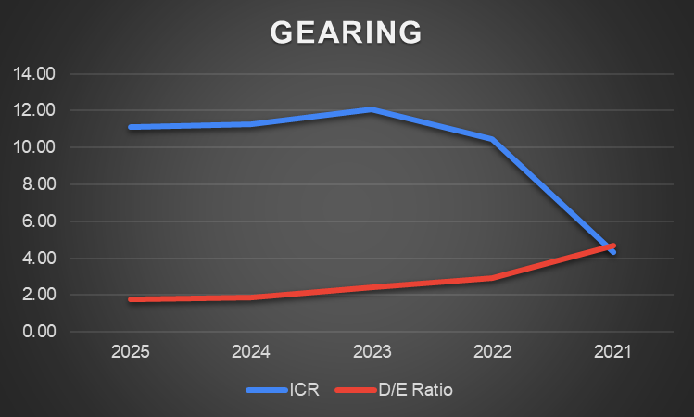

Figure 4: Gearing Ratios
(Source: Excel)
Interest Coverage Ratio of Next Plc was 11.13 in 2025, 11.29 in 2024, 12.09 in 2023, 10.47 in 2022 and 4.33 in 2021. A decrease in the ratio can be seen over the period of 5 years which is not good. The decrease in the ratio shows that the company is paying interest expenses to the investors a smaller number of times throughout the year. In other words, the company possesses less operating profit to pay interest over debt. Based on the views of Shabrina and Hadian (2021), DER is the ratio used for quantifying how big of debt to equity. Debt-to-Equity Ratio of Next Plc was 1.78 in 2025, 1.88 in 2024, 2.42 in 2023, 2.94 in 2022 and 4.69 in 2021. The ratio is decreasing but it is significantly high indicating poor gearing performance of Next PLC. The ratio being greater than 1 indicates that a larger portion of the assets of the business are being financed through debt capital which makes it highly leveraged. Because of the leverage, the company is enjoying a tax shield, but it is also increasing risk. If interest rate increases in future, then the company will have to bear the burden of the same which is not desirable. However, the company is repaying its debt capital and collecting more equity which leads to an improvement in the capital structure. In other words, the company did not create an optimum capital structure which is leading to poor gearing performance. Further improvement in capital structure is required so that the company can reduce the risk to which it is subject.
Efficiency Ratios:
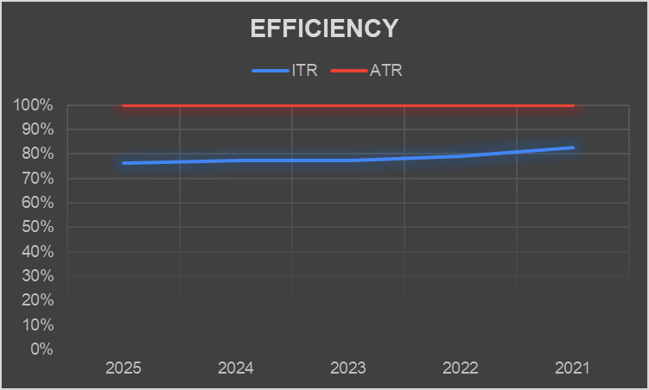

Figure 5: Efficiency Ratios
(Source: Excel)
Inventory Turnover Ratio of Next Plc was 4 in 2025, 3.95 in 2024, 4.27 in 2023, 4.15 in 2022 and 4.16 in 2021. Influenced by the views of Patki (2021), inventory turnover gives an indication of the number of times the inventory has been replaced in a time of one year. In case of Next PLC, the ratio is quite low which indicates that the company is unable to convert its inventories into finished products and sales. This indicates poor usage of resources within the business which is not desirable. This also indicates that the company is not making sufficient sales during the year. Inventories are not being used by the business sufficiently. Asset Turnover Ratio of Next Plc was 1.26 in 2025, 1.16 in 2024, 1.26 in 2023, 1.10 in 2022 and 0.87 in 2021. In the same way, asset turnover of the business is quite low indicating poor usage of resources in making sales. Despite the increasing balance of assets, the company is unable to make enough sales which is not desirable for its long-term sustainability. Poor usage of resources can be estimated from such a low ratio indicating overall bad efficiency. There is a need to achieve improvement in sales so that the company can earn greater returns in the future.
Investment Ratios:
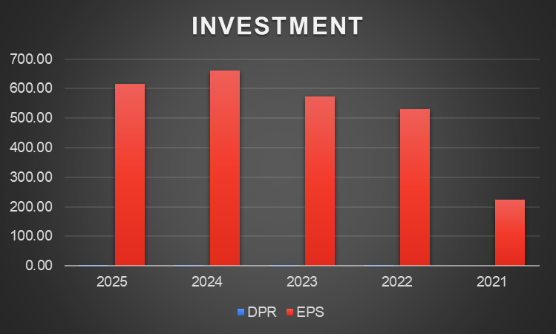

Figure 6: Investment Ratios
(Source: Excel)
Dividend Payout Ratio of Next Plc was 0.35 in 2025, 0.31 in 2024, 0.33 in 2023, 0.51 in 2022 and 0 in 2021. The ratio is an indication of dividends that have been paid to shareholders over total net profit generated during the year. The above ratio shows that the company is paying 35% of its net profit as dividends to the shareholders which is significantly high. This enhances investment performance of the business because it indicates that the company is creating value for its shareholders. In addition, EPS of Next Plc was 615.1p in 2025, 661.6p in 2024, 573.4p in 2023, 530.8p in 2022 and 223.3p in 2021. Inspired by the ideas of Bustani et al. (2021), EPS ratio evaluates the strength of a business in generating earnings based on earnings over each share. The ratio is decreasing which is an indication of a decrease in the earnings made by the company. However, the value of EPS is significantly high which means that the company is earning enough returns over its outstanding shares. In this way, the company is also creating value for its shareholders who invest money within the business. Investment performance of the company is quite strong which ensures that Next PLC would sustain the industry for an extended period.

4. Working Capital Management
Firm’s 5 years working capital management:
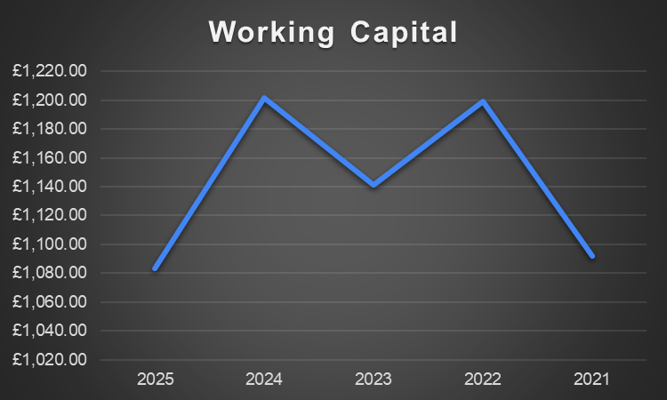

Figure 7: Working Capital
(Source: Excel)
Working Capital shows the difference between current assets and current liabilities. Based on the views of Banerjee and Deb (2023), there are many challenges of raising external funds due to which managers engage in more efficient management of working capital to release extra working capital funds. Annual report of the company shows that Current Assets of Next Plc was £ 2649.90 million in 2025, £ 2447.70 million in 2024, £ 2234.50 million in 2023, £ 2407.20 million in 2022 and £ 2288.60 million in 2021. Contrary to this, Current Liabilities of the business was £ 1566.40 million in 2025, £ 1245.70 million in 2024, £ 1093.30 in 2023, £1208.10 million in 2022 and £ 1196.8 million in 2021. As current assets are greater than current liabilities, the business is operating with positive working capital making it easy for the company to pay its obligations and liabilities in the short run. Working Capital of Next Plc was £ 1083.50 million in 2025, £ 1202 million in 2024, £ 1141.2 million in 2023, £ 1199.10 million in 2022 and £ 1091.8 in 2021. The working capital of the business is decreasing which is not good as shown in Figure 7. The company is already using its working capital for investment purposes rather than keeping a significant amount of funds idle within the business to earn returns. A material swing can be seen in working capital of the business in 2023 which was invested on acquisition of inventories being a major source of revenue for the business.
Cash flow statement for evaluation:
Cash flow statement of the company shows a positive cash balance from operating activities indicating that inflow has been greater than the outflow of cash. The company has used its working capital successfully in making payments to the suppliers and employees of the business which ensures smooth operations. In 2025, working capital was an outflow worth 30 million pounds mostly due to payment made to staff as incentive and higher purchase of stocks. In 2024, working capital was an inflow worth 44 million pounds because of staff incentive being outstanding for the year. In 2023, working capital outflow was 140 million pounds which was significantly high due to significant outflows into staff incentives, stocks, and debtors. In 2022, working capital outflow was 225 million pounds which is significantly high because of debtors, stocks, staff incentives, and ESOT. The company expects to use working capital as cash outflow worth 66 million pounds in the next year. Generation of operating cash is strong for the business which is cushioning volatility of working capital. Along with this, a clear investment programme would reduce operating expenses as well as enhance inventories overall. However, one-off items or large timing are causing big cash swings. These movements of cash can be managed but would not generate any earnings. Along with this, the scale of customer receivable is quite huge, increasing exposure to credit risk. Evaluating working capital of the business it can be said that improvement is required in metrics of inventory management. ESOT cash flows must be smoothed as well as collections must be made stricter. Total platform control must be implemented to ensure that cash inflow is achieved on a timely basis. The company is already trying to decrease its short-term debt capital to be able to manage its working capital better along with increasing liquid resources.

5. Overall Financial Performance Summary
Summary of findings:
The annual report has been used for the calculation of the ratios, considering the statement of 2025, 2024, 2023, 2022, and 2021. Here, the statement articulates a fluctuation in the net profit of Next plc, which has been reduced from £ 800.5 million in 2024 to £ 743.2 million in 2025 (Next Plc, 2025). This reflects a negative impact on the investor confidence, as well as employee morale to meet the organisational objectives effectively. On the other hand, the revenue margin of the company has a significant growth trend, including £ 5491.0 million in 2024 and £ 6118.1 million in 2025, demonstrating effective credit account interest (Next Plc, 2025). This highlights that the firm has strengthened its financial health and efficiency to invest in profitable projects and manage its operational dynamics. Thus, a higher sale brings efficiency in the liquidity administration and provides capital for inclusive expansion and investment in research and development. The current assets and liabilities of Next plc have a marginal growth rate from 2021 to 2025, reflecting an efficient opportunity to meet its short-term obligations. Based on the annual report, it has been analysed that the valuation of shareholder’s equity has also been raised from £ 660.90 in 2021 to £ 1,754.30 in 2025, reflecting inclusive financial health and stability in the competitive landscape.
Strengths and weaknesses:
In terms of financial performance and position, the biggest strength for the business involves its liquidity position. Working capital of the business is positive which Next PLC is using in paying expenses and dues of the investors. Liquidity of the business helps it in keeping its investors satisfied. Another strength of the business involves its strong investment position. The company is earning a significant amount of earnings over its outstanding shares which helps in creating value for the shareholders and keeps them satisfied. Along with this, the company is paying enough dividends to the shareholders which helps the business in reducing agency problems and agency costs. On the other hand, the biggest weakness of the business is its poor capital structure. The company depends significantly on debt capital when it comes to financing business operations making it very risky. Along with this, the ability to pay interest is decreasing. Another weakness of the business involves lower profitability position and poor efficiency of managing assets and inventories.

Task 2: Academic Essay on Investment Appraisal Methods

1. Introduction
Importance of investment appraisal in financial decision-making:
Application of techniques of forecasting as a part of project evaluation is necessary otherwise incorrect decisions would be taken by the organisations. As per the views put forward by Shahriar et al. (2021), evaluation of a project can be done using investment appraisal techniques like payback period, IRR, ARR and NPV. Financial decision making requires investment appraisal techniques because it helps in determining profitability of the investment options and selecting the best project for investment. Its application reduces chances of error while selecting projects. It becomes difficult for companies to select projects just by looking at the cashflows there is a need for proper evaluation of the earnings and spendings. This detailed evaluation of the spendings is possible with the help of investment appraisal techniques.
Scope of essay and methods:
The study includes a discussion on investment appraisal techniques like NPV, IRR and payback period. In addition, strengths and limitations of these techniques have been discussed. Numerical examples have been explained regarding these techniques from the course materials. Application of capital rationing is also included with the help of hypothetical examples.

2. Main Body
Overview of Methods:
NPV: NPV is a technique of investment appraisal which compares future earnings and expenses of a project after converting them to their present values. NPV is determined using the equation: “-CF0 + CF1/(1+r) ^1 + CF2/(1+r) ^2 + CF3/(1+r) ^3 + CF4/(1+r) ^4 + CF5/(1+r) ^5”. If NPV is used in project selection, then the criteria are that the value must be equal to zero or greater than zero. Contrary to this, a project having NPV less than zero must not be selected.
IRR: IRR is a technique of investment appraisal which generates the rate of return at which NPV of all cash flows are equal to zero. IRR is determined using the equation: “R1 + NPV1 / (NPV1 - NPV2) x (R2 - R1)”. If IRR is used in project selection, then the criteria is that the value must be greater than cost of capital. Contrary to this, a project having IRR less than cost of capital must not be selected.
PBP: PBP is a technique of investment appraisal which generates the time after which initial investment from a project would be earned back by the investor. PBP is determined using the equation: “Years before breakeven + Unrecovered Amount / Cash Flow in Recovery Year.” If PBP is used in project selection, then the criteria are that the value must be the lowest number of years. Contrary to this, a project with a higher payback period must not be selected.
Strengths and Limitations:
NPV: The biggest strength of NPV is that it takes ‘time value of money’ into consideration. Based on the views of Shou (2022), ‘value of money’ today is greater than the value tomorrow. This means if investors and firms ignore discounting rates and perform calculations with only current value, then the result in future would be overvalued which is a loss for them. Another advantage of NPV is that it eliminates the risk of stewardship problem where project managers are found to put more emphasis on stages, they are responsible for than on the succeeding phases. NPV ensures that all relevant consequences of the project are considered at the time of evaluation. Another strength of NPV is application of a single discounting factor on all projects which helps in performing comparison. NPV is considered effective in terms of decision making when it comes to determining financial profitability of investment projects. Managers are more likely to use this technique for selecting the most profitable investment options compared to other techniques of investment appraisal. However, the biggest disadvantage of NPV is the assumption made for the discounting factor. If the discounting factor is selected incorrectly then the chosen project might lead to significant losses for the investors. A significant limitation of this technique is in effectiveness in decision making when it comes to comparing projects of many sizes. Projects with largest size would report higher NPV whereas projects with smallest size would report lowest NPV making it difficult to select more profitable investment options.
IRR: As commented by Failasufa and Mukhtaruddin (2025), IRR can be defined as a method which is used for determining the value of investment of interest rate from expenses as well as income creating a balance. The biggest strength of IRR is that it does not require a hurdle rate or discounting rate. Therefore, no assumption is required in terms of discounting rate if this technique of investment appraisal is used for evaluation. Along with this, IRR is applicable in case of projects having varied sizes unlike NPV. This means both projects with larger size and projects with smaller size would have no impact over the outcome of IRR making selection of projects easier in comparison. Interpretation of IRR is comparatively easy because the outcome is expressed in the form of percentage. Contrary to this, it is assumed that reinvestment is done at IRR, but this assumption is unrealistic if the rate is extremely high. Studies have also shown that IRR becomes misleading in case of projects that are mutually exclusive. In other words, a project having higher IRR, but lower NPV cannot be considered optimal for the purpose of investment. IRR can be considered less dependable in case of projects having long duration or unconventional nature.
Payback: The biggest strength of payback is its ability to determine liquidity of a project unlike NPV and IRR. This means payback helps investors in determining liquidity in place of profitability which makes it unique. The technique is also extremely easy and simple to calculate because of the absence of complex calculations and no need of discounting. If investors are willing to select projects based on their liquidity or ability to regenerate initial investment, then the payback period must be used for decision making. This technique is also beneficial for evaluating risk exposure in the short term (Lan et al. 2022). Contrary to this, the biggest limitation of the payback period is ignoring ‘time value of money’ as it is a non-discounting technique. As a result, making decisions only based on payback period can lead to incorrect decision making. This technique also ignores cash flows that would be generated after the payback period. As far as alignment with wealth maximization goals of stakeholders are considered this technique of investment appraisal cannot be considered effective.
Numerical examples:
NPV:
For instance, a project having initial investment of 100000 pounds and cashflows worth 10000 pounds, 20000 pounds, 30000 pounds, 40000 pounds and 50000 pounds at a discount rate of 10% would have an NPV worth:
= -100000 + 10000/ (1.10) ^1 + 20000/ (1.10) ^2 + 30000/ (1.10) ^3 + 40000/ (1.10) ^4 + 50000/ (1.10) ^5
= -100000 + 9090.9 + 16528.9 + 22539.4 + 27320.5 + 31046.06
= 6525.8 pounds
The positive value makes the project worth selecting.
IRR:
For instance, a project having initial investment of 100000 pounds and cashflows worth 10000 pounds, 20000 pounds, 30000 pounds, 40000 pounds and 50000 pounds at a discount rate of 10% would have an IRR worth:
= 10% + 6525.8 / (6525.8 - 17.92) x (12% - 10%)
= 12%
IRR is greater than WACC which makes the project worth selecting.
Payback:
For instance, a project having initial investment of 100000 pounds and cashflows worth 30000 pounds for each year till 5 years would have an PBP worth:
= 100000 / 30000
= 3.33 or 3 years 4 months
Payback period is less which makes the project worth selecting.
Application in Capital Rationing:
Methods assisting firms in making capital allocation decisions:
Companies execute capital rationing when they face limitations of budget while making investment decisions. Because of limited financial resources, companies are unable to invest in all the projects with positive NPV. Such challenges might take place because of lack of external funding, absence of internal funding, strategic priorities, or risk control (Awodire et al. 2023). In such a situation, managers can allocate scarce resources to projects that are enhancing value for the business the most using capital rationing. NPV is the best technique which is used for the purpose of capital rationing as it can correctly measure the absolute value that the projects would create. This means companies would select a combination of different projects that would maximise total NPV despite budget constraints. Similarly, IRR can be used in the process of capital rationing where companies would compare projects having similar scale. In this way, managers will be able to understand the characteristics of risk and return for each project. However, it is important to mention that IRR would not determine value numerically rather it would measure in percentage which can lead to suboptimal allocation. Some companies have also used a payback period in the process of capital rationing at pilot stages especially for investors who consider liquidity to be important. It has been found that projects that are able to recover initial investment as soon as possible are preferred under scenarios with severe shortage of cash. However, it is important to mention that in case of capital rationing, decisions cannot be made solely with the help of the payback period because it ignores the value to be created by the project in the future. Rather, NPV and IRR must be considered along with a payback period in the process of capital reasoning for better decision making.
Hypothetical examples for the techniques in capital rationing:
For instance, an organisation has a total budget of 400000 pounds along with 3 available projects. Project A requires an investment of 200000 pounds with NPV of 30000 pounds, project B requires 100000 pounds with NPV of 15000 pounds and project C requires 200000 pounds with an NPV of 25000 pounds. Due to shortage of budget the firm cannot select all three of them, and the best combination would be project A and project C which needs total investment of 400000 pounds along with NPV of 55000 pounds. Again, in the same instance, Project A has an IRR of 25%, project B has 18% and project C has 20%. Following the principle of capital rationing, firms can select a combination of project A and C based on the IRR. However, in the process of capital rationing, NPV must be considered along with IRR for better decision making. Even if the IRR of a project is greater but NPV is lower in comparison then more preference must be given on NPV at the time of selecting projects. Again, at the time of economic downturn, companies must select projects having shorter payback periods for maintaining sufficient cash reserves despite lower NPV. For instance, a project with lower NPV and payback is preferable over a project with higher NPV and payback.

3. Conclusions
Summary of key insights:
All the three techniques of NPV, IRR and payback possess their own limitations and strengths when it comes to evaluating projects. Payback period focuses on liquidity of a project when it comes to selection ignoring ‘time value of money.’ On the other hand, discounting methods like NPV and IRR give more focus on ‘time value of money’ because of which they are considered more useful for decision making. In some cases, the technique of capital rationing can be used making the process of project selection easier only if the investor possesses sufficient financial resources.
Reflection on effectiveness of appraisal methods in investment decisions:
Investment appraisal methods are effective when it comes to financial decision mostly making. Payback period can help investors in determining liquidity whereas NPV would help in determining profitability. However, the effectiveness of these techniques depends significantly on the assumptions that were made by the investors along with collection of reliable information. For instance, the selection of discounting rate is extremely critical when calculating NPV. Managers have always supported NPV as the best technique for decision making considering payback period and IRR as supplementary tools in decision making.

References
Awodire, M., Agboola, O., Ogundojutimi, O. and Odumuwagun, O., (2023). Capital Budgeting and Financial Investment Appraisal: A Review of Archival Literature. American Journal of Multidisciplinary Research in Africa, 3(10.58314). Available at: https://www.academia.edu/download/115377930/Capital_Budgeting_and_Financial_Investme.pdf [Accessed: 02 December 2025]
Banerjee, P. and Deb, S.G., (2023). Capital investment, working capital management, and firm performance: Role of managerial ability in US coordination industry. Transportation Research Part E: Logistics and Transportation Review, 176, p.103224. Available at: https://www.karlancer.com/api/file/1734235590-Ifei.pdf [Accessed: 02 December 2025]
Bustani, B., Kurniaty, K. and Widyanti, R., (2021). The effect of earning per share, price to book value, dividend payout ratio, and net profit margin on the stock price in Indonesia stock exchange. Journal Maksipreneur: Manajemen, Koperasi, Dan Entrepreneurship, 11(1), pp.1-18. Available at: https://ejournal.up45.ac.id/index.php/maksipreneur/article/download/810/641 [Accessed: 02 December 2025]
Companies Market Cap, (2025). Next plc (NXT.L) - Market capitalization. Available at: https://companiesmarketcap.com/inr/next-plc/marketcap/#:~:text=As%20of%20November%202025%20Next,cap%20according%20to%20our%20data. [Accessed: 02 December 2025]
Failasufa, M. and Mukhtaruddin, M., (2025). THE INFLUENCE OF CAPITAL BUDGETING METHODS ON THE FEASIBILITY OF COMPANY INVESTMENT: A LITERATURE REVIEW STUDY. Jurnal Manajemen Perbankan Keuangan Nitro, 1(1), pp.60-69. Available at: [Accessed: 02 December 2025]
Lan, H.Y., Afero, F., Huang, C.T., Chen, B.Y., Huang, P.L. and Hou, Y.L., (2022). Investment feasibility analysis of large submersible cage culture in Taiwan: a case study of Snubnose Pompano (Trachinotus anak) and Cobia (Rachycentron canadum). Fishes, 7(4), p.151. Available at: https://www.mdpi.com/2410-3888/7/4/151 [Accessed: 02 December 2025]
Next Plc, (2021). Next Plc annual report 2021. Available at: https://www.nextplc.co.uk/~/media/Files/N/Next-PLC-V2/documents/2021/annual-report-and-accounts-jan21.pdf [Accessed: 02 December 2025]
Next Plc, (2022). Next Plc annual report 2022. Available at: https://www.nextplc.co.uk/~/media/Files/N/Next-PLC-V2/documents/2022/annual-reports-and-account-jan-2022.pdf [Accessed: 02 December 2025]
Next Plc, (2023). Next Plc annual report 2023. Available at: https://www.nextplc.co.uk/~/media/Files/N/Next-PLC-V2/documents/2023/annual-reports-and-account-jan-2023.pdf [Accessed: 02 December 2025]
Next Plc, (2024). Next Plc annual report 2024. Available at: https://www.nextplc.co.uk/~/media/Files/N/next-plc-v4/about-next/annual-report-and-accounts-jan-2024.pdf [Accessed: 02 December 2025]
Next Plc, (2025). About Next Plc. Available at: https://www.nextplc.co.uk/ [Accessed: 02 December 2025]
Patki, A., (2021). Analysis of Inventory Turnover Ratio and its Impact on Profitability of Enterprises in Indian Retail Industry. Indian Institute of Finance Vol. XXXV No, 2. Available at: https://www.researchgate.net/profile/Aarti-Patki/publication/354667889_Analysis_of_Inventory_Turnover_Ratio_and_Its_Impact_on_Profitability_of_Enterprises_in_Indian_Retail_Industry_Author/links/61453e0b3c6cb31069772185/Analysis-of-Inventory-Turnover-Ratio-and-Its-Impact-on-Profitability-of-Enterprises-in-Indian-Retail-Industry-Author.pdf [Accessed: 02 December 2025]
Shabrina, W. and Hadian, N., (2021). The influence of current ratio, debt to equity ratio, and return on assets on dividend payout ratio. International Journal of Financial, Accounting, and Management, 3(3), pp.193-204. Available at: https://pdfs.semanticscholar.org/4b29/bdf34d35e24a259a4ba325104a1c10bd8402.pdf [Accessed: 02 December 2025]
Shahriar, M.S., Hasan, K.B.M.R., Hossain, T., Beg, T.H., Islam, K.A. and Zayed, N.M., (2021). Financial decision making and forecasting techniques on project evaluation: a planning, development, and entrepreneurial perspective. Academy of Entrepreneurship Journal, 27(4), pp.1-7. Available at: https://www.academia.edu/download/91261672/Financial-decision-making-and-forecasting-techniques-on-project-evaluation-a-planning-development-1528-2686-27-4-553.pdf [Accessed: 02 December 2025]
Shou, T., (2022), July. A literature review on the net present value (NPV) valuation method. In 2022 2nd International Conference on Enterprise Management and Economic Development (ICEMED 2022) (pp. 826-830). Atlantis Press. Available at: https://www.atlantis-press.com/article/125975449.pdf [Accessed: 02 December 2025]
Statista, (2025). Next plc - statistics & facts. Available at: https://www.statista.com/topics/11004/next-plc/?srsltid=AfmBOoq1DGv_dleVEPJLpiWwC2fOHb_WJ9kLqxFZCUEGy5Ts35T5Kwtv [Accessed: 02 December 2025]
Widiasmara, A., Kusherawati, A., Cahyaningati, R. and Paramita, R.W.D., (2022). The Effect of Current Ratio, Debt to Equity Ratio, Return on Assets, and Net Profit Margin on Profit Growth. Assets: Jurnal Ilmiah Ilmu Akuntansi, Keuangan Dan Pajak, 6(1), pp.8-15. Available at: https://pdfs.semanticscholar.org/aa04/03048865d1266d764dda6c89cb67d7971c39.pdf [Accessed: 02 December 2025]

