Component 1
Introduction to Physiology (BMHP5023)

Tutor Name: Robert Nartowski
Syed Mudassar Hussain (2407258)
10th November 2025
Word Count: 2180

Contents
Asthma in Adolescents 2
1 Introduction 2
2 Respiratory System and Mechanics of Breathing 3
2.1 Anatomical Structure 3
2.2 Mechanical Respiration 3
3 Gas Exchange in the Lungs 4
4 Influence of Irritants on Respiratory Tissue 5
4.1Triggering Inflammation and Harm to Epithelial Cells 5
4.2 Methods of Limiting Airflow 5
5 Monitoring Respiratory Function 7
5.1 Justification for Peak Flow Monitoring 7
5.2 Limitations and Critical Assessment 7
6 Evidence-Based Lifestyle Recommendations 9
6.1 Abandonment of Smoking and Vaping 9
6.2 Dietary Adjustments 9
6.3 Promoting Physical Activity 10
7 Conclusion 11
8 References 12

Asthma in Adolescents

1 Introduction
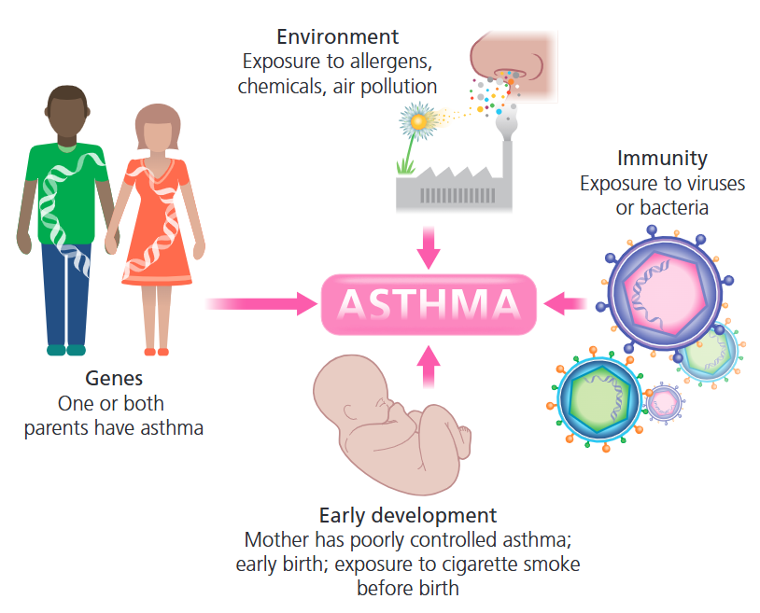
Asthma is a chronic respiratory disease marked by inflammation and muscle constriction around the airways, leading to breathing difficulties and affecting around 262 million people in 2019, resulting in 455,000 deaths (WHO, 2024). According to the World Health Organization (WHO) (2024), symptoms frequently intensify at night or during exercise, and common asthma symptoms include a lasting cough, particularly at night, wheezing, shortness of breath, and chest tightness. These symptoms typically exhibit a daily pattern, often intensifying at night or in response to specific triggers, including cold air or exercise (Sinyor and Perez, 2023). Recent research indicates that the global prevalence of asthma among adolescents is 11.0% (Yuan et al., 2025). An adolescent with a chronic condition such as asthma faces two main transitions: from adolescence to adulthood and from paediatric to adult healthcare (Ödling et al.,2023).
The origin of asthma is unclear, but several risk factors can increase the likelihood of developing it. Genetics play a role, with a 25% risk if one parent has it and a 50% risk if both parents do (Harrington, 2020). Individuals with multiple allergies, known as atopy, are also at higher risk; this affects 90% of children and 70% of adults with asthma. Common triggers include pollen, chemicals, dust, and air pollution, particularly near busy roads. Interestingly, children raised on farms tend to have lower rates of asthma and allergies than urban children, possibly because they have less exposure to beneficial microbes. Early-life factors such as being born prematurely, exposure to smoking, and short breastfeeding duration may also contribute to asthma development (Harrington, 2020).
Fig. 01(Harrington, 2020)

2 Respiratory System and Mechanics of Breathing

2.1 Anatomical Structure
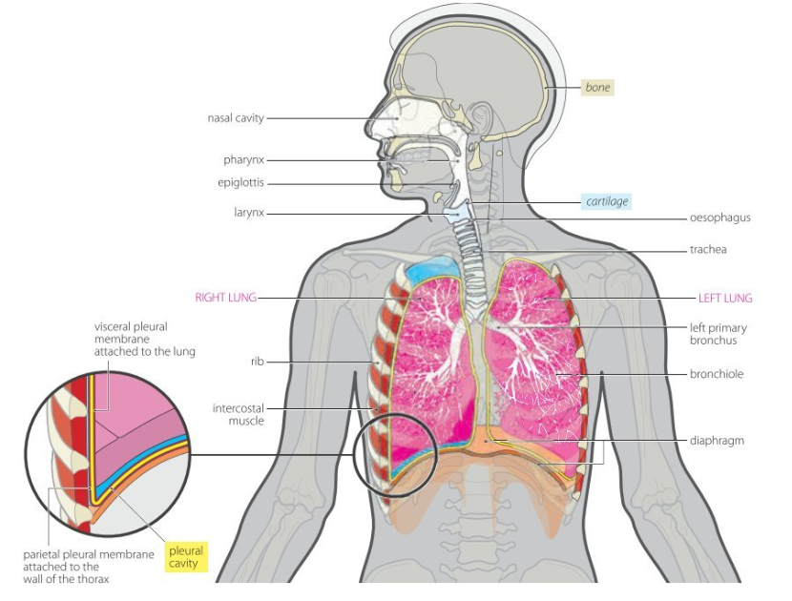
The human respiratory system facilitates the continuous exchange of gases, including oxygen (O₂) and carbon dioxide (CO₂), between the environment and the body (Tucker, 2015). The nose filters incoming air, removing dust and bacteria before they reach the pharynx, the tube connecting the back of the nose to the mouth. The pharynx not only serves as a conduit for air but also helps warm and moisten it. The air then travels down to the larynx, where it is further filtered and contributes to voice production. The trachea is a tube that connects the neck to the chest and branches into two bronchi that lead to the lungs, serving as a pathway for air between the larynx and the bronchi. The bronchioles are the final tubes in the airways, directing air into a network of alveoli. The lungs are central to the respiratory system, enabling gas exchange between the blood and the environment. Breathing is controlled by the diaphragm and intercostal muscles, which regulate the volume of the thoracic cavity (Tucker, 2015).
Fig. 02 (Minett and Ginesi, 2020) - Respiratory System

2.2 Mechanical Respiration
Ventilation (breathing) is a primarily involuntary process in which air is drawn into the lungs (inspiration) and expelled (expiration) (Minett and Ginesi, 2020). This lung movement, involving expansion and contraction, is aided by the intercostal muscles between the ribs and the diaphragm. Each breath consists of the following steps: the ribcage expands, the diaphragm flattens, and the lungs fill with air as the pressure inside decreases, allowing air to rush in. Gas exchange happens in the alveoli, where O₂ enters the blood and CO₂ exits. The ribcage contracts, the diaphragm relaxes, and air is expelled from the lungs (Minett and Ginesi, 2020). The increase in smooth muscle fibres in the airways leading to the alveoli plays a key role in asthma pathophysiology by causing bronchoconstriction (Sinyor and Perez, 2023).

3 Gas Exchange in the Lungs
Fick’s Law of Diffusion states that gases diffuse from regions of higher pressure to areas of lower pressure until equilibrium is reached (Tucker, 2015). O₂ from the atmosphere diffuses from an area of high pressure in the alveoli to an area of lower pressure in the pulmonary circulation (Sturgeon, 2018). The partial pressure of O2 in alveolar air is approximately 100 mmHg, while the blood entering pulmonary capillaries has a partial pressure of around 40 mmHg. After diffusion, the O2 pressure in the blood returning to the left side of the heart is again approximately 100 mmHg. Concurrently, CO₂ transitions from a high partial pressure in the pulmonary capillaries to a lower partial pressure in the alveoli. The alveoli's surface area and proximity to capillaries enhance gas exchange (Sturgeon, 2018).

4 Influence of Irritants on Respiratory Tissue

4.1Triggering Inflammation and Harm to Epithelial Cells
The main pathological occurrence of asthma is chronic airway inflammation, which is frequently initiated or aggravated by external triggers. The presence of irritants, including airborne allergens (such as mould), pathogens (such as viral infections), and harmful substances (such as tobacco smoke), frequently triggers this response (Kostakou et al., 2019). Inhalation of pollutants like diesel exhaust and wildfire smoke induces oxidative stress at the bronchial cell surface, disrupting the airway epithelial barrier (Bronte-Moreno et al., 2023). When this barrier fails, allergens and irritants can enter and trigger a strong immune response, leading to allergic sensitisation (Yuksel and Turkeli, 2017). Research shows that issues with the epithelial barrier can lead to allergen sensitisation by letting antigens reach dendritic and other immune cells beneath the epithelium. This encourages Th2-type immune responses, with increased cytokines like IL-4, IL-5, and IL-13, leading to eosinophilic inflammation and mucus hypersecretion (Aghapour et al., 2022).

4.2 Methods of Limiting Airflow
In asthma, airflow obstruction occurs due to the simultaneous narrowing of the airway lumen through three main mechanisms.
4.2.1 Smooth Muscle Constriction
Asthmatic airways react strongly to triggers like allergens and irritants, leading to bronchoconstriction that narrows the airways and limits airflow. In asthma, smooth muscle cells often enlarge (hypertrophy) and increase in number (hyperplasia), reducing lumen size and raising airway resistance (Varricchi et al., 2024).
4.2.2 Mucus Hypersecretion
Inflammatory factors increase goblet cells and mucus gland size, leading to overproduction of mucus. The mucus thickens and gathers, forming plugs that block the airway lumen and block airflow. This has a significant impact on airflow during asthma episodes (Bonser and Erle, 2017).
4.2.3 Airway Inflammation and Oedema
In asthma, exposure to allergens or irritants activates immune cells like mast cells, eosinophils, and Th2 lymphocytes. These cells emit pro-inflammatory cytokines (such as IL-4, IL-5, and IL-13), which increase vascular permeability and attract additional inflammatory cells. This leads to tissue oedema, thickening of the airway wall, and a reduced lumen diameter (Reza and Ambhore, 2025).
In summary, increased inhaled irritants lead to more airway inflammation and mucus production, constricting airways and reducing ventilation efficiency.

5 Monitoring Respiratory Function
Effective asthma management relies on controlling symptoms and reducing the frequency and intensity of flare-ups (Kandola et al., 2024). Asthma patients who self-monitor and follow a written action plan, along with regular medical check-ups, experience fewer hospital stays, emergency visits, and work absences (Gibson, 2000). Observing respiratory functions, particularly peak expiratory flow (PEF), is crucial for self-managing asthma.

5.1 Justification for Peak Flow Monitoring
Peak expiratory flow (PEF) measurement is a simple, cost-effective method for assessing airflow obstruction by measuring the peak flow rate during forced exhalation from fully inflated lungs, reflecting the size of the larger airways and the strength of the respiratory muscles (DeVrieze, Goldin and Giwa, 2024). Monitoring and documenting respiratory functions, especially PEF with a peak flow meter (PFM), is vital for managing asthma independently. Such monitoring aids early detection of airflow obstruction, enabling identification of airway changes before symptoms are apparent (AAFA, 2017). A PFM can also assist patients and physicians (Fig. 03):
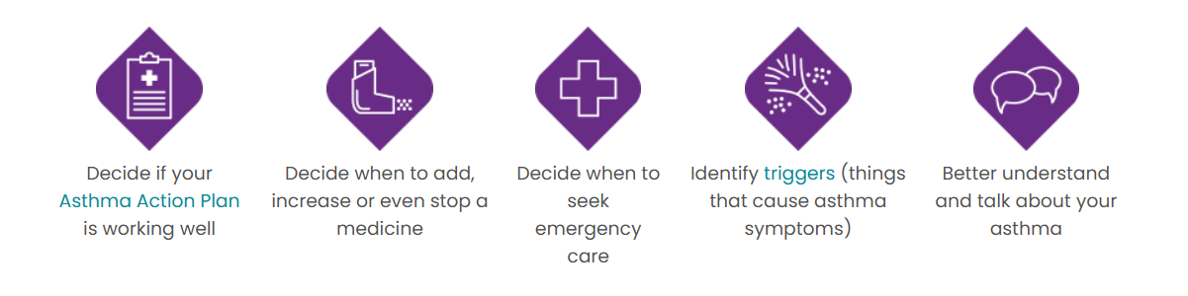

Fig. 03 (AAFA, 2017)
By achieving a personal best reading while managing asthma for two to three weeks, clinicians can create individualised asthma action plans (PAPs) that use colour-coded zones (Green, Yellow, Red) to indicate when to intensify treatment or seek help (DeVrieze, Goldin and Giwa, 2024).

5.2 Limitations and Critical Assessment
PEF requires proper technique and maximum effort; otherwise, it can be underestimated and less reliable unless patients are trained and monitored (Rhee et al., 2015). It cannot accurately assess airflow in smaller airways, potentially leading to an underestimation of airflow limitation (Ojo et al., 2023). Gerald and Carr (2024) note that devices from different manufacturers can differ in reproducibility and accuracy, and that calibrating them can be pretty challenging. They also emphasise that monitoring a patient during a peak expiratory flow (PEF) manoeuvre can improve the reliability of PEF measurements by providing better training and guidance. Although PFM is helpful for quick assessments, it lacks the diagnostic depth of spirometry, which offers detailed data on lung volumes and flow rates (Sylvester et al., 2021). PEF monitoring offers distinct advantages for adolescents by providing objective data to accurately assess symptoms, encouraging active management of their condition, and helping identify environmental triggers in settings like school, home, and social situations (DeVrieze, Goldin, and Giwa, 2024). Digital monitoring facilitates early detection of worsening symptoms by analysing symptom logs, peak flow trends, inhaler use, and environmental factors. For example, tools for childhood asthma have proven effective in recognising disease progression and assessing treatment efficacy (Au-Doung et al., 2024).

6 Evidence-Based Lifestyle Recommendations
Health behaviours and self-management skills are formed in adolescence, and successful habit changes during this time can influence adulthood (Mosnaim et al., 2016). Lifestyle adjustments can reduce allergy symptoms and triggers (including pollen and dust mites), improving adolescents' quality of life (MountSinai, 2025).

6.1 Abandonment of Smoking and Vaping
Quitting tobacco is crucial, as it significantly improves lung function and alleviates symptoms (Bellou, Gogali and Kostikas, 2022). Current smokers with asthma experience considerably worse clinical and functional results, such as increased rates of exacerbations and diminished control, in comparison to individuals who have never engaged in smoking (Tiotiu et al., 2021). Studies demonstrate that quitting smoking results in considerable improvements in asthma symptoms and overall lung function (Polosa and Thomson, 2013). Adolescents who use e-cigarettes require cessation education, as these devices can harm lung function, increase airway inflammation, especially in asthma patients, and lead to higher school absences (National Asthma Council Australia, 2025). Clinicians should educate adolescents about smoking and vaping risks, while school interventions can improve awareness and reduce asthma issues (Bonomo et al., 2025). Use the 5 A's framework (Gaddey, Dakkak and Jackson, 2022) for behavioural support, treating vaping like tobacco. Recommend complete household quitting for homes with smokers to reduce second-hand exposure. Specialised Programs like Not On Tobacco (N-O-T) support adolescents in overcoming substance use by addressing their unique developmental, psychological and social factors (American Lung Association, 2025). Supporting adolescents to stop smoking and vaping improves asthma management and lung health. Education, behavioural support, and family involvement are key to lasting respiratory wellness.

6.2 Dietary Adjustments
Mediterranean diets, rich in fish, fruits, vegetables, and whole grains while low in processed foods, may reduce asthma risk and airway inflammation in children, though findings aren't conclusive (Papamichael et al., 2018). It is recommended to replace processed snacks with nuts and fruits, use olive oil, and eat oily fish like salmon 1 to 2 times weekly. Creating family-centred meal plans can also promote healthier eating habits among adolescents (Papamichael et al., 2018). Weight loss interventions greatly benefit obese adolescents with asthma, as even a 5-10% reduction in body weight can enhance quality of life and asthma management (Stoodley et al., 2019). A multidisciplinary approach involving dietitians and family support is recommended, emphasising sustainable calorie reduction, balanced meals, and behaviour changes (Alexander et al., 2017). Therefore, encouraging adolescents to adopt a balanced Mediterranean-style diet and maintain a healthy weight can improve asthma management, reduce inflammation, and promote long-term respiratory health.

6.3 Promoting Physical Activity
Supervised exercise effectively aids asthma treatment and can reduce corticosteroid use (Privitera and Privitera, 2023). Patients who engaged in 24 weeks of aerobic exercise showed a 23% improvement in Asthma Control Test scores and reduced dyspnoea (Jaakkola et al., 2019). Stoodley et al. (2019) recommend swimming for asthmatic children due to warm air and reduced pollen levels, suggesting it may improve cardiopulmonary fitness and lung function, though the evidence is inconclusive. It's advisable to start with moderate activities, such as brisk walking or cycling, 2 to 3 times a week for 8 to 12 weeks, gradually increasing intensity while monitoring symptoms (Wanrooij et al., 2014). Hence, regular and supervised exercise helps adolescents manage asthma and improve lung function. Enjoyable physical activity boosts confidence and supports long-term respiratory health.

7 Conclusion
Severe asthma exacerbations in adolescents stem from persistent airway inflammation compounded by lifestyle-related irritants and pathogens. Effective management depends on a comprehensive understanding of the respiratory system's anatomy and physiology. Awareness of ventilation, gas exchange, and the body’s response to irritants such as tobacco smoke and vaping is essential. This knowledge empowers adolescents to recognise how their choices and treatment options influence their respiratory health. Objective monitoring through peak flow measurements is vital for the early detection of asthma deterioration and facilitates timely interventions in accordance with personalised action plans. When combined with lifestyle modifications, such as quitting smoking, making dietary adjustments, and increasing physical activity, this monitoring enables adolescents to take a proactive role in managing their health. The recommendations outlined in this report, supported by contemporary clinical research, offer a framework for healthcare providers to help adolescents achieve improved asthma control.

8 References
Aghapour, M., Ubags, N.D., Bruder, D., Hiemstra, P.S., Sidhaye, V., Rezaee, F. and Heijink, I.H. (2022) 'Role of air pollutants in airway epithelial barrier dysfunction in asthma and COPD', European Respiratory Review, 31(163). Available at: https://doi.org/10.1183/16000617.0112-2021.
Alexander, G.L., Olden, H.A., Troy, T., Miree, C.A. and Joseph, C.L.M. (2017) 'Overweight adolescents and asthma: revealing motivations and challenges with adolescent-provider communication', Journal of Asthma, 55(3), pp.266-274. Available at: https://doi.org/10.1080/02770903.2017.1323921.
American Lung Association (2025) N-O-T: Not On Tobacco—Proven Teen Smoking and Vaping Cessation Program. Available at: https://www.lung.org/quit-smoking/helping-teens-quit/not-on-tobacco (Accessed: 04 November 2025).
Asthma and Allergy Foundation of America (AAFA) (2017) Peak Flow Meters. Available at: https://aafa.org/asthma/asthma-diagnosis/lung-function-tests-diagnose-asthma/peak-flow-meters (Accessed: 31 October 2025).
Au-Doung, P.L.W., Chan, J.C.H., Kui, O.Y.H., Ho, M.K.Y., Cheung, Y.T., Lam, J.K.W., Chan, H., Brannan, J., Chan, K.C.C., Li, A.M. and Leung, S.S.Y. (2024) 'Objective monitoring tools for improved management of childhood asthma', Respiratory Research, 25(1), p.194. Available at: https://doi.org/10.1186/s12931-024-02817-y.
Bellou, V., Gogali, A. and Kostikas, K. (2022) 'Asthma and tobacco smoking', Journal of Personalized Medicine, 12(8), p.1231. Available at: https://doi.org/doi:10.3390/jpm12081231.
Bonomo, F., Ferrante, G., Piazza, M., Tenero, L., Zaffanello, M. and Piacentini, G. (2025) 'Severe asthma in adolescents: Clinical implications and beyond', Paediatric Respiratory Reviews, Available at: https://doi.org/10.1016/j.prrv.2025.01.006.
Bonser, L.R. and Erle, D.J. (2017) 'Airway mucus and asthma: the role of MUC5AC and MUC5B', Journal of clinical medicine, 6(12), p.112. Available at: https://doi.org/10.3390/jcm6120112.
Bronte-Moreno, O., González-Barcala, F.J., Muñoz-Gall, X., Pueyo-Bastida, A., Ramos-González, J. and Urrutia-Landa, I. (2023) 'Impact of air pollution on asthma: a scoping review', Open Respiratory Archives, 5(2), p.100229. Available at: https://doi.org/10.1016/j.opresp.2022.100229.
DeVrieze, B.W., Goldin, J. and Giwa, A.O. (2024) Peak Flow Rate Measurement. Available at: https://www.ncbi.nlm.nih.gov/books/NBK459325 (Accessed: 30 October 2025).
Gaddey, H.L., Dakkak, M. and Jackson, N.M. (2022) Smoking Cessation Interventions. Available at: https://www.aafp.org/pubs/afp/issues/2022/1100/smoking-cessation-interventions.html (Accessed: 04 November 2025).
Gerald, L.B. and Carr, T.F. (2024) Peak expiratory flow monitoring in asthma. Available at: https://www.uptodate.com/contents/peak-expiratory-flow-monitoring-in-asthma (Accessed: 01 November 2025).
Gibson, P.G. (2000) 'Monitoring the patient with asthma: an evidence-based approach', Journal of Allergy and Clinical Immunology, 106(1), pp.17-26. Available at: https://doi.org/10.1067/mai.2000.108307.
Harrington, J. (2020). Fast Facts for Patients and their supporters: Asthma. Karger.
Jaakkola, J.J., Aalto, S.A., Hernberg, S., Kiihamäki, S.P. and Jaakkola, M.S. (2019) 'Regular exercise improves asthma control in adults: A randomized controlled trial', Scientific reports, 9(1), p.12088. Available at: https://doi.org/10.1038/s41598-019-48484-8.
Kandola, A., Edwards, K., Straatman, J., Dührkoop, B., Hein, B. and Hayes, J. (2024) 'Digital self-management platform for adult asthma: randomized attention-placebo controlled trial', Journal of medical Internet research, 24. Available at: https://doi.org/10.2196/50855.
Kostakou, E., Kaniaris, E., Filiou, E., Vasileiadis, I., Katsaounou, P., Tzortzaki, E., Koulouris, N., Koutsoukou, A. and Rovina, N. (2019) 'Acute severe asthma in adolescent and adult patients: current perspectives on assessment and management', Journal of clinical medicine, Issue information, 8(9), p.1283. Available at: https://doi.org/10.3390/jcm8091283.
Minett, P.M. and Ginesi, L. (2020) Anatomy & physiology : an introduction for nursing and healthcare. Lantern.
Mosnaim, G.S., Pappalardo, A.A., Resnick, S.E., Codispoti, C.D., Bandi, S., Nackers, L., Malik, R.N., Vijayaraghavan, V., Lynch, E.B. and Powell, L.H. (2016) 'Behavioral interventions to improve asthma outcomes for adolescents: a systematic review', The Journal of Allergy and Clinical Immunology: In Practice, 4(1), pp.130-141. Available at: https://doi.org/10.1016/j.jaip.2015.09.011.
MountSinai (2025) Asthma in children and adolescents. Available at: https://www.mountsinai.org/health-library/report/asthma-in-children-and-adolescents (Accessed: 02 November 2025).
National Asthma Council Australia (2025) Smoking and vaping. Available at: https://www.asthmahandbook.org.au/clinical-topics/smoking-and-vaping (Accessed: 3 November 2025).
Ödling, M., Andersson, N., Janson, C., Melén, E., Bergström, A. and Kull, I. (2023) 'Health-related quality of life decreases in young people with asthma during the transition from adolescence to young adulthood: a birth cohort study', BMC pulmonary medicine, 23(1), p.34. Available at: https://doi.org/10.1186/s12890-022-02259-6.
Ojo, O.T., Ajibare, A.O., Odeyemi, A., Fapohunda, T. and Adeyeye, O.O. (2023) 'Clinical utility of peak flow meter in asthma diagnosis and monitoring in low-and middle-income countries: a narrative review', International Journal of Medicine and Health Development, 28(2), pp.87-92. Available at: https://doi.org/10.4103/ijmh.IJMH_4_23.
Papamichael, M.M., Katsardis, Ch., Lambert, K., Tsoukalas, D., Koutsilieris, M., Erbas, B. and Itsiopoulos, C. (2018) 'Efficacy of a Mediterranean diet supplemented with fatty fish in ameliorating inflammation in paediatric asthma: a randomised controlled trial', Journal of Human Nutrition and Dietetics, 32(2), pp.185–197. Available at: https://doi.org/10.1111/jhn.12609.
Polosa, R. and Thomson, N.C. (2013) 'Smoking and asthma: dangerous liaisons', European respiratory journal, 41(3), pp.716-726. Available at: https://doi.org/10.1183/09031936.00073312.
Privitera, A., and Privitera, S. (2023) 'Physical exercise in asthma adolescents: a concept review', Multidisciplinary respiratory medicine, 18(1), 924. Available at: https://doi.org/10.4081/mrm.2023.924.
Reza, M.I. and Ambhore, N.S. (2025) 'Inflammation in Asthma: Mechanistic Insights and the Role of Biologics in Therapeutic Frontiers', Biomedicines, 13(6), p.1342. Available at: https://doi.org/10.3390/biomedicines13061342.
Rhee, H., Belyea, M.J., Sterling, M. and Bocko, M.F. (2015) 'Evaluating the validity of an automated device for asthma monitoring for adolescents: correlational design', Journal of medical Internet research, 17(10), p.e234. Available at: https://doi.org/10.2196/jmir.4975.
Sinyor, B. and Perez, L.C. (2023) Pathophysiology Of Asthma. Available at: https://www.ncbi.nlm.nih.gov/books/NBK551579 (Accessed: 18 October 2025).
Stoodley, I., Williams, L., Thompson, C., Scott, H., and Wood, L. (2019) 'Evidence for lifestyle interventions in asthma', Breathe, 15(2), pp.e50-e61. Available at: https://doi.org/10.1183/20734735.0019-2019.
Sturgeon, D. (2018) Introduction to Anatomy and Physiology for Healthcare Students. Routledge.
Sylvester, K.P., Youngs, L., Rutter, M.A., Beech, R. and Mahadeva, R. (2021) 'Early respiratory diagnosis: benefits of enhanced lung function assessment', BMJ Open Respiratory Research, 8(1). Available at: https://doi.org/10.1136/bmjresp-2021-001012.
Tiotiu, A., Ioan, I., Wirth, N., Romero-Fernandez, R. and González-Barcala, F.J. (2021) 'The impact of tobacco smoking on adult asthma outcomes', International journal of environmental research and public health, 18(3), p.992. Available at: https://doi.org/10.3390/ijerph18030992.
Tucker, L. (2015) An Introductory Guide to Anatomy & Physiology. 5th edn. EMS Publishing.
Varricchi, G., Brightling, C.E., Grainge, C., Lambrecht, B.N. and Chanez, P. (2024) 'Airway remodelling in asthma and the epithelium: on the edge of a new era', European Respiratory Journal, 63(4). Available at: https://doi.org/10.1183/13993003.01619-2023.
Wanrooij, V.H., Willeboordse, M., Dompeling, E. and Van de Kant, K.D. (2014) 'Exercise training in children with asthma: a systematic review', British Journal of Sports Medicine, 48(13), pp.1024-1031. Available at: https://doi:10.1136/bjsports-2012-091347.
World Health Organization (WHO) (2024) Asthma. Available at: https://www.who.int/news-room/fact-sheets/detail/asthma (Accessed: 18 October 2025).
Yuan, L., Tao, J., Wang, J., She, W., Zou, Y., Li, R., Ma, Y., Sun, C., Bi, S., Wei, S. and Chen, H. (2025) 'Global, regional, national burden of asthma from 1990 to 2021, with projections of incidence to 2050: a systematic analysis of the global burden of disease study 2021.', EClinicalMedicine, 80, 103051. Available at: https://doi.org/10.1016/j.eclinm.2024.103051.
Yuksel, H., and Turkeli, A. (2017) 'Airway epithelial barrier dysfunction in the pathogenesis and prognosis of respiratory tract diseases in childhood and adulthood', Tissue barriers, 5(4), e1367458. Available at: https://doi.org/10.1080/21688370.2017.1367458.

