University of Wales Trinity Saint David
Operating Systems Assignment
L4 – Computer Architecture and Operating Systems (ACCA4022)
Jake Richards
4-24-2026

Table of Contents
Operating Systems 3
Windows OS CLI Commands 6
Linux OS CLI Commands 9
Conclusion 11

Operating Systems
The operating system (OS) is a critical component to the general management of a computer system. The OS will primarily perform maintenance tasks such as managing hardware and software resources through process, memory, file and storage, device, security and finally, network and communications.
Process Management is one of the primary tools utilised by an OS that handles the creation, scheduling and coordination of critical CPU resources to ensure efficient performance and smooth system performance. [1] Within the Windows OS, users can view the current performance and allocation of system resources such as CPU usage and memory consumption through the program Task Manager. Linux distributions such as Ubuntu offer similar performance metrics through terminal commands such as top and ps.
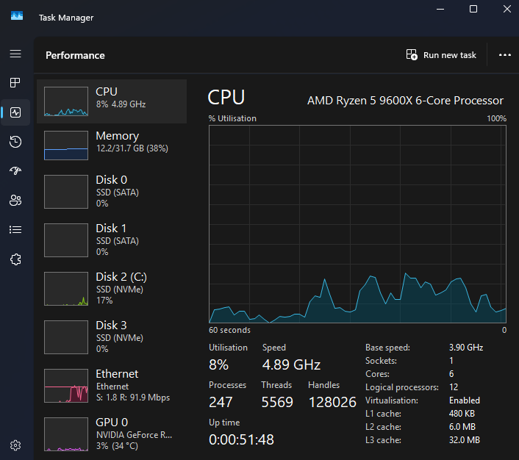
Figure 1: Windows Task Manager

Memory Management is another critical component within an operating system, it utilises the process of allocating and organising a computer’s memory called “blocks” to different executing programmes to improve system performance. [2] Without proper memory management, programs crash and slow the system down.
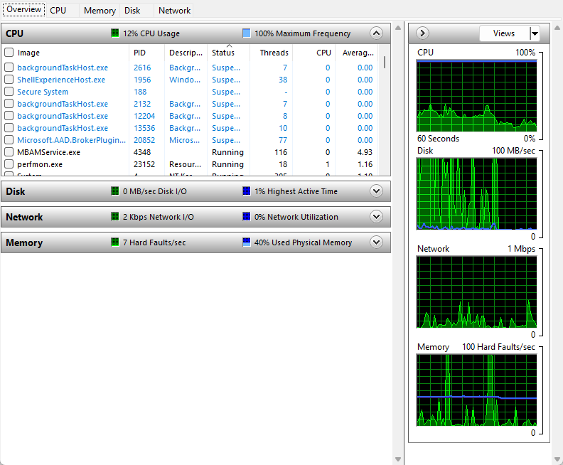
Figure 2: Windows Resource Monitor
Operating systems are also responsible for file and storage management. This will include processes such as file organisation, directory management/security and managing device connections such as hard drives. Windows utilises file systems such as NTFS but incorporates deprecated file system formats such as FAT32. Other operating systems such as Linux will utilise EXT4 for their file system management. [3]
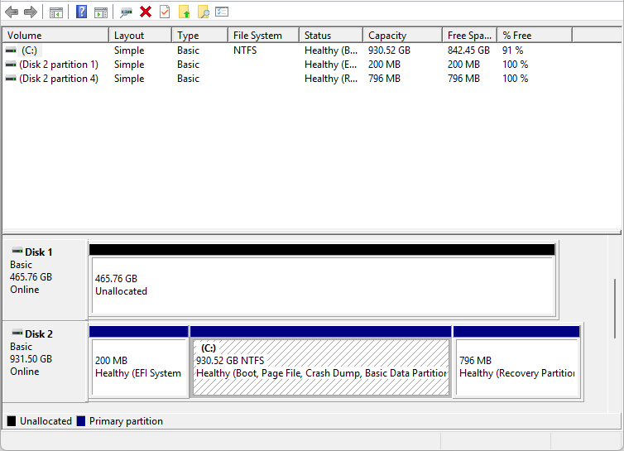
Figure 3: Windows Disk Management
Device Management is a key operating system function, it handles all communication with hardware devices utilising drivers, process scheduling, error handling and resource allocation. Moreover, it maintains system security by excluding unauthorised devices and preventing devices from running outside safe limits. Windows has an incorporated device management tool that allows users to safely manage devices and handle errors efficiently. [4]
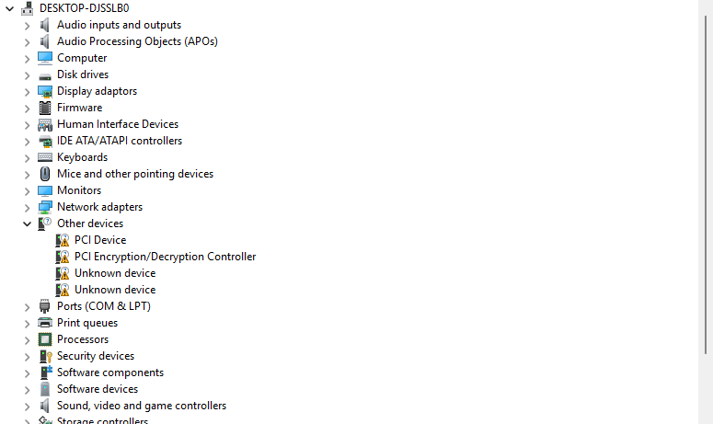
Figure 4: Windows Device Manager
Modern operating systems have implemented measures to prevent malicious users from using system resources or accessing private files. Measures such as passwords and encrypted file systems are the main methods for secure file systems but also file integrity. Operating systems allow administrators to separate accounts with different permission levels to thwart security breaches and prevent illegitimate access to files. [5]
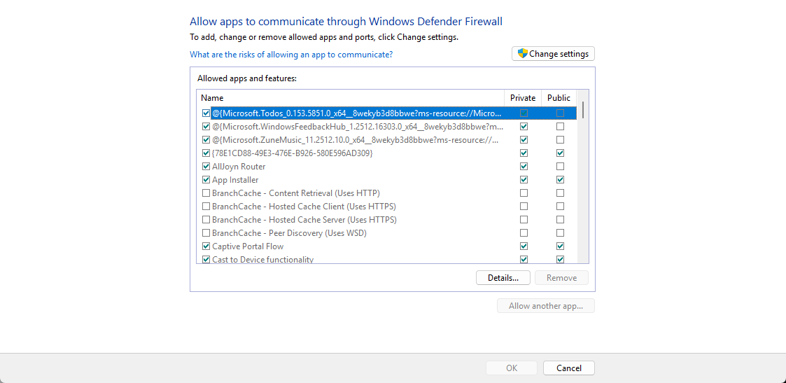
Figure 5: Windows Defender Firewall

Windows OS CLI Commands
Windows OS offers two command-line shells. Command and PowerShell. These command line interfaces provide direct communication between a user and the operating system. [6]
For process management, tasklist is a command that will display all running processes and their unique identification. Subsequently, utilising taskkill /pid will allow a user to terminate unresponsive processes effectively.
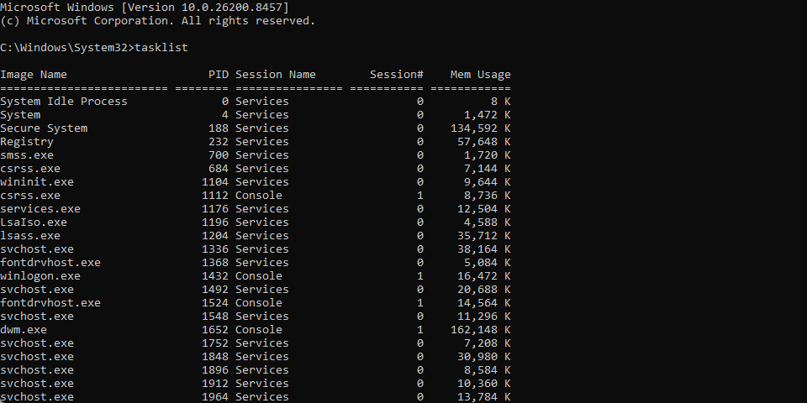
Figure 6: Windows CMD - tasklist
Figure 7: Windows CMD - taskkill /pid 23152 (perfmon.exe)
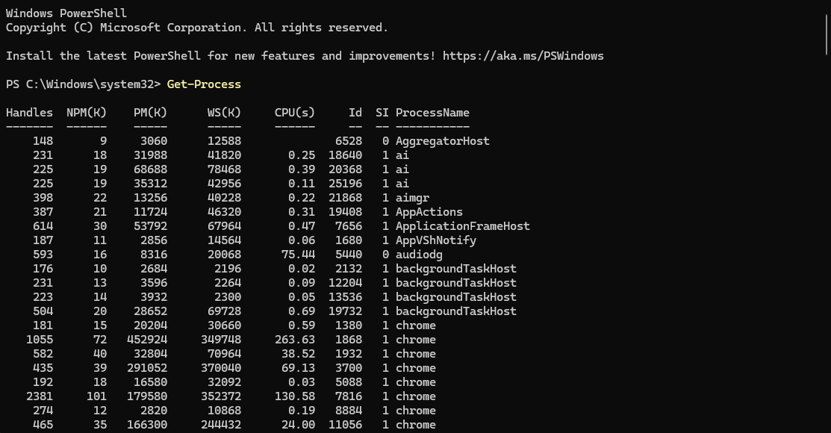
Figure 8: Windows Powershell - Get-Process
Within Windows Command and PowerShell interfaces, utilising dir to list files and folders across a directory while using mkdir to create a folder. The use of copy will duplicate a file inside the directory. The del command will remove a file that has been specified.
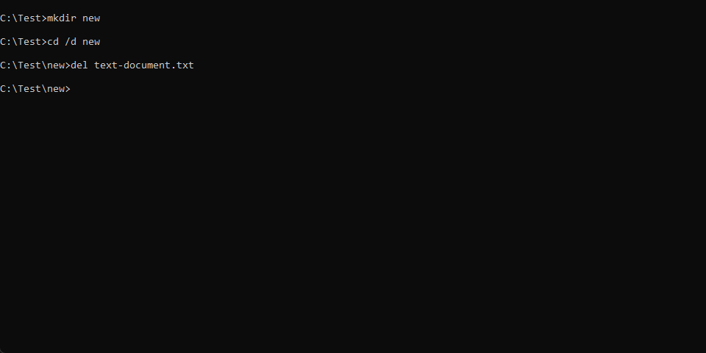
Figure 9: Windows CMD - mkdir & del
For network management, administrators can utilise ipconfig that can display network configuration information such as IP address and its default gateway. Ping command tests for connectivity between devices by sending packets to the destination host while netstat displays active network connections.
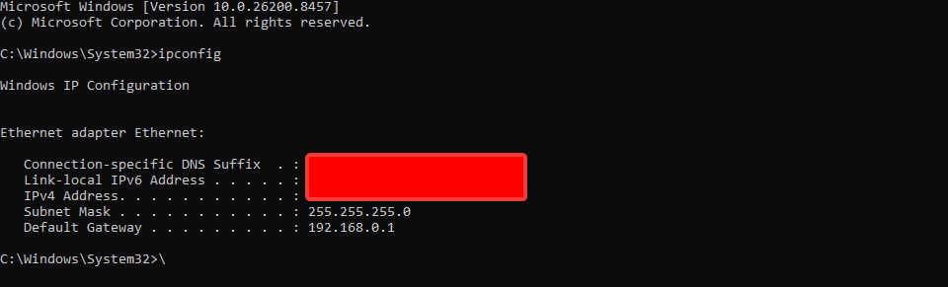
Figure 10: Windows CMD - ipconfig
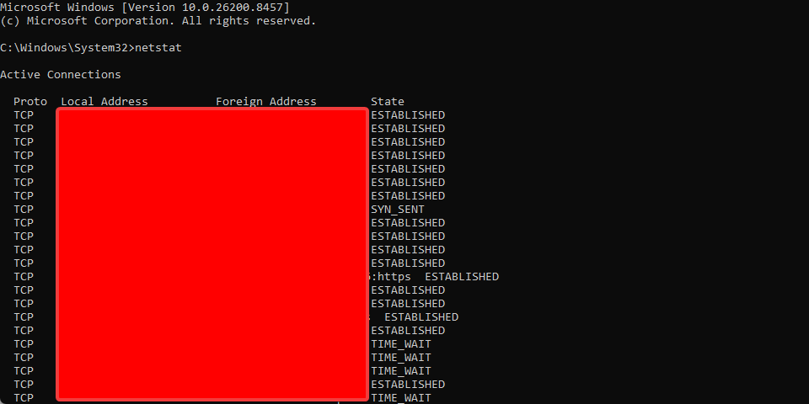
Figure 11: Windows CMD – netstat

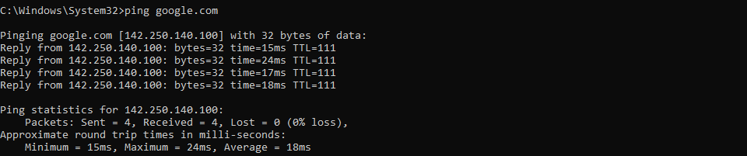
Figure 12: Windows CMD - ping google.com
For user management, whoami will identify any logged in users on a single machine, while net user will display local user accounts, this command can be modified with additional parameters to create, modify or remove accounts utilising the terminal.
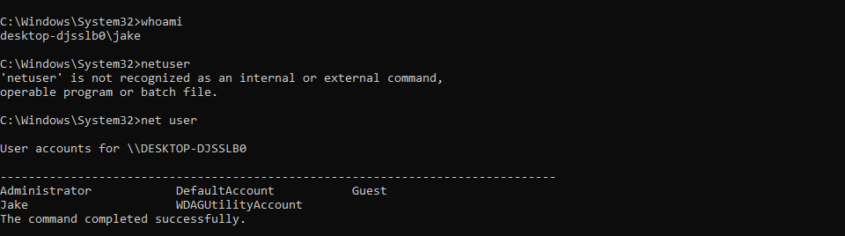
Figure 13: Windows CMD - net user & whoami

Linux OS CLI Commands
Within Linux distributions, the command-line interface is heavily relied on for system administration, automation and troubleshooting.
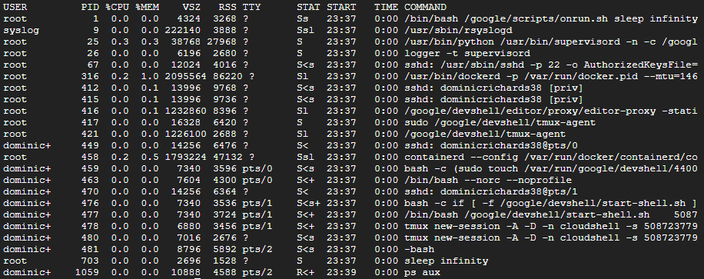
Figure 14: Linux ps aux
The Linux ps aux bash command displays a list of currently active processes, including CPU and memory usage by each process.
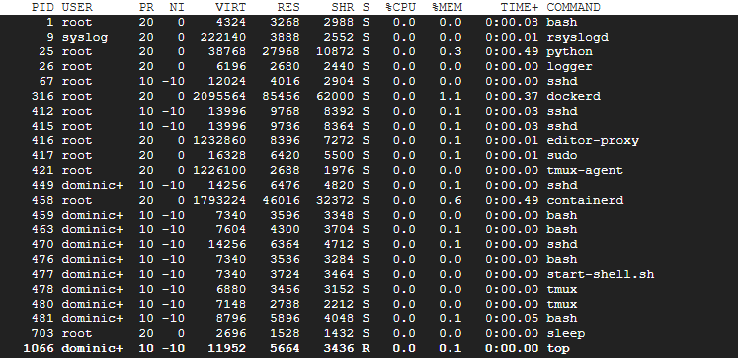
Figure 15: Linux top
Linux’s top bash command displays all active processes with active CPU and memory usage with the runtime of each process.
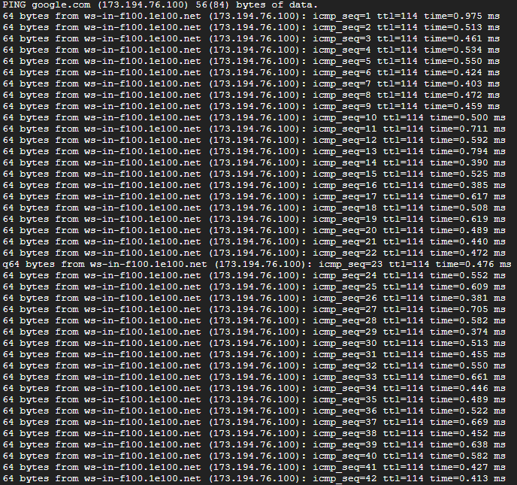
Figure 16: Linux ping
Very similar to how a Windows command line operates, the Linux bash ping command allows administrators to identify key network connectivity issues straight from a command line interface.

Conclusion
All in all, operating systems across all computer systems play a pivotal role in managing hardware, software and user interaction. The key functions of each OS (process, memory, file and device management) all demonstrated the key metrics for maintaining system performance and stability for users interacting either through command-line interfaces or graphical user interfaces.
The use of command-line interface tools within Windows and Linux such as ping, taskkill, ipconfig, top and ps aux all demonstrated the core functions to effective management of a computer system as an administrator in the event troubleshooting is required.

Appendices

Tutorial Activity
The Operating System is a critical piece to managing hardware, software resources and communication between the end-user and devices. There are several different types of operating systems that are designed with various purposes and requirements dependent on the use case or environment.
The Desktop Operating System operates using a graphical user interface which is commonly found inside personal computers and laptops. Operating systems may include Windows 11, macOS and Ubuntu. All of these operating systems utilise features such as multitasking, file management and support for a wide range of educational, business and entertainment applications. [7]
On the contrary, large scale businesses may require the use of a server operating system, these systems are designed to support multiuser authentication, management of network connections and provide centralised services such as file sharing and databases. These would include operating systems such as Windows Server 2019 and Ubuntu Server [8]
In recent years, mobile phones have adopted the graphic user interface for general use and connectivity with the outside world. These operating systems were designed with touch-screen compatibility, wireless connectivity and mobile applications while providing security and optimised battery performance. [9]
Finally, embedded operating systems are lightweight and purpose built designed to work inside specialised devices such as ATMs and vehicles. The OS is optimised for limited hardware resources and dedicated tasks. [10]

Cisco Networking Academy - Operating Systems Basics
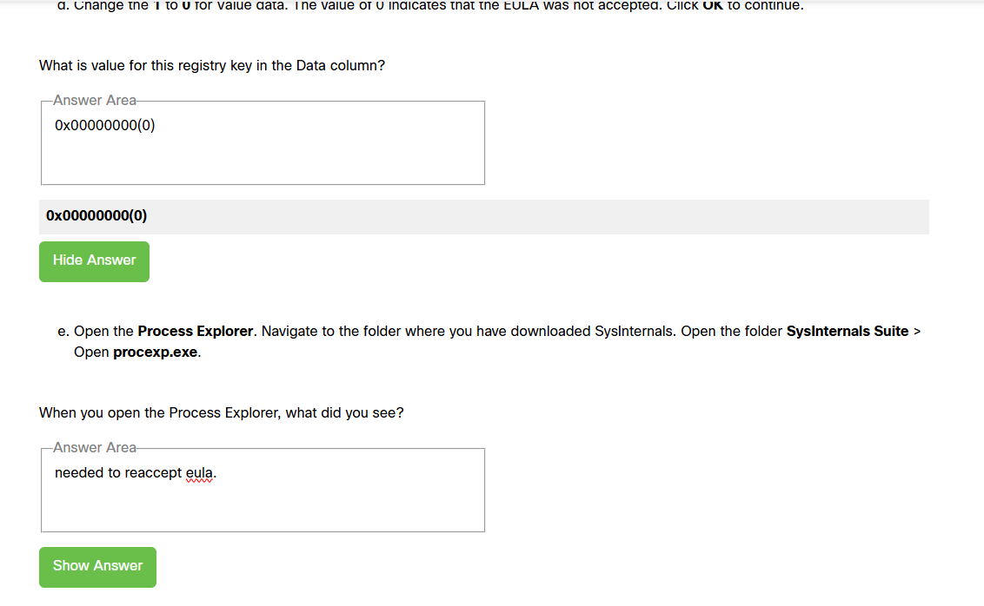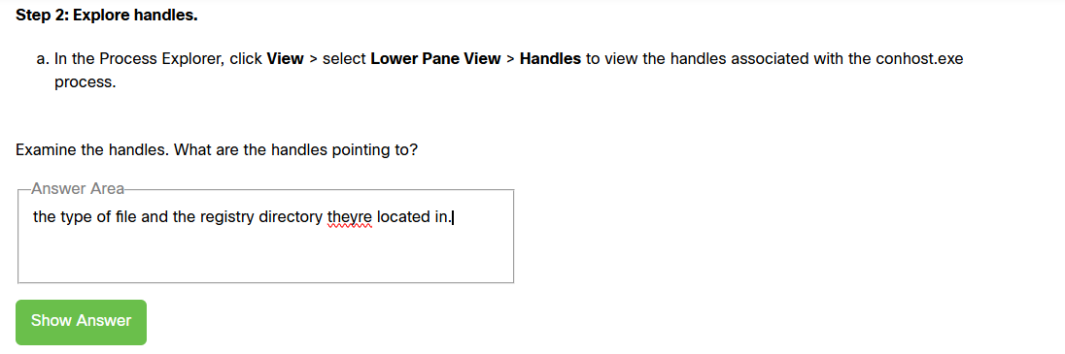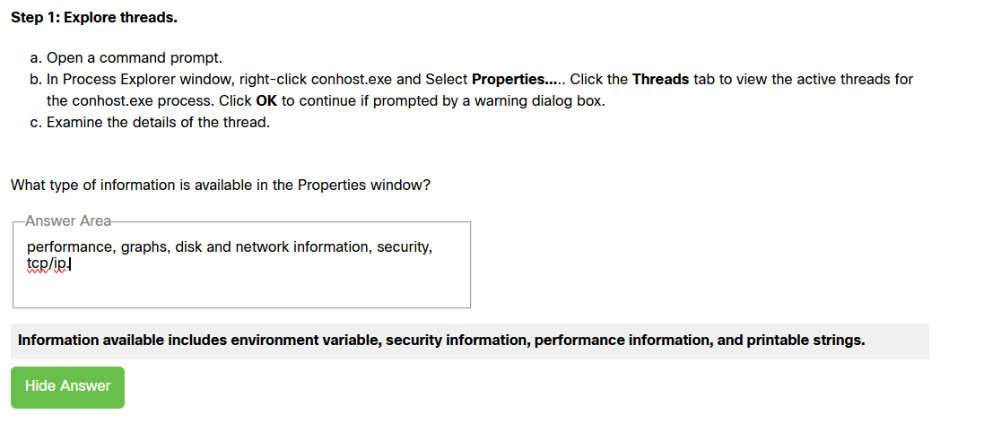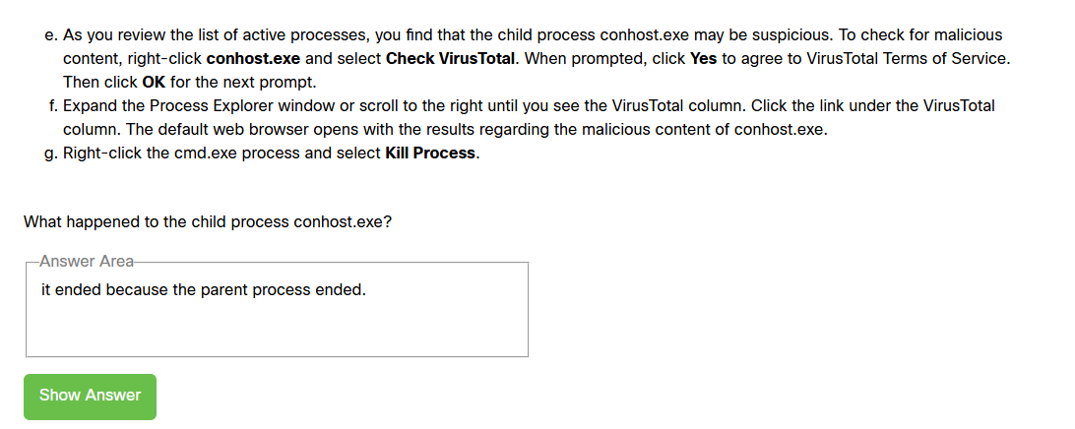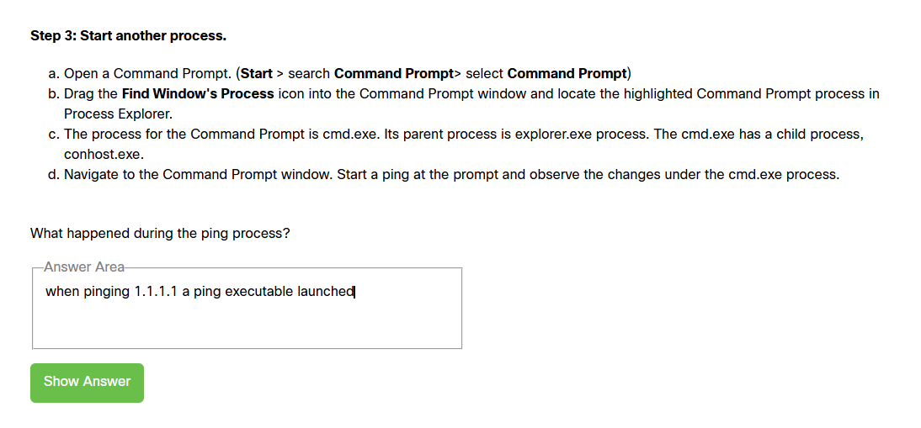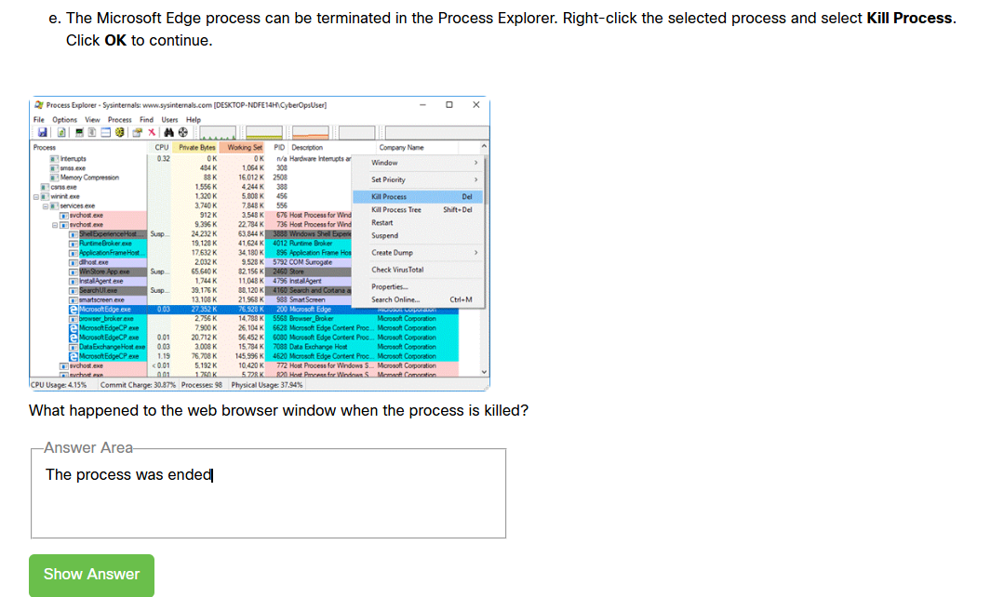
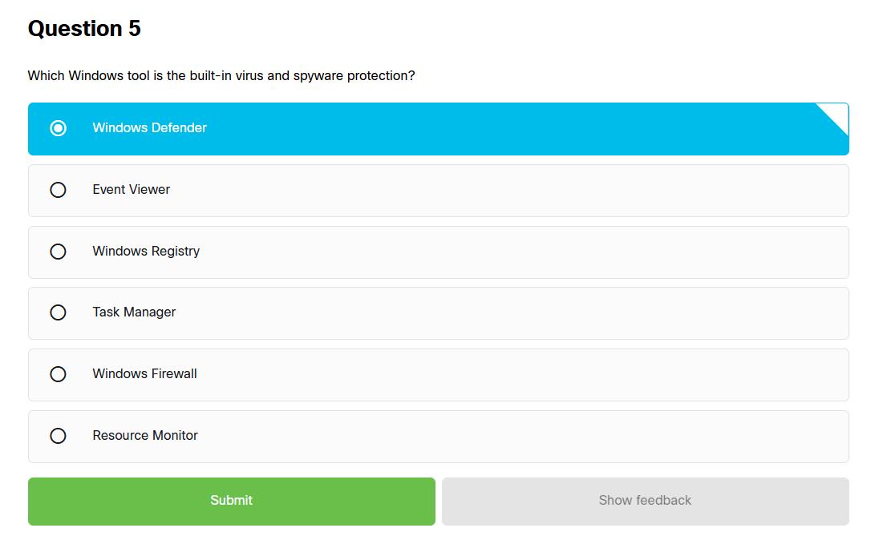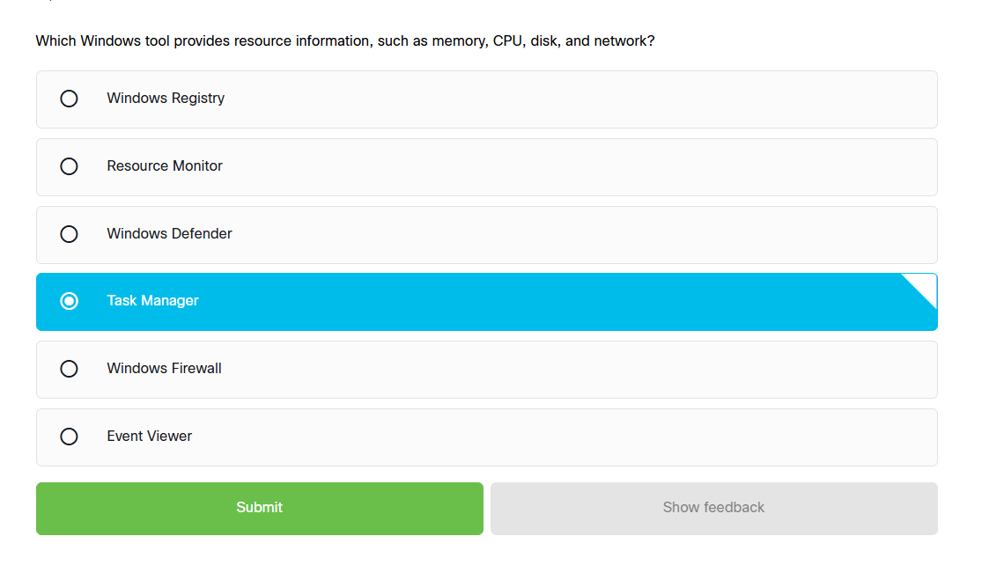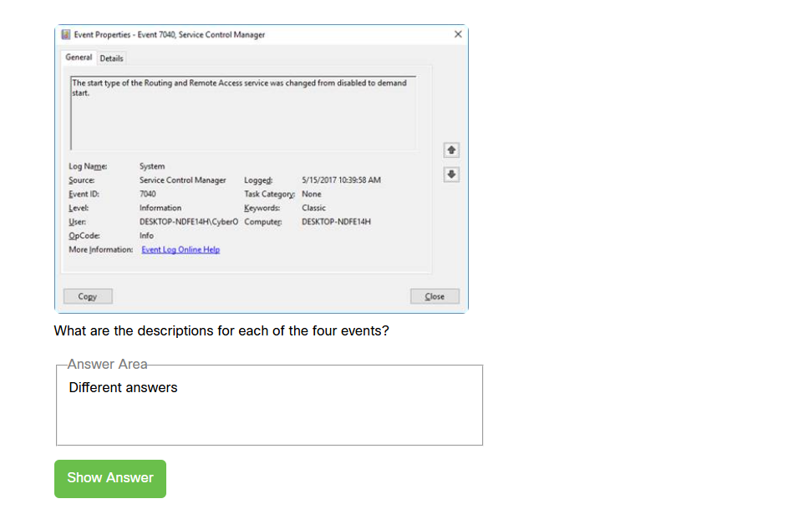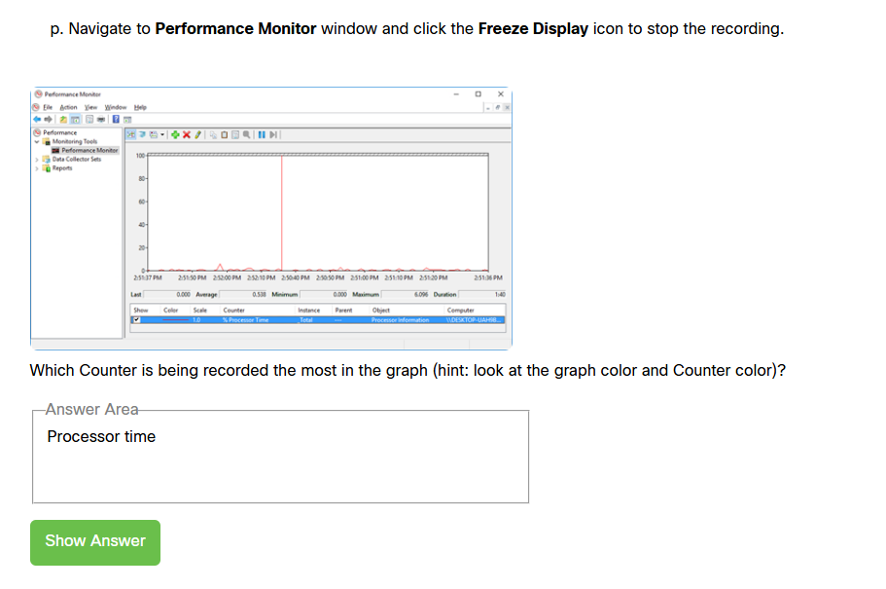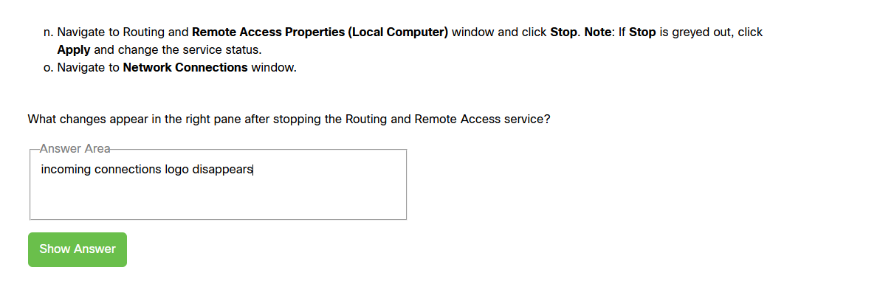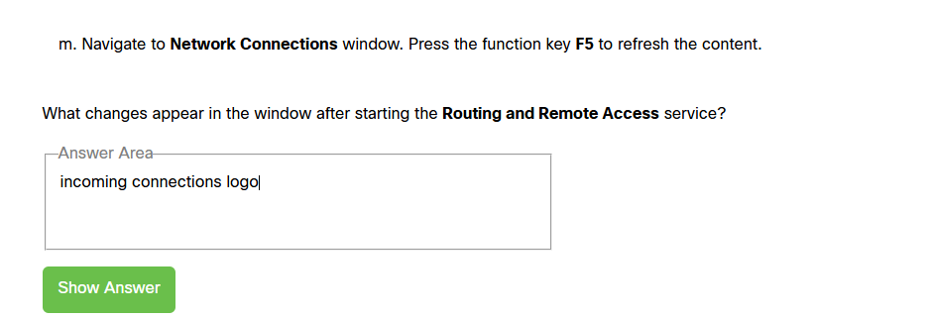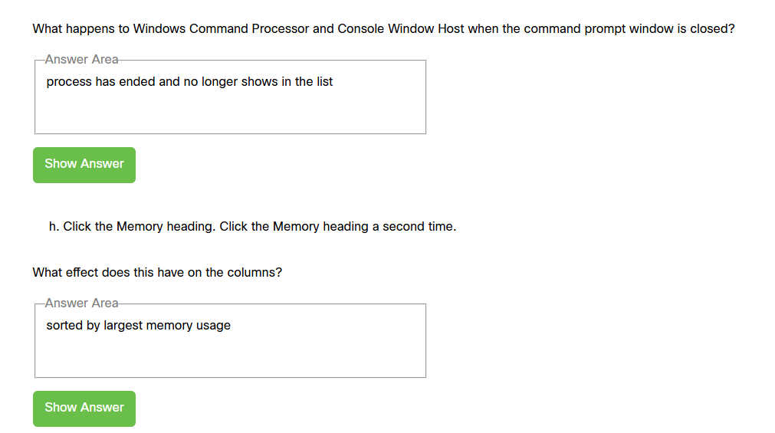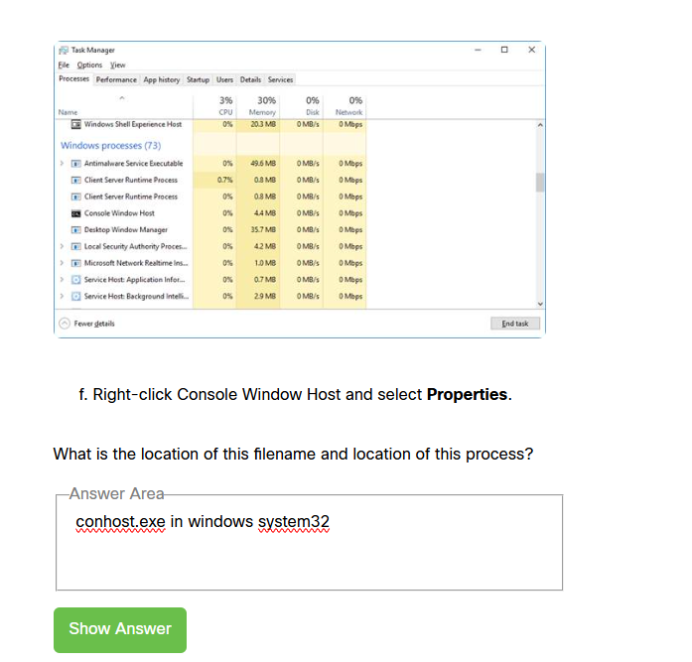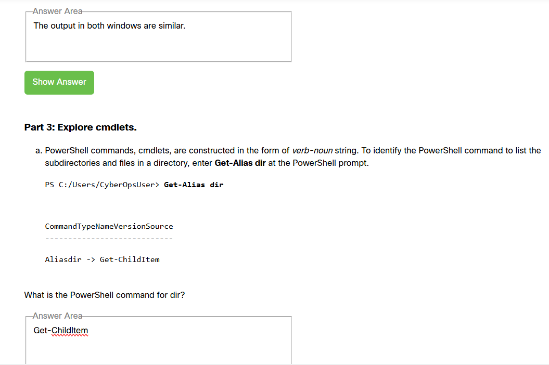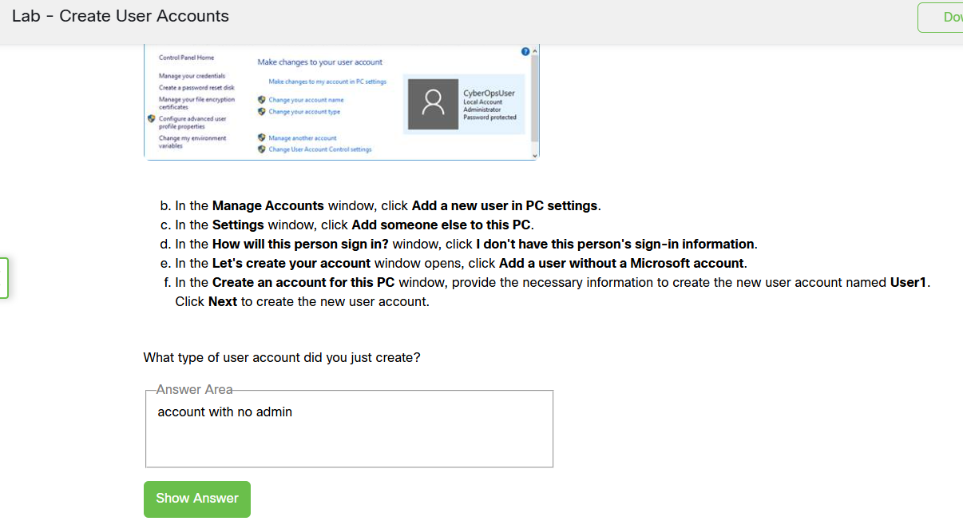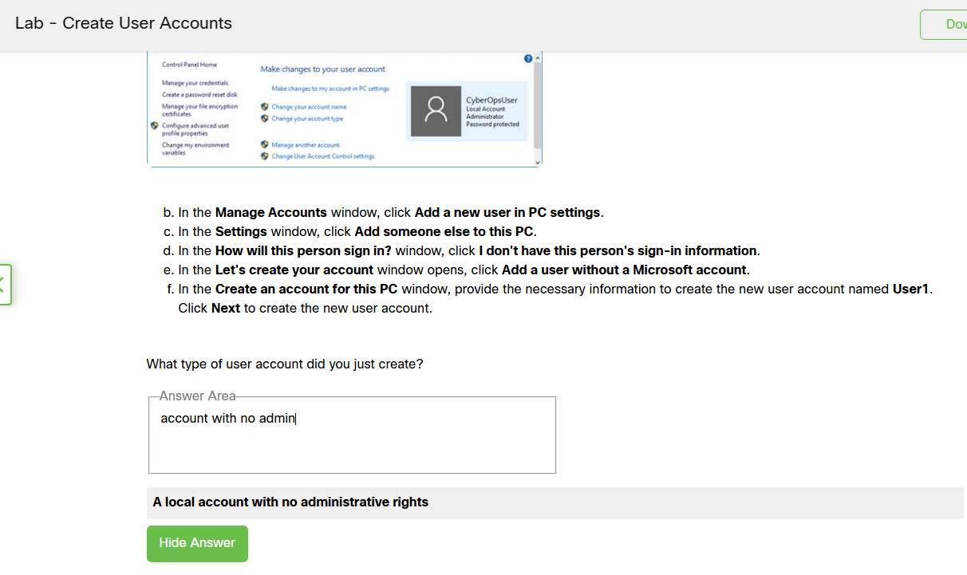

References
[1] "Introduction of Process Management." Accessed: May 12 2026. [Online]. Available: https://www.geeksforgeeks.org/operating-systems/introduction-of-process-management/
[2] "Memory Management in Operating System." Accessed: May 12 2026. [Online]. Available: https://www.geeksforgeeks.org/operating-systems/memory-management-in-operating-system/
[3] A. Pain. "A Comprehensive Guide to File Management in Operating Systems." Linkedin. Accessed: 12/05 2026. [Online]. Available: https://www.linkedin.com/pulse/comprehensive-guide-file-management-operating-systems-aritra-pain-cwkcf
[4] "Device Management in Operating System: Types & its Functions." Accessed: May 12 2026. [Online]. Available: https://www.ccbp.in/blog/articles/device-management-in-operating-system
[5] "Operating System Security." Accessed: May 12 2026. [Online]. Available: https://www.geeksforgeeks.org/operating-systems/operating-system-security/
[6] Windows Learn. "Windows Commands." Microsoft Learn. Accessed: 12/05 2026. [Online]. Available: https://learn.microsoft.com/en-us/windows-server/administration/windows-commands/windows-commands
[7] Microsoft. "Microsoft Windows." Accessed: 13/05 2026. [Online]. Available: https://learn.microsoft.com/en-gb/windows/
[8] "Ubuntu Server documentation." Accessed: May 13 2026. [Online]. Available: https://ubuntu.com/server/docs/
[9] "Mobile Operating Systems Explained and Compared." Accessed: May 13 2026. [Online]. Available: https://www.uswitch.com/mobiles/guides/mobile-operating-systems/
[10] "What is an Embedded Operating System?" Accessed: May 13 2026. [Online]. Available: https://www.techtarget.com/iotagenda/definition/embedded-operating-system

