Assignment Three
Site Analysis – Karahan Tepe
January 2026 - J McConaghy
______________________________________________

Approaching Karahan Tepe in our times is usually a dusty and dry experience. You might pass local herdsmen and their goats or maybe meet families that have come down from the nearby Karaca Dağ mountains to graze their flocks (Çelik, 2000a. p.6). This rural site was named after a nearby field, since it was nameless on discovery (Celik, 2000a, p. 6), and the name Karahan Tepe translates to ‘Stone Hill’ - a very unassuming moniker given the surprises the site would offer.
Situated at a height of 705 metres above sea level in the TekTek mountains of southeastern Anatolia, the site covers an area of 13.23 hectares (Collins, No Date, p. 1) high above the Harran plain to the east (Collins, 2024) with the nearest urban centre being Şanliurfa. Considered a sister site to Karahan Tepe, Göbekli Tepe lies only 37km to the northwest (Collins, No Date, p. 1). Discovered in the mid-1990s by Bahattin Çelik carrying out survey works (Çelik, 2011), the site only began to give up its secrets in 2019, when Prof. Dr. Neçmi Karul began excavations (Karul, 2021).

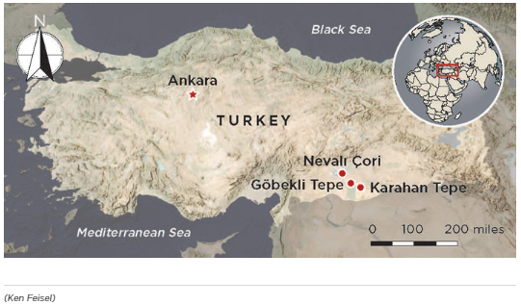
Image 1: Location of Karahan Tepe in relation to Nevali Çori and Göbekli Tepe
Photographer: Ken Feisel for Archaeology Magazine
Can be found here: Features - Last Stand of the Hunter-Gatherers? - Archaeology Magazine - May/June 2021
Accessed 27/01/20226

A journey to the site in Neolithic times would have looked far different – lush deciduous forests existed, harbouring oak, willow, walnut, pine, fir, olive and juniper trees (Peters et al. 2005; cited in Biltekin, et al., 2024, p.304) and an array of animals, some of which we would recognise today - wild boar, deer, gazelles, foxes, badgers and jackals - along with others we might not; wild cats, aurochs and mouflon (Siddiq & Ozkaya, 2024, p. 4). Conditions were favourable for small rodents and other mammals as well as birds and, in the swamps of the lower lands fed by the melt waters of the changing climate, fish and amphibians (Peters et al. 2005; cited in Siddiq & Ozkaya, 2024, pp.7-9).
Average daily temperatures in the region during the period that the site was in use for -approximately 1,400 years from 9400 BCE (Oguz, 2025) - varied between 14.5 and 19 degrees Celsius, with rainfall a generous 675mm to 950mm according to paleoclimatic evidence. The period spanning 9500BCE to 6200BC was one of the wettest the area has ever seen (Roberts et al. 2008; Turner et al. 2010; cited in Siddiq & Ozkaya, 2024, p.4). The rainfall and the mild temperatures created meadows and pastureland, grassy plains and the aforementioned cool wooded forests (Turner et al 2010; sited in Siddiq & Ozkaya, 2024, p.4); the meltwaters from the higher hills turned into wide rivers and tributaries including the Tigris and the Euphrates, creating bogs and swamps in the lowlands (Siddiq & Ozkaya, 2024, p. 4).
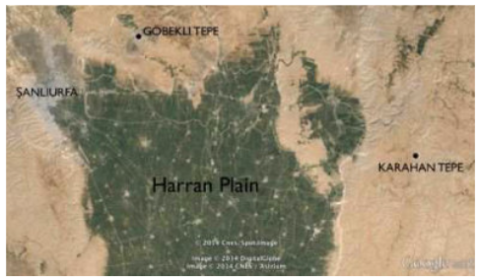
Image 2: Map showing Karahan Tepe in relation to the Harran Plain
Photographer: Digital Globe/CNES/ Astrium, ©
2014
Available at (3) Karahan Tepe: Göbekli Tepe's Sister Site - Another Temple of the Stars?
(Collins, No Date)
Accessed 27/01/2026
When considering the geography of the ‘hilly rather than mountainous’ plateau (Karul, 2021) Prof. Dr. Neçmi Karul, suggests that the valleys running through the TekTek mountains could have been used as ‘convenient hunting grounds’, by manufacturing walls at one end thus blocking the movement of the prey (Karul, 2021, p. 22). Without a doubt, the conditions described certainly give the impression of a plentiful land with enough resources to sustain the large populations that gathered here. As pointed out by Karul, in order for the Taş Tepeler sites to exist, there must have been ample food sources to attract and sustain populations the size of which were needed to create the sites themselves. Feasting was already a common human phenomenon during the Epipaleolithic period (c. 20,000-10,000BCE) for social and ritualistic purposes (Munro and Grossman, 2010; Byrd 2005; Twiss 2008; cited in Biltekin, et al., 2024) and one can suppose that the drive to come together in even bigger groups was a natural development of what had already been happening for over ten thousand years.
Leaving these lush grasslands, forests and rivers behind to the west, any visitor or resident wanting to visit Karahan Tepe would have needed to climb the hills leading up to the site. A cooler journey than we would likely have today, with perhaps a bit of rain would have made the ascent less arduous.
Smoke rising from dwellings ahead would have signalled that you were approaching the site itself. A cluster of approximately thirty domestic spaces built side by side almost as extensions of one another in a honeycomb fashion have recently been discovered (Buyukyildirim, 2025). Carved from the bedrock and dry-stone walled into shape, these spaces range from 3 metres to 6 metres in diameter, in a roughly oval shape and blending domestic and sacred features. Hearths were found, as well as stone platforms, grinding tools and recesses in the walls (Buyukyildirim, 2025). These appear to be evidence that people settled here for long periods, marking a shift from their previous hunter-gatherer lifestyles. Stone hearths to gather around and keep warm in colder weather, grinding tools to process the wild emmer and einkorn found nearby – evidence of this exists at nearby sites such as Nevali Çori (Biltekin, et al., 2024), alcoves to store tools and food items in (Buyukyildirim, 2025). I find this small detail very telling – instead of having to ‘travel light’ from one hunting location to another, people were able to collect and gather useful and meaningful items, as well as storing foods that might be scarcer at certain times of the year.
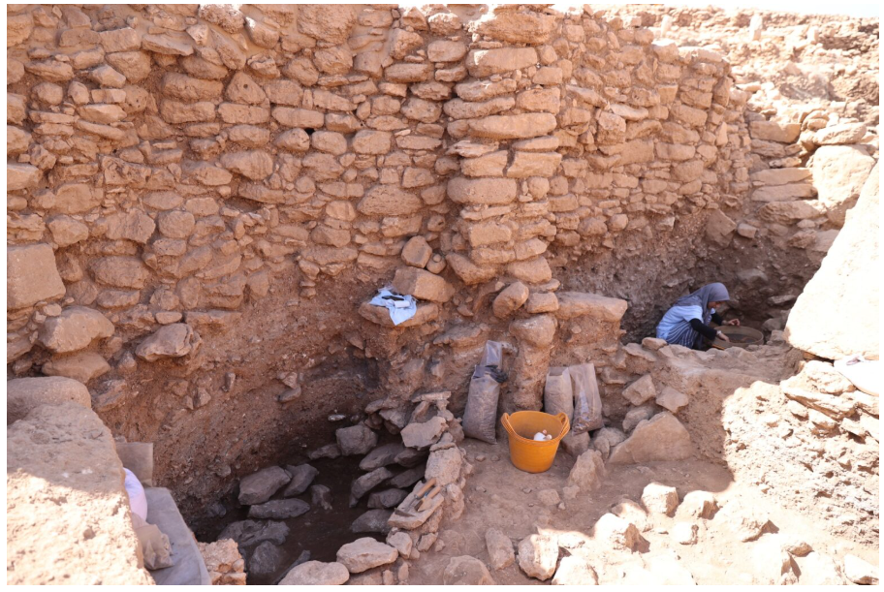
Image 3: The interior of one of the dwelling spaces, during excavation.
Photographer: Eşber Ayaydın for Arkeonews
Available at Archaeologists Unearth 30 Neolithic Homes at Karahantepe, Revealing Daily Life and Diet of Early Settlers - Arkeonews
Accessed 27/01/2026

Clustered close together, with no space between them, the dwellings were built adjacent to the south and east of one of the communal spaces. T-shaped pillars have been identified within, possibly as a ritualistic or spiritual feature, showing that the spaces acted not only as protective homes, but also spaces where the sacred was considered (Ministry, n.d.). The lack of space between each dwelling means that they must have been accessed from the roof, echoing the architectural style of Çatalhöyük (Bosch, 2018, p. 2). The Karahan Tepe dwellings were built in alignment with the slopes of the hill itself, leading one to imagine a terraced collection of roofs, possibly made of perishable materials and no longer existing at the site. Despite the lack of material evidence, the roofs must have been robust enough to walk on given that they provided access to the space below. Perhaps people used the roofs as additional spaces to sleep, eat or socialise, as seen in Çatalhöyük (Bosch, 2018, p. 2).
Excavated by Prof. Dr. Neçmi Karul in 2019-2020, four unusual subterranean spaces were discovered (Karul, 2021), each with a very distinct character. The largest of these, labelled AD and referred to as the Great Ellipse by Andrew B. Collins (Collins, 2024, p. 3), is 23 metres in diameter. Half of this large space was created by carving out the bedrock directly, creating benches and stone supports from the hill itself, while the remaining half was created with dry-stone walling at a thickness of 1.5 meters. Again, we see T-shaped pillars around the circumference of the enclosure and benches extending along the remaining walls (Karul, 2021, p. 23). The size of this structure sets it apart from the adjacent, much smaller dwellings previously discussed.
At the northernmost end of the bedrock bench is a small opening into another inter-connected space – referred to by Andrew B. Collins as the Pillars Shrine (Collins, 2024, p. 5) but formally labelled as AB on site plans. Karul asserts that ‘It is clear that Str.AB was built for special purposes’ (Karul, 2021, p. 24) and this is striking on first sight of this very unusual space. Carved entirely from the bedrock and existing wholly below floor level, this pit contains some strange features. Eleven pillars stand perpendicular to the floor, ten of them appearing to be phallic-shaped and, again, created from the bedrock itself. One in the centre is different – flatter, crescent shaped and formed separately and slotted into the floor. A clearly human head seems to stretch out from the western wall, three times larger than life size and inclined slightly to face towards the entrance from AD.
The third inter-connected shrine, or pit, is labelled as AA, and Collins names it the Pit Shrine (Collins, 2024, p. 9). Accessed via a gap in the north eastern wall of the Pillars Shrine, this space is, as the name describes, a deep pit, with further pits found in the floor – two smaller ones adjacent to one another below what appears to be a bench in the upper portion of the wall, and one larger irregular shaped pit in the northern half of the space (Collins, 2024, p. 9). What is interesting about this structure is a large horizontal snake carved along the front of the length of the aforementioned bench.
The final space, not directly connected to the previous three, is structure AC. Lying approximately 20 metres northeast of the Pit Shrine AA (Collins, 2024, p. 15), this is a much less developed construction than its neighbours. A basic excavation by the neolithic builders of part of the hill has created a semi-circular bench (Collins, 2024) resembling a look out point.
I have outlined the basic construction and physical appearance of these four constructions, but what can they tell us of the people that used them and experienced them? Andrew C. Collins has laid out some very interesting ideas in his article ‘Karahan Tepe – Its Three Interconnected Structures Examined’ written in 2024.

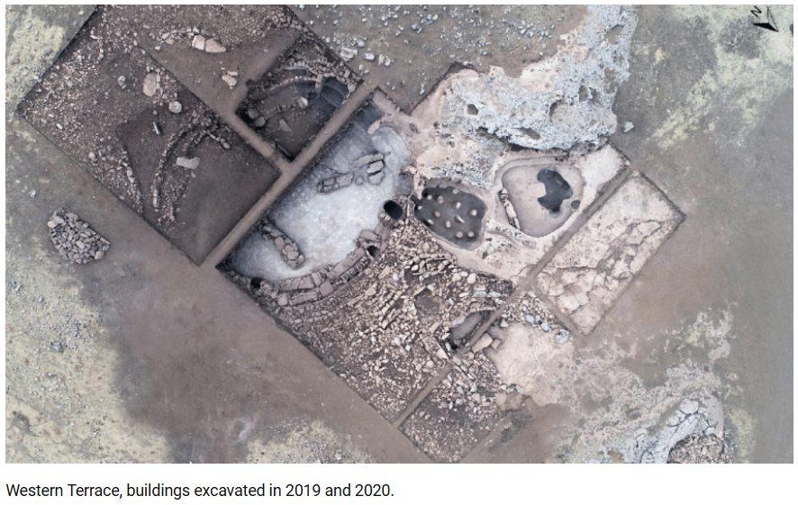
Image 4: Western Terrace aerial view, showing the half excavated Structure AD, and adjoining AB and AA.
Photographer: Neçmi Karul in ‘Buried Buildings at Pre-Pottery Neolithic Karahantepe’
Available here: (3) Buried Buildings at Pre-Pottery Neolithic Karahantepe/ Karahantepe Çanak Çömleksiz Neolitik Dönem Gömülü Yapıları / 2021
Accessed 27/01/2026

He believes that the start point for use of these would have likely been AD, the Great Ellipse, the largest and most clearly a gathering space. The seating around the perimeter predisposes the site to being that of a communal space where large numbers of people would gather, with these seats being interspersed with eighteen T-shaped pillars (Collins, 2024, p. 2). Some of the benches appear to be more elaborate than the others, flanked with buttresses carved with possible leopards, or at the very least, leopard pelts. One of the benches clearly appears to be a recycled T-shaped pillar, which seems peculiar to me that some are revered, and others considered simply useful material products. It raises the question of what changed in their use and regard to have been downgraded to mere seating? Collins goes so far as to suggest that these are almost throne-like in their appearance and wonders if this might have been where the community elders or leaders of some description took their places to oversee proceedings (Collins, 2024, p. 3). I am inclined to agree – it seems obvious that a larger, more elaborate space would indicate that a person perceived as more important would use it. We can use direct modern parallels – a bride and groom sit at the ‘top table,’ kings or queens even today have thrones, and box seats sell for a premium at concerts, sporting events and theatre performances. We might at this point be able to also address the issue of using T-pillars as seating – an important and valued piece of stone to match the perceived importance and value of the person using it.
So, the start point, according to Collins, would have been here, in this Great Ellipse, filled with familiar faces from the community and presided over by leaders of some kind. It isn’t possible to know what happened during those ceremonies, but we can suppose that the inter-connectedness of the structures indicates that they were all somehow involved in what was taking place.
In the northwest corner of the Ellipse, adjacent to the end of the elders’ bench, is a small gap. A stone frame, known as a porthole, was found here and placed in the gap would have created a space no bigger than 70 centimetres to crawl through to access the next space, the Pillars Shrine (Karul, 2021 p.23). On the other side of the porthole, five rough steps are carved from the bedrock, leading down to the floor of the Shrine (Karul, 2021 p.23). In my opinion, the Pillars Shrine in any light, at any time of day and under any circumstances, whether roofed or not, would have been an intense and potentially claustrophobic experience. Likely in darkness, descending on slippery steps after leaving the safety of the larger gathering space by squeezing through a small gap, you arrive in a dank pit. You might be aware of a strange change in the quality of sound as it bounces around the pillars. Your passage from one end to the exit at the farthest end, would be dictated by these phallic-shaped pillars, ranging from 1 to 1.7 metres in height (Collins, 2024) and there would have been no avoiding them. Forced to walk around them and between them, watched by the enormous head 2 metres above you (Collins, 2024, p. 11) it must have been a disturbing experience. I am free of the preconceptions of what this structure might have symbolised to the people of the time but adding another layer of myth, and stories of previous encounters in there must have created a charged atmosphere, and possibly distressing experiences inside the Pillars Shrine. To take the scenario further, being met inside by a spiritually powerful person, not unlike a shaman, perhaps under the influence of mind-altering substances yourself, and maybe surrounded by chanting or drums, you would feel as though you had entered a different dimension of some kind. The alternative is that you are alone, and there is silence inside the pit. Either possibility would have left a psychological mark on you.
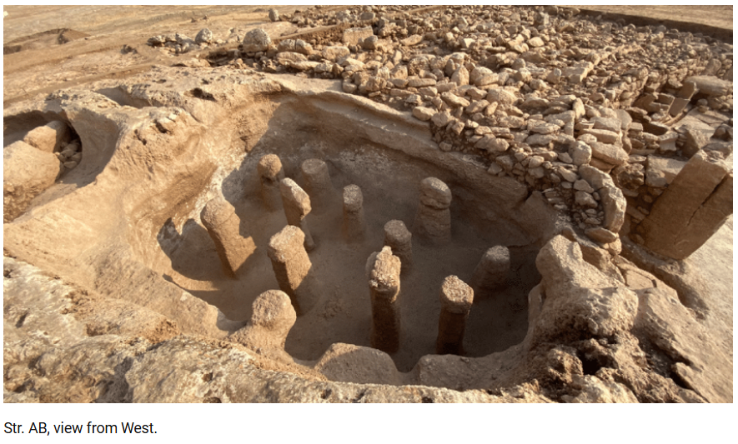
Image 5 : Structure AB, The Pillars Shrine, showing the eleven pillars and the back of the stone head on the western wall.
Photographer: Neçmi Karul for ‘Buried Buildings at Pre-Pottery Neolithic Karahantepe’ by Neçmi Karul.
Available at (3) Buried Buildings at Pre-Pottery Neolithic Karahantepe/ Karahantepe Çanak Çömleksiz Neolitik Dönem Gömülü Yapıları / 2021
Accessed 27/01/2026
Curiously, a winding channel or groove in the bedrock connects the Pillars Shrine, AB, to the Pit Shrine, AA. Karul describes this as a ‘serpentine channel’ (Karul, 2021 p.24) and certainly the whole site of Karahan Tepe abounds with snake iconography – the Pit Shrine itself has a long carved snake beneath the upper bench, visible to those in the pit itself, but, visible only from above are two large boreholes on the upper face of the bench, clearly creating an image of a serpent’s eyes when seen in combination with the aforementioned snake etched into the rock above you (Collins, 2024, p. 11).
It seems that whatever occurred in this structure, AA, was watched. The long bench above the pit invites imagery of an observer, or observers, paying close attention to what was happening below them. Collins himself asks questions of the Shrine – who sat on the benches? Did people descend from the bench? Or was the pit a pen of sorts for some kind of animal, perhaps snakes? He sees analogies with Karul’s ‘serpentine channel’ (Karul, 2021 p.24). He also recognises that it may well have been used to move liquid of some kind from AA to AB - a slight rise in the channel makes this more challenging, but certainly technically possible (Collins, 2024, p. 12).
Other significant features of this third space are further deep pits sculpted out of the ground, two smaller ones beneath the carved snake, a larger one at the opposite end, and a recess, large enough to crawl into, in the side of the pit (Collins, 2024, p. 11). Could these have been used to hold snakes perhaps? Or did someone wait in them? Or did participants crawl into them, forming part of the ritual that took place here? They may be burials, although there is no remaining evidence that this is the case. However, as we will see later, all of these shrines were deliberately back-filled (Karul, 2021),so might human remains have been disinterred at this point and moved with the population to wherever they went? We can only speculate at this point. Perhaps the answers will reveal themselves as more of the site is uncovered.
The fourth structure invites less scholarly discussion, but I find it very engaging. Structure AC is another curved bench chiselled once again from the bedrock of the site. It is a little distance away from the previous three, about 20 metres to the north east (Karul, 2021), so still conceivably part of the processional arrangement.
It is at this point that I would like to provide an alternative view of how the chambers might have been used. Both Collins and Karul agree that the order of direction begins at the large communal space, AD, and proceeds through AB, the Pillar Shrine, and into AA, the Pit Shrine (Collins, 2024) (Karul, 2021 p.25). It is at this point, from a phenomenological perspective, I wonder what may have happened next. After enduring what, to my mind, may well have been a distressing experience, you emerge to the north of the Pit Shrine. From fetid pits, possibly containing snakes or other animals, maybe encounters with other-worldly beings, possibly alone or observed from above, you will have experienced something very extraordinary. Stepping outside once again into fresh air and a starlight sky, it might be at this point that you are met with your kinfolk and reassured. Maybe there is a further ceremony held at the bench AC. I do wonder, however, if the processional order might have also worked in reverse, starting with a small gathering at AC and culminating in a large ceremony in AD, the Great Ellipse. Surely an experience of this magnitude would have incited celebration, community effervescence, a sense of shared belief. Instead of distress, maybe emerging from the porthole between the Pillars Shrine and the Great Ellipse created a sense of relief and belonging. Maybe the sounds of the people gathered might have galvanised and strengthened the resolve of whoever was enduring the procession through the three enclosures. And just maybe, that chink of light from the fires in AD, visible certainly from the Pillars Shrine, might have been viewed as a rebirth to the living world again.
There is another angle to explore when considering the construction of these enclosures, which is that of the possible celestial alignment of the site. In ‘Reconstructing Karahan Tepe’s 11,400-year-old Winter Solstice Alignment’ by Hugh Newman and J.J. Ainsworth 2024, they describe observing the Winter Solstice crossing the face of the human head inside the Pillars Shrine, AB. They used technology to recreate the night sky in 9000 BCE, and state that this ‘would have illuminated the head more completely’ (Newman & Ainsworth, 2024, p. 2). They also propose that the pillars in AB could have corresponded to the lunar months, with the stone head representing one, the eleven pillars, including the anomalous central one, bringing the total to twelve, and adding on epagomenal days to account for soltices and equinoxes (Newman & Ainsworth, 2024, pp. 5-6)
Problems arise with this theory when you consider whether or not the structures were roofed. As has been seen with the honeycomb dwelling structures, roofs must have existed – the climate was wetter than today and there are no gaps between the buildings, necessitating access via the roof. But did the larger communal structures also have roofs? It has been suggested that the arrangement of T-shaped pillars – take for example the structure AD, the communal Great Ellipse, where eighteen pillars are secured into the perimeter wall – could have acted to support roofs of some description. We have already learnt that the site was close to deciduous forest containing an abundance of building material – would the builders of the site not have taken advantage of this to protect their creations? Yet no traces of wood have been found at the site. Newman and Ainsworth nevertheless theorise that either non-permanent roof structures, or possibly a roof with a gap between two of the T-shaped pillars aligned with the stone head in AB, would have allowed coverage of the enclosure and could still have accommodated the winter solstice sunrise and its interaction with the stone head of the Pillars Shrine (Newman & Ainsworth, 2024).
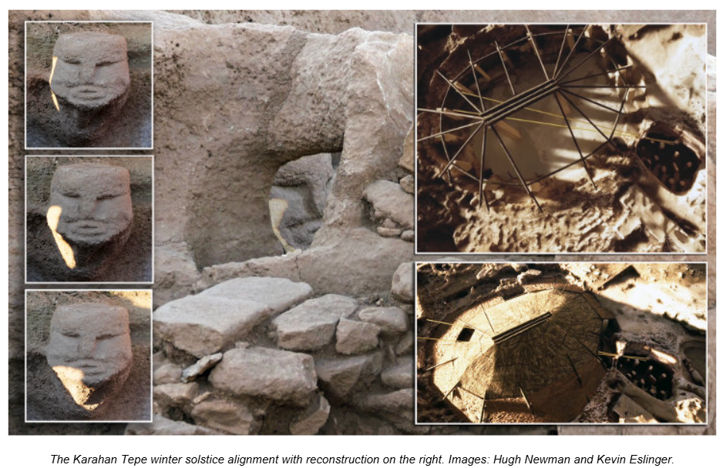
Image 6: Winter solstice sunrise passing over the ‘Stone Head’ inside Structure AB. Created images of potential roof arrangement at Structure AD.
Photographer: Hugh Newman/Keving Eslinger for ‘Reconstructing Karahan Tepe's 11,400-year-old Winter Solstice Alignment by Hugh Newman and JJ Ainsworth
Available here: (3) Reconstructing Karahan Tepe's 11,400-year-old Winter Solstice Alignment
Accessed 27/01/2026

One further exciting discovery has recently been uncovered at the site – a large enclosure, closely resembling what we might recognise as an amphitheatre. Approximately 17 metres in diameter, the structure houses tiered stone benches and contained a number of human sculptures and carved heads secured into the walls. What is perhaps most interesting about this amphitheatre-style construction though, is the appearance of the human statues and heads found within. Oguz proposes that this demonstrates a significant shift in the mindset of those living at Karahan Tepe – a move away from the animal-centred imagery commonly found at the site, towards a more anthro-centric view (Oguz, 2025). Does this space tell us of a people who were no longer wholly reliant on the whims of nature to sustain themselves? That they recognised that they were able to control and manipulate the environment to better manage resources and thus their own survival? Karul believes that the purpose of the space was social, involving the whole community. He frames it as a building designed to facilitate society, a space where peole could manage the new demands put upon them by living together in larger groups, namely ‘cooperation, resource management, leadership, and shared cultural practices (Oguz, 2025)’ as well as being a place where the bonds of community are built, where large ceremonies might be held, stories told, people listened to and community decisions made (Oguz, 2025). This space could well have been where the first large, complex societies were forged, where we first learned to live for long periods alongside others, beyond the traditional small bands of nomadic hunter-gatherers of the past.

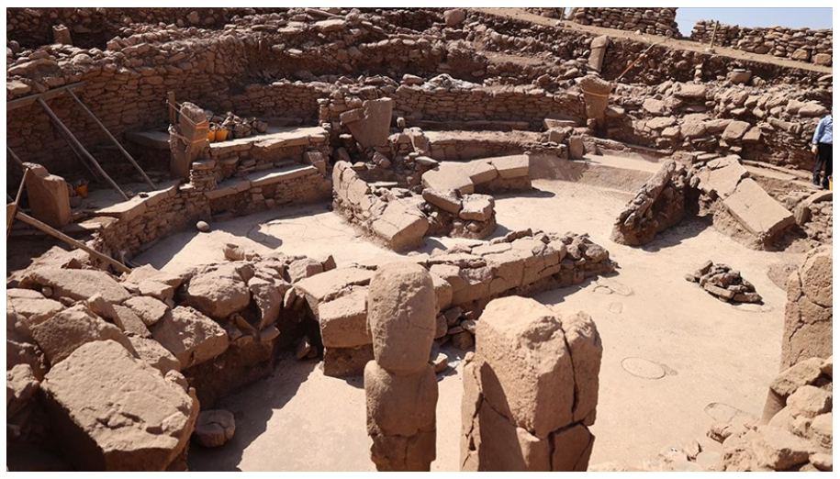
Image7 : The amphitheatre-style structure, showing tiered benches and human statue in the foreground.
Photographer: Eşber Ayaydin for Arkeonews.
Can be found here A 11,000-Year-Old Neolithic “Amphitheater” Discovered at Karahantepe - Arkeonews
Accessed 27/01/2026

Karahan Tepe was occupied for around 1400 years, and those that lived there carried out one final act which has, presumably unknowingly to them, preserved the site for us. All of the previously discussed enclosures and spaces were deliberately covered up and hidden from sight – in the Great Ellipse, AD, soil levels did not align with the slope of the land, indicating that man-made processes were at hand. Steeper inclines of stone and soil around the edges and flatter deposits in the centre tell of people deliberately filling the structure from the perimeter (Karul, 2021 p.23). In both the Pillars Shrine and the Pit Shrine, the infill material was covered with large slabs of bedrock, raising it to floor level. Large stones were laid vertically at the entrance to the Pillars Shrine AB from the larger enclosure AD, appearing to be a deliberate attempt to block it. Structure AA, was similarly filled and large stones laid over it to its boundary (Karul, 2021 p.24). This intentional treatment of the site at the end of its use demonstrates a level of planning and coordination within the society (Karul, 2021 p.24). Clearly there is a purpose to this. Karul says that ‘Construction, useful lifespan, and burial of the building are parts of (the) same ritual’ (Karul, 2021 p.25). Ritualistic reasons are of course highly likely in a society such as this, who covered their stones with mysterious carvings and imagery. Maybe an event occurred that meant that they needed to leave, to erase all traces of their physical presence in the hills. Or just maybe, being some of the earliest peoples to manipulate the natural world to their own end, they wanted to leave everything just as they had found it – a fanciful idea perhaps.
I feel fortunate to live in a time when such discoveries are being made – our human story is, in part, spoken to us by the stones of Karahan Tepe and the other Taş Tepeler sites. ‘Rather than a silent ruin, the site speaks clearly: long before cities, writing, or metal, humans were already builders of community’ (Oguz, 2025, p. para 11). This quote, from Arkeonews’ November 2025 report about the newly-discovered amphitheatre-style structure, summarises the importance of the site (Oguz, 2025). The mix of domestic dwellings, ritual spaces and communal buildings tells a story of a richly cultural population that made some of the earliest transformations from small mobile groups to a larger settled society. The site gives us glimpses of a world that we might recognise today, where babies are born into a static built environment that would have become very familiar to them as they grew and became useful members of a complex, purposeful and organised community. They would have visited buildings made for specific purposes and participated in rituals, ceremonies, feasts and rites together with their kith and kin. They may even have been some of the first people to live and die in the same place; to have a safe, stable, resource-rich place to call home, from the beginning of their lives until the very end.

Works Cited
Biltekin, D. et al., 2024. Exploring Pre-Neolithic Environmental Dynamics: Paleoecology Around The Gobekli Tepe Based On A Multiproxy Approach In Southeastern Turkey, s.l.: Springer.
Bosch, E., 2018. Çatalhöyük: A Study of Light and darkness - A Photo Essay. In: Oxford Handbook of Light in Archaeology. s.l.:s.n.
Buyukyildirim, O., 2025. Archaeologists Unearth 30 Neolithic Homes at Karahantepe, Revealing Daily Life and Diet of Early Settlers. Arkeonews, 18 October.
Çelik, B., 2000a. A New Early Neolithic Settlement: Karahan Tepe. Neo-Lithics - A Newsletter of Southwest Asian Lithics Research, February/March.
Çelik, B., 2000b. An Early Neolithic Settlement in the Centre of Sanliurfa, Turkey. Neo-Lithics - A Newsletter of Southwest Asian Lithics Research, February/March.
Çelik, B., 2011. Karahan Tepe: A New Cultural Centre in the Urfa Area in Turkey, s.l.: Documenta Praehistorica XXXVIII.
Collins, A. B., 2024. Karahan Tepe - Its Three Interconnected, Rock-cut Structures Examined.
Collins, A., No Date. Karahan Tepe: Göbekli Tepe’s Sister Site—Another Temple Of The Stars?. s.l.:academia.edu.
Karul, N., 2021. Buried Buildings at Pre-Pottery Neolithic Karahantepe. Türk Arkeoloji ve Etnografya Dergisi 82, pp. 21-31.
Ministry, T. C. A. T., n.d. www.tastepeler.org. [Online]
Available at: https://tastepeler.org/en/yerlesmeler/karahantepe
[Accessed 26 January 2026].
Newman, H. & Ainsworth, J., 2024. Reconstructing Karahan Tepe's 11,400-Year-Old Winter Solstice Alignment.
Oguz, K., 2025. A 11,000-Year-Old Neolithic “Amphitheater” Discovered at Karahantepe. Arkeonews, 28 November.
Schmidt, K. & Köksal-Schmidt, Ç., 2014. Like a Carpet of Snakes – Towards an Iconography of the PPN in Upper Mesopotamia. In: Settlement, Survey, and Stone. Berlin: ex oriente, pp. 73-77.
Siddiq, A. B. & Ozkaya, V., 2024. Hunting and Fishing in Neolithic Anatolia. Archaeopress.
Ulas, B., Abbo, S. & Gopher, A., 2024. Drawing diffusion patterns of Neolithic agriculture in Anatolia. Review of Palaeobotany and Palynology, March, Volume 322.

