By
Student: Tuty Jallow Sarr - Student Number - 2027118

Module: Introduction to Physiology, Module Code BMHP5003_BIRM
Lecturer Rachael Rivers
Health Assessment Report
On Bob the Truck Driver

Table of Contents
Introduction 2
Section One: Health Assessment, Importance, and benefit 3
Health and Wellbeing Care Plan 4
Reference list 5

Introduction
Health Assessment (HA) is a way of finding out and understanding one’s health concerns on one’s physical, mental, psychological, and sexual wellbeing (Labeit, Peinemann, and Baker, 2013). HA will help improve Bob's quality of life and lower the dangers his health posed as a result of eating unhealthy food, not exercising, smoking tobacco, drinking alcohol, and no social life or interactions (WHO, 2022). As such, HA is important and should be done at least twice a year instead of when we feel ill (Stockhill, 2022). This will enable identifying and take precautions on any health concerned particularly certain diseases before it is too late (Stockhill, 2022).
In view of the above, the first section of the report will focus on a baseline health status of Bob, a truck driver based on a case study and questionnaire. Bob’s daily activities are work, smoke, and drink whiskey to sleep, and he hardly do a health checkup. Section two will evaluate Bob’s Health assessment in terms of his fitness and wellbeing; identifying any physiology, abnormal physiology health issues; evaluate and analyses truck driver lifestyle including Bob for a proper health and wellbeing care plan. Section three will deal with both short term and long-term care plan for Bob that will benefit truck drivers in general. Section four will be conclusion and way forward to help Bob and other truck drivers to live a better, meaningful, and happier life, followed by reference list.

-

Section One: Health Assessment of Bob Based on the Case Study
Bob a lonely 53-year-old man weighing 11 stones, with height 5’9. He earns his living on truck driver, who drinks whiskey, which is extremely elevated level of alcohol according to (Preedy and Watson, 2004), smoke cigarette, eat unhealthy food, and have sleep disorder. Bob’s historical information clearly indicated has a sleeping disorder which makes him to drink whiskey to put himself to sleep. He is likely to be having mental problem, the fact being he is divorced and so he is a very unhappy person and does not really have healthy routine for his life. His job is not a job that is highly active. It is a very lonely job. The most physical activity Bob does is driving a truck. All these attitudes of Bob pose a serious health implication on his physical wellbeing. The main reason to do a Health assessment for Bob in order to find out and understand health concerns on his physical, mental, psychological, and sexual wellbeing (Labeit, Peinemann, and Baker, 2013). HA is important and should be done at least twice a year instead of when we feel ill (Stockhill, 2022) as recommended by health practitioners. This will enable identifying and take precautions on any health concerned particularly certain diseases before it is too late (Stockhill, 2022).
On closer looked at Bob’s case study, he drinks alcohol, smoke tobacco, eat unhealthy food and physical inactive are biggest issues. Based on his age, height and weight, his Body mass Index (BMI) indicated (see fig 1 BMI result) (NHS,2018).
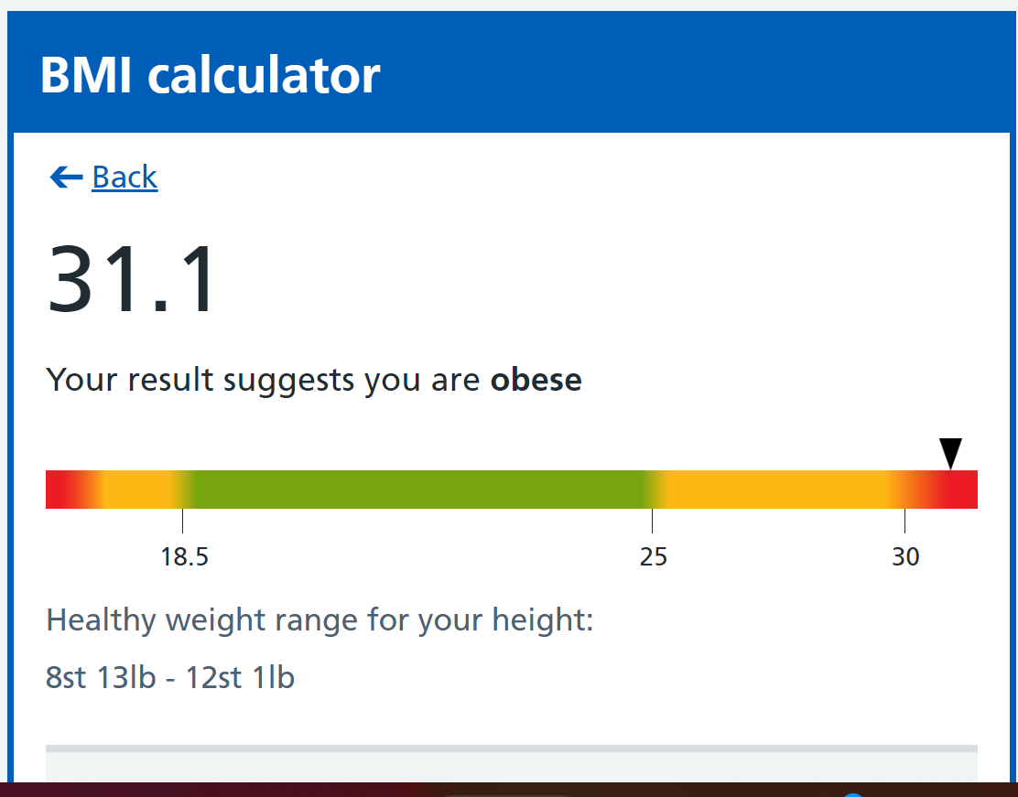 fig 1: BMI result
Based on the BMI and looking at Bob’s historical background, his physiological analysis will be dealt with in the next section.

Section two: Physiological Analysis of Bob’s Health and Fitness’
As indictive by the BMI calculator that Bob is Obese couple with his smoking and unhealth diet and physically inactive, and alcohol consumption, resulted on high blood pressure and other risk of health issues such as respiratory and cardiovascular disease (NHS, 2021).

Diet
Bob eats very unhealthy type of food not specific according to his historic information, (2022), however, he eats fast foods, and which is likely to be greasy and unhealthy, lacking required nutrients to be healthy. Probably not helping his weight 15 stones, his height being 5 feet 9 inches tall. According to NHS, (2018) health guidance he is definitely overweight and obese. According to his historical case he does not do physical activities other than driving, neither any social life. Further, Bob’s body will store a substantial portion of excess energy consumed in the form of fat and carbohydrates rather than burned off through exercise and physical activity will cause obesity (NHS, 2019). Obesity is a truck driver issue studies revealed that truck driver showed higher obesity than the national average rate (Clemes et al., 2019). Although there has not been focus on health promotion initiatives, their working conditions do not support a healthy lifestyle (Clemes et al., 2019). The NHS, (2019) guideline required that to maintain a healthy weight, the typical physically active man needs around 2,500 calories per day, whereas the typical physically active woman needs about 2,000 calories per day.

Potential Implication
In view of the above and the health questionnaire conducted on Bob’s health implied high cholesterol and diabetes borderline (NHS, 2017). Cholesterol and diabetes are primarily brought about by consuming fatty foods, failing to exercise regularly, being overweight, smoking, and using alcohol (NHS, 2017; NHS, 2018; NHS, 2019; Public Health England, 2022), which are all Bob’s main activities. Moreover, it can run in families (NHS, 2017). In addition, high cholesterol blocks your blood vessels posing the risk of cardiac arrest (NHS, 2017); with diabetes, sugar builds up in the bloodstream as a result of inadequate insulin production by the pancreas (Mayo Clinic, 2022). These factors affect truck drivers as studies revealed because of their long hours of work and lack of time to do physical exercise and eating fast food (Greenfield, et al., 2016; Clemes, 2019; Driver Require. 2022). Bob and his fellow truck drivers should follow the ‘eat well guidance set by the NHS, (2019), and WHO, (2022) outlined below.

Recommendation
To help Bob and his crew Drivers, they should eat healthy foods such as the 5-a-day fruits (NHS, 2019; WHO, 2022).
I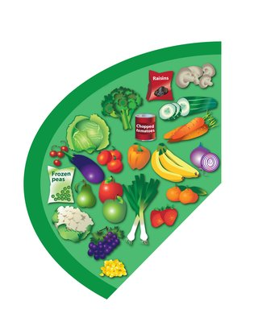fig 2: recommended fruits and vegetables (NHS, 2019)

Consume at least 5 servings daily of a range of fruits and vegetables (NHS, 2019). To acquire and maintain a healthy body weight, this entails consuming the appropriate mounts of food and drink, as well as a wide variety of meals in the appropriate quantities. Just over a third of the food we eat should be starchy (NHS, 2019). Choose wholegrain products with more fibre, including wholewheat pasta and brown rice, or just eat potatoes with their skins on (NHS, 2019). Fruits and vegetables, should make up little over a third of your daily diet, are a useful source of vitamins, minerals, and fibre (NHS, 2019). Truck driving is stressful therefore drivers needed to keep themselves hydrated by drinking at least 6 to 8 glasses of water daily as well as physical activities such as cycling aerobics (Driver Require, 2022).

Drinking
Bob drinks a whole bottle of whiskey witch clearly is not good for his health, and if he is drinking to go to sleep, is an indicator of sleeping disorder (Historical Information, 2022).
Bob’s body is not resting sufficiently enough (Historical Information, 2022) to give chances to be repaired because it is during sleep period our bodies naturally being repaired (Queensland Health, 2018). Bob just goes to sleep whenever he is drunk enough, however the level of his drinking is not really specific because you do not know how often he is going home (Historical Information, 2022). There is the impression that he does not drink when he is working, however, he has that level of dependency on alcohol for sleep. This will make him alert, very attentive, and quite tired and if he depends on it.

Potential Implication
According to NHS, (2018) Alcohol is a potential chemical that can negatively impact virtually every organ in your body, including your heart, bones, and brain. Bob is on the risk of digestion issues, liver illness, high blood pressure, heart disease, and stroke as a result of long-term alcohol usage and dependency. Bob’s blood pressure reads 140/90mm. this indicated a having high blood pressure. This resulted from his long-term alcohol dependency to sleep, unhealthy eating and physically inactive of Bob’s daily activities.

Recommendation

Smoking
He clearly is addicted to smoking from the age of 20, so he has 32 years of inhaling tobacco toxins (historical Information, 2022). Tobacco fumes is known to be the major cause of lung cancer as it contains cancer producing vell or caseinogen (NHS, 2018; Who,2022) on smoking risk of respiratory and cardiovascular diseases. His health is likely to be impacted given that he has been smoking all his life from an early age.

Potential Implication
Health assessment indicated a substantial risk of lung cancer as a result of smoking between 15 to 19 cigarettes and day. Further, his attitude of unhealth eating and physically inactive are all contributing factor to long cancer studies revealed (

Recommendation
with healthy diet such as ‘foods rich in vitamins, minerals, and antioxidants, such as fruits, nuts, and vegetables, to reduce inflammation and help fight oxidative damage (CDC, 2021; National Cancer Institute, 2019; NHS England, 2019).

Lifestyle
Bob’s social life is incredibly limited (Historical Information, 2022). His only daughter and grandchildren clearly live quite away from him, no meaningful family not even friendships and lives in the same area all his life (Historical Information, 2022). It seems like he does lot of shifts. His life is his work, and his work is his risk to his health (Historical Information, 2022). He does not really have healthy routine (Historical Information, 2022). According to the Historical Information, (2022) he does not have any hobbies, lost his parents, distance from his daughter, no relationship with his grandchildren (His only family), and a divorcee. Not much of a life other than his work causing him to be depressed and Isolated (Historical Information, 2022). Furthermore, working environment for drivers offers few options for good lifestyle choices and encourages unhealthy ones, such as inactivity, prolonged periods of sitting, poor food, smoking, and excessive alcohol consumption (Greenfield, et al., 2016; Clemes, et al, 2019), which is the same for Bob (Historical Information, 2022). He does not really have anything to validate his life

Potential Implication
The above highlighted lifestyle of Bob adversely impacts on his quality of life i.e., his physical and mental health. This can bring mental and other given health issues such as depression and anxiety as a result of his sleep disorder, divorce and bereavement for his parents, social isolation, exhaustion, decline in attention; risk of diabetes because of poor eating habits and inactiveness; respiratory and cardiovascular disease as a result tobacco smoking, alcohol consumption, poor diet, and physically inactive.

Recommendations
The only way Bob can change his risky unhealthy lifestyle to a healthy one is by seeking help from his GP with regular visits (NHS, 2021). Reduced shift hours, focus on physical exercise such as aerobics, walking 30 minutes a day, eat foods rich vitamins and iron such as fruits and vegetables, get a pet of his choice to keep him company, engaged in social activities such as going to the cinemas and join social media for connection with like-mind people.

Recommendation Care Plan for Bob and Truck Drivers
Studies revealed that working environment for drivers offers few options for good lifestyle choices and encourages unhealthy ones, such as inactivity, prolonged periods of sitting, poor food, smoking, and excessive alcohol consumption (Greenfield, et al., 2016; Clemes, et al, 2019). In order to help HGV drivers, take outstanding holistic care of themselves and maintain long-term performance and safety in their chosen professions, they should follow the below advice.

Change shift pattern: Ministry of transport, NHS and government policy makers should work together, and revisit truck driver shift pattern (Clemes, 2019). For instance, truck drivers and all commercial driving should not allow to drive more than six hours without a break. Government should incorporate on the highway a free rest hose at least every.

GP Check Up: NHS, (2019) recommended regular GP check-ups for general health and wellbeing in order to identify any health and wellbeing risk for early intervention

Eat and drink well: It is understood that the food you eat will have a significant impact on your health. You must, therefore, have a diet high in nutrients such as ‘foods rich in vitamins, minerals, and antioxidants, such as fruits, nuts, and vegetables, to reduce inflammation of the lungs and help fight oxidative damages to respiratory and cardiovascular systems (CDC, 2021; National Cancer Institute, 2019; NHS England, 2019). NHS (2018) suggested drinking two litres or six to eight glasses of water a day to avoid dehydration (Driver Require. n.d.). Keep a sizable, refillable water bottle in your truck and use it as needed throughout the day to save money instead of constantly purchasing fresh, pricey ones (Driver Require. n.d.; NHS. 2021)

Physical Exercise: NHS, (2021) guidelines suggested an engagement of daily physical exercise once or twice each week to reduce the risk of heart disease or stroke. 75 minutes of intense activity or 150 minutes of moderate activity per week are minimum requirements NHS, 2021). Reduces the amount of time spent driving or sitting down, and spread extended periods of inactivity with occasional movement

Conclusion
Working environment for drivers offers few options for good lifestyle choices and encourages unhealthy ones, such as inactivity, prolonged periods of sitting, poor food, smoking, and excessive alcohol consumption (Greenfield, et al., 2016; Clemes, et al, 2019). This impacted adversely on their health and wellbeing. As such, they required regular HA at least twice a year instead of when they feel ill (Stockhill, 2022). This will enable identifying any health and wellbeing concerned particularly certain diseases (lung cancer, diabetes, and heart attack) for precautions before it is too late (Stockhill, 2022).

Reference list:
Clemes, S.A. et al., (2019). Cluster randomised controlled trial to investigate the effectiveness and cost-effectiveness of a Structured Health Intervention for Truckers (the SHIFT study): a study protocol. BMJ Open, [online] 9(11), p.e030175. doi:10.1136/bmjopen-2019-030175. Available at: https://bmjopen.bmj.com/content/9/11/e030175 (Accessed 4th November 2022).

Driver Require. (n.d.). 5 Health & Wellness Tips That HGV Drivers Should Know. [online] Available at: https://driverrequire.co.uk/news/item/health-wellness-tips-for-hgv-drivers (Accessed 4 November 2022).

Greenfield, R. et al., (2016). Truck drivers’ perceptions on wearable devices and health promotion: a qualitative study. BMC Public Health, 16(1). doi:10.1186/s12889-016-3323-3. Available at: https://bmcpublichealth.biomedcentral.com/articles/10.1186/s12889-016-3323-3 (Accessed 4th November 2022).

Labeit, A., Peinemann, F. and Baker, R., (2013). Utilisation of preventative health check-ups in the UK: findings from individual-level repeated cross-sectional data from 1992 to 2008. BMJ open, 3(12), p.e003387.

Mayo Clinic, (2022). Diabetes - Symptoms and causes. [online] Available at: https://www.mayoclinic.org/diseases-conditions/diabetes/symptoms-causes/syc-20371444#:~:text=The%20exact%20cause%20of%20most (Accessed 14th November 2022).

NHS (2018). BMI Healthy Weight Calculator. [online] NHS. Available at: https://www.nhs.uk/live-well/healthy-wei ght/bmi-calculator/ (Accessed 14th November 2022).

NHS (2018). Risks - Alcohol misuse. [online] NHS. Available at: https://www.nhs.uk/conditions/alcohol-misuse/risks/. (Accessed 12th November 2022).

NHS (2019). Causes - obesity. [online] NHS. Available at: https://www.nhs.uk/conditions/obesity/causes/ (Accessed 13th November 2022).

NHS (2021). Physical Activity Guidelines for Adults Aged 19 to 64. [online] nhs.uk. Available at: https://www.nhs.uk/live-well/exercise/exercise-guidelines/physical-activity-guidelines-for-adults-aged-19-to-64/. (Accessed 12th November 2022).

NHS (2022). Eating a balanced diet. [online] nhs.uk. Available at: https://www.nhs.uk/live-well/eat-well/how-to-eat-a-balanced-diet/eating-a-balanced-diet/ (Accessed 12th November 2022).

NHS England (2019). NHS England» respiratory disease. [online] England.nhs.uk. Available at: https://www.england.nhs.uk/ourwork/clinical-policy/respiratory-disease/. (Accessed 9th October 2022).

Preedy, V.R. and Watson, R.R. (2004). Comprehensive Handbook of Alcohol Related Pathology. [online] Google Books. Elsevier. Available at: https://www.google.co.uk/books/edition/Comprehensive_Handbook_of_Alcohol_Relate/UXfdAAAAQBAJ?hl=en&gbpv=1&dq=alcohol+levels+in+whisky&pg=PT768&printsec=frontcover (Accessed 14th November 2022).

Public Health England (2019). Executive Summary. New Directions for Youth Development, [online] 2013(139), pp.5–8. doi:10.1002/yd.20064. Available at: https://assets.publishing.service.gov.uk/government/uploads/system/uploads/attachment_data/file/830105/PHE_Strategy__2020-25__Executive_Summary.pdf (Accessed 12th November 2022).

Public Health England (2022). Smoking and tobacco: Applying All Our Health. [online] GOV.UK. Available at: https://www.gov.uk/government/publications/smoking-and-tobacco-applying-all-our-health/smoking-and-tobacco-applying-all-our-health. (Accessed 12th November 2022).

Queensland Health (2018). 7 amazing things that happen to your body while you sleep. [online] Qld.gov.au. Available at: https://www.health.qld.gov.au/news-events/news/7-amazing-things-that-happen-to-your-body-while-you-sleep (Accessed 14th November 2022).

Stockhill, M. (2022). Top 5 benefits of having a Health Assessment. [online] London Doctors Clinic. Available at: https://www.londondoctorsclinic.co.uk/blog/top-5-benefits-of-having-a-health-screen/#:~:text=We%20routinely%20attend%20dental%20and (Accessed 4th November 2022).

World Health Organization (2022). First International Conference on Health Promotion, Ottawa, 21 November 1986. [online] www.who.int. Available at: https://www.who.int/teams/health-promotion/enhanced-wellbeing/first-global-conference/actions. (Accessed 12th November 2022).

www.nhs.uk. (2017). High cholesterol. [online] Available at: https://www.nhs.uk/conditions/high-cholesterol/#:~:text=It (Accessed 13th November 2022).

