Effective Team Working and Communication
BMSW4002
ASSIGNMENT

STUDENT NAME: CADMIEL OPRESCU
STUDENT NUMBER: 2133523
LeCTURER: LLOYD BEHARRY

ACADEMIC REPORT - JANUARY 03 2023

TABLE OF CONTENT

1. What is the definition of ‘Communication’ ?................................3
2. Models of Communication………………..………………………...3
2.1 Shannon and Weaver communication model……………………..…………3
2.2 Wilbur Schramm communication model………………………….......………4
2.3 Berlo’s SMCR model……………………………………………………………5
3. Communication Skills……………………………………………….5
3.1 Verbal communication………………………………………………………….5
3.2 Non-verbal communication…………………………………………………….5
3.3 Listening………………………………………………………………………….6
4. Advantages and Disadvantages of Communication Technology……………………………………………………………...8
4.1 Mobile Phones………..…………………………………………………………8
4.2 Internet………………………………………………………...…………………8
5. Conclusion……………………………………………………………9

- What is the definition of ‘Communication’?

Communication is the imparting or exchanging of information by speaking, writing, or using some other medium.

It is often said that we are living in the information age, when computers and network technologies have made it possible to overcome the limitations of time and space imposed on communications. Communication now has greater speed, larger capacity, more flexibility, and new varieties of messages.

- Models of Communication

2.1 American mathematician Claude Elwood Shannon and scientist Warren Weaver introduced the Shannon and Weaver communication model in 1949 in the article THE MATHEMATICAL THEORY OF COMMUNICATION. Initially, they proposed this mathematical model to describe the signal transmitting system and enhance telephone communication by minimizing noise.

The Six Elements of Shannon and Weaver’s Model of Communication are:

- Information Source.
- Transmitter.
- Channel.
- Receiver.
- Destination.
- Noise Source.
*See T&Cs on air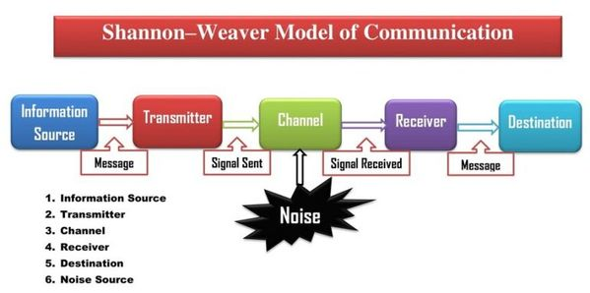

In the classroom we had two Case Studies regarding the models of communication.
In the first case ‘MARIA and PEDRO’, we could clearly see that the model of communication used was of course The SHANNON and WEAVER one.
This is because Pedro received a wrong message from his wife Maria through the phone call and the cause was the noisy environment in which he was working (a building site). The noise distorted the message and Pedro heard the word ‘kitchen’ instead of ‘chicken’.

2.2 In 1954, Wilbur Schramm developed a model of communication which has its roots from the Shannon-Weaver model itself, but it is circular.
Information is of no use unless and until it is carefully put into words and conveyed to others. Encoding plays a very important role because it initiates the process of communication by converting the thought into content. When the information reaches the recipient his prime responsibility is to understand what the speaker intends to convey. Unless and until the second party is able to understand or decode the information what the sender wants to communicate, the message is actually of no use. According to the Schramm’s model, coding and decoding are the two essential processes of an effective communication.
He also emphasizes that the communication is incomplete unless and until the sender receives a feedback from the recipient.

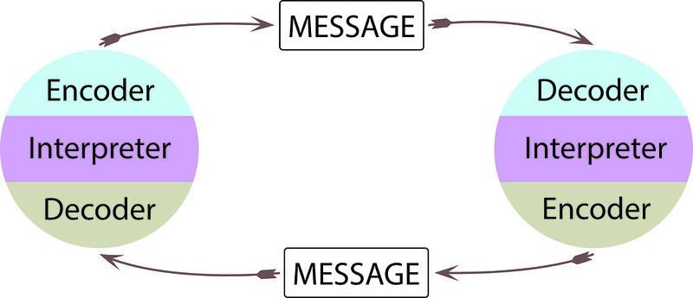

Because I work in the ticket office for a train company, I double-check the information related to the ticket with the customer before selling it to him, to make sure there is no confusion and to be able to sell the correct ticket.

2.3 The third one is Berlo’s SMCR Model
David K. Berlo (1960)²³ created the SMCR model of communication. SMCR stands for sender, message, channel, receiver.
Berlo’s model describes different components of the communication process. He argued that there are three main parts of all communication, which is the speaker, the subject, and the listener. He maintained that the listener determines the meaning of any message.
The receiver is the person who decodes the message. Similar to the models discussed earlier, the receiver is at the end. However, Berlo argued that for the receiver to understand and comprehend the message, there must be similar factors to the sender.
In ‘THE PROFESSOR and THE VILLAGE PEOPLE’ case study we observed that the English Professor used an academic vocabulary when he was asking for help from the citizens of a little village, instead of using simple words, like “fire”. His message hasn’t been decoded (understood), this kind of communication belongs to the Berlo’s model.

- Communication Skills

3.1 Verbal communication is the sharing of information between individuals by using speech.
In other words, it is the communication which uses spoken words to communicate a message.
Improving our verbal communication skills can help us to create better relationships with other students, our coworkers, friends, etc.
Verbal communication can be used to inform, inquire, argue and discuss topics of all kinds.
In ‘A DAY with the CHIEF’ case study, we observed that the verbal communication between Mark, the top salesman from London and his Chief Executive Officer (CEO), Mrs. Alana Brown from the company’s head office in California, was initially appropriate and professional, but after Mark starts feeling comfortable, relaxed and privileged, he is also changing his speech and starts talking selfish, arrogant, useless and unproductive stuff.
That is why the conversation and also the meeting between these two persons ends immediately.

3.2 Non-verbal communication is the message we send to others through facial expression, tone and pitch of our voice, gestures, hand and body movements and so on.
Non-verbal communication happens unintentionally and unknowingly, sets the tone of a conversation and it also affects how others interpret our message.
Our gestures tell our character and our message is conveyed in the form of actions.
People react to non-verbal signals more than spoken words, therefore it is important to pay attention and control our body language.
Analyzing again ‘A Day with the Chief’ case study, we could also highlight the non-verbal communication present here, which is closely related to verbal communication.
In the beginning Mark showed an appropriate behaviour and respect in front of his chief, because he was afraid and very emotional, but in the end his true character came out through his inappropriate gestures and attitude such as he loosens his tie or crosses his legs.
Mrs. Brown on the other side showed him that is happy to see him, by smiling at him with friendly eyes, she was polite and treated him well until he started to misbehave and from that moment she completely changed her attitude towards him, she became radical and very firm all at once.

3.3 Listening

A good listener creates a workplace environment where everyone feels safe to express ideas, opinions and feelings.
They can creatively solve problems in partnership and they can save time, avoiding conflict and misunderstanding.
Listening is one of the most important aspects of effective communication.

When we discuss about listening we refer to:
- Active Listening
- Empathetic Listening

Active listening means listening completely.
This is the act of fully hearing and comprehending the meaning of what someone else is saying, avoid getting distracted by our own thoughts, focus on the speaker and topping instead. It is important to try not to interrupt the other person, let them finished and then respond.
These are phrases that showed you interested and keep the other person talking:
- Tell me more.
- Go ahead, I am listening.
- That sounds interesting!
We can also show that we are listening using the body language and if appropriate could take notes storing important conversations or even paraphrase what other had said to make sure we are both on the same page.

Empathetic listening has a root word and that one is empathy and it means our ability to understand and share another person’s feelings. And when we discuss about empathetic listening, we refer to paying special attention to the way the other person is felling by putting ourselves in their shoes to understand where they are coming from.
One benefit of empathetic listening is that the other person feels understood.
This is one of the main reasons people go to see a counselor, a therapist or a friend who they know is a good listener.
It helps us understand how the other people around us are doing and that helps us respond in more helpful ways to the needs of the moment.
Being empathetic listeners does not mean we necessarily agree or have changed our mind.
Empathy also does not mean we should try to automatically fix a problem that the other person might have.
Listening with empathy is first and foremost about making that genuine effort to see the situation through the eyes of the other person, to feel what they are feeling. Second, we have to listen to their verbal and nonverbal communication.
People will usually show their emotions much sooner than will explain their feelings and sometimes their verbals and nonverbal don’t always match. And third, we reflect back to them what we sense they are feeling using our verbal and nonverbal skill. So this means communicating in plain language what we are noticing.
Other nonverbal might be a caring facial expression or nodding to show them that we are following them. If the person is feeling positive emotions we reflect back that to them too.

At my work place I have to be a good listener, and this is because I work in a customer service environment, dealing every day whit many different people and requirements for traveling.
Some times the customers request something from me and while serving them, they ask other questions or have more requirements, and that also requires me to pay more attention, have more concentration and listen to them very carefully, to be able to offer them help and answer them accordingly.

An other case study we had ‘MAX the MULTITASKER’ was adapted from Quintanilla, K.M. & Wahl, S.T in Maund, A., Shriek, M and Tinkler, A, Certificate in Higher Education: Skills for the Workplace. London.
In this case we can observe Max, the man who decided to start his own business, for planning and organising different types of events such as wedding, birthday parties or other anniversaries.
He started that business alone and considering not hiring someone else, in this way he was planning to obtain more profit, being strongly motivated to help his mother who was very ill, paying for her expensive medicines and also to pay for her staying in a nursing home.
The business was going well, but also Max became extremely busy, trying to solve many tasks at the same time by his own.
There came an unfortunate moment when all this situation turned around against him, due to the fact that he answered at two different phone calls in the same time and he got distracted, being unable to rebook Tamara’s parents’ 50th anniversary.
We can say that this was a bad example of ‘Active Listening’ and we can also conclude that for his customer Tamara, Max did not show ‘Empathetic Listening’ at all, instead he disappointed and lost her trust.
Max could have been prevented this unpleasant situation by listening active, being also an empathetic listener and could have been made it possible of course by answering one call and doing one task only at a time.

4. Advantages and Disadvantages of Communication Technology

4.1 Mobile Phones

Some Advantages of Mobile Phones:
- Mobile phones made communication easy with friends and family members.
- It is helpful in sending messages in written forms.
- Audio and videos can be sent on a button of click.
- Very useful applications are available in mobile phones like camera, alarm, calculators.
- It helps in spotting the location using GPS.
- Internet facility can be accessed at any place with the help of mobile phone.
- Mobile banking is done via mobile phones too.
- Through mobile phone video calls can be possible.
- It can be easily charge.
- The mobile phone is also wireless.
- It is easily carried from one place to another.

Some Disadvantages of Mobile Phones:
- Using mobile phones for long hours, it effect the eyes.
- Talking on mobile phones while driving is dangerous.
- Students get distracted by mobile phone while studding.
- There is a possibility of leakage of information.
- Excessive of use of phones made sleepless night.

4.2 Internet

The Internet is so far, one of the greatest inventions of all time. This Communication Technology has made it possible for us to do lots of things.

Advantages of the Internet :
- People can shop in online stores like eBay or Amazon.
- They communicate with family and friends via Skype or social media websites and this is very convenient.
- Send or receive emails.
- The Communication is unlimited because the Internet is cheap.
- They can watch the latest videos on YouTube and also make money from it.
- Through Teams or Zoom the students and lecturers could interact, they can study, share ideas, have meetings or presentations.
- It has multiple search engines that have made it easier for Internet users to find information and resources.
- From our office or home we can transfer funds, pay taxes and utility bills.

Disadvantages of the Internet :
- Spam Mail make it hard for people to access their email accounts.
- Virus can make the computer malfunction and this can be very costly, especially if you lose important data.
- Leakage of Private Information
- Spending a great amount of time on the Internet affects social interactions, can cause obesity or even led in some cases to some diseases.

5. Conclusion

In conclusion we could say that efficient communication, verbal or nonverbal, being able to listen active or empathetic, using the communication technology too, is very important for strong relationships, to study, to have a good business or work together as a team.

References:
Quintanilla, K.M. & Wahl, S.T in Maund, A., Shriek, M and Tinkler, A, Certificate in Higher Education: Skills for the Workplace. London.
https://www.youtube.com/watch?v=lO1gpzakbik&t=70s
https://www.youtube.com/watch?v=xtQfV6COHbU

