ECIE4004

Principles of Learning and Teaching

Blogs

Student Number: 2112098
Joy Bowen

Contents.

Blog 1 – ‘Rewards, Praise and Recognition.’ p.3-8
Blog 2 – ‘Spiral into Discovering’. p. 9-14
Blog 3 – ‘Operant Conditioning and Discovery Learning; do they work?’
p.15-17
Blog 4 – ‘Bruner and Skinner in a Secondary School’ p.18-20
References – p.21-25

Blog 1.

Rewards, Praise and Recognition


(VantageCircle, 2022.)
(Mania, n.d.)
(Dreamstime, A, n.d.)

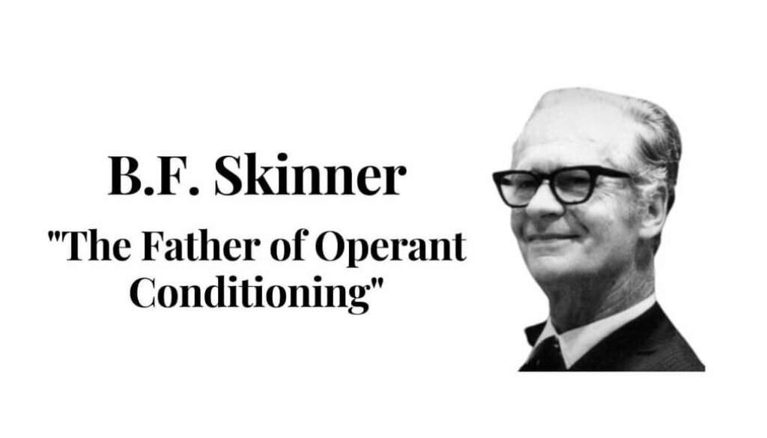
Positive recognition and rewards help us feel good about ourselves. If you think about it positive reinforcement is used throughout life as a way of motivating and encouraging positive behaviours (Mathis, Cotton and Sechrest, 2013). Though, have you ever sat back and looked at the theory behind it all? Well, today I am going to introduce you to the man who is considered the father of ‘Operant Conditioning’ (Boorla, 2013), Burrhus Frederick Skinner (1904-1990).

Who is Skinner?

Skinner was a psychologist who studied radical behaviourism (Brau, Fox and Robinson, n.d.). His work was influenced by a number of behaviourists including Ivan Pavlov (1902), Edward Lee Thorndike (1898) and John B. Watson (1920). Skinner’s work on Operant conditioning was inspired and motivated from Thorndike’s theory on ‘Law of Effect’ (1898) (Schlinger, 2021).
(Bajaj, 2020)
(Find out more on the other theorists at the following link. https://edtechbooks.org/education_research/behaviorismt)

What is Skinner’s Theory?
Skinner believed that our behaviour is learnt and can be changed through environmental stimulus (Frederickson and Cline,2015). McLeod (2018), explains that Skinner felt that in order to understand behaviour we need to look at the cause and effect. From there we can manipulate the desired behaviour through rewards and consequences which will help to increase or decrease the learned positive or negative behaviour (Sprouts, 2020).
As a behaviourist Skinner believed that your behaviour was determined by things you could see and measure. However, he differed from other behaviourists and had a more radical view; he took some of the measurable cognitive processes into account believing that they could ‘be controlled by environmental variables’ (Brau, Fox and Robinson, n.d.). Skinner conducted his research using animals to demonstrate that by having a consistent positive reinforcement to promote the learning of the desirable behaviour required. He called this theory – Operant Conditioning (McLeod, 2018).

The Pigeon
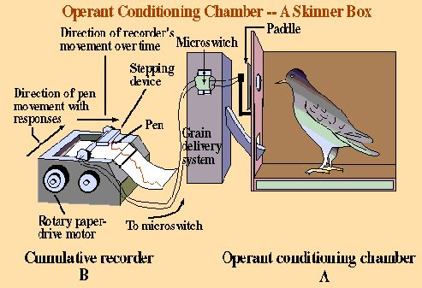
(Unknown, n.d)

Skinner trained pigeons that if they pecked at the right spot then they would be rewarded with food (Forgotten0506, 2007). The following link takes you to a video which shows Skinner conducting this experiment https://www.youtube.com/watch?v=rst7dIQ4hL8
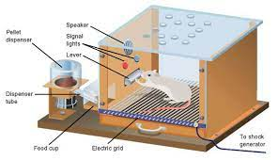
The Rats
(Mcleod, 2018)

Skinner introduced a negative reinforcement (as well as the positive of food / water) by adding punishment of grids that provided electric shocks when the rats ran over them. Bates (2019) explains that through his research, Skinner discovered that a positive reinforcement had a greater impact on gaining desired behaviour as opposed to the negative reinforcement.

This video by Udacity (2015) is a good visual explanation, which gives a more in depth understanding of how the Skinner box worked. https://www.youtube.com/watch?v=bDWwXdYWqGk
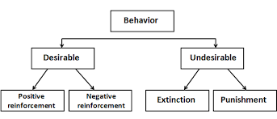
The aim of Operant Condition is that we want to produce more of the desirable behaviour and in turn decease or even eradicate unwanted behaviour.
(Gordon, 2022)
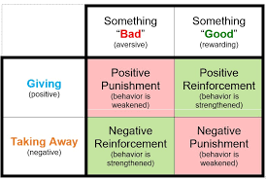
This is done through reinforcements.
(Pressbook, n.d.)

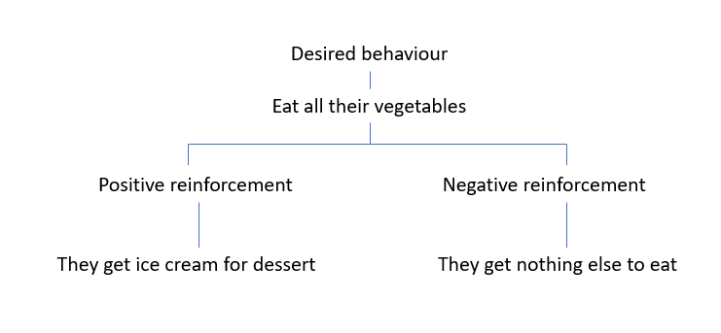
Example 1 – You want your child to eat all their vegetables.



The child will want to have ice cream and so will eat their vegetables resulting in them having their reward of the ice cream. Through consistency, this will become learned behaviour and the child will continue to eat their vegetables without being asked.
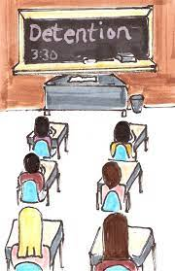

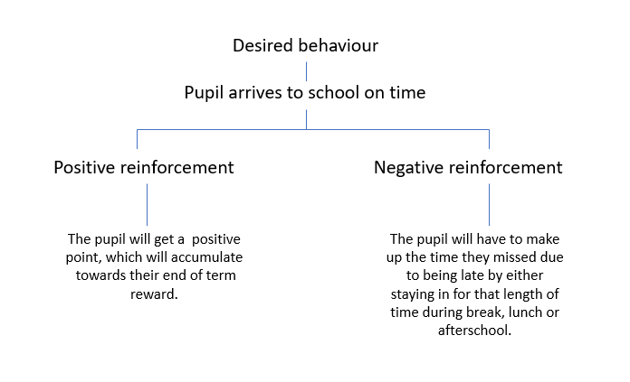
Example 2 – School is trying to increase the punctuality of the pupils arriving to school for morning registration.
The use of the positive reinforcement will encourage and motivate pupils to want to arrive in school on time so they can gain the extra points to have a great reward at the end of term.
The use of the negative reinforcement means it will help deter pupils from being late as they will not want to make that time back during time where they can be socialising with their friends.
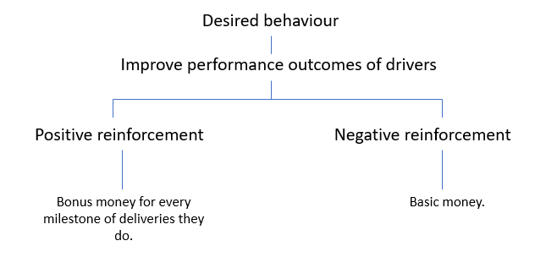
Example 3 – A delivery firm company is trying to improve performance outcomes of it’s employees.





The drivers will want to improve their performance outcomes so that they can achieve the extra bonus money.
To conclude, Skinner’s Theory on Operant Conditioning is one that is very widely used in day-to-day life. By using positive and negative reinforcers it helps to promote and encourage desired behaviours and helps to discourage and eradicate negative and unwanted behaviours. Through the few examples it is clear that the principles that make up this theory are evident within all environmental situations such as family and education. (Mathis, Cotton and Sechrest, 2013).
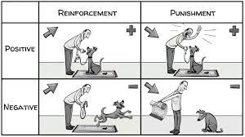

(Sprouts, 2020)

Blog 2.

Spiral into Discovering

(Dreamstime, b, n.d)

As a parent, I often sit back and wonder how these amazing small human beings progressed from full reliance on me doing everything for them such as feeding and dressing them, to me standing back and observing until they are faced with something trickier requiring my assistance. How is our knowledge and skills developed? McLeod (a, 2019) explains that ‘Bruner views the infant as an intelligent & active problem solver’.
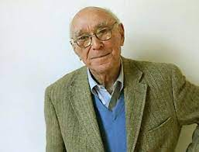
Who is Bruner?
Jerome Bruner (1915-2016) was an American psychologist and educationist whose focus was on cognitivism. According to Harvard University(n.d.) ‘Bruner was a leader of the cognitive revolution that ended the reign of behaviorism’.
(Evans, 2012)

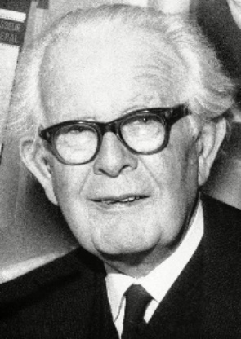
Who Influenced Bruner’s Ideas?
Jean Piaget (1896-1980) was also a constructivist who influenced Bruner’s theories.
(Encyclopedia Britannia, 2022)
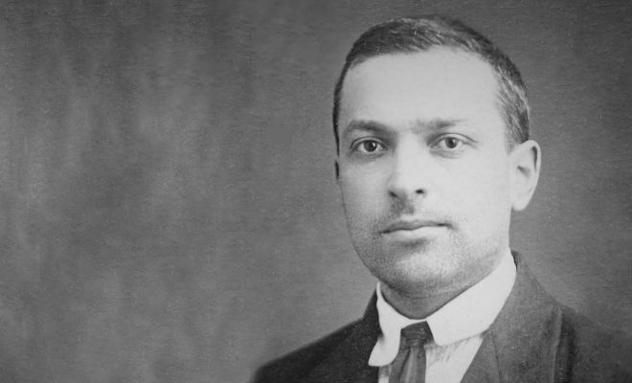

(First Discoverers, n.d)

Lev Vygotsky (1896-1934) was another big influencer to the beliefs and ideas of Bruner.
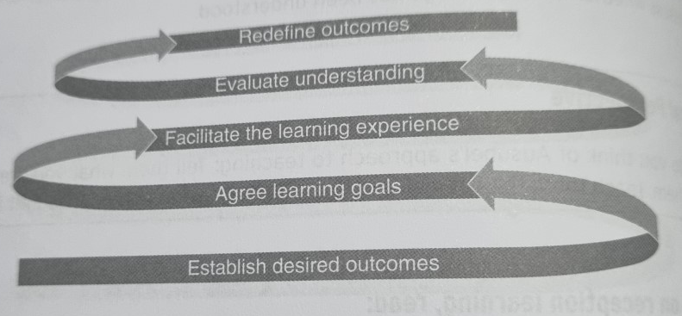
Discovery Learning, Scaffolding and Spiral Curriculum
(Bates, 2015, p.56)

Discovery Learning
Bruner believed that we learn through something called ‘Discovery Learning’. He explains that we should be playing active roles within our learning rather than be ‘spoon fed’ (Bates, 2015, p.23).
In 1966, Bruner’s research led him to the conclusion that through different stages of life we learn through different modes of discovering.
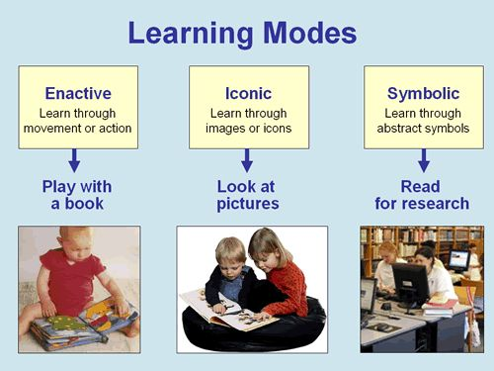
From birth to 1 years of age we learn through enactive mode. By this he means that we learn from being active discovering through doing things. We build knowledge and experiences through physical movements.
1-6 years of age we learn more through iconic modes; lots of multi-sensory stimuli to help with curiosity and discovery.
(Hook, n.d.)

From the age of 7 years plus we move onto being able to learn through symbolic mode. Our understanding of language and symbols are developing as we have gained more knowledge and experiences which help us to make relevant links and relationships to further build and understand things at a different level.
(McLeod, a, 2019).
Scaffolding
The term ‘scaffolding’ was invented by Bruner as a way of supporting his theory of the process for learning (McLeod, a, 2019).

Scaffolding is an analogy for the process of learning. If we think of what the purpose of scaffolding is; it is a support that helps us to support the structure of building something like a house, as the building progresses so the supports are removed until they are no longer needed and the house is independently standing (Hammond and Gibbons, 2005).
(gettyimages, n.d)

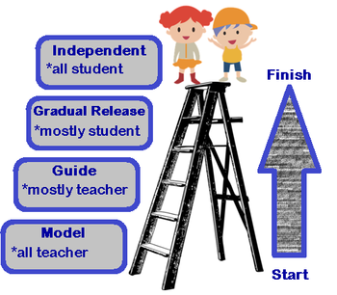
Within teaching and learning it is the same principle of providing temporary support to help facilitate learning until the learning has become solidified and the end goal has been achieved.
It is a way of providing structure within a classroom and help to develop a toolkit that can be used with solving similar future problems (Bosanquet, Radford, Webster, 2016).
Scaffolding requires clear end goals and learning activities that extend on existing knowledge or prior experiences and understanding. It is a toolkit that can be used within a variety of environments for example parenting, within schools and employment training (Hammond and Gibbons, 2005).
(Alcocer, 2021)
Spiral Curriculum
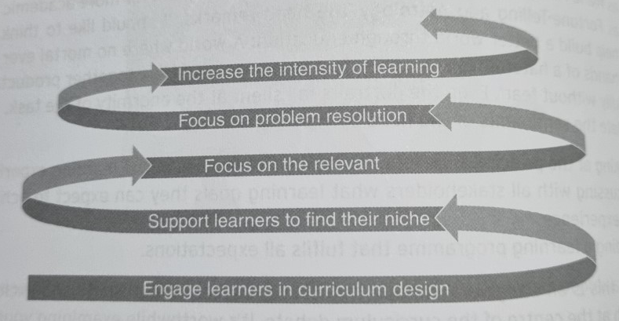

(Bates, 2015, p.272)

Bruner considered that topics can be introduced at any age providing simplification dependant on the stage of the leaner is provided and further extended the foundations on his theory of discovery learning to include a curriculum design which is known as ‘Spiral Curriculum’ (Bates, 2015).
A spiral curriculum simplifies information first, revisits, then builds on this knowledge to increase it to something more complex with assistance from a teacher. The teacher can adapt the level of assistance depending on the individual learner until the learner has succeeded in their understanding and arrival at the end goal for that topic (McLeod, a, 2019).
This link to the following video by Frieson (2018) is a good visual explanation of Bruner’s theory, with Bruner telling us about it himself. One of the key messages I believe is that we need to let the learners go through the steps for themselves to help them to gain an understanding and to be able to draw on their perceptions and experiences instead of just providing the answers. By assisting and guiding them, we are helping learners to gain the skills needed to become confident and independent problem solvers. https://www.youtube.com/watch?v=pZuHz49CYOA

To conclude, through looking at Bruner’s theory I agree that my children learnt their current skills from my modelling, assisting and encouragement. Once they had mastered one thing they moved onto learning and developing something else through using the scaffolding toolkit assisting them to reach more challenging goals, helping to build their confidence, independence and valuable skills.
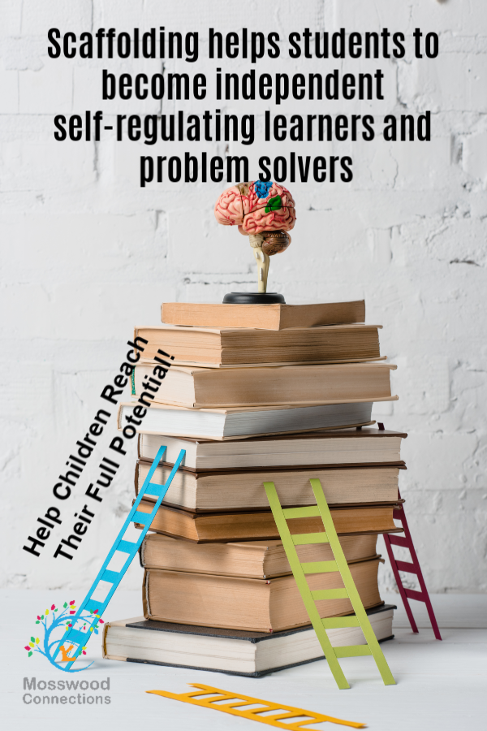
Blog 3.
(Moss, 2020)

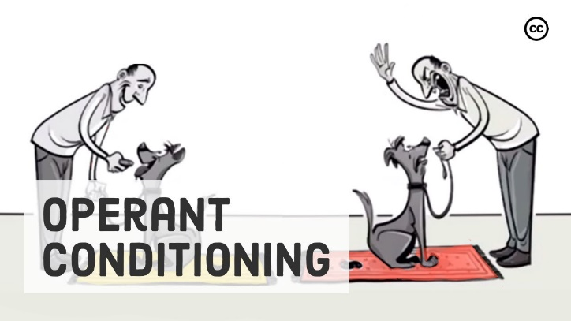
Operant Conditioning and Discovery Learning; Do They Work?
(Sprouts,2020)
(Koblin, 2021)
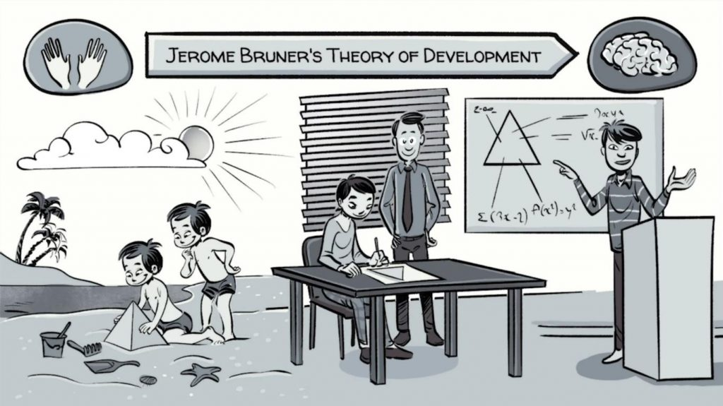

(iStock, n.d)


It is important to remember that one theory will not work or apply to all learners. Everyone is different and has their own individual knowledge, experience and understanding of the world. It is also important to remember that theories are ideas, and they are not strict rules to follow but can be used, adapted and expanded on to find the right fit for the individual learner.
The New Welsh Curriculum
The new Welsh Curriculum identifies the importance of focusing on learners as individuals. There are currently four key purposes which are there to ensure every learner is given an equal opportunity to achieve and be supported to be the best they can be (Welsh Government, A, 2021).
The new integrated approach means learners will be able to make more relevant links between different areas of learning and gain a better understanding of the reasoning behind what they are being taught. This will help them with broadening their knowledge, confidence and resilience (Welsh Government, (Welsh Government, B, 2021).
Within this framework they take on the concepts of Jerome Bruner’s (1960) Spiral Curriculum. Welsh Government (B, 2021) has made it clear within the framework they want learners to explore, revisit and then expand to develop a deeper knowledge and broaden their level of understanding. Topics are not to be standalone but to be linked back to help learners give opportunities to recall what knowledge and experience they already know and gain further understanding in the process.
Inclusive Pedagogy
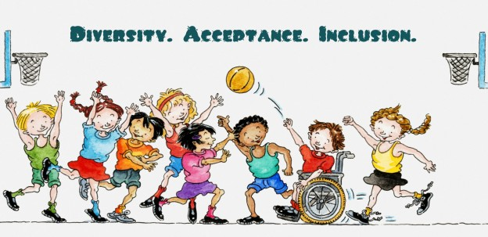
Is ‘A Conceptual Framework for Educating Students of Diversity’ (Pinnegar, Draper and Steffieri, 2020).
(D’Entremont, 2015)

The inclusive pedagogy emphasises the importance of a child-centred approach. Bruner (1961) supported these views by making it clear he did not believe education was for passing on knowledge but rather for facilitating learners to develop thinking and problem solving skills that would equip learners for integration and contribution to society (McLeod, a, 2019). Through discovery learning, learners can be curious and take risks within a safe guided environment to help develop skills of problem solving and encouraging the individual to become their own person (Friesen, 2018).

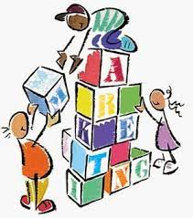
It is important that learners are kept motivated and engaged within the learning, this is where Burrhus Frederick Skinner’s (1937) operant condition theory becomes practice for some individual learners. Some learners thrive on needing positive reinforcement to help encourage and keep them motivated. Bruner also agrees to an extent on positive reinforcement as he believes that feeding learners with praise helps to develop their confidence (Pwalshy, 2019). I believe that this does work for some individuals and reflecting on my own preferences for learning, I know I am more likely to reach for new goals and challenges when supported and encouraged along the way. How about you? As not all learners like attention being drawn to them. Teachers need to look at the child as an individual and ensure that they are showing encouragement and praise in a way that the learner feels comfortable and will continue to engage.
(Alm, n.d)
Bruner and Skinner’s theories link within modern education however they contain different foci. Bruner’s theory is from a constructivist view which focuses on building and learning skills and knowledge. It looks at drawing links on experiences and gaining a personal perception, considering the relevance that these experiences have within the individual’s life (Mcleod, b, 2019).
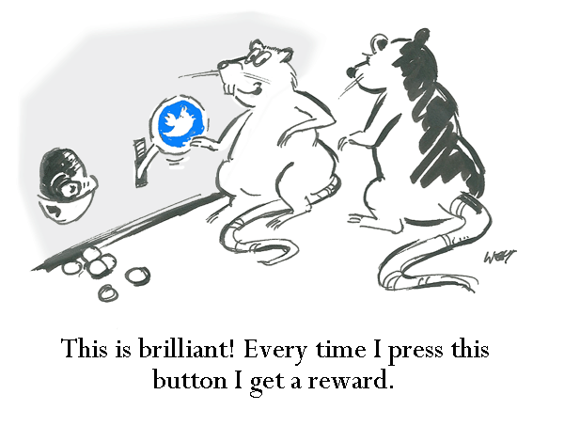
Skinner’s theory is from a radical behaviourist view which means that the focus is on behaviour. It looks at how learners interact with their environments (Schlinger, 2021) and how behaviour can be manipulated with the use of positive and negative reinforcements to help gain the reinforcer’s desired behaviour (Sprouts, 2020).
(Buchholtz, 2017)
(KL, n.d)

I believe to some extent that Skinner’s theory can be effective but it has its limitations and I disagree with Skinner in regard to using what you can see and measure to determine behaviour. Through my own experience and observation, like Thynne (2022, p.5) observes ‘behaviour is a form of communication’. I believe we should be challenging and underpinning the reason behind a learner’s behaviour as a way forward to ensure we have the learner’s best interest at heart rather than a manipulation through reward. This involves letting learners have a chance for their voices to be heard, which ensures we are meeting our obligation to The United Nations Convention of Rights of the Child’ (1989) and fulfilling “article 12 – respect the views of the child” (Unicef, 1992).
(Unicef, n.d)
I conclude that both Bruner and Skinner’s ideas have influenced many practices within teaching and learning and know that they will continue to influence teaching and learning for many years however these notions and theories do not stand alone and need to be adapted and broadened to focus on the individual and society of today.

Blog 4.
Bruner and Skinner in a Secondary School.
I love my job! There are not many people that say that, yes there are many ups and downs, but overall it is a role that keeps me motivated, challenged and it can be rewarding. I work in a secondary school in Wales.
Person- Centred Practice.
Within Wales there has been much work around changing practice to service our more diverse society. Welsh Government (a and b, 2021) set about the aims of the new curriculum to ensure each learner is given equal opportunities through supporting learners as individuals.
The new Additional Learning Needs (ALN) code for Wales (Welsh Government, c, 2021) has also influenced this change within the curriculum. As we have developed and gained a greater understanding, we have moved to a more person-centred approach which includes The United Nations Convention of Rights of the Child (1989) being adhered to.

Secondary School Practice
Day-to-day Lessons
As a school every lesson follows a similar structure. These lessons take on many of Jerome Bruner’s ideas and notions on discovery learning, scaffolding and spiral curriculum.
Each lesson, there is always a learning objective – which clearly highlights what the goal is for that lesson.
Learners begin with working on a ‘Do It Now’ task. This task always involves learners re-calling on prior knowledge and experiences. So, begins thinking processes and prepares learners for the next link - what they will be discovering next.
The lesson will include information broken down into chunks, with modelling, and guided assistance in helping learners to understand or master that new information or skill. The lesson will keep progressing until the final lesson objective has been achieved.
At the end of the lesson, learners have an opportunity to reflect on what they have learnt.
Through year 7 to year 11, topics will be revisited and expanded on to a more sophisticated level for the stage of the learner. Which again takes into Bruner’s belief that any topic can be taught at any age (Bates, 2015).
Teaching Assistants (TA)
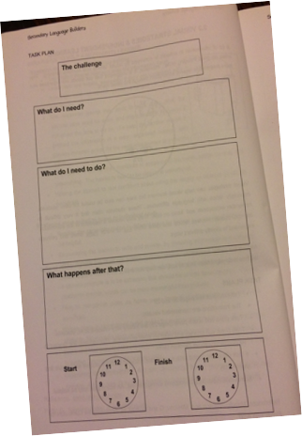
According to Bosanquet, Radford and Webster, scaffolding is a ‘key role for TA’s ‘(2016, p.32). I agree with this as TA’s adapt their support, promote engagement and encouragement depending on the individual learner.
Teaching assistants within our school use something called ‘Task Plans’ to help individuals who need that additional scaffolding. This is a great tool as it promotes independence and ensures the learner is discovery learning and not being ‘spoon fed’.
Mini white boards have become another vital tool for TA’s within our school. We have found that many learners find having the task visually modelled in front of them helps with making links and forming relationships to the new content that they are learning that lesson.
One of the biggest challenges we face with learners is their fear of getting things wrong. Bates (2015), explains that within Bruner’s Spiral curriculum idea we should be role models and reassure our learners that making mistakes is ok. These experiences help with the process of learning. I will openly admit if I do something wrong, or I do not know something. I will then be a role model and show my resilience in trying again or finding out the relevant information to help me succeed. I believe that through modelling the metacognition and my processes it has helped many learners I have worked with start to take risks and face more difficult challenges.
(McLachlan and Elks, 2015)

Positive Reinforcers
As a school we recognise that to help learners’ confidence and self-esteem grow and to motivate and fully engage our learners there are times where Burrhus Frederick Skinner’s theory on Operant conditioning (1937) is relevant within practice.
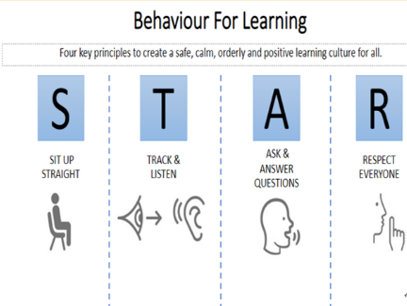
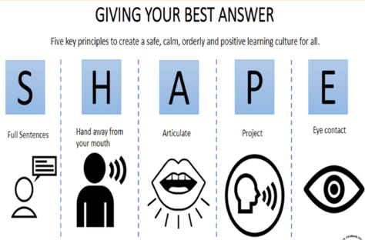
Rules and expectations are made clear within our setting. The key information is highlighted on the walls in every classroom.
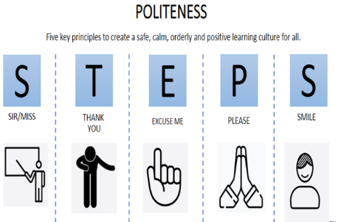
(School A, 2022)

When a learner succeeds in following any of the culture codes, they are rewarded with a positive recognition point.
We use a system called, ClassCharts. It is used by all staff and they can award learners with positive and negative points. This system is linked with home so that parents and carers can also see when their child has achieved something good or negative.
Points on classcharts are taken into consideration when it comes to things like school trips and the year 11 prom.
Every week head of year groups and the head teacher will reward pupils who have been identified that week and celebrate their positives through giving them praise and recognition.
Negative reinforcers come into play when there are consequences to unwanted behaviour for example when learners are late, that time is to be made back during break, lunch or an after-school detention.
To conclude I believe that our school setting is influenced by the research and ideas of Brunner and Skinner. I believe we do not rigidly conform to their theories; however, we do implement, adapt and build on their concepts throughout our policies and school processes.

References
Alcocer, Y.Y. (2021) Scaffolding in Teaching. [image] available at: https://study.com/academy/lesson/scaffolding-student-knowledge-in-mathematics.html Accessed: 6 January 2023
Alm, J. (n.d.) Improve employee engagement using recognition and reward. [image] Available at: https://blog.jostle.me/blog/improve-employee-engagement-using-recognition-and-reward Accessed: 7 January 2023.
Bajaj, A. (2020) B.F. Skinner Biography: Theory, Experiment, & behaviorism [Image] Available at: https://zerotoeternity.com/psychology/bf-skinner-biography/ Accessed: 3 January 2023.
Bates, B. (2019). Learning Theories Simplified…and how to apply them to teaching. 2nd edn. London:Sage.
Boorla, V. (2013) ‘Burrhus Frederic Skinner’ Archives of Mental Health, 14(2), pp. 181-183 Available at: DOAJ.org Accessed: 31 December 2022.
Bosanquet, P, Radford, J and Webster, R. (2016). The Teaching Assistant’s Guide To Effective Interaction. How to Maximise Your Practice. Oxon and New York: Routledge.
Brau, B, Fox, N and Robinson, E. (n.d.) Behaviorism’ Available at: https://edtechbooks.org/education_research/behaviorismt Accessed: 31 December 2022.
Buchhholtz, S. (2017) Constructivist Learning Theory, Teaching, and Learning. [Image] Available at: https://scottbuchholtzblog.wordpress.com/2017/11/29/constructivist-learning-theory-teaching-and-learning/ Accessed: 7 January 2023.
D’Entremont, L. (2015). Six Children’s Books on Diversity and Acceptance of Self and Others. [image] Available at: https://www.friendshipcircle.org/blog/2015/11/13/six-childrens-books-on-diversity-and-acceptance-of-self-and-others/ Accessed: 6 January 2023
Dreamstime, A. (n.d.) You Deserve It Earn Recognition Rewards Stars 3d Illustration. [Image]. Available at: https://www.dreamstime.com/stock-illustration-you-deserve-earn-recognition-rewards-stars-d-illustration-image79893366 Accessed: 3 January 2023.
Dreamstime, B. (n.d.) Collage of stages of baby walking in studio. [Image]. Available at: https://www.dreamstime.com/collage-stages-baby-walking-studio-image193541619 Accessed: 5 January 2023
Encyclopaedia Britannia. (2022) Jean Piaget Swiss psychologist. [image] Available at: https://www.britannica.com/biography/Jean-Piaget Accessed: 6 January 2023.
Evans, J. (2012) Jerome Bruner and the cultural construction of emotions. [Image] Available at: https://emotionsblog.history.qmul.ac.uk/2012/04/the-role-of-meaning-and-culture-in-emotional-constructions/ Accessed: 5 January 2023
First Discoverers. (n.d.) Child Development Theories: Lev Vygotsky. [image] Available at: https://www.firstdiscoverers.co.uk/lev-vygotsky-child-development-theories/ Accessed 6 January 2023.
Forgotten0506. (2007). Schedule of Reinforcement. [Video] Available at: https://www.youtube.com/watch?v=rst7dIQ4hL8 Accessed: 3 January 2023.
Frederickson, N and Cline, T. (2015) Special Education Needs, Inclusion and Diversity. 3rd edn. England: Open University Press.
Friesen, N. (2018) Jerome Bruner on Discovery Learning. Available at: https://www.youtube.com/watch?v=pZuHz49CYOA Accessed: 6 January 2023
Gettyimages. (n.d.) Scaffolding around house under construction - stock photo [image] Available at: https://www.gettyimages.co.uk/detail/photo/scaffolding-around-house-under-construction-royalty-free-image/200372705-001 accessed: 6 January 2023.
Gordon, J. (2022) Reinforcement Theory of Motivation – Explained. [Diagram] Available at: https://thebusinessprofessor.com/en_US/management-leadership-organizational-behavior/reinforcement-theory-of-motivation Accessed: 3 January 2023.
Hammond, J and Gibbons, P. (2005) ‘What is Scaffolding?’ Teacher’s Voices, 8, pp 8-16 Available at: https://www.dr-hatfield.com/educ341/readassign/1%20explicitly%20supporting%20reading%20&%20writing.pdf#page=15 Accessed: 6 January 2023.
Harvard University (n.d.) Jerome Bruner. [Website] Available at: https://psychology.fas.harvard.edu/people/jerome-bruner accessed: 6 January 2023.
Hook, D. (n.d.) Learning Modes. [Image] Available at: https://www.pinterest.co.uk/pin/533676624587097415/ Accessed: 6 January 2023.
iStock. (n.d.) 1,092 3d White Man With Question Mark Pictures, Images and Stock Photos. [Image] Available at: https://www.istockphoto.com/search/2/image?phrase=3d+white+man+with+question+mark Accessed: 6 January 2023.
KL. (n.d.) behaviourism. [image] Available at: https://www.blendspace.com/lessons/BL9swmYluu9xJw/behaviourism Accessed: 7 January 2023
Koblin, J. (2021) Bruner’s 3 Steps of Learning in a Spiral Curriculum. [Image] Available at: https://sproutsschools.com/bruners-spiral-curriculum/ Accessed: 6 January 2023.
Mania, T. (n.d.). 10 Ideas for Reward and Recognition Programs for Employees. [Image]. Available at: https://www.pinterest.co.uk/pin/61924563602777972/ Accessed: 3 January 2023.
Mathis, B.C, Cotton, J.W and Sechrest, L. (2013) Psychological Foundations of Education: Learning and Teaching. London: Academic Press
McLachlan, H and Elks, L. (2015) Secondary Language Builders. Cornwall: Elklan.
McLeod, S. (2018) What Is Operant Conditioning and How Does It Work? [Website] Available at: https://www.simplypsychology.org/operant-conditioning.html#:~:text=BF%20Skinner%3A%20Operant%20Conditioning&text=According%20to%20this%20principle%2C%20behavior,the%20Law%20of%20Effect%20%2D%20Reinforcement. Accessed: 3 January 2023
McLeod, S. a. (2019) Bruner – Learning Theory in Education. [Website] Available at: https://www.simplypsychology.org/bruner.html Accessed: 5 January 2023.
McLeod, S. b. (2019) Constructivism as a theory for teaching and learning. [Website] Available at: https://www.simplypsychology.org/constructivism.html Accessed: 7 January 2022.
Moss, S. (2020) How Scaffolding Learning Strategies Helps Your Child [image] Available at: https://www.mosswoodconnections.com/the-importance-of-using-scaffolding-learning-strategies-with-students-and-children-on-the-autism-spectrum/ Accessed: 6 January 2023
Pinnegar, S. E., Draper, P., & Staffieri, C. (2020). Tools for Guiding the Teaching of English Language Learners. Available at: https://edtechbooks.org/ell_tools Accessed: 6 January 2023.
Pwalshy. (2019) Discovery Learning – Bruner. [video] Available at: https://www.youtube.com/watch?v=e1MTybVmF5Y Accessed: 5 January 2023.
Pressbook. (n.d.) Principles of Learning and behavior: Module 6: Operant Conditioning [Diagram] Available at: https://opentext.wsu.edu/principles-of-learning-and-behavior/chapter/module-6-operant-conditioning/ Accessed: 3 January 2023.
Schlinger, H.D. (2021) ‘The Impact of B.F.Skinners Science of Operant Learning on Early Childhood Research Theory, Treatment and Care’. Early Child Development and Care. 191(7-8) pp. 1089-1106. DOI:/web.https://doi-org.ezproxy.uwtsd.ac.uk/1080/03004430.2020.1855155
School A. (2022) Classroom Culture – Routines for Learning September 2022. [Images] Accessed: 7 January 2023.
Sprouts. (2020) Skinner’s Operant Conditioning: Rewards and Punishments [Video] Available at: https://www.youtube.com/watch?v=ne6o-uPJarA Accessed: 31 December 2022
Thynne, R. (2022) Behaviour Barriers and Beyond: Practical Stratefies to Help All Pupils Thrive. 1st edn. New York: Routledge.
Udacity.(2015) Skinner box - Intro to Psychology. [Video] Available at: https://www.youtube.com/watch?v=bDWwXdYWqGk Accessed 3 January 2023.
Unicef. (1992). A Summary of The UN Convention on the Rights of the Child. Available at: https://www.unicef.org.uk/wp-content/uploads/2019/10/UNCRC_summary-1_1.pdf Accessed: 15 October 2022.
Unicef. (n.d.) UNICEF [image] available at: https://www.egnetwork.eu/member/unicef/ Accessed: 7 January 2023
Unknown. (n.d.) Operant Conditioning Chamber – A Skinner Box [Diagram] Available at: https://www.pinterest.co.uk/pin/393924298635348742/ Accessed: 3 January 2023
VantageCircle. (2022). The Ultimate Guide To Employee Rewards and Recognition. [Image]. Available at: https://blog.vantagecircle.com/employee-rewards-and-recognition/ Accessed: 3 January 2023.
Welsh Government. A. (2021). 5 things you may not know about Wales’s new curriculum. [Website] Available at: https://www.gov.wales/5-things-you-may-not-know-about-waless-new-curriculum#:~:text=Ultimately%2C%20the%20aim%20of%20a,of%20Wales%20and%20the%20world Accessed: 6 January 2023
Welsh Government. B. (2021) Introduction to Curriculum for Wales guidance. [Website] Available at: https://hwb.gov.wales/curriculum-for-wales/introduction/ accessed: 6 January 2023
Welsh Government. C. (2021) The Additional Needs Code for Wales 2021.Available at: https://gove.wales/sites/default/files/publications/2021-03/210326-the-additional-learning-needs-code-for-wales-2021.pdf accessed: 6 October 2022.

