
MSc Public Health and Social Care in Practice
Module: Practice-Based Research
Module Code: LCHS7008
Lecturer’s Name: Mohammad Khan
Environmental Risk and Inherited Genetic Factors Affects the Development of Skin Cancer in UK Adults: A Systematic Review
Student Name: Priyaben bhupendrabhai Patel
Student Number: 2503904

Table of Contents
1. Prevalence of the Problem 3
2. Introduction and Literature Based Background 4
Overview of Skin Cancer and UK Context 4
Environmental and Genetic Risk Factors 5
Literature Gap and Critical Perspective 6
3. Rationale & Research Question/Aims/hypothesis 7
Rationale 7
Aim 8
Objectives 8
Research Question 8
4. Research Methodology 8
Research Type and Strategy 8
Research Philosophy and Approach 9
Justification of Methodological Choices 9
5. Research Design 9
6. Recruitment, Sampling & Study Participants 10
7. Data Collection Methods 10
8. Data Analysis Technique 11
9. Ethical Considerations 11
10. Implications of Research 11
11. Plan of Work and Time Schedule 12
12. References 14

1. Prevalence of the Problem
The problem of skin cancer is one of the fastest-growing cancers in the UK, with an estimated more than 250,000 new non-melanoma cases in the UK and about 16 000-17,000 cases of melanoma each year. This may have escalated the incidence of melanoma alone by itself significantly over the years by approximately 25-32% over the past decade and is projected to rise further in the coming years. This trend thus reasserts an increase in public health burden that needs to be addressed as soon as possible (Khoshakhlagh et al., 2024).
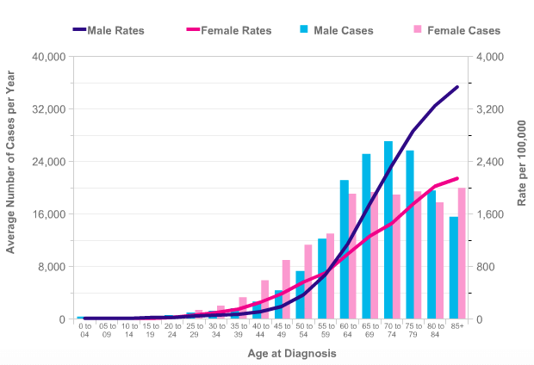

Figure 1: Statistics of Cancers
(Source: Chandla, Danny & Brown, 2015)
The number of cases that can be prevented is significant, since about 86% of melanoma instances are connected with exposure to ultraviolet (UV) radiation, which supports the leading role of environmental risk factors in the development of the disease (Wunderlich et al., 2024). Moreover, the light-skinned populations may exhibit a greater degree of vulnerability and has a lower melanin protection, which also means that the incidence is higher in the UK than in other areas (Al-Adwan et al., 2024).
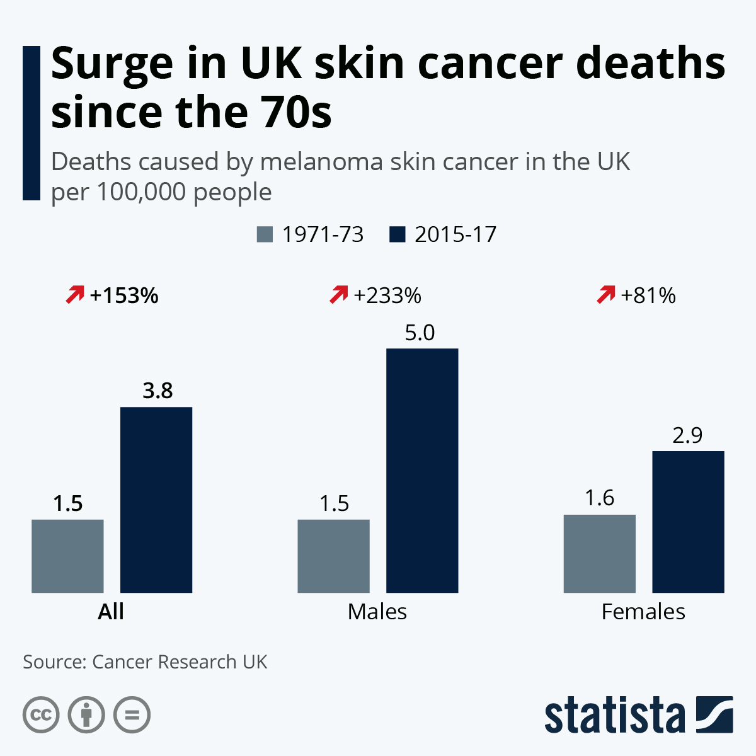

Figure 2: Surge in UK skin cancer deaths since the 70s
(Source: Armstrong, 2020)
Mortality trends show a different trend even though the incidence is increasing. In the UK, melanoma causes approximately 2,300 deaths each year but with early detection, the survival is better which shows that this disease is highly preventable and treatable when detected at the early stages. Nonetheless, the rising cases is a huge economic drain to the NHS in terms of the cost of diagnosis, treatment and long-term care (Hartmane, 2024).

2. Introduction and Literature Based Background

Overview of Skin Cancer and UK Context
Skin cancer is characterized as a category of malignant diseases that develop as a result of the uncontrolled growth of skin cells, most of them being melanoma and non-melanoma including basal cell carcinoma and squamous cell carcinoma (Sathe & Zito, 2025). Melanoma is viewed as the most aggressive type as it has a high potential to metastasize, whereas non-melanoma cancers represent the largest number of diagnosed worldwide (Tasdogan et al., 2025). The incidence of skin cancer in the UK is going to increase with more than 150,000 new cases every year, which is a serious issue impacting the population due to environmental and behavioural determinants (Abubakar, 2024).
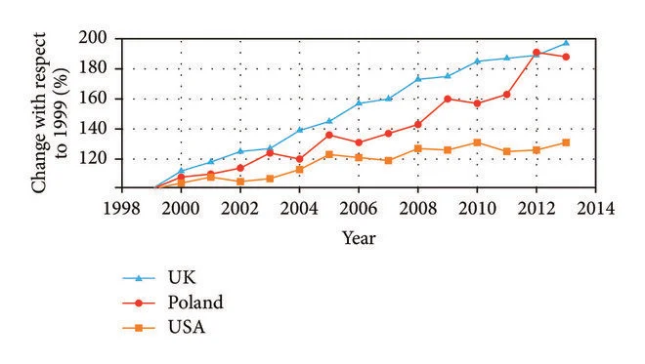

Figure 3: The Increase in Incidence Rate of Skin Melanoma Observed in the UK, Poland, and the USA between 1999 and 2013
(Source: Jaworek-Korjakowska and Kleczek, 2018)
Epidemiological patterns shows that the prevalence of melanoma has risen by about 50% during the last 10 years, which means that the health care systems experience an increased load and have to implement better preventive measures (Wunderlich et al., 2024). This rising trends require a more in-depth knowledge of the risk factors that lie behind the development of the disease.

Environmental and Genetic Risk Factors
The impact of environmental risk factors is predominant in the development of skin cancer and the ultraviolet (UV) radiation is the most significant contributory factor. It has been estimated that about 86% of melanoma cases is linked to overexposure to UV radiation, including both natural and artificial sources of UV radiation like tanning beds (Lewandowska et al., 2023). The cumulative UV damage is further promoted by occupational exposure, especially among outdoor workers, and lifestyle choices, including a lack of sunscreen application and deliberate sun tanning, increases the risk greatly (Raymond-Lezman et al., 2023).
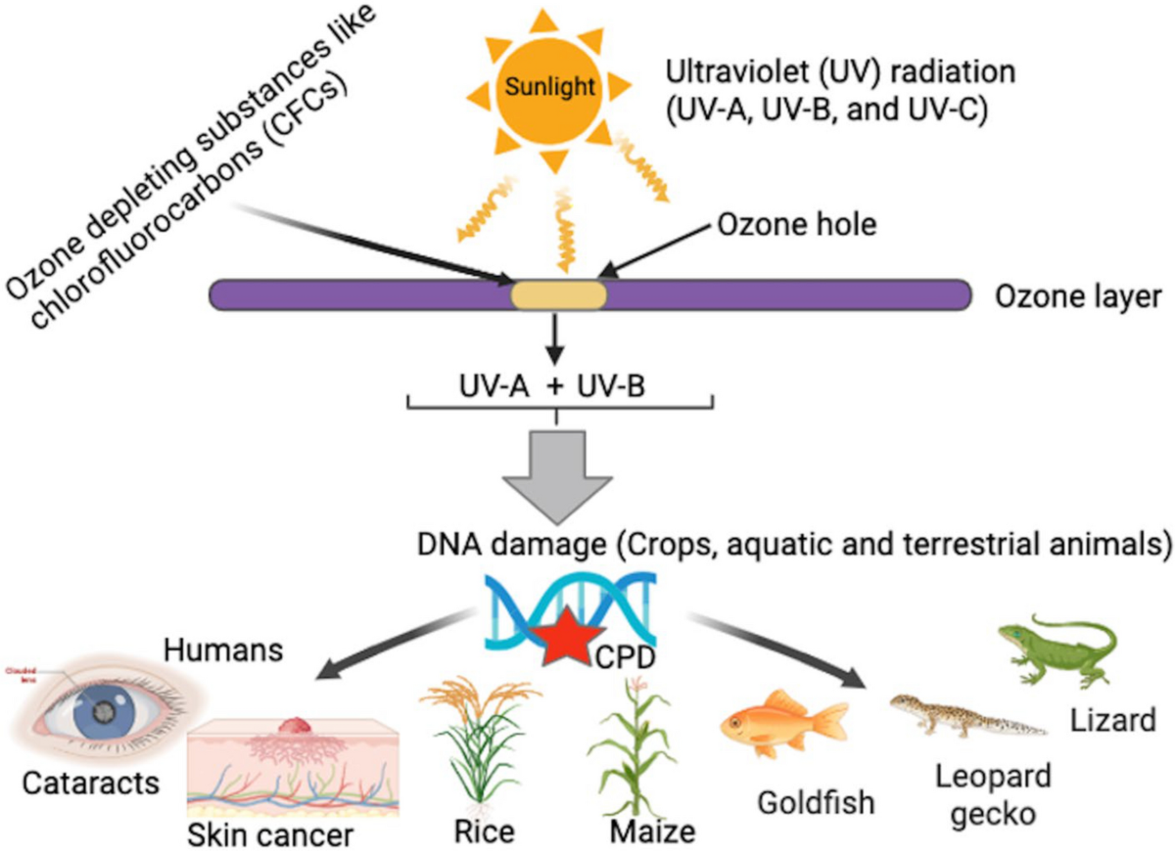

Figure 4: Environment and Health Impacts of UV
(Source: Mmbando and Ngongolo, 2024)
In addition to the environmental factors, inherited genetic factors play a role in an individual's susceptibility. The susceptibility to UV-induced damage and cancer development is enhanced by genetic mutations, especially in genes involved in DNA repair (Jeremian et al., 2023). Hereditary predisposition is significant because individuals with a family history of skin cancer is two to three times more at risk than the general population (Ju et al., 2023).

Literature Gap and Critical Perspective
The major advantage of the role of UV exposure as the primary risk factor of the environment is supported by existing literature, and the role of genetic research emphasizes the role of inherited susceptibility in altering risks in individuals (Shraim et al., 2023). Nevertheless, numerous studies examine environmental and genetic factors separately, which does not allow a thorough consideration of their interactions. Wider gene-environment studies indicate that complicated interactions of external exposures and genetic composition could have a strong effect on disease outcomes, but these kinds of connections are under-investigated in skin cancer studies (Virolainen et al., 2023).
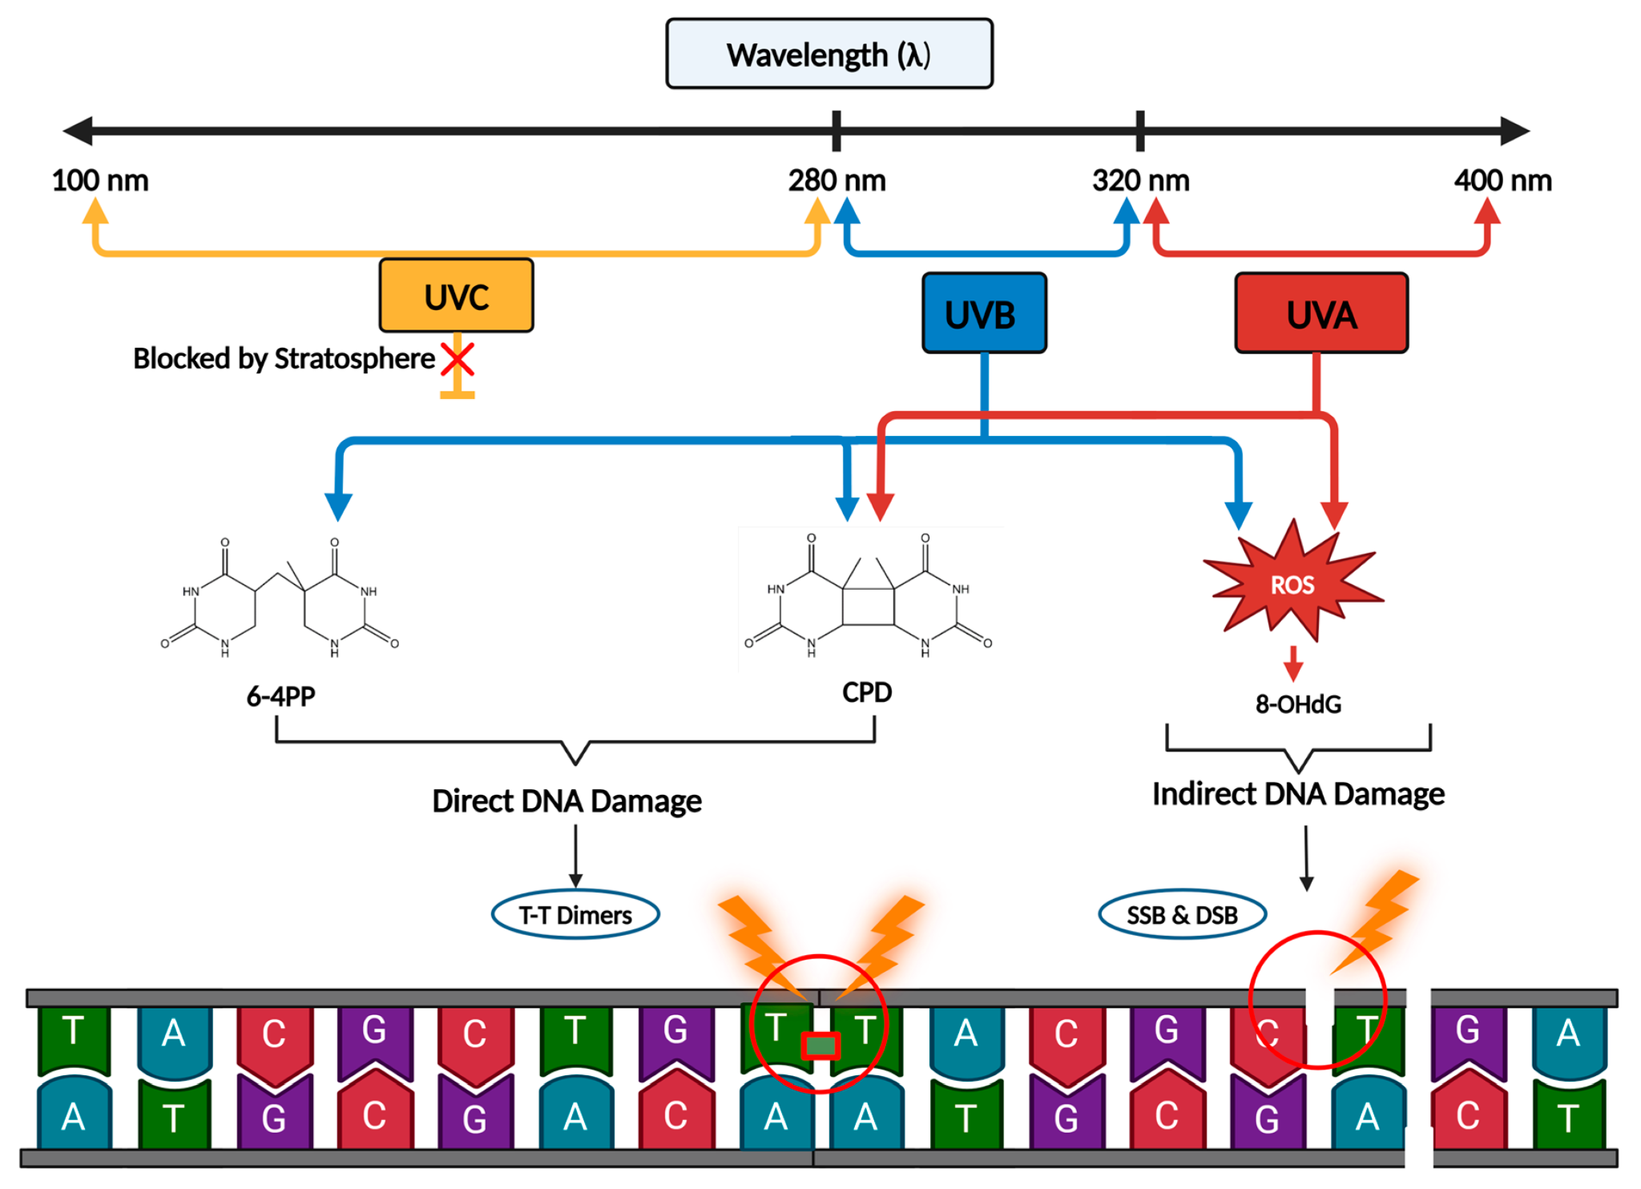

Figure 5: Types of UV-induced DNA damage
(Source: Al-Sadek and Yusuf, 2024)
Moreover, others may give much emphasis on behavioural factors without giving much consideration to biological predisposition or genetic mutations without taking into consideration environmental triggers (Gbemudu, 2023). This disjointed strategy may cause a crucial knowledge gap especially in the UK scenario where both high UV exposure behaviour and genetic diversity both exist.

3. Rationale & Research Question/Aims/hypothesis

Rationale
This research is significant, as existing literature on skin cancer tends to study environmental and genetic risk factors separately, restricting a thorough comprehension of the interaction of these factors in real life. It is proven that ultraviolet (UV) exposure is the primary environmental risk factor, and genetic predisposition would help in determining the vulnerable state of an individual, but the interaction of these factors is inadequately studied (Shraim et al., 2023). This gap thus limits the formulation of effective risk prediction models and limits the effectiveness of the interventions that are targeted.
The development of the personalised prevention strategies is facilitated by a more integrated analysis which allows identifying the high-risk individuals depending on the environmental exposure as well as genetic profile. This would be especially be applicable in the UK scenario where the increasing rates of incidence exerts more demands on healthcare systems (Elendu et al., 2025). Moreover, the findings are policy relevant since they guide the population health campaigns, screening programmes, and resource allocation to preventable cases and to enhance the outcome of early detection.

Aim
The aim of this study is to systematically review and synthesise existing literature on the role of environmental and genetic factors in the development of skin cancer in UK adults, in order to inform more effective personalised prevention and treatment approaches.

Objectives
- To evaluate the impact of environmental risk factors, including UV radiation exposure, occupational sun exposure, and lifestyle behaviours, on the incidence of skin cancer in UK adults.
- To examine the role of inherited genetic factors and family history in increasing individual susceptibility to skin cancer.
- To analyse the interaction between environmental and genetic factors in influencing skin cancer development.
- To identify evidence-based strategies for personalised prevention, early screening, and targeted treatment interventions for high-risk groups.

Research Question
What are the environmental risk factors and inherited genetic influences contributing to the development of skin cancer among UK adults, and how can this knowledge support improved personalised prevention and treatment strategies?

4. Research Methodology

Research Type and Strategy
This research is based on a secondary data research design with a systematic literature review method, which is entirely consistent with the approved form of ethics. No primary data, and around 30-40 peer-reviewed journals that were published in 2015-2025 is analysed to guarantee relevance and quality. The qualitative research strategy is to be used in the given study, as the research would not account any numerical data but interpret findings, determine patterns and synthesise evidence. This strategy enables a thorough appreciation of the discussion of how environmental and genetic factors are addressed in the literature available (Morrow et al., 2021).

Research Philosophy and Approach
This research follows an interpretivist research philosophy since the research seeks to comprehend meanings, perspectives and relationships as expressed in literature. The research would not measure variables but seeks to explain the relationship between UV exposure and genetic vulnerability as indicated by different studies. This philosophical approach suits well in examining complicated health problems where context and interpretation are critical (Bahrami and Tafrihi, 2023).
The inductive approach is used and no predetermined hypothesis is tested but by observing the patterns and themes that are apparent in the literature. By examining at least 30 scholarly materials, the research thus determines common themes, including environmental exposure, genetic predisposition, and their interaction in the development of the disease.

Justification of Methodological Choices
This study does not use a quantitative approach since the study does not involve the use of statistical tests or primary datasets. Rather, the systematic review approach is more suitable, since it allows synthesizing the broad scope of existing evidence in a systematic and transparent way (Shaheen et al., 2023).). Systematic review methods, such as PRISMA guidelines, is used to guarantee rigour, reproducibility and reliability in the research process (Batten and Brackett, 2022).
The research would thus be qualitative, interpretivist and inductive in its approach of analysing existing literature to produce a detailed knowledge of the risk factors of skin cancer in the UK setting.

5. Research Design
The present study uses a descriptive research design because the study aims to summarise and synthesise the current knowledge on the environmental and genetic risk factors that affect skin cancer. This can help in describing the collected data without inferring with the other stances (Ghanad, 2023). The study does not involve any hypothesis testing because the researcher does not analyse any new empirical data, but analysing the results of past work. The structure is appropriate to a systematic literature review, which allows drawing conclusions based on about 30-40 chosen studies. One of the main advantages of this method is that it offers a wide and comprehensive insight into the subject. Nonetheless, a drawback is its reliance on the quality, reliability, and extent of literature available.

6. Recruitment, Sampling & Study Participants
No human subjects are involved in this study and as such, there is no need to have a recruitment process, which is fully compliant with the approved ethics form. Rather, sampling is used to mean the choice of the pertinent academic literature. The number of peer-reviewed articles is around 30-40, depending on specific criteria. The inclusion criteria are based on the studies that concentrate on adult populations; UK based or contextually oriented research and publications in the recognised academic journals. The inclusion criteria exclude studies that are not related to skin cancer, publications in non-English and low quality and peer-reviewed articles. Such a systematic method of sampling helps to make sure that only valid and pertinent evidence is considered (Alsuhaymi et al., 2024).

7. Data Collection Methods
A systematic literature review is conducted to gather data in a structured systematic way. The searches are made in electronic databases such as PubMed, Scopus, and Web of Science to find peer-reviewed studies on the topic. These databases is chosen because they have a wide scope of medical and public health studies (Heath et al., 2022). The keywords to be used and a predefined search strategy is based on skin cancer, UV exposure, and genetic risk, melanoma, and UK adults. Results is refined with the help of the logical operators (AND, OR) and is used to enhance the search.
The preliminary search would yield around 800-1000 articles that is narrowed down to a shortlist of 15 articles after a multi-step screening process. The initial step is to screen the titles to eliminate obviously irrelevant studies. This needs to be followed by abstract screening and narrowing down the number to approximately 150-200 articles. A conclusive full-text review is conducted to select about 30-40 high-quality studies to include.
The PRISMA guidelines is applied in the selection process and the identification, screening, eligibility, and inclusion steps is presented by the use of a flow diagram. This helps in making the study transparent as well as reproducible. One of the strong aspects of this approach is the use of peer-reviewed, reliable sources. Nevertheless, a weakness is the possible publication bias since the studies that have substantial results are more prone to publication and inclusion.

8. Data Analysis Technique
The systematic review of literature with the help of thematic analysis is used to analyse data. About 30-40 identified studies is subjected to data extraction using the structured approach with all important variables including risk factors, study design and findings being captured. It is followed by coding, which allows to transmute like ideas to be put into categories. Approximately 3-5 key themes are likely to come up, such as UV exposure, genetic predisposition and gene-environment interaction.
The interpretation analysis is conducted instead of numerical measurement, which allows a deeper insight into the trends in studies. Nevertheless, subjectivity isa weakness, because the identification of themes can be different based on interpretation even though they attempt to stay consistent and transparent.

9. Ethical Considerations
There are no human subjects, no consent, and no data collection of personal or sensitive data, therefore, the proposed study would fully comply with the approved ethics form. All information is sourced in academic databases that are credible and academic referencing is done in accordance to the Harvard referencing, ensuring that the academic integrity is upheld and plagiarism is avoided. To be reliable, about 30-40 peer-reviewed studies is utilized.
Possible threats involve fatigue of the researchers because of the analysis time and misinterpretation of data (Ashley, 2021). The mitigation of these risks would involve proper time management, organization of the work schedule, and references and plagiarism-checking software to prevent mistakes and unethical conduct.

10. Implications of Research
This research is useful in the academic field as it offers a comprehensive view of both environmental and genetic influences and would bring evidence-based research of around 30-40 studies together in order to fill the current gaps in research. In practice, the results would aid the NHS to enhance prevention approaches especially focusing on the 86% of cases that may be related to UV exposure and improve early detection of those at risk (Manganelli et al., 2021). The policy level could use the results to inform policy-level public health campaigns to minimize the increasing incidence rates in more than 250,000 cases per year in the UK. Nonetheless, generalisability challenges are present because of the use of secondary data, which would place emphasis on conducting primary research in the future (Sawicki et al., 2021).

11. Plan of Work and Time Schedule
The research takes 6 weeks (42 days) to complete, according to a specific schedule in order to have a systematic development. A comprehensive literature search is conducted, which would collect about 800-1000 studies, and screening and selection of about 30-40 relevant articles are to be needed. The following weeks is dedicated to data extraction, thematic analysis, and writing a final report. This time management plan is significant in the management of time efficiently and the completion of all the research activities in time.
Table 1: Gantt chart (Research Timeline)
Task | W1 | W2 | W3 | W4 | W5 | W6 | W7 | W8 | W9 | W10 | W11 | W12 | W13 | W14 | W15 | W16
Identification of Topic | ✔ | ✔
Setting Aim and Objectives |  | ✔ | ✔
Literature Search |  |  | ✔ | ✔ | ✔ | ✔
Data Screening (Title/Abstract) |  |  |  | ✔ | ✔ | ✔
Full-Text Review & Selection |  |  |  |  |  | ✔ | ✔
Data Extraction |  |  |  |  |  |  | ✔ | ✔ | ✔
Data Analysis (Thematic) |  |  |  |  |  |  |  |  | ✔ | ✔ | ✔
Draft Writing |  |  |  |  |  |  |  |  |  | ✔ | ✔ | ✔
Final Writing & Editing |  |  |  |  |  |  |  |  |  |  |  | ✔ | ✔
Proofreading & Submission |  |  |  |  |  |  |  |  |  |  |  |  |  | ✔ | ✔ | ✔

12. References
Abubakar, M., (2024). Overview of skin cancer and risk factors. International Journal of General Practice Nursing, 2(3), pp.42-56.
Al-Adwan, S., Alqaisi, K.M. and Al Katheri, G., (2024). Nevus Variations in the Jordanian Population: Effects of Age, Medical Conditions, Environment, Congenital, Inherited, and Genetic Factors. Clinical, Cosmetic and Investigational Dermatology, pp.17-29.
Al-Sadek, T. and Yusuf, N. (2024). Ultraviolet Radiation Biological and Medical Implications. Current Issues in Molecular Biology, [online] 46(3), pp.1924–1942. doi:https://doi.org/10.3390/cimb46030126.
Alsuhaymi, M.A.S., Faqih, O.A.G., AlAlyani, M.M.A., Alkhodidi, M.S.S., Alfahmi, S.H.H., Almohaisen, S.M.A.M., Alsahly, T.G.S., Alzahrani, A.S., Fateh, A.A.A., Alshareq, W.A. and Al-Harbi, A.S.S., (2024). Epidemiology of cancer in Saudi Arabia: a systematic review 2024. The Review of Diabetic Studies, pp.577-591.
Armstrong, M. (2020). Infographic: Surge in UK skin cancer deaths since the 70s. [online] Statista Daily Data. Available at: https://www.statista.com/chart/22639/skin-cancer-death-rates-uk/?srsltid=AfmBOopUKRWwd_84EyU3i7l3psB_ST7kRZwnIjkJ7dzKXjrIc2WuSOSZ [Accessed 20 Apr. 2026].
Ashley, F. (2021). Accounting for research fatigue in research ethics. Bioethics, 35(3), 270-276. https://www.florenceashley.com/uploads/1/2/4/4/124439164/ashley_accounting_for_research_fatigue_in_research_ethics.pdf
Bahrami, H. and Tafrihi, M., (2023). Global trends of cancer: The role of diet, lifestyle, and environmental factors. Cancer innovation, 2(4), pp.290-301.
Batten, J., and Brackett, A. (2022). Ensuring rigor in systematic reviews: Part 6, reporting guidelines. Heart & Lung, 52, 22-25. https://www.sciencedirect.com/science/article/pii/S0147956321002685
Chandla, Danny & Brown, Scott. (2015). Modelling the Mutation Rate of The Flash in Context. Journal of Interdisciplinary Science Topics. 4. https://www.researchgate.net/figure/ncidence-Statistics-for-Cancers-excluding-non-melanoma-skin-cancer-in-the-UK-2009-11_fig2_273905149
Elendu, C., Nzeako, T.R., Nwachukwu, N.O., Akpa, K.N., Omiko, R.A., Ayobami-Ojo, P.S., Orji, U.W., Nwankwo, V.C., Amaefule, K.C., Chima, C.S. and Chika, N.W., (2025). Genetic factors and management strategies in aortic health: a literature review of inherited aortopathy. Annals of Medicine and Surgery, 87(2), pp.598-615.
Gbemudu, B.A., (2023). Environmental risk factors in lung and skin cancer. Available at SSRN 4579295.
Ghanad, A. (2023). An overview of quantitative research methods. International journal of multidisciplinary research and analysis, 6(08), 3794-3803. https://www.researchgate.net/profile/Anahita-Ghanad/publication/373370007_An_Overview_of_Quantitative_Research_Methods/links/67b28ffc645ef274a48341a1/An-Overview-of-Quantitative-Research-Methods.pdf
Hartmane, I., (2024). Study of genetic mutations and their association with the development of atopic dermatitis and other skin diseases. Plastic and Aesthetic Nursing, 44(3), pp.200-209.
Heath, A., Levay, P., and Tuvey, D. (2022). Literature searching methods or guidance and their application to public health topics: a narrative review. Health Information & Libraries Journal, 39(1), 6-21. https://onlinelibrary.wiley.com/doi/pdf/10.1111/hir.12414
Jaworek-Korjakowska, J. and Kleczek, P. (2018). eSkin: Study on the Smartphone Application for Early Detection of Malignant Melanoma. Wireless Communications and Mobile Computing, 2018, pp.1–11. doi:https://doi.org/10.1155/2018/5767360.
Jeremian, R., Xie, P., Fotovati, M., Lefrançois, P. and Litvinov, I.V., (2023). Gene–Environment analyses in a UK biobank skin Cancer cohort identifies important SNPs in DNA repair genes that May help prognosticate disease risk. Cancer Epidemiology, Biomarkers & Prevention, 32(11), pp.1599-1607.
Ju, S., Fan, W., Rokohl, A.C., Guo, Y., Kakkassery, V. and Heindl, L.M., (2023). Genetic factors underlying basal cell carcinoma risk: a narrative review. Frontiers of Oral and Maxillofacial Medicine, 5.
Khoshakhlagh, A.H., Mohammadzadeh, M. and Gruszecka-Kosowska, A., (2024). The preventive and carcinogenic effect of metals on cancer: a systematic review. BMC Public Health, 24(1), p.2079.
Lewandowska, A., Lewandowski, T., Rudzki, G., Próchnicki, M., Laskowska, B., Pavlov, S., Vlasenko, O., Rudzki, S. and Wójcik, W., (2023). The Risk of Melanoma due to Exposure to Sun and Solarium Use in Poland: A Large-Scale, Hospital Based Case-Control Study. Asian Pacific journal of cancer prevention: APJCP, 24(7), p.2259.
Manganelli, M., Guida, S., Ferretta, A., Pellacani, G., Porcelli, L., Azzariti, A. and Guida, G., (2021). Behind the scene: exploiting MC1R in skin cancer risk and prevention. Genes, 12(7), p.1093.
Mmbando, G.S. and Ngongolo, K. (2024). Environmental & health impacts of ultraviolet radiation: current trends and mitigation strategies. Discover Sustainability, 5(1). doi:https://doi.org/10.1007/s43621-024-00698-1.
Morrow, A., Chan, P., Tucker, K. M., and Taylor, N. (2021). The design, implementation, and effectiveness of intervention strategies aimed at improving genetic referral practices: a systematic review of the literature. Genetics in Medicine, 23(12), 2239-2249. https://www.sciencedirect.com/science/article/pii/S1098360021054472
Raymond-Lezman, J.R., Riskin, S., Lezman, J. and Riskin, S.I., (2023). Attitudes, behaviors, and risks of sun protection to prevent skin cancer amongst children, adolescents, and adults. Cureus, 15(2).
Sathe, N. C., & Zito, P. M. (2025, February 17). Skin cancer. StatPearls - NCBI Bookshelf. https://www.ncbi.nlm.nih.gov/books/NBK441949/#:~:text=Continuing%20Education%20Activity,to%20determine%20the%20specific%20type .
Sawicki, T., Ruszkowska, M., Danielewicz, A., Niedźwiedzka, E., Arłukowicz, T. and Przybyłowicz, K.E., (2021). A review of colorectal cancer in terms of epidemiology, risk factors, development, symptoms and diagnosis. Cancers, 13(9), p.2025.
Shaheen, N., Shaheen, A., Ramadan, A., Hefnawy, M. T., Ramadan, A., Ibrahim, I. A., ... and Flouty, O. (2023). Appraising systematic reviews: a comprehensive guide to ensuring validity and reliability. Frontiers in research metrics and analytics, 8, 1268045. https://www.frontiersin.org/journals/research-metrics-and-analytics/articles/10.3389/frma.2023.1268045/pdf
Shraim, R., Farran, M.Z., He, G., Marunica Karsaj, J., Zgaga, L. and McManus, R., (2023). Systematic review on gene–sun exposure interactions in skin cancer. Molecular genetics & genomic medicine, 11(10), p.e2259.
Tasdogan, A., Sullivan, R.J., Katalinic, A., Lebbe, C., Whitaker, D., Puig, S., van de Poll-Franse, L.V., Massi, D. and Schadendorf, D., (2025). Cutaneous melanoma. Nature Reviews Disease Primers, 11(1), p.23.
Wunderlich, K., Suppa, M., Gandini, S., Lipski, J., White, J. M., & Del Marmol, V. (2024). Risk factors and innovations in risk assessment for melanoma, basal cell carcinoma, and squamous cell carcinoma. Cancers, 16(5), 1016. https://doi.org/10.3390/cancers16051016
Wunderlich, K., Suppa, M., Gandini, S., Lipski, J., White, J.M. and Del Marmol, V., (2024). Risk factors and innovations in risk assessment for melanoma, basal cell carcinoma, and squamous cell carcinoma. Cancers, 16(5), p.1016.

