Janhara Bibi (2025745)
Summary
This report was written based on the Green Fields Care Home scenario. It describes and explains what an effective team is, the roles needed and how they can be developed in health and social care settings. There is also a discussion of the benefits and impacts of both effective and ineffective teamwork. Conclusions and recommendations are then made based on the research.
Component 1 report: effective teamworking for team success
MODULE: EFFECTIVE TEAM WORKING AND COMMUNICATION (BMSW4002_BIRM)

CONTENTS

Introduction ………………………………………………………………………..………………… 2

Overview of Team Working ..……………………………………………………………………… 3

Models of Team Development .………..………………………………………………………….. 4

Team Roles .……………………………………………….………………………………………... 6

Discussion ...…………………………………………..…………………………………………….. 8

Conclusion and Recommendations .…………………………………………………………….. 10

Reference List .…………………………………………………………………………………….. 11

INTRODUCTION

This report will be discussing team working particularly in health and social care settings. It will begin with an overview of what a team is and what is needed for teamwork to be effective. Different models of team development will then be explored and compared with one another. Team roles based on Belbin’s theory were then looked at and how they might lead to a team becoming effective. There was then a discussion about the advantages of effective teamworking and the potential impacts of ineffective teamworking. The report then ends with the conclusions drawn and future recommendations.

This report was written for the management team at the Green Fields Care Home. It is intended to show the importance of effective teamwork and how to create an effective team to help the team at Green Fields deal with their issues. It is hoped that both the team at Green Fields and the residents of the home benefit from this report.

OVERVIEW OF TEAM WORKING

A team has been defined as people working together closely to achieve a shared goal or task (Wageman et al, 2012). Teams are seen as being different from groups. One way in which the two are seen as being different is in terms of their purpose. The purpose of teams usually is to achieve an obvious goal (e.g., to improve patient care), however groups sometimes do not have a purpose and exist for the members themselves rather than another reason (Rowland, 1989).

In order for goals to be achieved, teams must be able to work together effectively. The following factors have been found by Tarricone and Luca (2002) to contribute to effective teamwork, these include:
- The members of the team being committed to the team and its goal/s
- Being interdependent (i.e., the team members helping and encouraging each other to work at their best)
- Being able to talk openly about issues and giving feedback
- All members of the team knowing what they need to contribute
- Having a strong leader to make decisions.

Similar factors have been identified as being important for an effective team in health and social care settings (Ryan, 2017). Effective teamwork is especially important in health and social care as it ensures that patients receive the appropriate level of care and their conditions do not worsen (Leonard et al, 2004).

However, in some cases team members (such as those working at the Green Fields Care Home) may struggle to work together effectively. Griffith and Dunham (2015) offered some explanations for why this may happen including:
- Team members not being fully committed to the team
- Team members not communicating properly with each other
- Issues between the team members etc.
MODELS OF TEAM DEVELOPMENT

There have been many different models of team development that have been designed over the years. Although, one of the most popular models was proposed by Tuckman which focused on the relationships of team members and how they go about completing their tasks. Tuckman and Jensen (1977) later added to this model of team development and suggested that there were four stages involved in team development: forming, storming, norming and performing. A fifth stage, adjourning, was also added later on. The order of these stages can be seen below in Figure 1.

Figure 1 – A diagram of Tuckman’s Model of Team Development from Bonebright (2010).

Bonebright (2010) summarised the stages in Tuckman’s model as follows:
- Forming; this is when the team create basic rules and familiarises themselves with each other and their leader
- Storming; the team members initially disagree with each other over their ideas but eventually come together
- Norming; the team members accept their differences and begin to feel committed to the team
- Performing; each team member follows their role and all work towards completing the task
- Adjourning; when the team completes their task and happily go their separate ways.

Another popular model of team development comes from Gersick (1988). Unlike Tuckman, Gersick’s model of team development focuses on “task dimension” which in other words is how much work is needed to complete the task. Gersick suggested that there were three phases in team development: the stable phase (1), the instability phase (2) and another stable phase (3). A diagram displaying these phases is shown in Figure 2.
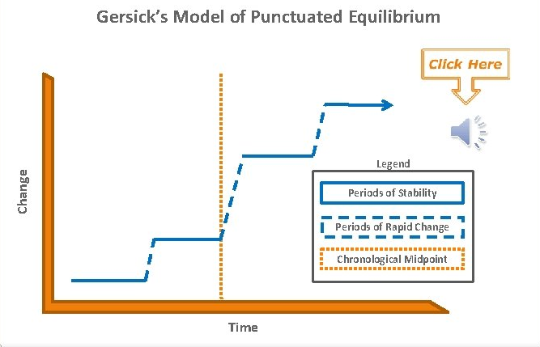
Figure 2 – A diagram of Gersick’s Model of Team Development

Johnson et al (2002) summarised the phases in Gersick’s model as follows:
- Stability Phase (1); this is when the team first meets and discusses how they will complete the task, they begin working according to their plan
- Instability Phase (2); this is when the team regroups and talk over their plan, typically after experiencing an issue
- Stability Phase (3); the team overcomes their issue and remain committed to completing the task until it is finished.

From reviewing the different models of team development, it would be beneficial if the Green Fields Care Home follows Tuckman’s model of team development. As researchers have suggested, Gersick’s model focuses more on the task’s completion timeline. Tuckman’s model would therefore benefit the staff at Green Fields more as it would allow them to work on their relationships with each other as a team.

TEAM ROLES

As explained in the ‘overview of team working’ section, a team that wishes to work effectively must assign each member a role. The most popular theory relating to the roles needed for an effective team was developed by Belbin (2010). As a part of this theory, Belbin suggested that teams require their members to take on nine specific roles which fit into three different categories.

The three categories of roles proposed by Belbin include:
- “Thinking-Oriented Roles”
- “Action-Oriented Roles”
- “People-Oriented Roles”

Under the “Thinking-Oriented Roles” category, the roles include:
- Plant; this involves proposing ideas and making solutions for any problems
- Monitor Evaluator; this involves hearing all of the possible options and ideas and choosing which one is most appropriate
- Specialist; this entails providing expert knowledge and skills needed for the task(s).

Under the “Action-Oriented Roles” category, the roles include:
- Shaper; someone who works well under pressure and is willing to overcome issues
- Implementer; this involves changing the plant’s ideas into physical products and arranging the work for this
- Completer Finisher; this involves looking for errors and correcting them.

Finally, under the “People-Oriented Roles” category, the roles include:
- Coordinator; this involves taking some form of leadership by emphasising the team’s goals and ensuring that everyone has a role
- Team Worker; someone who addresses their fellow members’ concerns and tries to prevent conflict
- Resource Investigator; this involves looking for opportunities and resources to help the team complete their task(s).
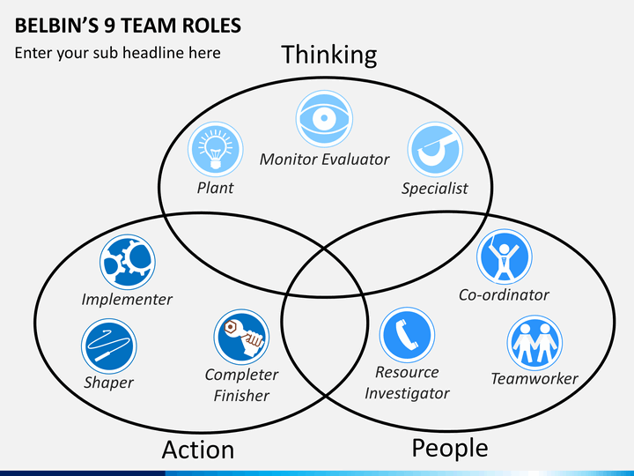
Figure 3 – A diagram of Belbin’s Team Roles
Interestingly, McCrimmon (1995) criticised Belbin’s team roles. She claimed that teams generally do not have fixed roles. Instead McCrimmon suggested that it would be better for teams if all the members had different skills (similar to those that Belbin suggested for each role) so they can take on a role whenever it is needed.

It is not only important to consider team roles in the existing team at Green Fields Care Home but also when recruiting new staff. New staff members must be effectively integrated into the existing team and by giving them a role in the team, it might help them get more comfortable quickly. Also, by having to manage their own role, it would allow the new staff to gain an understanding and respect for the other team members (Desveaux et al, 2019). This would be especially helpful at Green Fields as the quicker that the new staff can settle in, the better it would be for the patients.
DISCUSSION

There are many advantages of effective teamworking that the team at Green Fields Care Home might benefit from.

One advantage of effective teamworking, especially in healthcare settings, is that a higher quality of care can be delivered to patients. West et al (2002) found that teamwork in health and social care settings tends to be associated with less stress. This might be because the team members are able to equally share out their roles and tasks which means that they can spend more time and effort delivering the best care to their patients. This advantage is relevant to the Green Fields Care Home as they cater to older people who are likely to be frail and suffer from many conditions. Therefore, effective teamworking will ensure that the residents do not suffer more than they already are and are able to live peacefully.

Another advantage of effective teamworking is that improves both the wellbeing and job satisfaction of the team’s members. Mickan (2005) found that staff members in healthcare settings enjoyed working as part of a team as they felt like they were able to use their skills and take part in discussions. This advantage would be beneficial for the Green Fields Care Home as the less stressed and unsatisfied the staff members are, the more likely they are to help the residents and their colleagues.

A third advantage of effective teamworking is that it creates an environment that makes everyone feel comfortable to talk about their mistakes and improve on them. As a part of the Culture Code theory, Coyle (2018) suggested that effective teams are able to “share vulnerability”. With this skill, effective teams are able to openly admit where they have gone wrong and then reassure each other. By admitting their flaws, team members are then able to act on any feedback and improve for the future. This would benefit the Green Fields Care Home as it would allow the team to discuss how some of the staff are not accepting of the resident’s backgrounds and how they can then go about changing this.

However, teamworking such as what is currently being seen in the Green Fields Care Home can be ineffective. Ineffective teamworking can have many negative impacts for organisations.

One impact of ineffective teamworking is the creation of “inter group bias”. Van Knippenburg and Schippers (2007) suggested that this type of bias involves there being a division between team members – for example, managers being seen as more powerful and valuable than regular staff members. This bias can create tension in the workplace as some staff, especially those in the lower positions, may feel unvalued and therefore might stop working as best they can. If this happened in the Green Fields Care Home, it might affect patient care and cause resident’s conditions to get worse.

Another impact of ineffective and poor teamworking is that new staff are unlikely to join the team. Ineffective teams are likely to lose members as the staff become unsatisfied and begin to dislike their jobs. This means that these organisations would need to employ more people to make up for this loss. However, with social media and other websites like Glassdoor it is easy for past staff members to write reviews about their former workplace. People that may be considering applying for the job may be put off reading poor reviews about the team. This may happen at the Green Fields Care Home if they continue to have poor teamworking as they will struggle to employ more staff which would again cause the residents to suffer.

CONCLUSION AND RECOMMENDATIONS

In conclusion, teamworking is an important practice for organisations including the Green Fields Care Home. Without effective teamworking and following appropriate team roles, the Green Fields Care Home will struggle to function.

In order to begin working effectively together as a team, the staff at Green Fields Care Home will need to begin to create an atmosphere where they feel comfortable to point out each other’s flaws including their lack of tolerance (Coyle, 2018). The team at Green Fields would also benefit from following Belbin’s Team Roles as it would mean that everyone’s skills are being put to use in the best way.

It would be best if the team at Green Fields followed Tuckman’s model of team development to deal with these issues. This is because Tuckman’s model would allow them to specifically focus on their relationship with one another as a team and perhaps overcome some of the conflict that they had in the past.
REFERENCE LIST

Belbin, M., (2010), Team Roles at Work, eBook Collection (EBSCOhost), Routledge

Bonebright, D. A. (2010). 40 years of storming: a historical review of Tuckman’s model of small group development. Human Resource Development International, 13(1), pp. 111-120.

Coyle, D. (2018), The Culture Code, London: Random House Business.

Desveaux, L., Haiko, R., Marani, H., Feldman, S., & Ivers, N. H. (2019). Importance of Team Functioning as a Target of Quality Improvement Initiatives in Nursing Homes: A Qualitative Process Evaluation. The Journal of Continuining Education in the Health Professions, 39(1), pp. 21-28.

Gersick, C. J. (1988). Time and transition in work teams: Toward a new model of group development. Academy of Management journal, 31(1), pp. 9-41.

Griffith, B. A., & Dunham, E. B. (2015). Working in Teams: Moving From High Potential to High Performance, SAGE Publications.

Johnson, S. D., Suriya, C., Yoon, S. W., Berrett, J. V. & La Fleur, J. (2002). Team development and group processes of virtual learning teams. Computers & Education, 39(4), pp. 379-393.

Leonard, M., Graham, S., & Bonacum, D. (2004). The human factor: the critical importance of effective teamwork and communication in providing safe care. BMJ Quality & Safety, 13(1), pp. 85-90.

McCrimmon, M. (1995). Teams without roles: empowering teams for greater creativity. Journal of Management Development, 14, pp. 35-41.

Mickan, S. (2005). Evaluating the effectiveness of health care teams. Australian heath review: a publication of the Australian Hospital Association, 299(2), pp. 211-217.

Rowland, S. (1989). Groups and Teams. Journals of In-Service Education, 15(3), pp. 209-212.

Ryan, S. (2017). Promoting effective teamwork in the healthcare setting. Nursing Standard, 31(30), pp. 52-60.

Tarricone, P., & Luca, J. (2002). Successful teamwork: A case study. Quality Conversations, Proceedings of the 25th HERDSA Annual Conference, pp. 640-646.

Tuckman, B. W., & Jensen, M. A. C. (1997). Stages of small-group development revisited. Group & organization studies, 2(4), pp. 419-427.

Van Knippenburg, D. and Schnippers, M.C. (2007) ‘Work Group Diversity’. Annual Review of Psychology, 58, pp.515-541.

Wageman, R., Gardner, H., & Mortensen, M. (2012). The changing ecology of teams: New directions for teams research. Journal of Organizational Behavior, 33(3), pp. 301-315.

West, M. A., Borrill, C., Dawson, J., Scully, J., Carter, M., Anelay, S., Patterson, M., & Waring, J. (2002). The link between the management of employees and patient mortality in acute hospitals. The International Journa of Human Resource Management, 13(8), pp. 1299-1310.

