BMHP5015 – Changemakers: Building your Personal Brand for Sustainable Employment
Component 2: Assignment (Report)
Student Name: Nabila Nazam
Student ID:2324644
Date of Submission: 31/3/26
Teacher: Olufemi Oluranti

Table of Contents
1. Introduction 2
2. Job Description and Personal Specification 3
3. Employability Skills Analysis 6
4. Assessing my Own Skills 6
5. Health and Social Care Experience and Qualification 7
6. Building Personal Brand 7
7. Adding Value to the Job 8
8. Action Plan and Timeline 8
9. Resources Required 10
10. Communicating my Skills 10
11. Conclusion 10

1. Introduction
This report is intended to examine the skills and requirements required in the position of Senior Support Worker and my suitability to this position. The job role I have selected is a leadership role in the health and social care sector focusing on children. The report will look at the job description and employability core skills to be applied then do a self-evaluation of my strengths and weaknesses. My current experience and qualification, the value I can offer to the position, and how I will develop my personal brand will also be discussed in the report. Besides it shall outline an action plan, resources and modes necessary to market my skills to prospective employers.

2. Job Description and Personal Specification
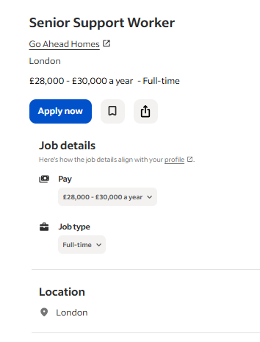
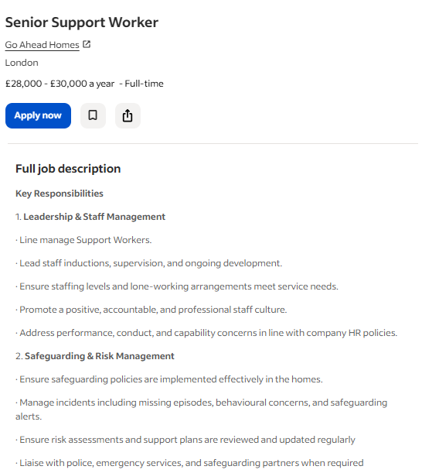
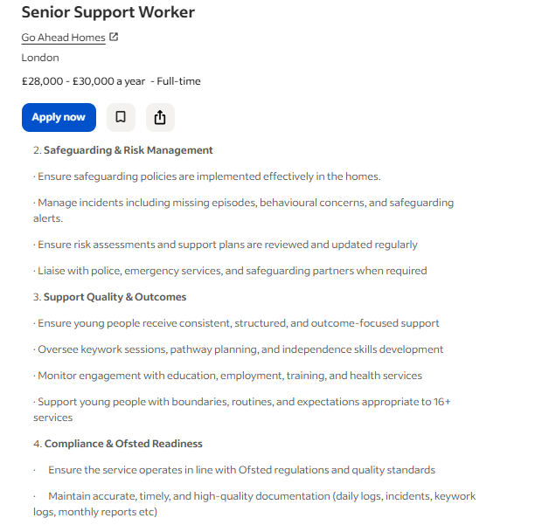

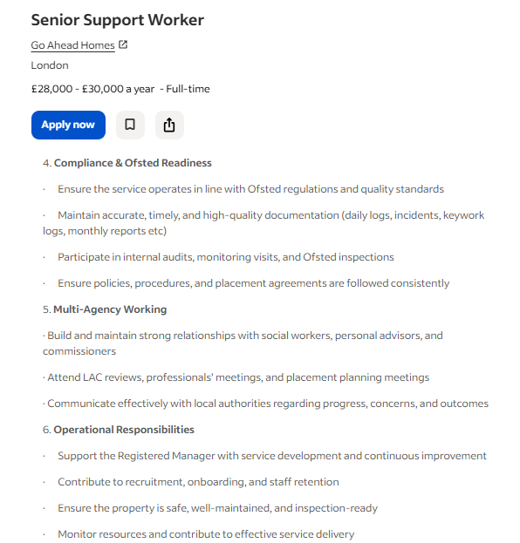
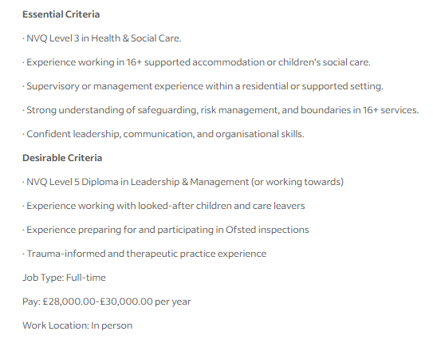
As illustrated in the screenshots of the job description of the Senior Support Worker at Go Ahead Homes, the role is a combination of direct support services, leadership and operational duties in a 16+ supported accommodation facility. The job will involve the supervision of personnel, handling safeguarding incidents, inspecting risk-assessment, keywork planning and pathway planning, making sure of records, Ofsted-ready support and work with social workers, commissioners and other professionals. The person specification demonstrates that the employer would like to find NVQ Level 3 in Health and Social Care, the experience in the field of social care of children or 16+ housing, the experience in supervision, and excellent safeguarding, leadership, and communication and organisation skills (Go Ahead Homes, 2026).

3. Employability Skills Analysis
In this job advertisement, the two most potent employability skills are leadership and safeguarding/risk management. It is relevant since in the post, the worker has to transform the standards into a regular staff practice by supervising, being accountable and making daily decisions, rather than merely having a senior title (Go Ahead Homes, 2026). Here, it is critical that inclusive leadership can be linked to the enhancement of workgroup inclusion and quality of care and demonstrate that good leaders enhance the functionality of teams and the safety of provision (Yousef, Khan and Paracha, 2022). The multiagency protection and risk management are also of great focus, as the job will imply taking actions in response to the incident, investigate risk reviews, and communicate with external agencies (Go Ahead Homes, 2026). Ball et al. (2024) demonstrate that multi-agency protection is a challenge at the frontline level and, thus, the skill is not merely a piece of procedural knowledge but a skill to exchange information, make decisions and turn policy into immediate protective measures towards young people.

4. Assessing my Own Skills
Communication is one of my strong capabilities. I am able to communicate effectively, listen and remain composed in the face of others, and this is noteworthy when entering into a position where one must offer support to the youth, handle people and act in a professional manner when I faced external agencies. Responsibility is also another strength. I am serious about tasks, attempt to be reliable and would know how important it is to work to the procedure. This is applicable since the job demands proper record keeping, professional limits and assessing risks. The primary area of my improvement is practice in leadership. Currently, I do not have much practice of managing people, providing guidance in problematic scenarios and addressing performance concerns, which are primary requirements in a top position. I am also to enhance my practical knowledge of risk evaluation and security. I do not just imply being familiar with the theory but being capable of identifying issues, acting appropriately and documenting the behaviours accurately in actual life. In order to evaluate these areas, I made use of a SWOT analysis writing my own strengths and weaknesses and analysing threats which I need to observe and opportunities which I need to avail. Tutor, mentor or experienced support worker feedback would also assist me in pointing areas of weakness and work towards them.

5. Health and Social Care Experience and Qualification
Up to this point, I can offer myself as a person who is just beginning to develop the necessary health and social care experience via studying, training, and supportive practice but not by senior responsibility. My transferable experience has been gained during the interaction with people under caring, service-based or community-oriented conditions where being patient, communicating clearly, being reliable and empathetic were significant. I could as well lean upon any voluntary work or informal support positions or any experience of a place where I assisted people, listened to their needs and took instructions in a way. Regarding qualification, I would state the education I have completed now, any health and social care modules, safety and health understanding training, first aid and basic qualifications that are all related to care practice as evidence to this position. In spite of the fact that I am yet to gain a great leadership experience, my framework of person-centre support, professional conduct and teamwork is present. The following experiences allow me to say that I am starting to realize the importance of care work and that I now have a ground to progress to the next stage of becoming a Senior Support Worker.

6. Building Personal Brand
I could create my personal brand by offering a transparent and cohesive image of what I am good at, what I value, and where I want to go. Promotion of self is not the only element of personal branding. It is a calculated approach of demonstrating to others what is available to me and how I would prefer to be known in the field of work which could enhance employability and professional presence (Khedher, 2019). I would thus position my brand on the current strengths that I possess that includes communication, patience, reliability, empathy and willingness to learn and demonstrate that I am in progress of acquiring even greater safeguarding knowledge and practical care skills. I would support this by using LinkedIn, personalized resume, a well crafted personal statement and training, certification, volunteering or placement work sample evidence. LinkedIn is particularly helpful since it can assist individuals to introduce and uphold a professional existence on-line in a systematic and visible manner (Marin and Nilă, 2021). I would also strive to make a professional impression that seems genuine, concentrated and applicable in my future career.

7. Adding Value to the Job
The primary contribution I might make to this role is a calm, reliable and person-focused style of support. At this level, my special selling point would not be senior leadership, but rather a combination of patience, effective communication with a clear desire to learn. Practically, this implies that I would be empowered to establish positive relationships with young people, learn to listen and respond to them appropriately, maintain continuous and conducive following and responding respectively. Such attributes are important since soft skills like communication, flexibility and emotional management enable individuals to convert knowledge into efficacious behaviour in complicated work environments and enhance the ability of individuals to be employed. My attitude of being reflective is also likely to be valuable, as I will allow feedback and strive to become better than I think I know. This can be used in a support environment to establish trust, consistency and a better experience in the lives of the youth in the situation I go through to advance to higher levels.

8. Action Plan and Timeline
Timeframe | What I Need to Learn | Action Plan | Skills Developed
Year 1 | Basic safeguarding, care principles, health & safety | Complete short courses (safeguarding, first aid, care basics) and attend workshops or online training | Safeguarding awareness, basic care knowledge, confidence
Year 2 | Understanding real care environments and client needs | Gain voluntary or paid experience, shadow experienced staff and observe real situations | Practical experience, communication, teamwork
Year 3 | Record keeping, risk assessment and professional practice | Take responsibility for tasks such as writing reports, following care plans and asking for feedback | Organisation, documentation, risk management
Year 4 | Decision-making and early leadership exposure | Support team tasks, guide new staff informally and observe how senior staff manage situations | Confidence, responsibility, basic leadership skills
Year 5 | Advanced practice and career progression | Work towards further qualifications and apply for higher-level support roles | Career readiness, professional development

During the initial years, I would work on the acquisition of the minimum knowledge and exposure to the actual care environments. The middle stage would involve practical skills in documentation and risk awareness that I would develop through the practical experience. Along the way, I would slowly gain confidence and become more responsible in later stages even at the initial stages of leadership. At the end of my last year, I will be ready to occupy more advanced positions that have enhanced competencies, experience, and professional knowledge.

9. Resources Required
I would have to combine training, exposure and professional support in workplace in order to achieve the skills needed in this position. To begin with, I would require accredited short courses in such fields as safeguarding, first aid, record keeping, risk awareness and trauma informed practice due to the emphasis that Skills for Care gives on formal training and development programmes as a means of developing a skilled and effective workforce in the care setting. I would also apply Care Certificate standards as guidance in the process of early development since the standards define what is required in relation to knowledge, skills and behaviours expected in the context of health and social care and can enable me understand the areas I need to improve on further. In addition to this, I would require either voluntary or paid experience in care, shadows and frequent observation by the seasoned personnel. This is important since through work based learning individuals get to gain more skills of employability since they learn to relate their learning and practice and also gain confidence with time.

10. Communicating my Skills
The first step I would take is to ensure my CV is well written and displays my training, education, relevant experience and the required skills in the job. A personalized cover letter would be written too to elaborate on why I would like the job and what I could do. Also, I would ensure that I update my LinkedIn profile to make my qualifications, achievements and career goals visible to the employers. I might also be able to develop a basic personal portfolio on the needed occasion to present the certificates, training and voluntary experience all in one.

11. Conclusion
In summary, the present report has created a clear and organized knowledge about the position of the Senior Support Worker and the competencies to be used to be successful in the position. The job description and person specification analysis indicated that the position needs effective communication, awareness protection, responsibility and teamworking capabilities. As a result of self-assessment, I have concluded that I already possess several applicable strengths, specifically, in communication, reliability and willingness to learn. Nevertheless, I also identified key points of improvement particularly on leadership, practical safeguarding application and professional decision-making. My present experience and credentials were also noted in the report that demonstrated that I possess an elementary background regarding care-related values and competences. The action plan and schedule that I was presented with offered me a realistic roadmap in which to build these skills over time using training and working experience coupled with feedback. Moreover, my own brand development, relying on relevant resources and effective communication of skills will also help me become more employable in the future. On the whole, this report proves that I am aware of what will be needed in this position and my determination to provide the required skills to attain it in an organized and realistic manner.

References
Ball, E., McManus, M., McCoy, E. & Quigg, Z. 2024, ‘Implementation of multi-agency safeguarding arrangements regarding exploitation of young people: aligning policy and practice using normalisation processing theory’, Journal of Applied Youth Studies, vol. 7, pp. 449–468, doi: 10.1007/s43151-024-00133-2.
Go Ahead Homes 2026, Senior Support Worker, Indeed job advertisement, viewed 30 March 2026.
Yousaf, M., Khan, M.M. & Paracha, A.T. 2022, ‘Effects of inclusive leadership on quality of care: the mediating role of psychological safety climate and perceived workgroup inclusion’, Healthcare, vol. 10, no. 11, article 2258, doi: 10.3390/healthcare10112258.
Khedher, M. 2019, ‘Conceptualizing and researching personal branding effects on the employability’, Journal of Brand Management, vol. 26, no. 2, pp. 99–109. Available at: https://doi.org/10.1057/s41262-018-0117-1
Marin, G.D. & Nilă, C. 2021, ‘Branding in social media. Using LinkedIn in personal brand communication: A study on communications/marketing and recruitment/human resources specialists’ perception’, Social Sciences & Humanities Open, vol. 4, no. 1, article 100174. Available at: https://doi.org/10.1016/j.ssaho.2021.100174
Chrzan-Rodak, A., Nowicki, G.J., Schneider-Matyka, D., Grochans, E. & Ślusarska, B. 2023, ‘Impact of the empathic understanding of people and type D personality as the correlates of social skills of primary health care nurses: a cross-sectional study’, International Journal of Environmental Research and Public Health, vol. 20, no. 1, article 201. Available at: https://doi.org/10.3390/ijerph20010201
Ingusci, E., Signore, F., Crescenzo, P., Cortese, C.G. & Manuti, A. 2026, ‘Are university students ready to work? The role of soft skills and psychological capital in building sustainable employability’, Education Sciences, vol. 16, no. 2, article 181. Available at: https://doi.org/10.3390/educsci16020181
Skills for Care 2026, Care Certificate standards, Skills for Care, viewed 30 March 2026, available at: https://www.skillsforcare.org.uk/Developing-your-workforce/Care-Certificate/Care-Certificate-standards.aspx
Skills for Care 2026, Skills for Care training seminars and programmes, Skills for Care, viewed 30 March 2026, available at: https://www.skillsforcare.org.uk/Developing-your-workforce/Skills-for-Care-training-seminars-and-programmes.aspx
Skills for Care 2026, Statutory and mandatory training, Skills for Care, viewed 30 March 2026, available at: https://www.skillsforcare.org.uk/Developing-your-workforce/Guide-to-developing-your-staff/Statutory-and-mandatory-training.aspx
Suyitno, S., Nurtanto, M., Jatmoko, D., Widiyono, Y., Purwoko, R.Y., Abdillah, F., Setuju & Hermawan, Y. 2025, ‘The effect of work-based learning on employability skills: The role of self-efficacy and vocational identity’, European Journal of Educational Research, vol. 14, no. 1, pp. 309–321, doi: 10.12973/eu-jer.14.1.309.

