I acknowledge the use of Grammarly (https://www.grammarly.com/) between the October 2025 and March 2026 to check my work using the automated grammar and punctuation. I confirm that I have not presented any AI generated text as my own work. I confirm I have copies of my drafts, notes, and other resources I used before, and after the use of AI tools which I may be asked to provide in evidence.

I acknowledge the use of google scholar (https://scholar.google.com/) between the October 2025 and March 2026 to search for relevant papers for my thesis. I confirm that I have not presented any AI generated materials as my own work. I confirm I have copies of my drafts, notes, and other resources I used before, and after the use of AI tools which I may be asked to provide in evidence.

I acknowledge the use of google (https://www.google.com/) between October 2025 and March 2026 to search for journals for my report. I confirm that I have not presented any AI generated materials as my own work. I confirm I have copies of my drafts, notes, and other resources I used before, and after the use of AI tools which I may be asked to provide in evidence.



Mind The Gap: Experiences of Support For Neurodivergent Students (Aged Under 25) From Secondary School to University and its Impact on Mental Health – A Qualitative Study.

Claudia Joan Varallo

MA Children and Young People’s Mental Health

University of Wales Trinity Saint David School of Psychology

Empirical Thesis: March 2026

Declaration

The dissertation does not include work accepted for any other degree or professional qualifications
Signed
Date:
The dissertation has been composed by me and is my own work.
Signed:
Dated:

Acknowledgements

Table of contents

Table of contents v
Chapter 1: Plain English Summary 1
Chapter 2: Systematic Literature Review 3
2.1: Abstract 3
2.2: Introduction 4
2.3:Methods 15
2.3.1: Search process 15
2.3.2: Table 1 15
2.3.3: Inclusion and exclusion criteria 15
2.3.4: Screening and study selection 16
2.3.5: Quality appraisal 16
2.3.6: Table 2 18
2.4: Results and Discussion 21
2.4.1: Support discontinuity across educational contexts 21
2.4.2: Disclosure and the burden of self-advocacy 22
2.4.3: Staff understanding, institutional culture, and enactment of support 24
2.4.4: Belonging, peer support, and relational buffering 25
2.4.5: Systemic and administrative barriers 26
2.4.6: Synthesis and implications 26
2.4.7: Research Gap, Aims, and Research Questions 27
2.4.8: References 30
Chapter 3: Research Paper 32
3.1: Abstract 32
3.2: Introduction 33
3.3: Methods 37
3.3.1: Overview of methodological approach 37
3.3.2: Participants 37
3.3.3: Sampling characteristics and ethics 37
3.3.4: Table 1 38
3.3.5: Recruitment 38
3.3.6: Procedure 38
3.3.7: Materials 39
3.3.8: Design 39
3.3.9: Data analysis 39
3.4: Results 40
3.4.1: Table 1 40
Theme 1: Institutionalised Independence and Withdrawal of Care 41
Loss of embedded scaffolding 41
Fragmentation and process barriers 42
Theme 2: Psychological Negotiation of Competence 42
Anxiety, exhaustion, and internalised doubt 43
Restoring stability through enacted support 43
Theme 3: Belonging, Exclusion, and Calls for Change 44
Social positioning and belonging 44
Reforming transition support 44
3.5: Discussion 46
3.5.1: Conclusion 51
3.6: References 53
Chapter 4: Reflective Chapter 56
4.1: Reference 63
Appendices 64
Appendix 1: Ethics Form 64
Appendix 2: Survey 91
Appendix 3: information sheet 92
Appendix 4: consent form 93
Appendix 5: debrief form 94
Appendix 6: Transcripts examples (uncoded and coded) 95
Appendix 7: coding and themes 101
Appendix 8: Familiarisation phase 103
Appendix 9: proposal 104

Chapter 1: Plain English Summary
This study explored how neurodivergent students experience the move from secondary school to university, and how the social support they receive before and after this transition affects their wellbeing, confidence, and ability to settle into university life. With social support referring to things such as help and guidance from teachers or university staff, clear communication about expectations, academic adjustments, emotional encouragement, and opportunities to connect with supportive peers The term neurodivergent describes people whose brains work differently from what is typically expected in educational settings, including students who are autistic, or have ADHD (Attention Deficit Hyperactivity Disorder), dyslexia, dyspraxia, or a combination of these differences. ADHD is a condition that can affect attention, concentration, and organisation. Dyslexia is a learning difference that mainly affects reading, writing, and processing written information. Dyspraxia (also known as Developmental Coordination Disorder) affects coordination and motor skills and can make planning, organisation, and some everyday tasks more difficult. Many neurodivergent young people experience challenges at school, such as difficulties with organisation, workload, sensory environments, understanding expectations, and social inclusion. At school, support is often built into daily routines and provided by familiar staff. When students move to university, routines change and support systems are very different. Students are expected to manage more independently and to ask for help themselves, which can feel overwhelming.
The purpose of this research was to understand how support changes across this transition and whether support at both stages helps protect mental health and support adjustment. Previous research suggests that many neurodivergent students experience high levels of stress and anxiety when starting university, often linked to uncertainty and reduced structure. Some students report positive experiences when universities provide clear communication, flexible teaching, and supportive relationships. However, research in this area is limited, particularly in the UK, and often focuses only on autistic students.
This dissertation has two parts. The first part is a systematic review of existing research on neurodivergent students’ (NDS) experiences of support, transition, and wellbeing in higher education. It brings together findings on changes in support, disclosure, staff understanding, peer relationships, and mental health, and highlights gaps in current knowledge.
The second part is a new research study. Neurodivergent university students under 25 complete a survey about the support they received at school and university, their experience of stress, anxiety, self-esteem, and how well they feel they are settling academically and socially, to see what helped, what made things harder, and what could improve the experience for future students. By identifying these helpful supports and gaps in provision, this research aims to inform schools, universities, and policy makers about how to reduce support gaps and improve wellbeing, so neurodivergent students are better supported to succeed at university. This is particularly important at a time when increasing numbers of neurodivergent students are entering higher education, highlighting the need for universities to ensure their support systems meet diverse learning and wellbeing needs.

Chapter 2: Systematic Literature Review
Support Experiences of Neurodivergent Students in Educational Transition

2.1: Abstract
This systematic literature review examined how neurodivergent students (NDS) in the UK experience social support during the transition from secondary education to higher education, and how these experiences relate to wellbeing and adjustment. A systematic search of seven databases (2010–2025) identified 16 peer-reviewed studies spanning qualitative, mixed-methods, and review designs. Using a narrative synthesis and quality-informed weighting, five interrelated themes were identified: (1) discontinuity of support across educational contexts; (2) the burden of disclosure and self-advocacy; (3) variability in staff understanding and institutional culture; (4) belonging and peer-based relational buffering; and (5) systemic and administrative barriers. Evidence consistently indicated that distress experienced during transition reflects structural and relational misalignment rather than individual deficits. However, methodological limitations—including small samples, retrospective designs, and limited use of validated mental health measures—temper the strength of claims regarding psychological impact. These findings highlight the need for UK-based research integrating validated mental health outcomes with detailed exploration of perceived support across educational stages.

2.2: Introduction
The transition from secondary to higher education is widely recognised as a complex developmental and institutional shift; however, literature has increasingly demonstrated that for neurodivergent students (NDS) this transition is not merely more challenging, but qualitatively different. Across qualitative, mixed-methods, and review research, NDS describe a reconfiguration of support upon entry to university, characterised by reduced relational continuity, heightened procedural complexity, and increased expectations of independence and self-advocacy. These systemic changes are associated with anxiety, reduced confidence, and academic and social adjustment difficulties (Clouder et al., 2020; McDowall & Kiseleva, 2024). Where anxiety or stress is discussed, studies typically reflect participants’ reported experiences rather than validated psychological outcomes. outcomes due to limited use of standardised mental health measures.
Rather than locating these outcomes within individual deficit, the literature increasingly adopts neurodiversity-affirming and ecological perspectives, framing distress as arising from misalignment between students’ needs and institutional structures, practices, and cultures. Clouder et al.’s (2020) narrative synthesis is foundational in this regard, arguing that higher education continues to privilege normative assumptions about learning, communication, and independence. Within such systems, NDS are positioned as requiring individualised accommodations rather than institutions being required to adapt in structurally inclusive ways. A strength of Clouder et al.’s (2020) synthesis was its interdisciplinary scope, drawing together education, psychology, and disability studies to highlight persistent gaps between inclusion rhetoric and lived experience. However, as a narrative review, its conclusions relied on interpretive synthesis rather than systematic appraisal, limiting its capacity to assess strength of evidence across studies. Nonetheless, its conceptual framing has strongly influenced subsequent empirical work, which increasingly foregrounds relational, cultural, and systemic dimensions of support as central to wellbeing and adjustment.
A consistent finding across the literature concerns discontinuity of support across educational contexts. In secondary education, support is described as proactive, relational, and embedded within everyday interactions with familiar staff. In contrast, university support is experienced as conditional, fragmented, and dependent on students’ ability to recognise difficulties, disclose needs, and navigate institutional systems. McDowall and Kiseleva’s (2024) rapid review synthesised international evidence across neurodivergent groups and concludes that although support provision has expanded in scope, students’ lived experiences frequently reflect limited accessibility, poor coordination between services, and reactive rather than preventative models of support. A key contribution of this review is its explicit focus on policy–practice gaps, highlighting how institutional commitments to inclusion often fail to translate into consistent support experiences. However, the rapid review methodology, while appropriate for identifying broad trends, necessarily limits depth of critical appraisal and excludes some nuance regarding diagnostic and contextual variation.
Qualitative research provides insight into how this discontinuity is experienced. Butcher and Lane’s (2025) ecological systems theory study examined the lived experiences of AS and ADHD-S through in-depth interviews, situating students’ accounts across microsystem, mesosystem, and macrosystem levels. A strength of this work lies in its theoretical coherence: by explicitly applying ecological systems theory, the authors move beyond individualised explanations and demonstrate how institutional structures, cultural expectations, and service fragmentation interact to shape support experiences. Participants described arriving at university with minimal guidance on accessing support, despite having relied heavily on structured assistance in earlier education. Importantly, distress was not framed solely in terms of academic challenge but was closely linked to loss of relational safety, uncertainty about expectations, and perceptions of institutional indifference. Nevertheless, the study’s qualitative design introduces limitations common across this literature. However, the small self-selecting sample may over-represent students already engaged in support discourse. Additionally, although the inclusion of both autism and ADHD represents a methodological advance beyond autism-only research, the analysis does not fully disaggregate experiences by diagnostic profile. This limits conclusions regarding whether identified barriers are shared across neurodivergence or manifest differently depending on cognitive and attentional profiles. Such limitations underscore the need for research designs that balance depth of lived experience with broader representativeness.
Comparable patterns of support discontinuity and uncertainty are evident in dyslexia-focused transition research. O’Byrne et al. (2019) conducted a qualitative case study examining students with dyslexia – DYS, experiences of transition to university, using interviews conducted at different stages of study. The longitudinal element a notable strength, enabling exploration of how support needs and emotional responses evolved over time rather than treating transition as a discrete event. Students reported persistent anxiety related to assessment formats, inconsistent access to assistive technology, and concern about being perceived as less capable by staff. These experiences were exacerbated by variable staff understanding and inconsistent implementation of reasonable adjustments. However, the study’s focus on a single institutional context limits transferability, and the absence of validated mental health measures constrains interpretation of the psychological impacts described. Nonetheless, the findings provide valuable insight into how dyslexia-related support needs intersect with identity, confidence, and belonging during transition.
Across the literature, the escalation of self-management demands during transition is consistently identified as interacting with executive functioning differences common across neurodivergent profiles. Although executive functioning is often framed as an individual cognitive attribute, the reviewed studies suggest that institutional expectations of independence frequently fail to account for variability in planning, organisation, initiation, and self-regulation. McDowall and Kiseleva (2024) critically note that independence within higher education is often operationalised as withdrawal of institutional responsibility rather than supported autonomy. This framing places disproportionate responsibility on students to manage difficulties without adequate scaffolding, particularly during early transition when multiple systems - academic, social, and administrative - are changing simultaneously. From an ecological perspective, this withdrawal of support represents a breakdown in mesosystem continuity, with significant implications for wellbeing and adjustment, and is repeatedly associated with stress and anxiety in participants’ accounts, albeit typically without validated measurement within qualitative designs.
Disclosure is one of the most examined and problematised mechanisms through which support is accessed in higher education. Qualitative studies repeatedly describe disclosure as emotionally demanding, cognitively taxing, and fraught with uncertainty regarding stigma and staff responses. Quigley’s (2025) empirical analysis offers a particularly nuanced contribution through the concept of “double masking” capturing how NDS simultaneously conceal difficulties to meet institutional expectations of competence while selectively disclosing in order to access support. Drawing on in-depth interviews across autism, ADHD, dyslexia, and dyspraxia, Quigley demonstrates how this dual process generates emotional labour, exhaustion, and anxiety particularly where disclosure outcomes are unpredictable. A strength of this study lies in its cross-diagnostic scope, addressing a major gap in the literature. However, its reliance on self-reported experiences limits capacity to examine how disclosure practices translate into measurable mental health outcomes. The reliance on disclosure-based systems is further critiqued in McDowall and Kiseleva’s (2024) review, which highlights how documentation requirements and eligibility criteria function as institutional gatekeeping mechanisms. Students who are self-identifying, awaiting diagnosis, or whose needs fluctuate are particularly disadvantaged, often being excluded from formal support during critical transition periods. This issue is especially salient in the UK context, where prolonged waiting times for neurodevelopmental assessment are well documented. From a mental health perspective, such delays may exacerbate distress by leaving students without validation or support during a period of heightened vulnerability, reinforcing cycles of disengagement and self-doubt; however, the extent of this impact is more commonly inferred from reported experience than demonstrated through validated mental health measurement in the included studies.
Staff understanding and institutional culture are repeatedly identified as shaping whether support is enabling or obstructive. Butcher and Lane (2025) report substantial variability in staff responses within the same institution, with some lecturers demonstrating flexibility and collaborative problem-solving, while others were described as rigid or dismissive. This inconsistency undermined trust and discouraged help-seeking, particularly when students feared being perceived as difficult or less capable. These findings align with Clouder et al.’s (2020) argument that inclusion cannot be reduced to policy presence alone; rather, it is enacted through everyday interactions, attitudes, and relational practices. Importantly, this literature suggests that negative support encounters may have cumulative effects, shaping future help-seeking behaviour and contributing to chronic stress, though this is typically reflected in participant narrative rather than standardised clinical outcomes.
Recent pedagogical research has explored whether inclusive teaching might reduce reliance on disclosure by embedding flexibility within mainstream provision. Durgungoz’s (2025) mixed-methods study examined NDS experiences of Universal Design for Learning and found that clear structure, multiple modes of engagement, and reduced pressure for social performance supported participation and confidence. The mixed-methods design strengthens the study by triangulating student narratives with survey data, allowing for greater analytic depth. However, the findings also highlight that implementation remains inconsistent and often dependent on individual staff commitment rather than institutional mandate. This reinforces concerns raised elsewhere in the literature that inclusive practices may be unevenly enacted and insufficiently resourced.
Peer relationships and belonging are consistently identified as protective factors, yet many NDS report difficulty navigating unstructured social environments in higher education. Coyle et al.’s (2025) evaluation of the Synapse programme provides insight into the potential of co-designed peer support initiatives. Developed collaboratively with NDS, the programme emphasised predictability, shared identity, and empowerment. Participants reported enhanced confidence, connectedness, and sense of belonging, suggesting that relational support can buffer stress during transition. Nevertheless, the qualitative design and absence of comparison groups limit conclusions regarding effectiveness and scalability. As McDowall and Kiseleva (2024) caution, peer initiatives are often small-scale and resource-dependent, raising questions about sustainability and their capacity to address systemic barriers rather than mitigate their effects.
Across the literature, several methodological limitations constrained cumulative knowledge development. Samples are frequently small, self-selecting, and demographically homogeneous, with limited reporting of ethnicity, socioeconomic status, or first-generation status. Intersectional analysis remains rare, despite ecological theory suggesting that such factors are likely to shape support experiences and wellbeing outcomes. Additionally, much of the research examines higher education in isolation rather than explicitly comparing experiences across secondary and tertiary settings within the same design. Claims regarding support discontinuity therefore often rely on retrospective comparison. A further limitation concerns the disconnect between experiential and outcome-focused research. Qualitative studies richly document anxiety, stress, and emotional labour but rarely incorporate validated mental health measures. Conversely, quantitative studies that assess anxiety or wellbeing often lack contextual detail regarding support mechanisms. This methodological separation limits understanding of how specific support experiences translate into mental health and adjustment outcomes, highlighting the need for integrative research designs. Taken together, the literature provides compelling evidence that NDS experience transition to university as a period of heightened vulnerability shaped by systemic, relational, and cultural factors rather than individual deficit. However, the dominance of autism-focused research, limited longitudinal designs, and under-integration of mental health outcomes highlight significant gaps. These limitations strengthen the rationale for research that explicitly examines continuity and change in perceived support across educational stages and links these experiences to validated indicators of mental health and adjustment.
McDowall and Kiseleva’s (2024) rapid review further illustrate strengths and limitations of the evidence base. Their review synthesises findings from a wide range of international studies addressing support provision for neurodivergent students in higher education, including autism, ADHD, dyslexia, and mixed neurodivergent profiles. A key strength lies in the breadth of coverage and the explicit focus on institutional support systems rather than individual pathology. The authors identify consistent patterns across contexts, including fragmented provision, reliance on disclosure, and limited evaluation of support effectiveness. Importantly, the review foregrounds the absence of outcome-focused evidence, noting that few studies systematically examine how support experiences relate to mental health, retention, or academic success. However, as a rapid review, the study necessarily prioritises scope over depth. Inclusion criteria are relatively broad, and the synthesis does not fully differentiate between types of support or methodological quality across included studies. Consequently, while the review is highly effective in identifying systemic gaps, it is less able to specify which forms of support are most protective for mental health during transition.
Comparative analysis across empirical studies strengthens understanding of how systemic gaps manifest in lived experience. When considered alongside Butcher and Lane’s (2025) ecological systems study, O’Byrne et al.’s (2019) dyslexia-focused case study, and Quigley’s (2025) multi-diagnostic analysis of masking and disclosure, a striking convergence emerges despite methodological and population differences. All three studies employ qualitative designs and prioritise student voice, yet each foregrounds different aspects of transition. Butcher and Lane (2025) emphasise systemic fragmentation and cultural expectations of independence; O’Byrne et al. (2019) highlight academic practices and assessment-related anxiety; and Quigley (2025) centres identity negotiation and emotional labour. Despite these differences, students across studies describe remarkably similar experiences of uncertainty, exhaustion, and diminished confidence associated with navigating support systems. This convergence suggests that support-related distress is not condition-specific but structurally produced, reinforcing arguments for cross-diagnostic approaches to inclusion.
Methodologically, these studies reveal important tensions. Qualitative designs enable rich exploration of meaning, emotion, and relational context, which are essential for understanding support experiences. However, reliance on retrospective self-report introduces potential recall bias, particularly when participants reflect on earlier stages of transition. Furthermore, participants are often recruited through disability services or neurodivergent networks, which may exclude students who disengage from support or who remain undiagnosed. This sampling bias is rarely acknowledged explicitly, yet it has significant implications for interpretation. Students most marginalised by support systems may be under-represented, meaning that existing literature may underestimate the extent of distress and disengagement experienced during transition.
The dominance of autism-focused research further constrains generalisability. While recent studies have begun to include ADHD-S, DYS, and DYP-S, these profiles remain comparatively under-examined, particularly in relation to mental health outcomes. Where non-autistic neurodivergence is included, it is often grouped together without sufficient analytic differentiation. This limits understanding of how support needs and barriers may vary across neurodivergent profiles while simultaneously obscuring shared structural challenges. Quigley’s (2025) inclusion of multiple diagnoses represents a notable advance, yet even this work acknowledges that institutional responses often fail to recognise co-occurring identities, resulting in fragmented or inappropriate support.
A further limitation concerns the operationalisation of mental health. Although anxiety and stress are frequently reported, few studies employ validated mental health measures. Instead, mental health is often inferred from narrative accounts. While such accounts are valuable, their interpretive nature limits capacity to assess magnitude, change over time, or differential risk. Reviews such as McDowall and Kiseleva (2024) explicitly identify this as a critical gap, noting the need for research that integrates experiential data with standardised indicators of wellbeing and adjustment. Without such integration, it remains difficult to determine which aspects of support are most salient for mental health and which students are most vulnerable during transition.
The literature shows limited attention to temporal processes. Transition is frequently treated as an early-university phenomenon rather than a longitudinal process extending across educational stages. O’Byrne et al.’s (2019) longitudinal design is therefore notable, demonstrating that challenges related to support, confidence, and identity persist beyond initial entry to university. However, even this study relies on retrospective comparison rather than direct measurement of secondary school support. As a result, claims regarding support discontinuity are often inferred rather than empirically demonstrated. This remains a significant gap in the literature. From a theoretical perspective, ecological and neurodiversity-affirming frameworks provide a coherent lens through which to interpret these findings. By situating support within interacting systems rather than individual traits, these approaches help explain why similar patterns of distress emerge across diagnoses and contexts. However, empirical application of ecological theory remains uneven. While Butcher and Lane (2025) explicitly operationalise ecological systems theory, many studies implicitly adopt ecological assumptions without systematic analysis of system-level interactions. Greater theoretical consistency would strengthen the explanatory power of the literature and support more precise intervention development.
Taken together, this synthesis suggests that NDS difficulties during transition are structurally and relationally produced rather than individually determined. Support discontinuity, reliance on disclosure, inconsistent staff understanding, and procedural complexity interact to generate stress, anxiety, and reduced confidence. Although resilience and peer support may mitigate some effects, the literature indicates that systemic change is required to support equitable adjustment. However, the evidence base remains fragmented. Methodological limitations, diagnostic imbalances, limited longitudinal research, and weak integration of mental health outcomes constrain development of evidence-based support models. These gaps highlight the need for research comparing support experiences across educational stages, integrating validated mental health measures, and capturing lived experiences across diverse neurodivergent identities.
The present review was conducted as a systematic literature review using a structured search and narrative synthesis. This approach enabled integration of heterogeneous evidence, including qualitative, mixed-methods, and review studies with varied designs and outcomes. Qualitative studies were weighted for insight into relational processes and lived experiences of support, while mixed-methods and review studies provided triangulation and conceptual context. However, many studies discussed anxiety and wellbeing without validated measures, limiting comparability across contexts. This highlighted the need for research examining how support experiences relate to students’ psychological adjustment during transition. The empirical study therefore explored how neurodivergent students interpreted support across school and university contexts and how these experiences related to wellbeing.

2.3:Methods

2.3.1: Search process
A systematic search of published literature from January 2010 to March 2025 was conducted across PsycINFO, PsycARTICLES, MEDLINE/PubMed, Scopus, Web of Science, ERIC, and Education Research Complete. Search strings were developed iteratively and combined terms relating to neurodivergence, transition to higher education, support, and mental health or adjustment outcomes. Boolean operators were used to combine key facets, with synonyms linked using OR and facets combined using AND. Reference lists of included studies were manually screened to identify additional eligible papers not captured through database indexing.

2.3.2: Table 1
Search terms used for the systematic literature review
Facet | Search terms
Neurodivergence | autism OR ASD OR ADHD OR dyslexia OR dyspraxia OR neurodivergent OR neurodiversity OR “specific learning difference*”
Transition | transition* OR “school transition” OR “transition to university” OR “post-secondary transition” OR “higher education transition” OR “first year”
Support | “academic support” OR “social support” OR “disability service*” OR accommodation* OR “reasonable adjustment*” OR “inclusive teaching” OR UDL OR “universal design for learning”
Outcomes | anxiety OR stress OR “mental health” OR wellbeing OR “academic adjustment” OR “social adjustment” OR belonging
Population | student* OR undergraduate* OR “young people” OR adolescent*
Note: All facets combined with AND; all terms within facets combined with OR.

2.3.3: Inclusion and exclusion criteria
Studies were included if they: (a) examined NDS, including AS, ADHD-S, DYS, DYP-S, or mixed neurodivergent profiles, in relation to transition into higher education and/or early adjustment in higher education where transition processes remained salient; (b) used qualitative, quantitative, mixed-methods, or review designs; (c) examined experiences of support (formal and/or informal), inclusion practices, disclosure/adjustments, or support accessibility; and (d) were published in English in peer-reviewed outlets. Studies were excluded if they: (a) did not involve higher education contexts; (b) focused exclusively on adults outside education; (c) did not meaningfully analyse support (for example, neurodivergence only appearing as a demographic descriptor); (d) lacked sufficient methodological detail to support appraisal of credibility; or (e) were not peer-reviewed.

2.3.4: Screening and study selection
Records were screened in two stages. Titles and abstracts were first assessed against eligibility criteria, followed by full-text screening. The final set of included studies was selected on the basis of direct relevance to the review question (support experiences during/around transition to higher education and implications for wellbeing and adjustment), rather than diagnostic category alone.

2.3.5: Quality appraisal
Qualitative studies were appraised using COREQ (Tong et al., 2007), focusing on transparency of sampling, data generation, analytic approach, and reflexive positioning. For quantitative and mixed-methods studies, appraisal focused on clarity of design, adequacy and description of sample, appropriateness of measures, and coherence of analytic strategy. For review papers, appraisal focused on transparency of search strategy, inclusion criteria, and synthesis approach. Where reporting limitations were present, these were treated as constraints on confidence and transferability rather than automatic grounds for exclusion.
Studies characterised by limited methodological transparency, small self-selecting samples, or absent validated outcome measures were included but interpreted cautiously, with findings primarily used to illustrate experiential patterns rather than support stronger claims about prevalence or effect. Conversely, studies demonstrating clearer analytic procedures, coherent theoretical framing, or mixed-methods triangulation were afforded greater weight when developing and refining themes.

2.3.6: Table 2

Summary characteristics of included studies on neurodivergent students’ support and transition to higher education
Reference | Design & focus | Method, sample & setting | Key findings | Quality & comments
Clouder et al. (2020) | Narrative synthesis; neurodiversity in HE | Review; international HE literature | Inclusion framed as institutional responsibility; mismatch between provision and lived experience; support often reactive | Strong conceptual synthesis; narrative methods may introduce selection bias
McDowall & Kiseleva (2024) | Rapid review; supports for neurodivergent students in HE | Review; neurodivergent HE literature | Support uneven, outcome evidence limited; highlights priorities for research/practice | Strong for recency and scope; rapid review less exhaustive than full systematic
Butcher & Lane (2025) | Qualitative; access and inclusion via ecological systems theory | Interviews; autistic and ADHD students; HE setting | Barriers across systems (policy/culture/service pathways); support fragmented; self-advocacy burdens | Strong theoretical framing; self-selected sample; condition-specific comparisons may be limited. Evidence weighted for mechanism and lived impact, not prevalence.
Davies & Bagnall (2024) | Qualitative; staff perspectives on autism transition support (UK) | Interviews; disability support staff; UK universities | System constraints, capacity and process barriers; “good transition” depends on coordination and early support | Strong system-level insight; staff view may not map neatly onto student experience; used to triangulate institutional barriers rather than emotional outcomes.
O’Byrne et al. (2019) | Qualitative case study; dyslexia transition | Interviews; five dyslexic students; UK HE | Variable support visibility; assessment barriers; confidence shaped by staff responses and adjustment consistency | Rich depth but small sample; transferability limited, no validated mental health measures.
Reference | Design & focus | Method, sample & setting | Key findings | Quality & comments
Kim et al. (2021) | Qualitative; autistic transition and adjustment | Interviews; autistic undergraduates; HE context | Early transition challenging; support and adaptation processes shape adjustment over time | Strong for process detail; autism-only focus limits cross ND inference.
Aguilera Rodríguez & García-Torres (2024) | Empirical; ND students and graduates’ academic/emotional needs | Study of neurodiverse participants; HE context | Emotional and academic needs linked to support access, inclusion, and wellbeing | Useful multi-condition lens; transferability depends on setting/context
Durgungoz (2025) | Mixed-methods; UDL and neurodivergent student voice | Mixed methods; ND students in HE | UDL-aligned structure and flexibility can reduce access barriers; implementation consistency matters | Strong applied relevance; effect attribution limited without strong comparison
Quigley (2025) | Empirical; “double masking” and support experiences | Empirical design; ND students (autism/ADHD/dyslexia/dyspraxia) | Double masking creates fatigue and support avoidance; inclusion rhetoric vs lived reality | Valuable. cross-condition focus; credibility depends on analytic transparency
Dwyer et al. (2023) | Policy/practice paper; inclusive campuses | JPPD; institutional practices and recommendations | Culture, training, and service design shape accessibility; inclusion requires systemic change | Practice-oriented; may be less empirically dense than primary qualitative papers
Davis et al. (2021) | Systematic review; autistic students’ firsthand experiences/support | Review; HE autism literature | Consistent barriers: disclosure burden, staff understanding, mentoring/adjustments variability | Strong overview; heterogeneity limits specificity. Autism weighted evidence base note in limitations.
Widman & Lopez-Reyna (2020) | Systematic review; supports for autistic HE students | Review; autism in HE | Support types mapped; evidence base uneven; need stronger evaluations | Strong mapping; limited transition-specific granularity in some included studies
Reference | Design & focus | Method, sample & setting | Key findings | Quality & comments
González-Rodríguez et al. (2024) | Systematic review; transition from upper secondary to university for autistic students | Review; transition-focused autism literature | Transition barriers and facilitators; highlights the need for coordinated supports bridging sectors | Highly relevant to “school to university” transition focus. Autism only and varied study quality; supports transition discontinuity theme with diagnostic caveat.
Bhandari & Rainford (2023) | Qualitative; Access to HE → Level One study | Narratives; neurodivergent Access students | Study skills, support navigation, and institutional scaffolding shape progression | Relevance strong for “transition pathways”; bibliographic details should be verified from the final journal version
Coyle et al. (2025) | Participatory evaluation; co-designed peer support (Synapse) | Co-design/participatory; ND students; HE | Peer connection, belonging, empowerment; programme value but resource dependence | Strong co-production alignment: scalability/effect size often limited in programme evals; no comparison group/limited generalisability.
Le Cunff et al. (2025) | Participatory priority-setting; research questions for ND in HE | Participatory exercise; ND students/staff | Identifies priority domains (support, inclusion, mental health, systems change) | Strong for agenda-setting; not outcome evidence; used to justify research gaps/priorities, not impact claims.

2.4: Results and Discussion
Five interrelated themes were identified: (1) discontinuity of support across educational contexts; (2) the burden of disclosure and self-advocacy; (3) variability in staff understanding and institutional culture; (4) belonging and peer-based support; and (5) systemic and administrative barriers. These themes are discussed below, with attention to how methodological features of the included studies shape the strength and interpretation of the evidence.

2.4.1: Support discontinuity across educational contexts
Across the reviewed literature, the most consistent finding concerns the loss of relationally embedded support as students move from secondary education into higher education. Qualitative studies across autism, ADHD, and dyslexia populations describe secondary school support as proactive, predictable, and scaffolded through ongoing relationships with known staff, whereas university support is experienced as conditional and student-initiated (Butcher & Lane, 2025; O’Byrne et al., 2019; Kim et al., 2021). This pattern is reinforced by McDowall and Kiseleva’s (2024) rapid review, which synthesised evidence across ND groups and concluded that higher education systems often fail to provide continuity or anticipatory guidance during transition. As indicated in Table 2, this theme is strongly supported by convergent qualitative accounts yet is weighted more cautiously for claims about prevalence or causal sequencing because much of the evidence derives from small, self-selecting samples and predominantly retrospective comparison rather than longitudinal designs.
A strength of the qualitative evidence lies in its ability to capture how this discontinuity is experienced emotionally and practically. For example, Butcher and Lane (2025) demonstrate how loss of relational safety intersects with institutional expectations of independence, producing uncertainty and anxiety even among academically capable students. The ecological framing of this study strengthens its explanatory power by locating distress within interactions between systems rather than within individual functioning. However, as with many qualitative studies in this field, the reliance on self-selecting participants may bias findings toward students who experienced greater difficulty or who were already engaged in support discourse.
While review papers such as Clouder et al. (2020) and McDowall and Kiseleva (2024) provide breadth and conceptual clarity, they are limited in their capacity to demonstrate how support discontinuity unfolds over time, as few primary studies employ longitudinal designs. O’Byrne et al.’s (2019) dyslexia case study partially addresses this gap by examining experiences at different stages of study, revealing that early negative encounters with support can shape longer-term confidence and engagement. However, the small sample and single-institution focus constrain generalisability. Collectively, the evidence strongly supports the existence of support discontinuity but remains limited in its ability to map causal pathways across transition. This indicates that although discontinuity is widely reported, current evidence cannot yet determine how or when these differences in support emerge during transition.

2.4.2: Disclosure and the burden of self-advocacy
Disclosure emerged as a central mechanism through which support is accessed in higher education and as one of the most consistently problematised processes across studies. Empirical qualitative research indicates that disclosure is rarely a neutral or one-time event; instead, students describe repeated disclosure across services, modules, and staff, often accompanied by uncertainty regarding credibility, stigma, or staff understanding (Quigley, 2025; Davies & Bagnall, 2024). Quigley’s (2025) concept of “double masking” is particularly valuable in articulating how neurodivergent students simultaneously attempt to conceal difficulties to meet expectations of competence while disclosing selectively to access support. This dual process was associated with emotional exhaustion and avoidance of services, highlighting disclosure itself as a potential stressor. While Table 2 shows consistent convergence across qualitative and review evidence on disclosure burden, confidence in mental health impact is moderated because anxiety and exhaustion are most often described as reported experience and are rarely captured using validated mental health measures within the included primary studies. As a result, the literature provides strong evidence of perceived emotional burden but limited evidence that disclosure processes directly affect measurable mental health outcomes.
The strength of Quigley’s contribution lies in its inclusion of multiple neurodivergent profiles, addressing a key limitation in the literature’s autism-dominant focus. However, as with many experiential studies, the absence of validated mental health measures limits the ability to quantify the psychological impact described. Review evidence complements these findings by highlighting structural contributors to disclosure burden. McDowall and Kiseleva (2024) identify documentation requirements and eligibility thresholds as institutional gatekeeping mechanisms that disproportionately disadvantage students who are undiagnosed, awaiting assessment, or whose needs fluctuate. This critique is particularly salient in the UK context, where prolonged diagnostic waiting times are well documented and may leave students unsupported during transition.
Staff-focused research further complicates the disclosure narrative. Davies and Bagnall (2024) show that disability support staff recognise systemic constraints, including workload pressures and fragmented service pathways, which limit their capacity to provide proactive support. While staff perspectives provide valuable system-level insight, they may understate the cumulative emotional labour experienced by students navigating these systems. Together, the evidence suggests that disclosure-based support models place disproportionate responsibility on students and may inadvertently exacerbate distress. Consequently, disclosure functions not only as an administrative requirement but as a structural mechanism shaping students’ access to support and emotional wellbeing.

2.4.3: Staff understanding, institutional culture, and enactment of support
Across the included studies, variability in staff understanding and response was a key determinant of whether support was experienced as enabling or obstructive. Students consistently reported that institutional policies or formal adjustments were insufficient if staff attitudes were dismissive, inflexible, or inconsistent (Butcher & Lane, 2025; O’Byrne et al., 2019). These findings align with Clouder et al.’s (2020) argument that inclusion is enacted through everyday practices rather than policy statements alone. Table 2 highlights that this theme is strengthened by triangulation across student and staff perspectives, though conclusions about consistency and institutional generalisability are treated cautiously because several studies are context-specific and rely on small samples or single-institution settings.
Mixed-methods research exploring inclusive pedagogy offers partial counterpoints. Durgungoz (2025) demonstrates that Universal Design for Learning approaches—such as clear structure, multiple modes of engagement, and reduced emphasis on social performance—can reduce barriers and support engagement. The mixed-methods design strengthens the credibility of these findings by triangulating student accounts with broader survey data. However, the study also highlights uneven implementation, often dependent on individual staff commitment rather than institutional mandate, limiting scalability.
Policy-oriented work, such as Dwyer et al. (2023), reinforces the importance of organisational culture, staff training, and leadership in shaping inclusion. While such papers offer practical recommendations, they are less able to demonstrate impact on student mental health or adjustment outcomes. Overall, the evidence suggests that staff understanding is a critical mediator of support effectiveness yet remains inconsistently addressed within institutional systems. However, because most studies rely on single-institution qualitative designs, it remains unclear whether these patterns reflect systemic trends across higher education or context-specific institutional practices. This suggests that institutional culture and staff practices may be as influential as formal support policies in shaping students’ experiences of inclusion.

2.4.4: Belonging, peer support, and relational buffering
Feelings of belonging and peer connection were consistently identified as protective factors across studies, particularly during early transition. Qualitative evidence suggests that structured, predictable peer environments can buffer stress and enhance confidence, whereas unstructured social contexts may exacerbate isolation (Kim et al., 2021; Aguilera Rodríguez & García-Torres, 2024). Coyle et al.’s (2025) participatory evaluation of the Synapse programme provides a strong example of co-designed peer support, with participants reporting increased connectedness and empowerment. As shown in Table 2, evidence for peer-based buffering is weighted as strong for acceptability and perceived benefit but limited for effectiveness claims, given the predominance of qualitative programme evaluations, small samples, and the frequent absence of comparison groups or validated outcome measures.
The participatory design of the Synapse study strengthens its alignment with neurodiversity-affirming principles and enhances ecological validity. However, as with many programme evaluations, the absence of comparison groups and reliance on qualitative outcomes limit conclusions regarding effectiveness and generalisability. Review-level evidence cautions that peer initiatives are often small-scale and resource-dependent, raising concerns about sustainability and the risk of positioning peer support as a substitute for systemic accessibility (McDowall & Kiseleva, 2024). These findings suggest that peer support may act as an important relational buffer during transition, although its broader impact remains difficult to determine given existing methodological limitations.

2.4.5: Systemic and administrative barriers
Administrative complexity emerged as a cross-cutting theme across student- and staff-focused studies. Opaque pathways, delayed responses, and fragmented services were commonly described, contributing to crisis-driven rather than preventative engagement with support (Davies & Bagnall, 2024; Widman & Lopez-Reyna, 2020). Review evidence highlights that while many universities offer a range of services, students’ perceived accessibility of these services is often low, undermining their protective potential. As summarised in Table 2, confidence in this theme is strengthened by consistency across qualitative, mixed-methods, and review designs, although links to mental health outcomes remain interpretively cautious because administrative barriers are rarely examined alongside validated measures of anxiety, stress, or adjustment.
Methodologically, much of this evidence relies on retrospective accounts, which may be influenced by recall bias. However, the consistency of findings across qualitative, mixed-methods, and review designs strengthens confidence in the overall pattern. Notably, few studies systematically examine how administrative barriers interact with mental health outcomes using validated measures, limiting causal inference. Consequently, while administrative barriers are consistently identified, the literature provides limited evidence on how strongly these processes influence mental health or adjustment outcomes. This reinforces the view that barriers to support are often embedded within institutional processes rather than arising from individual student characteristics alone.

2.4.6: Synthesis and implications
Taken together, the reviewed evidence indicates that neurodivergent students’ transition to higher education is shaped less by individual capability than by systemic arrangements governing access to support. Support is most effective when it is proactive, relationally grounded, and coordinated across academic and wellbeing domains. Conversely, reliance on self-advocacy, inconsistent staff responses, and fragmented systems intensify anxiety and undermine adjustment. However, the evidence base is constrained by several limitations: dominance of autism-focused research, limited longitudinal designs, under-representation of intersectional identities, and a lack of integration between experiential accounts and validated mental health outcomes. These gaps limit the field’s ability to determine which support mechanisms are most protective and for whom. These limitations directly justify the present study’s focus on perceived support across educational stages and its mixed-methods design. By integrating validated mental health measures with qualitative exploration of lived experience, the present study addresses a key methodological gap and enables clearer examination of how support experiences relate to students’ psychological adjustment during transition.

2.4.7: Research Gap, Aims, and Research Questions
The systematic literature review has demonstrated that NDS consistently experience the transition to higher education as a period of heightened vulnerability, shaped by discontinuities in support, increased reliance on self-advocacy, and variable institutional responses. Although the existing literature provides rich insight into lived experiences of support in higher education, several critical gaps remain.
First, the evidence base is heavily weighted toward autism-focused research, with comparatively limited attention to ADHD-S, DYS, DYP-S, or mixed neurodivergent profiles. This diagnostic imbalance restricts understanding of whether identified support barriers reflect autism-specific challenges or broader structural issues affecting NDS more generally. Second, much of the research examines higher education in isolation, relying on retrospective accounts of schooling rather than directly comparing perceived support across secondary and tertiary educational contexts. As a result, the mechanisms through which support discontinuities emerge and their implications for adjustment remain under-theorised and under-measured. Third, there is a notable methodological divide between qualitative studies that richly document distress, anxiety, and emotional labour, and quantitative studies that assess mental health outcomes without adequately capturing the institutional and relational processes that shape them. Few studies integrate validated measures of mental health and adjustment with detailed exploration of students’ support experiences. Finally, intersectional influences such as socioeconomic background, diagnostic access, and institutional context are rarely examined, limiting the transferability and inclusivity of current findings. Taken together, these limitations mean that current research provides valuable insight into students’ experiences but offers limited explanatory clarity regarding how support structures influence mental health and adjustment during transition.
These gaps collectively indicate the need for a UK-focused investigation that explicitly examines continuity and change in perceived social support across the transition from secondary school to university, and that integrates experiential and outcome-focused evidence. Addressing these limitations requires a design capable of capturing both patterns of association between support and mental health and adjustment and the lived mechanisms through which support is experienced as accessible, burdensome, or absent. Accordingly, the aim of the present study is to investigate how neurodivergent students aged under 25 experience social support across the transition from secondary education to higher education in the UK and how these experiences relate to mental health and academic and social adjustment.
To achieve this aim, the study is guided by the following research questions:
- How do NDS perceive social support in secondary education compared with higher education?
- How do students describe the relationship between social support experiences and anxiety, stress, self-esteem, and academic and social adjustment among NDS?
- How do NDS describe their lived experiences of support continuity and discontinuity across the transition to university?
- What barriers and enablers to effective social support do NDS identify, and how do these shape wellbeing and adjustment during transition?
Together, these aims and research questions provide a coherent foundation for the qualitative study that follows, enabling systematic examination of both the structural patterns and lived realities of support during a critical developmental and educational transition.

2.4.8: References
Aguilera Rodríguez, G., & García-Torres, E. (2024). University experiences of students and graduates with neurodiversity: Academic and emotional needs. Frontiers in Education, 9, 1432930. https://doi.org/10.3389/feduc.2024.1432930
Bhandari, R., & Rainford, J. (2023). Exploring the transitions of neurodivergent Access students to Level One study: Narratives of study skills and support. International Journal of Educational and Life Transitions, 2(1). https://doi.org/10.5334/ijelt.49
Butcher, L., & Lane, S. (2025). Neurodivergent (autism and ADHD) student experiences of access and inclusion in higher education: An ecological systems theory perspective. Higher Education, 90(2), 243–263. https://doi.org/10.1007/s10734-024-01319-6
Clouder, L., Karakus, M., Cinotti, A., Ferreyra, M. V., Azevedo, I., & Rojo, P. (2020). Neurodiversity in higher education: A narrative synthesis. Higher Education, 80(4), 757–778. https://doi.org/10.1007/s10734-020-00513-6
Coyle, A., Fleming, H., & Greene, R. K. (2025). Synapse: A co-designed peer support programme for neurodivergent students in higher education. Autism. Advance online publication.
Davies, J., & Bagnall, C. (2024). “A good transition is just key”: The views and experiences of disability support staff in supporting autistic students’ transition to university. Autism in Adulthood, 7(2), 155–170. https://doi.org/10.1089/aut.2024.0076
Davis, M. T., Watts, G. W., & López, E. J. (2021). A systematic review of firsthand experiences and supports for students with autism spectrum disorder in higher education. Research in Autism Spectrum Disorders, 84, 101883. https://doi.org/10.1016/j.rasd.2021.101883
Durgungoz, F. C. (2025). Hearing out neurodivergent students: Universal Design for Learning in higher education. Higher Education. Advance online publication.
Dwyer, P., Allred, K., & Smith, L. (2023). Building neurodiversity-inclusive postsecondary campuses. Journal of Postsecondary Education and Disability, 36(2), 109–127.
González-Rodríguez, L., Ramos-Cejudo, J., & Camacho, A. (2024). Transition from upper secondary school to university for autistic students: A systematic review. Review Journal of Autism and Developmental Disorders. https://doi.org/10.1007/s40489-024-00366-9
Kim, S. Y., Crowley, S., & Bottema-Beutel, K. (2021). Autistic undergraduate students’ experiences of transition and adjustment to university. Journal of Autism and Developmental Disorders, 51(7), 2257–2269. https://doi.org/10.1007/s10803-020-04728-1
Le Cunff, A.-L., Schäfer, M., & Marsden, R. (2025). Key research questions to support neurodiversity in higher education: A participatory priority-setting exercise. Education Sciences, 15(7), 839. https://doi.org/10.3390/educsci15070839
McDowall, A., & Kiseleva, M. (2024). A rapid review of supports for neurodivergent students in higher education: Implications for research and practice. Neurodiversity. https://doi.org/10.1177/27546330241291769
O’Byrne, C., Jagoe, C., & Lawler, M. (2019). Experiences of dyslexia and the transition to university: A case study of five students at different stages of study. Higher Education Research & Development, 38(5), 1031–1045. https://doi.org/10.1080/07294360.2019.1602593
Quigley, E. (2025). Neurodiversity and higher education: Double masking by autistic, ADHD, dyslexic and dyspraxic students. Journal of Postsecondary Education and Disability.
Tong, A., Sainsbury, P., & Craig, J. (2007). Consolidated criteria for reporting qualitative research (COREQ): a 32-item checklist for interviews and focus groups. International journal for quality in health care : journal of the International Society for Quality in Health Care, 19(6), 349–357. https://doi.org/10.1093/intqhc/mzm042
Widman, C. J., & Lopez-Reyna, N. A. (2020). Supports for postsecondary students with autism spectrum disorder: A systematic review. Journal of Autism and Developmental Disorders, 50(9), 3166–3178. https://doi.org/10.1007/s10803-020-04433-z

Chapter 3: Research Paper

This manuscript has been written for submission to Psychology & Education and the International Journal of Disability, Development and Education following that journal’s Instructions to Authors.

3.1: Abstract
This study examined how neurodivergent students in Wales experience support across the transition from secondary school to university and how these experiences relate to anxiety, stress, self-esteem, and academic and social adjustment. Twenty-five UK students aged under 25 completed an online qualitative survey. Data were analysed using reflexive thematic analysis following Braun and Clarke’s (2006, 2012, 2015) framework to generate an interpretive account of shared and differing experiences. Three themes were identified: institutionalised independence and withdrawal of care (loss of embedded scaffolding; fragmentation and process barriers), psychological negotiation of competence (anxiety, exhaustion, and internalised doubt; restoring stability through enacted support), and belonging, exclusion, and calls for change (social positioning and belonging; reforming transition support). Participants described a marked discontinuity between the proactive, relational support of secondary school and the procedural, self-initiated systems at university. Inconsistent communication, administrative delays, and repeated disclosure were linked to heightened anxiety, reduced confidence, and emotional fatigue, while clear guidance, relational responsiveness, and neurodivergent-affirming peer spaces supported adjustment.
Limitations include reliance on self-report qualitative survey data and variation in response depth. Future research should use longitudinal or mixed-methods designs to examine how support experiences evolve across the first year of university and to identify institutional practices that promote continuity, belonging, and wellbeing during transition.

3.2: Introduction
Beginning university involves substantial academic, social, and emotional adjustments, and the transition from school to higher education is widely recognised as a period of heightened vulnerability for young people (Ecclestone et al., 2010; Sundqvist et al., 2024). For neurodivergent students (NDS), such as those who are autistic or have ADHD, dyslexia, dyspraxia, or related cognitive differences, this transition can be especially challenging due to differences in executive functioning, sensory processing, information-handling, and social communication (Anderson et al., 2019; Daley & Birchwood, 2010; Kapp, 2025). Although increasing numbers of NDS progress into higher education, evidence shows that they frequently encounter difficulties in navigating new systems and expectations, which may affect mental health, confidence, and early adjustment (Gelbar et al., 2015; Quigley & Gallager, 2025).
Support structures change significantly across educational stages. Secondary education in the UK typically have provided predictable routines, close contact with staff, and proactive monitoring of wellbeing (Booth & Bond, 2025; Riddell & Weedon, 2014). In contrast, universities expect students to self-advocate, manage workloads independently, and navigate unfamiliar administrative systems (Kendall, 2016; Tomlinson et al., 2023). For NDS, this shift can feel abrupt, particularly when difficulties with organisation, planning, or sensory regulation are not fully accounted for within mainstream university practices (Richardson, 2015; Sideropoulos et al., 2024; Stampoltzis & Polychronopoulou, 2009). Furthermore, research suggests that NDS are more likely to experience anxiety during transitions and may require clear structure and relational support to manage new demands effectively (Goodenow et al., 2021).
Accessing formal support in higher education often depends on disclosure, yet disclosure itself can be complex. Studies show that students may fear stigma, misunderstanding, or negative judgement when disclosing neurodivergent identities (Cameron & Tredgold, 2019; Turnock et al., 2022). Others report difficulties navigating diagnostic pathways, presenting evidence, or repeatedly explaining their needs to multiple staff members (Jacklin et al., 2007; Smith et al., 2025). Although reasonable adjustments can improve participation and academic confidence, support systems are not always experienced as accessible or consistent, particularly when knowledge of neurodivergence varies between staff (Vincent & Chown, 2017). These barriers may discourage help-seeking and contribute to stress or reduced engagement during the first months of university.
Social support plays a key role in successful transitions. Perceived support from peers, family, and staff is strongly associated with improved mental health, greater sense of belonging, and higher academic persistence among university students (Pidgeon et al., 2014; Wilcox et al., 2005). For neurodivergent students, positive peer relationships can offer reassurance, predictability, and validation (Acker et al., 2018). However, forming such relationships can be difficult when social cues are ambiguous, environments feel overwhelming, or group-based activities rely heavily on unscripted interaction (Gillespie-Lynch et al., 2017). Students who feel socially excluded or disconnected are more likely to report loneliness, anxiety, and reduced academic motivation (Pitkethly & Prosser, 2001; Zhou et al., 2025). Understanding how neurodivergent students experience belonging during their transition is therefore vital, particularly as belonging is a known predictor of retention.
Institutional culture also shapes transition experiences. Inclusive teaching practices—such as offering multiple means of engagement, providing clear instructions, and reducing unnecessary sensory or organisational load—can support neurodivergent learners across disciplines (Moriña, 2017). Yet despite increasing commitments to inclusion, universities differ widely in how these practices are implemented in everyday teaching. Staff may feel uncertain about how best to support neurodivergent students, or lack training in conditions such as ADHD and dyspraxia, which remain under-researched in higher education (Hughes, 2009; Mortimore & Crozier, 2006). When support relies on individual staff discretion rather than coordinated institutional systems, students may experience inconsistency that affects confidence and wellbeing.
Although the literature on neurodiversity in higher education has expanded recently, several important gaps remain. Much existing research focuses on autism, with less attention to ADHD, dyslexia, dyspraxia, or students with multiple neurodivergent identities (Kent et al., 2019). Research also tends to examine university experiences in isolation rather than exploring how support changes between school and university, meaning that the mechanisms underpinning support discontinuity remain poorly understood. Few UK studies directly investigate the relationship between perceived support and mental health during the transition period, despite strong evidence that emotional wellbeing influences students’ ability to engage academically and socially (Brunsting et al., 2020). There is therefore a need for research that captures neurodivergent students’ own accounts of support across educational stages, and that explores how perceived changes in support shape anxiety, stress, self-esteem, and adjustment.
The present study addresses these gaps by examining how NDS, aged under 25, perceive support during the transition from secondary school to university in the UK, and how these experiences relate to mental health and academic and social adjustment. Using a qualitative survey design, this study seeks to explore the lived realities of support continuity and discontinuity, identify barriers and enablers to effective support, and provide insights that can inform more coordinated, equitable, and preventative transition practices.
The following research questions guided the study:
- How do neurodivergent students perceive social support in secondary education compared with higher education?
- How do students describe the relationship between perceived support experiences and anxiety, stress, self-esteem, and academic and social adjustment?
- How do neurodivergent students describe their lived experiences of support continuity and discontinuity across transition?
- What barriers and enablers to effective support do neurodivergent students identify during transition?

3.3: Methods

3.3.1: Overview of methodological approach
The study employed a qualitative survey design to explore neurodivergent students’ experiences of support across the transition from secondary school to university. A qualitative survey was selected because it allows collection of rich written accounts from a broader and more diverse sample than is typically feasible through interviews, reduces the social and sensory demands of synchronous data collection, and may be more accessible for participants who prefer written communication (Braun et al., 2021; Jansen, 2010). This approach was therefore considered appropriate for addressing the research questions, which focus on perceived support, barriers and enablers, and perceived impacts on wellbeing and adjustment.

3.3.2: Participants
A total of 25 neurodivergent students participated. All participants were aged under 25 and were currently studying at, or recently enrolled in, a university in the UK. Neurodivergence was self-defined and included a range of profiles (e.g., autism, ADHD, dyslexia, dyspraxia, and combination profiles). No diagnostic evidence was required in order to avoid excluding individuals who experience barriers to formal assessment.

3.3.3: Sampling characteristics and ethics
Opportunity sampling was used. This approach enabled recruitment of participants who were accessible through online student communities and was appropriate given the exploratory nature of the study. However, it is important to acknowledge that this method may have excluded neurodivergent students who were disengaged from university networks or support-related spaces, including those experiencing the greatest barriers, isolation, or dissatisfaction with support. As a result, the findings may more strongly reflect the views of students who were able or willing to engage with these communities and may under-represent those whose transition experiences were more marginalised or disconnected. Table 1 outlines the eligibility criteria applied during screening. Ethical approval was granted by the Faculty Ethics Committee (see Appendix 1). Participation was anonymous, and no identifying information was collected. Participants were informed that they could withdraw at any point prior to submitting the survey by closing the browser window or exiting the form. Given that the survey included questions relating to mental health, participants were reminded that they could skip any item and were provided with signposting to relevant support services within the debrief information.
3.3.4: Table 1
Inclusion and exclusion criteria
Inclusion criteria | Exclusion criteria
Aged under 25 | Not currently or recently enrolled in higher education
Self identifies as neurodivergent | Non-UK educational background
Currently studying or recently studied in the UK  Able to complete an online survey in English | Incomplete consent / no meaningful qualitative data

3.3.5: Recruitment
Recruitment took place online through university student communities and Facebook networks, including university-related groups and neurodiversity-focused student pages. A brief recruitment post outlined the study purpose, eligibility criteria, confidentiality/anonymity, and the voluntary nature of participation, and provided a link to the survey. Interested participants accessed the participant information and consent materials before completing the survey.

3.3.6: Procedure
Data were collected using an online survey hosted on Google Forms (see Appendix 2). After opening the link, participants first viewed the online information sheet (see Appendix 3) and then completed an online consent form before proceeding (see Appendix 4). Participants then completed demographic questions followed by open-text questions about their transition experience and support across educational contexts. The survey concluded with a debrief page including support signposting (see Appendix 5). The survey took approximately 10–15 minutes to complete.

3.3.7: Materials
Materials comprised (a) online participant information, consent, withdrawal and debrief materials, and (b) the online survey itself.

3.3.8: Design
The study used a cross-sectional qualitative survey design. The primary data consisted of free-text responses. This design was chosen to enable participants to report experiences in their own words, and to facilitate comparisons across participants regarding patterns of support continuity/discontinuity, perceived barriers and enablers, and perceived impacts on wellbeing and adjustment (Braun et al., 2021; Jansen, 2010).

3.3.9: Data analysis
Qualitative data were analysed using reflexive thematic analysis following Braun and Clarke (2006; 2021). Analysis followed six phases: (1) familiarisation through repeated reading, (See Appendix 8), (2) inductive semantic coding across the dataset, (3) grouping codes to generate initial themes, (4) reviewing themes for coherence and fit with the dataset, (5) refining and naming themes, and (6) producing the report through an analytic narrative supported by data extracts. Coding was completed manually to support close engagement with the data. Notes were kept during coding to record analytic decisions and support transparency in theme development (Byrne, 2022).
*See Appendix 6 for transcripts.
**See Appendix 7 for full list of codes, themes, and subthemes

3.4: Results
Reflexive thematic analysis of the 25 qualitative survey responses developed three overarching themes and six subthemes, two for each main theme, that directly address the study’s research questions concerning (1) perceived support in secondary school versus university, (2) the relationship between support experiences and mental health and adjustment, and (3) students lived experiences of continuity and discontinuity during the transition. These themes capture the structural, psychological, and relational processes described by neurodivergent students during early transition and reflect both the challenges and protective mechanisms identified across the dataset. The analysis highlights students’ accounts of institutional withdrawal of support, the emotional labour involved in navigating university systems, and the role of belonging and proactive relational practices in supporting adjustment. All themes, subthemes, and some example quotes are demonstrated in Table 1.

3.4.1: Table 1
Themes, subthemes and supporting quotes from surveys
Theme | Subtheme | Example Quotes
Institutionalised Independence and Withdrawal of Care | Loss of embedded scaffolding | “School felt structured… uni just expects you to magically cope.” (P07)
 |  | “At school teachers knew me… at uni I’m just another person.” (P04)
 | Fragmentation and process barriers | “Trying to get support is like chasing shadows.” (P12)
 |  | “I had to explain myself over and over — exhausting.” (P03)
Psychological Negotiation of Competence | Anxiety, exhaustion, and internalised doubt | “The transition made my anxiety skyrocket.” (P05)
 |  | “Being dismissed knocked my confidence completely.” (P09)
 | Restoring stability through enacted support | “One lecturer actually listened — and that changed everything.” (P14)
 |  | “Clear communication reduced my stress instantly.” (P02)
Belonging, Exclusion, and Calls for Change | Social positioning and belonging | “I feel like an outsider… everyone else seems to know the rules.” (P08)
 |  | “ND groups helped me feel like I belong somewhere.” (P10)
 | Reforming transition support | “Why isn’t there automatic support when you arrive?” (P01)
 |  | “If I had one named person, everything would be easier.” (P13)

Theme 1: Institutionalised Independence and Withdrawal of Care
This theme captures participants’ experiences of a marked shift from the structured, relationally grounded support of school to the self-directed and administratively complex systems of university. Students described school environments as predictable and scaffolded, with staff who knew them well, monitored their needs and offered support without requiring repeated self-disclosure. On the other hand, university systems were experienced as fragmented, impersonal and reliant on students identifying their own needs, initiating contact and navigating opaque processes.

Loss of embedded scaffolding
A large number of participants emphasised that the predictability and familiarity of school support systems did not continue into higher education. Students noted that at school, needs were recognised early and assistance was integrated into daily routines. Several participants highlighted the contrast with university expectations:
“School felt structured… uni just expects you to magically cope.” (P07)
“At school teachers knew me… at uni I’m just another person.” (P04)
Students described feeling overwhelmed by the sudden withdrawal of embedded support, with some reporting that the change contributed to early stress, confusion and reduced academic confidence.

Fragmentation and process barriers
Participants frequently described difficulties accessing university support due to complex procedures, inconsistent implementation and the need for repeated self-advocacy. Administrative delays were common, with students describing support pathways as unclear, slow or unresponsive. Several mentioned the emotional labour involved in repeatedly explaining their needs:
“Trying to get support is like chasing shadows.” (P12)
“I had to explain myself over and over — exhausting.” (P03)
Students highlighted how repeated disclosure — particularly of sensitive or distressing information — intensified anxiety and hindered engagement with available services. Poor signposting and inconsistent implementation of adjustments further undermined trust in institutional processes.

Theme 2: Psychological Negotiation of Competence
This theme showcases how students negotiated the emotional consequences of transition, including heightened anxiety, exhaustion and diminished confidence, as well as the stabilising effects of supportive interactions and clear communication. Participants described mental health impacts that were closely tied to the quality and consistency of institutional support.

Anxiety, exhaustion, and internalised doubt
Students frequently expressed increased anxiety during transition, often linked to unclear expectations, fear of disclosure and inconsistent support. Several participants described internalising blame or questioning their own competence when staff responses were dismissive or invalidating:
“The transition made my anxiety skyrocket.” (P05)
“Being dismissed knocked my confidence completely.” (P09)
Participants also conveyed emotional exhaustion from ongoing self-advocacy, with some expressing fear of asking for help to avoid being perceived as a burden. Experiences of repeated disclosure and mixed staff responses contributed to a growing sense of self-doubt and a decline in academic confidence.

Restoring stability through enacted support
Conversely, positive staff interactions had a clear stabilising effect on students’ emotional well-being and academic adjustment. Participants described moments where staff clarity, consistency and relational understanding significantly reduced stress and supported re-engagement. Even small acts of support were described as meaningful:
“One lecturer actually listened — and that changed everything.” (P14)
“Clear communication reduced my stress instantly.” (P02)
These accounts demonstrate that supportive encounters did more than resolve practical barriers. When adjustments were implemented reliably and staff demonstrated understanding, students reported improvements in confidence, reduced anxiety and greater academic persistence.

Theme 3: Belonging, Exclusion, and Calls for Change
This theme reflects students’ experiences of social positioning at university, including feelings of exclusion, the protective value of neurodivergent peer spaces and their recommendations for improving transition support. Across responses, belonging emerged as a core element of adjustment.

Social positioning and belonging
Participants commonly described feeling socially uncertain or “out of place” during early university transition. Several voiced unstructured social environments as overwhelming or difficult to navigate, contributing to feelings of isolation:
“I feel like an outsider… everyone else seems to know the rules.” (P08)
However, connection with other neurodivergent students or ND-affirming peer spaces was described as profoundly protective:
“ND groups helped me feel like I belong somewhere.” (P10)
These peer contexts provided shared understanding and reduced pressure to conceal or perform neurotypical expectations, supporting social and emotional adjustment.

Reforming transition support
Participants offered clear and consistent suggestions for improving transition processes, emphasising proactive, structured support rather than reactive systems that depend on self-advocacy. Many recommended automatic support initiation, better signposting and a single named contact:
“Why isn’t there automatic support when you arrive?” (P01)
“If I had one named person, everything would be easier.” (P13)
Participants framed these reforms as essential for reducing anxiety, improving consistency and preventing students from falling through institutional gaps.

3.5: Discussion
The purpose of this study was to examine how neurodivergent students perceived and navigated social support across the transition from secondary school to university, how these experiences related to mental health and adjustment, and what barriers and enablers shaped their wellbeing during this period. Drawing on reflexive thematic analysis of qualitative survey responses, the findings demonstrated that support during this transition is deeply embedded within institutional structures, relational practices, and students’ emotional landscapes. Rather than representing a straightforward shift in educational context, transition was experienced as a reconfiguration of responsibility, continuity, and belonging, consistent with previous research describing transition as a period of heightened vulnerability for young people (Ecclestone et al., 2010; Sundqvist et al., 2024). The discussion below situates these findings within the wider literature, identifies implications for policy and practice, examines methodological strengths and limitations, and reflects on the extent to which the research questions were answered.
A central contribution of the study is the clear contrast drawn by students between support in secondary education and support in higher education. Participants consistently understood school support as predictable, relationally embedded, and responsive to their needs. Teachers were described as familiar figures who anticipated challenges, monitored well-being, and provided adjustments without requiring repeated disclosure. This aligns with research showing that secondary education often operates through close student–staff relationships and scaffolded structures that distribute responsibility for support across multiple adults who interact with pupils daily (Booth & Bond, 2025; Riddell & Weedon, 2014). The literature suggests that this model affords neurodivergent students’ relational continuity, reduced ambiguity, and a sense of being known, all of which contribute to emotional containment and academic confidence and adjustment (Daley & Birchwood, 2010; Goodenow et al., 2021). In contrast, the transition to university was experienced as a move into a system that privileges autonomy at the expense of predictability. Students noted that support became conditional on self-identification, formal processes, and the ability to articulate needs to unfamiliar staff. This echoes established critiques of higher education environments, which highlight how institutional cultures emphasising independence and self-management may inadvertently marginalise neurodivergent learners (Kendall, 2016; Tomlinson et al., 2023; Richardson, 2015). The present findings extend this literature by illustrating how students themselves interpret this shift not as developmental independence but as a loss of relational security and predictability.
The perceived withdrawal of embedded scaffolding during transition was therefore not understood as a neutral or expected developmental shift, but as a structural mismatch between institutional expectations and students’ profiles of need. The literature increasingly recognises that notions of independence embedded in university systems are socially and culturally constructed rather than developmentally inevitable (Kapp, 2025). By locating responsibility for support primarily with the student, universities risk reinforcing inequalities that disproportionately affect those who require relational consistency, clear communication and structured adjustment processes (Sideropoulos et al., 2024; Stampoltzis & Polychronopoulou, 2009). Participants’ accounts affirm this critique by demonstrating that the abrupt change in relational ecology not only challenged their ability to access formal support but also altered their sense of security and identity within the institution. This suggests that transition difficulties arise not solely from academic demands but from a mismatch between institutional support structures and neurodivergent students’ relational needs.
Another key finding concerned the fragmented and procedurally complex nature of support once students arrived at university. Participants described administrative opacity, delayed responses, inconsistent implementation of adjustments and the emotional burden of repeated disclosure. These experiences resonate with research documenting bureaucratisation within university disability support processes and the uneven emotional load it places on neurodivergent students (Jacklin et al., 2007; Smith et al., 2025). Difficulties around disclosure are well documented, with students often fearing stigma, misunderstanding, or judgement (Cameron & Tredgold, 2019; Turnock et al., 2022). The current findings extend this by demonstrating the emotional and psychological consequences of these systems. Students interpreted delays and inconsistent responses not simply as inefficiencies but as indicators of institutional scepticism or indifference—mirroring findings that inconsistent staff knowledge and support can undermine student confidence (Vincent & Chown, 2017). This highlights how administrative processes can be experienced as relational signals, shaping students’ perceptions of legitimacy and belonging within the institution.
The emotional labour associated with self-advocacy was a particularly salient finding in relation to the second research question, which concerned the link between support experiences and mental health. Participants described anxiety, stress, internalised self-doubt and a diminished sense of competence when negotiating support systems. Evidence consistently shows that neurodivergent students frequently experience increased anxiety during transitions due to uncertainty, inconsistent expectations, and disruptive environments (Goodenow et al., 2021; Sundqvist et al., 2024). The present study contributes by illustrating that anxiety is often a response to structural unpredictability rather than an inherent individual characteristic. Students’ accounts of feeling “not good enough” or “like a burden” reflect internalised stigma arising from these institutional encounters, consistent with findings that transitions can intensify emotional vulnerability in neurodivergent young people (Quigley & Gallager, 2025). The present findings therefore suggest that anxiety during transition is often situationally produced through institutional interactions rather than solely reflecting individual vulnerability.
Moreover, the psychological impact of invalidation emerged clearly in the data. Several participants reported feeling dismissed or misunderstood by staff, which had immediate and lasting consequences for their confidence and willingness to seek further support. Relational pedagogy research emphasises that educator responses shape students’ academic identity and belonging (Wilcox et al., 2005; Pidgeon et al., 2014). Even brief interactions were interpreted as either affirming students’ legitimacy or undermining their confidence. Negative or inconsistent staff responses therefore risk creating a feedback loop in which reduced trust leads to reduced engagement, further increasing vulnerability during transition—aligning with Anderson et al.’s (2019) observation that relational support plays a central role in neurodivergent student wellbeing. This demostrates how even brief relational encounters can have disproportionate effects on students’ willingness to access support. Despite these difficulties, the findings also highlighted the stabilising effects of enacted support. Participants described how clear communication, proactive check-ins, and consistent implementation of adjustments made a noticeable difference to their stress levels and academic orientation. These findings align with inclusive pedagogical principles that emphasise the value of predictability, transparency, and relational attunement in supporting neurodivergent learners (Moriña, 2017). Importantly, narratives indicated that effective support did not require extensive resources; rather, small relational gestures and clear information significantly eased emotional strain. This reinforces the argument that inclusion is achieved through everyday relational practices rather than solely through structural reform (Acker et al., 2018).
The third research question explored how students described continuity and discontinuity across the transition. The analysis revealed that discontinuity was experienced not only in institutional structures but also in students’ sense of belonging. Participants frequently described feeling socially peripheral or uncertain in early transition, reflecting longstanding findings that belonging is a significant predictor of retention, wellbeing and academic motivation (Pitkethly & Prosser, 2001; Zhou et al., 2025). Belonging is especially salient for neurodivergent students, who may find unstructured social environments or ambiguous social cues difficult to navigate (Gillespie-Lynch et al., 2017). The present findings extend this by showing that institutional clarity and relational consistency function as structural foundations for belonging rather than simply social facilitators. At the same time, the study identified clear enablers of positive adjustment, including neurodivergent-affirming peer spaces. Students described these groups as offering safety, shared understanding and relief from masking demands—findings that align with research showing that identity-affirming communities support self-esteem and reduce anxiety (Acker et al., 2018). The value placed on peer support suggests that belonging is not simply a social benefit but a psychological resource that supports resilience during transition.
In evaluating the methodological strengths and limitations of this study, it is important to consider the choice of a qualitative survey design. One strength was that it enabled participation from students who find synchronous communication challenging, consistent with recommendations for accessible neurodivergent research (Anderson et al., 2019). Anonymity may have supported candid reflections. However, qualitative surveys inherently produce variable depth, meaning some nuance may have been lost relative to interviews. Additionally, the sample was restricted to UK students; although findings align with international patterns, generalisability should be treated cautiously (Hughes, 2009; Mortimore & Crozier, 2006). Nonetheless, the study offers valid insights due to its clear focus and coherent analytic approach.
The implications of these findings for practice are considerable. Universities may need to adopt more anticipatory and relational support models to facilitate smoother transitions for neurodivergent students. Automatic pre-arrival activation of adjustments could reduce uncertainty, while named contacts may offer relational continuity, consistent with calls for institutional coherence (Tomlinson et al., 2023). Staff training in neurodiversity-affirming communication could also reduce disclosure-related anxiety and support engagement. Investment in neurodivergent peer spaces may enhance belonging and provide emotional grounding during early transition.
Future research should consider building on this study by exploring transition longitudinally, capturing how support experiences evolve across the first year of university and how they relate to changing mental health. Research could also examine the experiences of undiagnosed or self-identifying neurodivergent students, who may face additional barriers due to lack of formal recognition. Mixed-methods approach incorporating validated mental health measures could further clarify the relationship between institutional support and psychological outcomes. Lastly, comparative studies across universities or countries may help identify which institutional structures most effectively facilitate continuity and belonging.

3.5.1: Conclusion
To conclude, this study set out to explore four central questions concerning neurodivergent students’ support experiences across the transition to university. The findings demonstrate that students perceived substantial differences between school and university support, with higher education environments characterised by reduced relational connection and increased reliance on self-advocacy. Support experiences were closely linked to mental health, with inconsistent or unclear systems contributing to anxiety and self-doubt, and effective support exerting protective effects. Students’ lived experiences revealed that continuity and belonging are key determinants of adjustment, while fragmented processes, unclear communication, and relational invalidation act as significant barriers. Enablers included proactive staff, clear information and neurodivergent-affirming peer communities. Taken together, these findings suggest that transition is not merely a logistical or academic process but an emotionally and relationally situated experience with profound implications for wellbeing and adjustment. By foregrounding neurodivergent students’ voices, this study offers a nuanced understanding of the mechanisms that shape successful transition and provides valuable direction for institutions seeking to create more inclusive and supportive environments.

3.6: References
Acker, L., Brabazon, T., & Littler, J. (2018). Supporting students on the autism spectrum at university. Journal of Inclusive Education, 22(8), 909–925. https://doi.org/10.1080/13603116.2017.1420250
Anderson, A., Stephenson, J., & Carter, M. (2019). A systematic review of transitions to adulthood for youth with autism. Review Journal of Autism and Developmental Disorders, 6, 373–389. https://doi.org/10.1007/s40489-019-00178-2
Booth, C., & Bond, C. (2025). Key factors that support and hinder mainstream secondary school staff in supporting the needs of social, emotional and mental health (SEMH) pupils in the UK. Pastoral Care in Education, 1–22. https://doi.org/10.1080/02643944.2025.2564100
Braun, V., & Clarke, V. (2006). Using thematic analysis in psychology. Qualitative Research in Psychology, 3(2), 77–101. https://doi.org/10.1191/1478088706qp063oa
Braun, V., & Clarke, V. (2013). Successful qualitative research: A practical guide for beginners. SAGE.
Braun, V., & Clarke, V. (2021). To saturate or not to saturate? Questioning data saturation in thematic analysis. Qualitative Research in Sport, Exercise and Health, 13(2), 201–216. https://doi.org/10.1080/2159676X.2019.1704846
Braun, V., Clarke, V., Boulton, E., Davey, L., & McEvoy, C. (2021). Thematic analysis and qualitative survey data: A worked example. Qualitative Research in Psychology, 18(3), 305–327. https://doi.org/10.1080/14780887.2020.1800804
Brunsting, N. C., Foley, T., & Lord, S. (2020). Anxiety and adjustment in first-year university students: A meta-analysis. Journal of College Student Development, 61(4), 473–487. https://doi.org/10.1353/csd.2020.0044
Cameron, H., & Tredgold, J. (2019). Disclosure of neurodivergent conditions in higher education. Disability & Society, 34(10), 1724–1744. https://doi.org/10.1080/09687599.2019.1581923
Daley, D., & Birchwood, J. (2010). ADHD and academic performance. Child: Care, Health and Development, 36(3), 455–464. https://doi.org/10.1111/j.1365-2214.2009.00998.x
Ecclestone, K., Biesta, G., & Hughes, M. (2010). Transitions and learning through the lifecourse. Routledge.
Gelbar, N. W., Shefcyk, A., & Reichow, B. (2015). A comprehensive survey of autism in higher education. Review of Educational Research, 85(1), 91–124. https://doi.org/10.3102/0034654314548516
Gillespie-Lynch, K., Kapp, S. K., Brooks, P. J., Pickens, J., & Schwartzman, B. (2017). Whose expertise? Autistic university students’ learning and peer relationships. Autism & Developmental Language Impairments, 2, 1–15. https://doi.org/10.1177/2396941516684417
Goodenow, C., Deacon, Z., & Vincent, P. (2021). Wellbeing and transition for students with neurodevelopmental conditions. Journal of Adolescent Research, 36(2), 123–148. https://doi.org/10.1177/0743558420905161
Hughes, G. (2009). Supporting dyslexic students in higher education. Innovations in Education and Teaching International, 46(2), 161–170. https://doi.org/10.1080/14703290902843944
Huws, J. C., Ralley, J., & Stamford, J. B. (2020). Conducting qualitative research online with autistic adults: Lessons for inclusive practice. British Journal of Learning Disabilities, 48(3), 235–244. https://doi.org/10.1111/bld.12323
Jacklin, A., Robinson, C., & O’Meara, L. (2007). Supporting disabled students: Disclosure and barriers. Studies in Higher Education, 32(2), 303–318. https://doi.org/10.1080/03075070701212595
Kapp S. K. (2025). Sensory-movement underpinnings of lifelong neurodivergence: getting a grip on autism. Frontiers in integrative neuroscience, 19, 1489322. https://doi.org/10.3389/fnint.2025.1489322
Kendall, L. (2016). Higher education and disability: Exploring student experiences. Disability & Society, 31(1), 73–89. https://doi.org/10.1080/09687599.2015.1127212
Kent, R. G., Pellicano, E., & Nicolaidis, C. (2019). Autism, ADHD, and transitions in higher education. Autism, 23(6), 1506–1518. https://doi.org/10.1177/1362361318810298
Moriña, A. (2017). Inclusive education in higher education: A review. European Journal of Special Needs Education, 32(3), 347–363. https://doi.org/10.1080/08856257.2016.1254964
Mortimore, T., & Crozier, W. R. (2006). Dyslexia and difficulties at university. Journal of Learning Disabilities, 39(2), 147–158. https://doi.org/10.1177/00222194060390020501
Nowell, L. S., Norris, J. M., White, D. E., & Moules, N. J. (2017). Thematic analysis: Striving to meet the trustworthiness criteria. International Journal of Qualitative Methods, 16(1), 1–13. https://doi.org/10.1177/1609406917733847
Pickard, H., Rowless, S., & Strohmeier, D. (2022). Online qualitative research with autistic adults: Benefits, challenges, and methodological considerations. Autism, 26(2), 522–534. https://doi.org/10.1177/13623613211056561
Pidgeon, A. M., et al. (2014). Examining characteristics and well-being of university students: The role of social support. International Journal of Mental Health and Addiction, 12(2), 174–187. https://doi.org/10.1007/s11469-013-9404-5
Pitkethly, A., & Prosser, M. (2001). The first-year experience: Transition and adjustment. Higher Education Research & Development, 20(2), 185–194. https://doi.org/10.1080/07294360123586
Quigley, E., & Gallagher, T. (2025). Neurodiversity and higher education: double masking by neurodivergent students. European Journal of Special Needs Education, 1–17. https://doi.org/10.1080/08856257.2025.2511369
Richardson, M. (2015). Dyslexia in higher education: Key challenges. Journal of Learning Disabilities, 48(5), 551–561. https://doi.org/10.1177/0022219414522700
Riddell, S., & Weedon, E. (2014). Disabled students and transitions: UK policy context. British Journal of Sociology of Education, 35(5), 659–675. https://doi.org/10.1080/01425692.2013.800451
Sideropoulos, V., Palikara, O., Burchell, E., Ashworth, M., & Van Herwegen, J. (2024). Anxiety during transition from primary to secondary schools in neurodivergent children. JCPP advances, 5(2), e12262. https://doi.org/10.1002/jcv2.12262
Smith, M., Armitage, K., Montasem, A., & Ibeachu, C. (2025). Challenges, Support, and Progression for Students with Autism in University: A Systematic Review. [Open peer-reviewed article]. Routledge Open Research. https://doi.org/10.12688/routledgeopenres.19371.1
Stampoltzis, A., & Polychronopoulou, S. (2009). Transition to university for students with learning disabilities. European Journal of Special Needs Education, 24(1), 103–115. https://doi.org/10.1080/08856250802596741
Sundqvist, A. J. E., Nyman-Kurkiala, P., Ness, O., & Hemberg, J. (2024). The influence of educational transitions on loneliness and mental health from emerging adults' perspectives. International journal of qualitative studies on health and well-being, 19(1), 2422142. https://doi.org/10.1080/17482631.2024.2422142
Thornton, L., Batterham, P. J., Fassnacht, D. B., Kay-Lambkin, F., Calear, A. L., & Hunt, S. (2016). Recruiting participants via social media in mental health research: A review. Internet Interventions, 4, 72–81. https://doi.org/10.1016/j.invent.2016.02.001
Tomlinson, A., Simpson, A., & Killingback, C. (2023). Student expectations of teaching and learning when starting university: a systematic review. Journal of Further and Higher Education, 47(8), 1054–1073. https://doi.org/10.1080/0309877X.2023.2212242
Turnock, A., Langley, K., & Jones, C. R. G. (2022). Understanding Stigma in Autism: A Narrative Review and Theoretical Model. Autism in adulthood, 4(1), 76–91. https://doi.org/10.1089/aut.2021.0005
Vincent, J., & Chown, N. (2017). Supporting autistic students in higher education: Staff perspectives. Journal of Autism and Developmental Disorders, 47(3), 759–769. https://doi.org/10.1007/s10803-016-2999-6
Wilcox, P., Winn, S., & Fyvie-Gauld, M. (2005). Social support and the first-year experience. Studies in Higher Education, 30(6), 707–722. https://doi.org/10.1080/03075070500340036
Zhou, L., Li, X., & Wang, F. (2025). Fear of missing out predicts loneliness through psychological and social pathways among doctoral students. Scientific reports, 15(1), 42804. https://doi.org/10.1038/s41598-025-27037-2

Chapter 4: Reflective Chapter
The process of completing this dissertation has been far more emotionally, academically, and professionally transformative than I anticipated when I began. Although Gibbs’ (1988) reflective cycle offers a structured framework for reflection, my learning did not unfold in neat, single rounds of description, evaluation, and conclusion. Instead, each stage of the project triggered its own set of reflections, emotions, and decisions, creating layers of insight that built upon one another. What follows is a continuous narrative reflection that draws implicitly on the principles of Gibbs’ cycle (1988), illustrating how my understanding, confidence, and identity as a researcher evolved across the duration of the study.
When I first began developing the project, I felt both energised and apprehensive. Choosing to explore neurodivergent students’ experiences of support during the transition to university felt meaningful and important, and I felt a strong sense of responsibility to do the topic justice. Designing the study, however, quickly made me aware of how much thought and care sit behind ethical qualitative work. Writing the ethics application, gathering all the necessary documents, and ensuring that every detail would protect participants’ wellbeing brought up far more anxiety than I expected. I worried about unintentionally overlooking something or failing to foresee a potential risk. At times, these concerns made me second-guess decisions I had previously felt confident about. Yet when ethical approval was finally granted, the relief was immense. It felt like a validation not only of the study design but of my ability to carry out the research responsibly. Looking back, this stage highlighted how deeply invested I was in creating a safe experience for participants, and how emotional investment, when balanced with methodological discipline, can strengthen the research process rather than hinder it.
One element I would change in hindsight, however, is my approach to accessibility at the planning stage. Although I worked carefully to design clear and inclusive materials, I relied heavily on my own assumptions about what neurodivergent students might find accessible. If I were to begin again, I would draw more directly on participatory design principles and collaborate with neurodivergent students much earlier. This would have enabled me to design materials informed more strongly by lived experience rather than interpretation. At the time, I lacked the confidence to reach out for this type of co-design, but now I can see that involving participants meaningfully at the start would have strengthened the study and reduced some of the emotional pressure I placed on myself.
Recruitment became one of the most emotionally complex periods of the dissertation. I initially assumed that interest in the topic would lead to a steady flow of responses, but early participation was very low. Each day without a new response brought a sense of dread and rising self-doubt. I began to worry that the study was not relevant, that my survey was too long, or that I had misjudged how to reach the intended population. Instead of recognising that slow recruitment is common in qualitative studies—especially with groups who may already be exhausted by institutional demands—I internalised it as a reflection of my own competence. This was one of the first moments where I realised how easily I equated external challenges with personal inadequacy. Despite this emotional turbulence, I persisted. I continued promoting the study, revisiting my recruitment strategies, and reminding myself that the topic mattered. Gradually, responses increased, and eventually I reached 25 participants. When that happened, I felt both relieved and deeply grateful. It shifted something in me: I began to see recruitment not simply as a metric of success, but as an act of trust from students who were willing to share experiences that were often painful, frustrating, or deeply personal. At the same time, the experience taught me the limits of relying on social media and informal networks. If I were doing the study again, I would diversify recruitment much earlier, contacting university services, staff networks, and student societies from the outset. Not only would this likely have improved the sample diversity, but it would also have reduced the emotional pressure I placed on myself during those long periods of waiting.
Data analysis became the stage where I felt most intellectually engaged but also the most emotionally stretched. Reading participants’ accounts of anxiety, invalidation, resilience, and exhaustion carried a weight I had not entirely anticipated. Because the topic was important to me personally, I found myself absorbing the emotional tone of what I was reading. When participants described feeling dismissed or misunderstood, I felt a corresponding heaviness, and I sometimes had to step away from the analysis to regain perspective. This emotional closeness gave me valuable insight into participants’ experiences, but it also risked narrowing my analytic lens. Recognising this, I paid closer attention to my own reactions and took time to document moments where I felt particularly affected. This reflexive practice helped me maintain a balance between empathy and analytical clarity.
Another key learning moment came from noticing my initial tendency to give more attention to longer, more expressive responses. I realised that I risked unintentionally prioritising certain voices because they provided more detail, not because their experiences were more significant. Acknowledging this bias allowed me to adjust my approach and ensure that each dataset was treated with equal analytic weight. This shift felt uncomfortable at first, because it required confronting how my emotions and assumptions were shaping my interpretation. However, it ultimately strengthened the credibility and depth of my findings.
As coding progressed and the thematic structure began to take shape, my confidence increased. I felt proud of the themes that emerged and how they captured not only the challenges students faced but also the underlying relational and systemic processes shaping their transition. Seeing the analysis come together was one of the most affirming moments of the entire project, as it helped me recognise the value of my interpretive decisions and the rigor of the process I had followed. It was also one of the first times I trusted myself fully as a researcher.
Writing the dissertation brought a different kind of learning—one rooted in discipline, persistence, and the ability to tolerate uncertainty. While the methodology and results chapters felt structured and manageable, the discussion chapter proved especially difficult. The challenge of weaving together participants’ voices, analytic insights, and wider literature without drifting into repetition or excessive speculation required intense focus and multiple rounds of revision. There were moments when I felt overwhelmed by the task of articulating the significance of the findings clearly, accurately, and within word limits. Yet these moments also pushed me to refine my thinking and become more precise in my arguments. Each revision strengthened the coherence of the narrative and taught me how to write with greater academic maturity. Looking back, this stage helped me develop not just better writing skills but also a more grounded confidence in my ability to think critically under pressure.
As I reflected on my progress across the project, I became increasingly aware of the internal narratives that shaped my experience. I realised I had a persistent tendency to undervalue my progress, especially when tasks felt unfamiliar or emotionally taxing. During analysis, for example, I often feared I was “missing something” or failing to interpret responses “properly,” despite following a rigorous, iterative process. In hindsight, these fears reflected not a lack of ability but a developing researcher identity still learning to trust their own judgement. Recognising this allowed me to approach uncertainty with greater acceptance. I began to see that qualitative research is not about achieving perfect certainty but about engaging deeply, reflexively, and ethically with complex data. This shift in perspective helped me develop more self-compassion and reduced the weight of self-criticism that often-accompanied difficult tasks.
I also learned a great deal about my working habits and how they influenced my emotional state. When I broke tasks into small, manageable steps and gave myself time to reflect between stages, I felt more grounded and capable. However, when deadlines converged or I allowed tasks to accumulate, I felt mentally saturated and found it difficult to maintain focus. These experiences highlighted the importance of pacing, boundary-setting, and intentional time management—skills I will prioritise more deliberately in future academic or professional work.
Another layer of reflection emerged when I considered how I personally experienced the pace, workload, and emotional pressure of completing the dissertation alongside other life commitments. There were periods where I felt genuinely overwhelmed, particularly when several demanding tasks converged at once. I often found myself caught between the desire to produce high-quality work and the fear of falling short, which created a push–pull dynamic between productivity and paralysis. On difficult days, I noticed physical signs of strain—tension, fatigue, and difficulty concentrating. In the past, I might have interpreted these sensations as evidence that I was not capable enough. Through reflection, however, I came to understand them as natural responses to the emotional labour of handling complex participant narratives, academic expectations, and the sheer volume of independent work. This realisation helped me become more compassionate towards myself and more aware of the importance of incorporating rest into intellectually and emotionally demanding work. At the same time, moments of achievement played an important role in counterbalancing the more challenging phases. Seeing the first full draft of the findings chapter come together, for instance, felt incredibly rewarding. It served as evidence that the effort I had invested—despite periods of doubt—had resulted in clear, meaningful insights. This moment strengthened my confidence and reminded me that progress often emerges gradually rather than all at once. It also helped me appreciate that persistence, even in small increments, can accumulate into substantial progress.
Looking back, I recognise that one of my strengths was my ability to return to the work consistently, even when I felt uncertain. I did not disengage or abandon tasks when they became difficult; instead, I took breaks when needed and then approached them again with renewed focus. However, I can see that there were moments when I could have supported myself better. I tended to work in long, intense stretches, believing that productivity meant sustained effort, even though this often left me mentally exhausted. In future projects, I would structure my work more intentionally, incorporate more frequent rest breaks, and ask for feedback earlier instead of assuming I needed to navigate complex sections alone. These changes would improve both productivity and emotional sustainability.
Another important dimension of learning emerged when I examined how I navigated uncertainty and ambiguity throughout the dissertation. At multiple points in the process, I became aware of how strongly I gravitated towards clear structure and predictability, yet qualitative research rarely offers either. For example, when drafting the introduction I often revisited my work repeatedly—not because it lacked academic quality, but because I wanted reassurance. The same pattern emerged when I encountered conflicting pieces of literature or when participants’ accounts challenged assumptions I had not realised I held. Initially, these situations generated discomfort and self-doubt. Over time, however, I learned that grappling with ambiguity is an essential part of qualitative inquiry. Rather than resisting it, I began to see uncertainty as a space for curiosity, creativity, and deeper interpretation. This shift helped me feel more grounded in the analytic process and more accepting of the iterative nature of qualitative research.
Reflecting across the project as a whole, one of the most transformative aspects of the process was recognising how emotional engagement and academic discipline interact. My personal investment in the topic enhanced the depth of the analysis, but it also required careful reflexivity to ensure that empathy did not override critical interpretation. Understanding how to hold both emotional attunement and analytical distance has been one of the most valuable skills I developed throughout this dissertation.
Looking ahead, if I were to undertake a similar project again, I would incorporate co-production earlier, collaborate more directly with neurodivergent students during the design phase, diversify recruitment methods from the outset, and maintain a structured reflexive journal throughout. I would also allocate more time for the discussion chapter, recognising now that synthesising complex data with existing literature requires more space and emotional energy than I initially anticipated. These changes would not only strengthen the methodological rigour of future studies but also support my own emotional sustainability during the research process.
Ultimately, completing this dissertation has shaped my academic development, my confidence and my emerging professional identity. It has strengthened my ability to conduct ethical, reflexive, and emotionally aware research, and it has deepened my understanding of the invisible emotional labour embedded within educational transitions. Most importantly, it has reinforced my commitment to contributing to more equitable and relationally responsive support for neurodivergent students. The insights gained through this process will continue to guide my practice, both as a researcher and as someone dedicated to fostering more inclusive educational environments.

4.1: Reference
Gibbs, G. (1988). Learning by doing: A guide to teaching and learning methods. Further Education Unit. Oxford.

Appendices

Appendix 1: Ethics Form
APPLICATION FOR ETHICAL APPROVAL
RESEARCH STUDENTS
This form is to be completed by the student within SIX months for full-time students and TWELVE months for part time students, after the commencement of the research degree or following progression to Part Two of your course.

Once complete, submit this form via the MyTSD Doctoral College Portal at (https://mytsd.uwtsd.ac.uk).

This document is also available in Welsh.

RESEARCH STAFF ONLY
All communications relating to this application during its processing must be in writing and emailed to pgresearch@uwtsd.ac.uk , with the title ‘Ethical Approval’ followed by your name.

STUDENTS ON UNDERGRADUATE OR TAUGHT MASTERS PROGRAMMES should submit this form (and receive the outcome) via systems explained to you by the supervisor/module leader.

In order for research to result in benefit and minimise risk of harm, it must be conducted ethically. A researcher may not be covered by the University’s insurance if ethical approval has not been obtained prior to commencement.

The University follows the OECD Frascati manual definition of research activity: “creative work undertaken on a systematic basis in order to increase the stock of knowledge, including knowledge of man, culture and society, and the use of this stock of knowledge to devise new applications”. As such this covers activities undertaken by members of staff, postgraduate research students, and both taught postgraduate and undergraduate students working on dissertations/projects.

The individual undertaking the research activity is known as the “principal researcher”.

Ethical approval is not required for routine audits, performance reviews, quality assurance studies, testing within normal educational requirements, and literary or artistic criticism.

Please read the notes for guidance before completing ALL sections of the form.

This form must be completed and approved prior to undertaking any research activity. Please see Checklist for details of process for different categories of application.

SECTION A: About You (Principal Researcher)
1 | Full Name: |  | Claudia Varallo
2 | Tick all boxes that apply: |  | Member of staff: | ☐ | Honorary research fellow: | ☐
 | Undergraduate Student | ​​☐​ | Taught Postgraduate Student | ​​☒​ | Postgraduate Research Student | ​​☐​

3 | Institute/Academic Discipline/Centre: | Centre for Psychology and Counselling
4 | Campus: | Carmarthen
5 | E-mail address: | 2100048@student.uwtsd.ac.uk
6 | Contact Telephone Number: | 07391614083
 | For students:
7 | Student Number: | 2100048
8 | Programme of Study: | Children and Young Peoples Mental Health
9 | Director of Studies/Supervisor: | Dr. Lymarie Rodriquez-Morales

SECTION B: Approval for Research Activity
1 | Has the research activity received approval in principle?  (please check the Guidance Notes as to the appropriate approval process for different levels of research by different categories of individual) |  | YES | ​​☒​ | NO | ​​☐​
 |  |  |  |  | Date
2 | If Yes, please indicate source of approval (and date where known): Approval in principle must be obtained from the relevant source prior to seeking ethical approval | Research Degrees Committee |  | ​​☐​
2 |  | Institute Research Committee |  | ​​☐​
2 |  | Other (write in)  Dr. Lymarie Rodriguez |  | ​​☒​ | 17/08/2025

SECTION C: Internal and External Ethical Guidance Materials
 | Please list the core ethical guidance documents that have been referred to during the completion of this form (including any discipline-specific codes of research ethics, location-specific codes of research ethics, and also any specific ethical guidance relating to the proposed methodology). Please tick to confirm that your research proposal adheres to these codes and guidelines. You may add rows to this table if needed.
1 | UWTSD Research Ethics & Integrity Code of Practice (2022) | ​​☒​
2 | UWTSD Research Data Management Policy (2022) | ​​☒​
3 | UWTSD Codes of Ethical Practice | ​​☒​
4 | BPS Code of Human Research Ethics (2014) | ​​☒​
5 | BPS Code of Ethics and Conduct (2021) | ​​☒​
6 | BPS Data Protection Regulation – Guidance for Researchers (2018) | ​​☒​

SECTION D: External Collaborative Research Activity
If there are external collaborators then you should gain consent from the contact persons to share their personal data with the university. If there are no external collaborators then leave this section blank and continue to section E.
1 | Institution
2 | Contact person name
3 | Contact person e-mail address
4 | Is your research externally funded? |  | YES | ​​☐​ | NO |  | ​​☐​
5 | Are you in receipt of a KESS scholarship? |  | YES | ​​☐​ | NO |  | ​​☐​
6 | Are you specifically employed to undertake this research in either a paid or voluntary capacity? | Voluntary | YES | ​​☐​ | NO | ​​☐​
7 |  | Employed | YES | ​​☐​ | NO | ​​☐​
8 | Is the research being undertaken within an existing UWTSD Athrofa Professional Learning Partnership (APLP)? | If YES then the permission question below does not need to be answered. | YES | ​​☐​ | NO |  | ​​☐​
9 | Has permission to undertake the research has been provided by the partner organisation? | (If YES attach copy)  If NO the application cannot continue | YES | ​​☐​ | NO |  | ​​☐​

Where research activity is carried out in collaboration with an external organisation
10 | Does this organisation have its own ethics approval system? | YES | ​​☐​ | NO | ​​☐​
 | If Yes, please attach a copy of any final approval (or interim approval) from the organisation (this may be a copy of an email if appropriate).

SECTION E: Details of Research Activity
1 | Indicative title: | Experiences of Social Support For Neurodivergent Students From Secondary School to University: A Mixed-Methods Study.
2 | Proposed start date: | 15.10.2025 | Proposed end date: | 01.03.2026
Introduction to the Research (maximum 300 words per section)
Ensure that you write for a Non-Specialist Audience when outlining your response to the points below:
- Purpose of Research Activity
- Proposed Research Question
- Aims of Research Activity
- Objectives of Research Activity
Demonstrate, briefly, how Existing Research has informed the proposed activity and explain
- What the research activity will add to the body of knowledge
- How it addresses an area of importance.
3 | Purpose of Research Activity  The purpose of this study is to investigate how students with neurodivergence (e.g., autism, ADHD) experience social support during the transition from secondary school to university, and how these experiences influence their mental health and academic adjustment. In this study, social support refers to the different kinds of help students may draw on from people around them, including encouragement from family and friends, understanding from teachers and staff, and connections with peers, as well as the personal strategies students use themselves to seek or build support. The study is informed by Bronfenbrenner’s Ecological Systems Theory (1979), which emphasises how environments such as family, school, and peers interact to shape development, and by Arnett’s Emerging Adulthood framework (2000), which situates the move to university within a key life stage marked by identity exploration and change.  Previous research shows that neurodivergent students can find this transition particularly challenging, reporting higher levels of stress, anxiety, and reduced self-esteem, alongside difficulties adjusting to new academic and social environments (Lambe et al., 2019; Kim et al., 2021; Clouder et al., 2020). However, much of this work has focused narrowly on autistic students, under-represented the wider neurodivergent population, and paid little attention to the links between social support, wellbeing, and academic adjustment in UK contexts (McDowall & Kiseleva, 2024). This study addresses these gaps through a mixed-methods design, combining quantitative and qualitative approaches to explore both measurable associations and lived experiences of transition. The findings aim to inform understanding of how neurodivergent students can be better supported during this important life stage.  References  Baker, R. W., & Siryk, B. (1984). Student adaptation to college questionnaire. Western Psychological Services. https://doi.org/10.1037%2F0022-0167.31.2.179  Bronfenbrenner, U. (1979). The ecology of human development: Experiments by nature and design. Harvard University Press.  Clouder, D., Karakus, M., Cinotti, A., Ferreyra, M. V., Amador Fierros, G., & Rojo, P. (2020). Neurodiversity in higher education: A narrative synthesis. Higher Education, 80(4), 757–778. https://doi.org/10.1007/s10734-020-00513-6  Kim, S. Y., Crowley, S., & Bottema-Beutel, K. (2021). Autistic undergraduate students’ transition and adjustment to higher education institutions. Research in Autism Spectrum Disorders, 89, 101883. https://doi.org/10.1016/j.rasd.2021.101883  Lambe, S., Russell, A., Butler, C., Fletcher, S., Ashwin, C., & Brosnan, M. (2019). Autism and the transition to university from the student perspective. Autism, 23(6), 1531–1541. https://doi.org/10.1177/1362361318803935  McDowall, A., & Kiseleva, M. (2024). A rapid review of supports for neurodivergent students in higher education: Implications for research and practice. Neurodiversity, 2. https://doi.org/10.1177/27546330241291769  Arnett, J. J. (2000). Emerging adulthood: A theory of development from the late teens through the twenties. American Psychologist, 55(5), 469–480. https://doi.org/10.1037/0003-066X.55.5.469
4 | Research Question  Quantitative Research Questions:  - What levels (kinds or types) of social support do neurodivergent students report in secondary school versus university?  - How are perceived social support levels associated with mental health outcomes (anxiety, stress, self-esteem)?  - How are perceived social support levels associated with academic adjustment?  Qualitative Research Questions:  - How do neurodivergent students describe their experiences of support across the transition?  - What factors do students identify as barriers or enablers of effective social support?  - How do students perceive the impact of social support experiences on their mental health and adjustment?  (this box should expand as you type)
5 | Aims of Research Activity  Aim 1: To investigate how neurodivergent students experience social support during the transition from secondary school to university, and how these experiences influence their mental health and academic adjustment.  Aim 2: To develop a holistic understanding of the barriers and enablers shaping this transition, using both quantitative and qualitative approaches, in order to inform inclusive practices that promote wellbeing and academic success.
6 | Objectives of Research Activity  Objective 1: To quantitatively assess perceived social support received by neurodivergent students in secondary school and university, and examine how support relates to mental health outcomes (anxiety, stress, self-esteem) and academic/social adjustment.  Objective 2: To explore subgroup differences between types of neurodivergence and identify which aspects of support most strongly predict mental health and adjustment outcomes.  Objective 3: To qualitatively explore students’ lived experiences of transition through semi-structured interviews, identifying barriers, enablers, and impacts of support, and integrating findings to generate recommendations for inclusive practice.  (this box should expand as you type)
Proposed methods (maximum 600 words)
Provide a brief summary of all the methods that may be used in the research activity, making it clear what specific techniques may be used. If methods other than those listed in this section are deemed appropriate later, additional ethical approval for those methods will be needed. You do not need to justify the methods here but should instead describe how you intend to collect the data necessary for you to complete your project.
7 | The study will use a concurrent mixed-methods design. The quantitative component will consist of an online survey (i.e. Qualtrics) capturing demographic information (age, gender, neurodivergence type, university, course), perceived support in secondary school and university (using self-developed items informed by existing literature), and mental health outcomes measured by the GAD-7 (Spitzer et al., 2006), Rosenberg Self-Esteem Scale (Rosenberg, 1965), Perceived Stress Scale (Cohen et al., 1983), and selected items from the SACQ (Baker & Siryk, 1984) focusing on academic and social adjustment. Survey responses will be anonymous and analysed using SPSS. Descriptive statistics will summarise participant characteristics and outcome scores. Pearson correlations will explore associations between perceived support and mental health/adjustment outcomes, and exploratory regression analyses will identify which aspects of support most strongly predict outcomes. Where possible, subgroup comparisons across neurodivergent conditions will be performed. The study will use a concurrent mixed-methods design, meaning that survey and interview data will be collected during the same period. The quantitative component will involve an online survey including demographic information (age, gender, type of neurodivergence, university, and course), perceptions of support received in secondary school and university (measured using self-developed items informed by existing literature), and indicators of mental health and adjustment. Mental health outcomes will be assessed using the GAD-7 (Spitzer et al., 2006), which was chosen as anxiety has consistently been identified as a common challenge for neurodivergent students during educational transitions, particularly in relation to navigating new environments and assessing support (Gelbar et al., 2014; Van Hees et al., 2015; Jackson et al., 2018). The GAD-7 is a brief, widely used and psychometrically validated tool that is suitable for student populations, allowing both clinical and subclinical levels of anxiety to be captured. Self-esteem will be measured using Rosenberg Self-Esteem Scale (Rosenberg, 1965), while perceived stress will be assessed using the Perceived Stress Scale (Cohen et al., 1983). Academic and social adjustment will be measured using selected items from the Student Adaptation to College Questionnaire (SACQ; Baker & Siryk, 1984).  The qualitative component will involve semi-structured interviews with approximately 10–15 participants drawn from the survey sample who consent to be contacted. Interviews will be conducted either in person at UWTSD or online, depending on participant preference. Topics will include experiences of support in school and university, barriers and enablers to accessing support, perceived emotional and academic impact, and recommendations for improvement. Interviews will be audio-recorded with consent, transcribed verbatim, and analysed using reflexive thematic analysis (Braun & Clarke, 2021). The qualitative component will consist of semi-structured interviews with approximately 10–12 participants drawn from the survey sample who consent to be contacted. Interviews will be conducted either in person at UWTSD or online, according to participant preference. The interviews will explore students’ experiences of social support across the transition from school to university, including perceived barriers and enablers, emotional and academic impacts, and suggestions for improving the transition experience. With consent, interviews will be audio-recorded, transcribed verbatim, and analysed using reflexive thematic analysis (Braun & Clarke, 2021). This component will provide rich, first-hand accounts that complement the survey findings and help develop a deeper understanding of the factors shaping transition.  References  Baker, R. W., & Siryk, B. (1984). Student adaptation to college questionnaire. Western Psychological Services. https://doi.org/10.1037%2F0022-0167.31.2.179  Braun, V., & Clarke, V. (2021). Thematic analysis: A practical guide. SAGE Publications.  Cohen, S., Kamarck, T., & Mermelstein, R. (1983). A global measure of perceived stress. Journal of Health and Social Behavior, 24(4), 385–396. https://doi.org/10.2307/2136404  Rosenberg, M. (1965). Society and the adolescent self-image. Princeton University Press.  Gelbar, N. W., Smith, I., & Reichow, B. (2014). College students with Autism Spectrum Disorder: Academic and campus experiences. Journal of Autism and Developmental Disorders, 44(10), 2593–2601. https://doi.org/10.1007/s10803-014-2135-5  Jackson, S. L. J., Hart, L., Brown, J. T., & Volkmar, F. R. (2018). Brief Report: Self-Reported Academic, Social, and Mental Health Experiences of Post-Secondary Students with Autism Spectrum Disorder. Journal of autism and developmental disorders, 48(3), 643–650. https://doi.org/10.1007/s10803-017-3315-x  Van Hees, V., Moyson, T., & Roeyers, H. (2015). Higher education experiences of students with autism spectrum disorder: challenges, benefits and support needs. Journal of autism and developmental disorders, 45(6), 1673–1688. https://doi.org/10.1007/s10803-014-2324-2  Spitzer, R. L., Kroenke, K., Williams, J. B. W., & Löwe, B. (2006). A brief measure for assessing generalized anxiety disorder: The GAD-7. Archives of Internal Medicine, 166(10), 1092–1097. https://doi.org/10.1001/archinte.166.10.1092  (this box should expand as you type)
Location of research activity
Identify all locations where research activity will take place.
8 | Research will take place within University of Wales Trinity Saint Davids Carmarthen campus, booking appropriate rooms within for the interviews. Online survey will be conducted via the university’s Qualtrics and Microsoft Teams.  (this box should expand as you type)
Research activity outside of the UK
If research activity will take place overseas, you are responsible for ensuring that local ethical considerations are complied with and that the relevant permissions are sought. Specify any local guidelines (e.g. from local professional associations/learned societies/universities) that exist and whether these involve any ethical stipulations beyond those usual in the UK (provide details of any licenses or permissions required). Also specify whether there are any specific ethical issues raised by the local context in which the research activity is taking place, for example, particular cultural and/or legal sensitivities or vulnerabilities of participants. If you live in the country where you will do the research then please state this.
9 | (this box should expand as you type)

10 | Use of documentation not in the public domain: Are any documents NOT publicly available? | NO | ​​☒​
10 |  | YES | ​​☐​
11 | If Yes, please provide details here of how you will gain access to specific documentation that is not in the public domain and that this is in accordance with the current data protection law of the country in question and that of England and Wales.  (this box should expand as you type)

 | Does your research relate to one or more of the seven aims of the Well-being of Future Generations (Wales) Act 2015? | YES | NO
12 | A prosperous Wales | ​​☒​ | ​​☐​
13 | A resilient Wales | ​​☒​ | ​​☐​
14 | A healthier Wales | ​​☒​ | ​​☐​
15 | A more equal Wales | ​​☒​ | ​​☐​
16 | A Wales of cohesive communities | ​​☒​ | ​​☐​
17 | A Wales of vibrant culture and thriving Welsh language | ​​☒​ | ​​☐​
18 | A globally responsible Wales | ​​☒​ | ​​☐​
19 | If YES to any of the above, please give details:
This study links closely with several of the well-being goals set out in the Well-being of Future Generations (Wales) Act 2015. By focusing on how neurodivergent students experience support when moving from secondary school to university, it contributes to A Prosperous Wales by helping more students reach their academic potential and improve future employment prospects. It supports A Healthier Wales by exploring how support relates to mental health outcomes such as anxiety, stress, and self-esteem, with the aim of highlighting what helps students to feel well and cope better during this transition. The project also supports A More Equal Wales, as it seeks to identify barriers and enablers that affect a group who are often marginalised in higher education, with the goal of making support fairer and more inclusive. Findings may also encourage Cohesive Communities within universities by helping to create spaces where neurodivergent students feel they belong.

(this box should expand as you type)

SECTION F: Scope of Research Activity
 | Will the research activity include: | YES | NO
1 | Use of a questionnaire or similar research instrument? | ​​☒​ | ​​☐​
2 | Use of interviews? | ​​☒​ | ​​☐​
3 | Use of focus groups? | ​​☐​ | ​​☒​
4 | Use of participant diaries? | ​​☐​ | ​​☒​
5 | Use of video or audio recording? | ​​☒​ | ​​☐​
6 | Use of computer-generated log files? | ​​☐​ | ​​☒​
7 | Participant observation with their knowledge? | ​​☐​ | ​​☒​
8 | Participant observation without their knowledge? | ​​☐​ | ​​☒​
9 | Access to personal or confidential information without the participants’ specific consent? | ​​☐​ | ​​☒​
10 | Administration of any questions, test stimuli, presentation that may be experienced as physically, mentally or emotionally harmful / offensive? | ​​☐​ | ​​☒​
11 | Performance of any acts which may cause embarrassment or affect self-esteem? | ​​☐​ | ​​☒​
12 | Investigation of participants involved in illegal activities? | ​​☐​ | ​​☒​
13 | Use of procedures that involve deception? | ​​☐​ | ​​☒​
14 | Administration of any substance, agent or placebo? | ​​☐​ | ​​☒​
15 | Working with live vertebrate animals? | ​​☐​ | ​​☒​
16 | Procedures that may have a negative impact on the environment? | ​​☐​ | ​​☒​
17 | Other primary data collection methods. Please indicate the type of data collection method(s) below. | ​​☐​ | ​​☒​
 | Details of any other primary data collection method:  (this box should expand as you type) | ​​☐​ | ​​☒​
If NO to every question, then the research activity is (ethically) low risk and may be exempt from some of the following sections (please refer to Guidance Notes).

If YES to any question, then no research activity should be undertaken until full ethical approval has been obtained.

SECTION G: Intended Participants
If there are no participants then do not complete this section, but go directly to section H.

 | Who are the intended participants: | YES | NO
1 | Students or staff at the University? | ​​☒​ | ​​☐​
2 | Adults (over the age of 18 and competent to give consent)? | ​​☒​ | ​​☐​
3 | Vulnerable adults? | ​​☐​ | ​​☒​
4 | Children and Young People under the age of 18? (Consent from Parent, Carer or Guardian will be required) | ​​☐​ | ​​☒​
5 | Prisoners? | ​​☐​ | ​​☒​
6 | Young offenders? | ​​☐​ | ​​☒​
7 | Those who could be considered to have a particularly dependent relationship with the investigator or a gatekeeper? | ​​☐​ | ​​☒​
8 | People engaged in illegal activities? | ​​☐​ | ​​☒​
9 | Others. Please indicate the participants below, and specifically any group who may be unable to give consent. | ​​☐​ | ​​☒​
 | Details of any other participant groups:  (this box should expand as you type) | ​​☐​ | ​​☒​

Participant numbers and source
Provide an estimate of the expected number of participants. How will you identify participants and how will they be recruited?
10 | How many participants are expected? | 100 participants for the survey and 10-12 participants for the interviews.  (this box should expand as you type)
11 | Who will the participants be? | The participants will be neurodivergent students 18-25 who are currently enrolled in UK higher education institutions. Eligible participants will include those who have received a formal diagnosis, in the process of being diagnosed and those who self-identify as neurodivergent (Autism, ADHD, dyspraxia, dyslexia or any other specific learning difference).  (this box should expand as you type)
12 | How will you identify the participants? | Participants will be recruited primarily through the Experimental Management System (EMS) at UWTSD, and advertised via UWTSD approved social media platforms. Students signing up through EMS will be allocated a unique participant number to ensure anonymity. Participants completing the survey via social media will also remain anonymous. At the end of the survey, there will be an option to express interest in a follow-up interview by providing an email address. These contact details will be stored securely and separately from survey responses to protect anonymity. Participants recruited through EMS will also have the option to sign up for interviews via the system.  For the qualitative component, all participants will be assigned a pseudonym, which will be used during transcription. Any identifying details mentioned in interviews (e.g., university name, course title, or location) will be removed or altered to prevent indirect identification.  (this box should expand as you type)

 | Information for participants: | YES | NO | N/A
13 | Will you describe the main research procedures to participants in advance, so that they are informed about what to expect? | ​​☒​ | ​​☐​ | ​​☐​
14 | Will you tell participants that their participation is voluntary? | ​​☒​ | ​​☐​ | ​​☐​
15 | Will you obtain written consent for participation? | ​​☒​ | ​​☐​ | ​​☐​
16 | Will you explain to participants that refusal to participate in the research will not affect their treatment or education (if relevant)? | ​​☒​ | ​​☐​ | ​​☐​
17 | If the research is observational, will you ask participants for their consent to being observed? | ​​☐​ | ​​☐​ | ​​☒​
18 | Will you tell participants that they may withdraw from the research at any time and for any reason? | ​​☒​ | ​​☐​ | ​​☐​
19 | With questionnaires, will you give participants the option of omitting questions they do not want to answer? | ​​☐​ | ​​☐​ | ​​☒​
20 | Will you tell participants that their data will be treated with full confidentiality and that, if published, it will not be identifiable as theirs? | ​​☒​ | ​​☐​ | ​​☐​
21 | Will you debrief participants at the end of their participation, in a way appropriate to the type of research undertaken? | ​​☒​ | ​​☐​ | ​​☐​
22 | If NO to any of above questions, please give an explanation
 | (this box should expand as you type)

 | Information for participants: | YES | NO | N/A
24 | Will participants be paid? | ​​☐​ | ​​☒​ | ​​☐​
25 | Is specialist electrical or other equipment to be used with participants? | ​​☐​ | ​​☒​ | ​​☐​
26 | Are there any financial or other interests to the investigator or University arising from this study? | ​​☐​ | ​​☒​ | ​​☐​
27 | Will the research activity involve deliberately misleading participants in any way, or the partial or full concealment of the specific study aims? | ​​☐​ | ​​☒​ | ​​☐​
28 | If YES to any question, please provide full details
 | (this box should expand as you type)

SECTION H: Anticipated Risks

Outline any anticipated risks that may adversely affect any of the participants, the researchers and/or the University, and the steps that will be taken to address them.

If you have completed a full risk assessment (for example as required by a laboratory, or external research collaborator) you may append that to this form.
1 | Full risk assessment completed and appended? |  | Yes | ​​☐​
1 |  |  | No | ​​☒​
2 | Risks to participants  For example: sector-specific health & safety, emotional distress, financial disclosure, physical harm, transfer of personal data, sensitive organisational information
 | Risk to participants:  Emotional distress: some participants may find reflecting on their transition experiences, mental health, or challenges with support upsetting. Some participants may experience emotional distress when reflecting on their transition to university, mental health, or experiences of social support. The risk is considered minimal, as participation is voluntary and involves only questionnaires and an interview. However, it is possible that discussing personal experiences could cause discomfort.  Confidentiality concerns: participants may worry about sharing personal information or being identified, particularly if discussing sensitive experiences.  Time burden: participation may cause minor inconvenience.  (this box should expand as you type) | How you will mitigate the risk to participants:  Participants will be fully informed of the purpose of the study and will have been provided with a participant information sheet before taking part. At the start of each interview, they will be reminded that they can take breaks, skip questions, or stop the interview at any time without giving a reason. If a participant becomes upset, the researcher will pause or end the interview as appropriate. Contact details for university wellbeing services and national helplines (e.g., NHS, Samaritans) will be included in a debrief sheet. The researcher will be supported by an academic supervisor, who can provide guidance if any concerns arise. All research materials will be reviewed and approved by the dissertation supervisor. The interview schedule will be piloted to check its accuracy and clarity, and to identify any ambiguities or potential difficulties participants may encounter when responding. The principal researcher has prior experience conducting face-to-face interviews for research.  Survey responses will be collected anonymously via Qualtrics. Interview data will be pseudonymised and stored securely on encrypted, password-protected devices. Any identifying information will be removed, and no personal details will appear in reports or publications.  The online survey will take approximately 10 minutes. Interviews will last around 45 minutes approximately and will be arranged at a time convenient for participants. Interviews may be conducted either in person (in a room on Carmarthen UWTSD campus) or via Microsoft Teams, depending on participant preference and participants will be given the option to pause, take breaks, or reschedule if needed. All Teams interviews will be recorded using the built-in function and downloaded directly to a secure, password-protected university OneDrive. Recordings will then be deleted from Teams immediately to protect data security. Transcripts will be pseudonymised and no identifying information will be shared within the outputs.  (this box should expand as you type)
3 | If research activity may include sensitive, embarrassing or upsetting topics (e.g. sexual activity, drug use) or issues likely to disclose information requiring further action (e.g. criminal activity), give details of the procedures to deal with these issues, including any support/advice (e.g. helpline numbers) to be offered to participants. Note that where applicable, consent procedures should make it clear that if something potentially or actually illegal is discovered in the course of a project, it may need to be disclosed to the proper authorities
N/A

(this box should expand as you type)
4 | Risks to the investigator  For example: personal health & safety, physical harm, emotional distress, risk of accusation of harm/impropriety, conflict of interest
 | Risk to the investigator:  Emotional impact: hearing about participants’ negative experiences may cause emotional strain.  Workload management: risk of burnout from balancing data collection, transcription and analysis.  Risk of accusation of harm or impropriety: As interviews involve discussion of sensitive experiences, there is a minimal risk that the researcher could be accused of causing distress or acting improperly.  (this box should expand as you type) | How you will mitigate the risk to the investigator:  Researcher will contact wellbeing support if required and have supervision meetings to discuss andreflect on any difficult material.  Clear project timeline, realistic recruitment targets and making sure to take time to self to recharge.  All research will be conducted in line with the UWTSD Research Ethics Policy and Code of Conduct. Interviews will be conducted professionally, with informed consent obtained, clear right to withdraw communicated and support information provided. Where interviews are online, Microsoft Teams will be used to ensure secure, professional setting. Supervision will provide oversight and detailed records (e.g., consent forms, debrief forms, pseudonymised transcripts) will be maintained to ensure transparency.  (this box should expand as you type)
5 | University/institutional risks  For example: adverse publicity, financial loss, data protection
 | Risk to the University:  Reputational Risk: findings may highlight gaps in current support provisions.  (this box should expand as you type) | How you will mitigate the risk to the University:  Results will be reported constructively and with sensitivity, focusing on student experience and recommendations rather than service evaluation.  (this box should expand as you type)
6 | Environmental risks  For example: accidental spillage of pollutants, damage to local ecosystems
 | Risk to the environment:  N/A  (this box should expand as you type) | How you will mitigate the risk to environment:  (this box should expand as you type)

 | Disclosure and Barring Service
 | If the research activity involves children or vulnerable adults, a Disclosure and Barring Service (DBS) certificate must be obtained before any contact with such participants. | YES | NO | N/A
7 | Does your research require you to hold a current DBS Certificate? | ​​☐​ | ​​☒​ | ​​☐​
8 | If YES, please give the certificate number. If the certificate number is not available please write “Pending”; in this case any ethical approval will be subject to providing the appropriate certificate number.

SECTION I: Feedback, Consent and Confidentiality

1 | Feedback  What de-briefing and feedback will be provided to participants, how will this be done and when?
Participants will be debriefed at the end of their participation, either on screen (for survey participants) or verbally (for interview participants). This will include a clear explanation of the purpose of the study, what the research hopes to achieve, and how their participation contributes to the overall project. A written debrief form will also be provided (or downloadable for online participants) containing the same information, alongside details of support services and researcher contact details for any follow-up questions. The debrief will include the process for withdrawing data, specifying a withdrawal deadline (e.g., within two weeks of participation, after which anonymised data will be included in the analysis). Participants will be thanked for their time and contribution and informed that a summary of the study findings will be available upon request once the project is complete.

(this box should expand as you type)
2 | Informed consent  Describe the arrangements to inform potential participants, before providing consent, of what is involved in participating. Describe the arrangements for participants to provide full consent before data collection begins. If gaining consent in this way is inappropriate, explain how consent will be obtained and recorded in accordance with prevailing data protection legislation.
Potential participants will be provided with a detailed Participant Information Sheet before deciding whether to take part. This will outline the study’s purpose, what participation involves, potential risks and benefits, confidentiality arrangements, the voluntary nature of participation, and the right to withdraw at any time without the need to provide a reason. For the online survey, consent will be recorded via a mandatory tick-box before proceeding, ensuring GDPR compliance. For interviews, written informed consent will be obtained either via a signed consent form (in person) or a secure online form (for remote interviews) prior to the start of data collection. Participants will be reminded verbally that they may skip any questions they do not wish to answer and can withdraw up until the point at which transcripts have been anonymised.

(this box should expand as you type)
3 | Confidentiality / Anonymity  Set out how anonymity of participants and confidentiality will be ensured in any outputs. If anonymity is not being offered, explain why this is the case.
Anonymity and confidentiality will be strictly maintained throughout the project. Survey data will be collected anonymously and stored securely on password-protected, encrypted university systems. Interview data will be pseudonymised, with all names and identifying information removed from transcripts. Each participant will be assigned a unique code, and any quotations used in the dissertation or future outputs will be attributed to this code rather than to a name. Audio recordings will be deleted once transcriptions are complete and verified. No identifying information will be included in the final dissertation, presentations, or publications. Only the researcher and supervisor will have access to raw data, ensuring confidentiality is preserved at all stages.

(this box should expand as you type)

SECTION J: Data Protection and Storage

 | Does the research activity involve personal data (as defined by the General Data Protection Regulation 2016 “GDPR” and the Data Protection Act 2018 “DPA”)? | YES | NO
1 | “Personal data” means any information relating to an identified or identifiable natural person (‘data subject’). An identifiable natural person is one who can be identified, directly or indirectly, in particular by reference to an identifier such as a name, an identification number, location data, an online identifier or to one or more factors specific to the physical, physiological, genetic, mental, economic, cultural or social identity of that natural person. Any video or audio recordings of participants is considered to be personal data. | ​​☒​ | ☐
 | If YES, provide a description of the data and explain why this data needs to be collected:
2 | This research will involve the collection of personal data as defined by the General Data Protection Regulation (GDPR, 2016) and the Data Protection Act (2018). The online survey will collect demographic information such as age, gender, type of neurodivergence, university, and course of study, which constitute personal data as they relate to an identifiable individual. In addition, semi-structured interviews will be audio-recorded to enable accurate transcription. These recordings are considered personal data as they capture participants’ voices and may include information that could indirectly identify them. Collecting this data is necessary to answer the research questions, as demographic information allows exploration of patterns across groups and subgroups, while recordings ensure that participants’ experiences are captured accurately and analysed rigorously. All personal data will be anonymised or pseudonymised as soon as possible, stored securely on encrypted, password-protected systems, and handled in full compliance with GDPR and institutional data management policies.  (this box should expand as you type)
 | Does it involve special category data (as defined by the GDPR)? | YES | NO
3 | “Special category data” means sensitive personal data consisting of information as to the data subjects’ –  (a) racial or ethnic origin,  (b) political opinions,  (c ) religious beliefs or other beliefs of a similar nature,  (d) membership of a trade union (within the meaning of the Trade Union and Labour Relations (Consolidation) Act 1992),  (e) physical or mental health or condition,  (f) sexual life,  (g) genetics,  (h) biometric data (as used for ID purposes), | ​​☒​ | ☐
 | If YES, provide a description of the special category data and explain why this data needs to be collected:
4 | This research involves the collection of special category data relating to participants’ physical and mental health or condition. Specifically, participants will be asked to indicate their type of neurodivergence (e.g., autism, ADHD, dyslexia, dyspraxia) and to complete validated self-report measures assessing mental health outcomes such as anxiety, perceived stress, and self-esteem. This data is essential to address the study’s aims, which focus on how social support experiences across the transition from secondary school to university relate to mental health and academic adjustment for neurodivergent students. Without collecting this information, it would not be possible to analyse these relationships or identify patterns that could inform improved support provision. All special category data will be collected with participants’ explicit consent, pseudonymised or anonymised as soon as possible, stored securely on encrypted and password-protected university systems, and processed in compliance with GDPR, the Data Protection Act 2018, and UWTSD policies.  (this box should expand as you type)

 | Will data from the research activity (collected data, drafts of the thesis, or materials for publication) be stored in any of the following ways? | YES | NO
5 | Manual files (i.e. in paper form)? | ​​☒​ | ​​☐​
6 | University computers? | ​​☒​ | ​​☐​
7 | Private company computers? | ​​☐​ | ​​☒​
8 | Home or other personal computers? | ​​☐​ | ​​☒​
9 | Laptop computers/ CDs/ Portable disk-drives/ memory sticks? | ​​☐​ | ​​☒​
10 | “Cloud” storage or websites? | ​​☒​ | ​​☐​
11 | Other – specify: | ​​☐​ | ​​☒​
12 | For all stored data, explain the measures in place to ensure the security of the data collected, data confidentiality, including details of backup procedures, password protection, encryption, anonymisation and pseudonymisation:
All questionnaire data will be stored on Qualtrics, which is accessible only by the principal researcher via password. Once downloaded, the raw data file will be stored on the researchers university laptop device and saved within a password protected folder. All materials related to the study, will also be saved within the same password protected folder. Interview recordings will be stored on the secure university OneDrive network that only the principal researcher will have access to. Once the interviews are over and the recordings have been processed, this will be downloaded and stored on a password protected university network and deleted from the online storage system. The recordings will be transcribed within 48 hours of the interviews taking place, and all identifiable information will be removed or replaced with a pseudonym. Only anonymised transcripts will be used for the purpose of analysis and write up. Any published study data will be completely anonymous and un-identifiable to participants.

(this box should expand as you type)

 | Data Protection
 | Will the research activity involve any of the following activities: | YES | NO
13 | Electronic transfer of data in any form? | ​​☒​ | ​​☐​
14 | Sharing of data with others at the University outside of the immediate research team? | ​​☐​ | ​​☒​
15 | Sharing of data with other organisations? | ​​☐​ | ​​☒​
16 | Export of data outside the UK or importing of data from outside the UK? | ​​☐​ | ​​☒​
17 | Use of personal addresses, postcodes, faxes, emails or telephone numbers? | ​​☐​ | ​​☒​
18 | Publication of data that might allow identification of individuals? | ​​☐​ | ​​☒​
19 | Use of data management system? | ​​☒​ | ​​☐​
20 | Data archiving? | ​​☐​ | ​​☒​
21 | If YES to any question, please provide full details, explaining how this will be conducted in accordance with the GDPR and Data Protection Act (2018) (and any international equivalents, where appropriate):
This research will involve several data protection considerations. Electronic transfer of data will take place when survey responses are submitted online (Qualtrics) and when interview transcripts are uploaded to encrypted, password-protected university systems (OneDrive). Only the researcher and supervisor will have access to raw data. Data will not be shared outside the immediate research team, with the exception of anonymised or aggregated findings included in the dissertation and possible future publications. No personal data will be exported outside the UK or shared with external organisations.
All data will be handled in accordance with GDPR and the Data Protection Act (2018), with anonymisation or pseudonymisation applied as soon as practicable. Any quotations used in outputs will be attributed to participant codes rather than names, ensuring no individual can be identified. Data will be stored securely for five years after project completion on university-managed systems before being permanently and securely destroyed.
(this box should expand as you type)
22 | List all who will have access to the data generated by the research activity:
Claudia Varallo (Researcher) and Dr. Lymarie Rodriguez-Morales (Supervisor).

(this box should expand as you type)
23 | List who will have control of, and act as custodian(s) for, data generated by the research activity:
Claudia Varallo (Researcher).

(this box should expand as you type)
24 | Give details of data storage arrangements, including security measures in place to protect the data, where data will be stored, how long for, and in what form. Will data be archived – if so how and if not why not.
All data will be stored securely in line with GDPR (2016), the Data Protection Act (2018), and UWTSD’s research data management policies. Survey data will be collected via a secure online platform and downloaded to an encrypted, password-protected university OneDrive account. Interview audio recordings will be stored temporarily on encrypted devices and transferred to secure university storage for transcription. Once transcripts are verified, audio files will be permanently deleted. Transcripts will be pseudonymised, with names and identifying details removed, and stored separately from the consent forms and contact details to ensure confidentiality.
Both quantitative and qualitative data will be retained only for the duration of the dissertation project to allow for analysis, write-up, and examination. Once the dissertation has been submitted and assessed, all data (including pseudonymised transcripts and survey files) will be permanently and securely deleted (electronic files securely erased, any paper records shredded).
The data will not be archived for long-term reuse, as the purpose of this study is to address specific research questions within the dissertation project timeframe. Only anonymised, aggregated results may be included in the final dissertation and possible academic presentations, with no personal data retained beyond project completion.

(this box should expand as you type)
25 | Please indicate if your data will be stored in the UWTSD Research Data Repository (see https://researchdata.uwtsd.ac.uk/ ). If so please explain. (Most relevant to academic staff)
N/A
(this box should expand as you type)
26 | Confirm that you have read the UWTSD guidance on data management (see https://www.uwtsd.ac.uk/library/research-data-management/) | YES | ​​☒​
27 | Confirm that you are aware that you need to keep all data until after your research has completed or the end of your funding | YES | ​​☒​

SECTION K: Declaration
The information which I have provided is correct and complete to the best of my knowledge. I have attempted to identify any risks and issues related to the research activity and acknowledge my obligations and the rights of the participants.

In submitting this application I hereby confirm that I undertake to ensure that the above named research activity will meet the University’s Research Ethics and Integrity Code of Practice which is published on the website: https://www.uwtsd.ac.uk/research/research-ethics/
1 | Signature of applicant: | C.J.Varallo | Date: 19/09/2025

For STUDENT Submissions:
2 | Director of Studies/Supervisor: | Dr Lymarie Rodriguez-Morales | Date: 26/09/25
3 | Signature: |  | Date: 26/09/25

For STAFF Submissions:
4 | Academic Director/ Assistant Dean: |  | Date:
5 | Signature: |  | Date:

Checklist: Please complete the checklist below to ensure that you have completed the form according to the guidelines and attached any required documentation:
​​☒​ | I have read the guidance notes supplied before completing the form.
​​☒​ | I have completed ALL RELEVANT sections of the form in full.
​​☒​ | I confirm that the research activity has received approval in principle
​​☐​ | I have attached a copy of final/interim approval from external organisation (where appropriate)
​​☐​ | I have attached a full risk assessment (where appropriate) ONLY TICK IF YOU HAVE ATTACHED A FULL RISK ASSESSMENT
​​☒​ | I understand that it is my responsibility to ensure that the above named research activity will meet the University’s Research Ethics and Integrity Code of Practice.
​​☒​ | I understand that before commencing data collection all documents aimed at respondents (including information sheets, consent forms, questionnaires, interview schedules etc.) must be confirmed by the DoS/Supervisor, module tutor or Academic Director.

RESEARCH STUDENTS ONLY
Once complete, submit this form via the MyTSD Doctoral College Portal at (https://mytsd.uwtsd.ac.uk).

RESEARCH STAFF ONLY
All communications relating to this application during its processing must be in writing and emailed to pgresearch@uwtsd.ac.uk , with the title ‘Ethical Approval’ followed by your name.

STUDENTS ON UNDERGRADUATE OR TAUGHT MASTERS PROGRAMMES should submit this form (and receive the outcome) via systems explained to you by the supervisor/module leader.

Appendix 2: Survey
https://docs.google.com/forms/d/e/1FAIpQLSdJv-MaVTBqkBeHVkwjwU__pNj9FyOKxjbHQMzsecgN9g9vKQ/viewform?usp=header

Appendix 3: information sheet
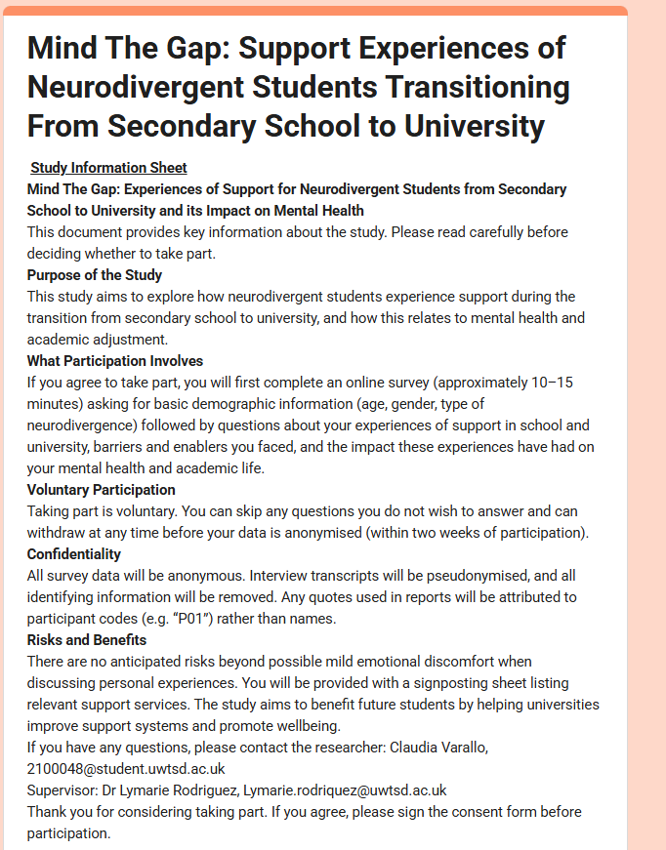

Appendix 4: consent form
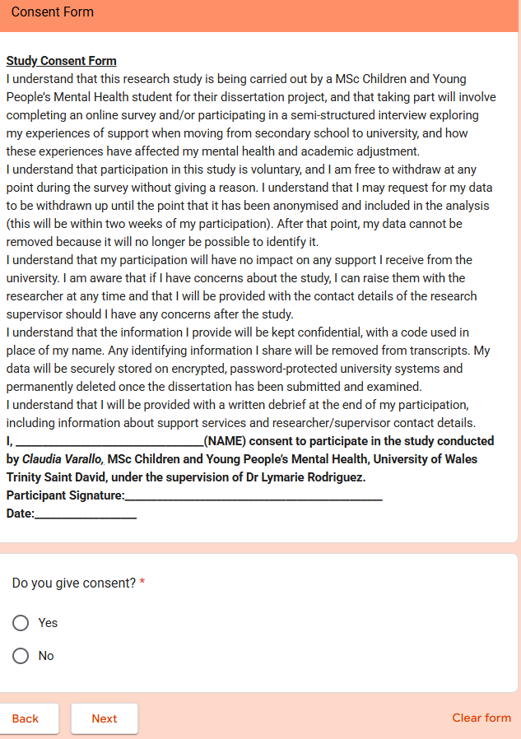

Appendix 5: debrief form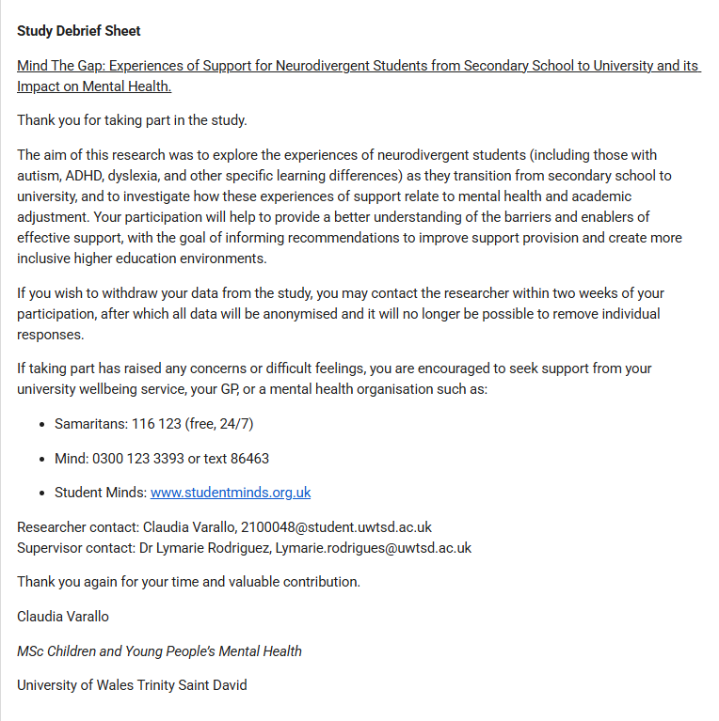

Appendix 6: Transcripts examples (uncoded and coded)
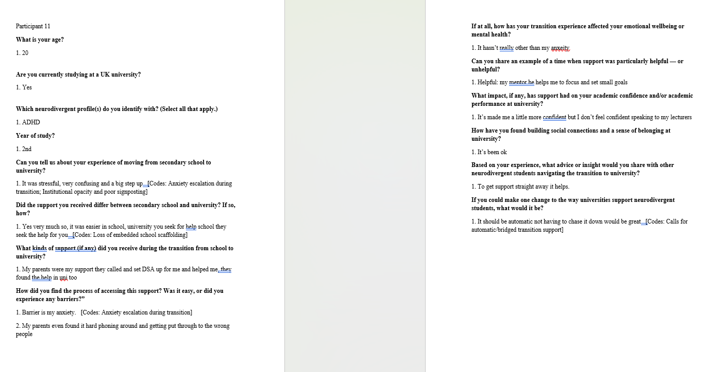
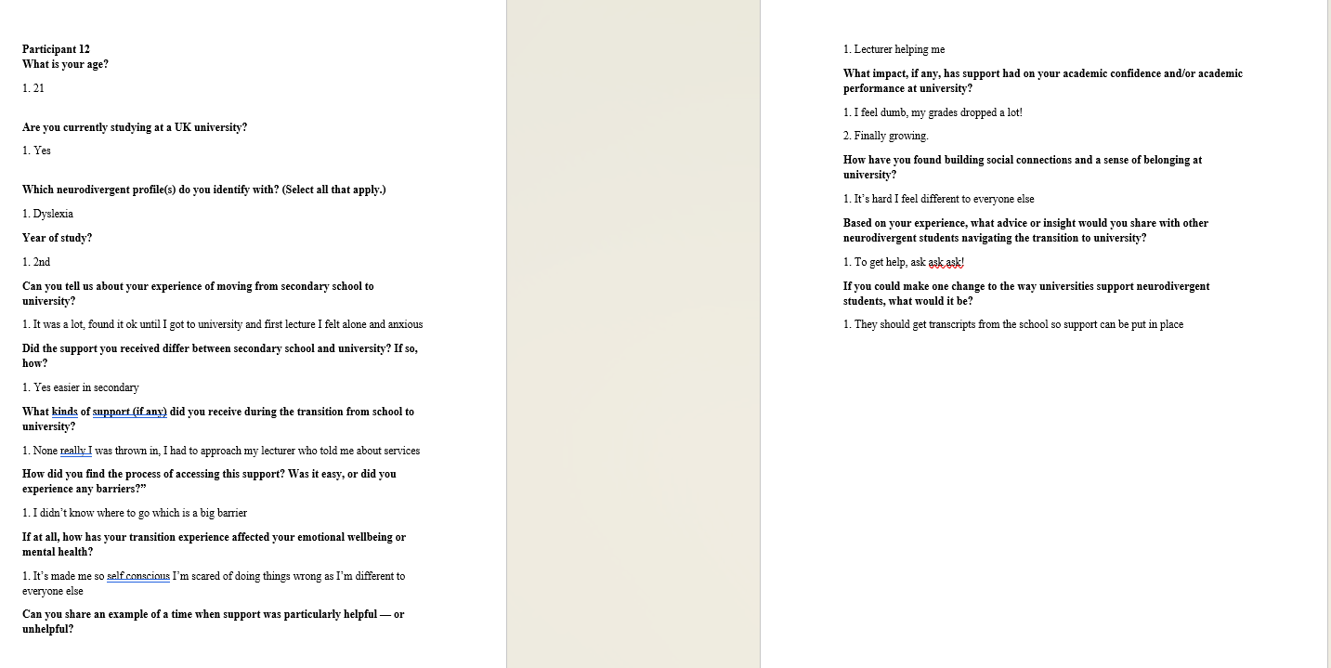
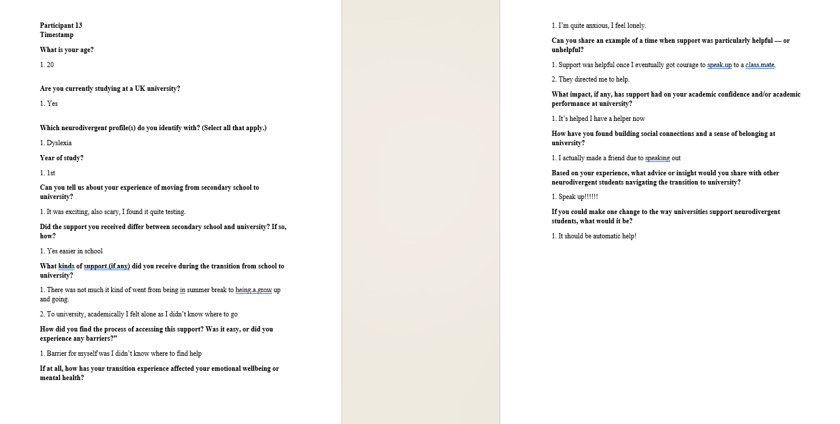
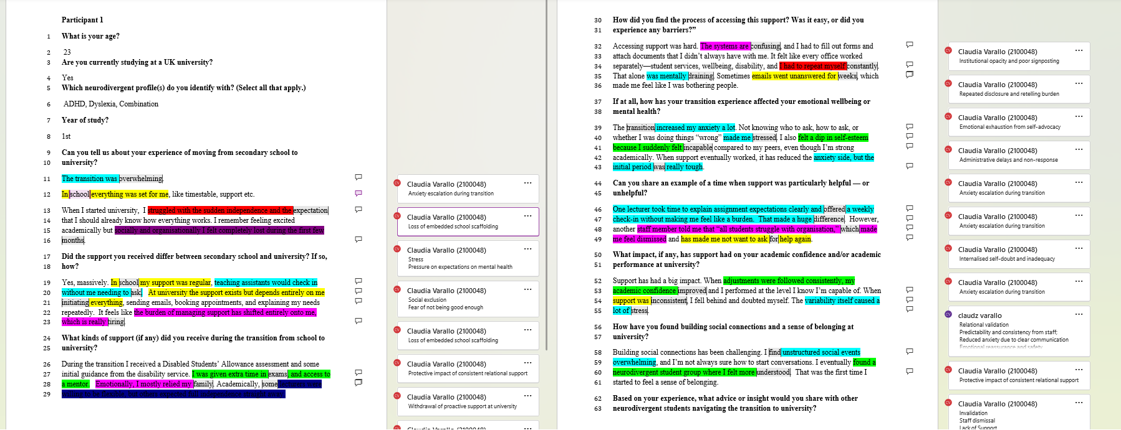
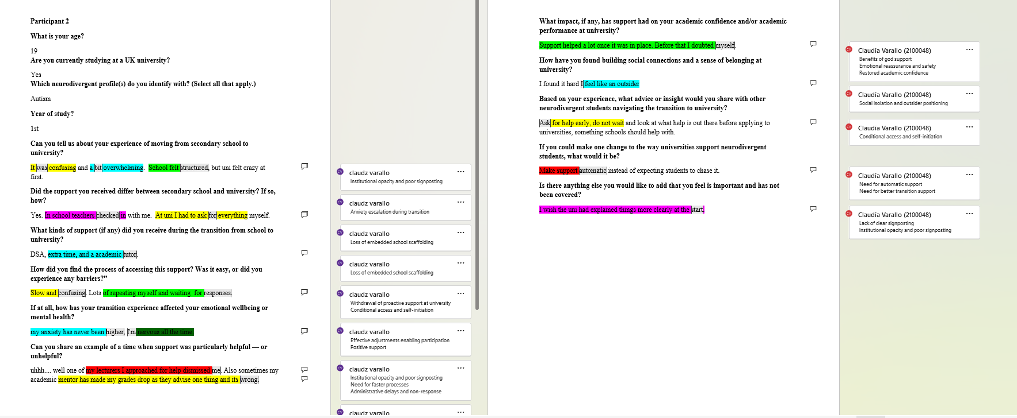
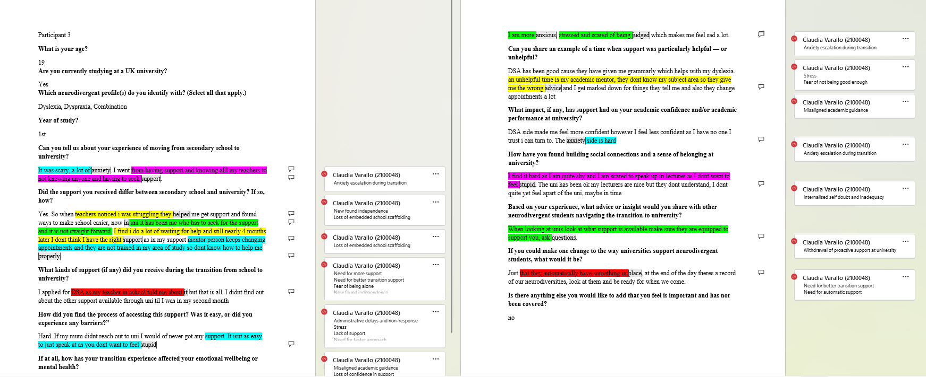

Appendix 7: coding and themes
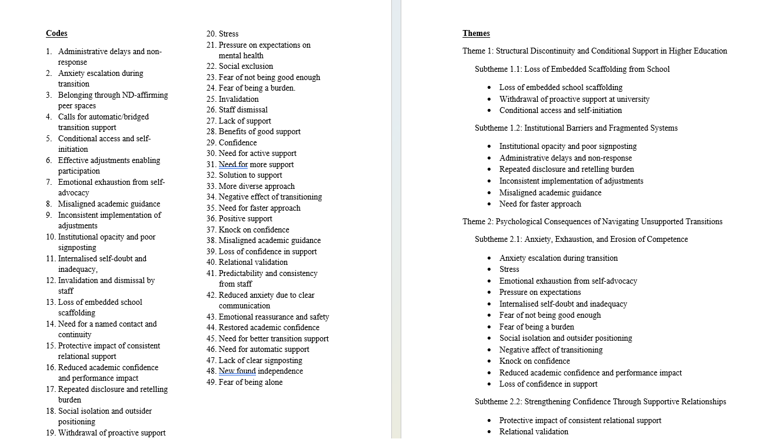

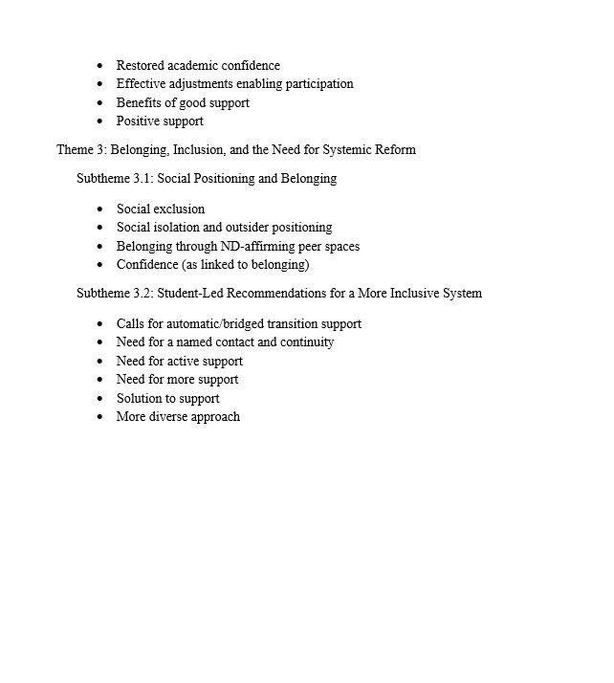

Appendix 8: Familiarisation phase

Familiarisation involved repeated reading of the dataset to develop an initial understanding of participants’ accounts. All responses were read in full several times to identify early patterns, contrasts, and points of emphasis relating to experiences of support during the transition from school to university. During this process, brief notes were recorded to capture initial observations about recurring ideas, language, and potential areas of interest, such as references to institutional processes, disclosure experiences, and relational support. This stage enabled immersion in the data and supported the development of preliminary analytic insights, which informed subsequent coding while maintaining a reflexive awareness of how interpretations were being shaped.

Appendix 9: proposal


