Module code: BMIH6005
Module Title: Organisational Consultancy
Assignment Title: Consultancy Report
Hotel Name: The Ritz Paris
Consultancy Firm: Prestige Hospitality
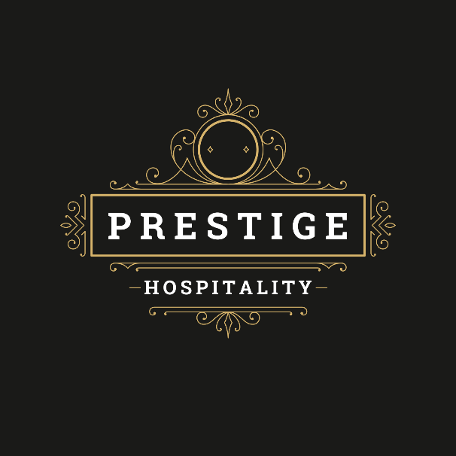
Student Name: Alina Iuliana Axinte
Student ID: 2223962
Lecture’s Name: Natalie Brailsford

AI Declaration
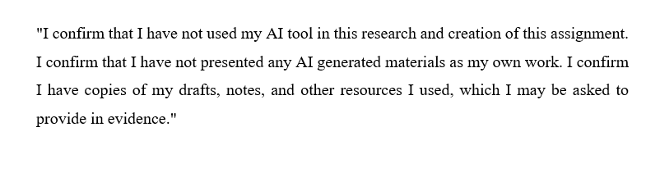

Executive Summary
The Ritz Paris, standing on the exclusive Place Vendome has been a long time standing reputation of considering leading hotel in the competitive hospitality sector of Europe. Opulence and French style have been associated with the hotel since its creation in 1898, as well as outstanding visitor experiences. It has 142 rooms and suites with world class dining, luxurious spa, and other high quality facilities that give pleasure to leisure and business passengers. The impressive image of the Ritz Paris hotel makes it a hotel of choice among the high-profile guests, including royalties, celebrities, and corporate executives. The historical importance and the perfect setting along with the unflawed service have certainly fixed its position in the market as one of the luxury hospitality leaders. They are severe labor shortage and lack of responsiveness among the existing workers. Consequence of these problems has been a workforce that is more than exhausted, low quality of service and lower level of satisfaction of the guests.
The issue of labour shortage at Ritz Paris has posed an actual challenge to its operations each day. The available workers are being overworked and this has led to exhaustion, lack of morale and job dissatisfaction. This has witnessed the delays in the service delivery processes like the room preparations and guest requests which are very critical processes in achieving the excellence standard of the hotel. In addition, the impersonal responses of employees have decreased the individual approach, so characteristic of the Ritz Paris, and this aspect also influences customer experiences. The harms of these issues do not remain at the stage of interpersonal relations. This has resulted into bad guest remarks due to bad service that has overshadowed the reputation of the hotel and hence chances of recurrent customers might be lost.
The routes of the labor issues of the Ritz Paris are in the internal and external factors. Internally, poor recruitment procedures and a lack of procedures to counter employee burnout have been some of the causes of staff shortage and disengagement. The employees are also not satisfied with high workloads and unsupportive work environment. On the outside, the Paris labor market competition also presents an extra challenge, with several luxury establishments competing over a small number of qualified hospitality professionals. The financial demands of the economy, together with legal and regulatory requirements have rendered the Ritz Paris unable to build and maintain talent through competitive compensation and benefits. The report used different tools of analysis such as STEEPLED, SWOT and TOWS analysis. The application of STEEPLED analysis addressed the identifying the external force that impacted the Ritz Paris, whereas the SWOT factors for the hotel. It was on the basis of these revelations that the TOWS analysis generated practical action steps that would solve labor and service problems in the hotel.
Nevertheless, the Ritz Paris still performs better in a number of areas that can affirm its competitive position. Its rich heritage and an international image of a luxury brand have bred the royal clientele. Visitors are attracted by its matchless position in the very center of Paris, its convenient transport connections with the main sights and attractions. Luxurious facilities of the hotel, such as Michelin-starred restaurants, famous bar and high-end spa also contribute to its popularity among high-income travelers. Another factor that has contributed to the success of the Ritz Paris is a group of loyal and skilled workers who realize the value of continuing the tradition of the hotel excellence. These employees together with good brand recognition and adequate marketing of the hotel continue to bring high profile customers to the hotel and create a good image on the brand.
A number of strategic recommendations have been provided on solving the problem of lack of skilled labour at The Ritz Paris and improve its quality of services. The services of hotel should intensify the process of recruitment by cooperating with the most successful hospitality schools, providing internships, and proposing favorable remuneration packages with benefits that determine towards efficiency of the work and balancing the life processes. It will help hire excellent individuals and restrict turnover to the extent that the workforce is more active and less prone to burnout.
Second, Ritz Paris has to implement the employee engagement programs, which include regular feedback sessions, rewarding strategies, and career development opportunities. With the provision of a good working environment that is rewarding but supportive, the morale of the employees will be boosted and with that service delivery will improve. Employee welfare training, customer service, and stress management will be able to train the employees to perform their tasks adequately without disrupting the standards of the hotel.
Regarding operational enhancements, Ritz Paris ought to incorporate automation scheduling, room management tools, and a guest service process to facilitate operations and alleviate the work burden on the employees. Sustainability processes like use of energy efficiencies in operations and management of waste will also help improve the services with increasing the image and cut down expenses within operations.
The implementation action plan contains a detailed schedule. The recruitment campaign and employee engagement programs will start immediately. Training and upgrading technologies will be gradual and accompanied by tangible milestones that will help monitor success. A follow-up and performance audit of the changes will be done regularly to ensure that they are functional and effective in guaranteeing higher employee retention rates, quality of service, and overall guest experiences that will put The Ritz Paris on a growth and development trajectory in the competitive landscape of hospitality industry.

Table of Contents
Executive Summary 1
1 Introduction 6
2 Analysis 8
2.1 Impact of the Issue on Hotel Operations 8
2.2 Root Cause 8
2.3 STEEPLED Analysis 8
2.4 SWOT Analysis 11
2.5 TOWS Analysis 12
2.6 Positive Performance Areas 13
3 Recommendations and Change Management 14
3.1 Strategic Recommendations 14
3.2 Change Management Strategy (Kotter’s 8 Step Model) 15
3.2.1 Create urgency 15
3.2.2 Form a Guiding Coalition 15
3.2.3 Create a Vision for Change 16
3.2.4 Communicate the Vision 16
3.2.5 Empower Others to Act on the Vision 16
3.2.6 Create Short-Term Wins 17
3.2.7 Consolidate Gains and Produce More Change 17
3.2.8 Anchor New Approaches in the Culture 17
3.3 Cost Breakdown 18
3.4 Impact Review Strategy 19
3.5 Expected Benefits 19
4 Action Plan 20
5 Conclusion 23
6 References 25

Introduction
The Ritz Paris is considered leading due to the provision of luxury and elegance in the impressive Place Vendôme of Paris. The hotel has been famous since 1898 for as the leading and largest hotel in European region (Tripadvisor, 2025). The Ritz Paris stands out because it offers royalty, famous people, top business figures, grand service, wonderful surroundings, and an old tradition that makes guests all over the planet want to visit it. There are 142 rooms and suites available, each showing how luxury and French style can go together. Guests of the Ritz Paris get to use a superb restaurant, a beautiful bar, a relaxing spa, and numerous facilities designed for their comfort. Visitors to top hotels have fun whether they are there for business or personal travel, and they always experience something different.
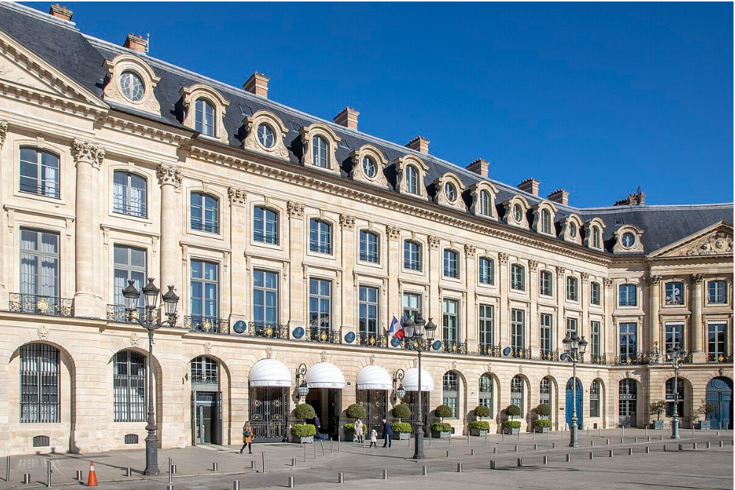
Figure 1 the Ritz Paris (Meghan, 2020)
The Ritz Paris continues to be at the forefront of luxury hospitality because it always offers top-quality service. All staff members are given the best training to meet top-quality requirements (Marija Mirić and Marko Slavković, 2023). The hotel's privileged place, long history, and prestige for luxury have helped it become one of the best hotels in Paris and elsewhere.
Still, given its prestige, The Ritz Paris is now facing problems that could decrease customers' satisfaction and the performance of the hotel. The hotel has a shortage of workers, and many staff members do not respond to guests' needs (Travel1971MR, 2024). Such problems are now harming both guests and the way hotels operate. If these issues are not solved, the hotel might not do well in the luxury hotel market, where guests have higher expectations than ever.
Due to a lack of workers at The Ritz Paris, the existing team has much more work and often feels tired and overworked. Besides, unresponsive employees have made the service less satisfactory, which has made guests even unhappy. If a luxury hotel has issues with its operations, it is worrying since these directly affect its ability to provision of deliberate service (Ali et al., 2021). Since The Ritz Paris wants to preserve its success, it should quickly deal with these problems by using solutions that boost staff work and the efficiency of the hotel.
The labour shortage and poor staff responses seriously affect the hotel's operations (Innerhofer, Nasta and Zehrer, 2022). As a result, the current staff is overloaded with duties, which causes them to become exhausted and unhappy. In addition, when staff do not respond, it reduces the quality of service delivered and influences all aspects of the operation (Asgeirsson et al., 2024). Since giving personalised service to guests is essential for the hotel, such issues can seriously harm its reputation.
Prestige Hospitality, a consultancy firm known for organisational and operational development, will help The Ritz Paris. Prestige Hospitality Consultancy has over a decade of experience working with luxury hotels and assisting clients by addressing their challenges, enhancing the workforce, and boosting customer satisfaction. They are skilled in training employees, hiring new staff members, managing changes, and ensuring their strategies are designed for each luxury hospitality business. Using data, the firm can understand the main problems, give suggestions to fix them, and boost the quality of services and results.
Prestige Hospitality Consultancy will examine The Ritz Paris' challenges using several proven frameworks. This framework will analyse the various external sources affecting the hotel's challenges. Moreover, a SWOT factors offer a complete picture of how it operates in the market. In the end, a TOWS analysis will help plan ways to address the problems, mainly by enhancing staff responsiveness and solving the labour shortage so that the hotel can succeed in the long run.

Analysis

Impact of the Issue on Hotel Operations
The absence of enough staff and their unresponsiveness at The Ritz Paris significantly affects the hotel's activities (Althubiti et al., 2025). Because the Ritz is known for its top-notch service, its staff is crucial in ensuring it always performs well. Because there are not enough workers, the remaining staff work overtime and feel tired, which decreases their performance. It affects both the hotel's operations and the service provided to guests (Grigoryan, 2024). Indications of delays in readying rooms, slow answers to guests' requests, and general unhappiness from guests have all been linked to the issue of understaffing.
Moreover, if staff do not respond well, communication slows down, leading to other business issues. If employees are not engaged, it can affect guests in a hotel that puts importance on personal service (Ozturk et al., 2021). Since every customer interaction is essential in luxury hospitality, not fulfilling guests' needs because of insufficient or distracted staff may result in a sharp decrease in satisfaction (Koniari, 2020). If negative reviews are posted, people talk negatively about the hotel and repeat customers drop; it can harm the reputation and image in the competitive market.

Root Cause
The main reason for the lack of workers and sluggish staff at The Ritz Paris comes from a mix of things happening within and outside the hotel. Bad recruiting practices might be responsible for the lack of workers (Liu-Lastres et al., 2022). The hotel cannot always have a whole team because so many people leave their jobs in the hospitality industry. Besides other reasons, a lack of addressing staff burnout could be responsible since current staff members are often required to do more work than they can manage (Baquero, 2023). It causes people to feel tired and less involved, and, in the end, their morale falls.
External factors in the labour market, like the competition for capable employees in Paris, may also contribute to the staff shortage (Veselin Stoimenov, 2025). Because the hospitality sector is very competitive, many premium hotels compete for the same qualified employees. When tough economic and legal matters arise, Ritz Paris may not match its competitors in offering reasonable compensation and a pleasant work environment.

STEEPLED Analysis
Table 1 STEEPLED Analysis
Factor | Description | Impact on The Ritz Paris
Social | Changes in consumer preferences and increasing demand for effective services in the leading competitive industry. | Visitors to The Ritz Paris look forward to being treated in a very personal and attentive way. If there are not enough workers and staff do not respond fast enough, it is difficult to provide the best hospitality, which reduces guest satisfaction and loyalty (Rao et al., 2021).
Technological | Advances in technology, including automation and digital platforms for booking and customer service, are transforming the hospitality industry. | The Ritz Paris may face pressure to integrate new technologies to enhance operational efficiency and guest experience. Failure to adapt to technological trends may result in a less competitive offering, especially for tech-savvy clientele (Ghosh and Chatterjee, 2025).
Economic | The global economy influences labour costs and consumer spending, including inflation and the economic downturn. | Economic fluctuations can impact recruitment, staff wages, and the hotel's ability to maintain competitive salaries, further exacerbating the labour shortage (Agarwal, Ayyagari and Kosová, 2023). Economic downturns may also lower demand for luxury services, affecting revenue.
Environmental | Increased awareness around sustainability practices and eco-friendly hotel operations. | Because environmental issues are becoming more important, hotels such as The Ritz Paris are expected to follow green standards. If sustainability is overlooked, it might cause harm to the hotel's image, yet it can help the hotel stand out (Lee and Huang, 2023).
Political | Labour laws, visa regulations, and political stability influence recruitment and operational processes. | Strict labour laws and visa restrictions can make it challenging to recruit international staff, contributing to labour shortages. Political instability or policy changes could further complicate staffing and operational planning for the hotel (Tetiana Hushtan and Korsak, 2024).
Legal | Labour regulations, minimum wage laws, and employee rights are subject to change, influencing staffing decisions and hotel policies. | Legal restrictions on working hours, staff compensation, and employment contracts could impact the Ritz's ability to resolve staff shortages or incentivise employee performance (Piso, 2022). Non-compliance can result in legal issues and reputational damage.
Ethical | The expectation for fair labour practices, ethical employment, and equal opportunities. | Ethical concerns regarding employee treatment and working conditions could influence staff morale and contribute to observed unresponsiveness (Saraç and Batman, 2022). The Ritz Paris must prioritise creating an ethical work environment to retain top talent and improve service standards.
Demographic | Changes in the demographic makeup of the labour market, including ageing populations and generational shifts in the workforce. | Attracting effective young workers and managing those who are getting older may be troublesome for The Ritz Paris. Since there are more diversity in age groups, businesses must adjust how they recruit and ensure they understand the needs of their different employees (Manoharan, Gross and Sardeshmukh, 2021).
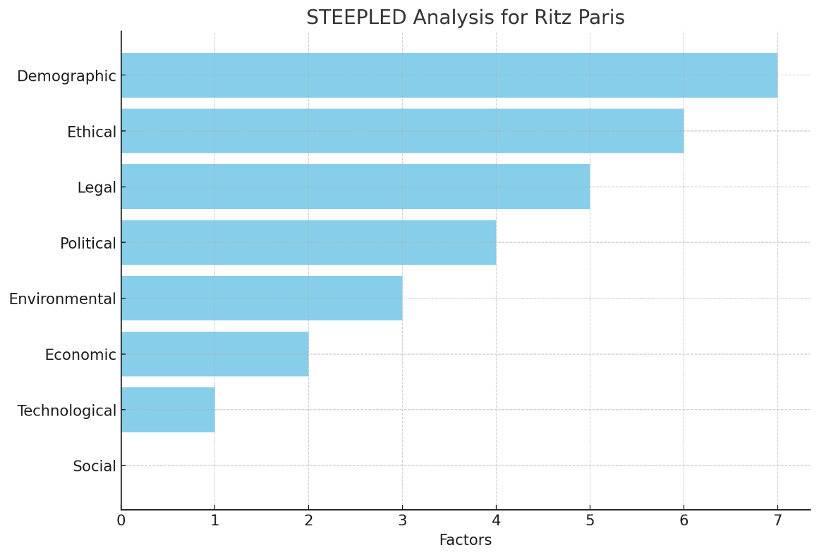
Figure 2 The effect of STTEEPLED Factors on Ritz Paris (Source: Author)

SWOT Analysis
Table 2 SWOT Analysis
Strengths | Weaknesses
A longstanding reputation for luxury and exceptional service. | The labour shortage is leading to an increased workload for existing staff.
The prime location is at Place Vendôme, attracting high-end clientele. | Unresponsive staff members affect guest satisfaction and service quality.
World-class amenities include Michelin-starred restaurants and a luxurious spa. | High staff turnover leads to recruitment and training challenges.
Strong brand recognition, appealing to VIPs, celebrities, and royalty. | Operational inefficiencies due to understaffing and disengaged employees.
Opportunities | Threats
Growing demand for luxury travel offering more potential high-profile guests. | The emergence of leading issues from other luxury hotels in Paris and Europe.
Technological advancements in guest services and staff management for operational efficiency. | Economic downturns or shifts in consumer behaviour affect revenue.
Increasing trend towards sustainability, allowing for the adoption of green initiatives. | Challenges in attracting skilled labour due to competition in the hospitality sector.
Focus on employee engagement programs to improve staff morale and performance. | Changes in labour laws or regulations increase operational complexity and costs.

TOWS Analysis
Table 3 TOWS Analysis
Strengths / Opportunities | Strengths / Threats
Leverage the Ritz's prestigious brand and prime location to attract more high-end guests, capitalising on the growing demand for luxury travel. | Use the hotel's strong brand recognition and excellent service reputation to retain loyal guests during economic downturns, ensuring stable revenue (Santos et al., 2024).
Utilise technological advancements to improve guest services, streamline operations, and enhance staff management, reinforcing the hotel's world-class offerings. | Invest in employee engagement programs to combat staff turnover and improve morale, protecting against competition's superior employee retention strategies (Timsina, 2024).
Implement sustainable practices and market them to attract eco-conscious travellers, enhancing the hotel's appeal and differentiation in luxury. | Use Ritz's high-quality services to outshine competitors, maintaining market share despite the competitive pressures.
Introduce employee development programs to improve skills and engagement, enhance service standards, and reduce unresponsive staff issues. | Train staff in adaptability to ensure that changes in labour laws or regulations are quickly incorporated into operational processes (Sony and Mekoth, 2022).
Weaknesses / Opportunities | Weaknesses / Threats
Address the labour shortage by improving managing policies with the provision of compensation and several advantages to the attraction of top talent in the growing luxury travel market. | Combat labour shortages and unresponsive staff by implementing performance incentives, ensuring the hotel stays competitive and operationally efficient amidst high turnover rates (Riekhoff et al., 2023).
Resolve staff unresponsiveness by introducing comprehensive training programs and leveraging new technological tools to improve service standards and efficiency. | To manage the risk of economic downturns, focus on increasing efficiency and reducing operational costs through improved staff training and technology use (Ivanov et al., 2020).
Improve operational efficiency by adopting technological tools and enhanced staff management systems, capitalising on luxury travel growth opportunities (Bharwani and Mathews, 2021). | Address potential operational inefficiencies caused by understaffing and unresponsive staff through better staff scheduling and incentive-based performance management.

Positive Performance Areas
In spite of a few problems, the hotel performs very well in different areas that aid it in managing current matters. The strengths in these areas show that the Ritz can preserve its reputation and draw loyal customers despite problems inside the organisation.
The Ritz Paris is well known for its reputation as an excellent hotel. Being a historic luxury hotel, it is famous everywhere for giving its guests the best service and unmatched experiences. Because of its history and world-famous reputation in hospitality, the Ritz Paris can maintain a leading brand in the luxury hotel market. Since guests at the Ritz want the best service, the hotel's success in delivering extraordinary experiences has made its customer base very loyal. The hotel's high level of personal service has supported its excellent reputation for years.
The Ritz Paris is also very famous for its central location. Because it is on Place Vendôme, the Ritz is close to some of Paris's iconic landmarks. In the middle of the city, the property provides fantastic views and remains a favourite among rich people, famous personalities, and busy business leaders. Its location near famous attractions always attracts wealthy patrons, so it faces less demand loss than other hotels.
Besides its prime address, the hotel's luxury facilities help make every guest experience memorable. The presence of Michelin-starred eateries, a famous cocktail spot, a superb spa, and superior services has made the hotel a leading name in luxury hotels (Ivanova, 2023). Because of these extra benefits, guests enjoy their time more, keep coming back, and leave positively-reviewed experiences. Moreover, having different dining and wellness options makes the Ritz attractive to wealthy travellers looking for luxury and excellent services (Milosh, 2023).
Many dedicated people work at The Ritz Paris. Despite labour difficulties, the hotel has staff members who know why it is essential to maintain the Ritz's top-notch service (Florent and Efin Shu Shu, 2023). Several employees have worked at the hotel for a long time, which allows them to understand guests' needs well. Because of these employees, the Ritz keeps its prestigious name, and the service is always the same (Selin, 2022).
Lastly, the strength of its marketing and the recognisability of the brand play a definite part for the achievement of goals and objectives (Banyeva et al., 2023). Because of its background, connection to luxury, and frequent features in high-class publications, the hotel is often the first choice for people looking for top hospitality. The Ritz Paris is regularly included in the world's most famous travel publications, fashion magazines, and entertainment platforms, making it even more popular among affluent travellers.

Recommendations based on using Change Management

Strategic Suggestions
The current issues at The Ritz Paris should be addressed with the help of a set of strategic suggestions. Firstly, optimization of recruitment processes to alleviate the current labour shortage is important (Morosan and Bowen, 2022). The hotel has to liaise with the famous hospitality institutions to develop internship and recruitment programmes that will help the hotel to access the best talents. In addition, they ought to have competitive pay packages that come with benefits that emphasize on work life balance and career development (Sun et al., 2023). This will not only attract skilled workers but also offer the company an opportunity to retain the existing workers as they will offer them better and more sustainable working environment.
The other necessary recommendation is to introduce more formal staff management system (Kravariti et al., 2021). This involves developing the best working schedules with the least possibility of burnout and also the work load is well shared in the group. The Ritz Paris must also come up with engagement programs to the staff to ensure that their morale is always high and the programs should entail regular feedback, recognition of performance and projects that would make the staff feel part of and valued (Ali Ababneh, Awwad and Abu-Haija, 2021). This will help the employees feel encouraged and interested in success of the hotel, this will benefit the performance and job satisfaction.
Also, the Ritz Paris needs to develop staff training and efficient processes for the improvements in the technical and soft skills(Janjua, Qureshi and Syed, 2025). This will assist the staff members in coping better with the requirements of high-profile clientele and offer the kind of exceptional service that the hotel has come to be identified with. Introducing training on customer service, stress management, and flexibility to change will equip the employees with future challenges; therefore, they will offer higher standard of service in the sector.
Finally, the introduction of sustainability efforts should be considered, following the trends of eco-friendly hospitality on a global scale (Rehman et al., 2023). The Ritz Paris can boost its brand value among customers concerned about the environment and earn more returns at the same time by integrating green initiatives like energy efficiency in the technologies, waste management system initiatives, and environment-friendly building materials. Such undertakings would go hand in hand with the image of luxury that the hotel projects and keep it at the top of the competitive hospitality industry.

Change Management Strategy (Kotter’s 8 Step Model)

Create urgency
The initial system in the Kotter allocation is to establish an atmosphere of urgency concerning the staffing problems in the hotel. Ritz Paris needs to inform every stakeholder about the dire situation of the labour shortage in terms of efficiency of operations, staff morale, and guest experience. Data and customer feedback that demonstrate the direct relationship between the overworked staff, slow service delivery, and deteriorating guest experiences should be shared by senior management (Iloejuafor, 2025). The necessity of promptly resolving the problem may also be stressed by pointing out the competitive threats other luxury hotels in Paris pose. This will encourage the employees and management to take quick action to prevent further damage to the reputation and financial results of the hotel.

Formation of a Guided Coalition
To implement change successfully, Ritz Paris should form a guiding coalition of influential leaders representing different departments, such as the HR department, the operations department, and the customer service department (Mennaalla Hassan Salem et al., 2023). This group must consist of top management, middle-level managers, and reputable and trusted members. The coalition will spearhead the change process, ensuring the appropriate resources are used and facilitating the process of overcoming the resistance to change. With such a varied group collaborating, Ritz Paris will be able to promote the easy adoption of changes and accommodate the concerns of both high and low ranks of personnel.

Creation of a Vision towards Change
Then, the hotel must develop an intense and vivid image of the future after the staffing problems are solved. This vision must be centred on developing a highly driven workforce that is well-equipped and ready to offer excellent service to guests. Ritz Paris should focus on decreasing staff burnout, optimizing recruitment, and increasing employee engagement (Fu et al., 2022). The vision will also motivate and lead the team through the change process as they will have visualized a desirable working environment where the employees are valued and empowered. The vision should also provide an overview of how such changes will impact both the personnel and the hotel positively.

Communication to the Vision
Effective communication makes a difference in the management of the change process. Ritz Paris should employ various communication methods to disseminate the change vision to all staff members so that everyone can know why the changes are needed and how they would help the hotel succeed in the long run (Alberto and Mercedes, 2022). They can be made clear and transparent using regular meetings, departmental briefings and internal newsletters. Trust and the reduction of uncertainties will be achieved with the help of informational consistency and frequent communications of the leadership, which will encourage the staff to invest into the change.

Empowerment towards the Actions on the Vision
In order to ensure the success of the change, Ritz Paris ought to remove the obstacles that are likely to inhibit the growth. This may include dealing with staff resistance when employees doubt the new processes or fear that their positions may be altered. Ritz Paris ought to give the employees the training and resources required to facilitate the changes, as they should possess the competencies and equipment to accommodate the alterations. Also, the hotel must redefine performance measures, and managers must be trained to identify and encourage workers to embrace new habits (Luo et al., 2022). The clear guidance and continuous support of the employees will empower them and make them feel ready to contribute to the success of the transformation.

Creation of the Short-Term Wins
It is essential to creation of definite shorter wins to keep the momentum and prove the changes are effective. Ritz Paris should aim to attain observable changes that can soon reveal the advantages of fixing staffing problems. For example, Ritz Paris can instantly reduce burnout and improve the workload by enhancing recruitment and hiring more employees (Yilmazdogan, 2024). In several weeks, the situation should improve regarding employee satisfaction, service delivery times, and guest feedback. These small wins should be celebrated, and the role of the staff in achieving them should be acknowledged, which will encourage them to remain managed in the change process.

Consolidation of the Gains and Production of More Change
Following the initial victories, Ritz Paris should capitalize on the victories by extending the changes within the organization. This involves more hiring, training sessions, investment in technology, and improved efficiency in operations. The hotel must seek other sections that need to be improved, like the advancement of staff scheduling systems that help in workload management (Osei et al., 2022). Incremental improvement should be sustained to guarantee that the impetus of change is sustained and becomes part of the hotel's culture. Tracking and measuring progress is also necessary to ensure that all initiatives bring the right results.

Anchoring pf New Approaches within the Culture
The last phase of the Kotter system is to make the differences in a part of the culture of Ritz Paris. This implies that the new staffing practices, employee engagement approaches, and operational efficiencies should be pegged upon the hotel's core values and service standards (Kikachukwu Odiaka and Chang, 2024). Ritz Paris should incorporate the changes in the company vision, staff training, and performance appraisal. The changes should become a new normal in hotel operations, and this should be reviewed by regularly checking the staff engagement levels and the quality of the services offered. Ritz Paris will be able to maintain the changes in staffing and quality of services when these practices are incorporated into the hotel's culture.
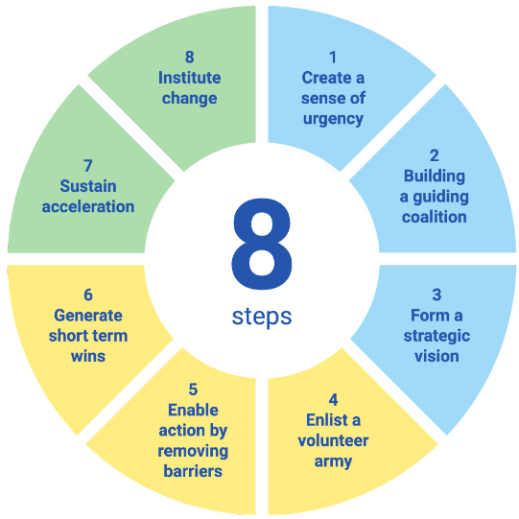
Figure 3 Kotter's 8 Step Mode

Cost Breakdown
Table 4 Cost Breakdown
Category | Description | Estimated Cost
Recruitment Campaign | Partnering with hospitality schools, hosting job fairs, and creating internship programs to attract top talent. | €100,000
Staffing and Compensation | Hiring additional staff to address labour shortages, providing competitive salary packages, and offering benefits (healthcare, paid leave, etc.). | €200,000
Employee Training & Development | Implementing comprehensive training programs on customer service, stress management, and employee engagement. | €150,000
Technology Integration | Investment in automation tools for scheduling, staff management, and operational efficiency to improve service delivery and reduce workload. | €120,000
Sustainability Initiatives | Implementation of definite eco-friendly services, such as production of energy-efficiency in the lighting, waste management programs, and sustainability certifications. | €80,000
Employee Engagement Programs | Creating programs for recognition, regular feedback sessions, and incentives to boost morale and reduce turnover. | €50,000
Change Management & Consulting | Hiring change management consultants to guide the implementation process and provide expertise in ensuring the success of the transformation. | €75,000
Miscellaneous Costs | Costs associated with contingency planning, unexpected issues during the transition, and minor operational improvements. | €25,000
Total Estimated Cost |  | €650,000

Impact Review Strategy
The Impact Review Strategy will be essential in tracking the success of the initiated changes at The Ritz Paris. The success of the changes should be measured, and quantitative and qualitative indicators should be considered to define the areas that need improvement and put the hotel back on track (Kim and Han, 2022). Employee engagement and satisfaction are two of the significant areas of focus. Issues such as job burnout, satisfaction with pay, and general working conditions can be measured with regular surveys and feedback sessions to help measure employee morale and satisfaction. Increased engagement scores will indicate that the changes in recruitment, compensation, and employee well-being are producing the right results.
The rate of staff turnover should also be closely monitored. A decrease in turnover, particularly in key departments, will indicate that the hotel is retaining its staff (Xu et al., 2022). Also, the level of staff retention, especially among senior employees, will be important in ensuring that high standards of services are maintained. Operation performance measures, including room readiness time and service response time, will help understand whether the workloads of the staff are equal and whether automation tools are enhancing the efficiency of operations. If these metrics improve, staffing issues will be addressed effectively. Guest satisfaction will be another key indicator.

Expected Benefits
The anticipated outcomes of the changes in Ritz Paris will profoundly affect employee experience, service delivery, business performance, and the competitiveness in the leading hospitality industry. The changes will not only help solve the immediate problem of labor shortage but will also put the hotel in a image to succeed in the competition.
Improved employee satisfaction and retention is amongst the key benefits (Yoopetch, Nimsai and Kongarchapatara, 2021). Ritz Paris will offer a better working environment with better recruitment procedures and remuneration packages that are competitive. The enhanced participation of the labor force will reduce the turnover levels and lead to the establishment of a team of individuals who will be more than willing to present their quality services to the visitors (Fleming et al., 2022). This approach to the wellbeing of the personnel will enable healthy organizational culture at the workplace, which is likely to increase the loyalty of both the personnel and their efficiency.
Another key benefit is the improvement of the quality of services and satisfaction of the guests (Abdullah et al., 2022). With the well-trained personnel of sufficiently large number, Ritz Paris will also be in a position of offering faster and more personal services. This shall lead to the shortening of response time and satisfaction of the customers (Kim and Han, 2023). This will translate to positive reviews, returning consumers and better brand loyalty which is required to maintain the competitive advantage in the emerging market.
Improvements in operation efficiency will also imply enormous advantages (Horng et al., 2022). Automation and simplification of internal procedures will help Ritz Paris to save on finances, improve its production and enhance delivery of services (Garg et al., 2025). These efficiencies will be in the form of better resource utilisation, quicker service and lesser delays, which will be converted into cost savings and higher operation efficiency.
The overall impact on Ritz Paris's competitive position in the luxury hotel market will be positive due to resolving the staffing issues and increasing service quality. The hotel will attract environmentally-sensitive customers by implementing sustainability programs, further setting it apart from its competitors. Sustainability will also help to improve the brand image of Ritz Paris, attract high-profile clients, and strengthen its position in the industry (Chakraborty, 2025).

Action Plan
Issue number | Issues | Potential Solution | Definite result | Timeline | Date of Completion | Estimated Budget
1 | Labor shortage and employee burnout | Implementation of a targeted recruitment campaign with competitive compensation packages and establish work-life balance incentives for staff (Budhiraja et al., 2022). | Reduce staff turnover, improve job satisfaction, and decrease burnout by hiring more employees and improving the work environment. | 6 months | 20/12/2025 | £300,000
2 | Poor employee engagement and high turnover rates | Introduce employee management programs, including collection of feedbacks, recognition schemes, and career increment opportunities (Chang and Werther, 2021). | Higher employee satisfaction, reduced turnover, and increased employee commitment to Ritz Paris’s service standards. | 4 months | 16/10/2025 | £150,000
3 | Inefficient service delivery due to understaffing | Investment in the training programs to make improvements in the staff skills in guest interaction, stress management, and personalized service (Saxena et al., 2023). | Improved service quality, faster response times, and greater guest satisfaction due to better-equipped staff. | 5 months | 25/11/2025 | £200,000
4 | Lack of technology integration in operations | To streamline operations and reduce workload, implement automation tools for staff scheduling, room management, and guest service requests. | Increased operational management , quicker service delivery, and reduced staff fatigue. | 4 months | 01/11/2025 | £180,000
5 | Outdated sustainability practices | Adopt eco-friendly approaches such as energy-efficient lighting, waste reduction values, and green certifications. | Reduced environmental impact, lower operational costs, and an enhanced image as an environmentally responsible luxury hotel. | 6 months | 10/12/2025 | £120,000
6 | Lack of employee career development and recognition | Establish mentorship programs, skill development workshops, and leadership training for existing employees (Anwar et al., 2024). | Higher employee retention, improved performance, and organizational leadership succession planning. | 5 months | 05/11/2025 | £100,000
7 | Inefficient communication and lack of internal alignment | Create a communication strategy involving regular team meetings, department updates, and clear expectations for staff performance. | Improved communication, clearer expectations, better alignment of goals across departments, and smoother implementation of the changes. | 3 months | 15/10/2025 | £50,000

Conclusion
The report has presented the analysis based on the staffing challenges at The Ritz Paris. It has highlighted a critical issue that has impacted directly on the image of the hotel and efficiency in the operational excellence. There is an international system for recognizing the luxury brand where The Ritz seemed offering the hallmark and implication of the definite commitment towards exceptional guest experiences. It seems in relying heavily on the management system of dedication and responsiveness within the staff. The issues based on the current shortage of employees that has provided the detailed in the report and leading towards the increase in the workloads, staff tiredness in the fatigue, and describing the decline in the management of the service standards. The report has elaborated the factors not only affect the daily operations but also managing the differences in the long-term standing of the hotel within the management of the competitive hospitality industry. There are some definite evidence that has been presented to make demonstration of a clear connection between understaffing and reduction in the guest satisfaction. There are possible delays in the management of room readiness, slower responses to manage the guest requests, and observable implication of the staff exhaustion to the contribution to the noticeable dip in overall management of the service quality.
There are different shortcomings for managing the risk eroding within the trust and loyalty of guests. It has determines the value of system for maintaining efficiency in the prestigious image of The Ritz Paris. For the provision of the luxury hospitality services, considering the effective management of the minor lapses in service, there are some significant repercussions that is providing the imperative processes for addressing the issues promptly and definite system of effectively. Moreover, there is an impact of understaffing for the management of services and immediate guest management and interactions. There are some overworked employees that are likely to make experience in the burnout, leading towards the higher turnover rates, and description of the management that is exacerbating the shortages in the staff. The cycle is not presenting the strains existing resources but also makes increases in the overall recruitment and training costs for the success of the hotel. There are some sustainable solution for not only filling the current vacancies but also allocation of the fostering of a supportive working environment and prioritizing the staff well-being and management of the professional growth.
Therefore, the report has presented the action plan for outlining the system and offering a comprehensive approach for resolving the issues within the staff. It has allocated the implementation of the targeted recruitment strategies, enhancement in the employee engagement, and optimization of the overall operational processes, The Ritz Paris has presented the elaborated standards of excellence. There are some definite use of investment in staff training and well-being initiatives that will not only used for improving the morale and retention but also allocate the guests to gain higher level of service as expected from the world-class establishment.

References
Abdullah, O., Sufi, T. and Kumar, S. (2022). Service Quality and its Influence on Customer Satisfaction and Customer Loyalty in the Restaurants of Five-Star Hotels. African Journal of Hospitality, Tourism and Leisure, (online) 11(6), pp.2173–2189.
Agarwal, S., Ayyagari, M. and Kosová, R. (2023). Minimum Wage Increases and Employer Performance: Role of Employer Heterogeneity. Management Science, 70(1).
Alberto, M. and Mercedes, R.-P.M. (2022). The effects of organizational communication, leadership, and employee commitment in organizational change in the hospitality sector. (online) Unav.edu. Available at: https://dadun.unav.edu/entities/publication/6996a55e-0237-436d-9854-13c44192f61b. (Accessed: 17 June 2025).
Ali Ababneh, O.M., Awwad, A.S. and Abu-Haija, A. (2021). The association between green human resources practices and employee engagement with environmental initiatives in hotels: The moderation effect of perceived transformational leadership. Journal of Human Resources in Hospitality & Tourism, 20(3), pp.1–27.
Ali, B.J., Gardi, B., Othman, B.J., Ahmed, S.A., Ismael, N.B., Hamza, P.A., Aziz, H.M., Sabir, B.Y., Sorguli, S. and Anwar, G. (2021). Hotel service quality: The impact of service quality on customer satisfaction in hospitality. International Journal of Engineering, Business and Management, (online) 5(3), pp.14–28.
Althubiti, K., Alhamadani, A., Khan, M. and Shah, M.G.H. (2025). Unveiling negative memorable experiences of hotel guests: An innovative algorithmic analysis. International Journal of Hospitality Management, (online) 126, p.104087.
Anwar, F.A., Deliana, D. and Suyamto, S. (2024). Digital Transformation in the Hospitality Industry: Improving Efficiency and Guest Experience. International Journal of Management Science and Information Technology, (online) 4(2), pp.428–437. Available at: https://lembagakita.org/journal/index.php/IJMSIT/article/view/3201. (Accessed: 18 June 2025).
Asgeirsson, M.H., Gudlaugsson, T. and Jóhannesson, G.T. (2024). The Relationships between Service Quality, Reputation, and Performance in Hospitality. Tourism and Hospitality, 5(3), pp.736–752.
Banyeva, I., Lebedieva, N., Nehrey, M., Velychko, O., Petrova, O. and Peresichna, S. (2023). Digital Tools of Marketing Strategies in Hotel Branding. Journal of Information Technology Management, (online) 15(1), pp.62–88.
Baquero, A. (2023). Hotel Employees’ Burnout and Intention to Quit: The Role of Psychological Distress and Financial Well-Being in a Moderation Mediation Model. Behavioral Sciences, (online) 13(2), p.84.
Bharwani, S. and Mathews, D. (2021). Techno-business strategies for enhancing guest experience in luxury hotels: a managerial perspective. Worldwide Hospitality and Tourism Themes, 13(2).
Budhiraja, S., Varkkey, B. and McKenna, S. (2022). Work–life balance indicators and talent management approach: a qualitative investigation of Indian luxury hotels. Employee Relations: The International Journal, 44(6).
Chakraborty, D. (2025). Generative AI (GAI) adoption in hotels and resorts: understanding competitive advantage using longitudinal & multi-group study. Current Issues in Tourism, pp.1–20.
Chang, C. and Werther, S. (2021). Talent Management Innovations in the Hospitality Industry: Insights from the Winners of the Hospitality HR Award. Talent Management Innovations in the International Hospitality Industry, pp.127–151.
Fleming, D.E., Artis, A.B., Harris, E.G., Fergurson, J.R. and Askew, M.A. (2022). Reducing Salesperson Turnover Intentions via Organizational Market Orientation and Selective Hiring: A Job Demand-Resources Approach. Journal of Business-to-Business Marketing, 29(3-4), pp.247–269.
Florent, V. and Efin Shu Shu (2023). The Influence of Training towards Employee Performance; The Mediating Factor of Teamwork at The Ritz-Carlton Hotel, Bali. Hospitality Management, 14(1), pp.1–21.
Fu, S., Zheng, X. and Wong, I.A. (2022). The perils of hotel technology: The robot usage resistance model. International Journal of Hospitality Management, 102, p.103174.
Garg, S., Srivastava, S.P., Malhotra, R.K. and Sharma, R. (2025). Sustainable Integration of Robotic Services in the Hospitality Industry: Enhancing Operational Efficiency and Employee Satisfaction. (online) pp.1377–1381.
Ghosh, D. and Chatterjee, S. (2025). Embracing Digital Transformation in Hospitality: Innovations, Challenges, and Opportunities With Case Studies. Digital Disruption in Hospitality, AI, and Emerging Technologies, pp.189–200.
Grigoryan, K. (2024). Labor Shortages in the Hospitality Industry: The Effects of Work-Life Balance, Employee Compensation, Government Issued Unemployment Benefits and Job Insecurity on Employees’ Turnover Intentions. Westcliff International Journal of Applied Research , (online) 8(1).
Horng, J.-S., Liu, C.-H., Chou, S.-F., Yu, T.-Y. and Hu, D.-C. (2022). Role of big data capabilities in enhancing competitive advantage and performance in the hospitality sector: Knowledge-based dynamic capabilities view. Journal of Hospitality and Tourism Management, 51, pp.22–38.
Iloejuafor, S. (2025). Employee retention in the hospitality industry. Theseus.fi. (online) Available at: http://www.theseus.fi/handle/10024/890480. (Accessed: 17 June 2025).
Innerhofer, J., Nasta, L. and Zehrer, A. (2022). Antecedents of labor shortage in the rural hospitality industry: a comparative study of employees and employers. Journal of Hospitality and Tourism Insights, (online) 7(1).
Ivanov, S.H., Webster, C., Stoilova, E. and Slobodskoy, D. (2020). Biosecurity, crisis management, automation technologies and economic performance of travel, tourism and hospitality companies – A conceptual framework. Tourism Economics, 28(1), p.135481662094654.
Ivanova, C. (2023). Transforming the Michelin restaurant industry: Redefining value-centric norms and paradigms - An explorative study of the pay-to-working-hour ratio in Michelin restaurants. aaltodoc.aalto.fi. (online) Available at: https://aaltodoc.aalto.fi/items/c64d529f-6724-4187-9e11-14cf990ab4ed. (Accessed: 16 June 2025).
Janjua, Z.A., Qureshi, S. and Syed (2025). Human Resource Strategies For Improving Leadership Skills Among Hospitality Graduates. (online) 3(1), pp.13–29.
Kikachukwu Odiaka and Chang, K. (2024). The efficacy of high-performance-work-practices (HPWPs) in enhancing employee engagement and service-oriented organisational citizenship behaviour: a qualitative study of hotel managers and employee. International journal of organizational analysis.
Kim, J.J. and Han, H. (2022). Saving the hotel industry: Strategic response to the COVID-19 pandemic, hotel selection analysis, and customer retention. International Journal of Hospitality Management, (online) 102(7), p.103163.
Kim, J.M. and Han, J. (2023). Examining the negative relationship between length of stay at a hotel and customer satisfaction: evidence from online customer reviews. International Journal of Contemporary Hospitality Management.
Koniari, A. (2020). The effect of burnout on employee wellbeing and job satisfaction in the hospitality industry. Lib.uom.gr. (online) Available at : http://dspace.lib.uom.gr/handle/2159/32824. (Accessed: 16 June 2025).
Kravariti, F., Voutsina, K., Tasoulis, K., Dibia, C. and Johnston, K. (2021). Talent management in hospitality and tourism: a systematic literature review and research agenda. International Journal of Contemporary Hospitality Management, 34(1), pp.321–360.
Lee, H.-H. and Huang, P.-Y. (2023). Food Waste and Environmental Sustainability of the Hotel Industry in Taiwan. Sustainability, (online) 15(21), p.15459.
Liu-Lastres, B., Wen, H. and Huang, W.-J. (2022). A reflection on the Great Resignation in the hospitality and tourism industry. International Journal of Contemporary Hospitality Management, (online) 35(1), pp.235–249.
Luo, C.-Y., Tsai, C.-H. (Ken), Su, C.-H. (Joan), Kim, H.J., Gao, J.-L. and Chen, M.-H. (2022). How does hotel employees’ psychological capital promote adaptive performance? The role of change readiness. Journal of Hospitality and Tourism Management, 51, pp.491–501.
Manoharan, A., Gross, M.J. and Sardeshmukh, S.R. (2021). Antecedents and outcomes of a culturally diverse workforce in hotels. Journal of Hospitality & Tourism Research, 45(8), p.109634802098690.
Marija Mirić and Marko Slavković (2023). Does training and development affect employee retention in the hotel industry? The mediator role of organizational commitment. Менаџмент у хотелијерству и туризму, (online) 11(1). Available at: https://cyberleninka.ru/article/n/does-training-and-development-affect-employee-retention-in-the-hotel-industry-the-mediator-role-of-organizational-commitment (Accessed: 19 June 2025).
Meghan (2020). Inside The Ritz Paris - wit & whimsy | Fashion. Beauty, Travel, & Lifestyle. (online) wit & whimsy. Available at: https://witwhimsy.com/inside-the-ritz-paris/. (Accessed: 18 June 2025).
Mennaalla Hassan Salem, Selem, K.M., Khalid, R., Raza, M. and Valeri, M. (2023). Humorous leadership, upward voice and resistance to change in the hotel context: from affective events theory perspective.
Milosh, P. (2023). Evolving Preferences: Understanding Contemporary Luxury Hotel Guests. (online) www.theseus.fi. Available at: https://www.theseus.fi/handle/10024/816941. (Accessed: 18 June 2025).
Morosan, C. and Bowen, J.T. (2022). Labor shortage solution: redefining hospitality through digitization. International Journal of Contemporary Hospitality Management, 34(12), pp.4674–4685.
Osei, H.V., Asiedu-Appiah, F. and Ansah, R.O. (2022). Work intensity, burnout and quality of work life in the hotel industry: The moderating role of psychological detachment. Journal of Human Resources in Hospitality & Tourism, pp.1–23.
Ozturk, A., Karatepe, O.M. and Okumus, F. (2021). The effect of servant leadership on hotel employees’ behavioral consequences: Work engagement versus job satisfaction. International Journal of Hospitality Management, 97(1), p.102994.
Piso, A. (2022). Controlling the clock: Working hours in the UK hotel sector. Research in Hospitality Management, (online) 12(1), pp.1–111–11. Available at: https://www.ajol.info/index.php/rhm/article/view/230160. (Accessed: 18 June 2025).
Rao, Y., Lao, L. and Liu, C. (2021). How do front-line employees make decisions on whether to hide their knowledge from co-workers in hospitality firms? International Journal of Contemporary Hospitality Management, ahead-of-print(ahead-of-print).
Rehman, S.U., Elrehail, H., Alshwayat, D., Ibrahim, B. and Alami, R. (2023). Linking hotel environmental management initiatives and sustainable hotel performance through employees’ eco-friendly behaviour and environmental strategies: a moderated-mediated model. European Business Review, 35(2).
Riekhoff, A.-J., Järnefelt, N., Laaksonen, M. and Liukko, J. (2023). Labour shortages and employer preferences in retaining and recruiting older workers. International Journal of Manpower, (online) 45(4), pp.838–863.
Santos, L.L., Gomes, C., Cátia Malheiros, Crespo, C. and Bento, C. (2024). Factors Influencing Hotel Revenue Management in Times of Crisis: Towards Financial Sustainability. International Journal of Financial Studies, (online) 12(4), pp.112–112.
Saraç, Ö. and Batman, O. (2022). The Effect of the Perception of Cronyism in Hotels on Employee Motivation. Journal of Quality Assurance in Hospitality & Tourism, pp.1–34.
Saxena, D., Ghai, R., Shiv, M. and Verma (2023). The role of HR policies in training programs is instrumental in enhancing guest feedback in hotels. (online) 4(11). Available at: https://irjhis.com/paper/IRJHIS2311011.pdf. (Accessed: 17 June 2025).
Selin, J. (2022). More than Just a Workplace: A Case Study of Diversity, Equity, and Inclusion in Marriott International Inc. Hotels. Experience Industry Management. (online) Available at: https://digitalcommons.calpoly.edu/expindsp/23/. (Accessed: 16 June 2025).
Sony, M. and Mekoth, N. (2022). Employee adaptability skills for Industry 4.0 success: a road map. Production & Manufacturing Research, 10(1), pp.24–41.
Sun, N., Liang, S., Li, H. and Song, H. (2023). Ex post i-deals, work-life balance, and work well-being in the hospitality industry: the moderating role of gender. International Journal of Contemporary Hospitality Management.
Tetiana Hushtan and Korsak, R. (2024). THE ROLE OF STATE SUPPORT IN THE DEVELOPMENT OF THE HOTEL AND RESTAURANT BUSINESS IN THE CONTEXT OF CRISIS PHENOMENA AND EUROINTEGRATION PROCESSES. Baltic Journal of Economic Studies, (online) 10(2). Available at: https://cyberleninka.ru/article/n/the-role-of-state-support-in-the-development-of-the-hotel-and-restaurant-business-in-the-context-of-crisis-phenomena-and. (Accessed: 16 June 2025).
Timsina, S. (2024). Employee Turnover and Engagement Programs for Retention. Theseus.fi, (online) 1(1). Available at: http://www.theseus.fi/handle/10024/851623. (Accessed: 16 June 2025).
Travel1971MR (2024). Disappointing Experiences at The Ritz Paris. (online) Tripadvisor.in. Available at: https://www.tripadvisor.in/ShowUserReviews-g187147-d188728-r960088388-Ritz_Paris-Paris_Ile_de_France.html (Accessed: 16 June 2025).
Tripadvisor. (2025). RITZ PARIS - Updated 2023 Prices & Hotel Reviews (France). (online) Available at: https://www.tripadvisor.com/Hotel_Review-g187147-d188728-Reviews-Ritz_Paris-Paris_Ile_de_France.html. (Accessed: 15 June 2025).
Veselin Stoimenov (2025). Advancing sustainability in the hospitality industry through green skills development. Предприемачество, (online) 13(1), pp.72–83. Available at: https://www.ceeol.com/search/article-detail?id=1337107 (Accessed: 15 June 2025).
Xu, Y., Jie, D., Wu, H., Shi, X., Badulescu, D., Akbar, S. and Badulescu, A. (2022). Reducing Employee Turnover Intentions in Tourism and Hospitality Sector: The Mediating Effect of Quality of Work Life and Intrinsic Motivation. International Journal of Environmental Research and Public Health, (online) 19(18), p.11222.
Yilmazdogan, O.C. (2024). Elevating workforce stability: augmented reality and artificial intelligence solutions for overcoming employee turnover challenges in hospitality and tourism. Worldwide Hospitality and Tourism Themes.
Yoopetch, C., Nimsai, S. and Kongarchapatara, B. (2021). The Effects of Employee Learning, Knowledge, Benefits, and Satisfaction on Employee Performance and Career Growth in the Hospitality Industry. Sustainability, (online) 13(8), p.4101.
Yurievna Nikolskaya, E., Vadimovna Zakharova, E., Dmitriy, Galkin, V., Natalia, Kovaleva, I., Nataliia and Panova, A. (2021). The Impact of Digital Technologies on the Transformation of the Tourism and Hospitality Industry. (online) 11(4), pp.2237-0722. Available at: https://revistageintec.net/old/wp-content/uploads/2022/03/2133.pdf. (Accessed: 16 June 2025).

