
Software Solutions For Business
Student Name: KasJuan Sullivan
Student ID: 2535557
20 July 2026
University of wales trinity saint david

Assignment: ACCA4026

Contents
Contents 1
E-Commerce Website Builders/Software Solutions 2
Shopify 2
WooCommerce 2
Mind Map of Contemporary Software Applications 4
Mind Mapping and Its Benefits in Business Operations 4
Mind Map of Contemporary Software Applications for Day-to-Day Business Operations 6
Office Applications for Creating, Storing, Presenting & Analyzing Information 7
Microsoft Word 7
Microsoft PowerPoint 9
Microsoft Excel 11
Microsoft Access 13
Comparison of the Four Applications 15
Examples of Two Features Used in MS Excel 16
Communication And Collaboration Applications 18
Microsoft Teams (Communication Application) 18
Microsoft Outlook (Online Collaboration Application) 20
Comparison of Microsoft Teams and Microsoft Outlook 22
Communication and Collaboration applications (Test Features) 23
References 26

E-Commerce Website Builders/Software Solutions

Shopify

Launched in 2006, Shopify is a modern Software as a Service e-commerce platform that lets businesses build and run online stores without requiring advanced technical skills. Since it operates on a subscription model, users avoid the hassle of having to manage their own servers or software installations. Instead, Shopify delivers an all-in-one cloud solution that bundles together web hosting, secure payments, inventory tracking, order fulfilment, customer management tools, and marketing features.[1]
A major benefit of Shopify is its user-friendly interface. Using its drag-and-drop builder and a selection of professional themes, businesses can quickly launch visually appealing online storefronts. The platform handles security automatically by including built-in features like SSL certificates and PCI DSS compliance, ensuring secure online transactions. Additionally, it integrates with numerous payment gateways and allows multi-channel selling across various platforms like Facebook, Instagram, TikTok, and Amazon. To customize and expand store features, users can also tap into the extensive Shopify App Store, which offers thousands of third-party add-ons for loyalty programs, customer reviews, email marketing and advanced analytics.[1]
Shopify scales effortlessly, making it equally effective for small startups and massive international retailers. However, companies must budget for ongoing monthly subscriptions, premium app renewals and potential transaction fees incurred when opting out of Shopify Payments.

WooCommerce

WooCommerce is a popular, open-source e-commerce plugin designed specifically for WordPress websites launched in 2011. It is widely favoured for its deep flexibility, cost-effectiveness, and unlimited customization options. Unlike Shopify's managed service, WooCommerce is self-hosted, which means businesses are responsible for purchasing their own web hosting, registering a domain name, and handling ongoing website maintenance and security.[2]
The chief benefit of WooCommerce is the total control it gives users over their site. Since the platform is open-source, businesses can modify every detail of their online store using a massive selection of free and premium themes, plugins and developer tools. It seamlessly integrates with a wide variety of payment gateways, shipping carriers, and inventory systems, making it highly adaptable to specific operational workflows. Additionally, since the core software is completely free, WooCommerce serves as a budget-friendly option for cost-conscious businesses, though companies must still account for the overhead of web hosting, paid extensions and site maintenance.[2]
WooCommerce integrates seamlessly with WordPress which results in it being an exceptional choice for brands that heavily prioritize blogging, content marketing and search engine optimization (SEO). However, it demands a higher level of technical expertise than Shopify. Users must personally manage software updates, website backups, security protocols and any compatibility conflicts that arise between plugins operational tasks that can grow significantly more complex as the store scales.[3]

In conclusion, Shopify and WooCommerce are both premier, modern e-commerce solutions, yet they cater to fundamentally different business models. Shopify provides a fully managed, user-friendly environment with built-in hosting and security, making it the perfect choice for entrepreneurs who want simplicity and low technical overhead. Conversely, WooCommerce delivers unmatched flexibility, absolute data ownership, and deep customization, making it ideal for brands that demand granular control and have the technical expertise to manage it. Ultimately, choosing the right platform hinges on your specific business size, budget, technical literacy, and long-term scaling strategy.

Mind Map of Contemporary Software Applications

Mind Mapping and Its Benefits in Business Operations

Mind mapping is a visual brainstorming method that helps organise information, generate new ideas, and solve problems by displaying concepts in a structured, graphic layout. Every mind map starts with a core concept at the centre of the page with related subtopics radiating outward using a mix of keywords, images, symbols and colours. This non-linear format mirrors how the human brain naturally connects thoughts, making it much easier to see and understand the relationships between different pieces of data.[4]
The concept was popularized in the 1970s by Tony Buzan, who introduced it as a powerful technique for boosting learning, memory, and creativity. Today, modern digital mind-mapping tools like XMind, MindMeister, and Microsoft Visio allow individuals and teams to build, modify, and share mind maps collaboratively in real time. In the corporate world, these applications are widely adopted for project planning, collaborative brainstorming, decision-making, knowledge management, and long-term strategic planning.[5]
A primary advantage of mind mapping in commercial settings is its ability to elevate brainstorming sessions and unlock creative thinking. During meetings or project planning, team members can freely pitch and develop ideas without the constraints of a rigid, linear format. This spatial, visual framework helps participants instantly spot hidden connections between disparate concepts, sparking innovative breakthroughs and helping companies craft unique solutions to complex business problems.[4]
Additionally, mind mapping streamlines project planning and organization. Companies can utilize mind maps to deconstruct complex initiatives into smaller, actionable tasks, clearly mapping out the dependencies between goals, resources, timelines, and roles. This visual hierarchy sharpens team coordination and allows managers to track milestones with greater precision. By transforming dense information into a clear visual format, mind maps eliminate ambiguity and accelerate a team's understanding of project requirements.[5]
Another major benefit is the boost it gives to communication and teamwork. Digital mind mapping software allows multiple users to collaborate simultaneously, making it an invaluable asset for remote and hybrid work environments. Team members can pitch ideas and update project parameters in real time, keeping everyone aligned on core business goals. This shared approach strengthens team synergy, eliminates misunderstandings, and drives more confident, effective decision making.[6]
Furthermore, mind mapping clarifies decision-making by organizing complex datasets into a transparent visual framework. Managers can easily weigh alternatives, pinpoint risks, evaluate potential opportunities, and analyse how different variables interact before executing strategic choices. This unique ability to view the overarching essence alongside granular details empowers organisations to make data-driven, well informed business decisions.
In addition, mind mapping optimizes knowledge management and internal learning within organisations. Employees can leverage mind maps to document workflows, training modules, meeting minutes and corporate intelligence in a highly digestible format. Since the information is structured visually, it is much easier to retain and recall than traditional, text-heavy documents, ultimately boosting employee productivity and accelerating cross-departmental knowledge sharing.[4]
Despite its clear advantages, mind mapping does have a few limitations. When a map becomes excessively large or hyper-detailed, the layout can get overcrowded and difficult to read. Furthermore, companies may need to invest in training to ensure team members use digital mind mapping software to its full potential. Nevertheless, the advantages typically eclipse these drawbacks, especially when teams leverage modern digital tools to keep their information organised and easily up to date.
Ultimately, mind mapping is a highly effective business strategy that drives creativity, project planning, team collaboration, decision-making, and knowledge retention. As modern workplaces increasingly rely on digital collaboration tools, mind mapping has established itself as an essential method for boosting daily productivity and streamlining core business operations.

Mind Map of Contemporary Software Applications for Day-to-Day Business Operations

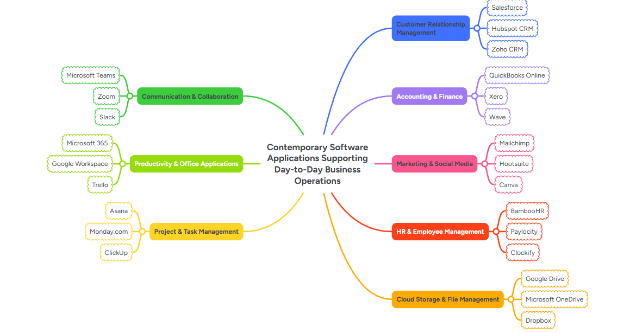
Figure 1: Displays Mind Map I made to illustrate Contemporary Software Applications supporting Day-to-Day Business Operations.

Office Applications for Creating, Storing, Presenting & Analyzing Information

Office productivity suites are vital tools that allow businesses to efficiently generate, store, present, manage and analyse operational data. Modern companies rely heavily on these applications to streamline communication, guide decision-making, boost employee output and organize corporate information. Microsoft 365 (formerly Microsoft Office) stands as one of the most prevalent productivity suites globally, offering a diverse ecosystem of programs tailored to various business operations. Within this suite, Microsoft Word, PowerPoint, Excel and Access serve as four core applications. While each program fulfils a distinct operational role, they connect seamlessly with one another to maximize organisational efficiency.[7]
This report analyses the specific purpose, core features, business benefits, and limitations of these four software solutions, highlighting how they support day-to-day corporate operations.

Microsoft Word
Microsoft Word is a specialized word-processing platform built for drafting, editing, formatting and sharing professional text documents. Since its debut in 1983, it has established itself as the global industry standard for creating corporate reports, letters, proposals, contracts, manuals and meeting minutes. Delivered as part of the Microsoft 365 ecosystem, the application supports both traditional desktop operations and real-time, cloud-based collaboration through seamless integration with OneDrive and SharePoint.[7]
Major Features
To help users produce polished, professional documents, Microsoft Word offers a wide array of powerful features, including:
- Advanced text formatting (fonts, colours, styles, themes)
- Built-in templates for reports, resumes, newsletters and business letters
- Spell checker, grammar checker and Editor writing assistance
- Tables, charts, SmartArt, images and shapes
- Headers, footers, page numbering and automatic table of contents
- Track Changes and Comments for collaborative editing
- Mail Merge for personalised letters and emails
- Export to PDF and multiple file formats
- Real-time collaboration through Microsoft 365
Benefits
Microsoft Word significantly elevates document quality and corporate communication. By leveraging built-in templates and automated formatting tools, employees can quickly generate polished, professional assets. Additionally, its collaborative features allow multiple team members to edit documents in real time, making group projects and reviews much more efficient.
The Track Changes functionality is highly beneficial for organisations with rigorous document review and approval workflows. Additionally, the Mail Merge feature dramatically reduces administrative overhead by pulling data from a database to automatically generate personalized letters, invoices, certificates or client communications. Word also interfaces seamlessly with Excel and Outlook, allowing businesses to automate a wide range of routine administrative tasks.[7]
Limitations
While highly versatile, Microsoft Word does have several notable limitations.
It is fundamentally unsuited for processing massive datasets or handling complex mathematical computations. Additionally, opening exceptionally large files packed with heavy graphics can severely slow down system performance during editing. Users may also encounter layout shifts or broken formatting when sharing documents with individuals using non-Microsoft word processors. Finally, while its cloud collaboration tools are incredibly powerful, they rely entirely on an active internet connection to function in real time.

Microsoft PowerPoint
Microsoft PowerPoint is a specialized presentation platform used to develop dynamic visual slide decks for corporate meetings, training modules, conferences, lectures and sales pitches. It allows users to effectively communicate information by structuring slides with a mix of text, images, charts, diagrams, videos, audio clips, animations and other multimedia elements.[7]
Major Features
To help users design highly engaging slide decks, PowerPoint offers a comprehensive suite of creative tools, including:
- Professional presentation templates
- Slide Master for consistent design
- SmartArt diagrams
- Charts and graphs
- Images, icons, 3D models and videos
- Animations and transition effects
- Presenter View
- Recording presentations with narration
- Real-time collaboration
- Export to PDF or video format
Benefits
PowerPoint enables businesses to translate complex data into a highly clear, visual narrative. By blending concise text with graphics, videos, animations, and charts, presentations can significantly capture and maintain audience engagement.
Executives and managers routinely rely on PowerPoint during strategic planning sessions, project updates, sales pitches, investor briefings, and employee training. The platform breaks down complex, intimidating concepts into digestible, step-by-step insights delivered slide by slide.
Furthermore, PowerPoint effectively facilitates remote communication by allowing slide decks to be broadcast over Microsoft Teams or shared instantly with global colleagues. The use of standardised templates dramatically cuts down on preparation time while ensuring a uniform, professional corporate identity.
Its tight integration with Excel allows users to import charts and financial models directly into slide decks, significantly boosting reporting accuracy and data consistency.[7]
Limitations
Slide decks can quickly lose their impact if they are overloaded with dense paragraphs or cluttered with distracting animations. Ultimately, a poorly designed presentation risks alienating the audience and lowering engagement rather than enhancing it.
Additionally, PowerPoint is entirely unsuited for archiving corporate repositories or performing complex numerical computations. High-resolution multimedia presentations can also result in massive file sizes, demanding substantial storage space and robust computer hardware to run smoothly.
Crafting high-quality presentations demands a solid grasp of visual design principles, meaning that inexperienced users may inadvertently produce less effective presentations.

Microsoft Excel
Microsoft Excel is a premier spreadsheet application designed for capturing, organising, computing, analysing and visualizing numerical datasets. It stands as one of the most critical software solutions in the enterprise ecosystem, serving as the foundational engine for financial management, predictive forecasting, corporate budgeting, performance reporting, inventory tracking and deep data analysis.[8]
Major Features
To help organizations unpack complex data, Excel provides a robust suite of advanced analytical tools, including:
- Worksheets and workbooks
- Mathematical and statistical formulas
- Functions (SUM, IF, VLOOKUP, XLOOKUP, INDEX, MATCH, etc.)
- PivotTables and Pivot Charts
- Sorting and filtering
- Conditional formatting
- Charts and dashboards
- What-If Analysis
- Power Query
- Macros using Visual Basic for Applications
- Data validation
- Collaboration through Microsoft 365
Benefits
Excel is exceptionally versatile and widely utilized by enterprises of all scales. It empowers organisations to evaluate massive volumes of data with outstanding speed and precision.
Finance departments rely on Excel to manage corporate budgeting, payroll computations, predictive forecasting and intricate financial modelling. Concurrently, sales teams utilize it to evaluate customer performance metrics, while logistics managers depend on it to monitor stock and inventory levels.
PivotTables compress thousands of data records into structured summaries within seconds, enabling managers to instantly spot emerging trends and operational patterns. Furthermore, its custom charts and interactive dashboards translate dense, raw data into meaningful visual assets that guide strategic corporate decisions.
Automating workflows through formulas and VBA macros drastically cuts down on repetitive manual tasks, boosting overall team productivity. Furthermore, Excel integrates seamlessly with Power BI, Access, SQL databases, and numerous external enterprise platforms, making it one of the most flexible and adaptable analytical tools available today.[8]
Limitations
Despite its immense analytical capabilities, Excel has several distinct limitations. Human error represents one of its biggest vulnerabilities, as a single mistyped formula or accidental data modification can completely distort analytical outcomes. Furthermore, attempting to process exceptionally large datasets can severely bog down system performance and cause processing delays.
Excel is not built to replace a true relational database management system. When multiple team members attempt to modify the same spreadsheet simultaneously, severe version control issues and data conflicts can arise. Additionally, highly complex workbooks often become nearly impossible to interpret or maintain if they lack thorough, clear documentation.[8]

Microsoft Access
Microsoft Access is a relational database management system built to help organisations efficiently store, structure, retrieve and manage large volumes of data. While Excel focuses heavily on numerical calculations and spreadsheet analysis, Access is specifically engineered for managing vast collections of interconnected datasets.[9]
Enterprises frequently rely on Access to run client databases, employee records, inventory tracking systems, vendor information networks, sales transaction histories, and reservation systems.
Major Features
To equip businesses with robust database management capabilities, Microsoft Access delivers a comprehensive set of structural tools, including:
- Relational database tables
- Primary and foreign keys
- Queries
- Forms
- Reports
- Macros
- Visual Basic for Applications
- Relationships between tables
- Import/export with Excel and SQL Server
- Data validation rules
Benefits
Microsoft Access significantly enhances data integrity by organising information into structured tables designed to minimize redundancy and duplication.
Advanced queries allow users to isolate and extract specific datasets instantly, eliminating the need for manual filtering. Concurrently, businesses can build tailored data-entry forms that simplify input workflows while drastically reducing data entry errors.
Automated reporting features instantly generate invoices, sales summaries, client registries, and executive performance updates. Furthermore, Access integrates seamlessly with Excel and Word, empowering organisations to effortlessly merge database repositories with analytical spreadsheets and official business documents.
For small and medium-sized enterprises, Access serves as a highly cost-effective database solution that demands significantly less technical expertise to deploy and maintain than large-scale enterprise database systems.[9]

Limitations
Microsoft Access is unsuited for massive corporations managing millions of database records or hosting thousands of concurrent users.
When contrasted with enterprise engines like SQL Server or Oracle Database, Access offers significantly lower scalability and computing performance. Furthermore, building an efficient database structure demands a fundamental understanding of data relationships, advanced queries and database normalization meaning that specialized technical training is required to use it effectively. Additionally, Access is exclusively available on Windows, limiting its compatibility with alternative operating systems.[9]

Comparison of the Four Applications
While all four applications belong to the unified Microsoft 365 ecosystem, each is engineered to fulfil a distinctly different operational purpose.
Microsoft Word concentrates on drafting professional documents and written correspondence, whereas Microsoft PowerPoint focuses on building visual slide decks to convey concepts effectively to an audience. Meanwhile, Microsoft Excel carries out mathematical calculations, data analysis, forecasting and reporting, while Microsoft Access specializes in managing structured relational databases and corporate records.
These applications complement one another through tight integration. For example, repositories stored in Access can be exported to Excel for deep analysis, charts built in Excel can be embedded directly into PowerPoint presentations, and formal reports drafted in Word can incorporate tables pulled straight from Excel or Access databases. This cross-platform compatibility drastically improves organizational efficiency and eliminates duplicate work.[10]
Conclusion
Microsoft Word, PowerPoint, Excel, and Access stand as essential office software solutions that anchor modern business operations. While each application executes highly specialized functions, they work in tandem to optimize daily productivity, corporate communication, data management, and strategic decision-making.
Microsoft Word empowers enterprises to efficiently draft polished, professional documentation. At the same time, Microsoft PowerPoint elevates corporate communication and presentations through dynamic visual media. Microsoft Excel delivers robust analytical tools that drive financial management, data reporting, and strategic decision making. Finally, Microsoft Access provides a structured database framework that optimizes data organisation and information retrieval.[10]
While each individual application carries specific limitations, their combined deployment arms organisations with a comprehensive toolkit for generating, storing, presenting and analysing critical information. Ultimately, their seamless integration within the Microsoft 365 ecosystem ensures they remain indispensable software solutions for enterprises across a diverse range of industries.

Examples of Two Features Used in MS Excel

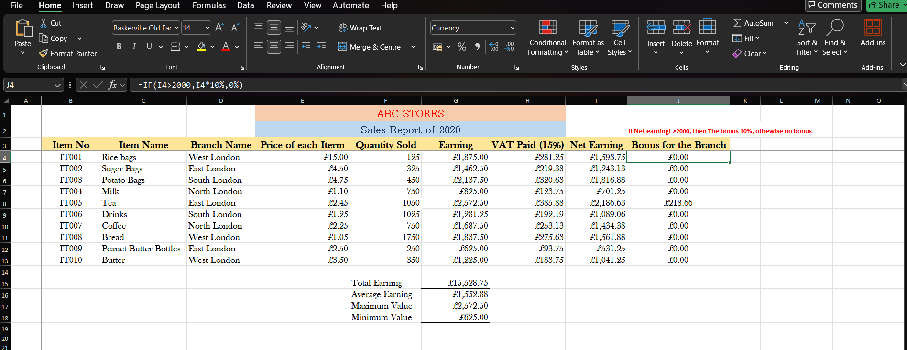
Figure 2: Demonstrates the use of the “IF Function” to determine Net Earning bonus.

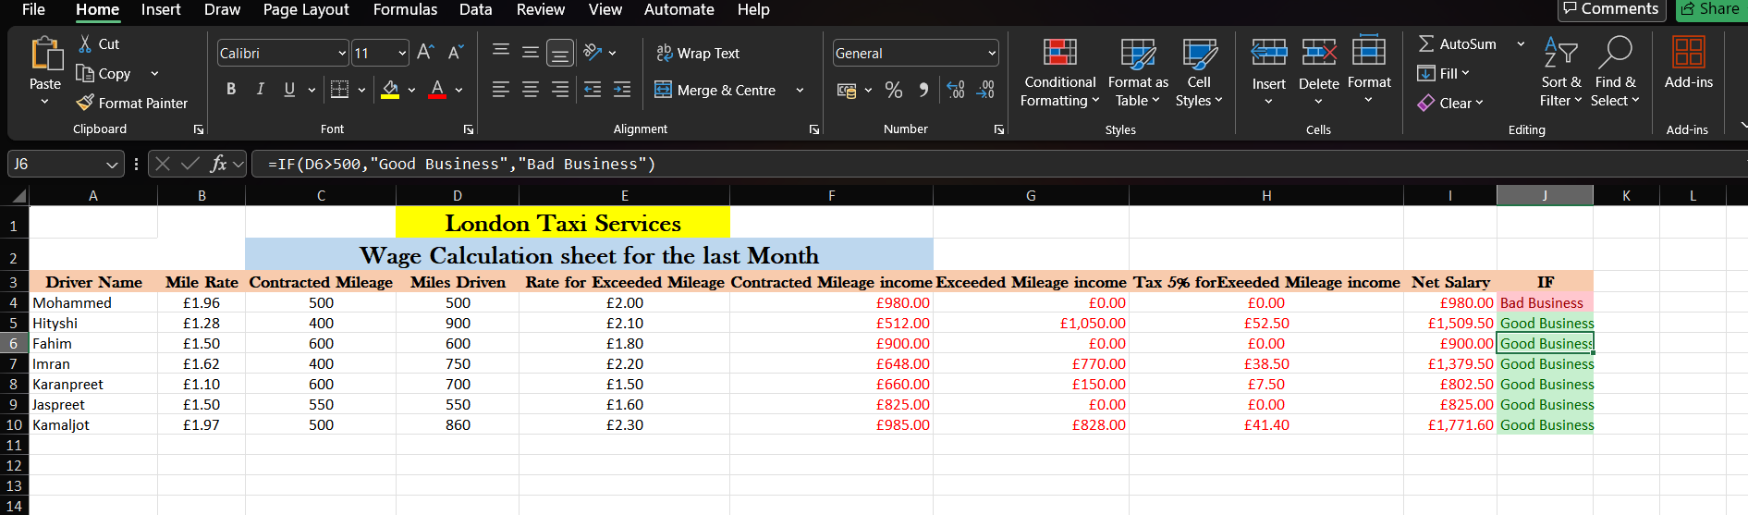
Figure 3: Shows the use of the “If Function” to determine the status of the business.

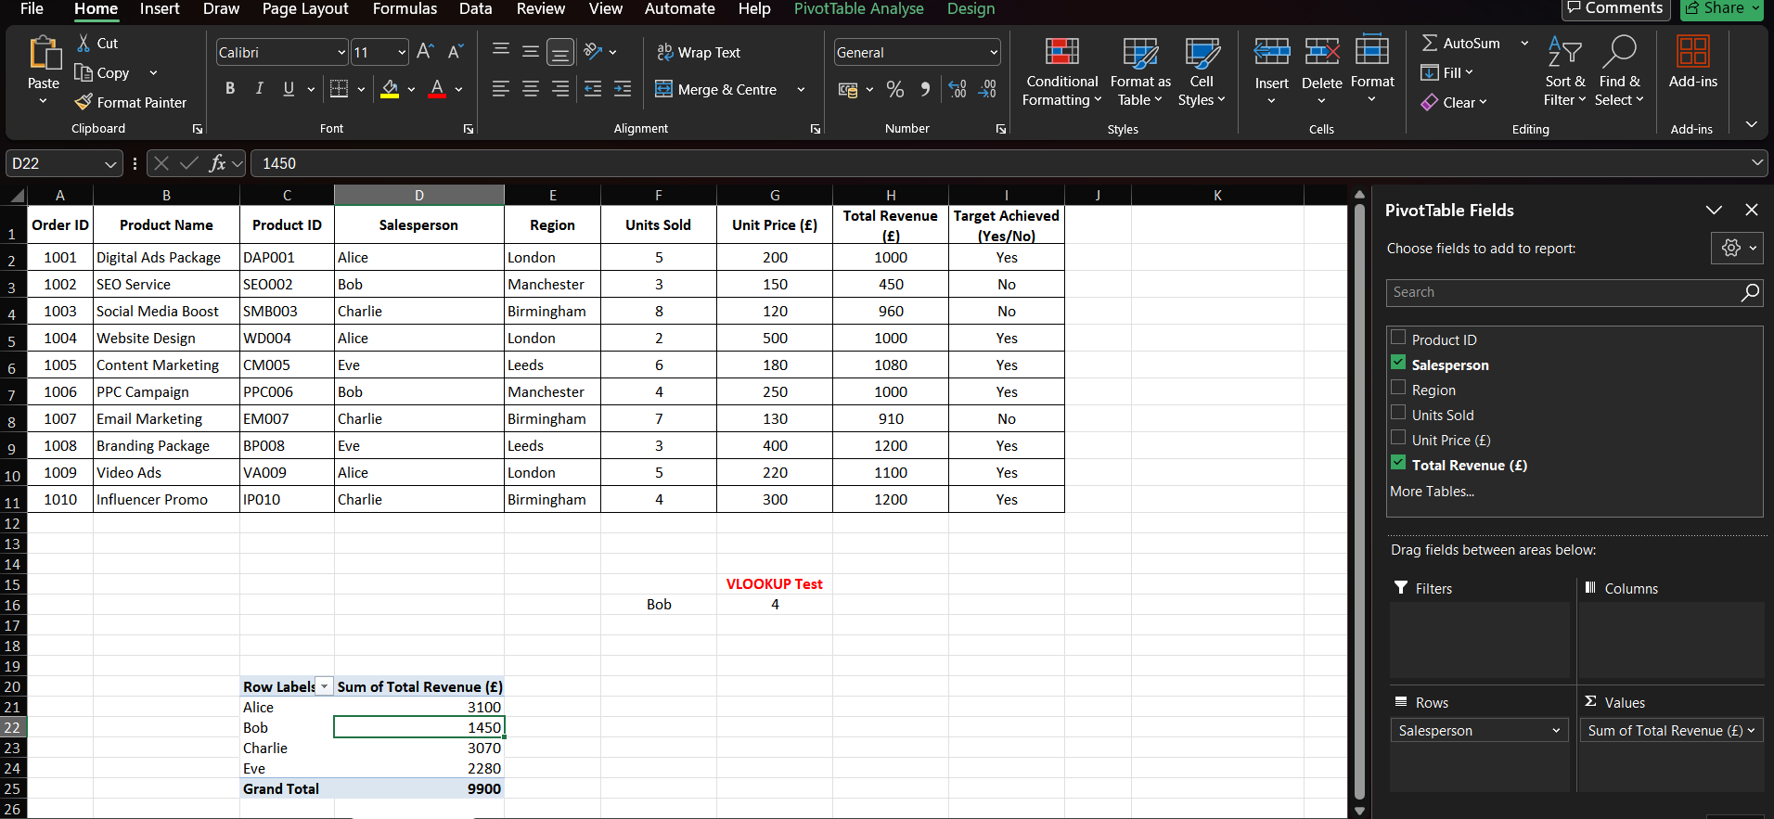
Figure 4: Illustrates the use and insertion of a PivotTable.

Communication And Collaboration Applications

Microsoft Teams (Communication Application)
Microsoft Teams is a cloud-based communication and collaboration hub developed by Microsoft as an integral part of the Microsoft 365 suite. It arms enterprises with a centralized workspace where team members can connect through instant messaging, voice calls, high-definition video conferencing, file sharing and real-time document co-authoring. Since debuting in 2017, the platform has emerged as a global leader in workplace communication driven by its seamless compatibility with the broader Microsoft software ecosystem.[11]

Figure 5: Shows Microsoft Teams Interface.
Key Features
To empower seamless corporate communication and teamwork, Microsoft Teams delivers several robust features, including:
- Instant messaging (private and group chats)
- Voice and video conferencing
- Screen sharing during meetings
- Team channels for departments and projects
- File sharing and collaborative document editing
- Meeting recording and live transcription
- Calendar integration with Microsoft Outlook
- Integration with Word, Excel, PowerPoint, OneDrive, and SharePoint
- Mobile and desktop applications
- Enterprise-level security and data encryption
Benefits
Microsoft Teams significantly optimizes workplace communication by consolidating conversations, virtual meetings and file sharing into a single interface. By transitioning routine exchanges to instant chat rather than relying strictly on traditional email, employees can accelerate corporate decision-making and resolve operational issues much faster.
High-definition video conferencing empowers employees to join meetings from any physical location, making Teams an invaluable asset for organisations navigating remote or hybrid work environments. Additionally, real-time screen sharing allows presenters to seamlessly demonstrate software workflows, review metrics and deliver slide decks during virtual sessions, while automated meeting recordings ensure that absent team members can easily catch up on discussions later.
Another major benefit is its native integration with the broader Microsoft 365 ecosystem. Users can edit Word documents, Excel spreadsheets, and PowerPoint presentations directly inside the Teams interface without ever needing to download files, facilitating seamless, real-time collaboration. This unified workflow prevents version duplication and significantly drives team productivity.
Microsoft Teams also incorporates enterprise-grade security protocols such as advanced encryption, multi-factor authentication and compliance with global data protection standards, rendering it highly dependable for businesses managing confidential information.[11]
Limitations
Despite its extensive advantages, Microsoft Teams is not without its limitations. Based on the fact of its vast array of features and complex settings, new users often require dedicated training to navigate the platform effectively. Additionally, unstable internet connectivity can severely degrade audio and video quality during live virtual meetings. The application can also heavily drain system resources, occasionally slowing down computer performance when running resource intensive video meetings or managing massive collaborative projects.[11]

Microsoft Outlook (Online Collaboration Application)
Microsoft Outlook is a specialized email and personal information management application embedded within the Microsoft 365 ecosystem. Although primarily recognized as an email client, it actively drives corporate collaboration through shared team calendars, coordinated task management, synchronized contact directories and group meeting scheduling. Furthermore, it supports shared departmental mailboxes and integrates natively with Microsoft Teams and other Microsoft applications to streamline cross-platform communication.[12]
Businesses widely utilize Outlook to manage both internal and external communication while systematically organizing corporate meetings, professional appointments and formal business correspondence.

Figure 6: Shows Microsoft Outlook Interface
Key Features
To facilitate efficient corporate communication and team collaboration, Microsoft Outlook includes a diverse array of functional features, including:
- Business email management
- Calendar and meeting scheduling
- Shared calendars
- Contact management
- Task and to-do list management
- Shared mailboxes
- Email folders and rules
- Search functionality
- Integration with Microsoft Teams
- Integration with Microsoft Word, Excel and PowerPoint
- Cloud synchronisation across devices
Benefits
A chief strength of Outlook is its capacity to streamline corporate communication efficiently. Employees can systematically manage large volumes of emails using folders, color-coded categories, automated rules and powerful search functions, boosting daily productivity and drastically reducing the time spent locating critical information.
The integrated calendar functionality allows users to schedule meetings, dispatch digital invitations, check coworker availability and reserve corporate conference rooms. Also, shared calendars dramatically improve interdepartmental coordination by allowing employees to view team schedules and proactively avoid appointment conflicts.
Outlook also integrates flawlessly with Microsoft Teams. Users can schedule virtual Teams sessions directly from the Outlook calendar interface, allowing participants to enter online meetings with a single click. This tight integration significantly simplifies meeting management and supports fluid hybrid working arrangements.
The application automatically synchronizes emails, calendars and contacts across desktop computers, smartphones and tablets using Microsoft Exchange and Microsoft 365 cloud networks. This real-time synchronization allows employees to stay securely connected and fully operational while working remotely or traveling.
Finally, Outlook incorporates advanced spam filtering, anti-phishing protection, email encryption, and multi-factor authentication for safeguarding organizational communications and protecting sensitive corporate data.[12]
Limitations
Despite its extensive strengths, Microsoft Outlook does have several notable limitations. Maintaining excessively large email archives can significantly degrade application performance and slow down search speeds. Additionally, inexperienced users may find advanced functionalities such as automated rules, color-coded categories and shared mailboxes difficult to configure effectively without dedicated technical training.
While Outlook effectively supports collaboration, its core design focuses primarily on asynchronous email management rather than instantaneous teamwork. Consequently, enterprises frequently deploy Outlook alongside Microsoft Teams to provide an exhaustive, multi-channel communication and collaboration solution.[12]

Comparison of Microsoft Teams and Microsoft Outlook
Although both Microsoft Teams and Microsoft Outlook facilitate essential workplace communication, they are engineered to fulfil fundamentally different operational purposes.
Microsoft Teams concentrates heavily on real-time communication and synchronous collaboration, including instant messaging, high-definition video meetings, voice calls, file sharing, and live document co-authoring. This focus enables employees to communicate rapidly and execute joint projects seamlessly, regardless of their physical location.
Conversely, Microsoft Outlook specializes in formal corporate communication and administrative scheduling. It serves as the primary gateway for official email correspondence, meeting distribution, calendar management, task tracking and contact directories.
These two applications complement each other perfectly within the Microsoft 365 ecosystem. For instance, a user can schedule a Teams meeting directly inside Outlook, receive the invitation instantly via email and launch the virtual session with a single click from their calendar. This tight integration creates a seamless communication environment that significantly drives organizational productivity.
Conclusion
Microsoft Teams and Microsoft Outlook stand as two of the most critical communication and collaboration applications in the modern corporate landscape. Microsoft Teams delivers a comprehensive workspace for real-time messaging, virtual hosting, cloud file sharing and synchronous group work, making it perfectly tailored to power remote and hybrid work environments. Concurrently, Microsoft Outlook remains the undisputed industry benchmark for formal email correspondence, calendar organisation, administrative scheduling and professional business communications.
Together, these applications empower organisations to communicate efficiently, coordinate projects, elevate team collaboration and boost overall productivity. Their native integration within the Microsoft 365 ecosystem allows businesses to optimize daily workflows while maintaining highly secure, reliable communications across different departments and global geographic locations.

Communication and Collaboration applications (Test Features)

Microsoft Teams
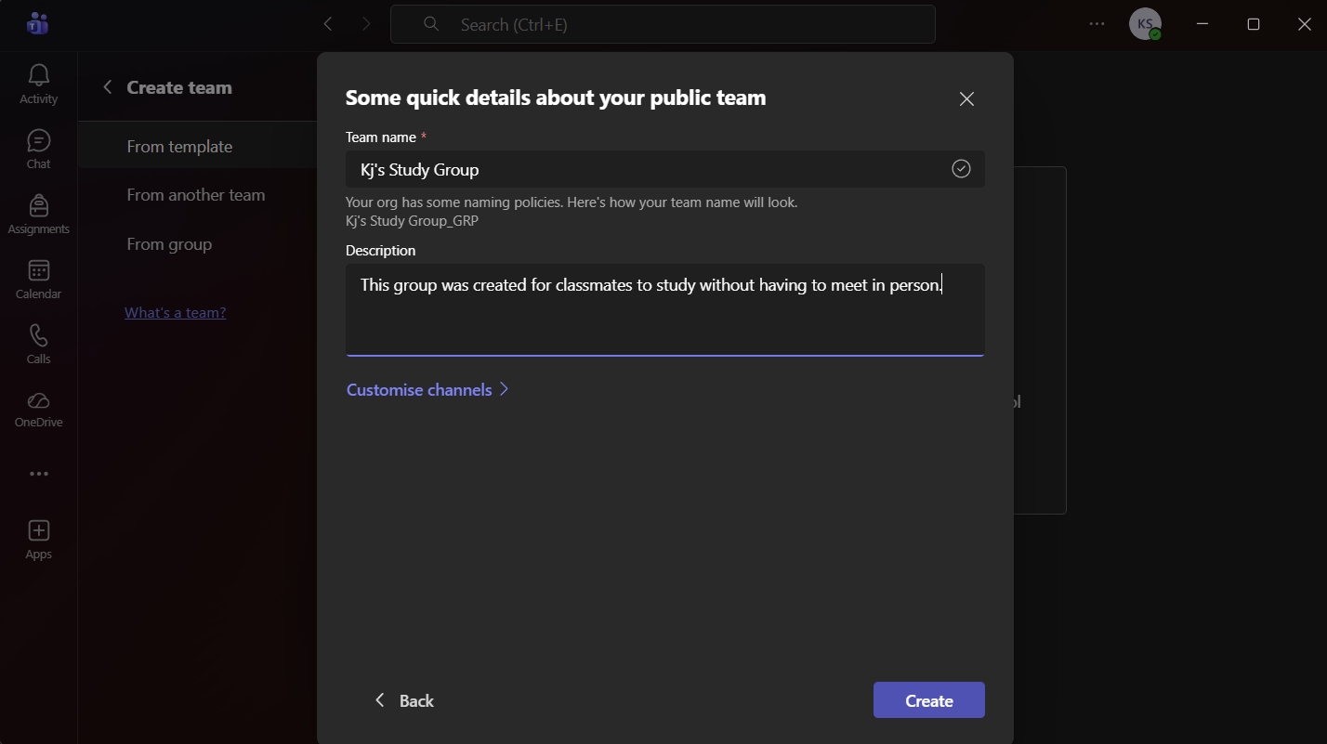
Figure 7: Illustrates the creation of a study group on Microsoft Teams.
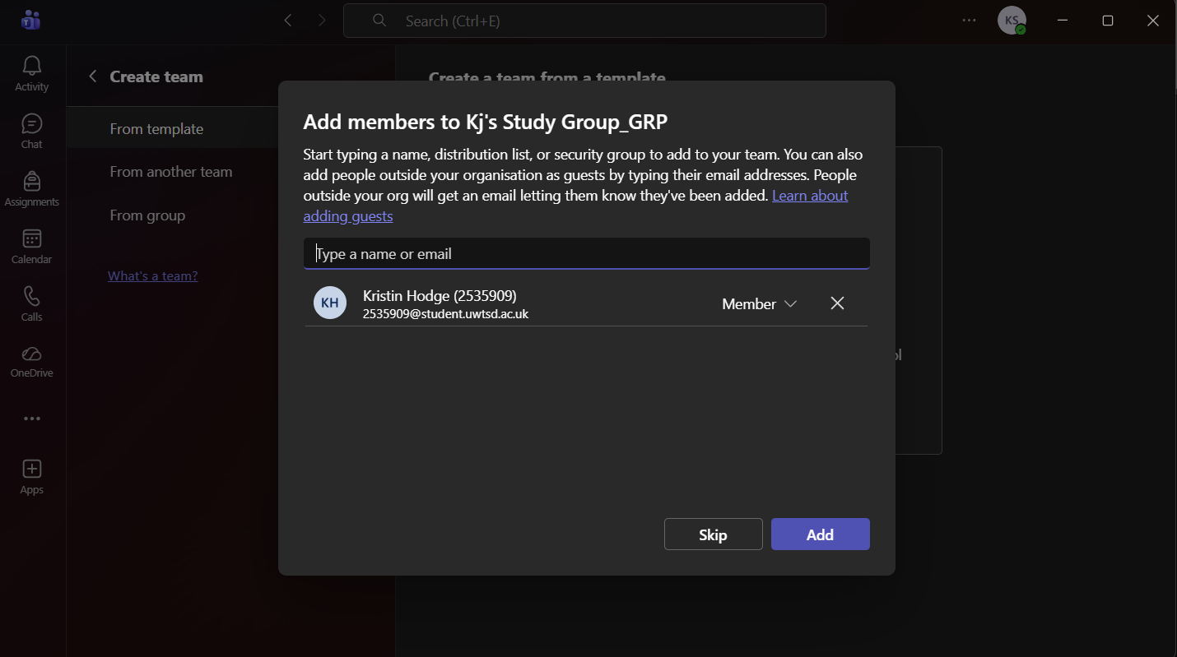
Figure 8: Shows the adding of classmates to the study group.

Figure 9: Shows the completion of the created group.

Microsoft Outlook
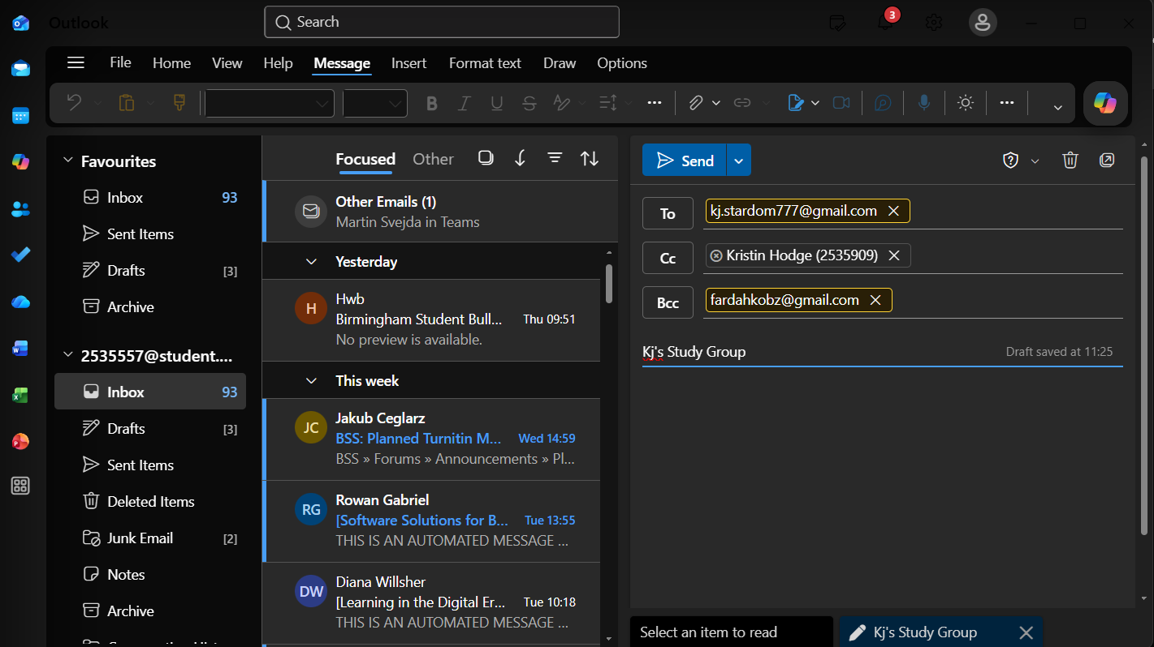
Figure 10: Shows the composing of an email using the TO, CC and BCC functions.

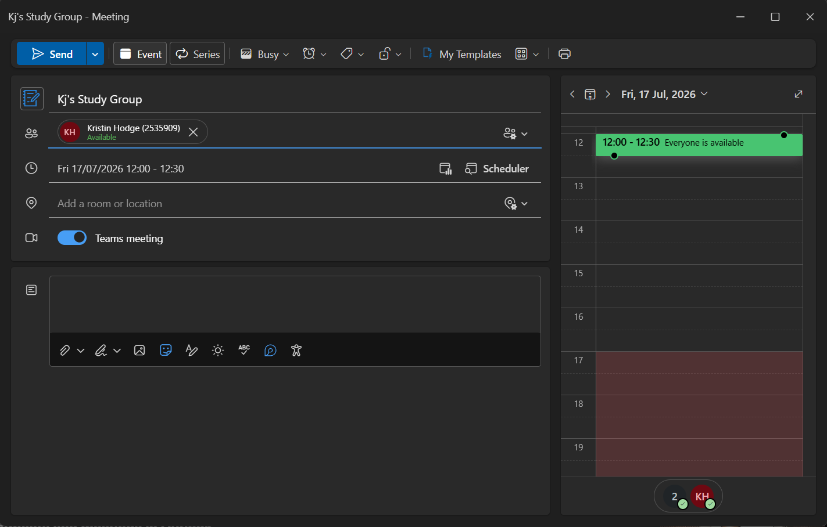
Figure 11: Illustrates the scheduling of a meeting using Microsoft Outlook.

References

[1]
Shopify Inc., Shopify. [Online]. Available: https://www.shopify.com/. [Accessed: Jul. 7, 2026].
[2]
Automattic Inc., WooCommerce. [Online]. Available: https://woocommerce.com/. [Accessed: Jul. 7, 2026].
[3]
K. C. Laudon and C. G. Traver, E-Commerce: Business, Technology, Society, 18th ed. Harlow, U.K.: Pearson, 2024.
[4]
T. Buzan and B. Buzan, The Mind Map Book, Revised ed. London, U.K.: BBC Active, 2010.
[5]
J. Davies, "Concept mapping, mind mapping and argument mapping: What are the differences and do they matter?" Higher Education, vol. 62, no. 3, pp. 279–301, 2011.
[6]
XMind Ltd., "XMind – Mind Mapping Software," [Online]. Available: https://xmind.app/. [Accessed: Jul. 15, 2026].
[7]
Microsoft Corporation, Microsoft 365 Applications. [Online]. Available: https://www.microsoft.com/microsoft-365. [Accessed: Jul. 16, 2026].
[8]
J. Walkenbach, Microsoft Excel 2021 Bible. Indianapolis, IN, USA: Wiley, 2021.
[9]
R. Carey, Beginning Microsoft Access 365 Database Development. Birmingham, U.K.: Packt Publishing, 2023.
[10]
J. Lambert and C. Cox, Microsoft Office 365 Step by Step. Redmond, WA, USA: Microsoft Press, 2022.
[11]
Microsoft Corporation, Microsoft Teams. [Online]. Available: https://www.microsoft.com/microsoft-teams. [Accessed: Jul. 18, 2026].

[12]
Microsoft Corporation, Microsoft Outlook. [Online]. Available: https://www.microsoft.com/microsoft-365/outlook/email-and-calendar-software-microsoft-outlook. [Accessed: Jul. 18, 2026].

