Analyse the work of illustrators and, particularly, author illustrators who tackle difficult, sensitive, and sometimes shocking themes.

Student Number:
2204666

Course Title:
Research in context

Word Count:
2,487

Created for:
Alice Samuel

Question 2: Analyse the work of illustrators and, particularly, author illustrators who tackle difficult, sensitive, and sometimes shocking themes.

Can an art piece or an art project start a conversation about sensitive or difficult topics within people? During this essay, I am going to be looking into the work of illustrators and author illustrators to find out how these artists are conveying messages, and if the work they create are about to start conversations that may or may not need to happen.

Nina Chanel Abney
Looking into the chosen question, I decided to start my investigation into the question by looking at Nina Chanel Abney and her work. Nina is a contemporary painter and artist who considers, what some people may consider to be sensitive topics such as gender, race, politics, homophobia, and pop culture in her work.
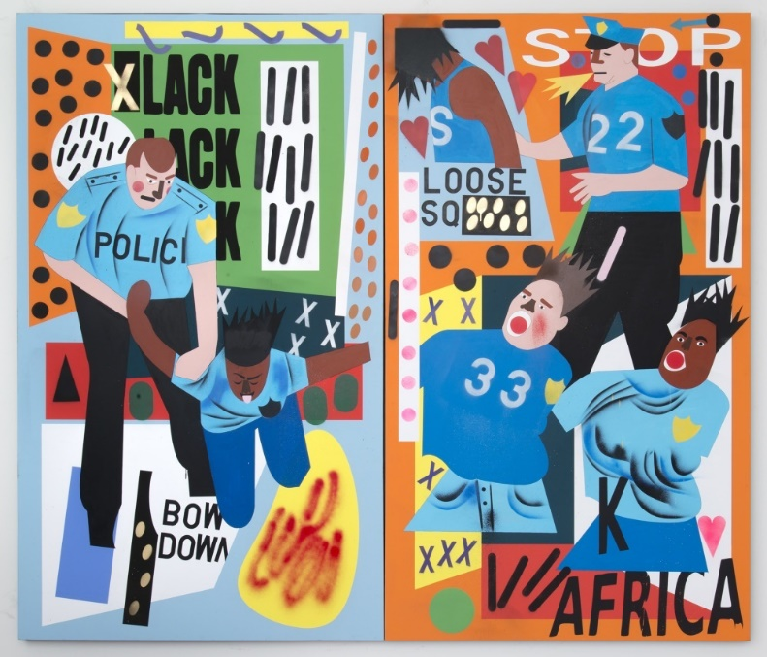
Researching her art pieces and art series, her series ‘ALWAYS A WINNER’ stood out. This series is about her addressing the movement known as the Black Lives Matter movement and reflecting information overload, the absurdness of the large internet era and questions the way that people are affected by other people that abuse their power because they have that ability to [thebelt.org, n.d]. In her works, for example, she uses clown make up to indicate racial distinctions, and police batons turn into phallic symbols [Artsy.net, n.d]. Through thorough investigation into her subtle messages and ‘phallic symbols’, it was determined that it meant as a symbol to celebrate fertility [text-bin.blogspot.com, November 2014] and this does link back to one of her topics such as gender. For her artwork, Abney welcomes a pop-surrealist style to which she makes large-scale canvas scenes that involve flat planes of bold colours, overlapping shapes, cartoon like figures, scattered numbers, symbolics objects and letters. She also has recurring themes which involve sexuality, contemporary culture, and racial conflict. To construct her scenes, she used current events, traditional storytelling, and autobiography [Artsy.net, n.d].
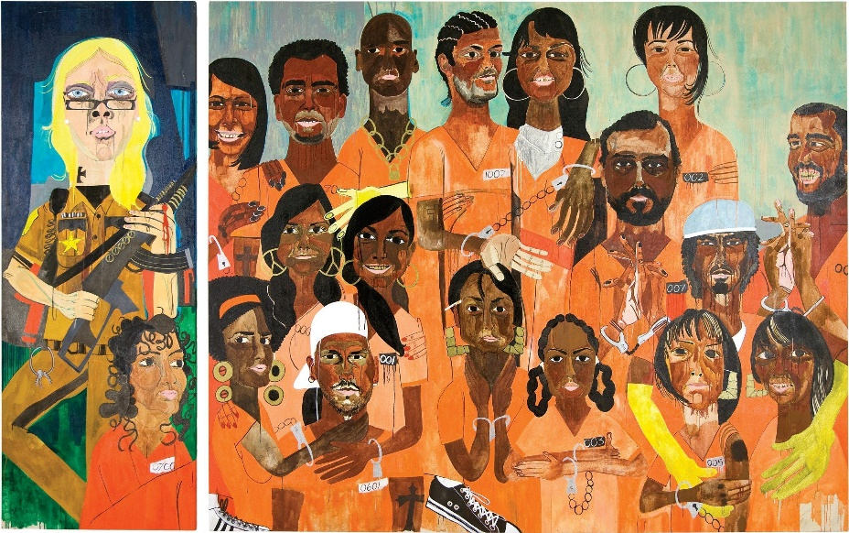
Furthermore, while investigating her pieces in the ‘ALWAYS A WINNER’ series, visually, her art is quite abstract and expressive because when you initially look at them, you can tell there is a message behind them, and that the artist is trying to convey that to the viewer. The ‘Class of 2007’ was her first piece where she became known, for this, she portrayed herself as a white gun-toting prison guard with flowing blonde locks, while being the only black student in her classroom. She then painted her white classmates as black inmates. She mentions that a couple of her classmates asked if she was mad at them. She states that “it’s nothing personal” (Nina Chanel Abney, 2015), because just like her paintings now, “it’s not you, it’s just a face” (Nina Chanel Abney, 2015) [Vanityfair.com, October 15th, 2015]. It seems that seeing the reaction of her classmates, shows that art can create reactions from people, and it is possible to do it in a way that you’re not offending anyone or being disrespectful, but rather just sending a message that the artist feels needs to be heard and talked about more. Alternitevely, it indicates that she handles sensitive topics well because taking topics such as racial conflict and creating a piece that brings attention to that in a calm way, she is not throwing it in the viewers face but she is making the viewers think and especially her classmates as they could physically see what it feels like.
Through thorough research, an interview by Victoria L. Valentine was discovered. In the interview, she was asked ‘was that to be provocative in general or was that to explore the dynamics and perceptions of race because you were the only black student during your two years there?’ In response she stated that she was trying to think of ways of talking about race that hadn’t been done yet. The decisions to make her white classmates black came from one question “how would they feel if they were portrayed black?” (Nina Chanel Abney, 2016). Considering the results, that is a tough question to ask as you never know how someone may react, such as how she had one classmate who she felt it would be uncomfortable for him, so she “made him extremely dark skinned” (Nina Chanel Abney, 2016). Also, showing someone visually what it would be like in that scenario, it appears that is the best way to get a message across.
Looking into her work, the simplistic style that she adopts has created a long-lasting affect especially on her classmates due to the nature of this work, and to the public because of the message that is behind it, it is very clear that the way she has tackled it and the way she has chosen to relay her message about race has been successful. The way she has also laid out her pieces such as having a simple background and bringing the attention to the front seems important to her as she repeats this process in a lot of her pieces, and having most of the colour and detailing in the front to essentially says pay attention to the message I am trying to convey.

Cori Doerrfeld
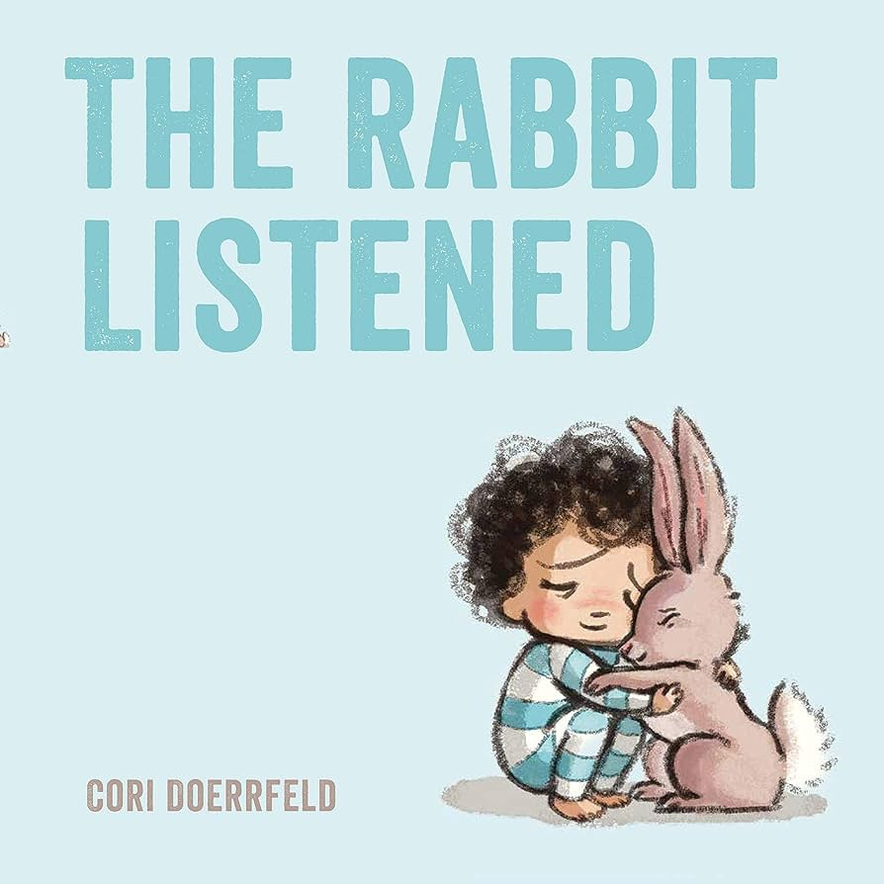
During my investigation into children’s books, the work of Cori Doerrfeld and specifically the book ‘The Rabbit Listened’ stood out. Reading an interview by Brightly Editors, Doerrfeld was asked a couple questions relating to her work, why she creates art and why she believes it is good for children to do the same. She stated that ‘The Rabbit Listened’ has white backgrounds so the focus is more on the subtle interactions such as the movement of the birds and the colour. She specifically enjoys “when things fall apart for the character”.

Later into the interview she was asked about her opinion on why art is important for kids, to which she responded that “art is a safe, yet powerful” way for children to express themselves and explore importance within their own beliefs, bringing forth a new world while escaping the one around them [readbrightly.com, n.d]. In the story, the main character, Taylor, they create a tall structure from some building blocks, and they are extremely happy of the results, and so when a passing flock of birds knock down the tower, Taylor is devastated. Well-meaning creatures come along to offer advice to the child. Chatty chicken suggest that they sit and talk about it, angry bear suggests that they shout and roar, while sly snake encourages spoiling someone else’s game. Nothing makes Taylor feel better until Rabbit takes a more passive approach. This story gives an ideal starting point for tough conversations about how it feels when things don’t go to plan, it brings forth the importance of listening and allowing time for children to come to terms with the emotions they’re processing and displays how to find positive ways to progress forward. This tale inspires children to widen their strategies to manage feelings and it helps them to broaden their emotional intelligence [booktrust.org.uk, n.d]. It is believed that white backgrounds are important so that you may focus on the detail of the actual story. It is also believed that kids need something simple because their attention spans can be very short, and so something simpler will help them focus a lot more.
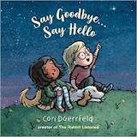
Examining the book ‘Say Hello, Say Goodbye’ which is also by Cori Doerrfeld, it is about two children, Charlie and Stella who meet, become friends, and soon learn about the sadness of saying hello or something new and the sadness of saying goodbye. Stella does not want to leave her mum and climb on the school bus; she is happy to say hello to Charlie when she arrives at the new school. When the kids are happily outside, they then must come inside. When the snowmen melt, there are puddles for the children to jump in, and then when the goldfish dies, there is a loving arm to give a ‘full heart’. However, there is one goodbye that is exceptionally difficult, Charlie’s family move away, and both children felt bereft (deprived or lacking something) [booksforkeeps.co.uk, 2020]. However, there will always be another hello, such as a new friend. A new little boy has moved into Charlie’s house. It is evident that this touching, simple illustrated story that has illustrations that help children learn about emotional highs and lows, and to also be able to cope with every hello and goodbye that they will experience.

The evidence on Scallywags Press has quotes from companies praising this book, they state about how it “recognises the difficulties of learning to cope with emotions, but is also full of emotions” (Juno Magazine, n.d). Another quote is a compliment towards how it is “a beautiful springboard for conversations with little ones at time of transition” (cbi reading guide, n.d). Lastly, Just Magazine stated that “teachers and parents will be delighted with this book. It will be a reassuring addition to any child’s bookshelf” (Just Magazine, n.d). The results indicate that having books to help children’s emotions benefits both the child and the parent or teacher.
Overall, the research indicates that these books that Cori Doerrfeld created are great examples of how to tackle emotions such as sadness and confusion because as Juno Magazine recognises, it “recognises the difficulties of learning to cope with emotions, but is also full of emotions” (Juno Magazine, n.d), and this recognition along with the colour palette chosen seems to have a lasting affect due to the popularity of ‘Say Goodbye, Say Hello’.

Caryolyn Crimi
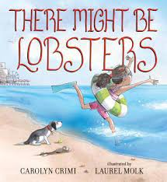
Lastly, through more investigation into books that help children understand certain emotions and how to deal with them, ‘There Might Be Lobsters’ by Carolyn Crimi, illustrated by Laurel Molk made it onto the list of top children’s books. Crimi’s book helps with children experiencing anxiety. This story tells a tale about a dog names Sukie who is afraid of the beach. The stairs are sandy, the balls are beachy, the water is whooshy and everything seems bigger as she is just a small dog. There also may be lobsters. Sukie’s human, Eleanor, tries her hardest to comfort Sukie and ease her fears but it’s only when Sukie’s favourite stuffed toy, Chunka Munka, gets swept away by a wave and its only then does the dog find the courage to venture into the scary ocean [Candlewick.com, n.d].

Reading into the article, Matt de la Pena expresses his opinion on children’s books and states that he doesn’t think that “the job of a picture book is to answer questions” (Matt de le Pena, 2020), because he believes that children’s books can help explore difficult issues without overwhelming them. He believes that books should start conversations and shouldn’t answer questions, and those conversations can be educational, silly, and sometimes profound. It is believed that children shouldn’t base a complete answer to a certain question on a singular book created by an adult, who has already processed everything while they’re still processing things because they’re still so young, such as in this aspect between the ages of 3 and 7, because their brains work differently. [npr.org, December 31st, 2020]. Researching into “There Might Be Lobsters”, Matt de la Pena commented on this book with his own opinion about how he thinks that “so many kids can’t identify why they’re anxious” (Matt de la Pena, 2020) but they just have a feeling of this “darkness inside them” (Matt de la Pena, 2020). He also mentions the difference between how adults may deal with anxiety which is to try to “examine and determine” (Matt de la Pena, 2020) it, children are “experiencing it viscerally” (Matt de la Pena, 2020). Investigating into the term ‘viscerally’, considering the results it means to show a reaction based on emotions and deep feelings, rather than on thought and reasons [dictionary.cambridge.org, n.d].
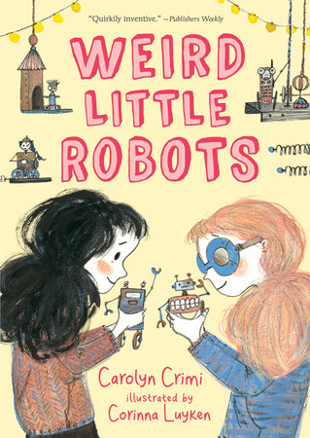
Another book Carolyn Crimi published was ‘Weird Little Robots’ who was illustrated by Corinna Luyken. The story talks about an eleven-year-old girl names Penny Rose, who has just moved to a new town, and the robots she builds seems to be her only company. However, with just a little magic, everything seems to change she becomes best friends with Lark, she has the chance to join a secret science club, and discover her robots are actually alive. With everything going well, Penny Rose hardly remembers about lonely she used to feel, but then a mishap forces her to choose between the club that she has always dreamed of and the best friend she has always wanted, and in the end, it may be her little robot friends that suffer [penguinrandomhouse.com, n.d]. An illustrated chapter from Carolyn Crimi and Corinna Luyken shows that creating a true friend and being able to make your own space is magical on its own.

With all the evidence collected and praises from companies such as Kirkus Reviews where they state that it was a “contemplation on the magic of friendship told with sweetness, simplicity and science” (Kirkus Reviews, n.d). Another quote stated that this would be a great “addition to an elementary library” (School Library Journal, n.d) if they wanted a book about friendships [penguinrandomhouse.com, n.d]. This shows that Carolyn Crimi has created a book that would be beneficial for learning about friendship.

Conclusion
Out of the stated questions, I chose to analyse the work of illustrators, and particularly, author illustrators who tackle difficult, sensitive, and sometimes shocking themes. After spending time investigating this question, I now can use the knowledge I have gained to answer the question.
During my research into my three chosen illustrators such as Nina Chanel Abney, Cori Doerrfeld and Carolyn Crimi and relating it into my own question: Can an art piece or an art project start a conversation about sensitive or difficult topics within people? I found that these illustrators have been able to take difficult topics and tackle them in a similar way. These illustrators have taken a simplistic approach towards their art pieces to which I believe would be easier for the viewers to understand, as for example, white backgrounds to be able to focus on the illustrations at hand such as Cori Doerrfeld’s book ‘The Rabbit Listened’. Another example of this would be a similar colour palette, all the artists I have chosen to investigate have a similar colour palette such as pastel browns and blues with a gravely texture, and with all the evidence collected and looking into the praise for each artist, I found that this helped the books have a calm feeling which is important as I feel it is especially important for children who need something not overwhelming and something that they can connect with.
Overall, with all the evidence that I have collected, these books are a great exampled of being able to tackle sensitive and difficult topics with a respectful manner but be able to have a big enough impact that people show a reaction and talk about it.

Bibliography
Abney, N.C. (no date a) Always a winner, Nina Chanel Abney Studio. Available at: https://www.ninachanelabney.com/always-a-winner/ (Accessed: 27 November 2023).

Abney, N.C. (no date b) Nina Chanel Abney, The Belt. Available at: https://www.thebelt.org/nina-chanel-abney (Accessed: 28 November 2023).

Abney, N.C. (no date c) Nina Chanel Abney - artworks for sale & more | artsy, Artsy net. Available at: https://www.artsy.net/artist/nina-chanel-abney (Accessed: 28 November 2023).

Cornish, A. (2020) Struggling to discuss tough topics with a kid? here are books that might help, NPR. Available at: https://www.npr.org/2020/12/31/952445588/books-to-share-with-kids-during-tough-times (Accessed: 28 November 2023).

Crimi, C. (no date a) Weird little robots by Carolyn Crimi: 9781536214710: Penguinrandomhouse.com: Books, PenguinRandomhouse.com. Available at: https://www.penguinrandomhouse.com/books/611942/weird-little-robots-by-carolyn-crimi-illustrated-by-corinna-luyken/ (Accessed: 28 November 2023).

Editors, the B. and Doerrfeld, C. (2018) Meet the illustrator: Cori Doerrfeld, Brightly. Available at: https://www.readbrightly.com/meet-illustrator-cori-doerrfeld/ (Accessed: 27 November 2023).

Furman, A.N. (1970) Phallic symbols, TextBin. Available at: https://text-bin.blogspot.com/2014/11/phallic-symbols.html#:~:text=In%20ancient%20Greece%2C%20Rome%2C%20and,all%20their%20silliness%20and%20joy. (Accessed: 27 November 2023).

Goodbye, hello: Helping children to cope with change (2020) BookTrust. Available at: https://www.booktrust.org.uk/news-and-features/features/2020/november/goodbye-hello-helping-children-to-cope-with-change/ (Accessed: 28 November 2023).

McVey, K. (2015) How Nina Chanel Abney is championing the black lives matter movement with a paintbrush, Vanity Fair. Available at: https://www.vanityfair.com/culture/2015/10/nina-chanel-abney-painter-always-a-winner-interview (Accessed: 25 November 2023).

Say goodbye ... say hello (no date) Scallywag Press - Say Goodbye ... Say Hello by Cori Doerrfeld. Available at: https://www.scallywagpress.com/books-say-goodbye.html (Accessed: 27 November 2023).

Shlenther , E. (2021) Bookskeeps, Books For Keeps. Available at: https://booksforkeeps.co.uk/review/say-goodbye-say-hello/ (Accessed: 26 November 2023).

There Might Be Lobsters (no date) Candlewick Press - Catalog. Available at: https://www.candlewick.com/cat.asp?mode=book&isbn=0763675423&browse=Author (Accessed: 29 November 2023).

Viscerally | english meaning - cambridge dictionary (no date) Cambridge Dictionary . Available at: https://dictionary.cambridge.org/dictionary/english/viscerally (Accessed: 27 November 2023).

