

Module: Digital Skills
Module code: LCLM4002

Student Name:Ibrahima Diop Diaban
Student ID:2435676

Task 2

Table of Contents
Introduction to Excel Charts 3
Step-by-Step Guide to Creating a Chart in Excel 3
Step 1: Prepare Your Data 3
Step 2: Select Your Data 3
Step 3: Insert a Chart 4
Step 4: Customize Your Chart 4
Step 5: Save and Share Your Chart 5
Best Practices and Tips for Creating Charts in Excel 5
Conclusion 6
References 7

How to Create a Chart in Excel: A Step-by-Step Guide
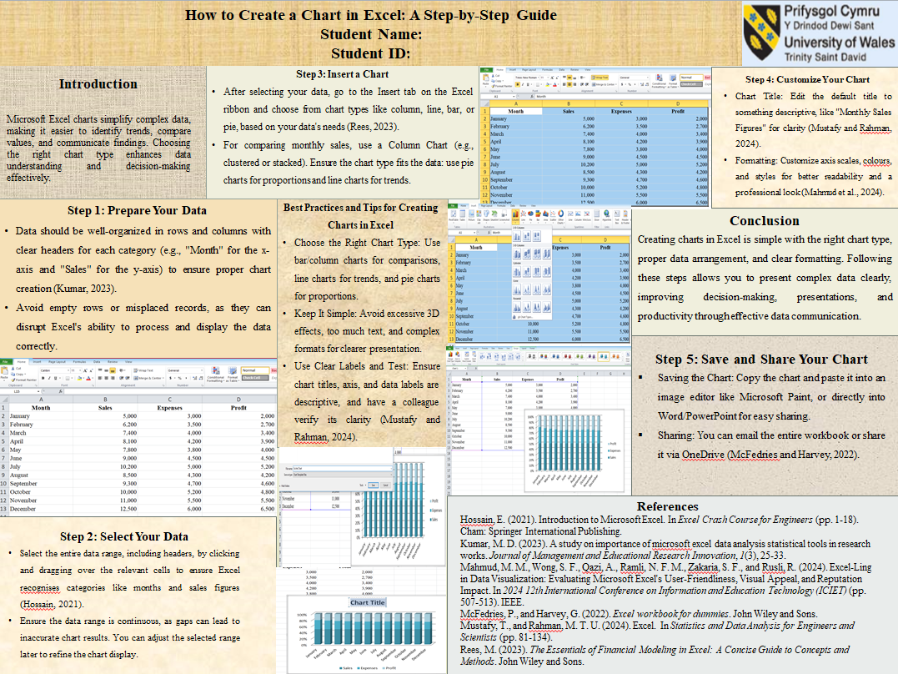

Introduction to Excel Charts
Microsoft Excel charts convert large and confusing data into easy-to-understand information. They assist users in identifying trends in a short time, comparing values, and making informed judgments of the visual patterns. Knowing how to create charts is a necessary skill in the workplace that improves the interpretation and communication of data.
There are a lot of chart types provided by Excel, such as bar, pie, line, and scatter charts, all of which have a purpose. The selection of the appropriate chart renders data more significant and comprehensive. These procedures will help you to prepare your data, create a chart, and present your findings.

Step-by-Step Guide to Creating a Chart in Excel

Step 1: Prepare Your Data
One should have well-prepared data before developing a chart. The chart can be as well as the structure that it has, and thus, it is imperative to organise information properly in rows and columns. The categories of the data represented by each column must have a clear header. In an illustration, when Month is used as the name of the first month and Sales as the name of the second, Excel figures out the appropriate values to be placed on the x-axis and the y-axis(Kumar, 2023). Empty rows or misplaced records cannot be permitted since they can break the way Excel will process the records.

Step 2: Select Your Data
After the data is suitably organised, the first thing should be to pick up the entire range you desire to be covered in the chart. This involves clicking and dragging on all the concerned cells, not to mention the headers(Hossain, 2021). Choosing a full set will mean that Excel will be able to recognise those categories, which include months and numerical figures, like the sales. Ensure that the range of data is continuous, as there might be gaps which will give inaccurate results in creating the chart. In case the primary selection needs to be narrowed, it is possible to make changes to the data range after selection in order to refine what will display in the chart using Excel.

Step 3: Insert a Chart
Once you have chosen your data, the second thing to do is to insert a chart. On the excel ribbon, go to the Insert tab and find charts in the form of column, line, bar and pie. These types of charts are categorised and selected to enable you to make a better choice that suits your data.
A Column Chart would be an appropriate one in case you are comparing monthly sales. Click on the button Insert Column or Bar Chart and select a style such as clustered or stacked. Excel will develop a default chart, and it will provide a clear starting point to make further formatting(Rees, 2023).
Critical Tip: Select a graph type that is appropriate to your data. Proportions should be done using pie charts, and trends should be done using line charts.

Step 4: Customize Your Chart
Excel has a number of customisation options that would allow you to refine your chart and make it more readable. The default chart is not the best; however, it can be modified in any way to suit your purpose.
Change the Chart Title: Hover your cursor over the default title and delete it, followed by a descriptive title. Some of the titles, like Monthly Sales Figures or Sales by Region, allow the viewer to perceive the purpose of charts at first glance(MustafyandRahman, 2024).
Format the Axes: Click either axis and under Format Axis, format scales, number formats or gridlines. This is particularly convenient in cases when you are either going to show values in thousands or simply changing intervals to have better readability.
Colour and Style: Excel also allows you to modify the colours of bars and lines, among others. The use of plain, replicated and contrasting colours ensures that the chart is professional and simple to use(Mahmud et al., 2024).
Add Data Labels: Click on the right button on the chart and select Add Data Labels to use the actual value on the chart. It is simpler to comprehend information without having to consult the axis values(Mustafy and Rahman, 2024).
Legend: Place the legend in a way that does not interfere with vital information. This can be dragged to a corner or side to make the chart clean up.
Chart Style: The preset chart styles available in Excel can easily add eye-catching looks, yet one needs to choose the chart style that helps information be better understood and not to be overshadowed by the chart.

Step 5: Save and Share Your Chart
After customising your chart, you can save it either in your Excel workbook or as an independent picture. In order to save it as a picture, copy the chart using right-clicks to copy and then paste it into an image editing program, such as Microsoft Paint or directly in Word or PowerPoint. Excel gives various options to share as well; you can e-mail the whole workbook or share it on OneDrive(McFedries and Harvey, 2022).

Best Practices and Tips for Creating Charts in Excel
Choose the Right Chart Type: As stated, categorical comparisons should be made using bar or column charts; time orientation charts used are trends, and proportions will be represented through pie charts.
Keep It Simple: Keep it minimal by reducing 3D effects, too much information written on data, or too complicated a format.
Use Clear Labels: Make sure that chart titles, axis labels and data labels are clear and descriptive.
Test for Understanding: Provide the chart to one of the colleagues to verify that the chart can be easily interpreted and that the information is presented clearly(Mustafy and Rahman, 2024).
Avoid Overuse of Colours: Use a small palette of colours, use only a small amount of colour and only apply colour to draw attention to important details.

Conclusion
Making the chart on Excel is easy; the only trick in making great charts is to select the chart type, arrange the data correctly, and shape the chart so that it is easy to understand and easy to see. With the steps taken in this guide, any complex data can then be presented in charts that clearly communicate and are easily understood. Charts are used in the workplace to aid in decision making, presentations, and to analyse data and learning to do this will go a long way in improving productivity and information presentation skills.

References
Hossain, E. (2021). Introduction to Microsoft Excel.In Excel Crash Course for Engineers (pp. 1-18). Cham: Springer International Publishing.
Kumar, M. D. (2023). A study on importance of microsoft excel data analysis statistical tools in research works. Journal of Management and Educational Research Innovation, 1(3), 25-33.
Mahmud, M. M., Wong, S. F., Qazi, A., Ramli, N. F. M., Zakaria, S. F., andRusli, R. (2024). Excel-Ling in Data Visualization: Evaluating Microsoft Excel's User-Friendliness, Visual Appeal, and Reputation Impact. In 2024 12th International Conference on Information and Education Technology (ICIET) (pp. 507-513).IEEE.
McFedries, P., and Harvey, G. (2022). Excel workbook for dummies. John Wiley and Sons.
Mustafy, T., and Rahman, M. T. U. (2024). Excel. In Statistics and Data Analysis for Engineers and Scientists (pp. 81-134).
Rees, M. (2023). The Essentials of Financial Modeling in Excel: A Concise Guide to Concepts and Methods. John Wiley and Sons.

