
Cloud Computing Level Six Term Two
University of Wales Trinity Saint David
Professor: Renuga Jayakumar
Student: Crina Elena Iordache

Cloud Computing Administration
Assignment One
ACCA6025

Table of Contents

abstract 2
introduction 2
azure cost calculation 3
TCo workload overview 5
Azure storage 16
azure database options 20
backup and retention policies 23
Video 26
disaster recovery plans 26
conclusion 28
references 28

abstract
In today’s digital age, educational institutions are experiencing growing needs for scalable and cost-efficient IT infrastructure in order to aid their academic and administrative functions. This study explores the important choice between implementing Microsoft Azure cloud services or sticking with traditional on-premises infrastructure for a medium-sized educational institution such as Global Learning Institute (GLI).By evaluating various aspects including total cost estimates, Azure file storage demonstrations, database options comparisons, backup schedules, and Azure Site Recovery, this analysis aims to provide comprehensive insights for institutions navigating the transition to cloud-based solutions.

introduction

The Global Learning Institute (GLI) must address the difficulties associated with maintaining IT infrastructure located on-site. The organization is currently facing challenges with rising upkeep expenses, restricted ability to grow, and built-in dangers related to hardware malfunctions and safeguarding data. GLI is considering moving to Microsoft Azure cloud services to address these challenges, aiming for scalability, reliability, and cost-effectiveness in overseeing its educational resources, user profiles, databases, and administrative systems.
This study intends to offer a comprehensive comparison of implementing Azure cloud solutions versus upkeeping traditional on-premises infrastructure for GLI. The assessment will start by estimating the overall expense of ownership (TCO), evaluating the monetary impact of operating servers on-premises versus using Azure cloud services. Afterwards, the paper will present how Azure file storage is used, highlighting how it meets GLI's specific requirements and advantages.
Moreover, the study will investigate the assessment of different Azure database choices. This evaluation will focus on the advantages and appropriateness of each database service for keeping user profiles, course materials, and administrative data in an educational setting. Furthermore, it will discuss setting up backup schedules and retention policies with Azure Backup to ensure preparedness for disaster recovery and protection of important storage and database assets. Finally, the examination will explore Azure Site Recovery, explaining how this tool guarantees operational consistency and reduces downtime when unexpected disruptions or disasters occur.
This study aims to analyse these essential components in order to equip GLI and other educational organizations with valuable knowledge for making informed choices about their IT infrastructure plans. By demonstrating a thorough analysis of Azure cloud capabilities regarding on-premises alternatives, this paper aims to demonstrate the necessary steps for a seamless and efficient transfer towards cloud-based solutions.

This study sets aims to deliver comprehensive research that will showcase the detailed analysis of Azure cloud versus on-premises infrastructure for the educational institution, focusing on key areas of cost estimation, file storage, database options, backup strategies, and disaster recovery.

azure cost calculation

Necessary workload for azure relocation outline:

- Virtual Machines (VMs):
Web Server VM:
Operating System: Windows Server or Linux
RAM Size: 16 GB
Storage: 2 TB (OS and application files)
Purpose: Hosting institution's website, portals, and learning management system (LMS).
Application Server VM:
Operating System: Windows Server or Linux
RAM Size: 16 GB
Storage: 2 TB (OS and application files)
Database Server VM:
Operating System: Windows Server or Linux
RAM Size: 32 GB
File Server VM:
Operating System: Windows Server or Linux
RAM Size: 16 GB
Storage:
System Drive: 100 GB (OS and file server software)
Data Drive: 2 TB (File shares for storing course materials, documents, and user profiles)
Purpose: Centralized file storage and sharing for students and faculty.
- Network Infrastructure:
Domain Controller:
Operating System: Windows Server
RAM Size: 8 GB
Storage: 100 GB (OS and Active Directory database)
Purpose: Centralized user authentication, group policy management, and DNS services.
Networking Devices:
Firewall, routers, switches, and access points to secure and manage network traffic within the institute.
- Storage Requirements:
HDD Storage:
Capacity: 10 TB (for VM storage, file shares, and backups)
Redundancy: RAID or other fault-tolerant configurations for data protection.
- Database Requirements:
Database Management System (DBMS):
Microsoft SQL Server or PostgreSQL
Database Instances:
Student Information System (SIS) database
Learning Management System (LMS) database
Administrative databases for HR, finance, and operations
5. Operating Systems:
Server Operating Systems:
Windows Server 2019 or Linux
User Operating Systems:
Windows 11 for student and faculty workstations
macOS or Linux distributions for specialized departments or labs

TCo workload overview
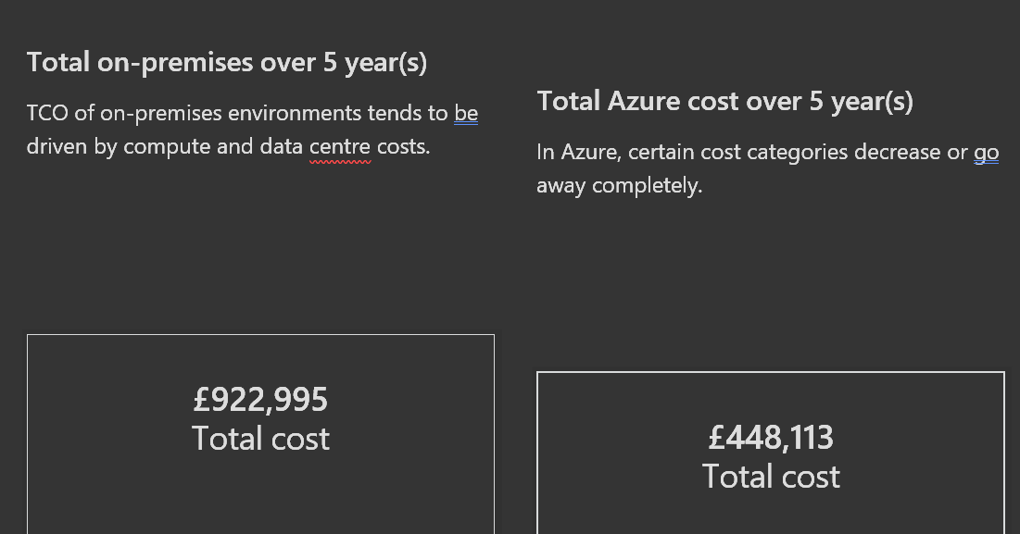
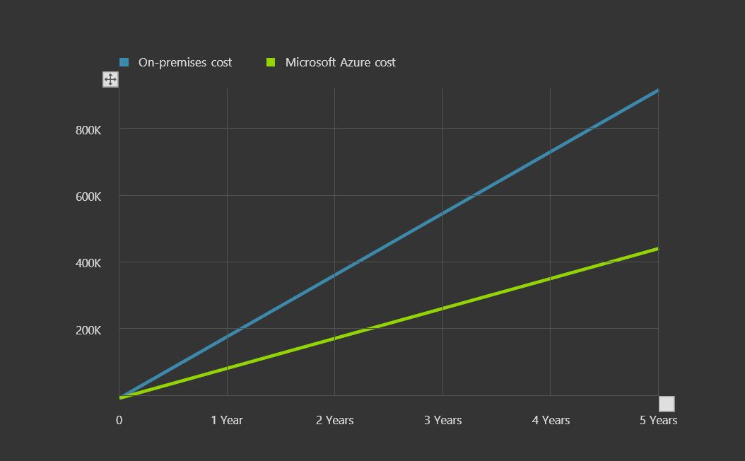
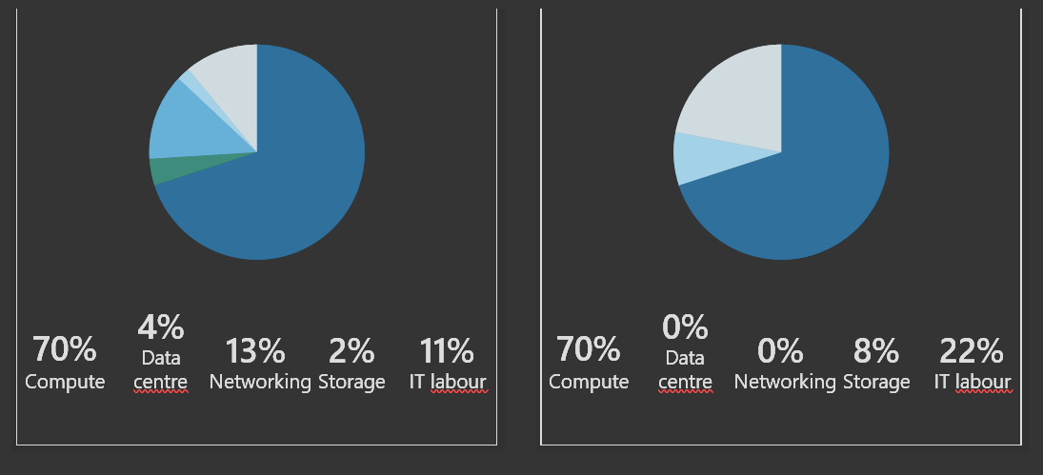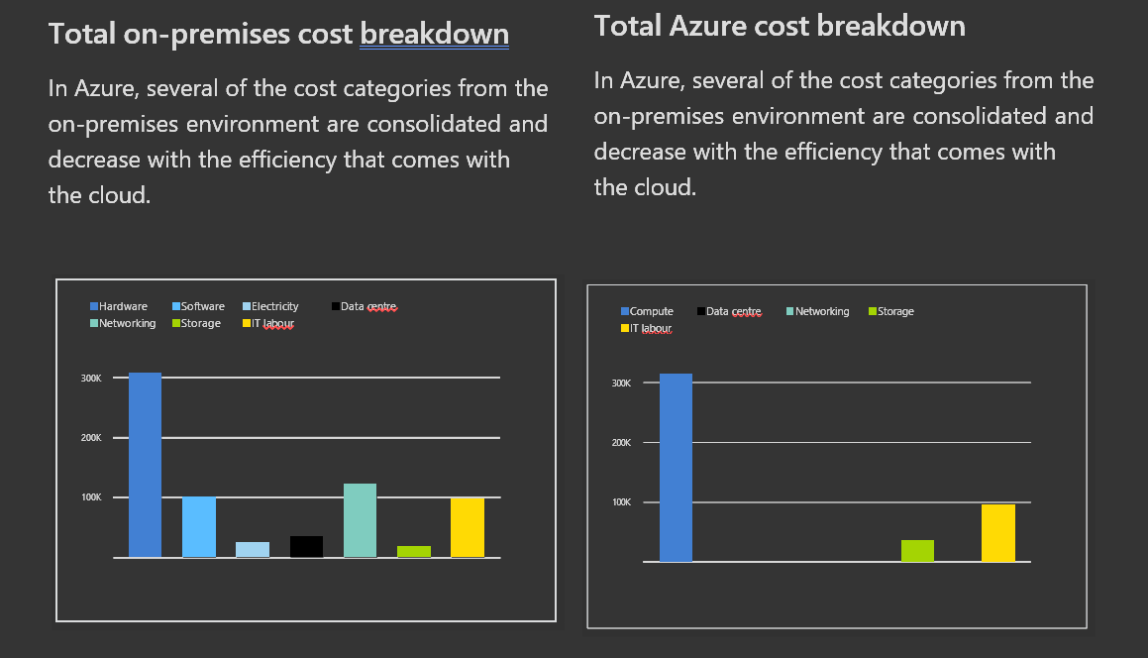

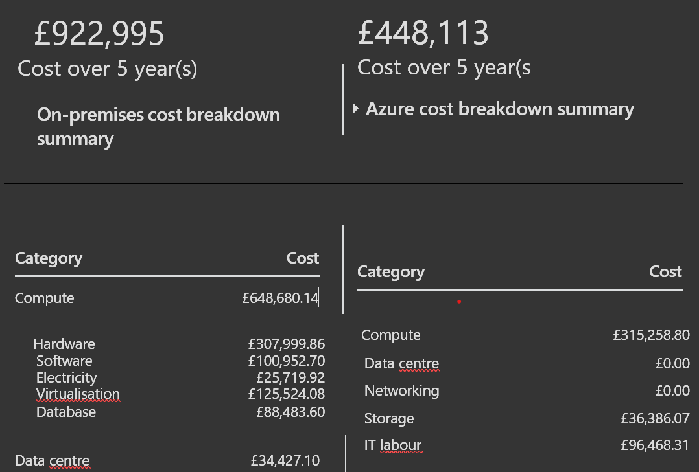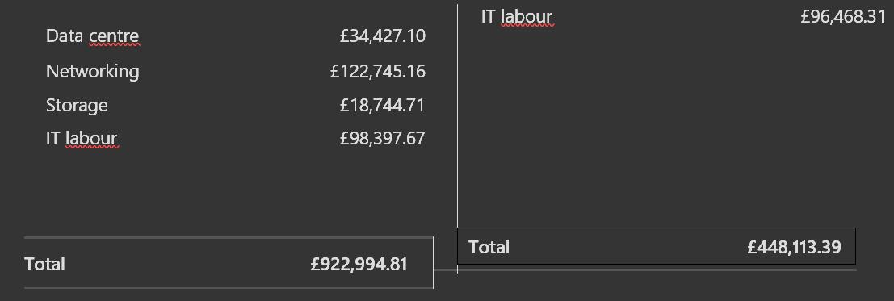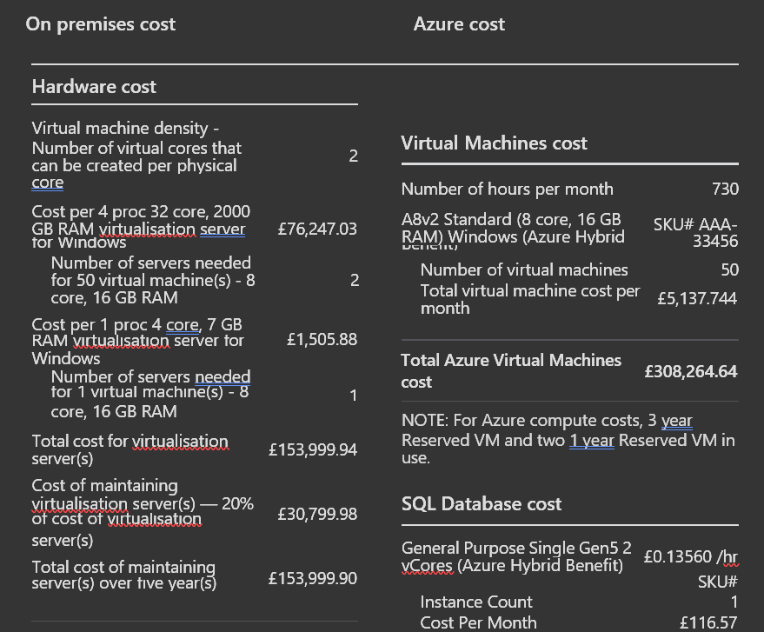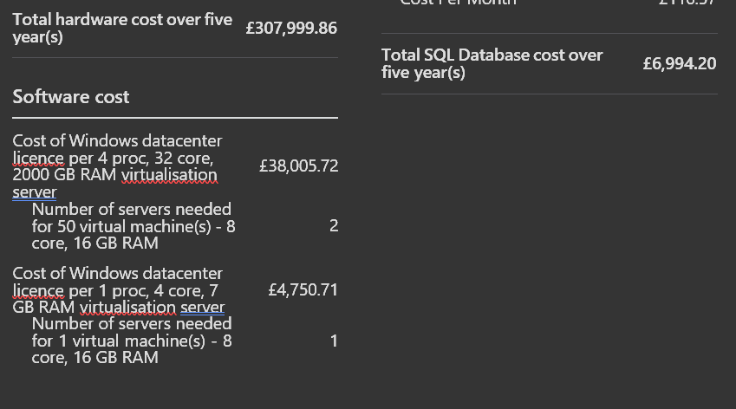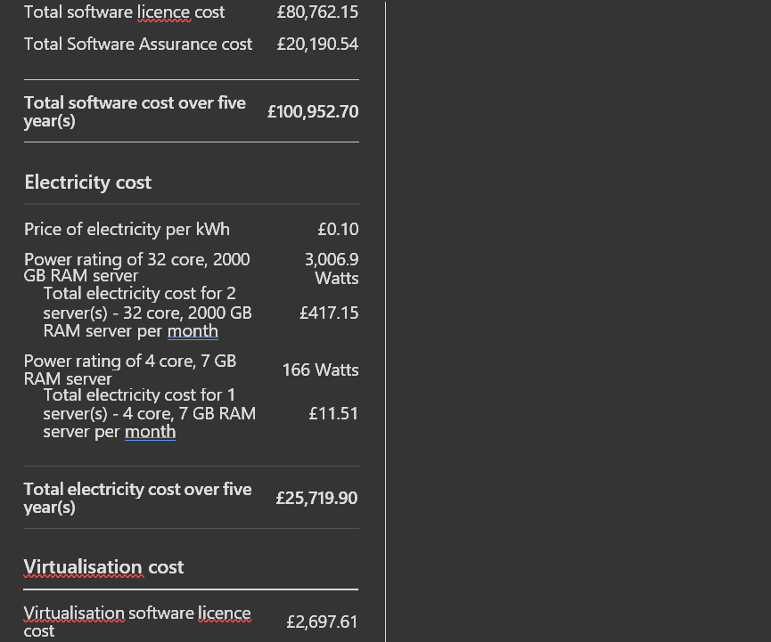

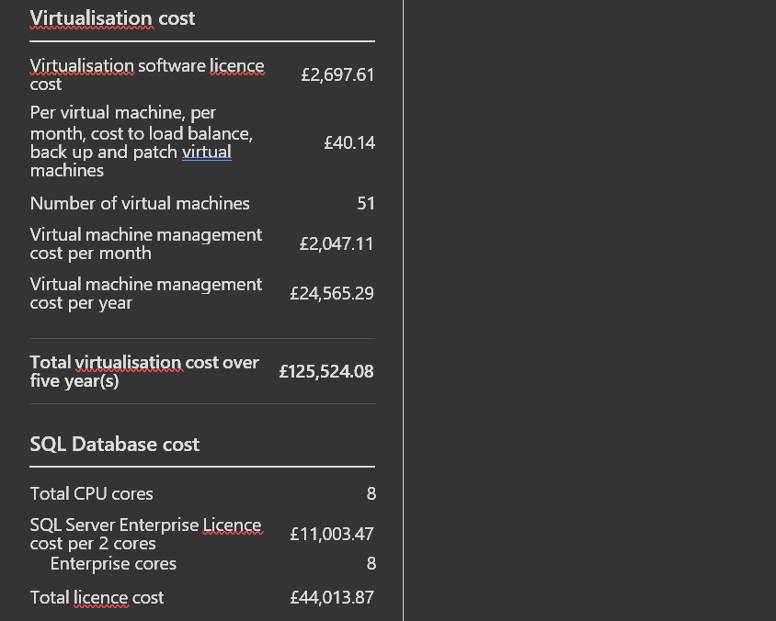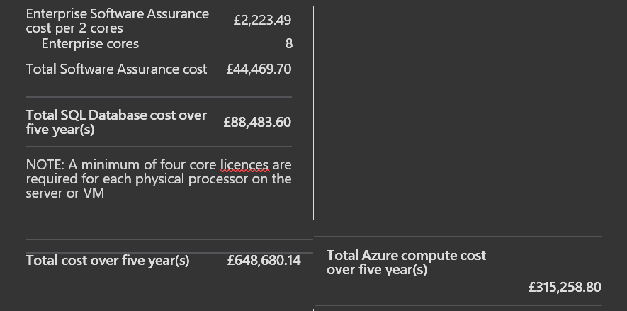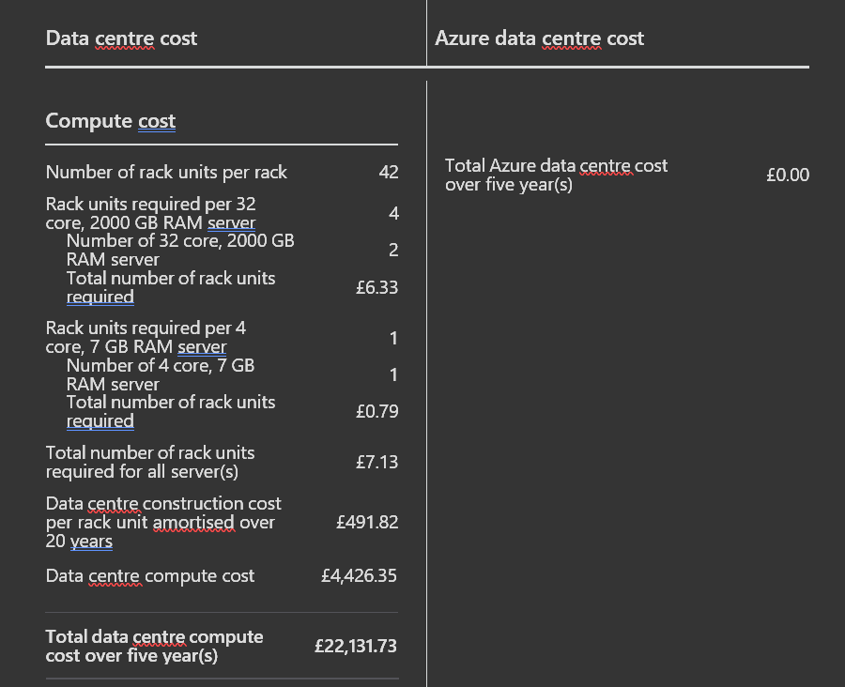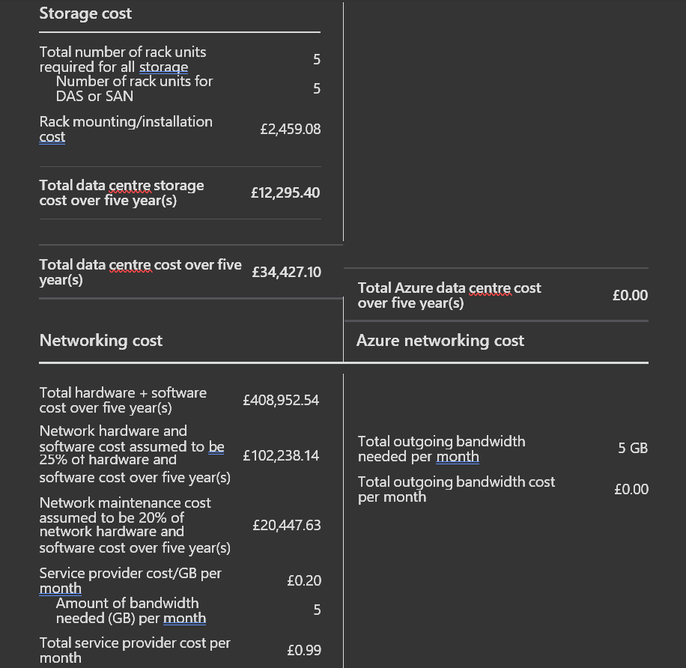

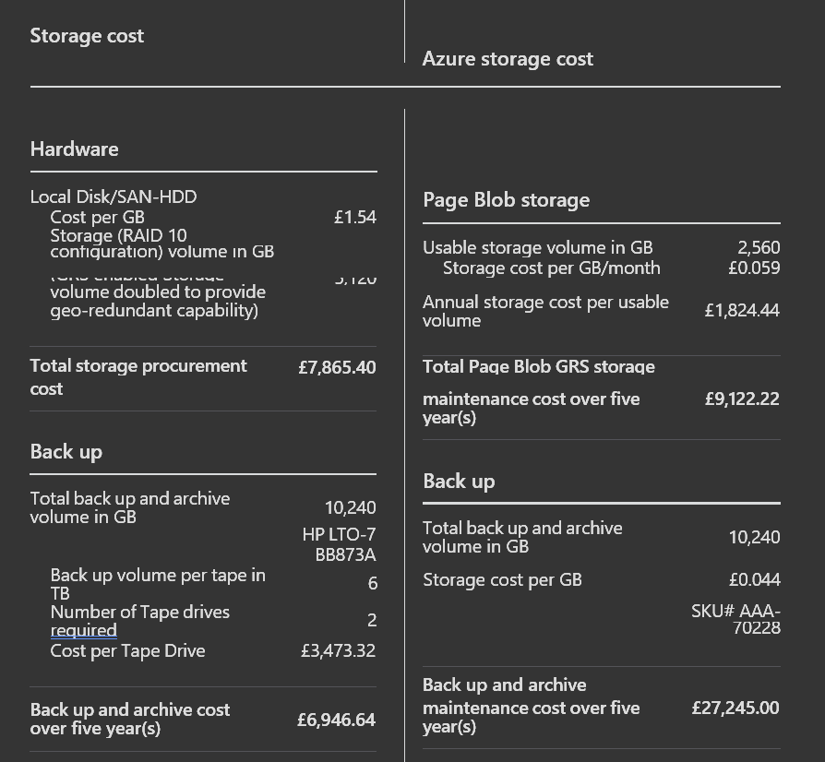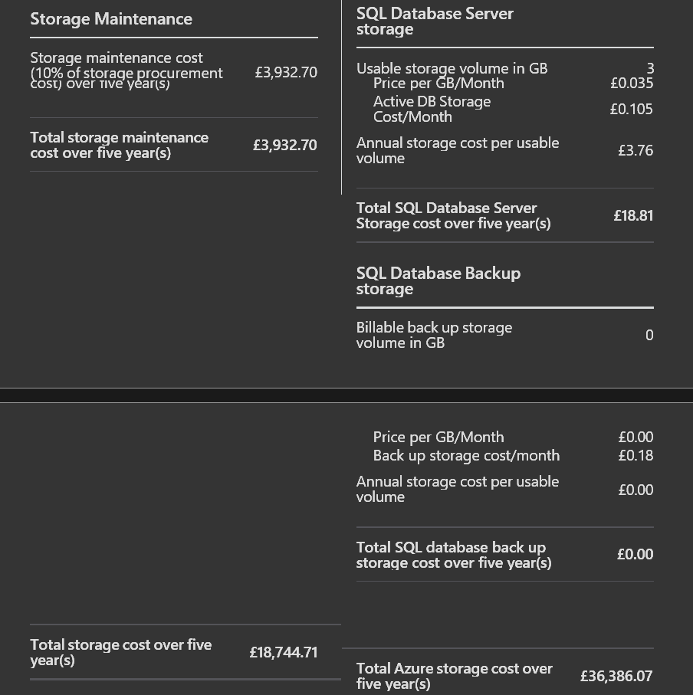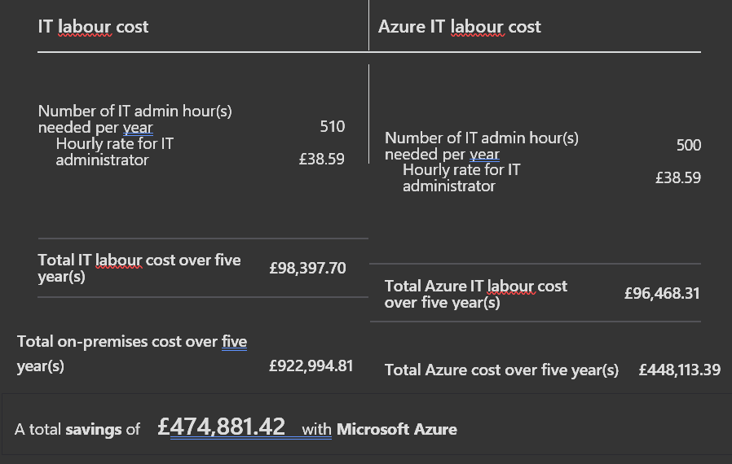
Selecting options such as 2TB storage, 16GB RAM for virtual machines, VMware or Hypervisor, Azure SQL Database or PostgreSQL, and 5GB bandwidth for a medium-sized educational institution requires evaluating factors like performance, scalability, compatibility, cost-efficiency, and ease of management.
A medium-sized institution such as GLI produces and administers a significant volume of information, such as student records, course resources, multimedia content, and administrative paperwork.
The storage space of 2TB offers enough space for expansion and meets the rising demands for data storage without the need for frequent upgrades. Adequate storage capacity enables data duplication, backups, and contingency plans to maintain data accuracy and uninterrupted operations. Critical applications, databases, and services hosted on virtual machines (VMs) need sufficient RAM for optimal operation. Improved productivity with 16GB of RAM, VMs can operate smoothly, allowing for multitasking, managing multiple user requests simultaneously, and running memory-heavy applications also futureproofing allows for scalability and meeting higher workload demands as the institution expands.
- Comparison between VMware and Hypervisor:

VMware provides cutting-edge virtualization platform with strong features, established ecosystem, and wide-ranging management abilities.
Hypervisor for example, Hyper-V seamlessly works with Microsoft ecosystem, it provides cost-effective solution for companies that have already bought into Microsoft technologies.

- Comparison between Azure SQL Database and PostgreSQL

ASB is a cloud-based database option provided by Microsoft, it is a database service based on SQL that allows incorporation through Azure services, intrinsic high availability, and scalability capabilities and it is suitable for companies with current SQL Server applications and knowledge.
PostgreSQL is a widespread open-source relational database administration system, and widely adopted in the open-source community, it provides flexibility, scalability, and interoperability with a range of platforms and is ideal for companies that facilitate open-source options or require particular PostgreSQL functionalities.
- Bandwidth capacity of five gigabytes.

The bandwidth is crucial in determining the capability and rate of data transfer among on-site systems, cloud services, and internet connectivity for individuals as sufficient bandwidth guarantees uninterrupted entry to online educational materials, platforms, teamwork aids and provides cloud connectivity by helping to streamline the transfer of data to and from cloud platforms like Azure, aiding in tasks such as backup, duplication, and synchronization.
The operational needs, growth projections, current IT infrastructure, and budget constraints of a medium-sized educational institution determine the specific configurations selected. Every decision made, whether involving storage, RAM allocation, virtualization platform, database selection, or bandwidth allocation, seeks to find a middle ground between performance, scalability, cost-effectiveness, and alignment with the organization's strategic goals. Assessing these factors thoroughly is crucial to guaranteeing that IT resources adequately back educational initiatives and administrative tasks, all while delivering a smooth user experience for students, faculty, and staff.

Azure storage

- Scalability and Flexibility:
Azure File Storage provides highly scalable and expandible storage capacity, allowing GLI to dynamically adjust storage needs based on demand. As GLI's online courses and certifications grow, Azure File Storage can seamlessly accommodate increasing data storage requirements without the need for extensive hardware upgrades or manual intervention.

- Accessibility and Collaboration:
Azure File Storage supports SMB (Server Message Block) protocol, enabling easy file sharing and access across different platforms and devices. GLI staff and students can securely access course materials and documents from anywhere, fostering better collaboration and productivity.

- Data Redundancy and High Availability:
Azure File Storage ensures data redundancy and high availability by replicating data within the same region or across distinct zones, based on configuration settings. This reduces the chances of data loss caused by hardware malfunctions or unexpected occurrences.
- Security Features:
Access Controls: it allows an easier integration with Azure Active Directory , allowing various levels of administration control and permission management. GLI can enforce role-based access policies to confirm that only allowed users have access to specific files and folders.
Encryption is offered for data stored in the file storage , making use of built-in encryption features in Azure to add another level of security.
Auditing and Monitoring: Azure Storage provides detailed logging and monitoring capabilities. GLI can monitor access patterns, audit storage activities, and receive alerts for suspicious behaviour, enhancing overall data security.
- Cost-Effectiveness:
Azure File Storage provides a pricing model that charges based on usage, enabling GLI to control expenses according to their actual needs. Azure File Storage offers the potential to reduce overall storage expenses for GLI when compared to managing on-premises storage infrastructure, without requiring any initial hardware investments and with pricing that is easy to predict.
Implementation of Azure Storage Account for GLI

- Create a storage account.
Sign in to Azure : Go to the login page,
Create a new resource:
Locate and select "Create a resource" in corner menu.
Look for storage account and choose it.

- Configure the account:
Choose a subscription and resource group.
Specify a unique name.
Choose an appropriate location (region) for data residency.
- Configure performance and redundancy:
Choose the performance tier (Standard or Premium) based on performance requirements.
Select the replication option (Locally redundant storage, Geo-redundant storage.) for data redundancy.

- Review and create:
Select Review + create to validate the configuration.
Once validation is passed, select Create to provision the storage account.
Step 2: Access and Manage Azure File Share

- Navigate to storage account:
Once the account is made, go to All resources.
Locate the recently generated storage account.

- Manage file shares:
In the account overview, navigate to File shares under the File service section.
Click "File shares" to view existing file shares or make a new file share.

- Create a File Share:
Click New file share.
Provide a name for the file share and specify the quota (storage capacity).

- Access Azure File Share
Mount File Share (Optional):
Azure File Shares can be accessed via SMB.

- Configure Access Controls:
Manage access to the file share using Azure active directory integration.
Define permissions and administration policies for users and groups.

- Secure Azure file storage:
Configure encryption options for the account to encrypt data.
Utilize the key vault for organising keys.

- Set the controls:
Use Azure role-based access control to manage authentication.
Implement Azure AD authentication for secure administration management.

Creating a Storage Account:

Managing File Shares:

Configuring Access Controls:

By following these steps, GLI can use Azure File Storage effectively to store, manage, and secure its educational resources and data, while benefiting from Azure's scalability, security, and cost-efficiency. Adjust the settings and configurations based on GLI's specific requirements and security policies.

azure database options

To evaluate and recommend the most suitable Azure database option for storing user profiles among Azure SQL database, Azure database for MySQL, and Azure Database for PostgreSQL, we need to consider factors such as scalability, performance, compatibility, and ease of management.

Azure SQL Database:
- Scalability: Offers integrated high availability and scalability with options for automatic scaling.
- Security: Integrated with Azure active directory for validation and advanced security features.
- Compatibility with Existing Apps: Ideal for applications already using SQL Server or requiring strong transactional support.

Azure Database for MySQL:
- Compatibility: Managed MySQL database service offering community MySQL database engine.
- Scalability: Scales dynamically based on workload with high availability.
- Security: Supports encryption at rest and in transit, as well as Azure AD integration.
- Compatibility with MySQL Ecosystem: Suitable for applications designed to work with MySQL databases.

Azure Database for PostgreSQL

Scalability Offers horizontal scaling capabilities with replication and failover, security supports SSL connections, encryption, integration with Azure AD for access control and compatibility with PostgreSQL Ecosystem Suitable for applications using PostgreSQL-specific features.
Azure SQL Database is recommended for storing user profiles due to the following reasons:
-Relational Model User profiles typically require structured data storage, which is well-suited for Azure SQL Database's relational model.
-Strong transaction support Azure SQL Database provides robust transactional capabilities, which are important for user profile management, it functions flawlessly with other services, facilitating application development and management, and it offers scalable performance tiers to manage varying workloads efficiently.

Steps to create an Azure SQL Database:

1. Sign in to your account
2. Set up a new Azure SQL database
Choose -create a resource.
Search for the service and select it from the results.

3.Configure SQL Database Settings:
Choose the appropriate subscription.
Select a current resource group or create one.
Database Details
Database name :Specify a name for your database.
Create an additional server or choose an active server.
Compute + storage: Select the desired compute and storage options (e.g., Basic, Standard, Premium).
Collation :Choose the collation settings based on your requirements.

4. Configure Additional Settings
Customize additional settings as needed, such as:
Networking : Define firewall rules and virtual network settings.
Advanced Data Security :Enable advanced security features like data encryption and threat detection.
Tags: Optionally add tags for resource management.

5. Review and Create
Choose Review + create to confirm the settings.

- Create the Azure SQL Database
Once validation is passed, click Create to provision the Azure SQL Database.

Example screenshot of database creation:

Through these configurations, you can easily create an Azure database to store user profiles efficiently and securely within the Azure cloud environment. Adjust the configuration settings based on your specific requirements and best practices for database management.

backup and retention policies

To configure backup schedules and retention policies using Azure Backup for file shares and databases at Global Learning Institute (GLI), we will focus on leveraging Azure's capabilities to ensure data protection and recovery. Let us break down the process for both file shares and databases, including backup configuration settings and the restoration process.

Configuring backup for file shares:

1. Setup Azure recovery services vault:
- Create an Azure Recovery Services vault if you have not already. This will be used to manage backup policies and retention for file shares.

2. Configure backup policy:
-Locate the recovery vault.
- Go to backup items > file shares > backup.
- Click on + backup to configure a new backup policy.
- Define the backup schedule (e.g., daily, weekly) and retention policy (how long to retain backups).
- Specify the file shares to be backed up and any advanced settings (like encryption or network settings).

3. Review and enable backup:
- Review the backup policy options and choose enable backup to start backing up file shares according to the defined schedule.

Configuring backup for databases:

1. Select Azure database service:
- Choose the specific Azure database service that you want to set up backups for.

2. Configure backup options:
- For Azure SQL Database:
- Select SQL Database resource.
- Go to Backup > Automated backups.
- Configure the backup retention period, frequency, and storage redundancy.
- Save the settings to enable automated backups for the SQL Database.

- For Azure database for MySQL:
- Similarly, choose the database resource.
- Configure backup settings under Backup or Point in time restore depending on the database type.
- Set the retention period and frequency of backups.

Process of restoring files and databases from backups:

Restoring files from Azure backup:

1. Navigate to recovery services sault:
- Access your recovery services vault.

2. Select Backup Item (File Share):
- Under Backup items, choose the file share that contains the files you wish to restore.

3. Initiate Restore Operation:
- Click on restore.
- Choose the recovery point (backup version) from which you want to restore the files.
- Specify the destination (original file share or alternate location) for restored files.

Restoring Databases from Azure Backup:

1. Navigate to Database Resource:
- Go to the particular database resource.

2. Initiate Restore Operation:
- For SQL Database:
- Under Backup, select Point in time restore.
- Choose the specific backup point (timestamp) to restore the database to.
- Go by the prompts to finish the restoration process.

- For MySQL:
- Locate the Restore option within the database management settings.
- Select the backup point and initiate the restore operation.

Example Screenshot of Backup Configuration Settings (Azure Portal):

Below is an example screenshot illustrating backup configuration settings for Azure SQL Database in the Azure Portal:

Additional Considerations:

- Configure monitoring and warnings for backup operations to ensure backups are running as expected and to address any issues promptly.
- Testing Restores: Periodically assess restore operations to verify backup integrity and ensure that data can be recovered successfully when needed.
- Compliance and Security: Ensure that backup and restore processes align with GLI's compliance requirements and security policies, including data encryption and access controls.

Through the given instructions GLI can effectively configure backup schedules and retention policies using Azure Backup for both file shares and databases, ensuring data safety and allowing streamlined recovery processes in the instance of data loss or corruption. Adjust the configurations based on specific requirements and business continuity needs.

Video

The video can be found at:…

disaster recovery plans

Azure Site Recovery is a widespread service from Microsoft Azure that can help Global Learning Institute (GLI) in ensuring business continuity and reducing downtime in case of unexpected outages or disasters impacting their storage and databases. Here is an assessment of how Azure Site Recovery could help GLI safeguard their important data assets.
Advantages of ASR for GLI:
- Automated duplication and backup in case of failure.
ASR allows for automatic copying of virtual machines (VMs), along with storage and databases, from GLI's main data centre (on-site) to Azure. This guarantees that information is consistently duplicated to Azure, creating a backup environment prepared for failover.
- Consistency in applications:
ASR provides application-consistent replication services for SQL Server, MySQL, and PostgreSQL databases. This guarantees that data is duplicated in a stable condition, reducing the chance of data corruption or discrepancies during failover.
- Almost no downtime:
During a disaster in GLI's main data centre, ASR enables quick transition to Azure for continued operations. This reduces the amount of time services and applications are unable to function and guarantees that critical services and applications remain operational.
- Adaptable Plans for Recovery:
GLI has the ability to design personalized recovery strategies in ASR for coordinating failover and failback procedures according to distinct recovery goals. This involves establishing recovery procedures, interconnections, and ordering for storage and database assets.
- Replication between sites:
ASR enables site-to-site replication, enabling GLI to replicate data to Azure and to another on-premises location or secondary data centre for increased redundancy and disaster recovery choices. ASR smoothly incorporates with Azure Backup and Azure Monitor, among other Azure services. This offers comprehensive monitoring, alerting, and backup features to improve the overall disaster recovery plan.
ASR duplicates GLI's virtual machines hosting important storage and database functions to Azure periodically. This guarantees that current copies of VMs remain accessible in Azure for failover purposes.
- Regular duplication of databases:
ASR uses application-aware replication technologies to maintain consistent replication for databases held on VMs or Azure databases. This warrants that data integrity is preserved in the case of failover situations.
- Automation for failover and failback processes:
GLI has the ability to create recovery plans within ASR to automatically switch over in the event of a disaster. ASR coordinates the transfer of VMs and their databases to Azure in the event of a failure, decreasing the need for manual involvement and lessening downtime.
- Ongoing Monitoring and Evaluation:
ASR offers ongoing monitoring to ensure the health of replication and readiness for recovery is maintained. GLI is able to conduct routine DR drills and tests with the use of ASR to confirm failover processes and guarantee preparedness for actual disaster situations.

Steps to implement Azure Site Recovery (ASR) at GLI:

Establish an Azure Site Recovery (ASR) Vault:
Set up an ASR vault in Azure Portal and adjust replication settings for virtual machines and databases.
- Describe rules for copying data.
Determine how often data should be copied, set goals for how much data can be lost in case of a disaster, and establish how long copies of data should be kept according to GLI's disaster recovery needs.
- Develop plans for recovery:
Specify recovery strategies in ASR to coordinate switching to backup systems and returning to the original systems for storage and database assets. Provide instructions for setting up virtual machines, configuring databases, and adjusting networking settings.
- Supervise and evaluate disaster recovery scenarios:
Consistently check the condition and status of replication in the ASR vault.
Perform disaster recovery drills and tests to confirm failover procedures and guarantee preparedness for potential disaster recovery incidents.
Azure Site Recovery is a powerful solution which empowers GLI to defend their storage and databases against unexpected outages or disasters. By leveraging ASR's automated replication, failover orchestration, and continuous monitoring capabilities, GLI can enhance business continuity, reduce downtime, and guarantee data resilience in the case of disruptions. The implementation of Azure Site Recovery aligns with GLI's goal of maintaining a robust and reliable IT infrastructure to support their educational initiatives and operations.

conclusion

In conclusion the administration of the GLI has been determined to be more advantageous for the cloud relocation compared to on premises location based on the above-mentioned research, illustrations, examples and cost calculator analysis.

references

