My production diary

By Hayden Hurley
(1701645)

In this assignment I was tasked to retopologize three characters in Maya using quad draw.
When starting this Assignment thought I had to retopologizing 3 characters rather than just one this means I will be mentioning characters one ,two and three during the process of the diary. I have also planned to compete three characters in my plane rather then just one and for some reason im missing September and first part of October in my plan.

When I started this assignment I thought I had more then enough time to Finnish the three characters however my computer unexpectedly broke, this was a big set back because I had planed on using the computer at times I wouldn’t be at Alex building and in the evenings work on what ever character I happened to be working on at that moment in time in the assignment process. I also didn’t plan that well for this assignment due to thinking it was going to be easy.

Monday 23^{rd oct} started on the chest and arm of character one using quad draw at this point I feel that this assignment is a simple one once you know the basic tropology of a human body .

Tuesday 24^{th oct} started on the head of character one using quad draw, I think the retopologize process of the head is going well I completed the eye and nose .

Thursday 26^{th oct} continued working on the head for character one using quad draw, I finished the ear and chin, I think I should be able to finish the head next time I work on this character

Saturday 28th oct finished head of character one using quad draw I had trouble with completing the head of character one because I didn’t plan ahead with the vertices.

Monday 30th oct finished the chest for character one , I found finishing the chest was very simple once the correct tropology for the arm and chest was placed .

Wednesday 1st nov started and finished leg and foot of character one , I found the retopologize process of the leg and foot easier then I expected at this point I think I know the reopologize process

Friday 3^{rd nov} started the arm and hand for character one, once I got the tropology for the arm right I found filling the rest of the arm out was simple and painless.

Wednesday 8th nov – I finished the hand using quad draw , I found getting the tropologhy right for the hand difficult but once I looked at a picture of tropology of a hand I found out how to Finnish my characters hand .

Thursday 9th nov - I finished the arm using quad draw

Friday 10th nov - I linked the head,chest,arm,hand,legs together by using target weld .

Tuesday 14th I started and completed the chest and hand of character two

Thursday 16th i started and completed the leg and foot of character two.

Friday 17th I started and completed the head of character two. This time completing the head was much easier because I planned ahead with the vertices.

Monday 20^{th nov}
I connected the arm and hand together of the 2nd character using quad draw however i still need to add in the correct tropology for the elbow at this point I am happy with my progress and confident I will Finnish all three characters before the deadline,

Wednesday 22th nov

I started on the third character and completed the face, hand, leg, and using quad draw next week I will need to complete the arm and chest and then mirror all 3 characters .I am positive that I can complete this assignment before the deadline.

My main setback during this assignment was my computer at home stopped working this was a problem because I did most of my work on said computer and planned ahead with being able to use this computer.

Risk assessment

The first risk I will face is losing my work this will have a negative impact on me completing the assignment on time because I will have to go back and spend mush needed time on retopologize the same character again up to the point where I last saved my work ,before i can start making progress again to finish the assignment on time .i will avoid this by making sure I have saved my work to at least three places for example a portable USB drive ,Google drive and the computer I work on this way I will always have a copy of my work for when I need it .
Another risk I could face is if my home computer stops working in the middle of this assignment this could have a negative impact because it will mean I don’t have as much access to a computer as I planed and will throw my production plan out of sync and could mean I don’t finish the characters on the day I though I would. Another negative impact that could happen if my home computer stops working during the process of this assignment is loss of work. I will avoid this by making sure my computer is working properly and in good condition before I start any work on it.

Another risk I could face during this assignment is breaking my hand this could have a negative impact on this assignment because breaking my hand will mean I cant use it for some time this will include retropologising the three characters, at the very least a broken hand will slow me down when I am in the process of retrologising three characters. I will avoid this by taking good care of my hands during this assignment.

An Alternative risk I could face is being stuck In London during the week while this assignment is in progress this could have a negative impact on me completing this assignment because both the computers I will use for this assignment will be in Swansea and I wont be able to make progress on this assignment while stuck in London. I will avoid this by making sure when I book a train back to London that book a return ticket at the same time and make sure there is engineering works that could end up coursing my train to be cancelled that weekend.

Production Plan

weeks | Mon | Tue | wed | Thus | Fri | sat
Week1  30th-6th October | I will finish the chest of character 1 | I will start the arm of character 1 | I will continue the arm of character 1 | I will Finnish the arm of character 1 | I will start the leg of character 1 | I will finish the leg of character 1
Week2  6th-13th November | I will put character 1 together | I will start the head of character 2 | I will continue the head of character 2 | I will finish the head of character 2 | I will start on the leg of character 2 | I will finish the leg of character 2
Week3  13th-20th  November | I will start the chest of character 2 | I will finish the chest of character2 | I will start on the arm of character 2 | I will finish the arm of character 2 | I will put character2 together | I will start the head of character 3
Week4  20th-27th  November | I will continue the head of character 3 | I will finish the head of character 3 | I will start the chest of character 3 | I will finish the chest of character 3 | I will start the leg of character 3 | I will finish the leg of character 3
Week5  27th-4th  December | I will start on the arm of character3 2 | I will Finnish the arm of character 3 | I will put character 3 together

References
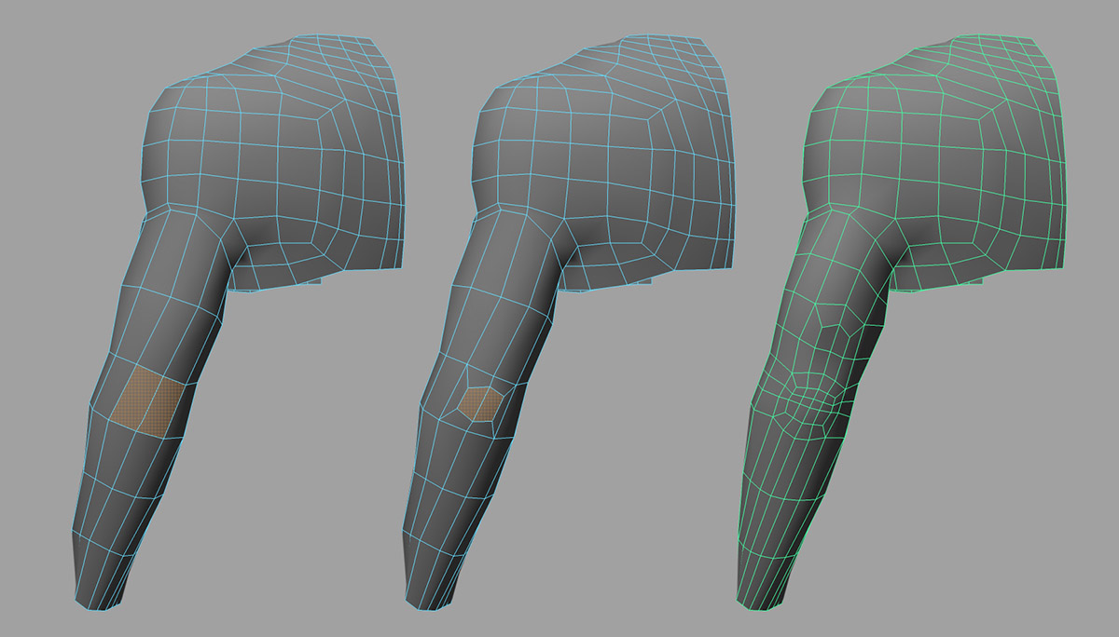
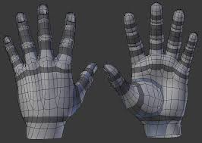
I used this picture to help me get the tropology right for the elbow.
The picture I used to help me with hand tropology

