Student Name: Oliver Rowe
P Number: 1706452
Programme of Study: BA Advertising and Brand Design
Module: M4X01559

Introduction
The topic which I have decided to use for my exhibition is, graffiti art or vandalism. The reason I have chosen to use graffiti for my curation is because it is an art form I am very passionate about but I have conflicting thoughts on the ethics due to the legality issues and offensive nature surrounding what can be a very uplifting and positive form of art. Through my exhibition, I would like to portray the discussion about whether graffiti is art or simply just mindless vandalism. I plan to present artists work such as Banksy and Keith Haring as these two artists each have a unique style and strong messages they will convey through their work, Banksy’s will often show social commentary about current world affairs such as immigration and politics whereas Haring will present peace, love and equality in a bright and colourful manner. I also plan to show the negative side of street art where it can often be used to attack people and spread anti-Semitic message within communities.
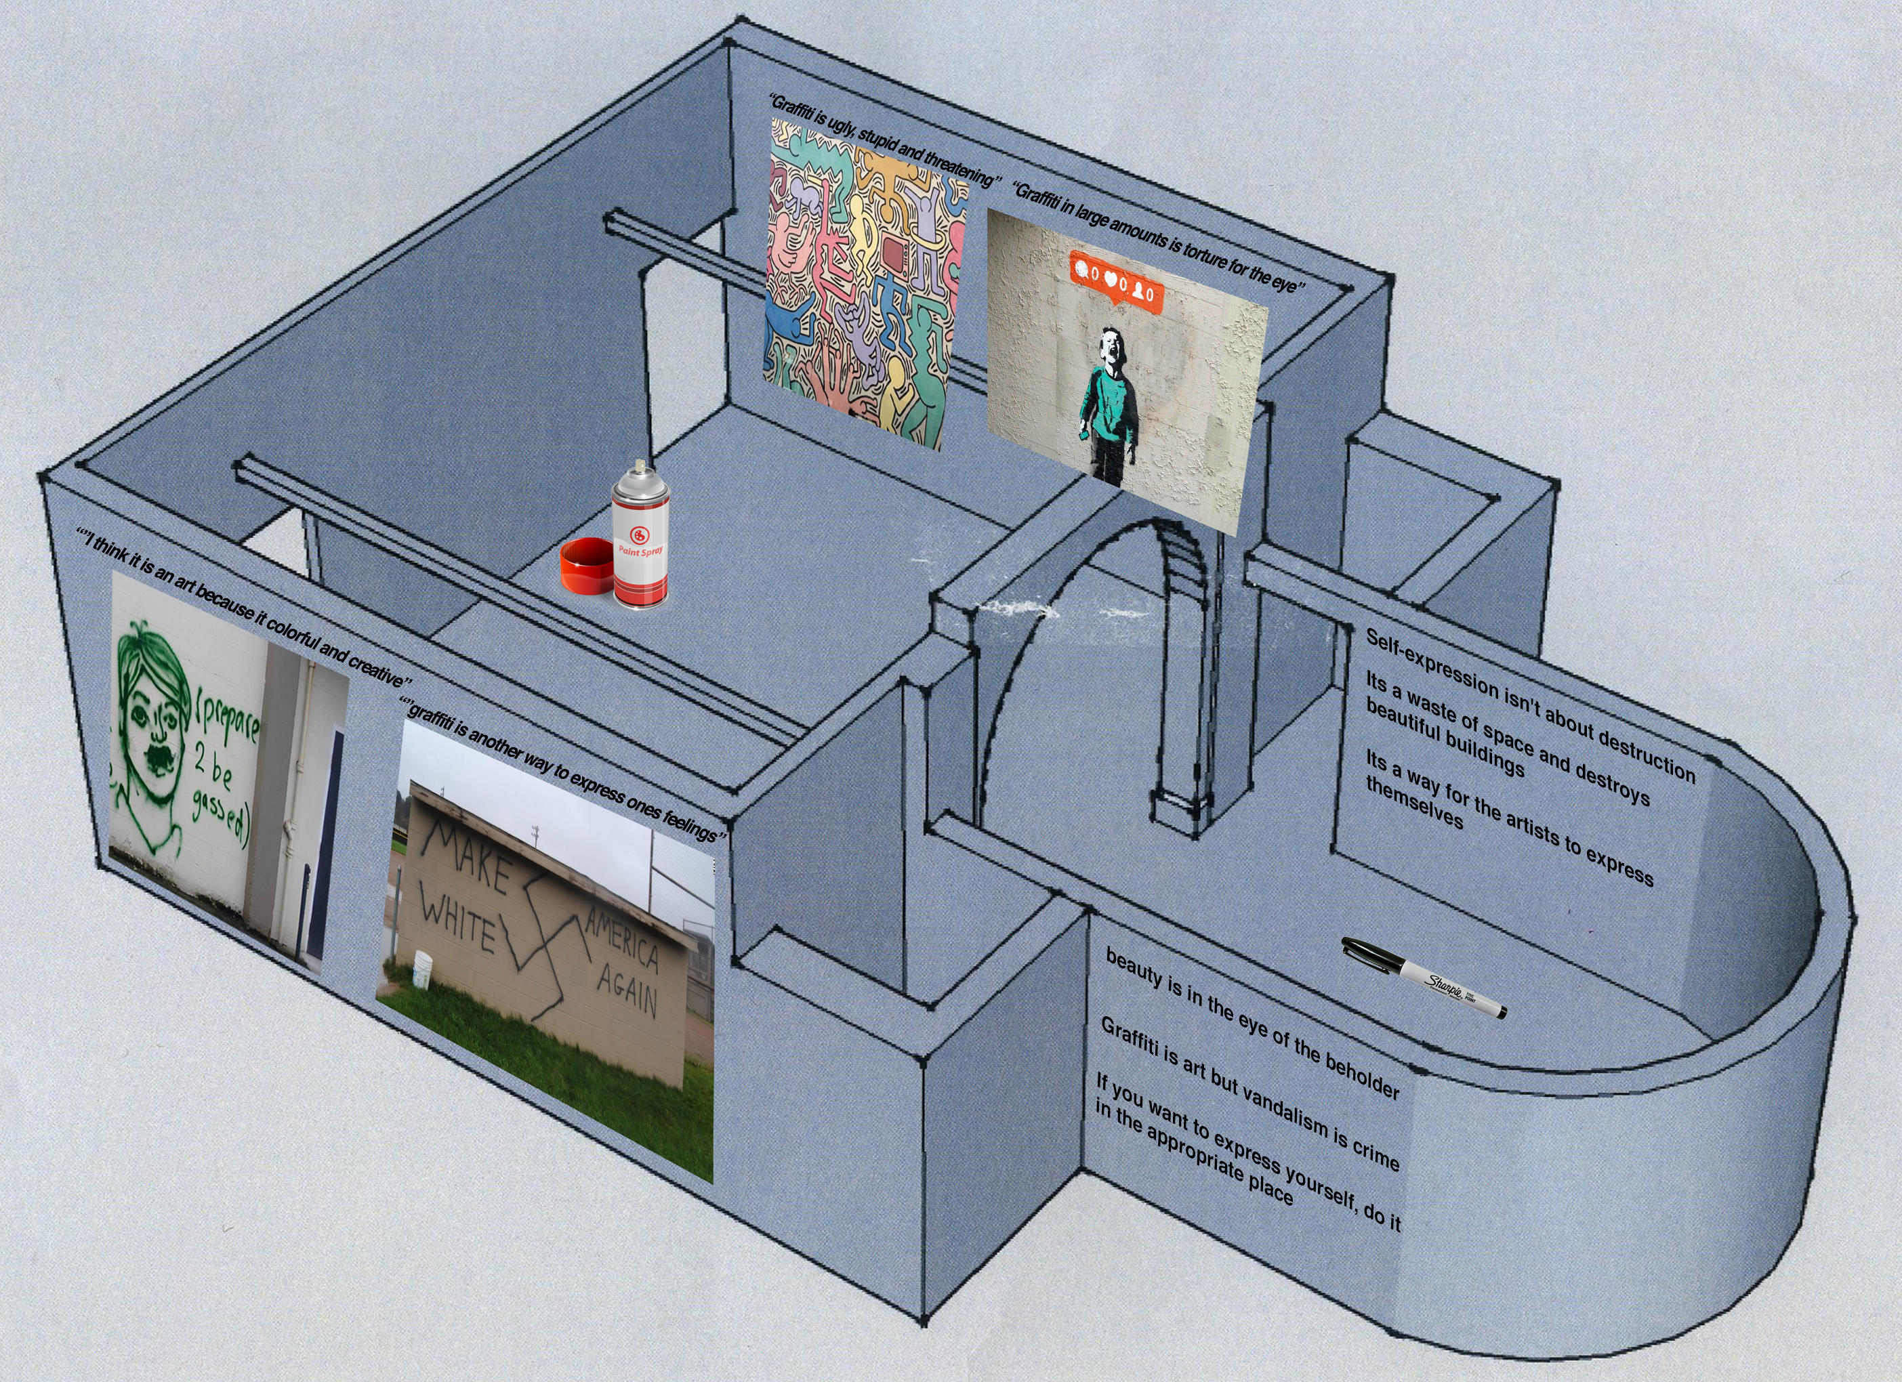

Context
Through my exhibition, I would like a wide variety of people with opposing opinions on my chosen theme whether they do believe that graffiti is art or believe that it is a crime or like me are on the fence on the topic believing that it is a creative art form but can understand why it is considered a crime.

The aim for my curation is that people will come with their initial opinions on the subject and by seeing the negative side of graffiti where people will use it to attack people and paint anti-Semitic and hateful messages directed at individuals will cause those who believe that there is nothing wrong with graffiti that there are various issues with what people can often convey through the medium which will convince the audience that believes there is nothing wrong with graffiti that there is definitely some grey areas. I would also like to convince those who believe that graffiti is just vandalism that there is a positive message that needs to be presented through this art form such as artists like Keith Haring who spread messages about equality and peace in un used areas in New York subway stations. My main goal is for people to leave and change their initial opinion or at the least question whether their original assumption.

A common assumption about graffiti is that it is strongly associated with criminal behaviour but that isn’t the case, there is a criminal aspect to vandalising that has become a result of our culture in the UK, other countries such as Brazil and Australia embrace street art by having a competitive sense to the matter by competing to have the most colourful and well design buildings and transport, “but in Melbourne van drivers compete with each other as to whose is more decorated” Graffiti: Street art &ndash; or crime? Independent 2008. Whether you support street art or not it is quite clear that graffiti is vandalism, but in the UK punishment for the crime is much more severe than anywhere else in the world, regardless London which causes artists to become supressed and the negative, criminal aspect to become much more prominent than the artistic side, “And yet we hate graffiti more than anywhere else in the world. England is by far and away the most draconian for punishments for what are only economic crimes” Graffiti: Street art &ndash; or crime? Independent 2008.

Within my gallery curation I plan to have negative opinions from the public surrounding the street art which has a positive message or artistic values as a way of contradicting the opinion that graffiti shouldn’t be allowed, I will also surround the images of negative examples with positive opinions from the public to show that there are grey areas in the topic which should be considered as vandalism or criminal. Within the gallery, I have planned to have a blank wall with various cans of spray paint where people attending the gallery can paint whatever they like with no consequence as an experiment which can be assessed throughout the curation to whether graffiti is artistic or vandalism. By giving the audience attending the gallery the freewill to spray paint whatever they like will give the result whether the public is likely to paint something artistic or expressive, or whether the will simply tag curse words or offensive imagery as a joke, in the moment of being able to do something which would often be illegal, in the heat of the moment I believe that an accurate representation of what people would do will be shown, similar to what Banksy stated in banging your head against a brick wall (2001) “Your mind is working at its best when you're being paranoid. You explore every avenue and possibility of your situation at high speed with total clarity”.

One of the artist I have featured within my gallery curation is Banksy. Banksy is often one of the main artists who is brought up whilst discussing the fine line between graffiti being considered as art or vandalism, due to his controversial social commentary and the fact that he has had to hide his identity due to what he is doing being illegal. Banksy’s art will often have very subliminal messages about our society today on topics such as war, politics and social media, but can also be a simple amusing painting to make the public laugh when they notice it, which is a trait not overly common with other mediums of art, Banksy sums this statement up well in banging your head against a brick wall (2001) ““Graffiti is one of the few tools you have if you have almost nothing. And even if you don't come up with a picture to cure world poverty you can make someone smile while they're having a piss”. 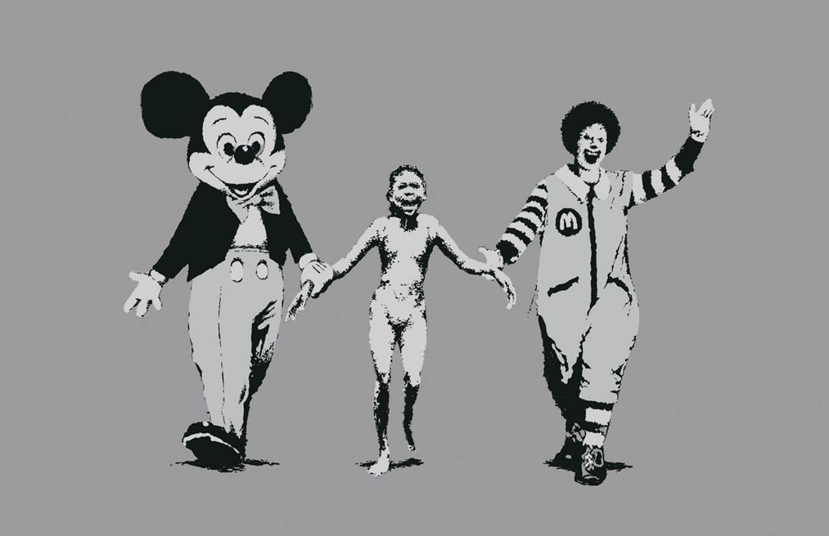
Napalm, Banksy, 2004

Another artist I have presented in my curation is Keith Haring. Haring was a prominent street artist during the 1980s rising to popularity due to his colourful chalk drawings on blank advertising panels in New York subway stations, even though the chalk drawings that Haring produced could just as easily be removed, he would often find himself getting arrested for attempting to liven up public areas and inspire the everyday person “Art should be something that liberates your soul, provokes the imagination and encourages people to go further” Keith Haring journals (2010).

I believe Haring is necessary to include in my curation as he has a clear, positive message on various topics such as peace, love and equality and it is what Haring is aiming to convey through his work is a strong reason to argue that graffiti cannot simply be a criminal act, a simple act of vandalism could not have Harings level of expression and I believe this is conveyed through well through Keith haring journals (2010) “See, when I paint, it is an experience that, at its best, is transcending reality”.


Untitled Keith Haring 1982
Bibliography
Independent (2008). Graffiti: Street art &ndash; or crime?. [online] Available at: https://www.independent.co.uk/arts-entertainment/art/features/graffiti-street-art-ndash-or-crime-868736.html [Accessed 2 May 2018].

Bansky. (2001). Banging your head against a brick wall. Edinburgh: AK Press.

Haring, K., Fairey, S. and Thompson, R. (2010). Keith Haring journals. New York: Penguin Publishing Group.

