
Project Planning and Management in the Workplace



Rusina Begum-1710303

Executive summary

The researcher has been asked to produce a critical analysis of project planning and management in the workplace of the chosen organisation. From the findings of this report the researcher has come to conclusion that for a successful project, it is important to understand and do more research on the all the tools of project management. The researcher has made recommendations for the organisation named and the team to be more effective with communication and delegating task according to the timeframe.

Contents
Executive summary 2
1.0 Introduction 4
1.1 Project management 4
1.2 MEND 4
2.0 Findings 5
2.1 Quad chart 5
2.2 Stakeholder analysis 5
2.3 Risk Analysis 6
2.4 Work breakdown structure (WBS) 6
2.5 Gantt chart 7
2.6 Monitoring and Evaluation 7
3.0 Conclusion 9
4.0 Recommendation 10
5.0 Appendix 11
5.1 Appendix A Quad chart 11
5.2 Appendix B Stakeholder Analysis 12
5.3 Appendix C Risk Analysis 13
5.4 Appendix D WBS 13
5.5 Appendix E Gantt chart 14
6.0 Reference 15

Introduction
For this report the author has chosen MEND as an organisation to help and support with the findings. This report will offer a critical insight into the criteria being evaluated and presents fair and reasonable evidence. Following the project life cycle planning phase, the author has used various tools and techniques of project management to support this report such as the quad chart, stakeholder analysis etc.

1.1 Project management
According to Lock (2007, p. 1) project management should start from the beginning until the end of a project. The aim is to satisfy any project sponsors/ stakeholders etc, and to foresee any danger or problems that may rise during planning. Project management allows to plan, organise and control activities so that the project can be completed successfully. According to Roberts (2011, P. 183) project management allows when and who can be involved in the project, use techniques for effective delegation of work and how to prepare for the project and review to determine the quality of a completed deliverable. It also helps analyse, assess and implement changes to the project.

MEND
MEND is an organisation which is funded by the community, MEND’s aims and objectives is to encourages British Muslims to engage more effectively with political, media institutions and help fight islamophobia. Also, to introduce new laws to protect British Muslims and equip Muslims with the skills, resources and materials for them to play a more active role in the society. According to MEND (2019), their aim is to ‘work with Muslims and non-Muslim organisations to ensure anti-Muslim prejudice is regarded just as socially unacceptable as anti-Semitism and other forms of racism’.

Findings
The aims and objectives of the project were to plan and organise events to raise awareness on islamophobia. To implement this, these were the tools that was utilised…

2.1 Quad chart
According to Ford & Wei (2015) Quad chart is structured into four categories for communicating information to the audience. Quad chart supports the importance of offering information of the organisation that is explicit and logical. The four categories are
- Purpose- aims and objectives
- Customers- stakeholders
- Desired end results- success factors
- Measures of success- standards/criteria
These categories help clarify exactly what the project is all about (The Audiopedia 2018). However, the Quad chart can also have seven boxes including the triangle, unmeasurable secondary benefits and measurable secondary benefits (see appendix A). As the quad chart is only one- page summary that can be a disadvantage as it might need further explanation of the motivation, ethics, values and passion of the project. The author was able to do a Quad chart for the exhibition/workshop which was held at the Swansea waterfront. The purpose of the exhibition was to reduce hate crimes across Swansea, to stop demonising of Muslims and close loopholes in legislation.
The target audience were MEND itself, Muslims of Swansea and Swansea council etc. The end results were to fight for new legislation and protection of Muslims. The author was able to measure the success from the support received from public during the exhibition and the feedback received from the attendees (see appendix A).

2.2 Stakeholder analysis

According to Thompson (1996-2019) stakeholder analysis allows one to identify who are the stakeholders and what influence they have on the project. The benefit of the stakeholder analysis is that it allows the project to get into shape, winning resources such as gaining support from more stakeholders, build understanding through communication and getting ahead by understanding the stakeholders in order to anticipate and predict their reaction to the project. It also allows one to prioritise the stakeholders, for example who has high, medium and low impact on the project. It is important to identify each stakeholder from the start of the project in order to be successful and should be an ongoing process as the stakeholders have the key to planning, implementing and execution of the project (Baker’s & Campbell M, 2003, p. 45 & 54)
According to Eskerod & Larsen (2018) the influence of stakeholders can increase the likelihood of project success, therefore understanding stakeholders is necessary. However, according to Leonard (2019) the disadvantage would be that the stakeholders may represent its own interests and as MEND’s stakeholders are mainly external, they might not act in the best interest of the project.
In the researchers own opinion they believe the highest stakeholders for the MEND project would be the Muslim community as they can build more confidence, the general community who can gain knowledge on islamophobia. And the victim support who can access the right resources, police who can provide support and protect the victims, Swansea council who can help fund events and MEND as they actively campaign to raise awareness on islamophobia. (see appendix B for the medium and low stakeholders).

2.3 Risk Analysis

Risk analysis is a structured process which identifies how objectives may be affected, risk is analysed in terms of consequences. To identify risk one can, analyse ‘what can happen and why, what are the consequences etc’ (Popv, Lyon & Hollcroft, 2016). According to Mindtool (2018) risk analysis is the process of identifying where risks might arise and then estimating the likelihood of them happening and then developing a plan to minimise its negative impact. To avoid many risks, it is important to analyse them throughout the project and through effective actions risk can be avoided. One of the disadvantages of a risk occurring late in the project means it can be more costly in terms of time and money (Lock 2007, p. 96).
Some of the risk which was involved while working with MEND were
- product risk- not having materials available for task, for example Mend posters, marketing materials
- scheduled risk- task organised after the deadline
- resource risk- not enough people turning up for events for example netball (APM, 2019)

Some risks were high such as the advertising of the exhibition as the link on the poster wasn’t specific, poor communication from the organisation and having to many tasks to be completed at a short amount of time. However, there were some medium risks involved such as the organisation not being local meant the researchers had to travel at own cost to attend workshops (see appendix C for more risk involved while working with MEND).

2.4 Work breakdown structure (WBS)

According to Baker’s & Campbell (2003, p. 92) work breakdown structure is hierarchical chart which is used to organise the activities from the project, which is then branched down into related areas. The chart is used to document, organise and summarise the work which is necessary to complete the project (Work breakdown structure 2019). The advantage of WBS is it can be branched into manageable chunks and allocated to managers and other team members (Lock, 2007, p. 160). It also allows to identify the important parts of the project which needs to be completed and allows to communicate the workload to other team members in order to complete the project successfully (Baker’s & Campbell, 2003, p. 93)
The disadvantage of using the WBS is it may result in more efficiency, cost and schedule slippages. Therefore, it is important to have a completed WBS for another team member to know what has been done throughout the project and what is outstanding.
The researcher and the team have used the top down approach as it was easier to manage as each task was given once the first task was completed. Using the top down approve meant decisions were made quicker and helped align the project goals with MENDs strategic goals. The researcher used five steps to meet the goals and complete the WBS by
- breaking the work into independent branches
- defined the length which took to complete each task
- combining tasks into milestones
- present the task into phases for another team member to understand easily
- verified the tasks which attained in all the project goals and objectives
The MENDs WBS is branched into four phases starting from meeting with the organisation to the feedbacks received from attendees and the organisation itself (see appendix D for the complete WBS).

2.5 Gantt chart
According to Maund (2018, p. 180) Gantt chart illustrates project tasks as bars which is placed across the days of a calendar. The tool is useful when trying to visualise a project task through time and communication which can be passed onto other team members, it also helps to plan and control complex projects. Gantt chart is useful in initial schedule planning for simple projects and the benefit of using a Gantt chart is that the entire project can be visualised and see how each task is progressing and can update team managers/ stakeholders more effectively (Baker’s & Campbell M, 2003, p. 132). The chart also allows each team member to see who’s doing which task and how the tasks are connected (Gantt.com, 2019). However, there are also disadvantage of using the Gantt chart as minor changes can cause major changes in the chart, this was argued by Maylor (2001) who believed Gantt chart is a blunt instrument and indictive of a limited approach to the subjects.
According to Maund (2018, p188) in order to complete a Gantt chart, it is important follow the five steps which is to
- Create a WBS
- Review the times needed to complete each task
- Determine which task needs to be completed first
- Construct the tasks across the projects calendar
- Determine the projects critical path
(See appendix E for a completed Gantt chart)

2.6 Monitoring and Evaluation

According to Baker’s & Campbell (2003) monitoring progress on the project must be done in an integrated manner regularly as this helps the project develop successfully. It also allows results and processes to be documented and used to make decisions and how to improve practices and activities in the future. Evaluation is to conclude a complete project and see what was relevant, how effective was the project, how it impacted the team etc. In order to address evaluation issues, it is important to have good understanding of the strengths and weaknesses from the information gathered during the monitoring stage, it is also used to understand how the project was handled and developed (Clarke & Dawson, 1999, p. 1).
The researcher believes during the motoring stage communication were consistent with the organisation through formal and informal communication via various channels for example meetings etc, this helped the team to stay on the right track and helped to complete the project on time. However, the researcher does believe at times the organisation didn’t have an ‘open-door policy’ for example when the team needed to discuss one of the tasks which unfortunately didn’t take place, getting a reply back ASAP meant the team didn’t have enough time to organise the event and missed an opportunity to spread more knowledge on islamophobia.
However, during the monitoring phase the team were able to delegate each task in order to complete it on time for example one-member baked cakes another made sweet boxes etc for the exhibition. Also, by continuous monitoring of the project it helped to evaluate what was done and what the team can do better in the future.
After evaluating the entire project the team came to a conclusion, that in order to complete all the tasks on time it is important to have enough time to organise events and believe from the information gathered while monitoring the team have learnt how to improve and run smoothly in the future. According to the quad chart the team did meet the aims and objectives as the project was a success from the feedback received from the organisation. To evaluate the project the researcher used Mckinsey’s 7s framework for guidance and came to conclusion that the hard elements were the strategy used such as attending the masterclass to further enhance knowledge on islamophobia. The structure was delegating tasks within the team, regular monitoring the project with team members meant the right system were used such as communicating via various channels. The soft elements were the shared values through the planning phase of the exhibition. The skills enhanced through ideas and activities, such as what to have on the stall at the exhibition which was successful again as the team had good feedbacks from other attendees of how impressive the stall was. The style the team approached was when the team built on each other’s ideas and leadership. Staff from Mend were approachable and had clear communications at times which was also a soft element.

3.0 Conclusion

To conclude this, report the researcher has made some recommendation of how to improve future projects, by having better understanding of the organisation and the project allocated. From the findings the researcher has come to conclusion that all project management tools such as the quad chart, Gantt chart etc is important to complete a project effectively and on time. From the findings it has been concluded that communication is also important with the organisation and the team in order to complete the tasks effectively.

4.0 Recommendation

From the findings the researcher has made few recommendations on how to enhance their knowledge on project management, which is to do more research before accepting a project and have better communication with the host organisation and delegate tasks according to the timeframe given. Also, during the first few meeting to understand how many and where each task would take place in order to manage time effectively.

5.0 Appendix

5.1 Appendix A Quad chart

Purpose  - To reduce hate crimes across Swansea  - Real life experience of islamophobia  - To stop demonising of Muslims  - Close loopholes in legislation  - Religious discrimination | Audience  - MEND  - Muslims of Swansea  - Swansea council  - Welsh ambulance service  - The FAN charity  - South wales police  - Swansea university  - Eyst  - National waterfront museum  - Victim support
Desired end results  - Fight for new law for Muslims  - Fair and equally treat other citizens  - Inclusion of Muslims  - Protection of Muslims | Measures of success  - good support from public  - interactions made successfully  - creation of awareness  - spreading message of islamophobia  - good turnout to the workshop  - interacting with other organisations  - Trying on hijabs  - Self-defence demonstration  - Individual and group discussions  - Good feedback
Unmeasurable secondary benefits  Attract all ethnicity, involve young and young adults from Eyst and universities | Measurable secondary benefits  Passionate about equality and protection for all

5.2 Appendix B Stakeholder Analysis

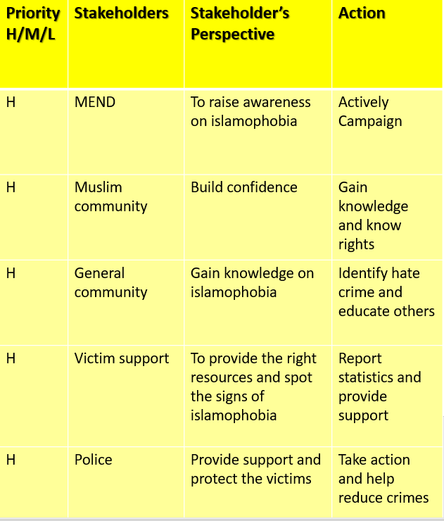
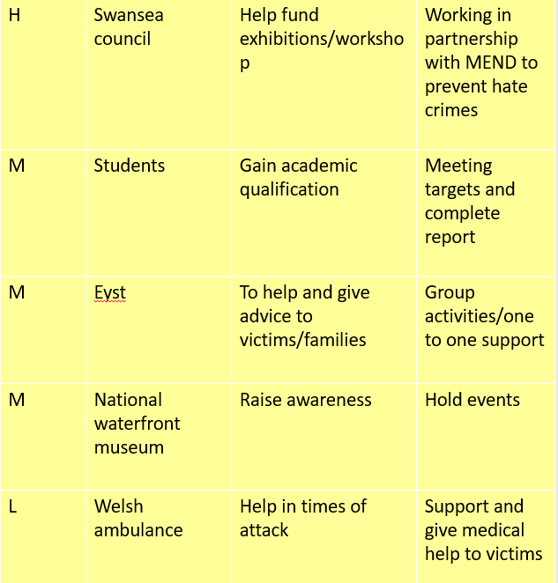

5.3 Appendix C Risk Analysis
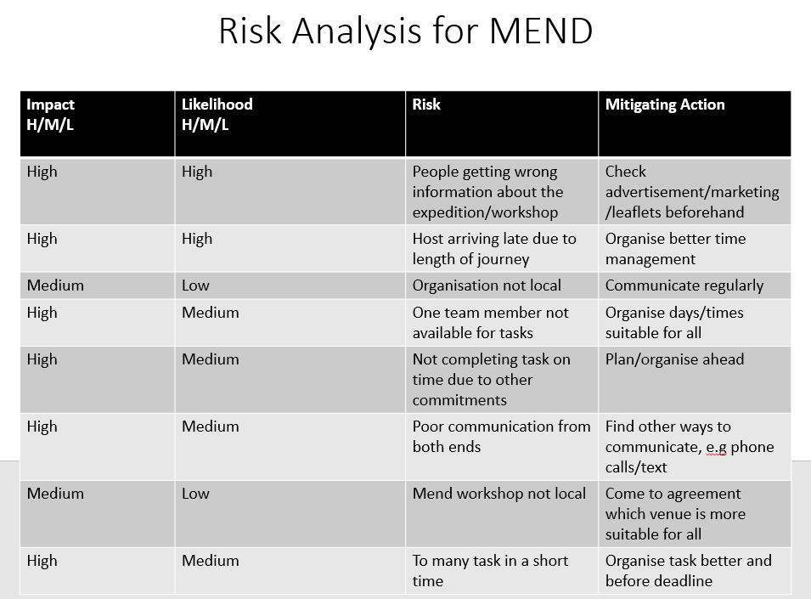

5.4 Appendix D WBS

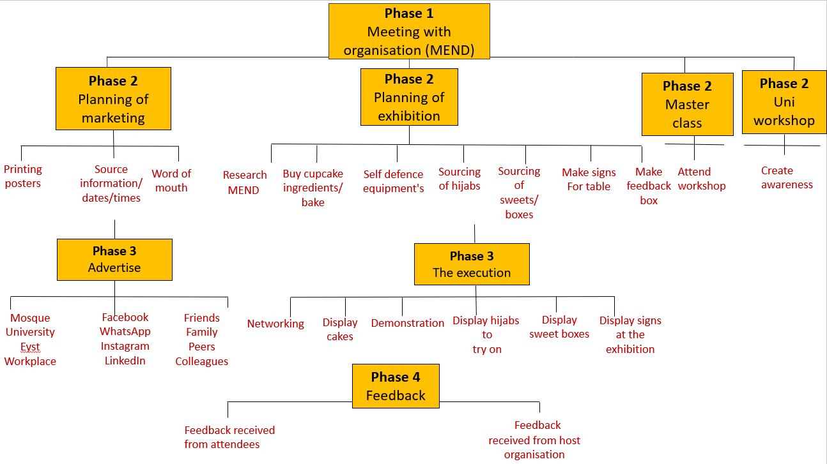

5.5 Appendix E Gantt chart

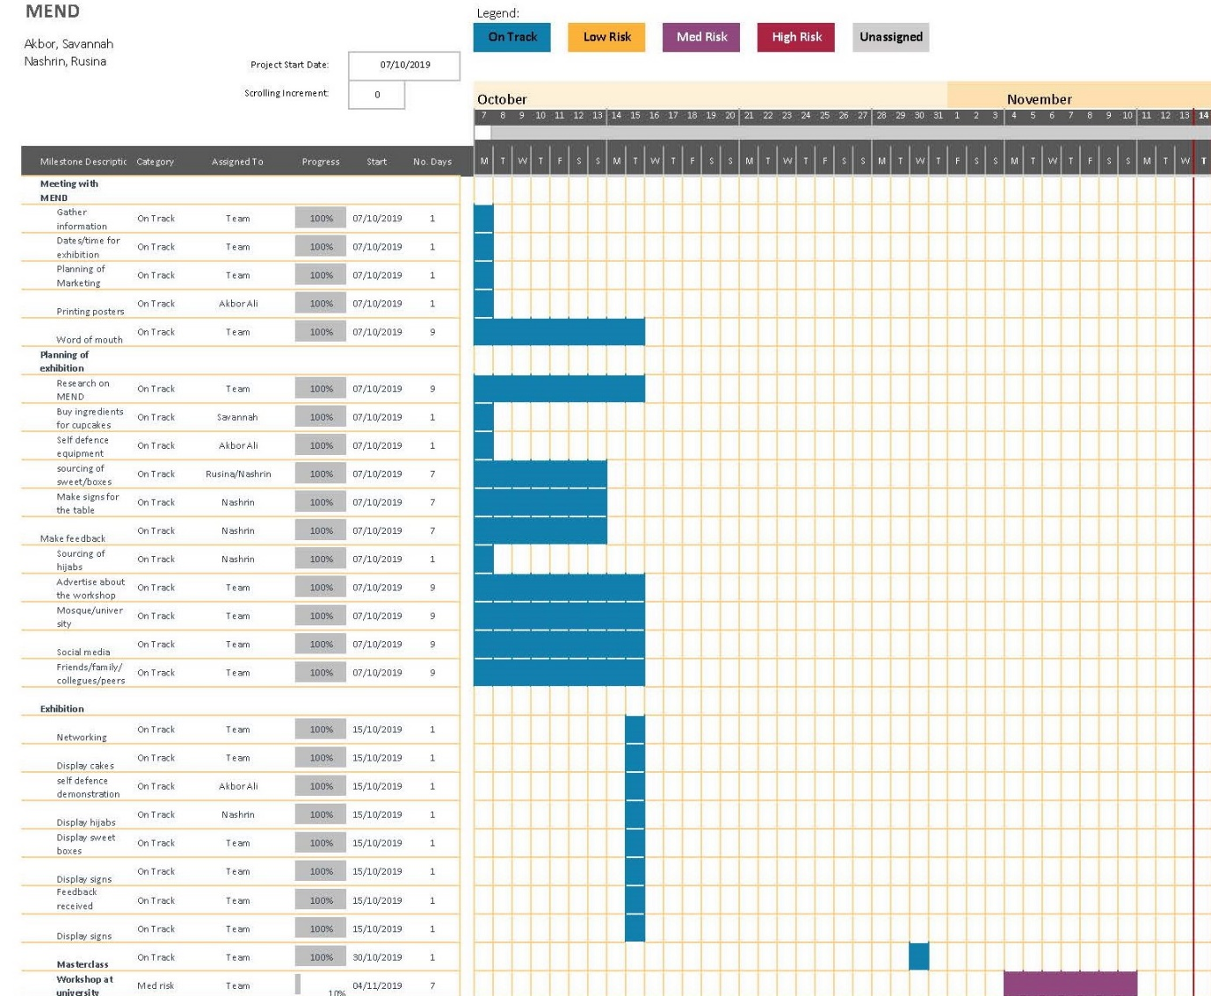

6.0 Reference

Association for project management APM, (2019). Introduction to Risk management. Available at: https://www.apm.org.uk/body-of-knowledge/delivery/risk-management/ (Accessed on 15th December 2019)
Baker, S., Baker, K & Campbell M. (2003). The Complete Idiots Guide to Project Management. 3rd ED. USA: Penguin Group
Clarke, A & Dawson, R (1999). Evaluation Research an Introduction to principles, Methods and Practices. Available at: https://www-dawsonera-com.ezproxy.uwtsd.ac.uk/readonline/9781446202203 (Accessed on 16th December 2019)
Eskerod, P & Larsen, T. (2018) ‘International journal of project management’, Advancing project stakeholder analysis by the concept ‘shadows of the context’. 36 (1), pp 161-169. Available at: https://www-sciencedirect-com.ezproxy.uwtsd.ac.uk/science/article/pii/S0263786317301114 (Accessed on 18th December 2019)
Ford, J.D & Wei, T. (2015). ‘Journal of technical writing and communication’, Quad Charts in the Classroom to Reinforce Technical Communication Fundamentals. 45 (3), PP 275-284. Available at: https://journals-sagepub-com.ezproxy.uwtsd.ac.uk/doi/10.1177/0047281615578848 (Accessed on 18th December 2019)
Gantt.com. (2019) What is a Gantt chart? Available at: https://www.gantt.com/ (Accessed on 16th December 2019)
Lock, D. (2007) Project Management 9th ED. U.K: MPG Books Ltd
Leonard, K. (2019) Advantages and Disadvantages of stakeholders. Available at: https://smallbusiness.chron.com/advantages-disadvantages-stakeholders-32179.html (Accessed on 18th December 2019)
Maylor, H (2001). Beyond the Gantt Chart: Project management moving on. European management journal, 19 (1), pp92-100. Available at: https://pdf.sciencedirectassets.com/271956/1-s2.0-S0263237300X00345/1-s2.0-S0263237300000748/main.pdf?X-Amz-Security-Token=IQoJb3JpZ2luX2VjEDQaCXVzLWVhc3QtMSJHMEUCIQD6mEK6nRp7%2BLoJ (Accessed on 17th December 2019)
MEND. (2019) MEND’S aims and objectives. Available at: https://www.mend.org.uk/about-mend/aims-and-objectives/ (Accessed on 18th December 2019)
MindTools Video, (2018). Risk Analysis and Risk management https://www.youtube.com/watch?v=ku0DvsnsLCA (accessed on 18th December 2019)
Popv, G., Lyon, B.K & Hollcroft, B, (2016). Risk assessment: a practical guide to assessing operational risks. Available at: https://www-dawsonera-com.ezproxy.uwtsd.ac.uk/readonline/9781119220916 (accessed on 17th December 2019)
Roberts, P. (2011) ‘Effective Project Management’ How can I keep the project under control? U.K, USA & New Delhi: Kogan Page Ltd. Available at: https://www-dawsonera-com.ezproxy.uwtsd.ac.uk/readonline/9780749461584 (Accessed on 18th December 2019)
The Audiopedia. (2018) QUAD CHART meaning, definition & explanation. Available at https://www.youtube.com/watch?v=TkRyzUVWtm0 (Accessed on 18th December 2019)
Work breakdown structure.com. (2019) Work breakdown structure (WBS). Available at https://www.workbreakdownstructure.com/ (Accessed on 18th December 2019)

