Design: Requirements, MVP (Minimum Viable Product) and design documentation.
When designing the application we decided what the key features are and also decided what are most viable for the minimum viable product. The features that we believe are key include:
- Working Map
- Pinpoint Location of Public Toilets
- Search Functionality
These three features will allow us to validate the product idea.

There are also a few more features that we considered such as:
- Reviews
- Location Finder
- Capability for Users to Add Toilets
We believe that these are also important features, but aren’t required for creating a minimum viable product.

Brand Advertising: Graphics (eg. Logo, Banner), Website, B/Vlog, Social Media, Poster/flyer.

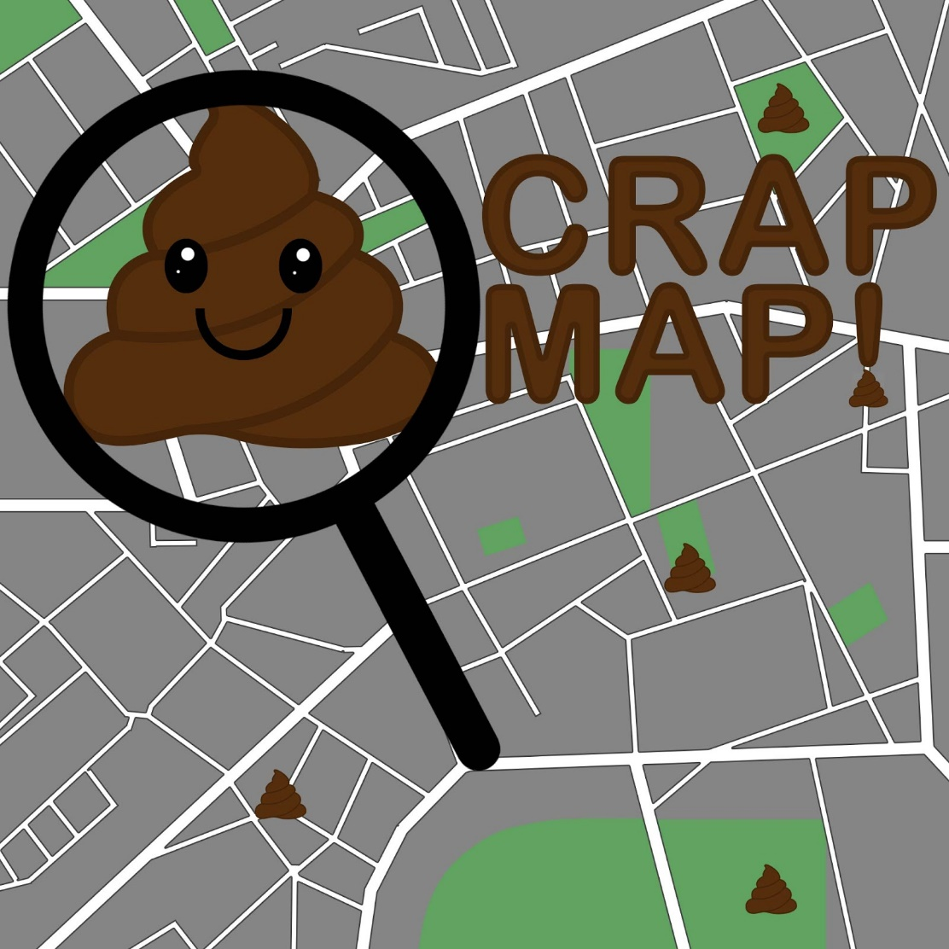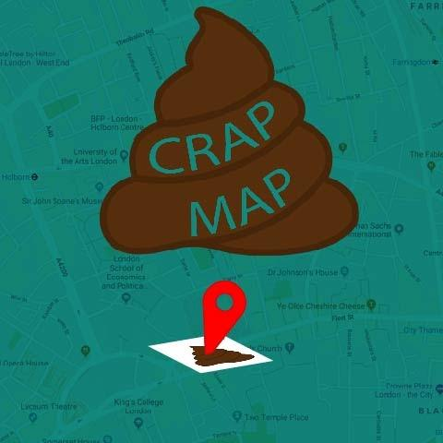
When deciding how we were going to advertise our brand we designed four different logos to potentially use. We felt that the first two logos were most suitable for use due to the other options being too convoluted. The first two logos not only stand out, but are simple. These logos will be used on our social media sites along with the first logo being used as the application logo due to it being a bit more flashy.

Although creating posters/flyers we decided that creating posters/flyers weren’t necessary as they aren’t as effective for advertising a mobile application.

We created social media accounts to advertise our application and also provide updates whenever necessary. When deciding what social media platforms to use, we decided to go with twitter and facebook as we feel they are the most suitable for the application we are going to create compared to some of the other platforms such as instagram.
https://twitter.com/crapmap_
https://www.facebook.com/CrapMap

Consider how much start-up funding is required & how it will be acquired e.g. savings, investors, partners or crowd-funding.
There isn’t any funding required to make this application due to the resources that we need being free on the android side of the development. If we choose to make this compatible with IOS then we’ll have to pay for a license that’ll allow us to release the app onto their stores, this would cost close to £80.

What overall skills are needed to run your potential Tech Start-Up? Do you have any skill-gap areas? How will they be solved?
A main skill that we’d need is communication to make sure that we are progressing properly and making sure we work efficiently together by splitting tasks that we have to do. Communication can help solve issues that we have individually by asking other members for assistance on certain parts of the project if they are struggling. Another skill required is time management, this is to make sure that we are working on track and to prevent us from being behind schedule for development.

Do you require Business premises? How will the Team collaborate moving forward? The required IT/Production facilities needed? Code of conduct?
Due to it being a mobile application we are able to work from home instead of using a facility. The team will be able to collaborate on the project by communicating online via services such as discord and github. The team will be able to work on seperate parts of the application and then merge it together whenever needed. We set deadlines to try and meet expectations, by meeting the deadlines it helps ensure that we’ll be able to keep on track for making our application. We also hold meetings every week to make sure that we’re all on track.

