Report
Introduction
I have researched some venues for the conference that I would hold, I looked into the price of the venue if it has a canteen, how many people it would be able to hold and how such it would cost for each person to come to the venue. After doing some research into all of these things into consideration and decided that the venue has chosen to use is the venue is the Newport conference centre. I have picked this location because of the fact it is already made ready for a conference, renting the location is a decent of price meaning it is affordable to hire. It has the capability of having 200 people in the conference meaning I would be able to hold a rather large meeting if I felt the need to have more people. They also have a canteen so people would be able to eat if they need. The venue has multiple rooms meaning I can select a room based on the topic that the meeting is for. I will also look into the well being generations act of wales in 2015. And apply it to my conference.
The conference I am doing will be about the wales well being generations act of 2015. This act has seven main goals that like to achieve.
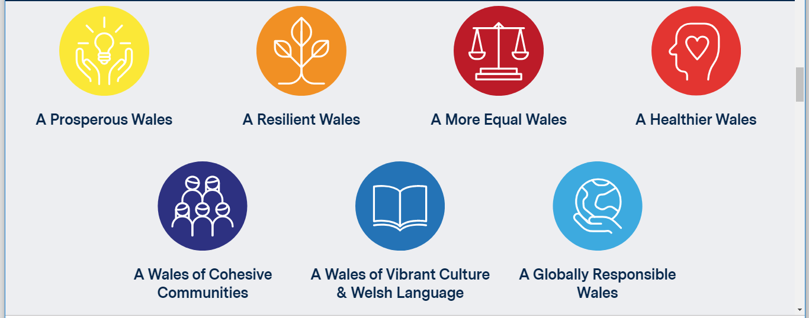
This screenshot above shows the seven goals that the well being generations act are trying to achieve. The first goal it shows “A prosperous wales” this is about trying to help get people to help the environment. This is also to help people learn skills that they need to have to help with employment lower the unemployment rate in the county
The next one is “A Resilient Wales” this is about making sure that they keep the natural environmental health good, meaning that they lower the amount of carbon dioxide that is being produced. They also want to use this to make sure that they are ready for change, this is so that if there is a sudden change that could course issues for example, global warming will be present new issues and can be unpredictable and being able to react and react well is important in this category.

The third option of the seven is “A More Equal Wales”
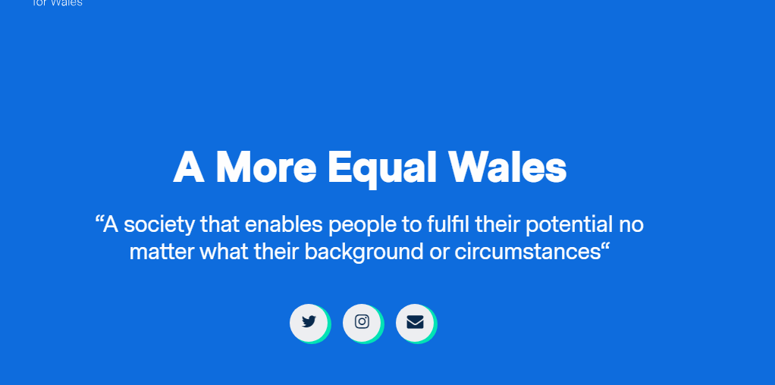

The screenshot above shows that this part of the act is all about making sure that every person is considered an equal, this apply a lot towards jobs and job interviews, this makes sure that an employer can’t dismiss a potential employee just because of a religious belief or because of gender meaning that no matter what the background of someone they will be considered all the same as every other candidate as well.
Part four is “a healthier Wales” this leaks into some of the other parts but the main point of this is to have a healthier population, where everyone is healthier physically but also mentally, to help educate people on decisions so that they make decisions that have a positive affect for the nation in the future, they want people to understand the decisions they make and how it affects the future so people can see clearly why they are making the correct decisions which help make the country healthier as well as making people mental healthier. this would help with the resilient of the country.
Part five of the seven Is “A Wales of cohesive communication” this is where they want everyone to be able to communicate easily and freely, not only to each other but also to people if power like their government. This is so that the country can work together to communicate and make the country better altogether. They also want to make sure that people feel safe and comfortable do this so that no one is worried about the safety of doing this and fell as though they are at risk.
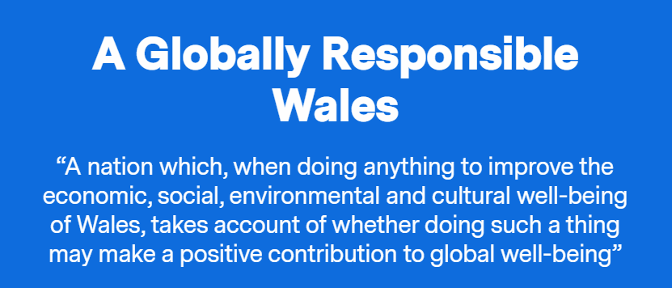
The next part being “A Wales of vibrant culture and welsh language”. They want to make sure that people know of the culture and the language and that the society promotes it and attracts more people to the country when they discover about the culture that they do have. They also want to promote the welsh language and get more people to speak the language. They also want people to promote other things like sport and get behind the country and show the passion they have for the country.

The screen shot above shows the final point, it shows that the act wants to consider more then just themselves, the act means that when they make any decisions to do with economic, social aspects and importantly the environmental aspects they make sure the decisions are not just a positive for the country but is something that helps globally. So, some things that could prove really helpful for wales but end up have a bad overall affect on a global scale then they will would stop as they would make sure that they have no negatives affect that would affect global issues that already exist or possible create a new one
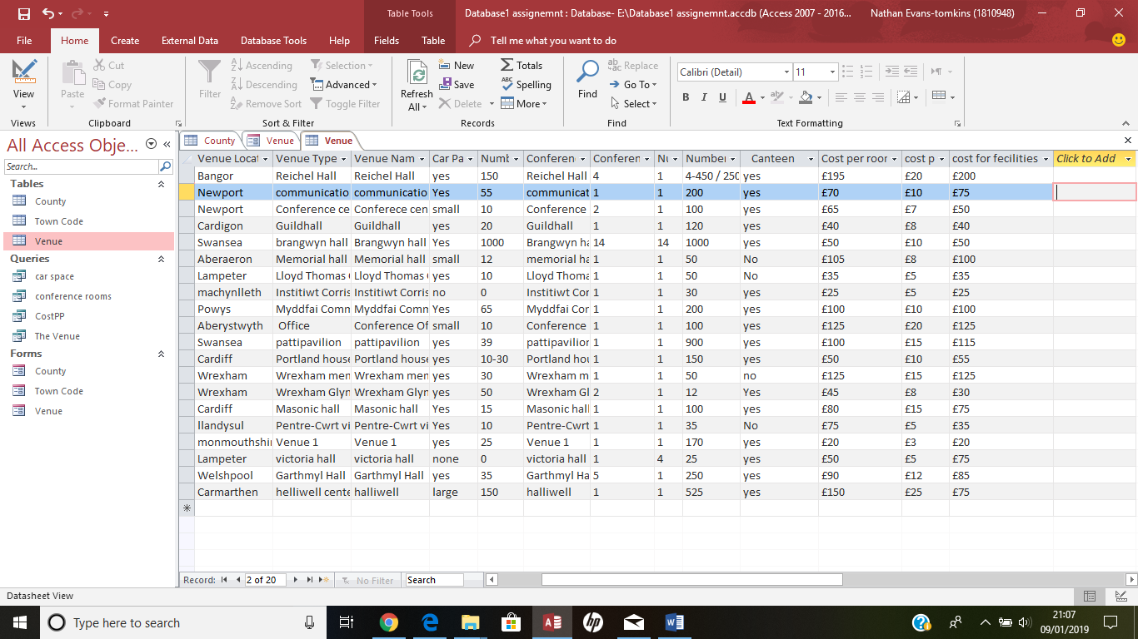
the screenshot above shows the venues that I looked at that I would like to host the conference at, the one that I have been most interested in is the section that is highlighted, that is the conference centre in Newport. I have considered thus one over the rest due to the cost per person being just £10 and the cost to hire the venue which with all prices considered being £145, I also looked into how many people would be able to come to the conference. I was looking for a venue with enough for 150-250 people being able to come, and the conference centre in Newport has the exact middle of that allowing 200 people to come to the venue in one time. The location of the venue was also a help into why I went with the venue as it being in a city it will be easy to find.
Based of the other venues looked at I fell that thus is the best venue I could have got for this type of event. Its in a well known area, affordable and has more then enough room for the mount off guests that would attend and just enough [parking spaces for people that would need to drive to the event
when designing this I thought about what I would consider priority, with the venue location and the cost but the most important parts where creating the town codes and county codes for the venues so that I could categories the venue to each section have the ability to funs section of each part a lot easier.
I created some “forms” which I designed to make differently for the three sections that I have, the first section being the county column, In the screenshot below I have done a design using a Cardiff as my example and create the text box’s in green and put the background colour in red to represent the welsh flag colours to show that every county I have done is in Wales.
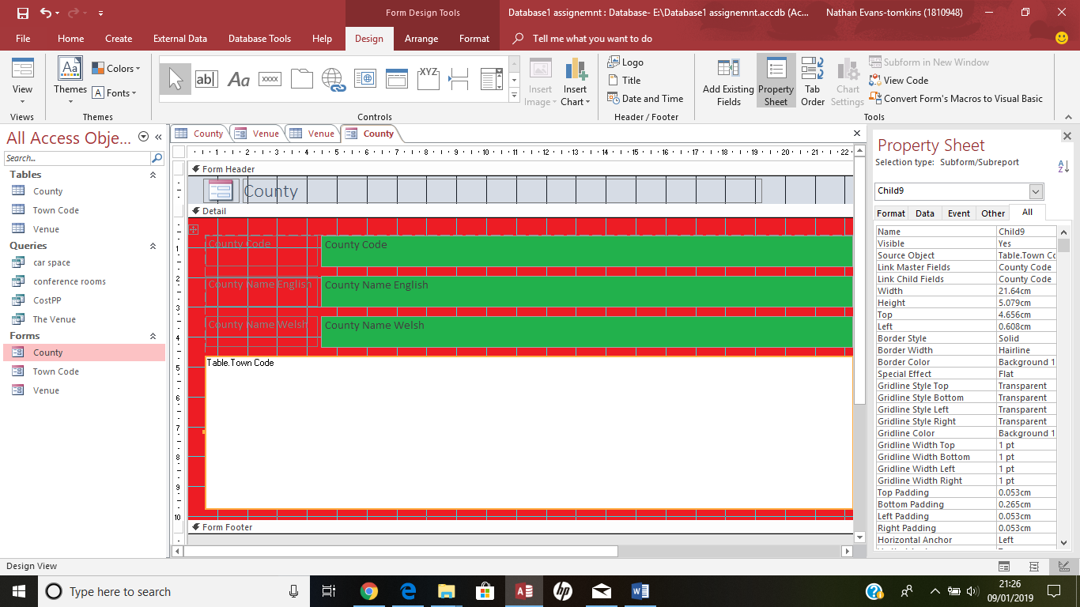
I changed the colour theme for each of the three different form sections. But sticking with the welsh theme and I have coloured the Town Code column of these in the welsh away colour from the euros with the main colour being black. The designing of this is a very simple part of the progress, once you have a colour theme it is easy to create all you have to do is go into “design view” which gives you the ability to edit almost any part of the designing progress. The design view is a progress that has to be done with almost every part of the creating the database, this is as it helps you create and design
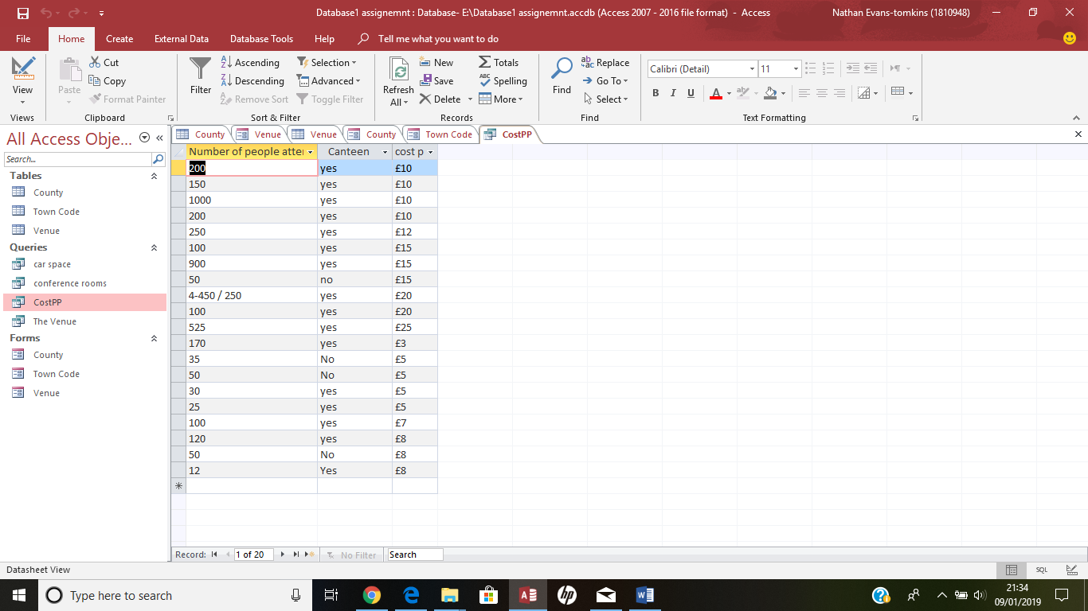
The screenshot above shows another part of the database I created, this is a queries section, this is so you can make things go into order so you can compare prices a lot easier. The screenshot above is the average cost per person. So, using this I am able to see that the venue I have chosen has a fairly average cost per person compared to the other venues I have looked at meaning t is neither a good cheap deal nor expensive.
I have done four different queries, the one i have already mentioned of the cost per person but I also did one for the amount of car parking there is, a third one for the amount of conference venues and finally I had one done for the locations of each venue.
Comparing this to a database I done for the 60 prosumer businesses, I would say that they data base that I created for the venues was more difficult to create but once I have finished creating the database for the venues it is a lot easier to use and navigate
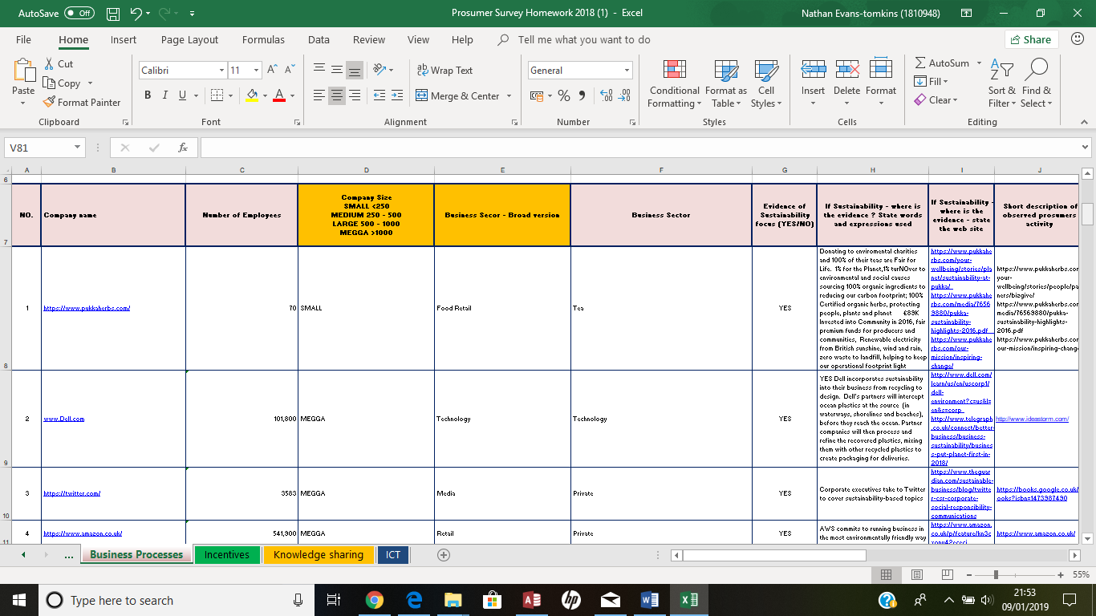
The screenshot above is the prosumer database that I created, this is a lot easier to create but once it is completed it can be hard to follow. In comparison the complex design of the venues database is mainly to make the it a lot easier to use n completion so most people would be able to use it, whereas the simple of the prosumer one is also why it’s complicated, you can’t see a full column and have to scroll a lot to be able to what part is answering what, but it has no ability for you to search a particular section so it is much slower way to find the each part. The looks of the prosumer database is very boring whereas with the venue one you have the ability to design how it will look in the end with the ability to choose the layout and colours and what information’s.
The information that is put in the prosumer database is very different to what has been put into the venue. In the venue database I didn’t look that into any of the properties other then look in at prices, capacity and locations of the venues, after that, there is not that much more on information in the venues one, that one is a lot more to do with looks and how well it works but with the prosumer database, a lot of information went into that one. There is information about the number of employees they have, whether the company allows you take out a loan from the company, they even go into detail about what they do to help with the environment. They go into 4 different sections for information including what they do online, so comparison the prosumer database, despite being a much simpler design, there is a lot more information on the database.
With the venues database there is many tools that can be used to make everything much easier to use once programmed and coded correctly. The codes are made so that people are able to find parts of information that need easily, and with the queries, this is so you are able to compare prices easily and out them in order based of category’s so that you are able to work things out a lot easier. It is also easy to create this. So, this is one of the few parts that are easy to make as you can’t do this unless you have all the information that you need to be able to do this. but if you have all the information then it can be done easily. the only complicated part of this progress is getting the town codes to match up as the could be duplications and links not forming. But once you have worked a way around this it is easy to solve and will be able make quick progress with out many problems. Once you have worked out how to use the database then you will have no troubles creating this. Its also a design that allows you to mess around with the themes and overall design of what you want so you are able to create it but if you decide you don’t like the colour scheme then you are able to change easily.
As a conclusion I believe that the database I used for the venue data base is a better way of producing the database as it is much quicker way to make but also a lot easier to use once created, it’s much easier to find information quicker with the ability to search for certain parts or type in the “town codes for example to jump straight to where you need to be where as for the prosumer data base you haven’t got the ability to search for something straight of the bat so it can take sometime to find what you are looking for and is difficult to locate the correct information if there is a lot of information to look through. There are no codes that where able to set up to make anything faster you just have to search through them manually. Meaning that the venue design platform is all round better for designing a database as it has all the tools and systems that you need to be able to make something fairly good and quickly with many issues. Unlike the prosumer one where there are not may tools that help. The biggest issue with the Access is the fact not ever computer can run the system.

References.
https://futuregenerations.wales/aotp/global-resonsibility/ 2015 – wellbeing generations act.
http://futuregenerations.wales/about-us/future-generations-act/ 2015 – wellbeing generations act.
https://www.wcva.org.uk/what-we-do/the-future-generations-(wales)-act-all-you-need-to-know
Stead, J.G. and Stead, W.E. (2014). Sustainable Strategic Management. 2nd edn. Sheffield: Greenleaf.

