

Applied Computing

Wales Institute of Science and Art (WISA)

Networks and Cybersecurity Essentials (ACCA4024)

Lab 6: Working with Ubuntu



n.kaliyamurthy@uwtsd.ac.uk 1

Objectives
Start working with your host machine. Create user credentials, authority and access rights as required.

Tasks
1. Configure User Management
a. Create, verify and set Groups, Users and Permissions

Required Resources
- PC with Ubuntu 16.0.4 LTS installed in a VirtualBox or VMware virtual machine.

Alternatively,

- Any Linux Platform

Task
- Login as User Cisco.
- Go to Terminal

Create Groups
Escalate privileges to the root level by entering the sudo su command. Enter the password password when prompted. cisco@ubuntu:~$ sudo su
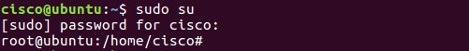
Add a new group named HR
root@ubuntu:/home/cisco# groupadd HR

Verify the created Groups
root@ubuntu:/home/cisco# cat /etc/group
The new group HR will be added to the bottom of the /etc/group file with a group ID of 1005.
Add the following groups and record your output
MGT
EMPGA
EMPGB
EMPGC
1. Record the command you used to create and verify Groups with the group ID.
Command to create a Group
Command to Verify the Group
Group ID for MGT - 1006
Group ID for EMPGA -1007
ID for EMPGB - 1008
Group ID for EMPGC - 1009

Create Users

Escalate privileges to the root level by entering the sudo su command. Enter the password password when prompted.
cisco@ubuntu:~$ sudo su

Create new user and password
Username | Password | Group | Name | Room | Phone | Phone | Others
jenny | lasocial | HR | Jenny | 101 | 2354 | 76698
joe | tooth | HR | Joe | 101 | 2354 | 76699
roy | roy1 | MGT | Roy | 100 | 2355 | 76610
jack | jac1 | EMPGA | Jack | 1011 | 2356 | 76601
ethan | eth1 | EMPGB | Ethan | 103 | 2357 | 76602
mac | mac1 | EMPGC | Mac |  |  | 76603
david | dav1 | EMPGC | David |  |  | 76604

root@ubuntu:/home/cisco# adduser jenny
When prompted for a new password, type lasocial. Press Enter.
When prompted again, type lasocial. Press Enter.
When prompted for a full name, type Jenny. Press Enter.
When prompted for other details, refer to the above table and enter the details.
If you don’t have the details, press Enter without adding the details.
Type Y for yes and press Enter.
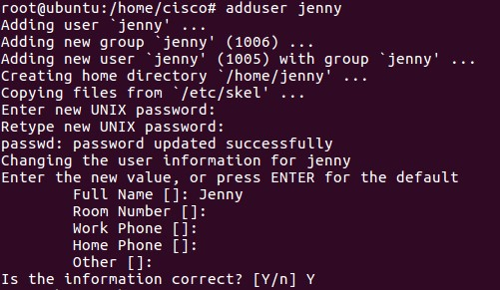
Repeat the same for all the other users listed in the table.

Place users to their respective groups
Place the user jenny in the HR group.
root@ubuntu:/home/cisco# usermod –G HR jenny

Verify users
Verify the newly created users in the passwd file.
root@ubuntu:/home/cisco# cat /etc/passwd
View the created users in the shadow file.
root@ubuntu:/home/cisco# cat /etc/shadow

2. Record the list of users.
in passwd file
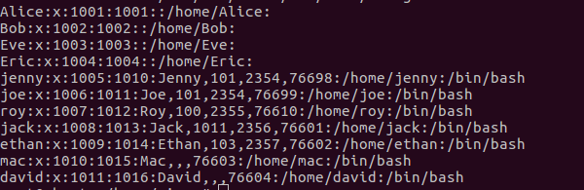
in shadow file
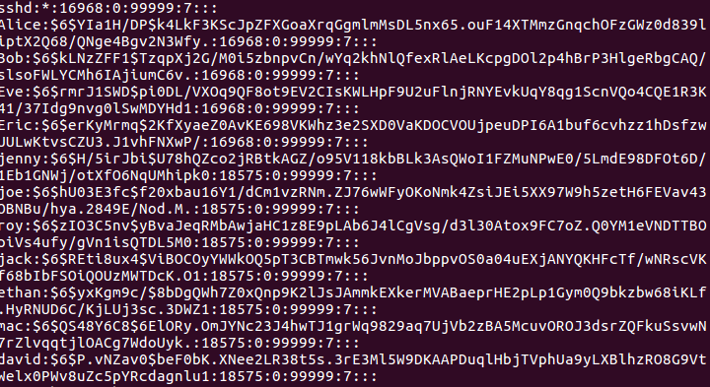

Using Symbolic Permissions
Note: While on the Ubuntu system, press and hold the keys CTRL+ALT+F1 the screen changes to the tty1 Terminal. If you are unable to use tty1 terminal, return to graphical user interface (GUI) of the host by using CTRL+ALT+F7 (If CTRL+ALT+F7 did not work, try CTRL+ALT+F8) and open a terminal window in the GUI Ubuntu OS. At the prompt, enter su –l jenny at the prompt and enter the password lasocial. Proceed further.
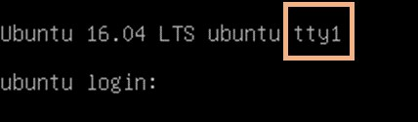
cisco@ubuntu:~$ su –l jenny
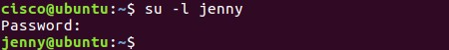
Once on the Terminal login screen, type jenny and press Enter.When prompted for the password, type lasocial and press Enter. After a successful login, you will see the jenny@ubuntu:~$ prompt.
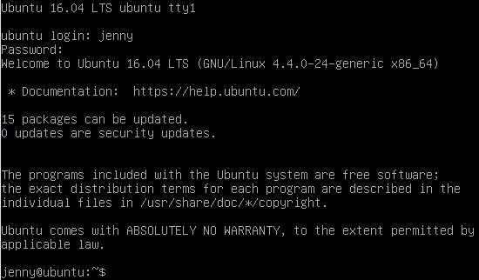
Since we are not logged in as the root (superuser), we are presented with the dollar sign instead of the # if we were to be logged in as the user root.

View your present directory.
jenny@ubuntu:~$ pwd
Go back one directory level to the /home directory. jenny@ubuntu:~$ cd ..
List all directories and their permissions.
jenny@ubuntu:/home$ ls -l
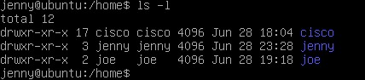
The Linux operating system has a total of 10 letters or dashes in the permissions fields:
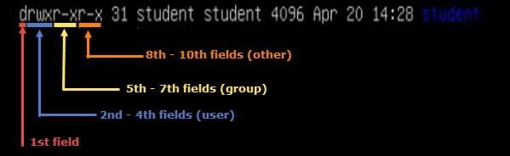
Enter Joe’s folder as Jenny by typing the command cd joe. jenny@ubuntu:/home$ cd joe
Notice that we are able to go into Joe’s home folder. jenny@ubuntu:/home/joe$ cd ..

Press and hold CTRL+ALT+F2 to switch to another Terminal session
(tty2).
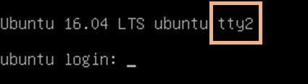
Login as the user root with the password secretpassword.
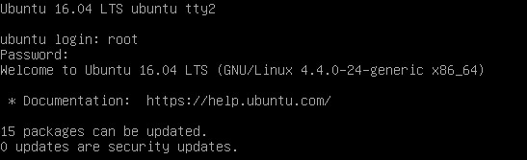
Note: If you are unable to use tty2 terminal, return to graphical user interface (GUI) of the host by using CTRL+ALT+F7 and open a terminal window in the GUI Ubuntu OS. At the prompt, enter sudo -i at the prompt and enter the password password.
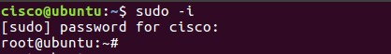
Change to the /home directory. root@ubuntu:~# cd /home
Change the “other” permission on joe’s folder by making it non-executable. root@ubuntu:/home# chmod o-x joe
List the directories once more with their respective permissions. root@ubuntu:/home# ls -l
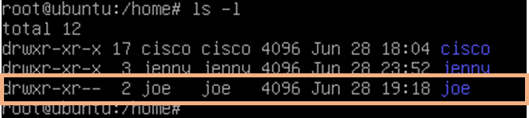
Notice now that there are two dashes in the “others” field for joe’s folder.
Press and hold CTRL+ALT+F1 to switch back to the other Terminal session (tty1).
Make sure you are viewing the following command prompt: jenny@ubuntu:/home$.
Attempt to go into Joe’s folder once more. jenny@ubuntu:/home$ cd joe
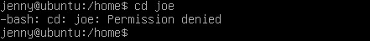
Notice that we do not have the permissions to do so.
The chart below shows examples of other ways the chmod command can be used:
chmod command | Results
chmod u+rwx | Adds read, write, and execute permissions for the user
chmod u+rw | Adds read and write permission for the user
chmod o+r | Adds read permission for others
chmod g-rwx | Removes read, write, and execute permissions for the group

Type exit followed by pressing Enter to logout of the Terminal session.

Absolute Permissions
Login as the user joe with the password tooth while on tty1.
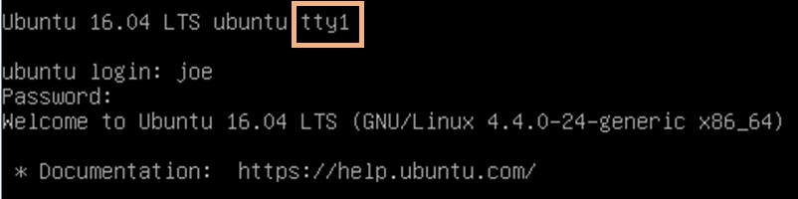
Print your current working directory.
- joe@ubuntu:~$ /home/joe
Go back one directory level to the /home directory.
- joe@ubuntu:~$ /home
List all directories and their permissions in the current working directory.

5. joe@ubuntu:/home~$ _________________
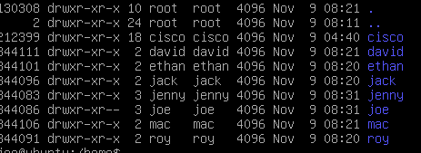
Notice that Joe’s folder is set so that “others” are not able to access the folder.
The other way of assigning permissions besides using symbolic permissions is the use of absolute permissions. Absolute permissions use a three digit octal number to represent the permissions for owner, group and other.
The table below outlines each absolute value and its corresponding permissions:
Number | Permissions
7 | Read, Write, and Execute
6 | Read and Write
5 | Read and Execute
4 | Read
3 | Write and Execute
2 | Write
1 | Execute
0 | None

By typing the command chmod 764 examplefile, the examplefile will be assigned the follow permissions:
The user will get read, write and execute permissions
The group will get read and write permissions
Others will get read access
Breakdown of how 764 represents these permissions:
Digit | Binary Equivalent | Permission
7 (user) | 111 | 1-Read 1-Write  1-Execute
6 (group) | 110 | 1-Read 1-Write  0-No Execute
4 (others) | 100 | 1-Read  0-No Write  0-No Execute

Modify the “others” field for Joe’s folder so that others will be able read and execute but not write while still maintaining the “user” field to read, write, and execute. joe@ubuntu:/home$ chmod 705 joe
List the file permissions of the current directory to see that the absolute changes were made. joe@ubuntu:/home$ ls -l
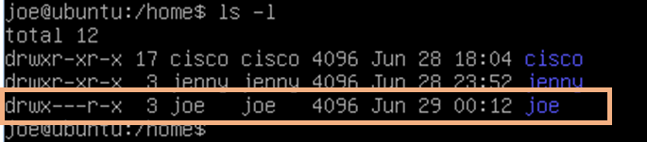
Change to the /home/joe directory. joe@ubuntu:/home$ cd joe
Create a simple text file named test.txt using touch. joe@ubuntu:~$ touch test.txt
Type exit followed by pressing Enter to log out of Joe’s session.
While on the tty1 Terminal, log back in as jenny and enter the password lasocial. Press Enter.
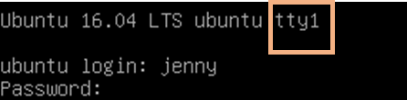
Change to the /home directory. jenny@ubuntu:~$ cd /home
List all directories with their respective permissions.
jenny@ubuntu:/home$ ls -l
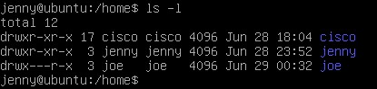
Change to the /home/joe directory and list the content of the directory.
jenny@ubuntu:/home$ cd joe
jenny@ubuntu:/home/joe$ ls -l
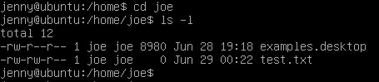
Notice that we are able to enter Joe’s folder and read the files within the directory. We are able to see the test.txt file.

Attempt to create a file.
jenny@ubuntu:/home/joe$ touch jenny.txt
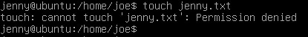
Notice we do not have permission to create the file.
Complete the following and submit the lab document with all the directory details as required.
- Make sure that, all the users listed below are created and assigned to various groups.

Username | Group | Filenames | File Contents
jenny | HR | file_jenny_c | This is Confidential HR Document
joe | HR | file_joe_g | This is a group Document
roy | MGT | file_roy | This is general Document
jack | EMPGA | file_jack | This is general Document
ethan | EMPGA | file_ethan_c | This is Confidential Employee Document
mac | EMPGA | file_mac_g | This is group Employee Document
david | EMPGA | file_dav_c | This is Confidential Employee Document

6. Create all the files as per the names from the stated users and input the contents in the file.
Make sure that all the filenames ending with
- _c are confidential that only the owners of the file could access and other users could not access. (Record the evidence)
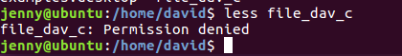

file_jenny_c

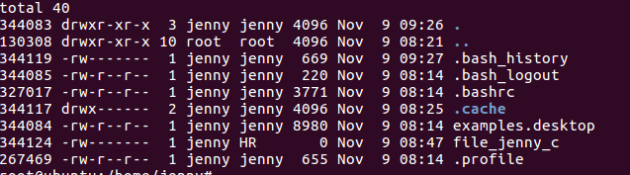
file_ethan_c
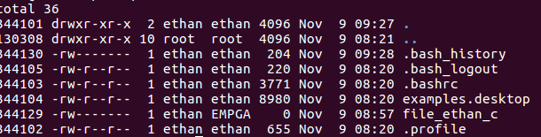
file_dav_c
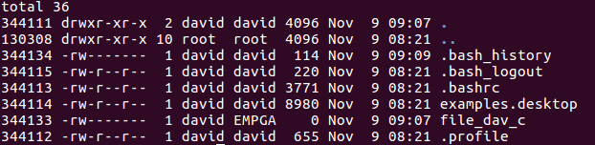

- _g are group files that only the owners and the group they belong to could access and other users could not access. (Record the evidence)
file_joe_g
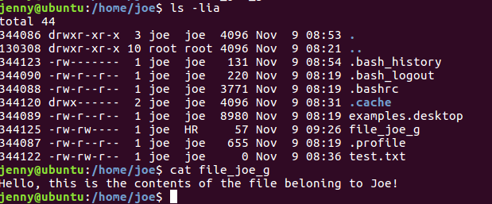
file_mac_g
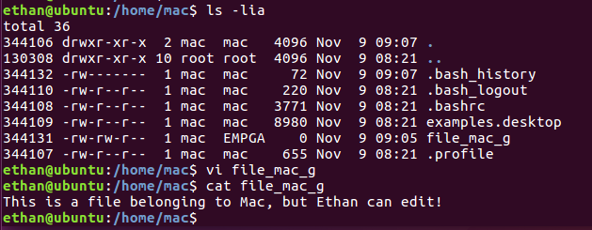
- File names without the above 2 notations are general files and could be accessed by all. (Record the evidence)
file_joe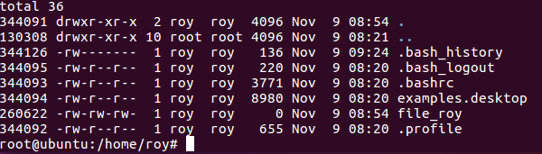file_jack

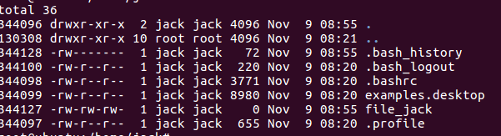

Learnings from tutorials so far:
Part 1 (Packet Tracer, Host Machines)
- Build a home Network
- Understand and configure IP Address
- Use Ping/ Trace route Utility to check the connection status
- Use ipconfig /all command to determine the MAC address of a Windows computer on an Ethernet network.
- Analyze a MAC address to determine the manufacturer.
- Analyze the Wired and Wireless Network connection.
- Analyze Address Resolution Protocol (ARP).
- Connect to a Wireless Router and configure the basic settings in a wireless router and add security features.
- Use nslookup command to understand the url to ip conversion.
- Configure basic connectivity settings in Intermediate devices (Switch/ Router).
- Work with SBA Packet Tracer Files/ environment
- Configure ftp, web, email, dns, ntp and aaa Servers Part 2
- Set up a virtual lab environment
- Troubleshooting the virtual lab environment
- Working with virtual machines
- Authentication, Authorization and Accounting

