

NAME: TALWINDER KAUR
STUDENT ID:2227879
SUBJECT: CLOUD ENGINEERING PRINCIPLE AND PRACTICE
PROFESSOR: Mike Dacey/Tim Bashford

Abstract

Definitions of terms and concepts used to describe "cloud computing" constantly change, occasionally requiring clarification. Press inclusion periodically depicts how associations make their responses available in the "cloud" or how "dispersed figuring" is the status quo done, which can be vague or neglect to convey how distributed computing functions contain or connotes totally. In addition to introducing cloud computing over the internet, this white paper examines the characteristics, service models, and deployment patterns currently in use and the advantages and disadvantages of cloud computing. In addition, the significance of scalability and adaptability in a cloud-based system and cloud communications services, including Cloud access methods like web APIs and media management interfaces, are discussed. The connection point choices accessible, including Web 2.0 APIs, media control interfaces, Java interfaces, and XML-based interfaces, taking care of a wide range of use and administration creation designers, ought to likewise be perceived by associations wishing to start utilizing correspondence administrations.

Table of contents

1.1. Introduction......................................................................................................
1.2. What is cloud computing?................................................................................

1.3. Why the Name Cloud?......................................................................................

1.4. Describe the types of cloud computing?...........................................................
1.5 What is cloud architecture?...............................................................................
2. What is Docker?.............................................................................................
2.2 Why is Docker?...................................................................................................
3. What is containerization?.....................................................................................
3.2. Benefits of containerization..............................................................................
3.3. What is the scalability in cloud computing?..................................................
3.4. Advantage Of the cloud scalability....................................................................
4 In cloud computing, what is load balancing?...................................................
4.2 Objective of load balancing................................................................................
4.3Benefits of load balancing ...................................................................................
5. What are the application gateways?.........................................................................
5.2. Application Gateway background......................................................................
5.3. Advantages........................................................................................................
5.4. Drawbacks.........................................................................................................
6. Reference list........................................................................................................

INTRODUCTION

What is cloud computing?
Cloud computing uses hosted services like software, servers, databases, networking, and data storage over the internet. The data is stored on physical servers managed by a cloud service provider. Data storage and processing power are two examples of computer system resources made available on demand in cloud computing and are not under the user's direct control. Examples of cloud computing services are AWS, Azure, and Google. [1]
Why the name Cloud?
The word "Cloud" was coined by network engineers to describe a network design that showed where different organizational gadgets were found and how they were associated. This network's architecture had a cloud-like shape.

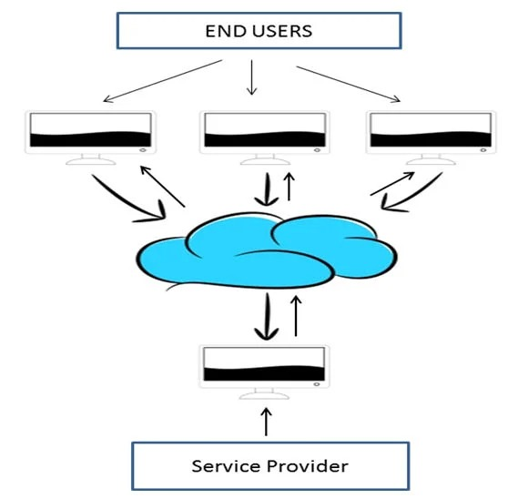

Describe the types of cloud computing.
Cloud computing can be classified according to its deployment model or type of service. We can partition mists into three classifications: depending on the particular deployment architecture, public, private, and hybrid. Depending on the service it provides, the cloud model can be classified as infrastructure-as-a-service (IaaS), platform-as-a-service (PaaS), or software-as-a-service (SaaS)[1].

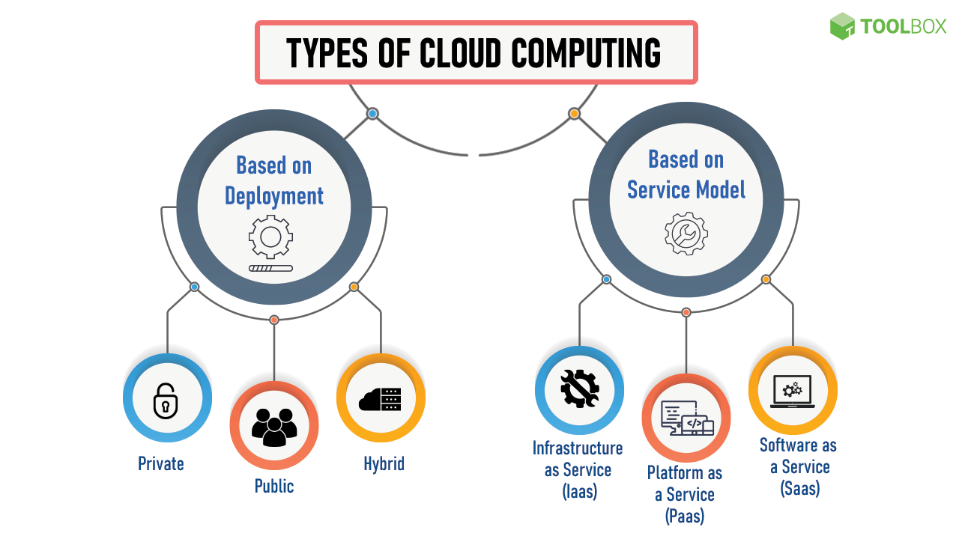

Private Cloud
Computing services are provided to a single company exclusively through a private IT network in a private cloud. A private cloud, which can also be referred to as an internal, enterprise, or corporate Cloud, is only accessible to employees and is frequently run on internal resources. Private cloud computing offers more control, security, and customization in addition to the benefits of a public cloud, including self-service, scalability, and elasticity. Confidential mists provide a more significant level of safety through corporate firewalls and interior facilitating to ensure that an organization's delicate information is blocked off from outside suppliers. The disadvantage of a private Cloud is that the company is now managing and maintaining the data centres, which can require a lot of resources.
Public Cloud
The expression "public cloud" depicts internet figuring administrations given by autonomous merchants. Unlike private clouds, the services offered by public clouds can be used or purchased by anyone. These administrations might be presented free of charge, or on a compensation for every utilization premise, with clients just paying for the computer chip time, extra room, or data transmission they use.[1]
Since the cloud specialist organization is accountable for the framework of the board, the public Cloud can help ventures save money on the procurement, organization, and upkeep of the on-premises foundation. Additionally, they offer scalable RAM and adaptable bandwidth, making it more straightforward for businesses to expand their storage requirements[1].

Hybrid Cloud
A hybrid cloud consolidates components from both public and confidential sources. Using the ", workloads can be transferred between private and public clouds the "best of both worlds" cloud concept when computer and pricing requirements change. Hybrid clouds are utilized when there is a fluctuating demand for processing and computation. Organizations can move their on-premises infrastructure to the public Cloud to manage the excess while assuring no other data centres can access their data. This opens a new window. Businesses using a hybrid cloud model only pay for the resources they use for a short time rather than purchasing and maintaining resources that might only be used for a short time. Without the security risks, a hybrid cloud offers the advantages of the public cloud. Let us dissect the idea of a hybrid cloud to its constituent pieces and talk about how to manage a hybrid cloud's performance effectively. Once we've completed that, we can put the pieces together to create a complete hybrid cloud architecture and examine the features for holistic performance management. After that, we'll explore how CloudOps, which is a little more strategic, incorporates all of this.
Infrastructure as a service (IaaS)
Infrastructure as a service, or IaaS, is a type of cloud computing in which a service provider provides servers, storage, and networking via a virtual interface. The user doesn't have to worry about managing the cloud infrastructure because this service lets them keep control of the applications, operating systems, and storage they have installed. An outside merchant has the servers, stockpiling, servers, and other foundation parts instead of the client. In addition, the vendor maintains a backup and hosts the user's applications.
Platform as a service (PaaS)
Platform as a service, or PaaS, is a type of cloud computing that provides a cloud-based environment for application development and deployment, allowing users to create and run applications without worrying about the infrastructure's complexity. Customers can use it to develop cloud-based applications with the tools it provides. A user uses this service to access resources through a secure connection and pays a vendor for them on a pay-as-you-go basis.[1]

Because of PaaS, clients are given command over the conveyed applications but are not expected to deal with the basic foundation, like the organization, servers, working frameworks, or capacity. Thus, associations feel better about the obligations of programming upkeep, arrangement, and asset acquisition, allowing them to focus on the performance and the board of their applications.[1]
Software as a service (SaaS)
SaaS, or programming as a service, allows clients to access a seller's product on the Cloud on a membership basis. Users do not need to download or install applications on their local devices for this type of cloud computing. The applications, on the other hand, are hosted on a remote cloud network that is accessible via an API or the web. The service provider oversees all hardware, middleware, application software, and security in the SaaS model. SaaS, also known as "hosted software" or "on-demand software," simplifies businesses' support and maintenance processes.
What is cloud computing architecture?
Cloud architecture is an essential component of cloud construction. It connects all the features and technologies needed for cloud computing and describes the organization. Moving to the Cloud can offer several advantages to businesses, including cost savings and improved agility and scalability over on-premises environments. A "lift-and-shift" strategy, in which existing on-premises applications are moved to the Cloud without much change, may initially be adopted by many businesses. However, in the end, developing and deploying cloud-compatible applications will be necessary.

The elements of cloud architecture
Among the elements of cloud architecture are the following:
A frontend platform
A backend platform
A cloud-based delivery model
A network (internet, intranet, or intercloud)

Cloud architecture layers
Consider all these elements as different layers stacked on top of one another to form a cloud platform for a more precise grasp of cloud architecture's functions.
Hardware: The Hardware components fuel the Cloud, such as servers, storage, networks, and other things.
Virtualization: A layer of abstraction that transforms physical processing and storage resources into a virtual representation. Multiple programmers can use the same resources, thanks to this.
Application and service: Assisting with requests from the frontend user interface, this layer coordinates and supports them while providing various cloud service model-based services, such as resource management, application development tools, and web-based application.

What is the Docker?
Containers are executable, standard parts that combine the source code of an application with the OS libraries and dependencies needed to run that code in any environment. Developers can build, distribute, operate, update, and manage containers using the open-source Docker platform.
Containers simplify the development and delivery of distributed applications. Cloud-native development and hybrid multi-cloud environments have gained popularity among businesses. By interacting directly with Linux and other operating system features, developers can build containers without Docker. However, containerization is accelerated, made more straightforward, and protected by Docker.
In addition, the term "Docker" can refer to both the open-source project that Docker, Inc., as well as numerous other companies and people, participate in, as well as the business that sells Docker in its commercial form.

Why use Docker?
Due to the widespread use of Docker, the terms "Docker" and "containers" are frequently used interchangeably. However, the initial technologies relating to containers have been around for years, if not decades.
Because it fully enabled virtualization for a single Linux instance, the 2008 release of the Linux kernel's Linux Containers (LXC) implementation was particularly significant. Even though LXC is still being used today, more current advancements utilize the Linux portion. The modern open-source Linux operating system Ubuntu also provides this functionality.
Docker provides developers easy-to-use commands and an application programming interface (API) that automates these native containerization features to save time. Docker, in contrast to LXC, offers the following:

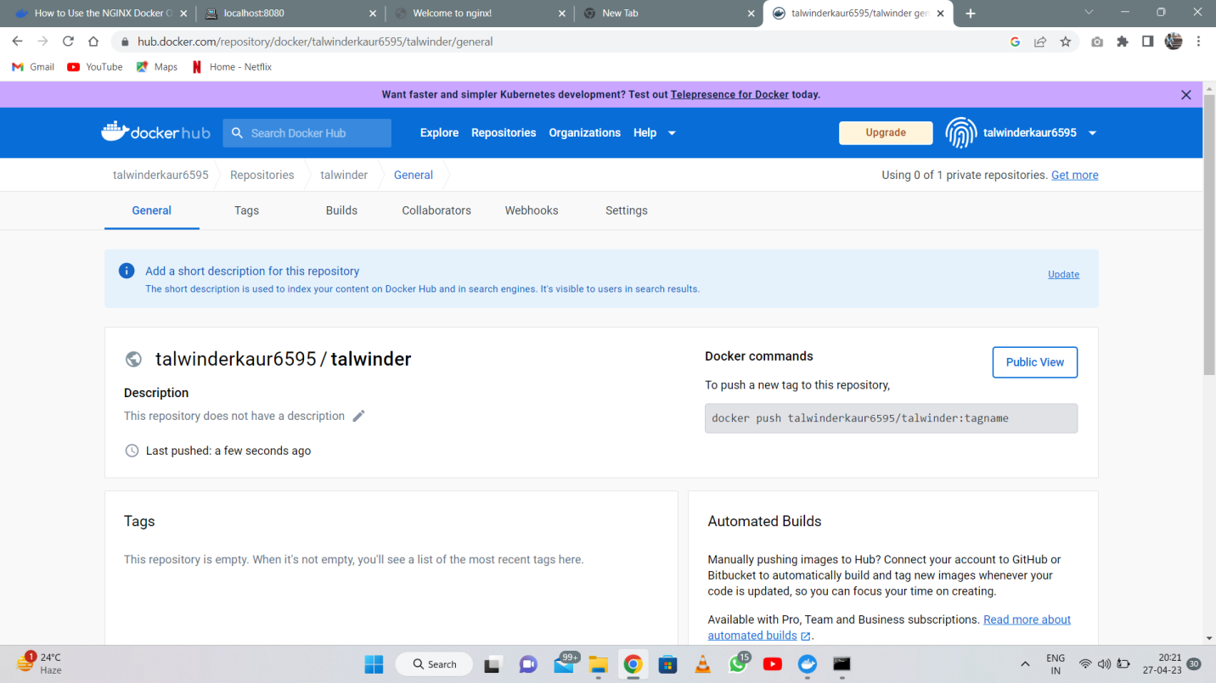

Improved seamless container portability: While Docker containers operate unaffected in any desktop, data centre, or cloud environment, LXC containers frequently use machine-specific parameters.
Updates with a lighter weight and greater granularity: Numerous cycles can be combined into a solitary holder utilizing LXC. Applications can now be developed that continue to function even when one of their components is offline for maintenance or repair.
Automated creation of containers: Docker can create a container automatically using the application's source code.
Container versioning: Docker can log changes made to a container image, revert to a previous version, and discover who made a version and how. The differences between an existing and an updated version might be uploaded.

Container reuse: Base images— templates for creating new containers—can be utilized with existing containers.

Libraries of shared containers: An open-source registry with thousands of containers users contribute is accessible to developers.
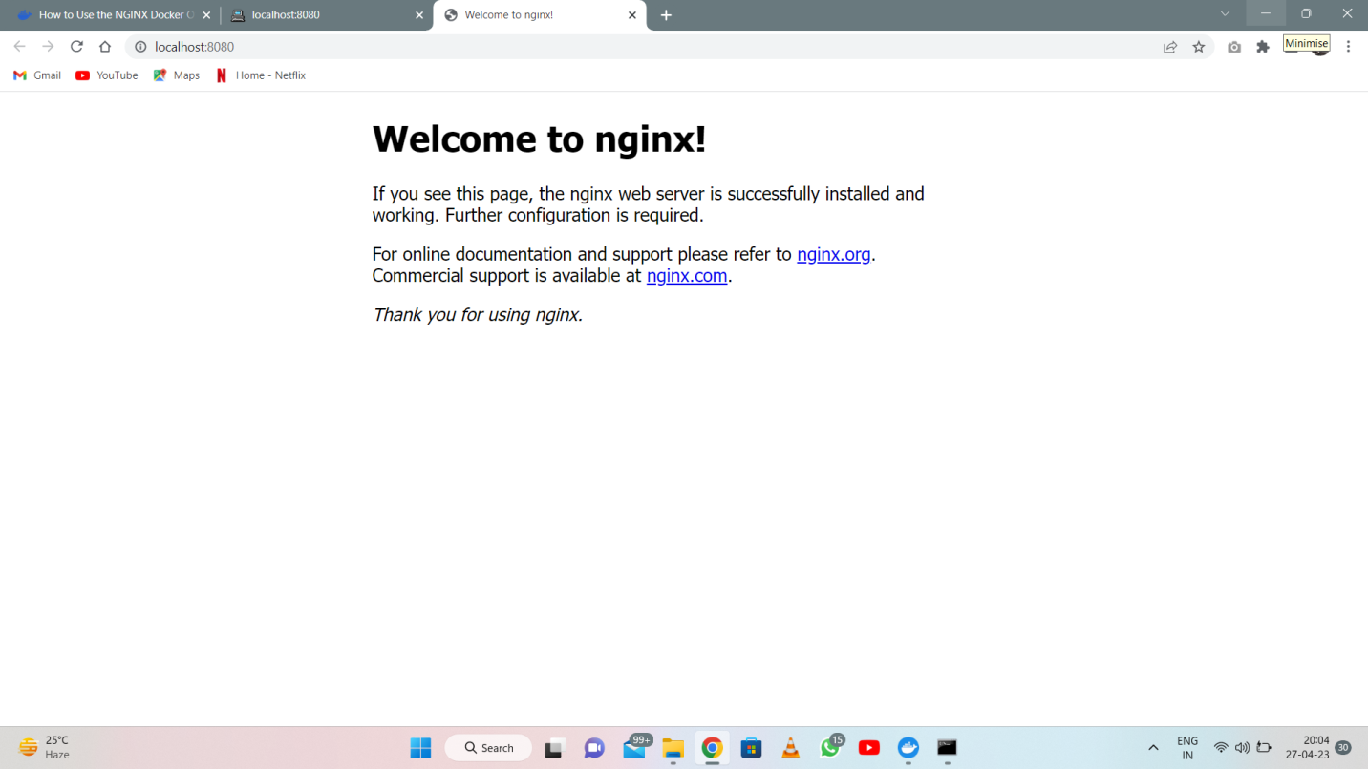

Today Both Apple MacOS and Microsoft Windows are compatible with Docker containerization. Every primary cloud provider, including Microsoft Azure, IBM Cloud, and Amazon Web Services (AWS), offers specialized services to assist developers in creating, deploying, and running applications that are containerized with Docker. Developers can run Docker containers on any operating system.

What is containerization?
The software can be packaged such that it can be run in separate settings using a technique called containerization. The code, libraries, and dependencies required to operate an application are packaged in containers, which are installed on top of the host OS. This implies several containers can share the host operating system's kernel while running on a single objective or virtual machine. Containers offer a variety of advantages, such as the simplicity with which applications may be packaged and deployed, the consistency with which they can function in each environment and the conflict-free operation of numerous apps on a single computer. The deployment, scaling, and networking of containers in a distributed system are managed by container orchestration tools, which are frequently used in conjunction with containers. Kubernetes and Docker Swarm are two standard solutions for container orchestration. [2]

Benefits of containerization
Using containerization has several advantages.
– Portability: It is simple to deploy an application on any system running a container runtime, such as Docker, thanks to containers, which make it possible to bundle an application and all of its dependencies into a single package.2]
– Consistency: Whether an application is being created on a developer's local PC or deployed in a production environment, containers guarantee that it will function identically in any setting.[2]
– Resource efficiency: Virtual machines must have an operating system installed for each one; however, containers are lighter than virtual machines. As a result, more containers can run on a single natural or virtual computer, and scalability in container deployment and management is facilitated.[2]
– Isolation: Applications can run independently of one another on a single system thanks to containers, which provide separation between them.[2]
– Ease of use: Application packaging, deployment, and management are made simple by containerization, and various tools and platforms are available to assist with these processes.[2]
– Security: Because they keep applications apart from one another and the host operating system, containers give an extra degree of protection.[2]

What the portability
Software portability is the ease with which an application can be moved from one computing environment to another. If the effort required to adapt it to the pristine environment is within reasonable limits, a computer software application is considered portable to the unique environment. The significance of the theoretical term 'sensible' relies on the idea of the application and is frequently hard to communicate in quantifiable units.
The expression "to port" signifies changing programming and makes it versatile in dealing with an alternate PC framework. For instance, modifying a program to run in a Linux environment is known as "porting" an application to Linux.
An application's ability to move between environments and platforms is referred to as "portability." To be clear, a computer platform typically only refers to the computer's hardware and software. The much larger computing environment includes the hardware, operating system, and interfaces with other applications, users, and programmers.

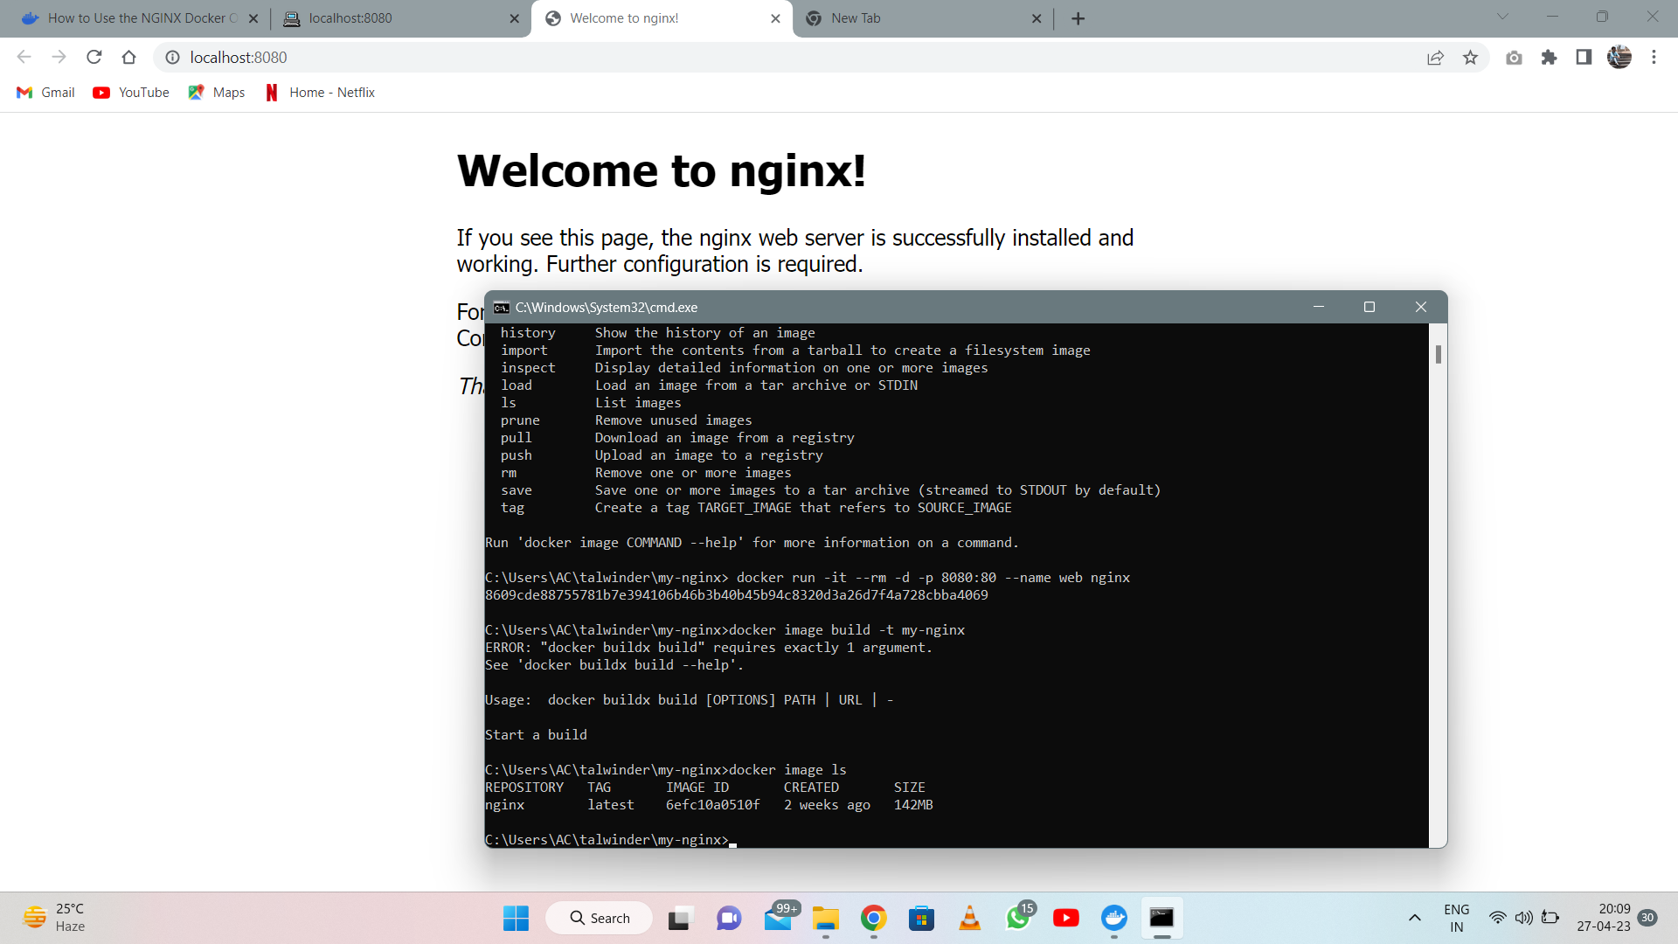

WHAT IS THE CONTAINER IMAGE AND PUBLISH IMAGE?
A packed application, its dependencies, and details about its launch processes are all contained in a container image.

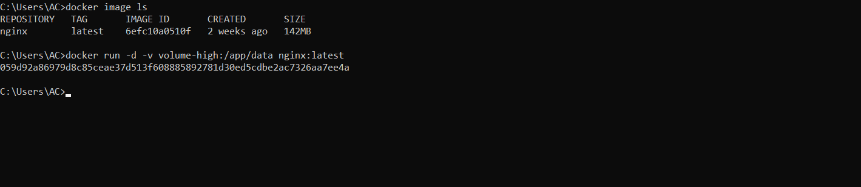

How does that work?
It is crucial to comprehend the following ideas in this order if you want to understand container images:
- Union file systems
- Copy-on-Write
- Overlay File Systems
- Snapshots

Union File Systems (Aufs) The Linux kernel includes the Union File System (UnionFS), which enables the merging of data from different file systems while maintaining the separation of the "physical" data. The data is organized in branches, but the result is a unified file system.

The concept behind this is that if you have numerous photos with the same data, rather than copying it over again, it will be shared through a layer.

Copy-on-write
A compartment hopes to have its own entire document framework when you initially start it. This means that you need a different copy of the file system for each container you run on the system. This would consume much circle space and destroy most of the day to boot the holders. No, a separate filesystem copy is not required for each container.
Images and containers accomplish this by employing a copy-on-write strategy. Instead of copying files, the copy-on-write technique copies the same data instance for multiple processes and only makes copies when a process needs to edit or write data. All other operations would continue to use the original data. Before any write operations are carried out, a copy of the file that will be updated is first placed on the writeable layer of the container.

Overlay File System
Sitting on top of an existing filesystem, an overlay merges the upper and lower directory trees into a single directory. These directories are referred to as layers. The lower layer has remained unchanged. In computing terminology, a union mount is a process by which each layer adds only the difference (or diff) from the layer below it.

Snapshot
s
Containers use layers and graph drivers as part of their container filesystem to build, manage, and distribute changes. However, using graph drivers is extraordinarily challenging and prone to mistakes. Because they are unaware of images or containers, SnapShotters are distinct from graph drivers.

What are the container volumes?
The parent container must be removed using the docker rm -v command (the -v is crucial), or the -rm flag must have been specified when running Docker. Only then are volumes automatically erased. The volume will not be destroyed even if another container does not relate to it. Docker never eliminates volumes connected to user-specified host directories.
Although there are a lot of volumes, it should be reasonably intuitive once you understand the underlying philosophy. Using volumes successfully is crucial for a productive Docker workflow; therefore, it is worthwhile to experiment with the commands until you fully grasp how they operate.

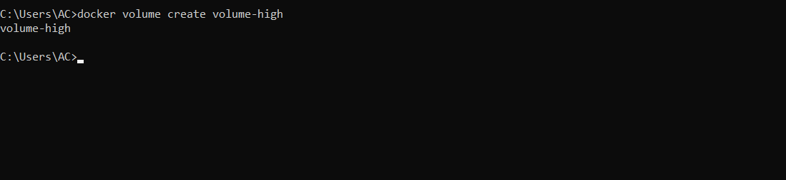
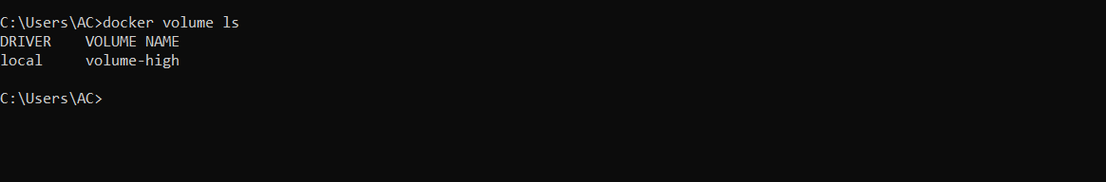

What is container networking?
Container networking, used in web-scale enterprise networking solutions and home desktops, is similar to a virtual machine. A Linux environment with its own users, file system, processes, and network stack is isolated from the host and all other containers inside the container. All running applications can access and modify the container's resources.

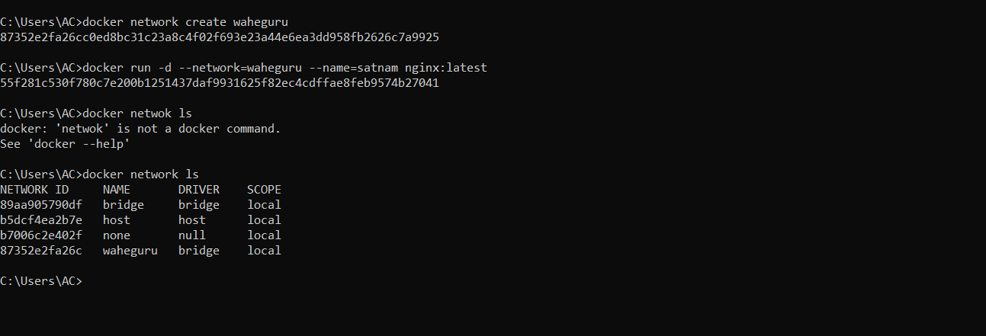

Multiple containers, each with its own installations and dependencies, can run simultaneously. This is especially helpful when updating a dependency for newer versions of an application could conflict with updating dependencies for other applications already running on the server. In contrast to virtual machines, containers share host resources rather than completely imitating the computer's hardware, which results in smaller, faster, and lower-maintenance containers. In web-scale applications, containers were developed as an alternative to virtual machines (VMs) as a platform for deploying microservice architectures.

How Does Container Networking Work?
Virtualization as a container network has distinct distinctions from virtual machines (VM) but is conceptually comparable. Comparing the container method to virtual machines (VMs), a type of hardware virtualization, the former is primarily an operating system virtualization.
Each virtual machine on a hypervisor has its own operating system, programmers, and libraries. It can also use a different filesystem than the host, install a new operating system, encapsulate persistent data, and use a different kernel version.
Then again, compartments are a "running occasion" of a picture, a transient working framework virtualization that twists up to complete a few obligations before being taken out and neglected. Due to the transitory nature of containers, system users run far more instances of them than virtual machines, which require more address space.

Benefits of Container Networking
Run Containerized Applications Close by Existing Jobs: Containerized programmers and traditional virtual machines can be run on the same infrastructure, offering flexibility and speed.

Integrate portability with management, security, and visibility: Containers' inherent nature makes task management, sandboxing, resource transparency with the host, portable execution environments, and increased security possible.
Utilization of your current infrastructure and scale quickly: use your current SDDC to avoid silos and time-consuming and costly infrastructure re-architecture. When multiple departments maintain their IT infrastructure within the same organization, this results in silos. This "silo effect" prevents IT policies and updates from being implemented across the entire organization because of the varying technical configurations found in each department. The costly and time-consuming process of reintegrating silos can be avoided through container networking.
Provide Developers with a Docker-Compatible Interface: An interface compatible with Docker allows developers to create applications in containers, which can then be provisioned using a self-service management site or user interface.
Application Deployments at Scale Using Container Networking
Deployment Ease: Containers can be made ready for deployment by embedding host configuration
Disposable: The setup and disposal of containers are made to be quick. If the host fails, a spare server can be easily added to resume application operation.

Fault-Tolerant: Databases and web servers can easily be redundant by using containers. Copying the same content across multiple node nodes achieves high fault tolerance and availability.
Types of Container Networking
There are five kinds of compartment organizing utilized today; their attributes revolve around IP-per-holder versus IP-per-case models and the necessity of organization address interpretation (NAT) versus no understanding required.
None: The container is given a network stack but disconnected from the outside world. This mode helps assign containers that do not need external connectivity, test containers, and stage a container for a future network connection.
Bridge: Containers enabled for communication with one another and are bridged on the internal host network of the same host. The host must be used to access containers. For Docker containers, the bridge network is the default.
Host: By sharing the host's network namespace, a generated container is given access to all its network interfaces thanks to this setup. Due to the common usage of networking interfaces, this sort of external networking configuration, which is the least sophisticated, is vulnerable to port disputes.
Underlay: Underlays are more effective than bridges since they do not require port mapping and open the host interfaces directly to containers executing on the host.
Overlay: When containers are hosted on different hosts, overlays use networking tunnels to communicate between them and make it appear as though they are on the same machine.

In cloud computing, what is load balancing?
Workloads and computer resources are divided among at least one server using cloud load balancing. This distribution style ensures the best performance with the quickest response time. Two or more servers, hard drives, network ports, or other computer resources are divided to better use resources and reduce the time spent reacting to system operations. Therefore, effective cloud load balancing may ensure that a website with high traffic continues to operate.
The phrase "load" refers to various factors, including server storage capacity, CPU load, network load, and website traffic.
Thanks to load balancing, every machine in the network is guaranteed to get a comparable amount of load at some arbitrary moment. They are all equally exploited and not in any way overworked as a result.
The load balancer distributes data based on each server or node's activity. The client will have to wait for his operation to be finished without a load balancer, which could be too taxing and demoralizing for him.

OBJECTIVES OF LOAD BALANCING

The following are the primary goals of load balancing:
1. Managing and regulating traffic peaks on a single server
2. Improving user request response times

BENEFITS OF LOAD BALANCING
High-Performance Applications: Cloud load-balancing strategies are more affordable and straightforward to implement than their traditional local counterparts. Businesses could lower their costs while improving the speed and performance of their customer apps.

Improved scalability: Cloud balancing help maintain the scalability and agility of website traffic. With efficient load balancers, you can easily match rising user traffic and spread it across multiple servers or network devices. It is significant for websites that handle thousands of internet users every second. Such efficient load balancers are required to distribute workloads during sales or other promotional activities.
Ability to handle spikes in traffic: During any result announcement, a normally operational University site could completely go down. This is because there is a chance of getting a lot of requests. If they use cloud load balancers, they will not need to be concerned about traffic spikes. Whatever the request's size, it can be thoughtfully distributed across several servers to produce the most outstanding results quickly.
Continuity with complete flexibility: Establishing a load balancer aims to protect or save a site from unexpected failures. When distributed over numerous servers or network units, the workload can be transferred to another active node even if one node fails.

What is the scalability of cloud computing?
Scalable cloud architectures can now be built thanks to virtualization. In contrast to actual machines, whose resources and performance are primarily fixed, virtual machines (VMs) are incredibly adaptable and easy to scale up or down. Applications and workloads can be hosted on multiple servers simultaneously or moved to larger virtual machines as needed.

In addition, small businesses need help to scale rapidly or profitably. The enormous hardware and software resources required to accomplish this already exist with third-party cloud providers.

ADVANTAGES OF THE CLOUD SCALABILITY
Businesses of all sizes are adopting the Cloud due to its significant advantages in terms of scalability:
Convenience: With just a few clicks, IT managers can frequently add additional VMs that are immediately accessible, tailored to the requirements of a particular organization, and ready to use. As a result, IT staff members can save time. Groups can chip away at different activities instead of going through days and hours setting up genuine equipment.
Flexibility and speed: IT can quickly respond to changes in business needs, including unexpected increases in demand, thanks to cloud scalability. Significantly more modest organizations can now use powerful assets that were beforehand too far because of cost. Because it is simple to update systems and increase power and storage, businesses now rely on out-of-date hardware.

Cost savings: Organizations should avoid causing the forthright expenses of purchasing costly hardware that can become outdated in a couple of years because of cloud versatility. By only paying for what they use through cloud service providers, they cut down on waste.
Disaster recovery: By doing away with the need to construct and manage additional data centres, scalable cloud computing allows you to lower disaster recovery expenses.

What are the application gateways?
Web application security is provided via an application gateway. They replace conventional online apps, which demand the same login information as the data centre. Instead, consumers use mobile apps and cloud services to access application gateways using their login information from the app.
The modern worker who frequently works from home or on the go has a solution in application gateways. Users need to access programmers that data centres and cloud solutions host, whether they are working on a laptop, smartphone, or another device. As VPNs (Virtual Private Networks) also aid in security against unauthorized access, several firms employ them. VPN (Virtual Private Network) maintenance, though, can be expensive.
An application gateway is a simple-to-install alternative that does away with the requirement for a VPN. Software programmers known as app gateways provide the same level of security as VPNs (Virtual Private Networks) without requiring configuration changes. They can be utilized in corporate data centres and standard servers.
Instead of using specialized endpoint protection, application gateways use conventional SSL encryption to safeguard corporate data moving over the internet.

Application Gateway background
With an Application Gateway installed, your network system is completely protected. What is the true goal, and why do you actually require one? First, customers must connect to the server to request database resources. To reach the primary server, the consumer must go even one more step as a result. The server's firewall is home to the Application Gateway. This safeguards the client's data for storage by maintaining the security of their IP addresses and other sensitive information.
Without the client's assistance or knowledge regarding the IP address, the Application Gateway and external computer operate. The truth is that two different connections are active at once, one between the client and the server. The second is situated in between the server and the last endpoint.
When everything is set up correctly, the server will ultimately make the decision. This is because computers that are secured by a firewall are safe.

ADVANTAGES

Numerous advantages exist. You get the same result as a firewall because of its filtering abilities. With assistance, information may also be kept secret from the network, and the authentication feature is fully protected to the required level.
The user is to be provided with a detailed login traffic itinerary from the Application Gateway that shows everything that enters and leaves the network. When you dissect this power, you have a complete record that can document any malicious efforts to hack into the network. With the Application Gateway installed, it is easier to determine when or how a break-in attempt was undertaken with this helpful functionality.

DRAWBACKS

The minuses accompany the pluses. An Application Gateway may have a slower impact than a packet filter. Additionally, taking it a step further, only some available connections can support this type of technology, which results in a less effective result. Ultimately, your business will benefit significantly more from having an Application Gateway than from not having one.

REFERENCE LISTS

- Patil, Prajakta, and Chiradeep BasuMallick. “What Is Cloud Computing? Definition, Benefits, Types, and Trends.” Spiceworks, 9 Feb. 2022, www.spiceworks.com/tech/cloud/articles/what-is-cloud-computing/.
- Peterson, Richard. “What Is Cloud Computing? Examples, Types & Benefits.” Www.guru99.com, 2 Jan. 2020, www.guru99.com/what-is-cloud-computing-with-example.html.
- “What Is Cloud Architecture? Benefits & Components.” Google Cloud, cloud.google.com/learn/what-is-cloud-architecture#:~:text=Cloud%20architecture%20refers%20to%20how.
- IBM. “What Is Docker? | IBM.” Www.ibm.com, 25 Apr. 2023, www.ibm.com/topics/docker.
- Sarkar, Taniya. “The Complete Guide to Cloud Containerization.” Cyfuture Cloud Blog, 9 Jan. 2023, cyfuture. Cloud/blog/all-you-need-to-know-about-cloud-containerization/. Accessed 23 Apr. 2023.
- Rouse, Margaret. "What Is Portability? - Definition from Techopedia.” Techopedia.com, 18 Aug. 2011, www.techopedia.com/definition/8921/portability.
- Velayudhan, Nived. “What Is a Container Image? | Opensource.com.” Opensource.com, 31 Aug. 2021, opensource.com/article/21/8/container-image. Accessed 28 Apr. 2023.
- Mouat, Adrian. “Understanding Volumes in Docker.” Blog.container-Solutions.com, 9 Dec. 2014, blog.container-solutions.com/understanding-volumes-docker. Accessed 28 Apr. 2023.
- VMWARE. “What Is Container Networking? | VMware Glossary.” VMware, 17 Dec. 2021, www.vmware.com/topics/glossary/content/container-networking.html.
- Ms Shalini Joshi, Dr Uma Kumari “Load Balancing in Cloud Computing: Challenges & Issues,” Conference: 2016 2nd International Conference on Contemporary Computing and Informatics, DOI:10.1109/IC3I.2016.7917945.
- Muhammad Asim Shahid, Noman Islam, Muhammad Mansoor Alam, Mazliham Mohd Su’ud, Shahrulniza Musa, "A Comprehensive Study of Load Balancing Approaches in the Cloud Computing Environment and a Novel Fault Tolerance Approach.” DOI: 10.1109/ACCESS.2020.3009184
- VMware. “What Is Cloud Scalability? | VMware Glossary.” VMware, 23 Mar. 2022, www.vmware.com/topics/glossary/content/cloud-scalability.html#:~:text=Cloud%20scalability%20in%20cloud%20computing.
- Brown, Schuyler. “What Is an Application Gateway (App Gateway)? | StrongDM.” Discover.strongdm.com, 31 Oct. 2022, www.strongdm.com/what-is/application-gateway. Accessed 24 Apr. 2023.
- Siegel |, Camille. “Application Gateway | Definition and Benefits of an Application Gateway.” Axway Blog, 31 July 2019, blog.axway.com/learning-center/digital-security/risk-management/application-gateway. Accessed 24 Apr. 2023.

