INTRODUTION:
JOSEPH BANGURA
09/08/2019
EFFECTIVE TEAM WORKING AND COMMUNICATION
(BMSK4002 LON)
LECTURER: DR. NAVAMI SUDARSAN

WHAT IS COMMUNICATION?
Communication is commonly used in the workplace, organisation and the environment. This is the way of exchanging information in the form of messages, signs, opinions, thoughts and eye contact. Communication of information like messages, opinions and speech can be done in a modern way through the internet, telephone and mobile. The way by which we can communicate to each other is speaking (Kinnick and Patron,2005).
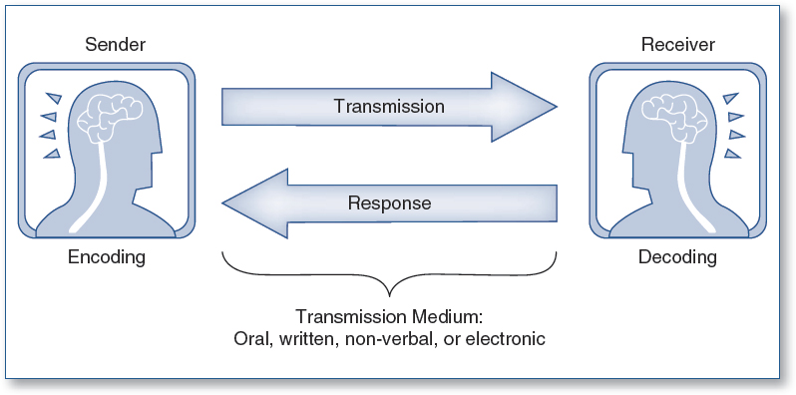
.

Methods of communication:
verbal communication includes sounds, words, languages and speaking. Good communication in the work place is about effectiveness in making ideals clear. Most workplaces require those who are competent in writing, computer literate and able to read etc. Verbal skills are an inseparable part of business communication. In a company or business, you come across people from various ages, cultures, and races. Fluent verbal communication is very essential to deal with people in business meeting. Moreover, in a work place self-confidence plays a vital role because fluent and clear communication skills can lead to success.
Non-verbal communication: This communication involves physical ways of communication such as tone of voice, touch, smell and body motion. Also, symbols and sign language are also including in non-verbal communication. Body language is also non-verbal; this contact conveys a lot of information by communicating verbally to someone. Another example of non-verbal communication is physical contact, like, shaking hands, pushing, eye contact, facial expressions all these are different ways of communication.
Written communication: Written communication is writing the words which you want to communicate. Good written communication is essential for business purposes. This communication is practiced in many different languages like E-mails, reports, articles and memos which are some of way of using written communication in the workplace. Moreover, written communication is also used for informal communication purposes like mobile SMS.
Visual communication: Visual communication is the visual display of information e.g. topography, photography, signs symbols and design. This kind of communication is used in advertising. Communication work effectively with Management and employees on the purpose of respect. Good communication at the workplace must identify the different methods of communicating with others, observation skills can overcome certain barriers in communications by listening. Use appropriate verbal and non-verbal communication skills. We consider ourselves a visual communication, because we really like to focus on telling our story through visual content, we personally believe that visual storytelling is an balance of visual communication or a product of visual communication in fact, there are 2 main products of visual communication visual storytelling, information visualization visual storytelling is about providing a full narrative through visual content where you really taking somebody through a beginning middle and end. Information visualization is about presenting the information in a visual way without providing any conclusions and instead of letting the viewer come to their own conclusions, but what is visual communication in the 1st place, visual communication graphically represents information to efficiently and effectively create meaning, now here's the real key with visual communication when necessary limited text is used to explicate the meaning what we mean by that is you should not have to rely on the text to understand the visual, instead the visual should always speak louder than words, so for example think about the caution wet floor sign that sign on its own without the words caution wet floor, let you know immediately you could slip you could break your back, you could hurt yourself really bad if you go across that floor that's wet just by looking at the image you know that you do not have to read the words caution wet floor to understand that is visual communication, now when you combine that very good icon that ends up being a universal image and you combine that universal image with short form text like caution wet floor you actually can increase understanding by 90 percent, and This is why visual communication is so powerful infographics take universal iconography and combined that iconography to tell a story or to get information across motion graphics that are produced very well through the exact same thing, any type of visual communication that you are focusing on should rely entirely on telling the story with visuals.

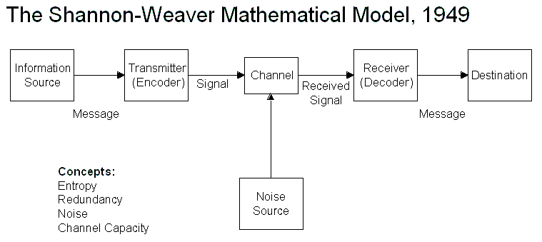 Different communication models:
The Shannon-Weaver Mathematical Model,1949, explained the fundamentals of communication and other messages, the first element is the sender. The second element is the message, now the message is the information that needs to be transmitted the third element is encoding, this could be the language choice of words or even speech and clarity. The fourth element is the channel, now this is the medium on which the messages is transmitted, in the user services environments, this could be over the telephone over online chat or even via email before the message gets to the recipient's it needs to be decoded. Now this is the fifth decoding is the understanding that the recipient places on the message. The sixth element is the recipient, now in order for the message to be received by the recipient in the manner in which it was intended to be sent by the sender, there needs to be a feedback loop and this is the seventh element, the feedback loop is continuous and happens from sender to receiver and back from receiver to sender, also take note that it is the sender's responsibility to be understood in a manner in which they have intended to be understood. This will then in turn alive with the receiver who will then become the sender and on and on the process goes (Weaver,1949).

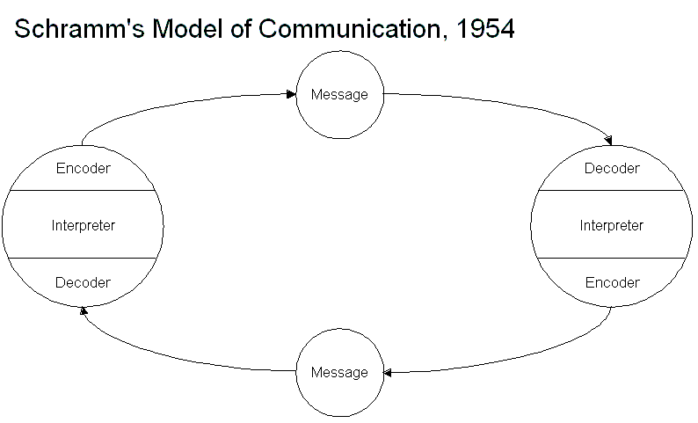
Schramm’s Model of communication explained the model of communication made by Oscar and scrapped, for example you want to text your friend, hello you want to eat out later? inviting him for lunch is the message we want to tell him, second is the encoder, the encoder is a person who sends the message and where the message originates from, raising the previous example since you are the one who sent the message you are the one who is entitled to be the encoder, the decoder is the person who receives the message. In this example if your friend is the person who received the message as the message was addressed to him, he is the decoder when your friend replies to, you become the decoder. Lastly, we have the interpreter is the one who tries to analyse an understanding, as you may be wondering why three rules are there when there are only two people talking. This shows that communication is circular in modern nature (Schramm1954).

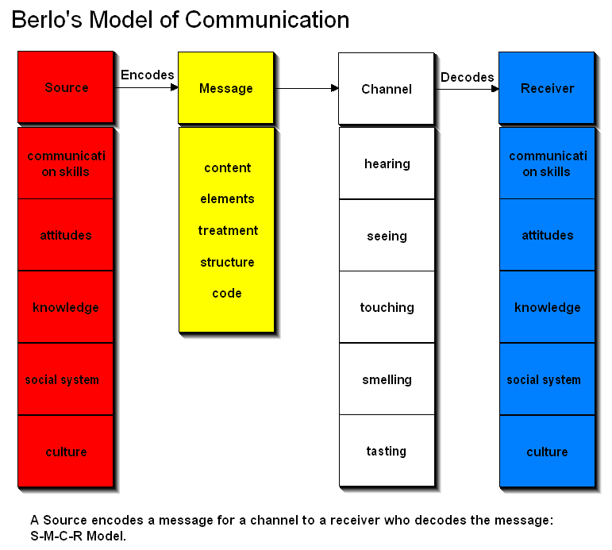
Berol’s Model of Communication by David Kenneth Berol (1960), this model of communications suggest that the speaker is the one who drives the entire communication, the Berol’s model of communication considers the emotional aspect of the message the variables models operates on the SMCR model. David Kenneth Barlow wrote the process of communication in his book, he focused on the purpose and objectives of communication and creative Berol’s model of communication, which he developed from Shannon and this model includes verbal and non-verbal communication, it also considers the emotional aspect of the message here's, Berol’s SMCR model of communication you have the source, the message channel and the receiver.
The 4 factors of the SMCR model Berol’s (1960), The Sender-person who originates the message. The Message-the content that is being communicated. The Channel-the medium being used to transmit the message. The Receiver-The person who the message is directed to. the sender he's the one that transfers information through the receiver after putting thoughts into words how does the source transfer is information to the recipient, it's done with help of communication skills attitude knowledge, social system and culture, next to your message when an individual converts his thoughts into words and a messages is created the process is also , encoding, channel send through the medium of how the information flows from the sender to the receiver. All the 5 senses are the channels which help human beings to communicate with each other, finally we have our receiver with the message reaches the receiver he tries to understand what the listener wants to invade, and then response accordingly this is also called as decoding. The problem for this model, first there's no feedback, doesn't mention any barriers to communication, known or noise or it's a complex model because it is a linear model for communication, but it needs People to be on the same level of communication to occur (Berlo1960).
COMMUNICATION IN MY WORKPLACE
The importance of effective communication. I was working with my supervisor one evening at a building site, and we are using the mobile tower to work on height level fixing some lights bulbs and cabling, He was on top of the mobile tower about Ten metre height and we are subsequently busy, we do not even have time for break. Because of the noise at the site communication was very bad and he came from different culture and country just like me. After more than two hours from our brake time, my supervisor said to me brake, that what I really heard, not knowing that to release the mobile tower it brakes so that he can move to another place of work. I did not receive the communication well or feedback, I just went to the toilet and wash my hands and I went to the shop, and I started to wonder why that my Supervisor told me to go break and he does not suppose to work alone because of health and safety reason at the workplace. He tried to call me on my mobile phone, but he cannot reach me because of the poor reception in the building, so when I returned to work, I did not see him at all, I to the Canteen and the smoking area he was no there. When I was coming back, I saw him towards the entrance very angry sad that you know you have to tell me if you want to go anywhere, I said to him, you told me to go for break. He said that “no I did not say that you have to go for break I said release the brake from the mobile tower” I said sorry to him because I only heard break, he accepted my apology with a verbal warning. I should have used the Shannon Model of communication the feedback loop.
The Challenges or problems of communication in workplace. The words you use, the tone you express the words in, speaking in a high or low voice and extremes voice can have negative impact on communicating. Poor insight posture, position in body language, behaviour, not listening, having to conversation at the time and interrupting. Other people’s conversation in the background, notices such as music, TV, someone on his telephone on in the background and one or two people trying to attract your attention at the same time. Not actively listening to what is being said, not asking enough questions to clarify the information, different in preferred language culture, intimidating to make someone feel uneasy and uncomfortable.
Solutions to solve the challenges/problems of communication workplace by make sure you aware of any cultural or religious practices of individuals before communicating, take your time when speaking, use language that will be understood and acceptable, speak calmly with an approachable tone. Do not swear, use aggressive or abusive language even frustrated, always ask if an individual has understood or happy with what you have said or if they have questions. And finally ask for constructive feedback from your managers, supervisors and your lecturers on your communication skills. Reflective practice helps to improve communication skills should similar situation arise in future.
Conclusions:
Good effective communication with your peers, family and your workplace, your skill contribution and actions can help to improve your organization and workplace. Communication breakdown as a result of many communication barriers that be credited to the sender or receiver. Without good communication nothing can be achieved, therefore, developing communication skills is a must. One must understand that all these forms or types of communication are very important, and one must develop communicative skills in all the medium. Communication is also important, because choosing the wrong medium undermines the message.

REFRENCES:
Kinnick, K.; Parton, S., (2005). Workplace Communication. Business Communication.
Careers-Communication Skills, (2019). Communication Skills for The Workplace. Available at: (https://www.thebalancecareers.com/communication-skills-list-2063779).(Accessed: 20th August 2019).
Skills you need (2011-2019), Communication Skills. Available at: (https://www.skillsyouneed.com/ips/communication-skills.html), (Accessed 21st August 2019).
Shannon and Weaver Model of Communication (1949), Models of Communication. Available at (https://www.businesstopia.net/communication/shannon-and-weaver-model-communication. (Accessed 22nd August 2019).
(Berlo1960), Model of Communication. Available at: (https://www.businesstopia.net/communication/berlo-model-communication), (Accessed 22nd August 2019).
(Schramm1954), Model of Communication. Available at: (https://www.managementstudyguide.com/role-of-communication-barriers-in-ineffective-communication.htm), (Accessed 22nd August 2019).
Study.com (2003-2019), Visual Communication. Available at: (https://study.com/academy/lesson/what-is-visual-communication-definition-history-theory-examples.html). (Accessed 23rd August 2019).



