Research in Context
Can Graphic Design really save your life?

Student Name: Jake Smith
Student Number: 2317131
Graphic Design and Visual Communications
Tutor Name: Donna Williams
Word Count: 2286
In a world fraught with challenges, graphic design emerges as both a beacon of hope and a potential double-edged sword. It serves as a ray of hope, offering creative solutions to pressing problems, exemplified by the compelling stories of Stephen Doe's mural and Biman Mullick's impactful posters. These instances vividly demonstrate how graphic design can spread crucial information, foster positive behavioural shifts, and strengthen communal bonds. Yet, as we marvel at its potential for good, we cannot ignore its darker manifestations throughout history. The propaganda machines of regimes like the Nazis and Soviet Russia stand as stark reminders of graphic design's susceptibility to manipulation and misuse. Thus, as we ponder the question of whether graphic design can genuinely save lives, we must also confront the unsettling reality: Can it, with its persuasive visual rhetoric, be harnessed for malevolent ends, perpetuating injustice and tyranny, shaping perceptions and controlling narratives in destructive ways? The potential of graphic design is not just limited to its aesthetic potential. It can be used as a very good tool for social change and engagement.
Ebola
One suitable example would be of Stephen Doe’s mural illustration used in Africa to inform communities of the deadly disease Ebola. In 2012 a street artist named Stephen Doe created a piece of extremely considerate art at the height of the Ebola outbreak which spread to five different countries and killed an estimated 2,300 people in Africa. (sites.northwestern.edu, n.d.) Stephen had recognized that many African communities struggle with literacy skills. His plan was to be able to contribute to these communities by creating a design that can enable people to visually educate themselves with crucial knowledge of how to stay safe from the symptoms of Ebola without the need of written instruction. This highly considerate piece of design not only allowed local people to stay safe but also allowed the community to be largely involved with the creation of the mural, allowing people to build a greater sense of collaboration within the community allowing them to become more aware of this illness together in a way that includes everybody, spreading the message further. Furthermore, Doe’s murals message was adapted and spread through other mediums such as flyers, posters and other print forms reaching a much larger audience than what was originally expected by Doe, this allowed many more people to become aware of this illness that not even Stephen would have initially would have predicted when planning his mural (Gorvett, n.d.) The legacy of this piece of work has allowed for more considerate thought around providing information for many people who are not capable of interacting with written language and highlighting this issue of non-literacy to others who could potentially be inspired by this message. As well as being an inspiration to any future designers focused on driving community empowerment and ultimately cultural change within the graphic design field to create a world that is enriched though lifesaving design that provokes emotion.
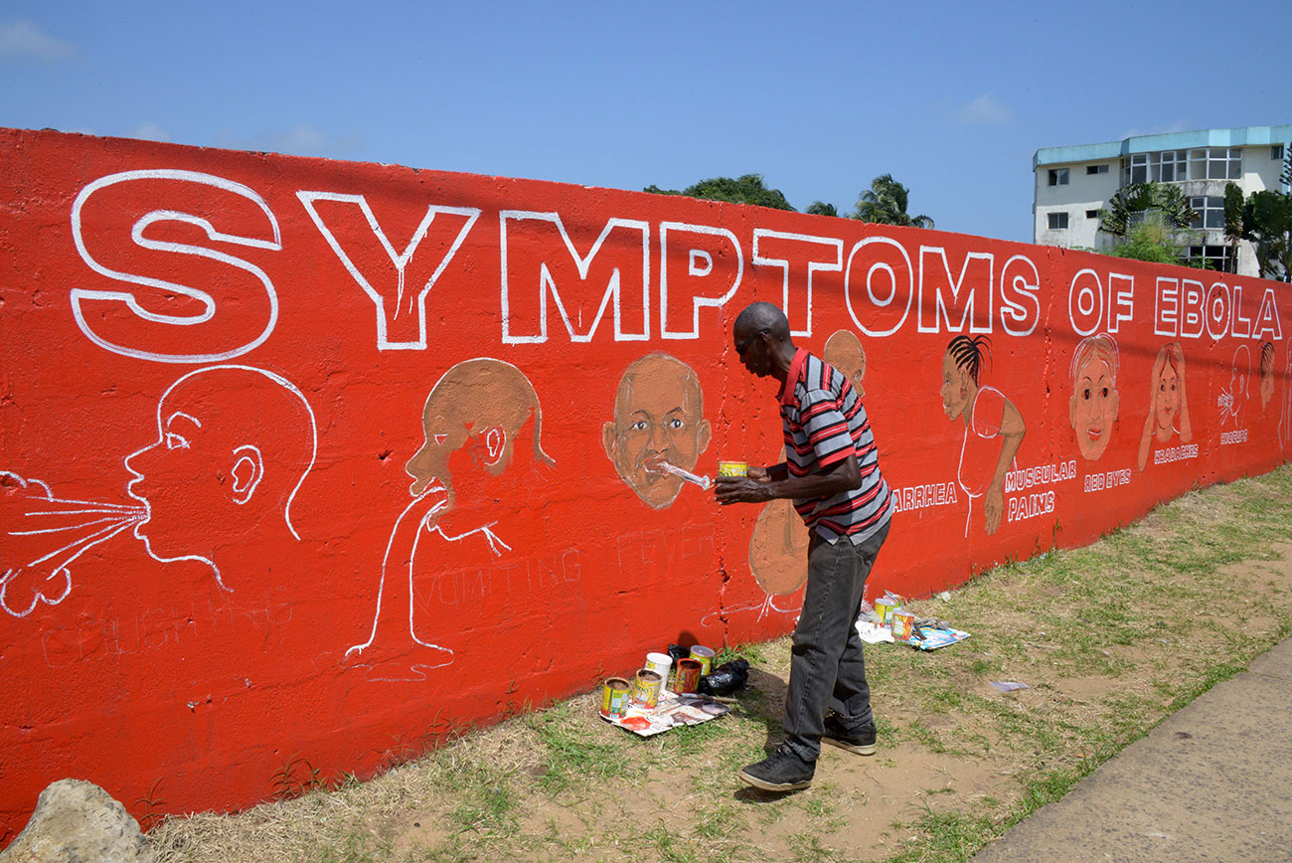 [1]
CleanAir Campaign
Following on from the example of Stephen Doe I would like to highlight the work of designer Biman Mullick who throughout the 1970s and 80s designed and distributed anti-smoking posters at a time where there was not a lot of pre-existing anti-smoking materials available to the public. During the 70s Mullick was working as an art teacher in England when he started considering the dangers of second-hand smoke and what could be done to spread this message of discouraging adults to not smoke around others in his work (Creative Review, 2017). Mullick had never been a smoker himself but became ever increasingly concerned about the dangers that smoking caused others potentially without even having to smoke cigarettes themselves. Smoking indoors in the 70s had yet to be criminalised meaning that the damage of second-hand smoke was much more of a danger to non-smokers who didn’t have the luxury of sitting in smokeless environments whilst cigarette smoking was at an all-time high sitting at around almost half of the UK adult population choosing to smoke cigarettes. Medical experts had found many links between the habit of smoking and developing cancer later in life but little known were the effects of second-hand smoke, thus inspiring Mullick’s work in raising awareness of the dangers of second-hand smoke. Mullick first started working on his anti-smoking posters whilst working as an art teacher eventually printing them in black and white and distributing the materials throughout the college he worked, this act was seen as rebellious by the head teacher at the college as during the time no laws against smoking in classrooms had been established and he deemed smoking a part of British culture. When looking back on his work at the college he believes that the posters he distributed around the college potentially cost his visiting lecturers contract to not be renewed by the college. The negative backlash from the college may have cost hm his contract by did not deter him in his mission of spreading anti-smoke messages through his work. Mullick later when on to found the anti-smoking organisation, CleanAir, which is an organisation that works towards their mission of a smoke free environment and continuing to spread the anti-smoking message. While now it is easy to see that Mullick’s campaign had nothing but pure intent to help people lead healthier lives often spending his own money to distribute materials, it was at the time mired in controversy by smokers as he was seen to be trying to take away the rights of smokers to smoke indoors and that the idea of passive smoking being dangerous was seen as quite a stretch of the imagination for the smoking population though this has never been the case some even debate second hand smoke could be more dangerous (Arcury et al., 2020). Mullick received a medal from the WHO for his posters that highlighted the dangers of smoking in a way that delivered a strong message in a way that is humorous and polite. He stopped campaigning against indoor smoking in 2006 after the UK criminalised indoor smoking across the board, Mullick has said that he never had known whether his posters inspired the change in the law but likes to think that it may have inspired people to think twice before smoking (Graphic Design, 2017). When I was researching Mullick, I found it interesting to observe just how humble and polite this designer was when creating such serious thought-provoking works that helped foster widescale change in his country. Mullick’s work whilst being one of the earliest anti-smoking campaigns remains untouched in its impact of spreading a message that ultimately could save countless lives whilst not being pushy and fearmongering which is a very common tactic of anti-smoking campaigns today, preferencing images of illness and warnings of death to deter the ever-aging population of smokers. I personally found this example inspiring due to the fact Mullick worked towards his vision of a smoke free society all the while not really knowing if he was making successful change or not, even after the legislation change in the UK working tirelessly to spread a message that he believed would truly change peoples lives though his designs. Alike Stephen Doe’s work, Mullick’s work visually demonstrated the dangers of smoking using visual stimuli that was simple and very easy to understand furthermore the work reached a far bigger target audience than expected when setting out on their designs dues to them being so accessible to any end user due to power of informative visual graphics.

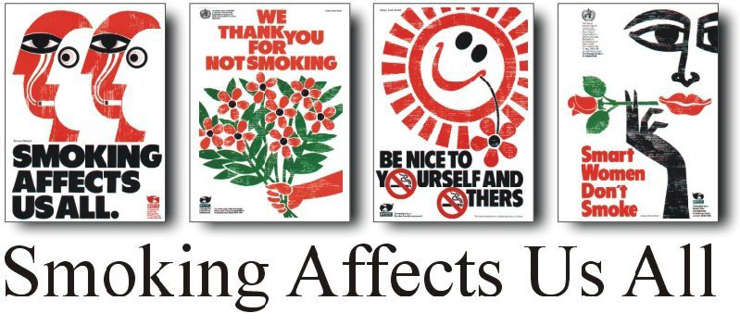[2]
Propaganda
As we have seen withing the previous 2 examples that used visual graphics as a tool to improve the lives of others through forward thinking designs. Graphic design has unfortunately been used to convey negative messages that have been used to break down communities of people. As strong as a force as graphic communication can be for the world there are also notable examples of it being used negatively to back up the opinions of very dangerous people, notably the use of propaganda by regimes such as the Nazis during WW2 as well as Russian Soviets in the 1920s. Propaganda by definition of Oxford Dictionary is ‘information, especially of a biased or misleading nature, used to promote a political cause or point of view.’ (www.oed.com, n.d.) and has been used throughout modern history to dictate the opinions of the masses by showing compromising visuals of whoever the enemy was to the regimes creating it, most of the time spreading misleading information designed to humourize the enemies downfall. In the case of the Nazis, most propaganda created was used to portray a negative image of Jews as to further justify the Nazis vast genocide and to rally support for the horrific acts committed towards the Jewish population of which approximately 6,000,000 died at the hand of the Nazi regime (United States Holocaust Memorial Museum, 2023). The soviets differed in their used of propaganda mainly distributing materials that would display how dangerous capitalism was for the world at a time of famine that ultimately lead to the loss of an estimated 1-10 million of the Russian population to the harsh famine in Soviet Russia between 1921-1922 with the most like estimate of deaths being around the 5 million mark (warwick.ac.uk, 2023). These examples of propaganda are important to reference as these graphically designed posters likely had large influence on the public during these times allowing negative ideas to spread. We’ve seen in our previous examples that the power of graphic design can be used for incredibly important change in the world whilst at the same time if unchecked can allow dangerous messages to be distributed at the detriment of others. It is often debated that designers during the periods of the Nazis and Soviets likely had little to no choice in how their talents would be used and were likely exploited due to the threat of death or career shutdown. An example of this would be the shutdown of the Bauhaus in Germany (Bauhaus.de, 2019). The Bauhaus, an immensely influential art institution, encountered the challenging task of moving to Berlin due to strong opposition from the Nazi regime. This forced relocation not only demonstrated the institution's resilience but also highlighted the oppressive forces that aimed to suppress creative freedom. Sadly, the increasing pressure from the Nazis ultimately resulted in the closure of Bauhaus by the end of the war, emphasizing how the arbitrary decisions of authoritarian governments could severely impede the careers and even endanger the lives of designers and artists. This historical event serves as a stark reminder of the significant power held by those in positions of authority and the serious repercussions that can arise when artistic expression clashes with political beliefs. (Bauhaus.de, 2019)
Given these historical lessons, it is crucial for modern designers to contemplate the ethical implications of their work. Every design choice has the potential to either support or undermine core values and principles. Therefore, designers must act conscientiousness and integrity in their creative pursuits. Today, designers have a wide array of tools and platforms to express their personal values and advocate for causes they believe in. By aligning their designs with ethical standards and societal values, designers can contribute to a more inclusive and fairer world. In essence, the legacy of Bauhaus serves as a poignant reminder of the ongoing struggle between artistic freedom and authoritarian influence. By recognizing and learning from such historical moments, designers can empower themselves to use their skills in ways that not only reflect their values but also benefit society. Through ethical design practices, designers can harness the transformative power of art to inspire positive change and promote a more equitable and compassionate world.
2 Examples of Soviet era propaganda
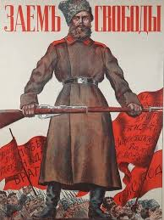[3] 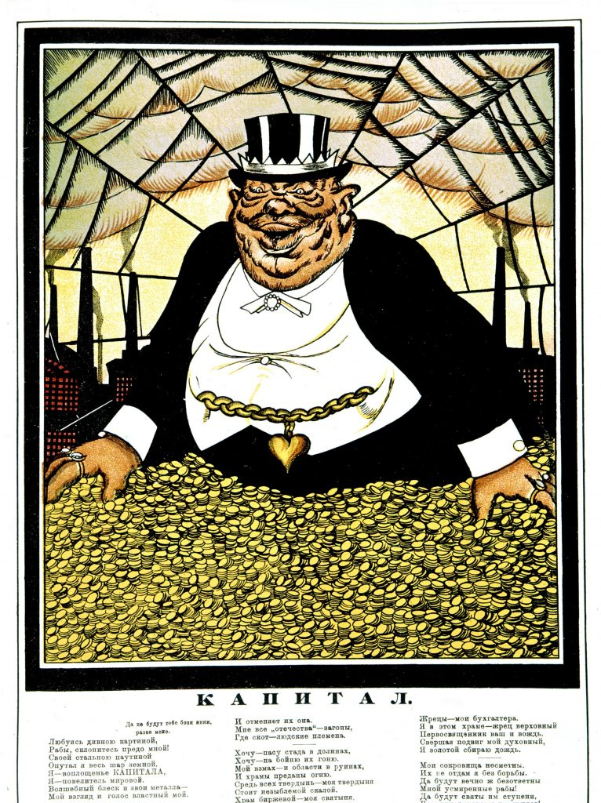[4]
2 Examples of Nazi era propaganda
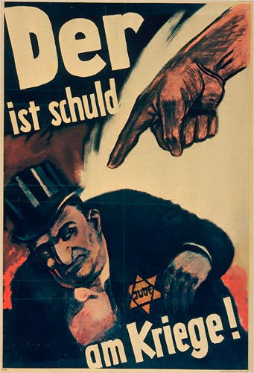 [5] 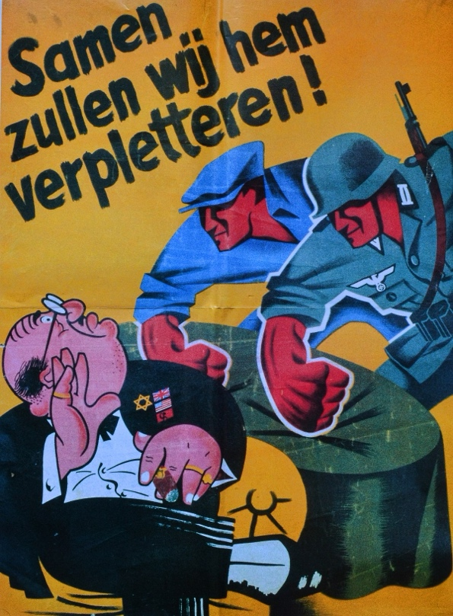 [6]

In reflection of the crucial role of graphic design in preserving lives, the accounts shared by Stephen Doe and Biman Mullick resonate with a positive impact. Their innovative creations showcase the influential capacity of graphic design in addressing public health emergencies, promoting awareness, and advocating for change. While we commend these achievements, it is essential to recognize the ethical obligations that come with wielding such influence. Graphic design, renowned for its ability to convey intricate concepts with clarity and effectiveness, possesses significant potential in shaping behaviours, attitudes, and societal standards. Designers have utilized their expertise in various fields, from health campaigns to social justice initiatives, to amplify marginalized voices, challenge dominant narratives, and inspire collective efforts. The enduring legacies of Stephen Doe's Ebola mural and Biman Mullick's anti-smoking posters stand as proof of graphic design's enduring impact as a catalyst for social transformation and empowerment.

Nevertheless, amidst the acknowledgment of graphic design's life-saving capabilities, it is imperative to remain vigilant against potential exploitation and manipulation. History reminds us of the harmful consequences of propaganda, where graphic design was misused to incite discord, spread hatred, and justify atrocities. As stewards of this influential medium, designers bear a weighty responsibility to uphold ethical standards, foster inclusivity, and advance the common good.

In navigating this intricate landscape, designers are urged to practice their craft with integrity, compassion, and foresight. By embracing ethical values and prioritizing community well-being, graphic designers can genuinely make a difference in saving lives through their designs. As we envision a future where design serves as a beacon of hope and healing, let us embark on this journey with humility, accountability, and steadfast commitment to the greater good. When entrusted to conscientious creators, graphic design transcends its superficial beauty, emerging as a potent force for positive change. Through thoughtful collaboration, innovation, and continuous learning, designers can harness the power of design to tackle complex societal issues, inspire meaningful connections, and shape a brighter tomorrow.

Reference List:

sites.northwestern.edu. (n.d.). Exhibit Case 1: Ebola in West Africa – Viruses, Past and Present. [online] Available at: https://sites.northwestern.edu/virusespastandpresent/exhibit-material-overview/exhibit-case-1-ebola/.

Gorvett, Z. (n.d.). The graphic design that can help save lives. [online] www.bbc.com. Available at: https://www.bbc.com/future/article/20170927-the-graphic-design-that-can-help-save-lives.

Creative Review. (2017). Biman Mullick’s anti-smoking posters. [online] Available at: https://www.creativereview.co.uk/biman-mullick-anti-smoking-posters/.

Graphic Design. (2017). Smoke free Britain. [online] Available at: https://leahbatchelor.wordpress.com/2017/09/15/smoke-free-britain/ [Accessed 16 Apr. 2024].

Arcury, T.A., Trejo, G., Moore, D., Howard, T.D., Quandt, S.A., Ip, E.H. and Sandberg, J.C. (2020). ‘It’s Worse to Breathe It Than to Smoke It’: Secondhand Smoke Beliefs in a Group of Mexican and Central American Immigrants in the United States. International Journal of Environmental Research and Public Health, [online] 17(22), p.8630. doi:https://doi.org/10.3390/ijerph17228630.

www.oed.com. (n.d.). propaganda, n. meanings, etymology and more | Oxford English Dictionary. [online] Available at: https://www.oed.com/dictionary/propaganda_n.

United States Holocaust Memorial Museum (2023). Nazi Propaganda. [online] Holocaust Encyclopedia. Available at: https://encyclopedia.ushmm.org/content/en/article/nazi-propaganda.

Bauhaus.de. (2019). After 1933 - Bauhaus-Archiv | Museum für Gestaltung, Berlin. [online] Available at: https://www.bauhaus.de/en/das_bauhaus/81_nach_1933/.

Visual Refrences:
[1] https://artsatva.com/wp-content/uploads/2017/11/Street-artist-Stephen-Doe-paints-an-educational-mural-about-Ebola-in-Liberia-2014-Credit-Dominique-Faget-AFP-Getty-Images.jpg
[2] https://www.bimanmullick.com/cleanair/
[3] https://www.bbc.co.uk/news/world-europe-41833406
[4] https://en.wikipedia.org/wiki/File:Kapital.jpg
[5] https://germanhistorydocs.org/en/nazi-germany-1933-1945/he-is-to-blame-for-the-war-1943-44
[6] https://en.wikipedia.org/wiki/File:Propaganda_Poster_SS-Freiwilligen-Grenadier-Division_Langemarck_met_anti-Semitisch_opschrift_Samen_zullen_wij_hem_verpletteren!.jpg

