Tomita Marius Olteanu
Student number: 2114416
Hotel Placement – Food and beverage operations (BMIH4002)
Lecturer: Ffion Cumberpatch

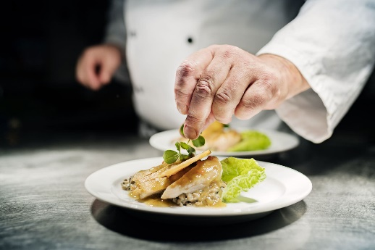

HOTEL TRINITY 4* - Millennium Restaurant




Opening times * card payment only * Online ordering through
Monday-Friday 12pm-22pm
Saturday-Sunday 10am-23pm

Please inform any member of our team if you have a food allergy or a special dietary requirement
Starters
Grilled prawns and poutargue risotto 11.50 (330 calories)
Sous vide cod cheeks with kimchi and peanut 11.50 (350 calories)
Chicken, manchego & chorizo brioche 10.50 (300 calories)
Beetroot, lentil, squash & paneer spring rolls 9.50 (350 calories)
Main course
Double smoked salmon with horseradish cream and lentil pilaf 21.00 (475 calories)
Seared scallops & baby spinach with spiced pomegranate glaze 20.00 (425 calories)
Herb broiled chicken breast with roasted potatoes & garlic white wine sauce 19.00 (455 calories)
Steamed mussels in white wine with crusty bread & mushroom sauce 17.50 (450 calories)
Wine pairings
White Wine Touraine Sauvignon Blanc – perfect with our chicken or salmon dish 330ml 13.00
Red Wine Riesling Roche Rulee – perfect with our mussels’ dish 330ml 12.50
Desserts
Truffle & white chocolate with truffle ice cream 13.00 (375 calories)
Dark chocolate pudding with lavender sorbet 10.00 (350 calories)
Peanut & caramelized banana cake with vanilla ice cream 9.50 (350 calories)
Buttermilk panna cotta with raspberry sauce 8.50 (330 calories)
Kids menu
Fish goujons with hand-cut chips and fresh peas 8.00 (300 calories)
Roasted chicken breast with baby potatoes and salad 7.00 (325 calories)
Tomato penne pasta with smoked cheddar cheese 6.00 (250 calories)
Beverages
Glenfiddich whiskey 30ml 8.99
Stella Artois beer 550ml 5.99
Lemonade 550ml 4.99
Peppermint tea 330ml 3.99
Latte 330ml 2.99

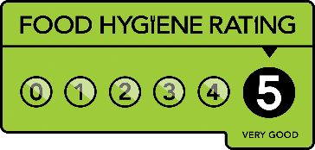


Ewch I food.gov.uk/ratings I ganfod sgor hylendid bwyd ein busnes neu gofynnwch inni beth yw ein sgor hylendid bwyd wrth archebu / Go to food.gov.uk/ratings to find out the food hygiene rating of our business or ask us for our food hygiene rating when you order.

References

Chihak, S. (2022) Treat Yourself to a Fine Dining Experience at Home with These Fancy Dinner Recipes. [online] Available at: <https://www.bhg.com/recipes/dinner/fancy-dinner-recipes/ > (Accessed 16 June 2022)
Great British Chefs (2022) Dessert recipes. [online] Available at: <https://www.greatbritishchefs.com/collections/michelin-star-dessert-recipes> (Accessed 16 June 2022)
Great British Chefs (2022) Starter recipes. [online] Available at: <https://www.greatbritishchefs.com/collections/starter-recipes> (Accessed 16 June 2022)
iStock (2022) Restaurant dish photo. [online] Available at: <https://www.finedininglovers.com/article/what-are-michelin-stars> (Accessed 16 June 2022)
Jacobs, C. (2022) The Ultimate Guide to Making The Fancy Restaurant Dishes You Never Thought You Could. [online] Available at: <https://www.thespruceeats.com/ultimate-guide-to-making-fancy-restaurant-dishes-at-home-5095895> (Accessed 16 June 2022)
StickPNG (2022) Deliveroo logo. [online] Available at: <https://assets.stickpng.com/images/580b57fcd9996e24bc43c520.png> (Accessed 16 June 2022)
The Wine Society (2022) Our wines. [online] Available at: <https://www.thewinesociety.com/food-wine-matcher/fish-course/smoked-salmon> (Accessed 16 June 2022)
TopPNG (2022) Uber Eats logo. [online] Available at: <https://toppng.com/uploads/preview/uber-eats-icon-logo-11609380423inqgltu4pe.png> (Accessed 16 June 2022)

