Information Engineering – Assesment 1 – BSc Cloud Computing – Level 4
Name: Iuliana Maria Gherasim
Student ID: 1919760

- Data Flow Diagram

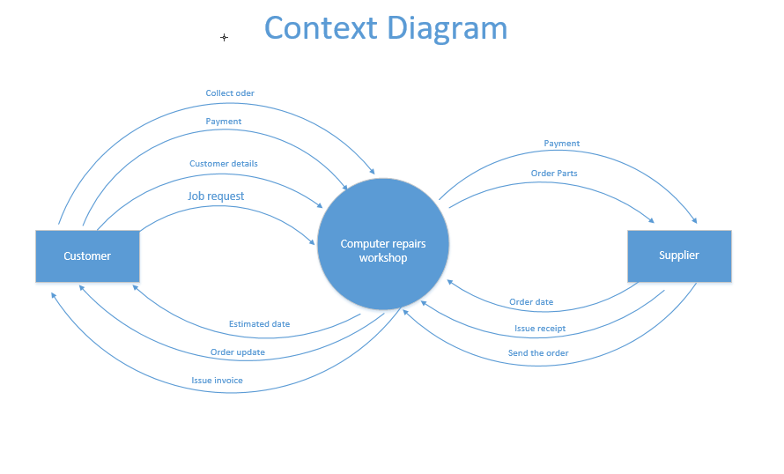

External entities: Data Process:
Customer Computer Repairs Workshop
Supplier

The Context Diagram clearly shows the flow and all the steps required between the external entities and the data processor. For this diagram, I used Visio program, which is considered a designing software suitable for this module.

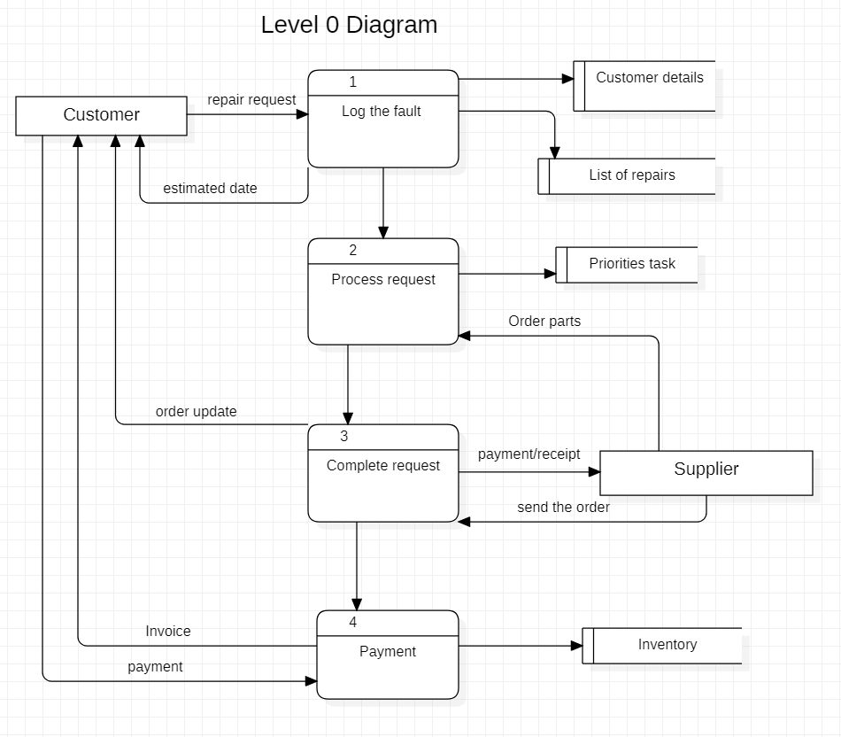

External entities: Data process: Data stores:
Customer Log the fault Customer details
Supplier Process request Priorities tasks
Complete request List of repairs
Payment Inventory

For the above diagram, I used StarUML which is also a designing software suitable for this assessment. The entities, data process and data stores have been identified accordingly, to show all the process from step A to step Z.

- Entity Relationship Diagram
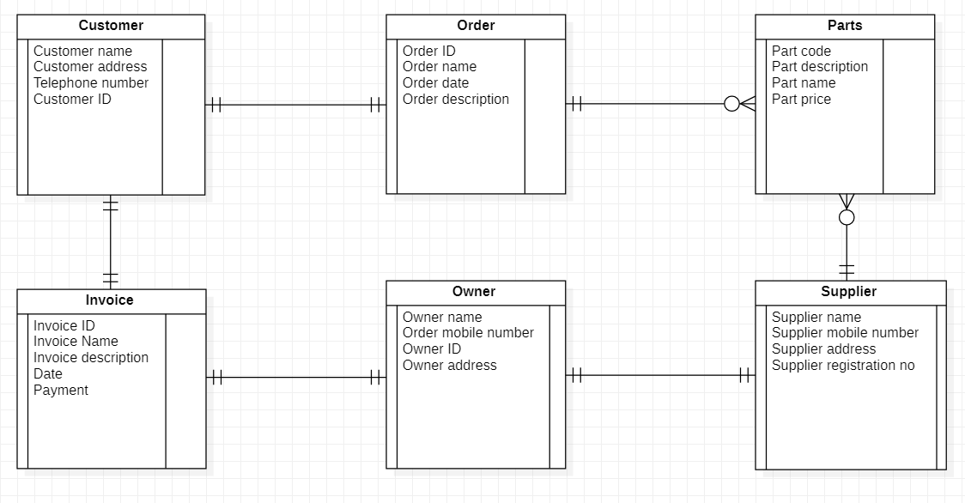

As you can see into the above diagram, I have identified the external entities and the relationships between them such as one to one relationship or many to many, depending on the case.
Also, each each entity have specific attributies, as name, address, mobile number and so on, which allow us to have a better understanding of the process.

- Use Case Diagram

Into this diagram, I have successfully identified the actors, along with the use cases. As requested into the assessment, I also included the system boundary and the associations between actors and the use cases.
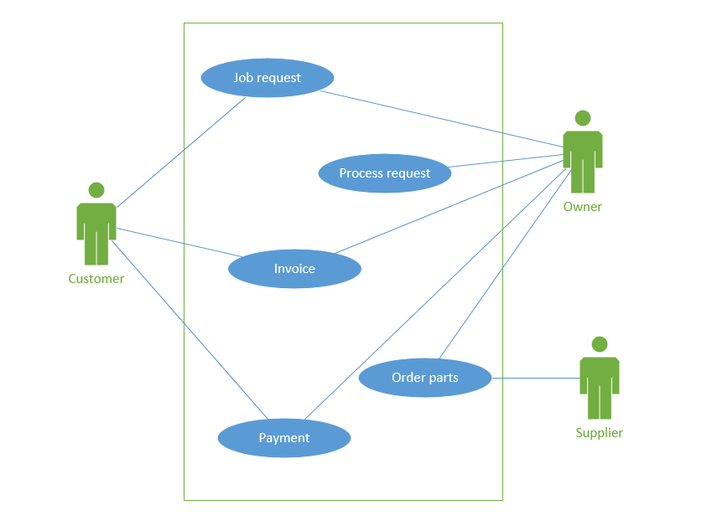

Actors: Use case:
Customer Job request
Supplier Process request
Owner Invoice
Payment
Order parts

Some of the use cases, have more association which I will mention below:
- For the job request, the customer need to provide his details and the owner to tell him the estimated date when he can collect the computer.
- The payment also includes the payment which owner provided to the supplier.
- The order parts include the inventory that the owner does it weekly for the centre repair.

