Kallum Doyle
2237962@student.uwtsd.ac.uk
ACDB4003

mathematics
Solving Mathematical Problems via MATLAB

Contents
Disclaimer 2
Questions 3
Question 1 3
$ex$ 3
Ln(x) 4
2x² + 3x³ 5
(2-x^{0.5})² 6
Question 2 7
Question 3 9
Question 4 11
Question 5 13
Question 6 15
Question 7 17
Question 8 19

Disclaimer
I certify that all work done in this document is my own.

Questions

Question 1
If x = 4.0, use MATLAB to evaluate:

$$e^{x}$$

Screenshot
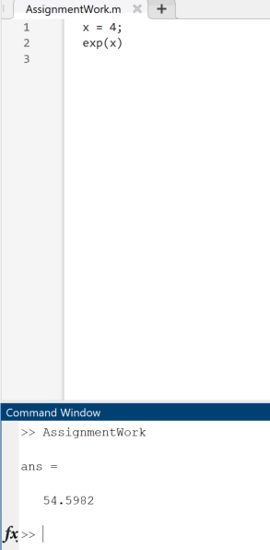

Method
x = 4;
exp(x)

Answer
ans = 54.5982

Ln(x)

Screenshot
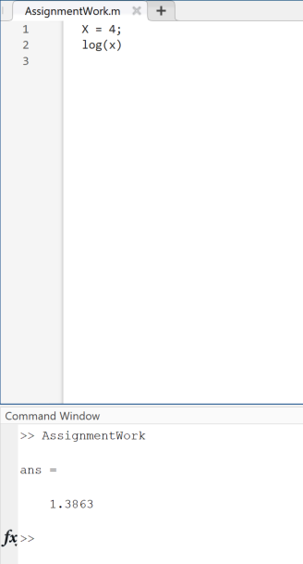

Method
X = 4;
log(x)

Answer
Ans = 1.3863

2x² + 3x³

Screenshot
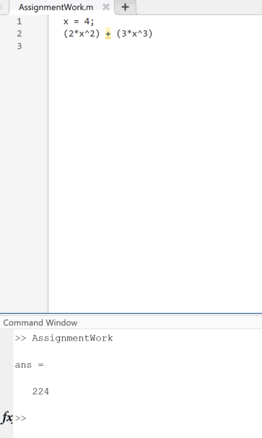

Method
x = 4;
(2*x^2) + (3*x^3)

Answer
ans = 224

(2-x^{0.5})²

Screenshot
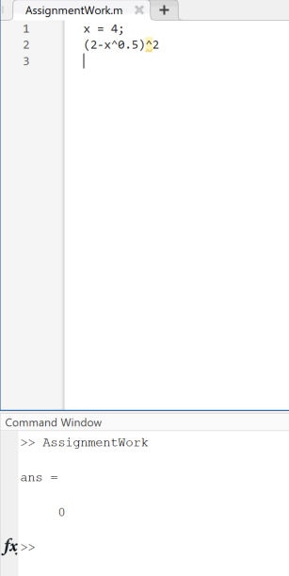

Method
x = 4;
(2-x^0.5)^2

Answer
ans = 0

Question 2

Question
Draw the graphs, in the same window of
- y=e^{-x}
- y=x²
From x=0 to x=4
Use the zoom tool to locate either of the points of intersection and then use the data cursor tool to find it coordinates correct to two decimal places.

Method
clear
fplot('exp(-x)',[0,4])
hold
fplot('x^2', [0,4])
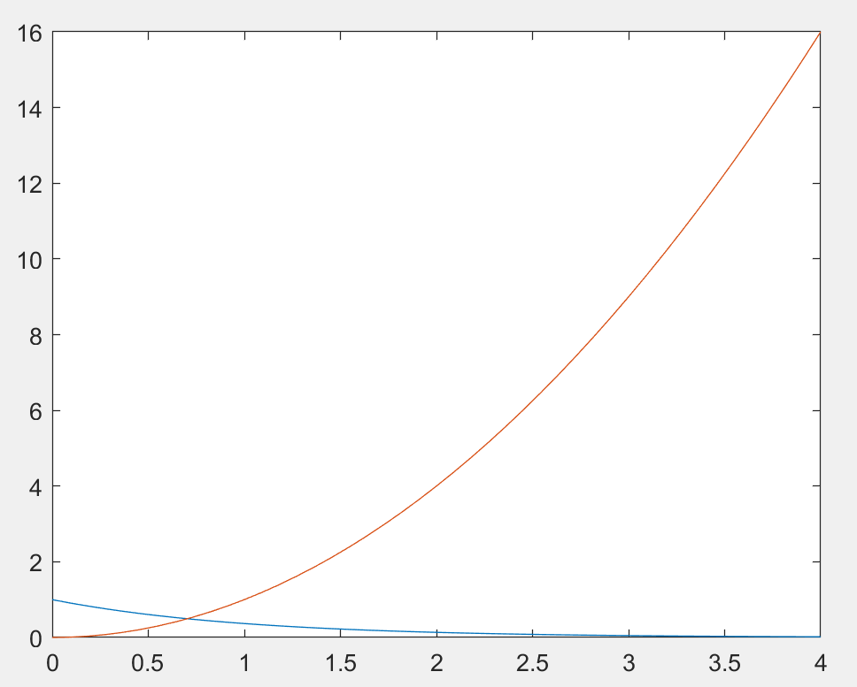
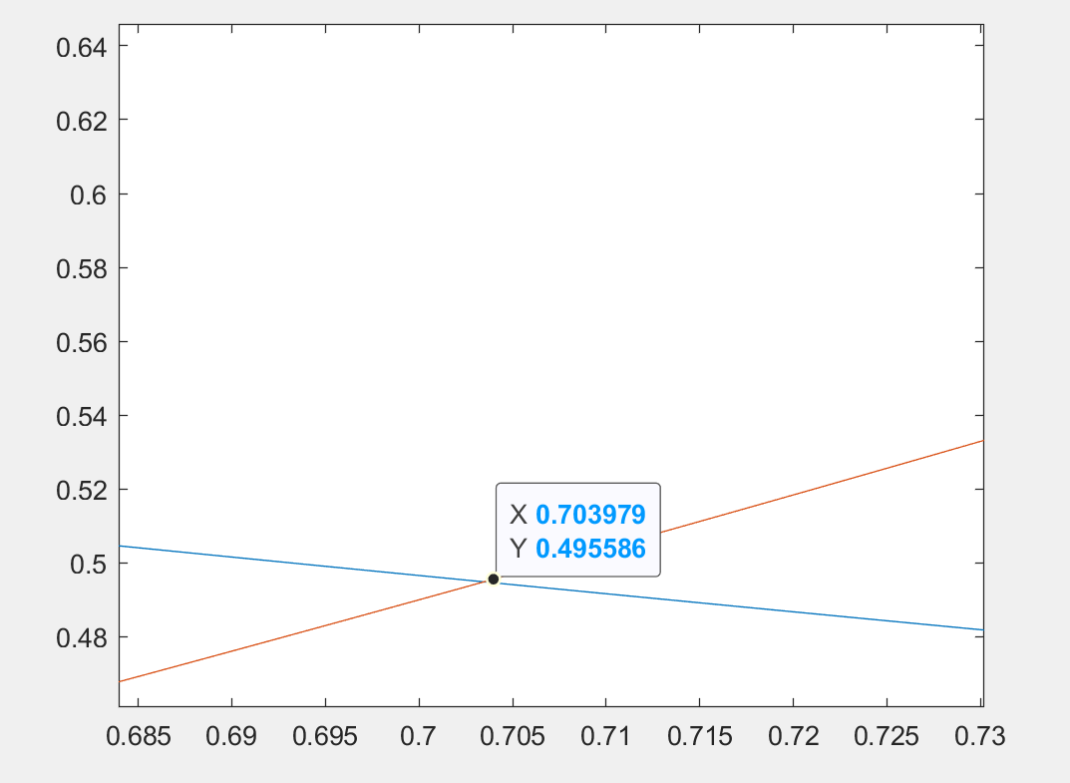

Answer
X = 0.70 (2 decimal places)
y = 0.50 (2 decimal places)

Question 3

Question
Use solve to find all roots of the equation
X⁴ + 5x² – 36 = 0

Screenshot
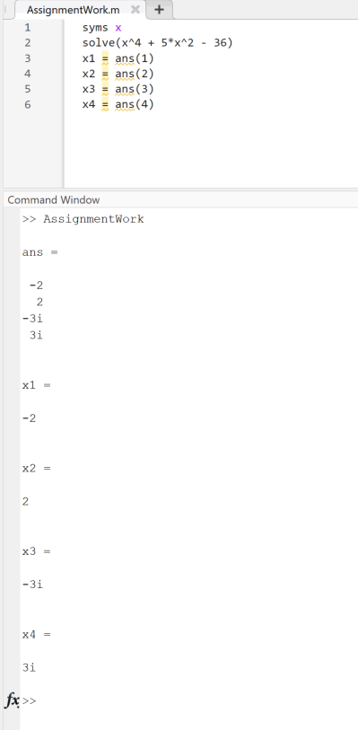

Method
syms x
solve(x^4 + 5*x^2 - 36)
x1 = ans(1)
x2 = ans(2)
x3 = ans(3)
x4 = ans(4)

Answer
ans = -2 2 -3i 3i
x1 = -2
x2 = 2
x3 = -3i
x4 = 3i

Question 4

Question
Find the gradient ‘m’ and constant ‘c’ in the equation of the straight line which is a least squares approximation to the data given in the provided table.
Calculates the y values according to the least squares line and draw the graphs of the original points and the line. Estimate the value of y at x=5.5

Screenshot
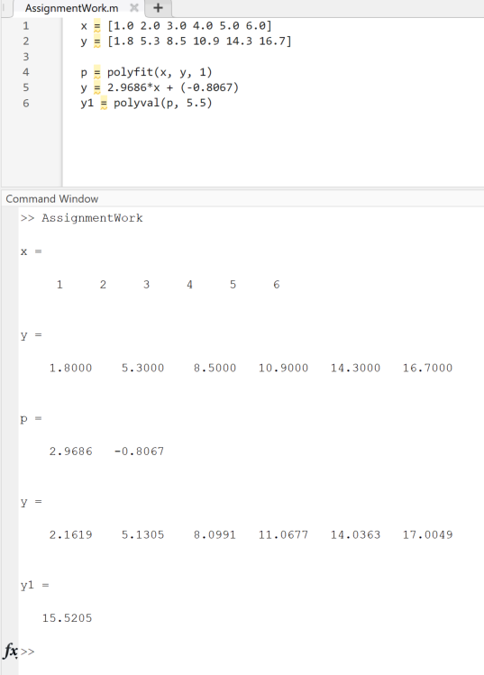

Method
x = [1.0 2.0 3.0 4.0 5.0 6.0]
y = [1.8 5.3 8.5 10.9 14.3 16.7]
p = polyfit(x, y, 1)
y = 2.9686*x + (-0.8067)
y1 = polyval(p, 5.5)

Answer
x = 1 2 3 4 5 6
y = 1.8000 5.3000 8.5000 10.9000 14.3000 16.7000
p = 2.9686 -0.8067
y = 2.1619 5.1305 8.0991 11.0677 14.0363 17.0049
y1 = 15.5205

Question 5

Question
Find the second derivative of y=sin(x)+cos(x)
Show that y satisfies the equation d²y/dx²+y=0

Screenshot
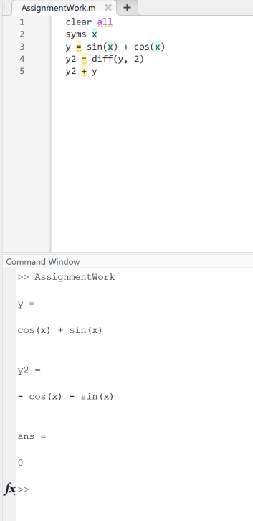

Method
clear all
syms x
y = sin(x) + cos(x)
y2 = diff(y, 2)
y2 + y

Answer
y = cos(x) + sin(x)
y2 = - cos(x) - sin(x)
ans = 0

Question 6

Question
For the two vector a=(2, 3, 5) and b=(1, -2, -3) find the dot product of a and b and the cross product of a with b.

Screenshot
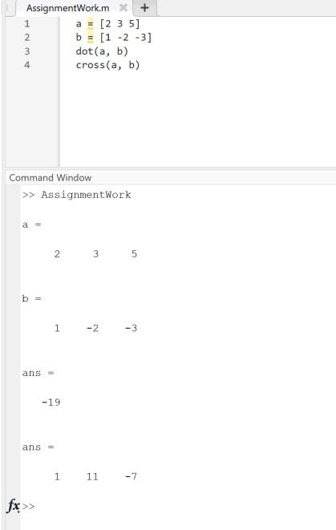

Method
a = [2 3 5]
b = [1 -2 -3]
dot(a, b)
cross(a, b)

Answer
a = 2 3 5
b = 1 -2 -3
ans = -19
ans = 1 11 -7

Question 7

Question
Find the determinant |A| and the inverse A⁻¹ of the matrix A

Screenshot
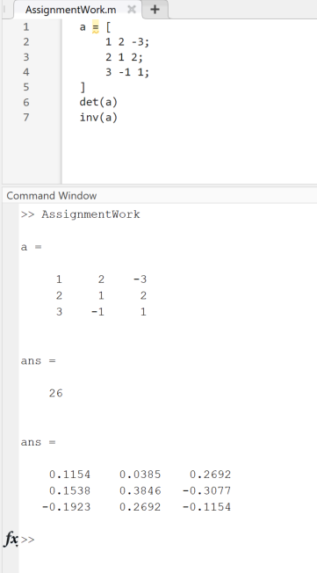

Method
a = [
1 2 -3;
2 1 2;
3 -1 1;
]
det(a)
inv(a)

Answer
a =
1 2 -3
2 1 2
3 -1 1
ans = 26
ans =
0.1154 0.0385 0.2692
0.1538 0.3846 -0.3077
-0.1923 0.2692 -0.1154

Question 8

Question
The following simultaneous equations are represented by the matrix equation AX=k where A is the matrix of question 7, X=[x,y,z]^{T} and k=[-4,3,5]^{T}
x + 2y – 3z = -4
2x + y + 2z = 3
3x - y + z = 5
Use MATLAB to solve for x,y and z by using the following matrix equation
X=A⁻¹k^{=T}

Screenshot
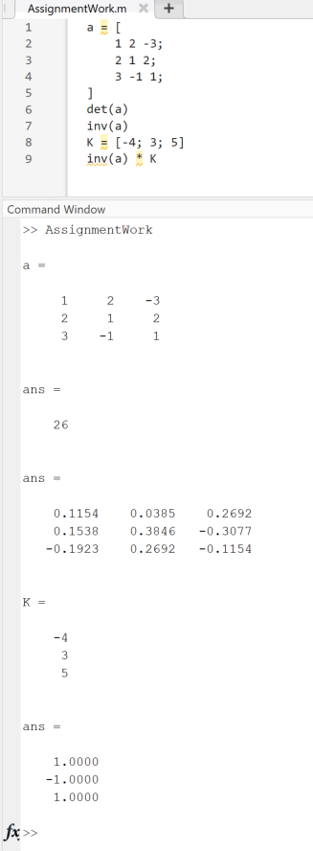

Method
a = [
1 2 -3;
2 1 2;
3 -1 1;
]
det(a)
inv(a)
K = [-4; 3; 5]
inv(a) * K

Answer
a =
1 2 -3
2 1 2
3 -1 1
ans = 26
ans =
0.1154 0.0385 0.2692
0.1538 0.3846 -0.3077
-0.1923 0.2692 -0.1154
K = -4 3 5
ans =
1.0000
-1.0000
1.0000

