Owen Williams

Mechanical Engineering

University of Wales Trinity Saint David

Reflective Project Report

ACMA5009 – Group Project

21st February 2022

Contents Page
- Introduction…………………………………………………………………………………………….3
1.1 Aim of Report……………………………………………………………………………………….3
1.2 Aim of Project……………………………………………………………………………………….3
- Project Plan…………………………………………………………………………………………….5
  - Gantt Chart…………………………………………………………………………………………..5
  - Pert Chart……………………………………………………………………………………….…...5
  - Failure Mode Effect Analysis…………………………………………………………………6
  - Work Breakdown Structure…………………………………………………………………..7
- Design/Solution………………………………………………………………………………………8
- Research…………………………………………………………………………………………………..9
  - Feasibility Studies………………………………………………………………………………….9
  - Character Selection Matrix……………………………………………………………………10
  - Component and Material Research……………………………………………………….11
- Implementation……………………………………………………………………………………..12
- Evaluation……………………………………………………………………………………………….15
- Further Recommendations………………………………………………………………….16
- Reference List…………………………………………………………………………………………17

Figure 1 – Product Design Specification…………………………………………………………………..4
Figure 2 – Gantt Charts……………………………………………………………………………………………5
Figure 3 – Pert Chart……………………………………………………………………………………………….6
Figure 4 – Failure Mode Effect Analysis…………………………………………………………………..7
Figure 5 – Work Breakdown Structure…………………………………………………………………….7
Figure 6 – Feasibility Studies…………………………………………………………………………………..9
Figure 7 & 8 – Character Selection Matrix……………………………………………………………….10
Figure 9 – Technical Data………………………………………………………………………………………..11
Figure 10 & 11 – New Pipework Research……………………………………………………………….11
Figure 12 – New Flow Controller…………………………………………………………………………….12
Figure 13 – Old Machine Layout……………………………………………………………………………..13
Figure 14 – Project Installation……………………………………………………………………………….13
Figure 15 – Sovema Drawing…………………………………………………………………………………..14
Figure 16 – Designed Wiring Diagram……………………………………………………………………..14
Figure 17 & 18 – Wiring Circuit……………………………………………………………………………….14

1.0 - Introduction
1.1 - Aim of Report
This reflective report was written 6 months after the project was carried out. This way a proper look at the results of the project could be looked at and determine whether the change to the machine was a success. The project was to improve the current water-cooling system for the casting tables, with the aim to reduce the amount of downtime and breakdowns which happen on the machine.
This report will include all the information and techniques used to determine the best approach to the project and what will make the project successful. The aim of the report is to analyse the effectiveness of the project and to see whether or not the whole change has been a success. By looking at different techniques and methods which were used it will allow an understanding to be gained on the impact they had on the project and why they were chosen over other techniques.
It is important to understand however that the methods and techniques used throughout this project may not be the best to use in different projects and were used simply due to them being best suited to work being done.
1.2 - Aim of Project
The current system has an infeed of water through pipes which enables the casting table to stay cool whilst running, however, having a higher demand for products means the tables are running for longer hours and more often leading to the machines overheating, therefore blowing the lids and causing damage as well as several days of downtime.
The aim is to change the pipework and also install a flow controller which will show how much water is going into the casting tables. Wiring this into the PLC will mean that when the water flow is not good it will stop the machine from running therefor minimising the damage and downtime caused. Hopefully, this will make the machine more effective and maintainable. The outcome aim from the project is to allow the machine to cope with the demand of production and not cause major downtime by having serious breakdowns, by coping with demand it will make the machine more reliable and efficient.
By making the machine more reliable it allows maintenance to not attend regular breakdowns of the machine and can instead focus on preventative maintenance or more important jobs. The old layout of the machine was not maintainable due to the fixed galvanised steel pipes which feeds the machine; therefore, it makes it tough to find issues or to fix issues as the pipes are hard to remove. By replacing these not only does it make the machine more reliable but if an issue was to occur it would be easier to find and rectify the fault.
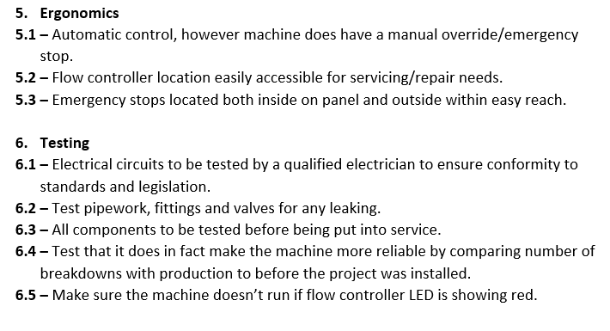
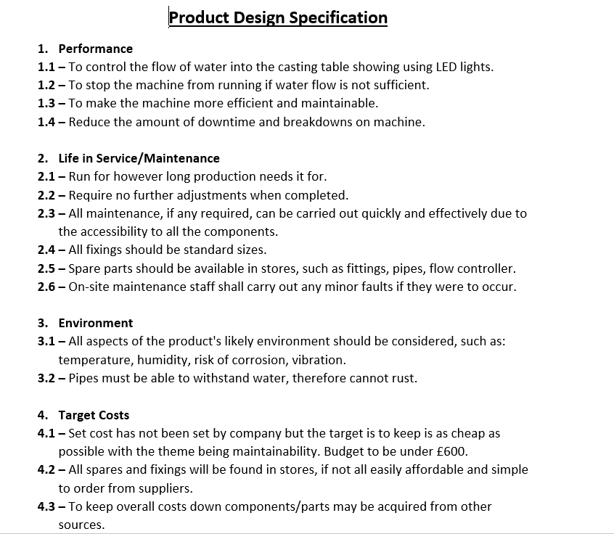
It is important within a project to set out a list of goals or specifications you want the project to adhere to. To do this a list of with detailed information regarding every aspect of the project, it is important to set achievable targets which are also testable and measurable. This document is known as a Product Design Specification (PDS), by creating a PDS it increases the chances of producing a successful project and helping supervisors or stakeholders have clarity throughout the process.

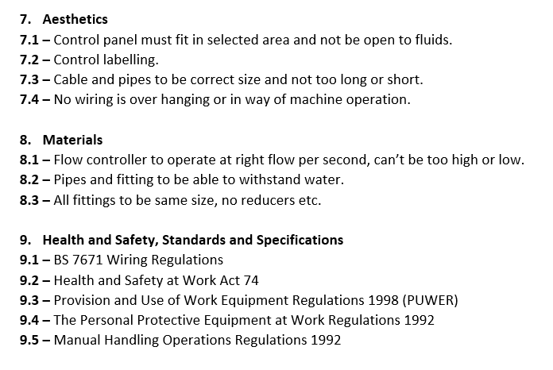

Figure 1 – Product Design Specification
As you can see from the project PDS above, different specifications are set for different aspects of the project and it is important that when testing and evaluating the overall project at the end that the product design specification is used to compare with in order to see whether or not it has been a success and achieved the goals it has set.
Geddes (2022) suggests that using PDS effectively will provide transparency and direction throughout the process or project. He also supports my point stating that by completing the list of specifications it can be turned into the list of requirements that must be met to make the project a success.
Often this process can be deemed to be lengthy however identifying these specifications can be key to making the project a success, they’re also very easy to carry out and complete and can help everyone understand the aims of the process. In order to make a successful product design specification you should limit detail in the specifications as it could hinder creativity, it is also vital that clear, realistic targets but make sure that they’re not too vague either as this would make it hard to compare to and undermine the clarity.

2.0 - Project Plan
The planning process is a vital part of any project and was a key aspect in making this project a success. Planning section allows you to set realistic and achievable targets to aim for and complete by. As well as this you could see how much components would be likely to cost, how long they would take to arrive and whether all of this would stay within the original budget which had been set. According to Business Organisation (2019) having a clear plan can lead to better project outcomes and allows tasks to be allocated and shows which tasks are dependent on.
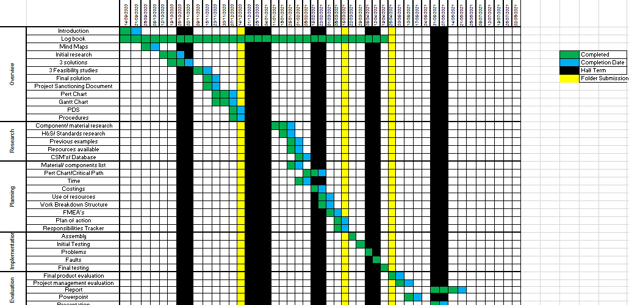
2.1 Gantt Chart
A Gantt chart was designed and followed for guidance throughout the project. Using a colour scheme to indicate specific tasks and how they were going helped the project move along. Green represented on track to hit set target, red behind schedule and blue to be completed. Gantt charts are used as roadmaps which allows dates and targets to be set for tasks, it allows you to keep a bird’s eye view of the project which Eddie Meardon (2021) states. The below figure shows the Gantt chart which was created and followed throughout the project, this allowed me to complete tasks by the dates I had set and help complete the project on time.

Figure 2 – Project Gantt Chart

2.2 - Pert Chart
Another key analytical tool used throughout the project was critical path analysis also known as PERT Charts. Critical path helps you understand what tasks are essential for keeping my project on track. This is vital as it helps you to know what tasks are dependent on others than others and what must be done to keep my target completion date intact. Denton (2021) suggests that using critical path to understand task dependencies is key to setting realistic deadlines.
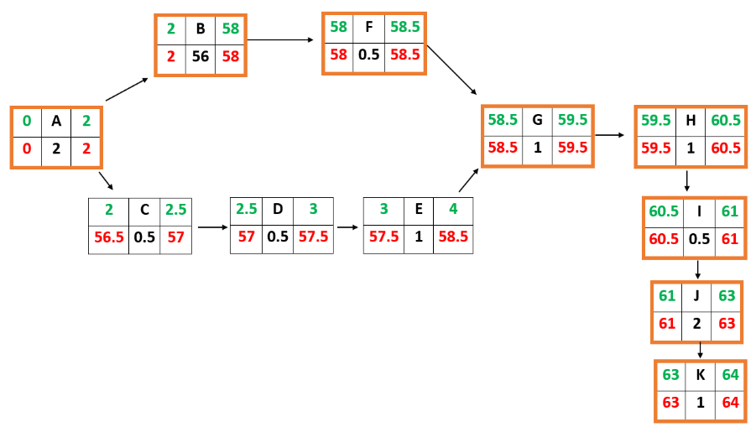
The below critical path shows that tasks C, D and E are not critical tasks within the pathway to completion. It shows that these tasks are not dependent on essential tasks and these can be done without affecting the deadline set.
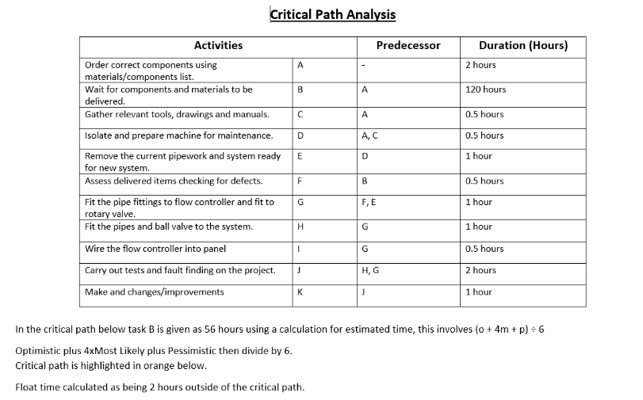
Figure 3 – Critical Path Analysis (PERT Chart).

2.3 – Failure Mode Effect Analysis (FMEA)
Failure Mode and Effect Analysis helps us review a process step and to identify potential failure modes in a system and their causes and effects that can occur. By identifying possible failures, you rate the severity of the problem as to how much it would affect the project. A score is also given as to how easy it would be to detect the fault and how often it would occur. By using FMEA it enables you to study the consequences of those failures on different process steps, this gave an idea as to what could go wrong with each task within the project.
According to Kent (2016), FMEA’s is an essential tool for improving processes and products. By completing the FMEA it will allow the process of design to be reviewed at each stage and find any issues or potential failures which may occur, by doing this it improves the overall outcome of the process or design. Long & Hillman (2014) support this and also add that human error is considered in the in the tool which makes it more relevant and suited to the project.
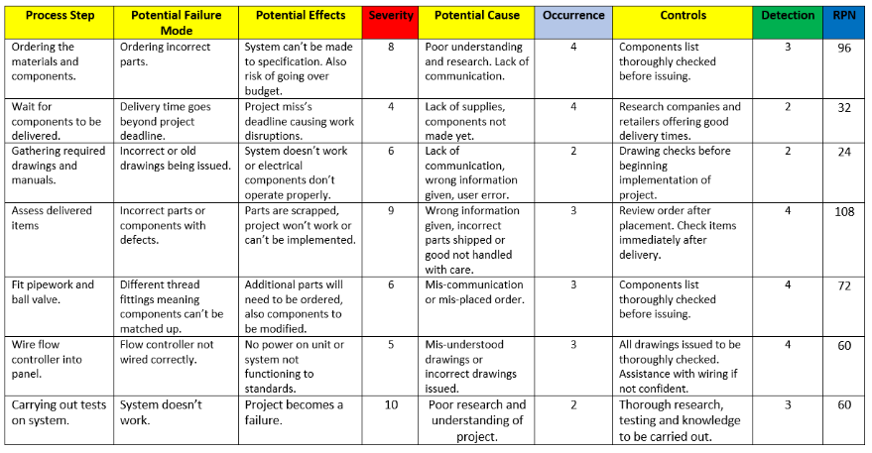
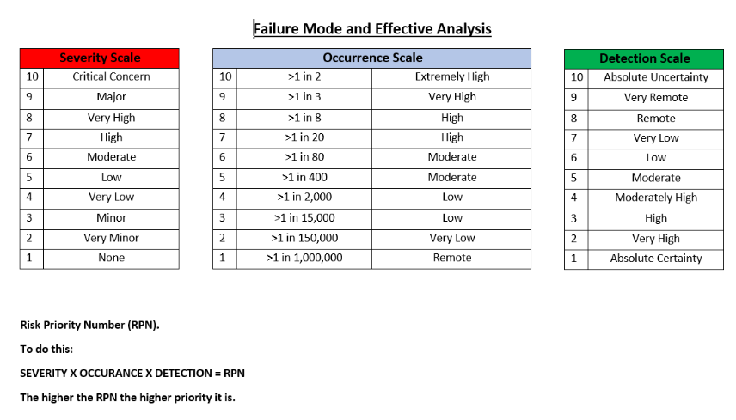
Figure 4 – Failure Mode Effect Analysis
As you can see from the FMEA table above the highest RPN score gathered was 108 which was scored from the ordering components section. This is due to the severity being high along with the occurrence and detection. By ordering the incorrect parts or having components which are faulty would delay the project along with waste money and time.
2.4 – Work Breakdown Structure
A work breakdown structure was carried out to help make the work more manageable and approachable. By breaking down each section for implementation you’re able to see what tasks need to be carried out for each section, this allows you to make a to do list as to what needs to be carried out before handing the new system over to production. Completing all these tasks by the final deadline will mean the system will be fully implemented and be a success.
Raeburn (2022) states that work breakdown structures are used to help breakdown project scopes to help give a visual project overview. They’re also incredibly easy to understand and complete, they increase transparency and productivity as the tasks are broken down into smaller parts to be delivered, the table is also easy to be monitor and be accountable for.
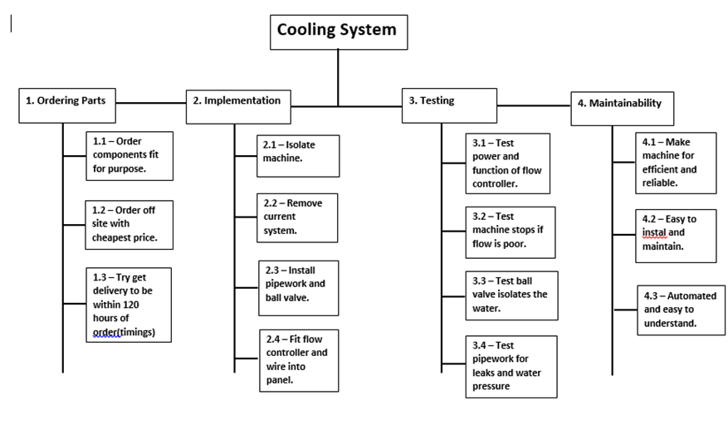

Figure 5 – Work Breakdown Structure

All the analytical tools were vital in planning the project and making it a success. Each analytical tool was important in different ways and each was used in order to avoid failures and improve the procedure and product, it also allowed for appropriate targets and deadlines to be set. The different tools used helped set goals for both long term and short term, various other tools could have been used such as fishbone diagram however the tools used suited the project best and gave the best visual as to what tasks were dependant on others, which tasks would cause the biggest issues if failed and also to set timescales and deadlines.

3.0 – Design/Solution
Solution 1 was chosen as it was the most suitable and gave the best feasible score when carrying out the task. Solution 1 was installing a flow controller along with updated pipework and a new ball valve, the aim was to remove the current problem which was the machine overheating causing the seal to break and water leaks to occur, this then led to downtime of around 48 hours due to what needed to be done. By installing a flow controller, it would allow the operator or maintenance to visually see a water flow going into the machine by the colour of the LEDs. By wiring this into the control panel it would break the cable going directly from the lead pump start pushbutton and add the water flow controller into the circuit, therefore, if the water is not flowing the sensor is not made and the lead pump will not start. This would then prevent the table from making any product if there’s not sufficient water flow going into the machine.
The positives of installing this is that it will make the machine more reliable by not having as many breakdowns which would lead to long amounts of downtime. It would offer a much more maintainable solution for the machine by being easy to install and maintain and operate, it would be easy to access and make the machine more efficient. As Granta (2017) suggests, an improvement to machine performance can simply be improving monitoring systems which would allow fault finding to be carried out more efficiently. By installing the flow meter, the operator can clearly see whether or not a flow of water is entering the table. He also suggests by introducing the visual inspection, quality of production will rise as it will help eliminate faulty products. By wiring it flow control into the lead pump circuit it means the product can’t be manufactured unless sufficient water is feeding the table therefore reducing the likelihood of producing faulty lead nuggets.
Another positive is the price of the solution. Costing £333 meant it was well below the £600 budget set, installing this system to make the machine more sustainable and to cope with the demand of production and do this whilst spending under budget is a huge bonus.
One negative to consider is that if a problem or fault was to occur within the machine then the flow controller wouldn’t detect it. For example, if the rotary union was broken or a water leak was present this wouldn’t affect the water flow going into the system. This has been identified and if the problem was to occur, another flow controller could be fitted to the flow pipe for the outflow of water, this way you can have an LED reading for the flow of water going both in and out of the casting table.
The main solution was chosen as it gave off the best score when carrying out feasibility studies and was therefore deemed the best option in making the machine more efficient, effective and maintainable.
4.0 – Research
A key part of any project is research, and researching in the key areas is vital to making the project a success. Researching in the wrong areas can lead to components being ordered which don’t comply with standards or the design of the project. It also helps set a realistic budget for the project and know the materials and components you need to match the performance and demands of the machine. Bentley (2019) suggests that research in projects is key as it helps outline issues such as financial or safety, he also states that research needs to be done to get the backing from stake holders or senior people within the company. A project can’t begin without proper research being done beforehand.
4.1 – Feasibility Studies
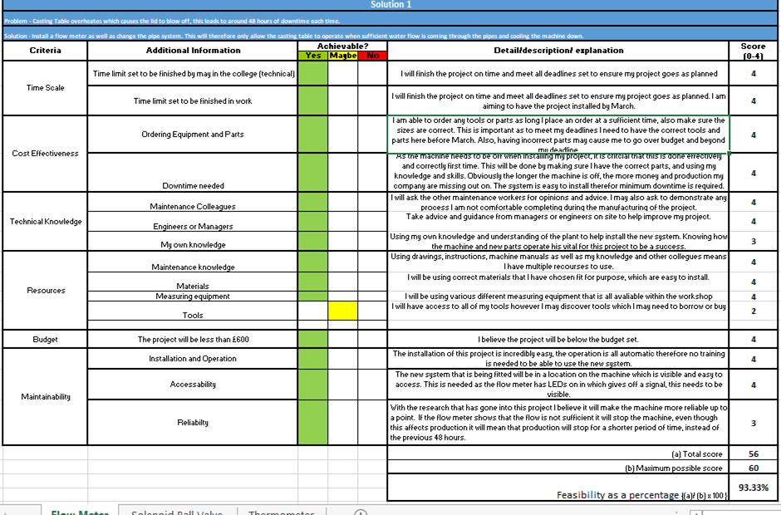
One of the first tools used in the research section was feasibility studies. Feasibility studies is an assessment used to find the practicality of plan or method. In the case of this project a feasibility study was conducted in order to find the best solution to fix the ongoing issue and use as the project. Below is the feasibility study carried out.

Figure 6 – Feasibility Studies
The project idea was created after using mind maps to generate project ideas on how to improve the current system for the casting table. This was then narrowed down to three different ideas and research was carried out to determine what needed to be involved and done for each solution. Using feasibility studies allows to compare and contrast the solutions by setting a list of criteria and seeing which solution was best suited. This allowed us to see what was the best project to carry out and helped with a final solution to be picked and drafted. The above concept scored the highest feasibility percentage which determined that this project would be the most effective for company, as well as being needed the most. According to Simplilearn (2022) feasibility studies is a way of getting it right before committing to resources, time or budget.
4.2 – Character Selection Matrix (CSMs)
Character selection matrix is a tool used to help evaluate and compare a list of options. In the case of this project the decision-making tool was used to determine the best material for the components. By setting a list of criteria for each component helped establish which would be best suited for the project.
The flow controller is a key part of the project, therefore having the right one is important. It needs to be maintainable, easy to use but most importantly be purpose fit for the project. The CSM shows that the EGE SDN 520 GR controller will be the best component to use.
The pipework needs to be researched thoroughly to find the best and most fit for purpose. The machine currently has metal pipes, the CSM shows that changing this to synthetic rubber would be better and make the project more maintainable and allow the machine to perform better.
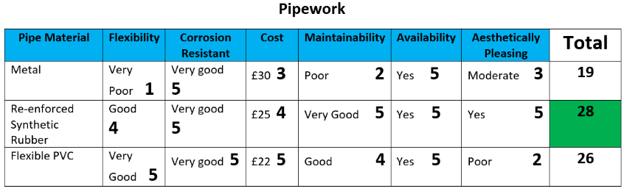
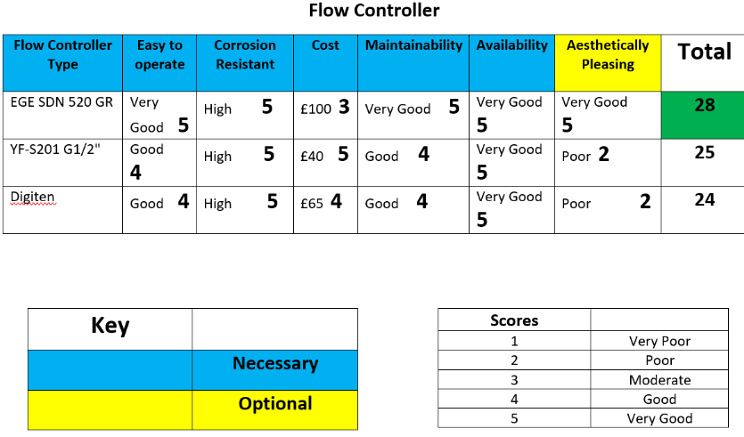

Figures 7 & 8 – CSMs

Using CSMs to help chose the right material and component meant that when implementing the project, the parts would be best suited to the machine and would help make the project a success. CSMs can be used in various other ways such as selecting roles of team members in a structure. It needs to be understood however that CSMs are only as good as you make them, for example the flow controller were thoroughly researched in order to find three which best suited the project, only from placing these into the selection matrix allowed for the best one to be found.

4.3 - Components and Material Research
After carrying out feasibility studies to determine which concept would be best, additional and thorough research can be then carried out to find the best materials and components to implement the project. By researching and finding the technical data of the machine it gives a better understanding of the components needed and what they need to cope with. Below you can see the data of the caster table machine, in order to achieve its optimum productivity of 16 tons per 8 hours the machine needs a constant flow of 40 litres per minute of water through a 3/4” supply feed. This allows for deeper research to be conducted to find pipework and a flow controller to withstand the requirements of the machine. This data was collected from Sovemagroup.
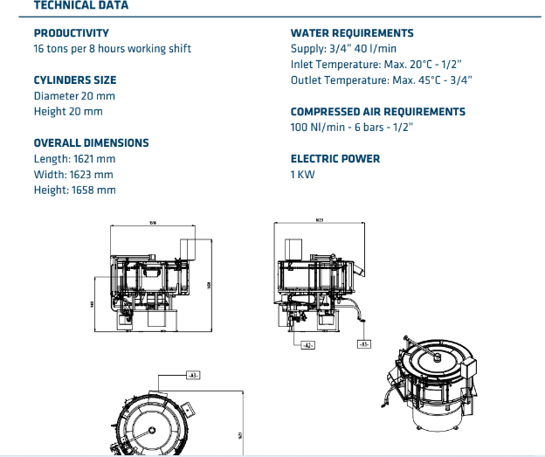
Following the technical data pipework first to be searched for, it was vital that the pipes can withstand the pressure, heat from the table and most importantly be maintainable. This meaning that the pipework is easily replaceable if needed but can cope with the demand of production.

Figure 9 – Technical Data
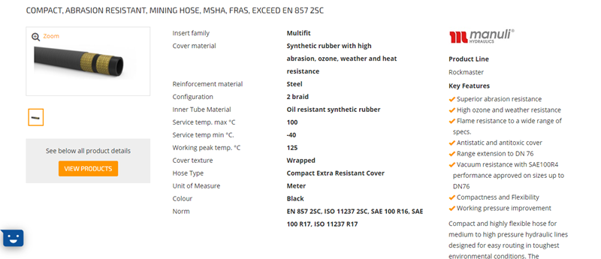
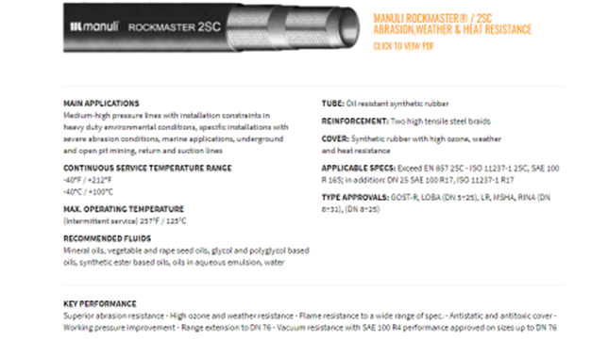
This pipe is synthetic rubber which is reinforced. It is corrosion resistant and also heavy duty therefore it can withstand any lead splashes which can occur. The pipe is also available in various sizes which is important as it can be bought as 3/4" to be suitable with the flow controller, rotary union and the water requirements shown in the technical data. Within Enersys we have an internal pipe supplier known as Hydraquip, this is who’ll supply the pipework.

Figure 10 and 11 – New pipework gathered from research.
Detailed research was also carried out for the flow controller. After researching it and placing it into the CSM it was clear to see the EGE SDN 520 GR flow controller was best suited for the project.
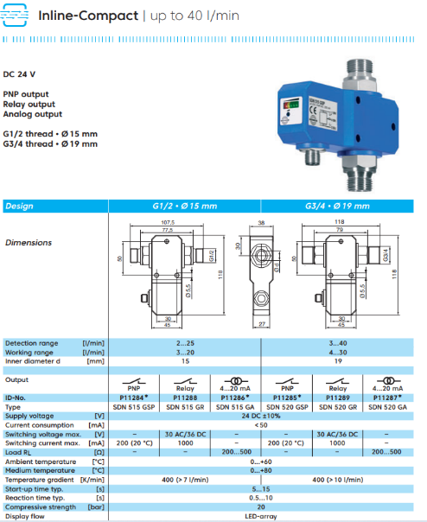
As you can see from the technical data the flow controller handled up to 40 l/min, along with having the correct 3/4" fittings on it and was easy to install and maintain. The clear LEDs on it gave a clear signal as to whether there is a good water flow or not, it was ideal for the project.

Figure 12 – New Flow Controller

5.0 - Implementation
On March 16th the project was scheduled to be implemented therefore the researched components were ordered the week before in order to give sufficient time for delivery, with the ongoing order delays due to COVID and various economic issues. However, despite multiple issues the parts and components were delivered on time, this was partly to do with Enersys having a pipework contract supplier so a call out was made and the pipes were manufactured along with stainless steel swivel fittings attached to them. With all the components and parts delivered the project was ready to be implemented on the 16th March, however due to a lack of communication and understanding production supervisors couldn’t put the machine down due to the demand of product. Due to this the project then had to get implemented on the 19th March when production had been arranged to work around the machine.
Before carrying out the assembly of my project it is important to isolate the machine mechanically by isolating the water supply, and electrically by isolating the main panel. This is to help me comply with the Health and Safety at Work throughout the implementation. During the assembly these legislations were followed:
- The Personal Protective Equipment at Work Regulations 1992 – This was done by wearing the appropriate PPE such as gloves, overalls, boots, ear protection.
- The Control of Lead at Work Regulations 2002 – Extracts were put in place as well as masks being worn and regular cleaning of the hands.
- BS 7671 – When wiring the flow controller into the panel.
- IEC 61508 – Making sure the electrical equipment is safe and operating in the correct way.
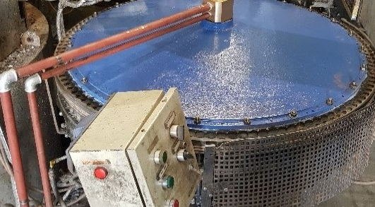
- BCAS installation Guide – Following to make sure all pipes and fittings are installed correctly and properly
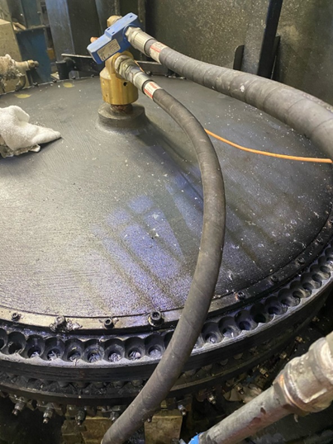
This was the layout and system of the machine before the project was implemented. As you can see it’s got hard-wall solid metal pipe. No indication or showing of the water flow and the only way to knock the water off is by stopping the main supply. The pipe work is also a lot more difficult to disassemble when faults or maintenance activities need to be done on the machine.
Figure 13 – Old layout of Machine
After the machine is isolated, the old system can then be removed and disposed of correctly. Pipes were fitted with 3/8” swivel fittings making them easier to fit and tighten up, 3/8” fittings were connected to the rotary union and to the flow controller along with a ball valve being fitted to the supply. The flow controller was placed on the top port of the rotary union as this was the infeed to the machine. Once all the pipework and components were in place engineering drawings were designed and followed to wire the flow controller into the panel.

Figure 14 – Project Installation

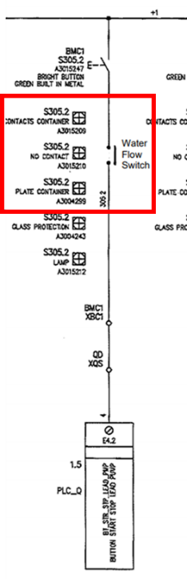
By breaking the cable going directly from the lead pump start pushbutton and adding the water flow controller into the circuit, if the water is not flowing the sensor is not made and the lead pump will not start. This prevents the table from making any product if there’s not sufficient water flow going into the machine. This is seen in the modified original Sovema drawing below with the red square.

Figure 15 – Modified Sovema Wiring Drawing
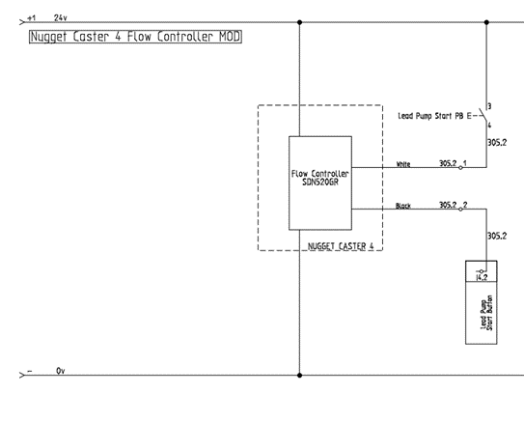
The second drawing is the drawing created that better shows what’s been done. This shows the sensor being supplied with the 24V and 0V it needs for power (Brown and blue on the pictures above) and we have broken into the circuit at the terminals where cables 305.2 are terminated and connected the sensor in series shown on the picture below (White and Black cable).
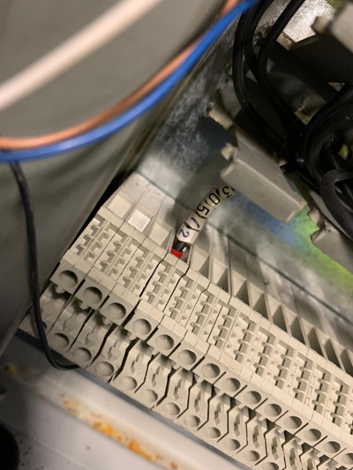
Figure 16 – Designed Wiring Drawing
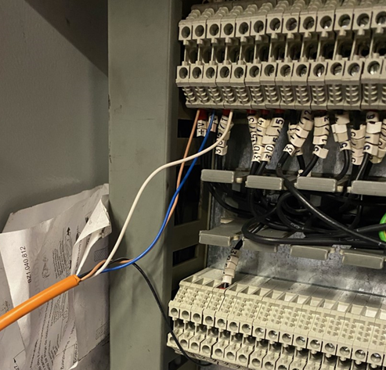
Water flow sensor cable interrupting the existing circuit between the Lead Pump start button, and Input 4.2 (Lead Pump Button Start).

Figure 17 – Wiring Circuit
Figure 18 – Wiring Circuit
After the project was implemented, relevant testing was carried out alongside the PDS to help determine whether or not the criteria and requirements have been achieved. A variety of tests were carried out to find that the new project was operating properly and there were no major electrical or mechanical issues.
6.0 – Evaluation
The project is fully installed and completed and has been performing how it should have since it has been implemented. The project now performs exactly to the PDS which I set at the start, by making the machine more maintainable it has allowed production to use it to keep up with the demand and has caused no breakdowns or downtime in doing so. By having a flow sensor, the operator can clearly see a good flow of water going into the machine by the signal off the LEDs. If the flow stops or isn’t sufficient enough, the flow sensor can recognise this and stop the machine from producing product, this stops the machine from overheating and causing huge amounts of downtime.
The project was completed in the set time and tasks were carried out in accordance to the Gantt chart and PERT charts. This helped achieve all the tasks for both theory and practical. Setting dates and times allowed helped guide the project and make it achievable. By carrying out tasks such as feasibility studies, CSMs and thorough research the best project was identified along with the best components and materials to use and the best way to go about it.
Carrying out the appropriate tasks and analysis helped create, design and implement a successful project. Since the implementation the machine hasn’t suffered any major breakdowns and has coped with the demand of production well. The project therefore has improved the efficiency and maintainability of the machine which were key requirements set at the start of the process. The project also came in under budget and the components used were easy to install and not obsolete or difficult to order.
Reviewing the issues with the project it is vital to understand the importance of communication throughout the project. During the process of the project the communication was very good with a clear plan and layout being shown to peers showing the progress of the planning and research aspects of the project. However as stated during the implementation communication broke down as the machine was not available due to production demands, this meant the implementation couldn’t begin on the target date. This didn’t affect the overall outcome as the target completion date was still achieved, however it meant unnecessary time was wasted and scheduled supervision had to be moved. This was possibly the only weakness of the project and in future projects it is important that all parties understand the dates set and adhere to the agreed timescale.
From the project multiple things were learnt such as the importance and role research and planning plays in creating and implementing a successful project. Carrying out thorough research meant a greater understanding was gained which reduced the likelihood of a failure or issue occurring in the project. Planning allowed for targets goals and deadlines to be set along with having a clear structure of how the tasks will be carried out as well as showing what tasks are dependant on others. Completing these to the highest standard allowed for the project to be a success and therefore be the strength of the process.

7.0 – Further Recommendations
Further work could be carried out on the machine to further improve it. The machine has an infeed and outfeed supply of water, this is so the water doesn’t stay in the machine too long and a constant supply of water can be pumped into the table. In future it would be an idea to install a flow meter on the outfeed pipes coming from the machine. This way it would indicate that water is flowing both in and out of the machine and therefore would show if there was a leak within the machine or even if a blockage occurred, this would be found by not having a sufficient flow coming out.
There is also multiple casting tables in the factory, if the implemented project continues to be successful over a longer period of time this can then be installed on the remaining machines to improve their efficiency and maintainability and reduce the amount of breakdowns occurring on them machines too.

Reference List
Bentley, M. (2019) Research in Project Management. Available: https://tihtc.co.uk/. Accessed 2022, May 10th
Business Organisation. (2019) Importance of Planning in Project Management. Available: https://www.business-opportunities.biz/. Accessed 2022, April 25th
EGE Elektronik. Available: https://ege-elektronik.com/. Accessed 2022, May 13th
Geddes, D. (2022) What is a Product Design Specification. Available: www.technicalfoamservices.co.uk/. Accessed 2022, April 23rd
Granta. (2017) Producivity, Efficiency and Effectiveness of Machinery. Available: https://www.granta-automation.co.uk/. Accessed 2022, May 9th
Long, D & Hillman, M. (2014) Clinical Engineering.
Kent, R. (2016) Quality Management in Plastic Processes.
Kenton, W. (2021) Critical Path Analysis. Available: https://www.investopedia.com/. Accessed 2022, May 4th
Meardon, E. (2021) What is a Gantt Chart? Available: https://www.atlassian.com/. Accessed 2022, April 27th
Raeburn, A. (2022) Work Breakdown Structure. Available: https://asana.com/. Accessed 2022, May 6th
Simplilearn. (2022) Feasibility Studies. Available: https://www.simplilearn.com/. Accessed 2022, May 12th.
Sovemagroup. Available: https://www.sovemagroup.com/. Accessed 2022, May 13th

