APPENDICES - ECAD5010.

CONTENTS
APPENDIX 1 - Teacher Questionnaire Template. (Pages 2 – 3)
APPENDIX 2 - Primary Pupils’ Questionnaire Template. (Pages 4 – 5)
APPENDIX 3 - Secondary Pupils’ Questionnaire Template. (Pages 6 – 7)
APPENDIX 4 - Observation Sheet (Blank Copy). (Page 8)
APPENDIX 5 - Interview Questions (Teachers). (Page 9)
APPENDIX 6 - Interview Questions (Primary Pupils). (Page 10)
APPENDIX 7 - Interview Questions (Secondary Pupils). (Page 11)
APPENDIX 8 - Yr Athrofa Ethics Form. (Pages 12 – 17)
APPENDIX 9 - Teachers Questionnaire Results. (Pages 18 – 19)
APPENDIX 10 - Pupils’ Questionnaire Results (Primary). (Pages 20 - 22)
APPENDIX 11 - Pupils’ Questionnaire Results (Secondary). (Pages 23 – 24)
APPENDIX 12 - Interview Transcript (Teachers). (Pages 25-26)
APPENDIX 13 – Primary Observation Sheet (Completed). (Page 27)
APPENDIX 14 – Secondary Observation Sheet (Completed). (Page 28)
APPENDIX 15 – Interview Transcript (Primary). (Page 29)
APPENDIX 16 – Interview Transcript (Secondary). (Page 30)

APPENDIX 1
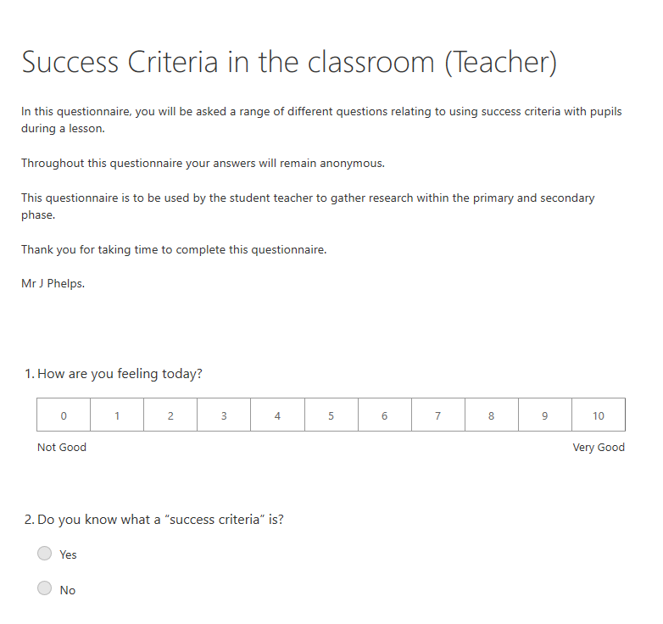
Available at: https://forms.office.com/Pages/DesignPage.aspx#FormId=-REPTm4EBUWcuNshUjEeIZVdhy4Rn5xOjTLixWL-I85UOUpTTDZHUTZPUVdSS0VIQ1NOTkMyNVpWMi4u
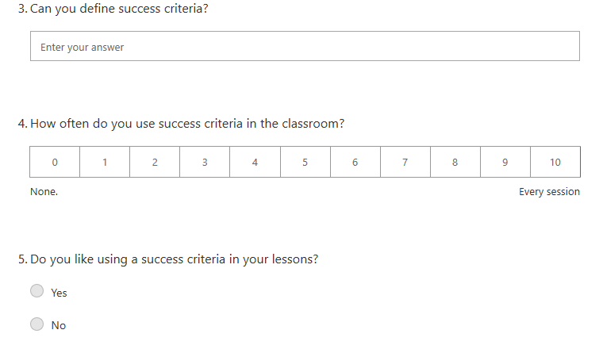
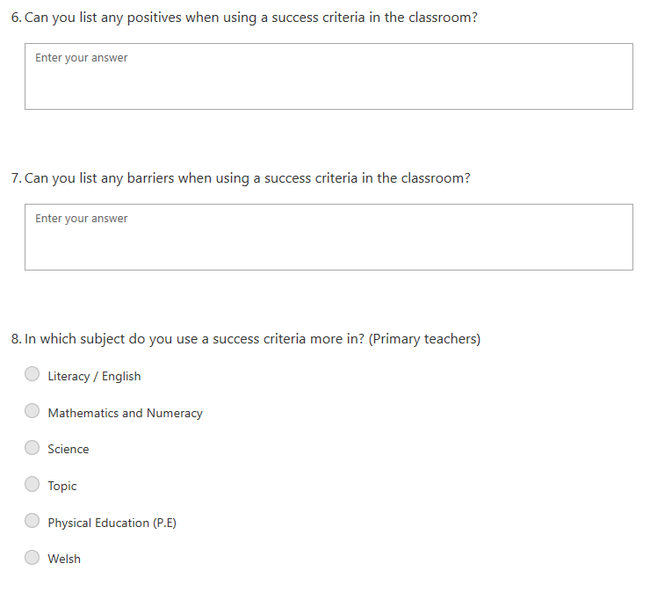

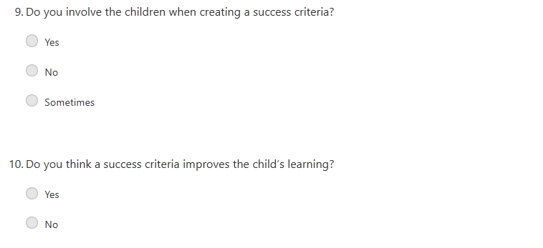

APPENDIX 2.
Available at: https://forms.office.com/Pages/DesignPage.aspx#FormId=-REPTm4EBUWcuNshUjEeIZVdhy4Rn5xOjTLixWL-I85UQ0VGNUM1UElZRzRIT01NMVc0WlI5Q09DUy4u
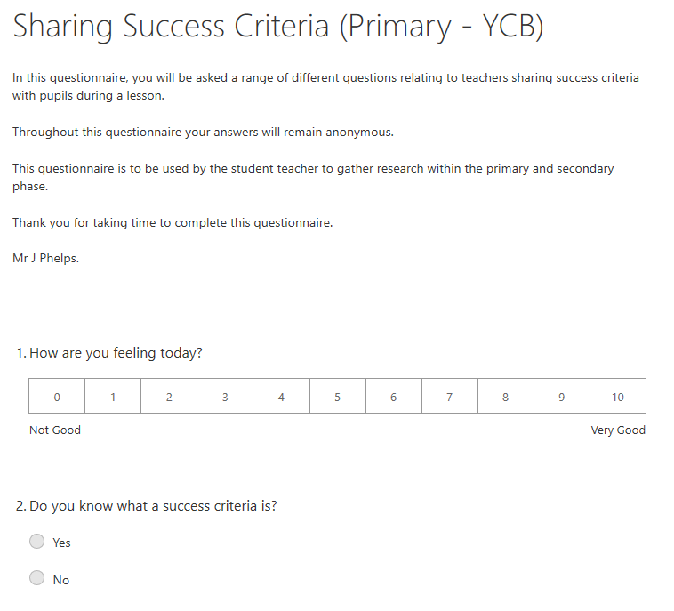

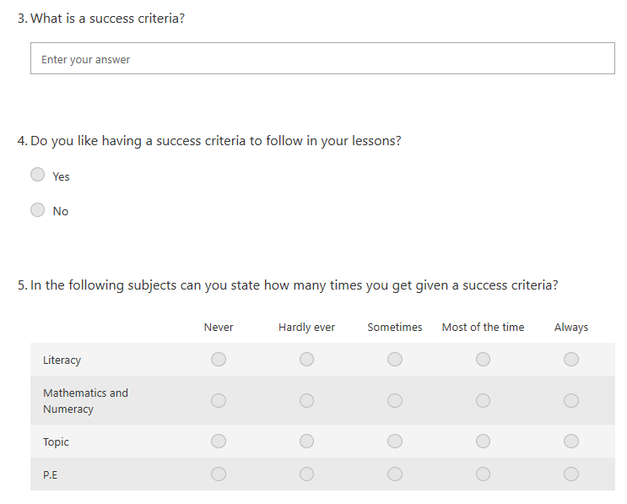
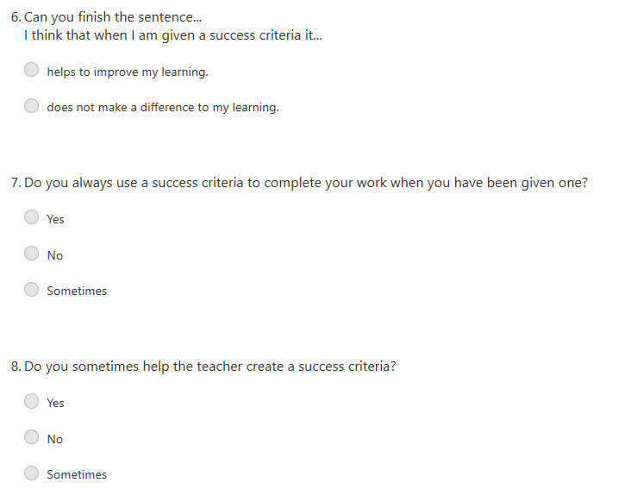

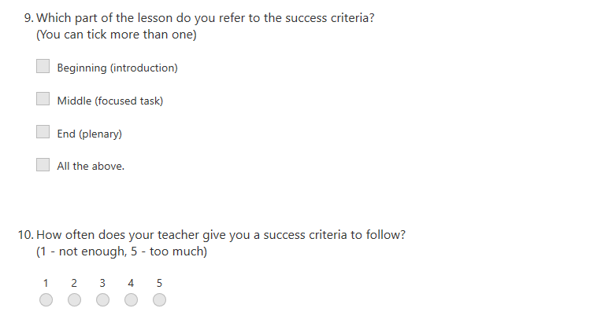

APPENDIX 3
Available at: https://forms.office.com/Pages/DesignPage.aspx#FormId=-REPTm4EBUWcuNshUjEeIZVdhy4Rn5xOjTLixWL-I85UNVlWS0o3MjVNSFZDTktMOUxZQlBVTTJGUC4u
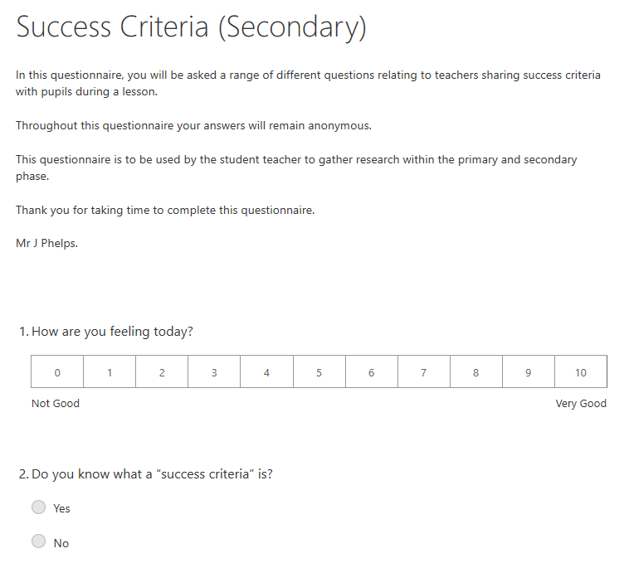

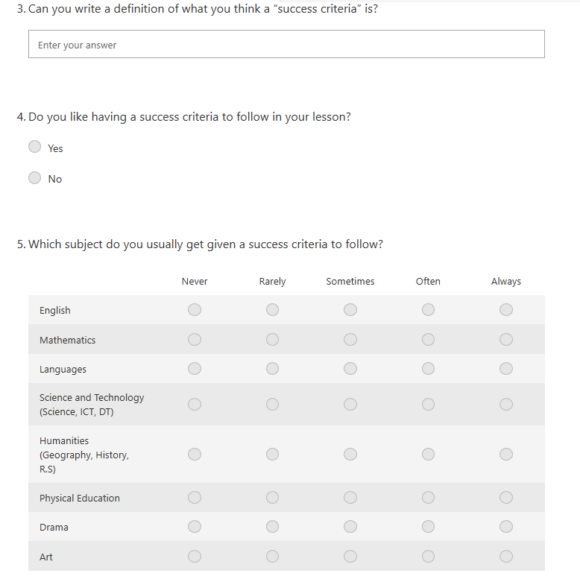

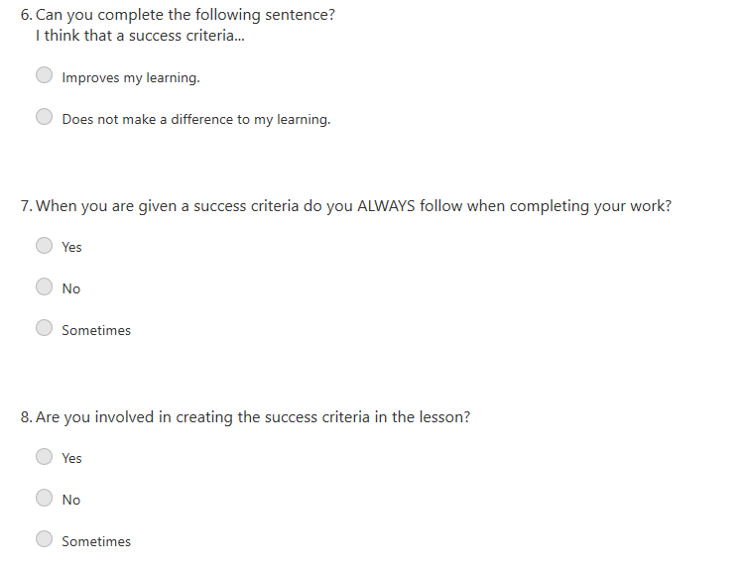
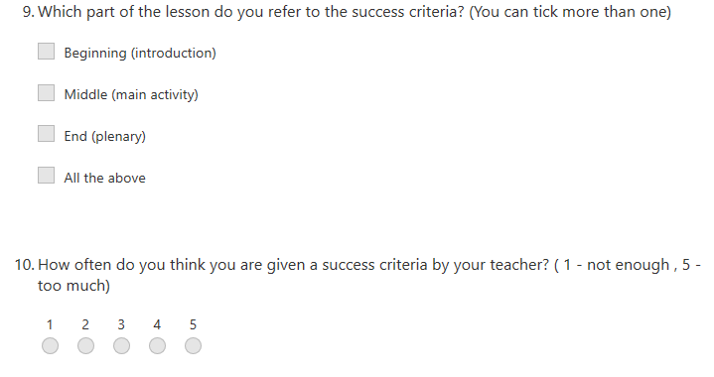

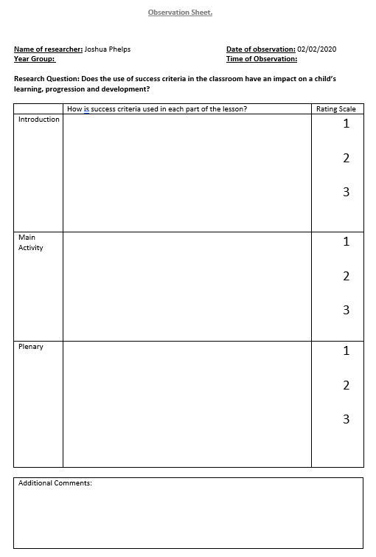
APPENDIX 4.
APPENDIX 5.

Teacher interview questions.

- How are you feeling today?

- Can you define success criteria?

- Do you like using a success criteria?

- Do you include a success criteria in your weekly planning?

- How often do you include success criteria in your lessons? (Why do you think that is?)

- Are there any particular year groups/ topics of study you prefer using success criteria in?

- Do you think that there are barriers when using a success criteria in lessons?

- What do you think is the main barrier when using a success criteria?

- Have you noticed any difference in the children’s progression and learning in lessons you use a success criteria and the lessons you do not?

- Thank you very much for answering these questions.

APPENDIX 6.

Primary interview questions.

1. How are you feeling today?

2. What have you been learning about in class?

3. Do you like learning about________?

4. Do you like it when a teacher gives you a success criteria? (Why?)

5. Why do you think your teacher gives you a success criteria when you’re working?

6. Do you think it helps your learning? (How?)

APPENDIX 7.

Secondary Interview Questions.

- How are you feeling today? (why?)

- What have you been learning about in (subject) recently?

- Do you like it when the teacher gives you a success criteria? (why?)

- Do you think it helps you with your work/ learning?

- DO you help the teacher make the success criteria?

APPENDIX 8.
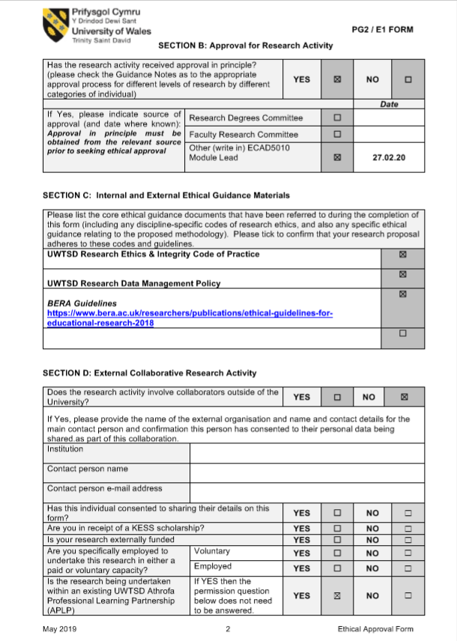

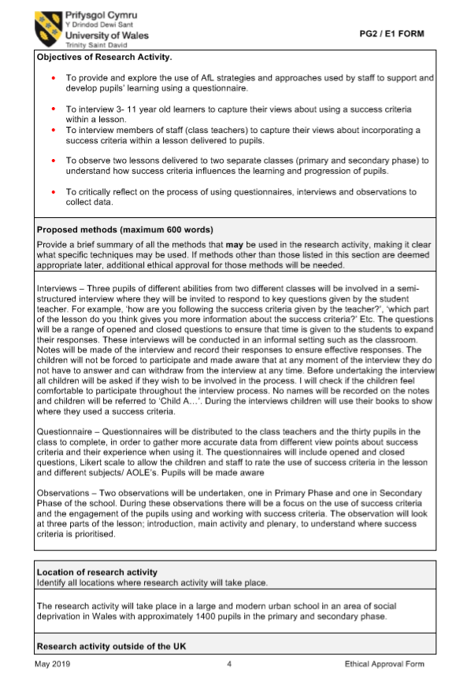
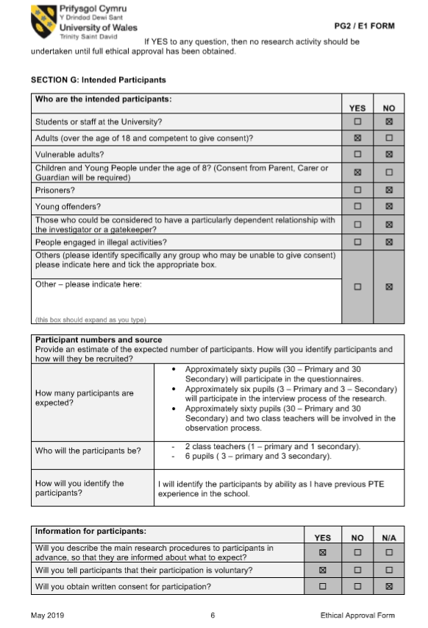
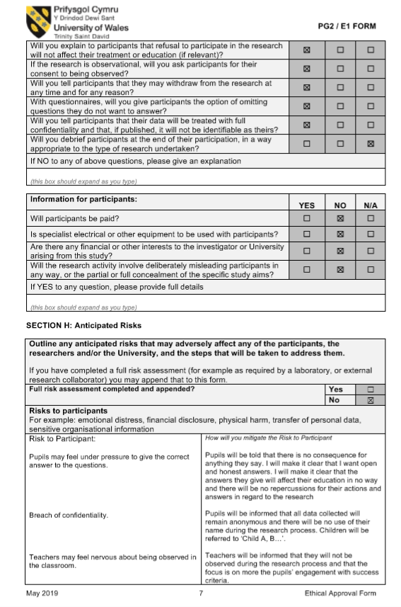
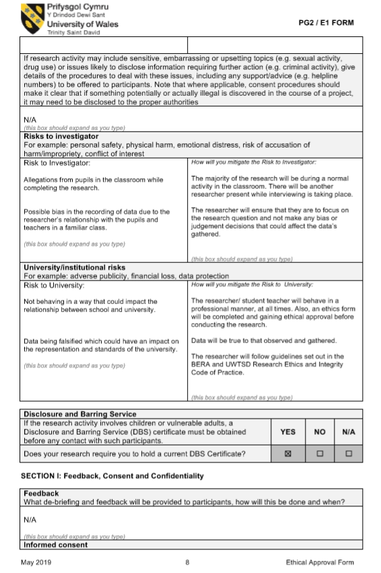
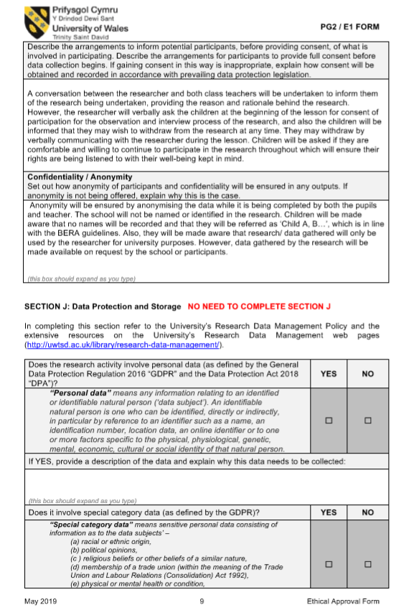

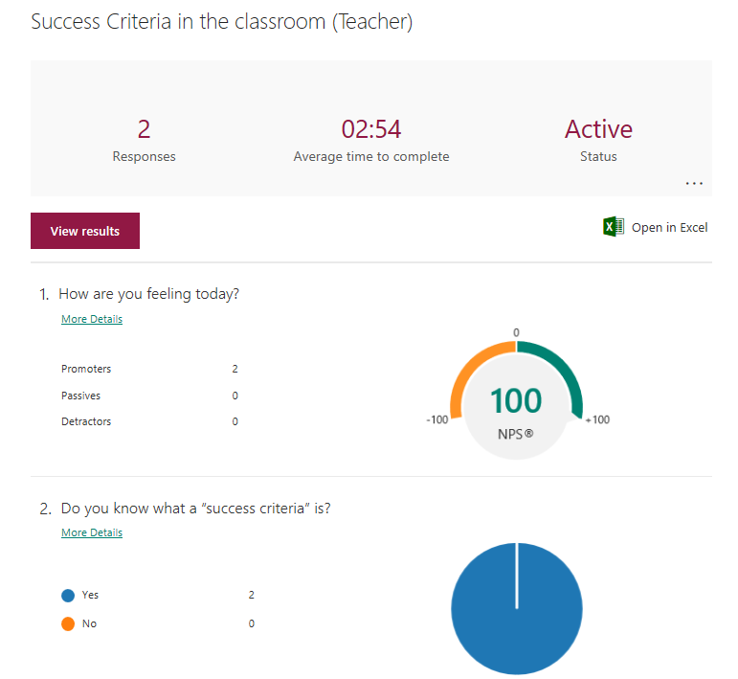
APPENDIX 9.

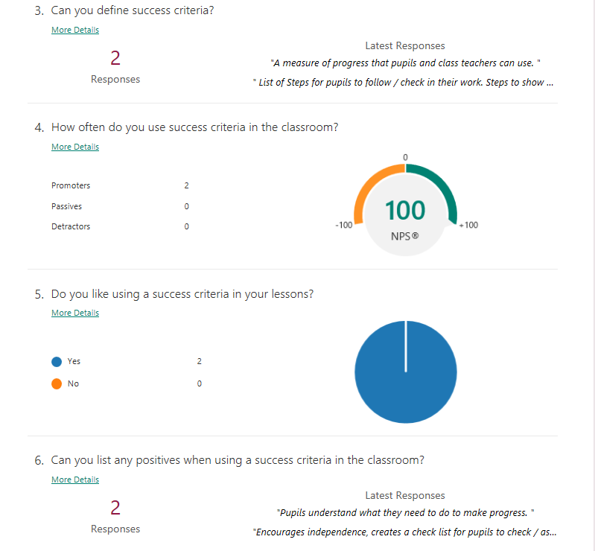

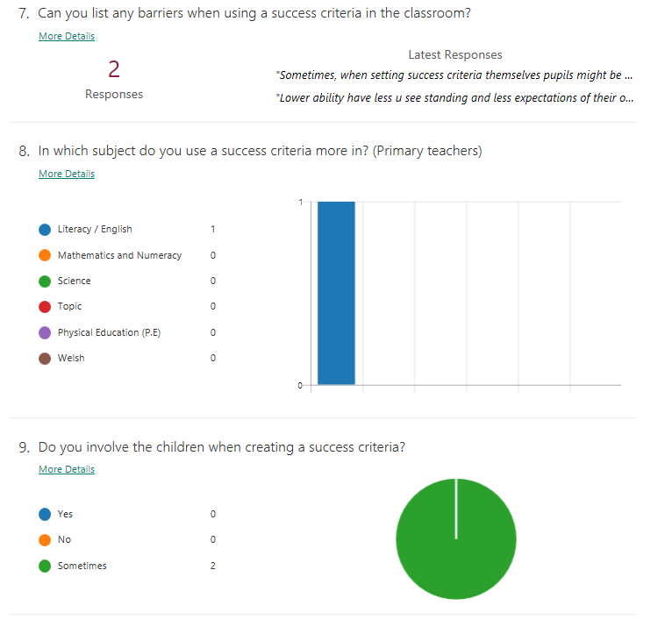

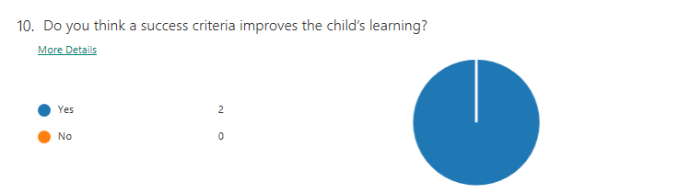

APPENDIX 10.
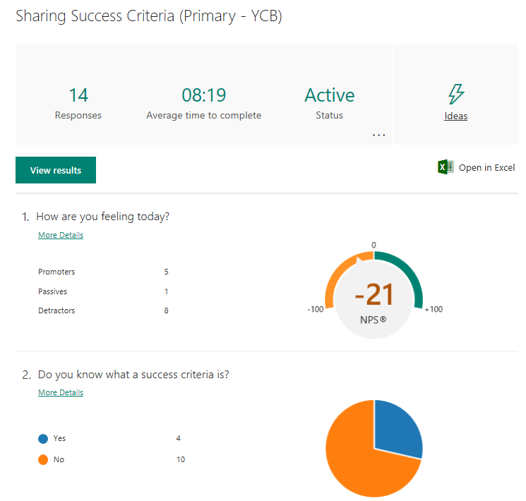

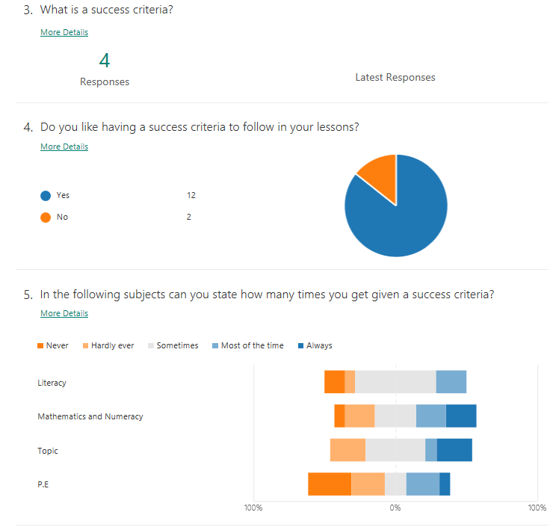

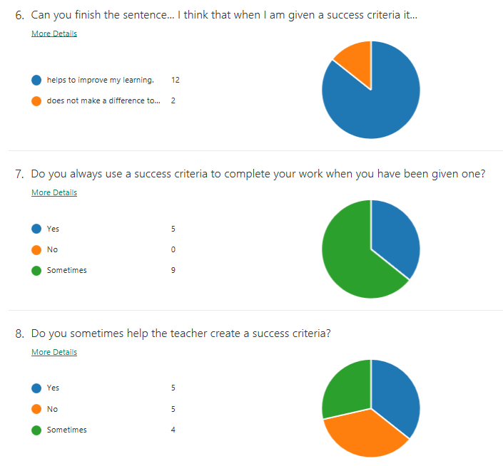

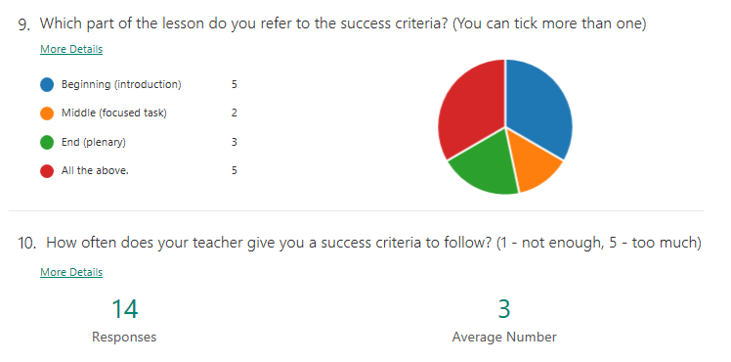

APPENDIX 11.
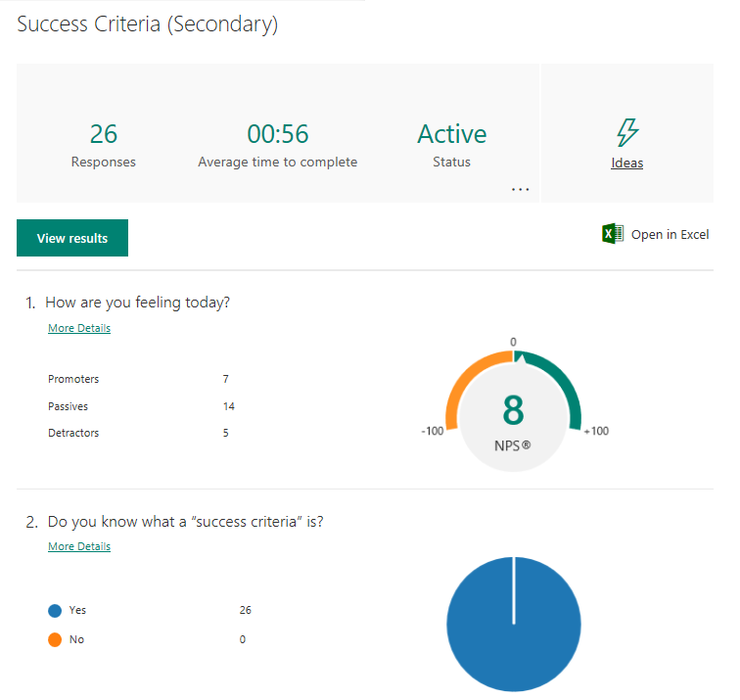

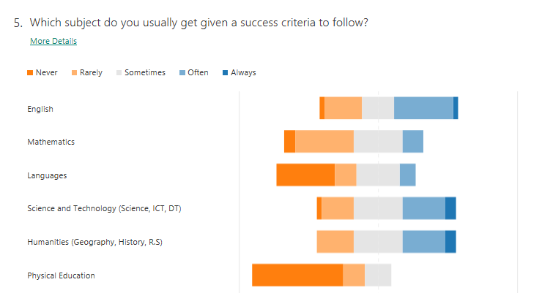

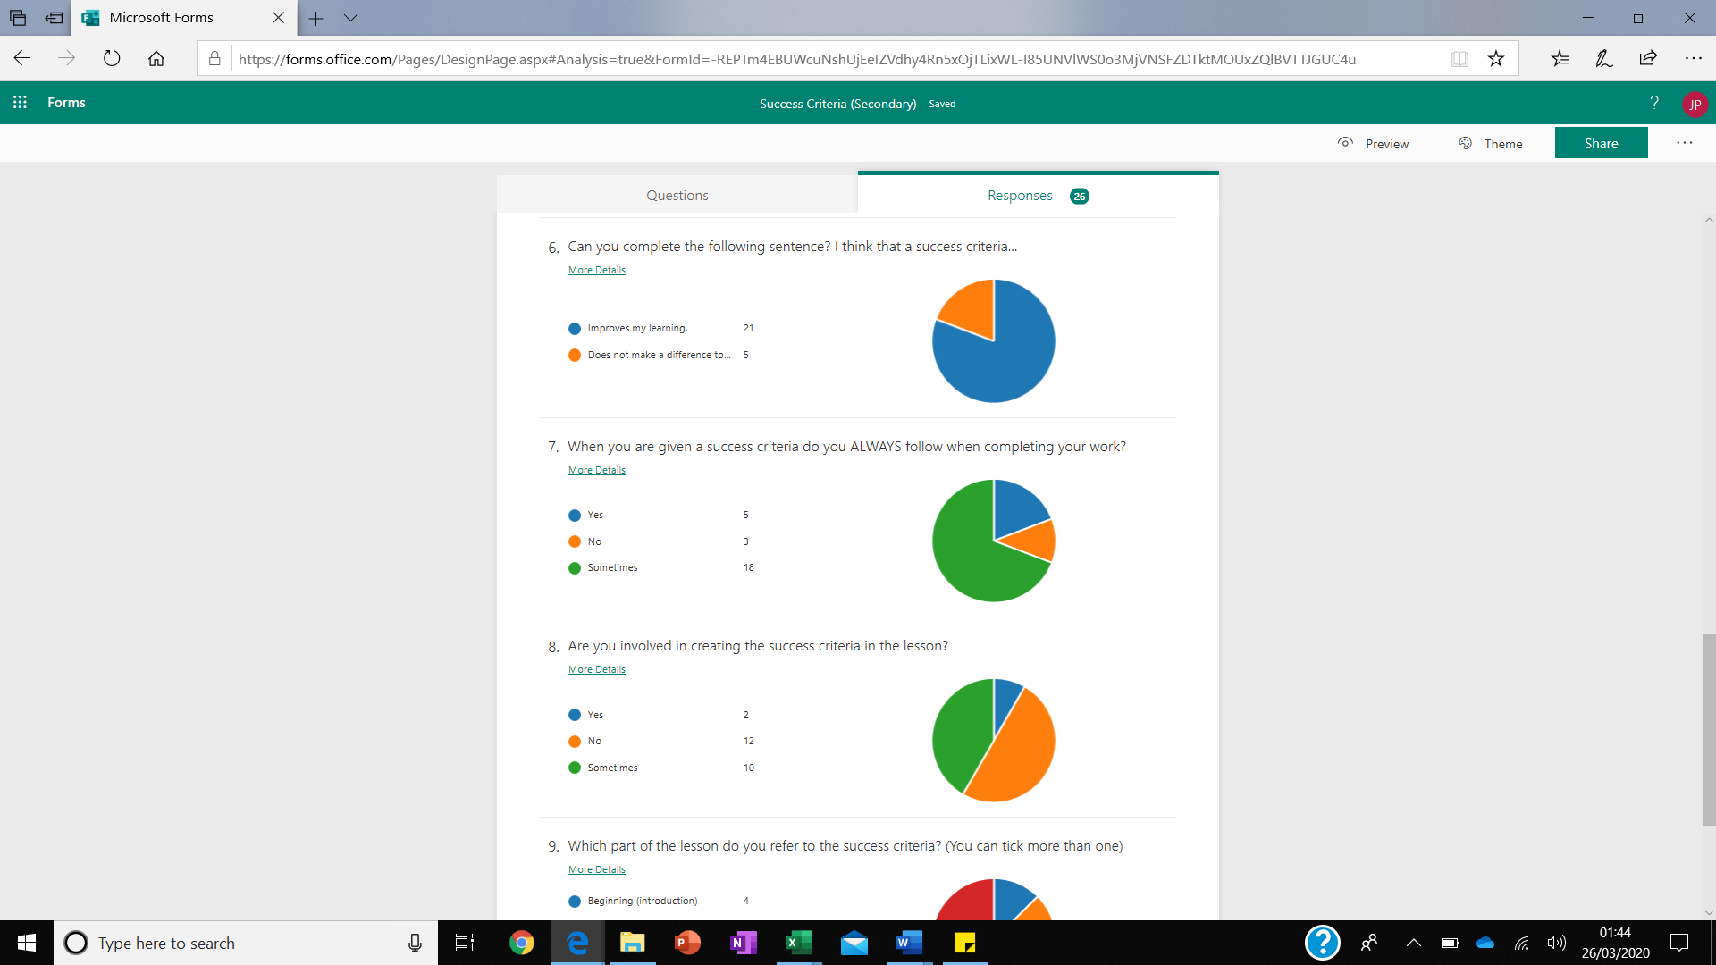
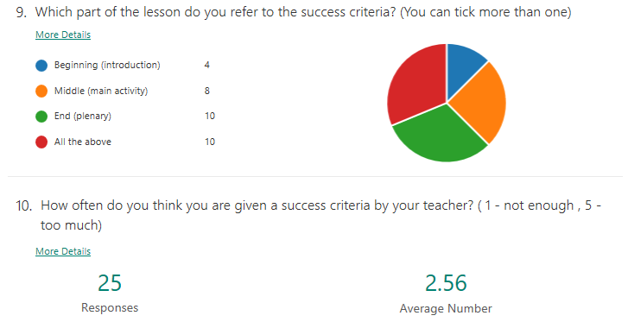

APPENDIX 12.
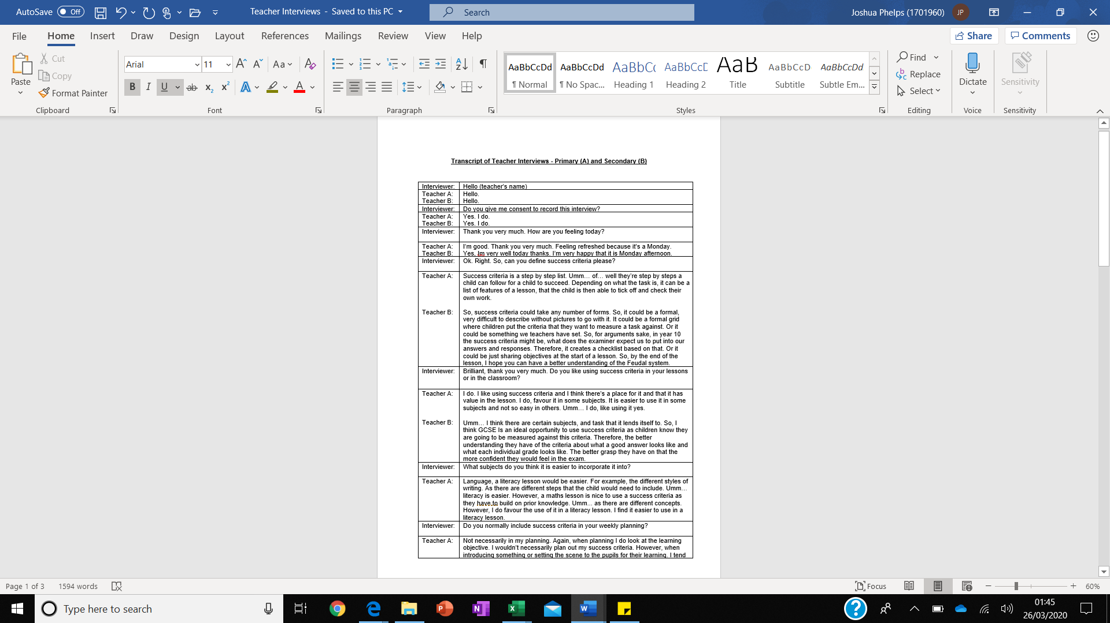

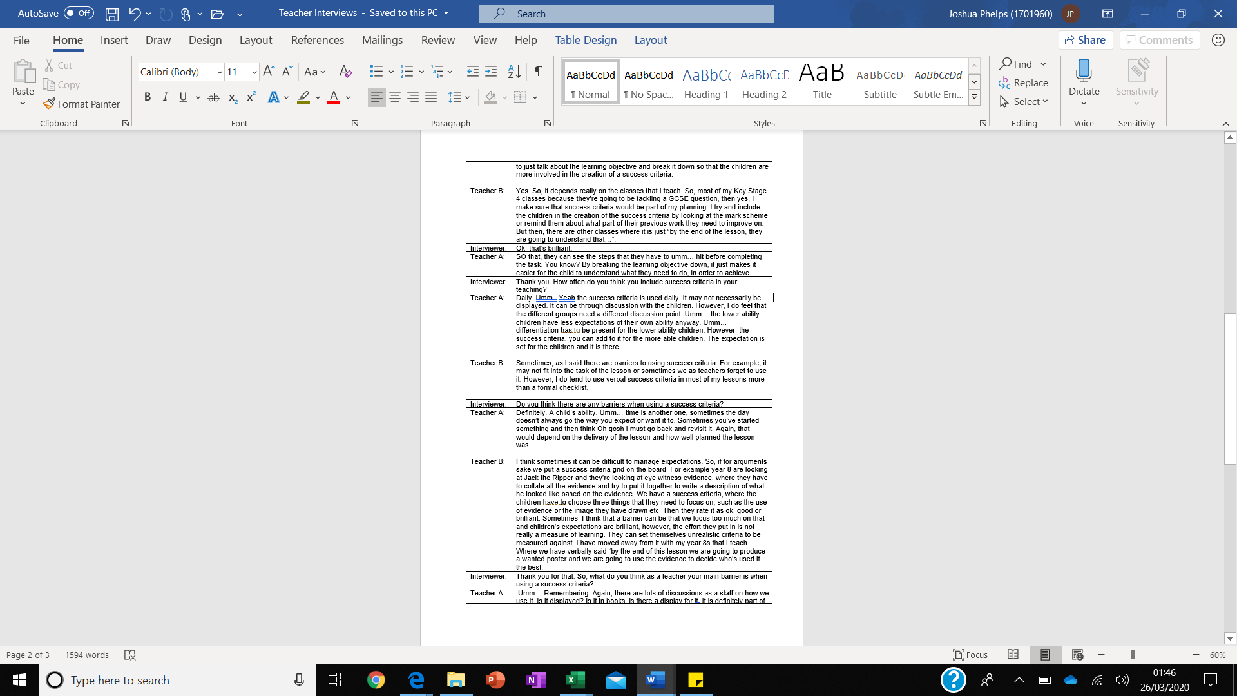

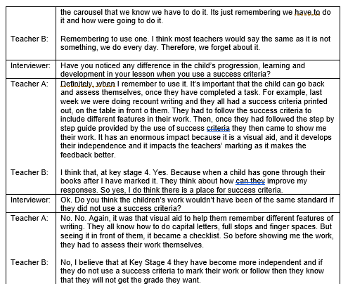

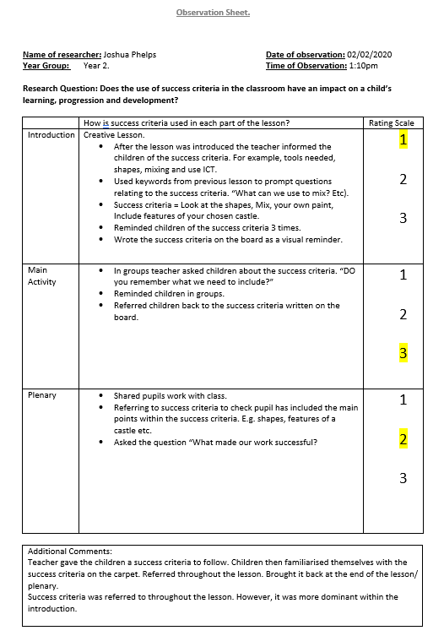
APPENDIX 13.
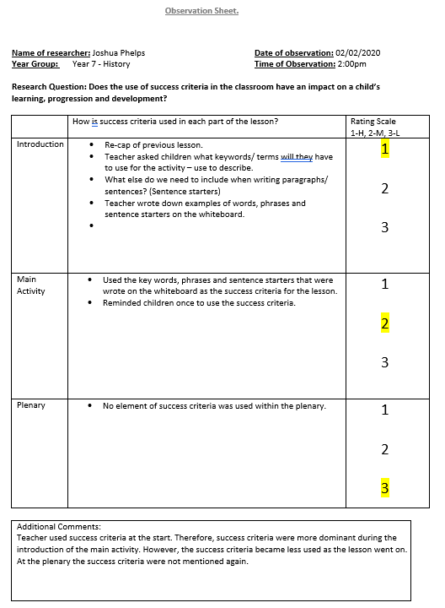
APPENDIX 14.

APPENDIX 15.
Transcript of Interview – Primary Pupils.

Interviewer: | So…… do you like it when the teacher gives you a success criteria?
Child A:  Child B:  Child C: | Yes!  Yes.  (nods head, yes)
Interviewer: | Can you tell me why you like it?
Child A:  Child B:  Child C: | Because umm, I can read it and see if I got it right or wrong.  Because I get to use it to help me with my work.  Because it reminds me about things.
Interviewer: | Do you think it helps you with your work?
Child A:  Child B:  Child C: | Yes.  Yes.  Yes
Interviewer: | Why’s that?
Child A:  Child B:  Child C: | Because it helps with your work and it shows you how to be successful.  It helps us with our learning and writing.  Yes it helps me learn all the things I have to write.
Interviewer: | Do you usually help the teacher create a success criteria?
Child A:  Child B:  Child C: | Sometimes, not all the time. (teacher) usually asks us what we think in our writing lessons.  It depends what lesson we are doing. Not all the time.  Sometimes, when we do writing.
Interviewer: | Thank you for answering my questions (name).
Child A:  Child B:  Child C: | It’s ok.  Ok.  (got up)

APPENDIX 16.

Transcript of Interview 3 (Secondary Pupils).

Interviewer: | Do you like it when the teacher gives you a success criteria?
Child A:  Child B:  Child C: | Yes!  Sometimes, yes.  Yeah, it’s ok.
Interviewer: | Can you tell me why you like it?
Child A:  Child B:  Child C: | Because I use it as a checklist when doing a task or a written piece of work.  It reminds me about what I need to do and where I need to be by the end of the lesson.  It reminds me what I need to put in my work
Interviewer: | Do you think it helps you with your work?
Child A:  Child B:  Child C: | Yes.  Yeah, most of the time.  Yes. I feel that it helps me with my learning, as it makes me more independent.
Interviewer: | Do you help the teacher make the success criteria?
Child A:  Child B:  Child C: | Not really, the teachers usually give us one at the start of the lesson and then we have to follow it.  Not really, the teachers never ask us what we think should go in the success criteria.  Sometimes. I mean, I think it depends what the task is. Usually with writing and literacy yes they do. They usually remind us to look at the learning objective and how we think we can be successful. However, not in every lesson as they just give us one they have already got.
Interviewer: | Thank you for answering my questions (name).
Child A:  Child B:  Child C: | It’s ok.  No problem. Am I ok to go now Sir?  No problem. It’s ok.

